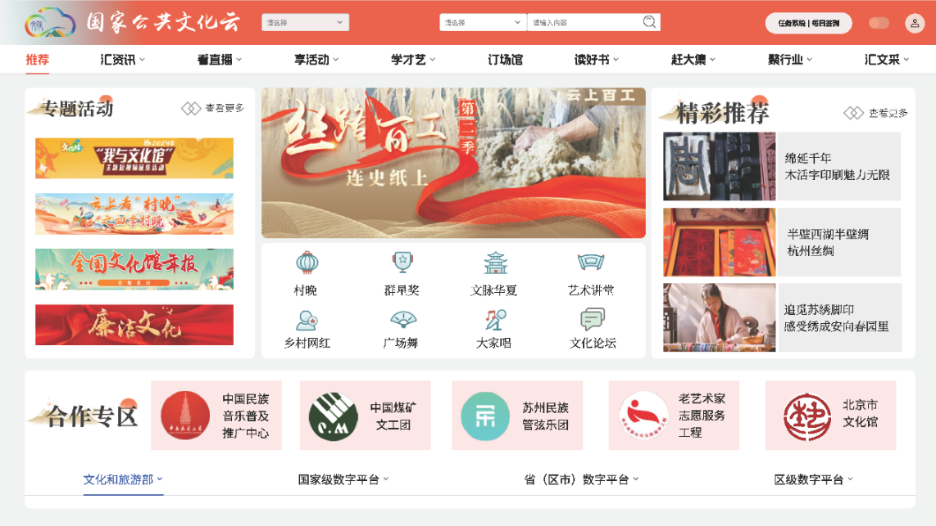
Fig. 4 National Public Culture Cloud homepage

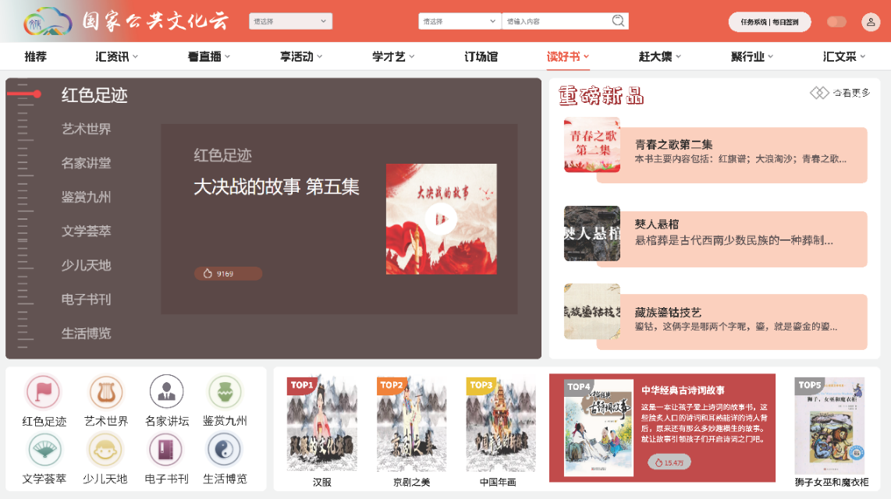
Fig.5 "Reading Books" section
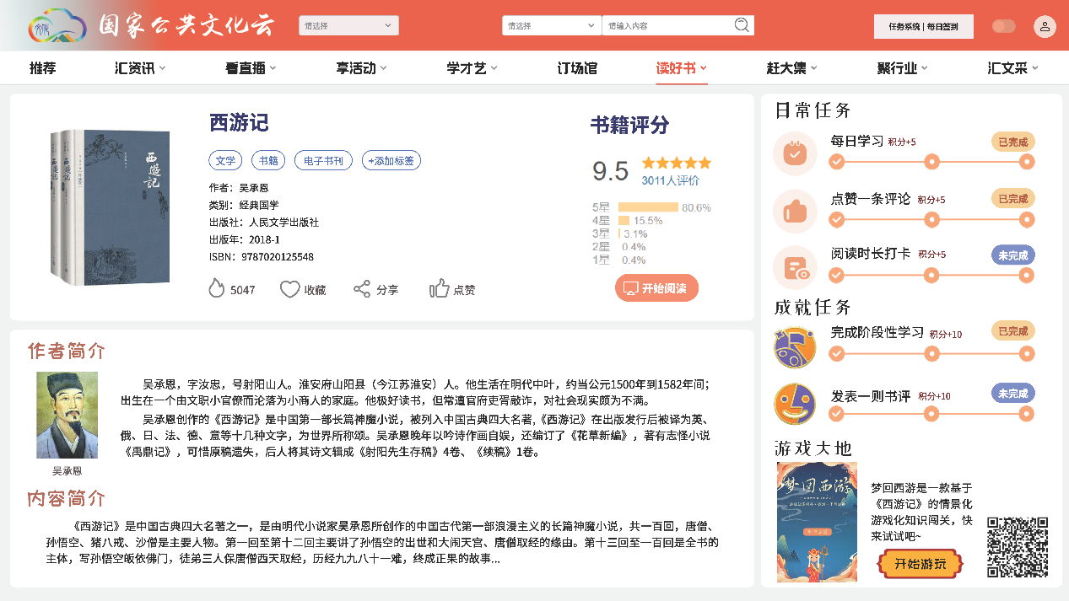
Fig.6 Gamification of "Reading Books" - Journey to the West
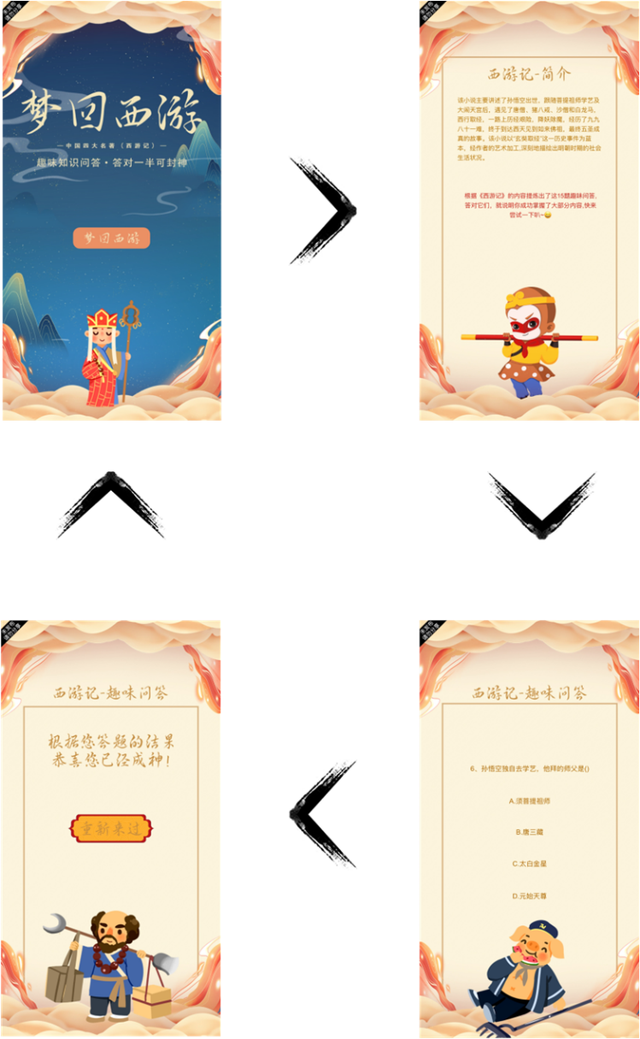
Fig.7 Dreaming of Journey to the West game process
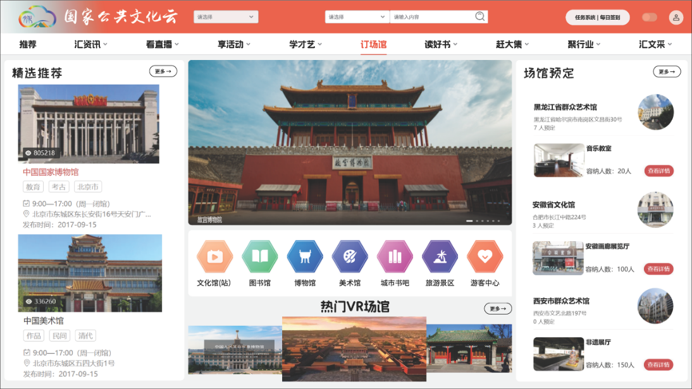
Fig.8 "Booking Venues" section

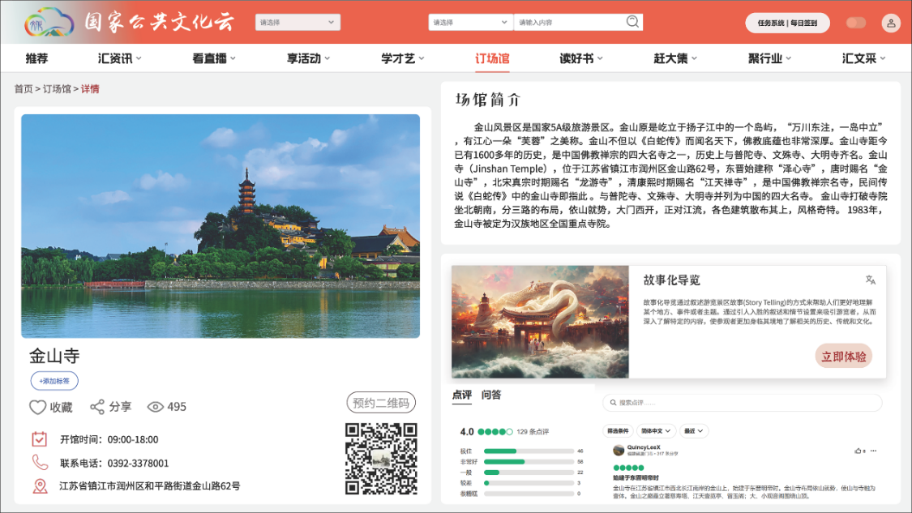
Fig.9 Gamification of "Booking Venues" - Jinshan Temple

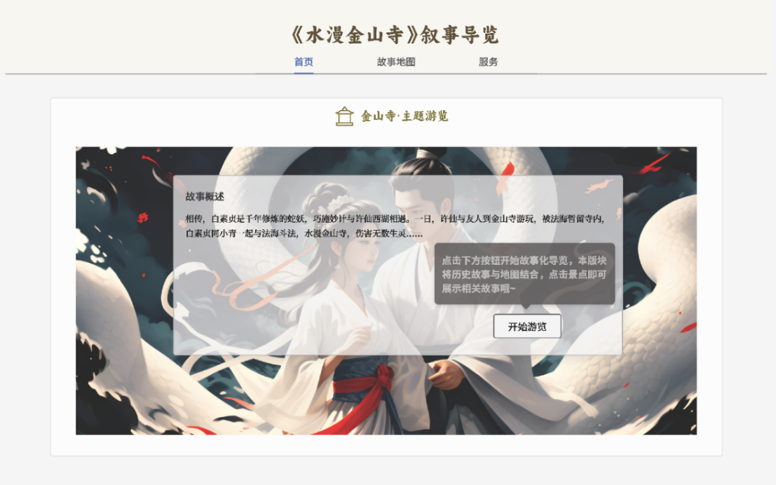
Fig.10 Storytelling Guide Homepage

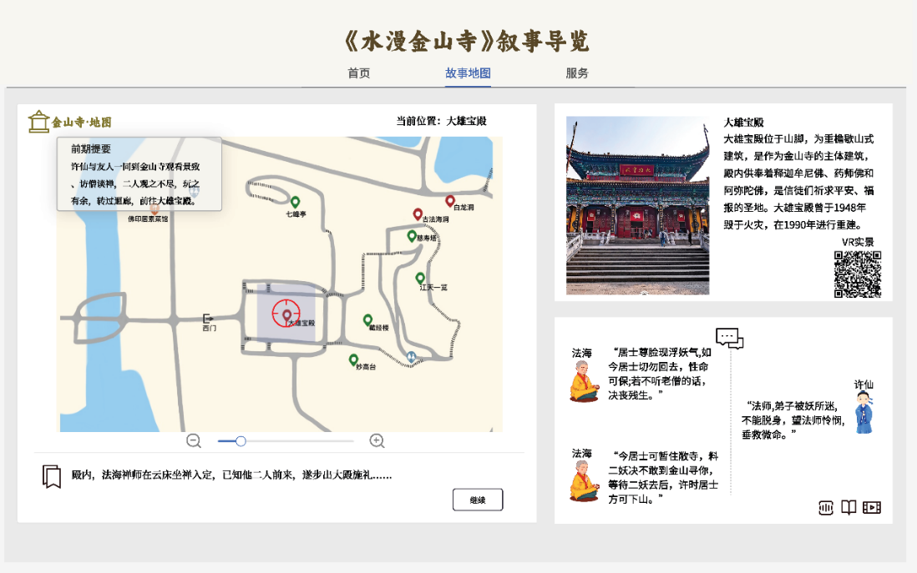
Fig.11 Storytelling Guide of Jinshan Temple
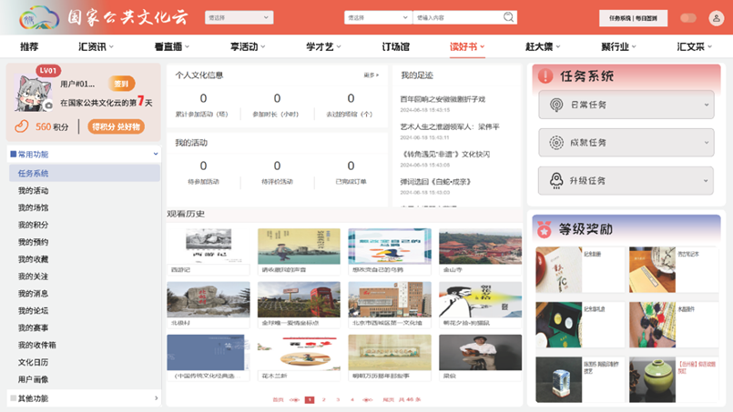
Fig.12 Personal Homepage

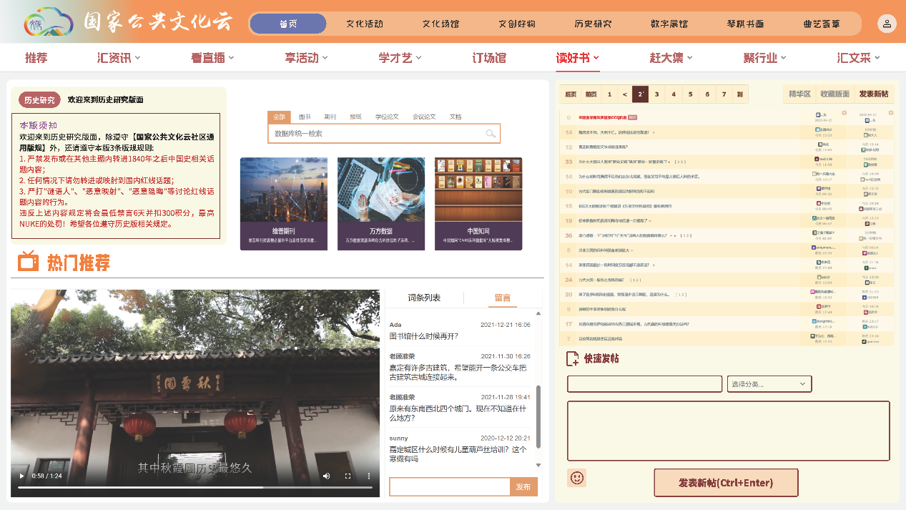
Fig.13 Cultural Communication Forum

