Supplementary Information
Future-Oriented Electrode Achieved by in-situ Generated Tetrahydrofuran-Based Binder
Nanyu Chen^{1,3}, Wei Wu^{1,3}, Jiafeng Ruan^{1,3}, Chenrui Li¹, Saihui Duan¹, Jiayun Zhang¹, Yanzhou Zhu¹, Xiayun Huang¹, Fang Fang^{1,2}, Dalin Sun^{1,2}, Yun Song^{1,2,*}
¹College of Smart Materials and Future Energy, Fudan University, Shanghai 200433, P. R. China
²The State Key Laboratory of Molecular Engineering of Polymers and Department of Macromolecular Science, Fudan University, Shanghai 200438, P. R. China.
³These authors contributed equally: Nanyu Chen, Wei Wu, Jiafeng Ruan.
*Corresponding author. E-mail address: songyun@fudan.edu.cn
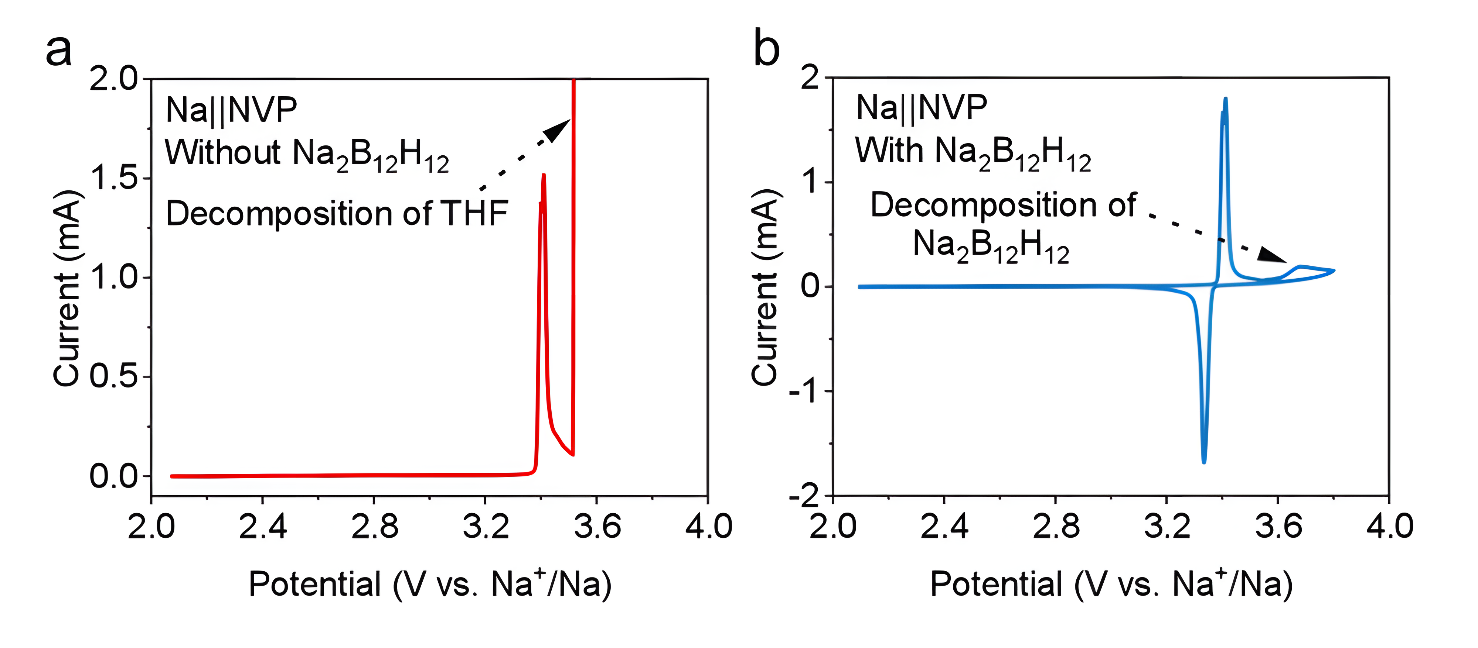
Figure S1. a, CV curve of Na||NVP@Al in NaPF₆-THF electrolyte. b, CV curve of Na||NVP@Al in NaPF₆-THF-Na₂B₁₂H₁₂ electrolyte.

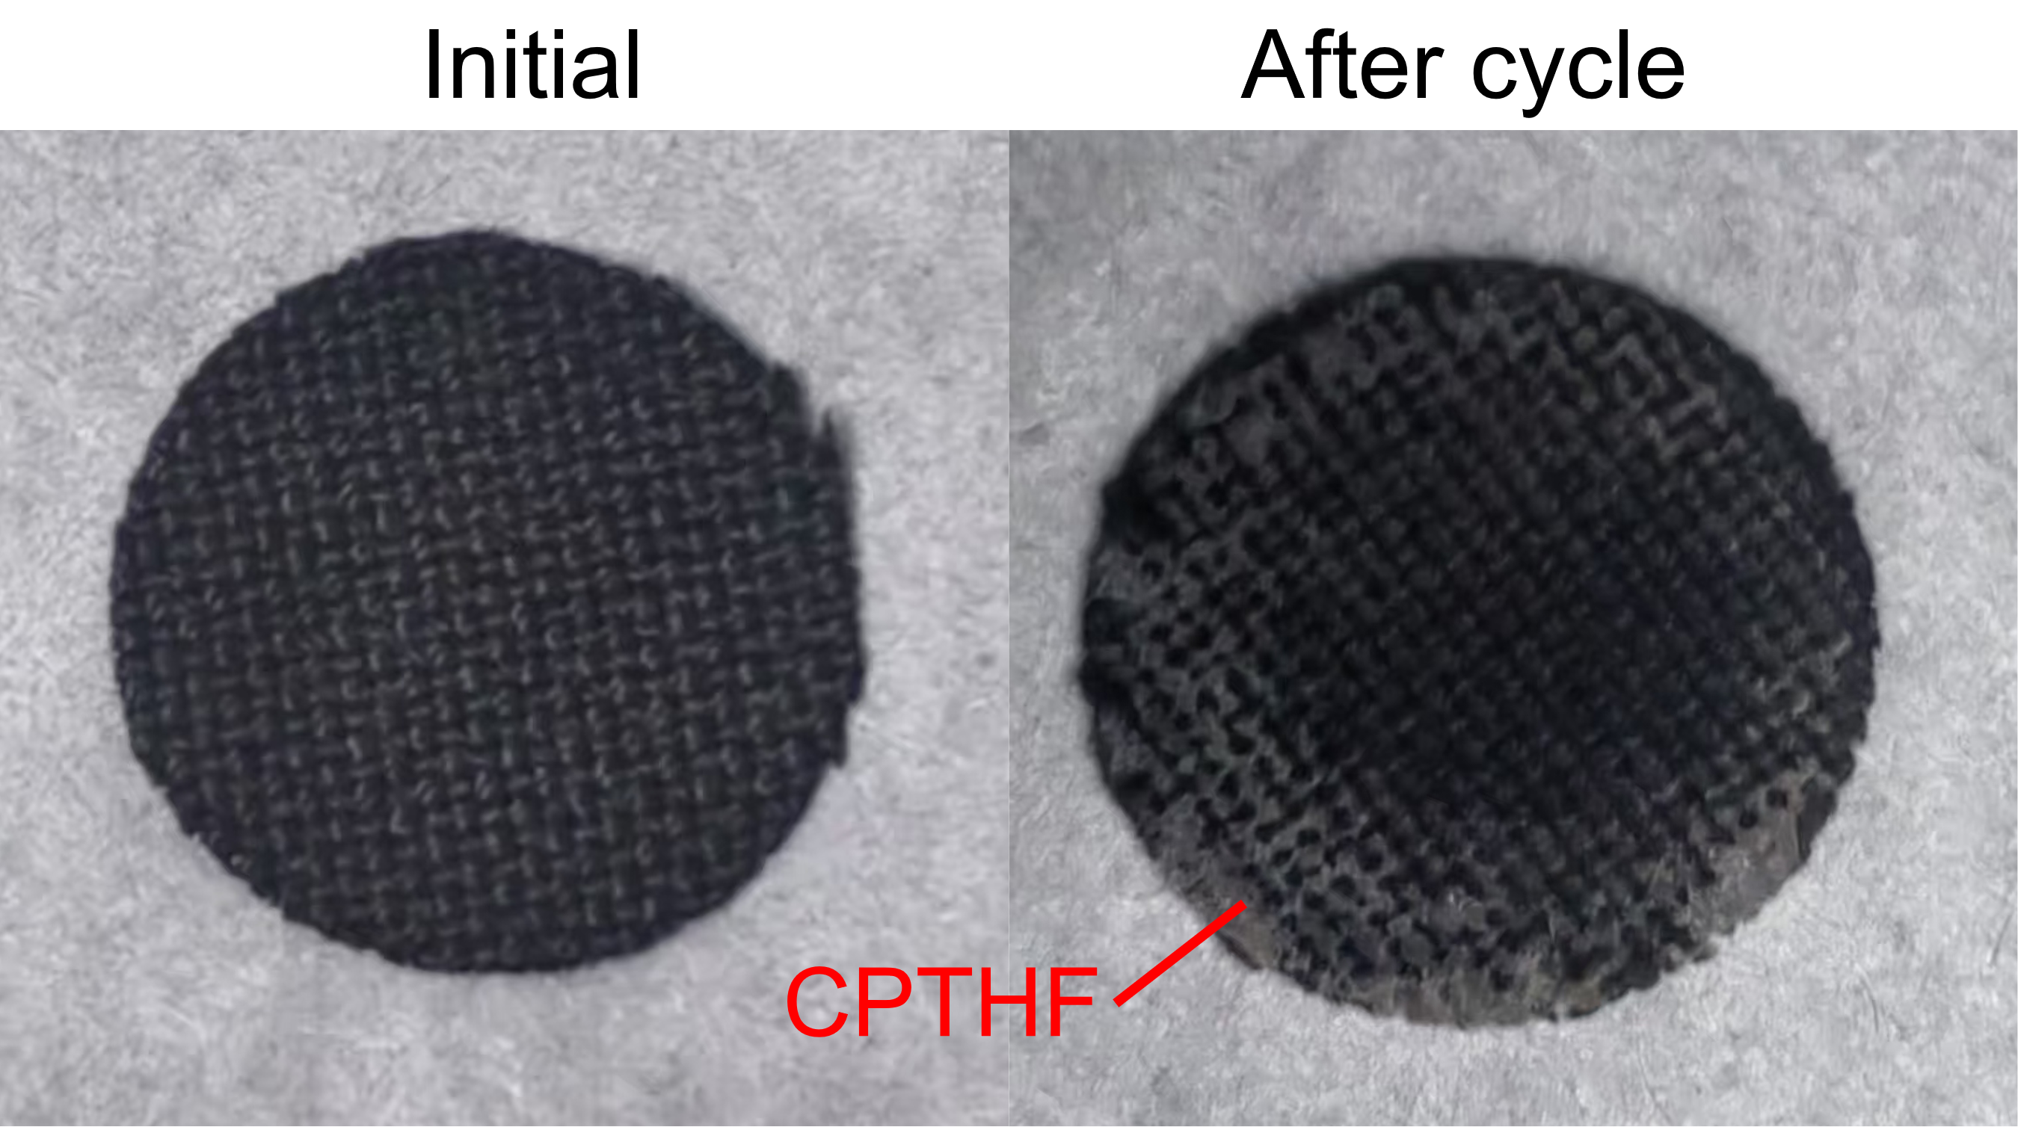
Figure S2. Optical images of NVP@CC and CPTHF@NVP@CC electrodes.

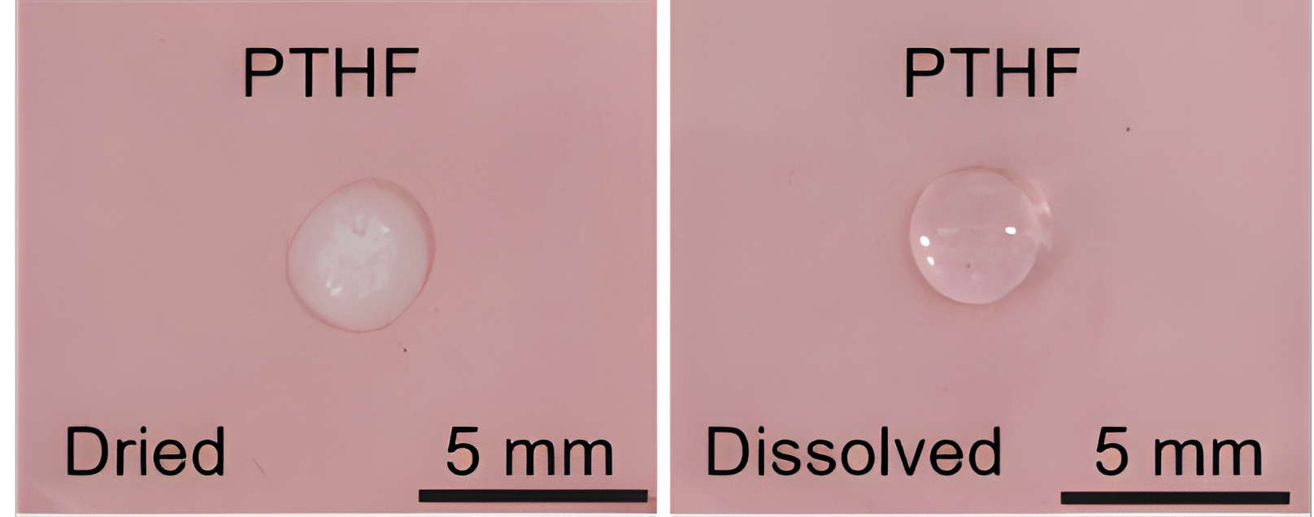
Figure S3. Optical images of dried/dissolved PTHF.

Figure S4. Optical image of THF (left), cycled NVP@Al using NaPF₆-THF immersed in THF (middle) and cycled NVP@Al using NaPF₆-THF-Na₂B₁₂H₁₂ immersed in THF (right), which ultrasonic treated for 240 s.

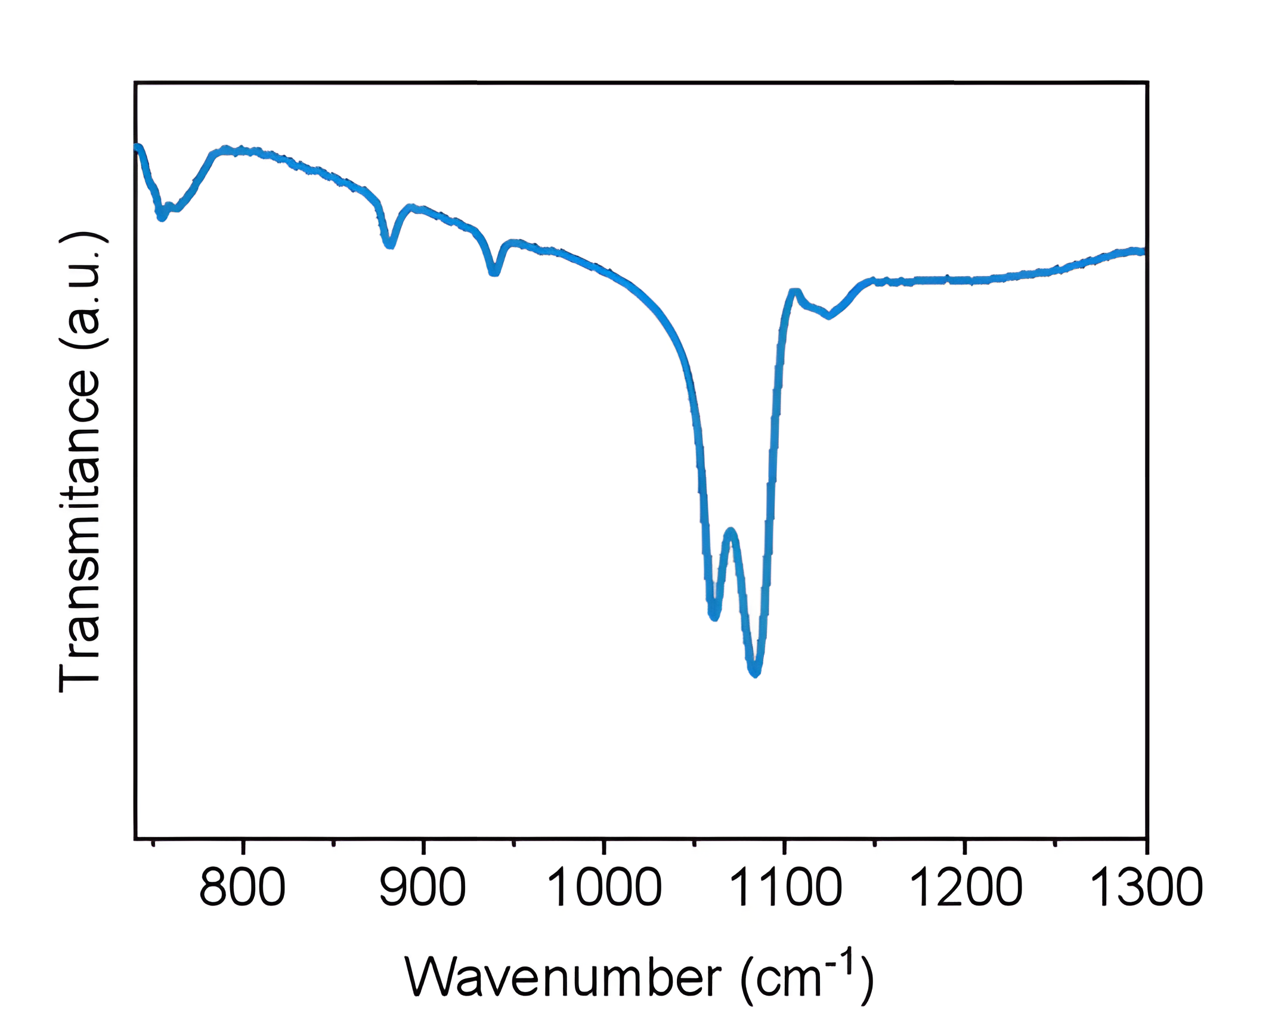
Figure S5. FT-IR spectrum of Na₂B₁₂H₁₂.

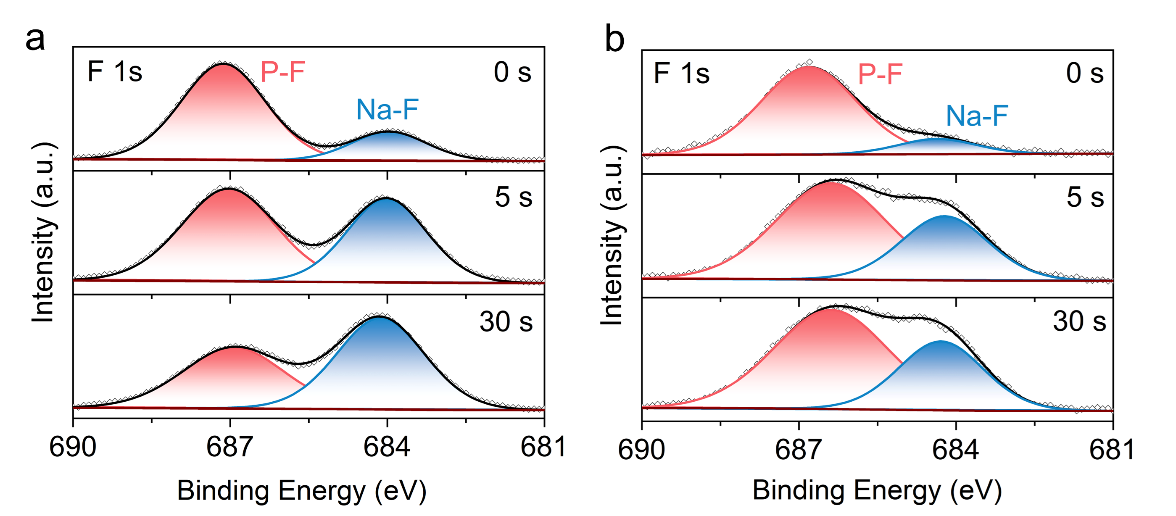
Figure S6. a,b F 1s XPS spectra of cycled NVP@Al using (a) NaPF₆-THF and (b) NaPF₆-THF-Na₂B₁₂H₁₂ electrolytes.

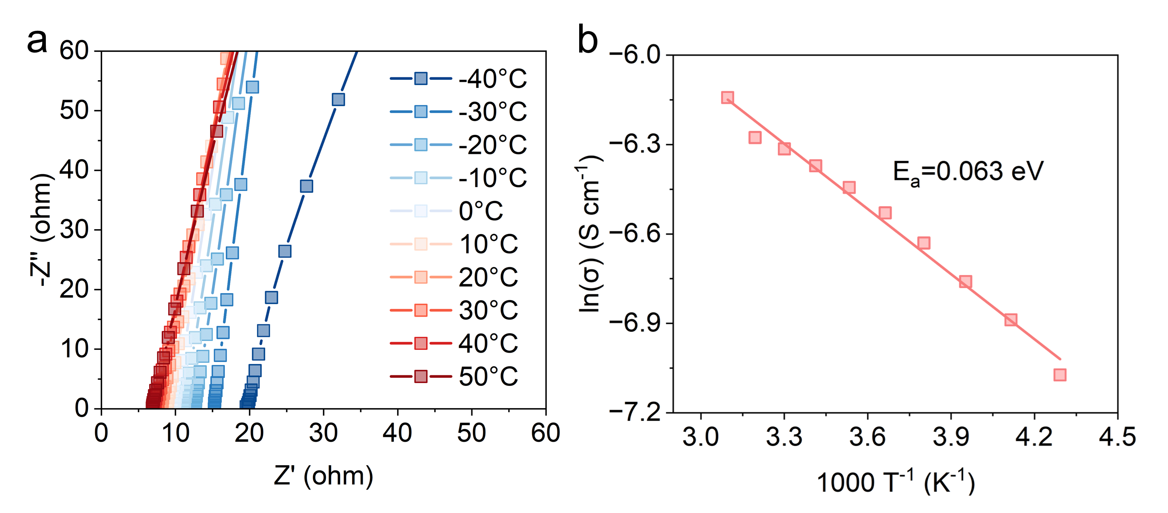
Figure S7. a, Variable-temperature Nyquist plots of CPTHF. b, Arrhenius plots of the ionic conductivity of CPTHF.

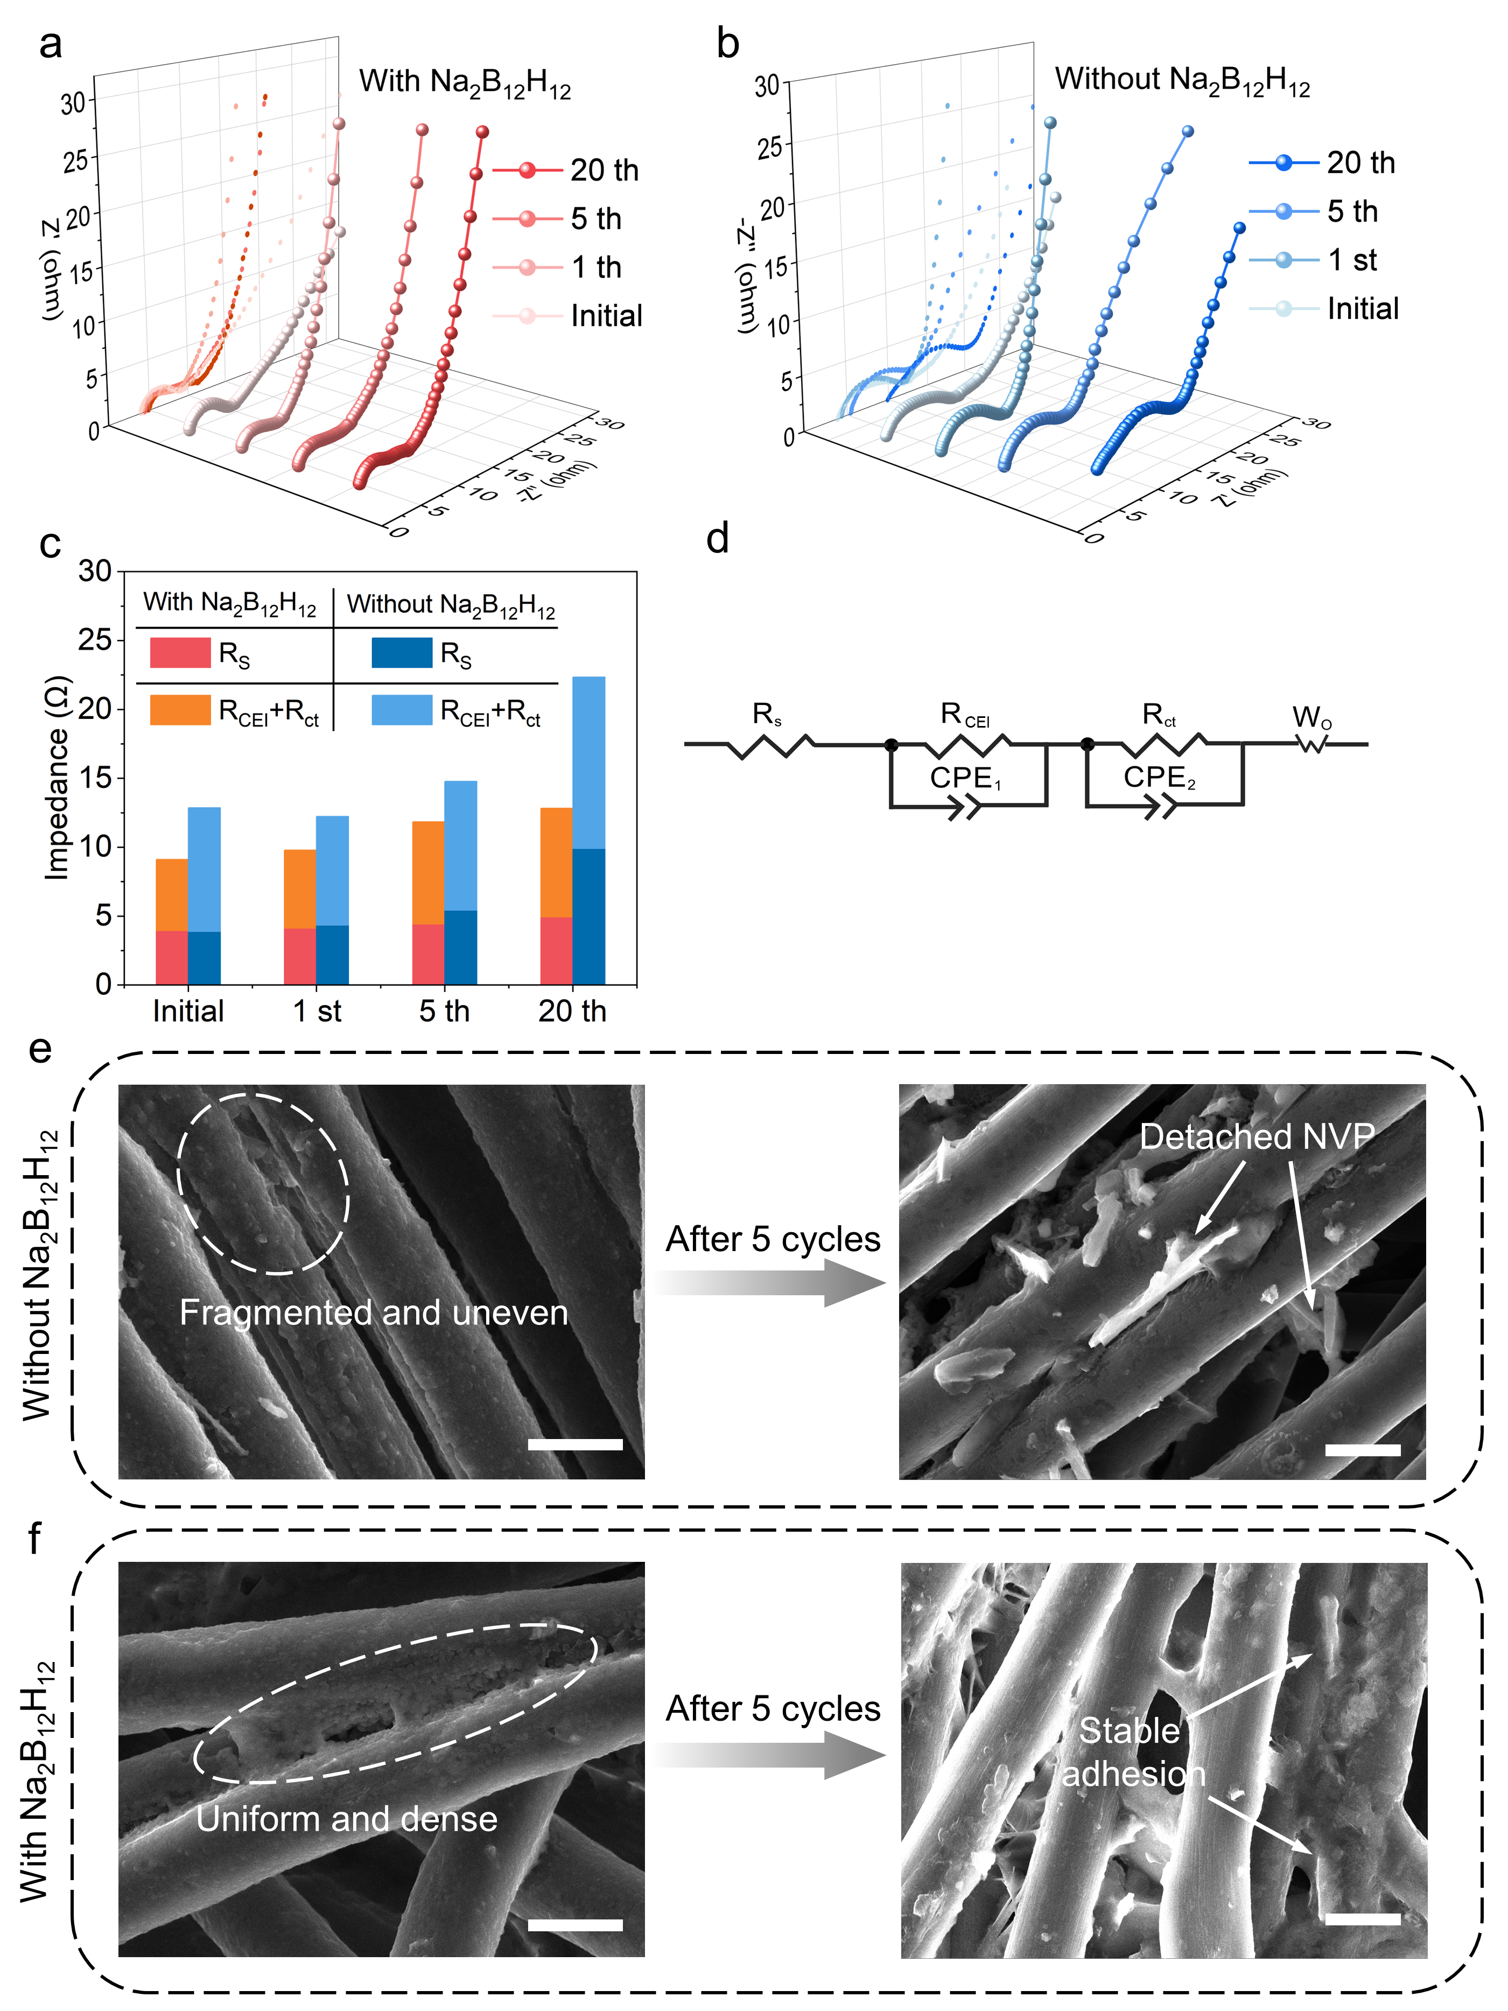
Figure S8. a,b Nyquist plots of NVP@CC in (a) NaPF₆-THF and (b) NaPF₆-THF-Na₂B₁₂H₁₂ at 25 °C. c, Corresponding profile of R_{S} and R_{CEI}. d, Equivalent circuit model used for fitting. e, SEM images of NVP@CC and NVP@CC cycled in NaPF₆-THF. f, SEM images of pristine NVP@CC and NVP@CC cycled in NaPF₆-THF-Na₂B₁₂H₁₂. The scale bar is 10 μm.

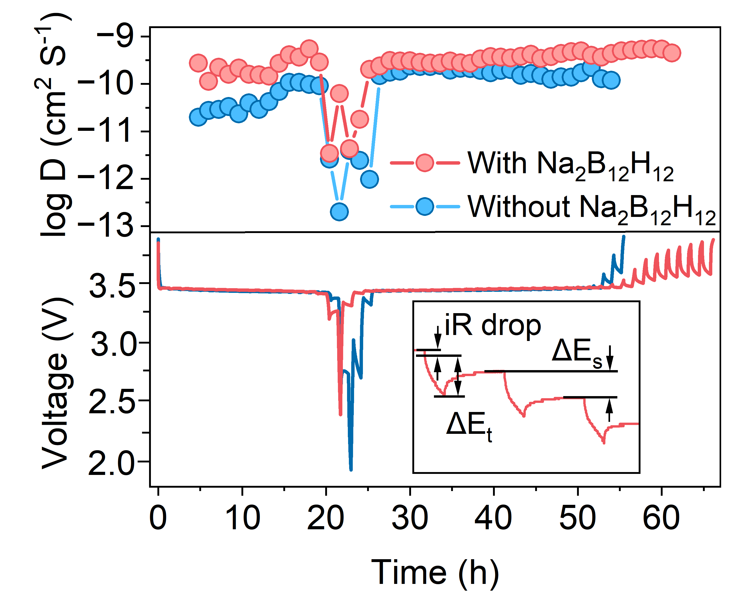
Figure S9. GITT curves of NaPF₆-THF and NaPF₆-THF-Na₂B₁₂H₁₂, together with comparison of Na⁺ diffusion coefficients.

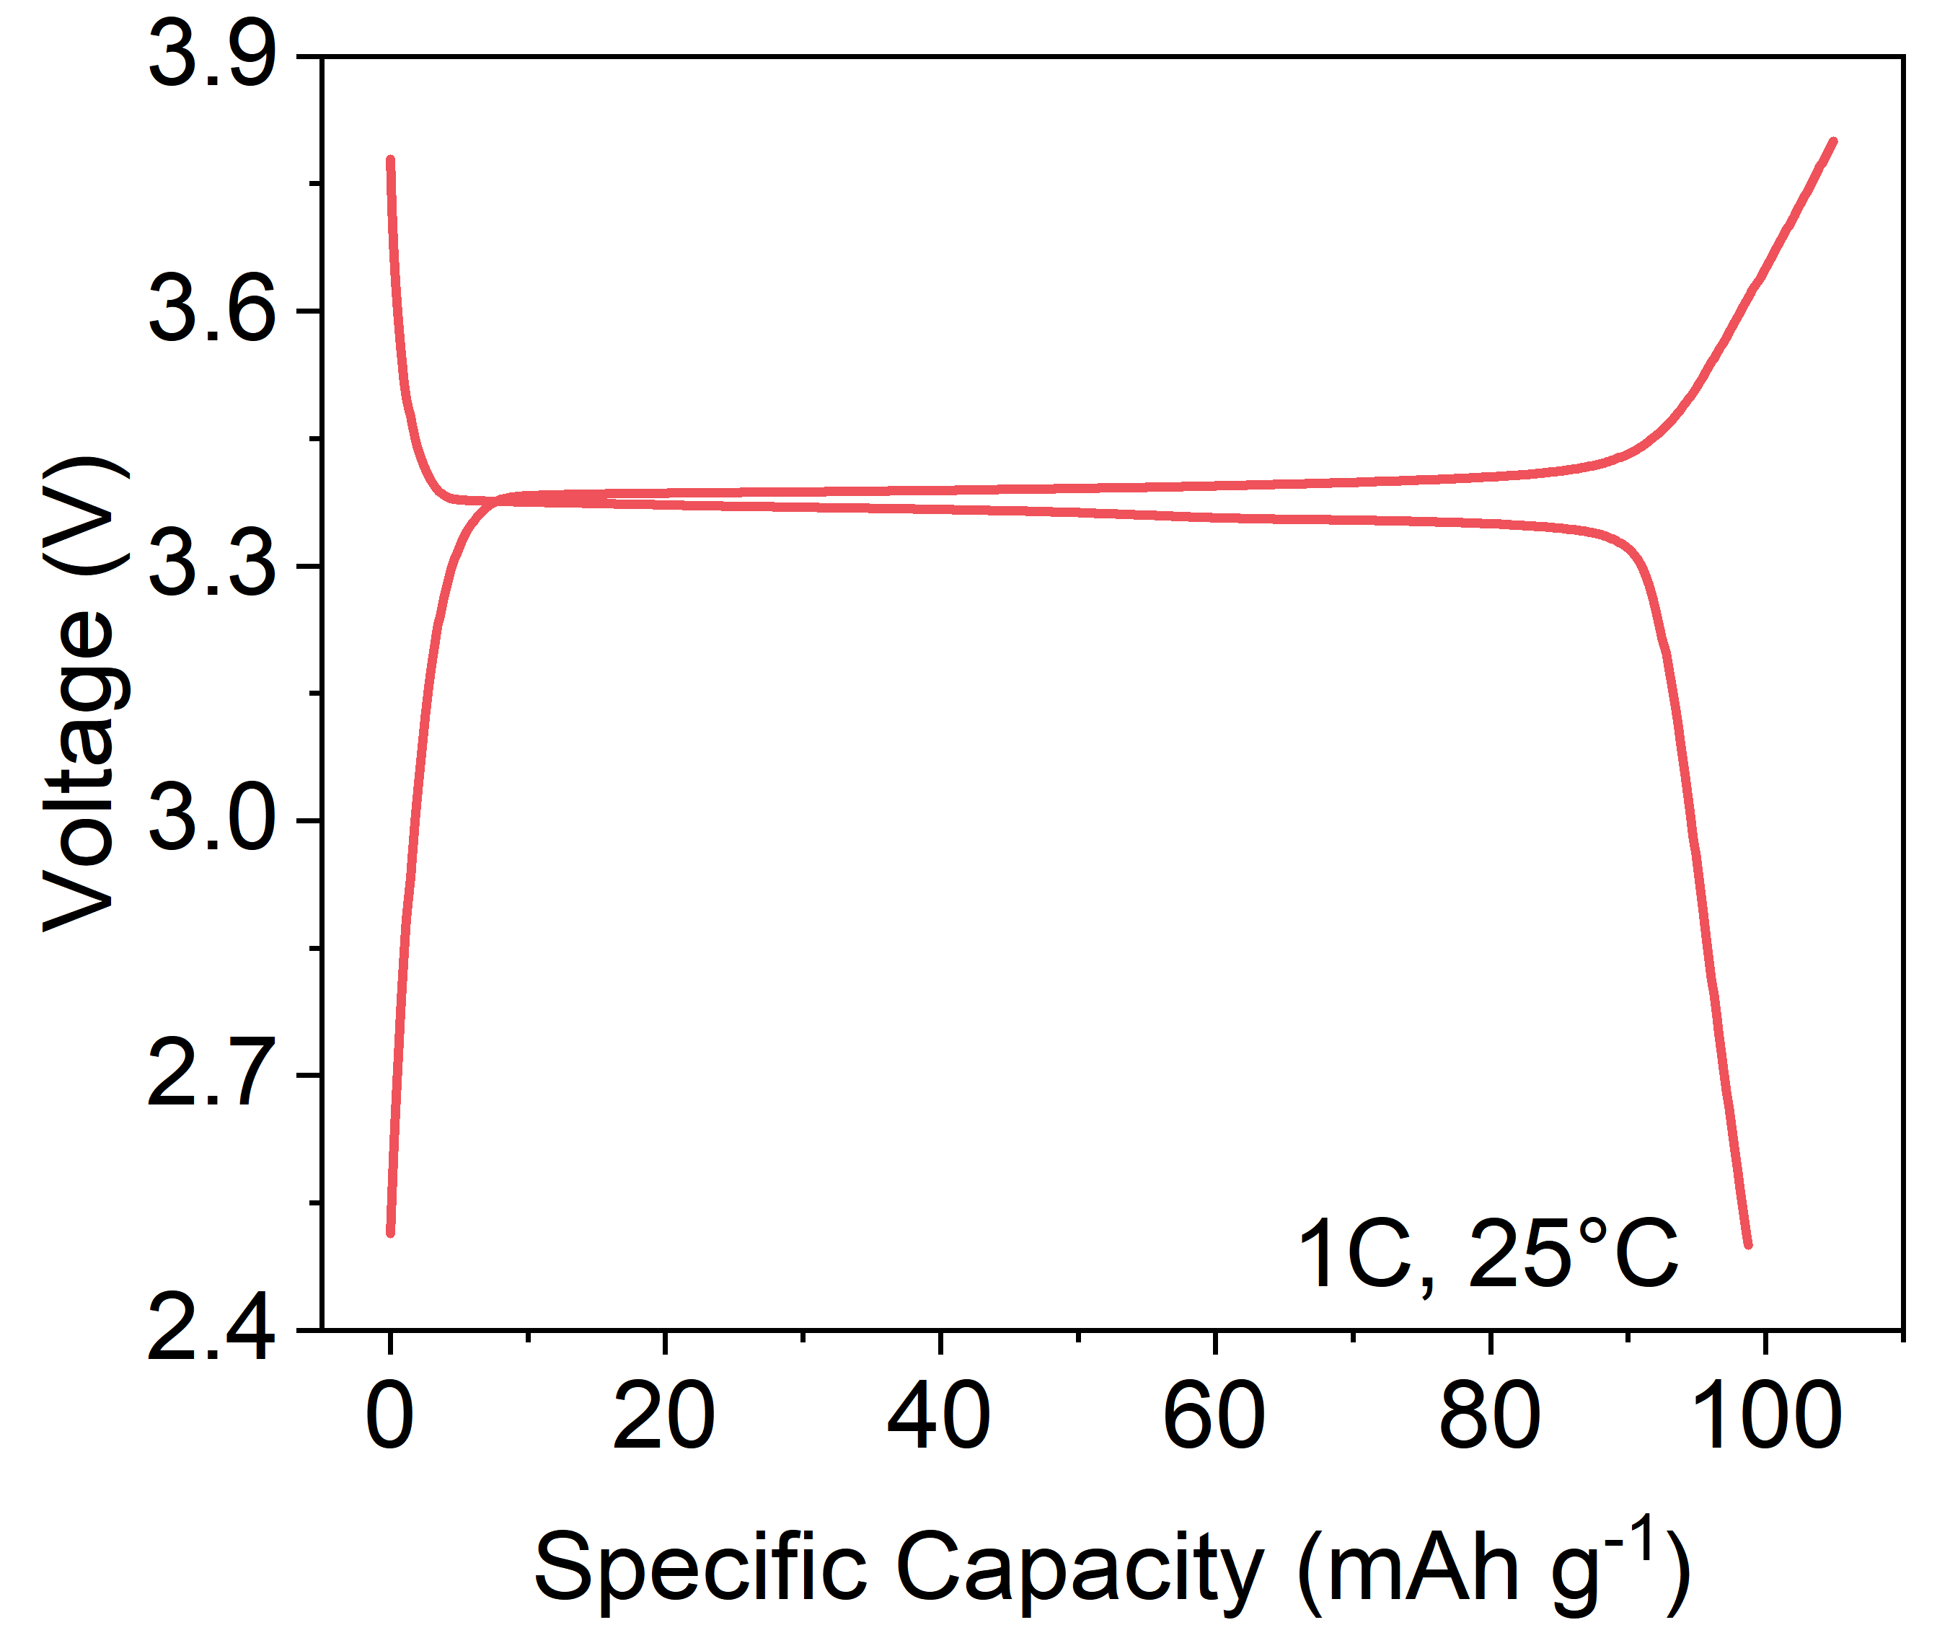
Figure S10. Galvanostatic charge-discharge (GCD) profiles of NVP in NaPF₆-THF-Na₂B₁₂H₁₂ electrolyte at 1 C@25 °C.

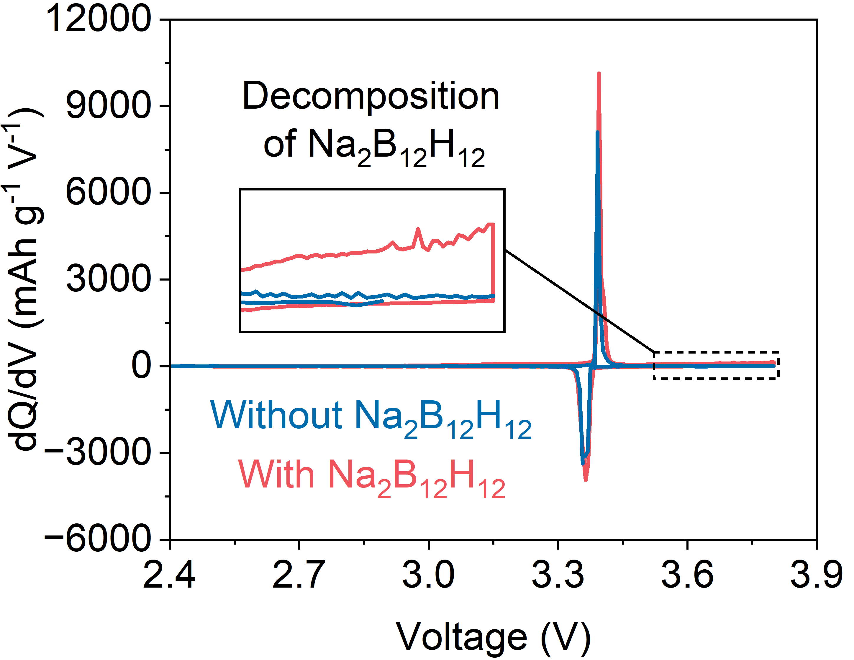
Figure S11. dQ/dV curves of NVP in NaPF₆-THF and NaPF₆-THF-Na₂B₁₂H₁₂ electrolytes at 1 C@25 °C.

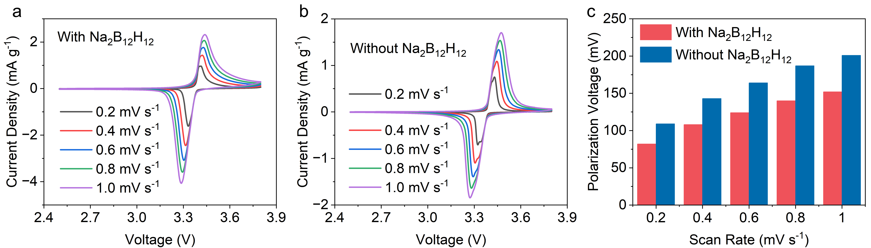
Figure S12. a,b CV curves measured at various scan rates of NVP@CC in (a) NaPF₆-THF-Na₂B₁₂H₁₂ and (b) NaPF₆-THF electrolytes. c, Polarization voltage calculated via CV curves.

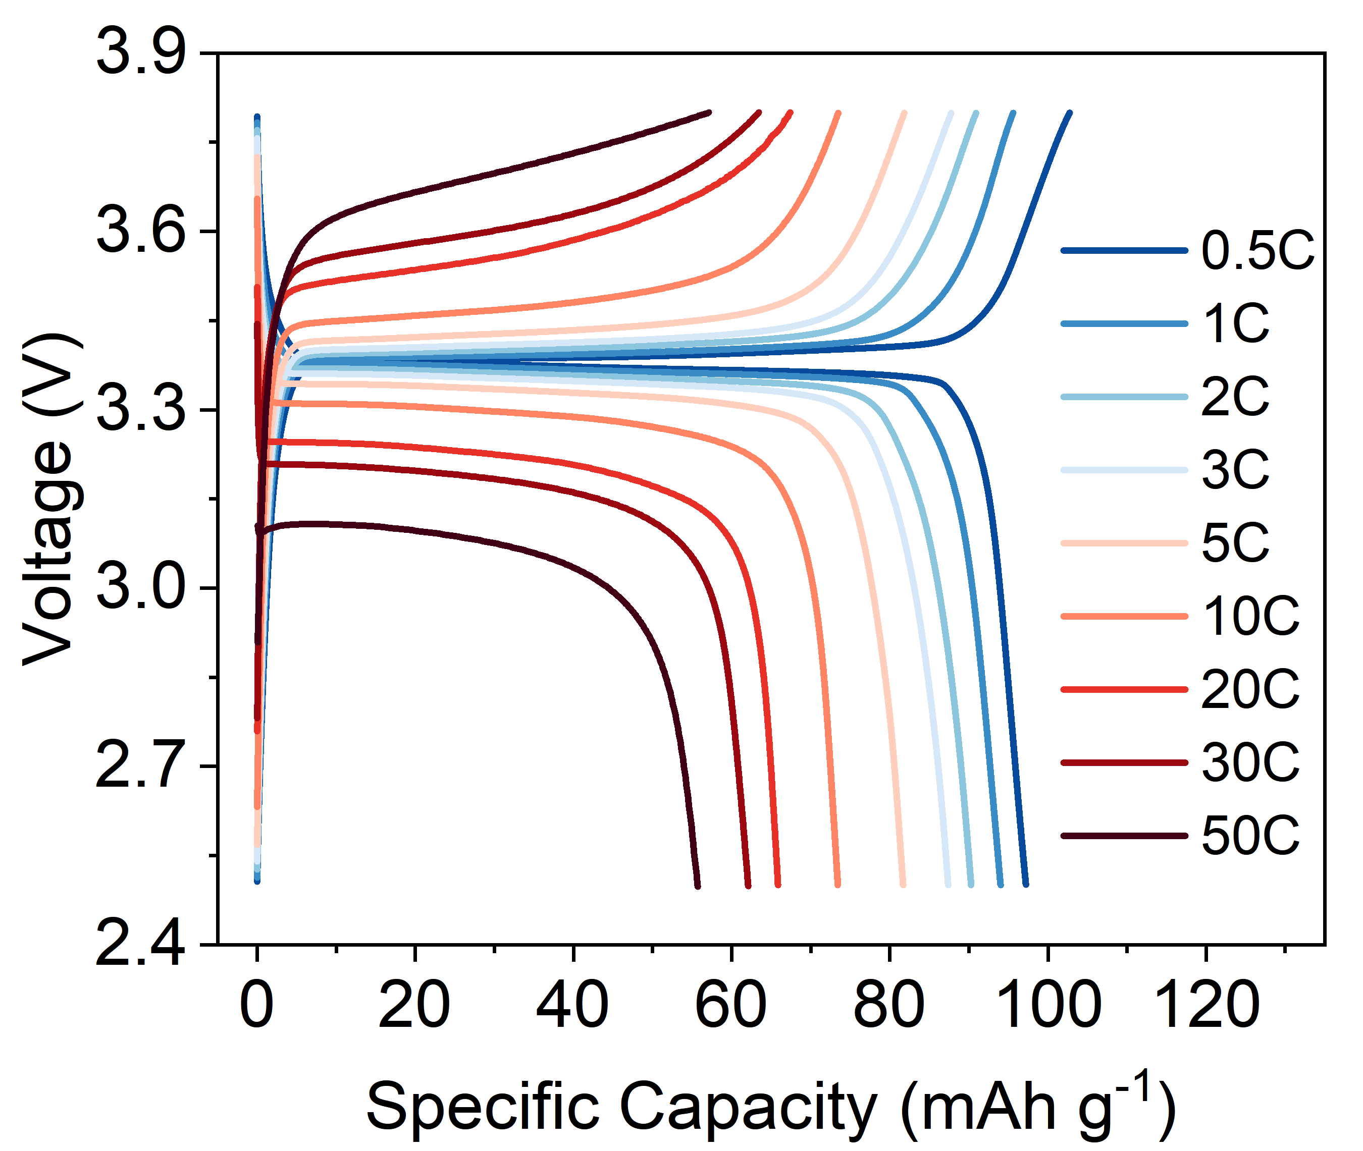
Figure S13. GCD curves at different current densities of NVP@CC in NaPF₆-THF-Na₂B₁₂H₁₂ electrolyte at 25 °C.

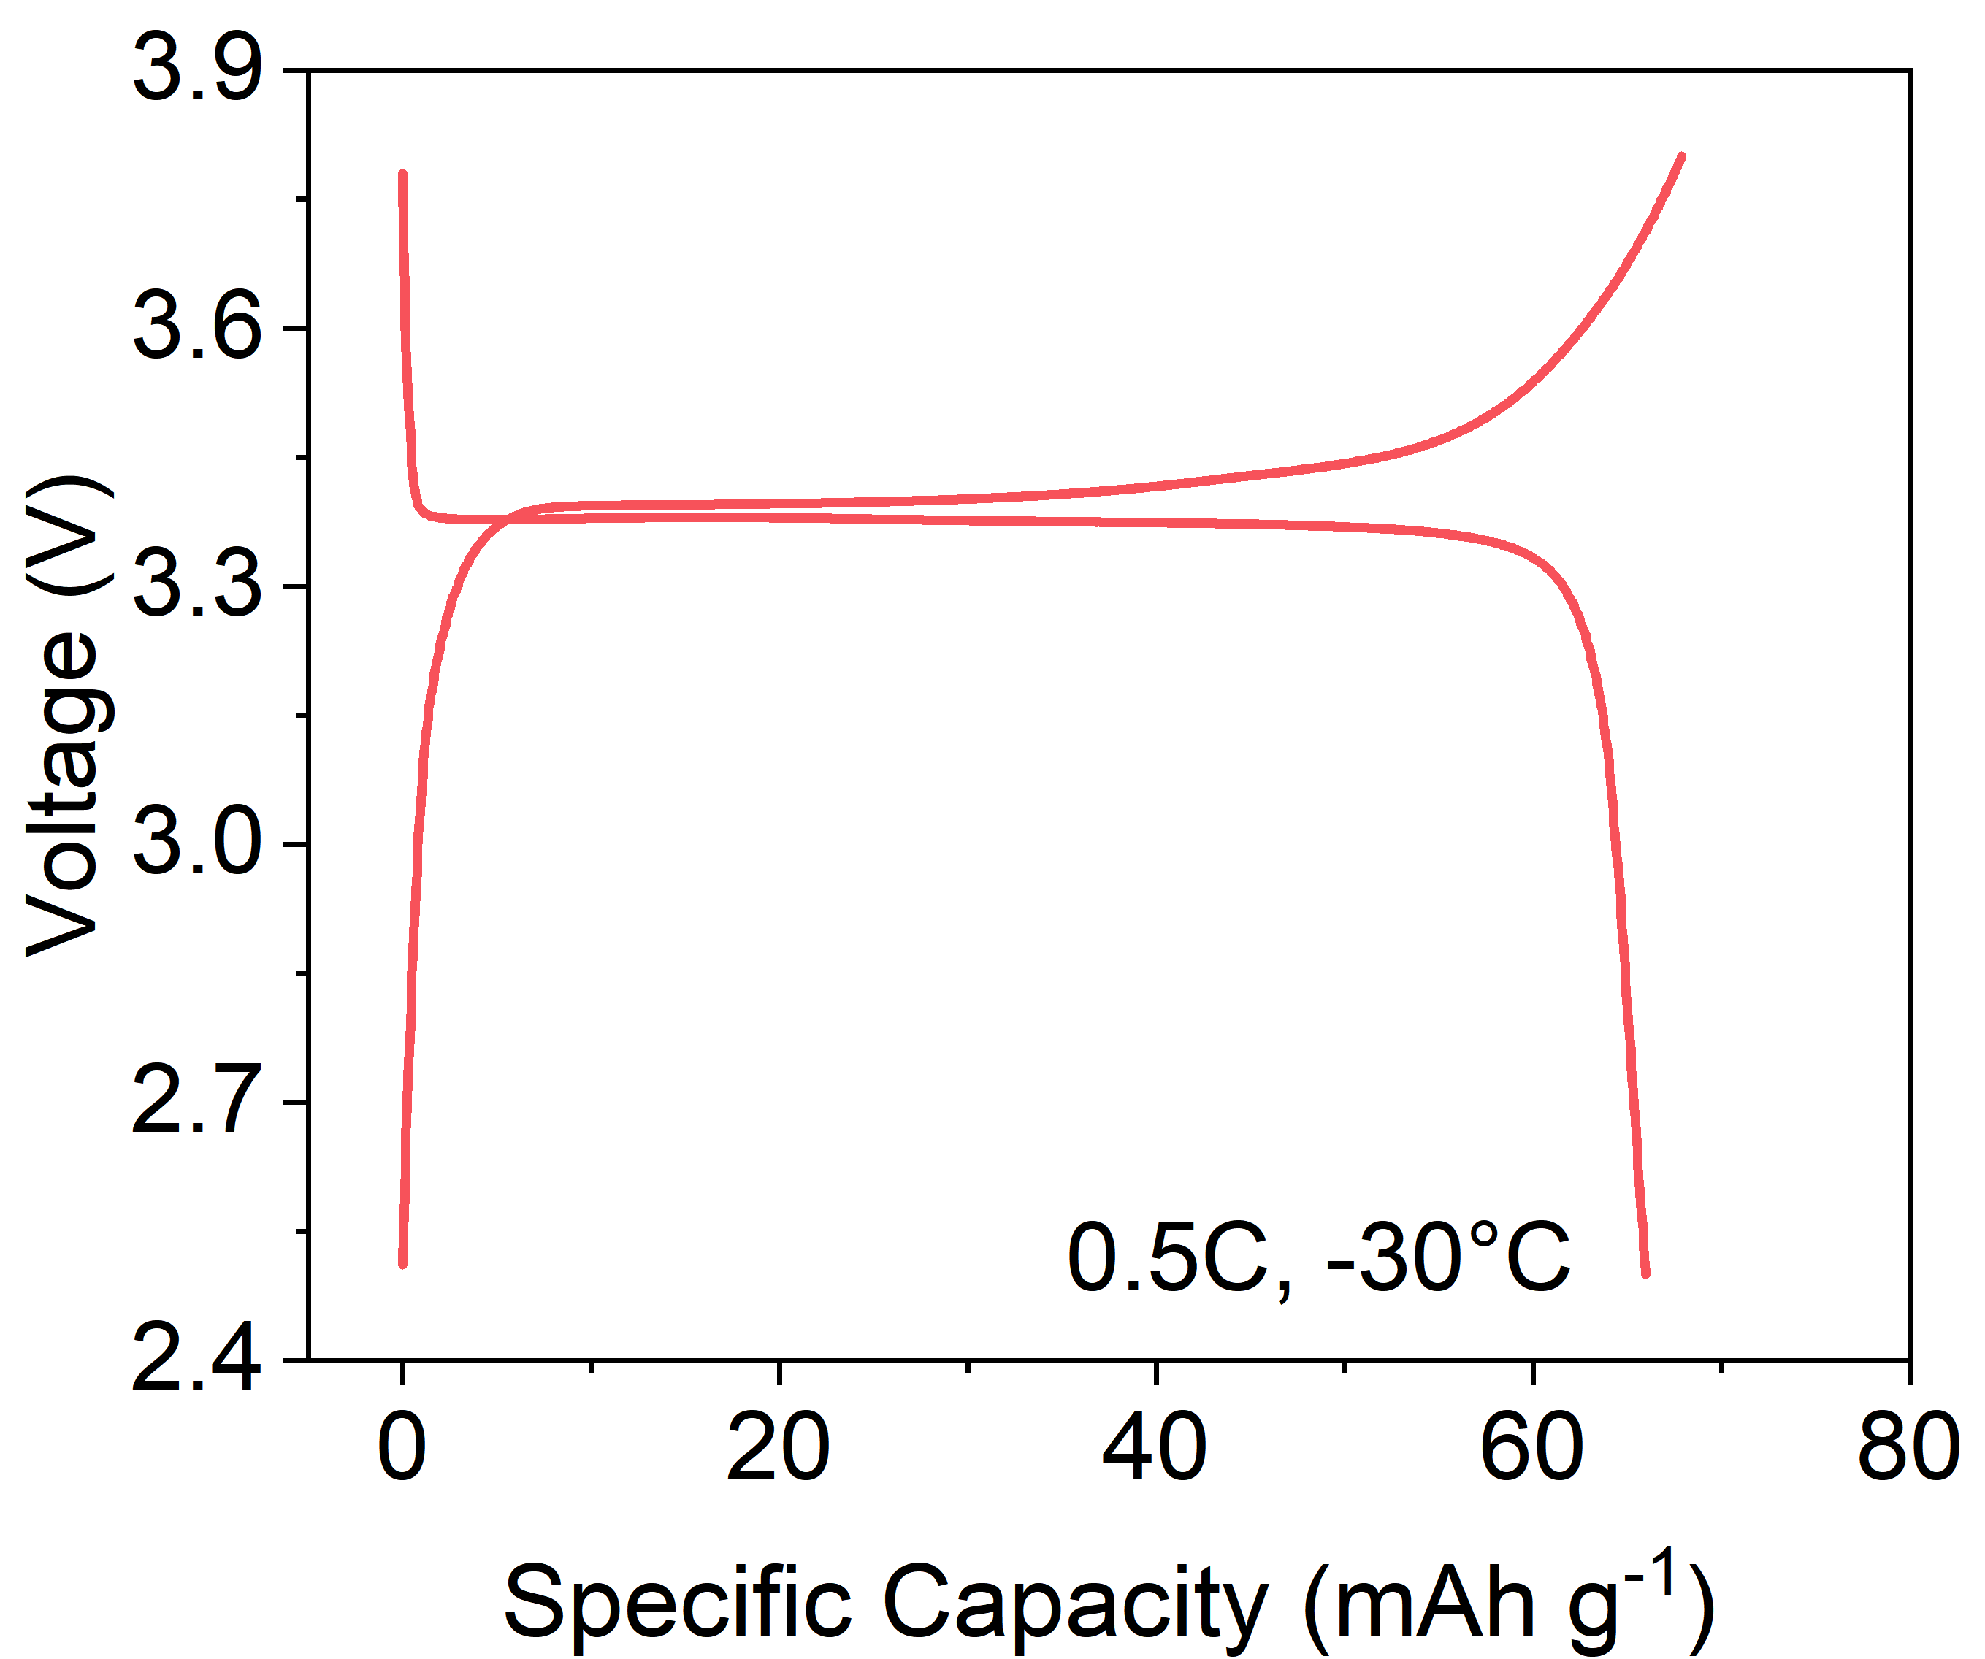
Figure S14. 1C GCD curves of NVP@CC in NaPF₆-THF-Na₂B₁₂H₁₂ electrolyte at −30 °C.

Table S1. Comparison of electrochemical performance.
Reference | Electrolyte | Temperature (°C) | Rate (C) | Lifespan
32 | G2/THF | −20 | 0.5 | 275
33 | ES/PC/DEC | −40 | 0.2 | 300
34 | G2/DOL | −40 | 0.2 | 100
35 | EC/PC/FEC | −25 | 3.4 | 1000
36 | EC/PC/FEC | −15 | 1 | 800
37 | G2 | −20 | 2 | 1000
38 | PC/FEC | −20 | 2 | 1000
39 | EC/PC | −25 | 2.4 | 1000

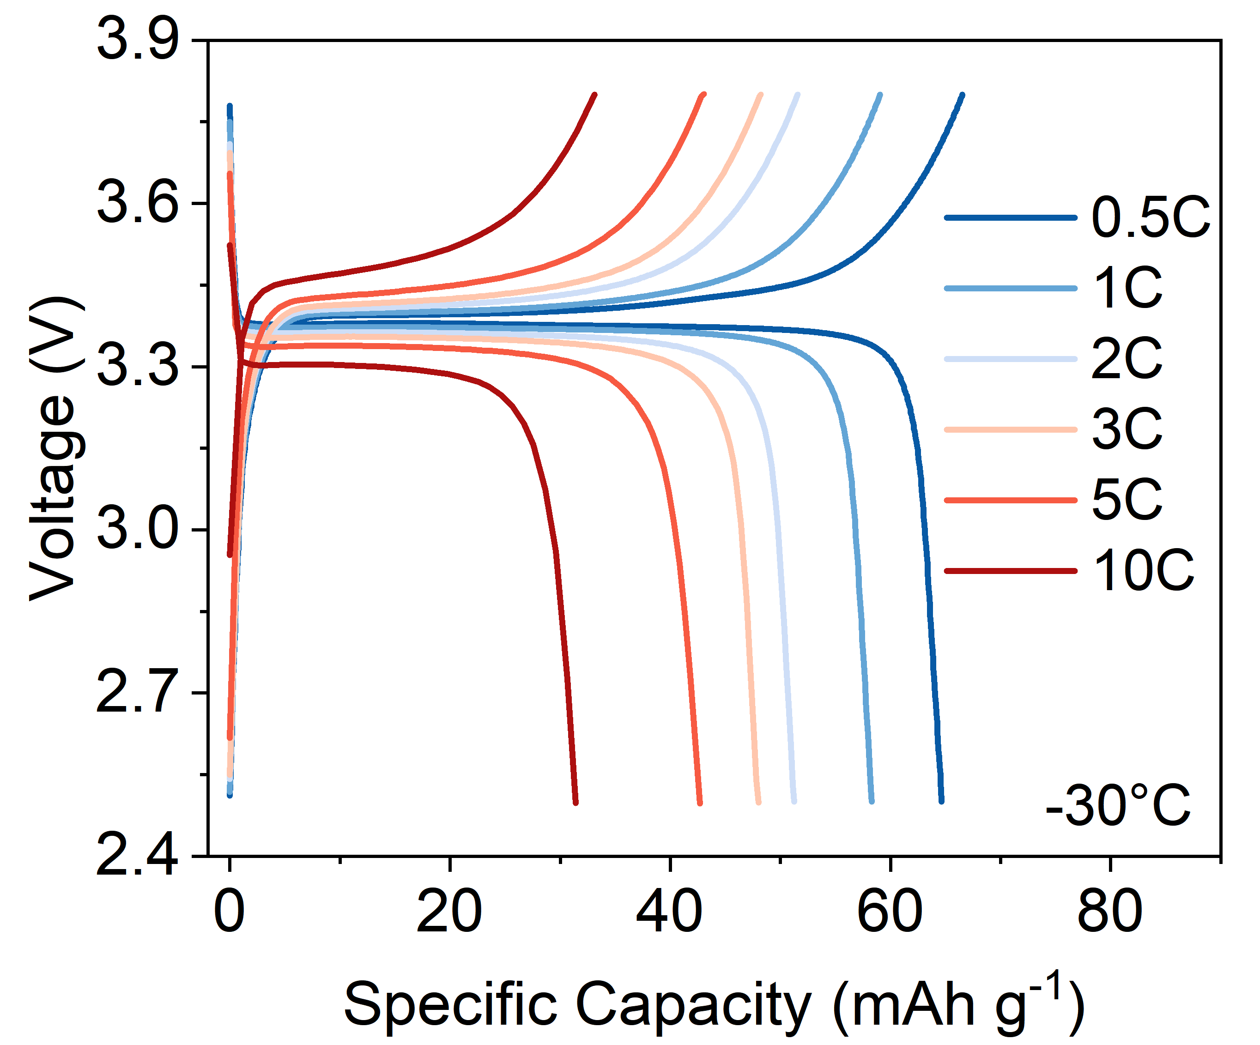
Figure S15. GCD curves at different current densities of NVP@CC in NaPF₆-THF-Na₂B₁₂H₁₂ electrolyte at −30 °C.

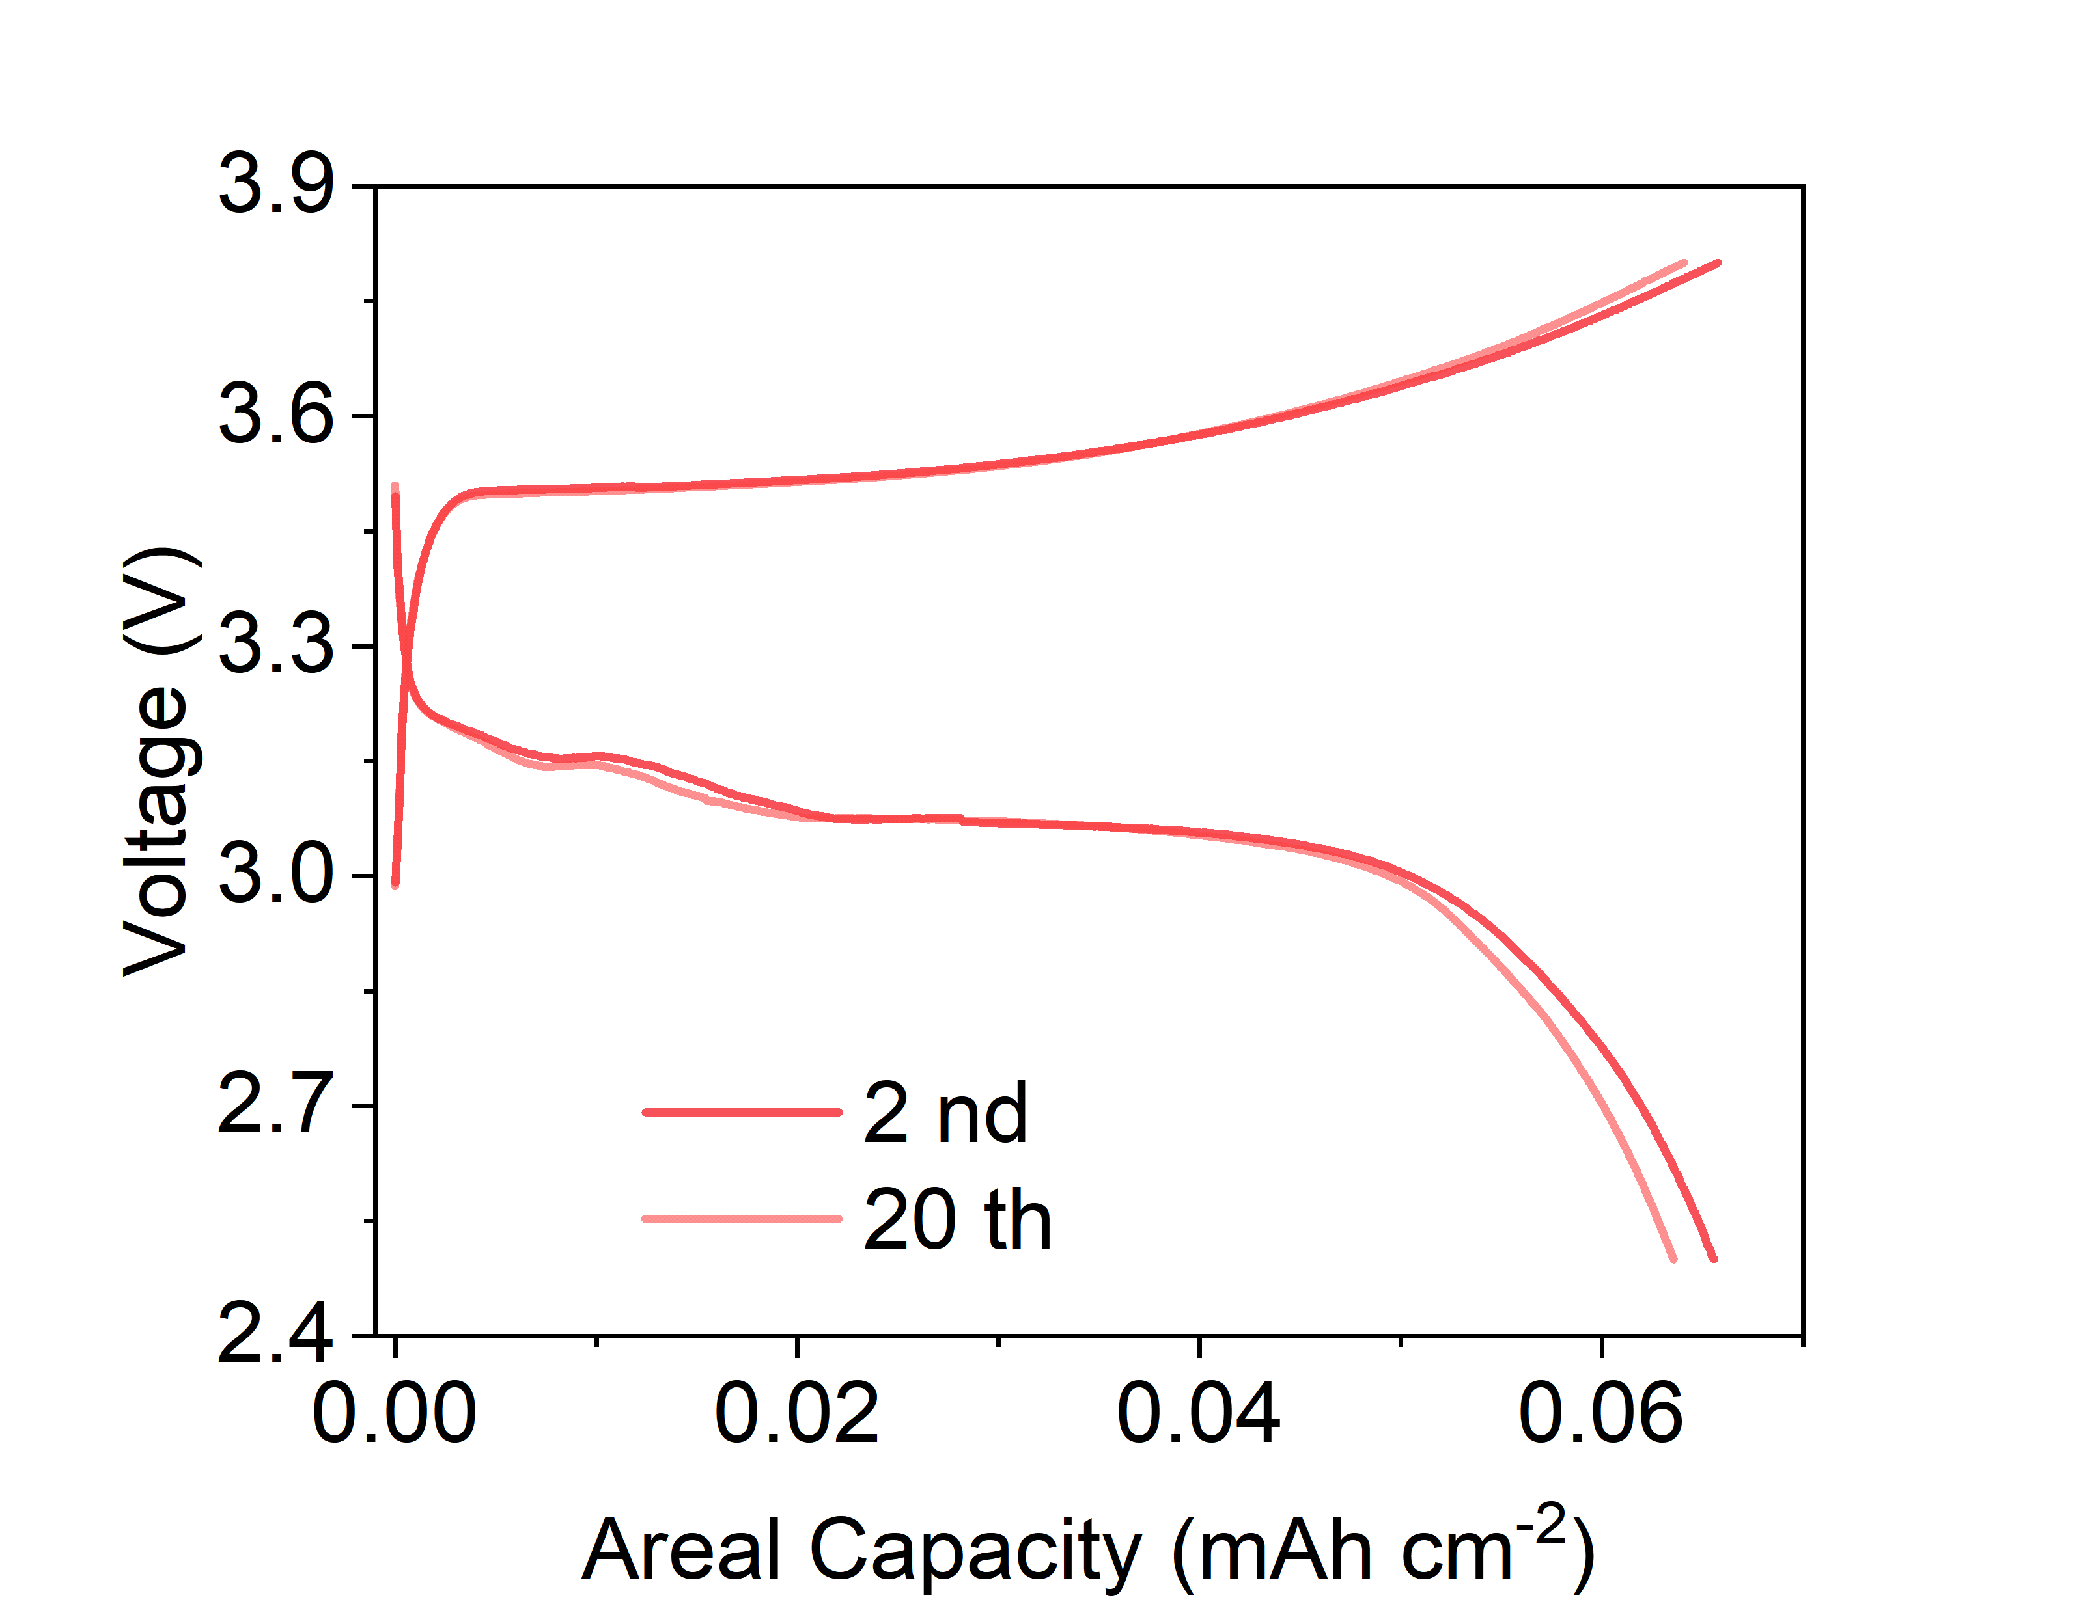
Figure S16. GCD curves of pouch cell at 1 C@−30 °C.

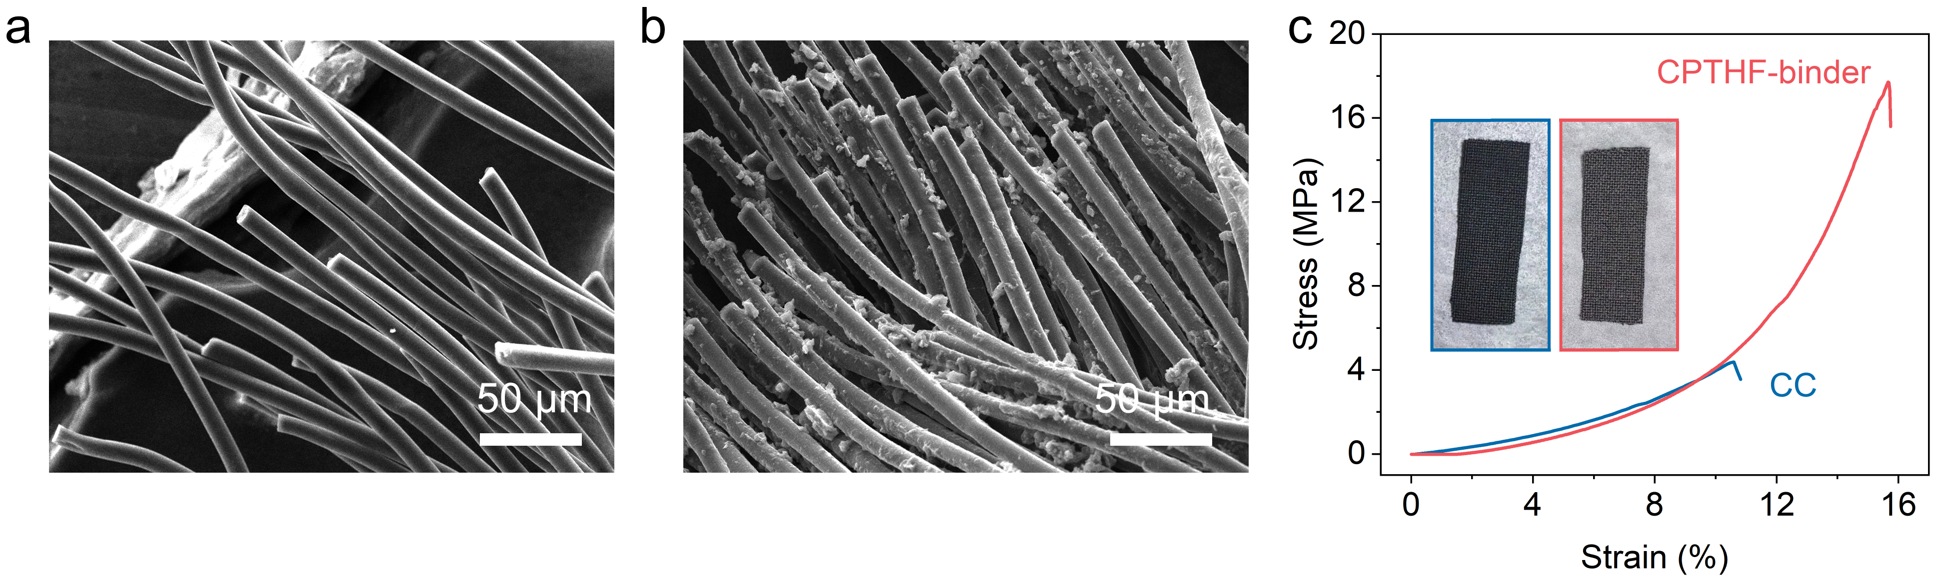
Figure S17. a, SEM image of the pristine carbon cloth after stretching. b, SEM image of CPTHF@NVP@CC electrode after stretching.

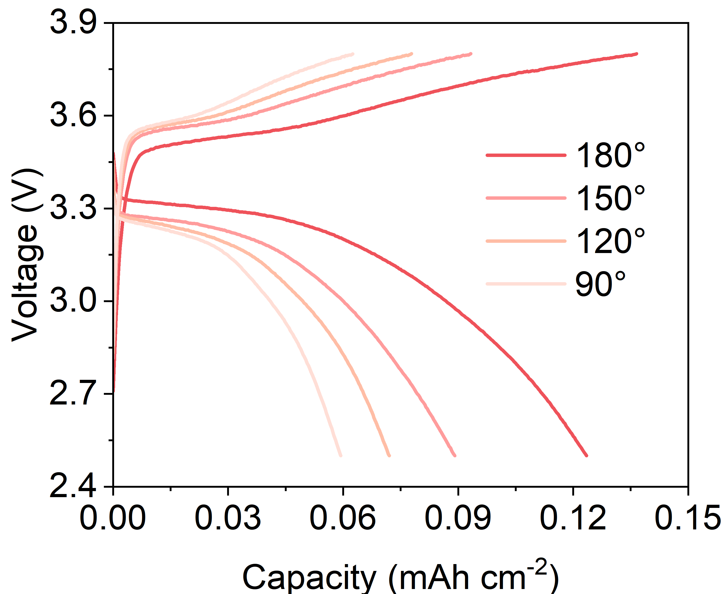
Figure S18. GCD curves of the pouch cell under different bending angles at 25 °C.


Figure S19. Absorbent paper after penetration and cutting test of pouch cell after cycles, no leakage of liquid can be observed from it.

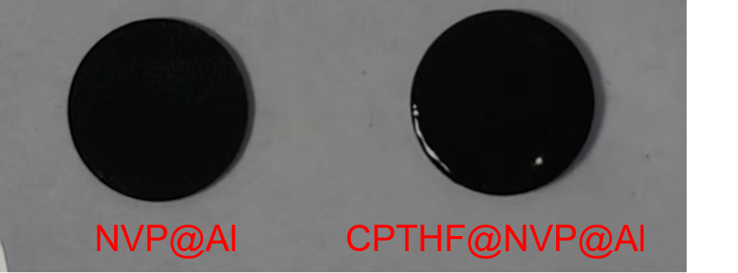
Figure S20. Optical images of NVP@CC and CPTHF@NVP@CC electrodes.

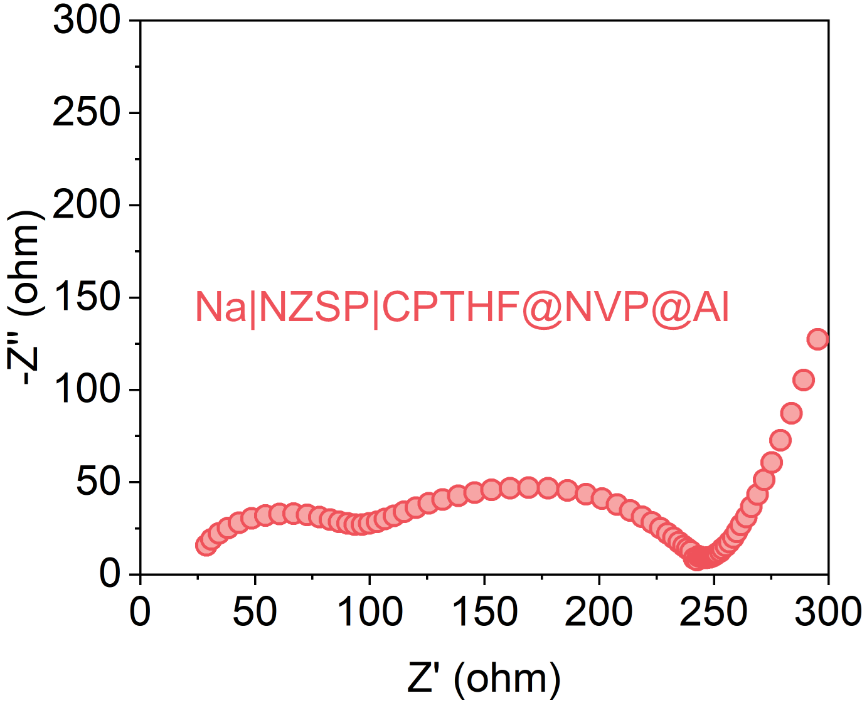
Figure S21. Nyquist plots of Na|NZSP|CPTHF@NVP@Al all-solid-state battery.

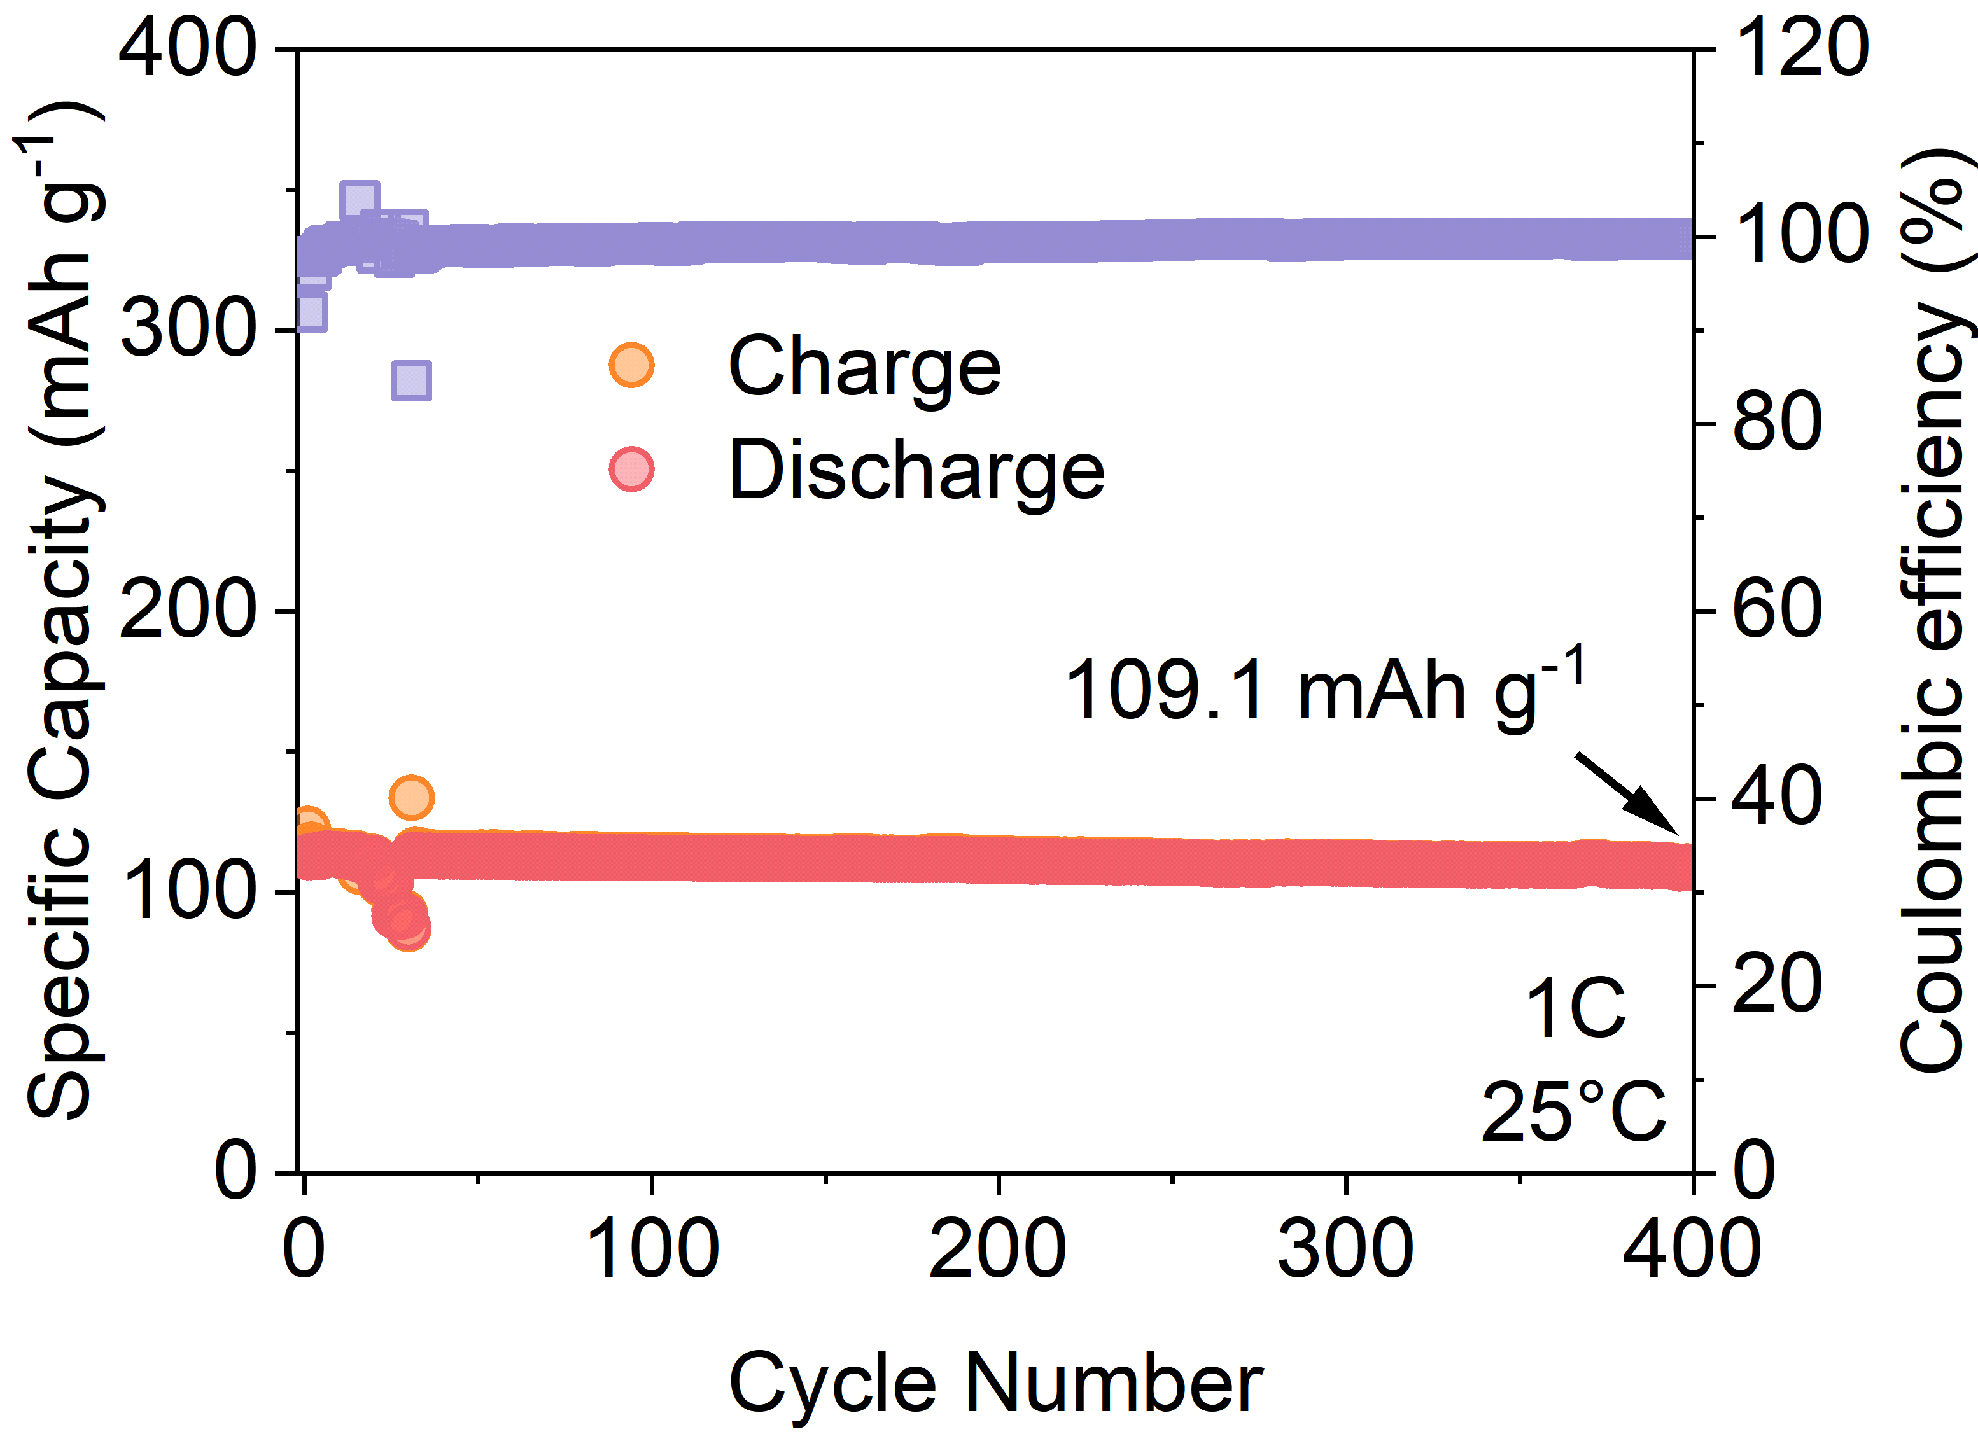
Figure S22. Cycling performance of all-solid-state batteries at 1 C@25 °C.

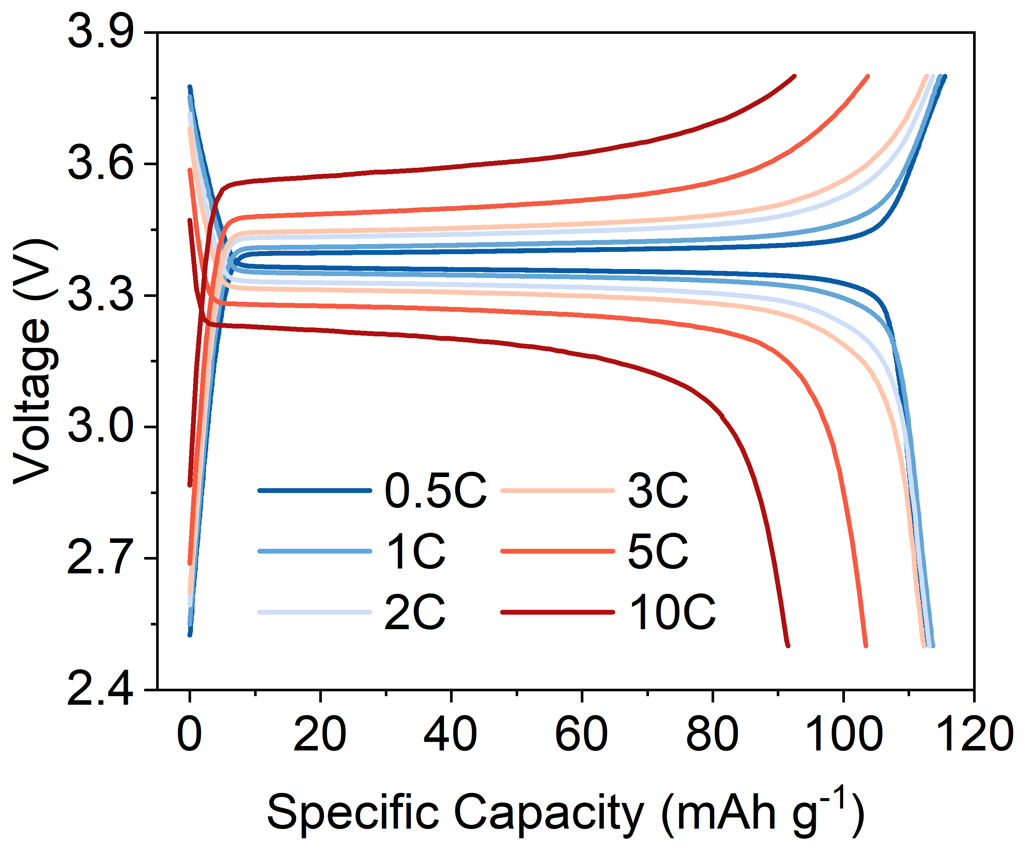
Figure S23. GCD curves at different current densities of Na|NZSP|CPTHF@NVP@Al all-solid-state battery.

