Supplementary Materials
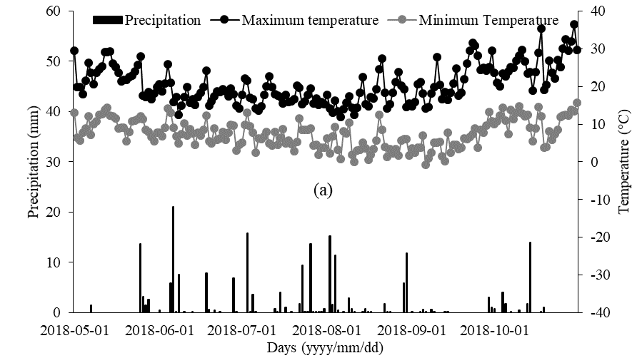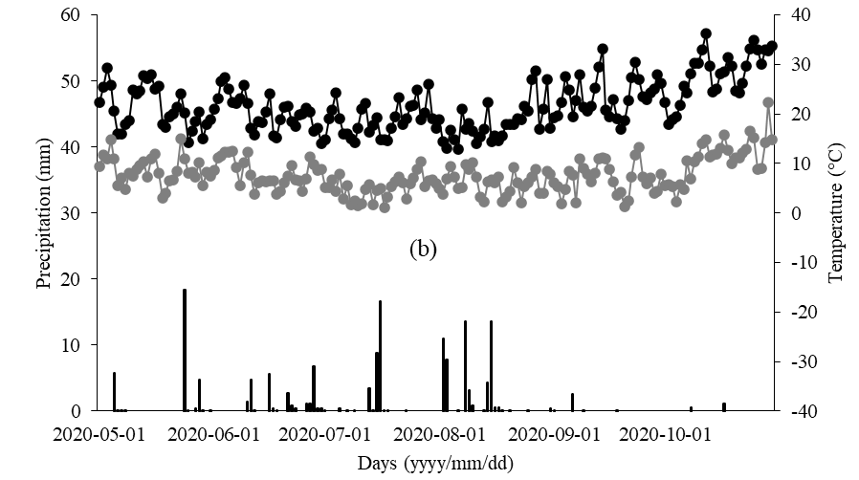
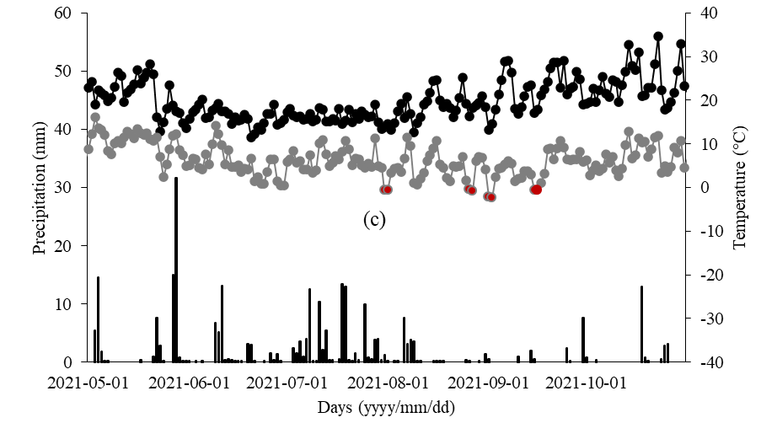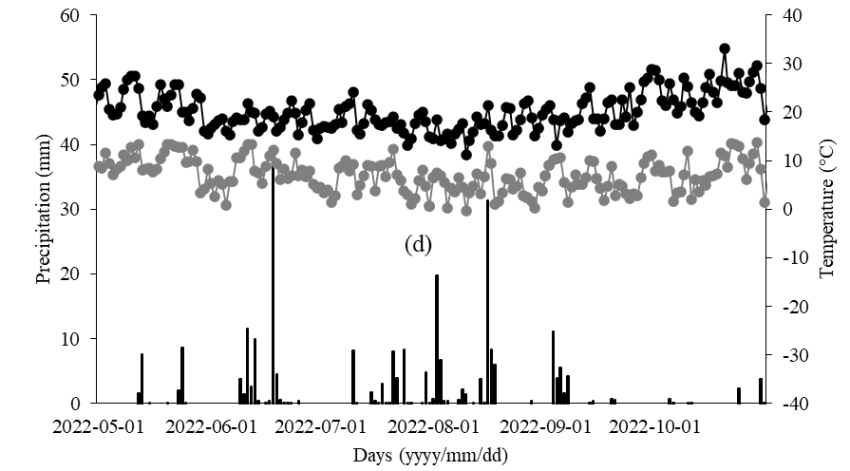
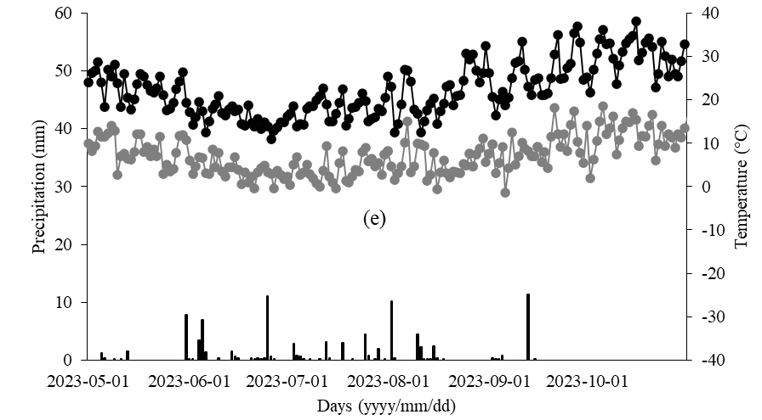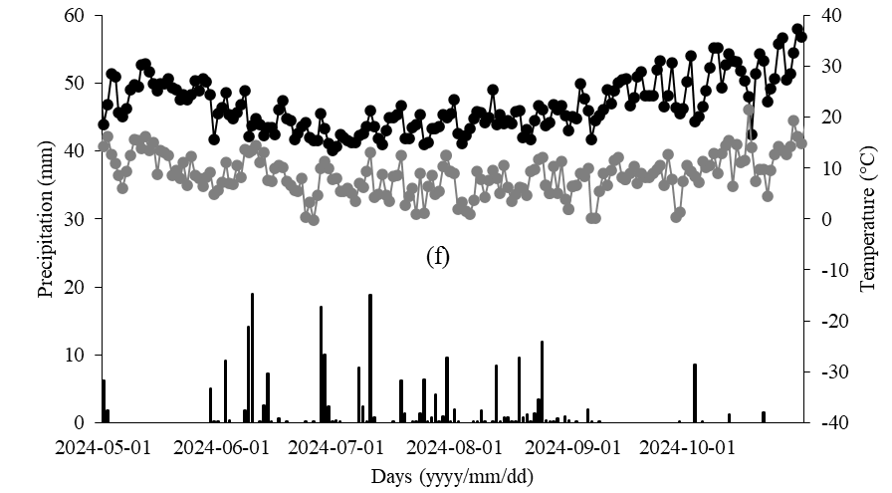
Figure S1. Daily precipitation and maximum and minimum temperatures during crop growing season (May-October) in (a) 2018, (b) 2020, (c) 2021, (d) 2022, (e) 2023 and (f) 2024. Red dotted data points in (c) refer to sub-zero temperature.
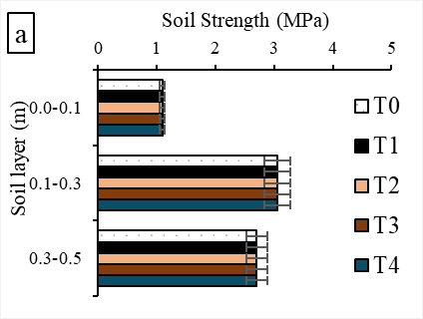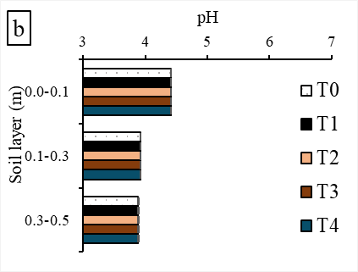
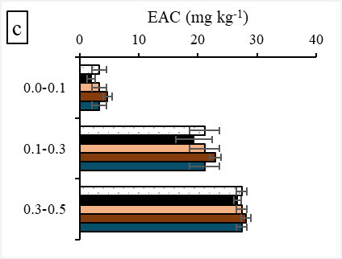
Figure S2. (a) Soil strength, (b) pH and (c) extractable aluminium concentration (EAC) before the treatments were applied. The treatments were: T0 = control (no lime or loosening), T1 = loosening of soil to 0.45 m depth, T2 = T1 plus incorporation of 1.5 t ha⁻¹ lime at 0–0.1 m, T3 = T1 plus incorporation of 4.5 t ha⁻¹ lime at 0–0.3 m, T4 = T1 plus incorporation of 6 t ha⁻¹ lime at 0–0.45 m. Horizontal error bars represent the standard error of the mean values.

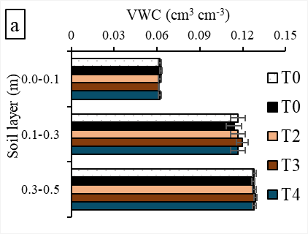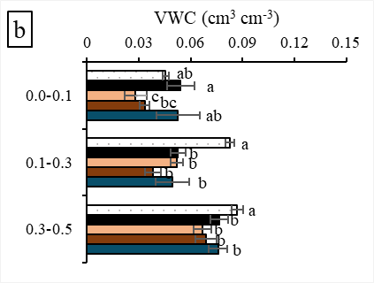
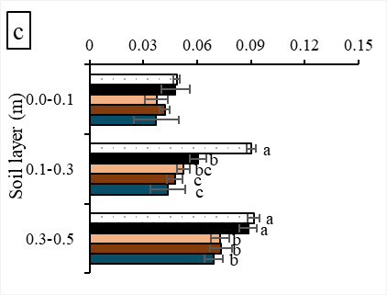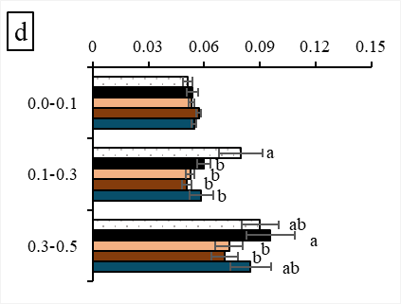
Figure S3. Volumetric water content (VWC) at (a) 0 (before the treatments were applied), (b) 2, (c) 26 and (d) 50 months after the establishment of the experiment. The treatments were: T0 = control (no lime or loosening), T1 = loosening of soil to 0.45 m depth, T2 = T1 plus incorporation of 1.5 t ha⁻¹ lime at 0–0.1 m, T3 = T1 plus incorporation of 4.5 t ha⁻¹ lime at 0–0.3 m, T4 = T1 plus incorporation of 6 t ha⁻¹ lime at 0–0.45 m. Different letters indicate statistically significant differences, and without letters, are statistically non-significant within the same sampling depth (P ≤ 0.05). Horizontal error bars represent the standard error of the mean VWC.

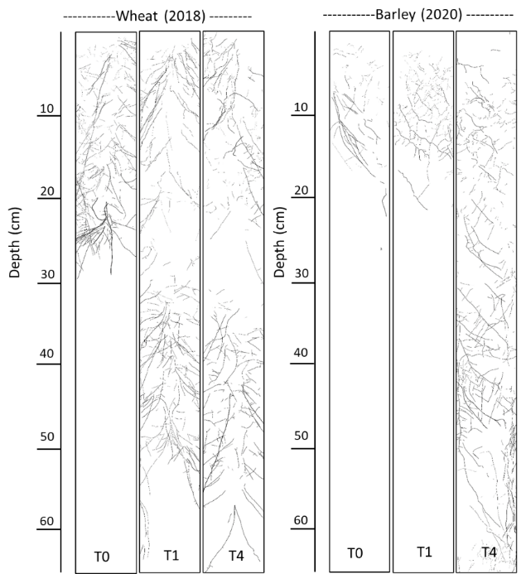
b
a
Figure S4. Representative processed root image of (a) wheat and (b) barley grown in the 2018 and 2020 seasons, respectively. The treatments were: T0 = control (no lime or loosening), T1 = loosening of soil to 0.45 m depth, and T4 = T1 plus incorporation of 6 t ha⁻¹ lime at 0–0.45 m.

Table S1. Physical and chemical properties of topsoil and subsoil from Kalannie, Western Australia.
Parameters | Topsoil | Subsoil
Sampling depth (m) | 0–0.10 | 0.20–0.50
Soil texture | Sandy loam | Sandy loam
pH in 0.01M CaC₂ | 4.4 | 4.0
Extractable aluminium concentration (mg kg⁻¹) | 2.5 | 22.2
Ammonium nitrogen (mg kg⁻¹) | 7.3 | 2.3
Nitrate nitrogen (mg kg⁻¹) | 11.0 | 6.3
Colwell phosphorus (mg kg⁻¹) | 31 | 4.3
Phosphorus Buffering Index | 24 | 63
Colwell potassium (mg kg⁻¹) | 53 | 32
Organic carbon (%) | 0.85 | 0.32
Cation exchange capacity (meq 100g⁻¹) | 1.5 | 1.1

Table S2. On-site weather data for the duration of the experiment (2018-2024).
Parameters | 2018  (wheat) | 2020  (barley) | 2021  (wheat) | 2022  (wheat) | 2023  (wheat) | 2024  (wheat)
Annual rainfall (mm) | 317 | 237 | 484 | 385 | 184 | 313
Growing Season Rainfall (Apr-Oct, mm) | 211 | 155 | 324 | 279 | 119 | 229
Jan-Mar (mm) | 26 | 25 | 39 | 32 | 10 | 11
Effective available moisture (mm) | 107 | 89 | 179 | 172 | 39 | 110
Temperature below 0°C (hours) | 6 | 0 | 20 | 1 | 6 | 1
Temperature below -2°C (hours) | 0 | 0 | 3* | 0 | 0 | 0
Aridity index# | 0.24 | 0.23 | 0.52 | 0.41 | 0.15 | 0.26
WLYP (t/ha)## | 2.14 | 1.79 | 3.58 | 3.44 | 0.77 | 2.20
*3 September 2021, 4-7 am; # calculated based on the method described in Barrett-Lennard et al. (2024); ##WLYP = water-limited yield potential estimated using the method described by Oliver et al.(Oliver et al., 2009).

