Supplementary Information

Supplementary Fig. 1 CV curves of a single MSC unit connected in parallel under bending and original states.
Supplementary Fig. 2 The SEM image of the interdigital electrodes of the MSCs in IWC-MSCs.
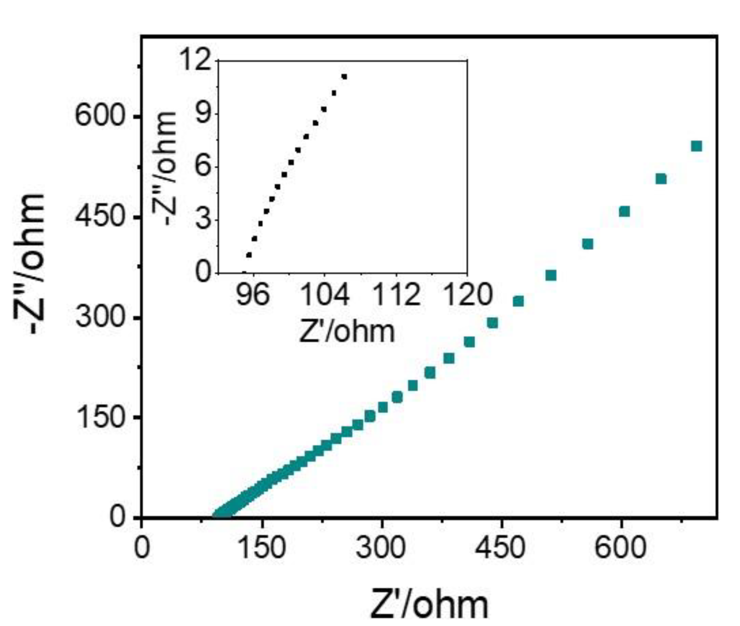
Supplementary Fig. 3 The Nyquist plot of a single MSC unit; The inset is magnified details of the Nyquist plot.
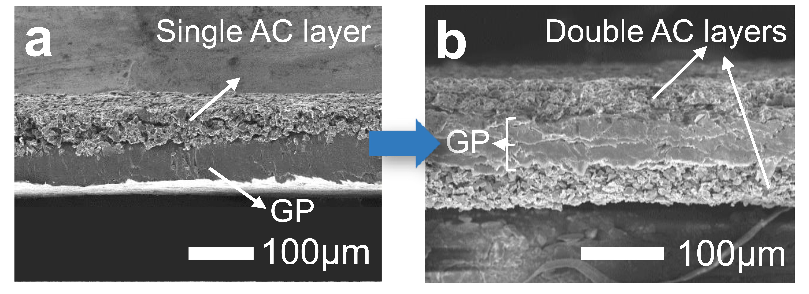
Supplementary Fig. 4 SEM image of the cross-section view of the a) SMSCs and b) DMSCs.
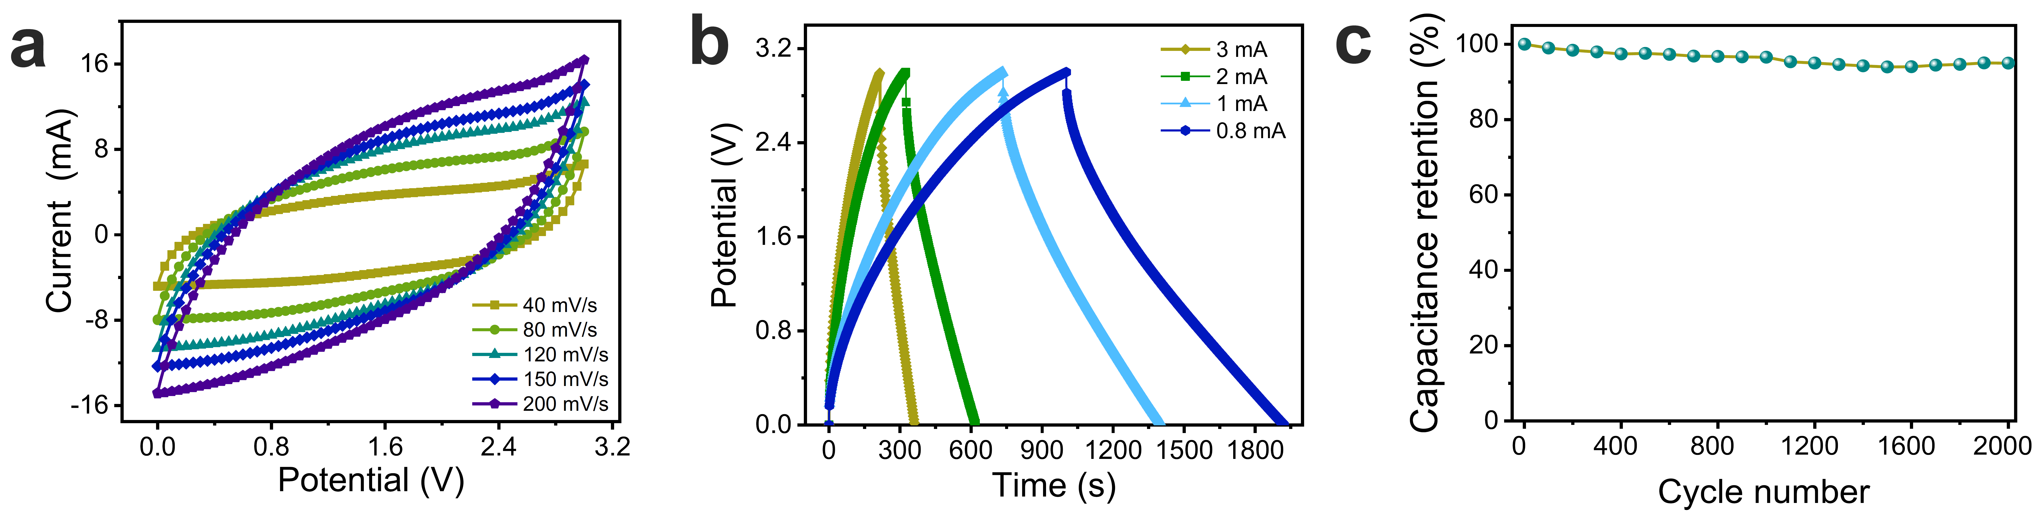
Supplementary Fig. 5 Electrochemical performance of the overall IMSCs. a) CV curves measured at scan rates of 40-200 mV/s. b) The galvanostatic charging/discharging curves of MSCs under different current values. c) Cycling performance of IMSCs under scanning rate of 80 mV/s.
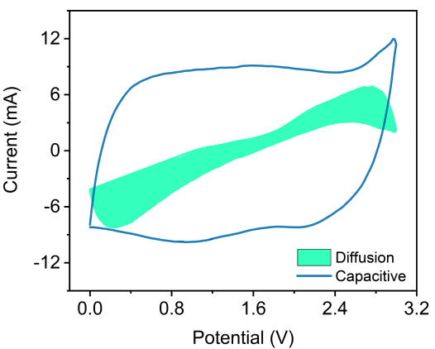
Supplementary Fig. 6 Contribution ratio of the capacitive-controlled charge under the scanning rate at 150 mV/s. This graph is calculated by$i=k_{1}v$+$k_{2}v^{\frac{1}{2}}$ and $i=av^{b}$, where $k_{1}v$ and $k_{2}v^{\frac{1}{2}}$ are capacitive and diffusion-controlled contributions of the current, and $i$ is the current, $v$ is the scanning rate, a and b are adjustable parameters.¹
Supplementary Fig. 7 Parameters investigation of WCC in IWC-MSCs. a) A schematic of the WCC (orange color) in IWC-MSCs. In fact, the whole IWC-MSCs functioning as a receiver. b) Sensing voltage signals of the WCC with various gap and c) the distance between the WCC and transmitter. d) Sensing current signals of WCC in the optimal state (0.8 mm gap and 1.0 cm distance).
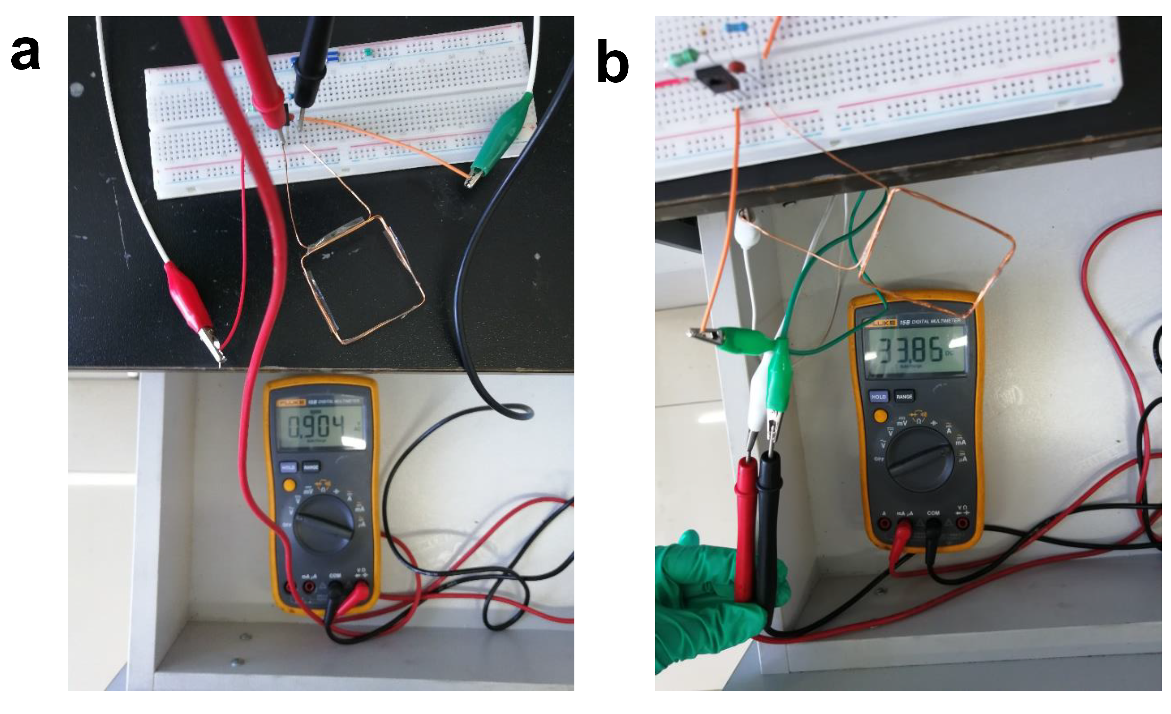
Supplementary Fig. 8 a) The alternative voltage and b) current of the transmitting coil of transmitter, which is 0.9V and 33.8 mA respectively.
The transmitting efficiency is calculated as following:
$ƞ=\frac{E_{r}}{E_{t}}*100\%$ (1)
$E=P*t$ (2)
$P=U*I$ (3)
where the $E_{r}$ and $E_{t}$is the received and transmitted energy, respectively; P is the electrical power; t is the wireless charging time; U is the voltage and I is the current. The receiving current and voltage are the optimum values (2.8mA; 5.8V) of the WCC in Supplementary Fig. 7. In consequence, the transmitting efficiency of the wireless charging system is 52.8%.
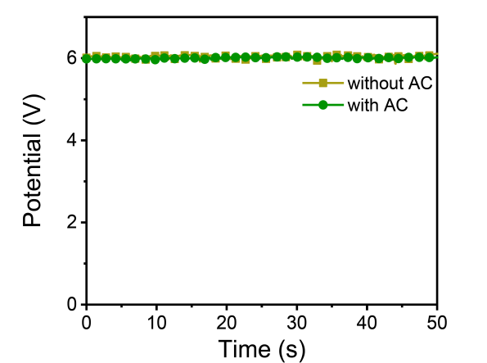
Supplementary Fig. 9 Receiving potential signals of the optimal WCC covered with AC layer and without AC layer placed in magnetic field.
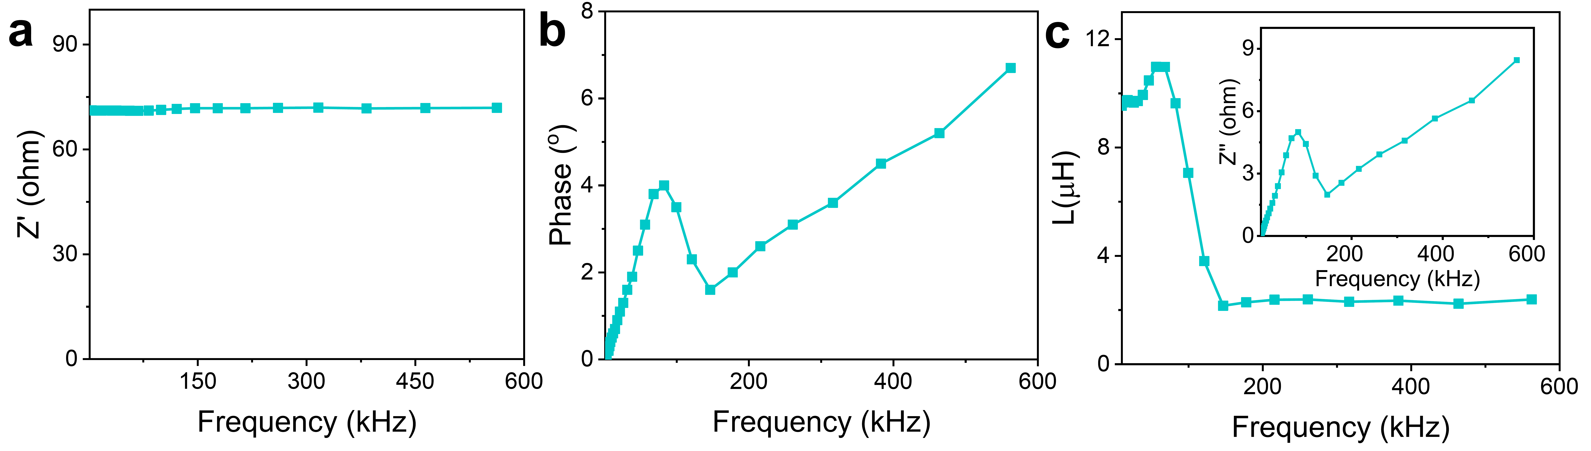
Supplementary Fig. 10 The inductance performance of WCC. a) Real impedance. b) Phase. c) Calculated inductance and imaginary impedance (inset).
The frequency of the wireless charging coil was measured from 1 kHz to 600 kHz, and the real impedance, phase, imaginary impedance and inductance were obtained in Supplementary Fig. 10a-10c, respectively. In Fig S10a, the real impedance within the whole frequency band has a small variation range, demonstrating the coil resistance and direct current loss are stable within the measurement range without causing fluctuations in transmission efficiency. It is because the antenna is made of graphite, whose conductivity is based on π electrons between layers contributing less frequency affection. Compared with graphite WCC, the commercial antenna are usually made of metal, whose free electrons has a skin effect. When the frequency gets higher, the free electrons tend to accumulate together resulting in lower conductivity. The inductance of the WCC in Supplementary Fig. 10c was obtained according to the imaginary impedance shown inset by using the formula:
$$L\left(H\right)=\frac{Z''(Ω)}{2πf(Hz)}$$
where L is the inductance of the WCC; Z" is the imaginary impedance of the WCC; f is the measured frequency.
Besides, by comparing Supplementary Fig. 10b and Supplementary Fig. 10c, both of the phase and inductance have experienced a steep decline near 140 kHz, so it can be inferred that the first resonant frequency of the coil is 140 kHz.
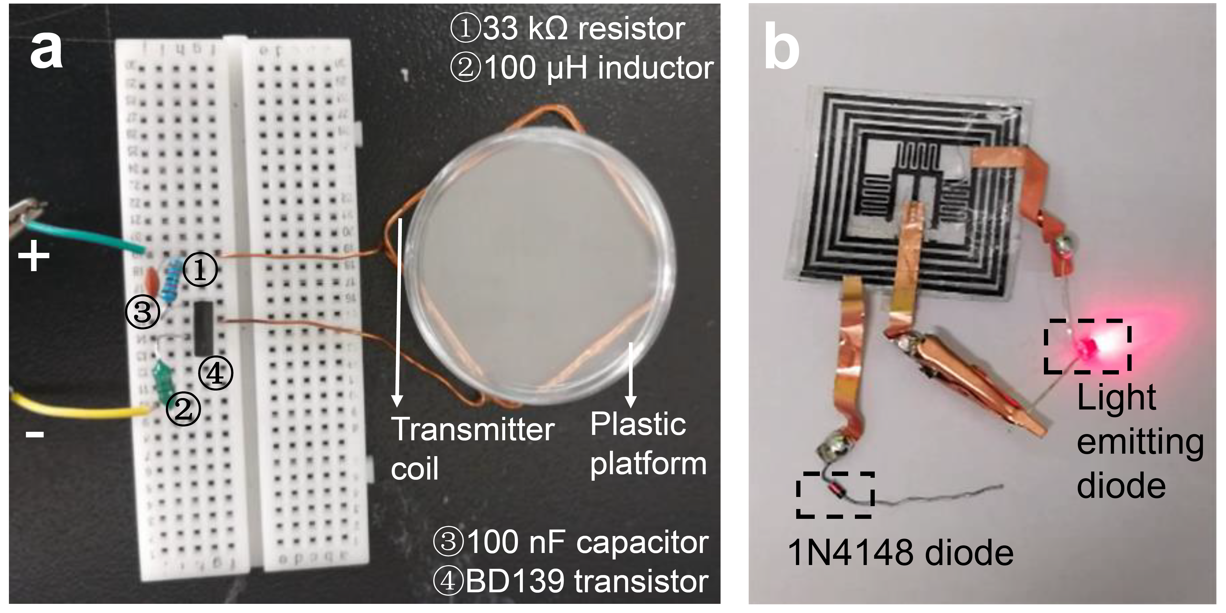
Supplementary Fig. 11 a) The transmitter system with a one-centimeter-high plastic platform (sometimes can remove away). The main transmitter coil is a square coil made by square-shaped copper wire. This transmitting system is charged by 10 V direct-current power source. b) The image of a red LED lit by SMSC of IWC-SMSCs after wireless charging for 2 minutes. The circuit diagram are consulted to the website (https://www.instructables.com/id/Easy-Wireless-LEDs) and references.²
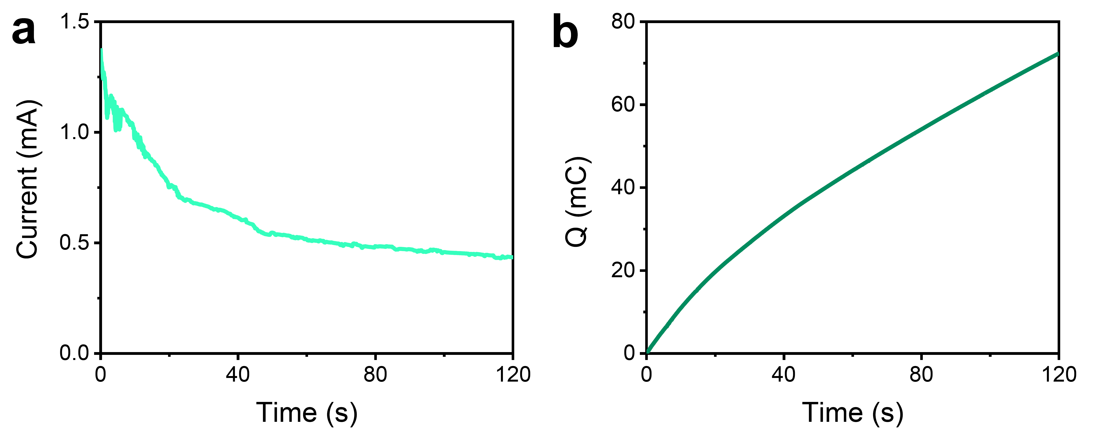
Supplementary Fig. 12 a) The received rectified current in SMSCs under wireless charging and b) the corresponding quantity of electric charges accumulated in SMSCs.

Supplementary Table 1 Comparison of the areal capacitance of planar micro-supercapacitors
MSC type | Electrode materials | Areal capacitance  (mF cm⁻²) |  | Ref
Symmetric MSC | Co(OH)₂/Pt micro-pillar array |  | 237 | ³
Symmetric MSC | Carbide-derived carbon/Au film |  | 36 | ⁴
Symmetric MSC | PANI nanowire |  | 25.67 | ⁵
Symmetric MSC | CoO/CNT nanocomposite |  | 50 | ⁶
Symmetric MSC | Laser-scribed graphene/MnO₂ |  | 160 | ⁷
Symmetric MSC | MnO₂/Au 3D structure |  | 69.15 | ⁸
Symmetric MSC  —carbon-based electrodes | Graphene flake/PEDOT layer |  | 15.3 | ⁹
Symmetric MSC  —carbon-based electrodes | Laser-scribed graphene |  | 2.28 | ¹⁰
Symmetric MSC  —carbon-based electrodes | Multiple-layer CNTs |  | 4.69 | ¹¹
Symmetric MSC  —carbon-based electrodes | Graphene film |  | 9 | ¹²
Symmetric MSC  —carbon-based electrodes | Laser-scribed graphene |  | 0.51 | ¹³
Symmetric MSC  —carbon-based electrodes | Printed graphene/SWCNT |  | 1.324 | ¹⁴
Symmetric MSC  —carbon-based electrodes | AC film |  | 454.1 | Our
Asymmetric MSCs | GQDs//PANI |  | 0.667 | ¹⁵
Asymmetric MSCs | MnO₂/rGO/SWCNT |  | 6.439 | ¹⁶
Asymmetric MSCs | Ti₃C₂T_{x}//Activated carbon |  | 7.8 | ¹⁷
Asymmetric MSCs | Metal hexacyanoferrate/graphene films |  | 19.84 | ¹⁸
Asymmetric MSCs | NiCoP@NiOOH//ZIF-C |  | 54.7 | ¹⁹
Asymmetric MSCs | 2D VN and Co(OH)₂ nanoflowers |  | 21 | ²⁰
Asymmetric MSCs | MnO₂//Ti₃C₂ |  | 295 | ²¹
Asymmetric MSCs | Graphene/MnO₂ deposited graphene |  | 400 | ²²
Asymmetric MSCs | N-GO//N-GO/MoO₂ |  | 33.6 | ²³

References
1 Liu, Q. et al. The first flexible dual-ion microbattery demonstrates superior capacity and ultrahigh energy density: small and powerful. Adv. Funct. Mater. 30, 2002086, doi:10.1002/adfm.202002086.
2 Yin, Z. et al. Splash-resistant and light-weight silk-sheathed wires for textile electronics. Nano Lett. 18, 7085-7091 (2018).
3 Tian, X. et al. Arbitrary shape engineerable spiral micropseudocapacitors with ultrahigh energy and power densities. Adv. Mater. 27, 7476-7482 (2015).
4 Chmiola, J., Largeot, C., Taberna, P.-L., Simon, P. & Gogotsi, Y. Monolithic carbide-derived carbon films for micro-supercapacitors. Science 328, 480-483 (2010).
5 Wang, K. et al. An all‐solid‐state flexible micro‐supercapacitor on a chip. Adv. Ener. Mater. 1, 1068-1072 (2011).
6 Zhu, Y. G., Wang, Y., Shi, Y., Wong, J. I. & Yang, H. Y. CoO nanoflowers woven by CNT network for high energy density flexible micro-supercapacitor. Nano Energy 3, 46-54 (2014).
7 Hwang, J. Y. et al. Direct preparation and processing of graphene/RuO₂ nanocomposite electrodes for high-performance capacitive energy storage. Nano Energy 18, 57-70 (2015).
8 Li, Y. Q. et al. Remarkable improvements in volumetric energy and power of 3D MnO₂ microsupercapacitors by tuning crystallographic structures. Adv. Funct. Mater. 26, 1830-1839 (2016).
9 Lee, H. U. & Kim, S. W. Pen lithography for flexible microsupercapacitors with layer-by-layer assembled graphene flake/PEDOT nanocomposite electrodes. J. Mater. Chem. A 5, 13581-13590 (2017).
10 El-Kady, M. F. & Kaner, R. B. Scalable fabrication of high-power graphene micro-supercapacitors for flexible and on-chip energy storage. Nat. Commun. 4, 1475 (2013).
11 Yu, W., Zhou, H., Li, B. Q. & Ding, S. 3D printing of carbon nanotubes-based microsupercapacitors. ACS Appl. Mater. Interfaces 9, 4597-4604 (2017).
12 Yadav, P., Basu, A., Suryawanshi, A., Game, O. & Ogale, S. Highly stable laser‐scribed flexible planar microsupercapacitor using mushroom derived carbon electrodes. Adv. Mater. Inter. 3, 1600057 (2016).
13 Gao, W. et al. Direct laser writing of micro-supercapacitors on hydrated graphite oxide films. Nat. Nanotechnol. 6, 496 (2011).
14 Bellani, S. et al. Scalable production of graphene inks via wet‐jet milling exfoliation for screen‐printed micro‐supercapacitors. Adv. Funct. Mater. 29, 1807659 (2019).
15 Liu, W., Yan, X., Chen, J., Feng, Y. & Xue, Q. Novel and high-performance asymmetric micro-supercapacitors based on graphene quantum dots and polyaniline nanofibers. Nanoscale 5, 6053-6062 (2013).
16 Yu, D. et al. Controlled functionalization of carbonaceous fibers for asymmetric solid‐state micro‐supercapacitors with high volumetric energy density. Adv. Mater. 26, 6790-6797 (2014).
17 Xie, Y. et al. High-voltage asymmetric MXene-based on-chip micro-supercapacitors. Nano Energy 74, 104928, doi:https://doi.org/10.1016/j.nanoen.2020.104928 (2020).
18 He, Y. et al. Nano-sandwiched metal hexacyanoferrate/graphene hybrid thin films for in-plane asymmetric micro-supercapacitors with ultrahigh energy density. Mater. Horiz. 6, 1041-1049 (2019).
19 Qiu, M., Sun, P., Cui, G., Tong, Y. & Mai, W. A flexible microsupercapacitor with integral photocatalytic fuel cell for self-charging. ACS Nano 13, 8246-8255 (2019).
20 Wang, S., Wu, Z. S., Feng, Z., Shi, X. & Bao, X. All-solid-state high-energy planar hybrid micro-supercapacitors based on 2D VN nanosheets and Co(OH)₂ nanoflowers. opj 2D Materials and Applications 2, 1-8 (2018).
21 Zhao, F. et al. All two-dimensional pseudocapacitive sheet materials for flexible asymmetric solid-state planar microsupercapacitors with high energy density. ACS Nano 14, 603-610, doi:10.1021/acsnano.9b07183 (2020).
22 Elkady, M. F. et al. Engineering three-dimensional hybrid supercapacitors and microsupercapacitors for high-performance integrated energy storage. Proc. Natl. Acad. Sci. U. S. A. 112, 4233-4238 (2015).
23 Zhang, L. et al. Shape-tailorable high-energy asymmetric micro-supercapacitors based on plasma reduced and nitrogen-doped graphene oxide and MoO₂ nanoparticles. J. Mater. Chem. A 7, 14328-14336, doi:10.1039/C9TA03620B (2019).

