Supporting Information
Fabrication of a core-shell structure from boron nitride nanosheets and ammonium polyphosphate (BN@APP) for reducing the fire hazards in waterborne polyurethane
Deyu Liu¹, Xuan Ba¹, Shaoyuan Wu¹, Jinghan Hu¹, Jihong Duan¹, Xingyu Guan¹, Guoyong Zhou², Kui Wang¹, Weijiang Huang¹, Wei Yan¹*
- School of Materials Science and Engineering, Guiyang University, Guiyang 550005, PR China
- School of Chemical Engineering, Guizhou Minzu University, Guiyang 550025, PR China
Correspondence: lrasyw@163.com

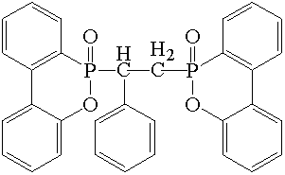
Fig.S1. DIDOPO structural formula.

Table S1 TGA and DTG results before and after modification of BN@APP.
Samples | T_{5%}(℃) | T_{max-1}(℃) | T_{max-2}(℃) | T_{max-3}(℃) | CharResidueat700℃  (wt.%)
APP | 292.3 | 318.9 | 356.5 | 546.2 | 46.64
BN | 221.2 | —— | —— | —— | 99.99
BN@APP | 307.3 | 327.1 | —— | —— | 51.46

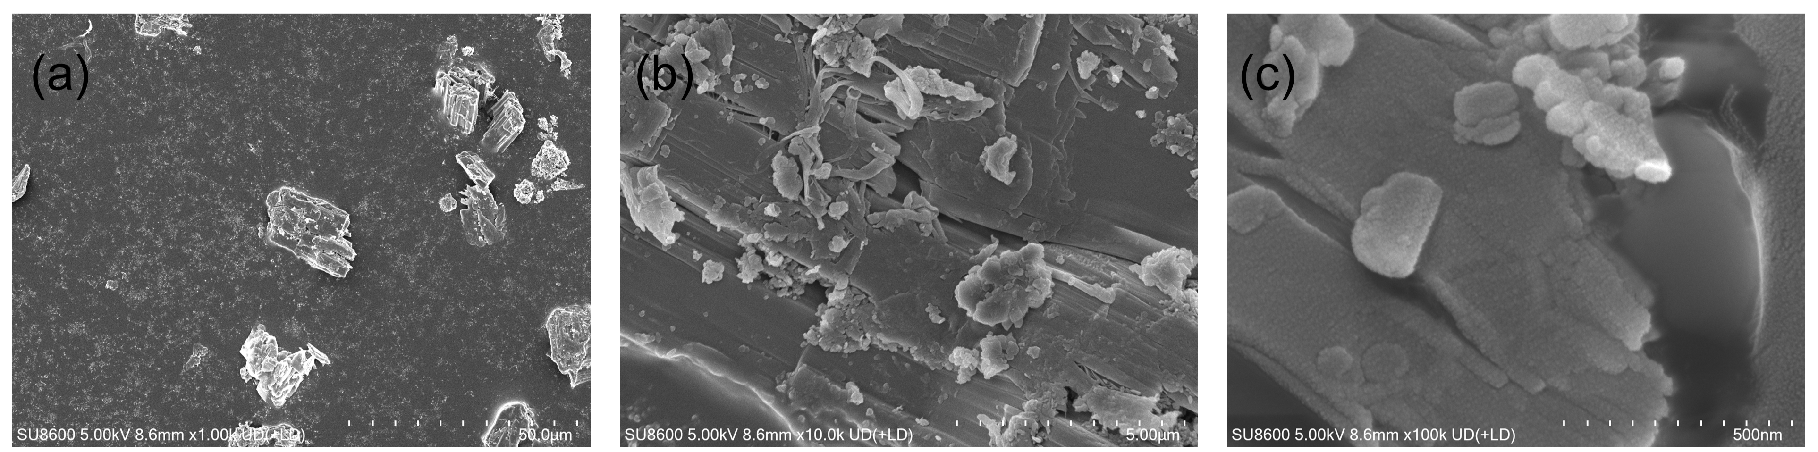
Fig.S2. SEM image of the BN@APP：(a) overview, with (b) and (c) showing magnified views of the selected areas, respectively.
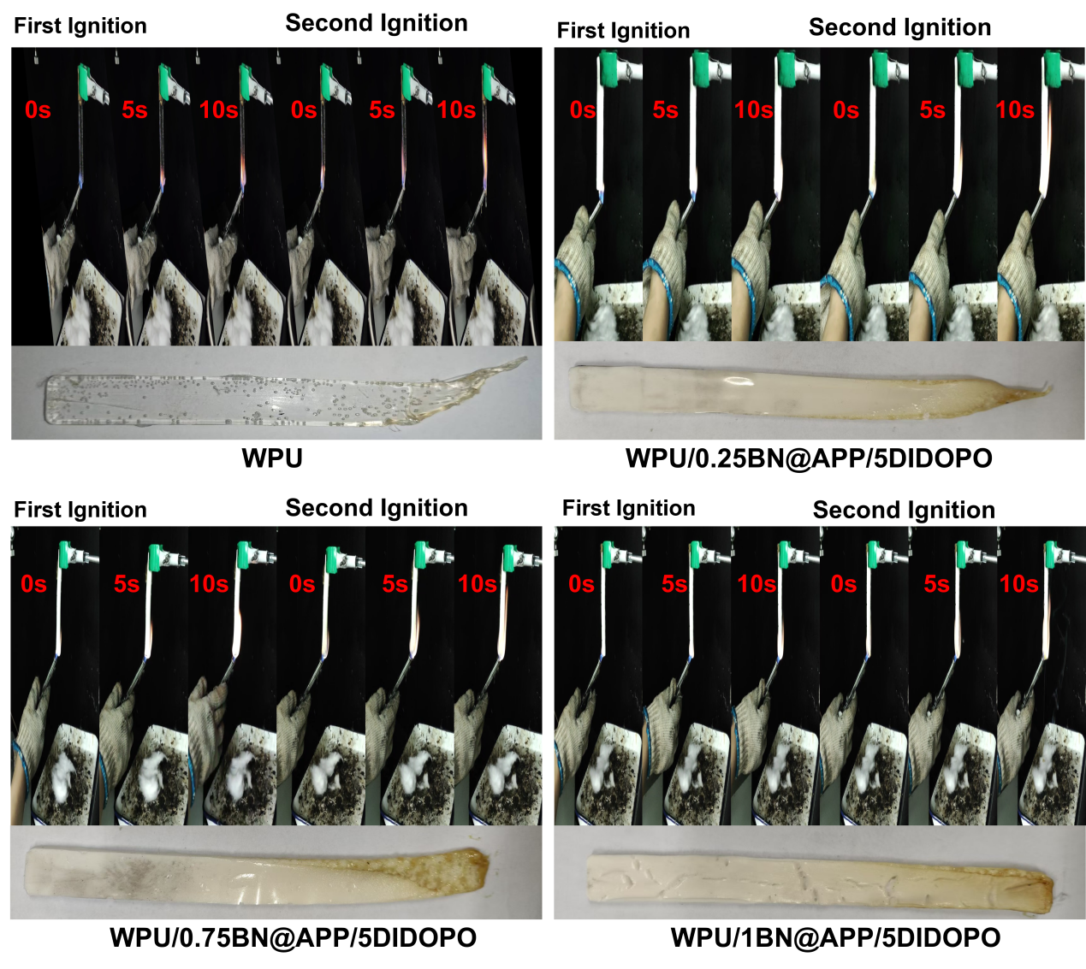

Fig.S3. Digital photographs of WPU and its composites from the UL-94 test.

Table S2 Mechanical propersties of WPU and its Composites
Sample | Breaking Stress(MPa) | Breaking Strain(%) | Elastic Modulus(GPa)
WPU | 8.07±0.2 | 5.15±0.08 | 1.57±0.02
WPU/0.25BN@APP/5DIDOPO | 17.94±0.4 | 4.95±0.35 | 3.62±0.08
WPU/0.5BN@APP/5DIDOPO | 13.96±1.1 | 5.24±0.92 | 2.66±0.09
WPU/0.75BN@APP/5DIDOPO | 9.31±0.7 | 5.77±0.65 | 1.61±0.07
WPU/1BN@APP/5DIDOPO | 5.97±0.3 | 4.45±0.24 | 1.34±0.01

