Supplementary Information

Replication fork stalling at DNA lesions is driven by competition between damage bypass pathways

Amit Cohen¹, Daniel Dovrat¹, Wiktoria A. Kabza², Elizabeth R. Colby³, Liliana S. Batista-Nascimento², Nicola Zilio², Helle D. Ulrich^{2*}, and Amir Aharoni^{1*}

¹Department of Life Sciences and the National Institute for Biotechnology in the Negev, Ben-Gurion University of the Negev, Be’er Sheva 84105, Israel. ²Institute of Molecular Biology gGmbH, Ackermannweg 4, 55128 Mainz, Germany. ³Bristol Renal, Bristol Medical School, University of Bristol, Bristol, United Kingdom.

*Correspondence: H.Ulrich@imb-mainz.de (H.D.U), aaharoni@bgu.ac.il (A.A)

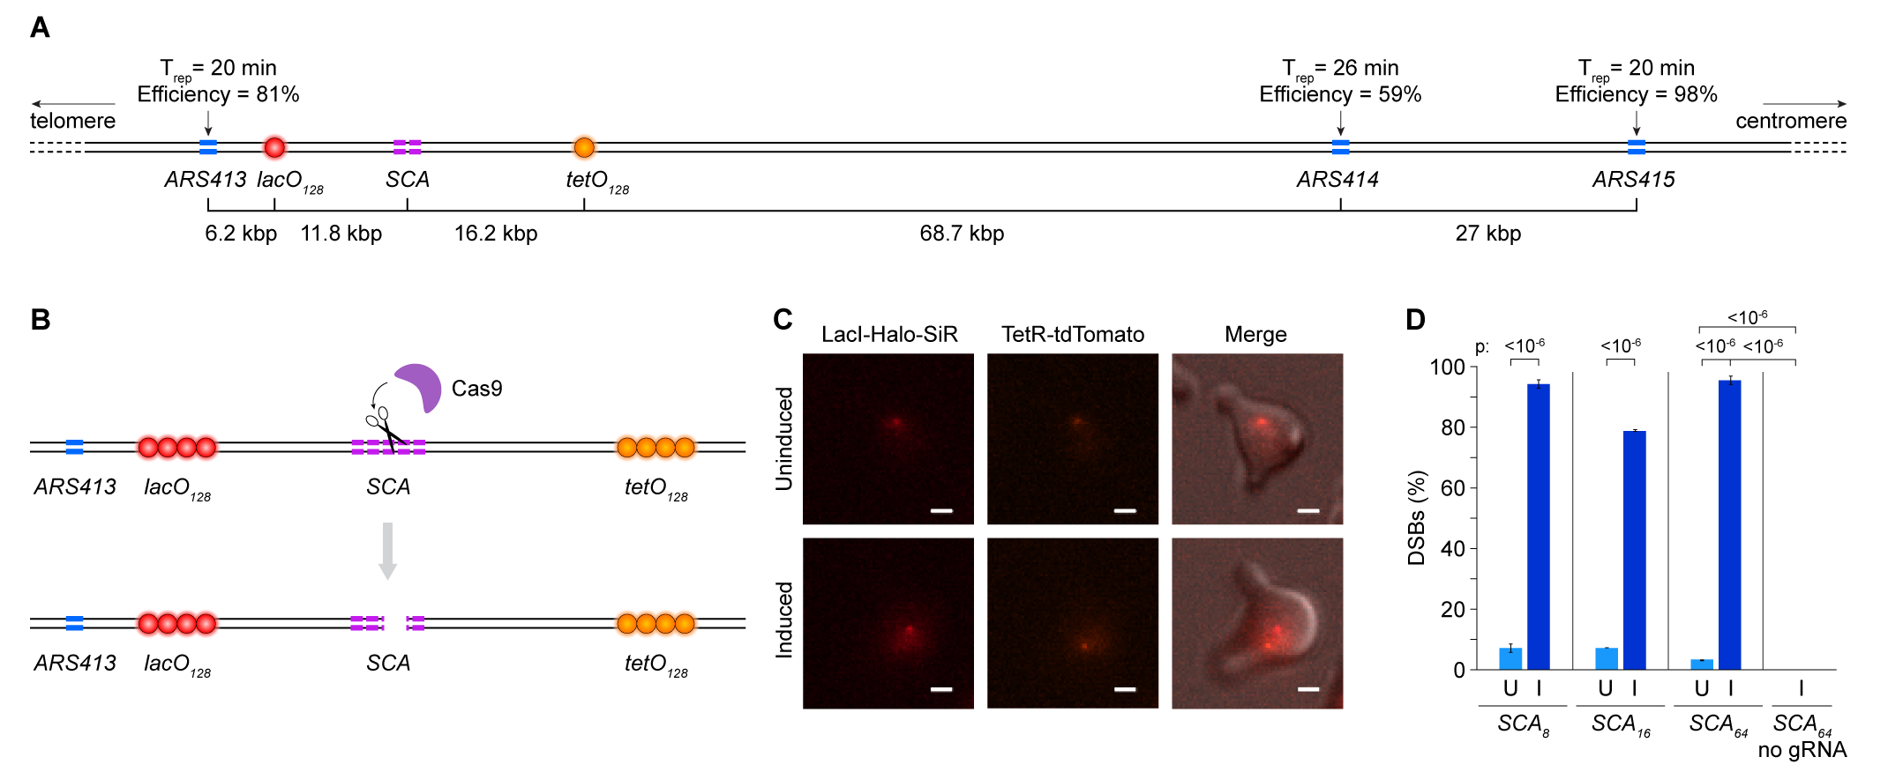

Supplementary Fig. 1: Validation of the system for the introduction of locus-specific AP sites. (A) Schematic of the region surrounding ARS413 and the target sequence used for monitoring replication. Active replication origins in this region are shown in light blue, with their respective initiation times and firing efficiencies. Placement of the lacO and tetO arrays close to ARS413, coupled with the characteristics of the downstream ARS414 origin (late firing, low efficiency, and distant location), ensures that both arrays are predominantly replicated by forks originating from ARS413. (B-D) Live Cas9 is efficiently recruited to the SCA and induces local DSBs. (B) Schematic showing live Cas9 recruitment to the SCA, leading to DSB formation and separation of the two reporter arrays. (C) Representative uninduced and induced cells showing colocalization and separation of the lacO and tetO foci, respectively. (D) Percentage of cells with DSBs, measured in strains harboring the different SCAs and matching gRNA in uninduced (U) or induced (I) conditions. A SCA₆₄ strain without gRNA serves as a control for non-specific damage.

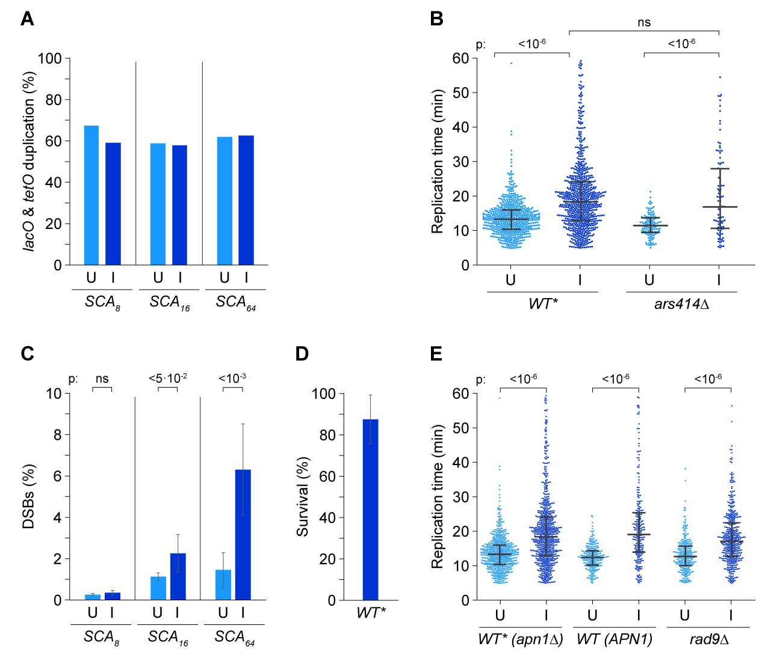

Supplementary Fig. 2: AP sites are successfully bypassed during replication of the SCA locus. (A) Induction of dCas9-UDG* does not influence the percentage of cells replicating both the lacO and the downstream tetO array, indicating successful fork passage through the SCA. Values correspond to the percentage of cells that duplicate both lacO and tetO out of the total number of cells showing lacO duplication with uninduced (U) or induced (I) dCas9-UDG*. Note that values are below 100% in all conditions due to technical reasons, including loss of the focal plane or bleaching of the tetO signal over time. (B) Deletion of ARS414 has no effect on the timing of replication through the SCA, indicating that the locus is predominantly replicated from ARS413. Replication times were measured with uninduced (U) or induced (I) dCas9-UDG* in WT* or ars414Δ cells containing SCA₆₄. (C) Induction of dCas9-UDG* leads to low levels of DSBs in strains containing SCA₈, SCA₁₆, or SCA₆₄. The percentage of cells exhibiting separation of lacO and tetO foci was determined using an automated script for image analysis (see Methods). (D) Induction of dCas9-UDG* does not strongly affect the viability of WT* SCA₆₄ cells. Viability was measured by colony formation and plotted as normalized to uninduced conditions. (E) Checkpoint activation and BER activity contribute little to replication slowdown through the AP sites. Replication times were recorded with uninduced (U) or induced (I) dCas9-UDG* in WT* (apn1∆), WT (APN1), and rad9Δ cells. The rad9Δ and ars414Δ mutants were generated in the WT* background.

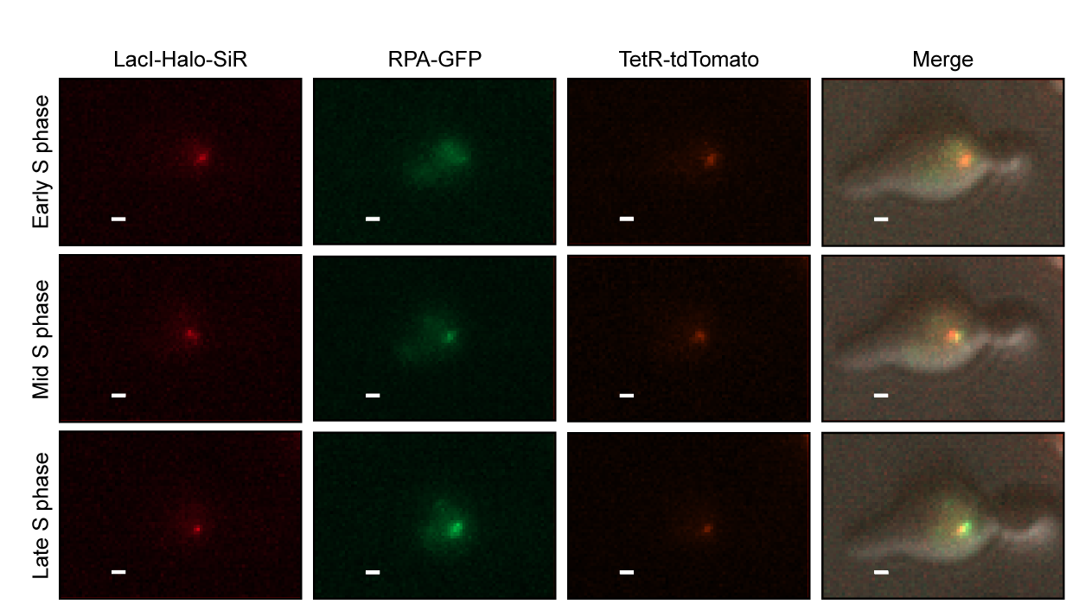

Supplementary Fig. 3: AP sites cause the formation of localized RPA foci. A representative WT* cell harboring SCA₆₄ was imaged during cell cycle progression after induction of dCas9-UDG* in G1. An RPA focus (RPA-GFP) that colocalizes with the labeled arrays (visible as LacI-Halo-SiR and TetR-tdTomato foci) appears during cell cycle progression (scale bar: 2 μm).
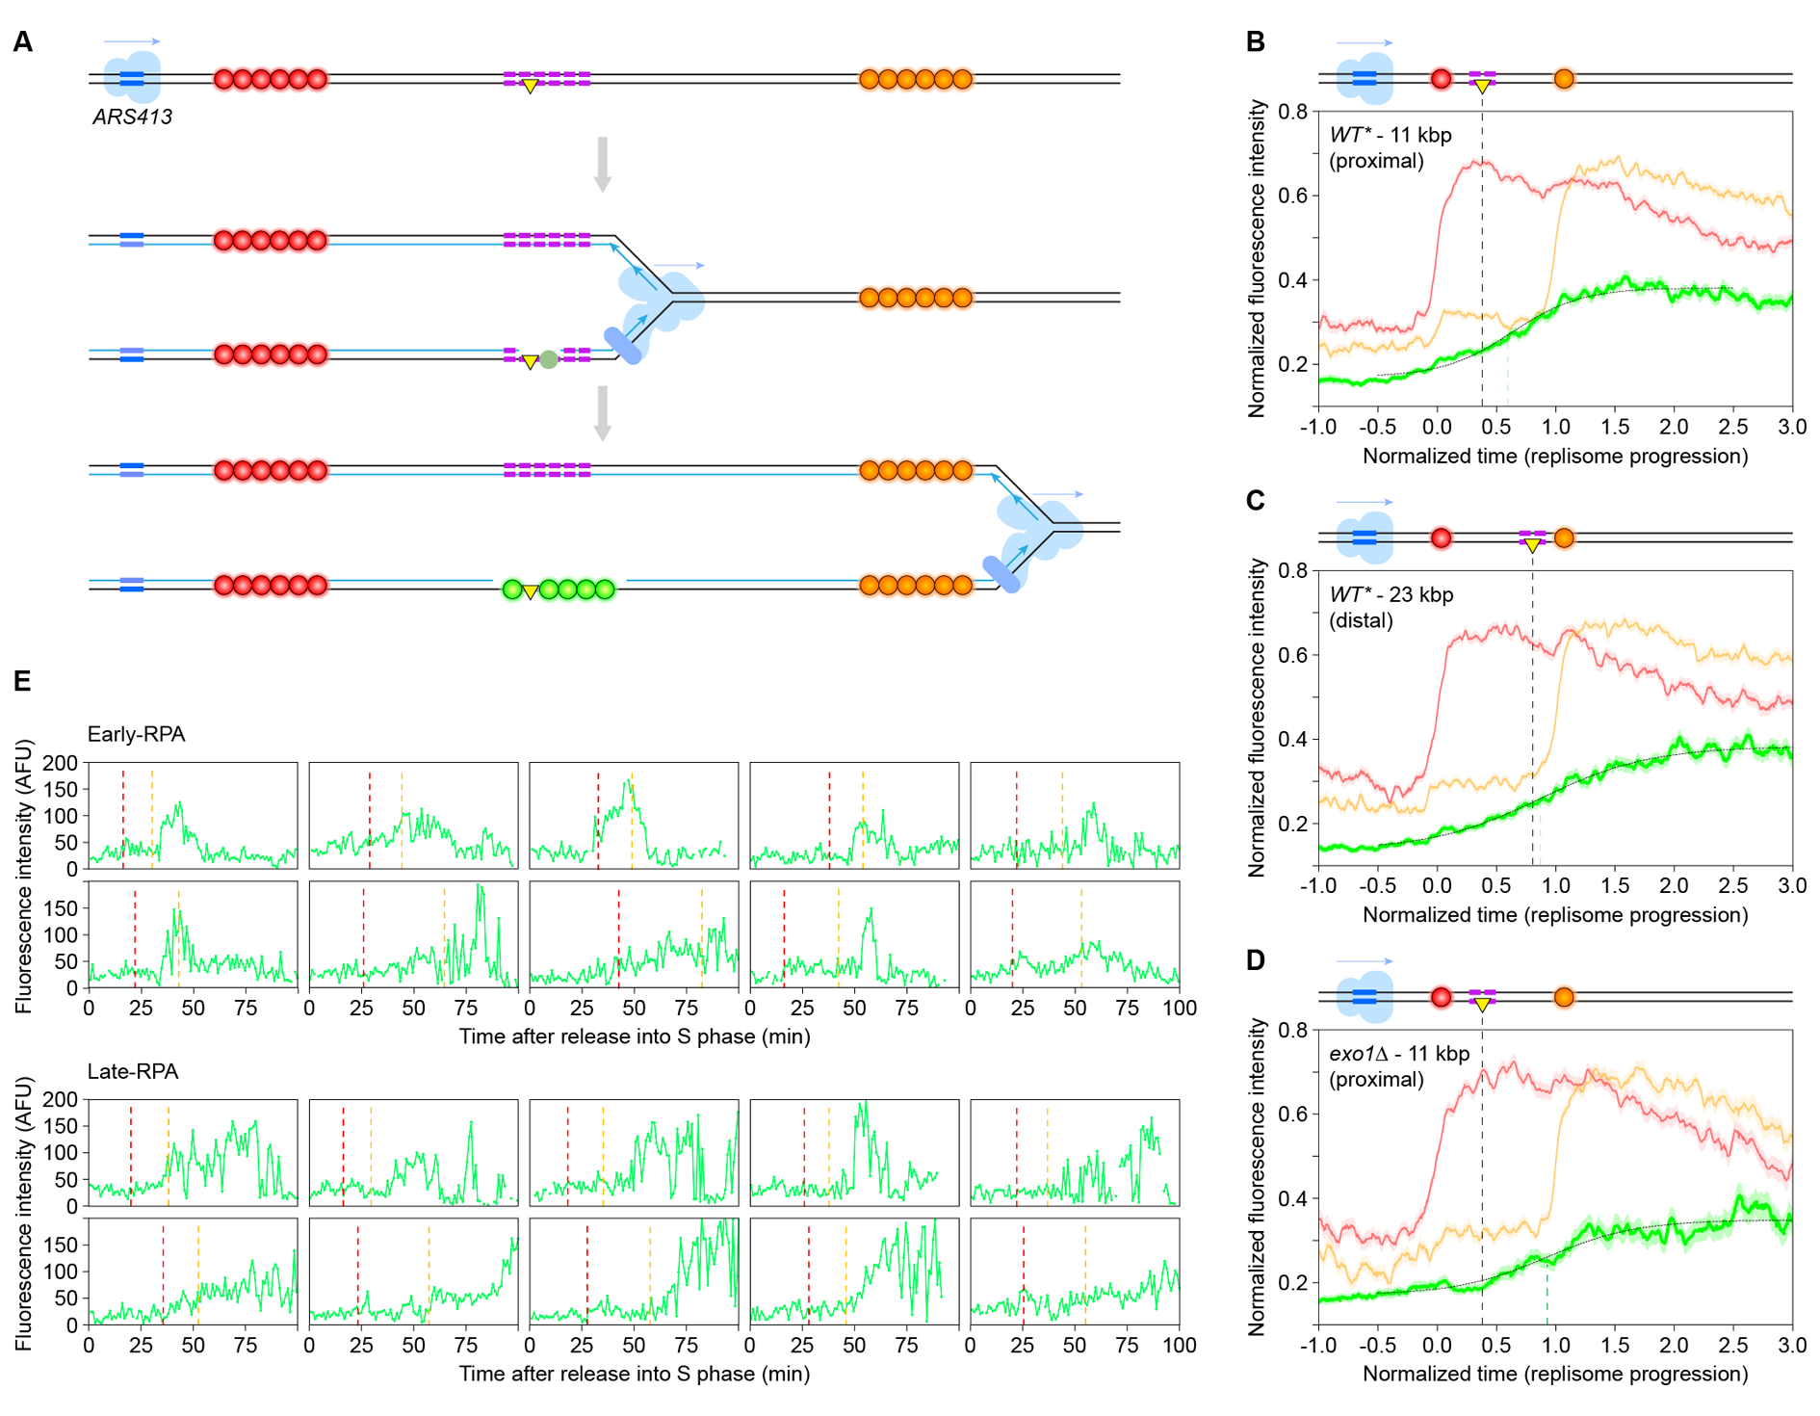

Supplementary Fig. 4: RPA foci formation is associated with replication fork progression through the damaged SCA. (A) Schematic illustration of replicative bypass of the AP sites and subsequent daughter-strand gap expansion, resulting in an observable RPA focus. (B-C). RPA foci formation follows replisome progression through the damaged SCA. RPA foci dynamics after dCas9-UDG* induction was measured during replication in WT* cells harboring SCA₆₄ located either at a proximal position (11 kbp from ARS413) (B), or at a distal position (23 kbp from ARS413) (C). RPA foci formation is delayed in the SCA₆₄-distal strain relative to the SCA₆₄-proximal strain in accordance with the more distal position of the SCA₆₄ (RPA midpoints: 0.63 and 0.87, respectively). (D) RPA foci formation is delayed in induced exo1Δ cells harboring SCA₆₄ (RPA midpoint: 0.93), relative to the respective WT* cells, suggesting that RPA foci mark expanded daughter-strand gaps. Dashed lines represent the respective location of the SCA₆₄ (black) and the midpoint of GFP fluorescence intensity (green). Panel B is from Fig. 4A and is shown for comparison. (E) RPA foci formation proceeds more gradually in late-RPA cells. Images show absolute time courses of GFP fluorescence after release into S phase for individual cells randomly selected from the early- and late-RPA populations. Dashed lines indicate midpoints of lacO (red) and tetO (orange) duplication (AFU: arbitrary fluorescence units).

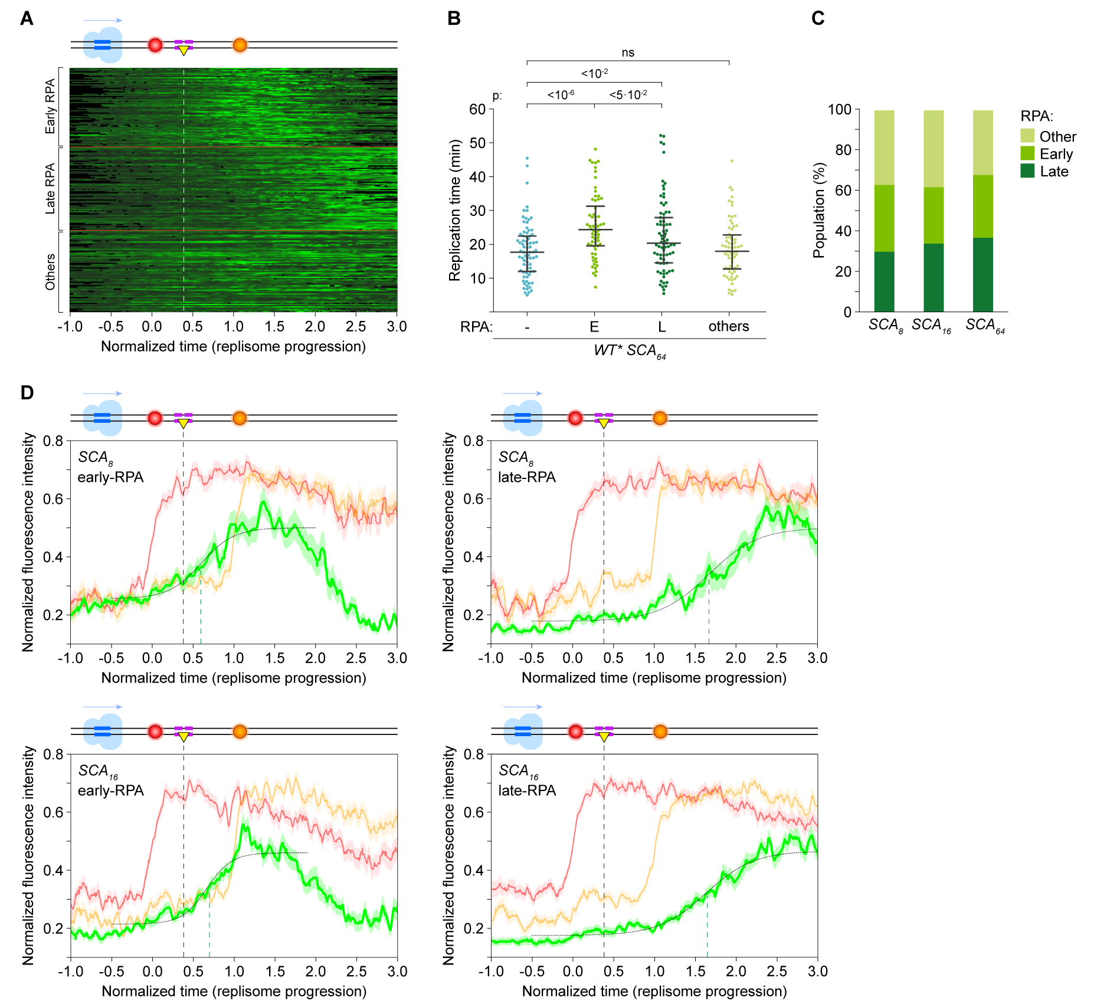

Supplementary Fig. 5: Three subpopulations with distinct RPA foci dynamics are identified among RPA-positive cells. (A) Heat map analysis of RPA foci dynamics of all RPA-positive cells containing SCA₆₄ allows the identification of early-RPA and late-RPA subpopulations in addition to cells with no distinct RPA foci dynamics (“others”). (B) Cells with undefined RPA pattern (“others”) exhibit replication times comparable to those of RPA-negative cells. (C) The distribution of subpopulations among RPA-positive cells is largely independent of the damage load imposed by SCA₈, SCA₁₆, and SCA₆₄. (D) RPA foci dynamics of early- and late-RPA cells harboring SCA₈ or SCA₁₆ resemble those of SCA₆₄ cells (see also Fig. 4 and Table S1). Dashed lines represent the location of the SCA (black) and the midpoint of GFP fluorescence (green). RPA midpoint values for early- and late-RPA cells are 0.6 and 1.67, respectively, for SCA₈ and 0.67 and 1.63, respectively, for SCA₁₆.

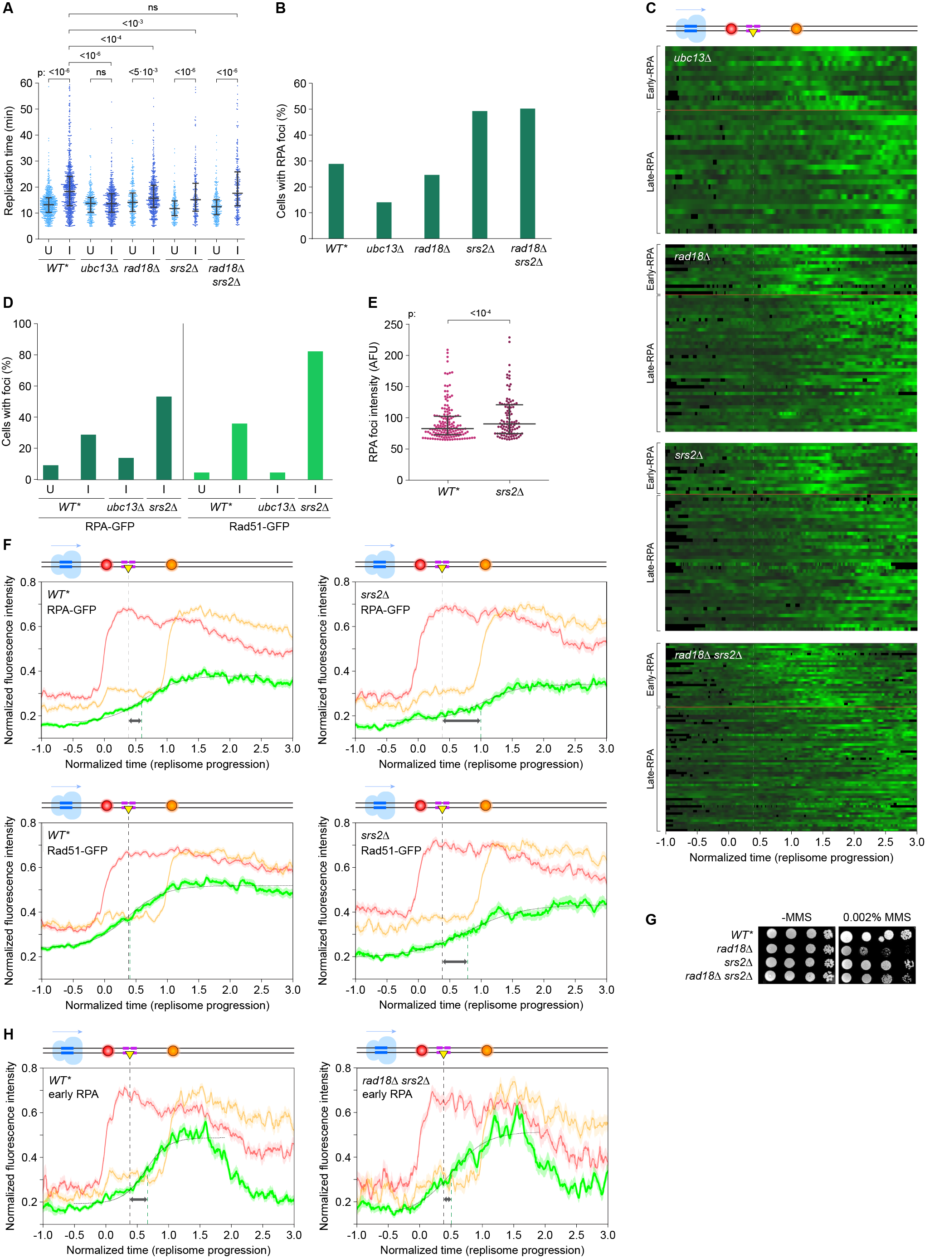
Supplementary Fig. 6: Replication delay and RPA or Rad51 foci dynamics are impacted by defects in ubiquitin-dependent DDT. (A) Replication delays following dCas9-UDG* induction are suppressed in ubc13Δ, rad18Δ, and srs2Δ but not in the rad18Δ srs2Δ double mutant. Replication times for WT* and the indicated mutants are shown for uninduced (U) or induced (I) conditions. (B) TS defects cause a reduction in the fraction of cells exhibiting RPA foci relative to WT* cells upon dCas9-UDG* induction, while deletion of SRS2 or RAD18 and SRS2 enhances foci formation. (C) Deletion of UBC13, RAD18, or SRS2 shifts the timing of RPA foci towards the late-RPA subpopulation, while the double deletion of RAD18 and SRS2 causes no delay in the timing of RPA foci (see also panel H). (D) Induction of AP sites does not induce Rad51 foci in ubc13Δ but causes enhanced formation in srs2Δ compared to WT* cells. The percentage of RPA-positive cells is shown for comparison. (E) Deletion of SRS2 leads to enhanced RPA foci intensity compared to WT* cells. (F) Formation of RPA and Rad51 foci is delayed in srs2Δ (midpoints: 1.03 and 0.82) versus WT* cells (midpoints: 0.63 and 0.40). Dashed lines mark the SCA₆₄ position and the RPA or Rad51 midpoints. (G) Deletion of SRS2 suppresses the sensitivity of rad18Δ towards MMS. Spot assays show growth on solid medium after spotting 10-fold serial dilutions of the indicated cultures. (H) Formation of early RPA foci is accelerated in rad18Δ srs2Δ (midpoint 0.50) versus WT* cells (midpoint: 0.63, see Fig. 4C). Dashed lines mark the SCA₆₄ position and the RPA midpoints. All mutants were generated in the WT* background.
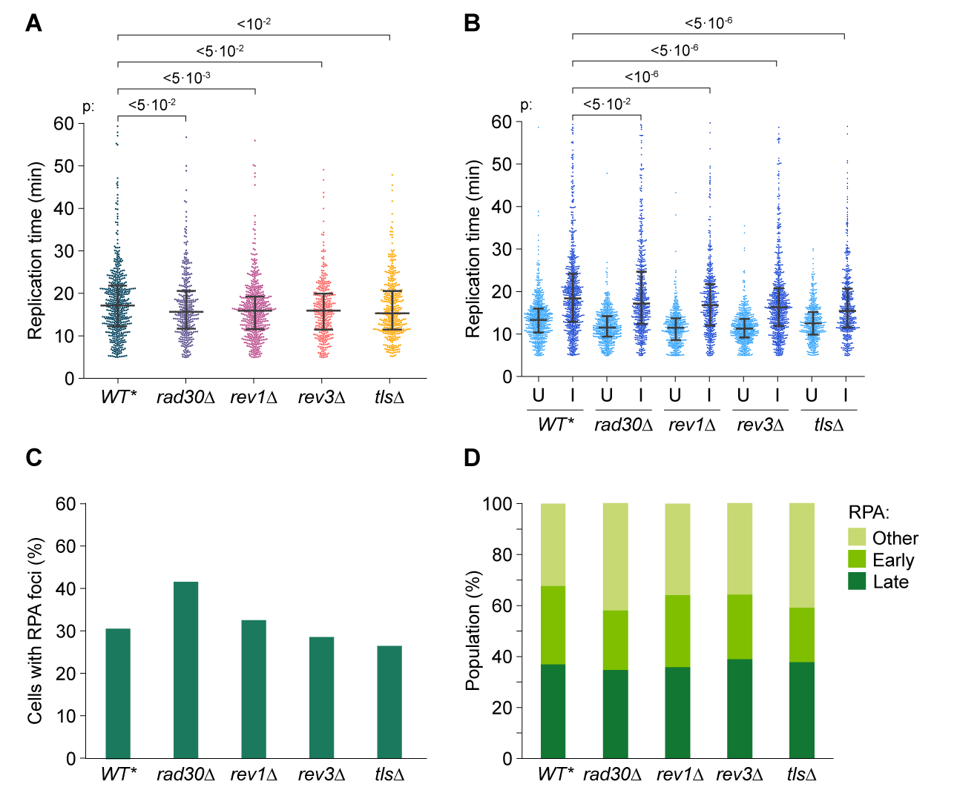

Supplementary Fig. 7: TLS polymerases affect damage-induced replication delay and RPA foci dynamics. (A-B) TLS defects partially suppress the dCas9-UDG*-induced replication delay. Replication times are plotted for RPA-negative cells (A) or total induced (I) and uninduced (U) cells (B). (C) Deletion of RAD30 causes an increase in the proportion of RPA-positive cells in response to AP site induction. (D) TLS defects have little impact on the distribution of the RPA-positive subpopulations. All mutants were generated in the WT* background.

Supplementary Table 1: Midpoint values of RPA foci appearance (GFP fluorescence increase) during replication fork progression through the SCA
Strainª | Type of  SCA | Location of SCA^{b} | Midpoint distance from SCA  RPA-positive^{c} | Midpoint distance from SCA  Early-RPA^{c,d} | Midpoint distance from SCA  Late-RPA^{c,d}
WT* | SCA₈ | 11 kbp | 8.8 kbp | 4.8 kbp | 31.9 kbp
WT* | SCA₁₆ | 11 kbp | 7.6 kbp | 6.5 kbp | 31.4 kbp
WT* | SCA₆₄ | 12 kbp | 5.9 kbp | 5.9 kbp | 31.5 kbp
WT* | SCA₆₄ | 24 kbp | 12.7 kbp | ND | ND
exo1∆ | SCA₆₄ | 12 kbp | 14.1 kbp | ND | ND
ubc13∆ | SCA₆₄ | 12 kbp | 22.9 kbp | 11.3 kbp | 36.9 kbp
rad18∆ | SCA₆₄ | 12 kbp | 14.6 kbp | 6.3 kbp | 34.1 kbp
srs2∆ | SCA₆₄ | 12 kbp | 17.0 kbp | 11.3 kbp | 30.4 kbp
rad18∆  srs2∆ | SCA₆₄ | 12 kbp | 5.6 kbp | 2.2 kbp | 34.7 kbp
rad30∆ | SCA₆₄ | 12 kbp | 5.9 kbp | 2.2 kbp | 31.6 kbp
rev1∆ | SCA₆₄ | 12 kbp | 5.5 kbp | 6.6 kbp | 34.7 kbp
rev3∆ | SCA₆₄ | 12 kbp | 8.4 kbp | 4.7 kbp | 29.2 kbp
tls∆ | SCA₆₄ | 12 kbp | 8.7 kbp | 1.3 kbp | 29.5 kbp

ª WT* carries the apn1∆ mutation; all mutants were generated in the WT* background.
^{b} Distance from ARS413.
^{c} Midpoint values of GFP fluorescence increase during replisome progression are presented as kbp distance from the SCA. “RPA-positive” designates all cells containing colocalized RPA foci above the threshold; “early-RPA” and “late-RPA” indicate the respective subpopulations according to the clustering shown in Fig. 4B.
^{d}ND – not determined.

Supplementary Table 2: Proportion of cells undergoing anaphase within 80 min after duplication of tetO₁₂₈
Strainª | Uninduced^{b} | RPA-negative^{b} | Early-RPA^{b} | Late-RPA^{b}
WT* SCA₈ | 54/55 (98%) | 55/58 (95%) | 24/27 (89%) | 16/27 (59%)
WT* SCA₁₆ | 36/40 (90%) | 45/51 (88%) | 16/24 (67%) | 7/19 (37%)
WT* SCA₆₄ | 31/43 (72%) | 40/60 (67%) | 8/38 (21%) | 2/42 (5%)
rad30Δ | 51/54 (94%) | 34/53 (64%) | 8/30 (27%) | 4/26 (15%)
rev1Δ | 49/56 (88%) | 12/30 (40%) | 8/26 (31%) | 4/28 (14%)
rev3Δ | 45/52 (87%) | 22/54 (41%) | 9/29 (21%) | 0/26 (0%)
tlsΔ | 40/49 (82%) | 30/50 (60%) | 8/15 (53%) | 9/30 (30%)

ªWT* carries the apn1∆ mutation; all mutants were generated in the WT* SCA₆₄ background.
^{b}”RPA-negative” designates cells with no colocalized RPA foci within the observation period (see Materials and Methods for criteria); “early-RPA” and “late-RPA” indicate the respective RPA-positive subpopulations according to the clustering shown in Fig. 4B.

Supplementary Table 3: Plasmids prepared and used in this study
Plasmidª | Unique elements | Purpose | Yeast marker
pAC-Cas9-27 | Cas9 expression  No gRNA | For inducible expression of Cas9 from GAL10 promoter, w/o gRNA | URA3
pAC-Cas9-28 | Cas9 expression  with gRNA | For inducible expression of Cas9 from GAL10 promoter, with gRNA | URA3
pAC-dCas9-53 | dCas9-UDG* expression  No gRNA | For inducible expression of dCas9-UDG* from GAL10 promoter, w/o gRNA | URA3
pAC-dCas9-54 | dCas9-UDG* expression  with gRNA | For inducible expression of dCas9-UDG* from GAL10 promoter, with gRNA | URA3
pAG25-GFP-RFA1 gRNA resistant | GFP amplification | For N-terminal GFP-tagging of RFA1, re-coded for Cas9-mediated integration | -
pCAS3-RFA1-g1-2 | Cas9 expression with gRNA for targeting RFA1 | For integration of GFP at the N-terminus of RFA1 | URA3
pDD-SCA16 | Synthetic CRISPR array containing 16 repeats | SCA₁₆ for integration to chrIV:340385 | -
pDD-SCA64 | Synthetic CRISPR array containing 64 repeats | SCA₆₄ for integration to chrIV:340385 | -
pAC-SCA64-3rd | Synthetic CRISPR array containing 64 repeats, 3rd integration targets | SCA₆₄ for integration to chrIV:358551 | -
pDDNat-3rd | NatMX Cassette with 3rd integration targets | NatMX-3rd for SCA integration to chrIV:358551 | NAT

ªAll plasmids contain a bacterial origin of replication and an ampicillin resistance cassette.

Supplementary Table 4: S. cerevisiae strains used in this study
Strainª | Unique feature | Genotype | Source
W1588 | - | MATa leu2-3,112 trp1-1 can1-100 ura3-1 ade2-1 his3-11,15 RAD5 | Kupiec lab TAU
AA849 | Replication system | W1588 chrIV:332960::lacO₁₂₈ pdr5::lacI-Halo chrIV:352560::tetO₁₂₈ ADE1::tetR-tdTomato+TIR1 RFA1::RFA1-GFP | This study
AA1568 | Empty gRNA  Cas9 SCA₆₄ | AA849 chrIV:340385::SCA₆₄ ura3-1::URA3-GAL10p-Cas9-IAA-empty gRNA apn1Δ trp1::TRP1-GEM | This study
AA1427 | Empty gRNA  dCas9-UDG*  SCA₆₄ | AA849 chrIV:340385::SCA₆₄ ura3-1::URA3-GAL10p-dCas9-UDG*-IAA-9xFlag-empty gRNA apn1Δ aur1::AUR1-GEM | This study
AA1461 | WT, gRNA dCas9-UDG*  SCA₆₄ | AA849 chrIV:340385::SCA₆₄ ura3-1::URA3-GAL10p-dCas9-UDG*-IAA-9xFlag-gRNA trp1::TRP1-GEM | This study
AA1626 | WT*, gRNA  Cas9 SCA₈ | AA849 chrIV:340385::SCA₈ ura3-1::URA3-GAL10p-Cas9-IAA- gRNA apn1Δ aur1::AUR1-GEM | This study
AA1602 | WT*, gRNA  Cas9 SCA₁₆ | AA849 chrIV:340385::SCA₁₆ ura3-1::URA3-GAL10p-Cas9-IAA-gRNA apn1Δ aur1::AUR1-GEM | This study
AA1455 | WT*, gRNA  Cas9 SCA₆₄ | AA849 chrIV:340385::SCA₆₄ ura3-1::URA3-GAL10p-Cas9-IAA-gRNA apn1Δ trp1::TRP1-GEM | This study
AA1623 | WT*, gRNA  dCas9-UDG*  SCA₈ | AA849 chrIV:340385::SCA₈ ura3-1::URA3-GAL10p-dCas9-IAA-UDG*-IAA-9xFlag-gRNA apn1Δ trp1::TRP1-GEM | This study
AA1607 | WT*, gRNA  dCas9-UDG*  SCA₁₆ | AA849 chrIV:340385::SCA₁₆ ura3-1::URA3-GAL10p-dCas9-IAA-UDG*-IAA-9xFlag-gRNA apn1Δ trp1::TRP1-GEM | This study
AA1428 | WT*, gRNA  dCas9-UDG*  SCA₆₄ | AA849 chrIV:340385::SCA₆₄ ura3-1::URA3-GAL10p-dCas9-IAA-UDG*-IAA-9xFlag-gRNA apn1Δ trp1::TRP1-GEM | This study
AA1548 | WT*, gRNA  dCas9-UDG*  SCA₆₄ distal | AA849 chrIV:352558::SCA₆₄ ura3-1::URA3-GAL10p-dCas9-IAA-UDG*-IAA-9xFlag-gRNA apn1Δ aur1::AUR1-GEM | This study
AA1512 | exo1∆ | AA1428 exo1::KanMX | This study
AA1436 | ubc13∆ | AA1428 ubc13::KanMX | This study
AA1444 | rad18∆ | AA1428 rad18::KanMX | This study
AA1543 | srs2∆ | AA1428 srs2::NatMX | This study
AA1555 | rad18∆ srs2∆ | AA1543 srs2::NatMX rad18::KanMX | This study
AA1612 | rad30∆ | AA1428 rad30::HIS3MX6 | This study
AA1613 | rev1∆ | AA1428 rev1::NatMX | This study
AA1614 | rev3∆ | AA1428 rev3::KanMX | This study
AA1611 | tls∆ | AA1428 aur1::AUR1-GEM rad30::HIS3MX6 rev1::NatMX rev3::KanMX | This study
AA1511 | WT*  Rad51-iGFP | RAD51::RAD51-iGFP chrIV:340385::SCA₆₄ ura3-1::URA3-GAL10p-dCas9-IAA-UDG*-IAA-9xFlag-gRNA apn1Δ trp1::TRP1-GEM | This study
AA1526 | ubc13∆  Rad51-iGFP | AA1511 ubc13::KanMX | This study
AA1537 | srs2∆  Rad51-iGFP | AA1511 srs2::NatMX | This study

ªAPN1 was deleted in all strains in a markerless manner by replacing APN1 with an antibiotic resistance cassette followed by removal of the cassette using CRISPR/Cas9 approach.

Table S5: Oligonucleotides used for GLOE-Seq analysis
ID | Name | Sequence (5’3’) | Use
3331 | Internal locus – fwd | CCATTGGTGGTGACCTGATTA | qPCR
3332 | Internal locus – rev | TTGGAAGAGCCCTTCGATTT | qPCR
3790 | Extension primer | CGAGATCTACACTCTTTCCCTACACGACGCTCTTCCGATCT | GLOE-Seq
3791 | Distal adaptor – top | GACTGGAGTTCAGACGTGTGCTCTTCCGATCT | GLOE-Seq
3898 | Proximal adaptor – bottom | CTACACGACGCTCTTCCGATCTNNNNN*N-(NH2) | GLOE-Seq
3899 | Proximal adaptor – top | (5‘PO4)AGATCGGAAGAGCGTCGTGTAGGGAAAGAGTGTAGATCTCGTTTT(3’BIOTIN) | GLOE-Seq
5773 | NotI ChrI – fwd | AGAGTTGGGAATGTGTGCCC | qPCR
5774 | NotI ChrI – rev | GGGCAGCAACACAAAGTGTC | qPCR
5775 | NotI ChrII – fwd | AGAACACTGCTAAAGTAAGAGA | qPCR
5776 | NotI ChrII – rev | TCCAGGAGCTTCAGAAATTG | qPCR
5805 | NotI ChrIV – fwd | CCGTGGATTCAGATGCGTTG | qPCR
5806 | NotI ChrIV – rev | CTGTTGCGGTGGTATCCTTTG | qPCR
5809 | NotI ChrVII – fwd | GGCAAGTTAGCTGGCCTAAATG | qPCR
5810 | NotI ChrVII – rev | CCACCACCCAAATCGTAAACTG | pPCR
7060 | Distal adaptor – bottom | (5‘PO4)GATCGGAAGAGCACACGTCTGAACTCCAGTCCCC | GLOE-Seq
P5 | IDT P5 | AATGATACGGCGACCACCGAGATCTACACTCTTTCCCTACACGACGCTCTTCCGATCT | Sequencing
P7 | IDT P7 | CAAGCAGAAGACGGCATACGAGAT(X)6GTGACTGGAGTTCAGACGTGTGCTCTTCCGATCT | Sequencing

