Chemical Characterization of Trace Elements in PM_{2.5} and PM₁₀ and their Source Apportionment by PMF Modelling with Associated Health Risk Assessment in the Aravalli Region, India

Figure S1: The total concentration and percentage contribution of these trace elements in PM_{2.5} and PM₁₀ samples are mentioned in the supplementary.
Table S1: Reference concentration dose (RF) and Inhalation Unit Risk (IUR) values of heavy elements for health risk assessment defined by USEPA.
Table S2. Seasonal variability of PM_{2.5} and PM₁₀ in Jaipur during the sampling period.
Table S3: Variability in concentration of trace elements presented in PM_{2.5} and PM₁₀ over sampling site in Jaipur, Rajasthan.

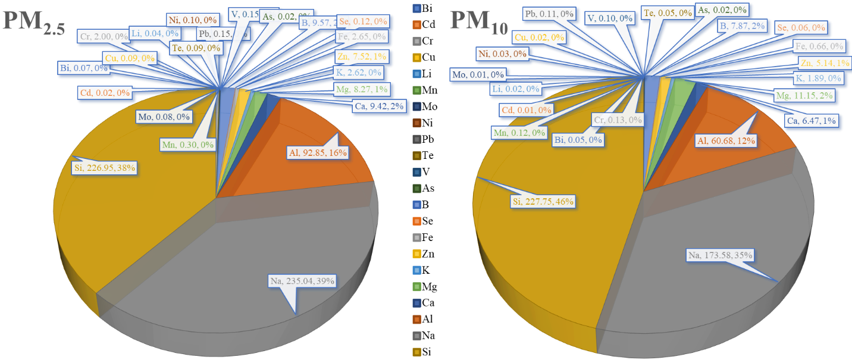
Figure S1: The total concentration and percentage contribution of these trace elements in PM_{2.5} and PM₁₀ samples are mentioned in the supplementary.

Table S1. Reference concentration dose (RF) and Inhalation Unit Risk (IUR) values of heavy elements for health risk assessment defined by USEPA.
Elements | RF (mg m⁻³) | IUR ((µg m⁻³)⁻¹)
As | 0.0003 | 0.0043
Cr | 0.0000286 | 0.012
Pb | 0.003520 | 0.000012
Mn | 0.0000143 | -
Ni | 0.00352 | 0.00024
Al | 0.0019 | -
Cu | 0.00402 | -
V | 1.00E-04
Zn | 0.301 | -

Table S2: Seasonal variability of PM_{2.5} and PM₁₀ in Jaipur during the sampling period.
 | AT | RH | WS | WD | Cum. RF | SR | BP | PM_{2.5} CPCB | PM_{2.5} CPCB | PM₁₀ Sampling | PM₁₀ Sampling
 | (°C) | (%) | (m/s) | (deg) | (mm) | (W/m²) | (mmHg) | (µg/m³) | (µg/m³) | (µg/m³) | (µg/m³)
Season
Winter (JF) | 18.6 | 47.41 | 0.97 | 227.21 | 0.12 | 295 | 731.25 | 57.65 | 160.24 | 80.04 | 155
Pre-Monsoon (MAM) | 28.06 | 37.47 | 1.23 | 218.85 | 0.68 | 528.65 | 731.37 | 43.94 | 118.37 | 72.1 | 126.41
Monsoon (JJAS) | 29.35 | 71.03 | 1.56 | 236.12 | 4.81 | 261.18 | 725.5 | 38.01 | 88.8 | 44.86 | 92.59
Post Monsoon (OND) | 23.05 | 47.49 | 0.85 | 217 | 0.02 | 123.68 | 735.02 | 89.07 | 145.19 | 82.4 | 133.19
Daily
Mean | 25.02 | 48.56 | 1.14 | 217.71 | - | 241.54 | 730.3 | 50.1 | 110.76 | 56.64 | 106.71
Median | 27.03 | 49.01 | 1.19 | 228.76 | 0 | 209.78 | 731.26 | 46.79 | 114.5 | 59.22 | 118.28
Std Dev | 5.47 | 20.61 | 0.4 | 54.85 | 0.1 | 206.21 | 4.37 | 28.25 | 52.83 | 35.29 | 56.03
Max | 36.94 | 98 | 2.58 | 318.05 | 1.67 | 847.7 | 739.77 | 176.47 | 361.93 | 193.54 | 326.43
Min | 10.84 | 14.25 | 0.48 | 78.68 | 0 | 67.32 | 720.54 | 16.59 | 33.44 | 1.25 | 3.7

Table S3: Variability in concentration of trace elements presented in PM_{2.5} and PM₁₀ over sampling site in Jaipur, Rajasthan.
Daily Statistics of observed trace elements in atmosphere
 |  | PM_{2.5} |  |  | PM₁₀
Sr No. | Element | Average | Mean | Std Dev | Average | Mean | Std Dev
1 | Cd | 0.02 | 0.02 | 0.01 | 0.01 | 0.01 | 0.01
2 | As | 0.02 | 0.02 | 0.01 | 0.02 | 0.02 | 0.01
3 | Li | 0.04 | 0.04 | 0.03 | 0.02 | 0.02 | 0.01
4 | Bi | 0.07 | 0.07 | 0.05 | 0.05 | 0.05 | 0.03
5 | Mo | 0.08 | 0.08 | 0.06 | 0.01 | 0.01 | 0.01
6 | Te | 0.09 | 0.09 | 0.07 | 0.05 | 0.05 | 0.05
7 | Cu | 0.09 | 0.09 | 0.15 | 0.02 | 0.02 | 0.02
8 | Ni | 0.10 | 0.10 | 0.09 | 0.03 | 0.03 | 0.02
9 | Se | 0.12 | 0.12 | 0.18 | 0.06 | 0.06 | 0.05
10 | V | 0.15 | 0.15 | 0.14 | 0.10 | 0.10 | 0.09
11 | Pb | 0.15 | 0.15 | 0.12 | 0.11 | 0.11 | 0.10
12 | Mn | 0.30 | 0.30 | 0.20 | 0.12 | 0.12 | 0.10
13 | Cr | 2.00 | 2.00 | 1.23 | 0.13 | 0.13 | 0.15
14 | K | 2.62 | 2.62 | 1.67 | 1.89 | 1.89 | 1.06
15 | Fe | 2.65 | 2.65 | 3.69 | 0.66 | 0.66 | 0.95
16 | Zn | 7.52 | 7.52 | 5.27 | 5.14 | 5.14 | 4.28
17 | Mg | 8.27 | 8.27 | 4.70 | 11.15 | 11.15 | 18.83
18 | Ca | 9.42 | 9.42 | 5.88 | 6.47 | 6.47 | 5.49
19 | B | 9.57 | 9.57 | 6.68 | 7.87 | 7.87 | 1.31
20 | Al | 92.85 | 92.85 | 77.61 | 60.68 | 60.68 | 61.88
21 | Si | 226.95 | 182.22 | 160.85 | 227.75 | 195.28 | 120.59
22 | Na | 235.04 | 235.04 | 67.49 | 173.58 | 173.58 | 53.59

