Supplementary Figures
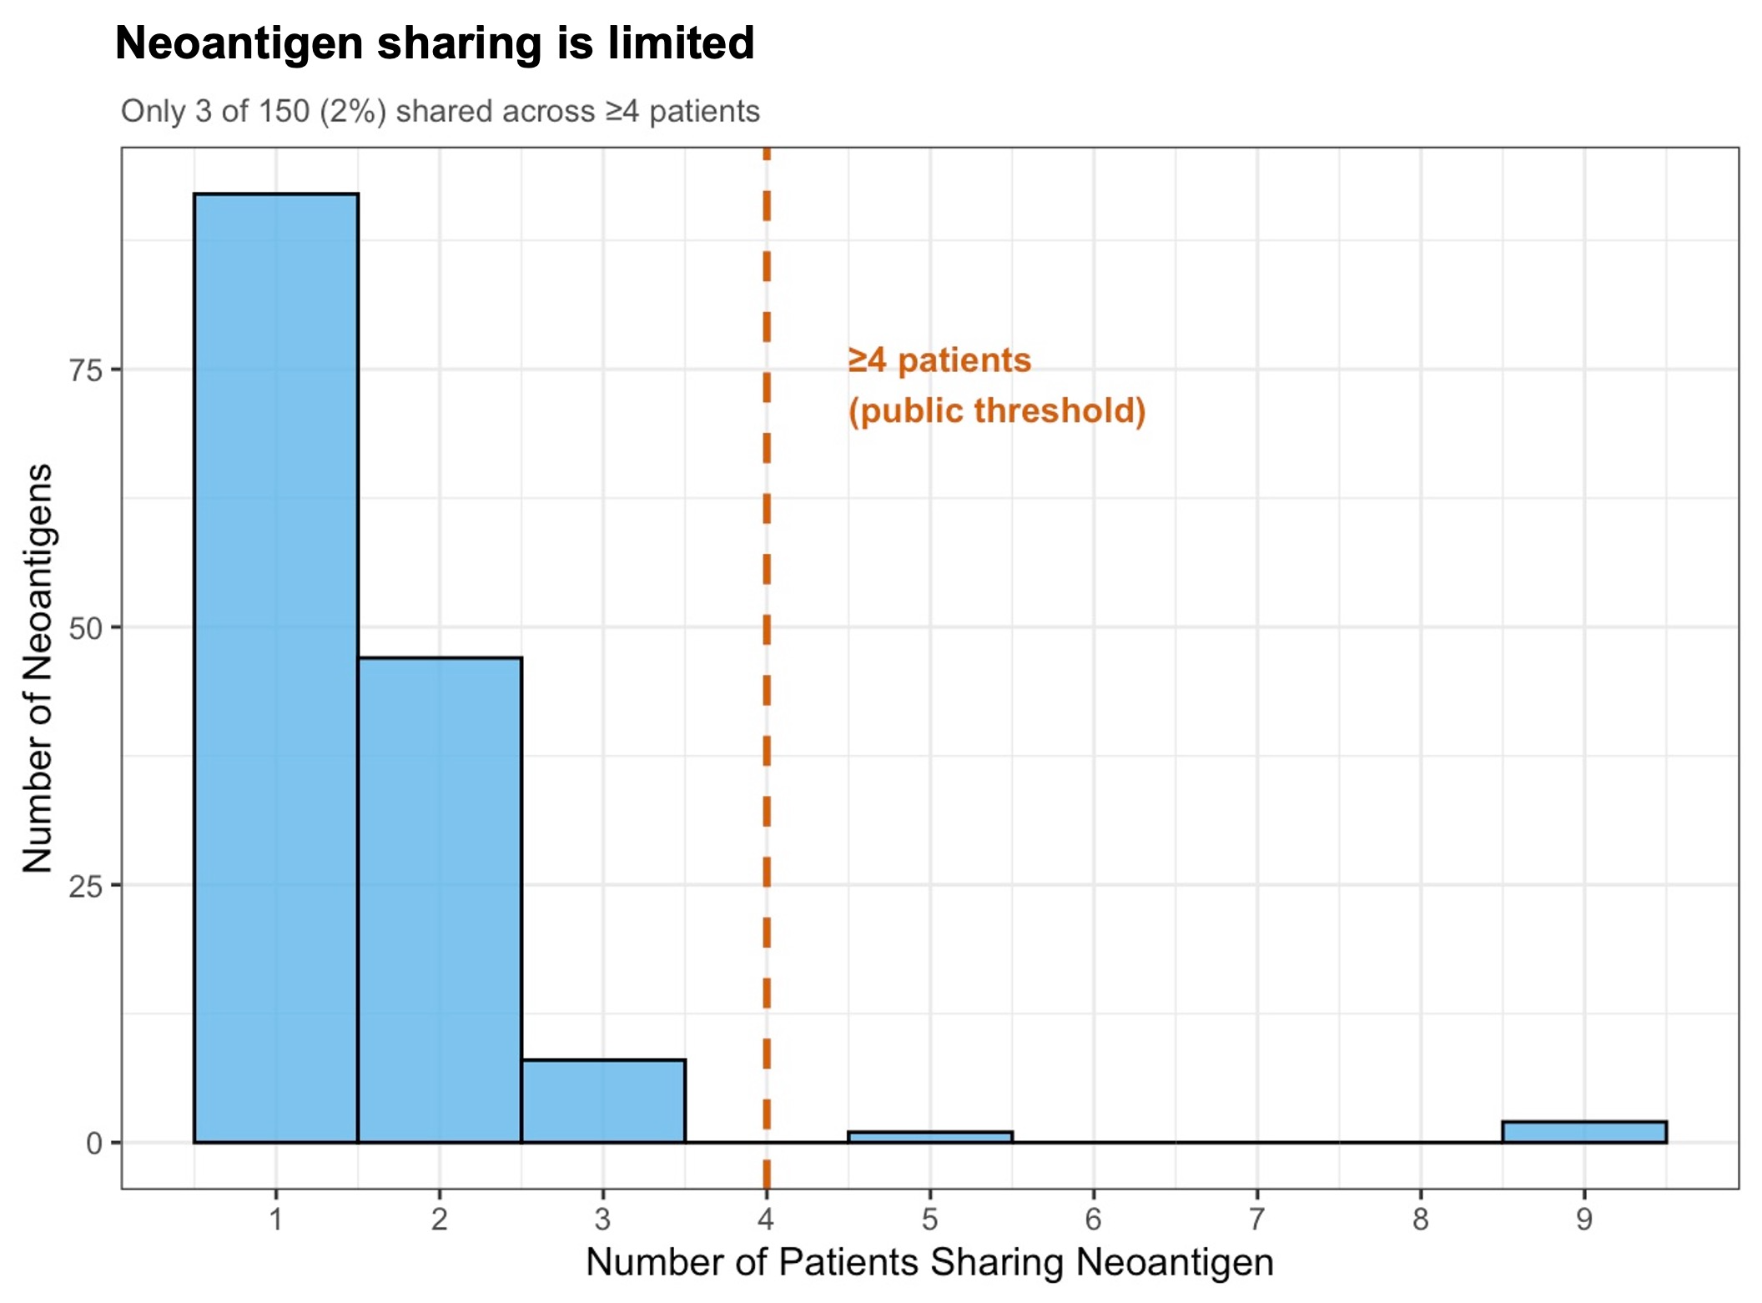
Supplementary Figure 1. Neoantigen sharing is rare in IDH-wildtype GBM.
Histogram showing the number of patients sharing each predicted strong neoantigen. Most neoantigens were unique to a single patient, with very few observed in multiple patients. Only 3 of 150 neoantigens (2%) were shared across ≥4 patients (dashed line), indicating a predominantly private neoantigen landscape in GBM.
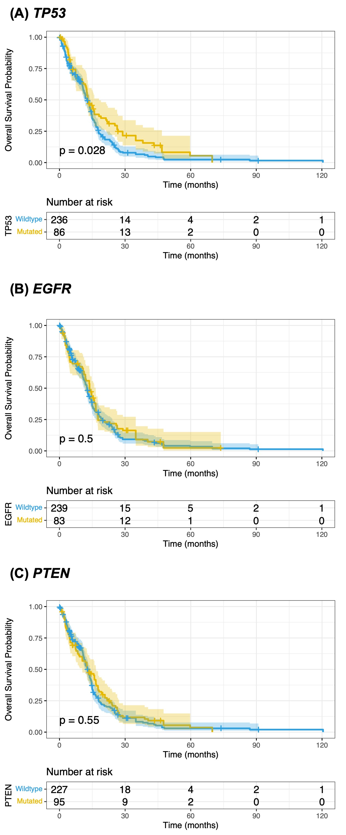
Supplementary Figure S2. Survival analysis stratified by driver gene mutation status in IDH-wildtype GBM. Kaplan-Meier survival curves for (A) TP53, (B) EGFR, and (C) PTEN mutation status in 322 IDH-wildtype GBM patients. Blue: wild type; yellow: mutant. Shaded areas represent 95% confidence intervals. Risk tables show patients at risk at each timepoint. P-values from log-rank tests are displayed.

