Supplementary Information

Ultra-Fast Ising Machine for Combinatorial Optimization using Sub-nanosecond CMOS-integrated Magnetoresistive Random Access Memory
Sai Li^{1,†}, Yihao Zhang^{1,2,†}, Albert Lee³, Zheng Zhu³, Lang Zeng^{1,2}, Peng Wang^{1,2}, Lei Gao⁴, Di Wu³ and Weisheng Zhao^{1,2,*}
¹School of Integrated Circuit Science and Engineering, Beihang University, Beijing, 100191, China.
²National Key Lab of Spintronics, Institute of International Innovation, Beihang University, Hangzhou, 311115, China.
³InstonTech, Suzhou, 215000, China.
⁴Empyrean Technology Co., Ltd., Beijing, 100102, China.
†These authors contributed equally: Sai Li, Yihao Zhang
*Corresponding author email: weisheng.zhao@buaa.edu.cn

Supplementary Note 1 Probabilistic Characteristics and Calibration of VCMA-MTJ Devices
The switching probability of VCMA-MTJs as a function of pulse width is illustrated in Supplementary Figure 1a. In Supplementary Figure 1b, these curves are fitted to a sigmoid-like function:
$$P_{sw}=\frac{1}{1+e^{−α(W_{v}−W_{0})}}$$
where $α$ and $W_{0}$ represent fitting coefficients. The update mechanism of the Ising machine is described as follows:
$$P_{flip}=\frac{1}{1+e^{−(δH/T)}}$$
By enforcing the equation $δH/T=α(W_{v}−W_{0})$ to be satisfied, a standard sigmoid curve can be effectively realized using any of these devices (Supplementary Figure 1c).
The switching probability under varying voltage pulses (ranging from 1.6 to 2.2 V) is presented in Supplementary Figure 1d. Lower voltage values result in a reduced peak switching probability (PSP). We define the working window of operational voltage as the range required to achieve a PSP exceeding 90%. As shown in Supplementary Figure 1d, a minimum voltage of approximately 1.9 V is necessary, while 2.2 V is sufficient to produce a well-defined sigmoid curve.
Supplementary Figure 1e displays the resistance distribution measurements across three dies, revealing a tunneling magnetoresistance ratio of 90–140%, which ensures an adequate read margin for reliable operation.
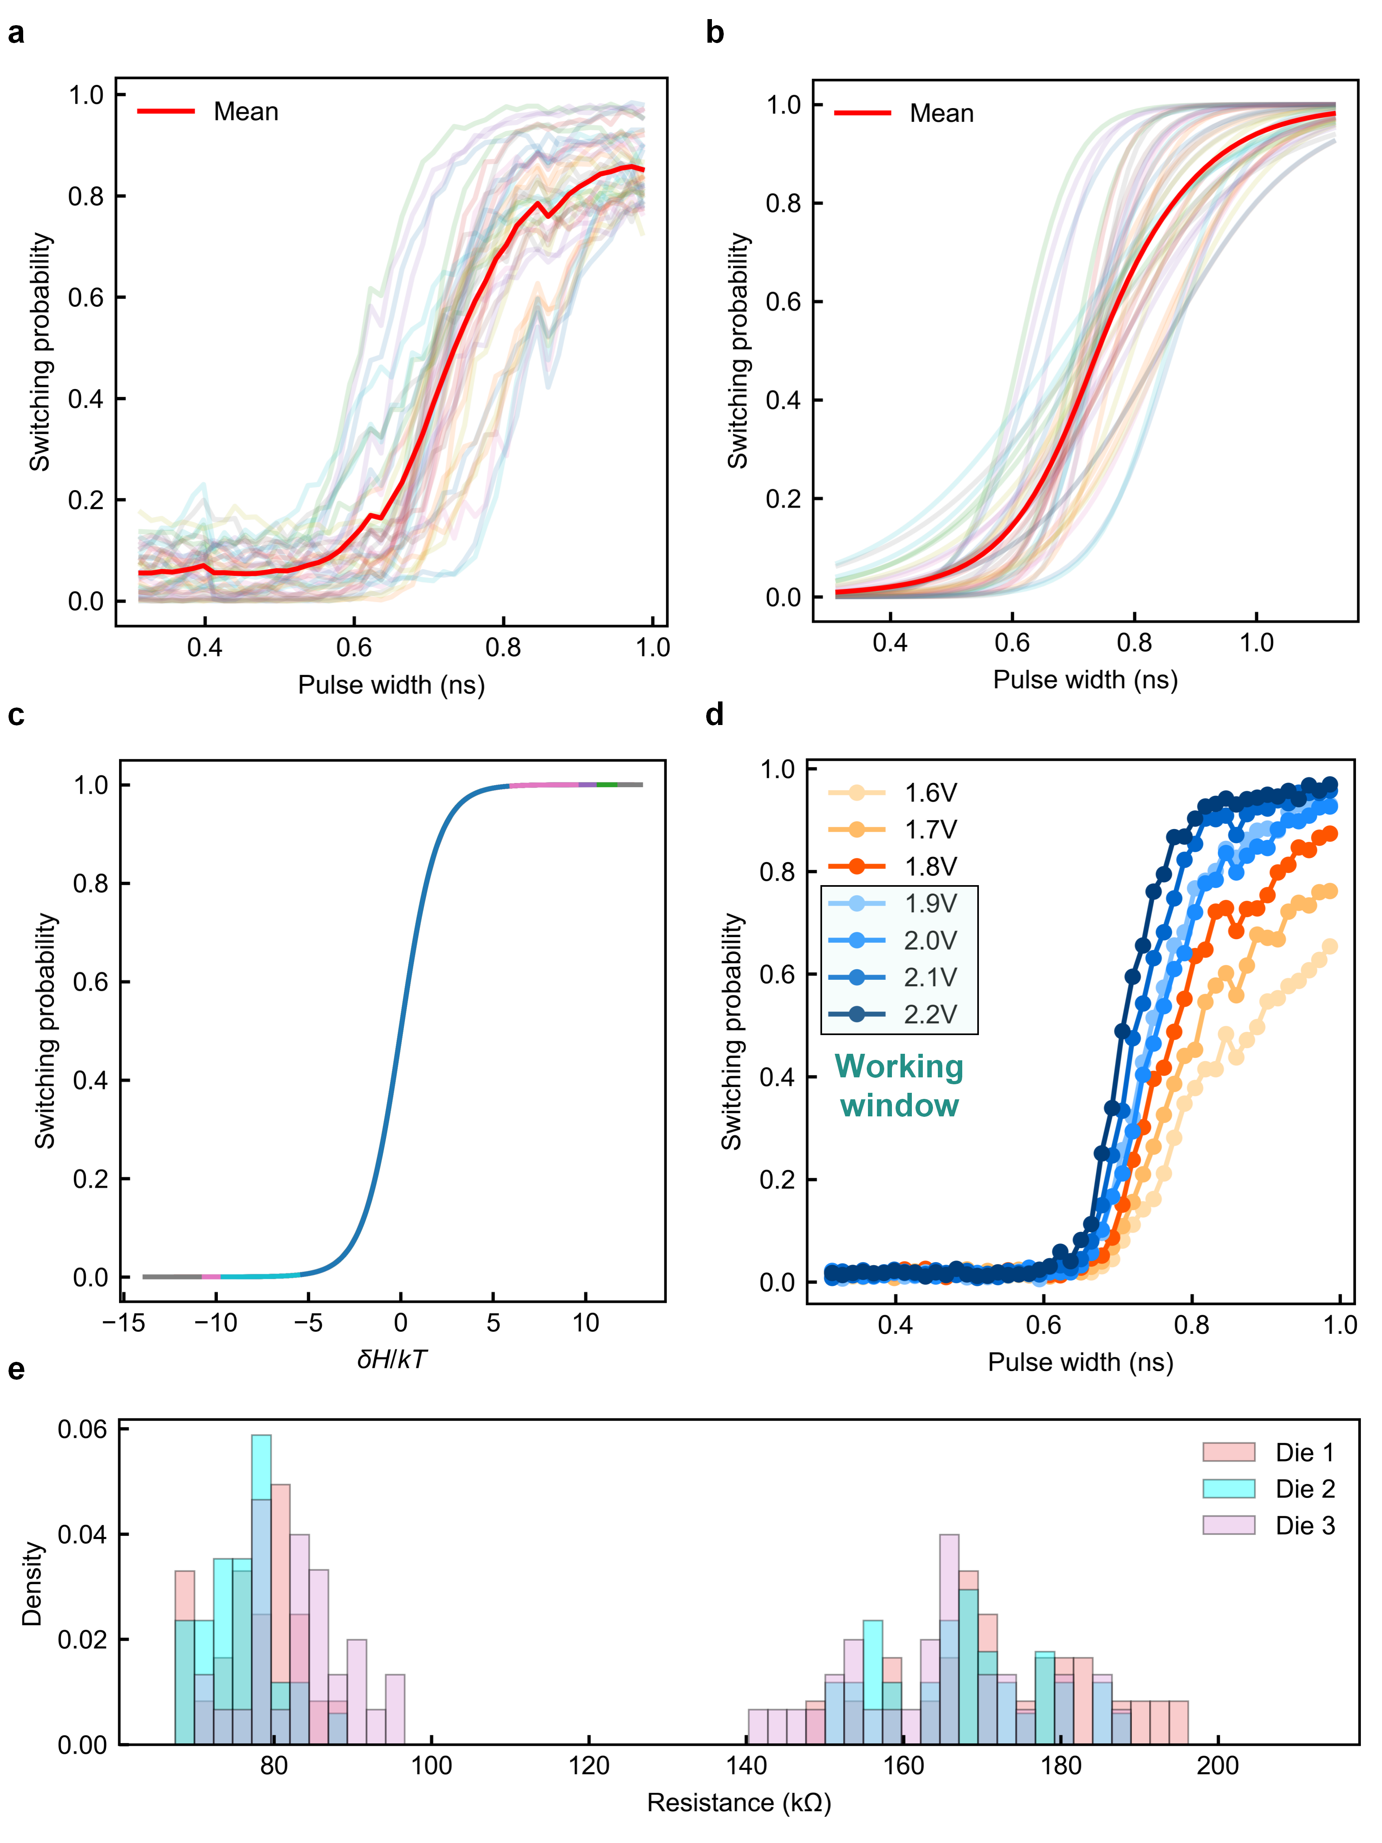
Supplementary Figure 1. Statistical characterization and calibration of VCMA-MTJs. a, Switching probability as a function of sub-nanosecond pulse width. b, Sigmoidal fitting results for the switching probability curves. c, Realization of a standard sigmoid function using the derived fitting coefficients. d, Switching probability under varying voltage pulses (1.6~2.2 V), highlighting the working window of 1.9~2.2 V. e, The resistance distribution measurements across three dies.

Supplementary Note 2 Quantitative Assessment of True Randomness Generated by VCMA-MTJ
The intrinsic stochasticity of VCMA-MTJs enables the generation of true randomness. To assess the randomness quality of VCMA-MTJs, which is critical for the operation of the Ising machine, we applied consecutive write pulses to the MTJs. The pulse width was set to correspond to a 50% switching probability. After each write pulse, the MTJ state was read out, producing random bit streams (RBSs). A representative RBS with a length of 6400 is shown in Supplementary Figure 2a, exhibiting a Shannon Entropy of 0.999997. Additionally, we performed an autocorrelation function (ACF) test and a Hamming distance test (Supplementary Figure 2b, c) to further evaluate the randomness. Moreover, the results of the NIST SP800-22 randomness tests, presented in Supplementary Table 1, consistently validate the high randomness quality of the VCMA-MTJ.
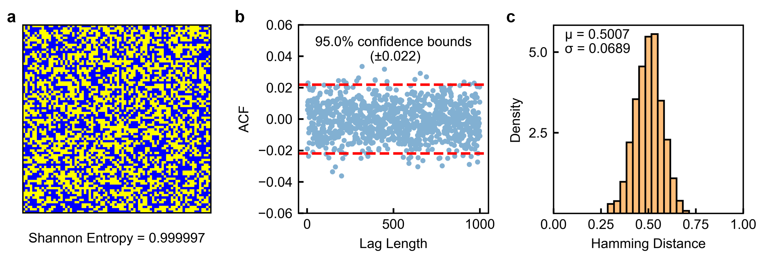
Supplementary Figure 2. Randomness quality tests of RBSs generated by VCMA-MTJ. a, Visualization of a RBS with a length of 6400, reshaped into an 80×80 matrix. Blue squares represent 0, and yellow squares represent 1. The Shannon Entropy of the RBS is 0.999997. b, ACF test result of a RBS at a 95% confidence level (±0.022). c, Inter-sample Hamming distance between multiple RBSs, with a mean value of 0.5.

Test | P-value | Result
Frequency | 0.68 | Pass
Block Frequency | 0.36 | Pass
Runs | 0.02 | Pass
Longest Runs of Ones | 0.73 | Pass
DFT | 0.94 | Pass
Non-overlapping Template Matching | 0.99 | Pass
Serial | 0.18 | Pass
Approximate Entropy | 0.21 | Pass
Cumulative Sums | 0.76 | Pass
Random Excursion | 0.25 | Pass
Random Excursions Variant | 0.31 | Pass
Supplementary Table 1. Results of NIST SP800-22 randomness test using RBSs generated by VCMA-MTJ.

Supplementary Note 3 On-Chip Pulse Modulation of VCMA-MTJ as Ising Spin
This supplementary note explains the on-chip pulse width modulation mechanism implemented in the VC-MRAM chip. As shown in Supplementary Figure 3, the pulse width modulation is achieved through an internal programmable delay circuit. When a write operation is initiated, a trigger signal is generated and used to control both the top and bottom electrodes of the VCMA-MTJ. One of these control signals passes through the programmable delay circuit, which determines the duration of the voltage pulse applied across the MTJ.
The timing diagram on the right side of Supplementary Figure 3 illustrates the applied voltage waveforms. The voltage at the top electrode ($V_{top}$) and bottom electrode ($V_{bottom}$) define the effective voltage across the MTJ ($V_{MTJ}$), which governs the switching behavior. By adjusting the delay, the pulse width can be modulated to control the switching probability of the MTJ. This tunability is critical for on-chip VCMA-MTJ-based Ising computing.
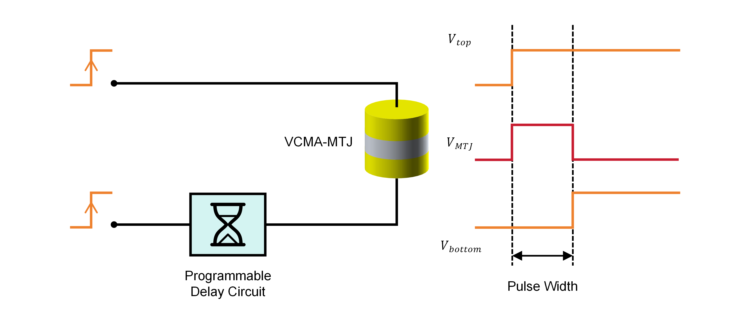
Supplementary Figure 3. On-chip pulse width modulation mechanism for VCMA-MTJ switching control. A programmable delay circuit adjusts the relative timing of the voltage signals applied to the top and bottom electrodes of the VCMA-MTJ, thereby modulating the pulse width of $V_{MTJ}$.
.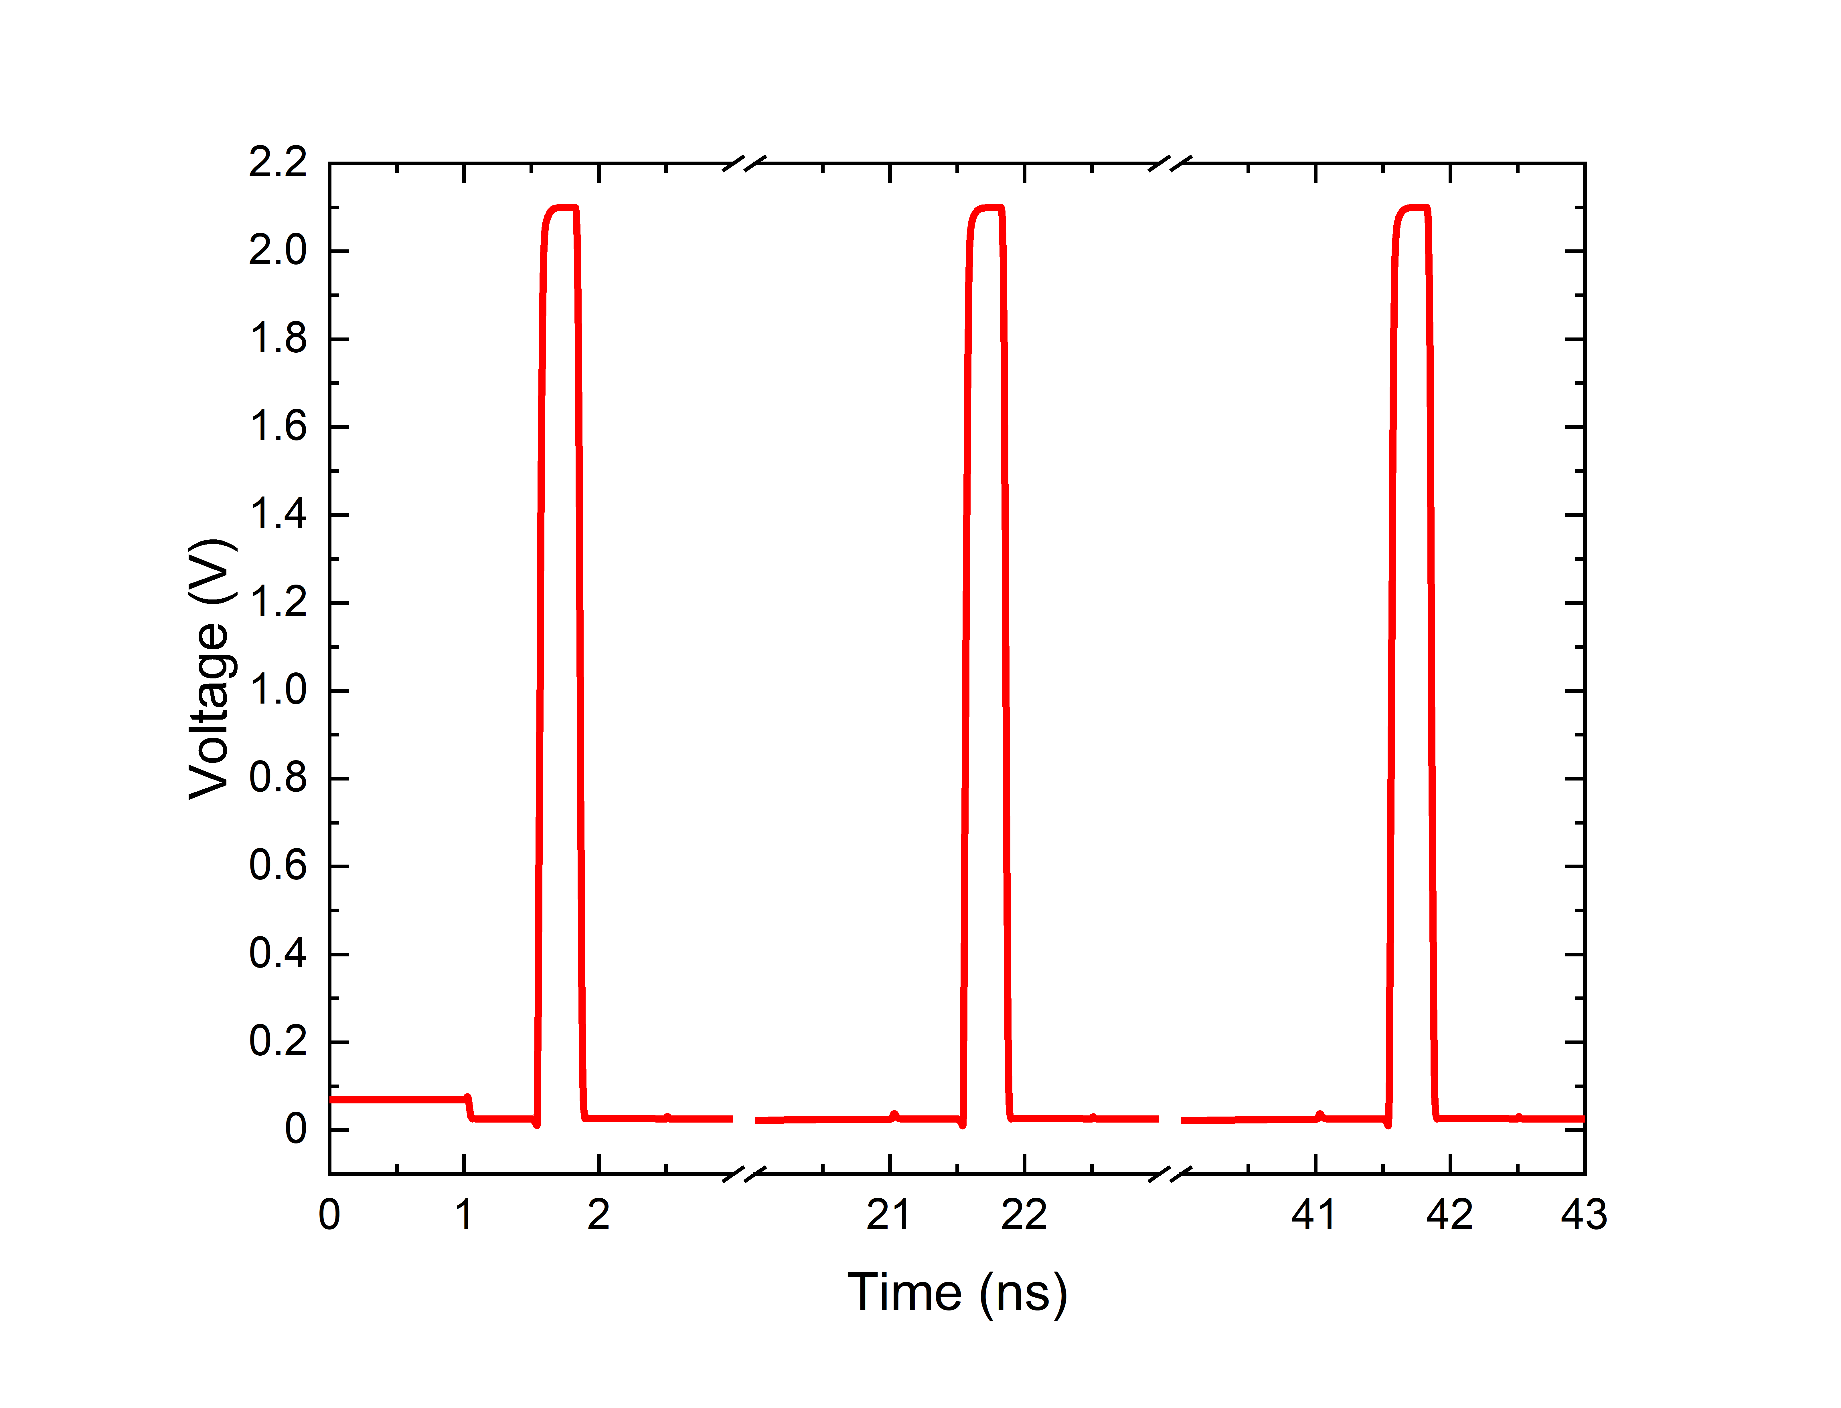
Supplementary Figure 4. Sub-nanosecond writing of VCMA-MTJ for ultra-fast Ising spin update. Circuit simulation of the write pulses exhibit a width of less than 1 ns ( $W_{v}$ ~0.3 ns in the figure as an example), enabling sub-nanosecond probabilistic spin updates. The periodic pulses ($V_{MTJ}$ ~2.1 V) demonstrate the feasibility of fast and energy-efficient MTJ operation in the Ising machine.

Supplementary Note 4 Ising Mapping of Global Routing Problem
The global routing problem can be modeled as a rectilinear Steiner minimum tree (RSMT) problem. The total Hamiltonian for the RSMT problem is stated as:
$$H_{RSMT}(x)=H_{o}+λ_{1}H_{c1}+λ_{2}H_{c2}+λ_{3}H_{c3}+λ_{4}H_{c4}$$
where $H_{o}$ represents the optimization objective, specifically the total cost of all edges in the Steiner tree:
$$H_{o}=\sum_{\begin{aligned}(u,v)∈E, \\ v≠v_{0}\end{aligned}}{c_{u,v}x_{u,v}^{e}}$$
$H_{c1}\sim H_{c4}$ denote four essential constraints for Steiner tree formation, with corresponding penalty coefficients $λ_{1}\sim λ_{4}$ that must be carefully calibrated for optimal performance. These constraints serve distinct purposes. $H_{c1}$ ensures that each terminal vertex (except the root) has precisely one incoming arc:
$$H_{c1}=\sum_{v∈U\backslash {\{v}_{0}\}}{{(1−\sum_{(u,v)∈E}{x_{u,v}^{e}})}^{2}}$$
$H_{c2}$ enforces acyclicity, a fundamental requirement for tree structures:
$$H_{c2}=\sum_{\begin{aligned}1≤u<v<w≤|V|, \\ u,v,w≠v_{0}\end{aligned}}{(x_{u,w}^{o}+x_{u,v}^{o}x_{v,w}^{o}−x_{u,v}^{o}x_{u,w}^{o}−x_{u,w}^{o}x_{v,w}^{o})}+\sum_{\begin{aligned}(u,v)∈E, \\ u<v, \\ u,v≠v_{0}\end{aligned}}{(x_{u,v}^{e}}(1−x_{u,v}^{o})+x_{v,u}^{e}x_{u,v}^{o})$$
$H_{c3}$ penalizes configurations where Steiner vertices either have multiple incoming arcs or possess outgoing arcs without any incoming ones:
$$H_{c3}=|V|\sum_{v∈W}{(\sum_{(u,v),(w,v)∈E}{x_{u,v}^{e}x_{w,v}^{e}})}+\sum_{v∈W}{(1−\sum_{(u,v)∈E}{x_{u,v}^{e}})(\sum_{(u,v)∈E}{x_{v,u}^{e}})}$$
$H_{c4}$ addresses the rectilinearity constraint specific to routing scenarios. When two vertices $u$ and $v$ cannot be connected by a straight segment (denote as $r_{u,v}=1$, otherwise $r_{u,v}=0$), a positive penalty is imposed:
$$H_{c4}=\sum_{\begin{aligned}(u,v)∈E, \\ v≠v_{0}\end{aligned}}{r_{u,v}x_{u,v}^{e}}$$
The spin variables $s$ in the Ising model is derived through a composite transformation of $x^{e}$ and $x^{o}$:
$$s=\left(\frac{s^{e}}{s^{o}}\right)=2∗\left(\frac{x^{e}}{x^{o}}\right)−1$$
where $s^{e}$ and $s^{o}$ are Ising spins for edge and order variables, respectively.
For convenience, denote $M=|U|,N=|V|$. All vertices are numbered sequentially from $0$ to $N−1$, with vertex $0$ assumed to be the root. The Ising Hamiltonian can be written as:
$$H_{Ising}=−\sum_{i,j,m,n}{J_{i,j,m,n}s_{i,j}s_{m,n}}−\sum_{i,j}{h_{i,j}s_{i,j}}$$
The ‘interactions’ and ‘external field’ brought by the objective term and all constraint terms in $H_{RSMT}$ are denoted as $J^{0},h^{0},J^{1},h^{1},...J^{4},h^{4}$, respectively. These terms are then subjected to variable substitution in sequence:
(1)
$$H_{o}=\sum_{1≤j<N}{\sum_{\begin{aligned}0≤i<N,i≠j\end{aligned}}{c_{i,j}∙\frac{s_{i,j}+1}{2}}}$$
$$J_{i,j,m,n}^{0}=0$$
$$h_{i,j}^{0}=−\frac{c_{i,j}}{2}, 0≤i<N,1≤j<N,i≠j$$
(2)
$$H_{c1}=\sum_{1≤j<M}{{(1−\sum_{0≤i<N,i≠j}{\frac{s_{i,j}+1}{2}})}^{2}}$$
$$=\frac{1}{4}\sum_{1≤j<M}{{(N−3+\sum_{0≤i<N,i≠j}{s_{i,j}})}^{2}}$$
$$=\frac{1}{4}\sum_{1≤j<M}{{[(\sum_{0≤i<N,i≠j}{s_{i,j}})}^{2}+2(N−3)\sum_{0≤i<N,i≠j}{s_{i,j}}]}$$
$$=\frac{1}{2}\sum_{1≤j<M}{\sum_{\begin{aligned}0≤i<m<N, \\ i≠j,m≠j\end{aligned}}{s_{i,j}s_{m,j}}}+\frac{N−3}{2}\sum_{1≤j<M}{\sum_{\begin{aligned}0≤i<N,\end{aligned}i≠j}{s_{i,j}}}$$
$$J_{i,j,m,n}^{1}=−\frac{1}{2}δ(j,n), 0≤i<m<N,1≤j,n<M,i≠j,m≠n$$
$$h_{i,j}^{1}=−\frac{N−3}{2}, 0≤i<N,1≤j<M,i≠j$$
(3)
$$H_{c2,1}=$$
$$\sum_{\begin{aligned}1≤i<j<k<N\end{aligned}}{(\frac{s_{N+i,k}+1}{2}+\frac{s_{N+i,j}+1}{2}∙\frac{s_{N+j,k}+1}{2}−\frac{s_{N+i,j}+1}{2}∙\frac{s_{N+i,k}+1}{2}−\frac{s_{N+i,k}+1}{2}∙\frac{s_{N+j,k}+1}{2})}=\frac{1}{4}\sum_{1≤i<j<k<N}{s_{N+i,j}s_{N+j,k}−s_{N+i,j}s_{N+i,k}−}s_{N+i,k}s_{N+j,k}$$
$$J_{i,j,m,n}^{2,1}=−\frac{1}{4}[δ(j+N,m)χ(i−N,j)χ(j,n)−δ(i,m)χ(i−N,j)χ(j,n)$$
$$−δ(j,n)χ(i,m)χ(m−N,n)], N+1≤i,m<2N,1≤j,n<N$$
$$h_{i,j}^{2,1}=0$$
(4)
$$H_{c2,2}=\sum_{\begin{aligned}1≤i<j<N\end{aligned}}{\frac{s_{i,j}+1}{2}}∙\frac{1−s_{N+i,j}}{2}+\frac{s_{j,i}+1}{2}∙\frac{s_{N+i,j}+1}{2}$$
$$=\frac{1}{4}\sum_{\begin{aligned}1≤i<j<N\end{aligned}}{s_{i,j}+s_{j,i}−s_{i,j}s_{N+i,j}+s_{j,i}s_{N+i,j}}$$
$$J_{i,j,m,n}^{2,2}=$$
$$\frac{1}{4}[δ(m,N+i)δ(n,j)χ(i,j)−δ(m,N+j)δ(n,i)χ(j,i)], 1≤i,j,n<N,N+1≤m<2N$$
$$h_{i,j}^{2,2}=−\frac{1}{4}, 1≤i≠j<N$$
(5)
$$H_{c3,1}=N\sum_{M≤j<N}{\sum_{\begin{aligned}0≤i<m<N, \\ i≠j,m≠j\end{aligned}}{\frac{s_{i,j}+1}{2}∙\frac{s_{m,j}+1}{2}}}$$
$$=\frac{N}{4}\sum_{M≤j<N}{\sum_{\begin{aligned}0≤i<m<N, \\ i≠j,m≠j\end{aligned}}{s_{i,j}s_{m,j}+s_{i,j}+s_{m,j}}}$$
$$=\frac{N}{4}\sum_{M≤j<N}{\sum_{\begin{aligned}0≤i<m<N, \\ i≠j,m≠j\end{aligned}}{s_{i,j}s_{m,j}}}+\frac{N(N−2)}{4}\sum_{M≤j<N}{\sum_{\begin{aligned}0≤i<N, \\ i≠j\end{aligned}}{s_{i,j}}}$$
$$J_{i,j,m,n}^{3,1}=−\frac{N}{4}δ(j,n), 0≤i<m<N,M≤j,n<N,i≠j,m≠n$$
$$h_{i,j}^{3,1}=−\frac{N(N−2)}{4}, 0≤i<N,M≤j<N,i≠j$$
(6)
$$H_{c3,2}=\sum_{M≤j<N}{(1−\sum_{0≤i<N,i≠j}{\frac{s_{i,j}+1}{2}})(\sum_{1≤i<N,i≠j}{\frac{s_{j,i}+1}{2}})}$$
$$=\frac{1}{4}\sum_{M≤j<N}{(3−N−\sum_{0≤i<N,i≠j}{s_{i,j}})(\sum_{1≤i<N,i≠j}{s_{j,i}+N−2})}$$
$$=−\frac{N−3}{4}\sum_{M≤j<N}{\sum_{1≤i<N,i≠j}{s_{j,i}}}−\frac{N−2}{4}\sum_{M≤j<N}{\sum_{0≤i<N,i≠j}{s_{i,j}}}−\frac{1}{4}\sum_{M≤j<N}{\sum_{0≤i<N,i≠j}{\sum_{1≤k<N,k≠j}{s_{i,j}s_{j,k}}}}$$
$$J_{i,j,m,n}^{3,2}=\frac{1}{4}[δ(j,m)χ(M−1,j)+δ(i,n)χ(M−1,i)], 0≤i<m<N,1≤j,n<M,i≠j,m≠n$$
$$h_{i,j}^{3,2}=\frac{N−2}{4}χ(M−1,j)+\frac{N−3}{4}χ(M−1,i), 0≤i<N,1≤j<N,i≠j$$
(7)
$$H_{c4}=\sum_{1≤j<N}{\sum_{\begin{aligned}0≤i<N,i≠j\end{aligned}}{r_{i,j}∙\frac{s_{i,j}+1}{2}}}$$
$$J_{i,j,m,n}^{4}=0$$
$$h_{i,j}^{4}=−\frac{r_{i,j}}{2}, 0≤i<N,1≤j<N,i≠j$$

In the derivation above, constant terms are omitted from the expressions, as the annealing process in the Ising machine only focuses on the relative changes in the Hamiltonian and not its absolute value. The definitions of the two functions $δ(i,j)$ and $χ(i,j)$ used are as follows.
$$δ(i,j)=\left\{\begin{aligned}1, i=j \\ 0, i≠j\end{aligned}\right.$$
$$χ(i,j)=\left\{\begin{aligned}1, i<j \\ 0, i≥j\end{aligned}\right.$$
By summing all components, the total $J$ and $h$ can be obtained:
$$J=J^{0}+λ_{1}J^{1}+λ_{2}(J^{2,1}+J^{2,2})+λ_{3}(J^{3,1}+J^{3,2})+λ_{4}J^{4}$$
$$h=h^{0}+λ_{1}h^{1}+λ_{2}(h^{2,1}+h^{2,2})+λ_{3}(h^{3,1}+h^{3,2})+λ_{4}h^{4}$$

The Ising mapping results corresponding to the global routing problem in Fig. 4a (main text) is demonstrated in Supplementary Figure 5.
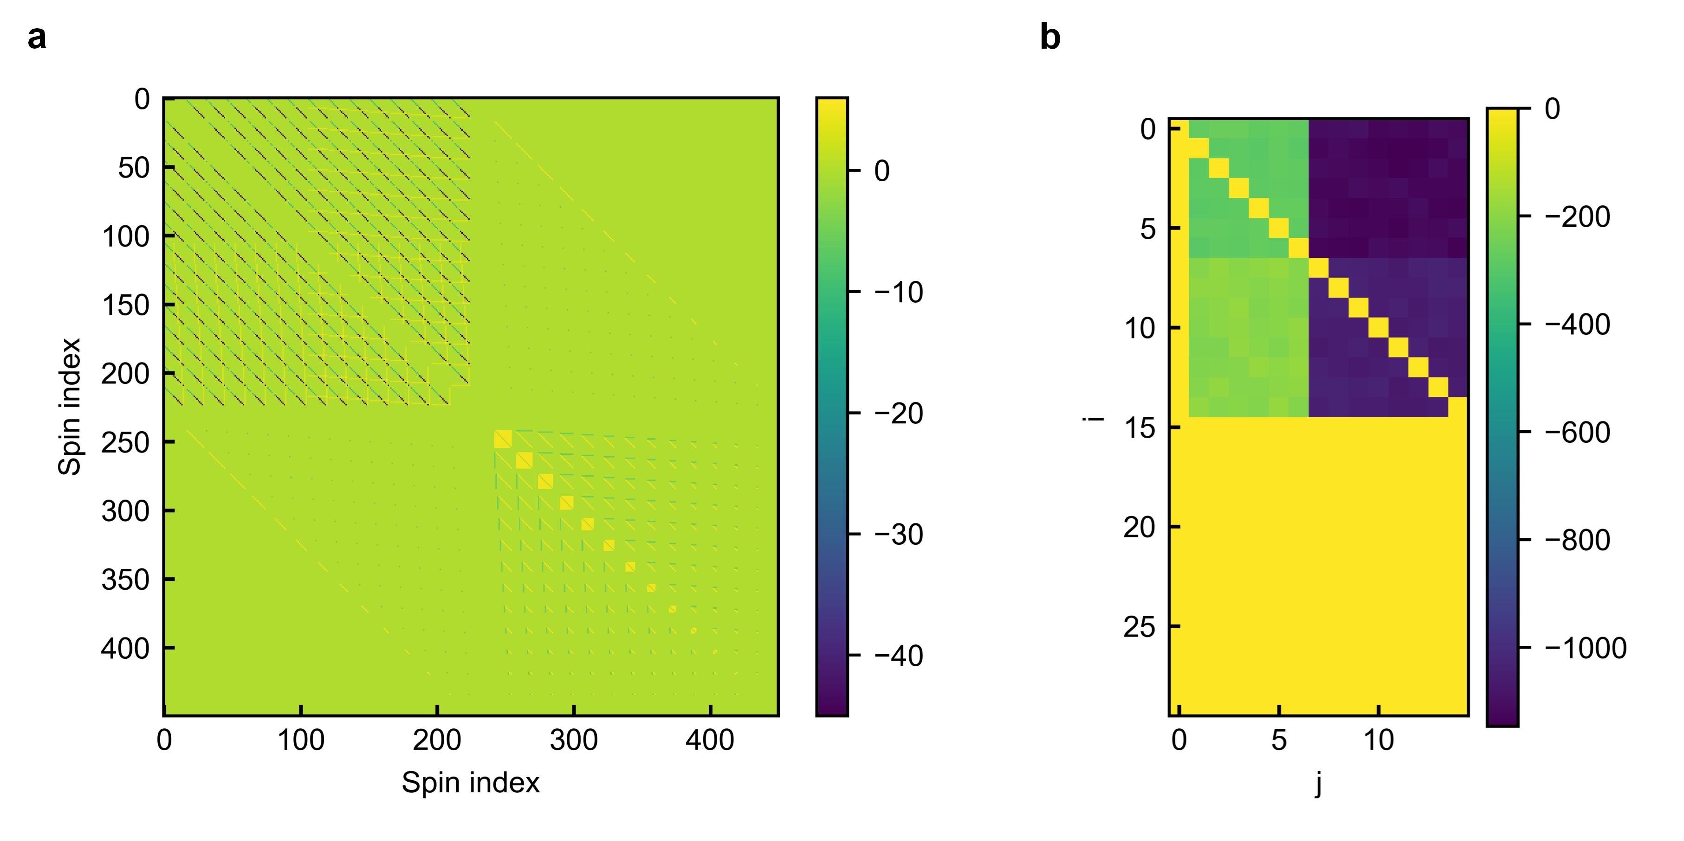
Supplementary Figure 5. Ising mapping results of a global routing problem. a, Heatmap of the coupling matrix $J$, visualized in a 2D representation after dimensionality reduction from the original 4D space for enhanced interpretability. b, Heatmap of the external field $h$, illustrating the local bias terms in the Ising model.

Supplementary Note 5 Impact of Penalty Coefficients on Global Routing Solution Probability
The selection of appropriate penalty coefficients is crucial for solving COPs using an Ising machine. In the context of the global routing problem, insufficient penalty values fail to enforce the necessary constraints for valid Steiner tree construction, while excessively large values hinder the optimization of the total cost. Supplementary Figure 6 (the same as the Extended Data Fig. 3) illustrates how the solution probability varies with different configurations of the four penalty coefficients ($λ_{1}\sim λ_{4}$).
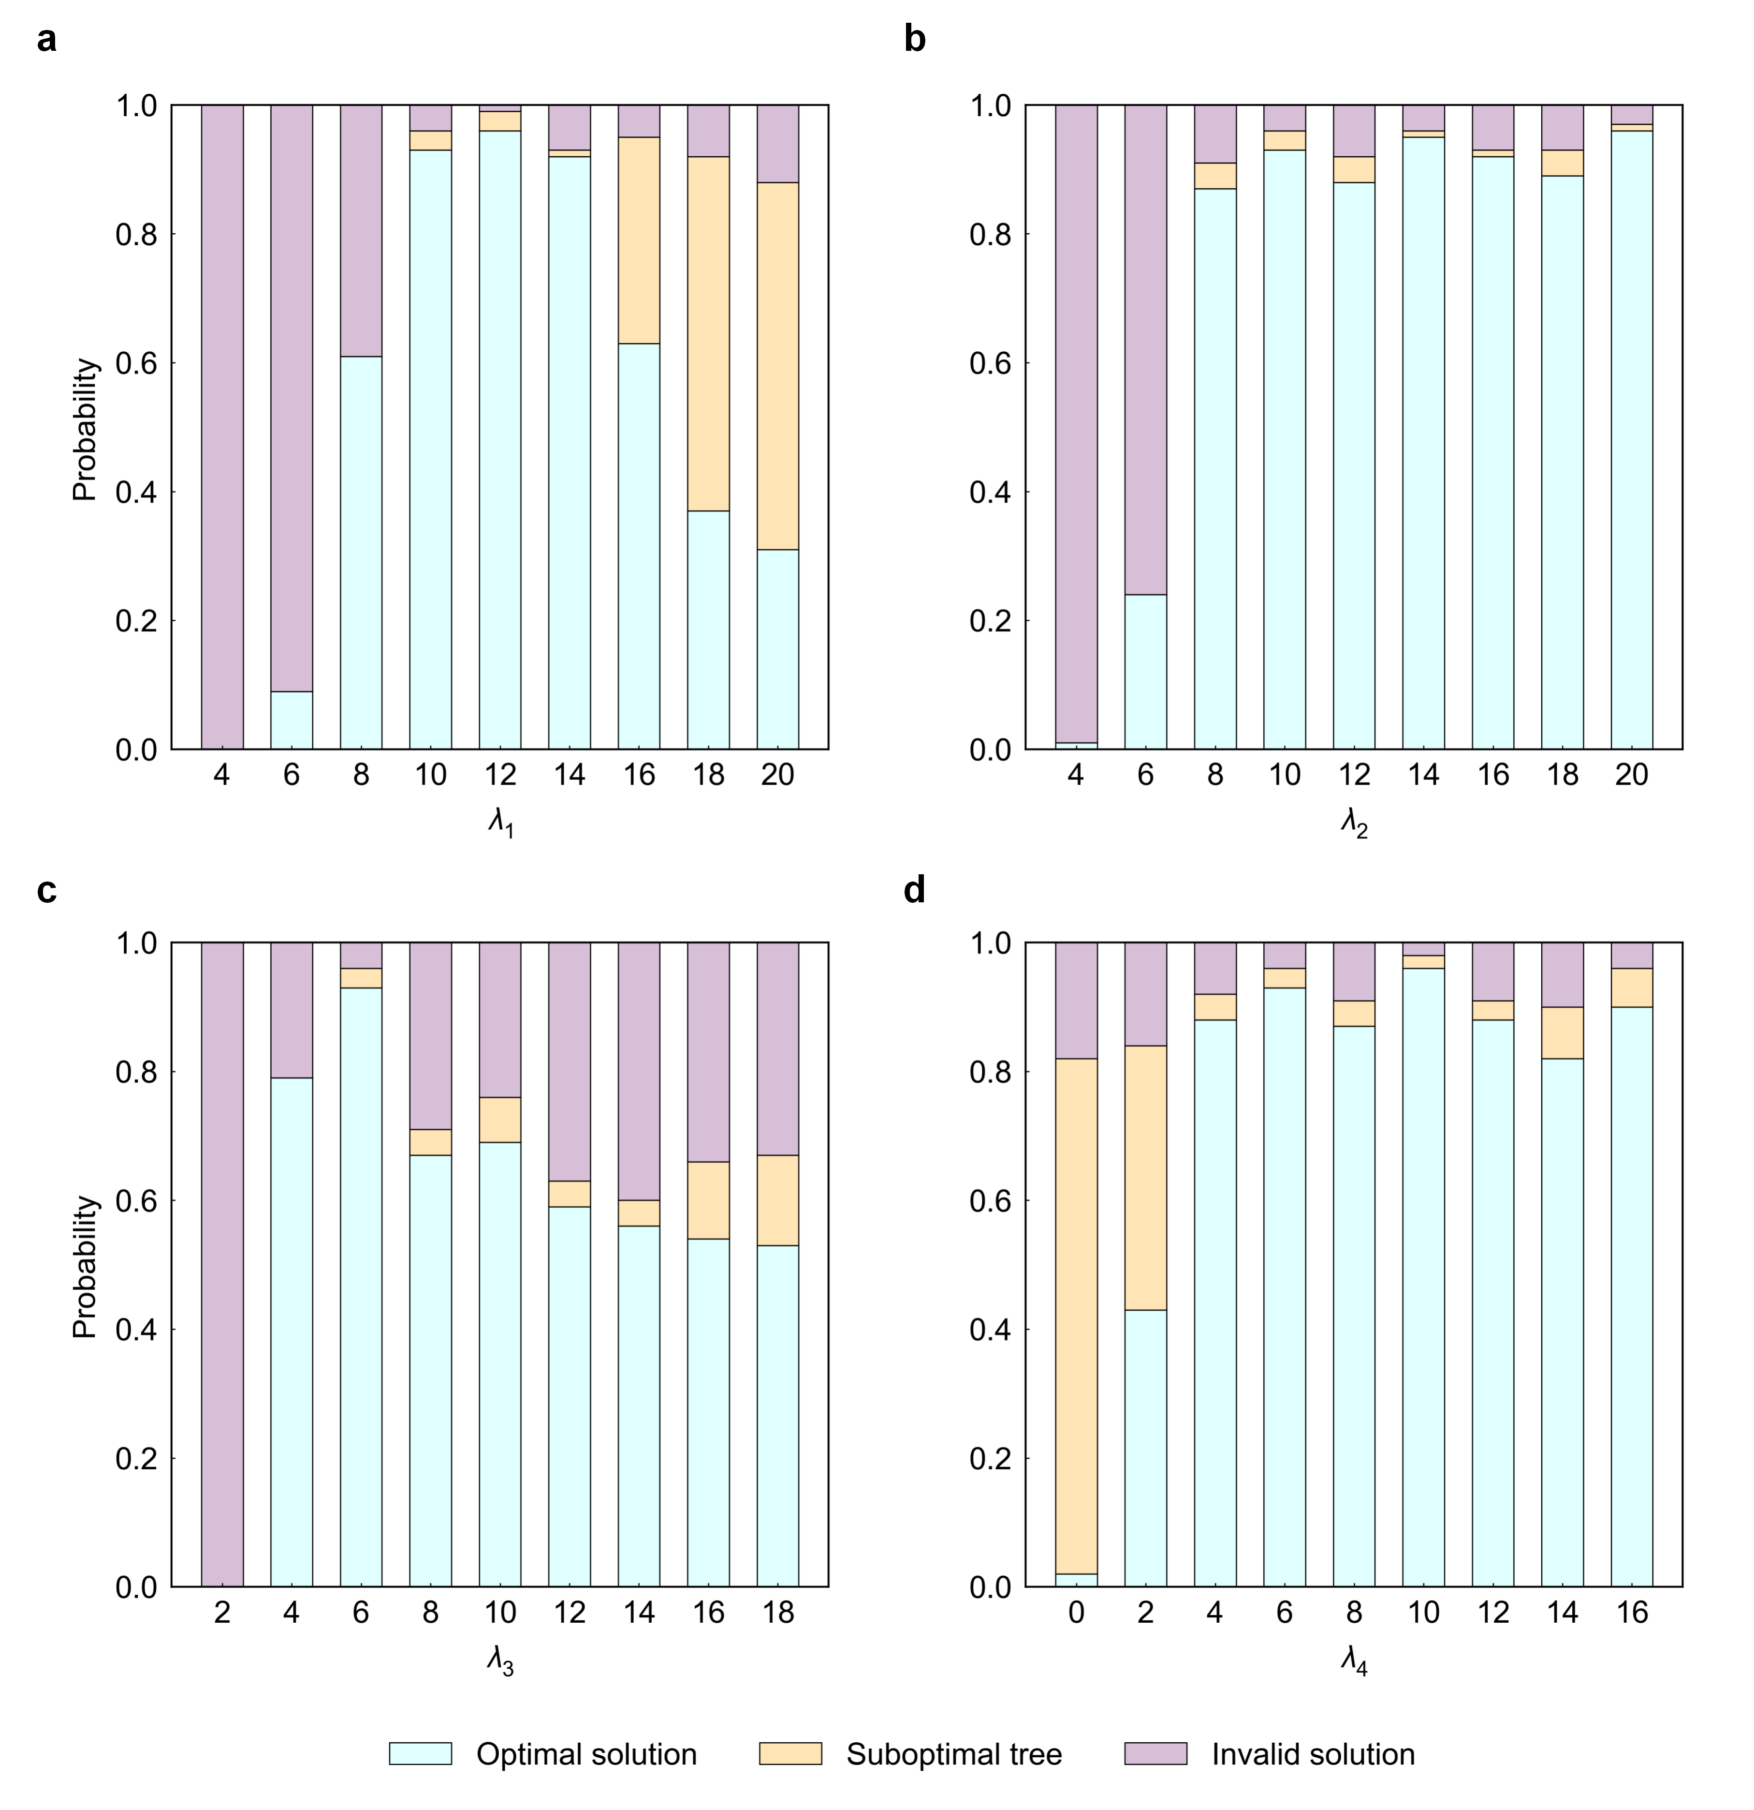
Supplementary Figure 6. Solution probability of global routing problem varying with penalty coefficient settings. The initial configuration is $λ_{1}=λ_{2}=10$ and $λ_{3}=λ_{4}=6$. In panels a, b, c, and d, only one of these coefficients is varied while the others remain fixed.

For $λ_{1}$, which controls the constraint on the number of incoming arcs at terminal vertices, a value that is too small results in invalid solutions due to the failure to form a proper tree structure (Supplementary Figure 6a). Conversely, an excessively large $λ_{1}$ creates a conflict between minimizing the total cost and satisfying the constraint, limiting the exploration of better solutions.
$λ_{2}$, associated with enforcing acyclicity, exhibits a similar behavior to $λ_{1}$: a value that is too small leads to invalid solutions by failing to guarantee the tree structure (Supplementary Figure 6b). However, unlike $λ_{1}$, increasing $λ_{2}$ does not reduce the solution probability, as minimizing the total cost and satisfying the acyclicity constraint are not inherently conflicting objectives.
$λ_{3}$ penalizes unreasonable arcs at Steiner vertices. As with $λ_{1}$ and $λ_{2}$, a value that is too small results in invalid solutions (Supplementary Figure 6c). Additionally, an excessively large $λ_{3}$ diminishes the relative importance of $λ_{1}$ and $λ_{2}$, increasing the likelihood of failing to form a valid tree.
Finally, $λ_{4}$ enforces the rectilinearity constraint specific to routing scenarios. Supplementary Figure 6d highlights the importance of $λ_{4}$: a value that is too small leads to suboptimal tree solutions. Increasing $λ_{4}$ does not reduce the solution probability, as the rectilinearity constraint neither conflicts with minimizing the total cost nor with satisfying the other constraints.

Supplementary Note 6 Ising Mapping of Layer Assignment Problem
When both reducing wire density and minimizing the usage of vias are considered, the layer assignment problem becomes a multi-objective optimization problem. The total Hamiltonian for the DVLA problem can be expressed as
$$H_{DVLA}=λ_{D}H_{D}+λ_{V}H_{V}$$
where $H_{D}$ and $H_{V}$ represent the density-driven and via-aware contributions to the overall objective, respectively. The coefficients $λ_{D}$ and $λ_{V}$ denote the relative importance of each component in the optimization process.
Let Ising spin variables $s=[s^{h} s^{v}]$ directly encode the layer assignment for each segment. The density-driven term $H_{D}$ is expressed as¹:
$$H_{D}=\frac{1}{2}\sum_{0≤i<j<N_{h}}{w_{i,j}^{h}(s_{i}^{h}s_{j}^{h}−1)}+\frac{1}{2}\sum_{0≤m<n<N_{v}}{w_{m,n}^{v}(s_{m}^{v}s_{n}^{v}−1)}$$
where $N_{h}$ and $N_{v}$ denote the numbers of horizontal and vertical segments, respectively, and $w^{h}$ and $w^{v}$ denote local density matrices of horizontal and vertical segments, respectively. In the case of $H_{V}$, vias are used when a horizontal segment and a vertical one need to be connected, or when a segment must reach a pin (assuming that all pins are located on $L_{0}$). The via-aware term $H_{V}$ can be expressed as:
$$H_{V}=\sum_{\begin{aligned}0≤i<N_{h}, \\ 0≤m<N_{v}\end{aligned}}{c_{i,m}[3(\frac{s_{m}^{v}+1}{2}−\frac{s_{i}^{h}+1}{2}∙\frac{s_{m}^{v}+1}{2})+(\frac{s_{i}^{h}+1}{2})+(\frac{{−s}_{i}^{h}+1}{2}∙\frac{{−s}_{m}^{v}+1}{2})]}+\sum_{0≤i<N_{h}}{p_{i}^{h}(s_{i}^{h}+2)}+\sum_{0≤m<N_{v}}{p_{m}^{v}(s_{m}^{v}+3)}$$
where $c_{i,m}$ indicates whether the $i$-th horizontal segment and the $m$-th vertical segment are connected, and $p_{i}^{h}/p_{m}^{v}$ denote the flag indicating if a segment must reach a pin. The first term of $H_{V}$ addresses all scenarios where a horizontal segment and a vertical segment require connection. Three vias are necessary only when the horizontal segment is on layer $L_{1}$ and the vertical segment is on layer $L_{4}$; in all other cases, only one via is required. The second and third terms of $H_{V}$ cover situations where a segment needs to connect to a pin. For horizontal segments, the number of vias needed is $s_{i}^{h}+2$; while for vertical segments, the number of vias needed is $s_{m}^{v}+3$.
The Ising Hamiltonian can be written as
$$H_{Ising}=−\sum_{i,j}{J_{i,j}s_{i}s_{j}}−\sum_{i}{h_{i}s_{i}}$$
By comparing the Ising Hamiltonian with $H_{DVLA}$, the expressions for $J$ and $h$ can be derived as follows:
$$J_{i,j}=\left\{\begin{aligned}−\frac{λ_{D}}{2}w_{i,j}^{h} , 0≤i<j<N_{h} \\ −\frac{λ_{D}}{2}w_{i−N_{h},j−N_{h}}^{v} , N_{h}≤i<j<N_{h}+N_{v} \\ \frac{λ_{V}}{2}c_{i,j−N_{h}} , 0≤i<N_{h} and N_{h}≤j<N_{h}+N_{v} \\ 0 , others\end{aligned}\right.$$
$$h_{i}=\left\{\begin{aligned}λ_{V}(−p_{i}^{h}+\frac{1}{2}\sum_{N_{h}≤j<N_{h}+N_{v}}{c_{i,j−N_{h}}}) , 0≤i<N_{h} \\ λ_{V}({−p}_{i}^{v}−\frac{1}{2}\sum_{0≤j<N_{h}}{c_{j,i−N_{h}}}) , N_{h}≤i<N_{h}+N_{v} \\ 0 , others\end{aligned}\right.$$
The matrix $J$ obtained above is an upper triangular matrix, and it needs to be symmetrized to obtain the final $J$. The Ising mapping results corresponding to the DVLA problem in Fig. 5a (main text) is demonstrated in Supplementary Figure 7.
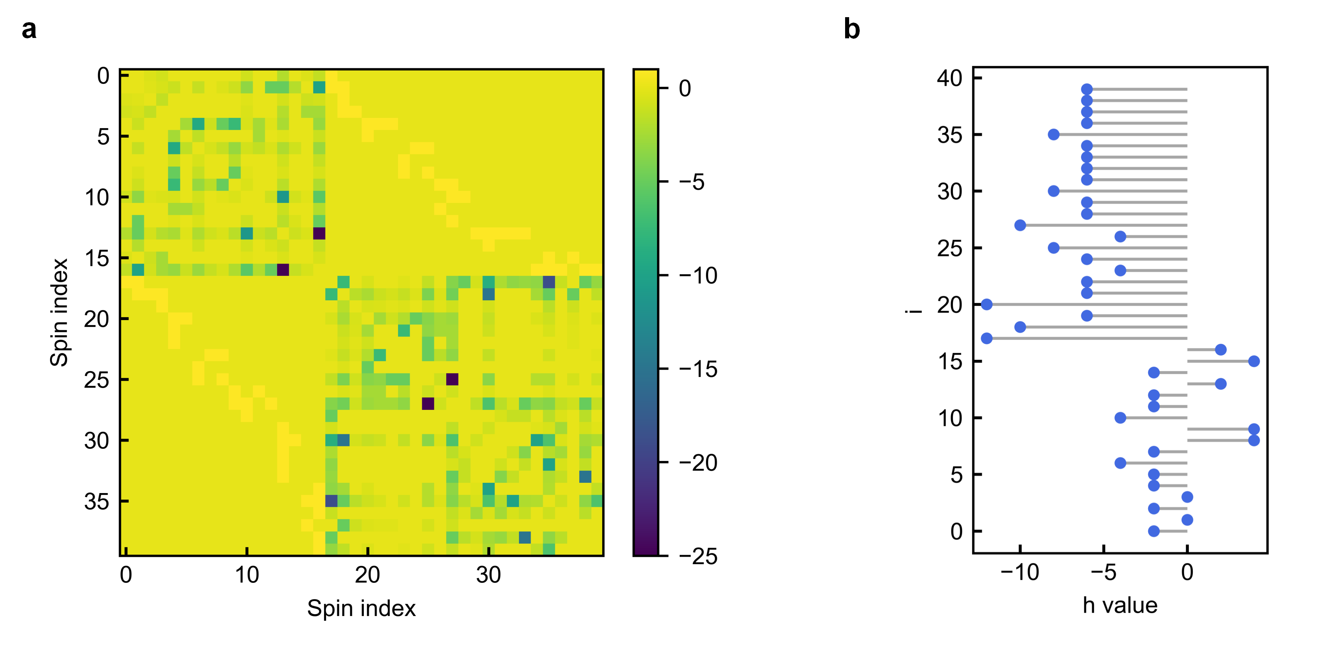
Supplementary Figure 7. Ising mapping results of a DVLA problem. a, Heatmap of the coupling matrix $J$. b, Stem plot of the external field $h$.

Supplementary Note 7 Speed, and Energy Estimation of Ising spin Implemented by CPU and GPU
We implemented the Ising spins using Python and leveraged various Python libraries to measure the runtime and power consumption of the Ising spin update on both CPU and GPU platforms. In this work, the CPU is Intel Xeon Platinum 8352V 12v@2.1 GHz, and the GPU is NVIDIA GeForce RTX 4090.
- CPU:
- The Ising spin node update code was executed 10³ times, and the runtime was recorded using the timeit library, yielding an average time of 13 μs.
- During this process, the CPU utilization was measured as 1.7% using the psutil library.
- Given the CPU's Thermal Design Power (TDP) of approximately 195 W, the energy consumption of one single spin update is estimated as: 195 W × 1.7% × 13 μs = 43 μJ.
- GPU:
- The GPU execution was facilitated using PyTorch. The Ising spin node update code was executed 10³ times, and the runtime was recorded using the timeit library, yielding an average time of 48 μs.
- The average GPU power consumption during this period was measured as 12 W using the subprocess library.
- The energy consumption is estimated as: 12 W × 48 μs = 576 μJ.

Supplementary Note 8 Speed, Area and Energy Estimation of Ising spin Implemented by FPGA
As shown in Supplementary Figure 8, we utilize a 16-bit LFSR, an 5-bit-input/16-bit-output sigmoid look-up table and a 16-bit digital comparator to implement a Ising spin in the FPGA. To ensure a fair comparison, a 5-bit input sigmoid look-up table is used, considering the MTJ switching probability curve is fitted with around 30 data points.
The FPGA employed in this work is the programmable logic portion of the Zynq-7000, fabricated using a 28 nm process. The implementation results in terms of timing, resource utilization, and power consumption are presented in Supplementary Table 2. The speed, area, and energy consumption of the FPGA-based Ising spin are estimated as follows:
- Speed: The critical path delay is calculated as 5.683 ns × 2 ≈ 11 ns.
- Area:
- The BRAM is used to store discrete values on the sigmoid curve. In this experiment, an 5-bit input and 16-bit output sigmoid look-up table is employed, assuming each storage unit is a 6-transistor SRAM.
- The flip-flops (FFs) are assumed to be edge-triggered D flip-flops, each composed of 16 transistors.
- The look-up tables (LUTs) are assumed to be 4-input and 8-bit wide, with each bit implemented as a 6-transistor SRAM.
Therefore, the total transistor count is calculated as:
2⁵×16×6+20×16+78×4×8×6=18368
- Energy consumption: The energy consumption is estimated as 11 ns × 540 μW = 5.94 pJ.
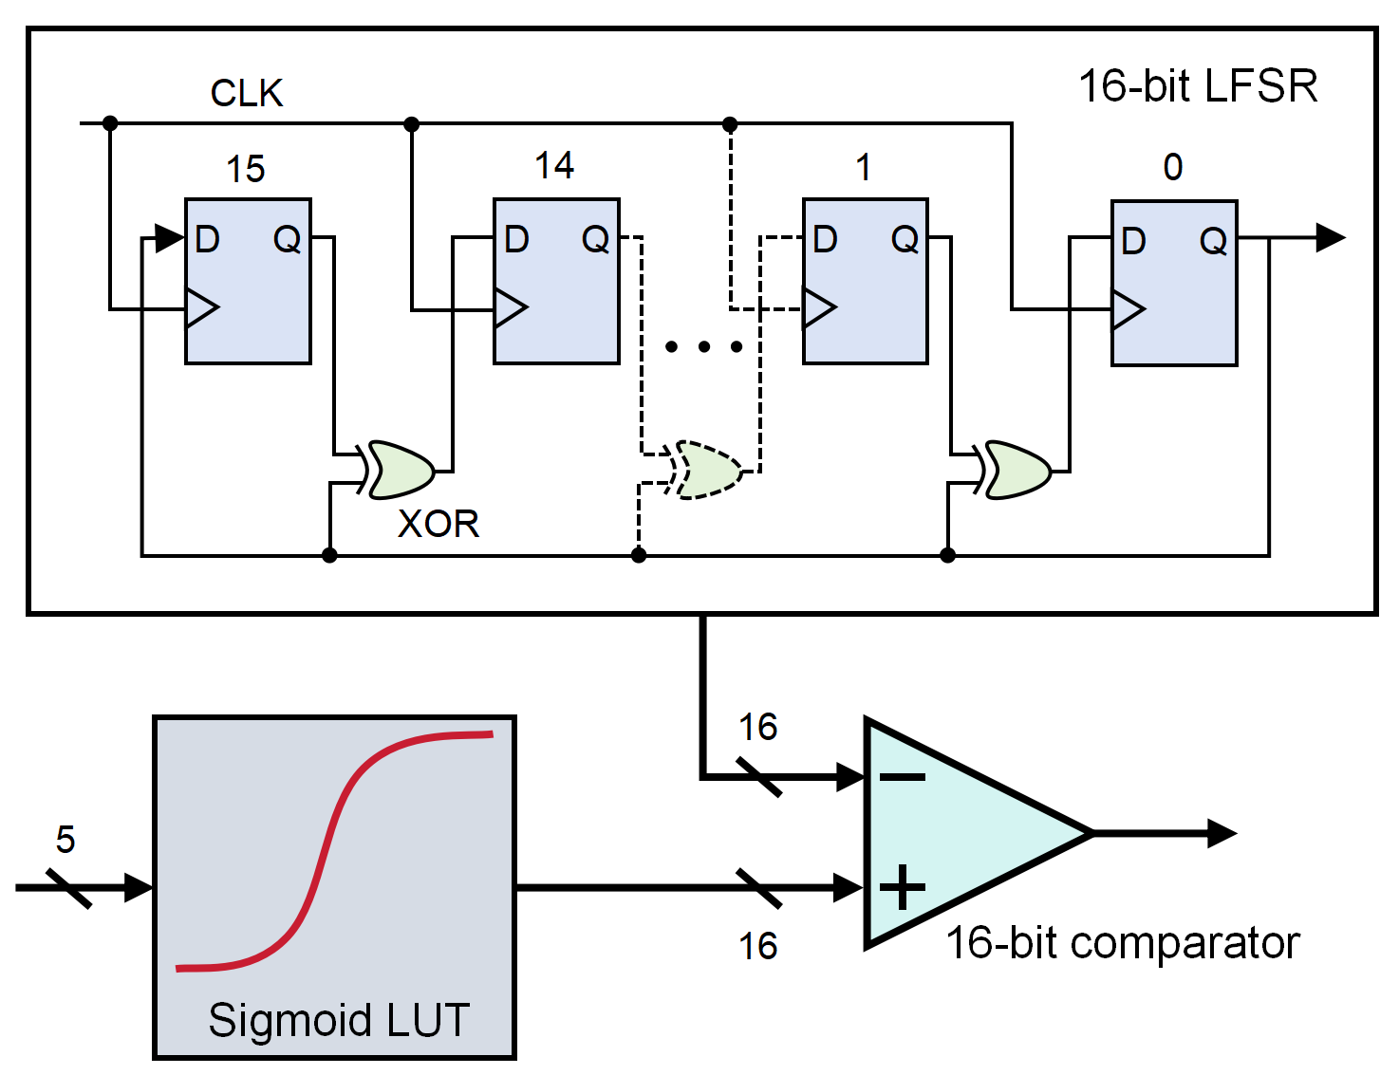
Supplementary Figure 8. FPGA implementation of Ising spin. A 16-bit LFSR generates random numbers, which are compared with the output of a sigmoid LUT to emulate the sigmoidal probabilistic behavior of Ising spin.

Timing |  | Utilization |  |  | Power
Estimated clock | Max clock cycles | BRAM | FF | LUT | Power
5.683 ns | 2 | 1 | 20 | 78 | 540 μW
Supplementary Table 2. Timing, utilization, and power reports of Ising spin implemented by FPGA.

Supplementary Note 9 Speed, Area and Energy Estimation of Ising spin Implemented by VCMA-MTJ
The VCMA-MTJ-based Ising spin, illustrated in Supplementary Figure 9, comprises a VCMA-MTJ, four transistors for R/W control, a reference resistor, and an inverter (INV).
Its performance metrics are estimated as follows:
- Speed: Leveraging the sub-nanosecond probabilistic switching characteristic of the VCMA-MTJ, the delay is maximally evaluated to be as the 1 ns.
- Area: The transistor count includes 4 from the R/W control and 2 from the INV, resulting in a total of 6 transistors.
- Energy consumption: Given the resistance range of VCMA-MTJs is 80–150 kΩ, a median value of 100 kΩ is used for energy estimation. With a write pulse configuration of 2.0 V and a maximum duration of 1 ns, the energy consumption is calculated as: (2.0 V)² / 100 kΩ × 1 ns = 40 fJ.
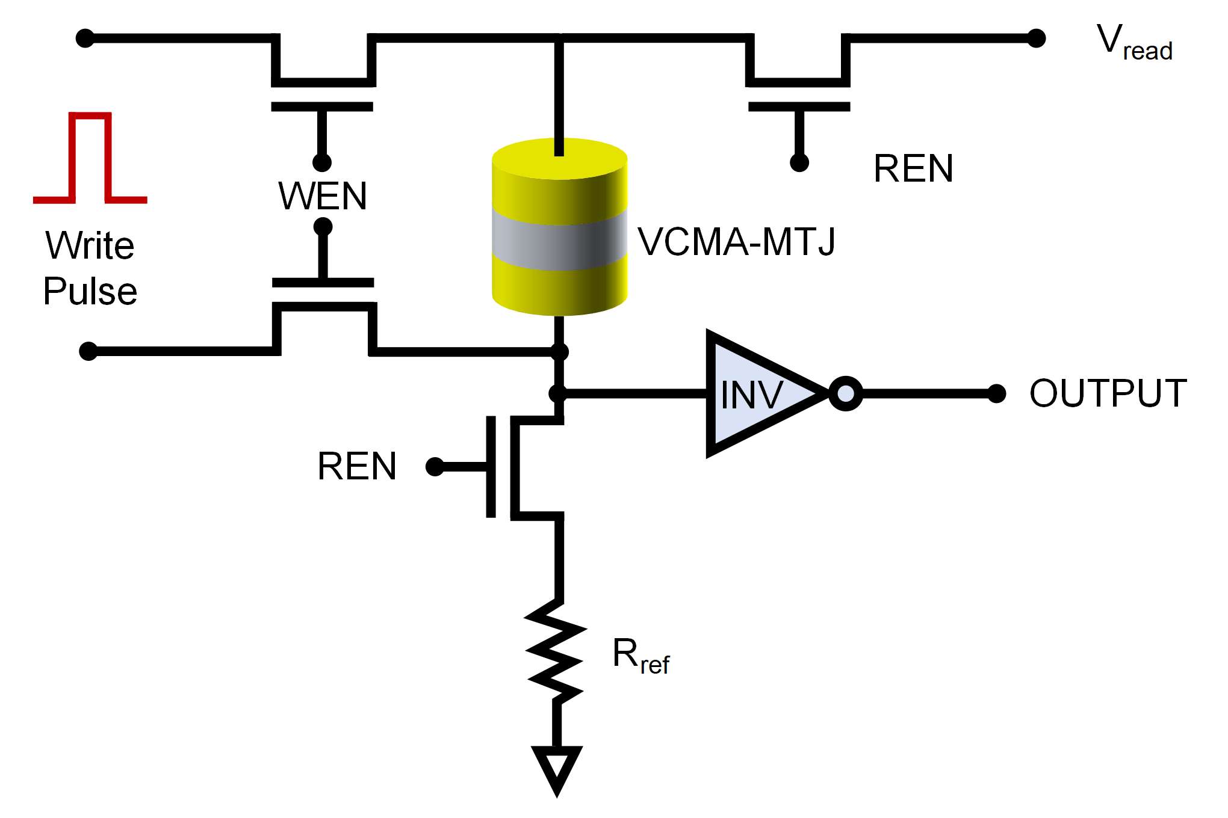
Supplementary Figure 9. VCMA-MTJ-based implementation of Ising spin. By leveraging the intrinsic stochasticity of the VCMA-MTJ, a compact Ising spin is realized. The ultra-fast writing capability of VCMA-MTJ ensures high efficiency in Ising computing.

Supplementary Note 10 Performance Comparison with State-of-the-Art Ising Machines
In Table 1 (main text), we present a compilation of representative cutting-edge Ising machines, with metrics related to Ising spin, system implementation, and applications extracted from the literature. To facilitate a fair comparison, their systematic performance is normalized to a system of 100 Ising spins executing 10,000 iterations, assuming that the time to solution scales linearly with the number of nodes and iterations².
The time for single spin update of these Ising machines is calculated as follows:
- GPU: The GPU (NVIDIA GeForce RTX 4090) consumes 1.31 s for an 800-node Max-cut problem with 512 replicas³, so the time for single spin update is estimated as 1.31 s / 800 / 512 = 3.2 μs.
- QPU: The annealing time of single spin is estimated as 7 ns⁴.
- CIM: A cavity round-trip time of 5 μs in the experiment⁵ can be considered as the single spin update time.
- PTNO: The 8-node proof-of-concept system requires 3.7 ms for 250 cycles⁶, so the time for single spin update is estimated as 3.7 ms / 8 / 250 = 1.85 μs.
- SOT-MTJ: The retention time of SOT-MTJs is evaluated as 4 μs experimentally⁷, which limits the speed of single spin update and can be estimated as the spin update time.
- SMTJ: The retention time of SMTJs is evaluated as 100 μs².
- V-MTJ: Voltage pulses with a duration of 10 ns are applied to V-MTJs to generate 50%/50% random bits⁸. Sixteen such random bits are combined to function as a single probabilistic bit (Ising spin), resulting in an estimated single-spin update time of 160 ns.
- VSIM: By harnessing the intrinsic stochasticity of VCMA-MTJ, the VSIM achieves single Ising spin update in just 1 ns.
These data enable the derivation of energy efficiency based on its definition: 1 / time to solution / system power, where the time to solution is calculated as 10⁶ times the spin update time. Furthermore, the energy consumption for spin updates across some implementations is quantified as follows:
- GPU: As presented in Supplementary Note 7, the power consumption of GPU-based Ising spin is estimated as 12 W, so the energy consumption per spin update calculates to 3.2 μs × 12 W = 38 μJ.
- PTNO: An average power dissipation of 25.5 μW per spin is evaluated for PTNO-based Ising machine⁶.The corresponding energy consumption is calculated as 1.85 μs × 25.5 μW = 47 pJ.
- SOT-MTJ: Experimental measurements⁷ indicate that driving a SOT-MTJ-based Ising spin requires a maximum current of 450 μA. With the SOT electrode resistance estimated at 1 kΩ, the energy consumption amounts to (450 μA)² × 1 kΩ × 4 μs = 810 pJ.
- SMTJ: For SMTJ-based Ising spins, experimental data² shows a maximum driving current of 5 μA. Given the estimated SMTJ resistance of 20 kΩ, the energy consumption equals (5 μA)² × 20 kΩ × 100 μs = 50 pJ.
- V-MTJ: Experimental measurements indicate that voltage pulses of 1.8 V are used to drive the V-MTJs during random bit generation⁸. The average device resistance is measured to be 110 kΩ. The energy consumption for single spin update can be calculated as (1.8 V)² / 110 kΩ × 160 ns = 4.7 pJ.
- VSIM: As demonstrated in Supplementary Note 9, the VCMA-MTJ-based Ising spin consumes 40 fJ per update.

References
1. Jun-Dong Cho, Raje, S. & Sarrafzadeh, M. Fast approximation algorithms on maxcut, k-coloring, and k-color ordering for VLSI applications. IEEE Trans. Comput. 47, 1253–1266 (1998).
2. Si, J. et al. Energy-efficient superparamagnetic Ising machine and its application to traveling salesman problems. Nat. Commun. 15, 3457 (2024).
3. Huang, K.-P., Nien, C.-F., Zhang, Y.-T., Lee, C.-K. & Wang, Y.-C. GPU-based Ising Machine for Solving Combinatorial Optimization Problems with Enhanced Parallel Tempering Techniques. in 2024 IEEE Asia Pacific Conference on Circuits and Systems (APCCAS) 636–640 (2024). doi:10.1109/APCCAS62602.2024.10808341.
4. King, A. D. et al. Beyond-classical computation in quantum simulation. Science 388, 199–204 (2025).
5. Inagaki, T. et al. A coherent Ising machine for 2000-node optimization problems. Science 354, 603–606 (2016).
6. Dutta, S. et al. An Ising Hamiltonian solver based on coupled stochastic phase-transition nano-oscillators. Nat. Electron. 4, 502–512 (2021).
7. Yin, J. et al. Scalable Ising Computer Based on Ultra-Fast Field-Free Spin Orbit Torque Stochastic Device with Extreme 1-Bit Quantization. in 2022 International Electron Devices Meeting (IEDM) 36.1.1-36.1.4 (IEEE, San Francisco, CA, USA, 2022). doi:10.1109/IEDM45625.2022.10019520.
8. Duffee, C. et al. An integrated-circuit-based probabilistic computer that uses voltage-controlled magnetic tunnel junctions as its entropy source. Nat. Electron. 8, 784–793 (2025).

