Additional file 1
Contents
Tables
Table 1：The prevalence of cardiovascular diseases in different regions from 1990 to 2021

Table 2：The death of cardiovascular diseases in different regions from 1990 to 2021

Table 3：The DALY of cardiovascular diseases in different regions from 1990 to 2021

Table 4：Cardiovascular disease mortality attributable to a diet low in vegetables in 204 countries from 1990 to 2021

Table 5：Cardiovascular disease DALY attributable to a diet low in vegetables in 204 countries from 1990 to 2021

Table 6：Cardiovascular disease mortality attributable to a diet low in vegetables by region from1990 to 2021

Table 7：Cardiovascular disease DALY attributable to a diet low in vegetables by region from1990 to 2021

Table 8：Cardiovascular disease mortality attributable to a diet low in vegetables among males by region from1990 to 2021

Table 9：Cardiovascular disease mortality attributable to a diet low in vegetables among females by region from1990 to 2021

Table 10：Cardiovascular disease DALY attributable to a diet low in vegetables among males by region from1990 to 2021

Table 11：Cardiovascular disease DALY attributable to a diet low in vegetables among females by region from1990 to 2021

Table 12：Stroke mortality attributable to a diet low in vegetables from 1990 to 2021

Table 13：Stroke DALY attributable to a diet low in vegetables from 1990 to 2021

Table 14：Ischemic heart disease mortality attributable to a diet low in vegetables from 1990 to 2021

Table 15：Ischemic heart disease DALY attributable to a diet low in vegetables from 1990 to 2021

Table 16：Lower extremity peripheral arterial disease mortality attributable to a diet low in vegetables from 1990 to 2021

Table 17：Lower extremity peripheral arterial disease DALY attributable to a diet low in vegetables from 1990 to 2021

Table 18：Hypertensive heart disease mortality attributable to a diet low in vegetables from 1990 to 2021

Table 19：Hypertensive heart disease DALY attributable to a diet low in vegetables from 1990 to 2021

Table 20：Aortic aneurysm mortality attributable to a diet low in vegetables from 1990 to 2021

Table 21：Aortic aneurysm DALY attributable to a diet low in vegetables from 1990 to 2021

Figures
Fig 1：Global cardiovascular disease attributable to a diet low in vegetables across 204 countries from 1990 to 2021

Fig 2：Cardiovascular disease attributable to a diet low in vegetables in age groups 20-54 and ≥55 years from 1990 to 2021

Fig 3：Cardiovascular disease attributable to a diet low in vegetables by SDI region from 1990 to 2021

Fig 4：Sex- and age-specific cardiovascular disease attributable to a diet low in vegetables globally in 1990 and 2021

Fig 5：Disease-specific death attributable to a diet low in vegetables by age and sex globally in 1990 and 2021

Fig 6：Disease-specific DALY attributable to a diet low in vegetables by age and sex globally in 1990 and 2021

Fig 7：Proportion of disease-specific death attributable to a diet low in vegetables by age group in 1990 and 2021

Fig 8：Proportion of disease-specific DALY attributable to a diet low in vegetables by age group in 1990 and 2021

Fig 9：Projected cardiovascular disease death number attributable to a diet low in vegetables by gender and age from 1990 to 2035

Fig 10：Projected cardiovascular disease death rate attributable to a diet low in vegetables by gender and age from 1990 to 2035

Fig 11：Projected cardiovascular disease mortality attributable to a diet low in vegetables by gender from 1990 to 2035
Table 1：The prevalence of cardiovascular diseases in different regions from 1990 to 2021
 | Number |  | PC | EAPC | Rate |  | PC | EAPC
location | 1990 | 2021 | 1990-2021 | 1990-2021 | 1990 | 2021 | 1990-2021 | 1990-2021
Global | 289550232.015(270659430.742-305371954.415) | 612059321.647(570319527.808-649806888.829) | 1.114(1.076-1.155) | 2.47(2.43,2.51) | 7116.054(6668.139-7482.018) | 7178.733(6696.148-7620.665) | 0.009(-0.006-0.027) | 0.02(0.01,0.04)
High SDI | 80350937.300(75748386.024-84752974.203) | 133551149.040(126027517.283-140825639.715) | 0.662(0.633-0.695) | 1.69(1.64,1.73) | 7388.754(6965.966-7804.624) | 6836.321(6438.054-7220.736) | -0.075(-0.092--0.057) | -0.25(-0.28,-0.22)
High-middle SDI | 68300358.051(64116408.408-72025763.905) | 133708687.057(124693476.868-142382206.808) | 0.958(0.918-1.005) | 2.16(2.14,2.18) | 6935.642(6522.156-7306.951) | 6954.119(6495.440-7391.037) | 0.003(-0.015-0.023) | -0.02(-0.03,-0.01)
Middle SDI | 73298818.233(68008828.315-78175040.511) | 185282136.830(171839333.555-198562375.146) | 1.528(1.451-1.609) | 3.08(3.04,3.13) | 6542.859(6111.065-6940.131) | 6986.960(6485.001-7482.171) | 0.068(0.050-0.092) | 0.23(0.21,0.24)
Low-middle SDI | 47591969.912(43957411.029-50984382.656) | 112606600.634(103904686.288-121313123.750) | 1.366(1.321-1.416) | 2.86(2.82,2.90) | 7146.525(6639.190-7633.037) | 7483.441(6931.032-8031.083) | 0.047(0.030-0.067) | 0.15(0.13,0.16)
Low SDI | 19679418.287(17970583.969-21263619.453) | 46376620.801(42181464.451-50391541.882) | 1.357(1.324-1.393) | 2.84(2.78,2.90) | 7377.858(6820.856-7894.999) | 7428.515(6862.970-7975.736) | 0.007(-0.009-0.025) | 0.00(-0.01,0.02)
African Union | 27860909.399(25638654.787-30044558.379) | 66238229.909(60649672.647-71567859.070) | 1.377(1.343-1.411) | 2.80(2.75,2.85) | 8198.001(7616.143-8749.951) | 8340.847(7749.078-8905.869) | 0.017(0.003-0.031) | 0.03(0.02,0.04)
Association of Southeast Asian Nations | 14821736.814(13946295.533-15594615.517) | 36779815.418(34356620.380-38839322.612) | 1.481(1.440-1.525) | 2.97(2.95,2.99) | 5683.043(5364.183-5981.328) | 5824.510(5454.282-6144.919) | 0.025(0.014-0.036) | 0.09(0.08,0.11)
Central Europe, Eastern Europe, and Central Asia | 35513064.278(33287160.191-37622424.246) | 49198853.353(45770456.436-52329324.616) | 0.385(0.360-0.413) | 1.00(0.96,1.04) | 7642.905(7170.634-8081.094) | 7787.854(7273.936-8269.029) | 0.019(0.003-0.037) | 0.03(0.01,0.04)
Commonwealth | 66612636.881(61306446.588-71658283.731) | 158689621.446(145594251.049-171595003.645) | 1.382(1.329-1.444) | 2.90(2.85,2.95) | 7237.248(6710.811-7746.911) | 7428.430(6818.211-8025.886) | 0.026(0.005-0.051) | 0.08(0.07,0.10)
European Union | 43723248.786(41294760.064-46069071.605) | 62126816.710(58257881.456-65589523.189) | 0.421(0.391-0.453) | 1.20(1.18,1.22) | 7459.872(7040.077-7856.548) | 6926.869(6478.488-7353.033) | -0.071(-0.093--0.050) | -0.22(-0.25,-0.20)
Four World Regions | 288975038.647(270104186.450-304771123.764) | 611023985.276(569338675.638-648727234.344) | 1.114(1.077-1.156) | 2.47(2.43,2.51) | 7116.496(6668.432-7482.430) | 7178.807(6696.004-7621.018) | 0.009(-0.006-0.027) | 0.02(0.01,0.04)
G20 | 215446247.091(201057856.081-227036396.672) | 441636085.467(410561607.411-471635598.317) | 1.050(1.005-1.100) | 2.37(2.33,2.41) | 6999.646(6561.380-7373.550) | 6945.603(6465.959-7413.650) | -0.008(-0.025-0.013) | -0.03(-0.04,-0.01)
Gulf Cooperation Council | 821422.986(781671.367-864825.151) | 3752857.802(3491404.142-4034722.785) | 3.569(3.412-3.743) | 5.02(4.88,5.16) | 9128.727(8716.962-9574.837) | 10166.266(9585.840-10768.837) | 0.114(0.084-0.144) | 0.41(0.37,0.45)
Health System Grouping Levels | 289221501.782(270345036.214-305029118.803) | 611525194.362(569812247.874-649245662.877) | 1.114(1.076-1.156) | 2.47(2.43,2.51) | 7115.779(6667.863-7481.750) | 7178.714(6696.015-7620.743) | 0.009(-0.006-0.027) | 0.02(0.01,0.04)
High-income | 85585556.309(80658404.988-90269836.923) | 136630901.548(128735913.175-144278122.554) | 0.596(0.564-0.632) | 1.55(1.51,1.58) | 7293.799(6879.927-7690.145) | 6759.416(6358.808-7164.756) | -0.073(-0.093--0.050) | -0.25(-0.28,-0.22)
Latin America and Caribbean | 16767893.895(15594879.531-17859752.101) | 41500760.395(38467779.399-44295316.699) | 1.475(1.405-1.556) | 3.01(2.99,3.03) | 6658.044(6213.636-7013.378) | 6702.978(6217.104-7146.567) | 0.007(-0.011-0.026) | 0.02(-0.02,0.05)
League of Arab States | 11168809.866(10631251.886-11729395.880) | 30848342.618(29031306.043-32632936.943) | 1.762(1.687-1.833) | 3.34(3.30,3.38) | 9621.481(9169.040-10040.675) | 10107.445(9573.420-10651.358) | 0.051(0.027-0.074) | 0.17(0.15,0.18)
Nordic Region | 2600335.040(2445915.167-2747198.999) | 3532355.761(3319547.956-3746073.193) | 0.358(0.330-0.389) | 0.96(0.86,1.07) | 7212.821(6769.477-7642.695) | 6567.387(6134.670-6983.892) | -0.089(-0.108--0.068) | -0.33(-0.37,-0.29)
North Africa and Middle East | 17770572.732(16906660.546-18654829.365) | 47397897.469(44551821.184-50454610.291) | 1.667(1.602-1.736) | 3.21(3.18,3.24) | 9660.056(9201.263-10122.836) | 9882.648(9335.514-10467.459) | 0.023(-0.000-0.045) | 0.06(0.05,0.07)
OECD Countries | 97600020.196(92056905.101-102779893.761) | 160902672.853(151417823.059-169661613.473) | 0.649(0.619-0.683) | 1.65(1.61,1.68) | 7382.269(6960.889-7781.222) | 6818.741(6400.068-7198.706) | -0.076(-0.094--0.057) | -0.28(-0.31,-0.25)
Organization of Islamic Cooperation | 45493291.884(42727567.156-47900872.632) | 113583075.921(105962548.861-120985703.742) | 1.497(1.455-1.540) | 3.00(2.94,3.06) | 7998.851(7528.907-8422.439) | 8310.572(7803.109-8779.694) | 0.039(0.024-0.055) | 0.12(0.12,0.13)
Sahel Region | 6173528.664(5635156.904-6699378.758) | 15080663.757(13695564.168-16490948.014) | 1.443(1.393-1.498) | 2.90(2.82,2.99) | 8097.525(7451.381-8743.525) | 8097.413(7453.688-8751.189) | -0.000(-0.016-0.016) | -0.04(-0.05,-0.02)
South Asia | 43469224.574(39750630.774-47182806.678) | 112650044.706(102341774.960-123863264.031) | 1.591(1.522-1.675) | 3.21(3.17,3.25) | 7070.812(6479.734-7688.835) | 7419.919(6732.272-8143.327) | 0.049(0.025-0.080) | 0.16(0.15,0.17)
Southeast Asia, East Asia, and Oceania | 70059633.412(64932161.097-74326991.526) | 177226456.860(164344689.613-189986218.006) | 1.530(1.449-1.616) | 3.07(3.03,3.11) | 5946.899(5550.712-6294.315) | 6415.068(5979.576-6835.798) | 0.079(0.060-0.104) | 0.26(0.24,0.29)
Sub-Saharan Africa | 20384286.815(18471045.030-22294602.130) | 47454407.315(42792275.819-52269268.720) | 1.328(1.296-1.363) | 2.72(2.67,2.78) | 7696.374(7067.147-8319.859) | 7594.232(6994.262-8222.913) | -0.013(-0.026-0.000) | -0.08(-0.10,-0.06)
WHO region | 287913179.548(269079650.806-303662150.339) | 608320368.816(566800624.075-645906305.838) | 1.113(1.075-1.154) | 2.47(2.42,2.51) | 7118.073(6669.333-7484.451) | 7180.609(6697.319-7623.543) | 0.009(-0.006-0.027) | 0.02(0.01,0.04)
World Bank Regions | 289091819.999(270219144.463-304895287.795) | 611306211.834(569602813.770-649014635.729) | 1.115(1.077-1.156) | 2.47(2.43,2.51) | 7115.825(6667.861-7481.813) | 7178.817(6696.010-7620.936) | 0.009(-0.006-0.027) | 0.02(0.01,0.04)

Table 2：The deaths of cardiovascular diseases in different regions from 1990 to 2021
 | Number |  | PC | EAPCs | Rate |  | PC | EAPCs
location | 1990 | 2021 | 1990-2021 | 1990-2021 | 1990 | 2021 | 1990-2021 | 1990-2021
Global | 12330009.301(11626404.987-12787471.591) | 19414853.088(17775807.464-20668512.494) | 0.575(0.483-0.671) | 1.39(1.35,1.43) | 358.122(333.741-372.629) | 235.181(214.636-250.521) | -0.343(-0.378--0.307) | -1.46(-1.52,-1.41)
High SDI | 3068129.442(2812106.707-3182090.369) | 2915728.767(2508058.973-3128618.015) | -0.050(-0.113--0.014) | -0.32(-0.44,-0.21) | 279.293(255.039-290.502) | 120.676(106.198-128.349) | -0.568(-0.587--0.556) | -2.88(-2.98,-2.78)
High-middle SDI | 3623409.564(3426829.200-3766722.931) | 5064431.468(4543851.254-5476622.440) | 0.398(0.286-0.513) | 0.83(0.65,1.02) | 433.572(403.501-451.993) | 263.913(235.960-285.615) | -0.391(-0.435--0.343) | -1.85(-2.06,-1.64)
Middle SDI | 3075367.760(2863825.152-3278008.521) | 6344628.423(5787321.949-6879029.954) | 1.063(0.870-1.305) | 2.38(2.32,2.43) | 368.926(339.382-393.453) | 268.134(242.459-290.671) | -0.273(-0.338--0.194) | -1.04(-1.09,-0.99)
Low-middle SDI | 1856725.416(1731444.831-1963813.380) | 3824731.360(3556182.874-4079680.717) | 1.060(0.911-1.236) | 2.45(2.39,2.50) | 345.386(319.250-367.351) | 299.559(277.532-318.969) | -0.133(-0.195--0.056) | -0.41(-0.45,-0.36)
Low SDI | 688215.591(631318.569-746087.484) | 1244981.653(1131577.416-1364117.447) | 0.809(0.660-0.961) | 1.93(1.83,2.04) | 352.111(319.599-380.919) | 291.987(266.558-318.274) | -0.171(-0.235--0.104) | -0.59(-0.68,-0.49)
African Union | 965314.025(905173.958-1016820.836) | 1737929.899(1567537.595-1897166.429) | 0.800(0.654-0.965) | 1.88(1.84,1.93) | 404.599(376.453-427.203) | 334.048(302.028-362.511) | -0.174(-0.239--0.102) | -0.63(-0.68,-0.57)
Association of Southeast Asian Nations | 748049.518(676972.340-813269.373) | 1664045.619(1508941.884-1798533.140) | 1.225(0.967-1.527) | 2.59(2.52,2.65) | 353.807(316.573-387.404) | 302.619(272.866-325.719) | -0.145(-0.240--0.023) | -0.51(-0.62,-0.41)
Central Europe, Eastern Europe, and Central Asia | 2334434.098(2236459.124-2379092.047) | 2466092.569(2275962.728-2628150.270) | 0.056(-0.002-0.116) | -0.22(-0.50,0.06) | 555.452(526.456-568.599) | 376.078(347.136-400.712) | -0.323(-0.357--0.286) | -1.70(-2.04,-1.36)
Commonwealth | 2389601.024(2207105.119-2525003.573) | 4677648.047(4356730.755-4991244.731) | 0.958(0.796-1.128) | 2.24(2.15,2.34) | 315.553(289.344-334.628) | 250.401(232.722-267.351) | -0.206(-0.265--0.138) | -0.74(-0.82,-0.66)
European Union | 1979659.748(1835226.885-2044755.602) | 1654607.886(1439208.173-1773526.332) | -0.164(-0.225--0.130) | -0.67(-0.75,-0.59) | 331.403(305.920-343.349) | 141.283(125.136-150.384) | -0.574(-0.595--0.559) | -2.89(-2.96,-2.82)
Four World Regions | 12302785.365(11600579.119-12759764.449) | 19385181.031(17748930.868-20638032.725) | 0.576(0.484-0.673) | 1.39(1.35,1.44) | 358.115(333.719-372.641) | 235.307(214.752-250.670) | -0.343(-0.378--0.307) | -1.46(-1.52,-1.41)
G20 | 9134399.199(8570426.529-9523594.752) | 13966726.796(12560256.778-15067763.724) | 0.529(0.411-0.655) | 1.31(1.26,1.35) | 344.113(318.507-359.019) | 218.135(195.800-235.274) | -0.366(-0.411--0.318) | -1.56(-1.61,-1.51)
Gulf Cooperation Council | 30955.495(24995.562-37363.380) | 71176.753(60530.120-83815.013) | 1.299(0.812-2.017) | 2.65(2.58,2.72) | 466.192(376.108-559.406) | 306.621(267.816-347.993) | -0.342(-0.465--0.160) | -1.37(-1.54,-1.21)
Health System Grouping Levels | 12311847.773(11609186.795-12768851.884) | 19394501.670(17756854.031-20647062.578) | 0.575(0.484-0.672) | 1.39(1.35,1.44) | 358.004(333.622-372.517) | 235.152(214.607-250.492) | -0.343(-0.378--0.307) | -1.46(-1.52,-1.41)
High-income | 3165240.148(2883372.680-3292865.949) | 2883088.086(2438129.762-3112984.052) | -0.089(-0.159--0.054) | -0.45(-0.57,-0.33) | 264.102(239.719-275.485) | 110.081(95.376-117.530) | -0.583(-0.603--0.573) | -2.98(-3.09,-2.87)
Latin America and Caribbean | 548392.425(522410.146-560817.574) | 964740.887(874141.330-1035163.097) | 0.759(0.649-0.872) | 1.84(1.73,1.94) | 281.667(264.566-289.510) | 160.950(145.490-172.741) | -0.429(-0.461--0.394) | -1.86(-1.98,-1.74)
League of Arab States | 507461.442(467809.430-542279.081) | 953169.758(830044.641-1079518.132) | 0.878(0.664-1.119) | 2.06(1.99,2.12) | 571.287(521.321-608.138) | 437.154(382.682-489.197) | -0.235(-0.315--0.144) | -0.86(-0.88,-0.84)
Nordic Region | 120368.267(110590.717-125049.533) | 76861.978(64866.654-83645.629) | -0.361(-0.417--0.328) | -1.57(-1.61,-1.52) | 299.178(275.646-310.623) | 110.180(94.572-119.156) | -0.632(-0.658--0.615) | -3.27(-3.32,-3.23)
North Africa and Middle East | 750006.034(698870.807-796221.328) | 1354625.624(1210244.299-1496618.134) | 0.806(0.645-0.990) | 1.98(1.89,2.06) | 529.231(486.443-560.617) | 363.478(322.345-397.264) | -0.313(-0.371--0.250) | -1.22(-1.29,-1.15)
OECD Countries | 3718575.078(3411209.675-3859144.018) | 3599639.599(3097289.476-3860240.706) | -0.032(-0.097-0.004) | -0.24(-0.37,-0.11) | 280.550(256.114-291.993) | 122.768(107.786-130.654) | -0.562(-0.581--0.550) | -2.83(-2.95,-2.72)
Organization of Islamic Cooperation | 1874528.213(1752991.269-1974238.101) | 3681732.170(3406863.143-3946866.227) | 0.964(0.829-1.120) | 2.18(2.15,2.21) | 420.940(388.370-445.918) | 354.984(325.805-378.294) | -0.157(-0.213--0.086) | -0.59(-0.66,-0.53)
Sahel Region | 228166.820(205551.974-250755.830) | 367458.995(323307.061-408741.865) | 0.610(0.412-0.847) | 1.46(1.38,1.55) | 405.117(366.443-443.952) | 319.313(288.010-352.941) | -0.212(-0.302--0.108) | -0.85(-0.91,-0.79)
South Asia | 1554654.693(1402490.361-1674221.669) | 3666331.022(3381321.531-3957645.153) | 1.358(1.104-1.620) | 2.92(2.81,3.03) | 302.469(271.069-326.804) | 278.140(256.531-299.598) | -0.080(-0.177-0.026) | -0.21(-0.32,-0.10)
Southeast Asia, East Asia, and Oceania | 3367452.131(3048334.546-3670484.082) | 6977309.858(6142161.274-7822582.263) | 1.072(0.789-1.422) | 2.41(2.33,2.49) | 385.941(349.326-419.985) | 284.346(248.719-318.641) | -0.263(-0.359--0.145) | -0.93(-1.09,-0.77)
Sub-Saharan Africa | 609829.771(561026.376-655175.374) | 1102665.041(995276.606-1217103.065) | 0.808(0.642-1.004) | 1.83(1.77,1.90) | 338.326(309.011-364.061) | 284.757(258.432-311.090) | -0.158(-0.229--0.075) | -0.64(-0.72,-0.55)
WHO region | 12271384.323(11570462.859-12728284.852) | 19345929.351(17712274.968-20595591.681) | 0.577(0.485-0.674) | 1.39(1.35,1.44) | 358.496(334.050-373.056) | 236.089(215.441-251.497) | -0.341(-0.376--0.305) | -1.46(-1.51,-1.40)
World Bank Regions | 12302566.092(11600294.303-12759258.499) | 19381139.067(17744534.458-20633111.632) | 0.575(0.484-0.672) | 1.39(1.35,1.44) | 357.914(333.530-372.426) | 235.067(214.530-250.405) | -0.343(-0.378--0.307) | -1.46(-1.52,-1.41)

Table 3：The DALY of cardiovascular diseases in different regions from 1990 to 2021
 | Number |  | PC | EAPCs | Rate |  | PC | EAPCs
location | 1990 | 2021 | 1990-2021 | 1990-2021 | 1990 | 2021 | 1990-2021 | 1990-2021
Global | 297507308.433(284600934.833-309345618.514) | 428327412.284(403683550.411-453711663.431) | 0.440(0.358-0.522) | 1.09(1.04,1.13) | 7550.168(7181.463-7861.993) | 5055.864(4759.549-5359.165) | -0.330(-0.365--0.294) | -1.42(-1.47,-1.36)
High SDI | 59840124.166(56518437.745-62029530.341) | 53384546.794(48351709.154-57086143.368) | -0.108(-0.145--0.075) | -0.50(-0.62,-0.39) | 5494.185(5185.459-5699.977) | 2588.780(2388.026-2762.803) | -0.529(-0.545--0.513) | -2.57(-2.68,-2.47)
High-middle SDI | 79552322.256(75496470.081-82962332.105) | 97878833.474(89801819.461-105738655.672) | 0.230(0.136-0.331) | 0.36(0.12,0.59) | 8451.907(8001.628-8819.151) | 5105.078(4685.728-5507.534) | -0.396(-0.441--0.348) | -1.93(-2.17,-1.68)
Middle SDI | 81736385.689(76736379.690-87079930.445) | 142519012.571(132081340.039-152962109.301) | 0.744(0.597-0.924) | 1.81(1.76,1.85) | 7843.604(7348.288-8338.516) | 5505.131(5088.949-5901.316) | -0.298(-0.357--0.225) | -1.17(-1.21,-1.14)
Low-middle SDI | 55008142.076(51439492.214-58047504.309) | 98787647.848(92030849.873-105635894.954) | 0.796(0.666-0.947) | 1.98(1.93,2.03) | 8149.905(7607.660-8594.905) | 6744.441(6289.074-7198.729) | -0.172(-0.230--0.103) | -0.58(-0.61,-0.55)
Low SDI | 20968132.605(19071303.486-22956100.915) | 35335445.458(31846845.258-39118035.376) | 0.685(0.537-0.834) | 1.64(1.55,1.74) | 8236.257(7566.486-8920.548) | 6474.721(5883.171-7124.508) | -0.214(-0.277--0.151) | -0.83(-0.91,-0.76)
African Union | 28503058.343(26857248.657-30166016.755) | 46944586.678(41945061.226-52118194.411) | 0.647(0.506-0.811) | 1.59(1.55,1.64) | 8939.979(8408.755-9436.959) | 6969.428(6277.967-7649.638) | -0.220(-0.281--0.151) | -0.83(-0.89,-0.78)
Association of Southeast Asian Nations | 21137257.388(19407125.195-22820181.527) | 42425107.815(38429432.231-46234628.766) | 1.007(0.783-1.228) | 2.27(2.22,2.31) | 8114.060(7371.113-8785.730) | 6735.555(6111.363-7291.641) | -0.170(-0.261--0.069) | -0.60(-0.68,-0.53)
Central Europe, Eastern Europe, and Central Asia | 48735288.402(47413377.776-49631080.035) | 47613117.393(44699537.685-50492834.726) | -0.023(-0.076-0.032) | -0.57(-0.94,-0.21) | 10767.951(10420.682-10983.101) | 7494.929(7035.354-7942.428) | -0.304(-0.340--0.265) | -1.67(-2.06,-1.27)
Commonwealth | 66654916.829(62096369.104-70446064.533) | 119971068.790(111749170.590-128505848.514) | 0.800(0.651-0.956) | 1.95(1.88,2.02) | 7274.263(6760.846-7676.550) | 5727.615(5350.971-6131.220) | -0.213(-0.279--0.145) | -0.78(-0.84,-0.72)
European Union | 37368572.299(35463564.787-38520605.598) | 27363761.960(24633159.759-29136662.925) | -0.268(-0.306--0.239) | -1.13(-1.20,-1.06) | 6342.308(6015.387-6539.998) | 2747.014(2514.783-2920.104) | -0.567(-0.583--0.551) | -2.86(-2.94,-2.79)
Four World Regions | 296914773.338(284023341.049-308738664.824) | 427725692.687(403127427.597-453066887.613) | 0.441(0.359-0.522) | 1.09(1.05,1.13) | 7550.613(7181.663-7862.655) | 5057.766(4761.168-5361.303) | -0.330(-0.365--0.294) | -1.41(-1.47,-1.35)
G20 | 213893702.501(203356119.635-223315466.237) | 295032092.372(275134161.850-314664001.755) | 0.379(0.285-0.489) | 0.96(0.91,1.00) | 7169.668(6780.613-7482.431) | 4638.499(4329.332-4940.882) | -0.353(-0.393--0.303) | -1.51(-1.57,-1.46)
Gulf Cooperation Council | 899953.972(730025.494-1083734.488) | 2330184.880(1948925.585-2793540.046) | 1.589(1.021-2.411) | 3.19(3.12,3.27) | 9922.500(8014.561-11934.048) | 6441.011(5631.514-7441.781) | -0.351(-0.477--0.168) | -1.35(-1.53,-1.17)
Health System Grouping Levels | 297105106.792(284207990.981-308933718.532) | 427905486.144(403283517.793-453266584.347) | 0.440(0.359-0.522) | 1.09(1.05,1.13) | 7548.157(7179.399-7860.031) | 5055.329(4758.924-5358.680) | -0.330(-0.365--0.294) | -1.41(-1.47,-1.36)
High-income | 60343894.697(56796061.963-62530712.642) | 50926549.399(45475540.859-54534809.160) | -0.156(-0.196--0.127) | -0.68(-0.80,-0.56) | 5114.155(4812.219-5304.279) | 2329.888(2140.000-2490.907) | -0.544(-0.557--0.531) | -2.67(-2.79,-2.56)
Latin America and Caribbean | 14143097.252(13721246.342-14515881.568) | 22231164.341(20724765.192-23900422.272) | 0.572(0.483-0.671) | 1.41(1.31,1.52) | 6113.625(5873.213-6275.868) | 3602.404(3352.119-3875.421) | -0.411(-0.443--0.374) | -1.80(-1.92,-1.68)
League of Arab States | 14902345.137(13912054.921-15848684.540) | 24358138.045(21059696.505-27958494.772) | 0.635(0.436-0.854) | 1.62(1.54,1.69) | 12377.294(11509.000-13196.600) | 8750.681(7606.251-9901.994) | -0.293(-0.372--0.205) | -1.13(-1.16,-1.11)
Nordic Region | 2166791.750(2040218.763-2241380.001) | 1252461.061(1118361.871-1357355.486) | -0.422(-0.458--0.392) | -1.87(-1.94,-1.80) | 5763.076(5453.429-5962.563) | 2074.402(1879.964-2243.492) | -0.640(-0.659--0.622) | -3.34(-3.37,-3.30)
North Africa and Middle East | 21342633.628(20071414.473-22683423.747) | 32979048.035(29306589.003-36634917.637) | 0.545(0.390-0.700) | 1.41(1.33,1.50) | 11421.795(10721.062-12113.695) | 7353.775(6598.625-8111.931) | -0.356(-0.415--0.293) | -1.46(-1.51,-1.42)
OECD Countries | 72654474.809(68603090.650-75141700.486) | 64788689.018(58750500.764-69211507.738) | -0.108(-0.147--0.078) | -0.51(-0.64,-0.38) | 5506.718(5192.812-5701.016) | 2580.641(2387.346-2744.897) | -0.531(-0.545--0.517) | -2.60(-2.73,-2.48)
Organization of Islamic Cooperation | 53039726.003(50235926.517-55557090.242) | 94644505.837(87241810.773-101904562.648) | 0.784(0.658-0.909) | 1.86(1.84,1.89) | 9383.714(8807.876-9866.374) | 7412.053(6852.446-7935.686) | -0.210(-0.263--0.152) | -0.81(-0.88,-0.75)
Sahel Region | 6817253.036(6170357.086-7476698.776) | 10802978.842(9336386.084-12207873.365) | 0.585(0.388-0.812) | 1.42(1.33,1.50) | 9209.313(8355.371-10065.281) | 6840.233(6043.745-7649.495) | -0.257(-0.344--0.154) | -1.05(-1.12,-0.99)
South Asia | 47373764.779(43286333.856-50779957.162) | 95358824.832(88177000.196-103033020.908) | 1.013(0.815-1.228) | 2.36(2.28,2.44) | 7379.853(6697.139-7927.068) | 6339.861(5860.422-6836.743) | -0.141(-0.231--0.049) | -0.47(-0.54,-0.39)
Southeast Asia, East Asia, and Oceania | 87585612.984(79827385.601-95441363.372) | 148017073.954(131443622.242-164253957.305) | 0.690(0.476-0.955) | 1.73(1.67,1.80) | 7991.236(7264.307-8683.773) | 5547.556(4913.419-6138.894) | -0.306(-0.390--0.202) | -1.16(-1.27,-1.04)
Sub-Saharan Africa | 17983016.690(16516060.939-19454335.503) | 31201634.330(27742229.641-35035162.679) | 0.735(0.578-0.916) | 1.69(1.63,1.76) | 7636.605(7065.540-8218.899) | 6140.063(5542.476-6772.744) | -0.196(-0.266--0.114) | -0.79(-0.87,-0.71)
WHO region | 296138502.631(283273842.146-307939674.863) | 426866279.879(402295495.322-452185386.352) | 0.441(0.360-0.523) | 1.09(1.05,1.13) | 7559.809(7190.168-7872.250) | 5072.085(4774.592-5376.872) | -0.329(-0.364--0.292) | -1.41(-1.47,-1.35)
World Bank Regions | 296907108.937(284014025.012-308730124.166) | 427654453.311(403057943.661-452990253.784) | 0.440(0.359-0.522) | 1.09(1.05,1.13) | 7546.572(7177.826-7858.456) | 5054.175(4757.841-5357.498) | -0.330(-0.365--0.294) | -1.41(-1.47,-1.36)

Table 4：Cardiovascular disease mortality attributable to a diet low in vegetables in 204 countries from 1990 to 2021
 | Number |  | PC | EAPC | Rate |  | PC | EAPC
location | 1990 | 2021 | 1990-2021 | 1990-2021 | 1990 | 2021 | 1990-2021 | 1990-2021
Afghanistan | 6958.270(3918.612-10023.374) | 7196.631(4198.675-10314.143) | 0.034(-0.181-0.382) | -0.25(-0.43,-0.07) | 113.338(66.234-162.774) | 82.205(49.866-115.886) | -0.275(-0.418--0.078) | -1.25(-1.47,-1.03)
Albania | 153.110(92.307-217.651) | 62.948(19.893-124.851) | -0.589(-0.844--0.302) | -3.90(-4.52,-3.28) | 8.891(5.368-12.700) | 1.703(0.555-3.357) | -0.808(-0.927--0.680) | -6.09(-6.59,-5.59)
Algeria | 2932.625(1959.800-4142.735) | 5323.746(3341.816-7555.648) | 0.815(0.363-1.424) | 1.86(1.72,2.00) | 36.561(24.916-50.248) | 21.228(13.442-30.523) | -0.419(-0.558--0.212) | -1.51(-1.65,-1.38)
American Samoa | 4.387(2.426-6.098) | 7.859(4.116-11.568) | 0.791(0.435-1.195) | 1.69(1.55,1.83) | 22.273(13.349-30.464) | 17.913(9.735-26.070) | -0.196(-0.368--0.014) | -0.79(-0.97,-0.60)
Andorra | 2.239(1.250-3.623) | 5.348(3.164-8.300) | 1.388(0.486-2.920) | 2.80(2.45,3.14) | 5.053(2.727-7.991) | 2.885(1.716-4.458) | -0.429(-0.637--0.077) | -1.51(-1.78,-1.24)
Angola | 2010.024(1196.110-2835.465) | 2595.403(1674.077-3593.743) | 0.291(-0.100-1.024) | 0.03(-0.31,0.38) | 62.850(40.304-85.926) | 31.444(20.011-43.246) | -0.500(-0.648--0.233) | -2.94(-3.21,-2.67)
Antigua and Barbuda | 13.287(10.073-16.895) | 21.780(17.145-26.980) | 0.639(0.360-1.005) | 1.72(1.24,2.19) | 23.560(18.102-29.966) | 23.907(18.641-30.154) | 0.015(-0.162-0.248) | 0.23(-0.15,0.61)
Argentina | 4871.739(3587.719-6211.716) | 4888.595(3709.930-6319.696) | 0.003(-0.180-0.217) | 0.34(0.14,0.54) | 16.413(12.069-20.920) | 8.389(6.384-10.838) | -0.489(-0.579--0.380) | -1.90(-2.12,-1.68)
Armenia | 149.252(72.451-248.053) | 26.847(2.128-78.750) | -0.820(-0.979--0.562) | -8.85(-10.20,-7.48) | 6.822(3.377-11.235) | 0.631(0.058-1.818) | -0.908(-0.988--0.786) | -10.57(-11.81,-9.31)
Australia | 1382.772(720.146-2054.822) | 1231.134(754.206-1753.320) | -0.110(-0.242-0.146) | -0.37(-0.57,-0.18) | 7.357(3.836-10.903) | 2.361(1.451-3.342) | -0.679(-0.722--0.600) | -3.62(-3.81,-3.42)
Austria | 1197.879(724.286-1683.850) | 1242.972(833.380-1690.339) | 0.038(-0.223-0.449) | 0.55(0.25,0.85) | 9.914(6.023-13.737) | 5.258(3.531-7.152) | -0.470(-0.589--0.299) | -1.75(-1.96,-1.54)
Azerbaijan | 678.351(410.018-1006.706) | 241.270(83.547-475.208) | -0.644(-0.845--0.428) | -5.31(-6.52,-4.09) | 16.195(10.095-24.081) | 3.392(1.208-6.743) | -0.791(-0.906--0.663) | -6.64(-7.72,-5.56)
Bahamas | 29.495(21.204-38.775) | 92.366(68.070-126.579) | 2.132(1.396-3.112) | 3.84(3.57,4.12) | 20.659(14.826-27.375) | 25.320(18.584-34.820) | 0.226(-0.049-0.622) | 0.70(0.42,0.98)
Bahrain | 18.106(10.158-27.465) | 26.995(13.548-43.425) | 0.491(-0.005-1.122) | 0.83(0.60,1.06) | 16.882(10.360-25.684) | 6.212(3.330-9.960) | -0.632(-0.774--0.442) | -3.51(-3.78,-3.25)
Bangladesh | 21284.472(9804.948-31451.105) | 29039.719(14208.799-45955.940) | 0.364(0.027-0.878) | 0.90(0.69,1.11) | 47.312(23.732-68.980) | 24.483(12.545-38.817) | -0.483(-0.620--0.267) | -2.36(-2.76,-1.95)
Barbados | 44.897(33.068-58.408) | 48.358(33.582-64.957) | 0.077(-0.143-0.340) | 0.22(-0.17,0.61) | 15.296(11.183-19.743) | 9.465(6.618-12.684) | -0.381(-0.504--0.233) | -1.35(-1.63,-1.06)
Belarus | 1488.009(746.404-2271.425) | 910.605(357.121-1621.528) | -0.388(-0.578--0.211) | -2.88(-3.58,-2.17) | 12.054(6.009-18.495) | 5.584(2.228-9.941) | -0.537(-0.681--0.398) | -3.82(-4.56,-3.08)
Belgium | 830.493(445.356-1255.593) | 415.668(241.189-646.937) | -0.499(-0.612--0.356) | -2.16(-2.28,-2.04) | 5.402(2.908-8.168) | 1.393(0.799-2.152) | -0.742(-0.793--0.681) | -4.36(-4.48,-4.24)
Belize | 16.140(11.142-21.452) | 44.976(34.416-56.697) | 1.787(1.315-2.488) | 3.73(3.40,4.07) | 17.419(12.071-23.163) | 16.352(12.474-20.525) | -0.061(-0.226-0.182) | 0.09(-0.15,0.33)
Benin | 328.277(218.197-455.513) | 637.149(429.214-898.029) | 0.941(0.407-1.634) | 2.30(2.16,2.44) | 18.063(12.033-25.077) | 14.378(9.613-20.287) | -0.204(-0.419-0.075) | -0.66(-0.73,-0.59)
Bermuda | 5.775(3.397-8.498) | 8.487(5.849-11.333) | 0.470(0.159-0.979) | 1.44(0.99,1.89) | 10.245(6.041-15.058) | 5.581(3.882-7.509) | -0.455(-0.566--0.270) | -1.87(-2.22,-1.53)
Bhutan | 48.859(26.288-73.169) | 78.776(50.935-111.544) | 0.612(0.196-1.391) | 1.59(1.44,1.74) | 24.510(13.708-36.219) | 14.356(9.397-20.226) | -0.414(-0.555--0.139) | -1.80(-1.95,-1.64)
Bolivia (Plurinational State of) | 619.076(370.323-891.241) | 1131.032(682.345-1643.523) | 0.827(0.397-1.458) | 2.33(2.22,2.44) | 23.218(14.150-32.976) | 14.656(9.026-21.219) | -0.369(-0.517--0.156) | -1.37(-1.43,-1.31)
Bosnia and Herzegovina | 374.930(226.000-539.512) | 305.843(160.211-481.277) | -0.184(-0.458-0.098) | -1.14(-1.47,-0.80) | 10.701(6.507-15.462) | 4.823(2.553-7.596) | -0.549(-0.700--0.388) | -3.09(-3.50,-2.67)
Botswana | 195.982(114.281-286.402) | 293.712(201.369-404.159) | 0.499(0.040-1.344) | 1.39(1.17,1.60) | 44.915(26.731-63.320) | 25.934(18.104-35.436) | -0.423(-0.593--0.103) | -1.56(-1.79,-1.33)
Brazil | 17411.611(11233.574-23129.399) | 20839.267(15064.944-26609.072) | 0.197(0.062-0.421) | 0.71(0.54,0.88) | 21.745(14.752-28.822) | 8.542(6.225-10.899) | -0.607(-0.649--0.549) | -2.89(-3.05,-2.73)
Brunei Darussalam | 14.466(9.684-19.436) | 25.419(17.500-34.442) | 0.757(0.432-1.190) | 2.01(1.71,2.31) | 16.804(11.820-22.427) | 10.554(7.492-13.830) | -0.372(-0.500--0.204) | -0.98(-1.27,-0.68)
Bulgaria | 1355.090(832.489-2045.058) | 2090.389(1098.323-3366.678) | 0.543(-0.018-1.355) | 1.08(0.58,1.59) | 14.317(8.513-21.774) | 15.484(8.445-24.323) | 0.081(-0.309-0.668) | -0.05(-0.63,0.53)
Burkina Faso | 1202.234(715.796-1667.568) | 2770.126(1585.305-3926.428) | 1.304(0.705-2.158) | 3.17(3.06,3.29) | 31.605(19.043-43.979) | 33.819(20.041-47.709) | 0.070(-0.211-0.450) | 0.60(0.47,0.74)
Burundi | 1151.299(533.813-1688.770) | 1283.831(653.053-1868.475) | 0.115(-0.165-0.634) | -0.26(-0.71,0.19) | 55.794(26.951-81.733) | 31.811(17.259-45.474) | -0.430(-0.579--0.178) | -2.44(-2.69,-2.18)
Cabo Verde | 41.268(27.640-57.522) | 43.967(28.847-60.668) | 0.065(-0.237-0.406) | -0.30(-0.78,0.19) | 17.805(11.963-24.853) | 10.339(6.787-14.276) | -0.419(-0.581--0.229) | -2.34(-2.86,-1.81)
Cambodia | 1919.810(1062.724-2807.787) | 3856.714(2197.999-5579.894) | 1.009(0.506-1.733) | 2.23(2.18,2.29) | 47.715(26.996-69.861) | 36.053(21.254-51.917) | -0.244(-0.426-0.018) | -1.03(-1.10,-0.95)
Cameroon | 978.659(618.263-1320.769) | 1585.686(896.035-2428.504) | 0.620(0.084-1.355) | 1.27(1.03,1.51) | 26.290(16.533-35.602) | 15.117(8.655-23.206) | -0.425(-0.597--0.161) | -2.09(-2.32,-1.87)
Canada | 1720.317(867.189-2647.806) | 1957.379(1150.600-2837.495) | 0.138(-0.023-0.493) | 0.51(0.26,0.76) | 5.415(2.733-8.323) | 2.538(1.527-3.648) | -0.531(-0.595--0.381) | -2.40(-2.65,-2.16)
Central African Republic | 719.741(372.530-1045.246) | 1191.481(614.821-1811.774) | 0.655(0.273-1.070) | 1.60(1.52,1.68) | 75.641(41.505-109.045) | 66.011(37.343-98.737) | -0.127(-0.324-0.099) | -0.50(-0.55,-0.44)
Chad | 1040.248(579.893-1506.226) | 2229.207(1180.712-3368.032) | 1.143(0.629-1.841) | 2.41(2.23,2.59) | 39.586(22.723-57.713) | 42.356(23.770-63.157) | 0.070(-0.187-0.396) | 0.14(-0.12,0.39)
Chile | 723.024(491.974-983.499) | 979.355(673.951-1332.131) | 0.355(0.117-0.687) | 1.47(1.29,1.65) | 8.158(5.507-11.175) | 3.735(2.589-5.101) | -0.542(-0.619--0.432) | -2.00(-2.17,-1.82)
China | 124165.187(88271.225-161716.892) | 32251.231(13212.276-58923.634) | -0.740(-0.884--0.549) | -5.04(-5.59,-4.49) | 21.566(15.074-27.647) | 2.032(0.816-3.742) | -0.906(-0.957--0.833) | -7.92(-8.20,-7.63)
Colombia | 2888.709(2119.165-3701.465) | 3345.920(2228.309-4619.720) | 0.158(-0.078-0.390) | 0.01(-0.18,0.21) | 18.967(13.988-24.266) | 5.871(3.907-8.146) | -0.690(-0.755--0.627) | -4.25(-4.47,-4.03)
Comoros | 93.444(49.991-134.918) | 153.900(79.864-227.138) | 0.647(0.189-1.299) | 1.36(1.10,1.62) | 56.772(33.097-81.560) | 36.544(20.059-53.997) | -0.356(-0.524--0.134) | -1.69(-1.91,-1.47)
Congo | 666.969(377.532-958.450) | 1160.223(665.584-1755.675) | 0.740(0.332-1.321) | 1.51(1.32,1.70) | 75.302(45.219-106.212) | 53.097(32.154-76.090) | -0.295(-0.450--0.073) | -1.38(-1.51,-1.25)
Cook Islands | 8.549(6.611-10.846) | 8.385(6.238-10.694) | -0.019(-0.263-0.300) | -0.01(-0.19,0.17) | 80.370(62.065-100.360) | 33.881(25.210-43.355) | -0.578(-0.685--0.445) | -2.77(-2.91,-2.62)
Costa Rica | 240.778(142.366-335.805) | 358.115(241.720-476.252) | 0.487(0.216-0.921) | 0.81(0.62,1.00) | 14.443(8.541-20.087) | 6.274(4.233-8.384) | -0.566(-0.639--0.450) | -3.17(-3.35,-2.99)
Côte d'Ivoire | 769.204(466.798-1061.822) | 2094.838(1228.058-3063.030) | 1.723(0.972-3.004) | 3.22(2.94,3.50) | 23.095(14.788-32.210) | 21.545(13.075-31.229) | -0.067(-0.316-0.346) | -0.20(-0.42,0.02)
Croatia | 843.807(542.526-1177.283) | 708.277(434.816-1021.585) | -0.161(-0.302-0.000) | -0.14(-0.39,0.12) | 16.461(10.527-22.989) | 7.341(4.532-10.467) | -0.554(-0.627--0.479) | -2.28(-2.50,-2.07)
Cuba | 1093.351(655.156-1563.659) | 1819.023(1239.101-2434.303) | 0.664(0.285-1.296) | 1.51(1.15,1.86) | 11.280(6.725-16.134) | 8.680(5.904-11.675) | -0.230(-0.405-0.066) | -1.03(-1.40,-0.66)
Cyprus | 94.166(54.713-134.412) | 123.083(81.407-174.094) | 0.307(-0.038-0.938) | 0.81(0.59,1.04) | 19.588(11.413-29.146) | 8.265(5.476-11.905) | -0.578(-0.702--0.344) | -2.88(-3.22,-2.54)
Czechia | 1759.662(890.156-2643.867) | 1744.820(1114.897-2396.653) | -0.008(-0.194-0.392) | 0.08(-0.16,0.32) | 13.086(6.619-19.758) | 7.567(4.803-10.412) | -0.422(-0.530--0.186) | -1.78(-1.97,-1.59)
Democratic People's Republic of Korea | 1334.355(806.489-2041.183) | 4132.439(2647.238-6043.992) | 2.097(1.132-3.958) | 4.02(3.77,4.27) | 12.295(7.419-18.583) | 14.480(9.302-21.065) | 0.178(-0.203-0.954) | 0.74(0.49,0.99)
Democratic Republic of the Congo | 6540.699(3659.957-9765.751) | 15309.808(8247.297-22122.281) | 1.341(0.716-2.073) | 2.69(2.59,2.78) | 51.272(30.467-74.188) | 53.416(29.993-75.543) | 0.042(-0.220-0.392) | 0.14(0.07,0.21)
Denmark | 720.459(355.265-1098.334) | 243.516(141.803-360.421) | -0.662(-0.716--0.562) | -3.90(-4.17,-3.64) | 8.587(4.283-13.050) | 1.818(1.054-2.683) | -0.788(-0.821--0.728) | -5.31(-5.53,-5.10)
Djibouti | 40.468(24.884-56.746) | 105.468(65.033-160.285) | 1.606(0.799-2.815) | 2.63(2.43,2.82) | 41.514(27.614-58.371) | 23.592(14.841-35.873) | -0.432(-0.593--0.184) | -2.26(-2.42,-2.09)
Dominica | 17.642(13.343-22.395) | 18.462(13.450-24.106) | 0.047(-0.188-0.360) | 0.21(-0.06,0.48) | 31.322(23.644-40.186) | 24.265(17.617-31.808) | -0.225(-0.401-0.002) | -0.76(-0.98,-0.54)
Dominican Republic | 640.833(438.849-870.879) | 1397.193(906.185-1946.636) | 1.180(0.649-1.820) | 2.89(2.69,3.09) | 20.178(13.790-27.311) | 14.278(9.286-19.921) | -0.292(-0.464--0.086) | -0.59(-0.81,-0.37)
Ecuador | 1363.295(945.268-1742.329) | 2245.656(1490.907-3093.066) | 0.647(0.289-1.095) | 2.56(2.02,3.11) | 29.311(21.086-37.068) | 15.550(10.564-21.388) | -0.469(-0.583--0.328) | -1.19(-1.70,-0.67)
Egypt | 3408.007(1681.992-5920.488) | 574.067(79.179-1582.094) | -0.832(-0.965--0.672) | -6.65(-8.03,-5.25) | 22.586(11.654-38.834) | 2.419(0.373-6.331) | -0.893(-0.977--0.767) | -7.34(-8.43,-6.23)
El Salvador | 393.212(202.294-566.857) | 417.139(244.166-601.205) | 0.061(-0.155-0.407) | 0.19(-0.24,0.62) | 13.384(7.057-19.286) | 6.191(3.581-8.959) | -0.537(-0.632--0.393) | -2.58(-3.03,-2.12)
Equatorial Guinea | 119.968(63.437-174.898) | 124.373(69.738-198.235) | 0.037(-0.287-0.630) | -0.39(-1.01,0.24) | 72.576(41.204-103.918) | 30.900(18.350-49.199) | -0.574(-0.697--0.346) | -3.35(-3.82,-2.89)
Eritrea | 690.581(394.682-980.264) | 1068.010(606.954-1568.321) | 0.547(0.162-1.154) | 1.70(1.51,1.89) | 79.268(49.357-108.249) | 51.232(31.122-71.840) | -0.354(-0.513--0.091) | -1.48(-1.57,-1.40)
Estonia | 362.128(209.201-523.230) | 739.775(500.910-1034.847) | 1.043(0.349-2.346) | 3.13(2.66,3.60) | 18.591(10.775-26.856) | 21.713(14.996-29.959) | 0.168(-0.222-0.887) | 1.21(0.78,1.65)
Eswatini | 115.715(72.116-161.850) | 215.902(126.099-325.108) | 0.866(0.324-1.664) | 2.32(1.67,2.99) | 49.538(32.435-69.927) | 45.705(27.549-67.301) | -0.077(-0.346-0.298) | 0.27(-0.27,0.80)
Ethiopia | 11126.559(6940.906-14946.383) | 10379.849(6875.704-14027.991) | -0.067(-0.281-0.294) | -0.88(-1.15,-0.61) | 67.616(44.360-89.633) | 28.766(19.511-38.282) | -0.575(-0.669--0.408) | -3.30(-3.50,-3.10)
Fiji | 148.338(80.361-208.581) | 164.263(97.248-239.730) | 0.107(-0.181-0.502) | 0.40(0.21,0.58) | 44.259(25.894-62.157) | 25.350(15.340-36.231) | -0.427(-0.560--0.265) | -1.95(-2.11,-1.79)
Finland | 777.323(421.809-1139.157) | 1020.139(671.101-1386.722) | 0.312(0.027-0.919) | 1.19(0.74,1.65) | 10.958(5.948-16.063) | 6.357(4.356-8.499) | -0.420(-0.534--0.171) | -1.47(-1.82,-1.12)
France | 4400.460(2901.690-6224.548) | 5082.491(3578.256-7011.018) | 0.155(-0.072-0.485) | 0.58(0.47,0.68) | 5.072(3.348-7.157) | 2.525(1.781-3.428) | -0.502(-0.582--0.382) | -2.13(-2.22,-2.04)
Gabon | 257.300(167.510-356.512) | 312.202(199.546-446.188) | 0.213(-0.118-0.703) | 0.49(0.38,0.60) | 52.148(34.152-72.675) | 38.275(25.104-55.582) | -0.266(-0.461-0.032) | -1.11(-1.24,-0.97)
Gambia | 109.420(56.331-161.656) | 316.822(175.043-468.474) | 1.895(1.109-3.051) | 3.41(3.19,3.64) | 34.407(18.695-50.678) | 35.362(20.233-52.372) | 0.028(-0.235-0.408) | -0.01(-0.15,0.13)
Georgia | 656.393(362.272-1002.023) | 1017.563(704.876-1384.146) | 0.550(0.152-1.392) | 2.12(1.22,3.03) | 11.645(6.405-17.584) | 15.646(10.851-21.093) | 0.344(0.014-1.070) | 1.61(0.81,2.41)
Germany | 14221.928(8890.760-19995.345) | 13546.074(9084.454-18249.474) | -0.048(-0.246-0.278) | 0.30(0.14,0.46) | 10.905(6.801-15.342) | 5.510(3.708-7.392) | -0.495(-0.589--0.340) | -1.78(-1.95,-1.60)
Ghana | 1629.007(970.741-2243.165) | 2887.926(1858.805-4094.540) | 0.773(0.253-1.569) | 1.76(1.52,2.01) | 29.222(18.056-39.853) | 19.356(12.623-27.360) | -0.338(-0.528--0.057) | -1.46(-1.69,-1.23)
Greece | 46.428(4.870-128.228) | 632.571(268.817-1166.371) | 12.625(4.858-93.444) | 10.47(9.82,11.12) | 0.410(0.056-1.095) | 1.767(0.775-3.232) | 3.309(1.005-21.040) | 6.53(5.88,7.19)
Greenland | 2.881(1.724-4.136) | 2.202(1.328-3.360) | -0.236(-0.428--0.026) | -0.79(-0.90,-0.67) | 9.855(5.754-14.788) | 3.789(2.316-5.742) | -0.616(-0.707--0.513) | -3.08(-3.18,-2.98)
Grenada | 25.688(15.741-35.310) | 23.994(16.810-31.215) | -0.066(-0.239-0.195) | -0.20(-0.50,0.10) | 34.606(20.446-47.438) | 24.205(16.973-31.571) | -0.301(-0.438--0.079) | -1.10(-1.31,-0.89)
Guam | 20.711(13.775-26.254) | 23.420(15.409-31.774) | 0.131(-0.155-0.670) | 0.51(0.11,0.92) | 36.462(24.544-46.294) | 11.151(7.417-15.196) | -0.694(-0.777--0.537) | -3.49(-4.08,-2.89)
Guatemala | 350.265(205.561-484.123) | 605.768(361.417-853.900) | 0.729(0.468-1.041) | 1.90(1.26,2.54) | 13.176(8.366-17.821) | 6.610(4.032-9.351) | -0.498(-0.569--0.425) | -2.15(-2.58,-1.72)
Guinea | 674.513(436.956-959.629) | 1292.464(800.138-1880.390) | 0.916(0.278-1.856) | 2.09(1.68,2.50) | 22.583(15.135-32.097) | 25.406(16.068-36.418) | 0.125(-0.249-0.671) | 0.50(0.23,0.77)
Guinea-Bissau | 241.784(117.120-353.085) | 372.986(182.158-558.388) | 0.543(0.170-1.088) | 1.47(1.41,1.52) | 64.353(34.235-93.148) | 55.743(29.107-82.520) | -0.134(-0.331-0.150) | -0.43(-0.56,-0.29)
Guyana | 268.108(171.371-355.513) | 199.610(143.461-270.851) | -0.255(-0.455-0.079) | -0.24(-0.84,0.36) | 76.201(50.371-99.884) | 35.798(25.873-47.345) | -0.530(-0.646--0.347) | -1.92(-2.34,-1.49)
Haiti | 1662.583(800.789-2470.157) | 3106.247(1551.222-4796.333) | 0.868(0.374-1.507) | 2.11(2.04,2.17) | 58.952(30.650-86.267) | 48.167(25.232-73.890) | -0.183(-0.380-0.074) | -0.61(-0.67,-0.55)
Honduras | 412.407(250.949-582.868) | 1100.942(747.131-1475.235) | 1.670(1.158-2.522) | 3.37(3.15,3.59) | 22.947(14.638-32.997) | 21.419(14.675-28.720) | -0.067(-0.241-0.176) | -0.11(-0.28,0.06)
Hungary | 2056.975(1311.075-2903.191) | 1608.210(1019.313-2344.321) | -0.218(-0.400--0.004) | -0.53(-0.90,-0.16) | 15.001(9.566-21.001) | 7.555(4.795-11.012) | -0.496(-0.610--0.360) | -2.06(-2.33,-1.78)
Iceland | 26.668(13.837-39.045) | 23.416(14.447-33.322) | -0.122(-0.261-0.119) | -0.21(-0.38,-0.03) | 8.944(4.665-13.140) | 3.390(2.079-4.840) | -0.621(-0.678--0.516) | -2.93(-3.05,-2.81)
India | 64983.194(41135.836-91455.944) | 140780.475(93832.959-187935.615) | 1.166(0.794-1.724) | 2.73(2.57,2.88) | 15.963(10.387-22.517) | 13.182(8.926-17.699) | -0.174(-0.324-0.050) | -0.45(-0.65,-0.25)
Indonesia | 26739.333(12546.848-39072.434) | 40113.100(23136.964-55970.004) | 0.500(0.153-1.081) | 1.29(1.20,1.39) | 28.588(14.694-42.017) | 19.583(11.423-27.473) | -0.315(-0.465--0.060) | -1.15(-1.23,-1.07)
Iran (Islamic Republic of) | 4471.907(3179.521-6022.427) | 4723.760(2898.011-7141.435) | 0.056(-0.236-0.379) | 0.25(-0.14,0.63) | 24.149(17.467-32.627) | 7.492(4.636-11.174) | -0.690(-0.774--0.598) | -3.92(-4.25,-3.58)
Iraq | 933.214(545.556-1438.261) | 1712.474(942.169-2709.211) | 0.835(0.261-1.606) | 0.59(0.17,1.00) | 12.576(7.381-19.197) | 10.020(5.747-15.292) | -0.203(-0.431-0.147) | -2.30(-2.76,-1.83)
Ireland | 382.121(198.643-572.252) | 177.197(101.656-264.145) | -0.536(-0.610--0.435) | -2.41(-2.61,-2.22) | 9.687(5.025-14.513) | 2.105(1.202-3.130) | -0.783(-0.816--0.740) | -4.80(-4.96,-4.64)
Israel | 98.994(43.265-182.153) | 44.341(11.759-94.926) | -0.552(-0.809--0.237) | -2.32(-3.57,-1.05) | 2.292(1.029-4.208) | 0.294(0.083-0.625) | -0.872(-0.944--0.787) | -6.26(-7.39,-5.11)
Italy | 3351.739(1986.443-4983.851) | 12460.984(8029.046-17414.385) | 2.718(1.667-4.238) | 5.21(4.93,5.49) | 4.054(2.403-5.960) | 5.853(3.889-8.098) | 0.444(0.073-0.980) | 2.06(1.78,2.34)
Jamaica | 475.984(382.094-572.846) | 559.158(407.919-732.870) | 0.175(-0.099-0.502) | 1.48(0.74,2.23) | 25.885(20.802-31.162) | 16.444(11.877-21.839) | -0.365(-0.517--0.186) | -0.57(-1.36,0.22)
Japan | 4888.316(3132.435-7067.938) | 5317.851(2785.263-8395.580) | 0.088(-0.235-0.457) | 1.12(0.35,1.90) | 3.261(2.073-4.757) | 0.919(0.518-1.408) | -0.718(-0.783--0.654) | -3.29(-4.02,-2.55)
Jordan | 269.048(192.043-366.144) | 742.891(485.955-1013.388) | 1.761(0.981-2.776) | 2.88(2.65,3.11) | 26.406(19.046-35.308) | 14.086(9.101-19.631) | -0.467(-0.624--0.263) | -2.38(-2.58,-2.19)
Kazakhstan | 1378.209(770.357-2050.226) | 388.024(155.376-750.289) | -0.718(-0.840--0.593) | -6.63(-7.96,-5.29) | 11.806(6.510-17.583) | 3.202(1.349-5.957) | -0.729(-0.833--0.619) | -6.48(-7.77,-5.17)
Kenya | 1337.748(955.161-1784.446) | 3095.204(2109.452-4200.772) | 1.314(0.779-1.941) | 3.16(3.00,3.32) | 20.108(14.560-27.034) | 18.953(12.661-26.132) | -0.057(-0.281-0.221) | 0.20(0.03,0.38)
Kiribati | 10.874(4.999-16.066) | 18.915(8.842-29.373) | 0.739(0.348-1.309) | 1.87(1.79,1.95) | 30.783(14.772-44.632) | 27.417(13.756-41.588) | -0.109(-0.302-0.148) | -0.39(-0.43,-0.35)
Kuwait | 52.432(31.274-78.353) | 66.935(28.645-120.028) | 0.277(-0.227-0.750) | 0.99(-0.51,2.52) | 11.030(6.728-16.454) | 2.794(1.252-4.995) | -0.747(-0.854--0.630) | -4.34(-5.58,-3.09)
Kyrgyzstan | 260.419(152.538-392.249) | 291.206(149.847-471.892) | 0.118(-0.234-0.495) | -0.73(-1.21,-0.25) | 9.680(5.670-14.610) | 7.651(4.021-12.138) | -0.210(-0.452-0.047) | -1.63(-2.09,-1.16)
Lao People's Democratic Republic | 1490.614(714.780-2212.585) | 925.447(606.630-1291.459) | -0.379(-0.558--0.040) | -2.08(-2.58,-1.58) | 76.863(38.220-113.155) | 24.159(15.914-33.627) | -0.686(-0.770--0.526) | -4.13(-4.53,-3.74)
Latvia | 392.765(189.896-614.107) | 410.417(264.175-593.671) | 0.045(-0.185-0.596) | -0.06(-0.38,0.27) | 11.362(5.496-17.803) | 9.057(5.818-12.981) | -0.203(-0.370-0.205) | -1.01(-1.40,-0.63)
Lebanon | 25.767(4.358-60.122) | 82.807(21.361-173.772) | 2.214(0.034-12.149) | 5.97(4.98,6.98) | 2.017(0.369-4.514) | 1.177(0.308-2.466) | -0.416(-0.806-1.246) | -0.55(-1.11,0.01)
Lesotho | 301.150(191.597-417.198) | 522.695(302.415-748.214) | 0.736(0.168-1.481) | 2.48(1.88,3.08) | 41.432(26.411-57.026) | 57.493(34.874-79.197) | 0.388(-0.051-1.044) | 2.03(1.51,2.56)
Liberia | 337.799(192.991-470.975) | 662.162(340.489-1006.566) | 0.960(0.401-1.725) | 1.88(1.69,2.08) | 32.300(18.936-44.284) | 34.163(18.848-51.457) | 0.058(-0.217-0.429) | -0.10(-0.33,0.12)
Libya | 175.226(100.677-272.922) | 660.839(393.402-1036.113) | 2.771(1.723-4.505) | 4.86(4.54,5.18) | 10.294(5.976-16.086) | 14.761(8.959-23.040) | 0.434(0.031-1.078) | 1.70(1.41,1.99)
Lithuania | 587.115(289.036-916.142) | 497.548(280.409-748.717) | -0.153(-0.306-0.088) | -0.72(-0.92,-0.52) | 13.379(6.562-20.877) | 7.551(4.274-11.351) | -0.436(-0.534--0.269) | -2.02(-2.25,-1.79)
Luxembourg | 41.772(24.072-60.674) | 37.514(24.957-52.929) | -0.102(-0.290-0.268) | -0.24(-0.49,0.02) | 8.012(4.700-11.689) | 2.977(1.972-4.209) | -0.628(-0.702--0.492) | -3.06(-3.21,-2.92)
Madagascar | 3268.873(1970.819-4423.492) | 5909.517(3166.815-8629.774) | 0.808(0.327-1.399) | 1.87(1.71,2.03) | 73.940(46.092-99.114) | 62.767(37.617-88.477) | -0.151(-0.362-0.127) | -0.67(-0.73,-0.60)
Malawi | 1081.817(591.803-1542.690) | 1992.949(1086.176-2895.372) | 0.842(0.460-1.352) | 1.51(1.30,1.72) | 34.874(20.620-48.550) | 32.209(18.913-46.656) | -0.076(-0.278-0.193) | -0.59(-0.79,-0.39)
Malaysia | 1806.413(776.131-2723.218) | 2287.337(1282.549-3303.349) | 0.266(0.089-0.724) | 0.67(0.37,0.97) | 20.069(8.998-30.334) | 8.752(4.849-12.730) | -0.564(-0.629--0.420) | -2.79(-2.99,-2.60)
Maldives | 15.478(8.738-22.019) | 18.851(12.064-25.996) | 0.218(-0.105-0.819) | 0.14(-0.24,0.52) | 20.439(11.587-29.471) | 6.297(4.132-8.694) | -0.692(-0.777--0.523) | -4.22(-4.46,-3.99)
Mali | 1078.434(586.189-1530.529) | 1768.019(942.940-2531.359) | 0.639(0.243-1.319) | 1.89(1.69,2.09) | 30.204(16.620-42.748) | 21.945(11.655-31.046) | -0.273(-0.448--0.012) | -0.97(-1.04,-0.89)
Malta | 30.773(17.158-45.613) | 25.632(13.648-39.694) | -0.167(-0.398-0.129) | -0.25(-0.50,0.01) | 7.776(4.313-11.507) | 2.216(1.176-3.455) | -0.715(-0.795--0.622) | -3.62(-3.82,-3.41)
Marshall Islands | 9.635(4.785-13.759) | 16.596(8.187-25.155) | 0.722(0.294-1.211) | 1.82(1.76,1.89) | 65.000(34.372-91.260) | 51.432(27.688-75.805) | -0.209(-0.388--0.007) | -0.74(-0.84,-0.65)
Mauritania | 484.430(247.163-711.191) | 580.020(337.484-864.935) | 0.197(-0.120-0.762) | 0.25(0.06,0.45) | 52.301(27.895-76.880) | 30.021(17.781-44.924) | -0.426(-0.573--0.172) | -2.16(-2.32,-1.99)
Mauritius | 212.183(154.214-270.056) | 229.340(173.572-294.576) | 0.081(-0.070-0.284) | 0.48(-0.03,1.00) | 32.639(23.927-41.443) | 13.667(10.383-17.667) | -0.581(-0.638--0.506) | -2.58(-3.08,-2.08)
Mexico | 4020.175(2786.016-5242.676) | 8596.662(5560.200-11997.284) | 1.138(0.788-1.510) | 2.59(2.21,2.98) | 11.952(8.648-15.644) | 7.519(4.890-10.411) | -0.371(-0.481--0.256) | -1.51(-1.86,-1.15)
Micronesia (Federated States of) | 31.155(15.902-44.839) | 35.348(18.170-53.223) | 0.135(-0.172-0.561) | 0.41(0.27,0.54) | 68.800(35.083-97.945) | 52.612(29.633-78.492) | -0.235(-0.430-0.030) | -0.86(-0.92,-0.79)
Monaco | 1.519(0.582-2.933) | 1.086(0.359-2.395) | -0.285(-0.710-0.380) | -0.74(-1.19,-0.28) | 1.875(0.745-3.561) | 0.838(0.279-1.742) | -0.553(-0.804--0.186) | -2.20(-2.57,-1.84)
Mongolia | 474.327(165.437-758.606) | 257.409(127.945-381.707) | -0.457(-0.559--0.196) | -3.14(-3.49,-2.78) | 49.349(17.776-78.236) | 14.318(7.105-21.382) | -0.710(-0.763--0.588) | -5.02(-5.41,-4.63)
Montenegro | 12.862(5.282-23.368) | 15.145(5.252-30.378) | 0.177(-0.329-0.975) | -1.59(-2.59,-0.58) | 2.280(0.954-4.113) | 2.127(0.809-4.163) | -0.067(-0.444-0.584) | -2.30(-3.29,-1.31)
Morocco | 3471.775(2262.588-4845.098) | 4049.363(2284.538-6362.131) | 0.166(-0.185-0.538) | 0.49(0.08,0.90) | 27.107(17.648-37.845) | 14.247(8.103-22.390) | -0.474(-0.620--0.316) | -2.05(-2.39,-1.71)
Mozambique | 2627.924(1437.393-3686.749) | 4429.909(2149.534-6564.343) | 0.686(0.222-1.195) | 2.04(1.92,2.16) | 55.720(34.113-76.730) | 50.317(26.467-73.099) | -0.097(-0.358-0.193) | 0.02(-0.11,0.15)
Myanmar | 9981.597(5230.006-14960.023) | 7309.174(4475.355-10512.568) | -0.268(-0.494-0.113) | -1.68(-2.00,-1.35) | 46.661(24.830-68.791) | 17.211(10.438-24.721) | -0.631(-0.741--0.435) | -3.79(-4.07,-3.52)
Namibia | 290.632(172.731-408.435) | 401.989(257.107-565.763) | 0.383(-0.060-1.024) | 0.46(0.12,0.80) | 54.618(34.663-75.453) | 37.942(24.636-53.107) | -0.305(-0.531--0.004) | -1.56(-1.83,-1.29)
Nauru | 2.292(1.183-3.322) | 2.758(1.405-4.246) | 0.204(-0.073-0.576) | 0.35(-0.34,1.04) | 51.532(28.683-74.156) | 48.522(25.703-73.150) | -0.058(-0.259-0.206) | -0.25(-0.85,0.35)
Nepal | 2224.721(1181.141-3240.702) | 3603.308(2471.322-5002.064) | 0.620(0.166-1.579) | 1.80(1.23,2.37) | 28.071(15.938-40.372) | 19.492(13.383-27.234) | -0.306(-0.494-0.049) | -1.09(-1.62,-0.55)
Netherlands | 1306.524(698.725-1924.883) | 974.027(610.728-1347.930) | -0.254(-0.373--0.008) | -1.03(-1.20,-0.86) | 6.517(3.495-9.580) | 2.460(1.570-3.403) | -0.623(-0.677--0.506) | -3.23(-3.34,-3.12)
New Zealand | 277.916(144.039-417.100) | 246.007(140.772-368.799) | -0.115(-0.221-0.044) | -0.51(-0.57,-0.46) | 7.263(3.756-10.900) | 2.707(1.548-4.044) | -0.627(-0.666--0.568) | -3.26(-3.32,-3.21)
Nicaragua | 288.047(159.682-404.061) | 610.069(340.363-862.419) | 1.118(0.765-1.533) | 2.38(2.10,2.65) | 20.562(11.597-28.971) | 13.991(7.940-19.536) | -0.320(-0.431--0.192) | -1.21(-1.40,-1.02)
Niger | 410.623(228.415-597.179) | 895.734(475.501-1374.176) | 1.181(0.524-2.358) | 2.57(2.25,2.89) | 18.271(10.081-27.098) | 13.338(7.215-20.235) | -0.270(-0.480-0.084) | -1.09(-1.33,-0.84)
Nigeria | 9102.447(6390.723-12576.622) | 9164.967(5612.707-12388.217) | 0.007(-0.327-0.353) | -0.76(-1.16,-0.35) | 24.463(17.390-33.163) | 12.181(7.818-16.327) | -0.502(-0.659--0.350) | -2.99(-3.35,-2.62)
Niue | 0.842(0.461-1.210) | 0.531(0.295-0.785) | -0.369(-0.510--0.216) | -1.80(-1.96,-1.63) | 36.856(19.755-53.221) | 25.745(14.296-38.084) | -0.301(-0.451--0.126) | -1.42(-1.51,-1.33)
North Macedonia | 96.794(47.611-164.278) | 99.108(34.702-196.125) | 0.024(-0.441-0.706) | -0.61(-1.19,-0.03) | 6.488(3.203-10.980) | 5.076(2.023-9.684) | -0.218(-0.579-0.304) | -1.72(-2.60,-0.82)
Northern Mariana Islands | 2.286(1.168-3.424) | 5.456(3.026-7.766) | 1.387(0.859-2.104) | 3.33(3.12,3.55) | 13.625(7.406-19.875) | 12.008(6.768-17.298) | -0.119(-0.292-0.092) | -0.20(-0.43,0.02)
Norway | 613.387(309.173-912.451) | 285.381(176.716-413.633) | -0.535(-0.599--0.405) | -2.65(-2.78,-2.51) | 8.563(4.306-12.633) | 2.379(1.447-3.422) | -0.722(-0.759--0.652) | -4.26(-4.37,-4.15)
Oman | 167.777(108.267-245.471) | 222.654(147.015-310.816) | 0.327(-0.152-0.992) | 0.88(0.35,1.42) | 31.542(20.815-45.803) | 16.174(10.535-22.851) | -0.487(-0.688--0.210) | -1.99(-2.49,-1.49)
Pakistan | 13595.301(7470.628-19800.903) | 25092.998(14623.846-37786.921) | 0.846(0.502-1.401) | 1.84(1.76,1.93) | 26.679(15.456-38.712) | 23.977(14.617-35.274) | -0.101(-0.265-0.146) | -0.46(-0.58,-0.33)
Palau | 2.608(1.163-3.969) | 4.047(1.969-6.226) | 0.552(0.174-1.048) | 1.29(1.15,1.44) | 28.375(13.436-42.899) | 20.413(10.141-31.357) | -0.281(-0.440--0.072) | -0.86(-0.96,-0.76)
Palestine | 438.650(279.713-609.628) | 364.970(252.464-487.082) | -0.168(-0.375-0.220) | -0.86(-1.37,-0.34) | 60.822(39.431-83.504) | 22.539(15.711-30.332) | -0.629(-0.720--0.464) | -3.29(-3.47,-3.10)
Panama | 152.110(77.090-222.548) | 308.020(186.170-428.993) | 1.025(0.605-1.836) | 2.04(1.81,2.27) | 10.779(5.553-15.784) | 6.726(4.064-9.424) | -0.376(-0.506--0.141) | -1.80(-2.03,-1.57)
Papua New Guinea | 400.681(211.086-589.053) | 1064.099(556.057-1560.759) | 1.656(0.785-2.762) | 3.34(3.25,3.42) | 25.720(14.166-38.051) | 23.291(12.616-34.294) | -0.094(-0.362-0.272) | -0.22(-0.29,-0.14)
Paraguay | 337.664(216.767-456.711) | 713.949(484.125-972.342) | 1.114(0.593-1.848) | 2.79(2.65,2.93) | 16.236(10.497-21.974) | 13.051(8.939-17.859) | -0.196(-0.391-0.077) | -0.36(-0.51,-0.21)
Peru | 1258.506(850.234-1674.350) | 1520.605(965.928-2165.742) | 0.208(-0.100-0.644) | 0.11(-0.32,0.54) | 11.342(7.826-15.062) | 4.487(2.859-6.425) | -0.604(-0.708--0.458) | -3.74(-4.17,-3.31)
Philippines | 7267.185(5040.975-9599.285) | 17553.295(12855.038-22638.164) | 1.415(0.993-1.977) | 3.00(2.91,3.09) | 30.125(21.699-39.437) | 24.233(17.897-31.219) | -0.196(-0.330--0.025) | -0.45(-0.55,-0.35)
Poland | 3931.422(2252.158-5906.754) | 3145.377(1796.577-4908.781) | -0.200(-0.426-0.079) | -0.96(-1.34,-0.59) | 9.578(5.504-14.342) | 3.989(2.281-6.160) | -0.584(-0.699--0.443) | -3.18(-3.41,-2.94)
Portugal | 577.068(321.880-896.679) | 737.762(424.062-1153.412) | 0.278(-0.125-0.913) | 1.41(1.17,1.65) | 4.929(2.775-7.664) | 2.199(1.277-3.440) | -0.554(-0.681--0.353) | -2.20(-2.36,-2.04)
Puerto Rico | 733.199(433.668-1008.827) | 756.476(522.133-999.176) | 0.032(-0.179-0.341) | -0.23(-0.49,0.03) | 21.657(12.823-29.777) | 8.799(6.124-11.659) | -0.594(-0.671--0.475) | -3.17(-3.45,-2.88)
Qatar | 4.172(1.660-8.101) | 3.163(0.588-7.604) | -0.242(-0.799-0.608) | -2.21(-2.78,-1.64) | 7.159(3.061-13.166) | 0.782(0.130-1.812) | -0.891(-0.971--0.768) | -8.97(-9.64,-8.29)
Republic of Korea | 680.797(368.250-1083.182) | 2601.575(1612.907-3897.926) | 2.821(1.529-5.283) | 5.53(5.05,6.01) | 5.163(3.037-7.610) | 3.062(1.886-4.573) | -0.407(-0.593--0.061) | -0.71(-1.26,-0.15)
Republic of Moldova | 369.053(179.931-585.163) | 917.081(628.982-1250.117) | 1.485(0.963-2.678) | 2.43(1.96,2.91) | 10.846(5.147-17.392) | 15.240(10.412-20.748) | 0.405(0.113-1.117) | 0.56(0.15,0.97)
Romania | 2091.400(1192.589-3221.041) | 490.863(83.258-1177.326) | -0.765(-0.936--0.538) | -6.07(-7.01,-5.12) | 9.384(5.316-14.598) | 1.143(0.199-2.687) | -0.878(-0.967--0.763) | -7.92(-8.54,-7.30)
Russian Federation | 16435.031(8493.451-25252.558) | 20027.289(11183.287-30238.903) | 0.219(0.084-0.398) | 0.89(0.50,1.28) | 10.266(5.243-15.830) | 8.402(4.712-12.605) | -0.181(-0.277--0.039) | -0.47(-0.90,-0.05)
Rwanda | 2010.604(1011.084-2817.246) | 1376.390(729.200-1990.000) | -0.315(-0.522-0.070) | -2.39(-3.07,-1.71) | 84.062(47.755-114.688) | 30.028(16.132-44.222) | -0.643(-0.751--0.452) | -4.57(-5.06,-4.07)
Saint Kitts and Nevis | 10.893(6.873-14.764) | 10.310(7.771-13.410) | -0.053(-0.241-0.262) | 0.49(-0.11,1.08) | 30.495(19.205-41.235) | 19.195(14.532-24.638) | -0.371(-0.491--0.156) | -0.80(-1.28,-0.32)
Saint Lucia | 29.297(19.056-39.690) | 43.325(31.603-56.677) | 0.479(0.172-0.975) | 1.52(0.87,2.17) | 39.301(26.089-52.964) | 18.953(13.720-24.819) | -0.518(-0.616--0.367) | -2.51(-3.02,-2.00)
Saint Vincent and the Grenadines | 29.697(20.077-38.853) | 43.615(33.831-53.699) | 0.469(0.166-0.895) | 1.24(0.60,1.88) | 45.390(30.984-59.611) | 35.052(27.251-42.987) | -0.228(-0.381--0.007) | -0.95(-1.54,-0.35)
Samoa | 48.229(23.099-70.587) | 66.333(33.299-97.762) | 0.375(0.106-0.768) | 0.99(0.90,1.09) | 62.156(31.701-88.888) | 49.367(25.306-72.021) | -0.206(-0.353-0.001) | -0.82(-0.94,-0.70)
San Marino | 1.666(1.045-2.405) | 2.192(1.240-3.345) | 0.315(-0.137-0.919) | 1.85(1.35,2.35) | 4.471(2.801-6.516) | 1.944(1.120-3.018) | -0.565(-0.714--0.374) | -1.75(-2.30,-1.21)
Sao Tome and Principe | 14.026(6.930-20.534) | 18.149(9.210-27.210) | 0.294(0.048-0.629) | 0.69(0.57,0.82) | 23.268(11.985-34.359) | 18.083(9.563-27.063) | -0.223(-0.363--0.043) | -0.89(-0.97,-0.80)
Saudi Arabia | 1364.596(847.958-2007.195) | 3503.262(2086.809-5233.641) | 1.567(0.830-2.701) | 3.12(2.99,3.25) | 29.478(18.636-43.211) | 21.968(13.258-31.887) | -0.255(-0.457-0.053) | -0.96(-1.17,-0.76)
Senegal | 711.843(420.429-1008.144) | 1279.070(831.411-1833.748) | 0.797(0.334-1.562) | 2.20(1.80,2.61) | 24.274(14.677-34.600) | 18.573(12.087-26.739) | -0.235(-0.426-0.066) | -0.76(-1.11,-0.40)
Serbia | 1548.903(1033.019-2238.614) | 1892.977(1184.262-2735.245) | 0.222(-0.031-0.525) | 0.37(0.20,0.53) | 18.986(12.561-27.408) | 11.072(6.968-15.997) | -0.417(-0.539--0.265) | -2.54(-2.88,-2.19)
Seychelles | 28.266(21.394-36.506) | 29.325(22.085-37.520) | 0.037(-0.129-0.259) | 0.21(0.10,0.32) | 50.575(38.261-65.333) | 28.778(21.362-36.660) | -0.431(-0.529--0.296) | -1.74(-1.85,-1.62)
Sierra Leone | 426.042(233.192-627.186) | 712.966(395.237-1044.331) | 0.673(0.259-1.278) | 1.77(1.57,1.96) | 22.310(12.435-32.748) | 20.495(11.685-30.171) | -0.081(-0.296-0.221) | -0.14(-0.48,0.20)
Singapore | 202.176(138.764-276.603) | 262.731(174.867-356.275) | 0.300(0.016-0.615) | 1.09(0.84,1.34) | 10.702(7.498-14.714) | 3.151(2.081-4.268) | -0.706(-0.768--0.638) | -3.61(-3.82,-3.41)
Slovakia | 828.130(463.260-1221.882) | 755.677(439.090-1086.555) | -0.087(-0.237-0.128) | -0.13(-0.24,-0.01) | 14.399(8.046-21.276) | 8.028(4.662-11.512) | -0.442(-0.533--0.308) | -1.73(-1.87,-1.59)
Slovenia | 240.592(163.027-335.682) | 356.784(232.033-485.231) | 0.483(0.136-1.046) | 1.54(1.27,1.81) | 9.943(6.775-13.849) | 6.268(4.185-8.418) | -0.370(-0.507--0.159) | -1.31(-1.46,-1.16)
Solomon Islands | 93.994(36.361-145.666) | 224.026(91.672-351.694) | 1.383(0.777-2.460) | 2.83(2.74,2.92) | 75.323(32.494-115.155) | 67.464(29.335-104.027) | -0.104(-0.312-0.208) | -0.32(-0.41,-0.23)
Somalia | 1451.703(749.248-2149.503) | 2472.314(1254.505-3745.329) | 0.703(0.251-1.273) | 1.75(1.63,1.87) | 73.178(42.815-103.299) | 50.054(26.239-72.359) | -0.316(-0.483--0.096) | -1.23(-1.32,-1.14)
South Africa | 3580.583(2634.521-4720.722) | 8191.282(6116.464-10591.301) | 1.288(0.968-1.654) | 2.55(2.12,2.98) | 18.885(13.892-24.710) | 21.082(15.471-27.443) | 0.116(-0.065-0.324) | 0.25(-0.17,0.68)
South Sudan | 928.628(548.559-1354.734) | 889.257(516.632-1367.028) | -0.042(-0.307-0.374) | -0.45(-0.87,-0.03) | 43.241(26.802-63.082) | 28.295(16.370-42.470) | -0.346(-0.513--0.084) | -1.66(-1.99,-1.33)
Spain | 1193.257(597.416-1945.682) | 3766.201(2383.528-5397.988) | 2.156(1.222-4.077) | 4.28(4.00,4.56) | 2.372(1.196-3.858) | 2.695(1.747-3.797) | 0.136(-0.168-0.744) | 0.87(0.64,1.11)
Sri Lanka | 2784.239(1727.526-3775.779) | 2824.249(1654.602-4338.483) | 0.014(-0.348-0.474) | -0.23(-0.43,-0.03) | 30.232(19.172-41.918) | 11.552(6.599-17.827) | -0.618(-0.750--0.436) | -3.16(-3.31,-3.01)
Sudan | 3161.483(2037.359-4396.715) | 4160.744(2556.635-6166.201) | 0.316(-0.047-0.804) | 0.57(0.43,0.72) | 39.453(25.848-54.762) | 24.730(15.337-36.927) | -0.373(-0.538--0.149) | -1.70(-1.82,-1.58)
Suriname | 61.699(42.814-79.717) | 105.223(70.348-146.866) | 0.705(0.295-1.256) | 2.17(1.92,2.43) | 25.802(18.298-33.307) | 17.447(11.659-24.528) | -0.324(-0.487--0.105) | -1.00(-1.20,-0.80)
Sweden | 1297.829(627.161-1972.339) | 1117.608(757.331-1508.912) | -0.139(-0.333-0.365) | -0.03(-0.25,0.19) | 8.020(3.941-12.112) | 3.962(2.679-5.391) | -0.506(-0.613--0.238) | -1.86(-2.05,-1.66)
Switzerland | 961.985(624.076-1338.242) | 1305.245(878.129-1763.527) | 0.357(0.013-0.887) | 1.28(1.08,1.47) | 8.663(5.586-12.048) | 5.027(3.415-6.720) | -0.420(-0.555--0.229) | -1.45(-1.67,-1.23)
Syrian Arab Republic | 1030.064(650.239-1457.347) | 2459.016(1494.957-3624.168) | 1.387(0.674-2.524) | 2.50(2.29,2.72) | 23.837(15.327-33.811) | 25.251(16.251-36.291) | 0.059(-0.243-0.522) | -0.40(-0.64,-0.15)
Taiwan (Province of China) | 1292.851(987.049-1614.606) | 1832.103(1227.125-2502.166) | 0.417(0.085-0.786) | 2.17(1.41,2.94) | 11.146(8.565-13.956) | 4.014(2.652-5.459) | -0.640(-0.726--0.549) | -2.42(-3.13,-1.71)
Tajikistan | 402.515(231.729-612.399) | 384.579(205.293-629.380) | -0.045(-0.368-0.359) | -1.49(-2.24,-0.73) | 16.955(9.636-26.081) | 10.072(5.581-16.125) | -0.406(-0.611--0.131) | -2.91(-3.79,-2.03)
Thailand | 3784.716(1625.761-5876.671) | 5250.658(2813.993-7759.991) | 0.387(0.051-1.104) | 0.48(0.24,0.72) | 11.987(5.543-18.496) | 4.923(2.639-7.283) | -0.589(-0.682--0.410) | -3.40(-3.62,-3.18)
Timor-Leste | 105.052(51.167-156.920) | 268.574(135.927-407.996) | 1.557(0.884-2.709) | 3.35(3.19,3.51) | 43.066(23.086-63.566) | 35.450(18.305-53.056) | -0.177(-0.393-0.164) | -0.61(-0.77,-0.46)
Togo | 365.184(190.038-523.989) | 1198.560(619.590-1824.482) | 2.282(1.408-3.450) | 3.99(3.79,4.19) | 32.386(17.455-45.864) | 34.558(18.334-52.087) | 0.067(-0.203-0.407) | 0.23(0.02,0.44)
Tokelau | 0.650(0.351-0.947) | 0.409(0.230-0.587) | -0.370(-0.499--0.198) | -1.64(-1.71,-1.58) | 52.307(29.328-75.373) | 28.009(15.772-40.232) | -0.465(-0.579--0.322) | -2.11(-2.15,-2.07)
Tonga | 10.421(4.900-15.661) | 12.370(6.012-18.619) | 0.187(-0.112-0.568) | 0.61(0.47,0.75) | 20.384(9.884-30.641) | 15.762(7.748-23.777) | -0.227(-0.414-0.000) | -0.72(-0.83,-0.62)
Trinidad and Tobago | 260.918(178.193-340.587) | 272.677(178.274-379.616) | 0.045(-0.200-0.317) | -0.61(-0.96,-0.25) | 36.773(25.775-47.568) | 14.729(9.581-20.394) | -0.599(-0.695--0.493) | -3.51(-3.83,-3.18)
Tunisia | 847.308(572.432-1193.767) | 1135.995(545.496-1970.562) | 0.341(-0.229-1.283) | 0.38(0.16,0.60) | 23.084(15.859-33.072) | 10.426(5.048-18.039) | -0.548(-0.732--0.236) | -3.01(-3.17,-2.84)
Türkiye | 536.629(127.677-1267.682) | 346.736(19.654-1158.825) | -0.354(-0.929-1.137) | 0.69(-0.17,1.55) | 2.180(0.513-5.140) | 0.478(0.026-1.623) | -0.781(-0.978--0.212) | -3.33(-4.01,-2.65)
Turkmenistan | 219.888(123.332-331.485) | 81.952(24.617-167.977) | -0.627(-0.843--0.385) | -5.41(-6.64,-4.15) | 13.581(7.658-20.218) | 2.709(0.878-5.580) | -0.801(-0.915--0.671) | -7.29(-8.49,-6.08)
Tuvalu | 4.299(2.087-6.098) | 4.185(2.191-6.036) | -0.026(-0.210-0.218) | -0.01(-0.12,0.11) | 72.359(37.540-100.289) | 44.046(22.814-63.086) | -0.391(-0.505--0.235) | -1.48(-1.57,-1.38)
Uganda | 1960.953(920.512-3098.430) | 2930.554(1472.032-4418.869) | 0.494(0.083-1.117) | 0.60(0.30,0.91) | 35.336(18.257-54.407) | 24.159(13.206-36.392) | -0.316(-0.499--0.027) | -1.81(-2.04,-1.58)
Ukraine | 6185.814(3100.127-9719.508) | 5653.091(2473.518-9981.477) | -0.086(-0.359-0.197) | -1.85(-2.53,-1.17) | 9.388(4.708-14.961) | 7.179(3.105-12.644) | -0.235(-0.459-0.014) | -2.47(-3.27,-1.67)
United Arab Emirates | 4.439(1.218-10.250) | 239.882(148.829-347.802) | 53.036(26.694-166.183) | 15.40(13.69,17.13) | 2.696(0.935-5.401) | 13.515(8.665-19.050) | 4.013(1.825-11.625) | 8.14(6.52,9.79)
United Kingdom | 7801.159(4075.343-11534.348) | 4280.497(2764.475-5999.968) | -0.451(-0.525--0.300) | -1.90(-2.17,-1.64) | 8.514(4.451-12.527) | 2.985(1.953-4.162) | -0.649(-0.692--0.556) | -3.40(-3.62,-3.18)
United Republic of Tanzania | 3235.403(1944.233-4385.472) | 5172.483(2951.093-7584.367) | 0.599(0.178-1.228) | 1.07(0.90,1.25) | 38.067(23.766-50.891) | 25.803(14.795-38.526) | -0.322(-0.497--0.058) | -1.62(-1.76,-1.47)
United States of America | 22551.986(13158.217-33356.899) | 38726.728(27488.433-50967.508) | 0.717(0.434-1.314) | 2.15(2.01,2.29) | 7.015(4.121-10.331) | 6.514(4.688-8.531) | -0.071(-0.223-0.252) | 0.15(0.03,0.27)
United States Virgin Islands | 16.019(11.419-20.981) | 17.661(11.797-24.111) | 0.103(-0.181-0.499) | 0.53(0.32,0.74) | 23.584(17.020-30.830) | 10.758(7.254-14.761) | -0.544(-0.654--0.400) | -2.22(-2.39,-2.05)
Uruguay | 550.669(315.053-783.111) | 543.027(396.314-687.979) | -0.014(-0.228-0.408) | -0.04(-0.28,0.21) | 14.382(8.133-20.447) | 8.292(6.035-10.476) | -0.423(-0.539--0.193) | -1.75(-1.99,-1.51)
Uzbekistan | 795.424(397.197-1302.725) | 200.439(40.846-461.327) | -0.748(-0.924--0.513) | -7.13(-8.42,-5.82) | 7.512(3.796-12.139) | 1.383(0.305-3.187) | -0.816(-0.942--0.654) | -7.47(-8.60,-6.32)
Vanuatu | 22.424(9.479-35.036) | 57.555(27.149-86.324) | 1.567(0.943-2.327) | 2.99(2.92,3.06) | 38.135(17.541-57.702) | 34.537(16.592-51.454) | -0.094(-0.283-0.137) | -0.37(-0.42,-0.32)
Venezuela (Bolivarian Republic of) | 1949.112(1310.802-2588.366) | 3827.573(2427.690-5340.347) | 0.964(0.482-1.460) | 1.95(1.58,2.32) | 21.911(15.078-29.073) | 13.465(8.604-18.608) | -0.385(-0.534--0.233) | -1.95(-2.37,-1.53)
Viet Nam | 9192.561(5007.119-13199.959) | 7678.477(4969.238-11209.151) | -0.165(-0.417-0.226) | -0.64(-1.32,0.05) | 24.942(14.131-35.981) | 9.194(5.936-13.364) | -0.631(-0.741--0.482) | -3.30(-3.89,-2.71)
Yemen | 2427.299(1448.859-3422.163) | 5763.595(3292.896-8618.018) | 1.374(0.709-2.594) | 2.61(2.44,2.78) | 61.792(39.438-87.315) | 50.517(30.293-75.250) | -0.182(-0.406-0.248) | -0.92(-1.08,-0.77)
Zambia | 1363.624(903.353-1863.812) | 2724.677(1623.248-3879.092) | 0.998(0.425-1.671) | 1.97(1.80,2.13) | 61.469(43.008-81.330) | 52.134(32.553-72.394) | -0.152(-0.380-0.137) | -0.84(-1.03,-0.66)
Zimbabwe | 1110.549(665.083-1568.236) | 2664.862(1438.976-3993.031) | 1.400(0.769-2.092) | 3.14(2.62,3.66) | 33.770(21.265-47.018) | 44.109(25.213-65.216) | 0.306(-0.010-0.674) | 1.52(1.02,2.02)

Table 5：Cardiovascular disease DALY attributable to a diet low in vegetables in 204 countries from 1990 to 2021
 | Number |  | PC | EAPC | Rate |  | PC | EAPC
location | 1990 | 2021 | 1990-2021 | 1990-2021 | 1990 | 2021 | 1990-2021 | 1990-2021
Afghanistan | 186609.804(102382.517-268796.997) | 218938.407(119793.158-317120.201) | 0.173(-0.081-0.611) | 0.09(-0.10,0.27) | 2695.659(1495.792-3860.373) | 1891.765(1118.170-2688.422) | -0.298(-0.442--0.066) | -1.41(-1.64,-1.18)
Albania | 3349.113(2000.935-4749.179) | 820.330(253.855-1725.019) | -0.755(-0.910--0.571) | -6.17(-6.99,-5.34) | 169.340(101.602-238.748) | 21.241(6.849-43.270) | -0.875(-0.952--0.788) | -7.95(-8.64,-7.25)
Algeria | 73217.258(48333.740-101467.867) | 112607.407(71035.868-163094.140) | 0.538(0.191-1.016) | 1.24(1.14,1.35) | 671.171(447.966-921.691) | 353.990(226.399-499.773) | -0.473(-0.593--0.310) | -2.03(-2.12,-1.94)
American Samoa | 139.158(74.457-198.953) | 227.745(114.283-337.469) | 0.637(0.310-1.019) | 1.37(1.23,1.51) | 544.127(301.040-756.243) | 458.664(233.732-671.207) | -0.157(-0.330-0.031) | -0.64(-0.82,-0.46)
Andorra | 45.193(24.860-73.641) | 77.511(46.673-118.299) | 0.715(0.103-1.720) | 1.64(1.38,1.90) | 86.719(48.940-140.422) | 46.339(28.163-69.786) | -0.466(-0.655--0.153) | -1.80(-2.08,-1.52)
Angola | 59216.135(33195.760-84941.285) | 69201.768(44208.469-98467.228) | 0.169(-0.197-0.849) | -0.35(-0.69,-0.00) | 1444.589(875.137-2018.896) | 615.512(399.543-843.441) | -0.574(-0.700--0.352) | -3.55(-3.85,-3.24)
Antigua and Barbuda | 258.334(199.290-325.774) | 445.996(356.021-539.370) | 0.726(0.470-1.027) | 2.01(1.59,2.44) | 483.118(372.809-606.906) | 439.463(349.736-538.348) | -0.090(-0.223-0.064) | -0.12(-0.49,0.25)
Argentina | 102885.473(74363.747-131289.281) | 82359.322(63426.194-104673.430) | -0.200(-0.310--0.072) | -0.57(-0.82,-0.33) | 327.753(237.060-418.730) | 145.835(112.732-185.582) | -0.555(-0.614--0.486) | -2.48(-2.72,-2.24)
Armenia | 2820.247(1306.905-4906.837) | 295.296(23.637-827.646) | -0.895(-0.986--0.745) | -11.33(-12.99,-9.64) | 114.685(54.611-194.009) | 6.871(0.611-19.023) | -0.940(-0.992--0.863) | -12.58(-14.03,-11.10)
Australia | 28260.306(15182.134-41177.365) | 20193.190(12464.206-28088.438) | -0.285(-0.372--0.119) | -1.10(-1.33,-0.86) | 147.324(78.955-214.919) | 44.798(27.864-62.024) | -0.696(-0.732--0.632) | -3.78(-4.00,-3.56)
Austria | 22211.083(13447.010-31115.828) | 16743.393(11439.827-23007.397) | -0.246(-0.394--0.025) | -0.66(-1.00,-0.32) | 192.491(118.460-269.362) | 80.996(54.891-111.144) | -0.579(-0.649--0.478) | -2.67(-2.95,-2.39)
Azerbaijan | 15880.371(9554.814-23773.796) | 4409.746(1444.072-9231.824) | -0.722(-0.887--0.533) | -6.65(-8.05,-5.22) | 326.941(198.696-485.297) | 52.919(18.373-107.137) | -0.838(-0.931--0.741) | -8.02(-9.34,-6.69)
Bahamas | 749.455(547.760-976.400) | 2230.424(1634.799-3066.577) | 1.976(1.281-2.956) | 3.70(3.47,3.93) | 458.479(333.603-595.312) | 545.806(402.174-754.057) | 0.190(-0.089-0.559) | 0.63(0.42,0.85)
Bahrain | 509.064(289.837-762.834) | 717.823(347.693-1189.182) | 0.410(-0.089-1.032) | 0.84(0.66,1.02) | 302.619(176.177-454.331) | 98.309(51.556-155.962) | -0.675(-0.786--0.531) | -4.06(-4.25,-3.88)
Bangladesh | 623287.568(254543.468-913229.648) | 707211.683(319434.654-1092380.954) | 0.135(-0.126-0.570) | 0.32(0.15,0.49) | 1198.733(525.753-1754.795) | 517.306(246.784-798.461) | -0.568(-0.670--0.413) | -2.92(-3.21,-2.63)
Barbados | 849.145(622.066-1091.406) | 924.991(653.247-1253.111) | 0.089(-0.127-0.361) | 0.44(0.06,0.82) | 302.320(220.181-387.161) | 186.162(131.816-250.933) | -0.384(-0.504--0.228) | -1.36(-1.65,-1.07)
Belarus | 33487.827(17784.956-49515.377) | 15712.954(6212.136-28207.132) | -0.531(-0.705--0.358) | -4.11(-5.00,-3.21) | 266.410(141.308-393.022) | 100.061(39.242-180.566) | -0.624(-0.763--0.491) | -4.83(-5.74,-3.92)
Belgium | 15952.115(8540.558-24212.161) | 6146.925(3357.024-9523.932) | -0.615(-0.687--0.524) | -3.07(-3.20,-2.93) | 108.127(58.243-162.506) | 24.785(13.549-38.338) | -0.771(-0.813--0.721) | -4.79(-4.90,-4.67)
Belize | 379.328(248.841-503.583) | 1105.274(832.700-1375.569) | 1.914(1.398-2.669) | 3.94(3.63,4.24) | 395.516(262.497-523.501) | 354.820(269.066-443.425) | -0.103(-0.255-0.125) | -0.08(-0.31,0.16)
Benin | 8399.293(5501.299-11483.592) | 17184.424(11676.772-24075.127) | 1.046(0.471-1.797) | 2.43(2.27,2.59) | 411.594(273.375-565.024) | 313.901(214.048-433.083) | -0.237(-0.444-0.029) | -0.81(-0.90,-0.72)
Bermuda | 122.394(73.231-178.620) | 145.807(101.602-197.591) | 0.191(-0.043-0.567) | 0.76(0.38,1.15) | 200.648(119.779-293.165) | 107.481(74.436-146.584) | -0.464(-0.567--0.297) | -1.89(-2.23,-1.54)
Bhutan | 1411.558(695.556-2100.479) | 1712.551(1069.174-2400.097) | 0.213(-0.123-0.788) | 0.54(0.39,0.70) | 552.476(302.083-821.176) | 282.919(179.340-396.209) | -0.488(-0.620--0.264) | -2.27(-2.43,-2.12)
Bolivia (Plurinational State of) | 15519.923(8917.406-22633.008) | 26296.939(15093.537-38438.077) | 0.694(0.307-1.269) | 1.96(1.88,2.04) | 483.525(288.158-695.917) | 295.248(177.661-429.948) | -0.389(-0.526--0.182) | -1.51(-1.59,-1.43)
Bosnia and Herzegovina | 9172.181(5554.480-13128.681) | 5114.561(2698.538-8040.448) | -0.442(-0.627--0.253) | -2.53(-2.87,-2.18) | 228.177(137.713-325.716) | 82.991(43.004-130.165) | -0.636(-0.756--0.515) | -3.90(-4.31,-3.48)
Botswana | 5338.968(3038.444-7913.567) | 7460.428(4896.378-10486.064) | 0.397(-0.035-1.179) | 1.05(0.84,1.25) | 965.007(566.681-1397.426) | 518.019(353.248-711.936) | -0.463(-0.625--0.171) | -1.88(-2.10,-1.66)
Brazil | 476863.093(299408.705-639744.368) | 477751.030(338106.184-620378.143) | 0.002(-0.107-0.207) | 0.01(-0.21,0.22) | 506.030(316.738-673.887) | 190.002(135.024-246.660) | -0.625(-0.663--0.560) | -3.15(-3.36,-2.95)
Brunei Darussalam | 405.535(269.158-545.949) | 728.918(481.297-983.429) | 0.797(0.490-1.203) | 1.98(1.65,2.32) | 343.362(229.562-463.372) | 206.465(141.739-275.938) | -0.399(-0.505--0.260) | -1.35(-1.63,-1.07)
Bulgaria | 29706.699(17897.629-44873.111) | 29166.273(14832.550-47450.016) | -0.018(-0.375-0.460) | -0.79(-1.28,-0.30) | 272.243(169.179-415.821) | 216.149(111.305-358.340) | -0.206(-0.485-0.172) | -1.50(-2.04,-0.96)
Burkina Faso | 33160.614(18966.283-45708.403) | 74236.697(41143.028-105633.561) | 1.239(0.636-2.020) | 3.06(2.94,3.18) | 745.899(440.254-1029.102) | 764.382(440.085-1077.107) | 0.025(-0.237-0.377) | 0.44(0.33,0.55)
Burundi | 32184.133(14083.484-47598.437) | 37589.379(18197.465-54729.180) | 0.168(-0.124-0.709) | -0.11(-0.56,0.34) | 1319.063(615.146-1940.152) | 708.735(366.918-1021.463) | -0.463(-0.596--0.216) | -2.66(-2.93,-2.38)
Cabo Verde | 970.877(635.760-1352.823) | 934.042(621.391-1290.753) | -0.038(-0.328-0.330) | -0.67(-1.14,-0.19) | 435.816(284.676-609.314) | 205.098(137.054-284.833) | -0.529(-0.666--0.349) | -3.02(-3.52,-2.52)
Cambodia | 55017.974(28360.171-79598.389) | 102524.031(55904.739-149401.548) | 0.863(0.394-1.567) | 1.95(1.87,2.02) | 1150.342(631.092-1677.795) | 810.484(458.400-1173.300) | -0.295(-0.469--0.048) | -1.30(-1.41,-1.19)
Cameroon | 26601.452(17182.710-35168.248) | 45300.235(25660.459-69099.989) | 0.703(0.139-1.436) | 1.40(1.20,1.60) | 587.202(380.180-781.930) | 331.395(191.295-504.364) | -0.436(-0.613--0.196) | -2.19(-2.39,-1.98)
Canada | 35528.614(18464.584-53416.824) | 38194.095(23805.828-54000.023) | 0.075(-0.063-0.396) | 0.43(0.20,0.67) | 111.580(58.074-167.562) | 57.652(37.499-80.139) | -0.483(-0.554--0.319) | -1.97(-2.23,-1.71)
Central African Republic | 21387.476(11041.298-31435.910) | 36698.372(18061.057-56252.884) | 0.716(0.294-1.189) | 1.73(1.66,1.80) | 1774.584(949.814-2560.984) | 1521.700(818.012-2306.060) | -0.143(-0.331-0.065) | -0.58(-0.64,-0.51)
Chad | 27959.545(14630.642-40283.977) | 65646.609(33410.141-99168.036) | 1.348(0.804-2.072) | 2.72(2.53,2.90) | 964.549(519.269-1389.350) | 1026.244(544.995-1543.293) | 0.064(-0.181-0.381) | 0.11(-0.16,0.37)
Chile | 15509.747(10650.464-20942.074) | 17729.910(12470.690-24053.456) | 0.143(-0.025-0.333) | 0.96(0.77,1.15) | 158.551(108.825-214.043) | 69.729(49.427-94.458) | -0.560(-0.622--0.489) | -2.13(-2.31,-1.94)
China | 2870500.741(2073499.236-3771634.263) | 481279.442(204982.919-894442.649) | -0.832(-0.919--0.705) | -6.60(-7.15,-6.04) | 391.191(278.679-507.010) | 27.663(11.875-50.735) | -0.929(-0.966--0.880) | -8.99(-9.37,-8.60)
Colombia | 66888.738(47802.905-85246.718) | 66935.796(42477.621-92923.691) | 0.001(-0.199-0.195) | -0.51(-0.71,-0.32) | 383.512(280.276-488.018) | 120.131(76.184-166.879) | -0.687(-0.753--0.626) | -4.24(-4.47,-4.01)
Comoros | 2652.716(1339.543-3942.022) | 4011.510(1979.551-5818.855) | 0.512(0.083-1.088) | 1.01(0.71,1.30) | 1299.242(704.380-1881.446) | 803.200(418.676-1175.021) | -0.382(-0.549--0.154) | -1.87(-2.12,-1.62)
Congo | 18870.226(10142.898-27493.028) | 33308.894(18607.318-50420.132) | 0.765(0.307-1.364) | 1.55(1.34,1.75) | 1731.843(976.686-2470.116) | 1163.209(673.758-1728.868) | -0.328(-0.485--0.109) | -1.58(-1.73,-1.43)
Cook Islands | 217.921(168.193-282.428) | 182.504(135.424-237.536) | -0.163(-0.375-0.131) | -0.46(-0.62,-0.30) | 1738.179(1358.475-2207.964) | 748.053(550.555-975.663) | -0.570(-0.679--0.421) | -2.63(-2.81,-2.45)
Costa Rica | 5625.484(3114.536-7953.111) | 7181.044(4665.922-9666.488) | 0.277(0.069-0.597) | 0.25(0.03,0.47) | 310.638(176.164-436.943) | 129.181(83.723-174.149) | -0.584(-0.649--0.491) | -3.35(-3.57,-3.12)
Croatia | 15990.539(10225.460-22487.842) | 11248.566(6984.867-15948.994) | -0.297(-0.408--0.191) | -0.88(-1.11,-0.65) | 286.313(184.914-398.736) | 126.758(79.870-178.419) | -0.557(-0.627--0.498) | -2.40(-2.59,-2.20)
Cuba | 24787.355(15271.656-34824.461) | 32983.597(22336.729-44732.898) | 0.331(0.051-0.818) | 0.72(0.36,1.09) | 244.984(150.809-343.688) | 168.243(114.080-226.811) | -0.313(-0.457--0.052) | -1.46(-1.84,-1.08)
Cyprus | 1718.386(1038.899-2440.612) | 1978.806(1299.800-2711.712) | 0.152(-0.095-0.574) | 0.36(0.16,0.55) | 285.287(171.677-410.977) | 115.831(77.446-160.081) | -0.594(-0.697--0.417) | -3.00(-3.27,-2.74)
Czechia | 38958.543(20594.183-57544.300) | 29168.833(18896.477-40515.623) | -0.251(-0.371--0.023) | -0.87(-1.05,-0.70) | 289.989(153.601-428.842) | 136.076(87.735-187.512) | -0.531(-0.605--0.393) | -2.45(-2.59,-2.30)
C么te d'Ivoire | 23871.748(14499.833-33018.736) | 63434.098(36416.971-93238.821) | 1.657(0.893-2.931) | 3.16(2.90,3.43) | 536.483(330.187-737.229) | 498.517(295.171-723.557) | -0.071(-0.322-0.344) | -0.19(-0.41,0.02)
Democratic People's Republic of Korea | 29431.082(17806.578-44265.527) | 89159.705(56392.833-129143.992) | 2.029(1.082-3.635) | 3.83(3.50,4.16) | 213.836(131.297-324.514) | 284.085(181.176-407.569) | 0.329(-0.086-1.037) | 1.08(0.80,1.37)
Democratic Republic of the Congo | 186926.320(98914.971-280753.296) | 420121.110(217264.769-611982.796) | 1.248(0.658-1.915) | 2.56(2.45,2.67) | 1166.424(661.985-1713.077) | 1136.358(619.436-1634.010) | -0.026(-0.277-0.270) | -0.10(-0.16,-0.04)
Denmark | 13811.969(7232.841-20709.182) | 3916.365(2271.435-5870.823) | -0.716(-0.759--0.647) | -4.42(-4.74,-4.10) | 177.069(94.218-264.506) | 33.231(19.466-49.727) | -0.812(-0.839--0.771) | -5.66(-5.93,-5.39)
Djibouti | 1195.472(718.927-1681.443) | 3015.454(1903.316-4563.500) | 1.522(0.678-2.727) | 2.46(2.23,2.68) | 856.646(542.127-1194.838) | 472.110(301.075-707.964) | -0.449(-0.607--0.221) | -2.42(-2.61,-2.23)
Dominica | 331.353(257.988-410.540) | 362.570(266.651-470.048) | 0.094(-0.136-0.394) | 0.44(0.10,0.78) | 573.485(448.505-708.658) | 451.007(334.378-582.577) | -0.214(-0.374-0.007) | -0.65(-0.93,-0.38)
Dominican Republic | 16743.937(11181.039-22979.677) | 32814.630(21550.558-45211.738) | 0.960(0.525-1.556) | 2.57(2.42,2.72) | 436.076(297.616-595.960) | 321.678(211.007-444.062) | -0.262(-0.430--0.046) | -0.53(-0.75,-0.32)
Ecuador | 31934.847(20194.877-42049.797) | 41657.634(27012.354-57544.637) | 0.304(0.001-0.671) | 1.48(1.02,1.94) | 590.130(395.320-764.395) | 267.465(176.416-367.753) | -0.547(-0.646--0.425) | -1.93(-2.38,-1.47)
Egypt | 77220.425(36166.358-139260.688) | 9791.435(1258.688-25686.823) | -0.873(-0.969--0.763) | -8.24(-9.94,-6.51) | 357.564(181.624-611.606) | 29.931(4.410-78.263) | -0.916(-0.981--0.837) | -8.56(-9.88,-7.23)
El Salvador | 10287.688(4780.459-14932.471) | 8548.262(4952.131-12435.772) | -0.169(-0.343-0.148) | -0.72(-1.26,-0.17) | 326.018(156.260-475.218) | 134.923(77.874-197.298) | -0.586(-0.670--0.437) | -2.98(-3.53,-2.43)
Equatorial Guinea | 3386.254(1692.171-5060.093) | 3392.273(1855.616-5441.510) | 0.002(-0.321-0.623) | -0.63(-1.30,0.04) | 1691.847(900.718-2478.612) | 640.112(366.699-1014.961) | -0.622(-0.735--0.405) | -3.81(-4.32,-3.29)
Eritrea | 22158.718(12066.488-32211.881) | 31449.148(17139.223-47279.678) | 0.419(0.042-0.981) | 1.45(1.24,1.66) | 1809.310(1073.504-2482.363) | 1086.744(638.059-1558.178) | -0.399(-0.545--0.176) | -1.70(-1.81,-1.59)
Estonia | 8103.657(4878.760-11533.140) | 9888.145(6889.946-13455.377) | 0.220(-0.144-0.937) | 1.02(0.70,1.35) | 410.145(248.956-582.433) | 323.502(230.265-443.663) | -0.211(-0.439-0.219) | -0.48(-0.84,-0.11)
Eswatini | 3116.995(1809.883-4355.936) | 6278.070(3515.268-9455.468) | 1.014(0.414-1.949) | 2.58(1.81,3.36) | 1071.138(665.046-1494.736) | 1047.235(617.561-1567.542) | -0.022(-0.297-0.400) | 0.40(-0.23,1.03)
Ethiopia | 318553.097(189222.911-428089.608) | 261021.642(162742.029-355417.396) | -0.181(-0.368-0.088) | -1.38(-1.66,-1.10) | 1557.491(973.906-2084.670) | 592.024(386.729-803.777) | -0.620(-0.706--0.486) | -3.72(-3.93,-3.51)
Fiji | 4889.440(2523.208-6953.045) | 4786.002(2768.186-7093.342) | -0.021(-0.279-0.358) | 0.04(-0.13,0.21) | 1134.170(618.788-1603.332) | 600.714(354.699-873.181) | -0.470(-0.602--0.295) | -2.11(-2.30,-1.93)
Finland | 16528.909(9144.512-23980.021) | 14354.328(10073.675-19244.695) | -0.132(-0.297-0.220) | -0.17(-0.56,0.22) | 239.117(132.903-345.677) | 106.399(73.876-141.872) | -0.555(-0.632--0.386) | -2.32(-2.64,-2.01)
France | 74720.733(47528.208-104746.398) | 74139.091(52822.161-100139.122) | -0.008(-0.166-0.220) | 0.07(0.02,0.13) | 90.864(57.631-127.561) | 46.843(32.462-63.435) | -0.484(-0.543--0.397) | -2.03(-2.13,-1.94)
Gabon | 6127.092(3863.936-8584.843) | 7728.751(4742.305-11206.659) | 0.261(-0.101-0.766) | 0.59(0.47,0.70) | 1102.861(703.828-1533.553) | 765.775(492.205-1089.499) | -0.306(-0.492--0.038) | -1.31(-1.46,-1.16)
Gambia | 3283.208(1612.518-4869.277) | 8959.110(4735.435-13251.920) | 1.729(0.989-2.807) | 3.09(2.85,3.33) | 842.691(434.297-1234.220) | 831.003(447.187-1233.018) | -0.014(-0.272-0.365) | -0.20(-0.38,-0.02)
Georgia | 14488.087(8066.974-22041.067) | 17786.386(12333.784-23847.038) | 0.228(-0.043-0.756) | 0.77(-0.09,1.63) | 242.593(135.646-368.776) | 299.156(210.483-401.129) | 0.233(-0.028-0.728) | 0.71(-0.10,1.54)
Germany | 263243.118(160256.837-368295.893) | 187976.030(129386.425-251000.261) | -0.286(-0.405--0.088) | -0.66(-0.79,-0.52) | 211.753(128.779-295.028) | 88.625(61.250-118.205) | -0.581(-0.639--0.492) | -2.42(-2.54,-2.30)
Ghana | 49689.094(28957.920-68859.103) | 86194.358(55660.011-121467.187) | 0.735(0.242-1.523) | 1.72(1.50,1.94) | 713.961(427.445-982.451) | 461.470(299.858-651.337) | -0.354(-0.537--0.074) | -1.47(-1.68,-1.26)
Greece | 485.357(50.924-1409.154) | 7397.388(3272.759-13741.482) | 14.241(6.017-110.824) | 11.09(10.39,11.79) | 4.089(0.532-10.995) | 24.340(10.501-45.589) | 4.953(1.833-28.659) | 7.79(7.13,8.45)
Greenland | 89.833(54.964-129.565) | 60.847(36.736-92.309) | -0.323(-0.505--0.123) | -1.15(-1.36,-0.94) | 230.721(139.251-331.529) | 89.591(54.642-132.415) | -0.612(-0.707--0.508) | -3.02(-3.14,-2.90)
Grenada | 582.369(338.276-798.794) | 557.975(385.241-729.074) | -0.042(-0.212-0.248) | 0.06(-0.24,0.36) | 857.064(485.439-1169.175) | 502.188(350.644-657.953) | -0.414(-0.523--0.219) | -1.60(-1.87,-1.33)
Guam | 573.998(392.095-728.230) | 677.639(454.911-927.185) | 0.181(-0.120-0.670) | 0.62(0.30,0.94) | 751.877(508.795-940.794) | 338.658(228.236-463.065) | -0.550(-0.663--0.362) | -2.34(-2.84,-1.83)
Guatemala | 9721.009(5286.317-13590.521) | 13350.204(7804.574-18924.472) | 0.373(0.164-0.610) | 0.86(0.24,1.48) | 274.226(161.539-379.071) | 124.330(74.251-175.542) | -0.547(-0.612--0.475) | -2.70(-3.21,-2.18)
Guinea | 17251.975(11245.111-24473.886) | 35086.801(21758.095-51789.304) | 1.034(0.335-2.061) | 2.22(1.88,2.56) | 515.832(333.171-731.855) | 583.110(365.135-855.248) | 0.130(-0.243-0.673) | 0.51(0.23,0.78)
Guinea-Bissau | 7474.912(3427.247-10945.916) | 12119.923(5822.929-18244.286) | 0.621(0.203-1.213) | 1.62(1.58,1.66) | 1684.329(823.864-2457.983) | 1389.277(691.057-2061.449) | -0.175(-0.370-0.113) | -0.59(-0.73,-0.46)
Guyana | 7155.659(4356.588-9638.950) | 5091.627(3605.023-6969.151) | -0.288(-0.491-0.105) | -0.42(-0.99,0.15) | 1784.350(1107.254-2388.096) | 786.260(564.178-1071.550) | -0.559(-0.680--0.343) | -2.09(-2.57,-1.60)
Haiti | 47986.512(21914.999-71330.580) | 91101.534(41684.658-140999.309) | 0.898(0.368-1.612) | 2.18(2.13,2.23) | 1397.698(674.552-2074.646) | 1138.878(568.726-1751.394) | -0.185(-0.397-0.089) | -0.59(-0.65,-0.53)
Honduras | 11302.425(6389.948-15938.672) | 25124.904(17020.888-33488.798) | 1.223(0.776-2.083) | 2.73(2.51,2.94) | 519.115(308.229-718.433) | 412.932(283.606-549.037) | -0.205(-0.354-0.041) | -0.66(-0.83,-0.48)
Hungary | 46462.809(29593.136-65183.583) | 26537.357(16586.187-39086.776) | -0.429(-0.560--0.278) | -1.80(-2.18,-1.42) | 332.989(211.985-463.686) | 136.837(84.157-201.664) | -0.589(-0.682--0.486) | -2.95(-3.28,-2.63)
Iceland | 527.318(284.127-764.098) | 362.177(217.755-511.685) | -0.313(-0.408--0.129) | -1.13(-1.30,-0.96) | 186.584(101.892-270.832) | 60.719(36.707-85.258) | -0.675(-0.716--0.594) | -3.56(-3.70,-3.43)
India | 1919623.689(1180355.203-2670328.209) | 3625548.107(2341430.181-4904253.915) | 0.889(0.576-1.330) | 2.22(2.10,2.33) | 384.893(244.043-537.394) | 299.064(197.081-401.555) | -0.223(-0.359--0.029) | -0.71(-0.84,-0.58)
Indonesia | 853517.220(361807.495-1252664.182) | 1148373.802(656022.239-1619237.727) | 0.345(0.047-0.870) | 0.98(0.86,1.10) | 758.669(345.711-1111.637) | 454.914(260.923-630.777) | -0.400(-0.533--0.172) | -1.57(-1.67,-1.48)
Iran (Islamic Republic of) | 113189.696(80383.649-153065.984) | 80922.319(48318.090-125660.636) | -0.285(-0.502--0.062) | -1.42(-1.87,-0.98) | 468.343(334.342-631.138) | 114.084(68.771-175.540) | -0.756(-0.827--0.685) | -4.93(-5.34,-4.51)
Iraq | 21670.083(12381.343-33655.945) | 39627.138(20963.835-64273.174) | 0.829(0.229-1.657) | 0.50(0.03,0.98) | 263.894(152.187-412.596) | 178.851(98.210-283.659) | -0.322(-0.530--0.037) | -2.84(-3.33,-2.35)
Ireland | 7958.354(4239.842-11785.354) | 2981.419(1640.016-4470.495) | -0.625(-0.674--0.558) | -3.15(-3.32,-2.97) | 201.349(107.820-299.318) | 37.911(20.748-56.637) | -0.812(-0.835--0.782) | -5.34(-5.49,-5.18)
Israel | 1702.915(724.027-3233.839) | 536.950(155.373-1143.474) | -0.685(-0.847--0.485) | -3.30(-4.82,-1.75) | 36.975(15.722-70.045) | 3.817(1.110-8.182) | -0.897(-0.950--0.839) | -6.81(-8.23,-5.37)
Italy | 52935.045(30295.933-79219.065) | 149889.421(101331.093-206735.606) | 1.832(1.165-2.945) | 4.23(3.97,4.48) | 62.707(35.901-94.069) | 81.505(55.921-110.976) | 0.300(0.024-0.746) | 1.59(1.35,1.84)
Jamaica | 8879.455(7159.363-10659.017) | 10712.950(7824.236-14146.709) | 0.206(-0.071-0.554) | 1.35(0.66,2.04) | 496.161(401.666-591.510) | 335.905(242.464-441.573) | -0.323(-0.483--0.129) | -0.57(-1.30,0.17)
Japan | 93907.523(60360.031-134315.587) | 69405.697(39325.996-107741.532) | -0.261(-0.444--0.067) | -0.34(-0.98,0.30) | 59.061(37.756-84.537) | 17.979(10.779-27.177) | -0.696(-0.751--0.642) | -3.17(-3.78,-2.56)
Jordan | 6888.901(4833.288-9487.363) | 17937.241(12036.974-24983.521) | 1.604(0.916-2.505) | 2.60(2.39,2.82) | 520.607(373.165-704.714) | 256.654(168.059-348.902) | -0.507(-0.646--0.333) | -2.72(-2.97,-2.48)
Kazakhstan | 36032.672(20995.415-52352.347) | 7204.693(2736.154-14273.968) | -0.800(-0.895--0.695) | -8.11(-9.64,-6.55) | 278.721(160.209-409.048) | 48.928(19.679-94.693) | -0.824(-0.899--0.742) | -8.31(-9.82,-6.76)
Kenya | 33845.307(23070.558-44881.077) | 78052.680(53872.128-104324.174) | 1.306(0.806-1.901) | 3.12(2.97,3.27) | 414.697(291.014-549.302) | 360.098(247.837-484.573) | -0.132(-0.329-0.094) | -0.09(-0.24,0.05)
Kiribati | 365.548(154.181-544.621) | 647.810(286.025-1014.241) | 0.772(0.350-1.387) | 1.94(1.88,2.01) | 853.361(390.327-1267.895) | 753.512(350.698-1166.769) | -0.117(-0.308-0.156) | -0.43(-0.48,-0.38)
Kuwait | 1483.464(837.345-2269.878) | 1693.143(672.778-3107.881) | 0.141(-0.319-0.614) | 0.77(-0.95,2.52) | 213.134(125.933-318.474) | 51.775(21.468-93.643) | -0.757(-0.846--0.669) | -4.41(-5.81,-2.99)
Kyrgyzstan | 6282.645(3752.013-9422.276) | 6316.889(3217.849-10471.759) | 0.005(-0.339-0.360) | -1.43(-2.01,-0.84) | 213.178(126.971-319.616) | 140.733(72.379-227.059) | -0.340(-0.556--0.114) | -2.54(-3.12,-1.96)
Lao People's Democratic Republic | 45100.322(20832.850-67523.610) | 24701.648(15901.600-34541.040) | -0.452(-0.617--0.114) | -2.52(-3.06,-1.98) | 1991.321(948.013-2961.056) | 516.278(335.844-717.025) | -0.741(-0.816--0.597) | -4.80(-5.24,-4.36)
Latvia | 8607.432(4341.994-13126.999) | 6843.813(4422.846-9757.978) | -0.205(-0.352-0.117) | -1.28(-1.70,-0.86) | 248.385(125.686-378.791) | 173.036(112.493-244.812) | -0.303(-0.432--0.045) | -1.78(-2.25,-1.31)
Lebanon | 294.551(46.995-741.381) | 1050.112(259.494-2231.500) | 2.565(0.308-12.622) | 6.69(5.58,7.82) | 21.469(3.794-50.206) | 15.380(3.787-32.591) | -0.284(-0.743-1.533) | 0.34(-0.33,1.02)
Lesotho | 7038.952(4382.714-9726.242) | 13855.012(7796.588-19923.271) | 0.968(0.337-1.854) | 2.98(2.33,3.64) | 856.664(543.487-1184.744) | 1274.560(743.753-1813.137) | 0.488(0.028-1.116) | 2.23(1.67,2.79)
Liberia | 9178.753(5097.416-12965.682) | 20236.591(9962.210-31032.719) | 1.205(0.578-2.104) | 2.41(2.20,2.61) | 765.697(429.077-1068.666) | 808.519(421.127-1220.090) | 0.056(-0.233-0.440) | -0.13(-0.36,0.10)
Libya | 4166.364(2367.037-6521.065) | 16580.576(9961.101-26189.191) | 2.980(1.883-4.660) | 4.93(4.61,5.26) | 210.109(120.886-328.598) | 300.440(180.673-474.057) | 0.430(0.043-1.035) | 1.49(1.19,1.78)
Lithuania | 12598.810(6703.504-18891.381) | 8158.363(4699.129-12178.907) | -0.352(-0.462--0.193) | -1.68(-1.96,-1.40) | 286.410(152.745-428.169) | 142.458(83.502-212.389) | -0.503(-0.590--0.376) | -2.50(-2.81,-2.20)
Luxembourg | 811.379(465.712-1171.788) | 545.165(361.871-765.247) | -0.328(-0.445--0.126) | -1.32(-1.57,-1.06) | 154.356(89.671-222.122) | 47.513(31.424-67.399) | -0.692(-0.742--0.608) | -3.83(-3.99,-3.67)
Madagascar | 91872.902(52675.896-126383.065) | 185438.427(97136.716-273850.920) | 1.018(0.499-1.666) | 2.26(2.14,2.38) | 1713.508(1027.451-2321.964) | 1447.055(793.281-2084.298) | -0.156(-0.361-0.102) | -0.67(-0.74,-0.60)
Malawi | 30617.567(15982.664-44290.923) | 57049.339(28946.549-84078.321) | 0.863(0.483-1.368) | 1.54(1.33,1.74) | 775.496(432.495-1100.211) | 716.379(390.910-1030.321) | -0.076(-0.255-0.174) | -0.66(-0.89,-0.43)
Malaysia | 52344.606(20871.250-78721.449) | 61796.727(35305.966-88044.187) | 0.181(0.007-0.706) | 0.56(0.25,0.87) | 514.561(213.586-775.541) | 210.530(119.646-301.032) | -0.591(-0.650--0.425) | -2.92(-3.21,-2.62)
Maldives | 478.590(259.116-683.198) | 485.368(305.797-658.144) | 0.014(-0.232-0.463) | -0.58(-1.06,-0.09) | 493.063(279.438-701.402) | 125.816(81.232-171.587) | -0.745(-0.807--0.622) | -4.91(-5.22,-4.60)
Mali | 31996.418(16991.240-45656.042) | 52874.126(28815.619-76157.416) | 0.653(0.232-1.287) | 1.85(1.65,2.04) | 748.733(406.182-1058.563) | 538.485(289.276-765.394) | -0.281(-0.446--0.010) | -1.01(-1.10,-0.93)
Malta | 614.638(339.858-917.071) | 348.134(177.061-544.494) | -0.434(-0.598--0.247) | -1.63(-1.88,-1.37) | 147.745(82.491-218.384) | 33.784(17.146-53.174) | -0.771(-0.838--0.703) | -4.46(-4.67,-4.26)
Marshall Islands | 300.275(141.638-430.393) | 564.767(268.841-860.446) | 0.881(0.412-1.429) | 2.10(1.95,2.26) | 1639.879(819.964-2331.134) | 1348.503(673.667-2023.315) | -0.178(-0.374-0.044) | -0.62(-0.73,-0.51)
Mauritania | 13193.675(6309.370-19338.546) | 15040.439(8363.125-22596.811) | 0.140(-0.161-0.640) | 0.05(-0.15,0.26) | 1266.632(625.895-1852.756) | 672.482(386.685-994.830) | -0.469(-0.611--0.239) | -2.43(-2.60,-2.26)
Mauritius | 5778.295(4086.587-7400.326) | 5162.039(3920.792-6619.536) | -0.107(-0.227-0.050) | -0.09(-0.57,0.40) | 759.959(545.919-972.339) | 298.721(225.808-380.631) | -0.607(-0.656--0.544) | -2.78(-3.28,-2.28)
Mexico | 88824.887(59969.450-117460.749) | 184514.247(116687.847-259884.884) | 1.077(0.766-1.380) | 2.43(2.03,2.84) | 218.044(152.162-286.557) | 148.138(94.461-208.368) | -0.321(-0.428--0.217) | -1.30(-1.68,-0.92)
Micronesia (Federated States of) | 947.977(447.110-1385.778) | 1127.513(572.201-1719.963) | 0.189(-0.144-0.662) | 0.59(0.49,0.68) | 1797.705(906.130-2576.763) | 1367.311(702.487-2043.484) | -0.239(-0.445-0.049) | -0.87(-0.93,-0.80)
Monaco | 23.496(9.557-45.463) | 14.085(5.026-28.870) | -0.401(-0.731-0.087) | -1.31(-1.71,-0.92) | 32.918(13.199-63.212) | 12.841(4.515-25.253) | -0.610(-0.817--0.319) | -2.66(-3.00,-2.32)
Mongolia | 12702.541(4170.192-20265.779) | 6934.495(3415.805-10362.782) | -0.454(-0.561--0.146) | -3.04(-3.39,-2.69) | 1173.435(395.425-1871.230) | 295.050(146.593-434.777) | -0.749(-0.795--0.617) | -5.54(-5.97,-5.11)
Montenegro | 244.674(94.813-464.930) | 203.389(70.128-421.267) | -0.169(-0.517-0.343) | -3.49(-4.79,-2.18) | 40.833(16.018-76.373) | 26.091(9.573-51.234) | -0.361(-0.598-0.048) | -4.29(-5.52,-3.04)
Morocco | 86230.459(55353.988-119419.593) | 87490.772(48672.327-141008.604) | 0.015(-0.310-0.342) | -0.09(-0.50,0.32) | 591.042(382.347-820.489) | 267.785(150.482-424.290) | -0.547(-0.682--0.403) | -2.64(-3.01,-2.28)
Mozambique | 70808.080(35634.417-99745.708) | 125290.599(58805.768-189726.603) | 0.769(0.313-1.332) | 2.22(2.09,2.35) | 1188.901(656.064-1673.812) | 1077.965(527.607-1588.542) | -0.093(-0.337-0.180) | 0.02(-0.11,0.15)
Myanmar | 298065.657(143091.538-449960.576) | 183050.759(113509.082-261203.147) | -0.386(-0.573--0.043) | -2.31(-2.63,-1.99) | 1191.494(607.035-1783.372) | 375.277(233.496-536.327) | -0.685(-0.780--0.522) | -4.36(-4.65,-4.07)
Namibia | 7842.949(4519.953-11101.371) | 9802.562(6175.409-13999.767) | 0.250(-0.147-0.816) | 0.01(-0.37,0.39) | 1211.546(726.349-1707.152) | 743.960(476.032-1049.138) | -0.386(-0.578--0.117) | -2.09(-2.41,-1.78)
Nauru | 80.089(40.375-117.071) | 95.717(47.072-149.140) | 0.195(-0.092-0.570) | 0.35(-0.37,1.08) | 1404.502(742.220-2033.547) | 1339.513(682.594-2057.550) | -0.046(-0.262-0.239) | -0.22(-0.86,0.44)
Nepal | 62782.493(31008.349-92790.002) | 81106.102(53672.892-112700.489) | 0.292(-0.071-1.067) | 0.94(0.40,1.48) | 641.598(342.199-933.973) | 370.721(251.521-510.338) | -0.422(-0.579--0.092) | -1.75(-2.27,-1.23)
Netherlands | 27236.821(14731.491-39695.446) | 15135.453(9464.385-20973.626) | -0.444(-0.517--0.306) | -2.09(-2.23,-1.96) | 140.470(76.723-204.317) | 42.648(26.736-59.078) | -0.696(-0.732--0.627) | -4.02(-4.14,-3.91)
New Zealand | 5922.253(3172.146-8800.727) | 4216.243(2487.811-6098.611) | -0.288(-0.363--0.184) | -1.23(-1.34,-1.13) | 154.885(83.016-229.042) | 51.124(30.284-73.460) | -0.670(-0.702--0.625) | -3.68(-3.78,-3.58)
Nicaragua | 7663.361(3796.033-10825.581) | 14918.735(7955.975-21993.929) | 0.947(0.625-1.374) | 2.06(1.87,2.25) | 464.158(245.034-652.866) | 299.437(164.266-434.039) | -0.355(-0.459--0.227) | -1.47(-1.63,-1.31)
Niger | 11917.202(6789.332-17196.167) | 24803.162(13564.286-37388.179) | 1.081(0.484-2.173) | 2.43(2.12,2.75) | 412.125(235.549-591.889) | 294.262(162.011-445.862) | -0.286(-0.487-0.077) | -1.13(-1.39,-0.87)
Nigeria | 228514.239(154749.740-317713.880) | 245887.499(150186.272-336032.787) | 0.076(-0.290-0.481) | -0.50(-0.88,-0.12) | 519.967(358.785-715.836) | 256.854(159.495-344.750) | -0.506(-0.665--0.338) | -2.99(-3.34,-2.63)
Niue | 19.769(10.180-29.412) | 13.380(7.079-20.191) | -0.323(-0.480--0.128) | -1.71(-1.91,-1.52) | 923.519(475.198-1379.891) | 640.973(337.934-967.183) | -0.306(-0.467--0.095) | -1.48(-1.58,-1.38)
North Macedonia | 1688.957(769.185-2965.954) | 1542.931(548.262-3085.106) | -0.086(-0.467-0.441) | -1.26(-2.03,-0.48) | 103.381(48.077-177.502) | 65.612(25.834-126.526) | -0.365(-0.610-0.002) | -2.51(-3.38,-1.63)
Northern Mariana Islands | 85.654(42.251-128.310) | 164.048(90.165-234.191) | 0.915(0.455-1.534) | 2.56(2.31,2.81) | 340.051(180.605-499.588) | 297.013(164.123-423.804) | -0.127(-0.310-0.099) | -0.19(-0.41,0.04)
Norway | 11923.003(6224.334-17429.453) | 4522.651(2700.191-6559.709) | -0.621(-0.666--0.539) | -3.30(-3.46,-3.13) | 184.438(97.170-271.255) | 43.428(25.769-62.808) | -0.765(-0.789--0.717) | -4.77(-4.88,-4.66)
Oman | 4172.908(2588.618-6097.172) | 5854.870(3843.518-8181.962) | 0.403(-0.076-1.067) | 1.07(0.60,1.55) | 615.943(397.183-905.834) | 291.726(193.721-407.218) | -0.526(-0.694--0.284) | -2.25(-2.59,-1.90)
Pakistan | 369211.145(187168.290-542468.928) | 718741.516(391351.684-1091802.143) | 0.947(0.581-1.594) | 2.05(1.98,2.13) | 630.503(332.877-927.812) | 539.639(309.180-807.315) | -0.144(-0.300-0.112) | -0.63(-0.76,-0.51)
Palau | 81.951(34.919-125.332) | 128.276(59.391-199.189) | 0.565(0.179-1.113) | 1.28(1.05,1.51) | 752.472(332.215-1139.127) | 547.980(265.382-839.128) | -0.272(-0.441--0.041) | -0.85(-0.93,-0.76)
Palestine | 9867.762(6003.210-13890.730) | 7587.825(5154.847-10171.242) | -0.231(-0.440-0.147) | -1.31(-1.90,-0.70) | 1176.314(740.235-1645.906) | 355.924(246.894-472.282) | -0.697(-0.774--0.549) | -4.10(-4.45,-3.74)
Panama | 3655.218(1744.601-5393.801) | 6439.607(3757.479-9174.683) | 0.762(0.399-1.390) | 1.54(1.35,1.74) | 237.815(116.639-350.002) | 144.192(84.216-206.096) | -0.394(-0.516--0.202) | -1.92(-2.12,-1.73)
Papua New Guinea | 12512.292(6488.421-18498.088) | 33574.462(17618.855-49363.717) | 1.683(0.824-2.954) | 3.43(3.33,3.53) | 629.727(336.934-923.770) | 570.234(302.833-830.302) | -0.094(-0.379-0.267) | -0.22(-0.29,-0.14)
Paraguay | 8054.570(4920.333-11010.477) | 15823.416(10519.879-21767.303) | 0.965(0.466-1.687) | 2.41(2.29,2.54) | 351.390(217.336-477.290) | 270.271(181.339-371.179) | -0.231(-0.426-0.041) | -0.62(-0.75,-0.49)
Peru | 29768.876(17557.127-41050.578) | 34486.587(21556.204-48244.001) | 0.158(-0.143-0.528) | 0.00(-0.44,0.44) | 240.907(149.654-328.780) | 99.916(62.754-140.042) | -0.585(-0.690--0.446) | -3.44(-3.86,-3.01)
Philippines | 206033.615(138660.138-271941.176) | 471517.424(339578.647-620989.892) | 1.289(0.896-1.837) | 2.85(2.77,2.94) | 656.436(455.065-868.887) | 551.057(401.196-713.329) | -0.161(-0.302-0.025) | -0.41(-0.50,-0.32)
Poland | 88530.469(50643.833-133240.813) | 48288.833(27834.151-73772.738) | -0.455(-0.595--0.296) | -2.26(-2.57,-1.95) | 208.290(118.776-313.540) | 65.793(38.374-100.536) | -0.684(-0.765--0.593) | -4.05(-4.29,-3.81)
Portugal | 10038.766(5487.466-15603.861) | 9197.077(5365.261-14339.998) | -0.084(-0.321-0.282) | 0.32(0.06,0.57) | 79.858(44.191-123.626) | 31.598(18.431-49.168) | -0.604(-0.700--0.476) | -2.54(-2.74,-2.34)
Puerto Rico | 16677.454(9732.831-22810.553) | 13191.880(9175.762-17366.459) | -0.209(-0.351-0.039) | -1.21(-1.47,-0.95) | 472.563(275.953-644.233) | 194.544(132.738-257.512) | -0.588(-0.662--0.470) | -3.28(-3.57,-2.98)
Qatar | 123.595(42.630-245.902) | 102.900(14.176-275.807) | -0.167(-0.817-1.050) | -1.67(-2.29,-1.06) | 116.387(46.961-218.197) | 11.718(2.334-27.640) | -0.899(-0.972--0.793) | -9.11(-9.74,-8.48)
Republic of Korea | 12850.223(6130.055-21931.538) | 33637.608(21098.478-52483.461) | 1.618(0.714-3.508) | 4.24(3.77,4.71) | 66.518(38.143-104.247) | 38.878(24.306-59.662) | -0.416(-0.578--0.089) | -0.78(-1.30,-0.27)
Republic of Moldova | 8065.281(4152.336-12562.731) | 17671.411(12009.720-24147.158) | 1.191(0.789-2.018) | 1.94(1.34,2.54) | 201.690(102.003-316.427) | 299.663(201.614-410.354) | 0.486(0.212-1.078) | 0.72(0.16,1.29)
Romania | 40272.024(22647.575-63925.352) | 5833.399(1014.729-13965.228) | -0.855(-0.960--0.722) | -8.15(-9.28,-7.01) | 161.345(92.622-252.137) | 14.175(2.627-33.687) | -0.912(-0.975--0.837) | -9.56(-10.45,-8.66)
Russian Federation | 391561.900(208556.368-590516.547) | 437724.900(243595.056-647073.900) | 0.118(0.000-0.261) | 0.53(0.11,0.96) | 226.769(119.313-341.395) | 190.308(107.200-279.991) | -0.161(-0.244--0.045) | -0.40(-0.85,0.05)
Rwanda | 58839.014(27797.216-83624.657) | 34845.528(18108.692-50074.262) | -0.408(-0.577--0.077) | -2.99(-3.66,-2.31) | 1966.515(1006.159-2742.845) | 579.609(314.108-829.413) | -0.705(-0.790--0.549) | -5.37(-5.92,-4.81)
Saint Kitts and Nevis | 238.263(147.499-322.775) | 230.827(167.973-304.087) | -0.031(-0.234-0.296) | 0.52(-0.23,1.27) | 671.019(407.583-909.334) | 358.574(268.525-467.979) | -0.466(-0.572--0.273) | -1.43(-2.01,-0.85)
Saint Lucia | 665.087(412.218-905.401) | 878.918(638.736-1175.691) | 0.322(0.064-0.817) | 1.15(0.58,1.72) | 797.306(500.128-1085.568) | 373.144(271.179-497.452) | -0.532(-0.624--0.369) | -2.43(-2.93,-1.93)
Saint Vincent and the Grenadines | 661.533(432.845-873.808) | 888.586(697.044-1107.448) | 0.343(0.071-0.772) | 0.92(0.27,1.58) | 946.859(617.608-1239.196) | 661.532(521.017-814.801) | -0.301(-0.442--0.094) | -1.30(-1.90,-0.70)
Samoa | 1391.694(614.387-2079.989) | 1912.433(931.448-2875.436) | 0.374(0.085-0.826) | 0.98(0.86,1.10) | 1552.573(723.347-2280.606) | 1250.288(619.772-1863.933) | -0.195(-0.364-0.052) | -0.78(-0.92,-0.64)
San Marino | 26.512(16.822-38.197) | 29.905(17.837-45.853) | 0.128(-0.217-0.602) | 1.26(0.80,1.72) | 74.591(47.080-108.262) | 33.514(19.662-52.146) | -0.551(-0.688--0.360) | -1.78(-2.27,-1.28)
Sao Tome and Principe | 379.636(177.002-549.319) | 538.024(263.676-824.320) | 0.417(0.138-0.858) | 0.93(0.79,1.08) | 580.388(275.789-836.399) | 434.862(224.254-650.823) | -0.251(-0.386--0.042) | -1.12(-1.25,-0.98)
Saudi Arabia | 33959.701(19979.678-50588.385) | 116288.494(67661.055-176341.580) | 2.424(1.352-4.030) | 4.25(4.09,4.42) | 569.279(349.966-841.357) | 467.083(285.563-679.975) | -0.180(-0.396-0.165) | -0.50(-0.74,-0.25)
Senegal | 20198.239(11704.855-29020.875) | 34755.905(22772.195-49686.423) | 0.721(0.271-1.489) | 2.12(1.66,2.58) | 587.655(345.537-835.501) | 423.346(279.175-599.843) | -0.280(-0.464-0.028) | -0.83(-1.26,-0.39)
Serbia | 31146.388(20359.515-44526.652) | 30486.257(19219.341-44054.288) | -0.021(-0.196-0.204) | -0.66(-0.95,-0.36) | 325.662(215.734-464.925) | 185.323(117.406-265.417) | -0.431(-0.536--0.306) | -2.56(-2.89,-2.24)
Seychelles | 634.067(462.548-810.192) | 678.474(498.445-872.431) | 0.070(-0.089-0.264) | 0.34(0.23,0.46) | 1123.794(818.856-1432.741) | 593.907(440.038-756.867) | -0.472(-0.550--0.367) | -1.97(-2.08,-1.85)
Sierra Leone | 11739.776(6252.054-17279.142) | 20863.514(11124.425-30450.230) | 0.777(0.343-1.446) | 2.06(1.87,2.25) | 544.182(292.406-807.128) | 491.194(269.460-716.975) | -0.097(-0.306-0.226) | -0.18(-0.52,0.16)
Singapore | 5015.012(3398.494-6749.493) | 5408.598(3606.129-7410.168) | 0.078(-0.153-0.327) | 0.63(0.38,0.88) | 221.407(150.545-300.530) | 63.608(42.730-86.988) | -0.713(-0.772--0.649) | -3.63(-3.84,-3.43)
Slovakia | 18552.551(10644.090-26950.309) | 13565.382(7952.893-19445.838) | -0.269(-0.384--0.124) | -0.96(-1.10,-0.81) | 316.671(181.770-459.884) | 146.271(86.065-207.993) | -0.538(-0.608--0.448) | -2.43(-2.60,-2.27)
Slovenia | 4901.310(3310.858-6686.862) | 4778.253(3273.612-6429.560) | -0.025(-0.216-0.271) | -0.02(-0.21,0.17) | 201.156(136.245-275.840) | 95.327(65.780-128.042) | -0.526(-0.613--0.404) | -2.41(-2.53,-2.30)
Solomon Islands | 3031.305(1118.037-4739.771) | 7366.326(2960.111-11553.846) | 1.430(0.778-2.665) | 2.91(2.80,3.01) | 1957.047(778.085-3015.351) | 1781.064(737.404-2781.640) | -0.090(-0.318-0.294) | -0.26(-0.37,-0.16)
Somalia | 45584.633(21632.104-68396.542) | 77879.764(38702.773-121577.659) | 0.708(0.248-1.311) | 1.69(1.58,1.80) | 1693.241(906.806-2466.217) | 1143.460(594.686-1694.862) | -0.325(-0.495--0.103) | -1.33(-1.42,-1.24)
South Africa | 99819.621(72291.255-126840.309) | 201282.972(150440.758-257913.267) | 1.016(0.757-1.301) | 2.12(1.67,2.57) | 441.854(320.291-570.240) | 435.209(324.335-562.583) | -0.015(-0.140-0.123) | -0.15(-0.57,0.26)
South Sudan | 23694.998(13393.523-35149.327) | 25140.976(14283.427-39273.075) | 0.061(-0.245-0.514) | -0.05(-0.51,0.40) | 931.645(553.581-1362.933) | 620.624(365.142-943.293) | -0.334(-0.509--0.050) | -1.62(-1.97,-1.27)
Spain | 19334.394(9329.349-32770.865) | 49047.372(32525.261-69107.898) | 1.537(0.832-3.006) | 3.54(3.22,3.86) | 38.021(18.690-64.322) | 42.333(28.355-60.305) | 0.113(-0.161-0.666) | 0.75(0.47,1.04)
Sri Lanka | 74177.527(46222.433-99884.370) | 65335.403(37901.606-97559.937) | -0.119(-0.435-0.304) | -0.77(-1.00,-0.54) | 667.991(420.056-899.189) | 249.742(146.438-374.735) | -0.626(-0.757--0.447) | -3.40(-3.60,-3.21)
Sudan | 84206.581(53170.469-116422.869) | 110742.140(68026.574-163845.683) | 0.315(-0.079-0.836) | 0.61(0.46,0.77) | 878.639(561.447-1205.819) | 524.373(323.527-776.810) | -0.403(-0.566--0.177) | -1.84(-1.94,-1.73)
Suriname | 1508.721(1014.180-1958.471) | 2496.742(1709.475-3446.541) | 0.655(0.273-1.158) | 1.99(1.74,2.23) | 579.258(393.857-752.592) | 393.032(271.004-542.640) | -0.321(-0.476--0.123) | -1.08(-1.30,-0.87)
Sweden | 23575.654(12123.874-35175.332) | 15553.030(10466.441-21201.943) | -0.340(-0.465--0.017) | -0.95(-1.15,-0.76) | 160.104(84.054-238.661) | 64.338(42.821-88.755) | -0.598(-0.667--0.421) | -2.56(-2.73,-2.40)
Switzerland | 15956.521(10184.670-22261.437) | 15911.865(10916.704-21088.627) | -0.003(-0.217-0.333) | 0.23(0.11,0.36) | 152.652(97.067-212.353) | 71.442(50.230-94.328) | -0.532(-0.619--0.402) | -2.22(-2.36,-2.07)
Syrian Arab Republic | 24333.473(14763.151-35663.870) | 58296.648(35255.190-87080.069) | 1.396(0.694-2.554) | 2.38(2.17,2.59) | 458.977(284.336-661.510) | 476.786(295.799-697.358) | 0.039(-0.254-0.519) | -0.56(-0.84,-0.28)
Taiwan (Province of China) | 29517.186(22559.672-36929.692) | 30088.530(19742.448-42059.910) | 0.019(-0.210-0.259) | 1.00(0.27,1.73) | 206.170(157.568-257.624) | 70.987(46.372-99.143) | -0.656(-0.733--0.580) | -2.57(-3.27,-1.85)
Tajikistan | 8268.055(4913.556-12051.148) | 8256.143(4207.205-13896.413) | -0.001(-0.336-0.389) | -1.63(-2.46,-0.78) | 312.742(184.699-465.949) | 166.193(87.342-269.460) | -0.469(-0.635--0.259) | -3.53(-4.51,-2.54)
Thailand | 110743.998(44110.071-168204.238) | 130473.081(70171.935-190501.772) | 0.178(-0.103-0.847) | -0.04(-0.26,0.18) | 289.330(121.868-444.241) | 127.609(68.172-187.366) | -0.559(-0.660--0.348) | -3.16(-3.38,-2.93)
Timor-Leste | 3289.821(1475.591-4959.905) | 6969.359(3396.328-10665.239) | 1.118(0.563-2.113) | 2.60(2.42,2.77) | 1015.129(508.147-1497.222) | 806.329(401.539-1218.491) | -0.206(-0.411-0.126) | -0.77(-0.94,-0.60)
Togo | 11145.679(5566.277-16349.640) | 36996.673(18307.621-56190.513) | 2.319(1.408-3.546) | 4.06(3.81,4.30) | 798.436(415.736-1144.645) | 846.012(439.493-1279.415) | 0.060(-0.209-0.425) | 0.25(0.01,0.48)
Tokelau | 16.351(8.255-24.046) | 10.031(5.352-14.708) | -0.386(-0.527--0.205) | -1.83(-1.95,-1.71) | 1265.903(651.325-1850.084) | 695.572(371.928-1017.172) | -0.451(-0.581--0.288) | -2.06(-2.11,-2.02)
Tonga | 303.510(140.095-454.967) | 328.798(150.909-495.549) | 0.083(-0.196-0.458) | 0.33(0.23,0.43) | 523.767(243.244-786.598) | 399.049(184.804-601.344) | -0.238(-0.429-0.010) | -0.79(-0.88,-0.71)
Trinidad and Tobago | 6227.651(4150.885-8149.984) | 6308.847(4045.631-8809.691) | 0.013(-0.222-0.285) | -0.74(-1.09,-0.39) | 759.919(509.532-988.829) | 338.931(218.734-470.151) | -0.554(-0.659--0.438) | -3.32(-3.67,-2.96)
Tunisia | 18965.243(13037.826-26755.448) | 19087.100(8655.238-33958.599) | 0.006(-0.439-0.732) | -0.74(-1.01,-0.46) | 418.480(287.366-588.593) | 160.123(75.688-278.726) | -0.617(-0.781--0.341) | -3.70(-3.93,-3.48)
Turkmenistan | 5441.156(3101.634-8206.147) | 1543.283(429.180-3407.460) | -0.716(-0.895--0.499) | -6.53(-8.01,-5.03) | 287.198(162.745-433.820) | 44.014(13.171-91.840) | -0.847(-0.939--0.741) | -8.33(-9.72,-6.92)
Tuvalu | 129.717(60.773-186.987) | 121.782(61.608-175.366) | -0.061(-0.244-0.179) | -0.09(-0.23,0.05) | 1846.797(899.278-2610.830) | 1139.075(588.563-1642.971) | -0.383(-0.501--0.227) | -1.42(-1.52,-1.31)
T眉rkiye | 8920.837(2060.009-21475.943) | 4047.093(312.718-12781.695) | -0.546(-0.929-0.361) | -0.56(-1.58,0.47) | 31.263(7.504-73.945) | 5.386(0.382-17.544) | -0.828(-0.976--0.457) | -4.09(-4.90,-3.28)
Uganda | 54345.999(24109.836-86659.060) | 82217.336(39526.858-123403.480) | 0.513(0.097-1.118) | 0.56(0.25,0.86) | 814.394(382.221-1279.959) | 525.732(266.241-787.855) | -0.354(-0.525--0.099) | -2.11(-2.38,-1.85)
Ukraine | 130720.545(69414.577-203267.867) | 98135.242(42403.098-172384.033) | -0.249(-0.503--0.003) | -2.75(-3.54,-1.96) | 190.148(100.907-294.107) | 129.091(55.915-226.141) | -0.321(-0.544--0.093) | -3.07(-3.91,-2.23)
United Arab Emirates | 99.892(19.493-262.602) | 8597.291(5405.003-12450.601) | 85.066(39.116-362.972) | 16.92(14.93,18.95) | 33.598(10.634-72.974) | 236.021(154.508-334.471) | 6.025(2.758-18.532) | 9.00(7.17,10.85)
United Kingdom | 158670.546(85300.986-232073.371) | 76231.019(49301.911-105969.689) | -0.520(-0.573--0.394) | -2.36(-2.64,-2.08) | 185.378(100.794-269.637) | 61.920(39.783-85.762) | -0.666(-0.703--0.581) | -3.54(-3.77,-3.31)
United Republic of Tanzania | 84729.147(51052.026-116488.153) | 125347.698(72076.640-178514.435) | 0.479(0.098-1.024) | 0.71(0.49,0.93) | 796.935(484.517-1076.215) | 500.280(293.390-726.357) | -0.372(-0.530--0.143) | -1.98(-2.17,-1.78)
United States of America | 475270.061(292488.243-684105.307) | 802649.896(587133.433-1044005.842) | 0.689(0.436-1.208) | 2.28(2.14,2.42) | 155.845(97.022-222.557) | 154.175(115.289-198.757) | -0.011(-0.159-0.292) | 0.52(0.38,0.65)
United States Virgin Islands | 406.191(286.181-532.655) | 349.204(235.581-467.548) | -0.140(-0.365-0.157) | -0.23(-0.43,-0.04) | 483.803(345.400-634.231) | 221.275(150.715-296.605) | -0.543(-0.654--0.395) | -2.24(-2.43,-2.05)
Uruguay | 12140.752(6684.443-17349.583) | 8874.307(6335.387-11289.664) | -0.269(-0.412-0.028) | -1.00(-1.30,-0.70) | 324.008(176.636-464.781) | 156.528(110.153-199.783) | -0.517(-0.605--0.326) | -2.31(-2.59,-2.03)
Uzbekistan | 17895.229(8863.833-29132.681) | 2547.445(494.829-6207.324) | -0.858(-0.957--0.717) | -9.81(-11.52,-8.08) | 155.093(77.324-253.498) | 15.559(3.148-36.191) | -0.900(-0.969--0.811) | -10.17(-11.62,-8.69)
Vanuatu | 760.518(308.847-1198.794) | 1939.275(893.347-2897.166) | 1.550(0.877-2.396) | 2.95(2.88,3.03) | 1013.845(434.549-1565.607) | 937.573(441.505-1395.372) | -0.075(-0.296-0.191) | -0.34(-0.41,-0.28)
Venezuela (Bolivarian Republic of) | 50213.056(32497.933-67124.761) | 84451.945(52363.600-119222.044) | 0.682(0.279-1.154) | 1.41(1.00,1.82) | 489.399(324.189-653.593) | 283.163(175.360-396.927) | -0.421(-0.561--0.270) | -2.20(-2.65,-1.75)
Viet Nam | 226459.093(115102.869-327233.151) | 171214.071(108070.412-250071.580) | -0.244(-0.482-0.172) | -0.93(-1.71,-0.15) | 563.526(292.588-814.871) | 178.953(115.128-259.971) | -0.682(-0.781--0.520) | -3.74(-4.44,-3.03)
Yemen | 65510.953(37896.789-94637.440) | 150073.310(82163.896-224215.854) | 1.291(0.629-2.387) | 2.45(2.26,2.64) | 1327.545(801.848-1878.778) | 1036.570(588.476-1537.805) | -0.219(-0.433-0.162) | -1.10(-1.26,-0.94)
Zambia | 35851.505(22481.526-48581.964) | 72955.802(40613.271-108022.212) | 1.035(0.421-1.737) | 1.95(1.79,2.12) | 1279.235(854.785-1730.146) | 1044.087(629.652-1485.471) | -0.184(-0.412-0.087) | -1.05(-1.28,-0.83)
Zimbabwe | 29184.671(16601.929-41467.817) | 79303.711(41369.451-118581.172) | 1.717(0.950-2.541) | 3.65(3.09,4.21) | 727.175(432.550-1025.438) | 1052.078(572.316-1567.994) | 0.447(0.086-0.853) | 1.83(1.24,2.41)

Table 6：Cardiovascular disease mortality attributable to inadequate vegetable intake by region from1990 to 2021
 | Number |  | PC | EAPC | Rate |  | PC | EAPC
location | 1990 | 2021 | 1990-2021 | 1990-2021 | 1990 | 2021 | 1990-2021 | 1990-2021
Global | 557760.841(367140.815-742379.086) | 682398.934(465824.237-900294.889) | 0.223(0.112-0.368) | 0.63(0.44,0.83) | 15.559(10.284-20.732) | 8.215(5.615-10.840) | -0.472(-0.515--0.414) | -2.09(-2.23,-1.96)
High SDI | 79300.222(47223.924-115630.869) | 94112.622(66924.540-124518.302) | 0.187(0.011-0.515) | 0.86(0.67,1.06) | 7.279(4.337-10.603) | 3.999(2.828-5.280) | -0.451(-0.523--0.314) | -1.66(-1.81,-1.51)
High-middle SDI | 91217.853(60656.855-124235.710) | 78002.510(50402.032-112621.820) | -0.145(-0.258--0.017) | -0.58(-0.71,-0.45) | 10.669(7.090-14.624) | 4.150(2.688-5.958) | -0.611(-0.661--0.555) | -3.06(-3.12,-2.99)
Middle SDI | 185946.732(128381.467-238587.549) | 188788.149(127494.684-254728.305) | 0.015(-0.138-0.201) | -0.09(-0.42,0.23) | 22.493(16.224-28.713) | 7.938(5.416-10.788) | -0.647(-0.701--0.579) | -3.48(-3.71,-3.25)
Low-middle SDI | 127290.770(76219.839-174490.970) | 201905.970(132037.992-269254.390) | 0.586(0.393-0.892) | 1.51(1.39,1.63) | 23.827(15.263-32.410) | 15.925(10.634-21.220) | -0.332(-0.411--0.205) | -1.32(-1.42,-1.23)
Low SDI | 73340.096(44947.778-98675.280) | 118766.603(74849.102-158541.195) | 0.619(0.436-0.887) | 1.44(1.30,1.58) | 8.826(4.500-13.206) | 3.811(2.522-5.155) | -0.568(-0.644--0.379) | -2.52(-2.74,-2.31)
African Union | 82461.253(54600.373-108640.172) | 123642.483(81452.295-163572.821) | 0.499(0.315-0.726) | 1.10(0.96,1.24) | 34.503(23.894-45.355) | 23.099(15.990-30.490) | -0.331(-0.415--0.221) | -1.46(-1.55,-1.37)
Association of Southeast Asian Nations | 62398.871(33310.138-88167.771) | 85262.352(55400.350-113287.772) | 0.366(0.126-0.790) | 0.92(0.73,1.11) | 15.558(10.284-20.730) | 8.213(5.613-10.837) | -0.472(-0.516--0.415) | -2.09(-2.23,-1.96)
Central Europe, Eastern Europe, and Central Asia | 46376.919(25437.076-70384.927) | 45517.608(26665.944-67729.433) | -0.019(-0.109-0.123) | -0.42(-0.66,-0.18) | 10.845(5.922-16.397) | 6.942(4.075-10.326) | -0.360(-0.422--0.265) | -1.83(-2.16,-1.51)
Commonwealth | 148435.179(89758.199-206206.422) | 257146.604(167635.010-343606.710) | 0.732(0.511-1.078) | 1.81(1.72,1.91) | 6.846(4.126-9.924) | 4.127(2.904-5.448) | -0.397(-0.475--0.257) | -1.35(-1.49,-1.20)
European Union | 44919.305(27278.077-65495.524) | 54151.578(37225.669-72042.114) | 0.206(-0.015-0.554) | 0.93(0.79,1.07) | 7.627(4.634-11.090) | 4.383(3.042-5.848) | -0.425(-0.517--0.277) | -1.53(-1.61,-1.45)
Four World Regions | 556313.296(366245.957-740454.394) | 680756.495(464622.007-898283.515) | 0.224(0.111-0.368) | 0.63(0.44,0.83) | 15.551(10.282-20.721) | 8.212(5.611-10.836) | -0.472(-0.516--0.415) | -2.09(-2.22,-1.96)
G20 | 348052.730(236449.554-456572.669) | 387804.640(268544.171-520744.648) | 0.114(-0.010-0.267) | 0.48(0.22,0.74) | 12.678(8.760-16.729) | 6.094(4.233-8.180) | -0.519(-0.570--0.457) | -2.25(-2.45,-2.05)
Gulf Cooperation Council | 1611.522(1030.579-2343.102) | 4062.890(2524.794-5915.248) | 1.521(0.865-2.481) | 3.15(3.07,3.24) | 26.632(17.293-38.698) | 16.503(10.514-23.676) | -0.380(-0.535--0.160) | -1.46(-1.63,-1.30)
Health System Grouping Levels | 557095.673(366727.649-741475.459) | 681575.854(465252.835-899239.641) | 0.223(0.111-0.368) | 0.63(0.44,0.83) | 27.505(15.402-38.806) | 14.841(9.811-19.648) | -0.460(-0.553--0.318) | -2.05(-2.18,-1.92)
High-income | 77878.630(47151.013-113098.423) | 104375.844(73967.940-136815.229) | 0.340(0.121-0.702) | 1.36(1.19,1.54) | 6.578(3.987-9.540) | 4.044(2.908-5.297) | -0.385(-0.476--0.225) | -1.19(-1.34,-1.04)
Latin America and Caribbean | 37310.975(24875.042-49006.668) | 54510.501(37429.909-71510.633) | 0.461(0.324-0.631) | 1.31(1.12,1.49) | 18.930(13.001-24.825) | 9.057(6.198-11.869) | -0.522(-0.563--0.478) | -2.36(-2.54,-2.17)
League of Arab States | 22802.034(15039.188-31045.078) | 34405.100(21924.007-47306.006) | 0.509(0.256-0.797) | 1.17(0.93,1.42) | 27.433(18.444-37.084) | 16.032(10.434-22.245) | -0.416(-0.515--0.306) | -1.86(-2.04,-1.67)
Nordic Region | 3438.548(1729.352-5167.173) | 2692.263(1803.128-3626.930) | -0.217(-0.363-0.164) | -0.61(-0.88,-0.35) | 37.825(24.971-50.129) | 27.709(18.367-36.496) | -0.267(-0.355--0.150) | -1.12(-1.23,-1.00)
North Africa and Middle East | 32716.691(21513.220-44820.924) | 43401.004(28195.282-59670.158) | 0.327(0.126-0.563) | 0.75(0.54,0.97) | 23.880(16.094-32.815) | 11.489(7.585-16.027) | -0.519(-0.592--0.432) | -2.55(-2.74,-2.36)
OECD Countries | 89917.682(54173.312-130618.087) | 120359.674(84945.986-159036.247) | 0.339(0.134-0.668) | 1.29(1.10,1.48) | 18.984(11.914-26.132) | 13.629(9.020-18.147) | -0.282(-0.372--0.143) | -1.09(-1.17,-1.00)
Organization of Islamic Cooperation | 124727.112(73840.998-172380.230) | 179196.159(113034.957-243345.198) | 0.437(0.262-0.671) | 0.99(0.87,1.11) | 27.161(16.791-37.506) | 16.573(10.810-22.422) | -0.390(-0.468--0.287) | -1.80(-1.90,-1.69)
Sahel Region | 19068.304(12425.838-25551.732) | 27678.092(17358.820-37599.244) | 0.452(0.170-0.735) | 1.03(0.85,1.20) | 34.027(22.538-45.565) | 22.783(14.840-30.749) | -0.330(-0.460--0.204) | -1.48(-1.59,-1.37)
South Asia | 102136.546(60671.574-143164.120) | 198595.277(125107.410-267168.597) | 0.944(0.660-1.409) | 2.29(2.18,2.39) | 20.227(12.745-28.036) | 15.213(9.980-20.560) | -0.248(-0.362--0.058) | -0.86(-0.97,-0.75)
Southeast Asia, East Asia, and Oceania | 193092.891(133706.678-250558.163) | 128480.955(81902.384-180458.401) | -0.335(-0.467--0.173) | -1.61(-2.04,-1.17) | 22.222(15.698-28.568) | 5.166(3.277-7.342) | -0.768(-0.819--0.703) | -4.90(-5.19,-4.60)
Sub-Saharan Africa | 68248.189(44457.676-89895.433) | 107517.745(69283.068-142804.253) | 0.575(0.372-0.820) | 1.24(1.11,1.36) | 37.144(25.561-48.536) | 26.914(18.264-35.397) | -0.275(-0.370--0.161) | -1.25(-1.35,-1.15)
WHO region | 555016.914(365270.539-738851.125) | 678921.780(463186.028-896098.205) | 0.223(0.111-0.367) | 0.63(0.44,0.82) | 15.570(10.291-20.751) | 8.232(5.625-10.864) | -0.471(-0.515--0.414) | -2.09(-2.22,-1.95)
World Bank Regions | 556988.839(366668.662-741308.295) | 681467.421(465200.039-899097.020) | 0.223(0.111-0.368) | 0.63(0.44,0.83) | 15.562(10.287-20.736) | 8.214(5.614-10.838) | -0.472(-0.516--0.415) | -2.09(-2.23,-1.96)

Table 7：Cardiovascular disease DALY attributable to inadequate vegetable intake by region from1990 to 2021
 | Number |  | PC | EAPCs | Rate |  | PC | EAPCs
location | 1990 | 2021 | 1990-2021 | 1990-2021 | 1990 | 2021 | 1990-2021 | 1990-2021
Global | 14114700.979(9024860.182-18941602.525) | 16001496.536(10422322.434-21138422.413) | 0.134(0.041-0.255) | 0.34(0.16,0.53) | 353.290(228.593-473.073) | 187.472(122.493-247.598) | -0.469(-0.511--0.418) | -2.12(-2.28,-1.96)
High SDI | 1602732.740(971012.658-2295845.570) | 1695160.507(1197747.462-2247609.539) | 0.058(-0.071-0.316) | 0.56(0.36,0.75) | 148.482(90.096-212.265) | 86.430(61.891-113.909) | -0.418(-0.485--0.279) | -1.39(-1.58,-1.21)
High-middle SDI | 2076618.080(1364820.212-2827216.414) | 1392169.036(888266.238-2012151.122) | -0.330(-0.412--0.247) | -1.51(-1.64,-1.38) | 217.476(142.724-295.615) | 73.299(46.990-105.476) | -0.663(-0.703--0.622) | -3.66(-3.76,-3.57)
Middle SDI | 4759869.871(3186242.536-6194114.259) | 4454519.458(2952886.760-5927545.864) | -0.064(-0.184-0.100) | -0.37(-0.68,-0.06) | 468.487(324.050-602.364) | 169.161(112.897-225.986) | -0.639(-0.687--0.576) | -3.44(-3.71,-3.16)
Low-middle SDI | 3593289.996(2035669.558-4934850.790) | 5171329.329(3254156.543-6920685.100) | 0.439(0.280-0.707) | 1.17(1.06,1.28) | 559.070(332.437-765.451) | 353.404(226.297-470.829) | -0.368(-0.437--0.253) | -1.52(-1.60,-1.43)
Low SDI | 2065802.671(1192509.575-2789592.229) | 3269665.970(1970522.056-4407207.733) | 0.583(0.416-0.824) | 1.32(1.18,1.45) | 878.684(537.561-1179.611) | 613.842(384.856-820.919) | -0.301(-0.377--0.192) | -1.34(-1.44,-1.23)
African Union | 2242533.977(1414638.138-2978076.165) | 3312971.379(2068847.645-4427161.259) | 0.477(0.309-0.686) | 1.03(0.89,1.16) | 771.535(505.002-1014.229) | 491.235(322.370-649.602) | -0.363(-0.438--0.270) | -1.66(-1.75,-1.57)
Association of Southeast Asian Nations | 1852703.032(907464.830-2656355.732) | 2299789.059(1464248.938-3057077.438) | 0.241(0.027-0.652) | 0.63(0.44,0.82) | 690.452(358.433-982.571) | 350.791(227.107-464.511) | -0.492(-0.580--0.337) | -2.24(-2.40,-2.07)
Central Europe, Eastern Europe, and Central Asia | 1047279.166(589336.831-1568994.203) | 859237.401(509353.154-1275216.838) | -0.180(-0.254--0.087) | -1.16(-1.47,-0.85) | 229.332(128.472-342.960) | 134.833(80.227-199.061) | -0.412(-0.463--0.345) | -2.23(-2.58,-1.87)
Commonwealth | 4140851.187(2400775.130-5716806.335) | 6625453.542(4122902.846-8854650.233) | 0.600(0.396-0.909) | 1.53(1.45,1.60) | 456.032(271.775-632.669) | 314.106(198.199-419.452) | -0.311(-0.398--0.179) | -1.24(-1.31,-1.18)
European Union | 863861.567(521915.431-1253411.133) | 748826.614(523954.033-1005166.953) | -0.133(-0.264-0.079) | -0.27(-0.40,-0.14) | 149.041(90.237-215.362) | 70.390(47.996-95.006) | -0.528(-0.588--0.432) | -2.29(-2.36,-2.22)
Four World Regions | 14080308.510(9003128.874-18896061.547) | 15968087.979(10400138.623-21096189.839) | 0.134(0.041-0.256) | 0.35(0.16,0.53) | 353.149(228.516-472.841) | 187.398(122.444-247.523) | -0.469(-0.511--0.418) | -2.12(-2.28,-1.96)
G20 | 8514826.001(5664338.962-11271600.451) | 8548307.528(5773122.262-11456100.622) | 0.004(-0.091-0.137) | 0.11(-0.15,0.37) | 280.631(187.962-370.292) | 135.141(91.000-180.861) | -0.518(-0.562--0.461) | -2.27(-2.50,-2.05)
Gulf Cooperation Council | 40348.623(24670.505-59229.238) | 133254.521(79439.506-196117.032) | 2.303(1.383-3.666) | 4.24(4.09,4.39) | 504.516(321.450-735.006) | 341.323(217.921-487.123) | -0.323(-0.485--0.077) | -1.07(-1.29,-0.85)
Health System Grouping Levels | 14098313.358(9014690.170-18918979.485) | 15982844.301(10410318.004-21113759.666) | 0.134(0.041-0.255) | 0.34(0.16,0.53) | 353.270(228.589-473.015) | 187.416(122.459-247.524) | -0.469(-0.511--0.418) | -2.12(-2.28,-1.96)
High-income | 1528464.205(937836.374-2184226.657) | 1737088.869(1258224.352-2297311.742) | 0.136(-0.020-0.435) | 0.86(0.68,1.05) | 131.338(80.814-187.052) | 82.495(59.256-108.146) | -0.372(-0.453--0.212) | -1.07(-1.24,-0.90)
Latin America and Caribbean | 956272.218(605272.322-1276385.922) | 1217406.875(824961.928-1616412.417) | 0.273(0.149-0.440) | 0.77(0.55,0.98) | 417.795(270.859-554.374) | 195.622(132.591-259.775) | -0.532(-0.573--0.483) | -2.50(-2.72,-2.28)
League of Arab States | 575547.173(367699.667-787649.035) | 864073.393(535849.334-1184152.646) | 0.501(0.261-0.781) | 1.13(0.90,1.36) | 554.325(362.655-756.472) | 309.363(197.128-426.924) | -0.442(-0.533--0.338) | -2.05(-2.23,-1.88)
Nordic Region | 66456.686(35126.648-98406.553) | 38769.398(25510.999-53132.529) | -0.417(-0.514--0.174) | -1.59(-1.85,-1.32) | 184.949(98.800-273.108) | 63.702(41.768-87.323) | -0.656(-0.706--0.528) | -3.26(-3.46,-3.06)
North Africa and Middle East | 822090.734(524643.673-1115420.987) | 1069031.135(684456.305-1470182.984) | 0.300(0.109-0.523) | 0.61(0.38,0.83) | 492.458(322.379-673.042) | 230.779(149.856-316.425) | -0.531(-0.601--0.452) | -2.70(-2.89,-2.51)
OECD Countries | 1801848.255(1095394.201-2579617.548) | 2046520.916(1423989.558-2713718.092) | 0.136(-0.001-0.409) | 0.76(0.57,0.95) | 137.804(83.886-196.767) | 83.432(58.958-110.380) | -0.395(-0.462--0.258) | -1.31(-1.48,-1.14)
Organization of Islamic Cooperation | 3480121.270(1931666.206-4853294.203) | 4797391.585(2897238.342-6508947.934) | 0.379(0.218-0.595) | 0.86(0.75,0.97) | 637.678(367.394-877.510) | 361.842(225.885-488.496) | -0.433(-0.499--0.341) | -2.02(-2.12,-1.93)
Sahel Region | 525357.155(331069.338-705484.136) | 788694.526(488129.137-1068451.002) | 0.501(0.219-0.800) | 1.15(0.97,1.32) | 788.000(510.891-1056.943) | 511.145(321.753-691.807) | -0.351(-0.472--0.225) | -1.58(-1.69,-1.47)
South Asia | 2976316.452(1653027.973-4165709.143) | 5134319.959(3059858.060-6971118.440) | 0.725(0.479-1.115) | 1.86(1.78,1.94) | 482.615(283.586-674.318) | 341.426(209.103-461.023) | -0.293(-0.396--0.129) | -1.08(-1.15,-1.02)
Southeast Asia, East Asia, and Oceania | 4891496.580(3321836.909-6380084.669) | 3032524.059(1963926.455-4109388.922) | -0.380(-0.481--0.259) | -1.81(-2.25,-1.37) | 453.029(317.192-586.578) | 111.914(72.537-153.318) | -0.753(-0.797--0.706) | -4.73(-5.11,-4.34)
Sub-Saharan Africa | 1892781.624(1163442.702-2520732.352) | 2951888.238(1822600.107-3968602.049) | 0.560(0.375-0.807) | 1.19(1.07,1.31) | 856.801(551.732-1133.372) | 587.005(375.016-778.561) | -0.315(-0.398--0.211) | -1.45(-1.55,-1.35)
WHO region | 14050685.140(8978285.649-18859501.282) | 15937928.571(10373539.710-21058381.239) | 0.134(0.042-0.257) | 0.34(0.16,0.53) | 353.778(228.762-473.783) | 187.925(122.707-248.245) | -0.469(-0.511--0.417) | -2.12(-2.27,-1.96)
World Bank Regions | 14096370.359(9013401.416-18915971.795) | 15981095.454(10409406.705-21110996.856) | 0.134(0.041-0.255) | 0.34(0.16,0.53) | 353.386(228.663-473.165) | 187.462(122.491-247.580) | -0.470(-0.512--0.418) | -2.12(-2.28,-1.96)

Table 8：Cardiovascular disease mortality attributable to inadequate vegetable intake among males by region from1990 to 2021
 | Number |  | PC | EAPC | Rate |  | PC | EAPC
location | 1990 | 2021 | 1990-2021 | 1990-2021 | 1990 | 2021 | 1990-2021 | 1990-2021
Global | 283711.520(185912.625-384053.262) | 336844.631(215656.933-454207.125) | 0.187(0.073-0.340) | 0.50(0.33,0.68) | 17.794(11.958-23.910) | 9.076(5.893-12.298) | -0.490(-0.539--0.426) | -2.22(-2.35,-2.10)
High-middle SDI | 46454.662(30960.994-64353.813) | 36611.580(23118.411-53887.969) | -0.212(-0.332--0.062) | -0.91(-1.04,-0.78) | 13.413(9.016-18.605) | 4.846(3.080-7.128) | -0.639(-0.697--0.565) | -3.30(-3.37,-3.23)
Middle SDI | 96379.034(65487.632-126757.637) | 99813.527(66393.663-139461.460) | 0.036(-0.131-0.242) | -0.02(-0.32,0.27) | 24.315(17.276-31.556) | 9.208(6.073-13.071) | -0.621(-0.689--0.539) | -3.24(-3.45,-3.03)
Low-middle SDI | 65509.606(37874.155-90035.145) | 100550.659(60480.502-136201.942) | 0.535(0.334-0.833) | 1.36(1.28,1.44) | 23.541(14.438-32.420) | 16.404(10.116-22.464) | -0.303(-0.393--0.169) | -1.21(-1.27,-1.15)
Low SDI | 35179.529(20055.183-49564.137) | 53356.322(29567.450-74853.808) | 0.517(0.344-0.803) | 1.18(1.05,1.30) | 34.279(20.808-47.705) | 23.948(13.945-33.210) | -0.301(-0.382--0.154) | -1.30(-1.40,-1.19)
African Union | 37938.251(22750.188-51752.242) | 55569.582(34197.348-76828.085) | 0.465(0.284-0.654) | 0.97(0.83,1.12) | 31.096(19.933-42.365) | 20.537(13.217-27.998) | -0.340(-0.424--0.259) | -1.56(-1.66,-1.46)
Association of Southeast Asian Nations | 32085.854(16772.161-45552.567) | 46660.799(30417.824-63940.094) | 0.454(0.183-0.933) | 1.17(0.97,1.37) | 29.767(16.598-42.534) | 17.194(11.293-23.408) | -0.422(-0.526--0.263) | -1.78(-1.91,-1.65)
Central Europe, Eastern Europe, and Central Asia | 22572.543(12393.152-34026.600) | 21090.285(12442.234-31462.912) | -0.066(-0.160-0.052) | -0.59(-0.87,-0.31) | 14.631(7.976-22.194) | 8.899(5.315-13.268) | -0.392(-0.452--0.309) | -1.94(-2.26,-1.63)
Commonwealth | 76251.558(42868.993-106944.699) | 125502.570(72258.801-179660.758) | 0.646(0.416-0.989) | 1.59(1.54,1.63) | 19.221(11.318-26.895) | 13.711(7.985-19.569) | -0.287(-0.383--0.138) | -1.14(-1.20,-1.08)
European Union | 21374.832(12525.743-31399.017) | 21975.772(14959.134-29590.348) | 0.028(-0.119-0.298) | 0.31(0.13,0.50) | 9.526(5.622-14.012) | 4.986(3.378-6.736) | -0.477(-0.546--0.352) | -1.89(-1.98,-1.81)
Four World Regions | 282934.787(185392.030-383025.594) | 336013.344(215078.280-453147.090) | 0.188(0.074-0.341) | 0.51(0.33,0.68) | 17.783(11.951-23.892) | 9.070(5.887-12.292) | -0.490(-0.539--0.426) | -2.22(-2.34,-2.10)
G20 | 177477.878(119691.275-238884.819) | 192014.373(123158.870-261325.692) | 0.082(-0.059-0.260) | 0.35(0.10,0.59) | 14.878(10.127-20.015) | 6.923(4.487-9.458) | -0.535(-0.594--0.458) | -2.38(-2.56,-2.20)
Gulf Cooperation Council | 918.752(552.467-1365.601) | 2786.819(1637.187-4164.135) | 2.033(1.264-3.071) | 3.75(3.65,3.86) | 27.021(16.433-39.923) | 17.481(10.556-25.890) | -0.353(-0.530--0.131) | -1.42(-1.64,-1.20)
Health System Grouping Levels | 283371.061(185697.637-383586.125) | 336439.504(215396.974-453682.842) | 0.187(0.073-0.341) | 0.50(0.33,0.68) | 17.793(11.958-23.906) | 9.073(5.891-12.295) | -0.490(-0.539--0.426) | -2.22(-2.35,-2.10)
High SDI | 39848.229(23380.234-58324.686) | 46107.415(31822.301-62144.217) | 0.157(0.002-0.453) | 0.79(0.55,1.02) | 9.346(5.471-13.737) | 4.952(3.450-6.625) | -0.470(-0.535--0.333) | -1.80(-1.97,-1.63)
High-income | 38513.021(22612.587-55866.063) | 48644.887(34126.896-65128.605) | 0.263(0.092-0.612) | 1.15(0.94,1.37) | 8.362(4.945-12.201) | 4.925(3.461-6.562) | -0.411(-0.488--0.253) | -1.36(-1.52,-1.20)
Latin America and Caribbean | 19243.408(12325.298-25589.793) | 27751.680(18644.346-36798.489) | 0.442(0.298-0.615) | 1.35(1.16,1.54) | 20.070(13.358-26.573) | 10.376(7.016-13.741) | -0.483(-0.534--0.425) | -2.03(-2.21,-1.86)
League of Arab States | 11945.733(7875.638-16154.878) | 19239.551(11842.391-27365.707) | 0.611(0.342-0.877) | 1.36(1.12,1.61) | 27.589(18.564-37.360) | 16.675(10.370-23.834) | -0.396(-0.500--0.288) | -1.82(-2.01,-1.63)
Nordic Region | 1899.347(982.087-2851.451) | 1169.354(751.911-1640.890) | -0.384(-0.475--0.176) | -1.49(-1.75,-1.23) | 12.367(6.405-18.544) | 4.288(2.763-6.000) | -0.653(-0.703--0.539) | -3.30(-3.45,-3.14)
North Africa and Middle East | 18151.494(11940.635-24429.838) | 24399.112(15495.481-34417.216) | 0.344(0.142-0.575) | 0.77(0.54,0.99) | 26.220(17.812-35.378) | 12.650(8.180-17.805) | -0.518(-0.592--0.432) | -2.59(-2.75,-2.43)
OECD Countries | 44411.902(26013.221-64594.635) | 56140.008(38491.158-75834.698) | 0.264(0.107-0.583) | 1.09(0.87,1.31) | 8.578(5.027-12.543) | 4.959(3.429-6.677) | -0.422(-0.492--0.280) | -1.50(-1.66,-1.34)
Organization of Islamic Cooperation | 65728.162(39184.694-91057.643) | 95677.941(57922.310-131426.063) | 0.456(0.274-0.706) | 1.02(0.90,1.14) | 28.077(17.360-38.590) | 17.486(11.064-23.992) | -0.377(-0.455--0.270) | -1.75(-1.86,-1.63)
Sahel Region | 8542.920(5231.953-11999.260) | 13359.101(8146.014-18763.631) | 0.564(0.270-0.894) | 1.28(1.15,1.41) | 29.348(18.776-41.160) | 21.126(13.423-29.725) | -0.280(-0.416--0.129) | -1.24(-1.34,-1.14)
South Asia | 54154.502(29642.548-77862.838) | 98208.946(53363.931-144366.542) | 0.813(0.505-1.286) | 1.98(1.94,2.02) | 19.653(11.078-28.255) | 15.184(8.333-22.524) | -0.227(-0.364--0.025) | -0.82(-0.88,-0.76)
Southeast Asia, East Asia, and Oceania | 100713.120(70089.186-134474.795) | 70377.054(44029.329-102926.559) | -0.301(-0.455--0.102) | -1.44(-1.87,-1.01) | 25.607(18.570-33.688) | 6.413(3.962-9.773) | -0.750(-0.817--0.661) | -4.63(-4.90,-4.37)
Sub-Saharan Africa | 30363.432(17680.961-42371.845) | 46372.666(27732.122-64062.976) | 0.527(0.351-0.754) | 1.08(0.95,1.22) | 32.287(19.832-44.998) | 23.198(14.666-31.853) | -0.282(-0.361--0.179) | -1.32(-1.44,-1.20)
WHO region | 282183.201(184813.441-382079.976) | 335028.468(214307.768-451895.866) | 0.187(0.073-0.341) | 0.50(0.33,0.68) | 17.810(11.962-23.933) | 9.090(5.899-12.322) | -0.490(-0.538--0.425) | -2.22(-2.34,-2.10)
World Bank Regions | 283316.572(185668.305-383504.210) | 336387.599(215367.991-453613.595) | 0.187(0.073-0.341) | 0.50(0.33,0.68) | 17.798(11.961-23.912) | 9.075(5.892-12.297) | -0.490(-0.539--0.426) | -2.22(-2.35,-2.10)

Table 9：Cardiovascular disease mortality attributable to inadequate vegetable intake among females by region from1990 to 2021
 | Number |  | PC | EAPC | Rate |  | PC | EAPC
location | 1990 | 2021 | 1990-2021 | 1990-2021 | 1990 | 2021 | 1990-2021 | 1990-2021
Global | 274049.321(183919.940-364364.937) | 345554.303(241358.991-453060.218) | 0.261(0.120-0.443) | 0.76(0.55,0.97) | 13.743(9.184-18.260) | 7.431(5.168-9.740) | -0.459(-0.517--0.385) | -1.99(-2.14,-1.84)
High SDI | 39451.993(23791.044-56879.328) | 48005.206(32161.126-64034.073) | 0.217(-0.009-0.573) | 0.94(0.79,1.10) | 5.672(3.436-8.170) | 3.107(2.164-4.096) | -0.452(-0.538--0.306) | -1.66(-1.80,-1.53)
High-middle SDI | 44763.191(29455.749-61965.023) | 41390.930(26797.635-59962.746) | -0.075(-0.232-0.103) | -0.26(-0.40,-0.12) | 8.771(5.765-12.269) | 3.558(2.305-5.152) | -0.594(-0.662--0.519) | -2.90(-2.96,-2.83)
Middle SDI | 89567.698(60802.551-116401.545) | 88974.623(60770.087-120939.654) | -0.007(-0.182-0.250) | -0.17(-0.54,0.20) | 20.775(14.234-26.758) | 6.872(4.712-9.351) | -0.669(-0.729--0.581) | -3.69(-3.95,-3.44)
Low-middle SDI | 61781.164(37836.756-84553.948) | 101355.311(68420.431-133829.655) | 0.641(0.395-1.035) | 1.66(1.50,1.82) | 23.982(15.188-32.376) | 15.375(10.634-20.343) | -0.359(-0.455--0.220) | -1.43(-1.57,-1.30)
Low SDI | 38160.567(23620.170-50845.895) | 65410.281(44044.702-85938.734) | 0.714(0.470-1.054) | 1.67(1.52,1.82) | 40.945(26.943-54.205) | 30.799(21.698-39.858) | -0.248(-0.360--0.095) | -1.01(-1.14,-0.88)
African Union | 44523.002(30109.646-58514.801) | 68072.901(46909.764-88788.364) | 0.529(0.291-0.841) | 1.21(1.08,1.34) | 37.291(25.805-48.541) | 25.135(17.748-33.000) | -0.326(-0.435--0.183) | -1.39(-1.47,-1.31)
Association of Southeast Asian Nations | 30313.017(16277.788-42960.290) | 38601.553(24349.134-52607.661) | 0.273(0.030-0.733) | 0.64(0.46,0.81) | 25.353(14.288-35.978) | 12.667(8.046-17.116) | -0.500(-0.595--0.336) | -2.34(-2.47,-2.21)
Central Europe, Eastern Europe, and Central Asia | 23804.376(13038.897-36563.976) | 24427.323(14112.884-36941.238) | 0.026(-0.094-0.190) | -0.26(-0.47,-0.06) | 8.461(4.620-12.916) | 5.523(3.189-8.323) | -0.347(-0.424--0.241) | -1.80(-2.12,-1.48)
Commonwealth | 72183.621(45515.829-99198.182) | 131644.034(90557.415-174290.629) | 0.824(0.536-1.279) | 2.04(1.88,2.21) | 18.540(11.890-25.281) | 13.415(9.409-17.700) | -0.276(-0.391--0.108) | -1.02(-1.16,-0.88)
European Union | 23544.473(14786.818-33912.857) | 32175.806(21702.643-43920.619) | 0.367(0.071-0.785) | 1.42(1.29,1.54) | 6.122(3.859-8.795) | 3.800(2.552-5.144) | -0.379(-0.501--0.206) | -1.22(-1.32,-1.13)
Four World Regions | 273378.509(183482.955-363488.757) | 344743.150(240824.015-451986.674) | 0.261(0.120-0.443) | 0.76(0.55,0.97) | 13.739(9.182-18.255) | 7.430(5.168-9.738) | -0.459(-0.517--0.385) | -1.99(-2.14,-1.84)
G20 | 170574.852(116613.904-226374.194) | 195790.267(137715.724-262493.003) | 0.148(-0.008-0.363) | 0.62(0.33,0.90) | 10.964(7.416-14.589) | 5.354(3.740-7.162) | -0.512(-0.574--0.428) | -2.17(-2.39,-1.95)
Gulf Cooperation Council | 692.770(407.741-1041.303) | 1276.071(796.295-1872.061) | 0.842(0.242-1.833) | 2.12(2.04,2.19) | 26.070(15.408-39.173) | 15.036(9.530-22.232) | -0.423(-0.612--0.067) | -1.59(-1.70,-1.48)
Health System Grouping Levels | 273724.612(183710.801-363933.581) | 345136.350(241094.028-452518.485) | 0.261(0.120-0.443) | 0.76(0.55,0.97) | 13.743(9.184-18.259) | 7.429(5.167-9.738) | -0.459(-0.517--0.385) | -1.99(-2.14,-1.84)
High-income | 39365.609(24026.798-56923.718) | 55730.957(37871.010-74319.104) | 0.416(0.124-0.836) | 1.56(1.40,1.71) | 5.177(3.168-7.471) | 3.225(2.248-4.205) | -0.377(-0.487--0.207) | -1.14(-1.28,-0.99)
Latin America and Caribbean | 18067.567(12189.115-23603.962) | 26758.820(18585.007-34824.140) | 0.481(0.323-0.649) | 1.26(1.09,1.44) | 17.772(12.210-23.166) | 7.915(5.498-10.287) | -0.555(-0.598--0.511) | -2.66(-2.85,-2.47)
League of Arab States | 10856.301(7038.334-15156.865) | 15165.549(9313.730-21421.405) | 0.397(0.118-0.756) | 0.95(0.71,1.19) | 27.226(17.935-37.992) | 15.324(9.683-21.768) | -0.437(-0.555--0.285) | -1.91(-2.09,-1.73)
Nordic Region | 1539.201(777.671-2317.381) | 1522.909(1035.581-2026.621) | -0.011(-0.244-0.562) | 0.23(-0.03,0.49) | 6.041(3.089-9.041) | 3.261(2.201-4.333) | -0.460(-0.580--0.174) | -1.75(-2.00,-1.50)
North Africa and Middle East | 14565.197(9400.683-20349.724) | 19001.892(12050.100-26963.107) | 0.305(0.051-0.604) | 0.74(0.52,0.95) | 21.568(13.914-30.136) | 10.312(6.575-14.784) | -0.522(-0.617--0.413) | -2.52(-2.73,-2.30)
OECD Countries | 45505.779(27489.705-65600.132) | 64219.666(43696.260-85943.757) | 0.411(0.149-0.781) | 1.47(1.31,1.64) | 5.470(3.325-7.876) | 3.353(2.362-4.426) | -0.387(-0.482--0.236) | -1.29(-1.43,-1.15)
Organization of Islamic Cooperation | 58998.950(35009.768-80734.998) | 83518.218(53557.852-113929.513) | 0.416(0.201-0.703) | 0.95(0.81,1.08) | 26.128(16.277-35.543) | 15.641(10.189-21.434) | -0.401(-0.495--0.278) | -1.84(-1.94,-1.74)
Sahel Region | 10525.384(6780.194-14398.033) | 14318.991(9097.058-19173.553) | 0.360(0.045-0.716) | 0.80(0.58,1.02) | 38.231(25.347-51.950) | 24.481(16.056-32.591) | -0.360(-0.508--0.196) | -1.62(-1.75,-1.50)
South Asia | 47982.044(28083.461-68450.299) | 100386.330(66974.492-135287.852) | 1.092(0.689-1.817) | 2.61(2.42,2.81) | 20.753(12.432-29.008) | 15.105(10.292-20.250) | -0.272(-0.415--0.023) | -0.94(-1.12,-0.75)
Southeast Asia, East Asia, and Oceania | 92379.771(60174.174-122583.783) | 58103.901(36005.691-82086.516) | -0.371(-0.528--0.130) | -1.80(-2.25,-1.36) | 19.740(13.029-26.125) | 4.227(2.572-6.067) | -0.786(-0.843--0.699) | -5.17(-5.47,-4.86)
Sub-Saharan Africa | 37884.757(25472.483-49723.820) | 61145.078(42002.612-79742.027) | 0.614(0.361-0.957) | 1.36(1.24,1.48) | 40.841(27.913-53.707) | 29.430(20.334-38.392) | -0.279(-0.397--0.126) | -1.23(-1.31,-1.14)
WHO region | 272833.713(183078.473-362848.372) | 343893.312(240286.724-450792.550) | 0.260(0.119-0.442) | 0.76(0.55,0.97) | 13.754(9.193-18.280) | 7.450(5.183-9.763) | -0.458(-0.516--0.383) | -1.99(-2.14,-1.84)
World Bank Regions | 273672.266(183681.903-363859.662) | 345079.822(241071.430-452413.307) | 0.261(0.120-0.443) | 0.76(0.55,0.97) | 13.747(9.187-18.264) | 7.431(5.168-9.739) | -0.459(-0.517--0.385) | -1.99(-2.14,-1.84)

Table 10：Cardiovascular disease DALY attributable to inadequate vegetable intake among males by region from1990 to 2021
 | Number |  | PC | EAPC | Rate |  | PC | EAPC
location | 1990 | 2021 | 1990-2021 | 1990-2021 | 1990 | 2021 | 1990-2021 | 1990-2021
Global | 7710107.198(4833450.921-10371839.805) | 8666980.608(5364680.406-11630086.518) | 0.124(0.026-0.247) | 0.30(0.15,0.46) | 410.203(264.758-554.028) | 214.858(133.942-287.792) | -0.476(-0.521--0.420) | -2.17(-2.31,-2.03)
High SDI | 938982.885(560758.979-1345608.569) | 987403.645(694950.551-1313998.416) | 0.052(-0.077-0.311) | 0.55(0.34,0.75) | 203.165(121.358-292.593) | 115.093(82.217-152.860) | -0.434(-0.505--0.288) | -1.49(-1.69,-1.30)
High-middle SDI | 1181984.443(771474.199-1634042.184) | 771878.963(476482.471-1131773.530) | -0.347(-0.442--0.251) | -1.63(-1.76,-1.51) | 281.980(187.203-389.200) | 92.475(57.427-135.553) | -0.672(-0.719--0.621) | -3.75(-3.85,-3.65)
Middle SDI | 2620960.096(1711021.914-3438624.138) | 2540788.525(1652739.104-3503870.802) | -0.031(-0.163-0.144) | -0.24(-0.50,0.03) | 520.741(357.141-680.409) | 201.840(132.226-278.166) | -0.612(-0.668--0.542) | -3.19(-3.43,-2.95)
Low-middle SDI | 1929490.334(1070872.618-2684407.961) | 2762327.866(1615970.732-3725001.220) | 0.432(0.245-0.697) | 1.12(1.05,1.20) | 577.524(333.546-797.066) | 382.791(228.081-517.165) | -0.337(-0.422--0.217) | -1.39(-1.44,-1.33)
Low SDI | 1029602.835(559841.056-1455677.530) | 1594493.447(855617.007-2229865.246) | 0.549(0.374-0.801) | 1.21(1.08,1.34) | 839.230(479.605-1179.158) | 579.010(320.753-811.005) | -0.310(-0.386--0.187) | -1.40(-1.50,-1.30)
African Union | 1089885.536(631271.096-1491980.091) | 1616033.913(955554.103-2216832.778) | 0.483(0.309-0.682) | 1.00(0.86,1.13) | 734.285(441.637-1002.491) | 473.696(291.479-647.093) | -0.355(-0.428--0.273) | -1.67(-1.77,-1.56)
Association of Southeast Asian Nations | 994184.585(484845.525-1413581.509) | 1350556.456(848719.232-1853371.654) | 0.358(0.092-0.866) | 0.98(0.78,1.17) | 770.307(395.257-1087.793) | 426.184(275.006-582.584) | -0.447(-0.550--0.263) | -1.92(-2.09,-1.76)
Central Europe, Eastern Europe, and Central Asia | 602086.596(334881.949-899705.583) | 478031.766(276542.726-713863.493) | -0.206(-0.283--0.112) | -1.26(-1.61,-0.92) | 329.791(183.508-494.024) | 187.960(109.857-280.521) | -0.430(-0.486--0.362) | -2.27(-2.62,-1.91)
Commonwealth | 2255091.355(1218504.542-3175183.350) | 3509667.421(1951213.391-4908218.396) | 0.556(0.344-0.857) | 1.39(1.35,1.43) | 480.285(267.454-675.548) | 335.617(190.579-471.866) | -0.301(-0.394--0.168) | -1.23(-1.28,-1.17)
European Union | 488633.502(283532.030-713622.707) | 365605.202(242132.182-501381.144) | -0.252(-0.340--0.089) | -0.84(-0.98,-0.70) | 203.148(118.735-295.896) | 88.926(58.595-122.627) | -0.562(-0.609--0.474) | -2.59(-2.67,-2.50)
Four World Regions | 7690206.766(4821273.071-10345589.064) | 8648237.719(5352395.069-11606180.733) | 0.125(0.027-0.248) | 0.31(0.15,0.46) | 409.968(264.700-553.738) | 214.733(133.849-287.661) | -0.476(-0.521--0.420) | -2.17(-2.31,-2.03)
G20 | 4706550.961(3087363.972-6313358.897) | 4708410.366(2997924.398-6413164.934) | 0.000(-0.116-0.146) | 0.08(-0.14,0.30) | 333.977(222.861-448.769) | 159.614(102.056-216.360) | -0.522(-0.578--0.451) | -2.31(-2.51,-2.11)
Gulf Cooperation Council | 24927.076(15333.974-36967.395) | 95141.292(53501.152-143973.161) | 2.817(1.779-4.219) | 4.76(4.58,4.95) | 518.358(314.207-767.894) | 368.090(227.242-539.535) | -0.290(-0.470--0.061) | -0.98(-1.24,-0.72)
Health System Grouping Levels | 7701020.593(4827913.376-10359673.466) | 8656892.445(5358323.688-11616712.374) | 0.124(0.026-0.248) | 0.30(0.15,0.46) | 410.163(264.766-553.969) | 214.790(133.897-287.694) | -0.476(-0.521--0.420) | -2.17(-2.31,-2.04)
High-income | 885224.531(527778.011-1265250.592) | 968175.526(694472.982-1286507.163) | 0.094(-0.042-0.395) | 0.73(0.55,0.92) | 179.318(107.267-256.782) | 109.156(79.447-143.922) | -0.391(-0.466--0.227) | -1.19(-1.36,-1.02)
Latin America and Caribbean | 524114.401(318654.646-710263.295) | 672361.187(440333.523-902893.502) | 0.283(0.150-0.450) | 0.88(0.65,1.11) | 468.410(294.926-628.894) | 234.418(154.346-314.089) | -0.500(-0.550--0.443) | -2.21(-2.43,-1.99)
League of Arab States | 313781.938(201765.958-435938.027) | 501429.575(304751.558-711985.919) | 0.598(0.353-0.869) | 1.34(1.11,1.57) | 578.307(379.858-789.628) | 332.860(205.274-470.694) | -0.424(-0.514--0.330) | -1.99(-2.17,-1.81)
Nordic Region | 41739.838(22343.776-61626.019) | 20320.219(12933.385-28213.605) | -0.513(-0.577--0.367) | -2.22(-2.46,-1.97) | 273.042(146.656-401.219) | 80.261(51.014-112.220) | -0.706(-0.741--0.621) | -3.80(-3.97,-3.64)
North Africa and Middle East | 470410.408(302643.760-641650.064) | 623140.095(390471.210-884879.403) | 0.325(0.134-0.553) | 0.67(0.43,0.91) | 551.620(363.624-740.404) | 259.926(164.235-365.161) | -0.529(-0.597--0.449) | -2.70(-2.89,-2.52)
OECD Countries | 1038255.374(613937.952-1495755.265) | 1136901.621(792497.285-1534761.346) | 0.095(-0.021-0.367) | 0.64(0.46,0.83) | 185.309(109.922-266.620) | 109.058(77.057-146.348) | -0.411(-0.474--0.267) | -1.40(-1.58,-1.23)
Organization of Islamic Cooperation | 1906691.746(1048175.458-2656731.088) | 2689345.955(1564527.573-3686119.734) | 0.410(0.225-0.652) | 0.93(0.83,1.04) | 680.256(395.722-941.975) | 398.232(240.108-544.482) | -0.415(-0.488--0.317) | -1.93(-2.03,-1.83)
Sahel Region | 247870.071(145169.455-351271.591) | 397396.908(238015.285-553435.982) | 0.603(0.305-0.940) | 1.37(1.23,1.51) | 711.367(434.919-998.488) | 499.459(307.352-700.661) | -0.298(-0.427--0.154) | -1.33(-1.43,-1.22)
South Asia | 1650816.303(866387.400-2355397.167) | 2737517.622(1453986.451-3970387.332) | 0.658(0.392-1.059) | 1.68(1.64,1.71) | 494.310(270.412-709.424) | 360.849(195.670-524.154) | -0.270(-0.390--0.094) | -1.02(-1.06,-0.98)
Southeast Asia, East Asia, and Oceania | 2679596.773(1803219.658-3566040.252) | 1780537.045(1137893.385-2517913.262) | -0.336(-0.459--0.189) | -1.56(-1.99,-1.13) | 518.048(363.907-688.110) | 138.845(89.471-199.712) | -0.732(-0.786--0.666) | -4.45(-4.81,-4.08)
Sub-Saharan Africa | 897858.186(499303.889-1247391.389) | 1407217.367(799051.453-1945599.342) | 0.567(0.383-0.798) | 1.16(1.03,1.29) | 795.607(460.860-1107.603) | 559.889(334.839-773.022) | -0.296(-0.373--0.197) | -1.41(-1.53,-1.29)
WHO region | 7671617.231(4805586.738-10322696.263) | 8629820.748(5337052.996-11584226.802) | 0.125(0.027-0.248) | 0.30(0.15,0.46) | 410.756(265.001-554.905) | 215.262(134.057-288.431) | -0.476(-0.520--0.420) | -2.17(-2.31,-2.04)
World Bank Regions | 7699927.079(4826972.379-10358156.294) | 8655957.337(5357814.228-11615651.452) | 0.124(0.026-0.248) | 0.30(0.15,0.46) | 410.298(264.836-554.119) | 214.843(133.932-287.771) | -0.476(-0.521--0.420) | -2.17(-2.31,-2.04)

Table 11：Cardiovascular disease DALY attributable to inadequate vegetable intake among females by region from1990 to 2021
 | Number |  | PC | EAPC | Rate |  | PC | EAPC
location | 1990 | 2021 | 1990-2021 | 1990-2021 | 1990 | 2021 | 1990-2021 | 1990-2021
Global | 6404593.781(4140166.215-8578107.628) | 7334515.928(4903347.891-9610800.620) | 0.145(0.023-0.302) | 0.39(0.17,0.61) | 302.235(196.648-404.657) | 161.244(106.979-211.460) | -0.466(-0.522--0.395) | -2.09(-2.27,-1.91)
High SDI | 663749.855(410501.860-953266.121) | 707756.862(506488.511-931304.879) | 0.066(-0.099-0.333) | 0.57(0.38,0.75) | 101.620(63.313-145.344) | 58.562(41.824-77.409) | -0.424(-0.506--0.293) | -1.43(-1.61,-1.24)
High-middle SDI | 894633.637(582437.304-1235203.589) | 620290.073(398480.988-899670.867) | -0.307(-0.417--0.190) | -1.36(-1.51,-1.20) | 165.581(108.605-227.604) | 55.700(35.731-80.468) | -0.664(-0.713--0.611) | -3.65(-3.75,-3.55)
Middle SDI | 2138909.775(1429965.851-2796514.152) | 1913730.934(1294536.357-2566069.858) | -0.105(-0.248-0.107) | -0.54(-0.91,-0.17) | 417.170(283.904-544.601) | 138.957(94.319-186.697) | -0.667(-0.719--0.587) | -3.71(-4.02,-3.40)
Low-middle SDI | 1663799.662(970826.396-2307403.533) | 2409001.463(1529687.709-3189430.225) | 0.448(0.242-0.773) | 1.22(1.06,1.38) | 538.098(324.305-737.736) | 323.757(210.999-427.160) | -0.398(-0.483--0.263) | -1.66(-1.79,-1.53)
Low SDI | 1036199.836(619466.292-1386128.703) | 1675172.524(1066647.599-2214363.340) | 0.617(0.403-0.926) | 1.41(1.27,1.56) | 914.330(565.593-1211.914) | 641.692(430.615-843.225) | -0.298(-0.394--0.165) | -1.29(-1.41,-1.18)
African Union | 1152648.441(749841.019-1513649.058) | 1696937.466(1125310.489-2224523.782) | 0.472(0.251-0.759) | 1.06(0.93,1.19) | 802.354(539.269-1054.108) | 503.476(344.836-656.293) | -0.373(-0.466--0.249) | -1.66(-1.74,-1.58)
Association of Southeast Asian Nations | 858518.447(427351.587-1243579.722) | 949232.603(595128.287-1295832.246) | 0.106(-0.102-0.540) | 0.18(-0.01,0.36) | 616.011(321.402-880.845) | 280.224(177.338-380.056) | -0.545(-0.629--0.379) | -2.64(-2.80,-2.49)
Central Europe, Eastern Europe, and Central Asia | 445192.570(249226.534-674058.175) | 381205.635(219805.128-573780.814) | -0.144(-0.239--0.030) | -1.01(-1.28,-0.74) | 155.253(87.330-233.999) | 92.626(53.682-138.903) | -0.403(-0.468--0.327) | -2.23(-2.57,-1.89)
Commonwealth | 1885759.832(1121129.300-2603449.238) | 3115786.121(2028251.161-4160650.366) | 0.652(0.394-1.054) | 1.68(1.53,1.84) | 427.703(261.609-587.149) | 291.269(192.799-388.132) | -0.319(-0.423--0.159) | -1.24(-1.37,-1.11)
European Union | 375228.065(234340.056-539728.892) | 383221.412(256839.158-517341.292) | 0.021(-0.174-0.297) | 0.38(0.26,0.50) | 102.640(64.142-146.689) | 52.942(35.839-71.134) | -0.484(-0.570--0.366) | -1.93(-2.00,-1.86)
Four World Regions | 6390101.744(4131509.680-8558305.802) | 7319850.260(4893213.693-9591810.344) | 0.145(0.023-0.303) | 0.39(0.17,0.62) | 302.178(196.661-404.555) | 161.214(106.962-211.423) | -0.466(-0.522--0.395) | -2.09(-2.27,-1.91)
G20 | 3808275.040(2561065.739-5064262.640) | 3839897.162(2614522.191-5058127.206) | 0.008(-0.123-0.183) | 0.14(-0.16,0.45) | 233.778(157.053-310.183) | 111.754(76.230-147.270) | -0.522(-0.581--0.445) | -2.28(-2.55,-2.02)
Gulf Cooperation Council | 15421.547(8878.674-23213.968) | 38113.229(23974.156-56558.327) | 1.471(0.685-2.803) | 3.18(3.08,3.27) | 482.144(281.351-726.691) | 296.240(188.462-439.219) | -0.386(-0.581--0.049) | -1.32(-1.47,-1.16)
Health System Grouping Levels | 6397292.765(4135821.084-8568037.692) | 7325951.855(4897993.508-9599814.928) | 0.145(0.023-0.302) | 0.39(0.17,0.61) | 302.232(196.664-404.637) | 161.200(106.960-211.407) | -0.467(-0.522--0.395) | -2.09(-2.28,-1.91)
High-income | 643239.673(403290.150-914243.229) | 768913.344(548274.883-1003037.357) | 0.195(-0.008-0.509) | 1.04(0.86,1.22) | 90.317(56.794-128.012) | 57.232(42.241-74.742) | -0.366(-0.460--0.216) | -1.03(-1.21,-0.85)
Latin America and Caribbean | 432157.817(279634.602-567906.325) | 545045.687(380101.587-709303.009) | 0.261(0.129-0.433) | 0.63(0.42,0.84) | 369.328(242.716-486.147) | 161.309(112.520-210.066) | -0.563(-0.605--0.519) | -2.81(-3.04,-2.59)
League of Arab States | 261765.235(168527.350-364025.647) | 362643.819(220240.204-506472.813) | 0.385(0.107-0.733) | 0.86(0.64,1.08) | 528.415(344.569-731.086) | 283.028(174.305-399.383) | -0.464(-0.569--0.331) | -2.15(-2.32,-1.98)
Nordic Region | 24716.847(12736.238-36695.782) | 18449.179(12712.626-24688.528) | -0.254(-0.412-0.128) | -0.73(-1.01,-0.45) | 108.833(57.071-160.136) | 46.706(32.017-62.435) | -0.571(-0.655--0.372) | -2.53(-2.77,-2.29)
North Africa and Middle East | 351680.326(221644.935-484641.877) | 445891.039(278678.475-628458.444) | 0.268(0.034-0.537) | 0.52(0.31,0.72) | 431.819(279.893-599.774) | 200.294(126.702-284.625) | -0.536(-0.624--0.436) | -2.71(-2.90,-2.52)
OECD Countries | 763592.880(473382.458-1085433.236) | 909619.295(654295.581-1203660.069) | 0.191(0.015-0.468) | 0.91(0.73,1.09) | 96.970(60.579-137.163) | 59.283(42.695-78.516) | -0.389(-0.468--0.261) | -1.29(-1.46,-1.12)
Organization of Islamic Cooperation | 1573429.524(883355.844-2164112.193) | 2108045.630(1301013.275-2874828.017) | 0.340(0.149-0.625) | 0.77(0.63,0.90) | 592.244(346.469-812.933) | 325.021(207.185-444.306) | -0.451(-0.531--0.341) | -2.12(-2.22,-2.03)
Sahel Region | 277487.084(176447.938-375297.799) | 391297.618(243589.571-526077.516) | 0.410(0.090-0.782) | 0.93(0.71,1.15) | 862.877(553.775-1162.824) | 524.782(335.691-702.146) | -0.392(-0.528--0.231) | -1.78(-1.91,-1.66)
South Asia | 1325500.149(733425.917-1877458.145) | 2396802.337(1537082.522-3272982.916) | 0.808(0.483-1.365) | 2.08(1.90,2.26) | 468.171(270.432-663.834) | 320.077(207.689-434.776) | -0.316(-0.445--0.100) | -1.16(-1.32,-0.99)
Southeast Asia, East Asia, and Oceania | 2211899.807(1421455.514-2937648.573) | 1251987.014(780586.853-1719519.190) | -0.434(-0.551--0.270) | -2.14(-2.59,-1.69) | 397.416(258.973-525.715) | 87.937(55.027-121.557) | -0.779(-0.826--0.713) | -5.10(-5.49,-4.71)
Sub-Saharan Africa | 994923.438(638455.885-1307616.935) | 1544670.871(1017034.056-2035306.763) | 0.553(0.313-0.876) | 1.22(1.10,1.34) | 905.947(602.769-1186.967) | 602.241(408.832-789.701) | -0.335(-0.435--0.197) | -1.50(-1.59,-1.42)
WHO region | 6379067.909(4121890.617-8543759.379) | 7308107.823(4883494.772-9575118.581) | 0.146(0.023-0.303) | 0.39(0.17,0.61) | 302.708(196.871-405.279) | 161.736(107.280-212.078) | -0.466(-0.522--0.394) | -2.09(-2.27,-1.90)
World Bank Regions | 6396443.281(4135218.134-8566504.522) | 7325138.117(4897121.969-9598575.816) | 0.145(0.023-0.302) | 0.39(0.17,0.61) | 302.333(196.724-404.753) | 161.239(106.978-211.455) | -0.467(-0.523--0.395) | -2.09(-2.28,-1.91)

Table 12：Stroke mortality attributable to a diet low in vegetables from 1990 to 2021
 | Number |  | PC | EAPC | Rate |  | PC | EAPC
location | 1990 | 2021 | 1990-2021 | 1990-2021 | 1990 | 2021 | 1990-2021 | 1990-2021
Global | 93336.872(20439.099-163691.897) | 82976.928(16762.176-147317.308) | -0.111(-0.276-0.051) | -0.54(-0.71,-0.36) | 2.364(0.445-4.269) | 0.963(0.189-1.731) | -0.592(-0.636--0.536) | -3.03(-3.17,-2.89)
High SDI | 4886.453(-1453.814-10688.828) | 2888.700(-1503.826-6908.758) | -0.409(-0.836-0.130) | -1.65(-1.88,-1.42) | 0.437(-0.144-0.971) | 0.126(-0.035-0.273) | -0.712(-0.790--0.650) | -3.94(-4.15,-3.74)
High-middle SDI | 8753.512(2186.759-15834.470) | 4173.902(-346.478-8512.171) | -0.523(-1.065--0.376) | -2.70(-2.94,-2.45) | 0.934(0.099-1.834) | 0.212(-0.026-0.441) | -0.773(-0.969--0.715) | -5.02(-5.22,-4.82)
Middle SDI | 28051.773(6486.527-49614.302) | 17663.945(4535.707-31616.211) | -0.370(-0.615--0.086) | -1.63(-1.96,-1.30) | 2.842(0.502-5.330) | 0.678(0.160-1.261) | -0.761(-0.859--0.668) | -4.68(-4.93,-4.43)
Low-middle SDI | 31662.191(4505.796-56166.885) | 31645.070(6709.867-56832.290) | -0.001(-0.280-0.332) | -0.18(-0.30,-0.06) | 5.251(0.879-9.383) | 2.282(0.408-4.262) | -0.565(-0.702--0.429) | -2.87(-2.98,-2.76)
Low SDI | 19869.771(2205.554-35912.209) | 26498.558(4056.097-47246.520) | 0.334(0.116-0.625) | 0.70(0.59,0.81) | 8.835(1.308-16.331) | 5.219(0.896-9.644) | -0.409(-0.506--0.278) | -1.93(-2.02,-1.83)
African Union | 19238.855(2607.585-34638.354) | 25034.398(4060.012-45045.639) | 0.301(0.085-0.585) | 0.58(0.46,0.70) | 6.812(1.107-12.589) | 3.880(0.617-7.196) | -0.430(-0.535--0.303) | -2.03(-2.11,-1.95)
Association of Southeast Asian Nations | 22559.611(2430.917-40379.395) | 15221.700(3288.331-27082.014) | -0.325(-0.595-0.081) | -1.60(-1.91,-1.29) | 9.168(1.199-16.898) | 2.498(0.454-4.644) | -0.728(-0.882--0.569) | -4.38(-4.63,-4.14)
Central Europe, Eastern Europe, and Central Asia | 4645.240(551.154-8757.748) | 3080.410(-229.467-6298.851) | -0.337(-0.783--0.211) | -1.97(-2.23,-1.70) | 1.028(-0.056-2.089) | 0.467(-0.025-0.940) | -0.546(-0.617--0.459) | -3.19(-3.47,-2.91)
Commonwealth | 32401.604(5423.625-56839.397) | 36373.145(7863.881-63920.890) | 0.123(-0.140-0.460) | 0.29(0.22,0.35) | 3.805(0.695-6.822) | 1.799(0.345-3.328) | -0.527(-0.636--0.399) | -2.52(-2.61,-2.44)
European Union | 3174.152(-1166.996-7061.651) | 1339.151(-1081.398-3480.939) | -0.578(-1.295-0.081) | -3.06(-3.25,-2.87) | 0.525(-0.201-1.178) | 0.119(-0.060-0.282) | -0.773(-0.870--0.658) | -5.04(-5.21,-4.86)
Four World Regions | 93124.717(20404.768-163309.500) | 82808.896(16747.837-147006.077) | -0.111(-0.276-0.051) | -0.53(-0.71,-0.36) | 2.363(0.445-4.267) | 0.963(0.189-1.731) | -0.592(-0.636--0.536) | -3.03(-3.17,-2.89)
G20 | 42778.377(10488.446-73719.035) | 30922.091(8304.586-55659.312) | -0.277(-0.506--0.139) | -1.01(-1.21,-0.80) | 1.426(0.310-2.582) | 0.475(0.126-0.858) | -0.667(-0.722--0.619) | -3.48(-3.64,-3.31)
Gulf Cooperation Council | 49.387(15.857-88.310) | 144.633(75.268-225.627) | 1.929(1.001-5.105) | 3.73(3.47,4.00) | 0.706(-0.038-1.486) | 0.460(0.067-0.864) | -0.347(-0.699-0.191) | -1.17(-1.54,-0.79)
Health System Grouping Levels | 93223.699(20418.564-163493.737) | 82870.177(16741.241-147122.913) | -0.111(-0.276-0.051) | -0.54(-0.71,-0.36) | 2.364(0.445-4.268) | 0.963(0.189-1.731) | -0.593(-0.636--0.536) | -3.03(-3.17,-2.89)
High-income | 4614.773(-1745.126-10406.895) | 2888.441(-1883.220-7205.506) | -0.374(-0.980-0.238) | -1.33(-1.58,-1.08) | 0.380(-0.152-0.867) | 0.116(-0.039-0.260) | -0.695(-0.756--0.627) | -3.61(-3.86,-3.36)
Latin America and Caribbean | 7441.164(1651.589-12893.063) | 5354.192(1052.010-9704.802) | -0.280(-0.551--0.053) | -1.38(-1.85,-0.91) | 3.314(0.620-5.946) | 0.868(0.174-1.612) | -0.738(-0.815--0.680) | -4.59(-5.03,-4.15)
League of Arab States | 1954.597(543.926-3375.545) | 2855.947(870.347-4982.012) | 0.461(0.181-0.787) | 0.90(0.67,1.14) | 1.914(0.462-3.533) | 1.035(0.219-1.967) | -0.459(-0.594--0.338) | -2.27(-2.44,-2.10)
Nordic Region | 325.536(-82.566-705.761) | 99.414(-88.995-261.578) | -0.695(-1.280-0.184) | -4.04(-4.18,-3.90) | 0.815(-0.148-1.722) | 0.144(-0.101-0.357) | -0.823(-1.109--0.414) | -5.73(-5.82,-5.63)
North Africa and Middle East | 2920.691(913.299-4948.782) | 3389.523(1083.722-5815.144) | 0.161(-0.072-0.466) | -0.02(-0.24,0.19) | 1.786(0.448-3.204) | 0.729(0.195-1.336) | -0.592(-0.685--0.495) | -3.35(-3.55,-3.15)
OECD Countries | 5684.978(-1596.184-12310.983) | 3673.378(-1768.329-8629.226) | -0.354(-0.790-0.122) | -1.41(-1.64,-1.19) | 0.423(-0.134-0.927) | 0.133(-0.033-0.287) | -0.685(-0.793--0.610) | -3.73(-3.94,-3.51)
Organization of Islamic Cooperation | 33616.724(4753.778-59816.654) | 36765.506(7526.841-65840.167) | 0.094(-0.156-0.431) | 0.13(0.01,0.25) | 6.487(1.066-11.685) | 2.997(0.479-5.576) | -0.538(-0.680--0.382) | -2.64(-2.74,-2.54)
Sahel Region | 4366.069(766.393-7869.064) | 5521.123(1103.628-9839.573) | 0.265(0.042-0.571) | 0.70(0.49,0.91) | 6.839(1.347-12.823) | 3.929(0.710-7.317) | -0.426(-0.546--0.278) | -1.81(-1.93,-1.70)
South Asia | 23036.367(3627.525-40798.491) | 26459.831(6283.512-46423.740) | 0.149(-0.153-0.535) | 0.45(0.37,0.52) | 4.137(0.734-7.490) | 1.861(0.358-3.480) | -0.550(-0.684--0.411) | -2.63(-2.71,-2.55)
Southeast Asia, East Asia, and Oceania | 32173.735(6925.344-56535.437) | 17351.093(3662.663-30999.854) | -0.461(-0.633--0.267) | -2.23(-2.61,-1.86) | 2.994(0.519-5.592) | 0.627(0.122-1.156) | -0.790(-0.852--0.722) | -5.17(-5.45,-4.88)
Sub-Saharan Africa | 18504.902(2176.744-33217.468) | 24453.439(3726.052-44208.879) | 0.321(0.098-0.634) | 0.63(0.52,0.75) | 8.707(1.322-16.208) | 5.180(0.814-9.645) | -0.405(-0.518--0.258) | -1.89(-1.97,-1.81)
WHO region | 93037.418(20370.239-163160.275) | 82782.493(16754.427-146952.440) | -0.110(-0.276-0.053) | -0.53(-0.71,-0.36) | 2.371(0.447-4.280) | 0.968(0.190-1.739) | -0.592(-0.636--0.535) | -3.03(-3.16,-2.89)
World Bank Regions | 93216.880(20418.190-163479.750) | 82864.182(16742.821-147108.434) | -0.111(-0.276-0.051) | -0.54(-0.71,-0.36) | 2.365(0.445-4.270) | 0.963(0.189-1.731) | -0.593(-0.636--0.536) | -3.03(-3.17,-2.89)

Table 13：Stroke DALY attributable to a diet low in vegetables from 1990 to 2021
 | Number |  | PC | EAPC | Rate |  | PC | EAPC
location | 1990 | 2021 | 1990-2021 | 1990-2021 | 1990 | 2021 | 1990-2021 | 1990-2021
Global | 2906480.899(587831.246-4902160.427) | 2540438.902(644870.323-4266752.273) | -0.126(-0.217-0.056) | -0.59(-0.78,-0.41) | 68.639(14.582-117.603) | 29.328(7.429-49.351) | -0.573(-0.610--0.509) | -2.89(-3.06,-2.73)
High SDI | 116327.140(29181.787-203262.924) | 80455.742(16587.760-143442.070) | -0.308(-0.400--0.243) | -0.98(-1.20,-0.75) | 10.601(2.840-18.427) | 4.355(1.791-7.246) | -0.589(-0.641--0.337) | -2.63(-2.86,-2.41)
High-middle SDI | 243452.420(110457.335-379014.283) | 107955.792(41774.246-181353.834) | -0.557(-0.702--0.453) | -2.92(-3.23,-2.61) | 24.127(10.160-39.218) | 5.582(2.185-9.377) | -0.769(-0.820--0.722) | -4.94(-5.22,-4.66)
Middle SDI | 895875.888(195337.408-1510957.549) | 533474.863(174882.704-885969.604) | -0.405(-0.510--0.101) | -1.84(-2.16,-1.51) | 77.920(18.437-134.304) | 19.309(6.215-32.619) | -0.752(-0.791--0.650) | -4.60(-4.89,-4.30)
Low-middle SDI | 1013780.497(137489.816-1756410.310) | 945809.540(220407.712-1607528.831) | -0.067(-0.212-0.234) | -0.41(-0.53,-0.29) | 147.015(22.050-259.359) | 61.301(14.855-105.942) | -0.583(-0.655--0.453) | -2.99(-3.09,-2.89)
Low SDI | 633585.729(69928.519-1109050.028) | 869415.247(133198.214-1497931.576) | 0.372(0.158-0.658) | 0.79(0.67,0.90) | 246.716(31.684-440.070) | 146.586(24.955-255.507) | -0.406(-0.496--0.286) | -1.93(-2.02,-1.83)
African Union | 615171.560(77421.124-1071444.328) | 818592.707(132811.804-1408656.787) | 0.331(0.130-0.623) | 0.65(0.53,0.77) | 191.437(28.635-337.732) | 107.566(19.834-188.497) | -0.438(-0.528--0.316) | -2.09(-2.18,-2.01)
Association of Southeast Asian Nations | 750313.905(78357.822-1317181.887) | 475981.582(123270.283-802338.980) | -0.366(-0.503-0.047) | -1.79(-2.10,-1.47) | 265.453(32.284-472.578) | 70.070(18.733-120.117) | -0.736(-0.801--0.569) | -4.50(-4.78,-4.22)
Central Europe, Eastern Europe, and Central Asia | 116713.248(51082.936-190627.365) | 77050.695(29375.748-128650.358) | -0.340(-0.460--0.264) | -1.98(-2.23,-1.73) | 24.675(9.389-41.428) | 12.116(4.964-19.956) | -0.509(-0.558--0.438) | -2.88(-3.12,-2.64)
Commonwealth | 1017666.840(165595.369-1759428.655) | 1097904.635(263245.526-1867945.008) | 0.079(-0.095-0.383) | 0.15(0.09,0.21) | 106.866(18.459-185.655) | 50.012(12.356-85.863) | -0.532(-0.604--0.409) | -2.56(-2.63,-2.48)
European Union | 70217.706(13443.717-126919.404) | 31010.398(-198.866-61006.454) | -0.558(-0.943--0.489) | -2.89(-3.06,-2.72) | 11.942(2.650-21.161) | 3.462(0.828-6.059) | -0.710(-0.737--0.654) | -4.23(-4.41,-4.05)
Four World Regions | 2900192.549(586529.644-4891233.564) | 2535617.957(643918.272-4258731.145) | -0.126(-0.217-0.056) | -0.59(-0.78,-0.41) | 68.627(14.579-117.585) | 29.318(7.430-49.336) | -0.573(-0.610--0.509) | -2.89(-3.06,-2.73)
G20 | 1311624.589(374642.825-2150393.583) | 901553.211(316167.380-1460092.940) | -0.313(-0.416--0.142) | -1.17(-1.40,-0.94) | 40.994(11.951-68.346) | 14.162(4.955-22.960) | -0.655(-0.693--0.587) | -3.36(-3.57,-3.16)
Gulf Cooperation Council | 1569.086(849.067-2439.403) | 6133.403(3595.769-9125.287) | 2.909(1.843-4.669) | 4.93(4.65,5.20) | 16.933(6.380-29.250) | 12.858(6.341-20.997) | -0.241(-0.432-0.107) | -0.61(-1.01,-0.20)
Health System Grouping Levels | 2903021.674(587173.305-4896276.916) | 2537111.185(644234.136-4261427.408) | -0.126(-0.217-0.056) | -0.59(-0.78,-0.41) | 68.631(14.581-117.589) | 29.314(7.428-49.331) | -0.573(-0.610--0.509) | -2.89(-3.06,-2.73)
High-income | 107416.540(21455.712-193063.341) | 77046.898(10019.689-141761.115) | -0.283(-0.426--0.220) | -0.73(-0.98,-0.48) | 9.092(2.073-16.129) | 4.000(1.507-6.736) | -0.560(-0.617--0.271) | -2.27(-2.53,-2.00)
Latin America and Caribbean | 237777.294(49079.558-405062.777) | 153489.571(43886.155-253706.818) | -0.354(-0.473--0.138) | -1.81(-2.34,-1.28) | 94.299(21.659-161.836) | 24.232(6.725-40.189) | -0.743(-0.781--0.676) | -4.72(-5.23,-4.20)
League of Arab States | 62396.266(19513.432-103630.223) | 94519.514(31541.345-156447.589) | 0.515(0.228-0.880) | 1.04(0.83,1.26) | 52.374(15.537-88.486) | 28.429(9.081-48.636) | -0.457(-0.553--0.331) | -2.27(-2.43,-2.10)
Nordic Region | 7408.061(1632.612-13034.524) | 2297.260(-204.565-4637.000) | -0.690(-1.065--0.617) | -3.99(-4.22,-3.76) | 20.450(6.581-34.482) | 4.272(0.795-7.717) | -0.791(-0.882--0.749) | -5.22(-5.41,-5.03)
North Africa and Middle East | 89109.152(31392.314-143536.790) | 115432.801(43584.330-182465.438) | 0.295(0.079-0.637) | 0.37(0.17,0.58) | 47.743(15.952-79.002) | 21.422(7.974-35.260) | -0.551(-0.628--0.441) | -3.06(-3.26,-2.86)
OECD Countries | 136254.042(37049.813-238115.570) | 98828.229(21065.816-177101.696) | -0.275(-0.397--0.217) | -0.93(-1.14,-0.71) | 10.296(2.967-17.914) | 4.410(1.777-7.402) | -0.572(-0.624--0.373) | -2.61(-2.84,-2.39)
Organization of Islamic Cooperation | 1095616.464(145691.978-1902461.467) | 1159821.721(250823.913-1979823.544) | 0.059(-0.087-0.355) | 0.03(-0.09,0.15) | 185.974(27.833-327.926) | 80.999(18.663-141.400) | -0.564(-0.641--0.436) | -2.81(-2.90,-2.72)
Sahel Region | 138956.309(23134.572-242108.876) | 183506.275(37319.756-313914.119) | 0.321(0.105-0.649) | 0.83(0.61,1.06) | 192.121(35.073-342.891) | 107.992(24.565-187.991) | -0.438(-0.530--0.289) | -1.91(-2.01,-1.80)
South Asia | 731582.347(110980.803-1252181.606) | 782721.918(186286.265-1343793.144) | 0.070(-0.118-0.415) | 0.21(0.15,0.28) | 112.938(18.976-196.218) | 49.675(12.382-86.522) | -0.560(-0.640--0.423) | -2.68(-2.76,-2.60)
Southeast Asia, East Asia, and Oceania | 1030841.104(212717.601-1748005.020) | 533939.765(143480.242-887151.023) | -0.482(-0.573--0.309) | -2.37(-2.75,-2.00) | 82.812(18.303-142.750) | 18.806(5.135-31.350) | -0.773(-0.810--0.702) | -4.96(-5.31,-4.60)
Sub-Saharan Africa | 593041.214(64998.762-1044178.020) | 800757.255(122476.723-1378739.860) | 0.350(0.137-0.657) | 0.70(0.58,0.81) | 245.413(33.086-437.013) | 142.678(25.151-251.806) | -0.419(-0.513--0.286) | -1.98(-2.07,-1.90)
WHO region | 2897391.786(584959.249-4887101.967) | 2534654.588(643286.065-4257184.029) | -0.125(-0.216-0.058) | -0.59(-0.77,-0.41) | 68.844(14.600-117.980) | 29.439(7.458-49.544) | -0.572(-0.610--0.508) | -2.89(-3.05,-2.72)
World Bank Regions | 2902869.297(587132.153-4896034.909) | 2536992.079(644186.585-4261304.589) | -0.126(-0.217-0.056) | -0.59(-0.78,-0.41) | 68.660(14.587-117.640) | 29.324(7.430-49.348) | -0.573(-0.610--0.509) | -2.89(-3.06,-2.73)

Table 14：Ischemic heart disease mortality attributable to a diet low in vegetables from 1990 to 2021
 | Number |  | PC | EAPC | Rate |  | PC | EAPC
location | 1990 | 2021 | 1990-2021 | 1990-2021 | 1990 | 2021 | 1990-2021 | 1990-2021
Global | 188671.503(90058.741-293076.600) | 239771.403(112004.696-379248.018) | 0.271(0.199-0.339) | 0.65(0.53,0.76) | 5.227(2.433-8.191) | 2.850(1.325-4.513) | -0.455(-0.484--0.425) | -2.11(-2.20,-2.03)
High SDI | 48686.461(21479.427-78260.955) | 32426.619(13979.302-53380.994) | -0.334(-0.377--0.304) | -1.43(-1.54,-1.33) | 4.463(1.972-7.163) | 1.434(0.633-2.319) | -0.679(-0.693--0.666) | -3.78(-3.87,-3.69)
High-middle SDI | 39538.508(17727.701-63095.528) | 34413.342(14725.663-58048.825) | -0.130(-0.208--0.051) | -0.82(-1.00,-0.65) | 4.587(2.013-7.391) | 1.793(0.766-3.022) | -0.609(-0.643--0.572) | -3.39(-3.60,-3.19)
Middle SDI | 43208.719(20932.017-65742.048) | 68967.120(31971.863-110866.818) | 0.596(0.459-0.744) | 1.38(1.23,1.52) | 4.737(2.217-7.367) | 2.752(1.250-4.472) | -0.419(-0.469--0.362) | -1.90(-1.98,-1.81)
Low-middle SDI | 40038.993(19900.128-59653.577) | 72419.276(35026.138-109750.630) | 0.809(0.632-1.001) | 2.04(1.91,2.17) | 6.837(3.311-10.434) | 5.304(2.493-8.084) | -0.224(-0.297--0.144) | -0.75(-0.85,-0.65)
Low SDI | 16914.779(8091.983-25438.086) | 31274.386(15163.479-46660.992) | 0.849(0.667-1.054) | 1.87(1.77,1.98) | 8.050(3.788-12.357) | 6.636(3.130-10.058) | -0.176(-0.250--0.087) | -0.74(-0.83,-0.65)
African Union | 16263.700(7711.107-24811.080) | 27379.351(13086.414-42019.395) | 0.683(0.525-0.862) | 1.42(1.28,1.55) | 6.405(2.944-9.946) | 4.788(2.212-7.442) | -0.252(-0.318--0.181) | -1.17(-1.27,-1.07)
Association of Southeast Asian Nations | 14025.306(6733.683-21398.665) | 25766.654(12363.162-39268.918) | 0.837(0.558-1.119) | 2.05(1.93,2.17) | 5.998(2.821-9.226) | 4.295(2.011-6.561) | -0.284(-0.386--0.173) | -1.02(-1.10,-0.94)
Central Europe, Eastern Europe, and Central Asia | 31601.928(14003.449-50636.014) | 26437.582(11463.271-43732.554) | -0.163(-0.234--0.093) | -1.11(-1.38,-0.85) | 7.402(3.250-11.966) | 4.037(1.760-6.667) | -0.455(-0.499--0.410) | -2.54(-2.88,-2.20)
Commonwealth | 55805.366(27674.144-83737.734) | 102597.560(49958.078-156529.575) | 0.838(0.661-1.018) | 2.08(1.96,2.20) | 6.771(3.263-10.340) | 5.155(2.454-7.915) | -0.239(-0.307--0.168) | -0.83(-0.93,-0.73)
European Union | 25949.173(11385.601-41865.124) | 15503.365(6492.194-25615.667) | -0.403(-0.456--0.367) | -1.84(-1.93,-1.74) | 4.397(1.939-7.071) | 1.385(0.593-2.261) | -0.685(-0.706--0.669) | -3.92(-4.01,-3.84)
Four World Regions | 187966.779(89723.940-291977.445) | 239226.950(111757.669-378367.128) | 0.273(0.201-0.341) | 0.65(0.54,0.76) | 5.218(2.429-8.177) | 2.849(1.324-4.510) | -0.454(-0.484--0.425) | -2.11(-2.19,-2.02)
G20 | 126434.505(59599.425-198405.255) | 150235.297(70112.337-237935.856) | 0.188(0.120-0.268) | 0.59(0.45,0.72) | 4.587(2.112-7.272) | 2.356(1.102-3.727) | -0.486(-0.514--0.452) | -2.15(-2.26,-2.05)
Gulf Cooperation Council | 460.340(211.920-771.446) | 1515.309(699.438-2465.380) | 2.292(1.453-3.574) | 4.19(3.97,4.42) | 6.196(2.710-10.256) | 4.432(1.912-7.170) | -0.285(-0.439--0.057) | -0.89(-1.20,-0.59)
Health System Grouping Levels | 188387.460(89926.029-292638.916) | 239500.743(111882.341-378817.451) | 0.271(0.200-0.340) | 0.65(0.54,0.76) | 5.225(2.432-8.188) | 2.850(1.325-4.511) | -0.455(-0.484--0.425) | -2.11(-2.20,-2.03)
High-income | 46737.209(20505.832-75266.295) | 32163.650(13957.348-52816.050) | -0.312(-0.358--0.280) | -1.28(-1.36,-1.19) | 3.943(1.736-6.340) | 1.328(0.591-2.154) | -0.663(-0.677--0.650) | -3.56(-3.64,-3.48)
Latin America and Caribbean | 12108.552(5929.663-18660.984) | 20140.769(9280.299-31544.053) | 0.663(0.531-0.790) | 1.64(1.43,1.86) | 5.956(2.843-9.268) | 3.293(1.508-5.164) | -0.447(-0.491--0.407) | -1.98(-2.21,-1.74)
League of Arab States | 6993.747(3201.676-11186.505) | 11283.682(5123.505-18473.802) | 0.613(0.414-0.862) | 1.22(1.03,1.41) | 7.508(3.318-12.154) | 4.686(2.047-7.828) | -0.376(-0.453--0.288) | -1.83(-1.97,-1.70)
Nordic Region | 2601.351(1159.661-4126.636) | 1062.441(455.444-1740.545) | -0.592(-0.629--0.565) | -3.03(-3.08,-2.98) | 6.742(3.051-10.643) | 1.608(0.708-2.600) | -0.761(-0.780--0.747) | -4.68(-4.73,-4.64)
North Africa and Middle East | 10844.194(5087.481-17330.395) | 14563.295(6714.664-23760.753) | 0.343(0.183-0.527) | 0.57(0.35,0.78) | 7.060(3.211-11.327) | 3.481(1.554-5.727) | -0.507(-0.563--0.445) | -2.69(-2.88,-2.50)
OECD Countries | 53841.572(23723.669-86676.451) | 40873.516(17770.015-66911.013) | -0.241(-0.282--0.208) | -0.99(-1.10,-0.88) | 4.088(1.804-6.574) | 1.488(0.662-2.398) | -0.636(-0.650--0.623) | -3.38(-3.49,-3.27)
Organization of Islamic Cooperation | 36664.652(17870.206-55749.782) | 57405.648(27313.979-87994.194) | 0.566(0.420-0.737) | 1.23(1.08,1.38) | 7.541(3.591-11.681) | 4.934(2.266-7.619) | -0.346(-0.406--0.278) | -1.62(-1.74,-1.50)
Sahel Region | 3905.344(1807.375-6004.150) | 7040.303(3262.583-10753.118) | 0.803(0.562-1.097) | 1.85(1.76,1.95) | 6.711(3.045-10.495) | 5.613(2.559-8.721) | -0.164(-0.266--0.036) | -0.63(-0.73,-0.54)
South Asia | 41164.242(20507.782-60820.960) | 87350.197(42542.416-132290.322) | 1.122(0.874-1.397) | 2.62(2.50,2.74) | 7.220(3.483-10.878) | 6.170(2.932-9.404) | -0.145(-0.243--0.040) | -0.39(-0.51,-0.28)
Southeast Asia, East Asia, and Oceania | 34578.737(16627.057-53416.378) | 37101.731(16529.672-61927.856) | 0.073(-0.102-0.264) | 0.08(-0.13,0.29) | 3.606(1.671-5.668) | 1.451(0.632-2.462) | -0.598(-0.667--0.519) | -3.04(-3.13,-2.94)
Sub-Saharan Africa | 11636.641(5443.206-17666.725) | 22014.179(10728.719-33119.733) | 0.892(0.671-1.147) | 1.82(1.69,1.94) | 6.016(2.739-9.284) | 5.135(2.411-7.834) | -0.146(-0.238--0.043) | -0.73(-0.87,-0.60)
WHO region | 187674.945(89588.817-291520.832) | 238931.819(111639.814-377905.861) | 0.273(0.202-0.342) | 0.65(0.54,0.76) | 5.229(2.434-8.194) | 2.860(1.329-4.528) | -0.453(-0.483--0.424) | -2.10(-2.19,-2.02)
World Bank Regions | 188354.293(89914.163-292596.097) | 239471.431(111873.172-378769.631) | 0.271(0.200-0.340) | 0.65(0.54,0.76) | 5.227(2.433-8.191) | 2.850(1.325-4.512) | -0.455(-0.484--0.425) | -2.11(-2.20,-2.03)

Table 15：Ischemic heart disease DALY attributable to a diet low in vegetables from 1990 to 2021
 | Number |  | PC | EAPC | Rate |  | PC | EAPC
location | 1990 | 2021 | 1990-2021 | 1990-2021 | 1990 | 2021 | 1990-2021 | 1990-2021
Global | 4939716.209(2500408.008-7431816.647) | 6119247.904(3027217.113-9487533.986) | 0.239(0.163-0.312) | 0.56(0.45,0.67) | 122.121(60.718-185.566) | 71.255(35.198-110.537) | -0.417(-0.450--0.382) | -1.91(-2.01,-1.80)
High SDI | 998522.529(463988.893-1555333.033) | 614832.938(279901.338-971790.674) | -0.384(-0.414--0.359) | -1.63(-1.74,-1.52) | 92.617(43.315-143.768) | 31.927(14.965-50.629) | -0.655(-0.672--0.640) | -3.50(-3.61,-3.38)
High-middle SDI | 936475.316(441731.371-1451340.762) | 698957.715(315316.874-1152314.984) | -0.254(-0.317--0.193) | -1.39(-1.58,-1.19) | 96.980(45.316-151.076) | 36.507(16.556-59.959) | -0.624(-0.653--0.593) | -3.57(-3.77,-3.36)
Middle SDI | 1263114.180(632517.173-1877656.287) | 1822801.093(895058.238-2847218.033) | 0.443(0.325-0.564) | 1.03(0.89,1.18) | 113.448(55.895-170.772) | 66.923(32.528-105.025) | -0.410(-0.455--0.360) | -1.89(-2.01,-1.76)
Low-middle SDI | 1231278.295(632041.352-1786727.984) | 2053719.800(1036600.717-3103239.939) | 0.668(0.492-0.852) | 1.76(1.65,1.87) | 179.231(90.081-263.712) | 133.167(66.362-201.872) | -0.257(-0.333--0.176) | -0.90(-0.99,-0.81)
Low SDI | 503352.169(247438.400-744174.027) | 922395.599(461764.171-1361014.695) | 0.833(0.633-1.043) | 1.80(1.69,1.91) | 202.735(97.101-302.699) | 162.017(79.011-241.190) | -0.201(-0.280--0.113) | -0.90(-1.00,-0.81)
African Union | 461870.706(229327.203-696426.514) | 764314.908(376694.427-1151480.952) | 0.655(0.485-0.847) | 1.34(1.20,1.48) | 152.360(73.432-231.344) | 108.171(51.911-166.116) | -0.290(-0.358--0.215) | -1.37(-1.48,-1.26)
Association of Southeast Asian Nations | 431933.764(216186.674-647777.797) | 738814.071(371497.187-1111958.220) | 0.710(0.459-0.970) | 1.85(1.73,1.97) | 154.666(75.486-233.272) | 108.859(53.793-164.690) | -0.296(-0.399--0.192) | -1.05(-1.16,-0.95)
Central Europe, Eastern Europe, and Central Asia | 716847.305(334026.629-1126021.995) | 520367.979(233340.314-849595.398) | -0.274(-0.336--0.214) | -1.68(-2.01,-1.35) | 157.156(72.992-246.918) | 82.047(36.999-133.133) | -0.478(-0.520--0.435) | -2.74(-3.11,-2.38)
Commonwealth | 1659503.222(847484.503-2413391.380) | 2904771.299(1449053.885-4354999.312) | 0.750(0.564-0.939) | 1.91(1.81,2.00) | 175.343(88.297-259.196) | 132.731(65.885-200.069) | -0.243(-0.317--0.165) | -0.86(-0.94,-0.79)
European Union | 530846.748(244124.682-831703.723) | 256617.938(112692.224-412701.924) | -0.517(-0.553--0.489) | -2.55(-2.64,-2.46) | 92.291(42.938-143.982) | 27.179(12.320-43.382) | -0.706(-0.722--0.690) | -4.16(-4.26,-4.07)
Four World Regions | 4923408.711(2492220.613-7407141.952) | 6107604.611(3021592.630-9469365.485) | 0.241(0.165-0.314) | 0.57(0.45,0.68) | 121.953(60.634-185.305) | 71.234(35.188-110.508) | -0.416(-0.449--0.382) | -1.90(-2.00,-1.80)
G20 | 3230131.390(1613397.863-4872204.432) | 3731307.238(1845169.331-5777385.871) | 0.155(0.087-0.238) | 0.50(0.37,0.64) | 105.255(51.899-160.659) | 59.359(29.508-91.770) | -0.436(-0.469--0.395) | -1.85(-1.98,-1.72)
Gulf Cooperation Council | 13876.037(6302.875-23097.587) | 55037.432(26031.908-89669.529) | 2.966(1.900-4.581) | 5.01(4.73,5.29) | 145.437(66.802-244.779) | 111.574(50.078-181.787) | -0.233(-0.412-0.039) | -0.54(-0.91,-0.17)
Health System Grouping Levels | 4932742.489(2496966.902-7420951.019) | 6112707.145(3024046.258-9477712.800) | 0.239(0.163-0.313) | 0.56(0.45,0.67) | 122.081(60.699-185.503) | 71.240(35.191-110.515) | -0.416(-0.450--0.382) | -1.90(-2.01,-1.80)
High-income | 939365.054(434160.554-1466031.666) | 585797.255(267531.223-933065.127) | -0.376(-0.409--0.351) | -1.53(-1.61,-1.45) | 80.835(37.693-125.537) | 28.863(13.625-45.408) | -0.643(-0.655--0.630) | -3.31(-3.40,-3.22)
Latin America and Caribbean | 324092.024(162859.903-485686.567) | 500171.966(244604.082-774846.304) | 0.543(0.420-0.664) | 1.36(1.16,1.57) | 138.460(68.867-209.746) | 79.253(38.557-122.868) | -0.428(-0.473--0.385) | -1.90(-2.13,-1.67)
League of Arab States | 198355.286(93713.874-312788.932) | 314118.530(148794.381-510643.691) | 0.584(0.372-0.841) | 1.17(1.00,1.34) | 174.811(81.171-278.250) | 102.293(46.839-167.249) | -0.415(-0.486--0.324) | -2.06(-2.20,-1.93)
Nordic Region | 50492.433(23646.678-79340.328) | 17119.875(7768.455-27259.837) | -0.661(-0.686--0.639) | -3.57(-3.65,-3.49) | 142.063(67.918-221.705) | 30.348(14.301-47.142) | -0.786(-0.800--0.773) | -4.99(-5.04,-4.93)
North Africa and Middle East | 307173.731(149602.327-482713.979) | 406899.167(191817.343-643334.767) | 0.325(0.163-0.511) | 0.51(0.29,0.72) | 168.848(80.225-268.201) | 80.965(37.592-130.068) | -0.520(-0.577--0.456) | -2.80(-3.00,-2.61)
OECD Countries | 1108129.158(514982.787-1726970.154) | 766799.701(352217.555-1210331.447) | -0.308(-0.337--0.282) | -1.26(-1.39,-1.14) | 84.827(39.666-131.782) | 32.623(15.442-51.236) | -0.615(-0.629--0.601) | -3.17(-3.30,-3.03)
Organization of Islamic Cooperation | 1078021.148(538732.356-1605889.299) | 1641454.955(812176.291-2460929.467) | 0.523(0.371-0.702) | 1.16(1.02,1.30) | 189.367(93.073-284.273) | 117.090(56.674-178.080) | -0.382(-0.440--0.314) | -1.79(-1.90,-1.67)
Sahel Region | 109471.246(52541.504-169529.861) | 200938.576(97047.283-304769.525) | 0.836(0.578-1.157) | 1.90(1.81,2.00) | 160.418(75.622-246.081) | 127.761(59.775-194.410) | -0.204(-0.307--0.070) | -0.81(-0.91,-0.71)
South Asia | 1316968.134(673265.448-1910612.592) | 2521324.758(1254317.055-3769976.223) | 0.914(0.681-1.165) | 2.25(2.15,2.34) | 196.483(98.762-287.562) | 158.886(78.699-238.842) | -0.191(-0.286--0.085) | -0.61(-0.69,-0.53)
Southeast Asia, East Asia, and Oceania | 1003143.453(497274.790-1528993.435) | 956835.981(454328.531-1514828.994) | -0.046(-0.178-0.100) | -0.30(-0.55,-0.06) | 84.628(41.192-129.934) | 34.914(16.382-55.297) | -0.587(-0.644--0.522) | -3.00(-3.21,-2.80)
Sub-Saharan Africa | 332126.507(160734.233-494103.704) | 627850.799(314293.081-925858.828) | 0.890(0.661-1.159) | 1.80(1.68,1.92) | 145.708(68.669-220.062) | 119.180(58.161-178.840) | -0.182(-0.278--0.074) | -0.90(-1.03,-0.76)
WHO region | 4916076.538(2488629.315-7395947.480) | 6101690.053(3019199.006-9460860.176) | 0.241(0.165-0.315) | 0.57(0.46,0.68) | 122.256(60.791-185.765) | 71.495(35.320-110.916) | -0.415(-0.448--0.381) | -1.90(-2.00,-1.79)
World Bank Regions | 4932039.668(2496719.416-7419631.852) | 6112180.602(3023892.788-9476951.815) | 0.239(0.163-0.313) | 0.56(0.45,0.67) | 122.121(60.722-185.563) | 71.260(35.202-110.546) | -0.416(-0.450--0.382) | -1.90(-2.01,-1.80)

Table 16：Lower extremity peripheral arterial disease mortality attributable to a diet low in vegetables from 1990 to 2021
 | Number |  | PC | EAPC | Rate |  | PC | EAPC
location | 1990 | 2021 | 1990-2021 | 1990-2021 | 1990 | 2021 | 1990-2021 | 1990-2021
Global | 116.373(-23.089-300.982) | 141.867(-27.519-372.710) | 0.219(0.130-0.322) | 0.42(0.31,0.53) | 0.004(-0.001-0.010) | 0.002(-0.000-0.005) | -0.560(-0.593--0.524) | -2.86(-2.99,-2.74)
High SDI | 61.087(-12.511-152.373) | 65.619(-12.465-169.342) | 0.074(-0.041-0.176) | 0.04(-0.19,0.27) | 0.006(-0.001-0.014) | 0.003(-0.000-0.007) | -0.552(-0.593--0.512) | -2.79(-3.03,-2.55)
High-middle SDI | 39.019(-7.880-101.539) | 35.956(-7.393-93.719) | -0.079(-0.204-0.080) | -0.54(-0.76,-0.31) | 0.005(-0.001-0.014) | 0.002(-0.000-0.005) | -0.636(-0.683--0.576) | -3.52(-3.70,-3.35)
Middle SDI | 8.566(-1.776-21.837) | 19.179(-4.151-49.560) | 1.239(0.932-1.564) | 2.35(2.19,2.51) | 0.001(-0.000-0.003) | 0.001(-0.000-0.002) | -0.319(-0.414--0.226) | -1.54(-1.67,-1.41)
Low-middle SDI | 4.214(-0.683-10.853) | 12.635(-2.470-33.490) | 1.999(1.329-2.858) | 3.65(3.55,3.76) | 0.001(-0.000-0.003) | 0.001(-0.000-0.003) | 0.135(-0.103-0.440) | 0.41(0.30,0.51)
Low SDI | 3.270(-0.430-10.386) | 8.238(-1.267-26.027) | 1.519(0.916-2.495) | 3.04(2.80,3.28) | 0.002(-0.000-0.007) | 0.002(-0.000-0.007) | 0.124(-0.126-0.542) | 0.38(0.16,0.60)
African Union | 5.319(-0.764-16.408) | 13.336(-2.409-38.896) | 1.507(0.965-2.344) | 2.89(2.72,3.06) | 0.003(-0.000-0.008) | 0.003(-0.001-0.009) | 0.087(-0.134-0.434) | 0.17(0.04,0.29)
Association of Southeast Asian Nations | 0.623(-0.121-1.619) | 1.549(-0.373-4.018) | 1.485(0.758-2.488) | 2.79(2.62,2.96) | 0.000(-0.000-0.001) | 0.000(-0.000-0.001) | -0.086(-0.335-0.263) | -0.49(-0.61,-0.36)
Central Europe, Eastern Europe, and Central Asia | 35.345(-7.232-92.233) | 30.464(-6.594-77.112) | -0.138(-0.270-0.016) | -0.86(-1.10,-0.62) | 0.009(-0.002-0.023) | 0.005(-0.001-0.012) | -0.472(-0.552--0.378) | -2.52(-2.73,-2.31)
Commonwealth | 17.642(-3.498-45.453) | 25.767(-4.934-68.234) | 0.461(0.263-0.691) | 1.08(0.92,1.24) | 0.003(-0.001-0.008) | 0.002(-0.000-0.004) | -0.483(-0.549--0.402) | -2.32(-2.50,-2.14)
European Union | 34.048(-7.056-85.333) | 36.823(-6.974-95.791) | 0.081(-0.057-0.216) | 0.58(0.26,0.89) | 0.006(-0.001-0.015) | 0.003(-0.001-0.008) | -0.502(-0.557--0.445) | -1.95(-2.31,-1.60)
Four World Regions | 115.968(-23.006-300.017) | 141.051(-27.357-370.430) | 0.216(0.126-0.320) | 0.41(0.30,0.52) | 0.004(-0.001-0.010) | 0.002(-0.000-0.005) | -0.561(-0.594--0.525) | -2.87(-3.00,-2.74)
G20 | 99.061(-20.104-250.738) | 113.862(-22.390-297.543) | 0.149(0.059-0.243) | 0.27(0.15,0.40) | 0.004(-0.001-0.011) | 0.002(-0.000-0.005) | -0.593(-0.623--0.560) | -3.06(-3.20,-2.92)
Gulf Cooperation Council | 0.004(-0.001-0.012) | 0.073(-0.016-0.190) | 15.234(8.681-26.983) | 11.18(10.46,11.91) | 0.000(-0.000-0.000) | 0.000(-0.000-0.001) | 3.017(1.219-6.419) | 6.34(5.61,7.06)
Health System Grouping Levels | 116.156(-23.044-300.431) | 141.627(-27.471-372.089) | 0.219(0.130-0.322) | 0.42(0.31,0.53) | 0.004(-0.001-0.010) | 0.002(-0.000-0.005) | -0.560(-0.593--0.524) | -2.87(-2.99,-2.74)
High-income | 63.787(-13.149-160.356) | 69.794(-13.284-179.646) | 0.094(-0.025-0.199) | 0.14(-0.06,0.35) | 0.005(-0.001-0.014) | 0.003(-0.000-0.006) | -0.540(-0.578--0.499) | -2.64(-2.84,-2.45)
Latin America and Caribbean | 6.985(-1.499-17.653) | 17.243(-3.751-44.646) | 1.469(1.122-1.814) | 2.66(2.47,2.85) | 0.004(-0.001-0.010) | 0.003(-0.001-0.008) | -0.293(-0.392--0.195) | -1.50(-1.72,-1.28)
League of Arab States | 0.108(-0.017-0.305) | 0.369(-0.066-1.067) | 2.429(1.390-4.007) | 4.33(4.06,4.60) | 0.000(-0.000-0.000) | 0.000(-0.000-0.001) | 0.279(-0.111-0.854) | 1.00(0.79,1.21)
Nordic Region | 5.090(-1.046-12.981) | 2.761(-0.547-7.207) | -0.457(-0.545--0.371) | -1.82(-2.13,-1.51) | 0.012(-0.003-0.032) | 0.004(-0.001-0.009) | -0.703(-0.747--0.658) | -3.70(-4.00,-3.39)
North Africa and Middle East | 0.088(-0.015-0.268) | 0.242(-0.051-0.637) | 1.748(0.601-4.382) | 4.77(4.00,5.55) | 0.000(-0.000-0.000) | 0.000(-0.000-0.000) | -0.131(-0.505-0.712) | 0.70(0.10,1.31)
OECD Countries | 71.827(-14.841-180.008) | 77.966(-14.902-199.435) | 0.085(-0.021-0.184) | 0.11(-0.06,0.29) | 0.006(-0.001-0.014) | 0.003(-0.000-0.006) | -0.553(-0.590--0.514) | -2.77(-2.95,-2.59)
Organization of Islamic Cooperation | 3.189(-0.448-9.555) | 7.601(-1.304-21.877) | 1.384(0.817-2.214) | 2.70(2.59,2.82) | 0.001(-0.000-0.003) | 0.001(-0.000-0.002) | -0.015(-0.244-0.317) | -0.23(-0.32,-0.15)
Sahel Region | 1.071(-0.139-3.482) | 2.359(-0.314-7.536) | 1.203(0.669-2.011) | 2.52(2.32,2.72) | 0.002(-0.000-0.008) | 0.003(-0.000-0.008) | 0.042(-0.206-0.416) | 0.06(-0.09,0.21)
South Asia | 2.358(-0.377-6.738) | 8.217(-1.574-23.132) | 2.485(1.384-4.220) | 4.47(4.30,4.65) | 0.001(-0.000-0.002) | 0.001(-0.000-0.002) | 0.267(-0.126-0.941) | 1.07(0.90,1.24)
Southeast Asia, East Asia, and Oceania | 2.510(-0.449-6.487) | 2.671(-0.583-7.040) | 0.064(-0.326-0.631) | -0.36(-0.75,0.02) | 0.000(-0.000-0.001) | 0.000(-0.000-0.000) | -0.636(-0.773--0.437) | -3.75(-3.98,-3.52)
Sub-Saharan Africa | 5.300(-0.760-16.368) | 13.237(-2.389-38.695) | 1.497(0.957-2.326) | 2.88(2.72,3.05) | 0.004(-0.001-0.011) | 0.004(-0.001-0.012) | 0.128(-0.104-0.486) | 0.28(0.18,0.38)
WHO region | 115.957(-23.004-299.992) | 141.022(-27.351-370.358) | 0.216(0.126-0.320) | 0.41(0.30,0.52) | 0.004(-0.001-0.010) | 0.002(-0.000-0.005) | -0.560(-0.592--0.523) | -2.86(-2.99,-2.73)
World Bank Regions | 116.150(-23.043-300.413) | 141.622(-27.470-372.079) | 0.219(0.130-0.322) | 0.42(0.31,0.53) | 0.004(-0.001-0.010) | 0.002(-0.000-0.005) | -0.560(-0.593--0.524) | -2.87(-2.99,-2.74)

Table 17：Lower extremity peripheral arterial disease DALY attributable to a diet low in vegetables from 1990 to 2021
 | Number |  | PC | EAPC | Rate |  | PC | EAPC
location | 1990 | 2021 | 1990-2021 | 1990-2021 | 1990 | 2021 | 1990-2021 | 1990-2021
Global | 2712.531(-533.456-7054.140) | 3111.499(-633.253-7986.704) | 0.147(0.072-0.225) | 0.23(0.13,0.33) | 0.080(-0.016-0.210) | 0.037(-0.008-0.096) | -0.537(-0.566--0.507) | -2.70(-2.78,-2.61)
High SDI | 1228.826(-256.107-3165.642) | 1203.996(-232.207-2988.153) | -0.020(-0.099-0.064) | -0.23(-0.37,-0.10) | 0.111(-0.023-0.286) | 0.052(-0.010-0.131) | -0.528(-0.563--0.489) | -2.60(-2.75,-2.45)
High-middle SDI | 817.110(-165.365-2089.146) | 696.184(-149.725-1792.668) | -0.148(-0.253--0.029) | -0.83(-1.05,-0.61) | 0.094(-0.019-0.240) | 0.035(-0.008-0.091) | -0.624(-0.668--0.575) | -3.43(-3.60,-3.26)
Middle SDI | 368.351(-72.151-988.389) | 565.480(-118.339-1486.220) | 0.535(0.294-0.797) | 1.08(0.86,1.29) | 0.042(-0.008-0.115) | 0.022(-0.005-0.059) | -0.470(-0.551--0.379) | -2.37(-2.52,-2.22)
Low-middle SDI | 188.362(-32.964-509.565) | 410.294(-76.916-1109.409) | 1.178(0.840-1.602) | 2.60(2.54,2.65) | 0.037(-0.007-0.101) | 0.032(-0.006-0.087) | -0.139(-0.270-0.039) | -0.47(-0.51,-0.43)
Low SDI | 105.438(-14.323-306.026) | 231.311(-35.455-673.520) | 1.194(0.801-1.707) | 2.53(2.35,2.72) | 0.056(-0.008-0.161) | 0.054(-0.008-0.157) | -0.035(-0.210-0.169) | -0.16(-0.28,-0.04)
African Union | 149.340(-21.876-416.999) | 344.113(-60.875-972.879) | 1.304(0.892-1.923) | 2.58(2.42,2.75) | 0.061(-0.009-0.174) | 0.060(-0.011-0.174) | -0.019(-0.189-0.225) | -0.19(-0.28,-0.09)
Association of Southeast Asian Nations | 73.797(-14.586-211.300) | 123.655(-25.823-339.657) | 0.676(0.456-1.016) | 1.52(1.37,1.67) | 0.034(-0.007-0.099) | 0.021(-0.004-0.057) | -0.402(-0.474--0.285) | -1.76(-1.85,-1.68)
Central Europe, Eastern Europe, and Central Asia | 684.839(-141.077-1761.418) | 571.889(-126.829-1477.128) | -0.165(-0.285--0.042) | -1.01(-1.22,-0.80) | 0.153(-0.031-0.393) | 0.085(-0.019-0.220) | -0.442(-0.520--0.362) | -2.33(-2.51,-2.14)
Commonwealth | 447.321(-83.182-1180.832) | 686.008(-130.498-1810.850) | 0.534(0.362-0.754) | 1.35(1.26,1.44) | 0.066(-0.012-0.172) | 0.038(-0.007-0.100) | -0.429(-0.491--0.352) | -1.91(-2.00,-1.82)
European Union | 656.138(-138.916-1685.895) | 606.344(-115.898-1506.583) | -0.076(-0.163-0.024) | -0.05(-0.30,0.20) | 0.109(-0.023-0.280) | 0.055(-0.011-0.137) | -0.497(-0.543--0.447) | -2.07(-2.33,-1.80)
Four World Regions | 2704.179(-531.750-7032.702) | 3097.629(-630.621-7951.824) | 0.145(0.071-0.224) | 0.23(0.13,0.32) | 0.080(-0.016-0.210) | 0.037(-0.008-0.095) | -0.537(-0.567--0.508) | -2.70(-2.78,-2.62)
G20 | 2259.412(-456.536-5854.118) | 2407.885(-489.786-6172.330) | 0.066(-0.008-0.138) | 0.03(-0.05,0.12) | 0.086(-0.017-0.224) | 0.037(-0.008-0.095) | -0.570(-0.597--0.540) | -2.89(-2.97,-2.81)
Gulf Cooperation Council | 0.515(-0.102-1.533) | 3.402(-0.654-9.007) | 5.600(3.474-9.178) | 6.97(6.72,7.23) | 0.009(-0.002-0.025) | 0.013(-0.003-0.036) | 0.525(0.054-1.331) | 1.98(1.74,2.23)
Health System Grouping Levels | 2708.086(-532.498-7042.783) | 3107.265(-632.308-7975.833) | 0.147(0.073-0.226) | 0.23(0.13,0.33) | 0.080(-0.016-0.210) | 0.037(-0.008-0.095) | -0.537(-0.566--0.507) | -2.70(-2.78,-2.61)
High-income | 1262.157(-265.048-3261.160) | 1276.604(-244.858-3171.834) | 0.011(-0.069-0.095) | -0.07(-0.18,0.04) | 0.104(-0.022-0.269) | 0.052(-0.010-0.131) | -0.498(-0.532--0.458) | -2.34(-2.45,-2.22)
Latin America and Caribbean | 169.411(-35.197-423.725) | 380.372(-81.959-972.166) | 1.245(0.979-1.512) | 2.35(2.18,2.51) | 0.086(-0.018-0.215) | 0.062(-0.013-0.159) | -0.279(-0.362--0.192) | -1.41(-1.59,-1.22)
League of Arab States | 10.520(-1.902-30.848) | 20.049(-3.499-54.528) | 0.906(0.582-1.428) | 1.92(1.60,2.24) | 0.012(-0.002-0.036) | 0.008(-0.001-0.022) | -0.318(-0.429--0.132) | -1.43(-1.68,-1.19)
Nordic Region | 88.622(-18.171-233.793) | 47.461(-9.055-119.781) | -0.464(-0.542--0.382) | -1.97(-2.16,-1.79) | 0.219(-0.045-0.572) | 0.071(-0.014-0.181) | -0.674(-0.721--0.624) | -3.53(-3.72,-3.34)
North Africa and Middle East | 12.895(-2.388-39.174) | 18.432(-3.398-54.134) | 0.429(0.212-0.799) | 0.97(0.57,1.37) | 0.009(-0.002-0.028) | 0.005(-0.001-0.013) | -0.506(-0.582--0.378) | -2.48(-2.81,-2.15)
OECD Countries | 1415.356(-299.152-3644.561) | 1411.442(-272.612-3539.491) | -0.003(-0.079-0.077) | -0.14(-0.25,-0.04) | 0.106(-0.022-0.273) | 0.051(-0.010-0.128) | -0.522(-0.554--0.487) | -2.54(-2.65,-2.43)
Organization of Islamic Cooperation | 143.917(-23.454-398.595) | 274.243(-46.819-768.696) | 0.906(0.635-1.353) | 1.97(1.87,2.07) | 0.033(-0.005-0.090) | 0.024(-0.004-0.069) | -0.254(-0.357--0.089) | -1.09(-1.14,-1.03)
Sahel Region | 29.587(-3.997-91.501) | 61.209(-8.465-194.072) | 1.069(0.646-1.644) | 2.25(2.05,2.46) | 0.055(-0.007-0.172) | 0.052(-0.007-0.163) | -0.057(-0.244-0.199) | -0.27(-0.38,-0.16)
South Asia | 146.856(-26.409-407.390) | 333.487(-62.827-893.289) | 1.271(0.851-1.866) | 2.92(2.81,3.02) | 0.031(-0.006-0.084) | 0.025(-0.005-0.068) | -0.180(-0.336-0.049) | -0.47(-0.56,-0.38)
Southeast Asia, East Asia, and Oceania | 293.058(-58.887-833.579) | 194.566(-37.244-561.375) | -0.336(-0.459--0.144) | -1.98(-2.42,-1.53) | 0.030(-0.006-0.087) | 0.007(-0.001-0.020) | -0.763(-0.810--0.690) | -5.19(-5.51,-4.86)
Sub-Saharan Africa | 143.317(-20.913-402.974) | 336.150(-59.478-953.428) | 1.346(0.911-1.967) | 2.65(2.50,2.80) | 0.078(-0.011-0.223) | 0.081(-0.014-0.235) | 0.033(-0.154-0.296) | -0.02(-0.10,0.06)
WHO region | 2699.545(-530.992-7019.221) | 3092.964(-629.601-7938.569) | 0.146(0.071-0.224) | 0.23(0.13,0.33) | 0.080(-0.016-0.210) | 0.037(-0.008-0.096) | -0.537(-0.566--0.507) | -2.70(-2.78,-2.61)
World Bank Regions | 2707.944(-532.470-7042.493) | 3107.154(-632.281-7975.623) | 0.147(0.073-0.226) | 0.23(0.13,0.33) | 0.080(-0.016-0.210) | 0.037(-0.008-0.096) | -0.537(-0.566--0.507) | -2.70(-2.78,-2.62)

Table 18：Hypertensive heart disease mortality attributable to a diet low in vegetables from 1990 to 2021
 | Number |  | PC | EAPC | Rate |  | PC | EAPC
location | 1990 | 2021 | 1990-2021 | 1990-2021 | 1990 | 2021 | 1990-2021 | 1990-2021
Global | 272519.903(209941.359-338613.099) | 355094.188(271237.945-438713.512) | 0.303(0.123-0.550) | 0.95(0.68,1.22) | 7.874(6.084-9.799) | 4.347(3.313-5.387) | -0.448(-0.519--0.350) | -1.83(-2.02,-1.65)
High SDI | 23756.099(18343.492-29706.668) | 57173.706(42111.314-72553.460) | 1.407(1.153-1.658) | 3.77(3.50,4.04) | 2.205(1.703-2.762) | 2.371(1.803-2.968) | 0.075(-0.018-0.179) | 1.06(0.83,1.30)
High-middle SDI | 42423.968(32371.476-54553.970) | 38620.073(26721.969-52729.528) | -0.090(-0.267-0.134) | -0.04(-0.38,0.30) | 5.092(3.892-6.538) | 2.104(1.464-2.866) | -0.587(-0.663--0.489) | -2.49(-2.69,-2.30)
Middle SDI | 114287.276(80221.373-142483.097) | 101111.175(74199.096-131158.456) | -0.115(-0.281-0.131) | -0.57(-0.98,-0.16) | 14.868(10.550-18.396) | 4.466(3.239-5.822) | -0.700(-0.755--0.615) | -4.01(-4.30,-3.72)
Low-middle SDI | 55367.084(38456.318-71890.801) | 97084.008(73481.309-121947.480) | 0.753(0.450-1.277) | 1.83(1.72,1.94) | 11.696(8.347-15.014) | 8.279(6.274-10.339) | -0.292(-0.413--0.097) | -1.14(-1.24,-1.04)
Low SDI | 36422.374(23578.468-48153.051) | 60664.865(42379.304-78040.340) | 0.666(0.342-1.215) | 1.58(1.41,1.75) | 20.868(14.139-27.150) | 15.779(11.508-20.011) | -0.244(-0.384--0.019) | -0.97(-1.13,-0.81)
African Union | 46745.752(33510.440-60212.146) | 70771.255(49144.237-90015.323) | 0.514(0.240-0.863) | 1.18(1.03,1.33) | 21.195(15.709-26.761) | 14.349(10.147-18.217) | -0.323(-0.453--0.173) | -1.39(-1.49,-1.29)
Association of Southeast Asian Nations | 25709.071(17215.660-33927.738) | 43939.785(31480.368-55872.238) | 0.709(0.431-1.177) | 1.61(1.49,1.73) | 12.285(8.296-16.130) | 7.983(5.710-10.167) | -0.350(-0.453--0.175) | -1.49(-1.57,-1.41)
Central Europe, Eastern Europe, and Central Asia | 9760.176(7105.586-12832.638) | 15442.924(10825.422-20882.335) | 0.582(0.412-0.755) | 1.64(1.31,1.97) | 2.333(1.705-3.064) | 2.353(1.643-3.181) | 0.009(-0.099-0.126) | 0.14(-0.29,0.58)
Commonwealth | 59294.119(42134.446-78450.625) | 116866.838(88995.442-149014.592) | 0.971(0.573-1.670) | 2.22(2.10,2.33) | 8.269(5.936-10.848) | 6.603(5.029-8.398) | -0.202(-0.361-0.058) | -0.76(-0.87,-0.65)
European Union | 15023.192(11229.147-19326.697) | 36568.882(26092.368-47727.075) | 1.434(1.062-1.758) | 3.79(3.54,4.04) | 2.579(1.938-3.314) | 2.810(2.019-3.672) | 0.090(-0.056-0.223) | 1.06(0.79,1.33)
Four World Regions | 271999.061(209494.813-337992.049) | 354174.658(270479.987-437518.957) | 0.302(0.122-0.549) | 0.95(0.68,1.21) | 7.876(6.085-9.803) | 4.345(3.310-5.384) | -0.448(-0.520--0.350) | -1.84(-2.02,-1.65)
G20 | 176193.969(133139.584-218843.648) | 203318.602(154909.262-258913.057) | 0.154(-0.041-0.418) | 0.69(0.31,1.07) | 6.566(4.991-8.152) | 3.212(2.452-4.091) | -0.511(-0.590--0.409) | -2.09(-2.38,-1.81)
Gulf Cooperation Council | 1101.522(670.155-1610.663) | 2399.987(1295.215-3763.805) | 1.179(0.435-2.167) | 2.58(2.52,2.63) | 19.727(12.275-28.696) | 11.601(6.648-17.541) | -0.412(-0.604--0.160) | -1.68(-1.79,-1.57)
Health System Grouping Levels | 272256.801(209735.413-338277.085) | 354653.826(270895.715-438154.748) | 0.303(0.122-0.550) | 0.95(0.68,1.22) | 7.875(6.085-9.801) | 4.346(3.311-5.385) | -0.448(-0.520--0.350) | -1.84(-2.02,-1.65)
High-income | 24492.539(18903.785-30934.270) | 67570.729(49295.678-85725.009) | 1.759(1.448-2.092) | 4.26(4.00,4.51) | 2.091(1.613-2.633) | 2.530(1.898-3.175) | 0.210(0.102-0.341) | 1.48(1.24,1.72)
Latin America and Caribbean | 17505.667(14819.864-20291.269) | 28327.163(22626.335-34783.072) | 0.618(0.446-0.775) | 1.76(1.65,1.87) | 9.537(8.065-11.097) | 4.782(3.825-5.868) | -0.499(-0.549--0.451) | -2.10(-2.20,-2.00)
League of Arab States | 13845.936(9383.842-18861.522) | 20237.723(12652.518-27888.714) | 0.462(0.130-0.825) | 1.19(0.90,1.48) | 18.003(12.499-24.809) | 10.300(6.564-14.336) | -0.428(-0.565--0.287) | -1.82(-2.05,-1.60)
Nordic Region | 360.247(283.676-438.568) | 1429.801(1020.948-1833.102) | 2.969(2.280-3.752) | 5.79(5.31,6.27) | 0.894(0.706-1.087) | 1.905(1.385-2.427) | 1.131(0.787-1.516) | 3.69(3.24,4.15)
North Africa and Middle East | 18943.948(12690.695-26059.831) | 25420.900(16282.954-35545.304) | 0.342(0.064-0.674) | 0.98(0.72,1.23) | 15.028(10.267-20.775) | 7.273(4.701-10.113) | -0.516(-0.616--0.396) | -2.39(-2.61,-2.16)
OECD Countries | 28284.257(21749.520-35980.956) | 73915.834(54135.672-93604.600) | 1.613(1.320-1.915) | 4.01(3.76,4.26) | 2.181(1.677-2.767) | 2.439(1.817-3.079) | 0.118(0.018-0.241) | 1.14(0.93,1.36)
Organization of Islamic Cooperation | 54257.260(38397.315-70341.615) | 84495.321(60022.330-107088.594) | 0.557(0.263-0.911) | 1.25(1.14,1.36) | 13.089(9.439-16.885) | 8.591(6.280-10.958) | -0.344(-0.470--0.195) | -1.56(-1.67,-1.45)
Sahel Region | 10754.462(6945.365-14299.822) | 15025.110(9413.753-20044.848) | 0.397(0.009-0.799) | 0.80(0.60,1.01) | 20.398(13.717-26.933) | 13.163(8.570-17.509) | -0.355(-0.529--0.178) | -1.70(-1.86,-1.54)
South Asia | 37769.945(24267.340-52737.956) | 84093.688(60442.271-114486.964) | 1.226(0.664-2.301) | 2.72(2.59,2.86) | 8.836(5.809-12.308) | 7.130(5.161-9.644) | -0.193(-0.395-0.188) | -0.65(-0.80,-0.49)
Southeast Asia, East Asia, and Oceania | 126150.819(85617.804-161938.210) | 73635.206(49402.961-101591.145) | -0.416(-0.554--0.225) | -2.12(-2.66,-1.58) | 15.601(10.512-19.780) | 3.072(2.015-4.353) | -0.803(-0.852--0.733) | -5.49(-5.86,-5.11)
Sub-Saharan Africa | 37896.810(26522.488-48584.370) | 60603.577(42575.683-76985.765) | 0.599(0.315-0.995) | 1.31(1.17,1.44) | 22.300(16.153-28.172) | 16.487(11.657-20.807) | -0.261(-0.402--0.088) | -1.18(-1.28,-1.08)
WHO region | 271088.664(208665.186-336876.814) | 352678.929(269029.288-435572.429) | 0.301(0.121-0.549) | 0.94(0.68,1.21) | 7.877(6.084-9.805) | 4.350(3.313-5.390) | -0.448(-0.519--0.349) | -1.84(-2.02,-1.65)
World Bank Regions | 272190.329(209695.219-338191.132) | 354581.230(270853.257-438036.273) | 0.303(0.122-0.550) | 0.95(0.68,1.22) | 7.877(6.087-9.802) | 4.346(3.312-5.385) | -0.448(-0.520--0.350) | -1.84(-2.02,-1.65)

Table 19：Hypertensive heart disease DALY attributable to a diet low in vegetables from 1990 to 2021
 | Number |  | PC | EAPC | Rate |  | PC | EAPC
location | 1990 | 2021 | 1990-2021 | 1990-2021 | 1990 | 2021 | 1990-2021 | 1990-2021
Global | 6200805.437(4721338.371-7686825.769) | 7247823.693(5557189.280-8968280.534) | 0.169(0.015-0.403) | 0.53(0.28,0.79) | 160.749(123.308-199.044) | 85.787(65.592-106.107) | -0.466(-0.534--0.368) | -2.00(-2.22,-1.79)
High SDI | 451197.347(350694.546-564119.488) | 972785.241(758394.423-1205535.322) | 1.156(0.969-1.355) | 3.48(3.19,3.76) | 42.002(32.790-52.463) | 48.842(38.388-60.589) | 0.163(0.064-0.274) | 1.41(1.15,1.68)
High-middle SDI | 885107.310(681347.092-1137787.486) | 568591.332(398261.023-764940.988) | -0.358(-0.476--0.212) | -1.39(-1.72,-1.06) | 95.187(73.311-122.398) | 30.356(21.223-40.913) | -0.681(-0.736--0.614) | -3.53(-3.76,-3.31)
Middle SDI | 2590575.806(1831981.717-3236092.146) | 2074517.757(1560483.694-2626962.976) | -0.199(-0.335-0.013) | -0.91(-1.31,-0.51) | 276.123(195.799-342.750) | 82.037(61.717-104.734) | -0.703(-0.752--0.622) | -4.08(-4.42,-3.74)
Low-middle SDI | 1342614.012(917894.815-1752382.727) | 2153827.767(1622471.721-2689606.738) | 0.604(0.336-1.109) | 1.50(1.40,1.60) | 231.896(162.234-300.619) | 157.687(119.668-196.331) | -0.320(-0.436--0.121) | -1.31(-1.39,-1.22)
Low SDI | 925458.672(585938.561-1229281.687) | 1469422.604(1009176.148-1909931.676) | 0.588(0.274-1.128) | 1.36(1.20,1.53) | 427.719(280.535-561.750) | 303.624(213.787-390.648) | -0.290(-0.424--0.071) | -1.24(-1.38,-1.11)
African Union | 1160212.415(805443.665-1503868.428) | 1718349.240(1195117.931-2182877.581) | 0.481(0.221-0.827) | 1.08(0.94,1.22) | 425.857(305.344-547.615) | 273.759(191.611-346.829) | -0.357(-0.470--0.214) | -1.59(-1.69,-1.49)
Association of Southeast Asian Nations | 667980.646(444935.363-882891.101) | 1077841.794(753602.643-1364102.270) | 0.614(0.342-1.105) | 1.44(1.34,1.54) | 269.273(181.342-355.110) | 170.653(121.762-216.518) | -0.366(-0.468--0.187) | -1.58(-1.66,-1.49)
Central Europe, Eastern Europe, and Central Asia | 204994.472(148767.845-269795.569) | 249711.667(176795.992-336739.035) | 0.218(0.108-0.342) | 0.49(0.06,0.91) | 45.652(33.133-59.984) | 38.767(27.469-52.281) | -0.151(-0.229--0.065) | -0.67(-1.16,-0.19)
Commonwealth | 1444909.859(1008769.550-1911744.231) | 2594050.547(1970879.243-3302103.876) | 0.795(0.443-1.438) | 1.86(1.76,1.95) | 171.389(121.876-225.878) | 129.939(98.728-164.985) | -0.242(-0.387-0.022) | -0.98(-1.07,-0.89)
European Union | 247980.856(186222.554-319340.445) | 448579.001(328141.616-587260.404) | 0.809(0.580-1.012) | 2.73(2.50,2.96) | 42.339(31.836-54.523) | 38.410(28.216-50.496) | -0.093(-0.185--0.008) | 0.37(0.16,0.59)
Four World Regions | 6189211.677(4711260.789-7674249.498) | 7231073.163(5544072.056-8948657.833) | 0.168(0.014-0.403) | 0.53(0.28,0.79) | 160.790(123.316-199.120) | 85.744(65.546-106.070) | -0.467(-0.535--0.368) | -2.01(-2.22,-1.80)
G20 | 3919092.570(2940516.932-4909711.518) | 3849439.947(2927838.817-4870782.094) | -0.018(-0.167-0.233) | 0.10(-0.28,0.48) | 132.534(100.138-165.395) | 60.594(46.239-76.557) | -0.543(-0.610--0.433) | -2.37(-2.69,-2.04)
Gulf Cooperation Council | 24894.697(15081.388-37412.463) | 71981.892(38313.566-116308.434) | 1.891(0.843-3.308) | 3.68(3.59,3.76) | 342.057(208.035-500.727) | 216.654(123.442-333.010) | -0.367(-0.573--0.096) | -1.35(-1.49,-1.21)
Health System Grouping Levels | 6194953.148(4716453.546-7680065.036) | 7239144.702(5550566.620-8957660.143) | 0.169(0.014-0.403) | 0.53(0.28,0.79) | 160.778(123.328-199.077) | 85.761(65.570-106.078) | -0.467(-0.535--0.368) | -2.01(-2.22,-1.79)
High-income | 444045.826(343202.775-551738.299) | 1044973.558(810568.538-1301262.311) | 1.353(1.142-1.594) | 3.77(3.50,4.04) | 38.324(29.617-47.676) | 48.265(38.420-59.733) | 0.259(0.151-0.389) | 1.68(1.42,1.93)
Latin America and Caribbean | 387934.410(328563.270-446554.864) | 548095.614(446070.270-672146.501) | 0.413(0.276-0.554) | 1.22(1.11,1.33) | 182.220(154.724-210.812) | 89.632(72.981-109.942) | -0.508(-0.555--0.461) | -2.24(-2.35,-2.12)
League of Arab States | 314572.774(205448.409-437260.667) | 454661.208(287610.689-624895.279) | 0.445(0.113-0.831) | 1.12(0.84,1.41) | 326.942(221.821-445.717) | 178.388(113.757-245.192) | -0.454(-0.574--0.317) | -2.01(-2.24,-1.79)
Nordic Region | 5704.381(4510.363-6889.222) | 17764.764(13495.974-22411.191) | 2.114(1.658-2.607) | 4.98(4.51,5.45) | 14.891(11.875-17.858) | 26.400(20.426-33.056) | 0.773(0.554-1.013) | 3.10(2.66,3.55)
North Africa and Middle East | 425579.226(278772.001-590406.351) | 545946.860(346303.426-760565.088) | 0.283(0.007-0.612) | 0.73(0.47,0.99) | 275.740(185.315-378.958) | 128.241(82.797-177.925) | -0.535(-0.631--0.421) | -2.57(-2.79,-2.35)
OECD Countries | 518116.913(399483.083-649170.949) | 1148719.024(890429.272-1437858.049) | 1.217(1.021-1.451) | 3.48(3.23,3.74) | 39.789(30.654-49.798) | 45.108(35.647-56.315) | 0.134(0.037-0.251) | 1.23(1.00,1.46)
Organization of Islamic Cooperation | 1301941.183(901011.182-1696436.376) | 1983526.712(1379705.007-2519774.929) | 0.524(0.242-0.880) | 1.17(1.07,1.27) | 261.438(184.372-339.062) | 162.748(115.904-206.045) | -0.377(-0.492--0.237) | -1.74(-1.85,-1.64)
Sahel Region | 275915.520(175311.257-369780.184) | 401930.944(247901.065-533791.528) | 0.457(0.054-0.905) | 0.95(0.75,1.16) | 433.847(282.260-576.168) | 273.778(172.948-363.579) | -0.369(-0.536--0.192) | -1.77(-1.92,-1.61)
South Asia | 923422.171(589024.891-1299664.885) | 1814049.064(1296393.008-2469538.694) | 0.964(0.470-1.925) | 2.26(2.15,2.37) | 172.440(112.206-240.526) | 131.765(94.586-178.846) | -0.236(-0.428-0.126) | -0.87(-0.98,-0.76)
Southeast Asia, East Asia, and Oceania | 2852403.261(1937457.642-3674703.501) | 1533194.710(1034268.133-2022504.050) | -0.462(-0.565--0.309) | -2.36(-2.90,-1.81) | 285.128(194.123-362.523) | 57.879(39.041-77.567) | -0.797(-0.836--0.739) | -5.42(-5.88,-4.95)
Sub-Saharan Africa | 962426.069(659750.824-1251020.730) | 1511852.220(1059393.549-1926932.295) | 0.571(0.285-0.958) | 1.23(1.10,1.36) | 463.210(324.907-594.384) | 322.824(229.096-407.551) | -0.303(-0.425--0.135) | -1.39(-1.49,-1.28)
WHO region | 6169915.459(4694522.543-7652685.956) | 7208156.646(5524665.126-8923760.055) | 0.168(0.014-0.403) | 0.53(0.27,0.78) | 160.896(123.355-199.259) | 85.889(65.691-106.281) | -0.466(-0.534--0.367) | -2.01(-2.22,-1.80)
World Bank Regions | 6193872.498(4715492.241-7678774.313) | 7238051.434(5549908.899-8956234.031) | 0.169(0.014-0.403) | 0.53(0.28,0.79) | 160.824(123.362-199.129) | 85.777(65.584-106.094) | -0.467(-0.535--0.368) | -2.01(-2.22,-1.79)

Table 20：Aortic aneurysm mortality attributable to a diet low in vegetables from 1990 to 2021
 | Number |  | PC | EAPC | Rate |  | PC | EAPC
location | 1990 | 2021 | 1990-2021 | 1990-2021 | 1990 | 2021 | 1990-2021 | 1990-2021
Global | 3116.189(2083.812-4402.195) | 4414.547(2966.388-6305.973) | 0.417(0.317-0.503) | 0.80(0.64,0.96) | 0.090(0.060-0.127) | 0.053(0.036-0.076) | -0.410(-0.452--0.375) | -2.04(-2.18,-1.91)
High SDI | 1910.122(1265.825-2750.159) | 1557.978(1021.727-2273.790) | -0.184(-0.268--0.111) | -1.13(-1.30,-0.97) | 0.168(0.111-0.242) | 0.066(0.044-0.097) | -0.605(-0.638--0.575) | -3.46(-3.63,-3.29)
High-middle SDI | 462.846(294.914-674.672) | 759.237(489.850-1113.791) | 0.640(0.496-0.775) | 1.43(1.25,1.62) | 0.051(0.032-0.074) | 0.039(0.025-0.057) | -0.237(-0.300--0.178) | -1.07(-1.23,-0.91)
Middle SDI | 390.397(264.145-541.263) | 1026.730(697.401-1466.058) | 1.630(1.318-1.948) | 2.78(2.65,2.91) | 0.045(0.031-0.063) | 0.042(0.028-0.059) | -0.083(-0.188-0.026) | -0.66(-0.81,-0.51)
Low-middle SDI | 218.290(133.580-345.888) | 744.981(479.604-1142.133) | 2.413(1.768-3.066) | 4.04(3.96,4.12) | 0.042(0.026-0.066) | 0.058(0.037-0.088) | 0.382(0.131-0.635) | 1.01(0.94,1.08)
Low SDI | 129.902(70.672-240.395) | 320.556(165.126-549.280) | 1.468(0.985-2.060) | 2.86(2.65,3.08) | 0.069(0.037-0.125) | 0.073(0.038-0.125) | 0.068(-0.136-0.304) | 0.12(-0.05,0.29)
African Union | 207.627(114.326-354.924) | 444.141(219.726-775.225) | 1.139(0.746-1.543) | 2.12(1.93,2.32) | 0.089(0.049-0.151) | 0.080(0.040-0.138) | -0.100(-0.252-0.052) | -0.68(-0.84,-0.52)
Association of Southeast Asian Nations | 104.260(65.782-153.416) | 332.664(220.461-478.962) | 2.191(1.490-3.058) | 3.60(3.52,3.68) | 0.054(0.034-0.080) | 0.064(0.043-0.093) | 0.203(-0.050-0.517) | 0.41(0.35,0.47)
Central Europe, Eastern Europe, and Central Asia | 334.230(213.682-484.824) | 526.228(336.274-775.717) | 0.574(0.433-0.710) | 1.21(0.89,1.53) | 0.073(0.047-0.105) | 0.080(0.051-0.119) | 0.102(0.001-0.193) | 0.02(-0.26,0.30)
Commonwealth | 916.447(615.481-1271.968) | 1283.295(839.396-1915.840) | 0.400(0.232-0.589) | 0.68(0.43,0.93) | 0.136(0.092-0.190) | 0.071(0.046-0.104) | -0.481(-0.542--0.410) | -2.57(-2.80,-2.34)
European Union | 738.739(478.665-1070.689) | 703.358(461.783-1013.698) | -0.048(-0.129-0.023) | -0.51(-0.65,-0.37) | 0.120(0.078-0.174) | 0.066(0.043-0.095) | -0.453(-0.493--0.417) | -2.35(-2.51,-2.18)
Four World Regions | 3106.770(2077.509-4389.139) | 4404.940(2959.398-6292.844) | 0.418(0.318-0.504) | 0.80(0.65,0.96) | 0.090(0.060-0.127) | 0.053(0.036-0.076) | -0.410(-0.451--0.374) | -2.04(-2.18,-1.90)
G20 | 2546.819(1679.848-3655.411) | 3214.788(2137.127-4653.679) | 0.262(0.174-0.343) | 0.46(0.31,0.61) | 0.095(0.063-0.136) | 0.050(0.033-0.072) | -0.474(-0.509--0.441) | -2.38(-2.51,-2.24)
Gulf Cooperation Council | 0.269(0.148-0.430) | 2.888(1.697-4.515) | 9.746(6.385-13.978) | 9.66(8.99,10.33) | 0.004(0.002-0.006) | 0.010(0.006-0.015) | 1.707(0.918-2.758) | 4.74(4.14,5.34)
Health System Grouping Levels | 3111.557(2080.765-4395.604) | 4409.482(2962.915-6298.798) | 0.417(0.318-0.504) | 0.80(0.64,0.96) | 0.090(0.060-0.127) | 0.053(0.036-0.076) | -0.410(-0.452--0.375) | -2.04(-2.18,-1.91)
High-income | 1970.323(1301.567-2846.964) | 1683.229(1105.756-2454.099) | -0.146(-0.228--0.075) | -0.93(-1.09,-0.78) | 0.159(0.105-0.229) | 0.068(0.045-0.099) | -0.571(-0.605--0.541) | -3.14(-3.31,-2.98)
Latin America and Caribbean | 248.607(170.367-341.567) | 671.134(458.105-925.747) | 1.700(1.481-1.904) | 2.85(2.68,3.03) | 0.120(0.082-0.165) | 0.111(0.076-0.153) | -0.077(-0.148--0.011) | -0.70(-0.87,-0.53)
League of Arab States | 7.646(4.519-11.908) | 27.379(16.227-40.825) | 2.581(1.787-3.562) | 4.29(4.12,4.46) | 0.008(0.005-0.012) | 0.011(0.007-0.016) | 0.370(0.076-0.715) | 1.12(0.99,1.25)
Nordic Region | 146.325(98.891-205.000) | 97.847(64.352-142.207) | -0.331(-0.403--0.254) | -1.86(-2.06,-1.65) | 0.363(0.246-0.506) | 0.149(0.098-0.218) | -0.588(-0.628--0.542) | -3.35(-3.59,-3.11)
North Africa and Middle East | 7.770(4.096-13.045) | 27.044(16.383-41.486) | 2.481(1.595-3.539) | 4.52(4.24,4.81) | 0.005(0.003-0.009) | 0.006(0.004-0.010) | 0.265(-0.053-0.647) | 1.14(0.89,1.39)
OECD Countries | 2035.047(1341.429-2946.880) | 1818.981(1197.726-2651.273) | -0.106(-0.188--0.037) | -0.81(-0.97,-0.66) | 0.148(0.098-0.214) | 0.065(0.043-0.094) | -0.564(-0.596--0.535) | -3.14(-3.30,-2.97)
Organization of Islamic Cooperation | 185.288(112.700-287.974) | 522.082(317.381-802.301) | 1.818(1.251-2.406) | 3.16(3.03,3.30) | 0.042(0.026-0.066) | 0.049(0.030-0.076) | 0.161(-0.072-0.388) | 0.22(0.11,0.33)
Sahel Region | 41.358(20.715-83.846) | 89.198(38.389-173.673) | 1.157(0.550-1.785) | 2.30(2.08,2.52) | 0.077(0.038-0.155) | 0.077(0.033-0.149) | 0.000(-0.281-0.283) | -0.18(-0.33,-0.03)
South Asia | 163.634(85.770-294.882) | 683.344(412.443-1105.816) | 3.176(2.101-4.754) | 4.87(4.76,4.97) | 0.033(0.017-0.059) | 0.052(0.031-0.083) | 0.547(0.144-1.143) | 1.51(1.40,1.62)
Southeast Asia, East Asia, and Oceania | 187.090(115.907-270.131) | 390.254(253.061-573.309) | 1.086(0.610-1.640) | 2.12(1.93,2.31) | 0.021(0.013-0.030) | 0.015(0.010-0.023) | -0.266(-0.428--0.083) | -1.26(-1.35,-1.17)
Sub-Saharan Africa | 204.535(112.344-351.646) | 433.313(212.151-761.615) | 1.119(0.721-1.522) | 2.08(1.88,2.27) | 0.117(0.065-0.200) | 0.107(0.053-0.187) | -0.081(-0.238-0.076) | -0.64(-0.80,-0.47)
WHO region | 3099.929(2073.031-4379.090) | 4387.517(2949.296-6267.476) | 0.415(0.315-0.502) | 0.80(0.64,0.96) | 0.090(0.060-0.127) | 0.053(0.036-0.076) | -0.410(-0.452--0.374) | -2.04(-2.18,-1.90)
World Bank Regions | 3111.187(2080.568-4395.025) | 4408.956(2962.626-6297.705) | 0.417(0.318-0.504) | 0.80(0.64,0.96) | 0.090(0.060-0.127) | 0.053(0.036-0.076) | -0.410(-0.452--0.375) | -2.04(-2.18,-1.91)

Table 21：Aortic aneurysm DALY attributable to a diet low in vegetables from 1990 to 2021
 | Number |  | PC | EAPC | Rate |  | PC | EAPC
location | 1990 | 2021 | 1990-2021 | 1990-2021 | 1990 | 2021 | 1990-2021 | 1990-2021
Global | 64985.903(43351.278-91246.309) | 90874.537(60917.926-129167.044) | 0.398(0.285-0.502) | 0.77(0.61,0.92) | 1.700(1.137-2.391) | 1.064(0.713-1.512) | -0.374(-0.425--0.329) | -1.85(-1.99,-1.71)
High SDI | 35456.899(23441.691-50944.842) | 25882.590(16940.053-37742.646) | -0.270(-0.327--0.220) | -1.46(-1.62,-1.30) | 3.152(2.084-4.525) | 1.253(0.823-1.819) | -0.602(-0.628--0.578) | -3.40(-3.56,-3.24)
High-middle SDI | 10765.922(6855.002-15657.981) | 15968.013(10249.560-23707.955) | 0.483(0.348-0.616) | 1.07(0.87,1.27) | 1.088(0.694-1.581) | 0.819(0.526-1.215) | -0.247(-0.315--0.184) | -1.13(-1.30,-0.96)
Middle SDI | 9935.646(6686.374-13691.337) | 23160.265(15661.321-32728.417) | 1.331(1.039-1.636) | 2.34(2.20,2.47) | 0.953(0.646-1.325) | 0.869(0.589-1.231) | -0.088(-0.200-0.025) | -0.73(-0.88,-0.58)
Low-middle SDI | 5428.830(3319.551-8663.647) | 17561.927(11391.826-27243.095) | 2.235(1.603-2.899) | 3.84(3.77,3.91) | 0.890(0.545-1.412) | 1.216(0.789-1.868) | 0.366(0.106-0.634) | 0.95(0.89,1.01)
Low SDI | 3300.663(1791.822-6145.267) | 8201.209(4225.559-14073.513) | 1.485(0.976-2.140) | 2.85(2.63,3.06) | 1.459(0.793-2.698) | 1.562(0.804-2.676) | 0.071(-0.140-0.330) | 0.08(-0.08,0.24)
African Union | 5129.956(2817.126-8886.166) | 11370.411(5495.915-20323.742) | 1.216(0.781-1.681) | 2.25(2.07,2.43) | 1.819(1.003-3.124) | 1.680(0.826-2.946) | -0.077(-0.245-0.100) | -0.59(-0.74,-0.44)
Association of Southeast Asian Nations | 2400.921(1509.662-3480.449) | 7027.957(4627.944-10185.334) | 1.927(1.235-2.775) | 3.30(3.22,3.39) | 1.025(0.645-1.506) | 1.189(0.781-1.713) | 0.159(-0.102-0.489) | 0.29(0.23,0.36)
Central Europe, Eastern Europe, and Central Asia | 8039.302(5138.784-11680.983) | 11535.171(7271.730-17083.638) | 0.435(0.296-0.562) | 0.85(0.56,1.14) | 1.696(1.087-2.458) | 1.818(1.152-2.696) | 0.072(-0.028-0.166) | -0.08(-0.33,0.18)
Commonwealth | 18323.945(12164.966-25641.457) | 28041.054(18099.557-42621.210) | 0.530(0.329-0.747) | 1.03(0.80,1.27) | 2.368(1.583-3.279) | 1.386(0.900-2.095) | -0.415(-0.490--0.332) | -2.15(-2.37,-1.92)
European Union | 14160.120(9171.587-20488.044) | 12012.933(7855.961-17327.134) | -0.152(-0.214--0.095) | -0.91(-1.07,-0.75) | 2.360(1.532-3.414) | 1.284(0.836-1.854) | -0.456(-0.492--0.419) | -2.36(-2.53,-2.19)
Four World Regions | 64791.394(43215.665-90975.382) | 90694.620(60797.668-128910.604) | 0.400(0.286-0.503) | 0.77(0.61,0.93) | 1.699(1.136-2.389) | 1.064(0.712-1.512) | -0.374(-0.425--0.329) | -1.85(-1.99,-1.71)
G20 | 51718.039(34107.187-73481.899) | 63599.247(42082.951-91457.932) | 0.230(0.151-0.303) | 0.40(0.26,0.55) | 1.763(1.166-2.512) | 0.988(0.654-1.421) | -0.439(-0.474--0.406) | -2.15(-2.28,-2.01)
Gulf Cooperation Council | 8.287(4.450-13.620) | 98.392(57.075-155.279) | 10.872(7.039-15.884) | 10.25(9.49,11.02) | 0.082(0.044-0.131) | 0.224(0.131-0.352) | 1.747(0.889-2.898) | 4.97(4.30,5.65)
Health System Grouping Levels | 64887.960(43285.956-91106.452) | 90774.005(60851.788-129022.378) | 0.399(0.285-0.503) | 0.77(0.61,0.93) | 1.700(1.137-2.390) | 1.064(0.712-1.512) | -0.374(-0.425--0.329) | -1.85(-1.99,-1.71)
High-income | 36374.627(23949.311-52393.628) | 27994.555(18355.256-40827.983) | -0.230(-0.289--0.181) | -1.24(-1.38,-1.09) | 2.982(1.963-4.289) | 1.313(0.860-1.910) | -0.560(-0.586--0.534) | -3.01(-3.16,-2.86)
Latin America and Caribbean | 6299.079(4308.940-8603.449) | 15269.352(10445.463-21020.310) | 1.424(1.248-1.605) | 2.45(2.28,2.62) | 2.729(1.870-3.733) | 2.443(1.670-3.365) | -0.105(-0.169--0.040) | -0.84(-1.02,-0.67)
League of Arab States | 212.325(125.189-332.112) | 754.093(445.829-1125.375) | 2.552(1.710-3.581) | 4.27(4.12,4.42) | 0.186(0.110-0.289) | 0.244(0.145-0.364) | 0.313(0.018-0.674) | 0.95(0.84,1.06)
Nordic Region | 2763.189(1874.084-3849.523) | 1540.038(1016.874-2213.788) | -0.443(-0.494--0.383) | -2.43(-2.63,-2.23) | 7.326(4.977-10.177) | 2.611(1.726-3.734) | -0.644(-0.673--0.610) | -3.83(-4.07,-3.58)
North Africa and Middle East | 215.731(113.702-365.178) | 733.874(443.831-1119.274) | 2.402(1.487-3.476) | 4.40(4.13,4.67) | 0.118(0.062-0.198) | 0.148(0.089-0.225) | 0.248(-0.077-0.627) | 1.04(0.80,1.28)
OECD Countries | 37932.786(24926.714-54722.227) | 30762.520(20131.512-44758.935) | -0.189(-0.244--0.139) | -1.11(-1.26,-0.96) | 2.787(1.831-4.017) | 1.240(0.812-1.794) | -0.555(-0.580--0.529) | -3.04(-3.19,-2.88)
Organization of Islamic Cooperation | 4398.558(2680.833-6898.205) | 12313.954(7321.302-18968.486) | 1.800(1.227-2.413) | 3.14(3.01,3.27) | 0.866(0.527-1.350) | 0.980(0.592-1.497) | 0.132(-0.097-0.369) | 0.15(0.04,0.25)
Sahel Region | 984.493(495.645-1993.971) | 2257.522(972.764-4394.822) | 1.293(0.640-2.004) | 2.51(2.26,2.75) | 1.560(0.783-3.170) | 1.563(0.672-3.046) | 0.002(-0.284-0.291) | -0.19(-0.34,-0.04)
South Asia | 4196.943(2195.298-7574.121) | 15890.732(9535.181-26381.222) | 2.786(1.799-4.250) | 4.47(4.39,4.55) | 0.723(0.380-1.308) | 1.075(0.647-1.772) | 0.488(0.104-1.055) | 1.32(1.25,1.40)
Southeast Asia, East Asia, and Oceania | 4815.704(2955.744-6866.808) | 8359.038(5432.061-12428.210) | 0.736(0.309-1.244) | 1.48(1.26,1.70) | 0.431(0.266-0.619) | 0.308(0.200-0.458) | -0.285(-0.456--0.081) | -1.38(-1.54,-1.22)
Sub-Saharan Africa | 5044.517(2760.945-8788.689) | 11091.814(5300.527-19963.279) | 1.199(0.756-1.659) | 2.21(2.03,2.40) | 2.391(1.314-4.125) | 2.242(1.092-3.960) | -0.062(-0.237-0.115) | -0.55(-0.70,-0.41)
WHO region | 64601.813(43091.403-90697.408) | 90334.321(60580.194-128354.105) | 0.398(0.285-0.501) | 0.77(0.61,0.93) | 1.701(1.137-2.392) | 1.065(0.713-1.513) | -0.374(-0.425--0.329) | -1.84(-1.99,-1.70)
World Bank Regions | 64880.952(43282.210-91095.032) | 90764.184(60846.747-129003.900) | 0.399(0.285-0.502) | 0.77(0.61,0.93) | 1.700(1.137-2.391) | 1.064(0.713-1.512) | -0.374(-0.425--0.329) | -1.85(-1.99,-1.71)

Fig 1：Global cardiovascular disease attributable to a diet low in vegetables across 204 countries from 1990 to 2021.（A）Global cardiovascular disease death number attributable to a diet low in vegetables from 1990 to 2021.（B）Global cardiovascular disease death rate attributable to a diet low in vegetables from 1990 to 2021.（C）Global cardiovascular disease DALY number attributable to a diet low in vegetables from 1990 to 2021.（D）Global cardiovascular disease DALY rate attributable to a diet low in vegetables from 1990 to 2021.
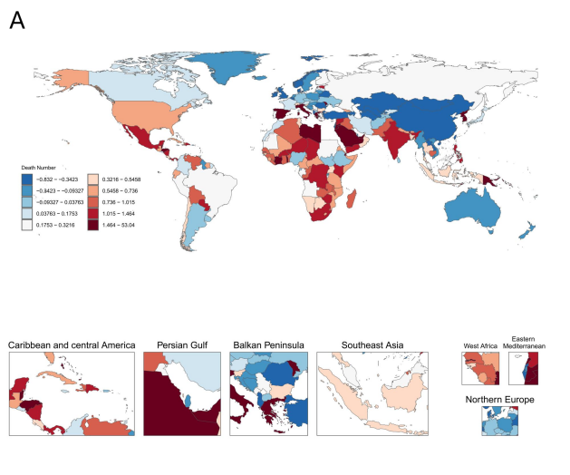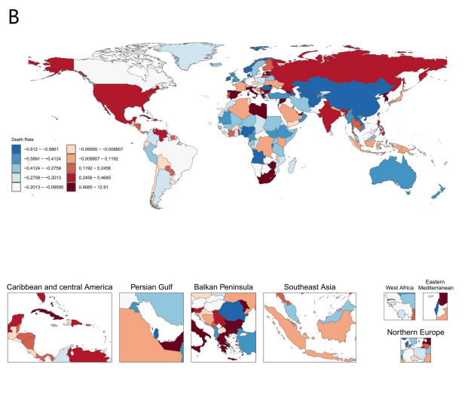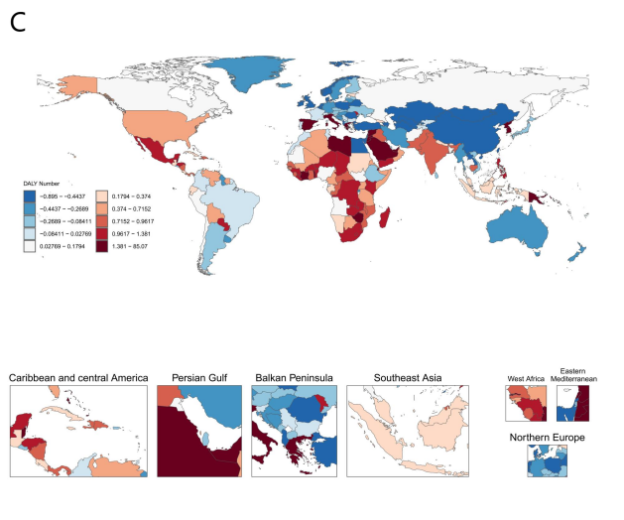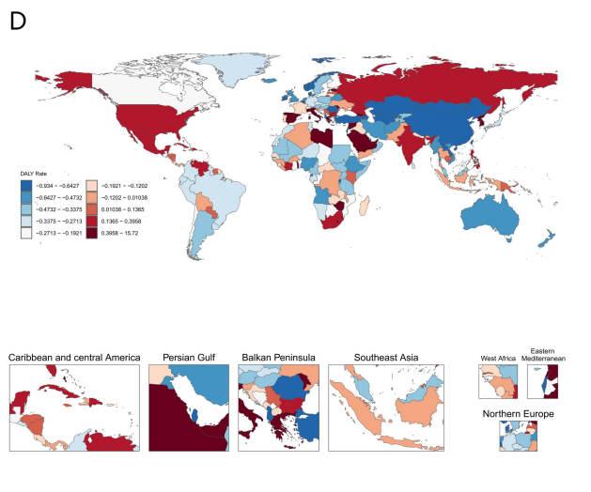
Fig 2：Cardiovascular disease attributable to a diet low in vegetables in age groups 20-54 and ≥55 years from 1990 to 2021.（A）Cardiovascular disease DALY attributable to a diet low in vegetables in age groups 20-54 and ≥55 years from 1990 to 2021.（B）Cardiovascular disease YLL attributable to a diet low in vegetables in age groups 20-54 and ≥55 years from 1990 to 2021.
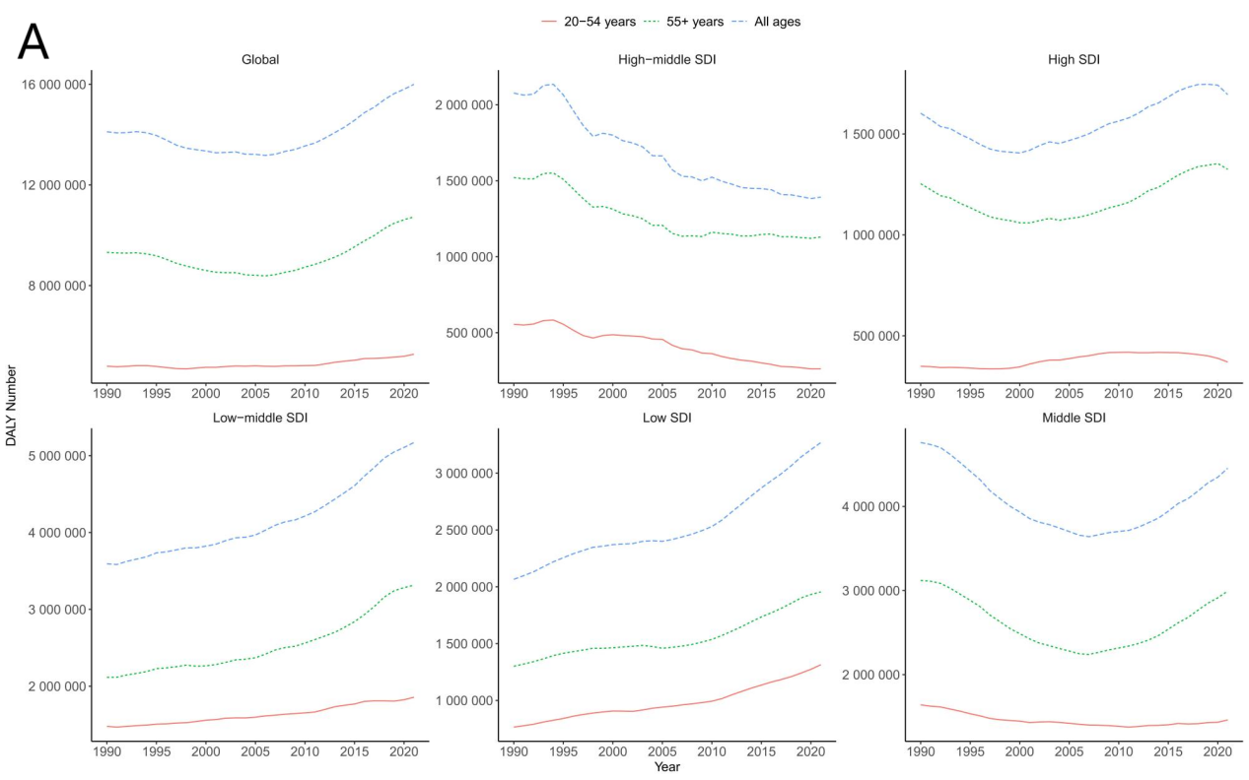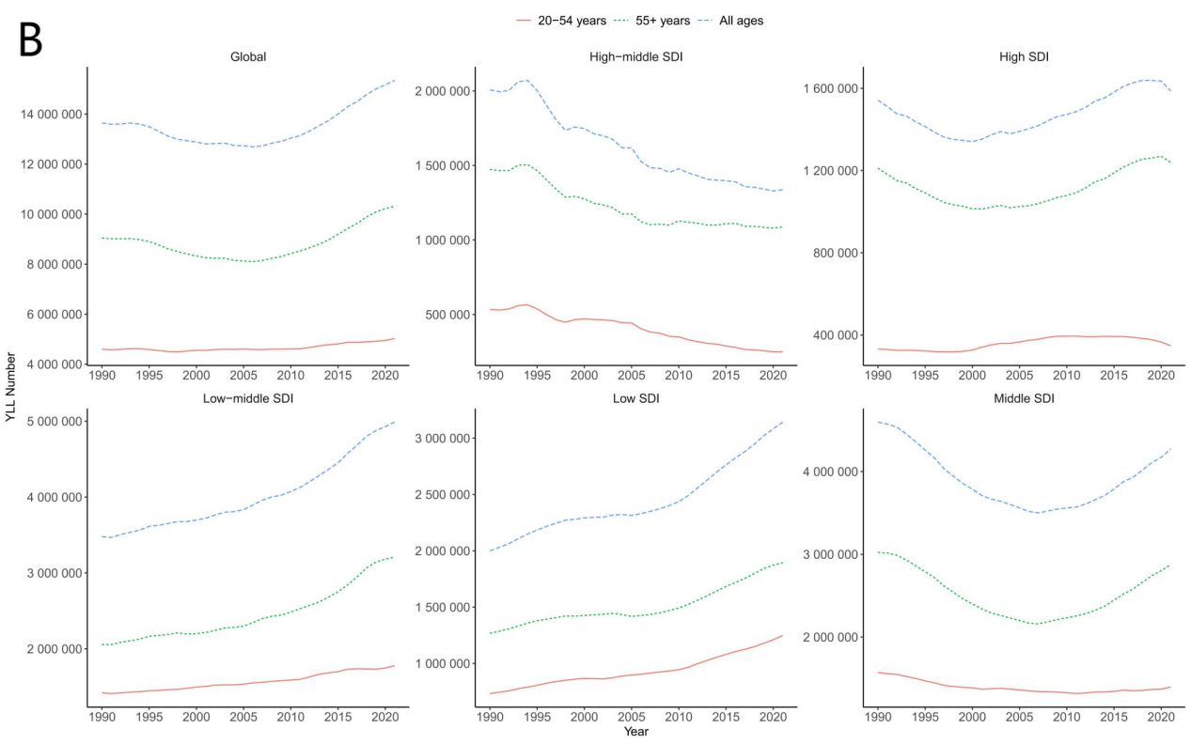

Fig 3：Cardiovascular disease attributable to a diet low in vegetables by SDI region from 1990 to 2021.（A）Cardiovascular disease DALY attributable to a diet low in vegetables by SDI region from 1990 to 2021.（B）Cardiovascular disease YLL attributable to a diet low in vegetables by SDI region from 1990 to 2021.
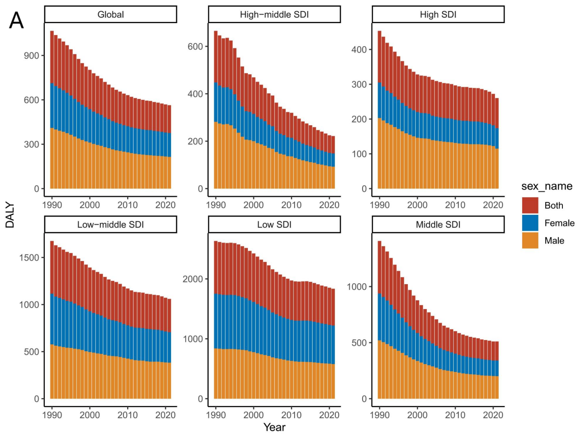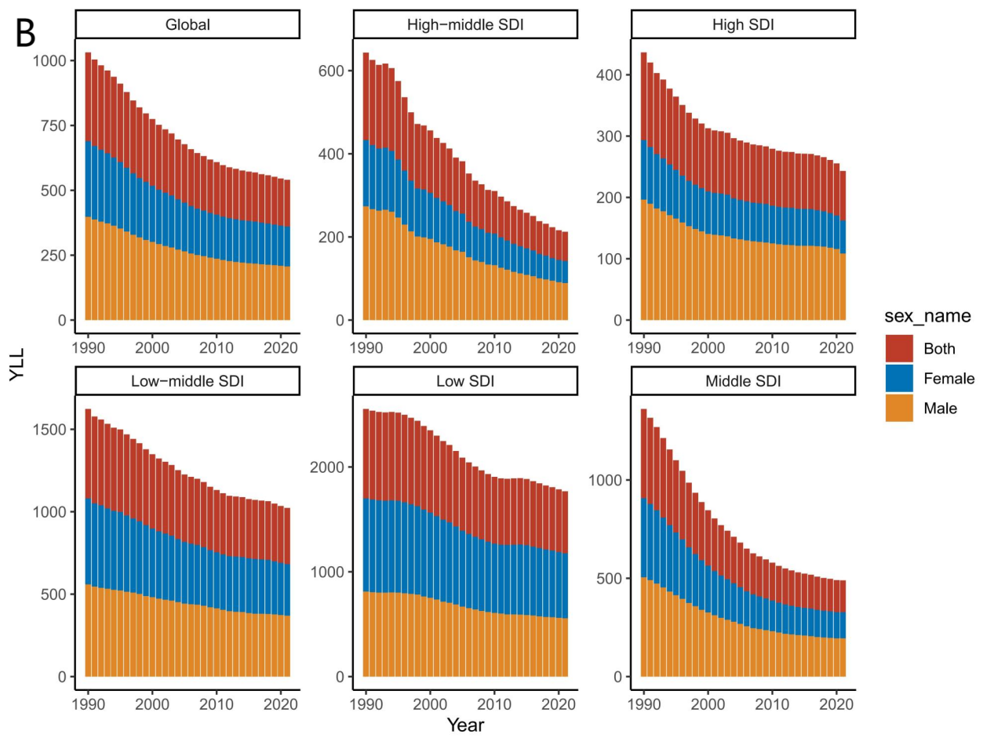
Fig 4：Sex- and age-specific cardiovascular disease attributable to a diet low in vegetables globally in 1990 and 2021.（A）Sex- and age-specific cardiovascular disease mortality attributable to a diet low in vegetables globally in 1990.（B）Sex- and age-specific cardiovascular disease mortality attributable to a diet low in vegetables globally in 2021.（C）Sex- and age-specific cardiovascular disease DALY attributable to a diet low in vegetables globally in 1990.（D）Sex- and age-specific cardiovascular disease DALY attributable to a diet low in vegetables globally in 2021.
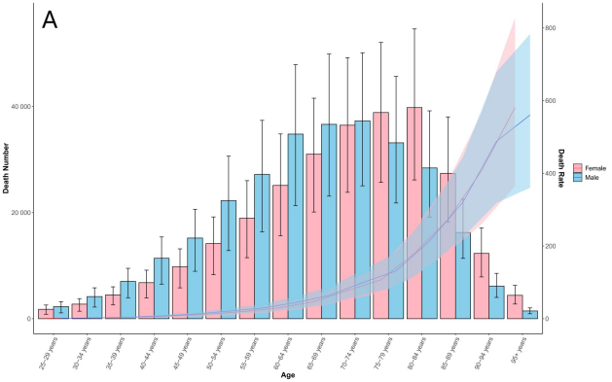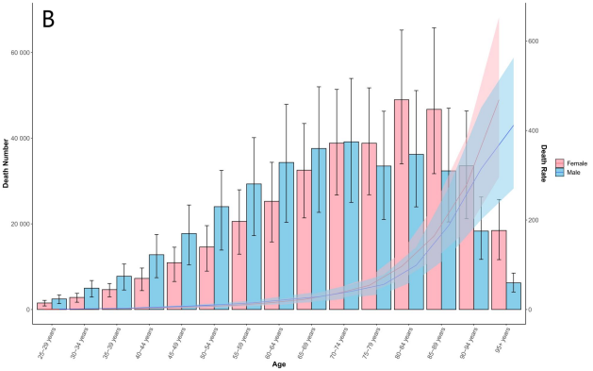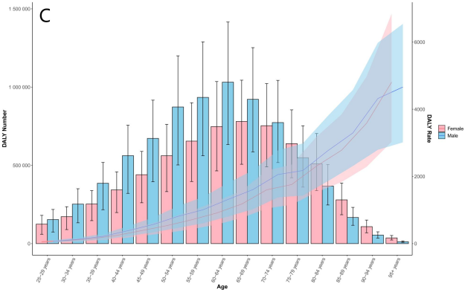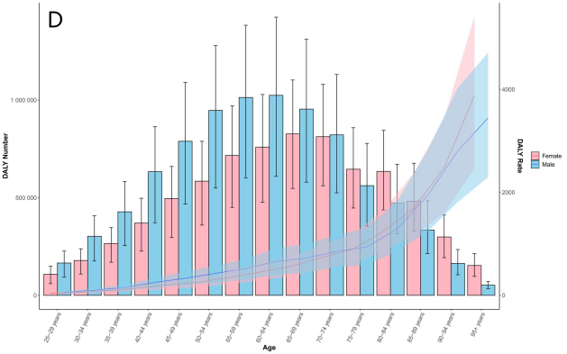

Fig 5：Disease-specific death attributable to a diet low in vegetables by age and sex globally in 1990 and 2021.（A）Disease-specific death number attributable to a diet low in vegetables by age and sex globally in 1990.（B）Disease-specific death number attributable to a diet low in vegetables by age and sex globally in 2021.（C）Disease-specific death rate attributable to a diet low in vegetables by age and sex globally in 1990.（D）Disease-specific death rate attributable to a diet low in vegetables by age and sex globally in 2021.
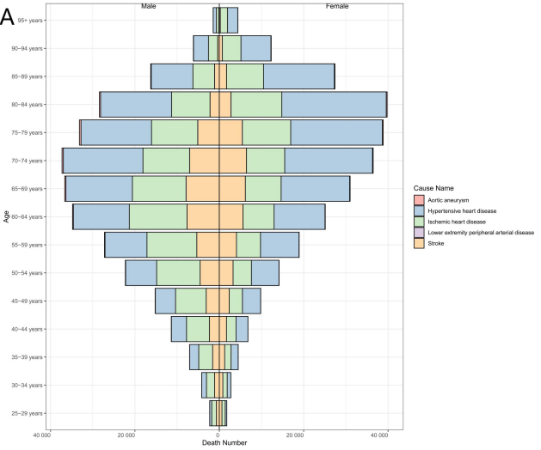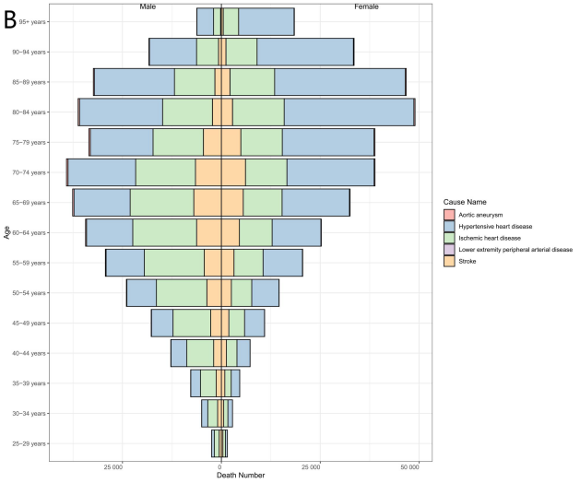
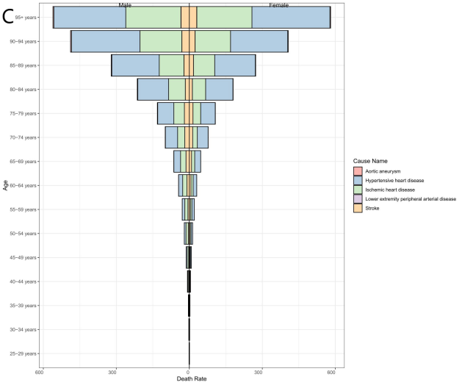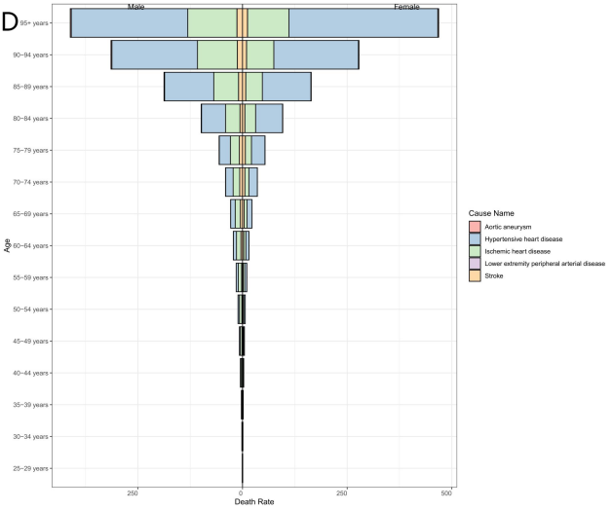

Fig 6：Disease-specific DALY attributable to a diet low in vegetables by age and sex globally in 1990 and 2021.（A）Disease-specific DALY number attributable to a diet low in vegetables by age and sex globally in 1990.（B）Disease-specific DALY number attributable to a diet low in vegetables by age and sex globally in 2021.（C）Disease-specific DALY rate attributable to a diet low in vegetables by age and sex globally in 1990.（B）Disease-specific DALY rate attributable to a diet low in vegetables by age and sex globally in 2021.
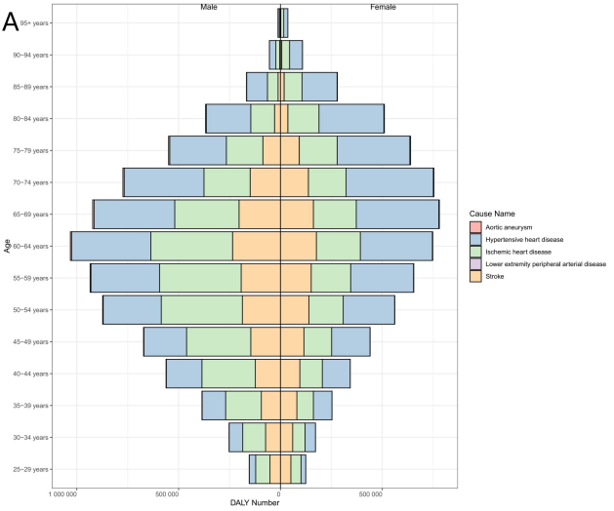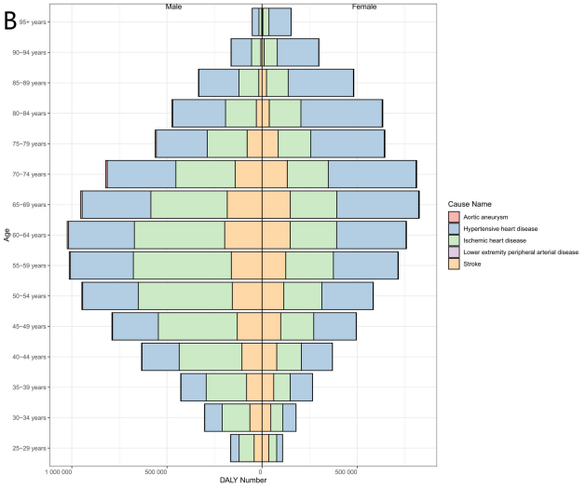
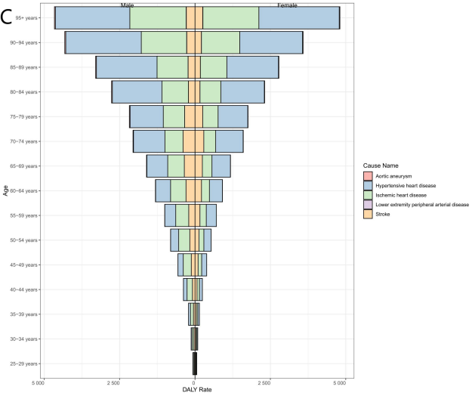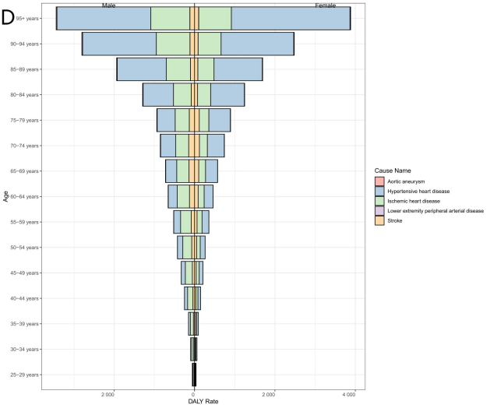

Fig 7：Proportion of disease-specific death attributable to a diet low in vegetables by age group in 1990 and 2021.（A）Proportion of disease-specific death number attributable to a diet low in vegetables by age group in 1990.（B）Proportion of disease-specific death number attributable to a diet low in vegetables by age group in 2021.（C）Proportion of disease-specific death rate attributable to a diet low in vegetables by age group in 1990.（D）Proportion of disease-specific death rate attributable to a diet low in vegetables by age group in 2021.
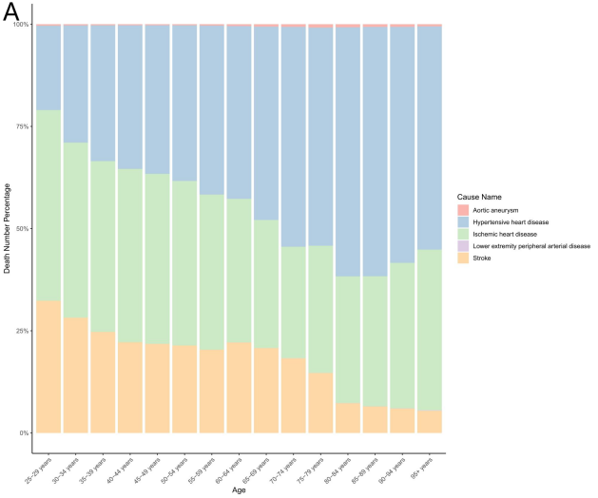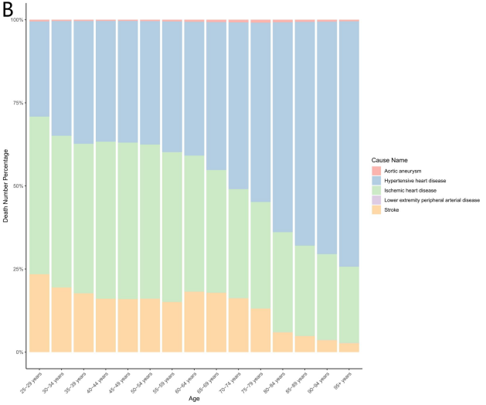
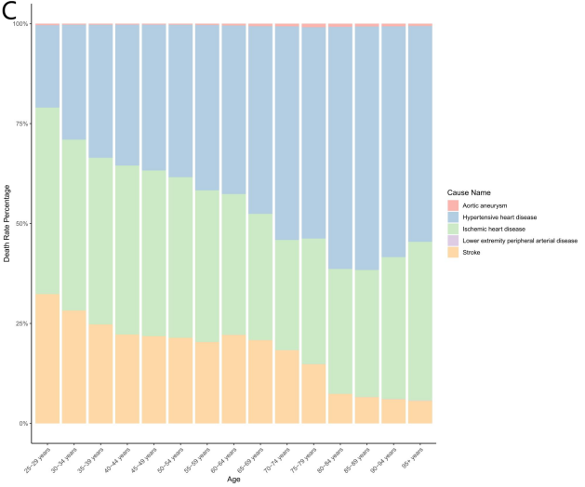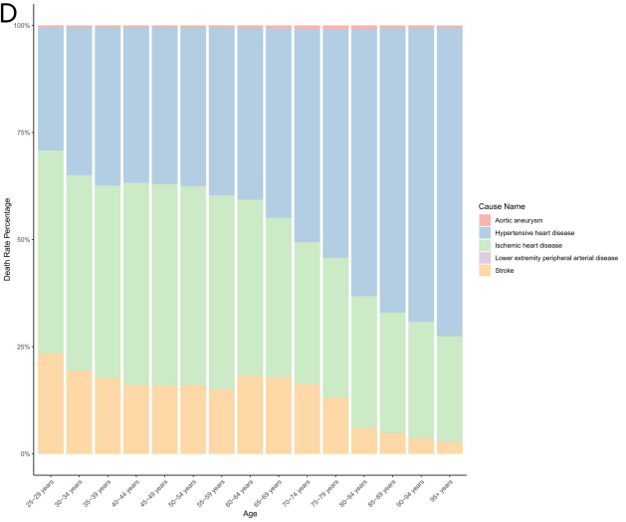

Fig 8：Proportion of disease-specific DALY attributable to a diet low in vegetables by age group in 1990 and 2021.（A）Proportion of disease-specific DALY number attributable to a diet low in vegetables by age group in 1990.（B）Proportion of disease-specific DALY number attributable to a diet low in vegetables by age group in 2021.（C）Proportion of disease-specific DALY rate attributable to a diet low in vegetables by age group in 1990.（D）Proportion of disease-specific DALY rate attributable to a diet low in vegetables by age group in 2021.
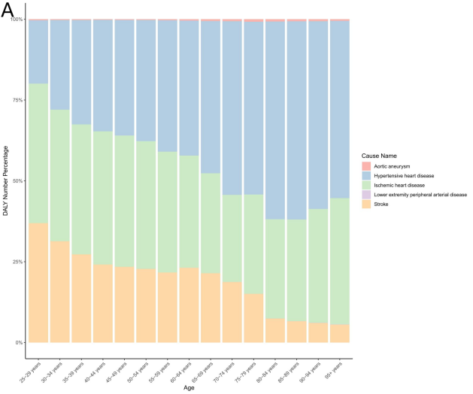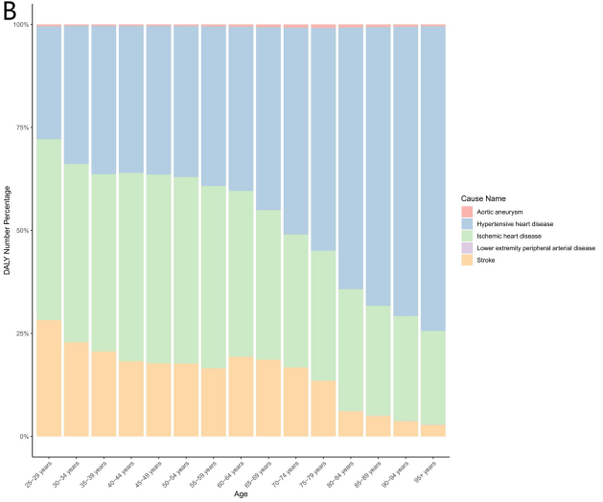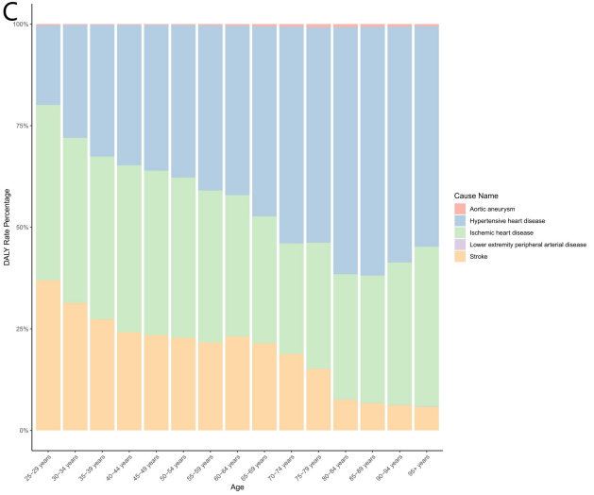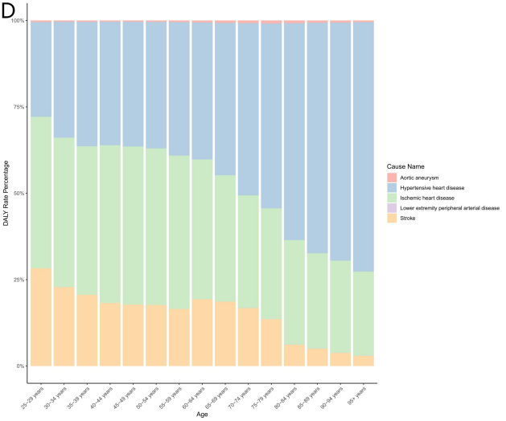

Fig 9：Projected cardiovascular disease death number attributable to a diet low in vegetables by gender and age from 1990 to 2035.（A）Projected cardiovascular disease death number attributable to a diet low in vegetables from 1990 to 2035.（B）Projected male cardiovascular disease death number attributable to a diet low in vegetables from 1990 to 2035.（C）Projected female cardiovascular disease death number attributable to a diet low in vegetables from 1990 to 2035.
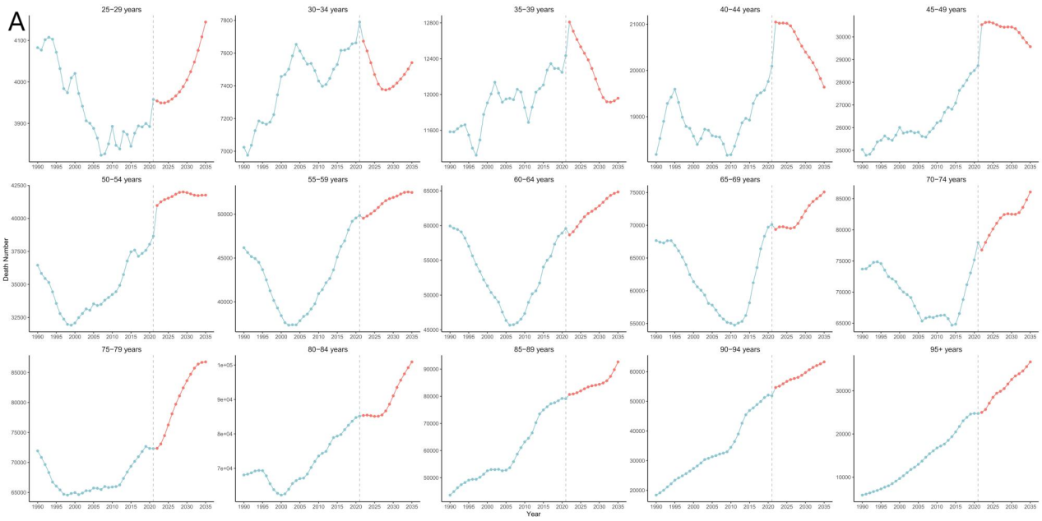
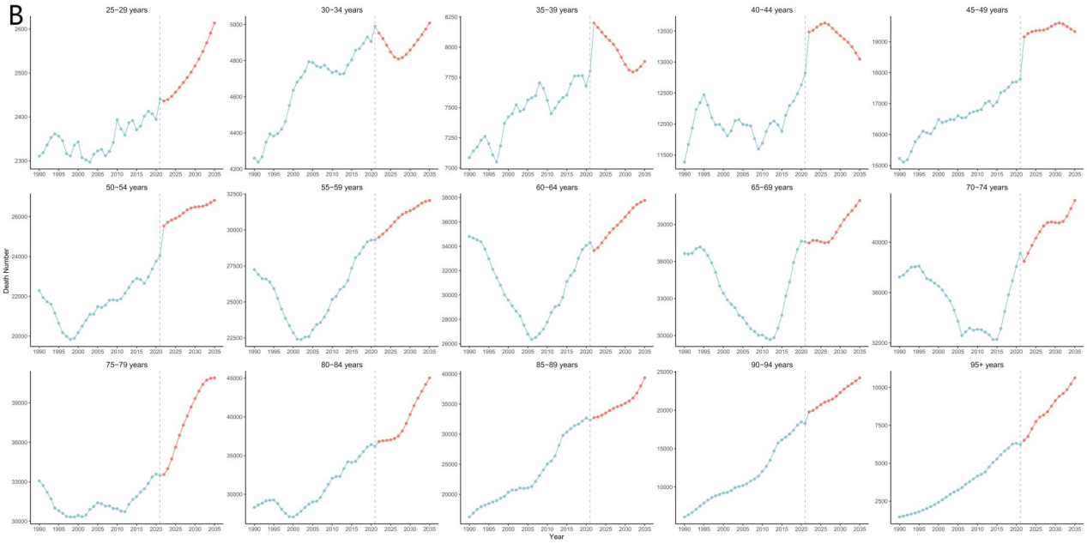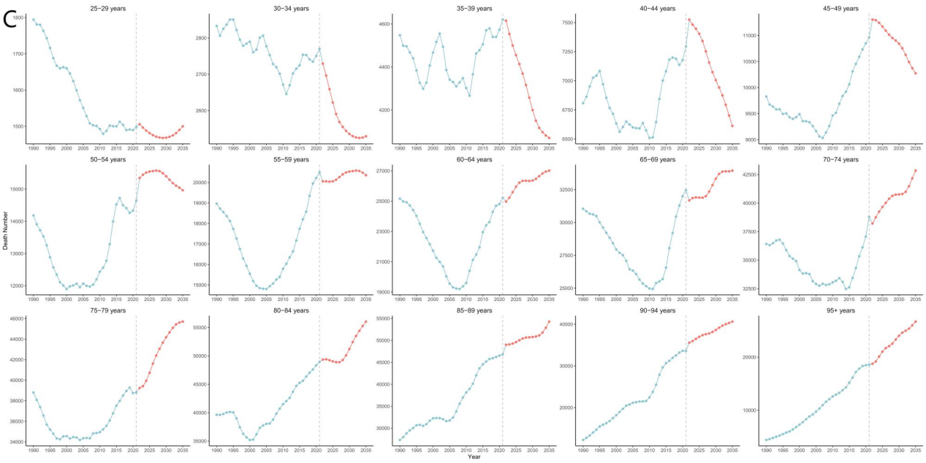
Fig 10：Projected cardiovascular disease death rate attributable to a diet low in vegetables by gender and age from 1990 to 2035.（A）Projected cardiovascular disease death rate attributable to a diet low in vegetables from 1990 to 2035.（B）Projected male cardiovascular disease death rate attributable to a diet low in vegetables from 1990 to 2035.（C）Projected female cardiovascular disease death rate attributable to a diet low in vegetables from 1990 to 2035.
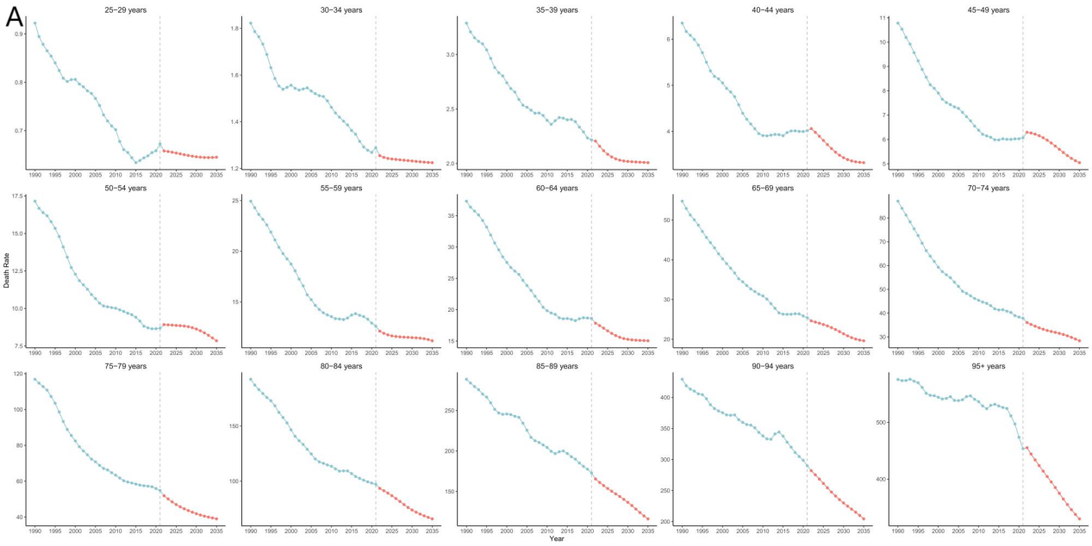
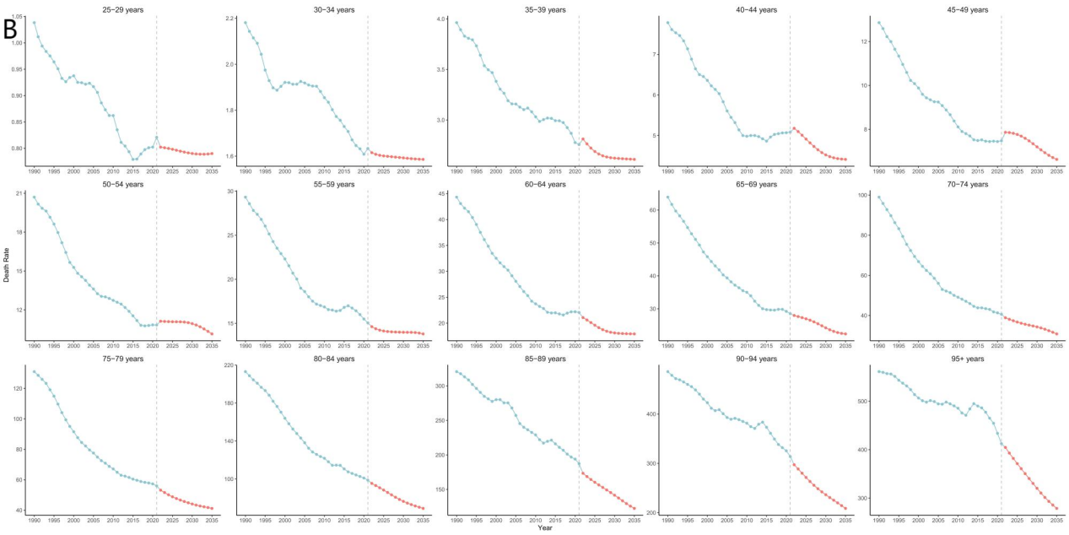
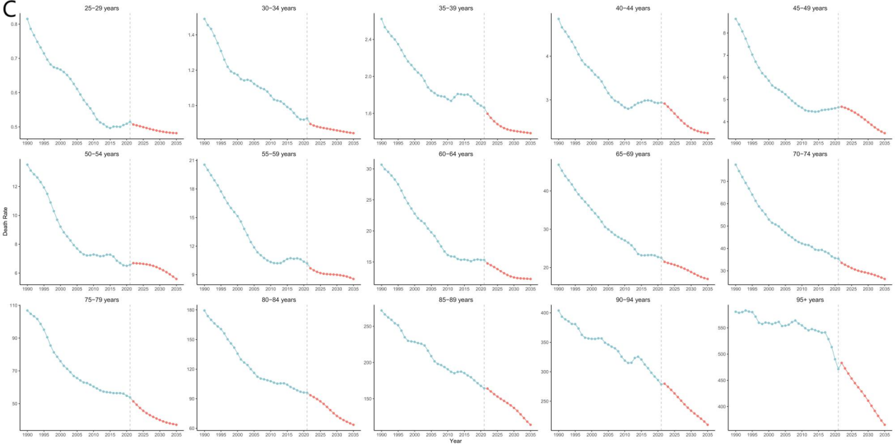
Fig 11：Projected cardiovascular disease mortality attributable to a diet low in vegetables by gender from 1990 to 2035.（A）Projected male cardiovascular disease mortality attributable to suboptimal vegetable intake from 1990 to 2035.（B）Projected female cardiovascular disease mortality attributable to suboptimal vegetable intake from 1990 to 2035.
