Supplementary Information
Contemporary ocean acidification and marine heatwaves shape individual energetics and rates of herbivory in a dominant ecosystem engineer.

Nathan B. Spindel¹*, Maya Munstermann⁴, Sam Karelitz^{4,}, Rachele Ferraro⁵, Ondine Pontier², Brenna Collicutt², Kate Rolheiser², Iria Gimenez², Evan Cronmiller², Megan Foss², Natalie Mahara², Daniel S. Swezey³, Laura Rogers-Bennett³, Daniel K. Okamoto⁴

¹Moss Landing Marine Laboratories, San Jose State University, Moss Landing, CA USA
²Hakai Institute, Heriot Bay, BC V0P 1H0, Canada.
³Bodega Marine Laboratory, University of California Davis Coastal and Marine Sciences Institute, P.O. Box 247 / 2099 Westshore Rd. Bodega Bay, CA 94923-0247
⁴Department of Integrative Biology, University of California, Berkeley. Berkeley, CA USA.
⁵Department of Biological Science, Florida State University, Tallahassee, FL USA
*Corresponding author: nathan.spindel@sjsu.edu
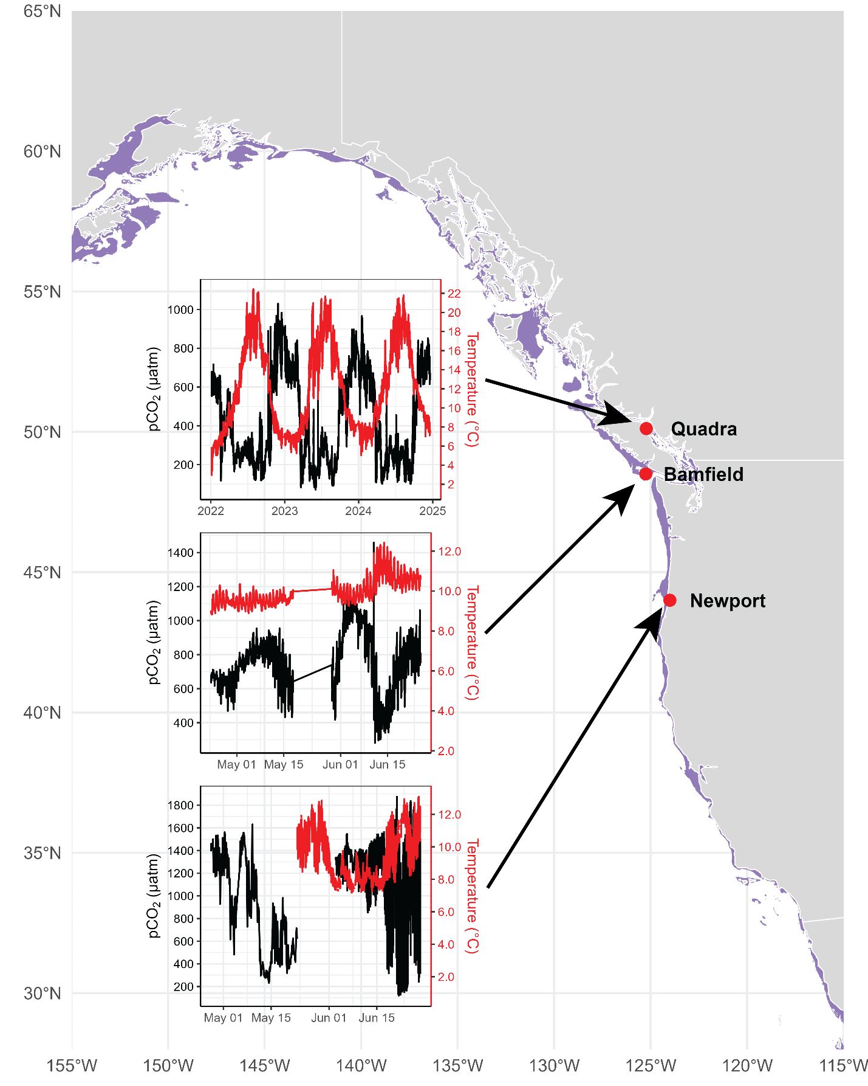
Figure S1. Map of the range of S. purpuratus. Purple regions represent the coastal area encompassing the reported depth range. Inset time series plots show in situ benthic temperature (black) and pCO₂ (red) at three locations in the region of the study location.
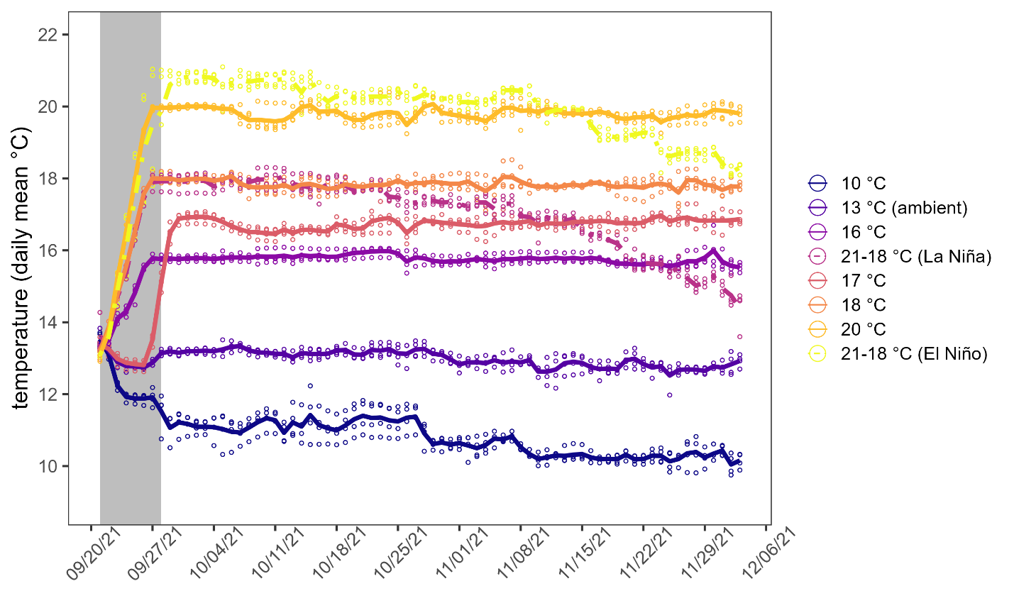
Figure S2: Time series of temperature data for all treatments. Lines represent daily treatment means and points represent daily tank replicate means. The grey shaded region indicates the ramp period over which most temperature adjustment for constant treatment targets occurred.
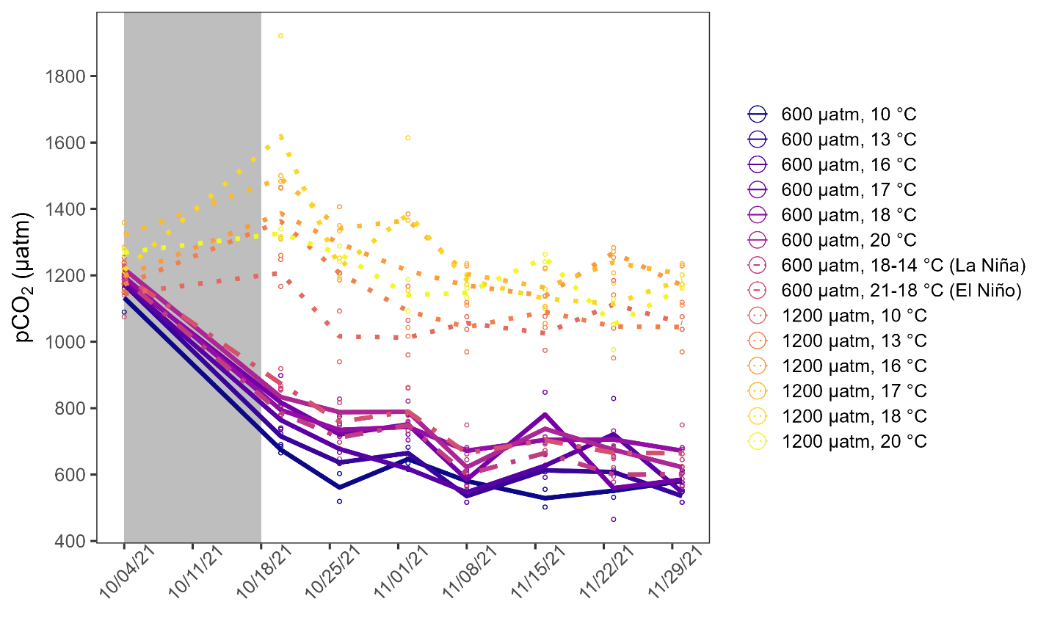
Figure S3. Time series of pCO₂ data for all treatments based on discrete water sampling events for carbonate chemistry analysis. Lines represent treatment means and points represent tank replicate values. We monitored pH in all mesocosms continuously (see Methods for details). The grey shaded region indicates the ramp period over which pCO₂ was manipulated toward treatment targets.

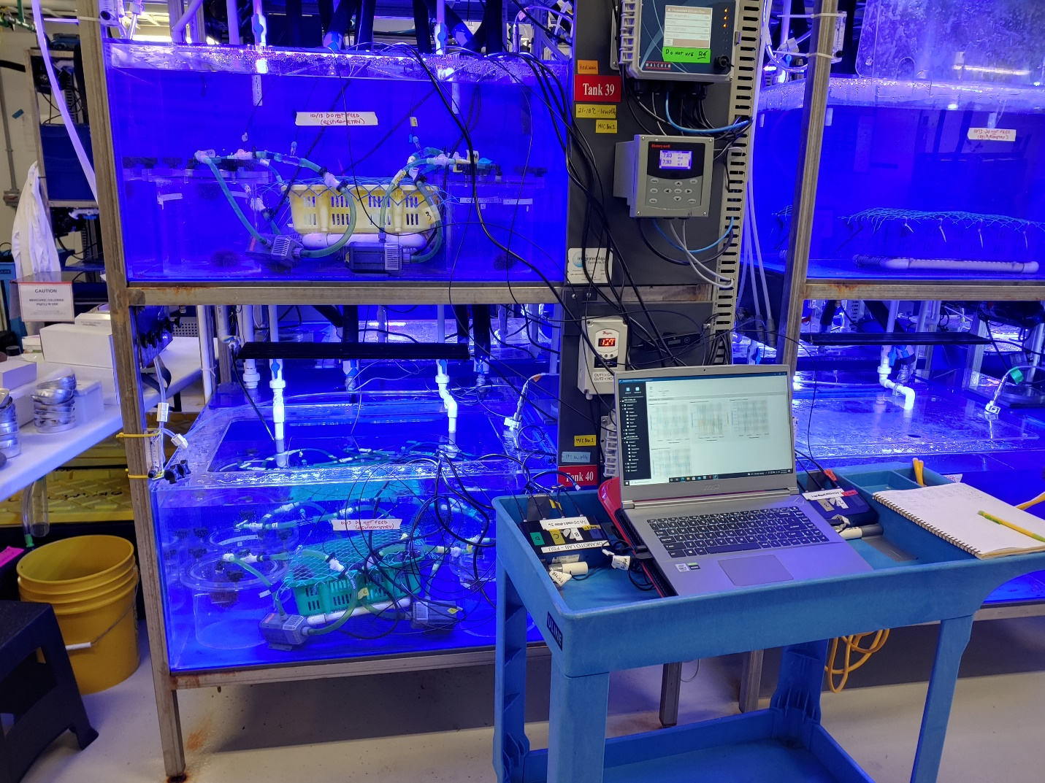
Figure S4. Mesocosm respirometry setup. Photograph by NBS.

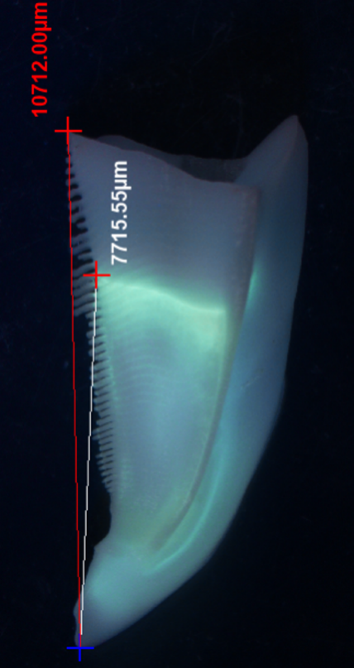
Figure S5. Photograph of sea urchin jaw (demipyramid) illustrating fluorescent tetracycline tag and example measurements taken using a stereoscopic microscope equipped with an ocular micrometer (Nikon Instruments Inc.). Photograph by RF.
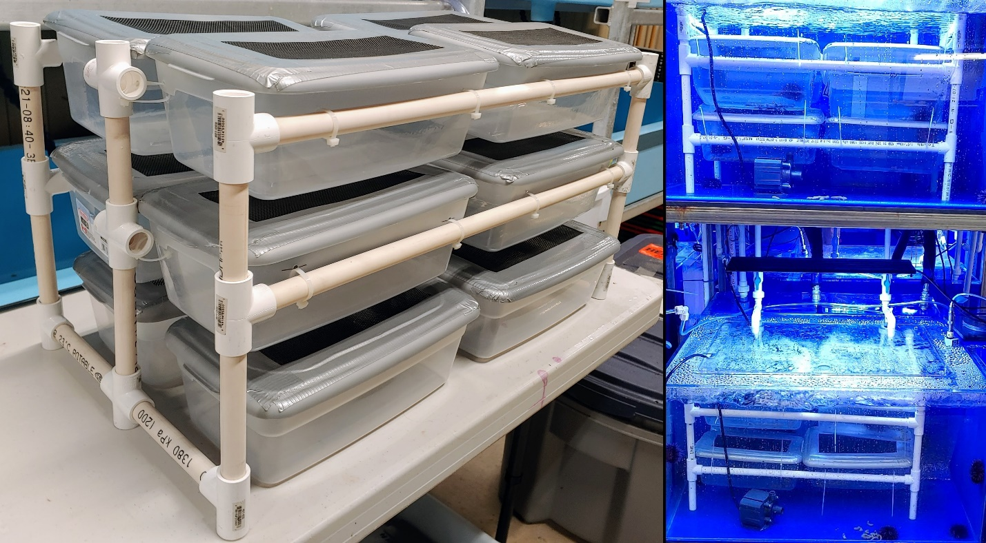
Figure S6. Assimilation efficiency assay apparatus. Photographs by NBS.

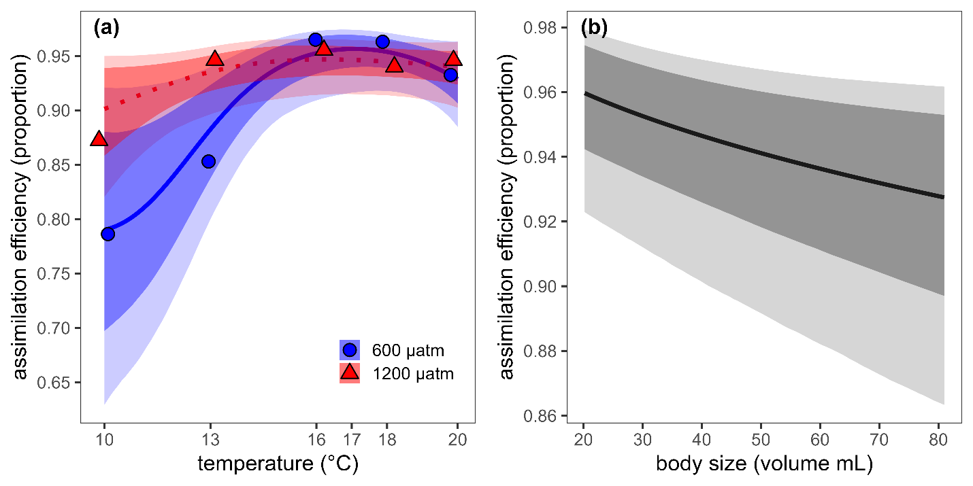
Figure S7. Effects of temperature, pCO₂, and body size on assimilation efficiency. Symbols represent empirical means for each tank replicate. Curves represent conditional means with dark and light bands representing 95% and 80% credible intervals, respectively. (a) At 600 μatm, assimilation efficiency increased from 10 °C towards an asymptote at 16 °C, whereas at 1200 μatm, assimilation efficiency stayed relatively high and unresponsive to increasing temperature across the range tested. (b) Assimilation efficiency declined linearly as a function of increasing body size.

Table S1. Model selection for RMR using leave one out cross validation stacking weights ⁶⁴.
Model | Predictors | LOO Stacking Weight
1 | log(AFDM) +  GP(temperature, k = 6, c = 5/4, by = pCO₂) + (1|tank_id) | 0.000
2 | log(AFDM) +  GP(temperature, k = 6, c = 5/4) +  (1|tank_id) | 0.002
3 | log(AFDM) +  temperature * pCO₂ +  (1|tank_id) | 0.000
4 | log(AFDM) +  temperature +  pCO₂ +  (1|tank_id) | 0.915
5 | log(AFDM) +  (1|tank_id) | 0.082
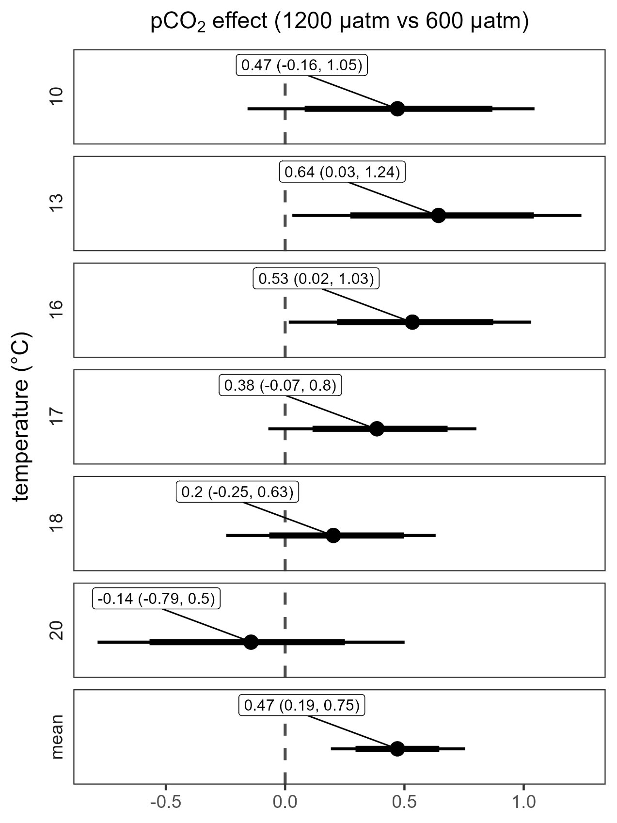
Figure S8. Post hoc contrasts based on estimated marginal means of RMR by treatment. Symbols represent point estimates of the difference in means. Thin and thick horizontal bars represent 95% and 80% credible intervals, respectively. The vertical dashed line highlights the position at which there is no difference between means for the focal contrast.
Table S3. Model selection for per capita consumption (aggregate) using leave one out cross validation stacking weights ⁶⁴.
Model | Predictors | LOO Stacking Weight
1 | GP(temperature, k = 6, c = 5/4, by = pCO₂) + (1|tank_id) | 1.000
2 | GP(temperature, k = 6, c = 5/4) +  (1|tank_id) | 0.000
3 | temperature * pCO₂ +  (1|tank_id) | 0.000
4 | temperature +  pCO₂ +  (1|tank_id) | 0.000
5 | (1|tank_id) | 0.000

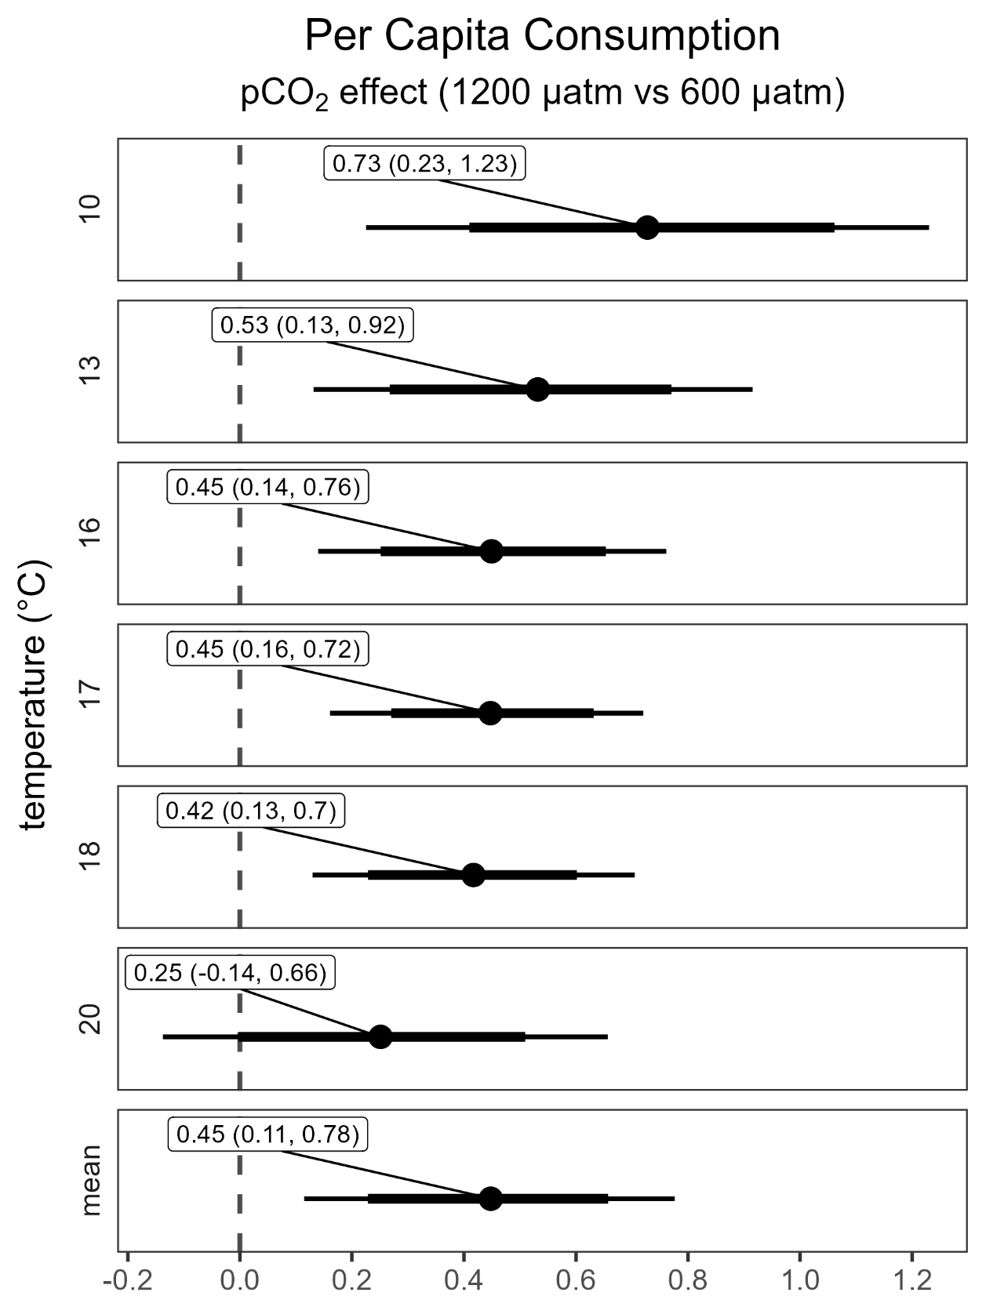
Figure S9. Post hoc contrasts based on estimated marginal means of per capita consumption by treatment. Symbols represent point estimates of the difference in means. Thin and thick horizontal bars represent 95% and 80% credible intervals, respectively. The vertical dashed line highlights the position at which there is no difference between means for the focal contrast.
Table S4. Model selection for gonad production using leave one out cross validation stacking weights ⁶⁴.
Model | Predictors | LOO Stacking Weight
1 | log(test volume) +  GP(temperature, k = 6, c = 5/4, by = pCO₂) + (1|tank_id) | 0.000
2 | log(test volume) +  GP(temperature, k = 6, c = 5/4) +  (1|tank_id) | 1.000
3 | log(test volume) +  temperature * pCO₂ +  (1|tank_id) | 0.000
4 | log(test volume) +  temperature +  pCO₂ +  (1|tank_id) | 0.000
5 | log(test volume) +  (1|tank_id) | 0.000

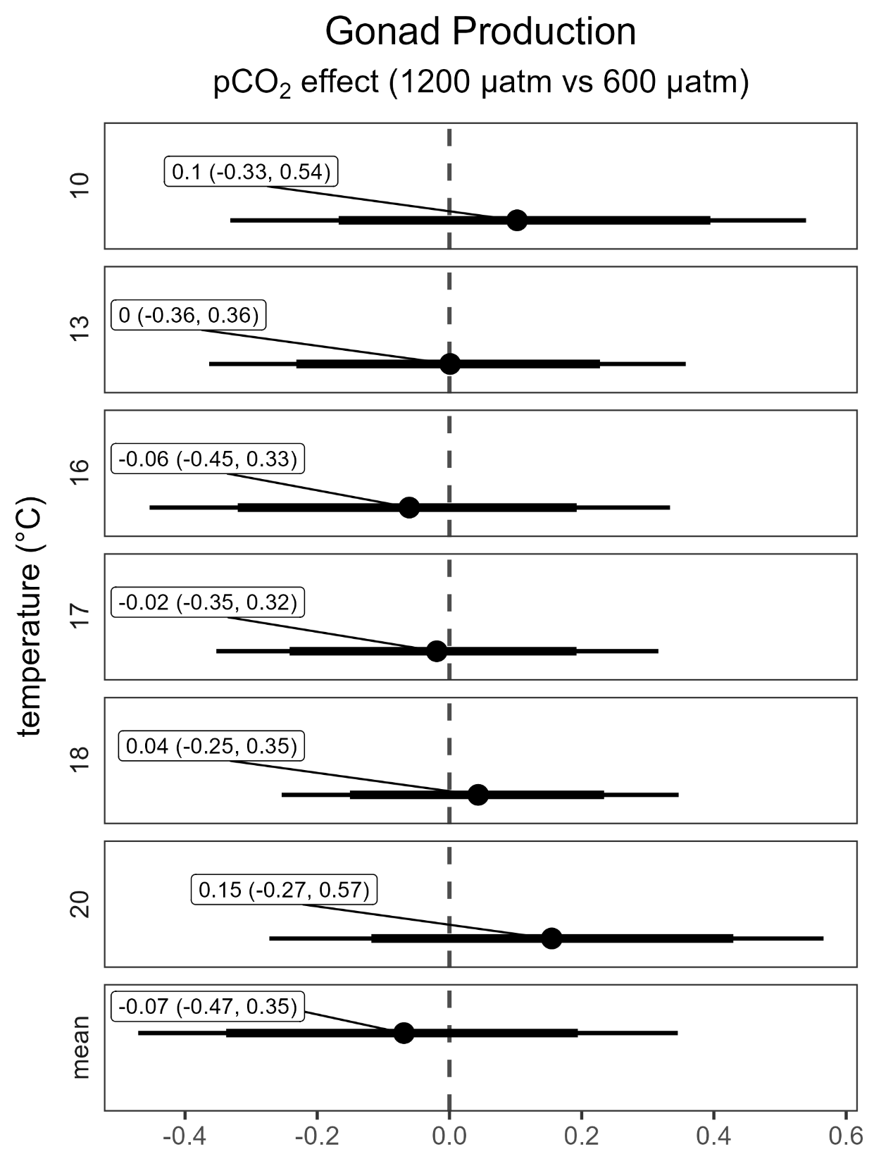
Figure S10. Post hoc contrasts based on estimated marginal means of gonad production by treatment. Symbols represent point estimates of the difference in means. Thin and thick horizontal bars represent 95% and 80% credible intervals, respectively. The vertical dashed line highlights the position at which there is no difference between means for the focal contrast.
Table S5. Model selection for food conversion efficiency using leave one out cross validation stacking weights ⁶⁴
Model | Predictors | LOO Stacking Weight
1 | log(test volume) +  GP(temperature, k = 6, c = 5/4, by = pCO₂) + (1|tank_id) | 1.000
2 | log(test volume) +  GP(temperature, k = 6, c = 5/4) +  (1|tank_id) | 0.000
3 | log(test volume) +  temperature * pCO₂ +  (1|tank_id) | 0.000
4 | log(test volume) +  temperature +  pCO₂ +  (1|tank_id) | 0.000
5 | log(test volume) +  (1|tank_id) | 0.000

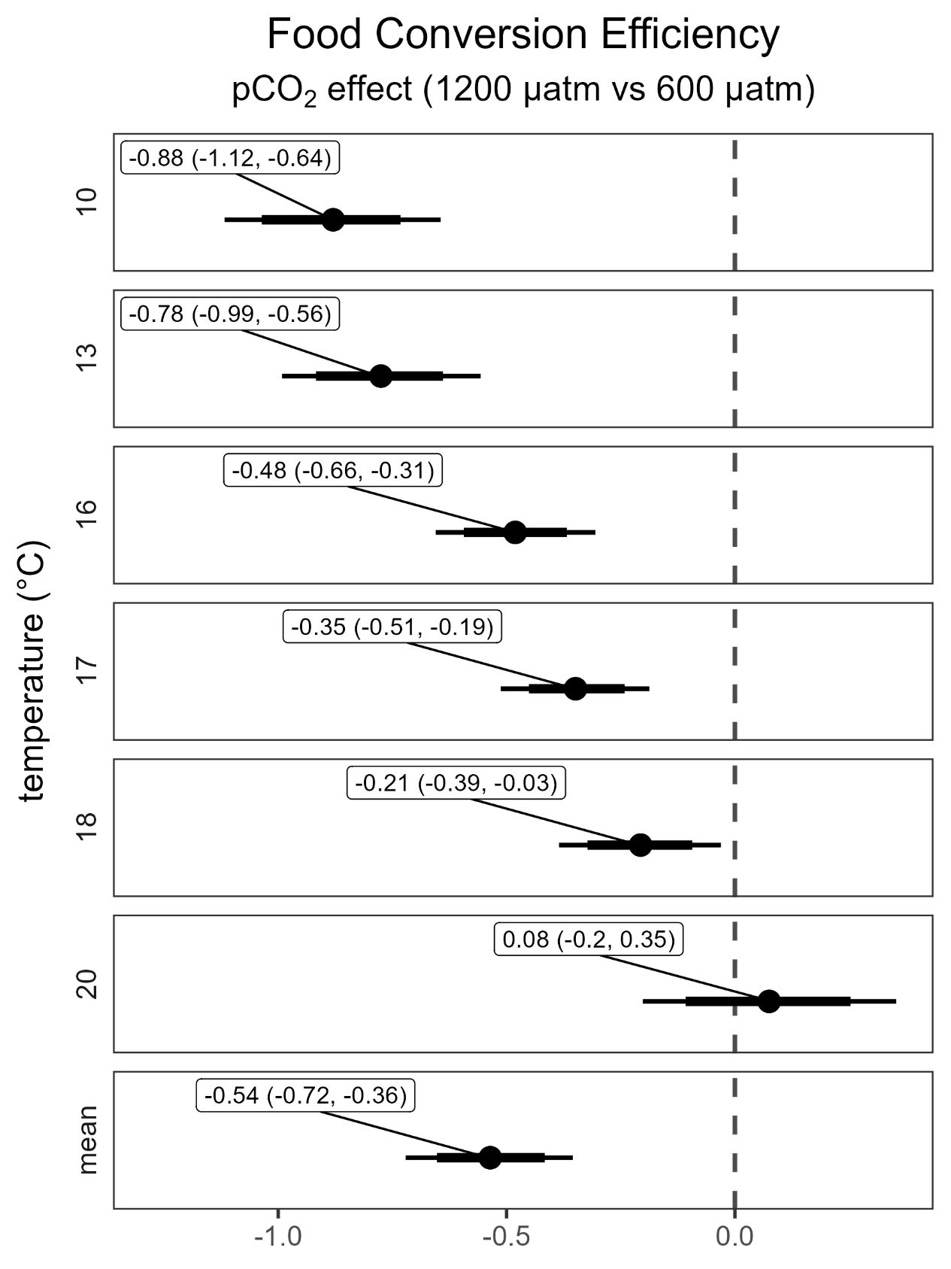
Figure S11. Post hoc contrasts based on estimated marginal means of food conversion efficiency by treatment. Symbols represent point estimates of the difference in means. Thin and thick horizontal bars represent 95% and 80% credible intervals, respectively. The vertical dashed line highlights the position at which there is no difference between means for the focal contrast.
Table S6. Model selection for jaw growth using leave one out cross validation stacking weights ⁶⁴
Model | Predictors | LOO Stacking Weight
1 | log(test volume) +  GP(temperature, k = 6, c = 5/4, by = pCO₂) + (1|tank_id) | 1.000
2 | log(test volume) +  GP(temperature, k = 6, c = 5/4) +  (1|tank_id) | 0.000
3 | log(test volume) +  temperature * pCO₂ +  (1|tank_id) | 0.000
4 | log(test volume) +  temperature +  pCO₂ +  (1|tank_id) | 0.000
5 | log(test volume) +  (1|tank_id) | 0.000
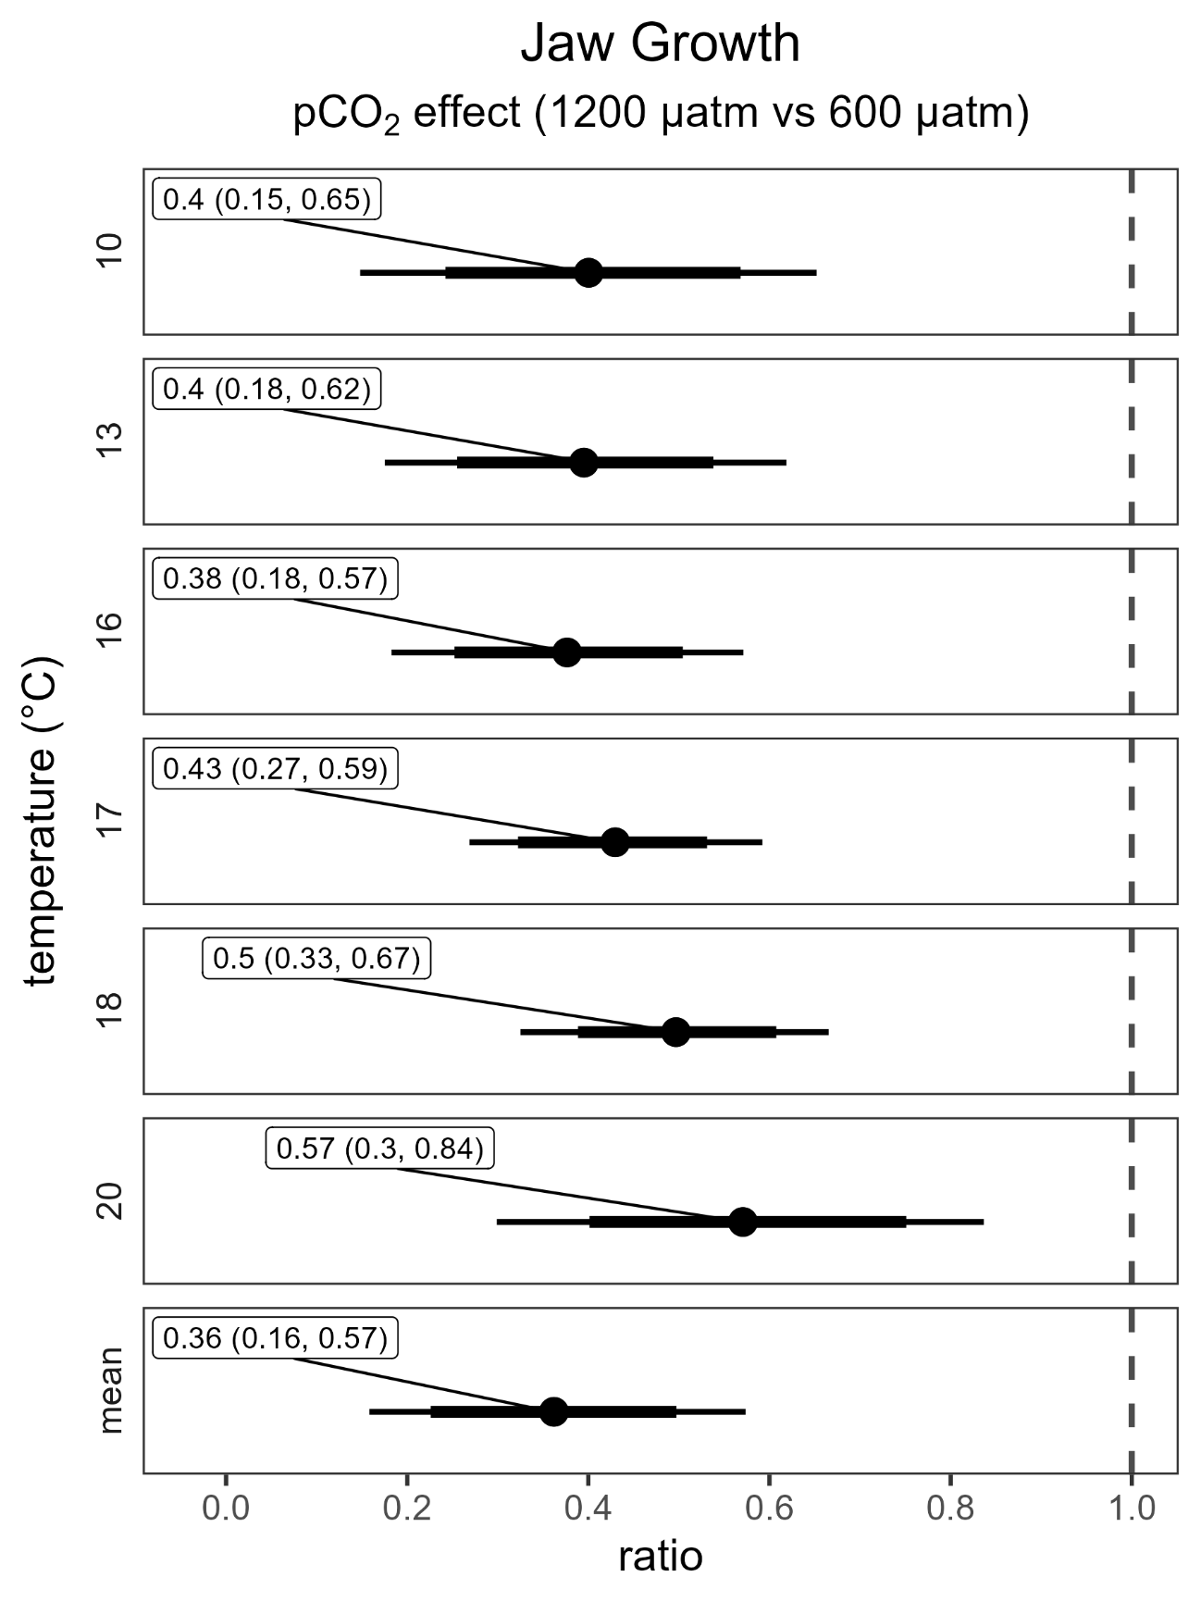
Figure S12. Post hoc contrasts based on estimated marginal means of demipyramid (Aristotle’s Lantern mouth part) by treatment. Symbols represent point estimates of the difference in means. Thin and thick horizontal bars represent 95% and 80% credible intervals, respectively. The vertical dashed line highlights the position at which there is no difference between means for the focal contrast.

