SUPPORTING INFORMATION
High-Resolution Imaging Dataset of Multiphase Fluid Dynamics for Geologic Carbon Sequestration

Prakash Purswani^{1,§}; Anna Herring²; Prabhav Borate³; Parisa Shokouhi³; Zuleima Karpyn^{1,}*

¹John and Willie Leone Family Department of Energy and Mineral Engineering and the EMS Energy Institute, The Pennsylvania State University, University Park, PA 16802, USA
²Department of Civil and Environmental Engineering, The University of Tennessee – Knoxville, TN 37996, USA
³Department of Engineering Science and Mechanics, The Pennsylvania State University, University Park, PA 16802, USA
§Currently at Earth and Environmental Sciences Division, Los Alamos National Laboratory, NM 87545, USA

*Corresponding author at: ZKarpyn@psu.edu

S1. Permeability estimation
Figure S1 shows the differential pressure measurements collected for single phase brine permeability estimation. This was completed during stage 5 of the experiment: Brine Flow for Permeability Estimation. Measurements were collected at different flow rates from 0.5 cc/min to 2 cc/min. Mean values for the differential pressures were used to estimate the brine permeability of the sample. Sample permeability was calculated from the slope of the flow rate versus differential pressure plot and was found to be ~98 mD (Figure S2).
Figure S1. Differential pressure over time for brine permeability estimation.
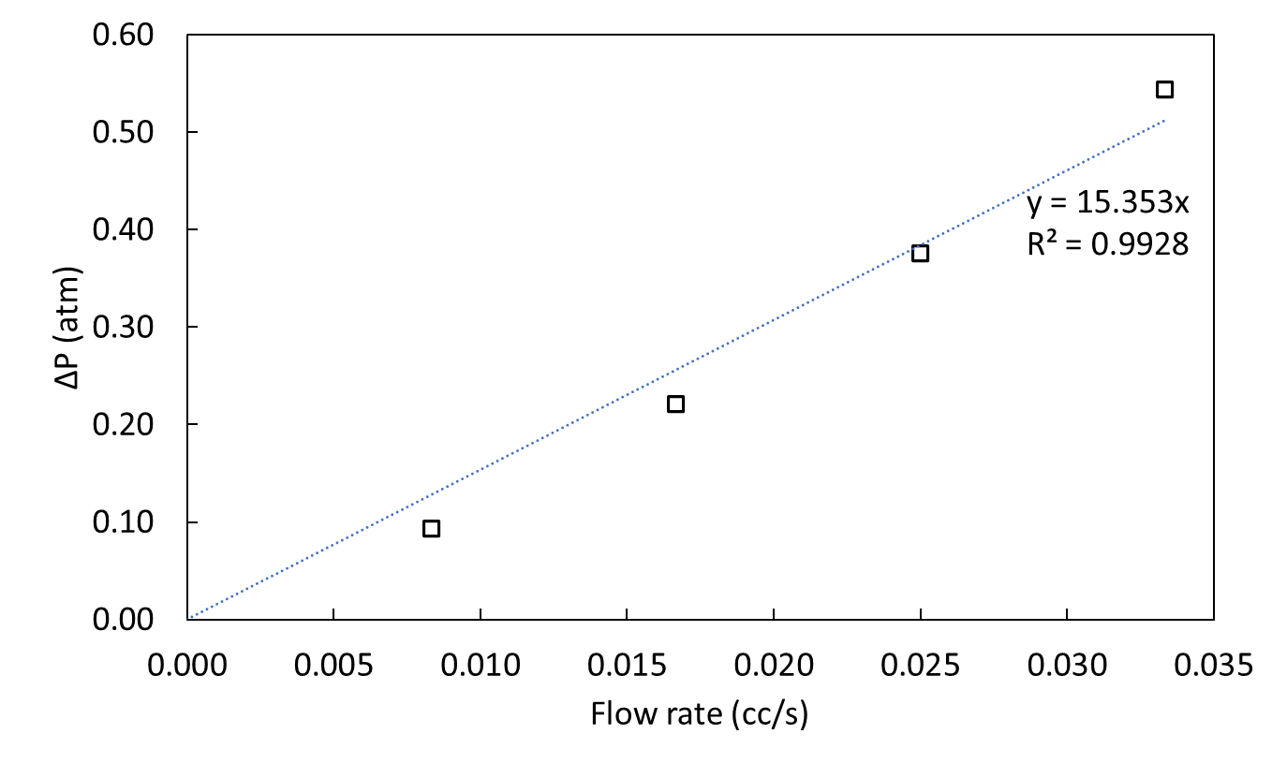
Figure S2. Average differential pressure versus flow rate for permeability estimation

S2. Image processing attributes
Parameters to accomplish segmentation of all data sets are included in Table S1. The intensity thresholds indicate the range for which the “converging active contours” (CAC) algorithm is applied; e.g., for the Vacuum data set, voxels with an intensity less than 35000 were initially labeled as “void”; voxels with intensity greater than 42000 were labeled “solid”, and voxels between these limits were determined via CAC. The region labeled “solid” in the Vacuum data set was applied as a mask to the subsequent partially-saturated data sets, and the CAC algorithm applied again to delineate scCO₂ phase from brine phase; e.g., for Initial scCO₂, all voxels with intensity below 33000 were labeled as scCO₂, all voxels with intensities greater than 42000 were labeled as brine, and CAC applied for the voxels with intensities between these values. Application of gradient thresholding prevents mislabeling at phase boundaries: voxels with very high intensity gradients are indicative of voxels at the boundary between void and solid which are prone to partial volume effects. High gradient voxels are thus set to be “unlabeled” after the initial labeling stage (even if the intensity value is beyond lower or upper intensity thresholds), enabling application of the CAC algorithm at these regions and reducing the “halo effect” associated with partial volume effects. For these scans, a gradient threshold of 4000 was generally used.
Table S1. User input parameters to the CAC segmentation algorithm applied to generate phase-labeled data from grayscale tomograms
 | Intensity Thresholds |  | Gradient Thresholds |  | Void:Grain Speed
 | lower | upper | Void | Grain | Void:Grain Speed
Vacuum | 35000 | 42000 | na | na | 0.95
scCO2 saturated brine | 33000 | 42000 | 4000 | 4000 | 1
Initial scCO2 | 33000 | 42000 | 4000 | 4000 | 1
Final scCO2 | 33000 | 42000 | na | 4000 | 1
Residual scCO2 | 33000 | 42000 | 4000 | 4000 | 1

Segmentation parameters were modified to assess the impact of user-input values on the resulting data quantification (Table S2). The baseline Vacuum segmentation deployed the CAC algorithm on a span of 7000 intensity values (between 35000 and 42000), approx. 13% of the full grayscale range. Intensity threshold values were modified to widen/narrow this window by 10%, and shift it upwards and downwards by 10%. Widening and narrowing the thresholds has minimal impact to porosity and Euler number calculations, shifting the window produces more significant differences in measured quantities.
Table S2. Sensitivity of quantitative metrics (phase volumes and void space topology) calculated from the Vacuum data volume for different CAC segmentation intensity thresholds
Noise removal required determination of cluster sizes representative of “real” scCO₂ clusters vs those indicative of speckle noise. Cluster size histograms were generated for the Residual scCO₂ scan (Figure S3). As shown, large numbers of very small clusters were present; but these have a relatively low contribution to the total scCO₂ volume. Assuming these very small clusters are dominantly noise, a size threshold was applied to convert these small (<375 voxels, red line in S3) scCO₂-labeled clusters to brine phase.
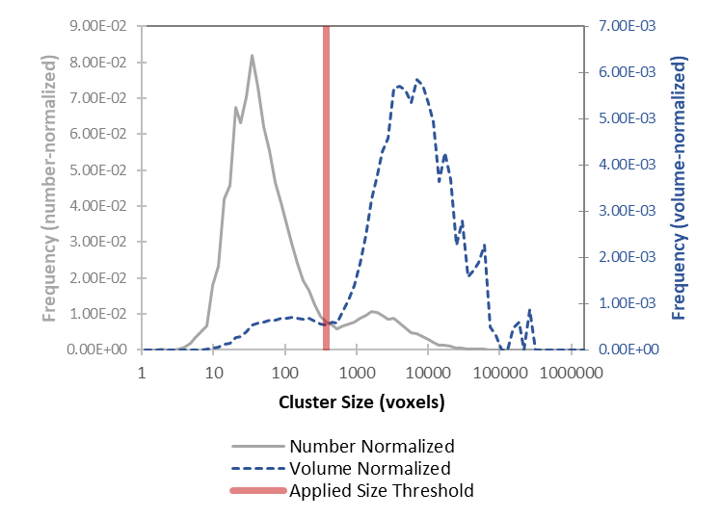
Figure S3. Cluster size distributions measured for scCO₂ phase from the residual scCO₂ scan. Histograms for clusters exhibit a bimodal distribution on both number-normalized and volume-normalized bases. It was assumed that most clusters in the smaller group represent falsely labeled scCO₂ phase (i.e. noise arising from the segmentation process); thus, clusters smaller than 375 voxels (0.0059 mm³) were re-labeled as brine phase in the final denoised segmentations.

