SUPPLEMENTARY INFORMATION

Axion Electrodynamics Realized in a Topologically Trivial Antiferromagnet
Abhilash Mishra¹, Robin Karothiya², Arti Kashyap², Christian Binek^{1,*}
¹Department of Physics & Astronomy and the Nebraska Center for Materials and Nanoscience, University of Nebraska, Lincoln, NE, 68588-0111, USA
²School of Physical Sciences, Indian Institute of Technology, Mandi, India
*To whom correspondence should be addressed. E-mail: cbinek@unl.edu

Supplementary Note 1. The zero-crossing temperature of chromia’s axion piece.
The temperature dependence of the isotropic magnetoelectric response follows the temperature dependence of the axion piece of a chromia single crystal $θ=\frac{1}{3}\left(2α_{⊥}+α_{∥}\right)$ which becomes zero for $α_{∥}=-2α_{⊥}$ . Fig. S1a shows the dependence of $α_{∥}$ and $α_{⊥}$ of chromia using the empirical functional forms introduced in Ref. [10]. One finds $α_{∥}=-2α_{⊥}$ at T =168 K.
Fig. S1b: Temperature dependence of the axion piece, $θ=\frac{1}{3}\left(2α_{⊥}+α_{∥}\right)$, of chromia. The arrow marks the zero-crossing at T=168 K.
Fig. S1a: Temperature dependence of the parallel and perpendicular ME susceptibility of chroma modeled with the help of the empirical functional forms introduced in Ref. [10].
Fig. S1b shows the temperature dependence of the axion piece $θ=\frac{1}{3}\left(2α_{⊥}+α_{∥}\right)$, which exhibits a zero crossing at T=168 K. This temperature dependence was previously obtained from experimental data of $α_{∥}$ and $α_{⊥}$ of chromia (see Refs. [6,7]). Its functional form closely matches the pure isotropic response observed in our engineered material and is consistent with our simulations of a powder sample produced by milling a magnetoelectrically annealed single crystal.

Supplementary Note 2. Qualitative determination of grain size distribution in ball milled powder.
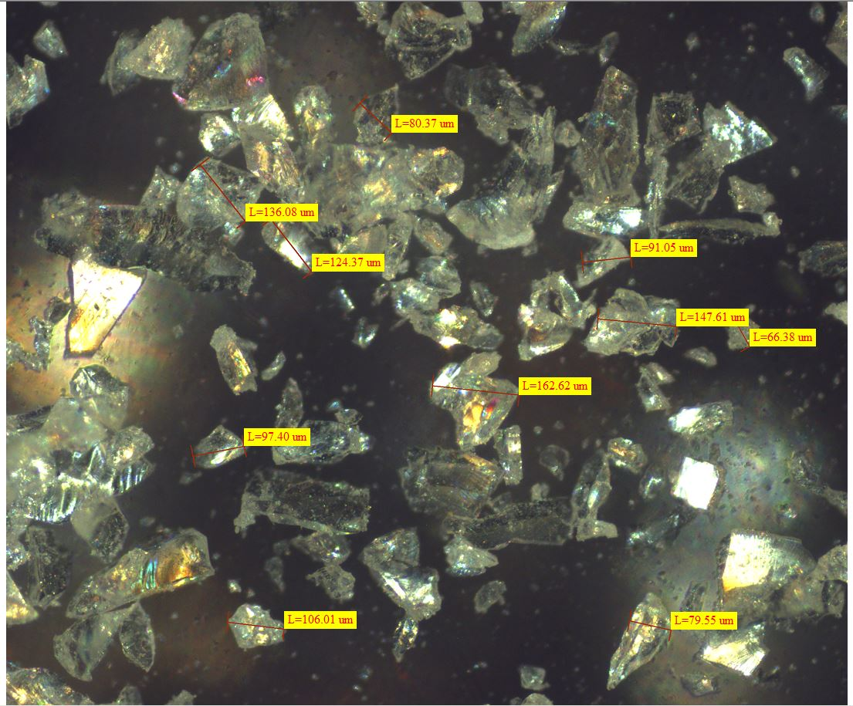
Fig. S2: Optical microscopy image of powder created by ball milling a sapphire crystal

Figure S2 shows the result of ball milling a sapphire single crystal into a powder with a broad grain-size distribution. The image reveals larger grains with characteristic dimensions of 80–150 µm on top of a background of much smaller grains down to the micron scale. Because chromia single crystals are quite expensive (a few thousand US dollars per piece), we used sapphire as a model system mimicking the milling behavior of chromia. Both materials are hard, brittle ceramic oxides with the same corundum structure. Although sapphire is somewhat harder and stiffer than chromia, it still approximates the milling behavior closely enough because, as outlined in the main text, the precise grain-size distribution is irrelevant for a magnetic material without shape anisotropy. The essential point is that milling produces a sufficiently large number of grains to allow meaningful ensemble averaging, and that the grains are large enough to avoid finite-size effects that could otherwise lead to a distribution of Néel temperatures. The fact that our simulations do not employ a Néel temperature distribution yet closely resemble the experimental findings confirms that the grain-size distribution does not influence the magnetoelectric response of the effective medium.

Supplementary Note 3.
An analytic condition,
$\tan^{2}{ϑ}=-\frac{α_{∥}\left(T_{N}^{-}\right)}{α_{⊥}\left(T_{N}^{-}\right)}$ (S3-1)
provides a reference critical angle 𝜗 separating two Neel states. This expression, however, requires knowledge of the ME tensor components $α_{∥}$ and $α_{⊥}$ extrapolated to just below the Néel temperature $T_{N}^{-}$ and assumes vanishing external fields.
The following derivation outlines how Eq. (S3-1) emerges from the angular dependence of the ME free energy for a single-domain grain of Cr₂O₃.
Following the formulation of Shah et al. [10], the ME contribution to the free energy for a grain whose crystallographic c-axis is oriented at polar and azimuthal angles ($θ$, $ϕ$) relative to the laboratory frame is
$F_{±}^{ME}\left(θ,ϕ\right) = ∓[α_{⊥}\left(E⋅\tilde{x}\right)\left(H⋅\tilde{x}\right)+α_{⊥}\left(E⋅\tilde{y}\right)\left(H⋅\tilde{y}\right)+α_{∥}\left(E⋅\tilde{z}\right)(H⋅\tilde{z})]$ ….(S3-2)
where the upper (+) and lower (–) signs correspond to the two 180° Néel-domain states.
Here $\tilde{x},\tilde{y},\tilde{z}$ form the local orthonormal basis of the grain, with $\tilde{z}$ along the Néel vector.
For the field geometry used in the experiment, both E and H are applied collinearly along the laboratory z-axis:
$E=E_{z}\hat{z}$, $H=H_{z}\hat{z}$.
Then $E.\tilde{z}=E_{z}cosθ$, $E.\tilde{x}=E_{x}sinθ$
And similarly for $H.$
Substituting these relation into Eq. S3-2 gives
$F_{±}^{ME}\left(θ\right)∝∓E_{z}Hz\left[α_{∥}\left(T\right)\cos^{2}{θ}+α_{⊥}\left(T\right)\sin^{2}{θ}\right].$ ….(S3-3)
The Néel vector adopts the orientation (parallel or antiparallel) that minimizes the free energy, i.e. that makes $F^{ME}$most negative. Accordingly:
- If $α_{∥}\left(T\right)\cos^{2}{θ}+α_{⊥}\left(T\right)\sin^{2}{θ} > 0$, the parallel state is preferred.
- If $α_{∥}\left(T\right)\cos^{2}{θ}+α_{⊥}\left(T\right)\sin^{2}{θ} < 0$, the antiparallel state is preferred.

The crossover angle is determined by the condition
$$α_{∥}\left(T\right)\cos^{2}{θ}+α_{⊥}\left(T\right)\sin^{2}{θ}= 0 ⟹ \tan^{2}{θ} = -\frac{α_{∥}}{α_{⊥}}$$
Using the extrapolated ME tensor components just below $T_{N}$, we obtain
$\tan^{2}{θ} = -\frac{α_{∥}\left(T_{N}^{-}\right)}{α_{⊥}\left(T_{N}^{-}\right)} ≈8.9$,
which corresponds to
$θ≈71.47° and 108.53°$.
These two angles partition the 0–180° range into three angular regimes:
- $0° ≤ θ < 71.47°$ : parallel
- $71.47°< θ < 108.53°$ : antiparallel
- $108.53°< θ ≤ 180°$ : parallel
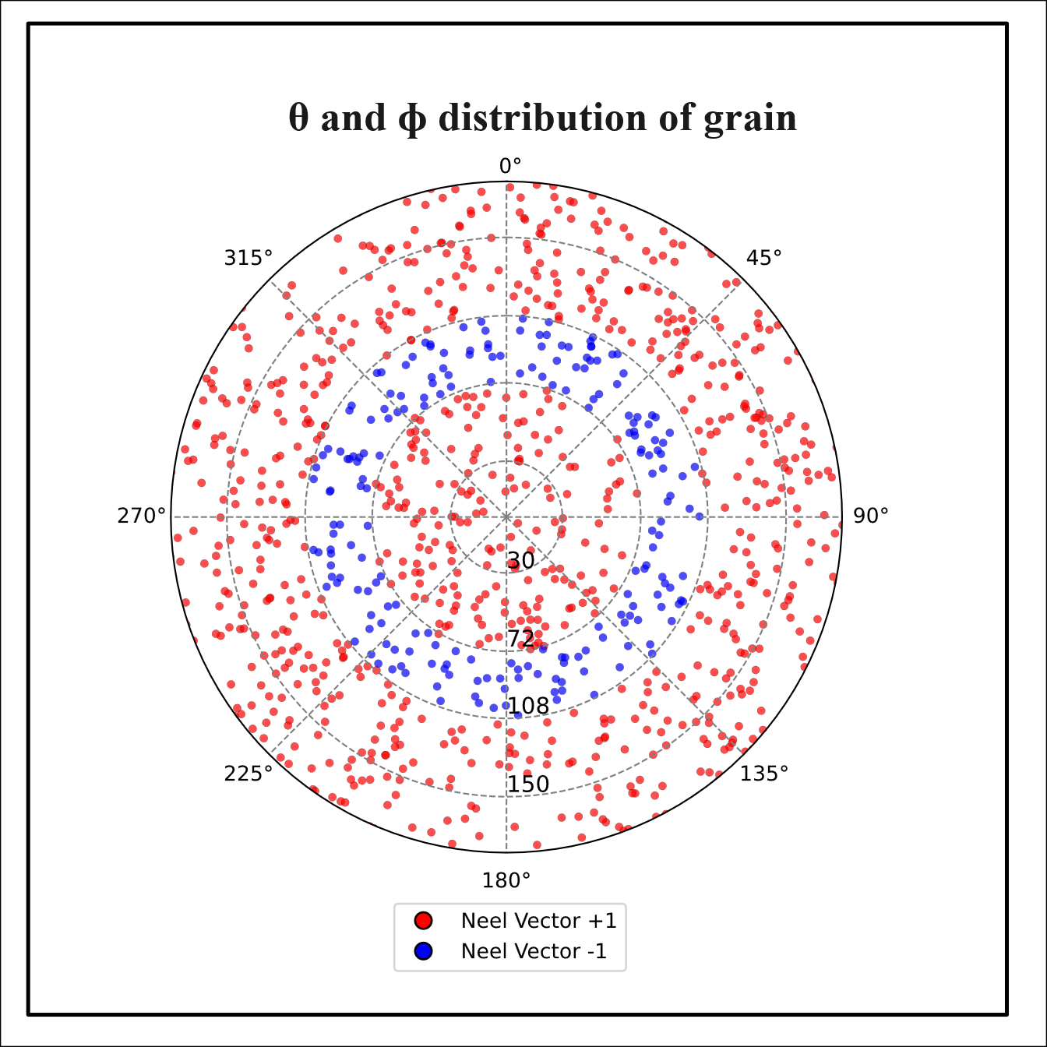
The red–blue–red pattern in Fig. S3a directly visualizes these alternating parallel–antiparallel regimes.

Fig. S3a: Angular separation between Neel states derived from the analytical condition. The boundary angles ϑ are determined from $\tan^{2}{θ} = -\frac{α∥}{α⊥}$, using extrapolated ME tensor components at ​T_{N.}

Supplementary Note 4
a).
b).
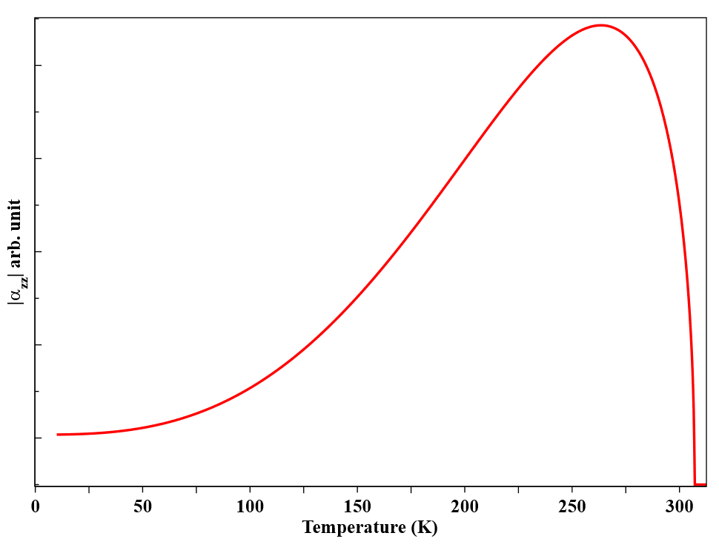
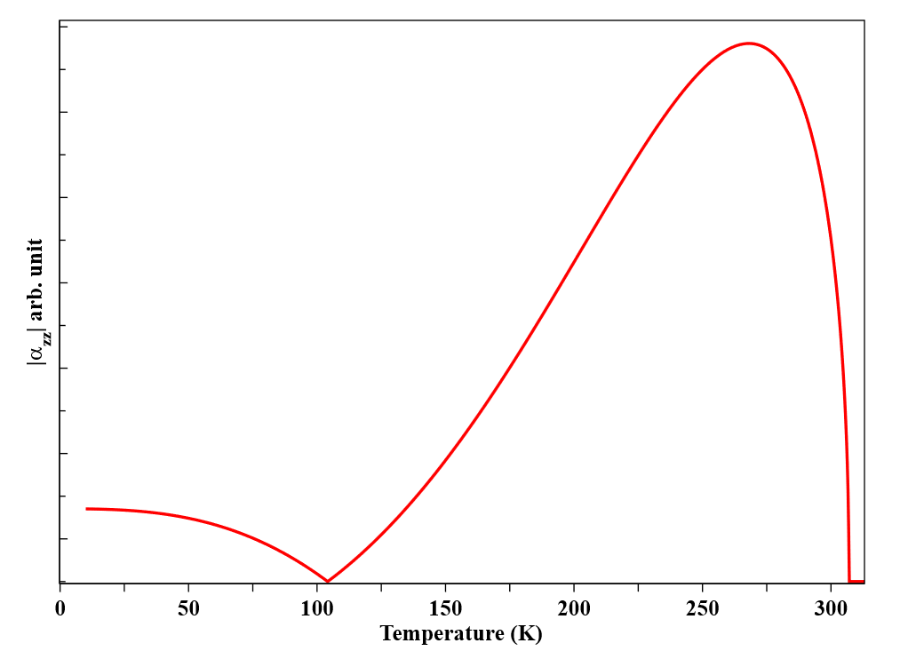

Figure S4: Simulated temperature dependence of the absolute values of the magnetoelectric susceptibility components, $\left|α_{ij}\right|$ for a single crystal milled into randomly oriented grains and cooled below the Néel temperature under collinear electric and magnetic fields. (a) $\left|α_{zz}\right|$; (b) $\left|α_{zx}\right|$ .

