Supplementary Materials A. Detailed Results
Article Title: Decades of Urban Water Quality Data: A Multivariate Exploration Using Indianapolis as a Case Study
Journal: Environmental Monitoring and Assessment
Authors: Raenah Bailey, Gabriel Filippelli, Jeffery Wilson
Corresponding Author:
Raenah Bailey
Department of Earth Sciences, Indiana University Indianapolis
Indianapolis, Indiana 46202, USA
Email: raeabail@iu.edu

A1. Overview
This Supplementary Materials document provides the full technical results supporting the analyses presented in the manuscript. It includes full descriptive statistics, principal component analysis (PCA) loading matrices, clustering, and spatial figures that were condensed in the main Results section for clarity and readability. These materials ensure transparency and reproducibility of the multivariate analyses. Additional site-level visualizations and interactive summaries are also available in the accompanying web application (https://raeabail.github.io/indy-urban-water-quality-app/).

A2. Descriptive Statistics
Comprehensive descriptive statistics for all measured water quality parameters measured across the three monitored sites (Eagle Creek, Fall Creek, and the Lower White River) are provided in Tables A2.1-A2.3. These tables include the full distributions (mean, standard deviation, minimum, and maximum) of nutrients, ions, heavy metals, and microbial indicators.

Table A2.1 Descriptive statistics of all parameters for Eagle Creek
Parameter | Units | Mean | Standard Deviation | Minimum | Maximum
Temperature | °C | 20.0 | 11.6 | -0.3 | 82.9
pH | Units | 7.94 | 0.58 | 6.59 | 12.6
Specific Conductivity  (SpCond) | µS/cm | 2.61 | 1.09 | 0.50 | 5980
Total Dissolved Solids (TDS) | mg/L | 404 | 236 | 0.70 | 7100
Dissolved Oxygen (DO) | mg/L | 10.2 | 30.2 | 0.87 | 748
E. coli | colonies/100mL | 140 | 995 | 1.00 | 24,200
NH₃ | mg/L | 0.189 | 1.37 | 0.10 | 60.2
NO₃ | mg/L | 2.86 | 2.88 | 0.50 | 42.0
NO₂ | mg/L | 0.314 | 0.099 | 0.30 | 2.60
Chloride | mg/L | 49.9 | 35.3 | 4.00 | 370
SO₄ | mg/L | 31.2 | 14.4 | 6.00 | 108
PO₄ | mg/L | 0.313 | 0.461 | 0.03 | 25.4
Arsenic | µg/L | 0.0015 | 0.0043 | 0.000 | 0.218
Barium | µg/L | 0.0647 | 0.0488 | 0.015 | 1.71
Cadmium | µg/L | 0.0011 | 0.0025 | 0.000 | 0.086
Chromium | µg/L | 0.0028 | 0.0061 | 0.001 | 0.131
Copper | µg/L | 0.0030 | 0.0166 | 0.001 | 0.572
Mercury | µg/L | 0.0000 | 0.0000 | 0.000 | 0.0004
Nickel | µg/L | 0.0028 | 0.0061 | 0.001 | 0.097
Lead | µg/L | 0.0015 | 0.0086 | 0.000 | 0.384

Table A2.2 Descriptive statistics of all parameters for Fall Creek
Parameter | Units | Mean | Standard Deviation | Minimum | Maximum
Temperature | °C | 19.1 | 13.0 | 0.10 | 80.2
pH | Units | 7.88 | 0.49 | 0.36 | 12.2
Specific Conductivity  (SpCond) | µS/cm | 0.602 | 0.258 | 0.140 | 6.06
Total Dissolved Solids (TDS) | mg/L | 0.403 | 0.405 | 0.0036 | 8.08
Dissolved Oxygen (DO) | mg/L | 8.53 | 4.22 | 1.86 | 69.6
E. coli | colonies/100 mL | 1,490 | 4,490 | 1.00 | 24,200
NH₃ | mg/L | 0.478 | 9.24 | 0.10 | 253
NO₃ | mg/L | 1.04 | 0.737 | 0.10 | 5.13
NO₂ | mg/L | 0.428 | 3.20 | 0.05 | 87.9
Chloride | mg/L | 50.2 | 30.2 | 3.50 | 537
SO₄ | mg/L | 32.6 | 13.0 | 6.00 | 101
Arsenic | µg/L | 0.0022 | 0.0017 | 0.001 | 0.042
Barium | µg/L | 0.0660 | 0.0254 | 0.015 | 0.620
Cadmium | µg/L | 0.0010 | 0.0006 | 0.001 | 0.017
Chromium | µg/L | 0.0101 | 0.0029 | 0.001 | 0.054
Copper | µg/L | 0.0402 | 0.0098 | 0.0025 | 0.217
Mercury | µg/L | 0.0004 | 0.0005 | 0.0004 | 0.012
Nickel | µg/L | 0.0049 | 0.0021 | 0.0010 | 0.029
Lead | µg/L | 0.0117 | 0.0016 | 0.0020 | 0.020
Zinc | µg/L | 0.0472 | 0.0101 | 0.0039 | 0.110

Table A2.3 Descriptive statistics of all parameters for Lower White River
Parameter | Units | Mean | Standard  Deviation | Minimum | Maximum
Temperature | °C | 17.8 | 13.6 | 0.001 | 81.0
pH | Units | 7.84 | 0.260 | 5.88 | 8.82
Specific Conductivity (SpCond) | µS/cm | 0.942 | 0.364 | 0.003 | 3.77
Total Dissolved Solids (TDS) | mg/L | 0.611 | 0.254 | 0.002 | 3.89
Dissolved Oxygen (DO) | mg/L | 9.31 | 2.97 | 1.98 | 25.2
E. coli | colonies/100 mL | 2,470 | 6,270 | 10.0 | 98,300
NH₃ | mg/L | 0.683 | 10.5 | 0.10 | 337
NO₃ | mg/L | 1.07 | 10.3 | 0.20 | 358
NO₂ | mg/L | 0.311 | 0.122 | 0.03 | 3.20
Chloride | mg/L | 157 | 382 | 4.00 | 9,680
SO₄ | mg/L | 51.6 | 25.7 | 2.30 | 157
PO₄ | mg/L | 0.425 | 2.93 | 0.19 | 80.6
Arsenic | µg/L | 2.15 | 2.15 | 1.00 | 51.8
Barium | µg/L | 72.9 | 1.1 | 5.90 | 756
Cadmium | µg/L | 1.00 | 0.0038 | 0.87 | 1.00
Chromium | µg/L | 10.0 | 1.71 | 1.10 | 37.9
Copper | µg/L | 40.5 | 7.11 | 20.1 | 171
Mercury | µg/L | 0.478 | 2.70 | 0.20 | 93.9
Nickel | µg/L | 4.34 | 1.56 | 1.00 | 13.2
Lead | µg/L | 11.6 | 5.90 | 1.20 | 148
Zinc | µg/L | 123 | 2,740 | 1.40 | 95,200

A3. Principal Component Analysis (PCA) Loading Matrices
PCA results for all three monitored sites (Eagle Creek, Fall Creek, and Lower White River) are presented in A3.1-A3.6. These tables include the full unrotated component loadings, varimax-rotated loadings, eigenvalues, and cumulative variance for each site. Eigenvalues and scree plots corresponding to each PCA are provided in Figures A3.1-3.3.

  Table A3.1 Eagle Creek PCA
  Parameters | PC1 | PC2 | PC3
  TDS | 0.076 | -0.096 | 0.068
  E. coli | -0.013 | -0.035 | -0.121
  Arsenic | 0.001 | 0.014 | -0.033
  Cadmium | 0.009 | 0.025 | -0.043
  Chromium | 0.027 | 0.117 | 0.963
  Copper | -0.005 | 0.003 | -0.008
  Chloride | 0.486 | -0.860 | 0.075
  NO₂ | 0.008 | 0.029 | -0.195
  PO₄ | 0.002 | 0.020 | -0.039
  SO₄ | 0.870 | 0.484 | -0.078
  Total Variance (%) | 64.543 | 11.913 | 5.666
  Cumulative Variance (%) | 64.543 | 76.457 | 82.123
  Table A3.2 Eagle Creek PCA after varimax rotation
  Parameters | VC1 | VC2 | VC3
  TDS | -0.01 | 0.64 | 0.08
  E. coli | 0.01 | 0.02 | -0.71
  Arsenic | 0.93 | -0.02 | 0.03
  Cadmium | 0.72 | 0.02 | 0.06
  Chromium | -0.01 | 0.04 | 0.70
  Copper | 0.00 | -0.07 | 0.03
  Chloride | -0.01 | 0.87 | -0.01
  NO₂ | 0.34 | 0.05 | -0.20
  PO₄ | 0.94 | -0.01 | 0.02
  SO₄ | 0.04 | 0.83 | 0.12
  Proportion % | 0.45 | 0.35 | 0.20
  Cumulative % | 0.45 | 0.80 | 1.00

  Table A3.3 Fall Creek PCA
  Parameters | PC1 | PC2 | PC3
  TDS | 0.007 | 0.056 | 0.026
  E. coli | 0.999 | -0.050 | 0.004
  Barium | 0.005 | 0.103 | -0.025
  Chromium | -0.004 | 0.002 | 0.031
  Copper | 0.001 | 0.023 | -0.127
  Lead | 0.003 | -0.037 | 0.557
  Zinc | -0.015 | -0.112 | 0.811
  Chloride | 0.025 | 0.273 | 0.042
  SO₄ | 0.043 | 0.946 | 0.110
  NH₃ | -0.001 | 0.011 | 0.007
  Total Variance (%) | 41.30 | 24.46 | 12.127
  Cumulative Variance (%) | 41.30 | 65.76 | 77.889
  Table A3.4 Fall Creek PCA after varimax rotation
  Parameters | VC1 | VC2 | VC3
  TDS | 0.41 | 0.10 | -0.10
  E. coli | 0.11 | 0.06 | -0.72
  Barium | 0.57 | -0.19 | 0.08
  Chromium | 0.01 | 0.11 | 0.45
  Copper | 0.03 | -0.67 | 0.02
  Lead | 0.04 | 0.74 | -0.01
  Zinc | -0.08 | 0.60 | 0.11
  Chloride | 0.85 | 0.00 | 0.01
  SO₄ | 0.83 | -0.06 | 0.07
  NH₃ | 0.06 | 0.00 | 0.52
  Proportion (%) | 0.44 | 0.33 | 0.23
  Cumulative (%) | 0.44 | 0.77 | 1.00

  Table A3.5 Lower White River PCA
  Parameters | PC1 | PC2 |  | PC3
  TDS | -1.856 | 0.059 |  | 0.603
  E. coli | 8.392 | -0.028 |  | -0.717
  Arsenic | -2.084 | 0.052 |  | 0.119
  Barium | -7.305 | 0.047 |  | 0.203
  Chromium | 1.505 | 0.130 |  | -0.012
  Nickel | 2.105 | 0.967 |  | -0.027
  Chloride | -3.486 | -0.015 |  | 0.151
  NO₂ | -1.472 | 0.003 |  | -0.009
  SO₄ | -9.522 | 0.198 |  | -0.210
  NH₃ | 8.462 | 0.006 |  | 0.012
  Total Variance (%) | 47.70 | 25.81 |  | 7.126
  Cumulative Variance (%) | 47.70 | 73.51 |  | 80.634
  Table A3.6 Lower White River PCA after varimax rotation
  Parameters | VC1 | VC2 | VC3 | VC4
  TDS | 0.71 | 0.02 | 0.42 | 0.05
  E. coli | -0.52 | 0.00 | 0.08 | 0.08
  Arsenic | 0.13 | 0.42 | 0.49 | -0.33
  Barium | 0.65 | 0.11 | 0.03 | 0.40
  Chromium | 0.02 | 0.77 | -0.03 | -0.02
  Nickel | -0.09 | 0.77 | -0.08 | 0.11
  Chloride | 0.17 | -0.15 | 0.68 | -0.08
  NO₂ | 0.34 | 0.03 | -0.54 | -0.46
  SO₄ | 0.71 | 0.11 | 0.11 | -0.04
  NH₃ | 0.08 | 0.04 | -0.09 | 0.75
  Proportion % | 0.34 | 0.25 | 0.22 | 0.19
  Cumulative % | 0.34 | 0.59 | 0.81 | 1.00

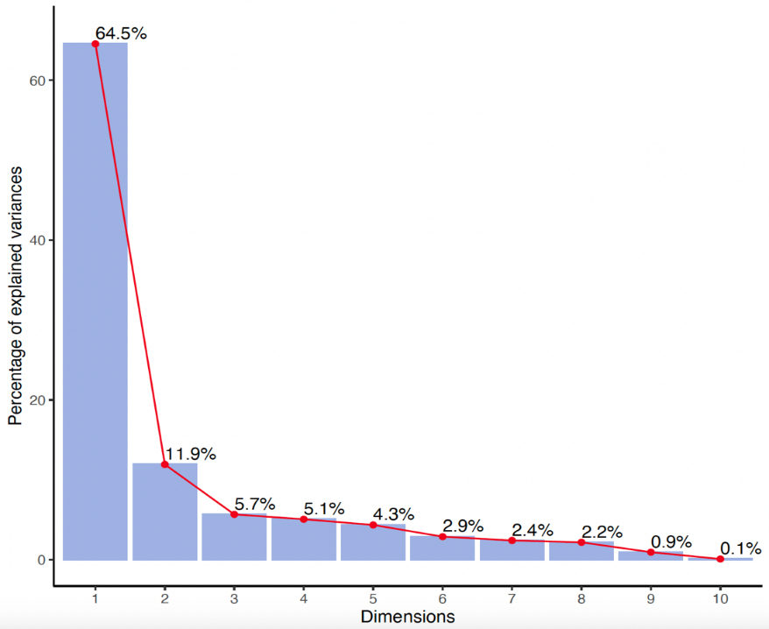
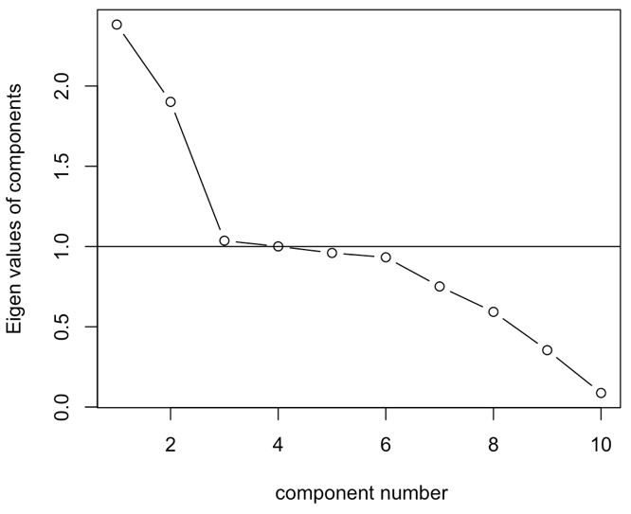
Fig A3.2 Eagle Creek scree plot of the principal components

Fig A3.1 Eagle Creek eigenvalues from PCA
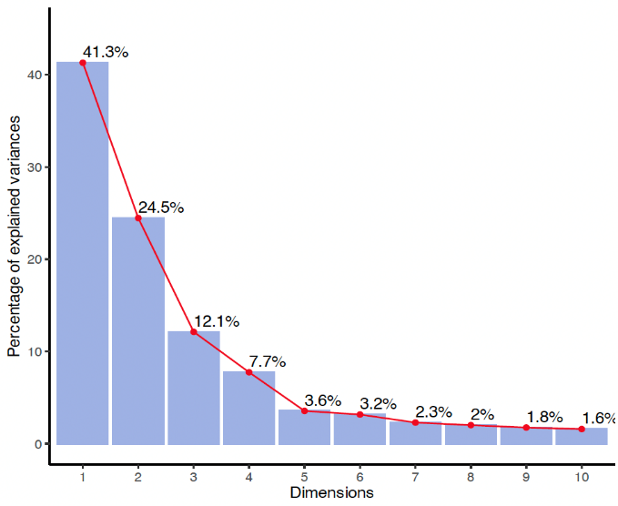
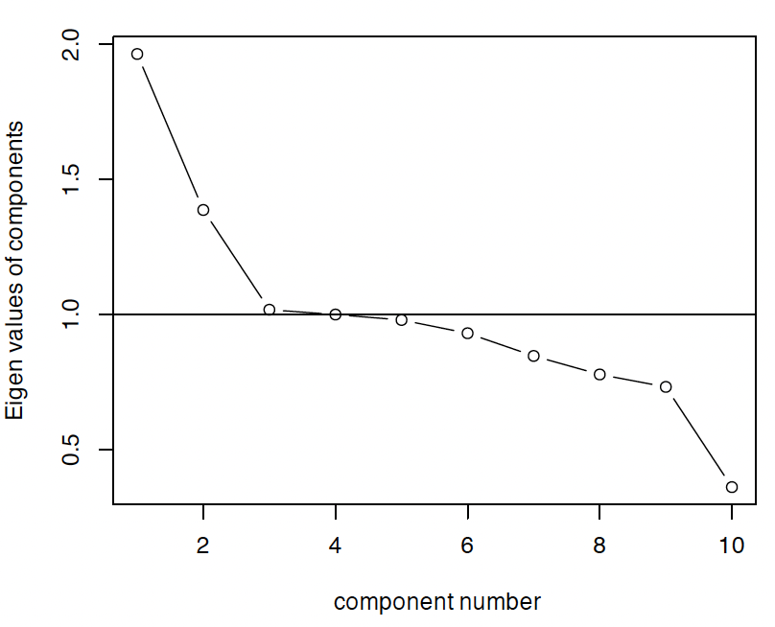
Fig A3.4 Fall Creek scree plot of the principal components
Fig A3.3 Fall Creek eigenvalues from PCA

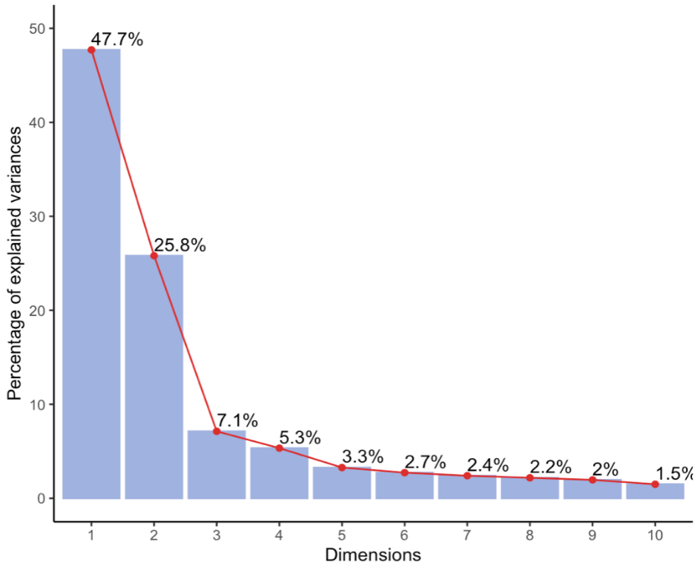
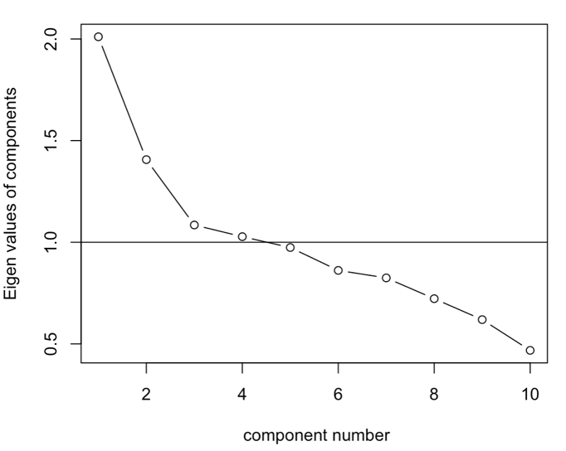
Fig A3.6 Lower White River scree plot of the principal components
Fig A3.5 Lower White River eigenvalues from PCA

