Supplementary material

QCT
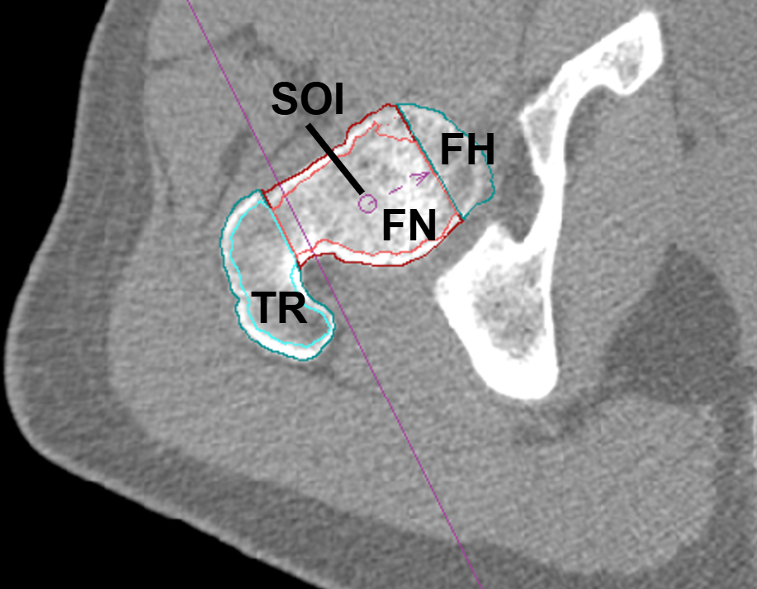 | 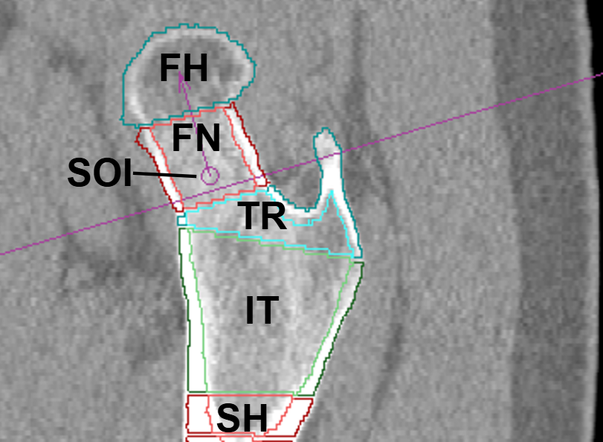
A | B
Figure 1: Segmentation of volumes of interest (VOIs), as analyzed by MIAF Femur at the right proximal femur. Axial view (A) illustrating the femoral head (FH), femoral neck (FN), greater trochanter (TR), and sausage of interest (SOI) VOIs. Sagittal view (B) depicting the FH, FN, SOI, TR, intertrochanteric region (IT) VOIs, and the subtrochanteric proximal shaft (SH) VOI with a fixed length of 10 mm.
Integral VOI | All Groups (N=24) | P-Value |  | P-Value
 | Δ% | Main Effect of Time |  | Time x Group Interaction
 | BDC-12/R+8 | ATS | ANOVA | ATS | ANOVA
FH vBMD | -2.34 ± 0.50 | <0.001 | <0.001 | 0.21 | <0.10
TF vBMD | -0.79 ± 0.64 | 0.44 | 0.16 | 0.34 | 0.22
FN vBMD | -1.34 ± 0.74 | 0.50 | 0.06 | 0.12 | 0.18
TR vBMD | -2.13 ± 0.55 | <0.001 | <0.001 | 0.73 | 0.28
IT vBMD | 0.42 ± 0.83 | 0.50 | 0.66 | 0.29 | 0.36
SH vBMD | -0.26 ± 0.69 | 0.62 | 0.67 | 0.18 | 0.14
FH BMC | -3.03 ± 0.66 | <0.01 | <0.001 | 0.53 | 0.21
TF BMC | -0.83 ± 0.67 | 0.53 | 0.13 | 0.96 | 0.27
FN BMC | -0.52 ± 1.06 | 0.24 | 0.35 | 0.08 | 0.33
TR BMC | -2.98 ± 0.80 | <0.001 | <0.001 | 0.85 | 0.56
IT BMC | 0.74 ± 0.84 | 0.68 | 0.52 | 0.59 | 0.34
SH BMC | 0.08 ± 0.51 | 0.62 | 0.91 | 0.21 | 0.35
FH Vol | -0.71 ± 0.34 | 0.14 | 0.08 | 0.72 | 0.77
TF Vol | -0.04 ± 0.12 | 0.43 | 0.48 | 0.53 | 0.92
FN Vol | 0.82 ± 0.61 | 0.08 | 0.02 | 0.45 | 0.97
TR Vol | -0.89 ± 0.45 | 0.04 | 0.05 | 0.78 | 0.99
IT Vol | 0.33 ± 0.34 | 0.63 | 0.30 | 0.44 | 0.95
SH Vol | 0.39 ± 0.38 | 0.38 | 0.22 | 0.37 | 0.23
Table 1: Results of longitudinal analyses of integral volumetric bone mineral density (vBMD), bone mineral content (BMC), and volume (Vol) at the femoral head (FH), total femur (TF), femoral neck (FN), trochanter major (TR), intertrochanteric region (IT), and subtrochanteric femoral shaft (SH) volumes of interest (VOIs); Relative percent changes (Δ%) of post bed rest (R+8) measurements compared to baseline (BDC-12) across pooled groups are presented as mean ± SEM. N indicates the number of participants. P-values for the main effect of time and the time × group interaction are reported for both parametric (repeated-measures ANOVA) and non-parametric (ANOVA-type statistic (ATS), nparLD) statistical testing.
VOI | Ctrl |  | cAG |  | iAG
 | Δ% | P-Value | Δ% | P-Value | Δ% | P-Value
 | BDC-12/R+8 |  | BDC-12/R+8 |  | BDC-12/R+8
FH vBMD | -3.41 ± 0.86 | <0.001 | -2.70 ± 0.82 | <0.01 | -0.92 ± 0.76 | 0.26
TF vBMD | -1.80 ± 0.81 | 0.06† | -1.28 ± 1.35 | 0.30 | 0.70 ± 1.06 | 0.60
FN vBMD | -2.57 ± 0.86 | 0.03 | -1.83 ± 1.35 | 0.16 | 0.39 ± 1.45 | 0.73
TR vBMD | -2.30 ± 0.84 | <0.01 | -3.18 ± 1.17 | <0.01 | -0.92 ± 0.73 | 0.26
IT vBMD | -0.95 ± 0.96 | 0.40 | 0.38 ± 1.67 | 0.64 | 1.84 ± 1.57 | 0.26
SH vBMD | -1.84 ± 0.70 | 0.09 | -0.29 ± 1.39 | 0.94 | 1.36 ± 1.26 | 0.27
FH BMC | -4.21 ± 1.06 | <0.001 | -3.44 ± 1.25 | 0.03* | -1.43 ± 1.04 | 0.16
TF BMC | -1.85 ± 0.79 | 0.05 | -1.40 ± 1.36 | 0.35 | 0.76 ± 1.21 | 0.77
FN BMC | -2.04 ± 0.69 | 0.13 | -1.30 ± 1.12 | 0.50 | 1.80 ± 2.86 | 0.57
TR BMC | -2.90 ± 0.89 | <0.01 | -3.88 ± 1.61 | 0.02 | -2.17 ± 1.66 | 0.17
IT BMC | -0.74 ± 1.00 | 0.45 | 0.47 ± 1.43 | 0.56 | 2.49 ± 1.79 | 0.20
SH BMC | -0.83 ± 0.68 | 0.27 | 0.38 ± 1.05 | 0.51 | 0.70 ± 0.89 | 0.51
FH Vol | -0.83 ± 0.55 | 0.11 | -0.78 ± 0.73 | 0.49 | -0.53 ± 0.53 | 0.41
TF Vol | -0.05 ± 0.15 | 0.50 | -0.12 ± 0.11 | 0.66 | 0.05 ± 0.32 | 0.92
FN Vol | 0.55 ± 0.29 | 0.52 | 0.57 ± 0.34 | 0.51 | 1.33 ± 1.86 | 0.34
TR Vol | -0.61 ± 0.32 | 0.24 | -0.76 ± 0.56 | 0.29 | -1.28 ± 1.25 | 0.20
IT Vol | 0.22 ± 0.12 | 0.66 | 0.12 ± 0.42 | 0.61 | 0.65 ± 0.96 | 0.39
SH Vol | 1.04 ± 0.54 | 0.08 | 0.72 ± 0.58 | 0.34 | -0.60 ± 0.77 | 0.53
Table 2: Results of longitudinal analyses of integral volumetric bone mineral density (vBMD), bone mineral content (BMC), and volume (Vol) at the femoral head (FH), total femur (TF), femoral neck (FN), trochanter major (TR), intertrochanteric region (IT), and subtrochanteric femoral shaft (SH) volumes of interest (VOIs). Relative percent changes (Δ%) of post bed rest (R+8) measurements compared to baseline (BDC-12 are presented as means ± SEM for each experimental group: control (Ctrl), continuous artificial gravity (cAG), and intermittent artificial gravity (iAG). N indicates the number of participants. Within-group changes from baseline as detected by repeated measures ANOVA are indicated as †p < 0.10 (trend), * p < 0.05, ** p < 0.01, <0.001*** (Bonferroni-corrected).

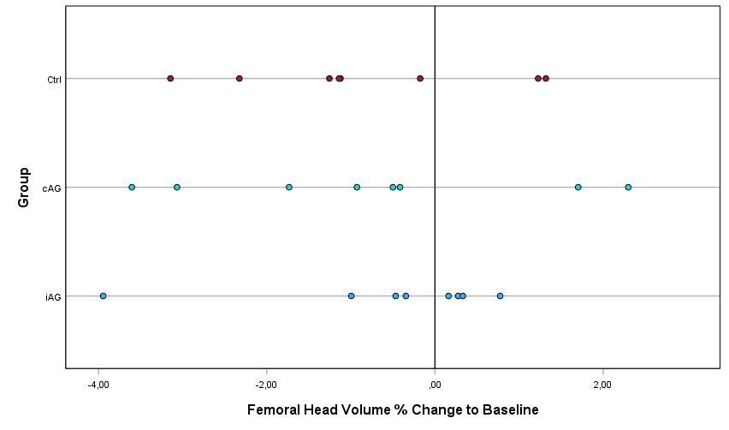A | 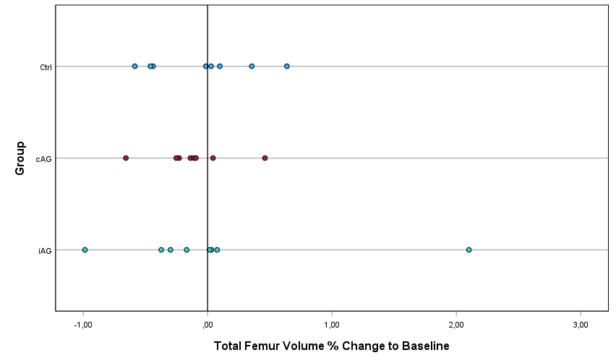  B
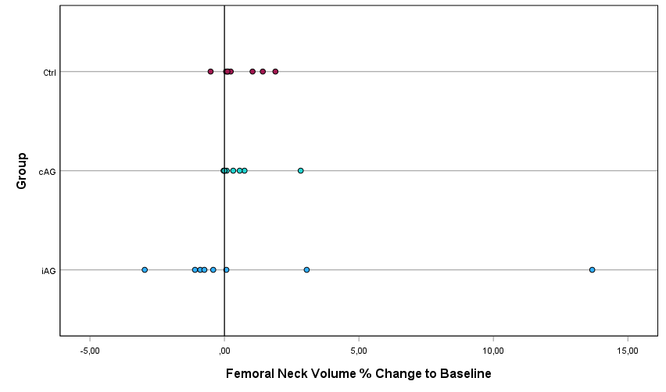C | 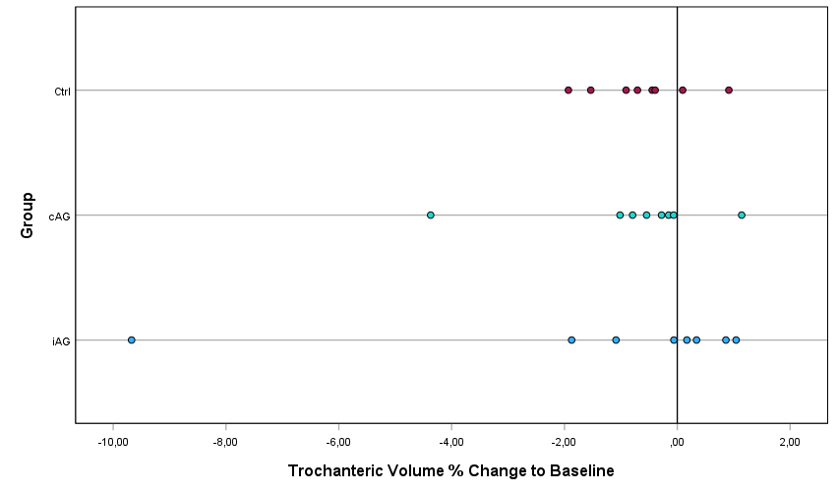D
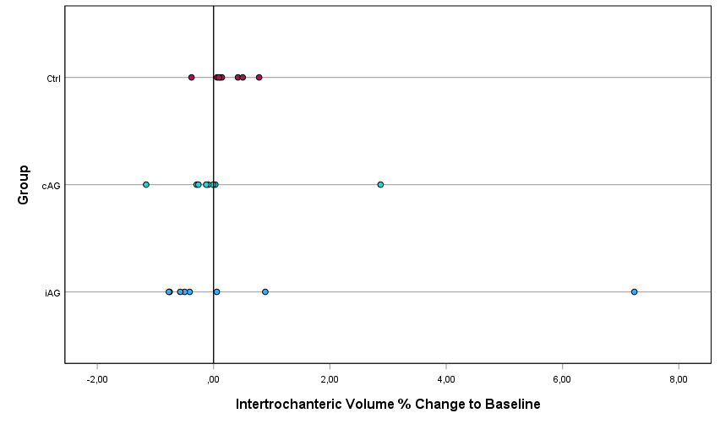E | 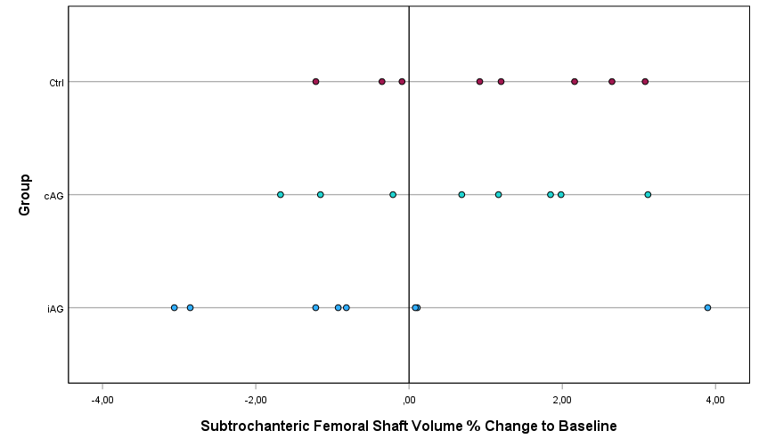F
Figure 2: Percent (%) change in volume from baseline (BDC–12) to post-bed rest (R+8) at the (A) femoral head volume of interest (VOI), (B) total femur VOI, comprising subregions (C) femoral neck, (D) greater trochanter, (E) intertrochanteric region, and (F) subtrochanteric femoral shaft. Individual values are displayed as scatter plots, grouped by experimental group (Ctrl = control; cAG = continuous artificial gravity; iAG = intermittent artificial gravity).

DXA
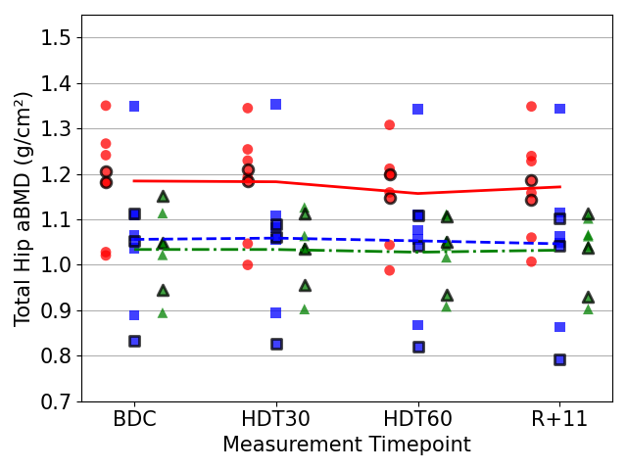  A1 | 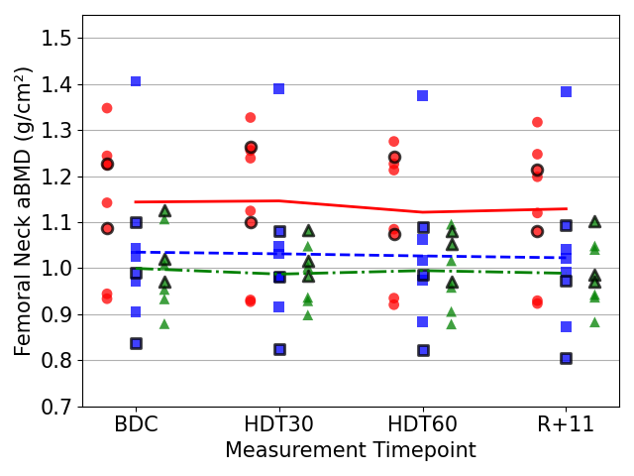  A2
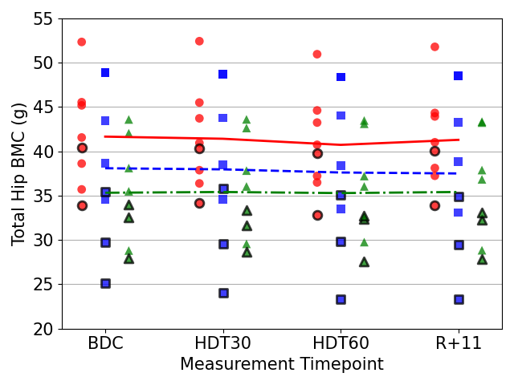  B1 | 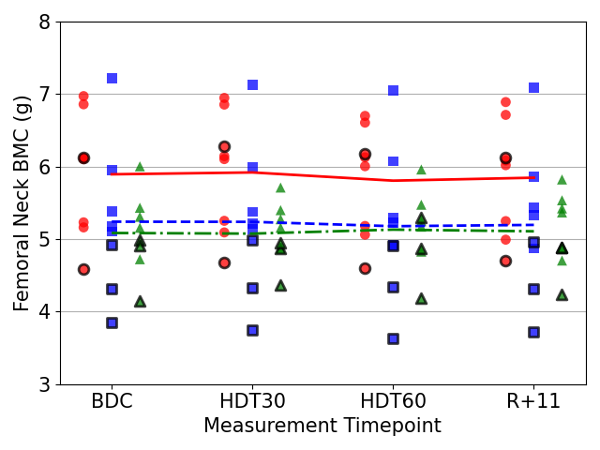  B2
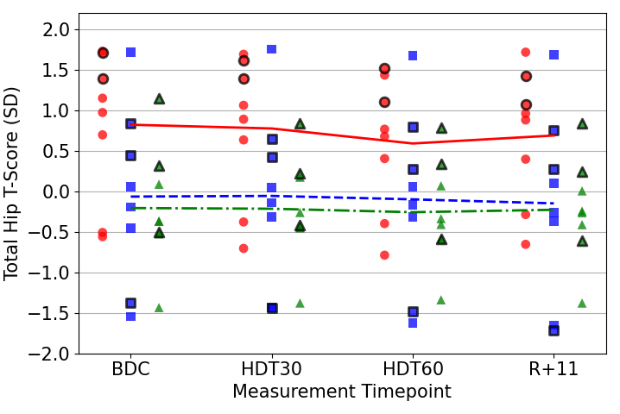  C1 | 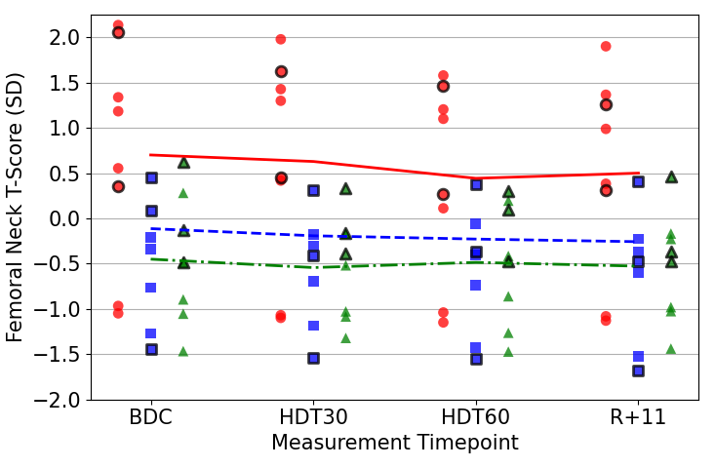  C2
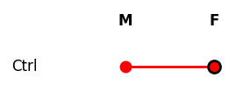 | 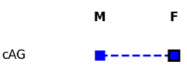 | 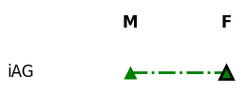

Figure 3: Scatterplots of areal bone mineral density (aBMD in g/cm²; A), bone mineral content (BMC in g; B), and T-scores (in standard deviations, SD; C) at the total hip (1) and femoral neck regions (2), measured at baseline (BDC), on day 30 (HDT30) and day 60 (HDT60) of bed rest, and 11 days post bed rest (R+11). Data points represent individual measurements categorized by intervention group: control (Ctrl), continuous artificial gravity (cAG), and intermittent artificial gravity (iAG); and by sex (male, M; female, F). Lines indicate group means.
 | Total Hip |  | Femoral Neck
 | Δ% aBMD (g/cm²) | Δ% aBMD (g/cm²) | Δ% aBMD (g/cm²) | Δ% aBMD (g/cm²)
Group | BDC/HDT60 | HDT60/R+11 | BDC/HDT60 | HDT60/R+11
Ctrl (N=8) | -2.24 ± 0.68 | 1. 23 ± 0.54 | -1.87 ± 0.79 | 0.63 ± 0.74
cAG (N=8) | -0.37 ± 0.49 | −0.72 ± 0.44 | -0.77 ± 0.49 | −0.47 ± 0.74
iAG (N=8) | -0.50 ± 0.73 | 0.42 ± 0.49 | -0.42 ± 1.02 | −0.47 ± 1.20
All Groups (N=24) | -1.03 ± 0.40 | 0.31 ± 0.32 | -1.02 ± 0.46 | -0.10 ± 0.52
Table 3: Relative percent changes (Δ%) of areal bone mineral density (aBMD, g/cm²) post bed rest (HDT60) compared to baseline measurements (BDC) and 11 days into the recovery phase (R+11) compared to HDT60 at total hip and femoral neck regions. Values are presented as means ± SEM by group: control (Ctrl), continuous artificial gravity (cAG), and intermittent artificial gravity (iAG). N indicates the number of participants.
 | Total Hip |  | Femoral Neck
 | Δ% BMC (g/cm²) | Δ% BMC (g/cm²) | Δ% BMC (g/cm²) | Δ% BMC (g/cm²)
Group | BDC/HDT60 | HDT60/R+11 | BDC/HDT60 | HDT60/R+11
Ctrl (N=8) | -2.15 ± 0.70 | 1.47 ± 0.43 | -1.35 ± 0.65 | 0.69 ± 0.61
cAG (N=8) | -1.25 ± 1.01 | -0.40 ± 0.34 | -1.30 ± 0.91 | 0.47 ± 0.75
iAG (N=8) | -0.12 ± 0.86 | 0.30 ± 0.59 | 1.00 ± 1.14 | -0.36 ± 1.52
All Groups (N=24) | -1.17 ± 0.51 | 0.46 ± 0.30 | -0.55 ± 0.56 | 0.27 ± 0.58
Table 4: Relative percent changes (Δ%) of bone mineral content (BMC, g) post bed rest (HDT60) compared to baseline measurements (BDC) and 11 days into the recovery phase (R+11) compared to HDT60 at total hip and femoral neck regions. Values are presented as means ± SEM by group: control (Ctrl), continuous artificial gravity (cAG), and intermittent artificial gravity (iAG). N indicates the number of participants.
Total Hip T-Score
Group |  | BDC | HDT30 | HDT60 | R+11
Ctrl (N=8) |  | 0.82 ± 0.32 | 0.77 ± 0.31 | 0.59 ± 0.29 | 0.69 ± 0.29
cAG (N=8) |  | -0.07 ± 0.39 | -0.06 ± 0.38 | -0.10 ± 0.39 | -0.15 ± 0.40
iAG (N=8) |  | -0.21 ± 0.26 | -0.22 ± 0.23 | -0.26 ± 0.23 | -0.23 ± 0.23
All Groups (N=24) |  | 0.18 ± 0.20 | 0.17 ± 0.19 | 0.08 ± 0.19 | 0.10 ± 0.19
Femoral Neck T-Score
 | Group | BDC | HDT30 | HDT60 | R+11
Ctrl (N=8) |  | 0.70 ± 0.43 | 0.63 ± 0.42 | 0.44 ± 0.38 | 0.50 ± 0.39
cAG (N=8) |  | -0.11 ± 0.45 | -0.19 ± 0.43 | -0.23 ± 0.43 | -0.26 ± 0.45
iAG (N=8) |  | -0.45 ± 0.25 | -0.54 ± 0.20 | -0.49 ± 0.24 | -0.53 ± 0.21
All Groups (N=24) |  | 0.05 ± 0.24 | -0.04 ± 0.23 | -0.09 ± 0.22 | -0.10 ± 0.22
Table 5: T-values (standard deviations) presented as mean ± SEM at baseline (BDC), on day 30 (HDT30) and day 60 (HDT60) of bed rest, and 11 days post bed rest (R+11) at total hip and femoral neck regions. Values are presented as means ± SEM by group: control (Ctrl), continuous artificial gravity (cAG), and intermittent artificial gravity (iAG). N indicates the number of participants.
Bed Rest Phase | P-Value | P-Value | P-Value
 | Main Effect | Main Effect | Within-Group-
 | of Time | of Time | Comparison^{B}
 | ANOVA | ANOVA | Ctrl | cAG | iAG
Total Hip aBMD | <0.001 | 0.03 | <0.01 | 1.0 | 1.0
Total Hip BMC | <0.01 | 0.14 | 0.01 | 0.73 | 1.0
Total Hip T-Score | <0.001 | 0.01 | <0.001 | 1.0 | 0.91
Femoral Neck aBMD | 0.04 | 0.09 | 0.06 | 1.0 | 1.0
Femoral Neck BMC | 0.29 | 0.12 | 0.28 | 0.66 | 1.0
Femoral Neck T-Score | <0.01 | <0.10 | <0.01 | 0.41 | 1.0
Table 6: Results of statistical testing for changes in DXA-derived parameters at the total hip and femoral neck regions between baseline data collection and end of bed rest (BDC, HDT30, HDT60). Shown are p-values for the main effect of time and the time × group interaction (mixed ANOVA, Huynh Feldt Correction), as well as exploratory within-group comparisons (^{B}Bonferroni-corrected) for each group: control (Ctrl), continuous artificial gravity (cAG), and intermittent artificial gravity (iAG). Significance levels are denoted as †p < 0.10 (trend), * p < 0.05, ** p < 0.01, *** p < 0.001.
Short Term Recovery Phase | P-Value | P-Value | P-Value
 | Main Effect | Main Effect | Within-Group-
 | of Time | of Time | Comparison^{B}
 | ANOVA | ANOVA | Ctrl | cAG | iAG
Total Hip aBMD | 0.19 | 0.03 | 0.01 | 0.23 | 0.40
Total Hip BMC | 0.07 | 0.02 | <0.01 | 0.40 | 0.46
Total Hip T-Score | 0.24 | 0.04 | 0.02 | 0.21 | 0.44
Femoral Neck aBMD | 0.89 | 0.60 | 0.46 | 0.69 | 0.56
Femoral Neck BMC | 0.71 | 0.72 | 0.47 | 0.75 | 0.69
Femoral Neck T-Score | 0.92 | 0.59 | 0.44 | 0.70 | 0.58
Table 7: Results of statistical testing for changes in DXA-derived parameters at the total hip and femoral neck regions during short term recovery from the end of bed rest to day 11 of recovery (HDT60 to R+11). Shown are p-values for the main effect of time and the time × group interaction (mixed ANOVA), as well as exploratory within-group comparisons (^{B}Bonferroni-corrected) for each group: control (Ctrl), continuous artificial gravity (cAG), and intermittent artificial gravity (iAG). Significance levels are denoted as †p < 0.10 (trend), * p < 0.05, ** p < 0.01.

