Screenshots of the SGED Score Dashboard Prototype in German
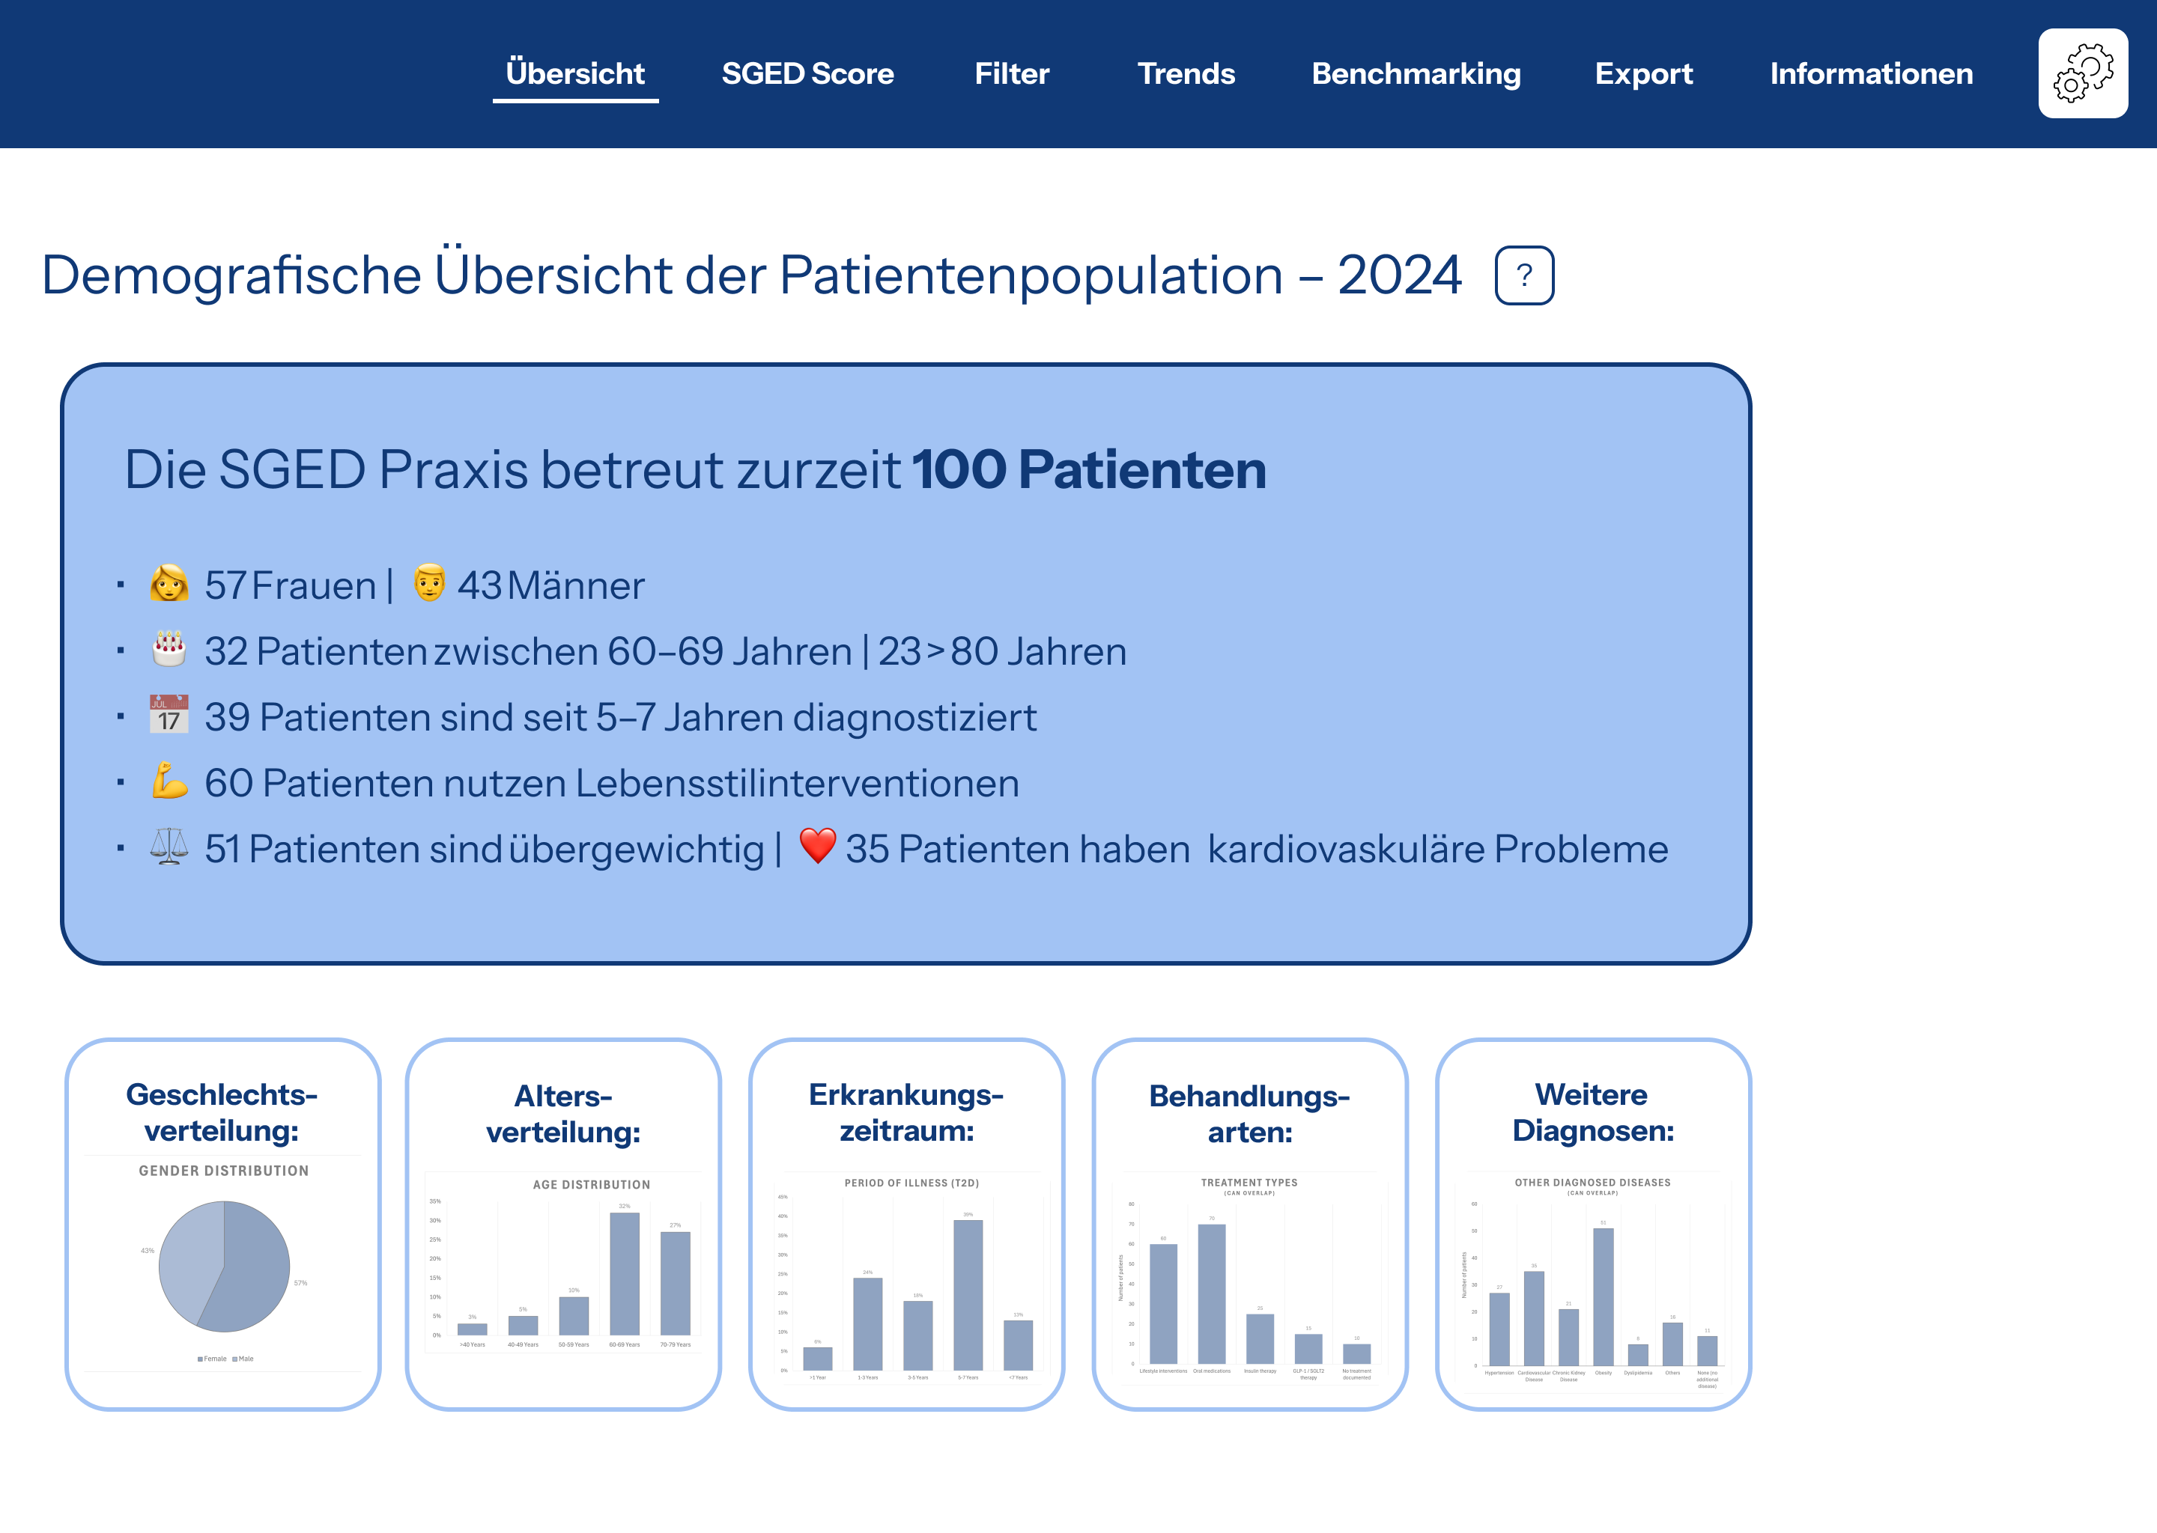
Figure 3: Demographic overview over the patient collective
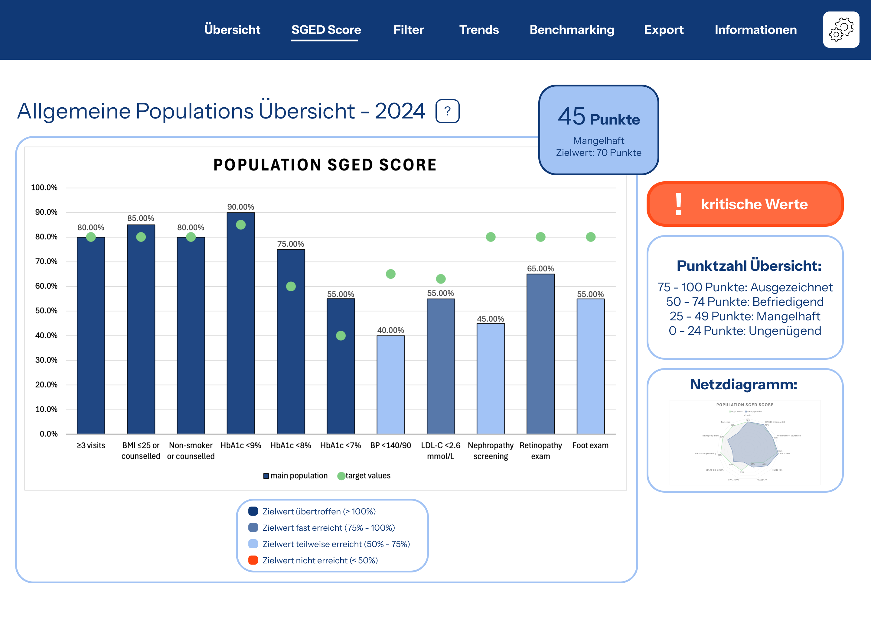
Figure 4: Visualization of the SGED score (main population)
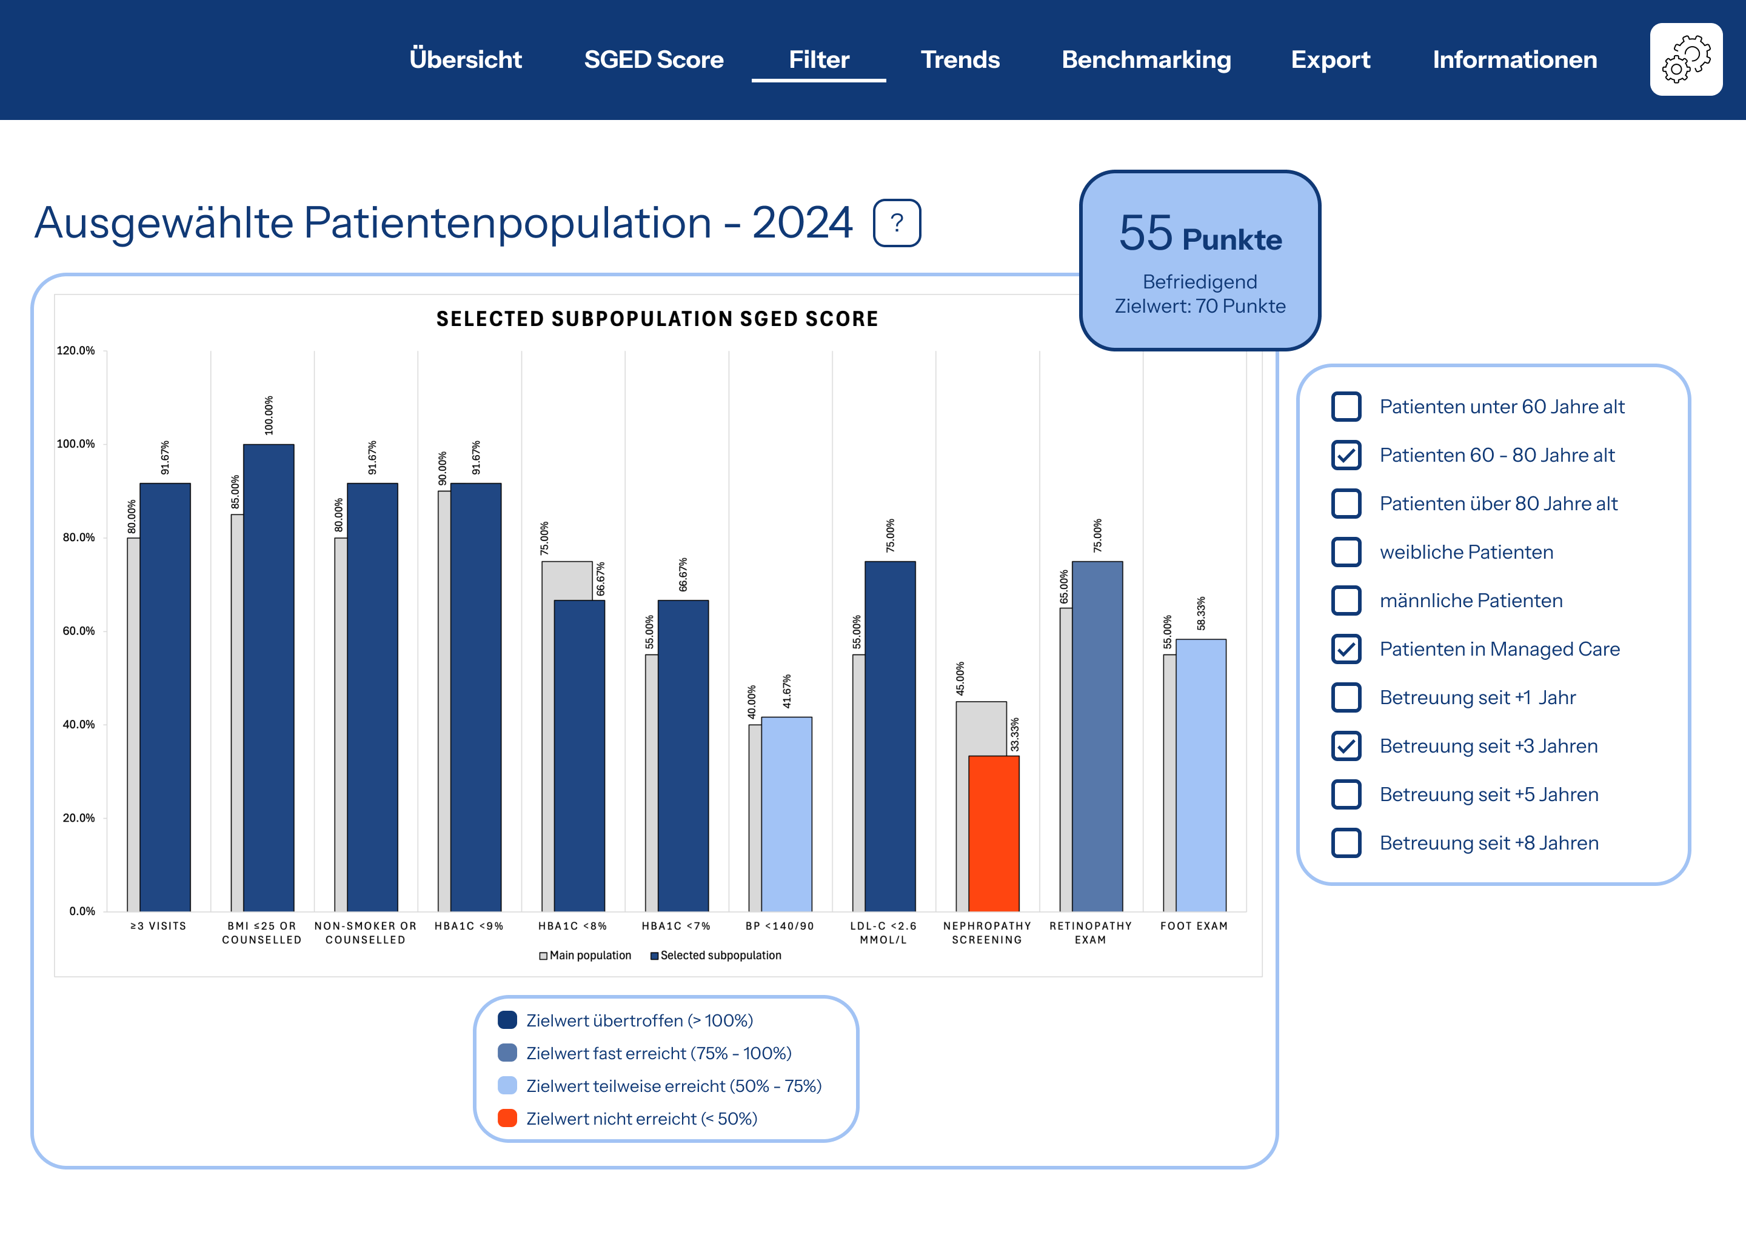
Figure 5: Filter possibilities to identify specific subgroups
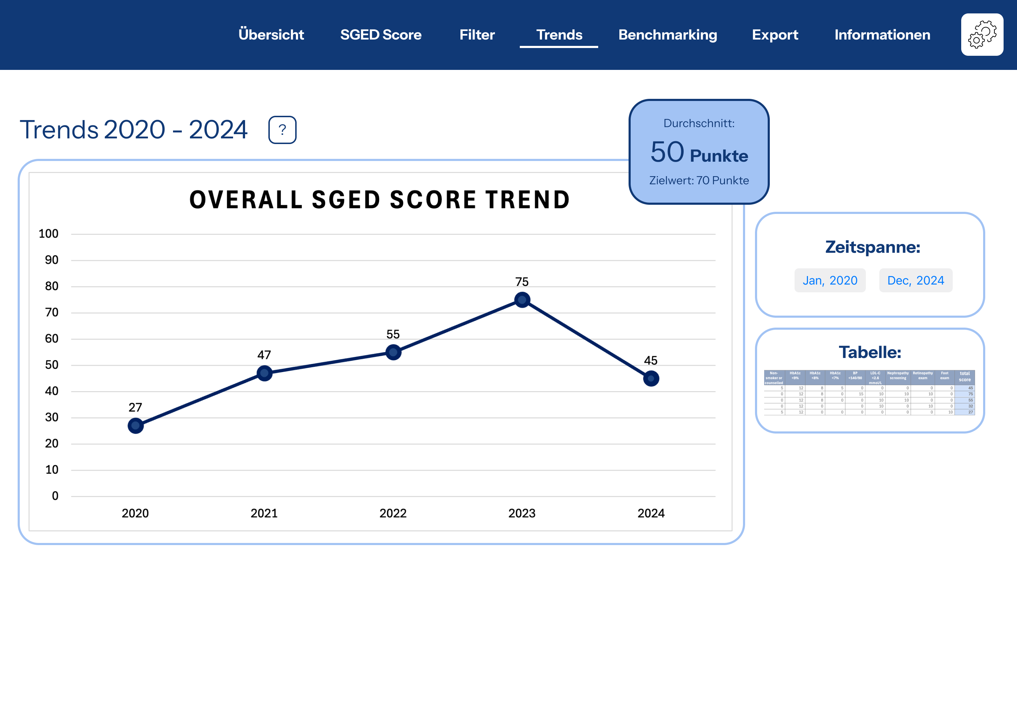
Figure 6: Long term trends
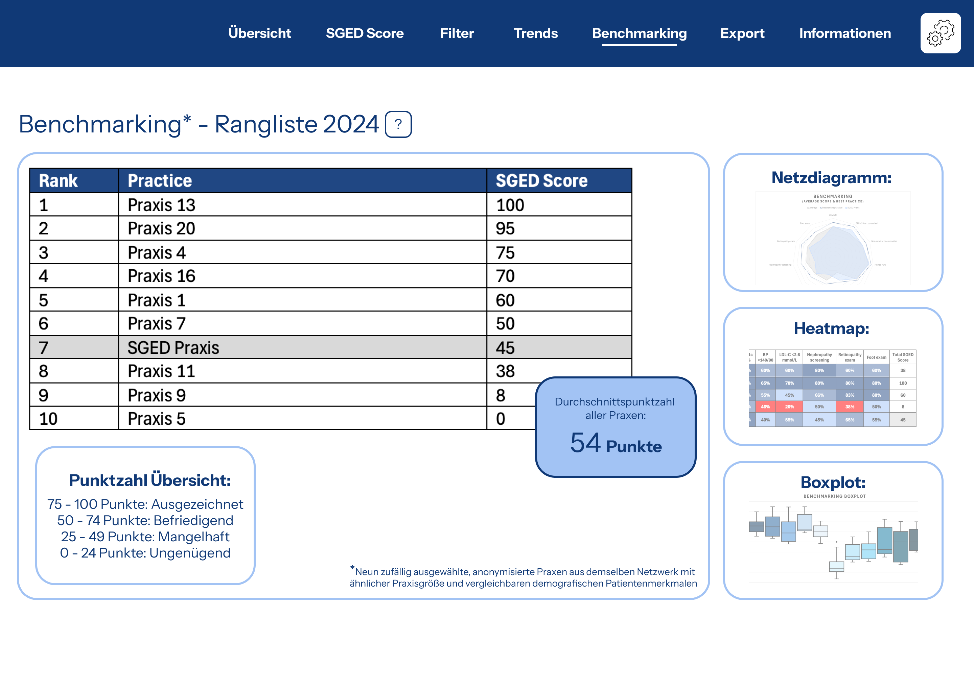
Figure 7: Anonymized benchmarking within the network
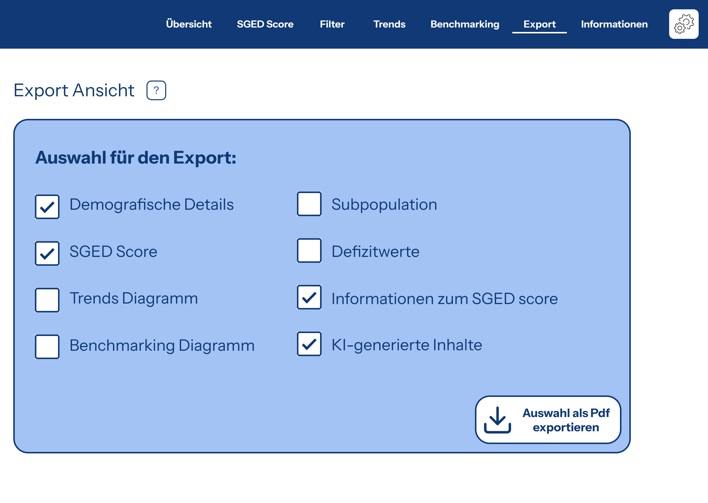
Figure 8: Exporting and reporting function
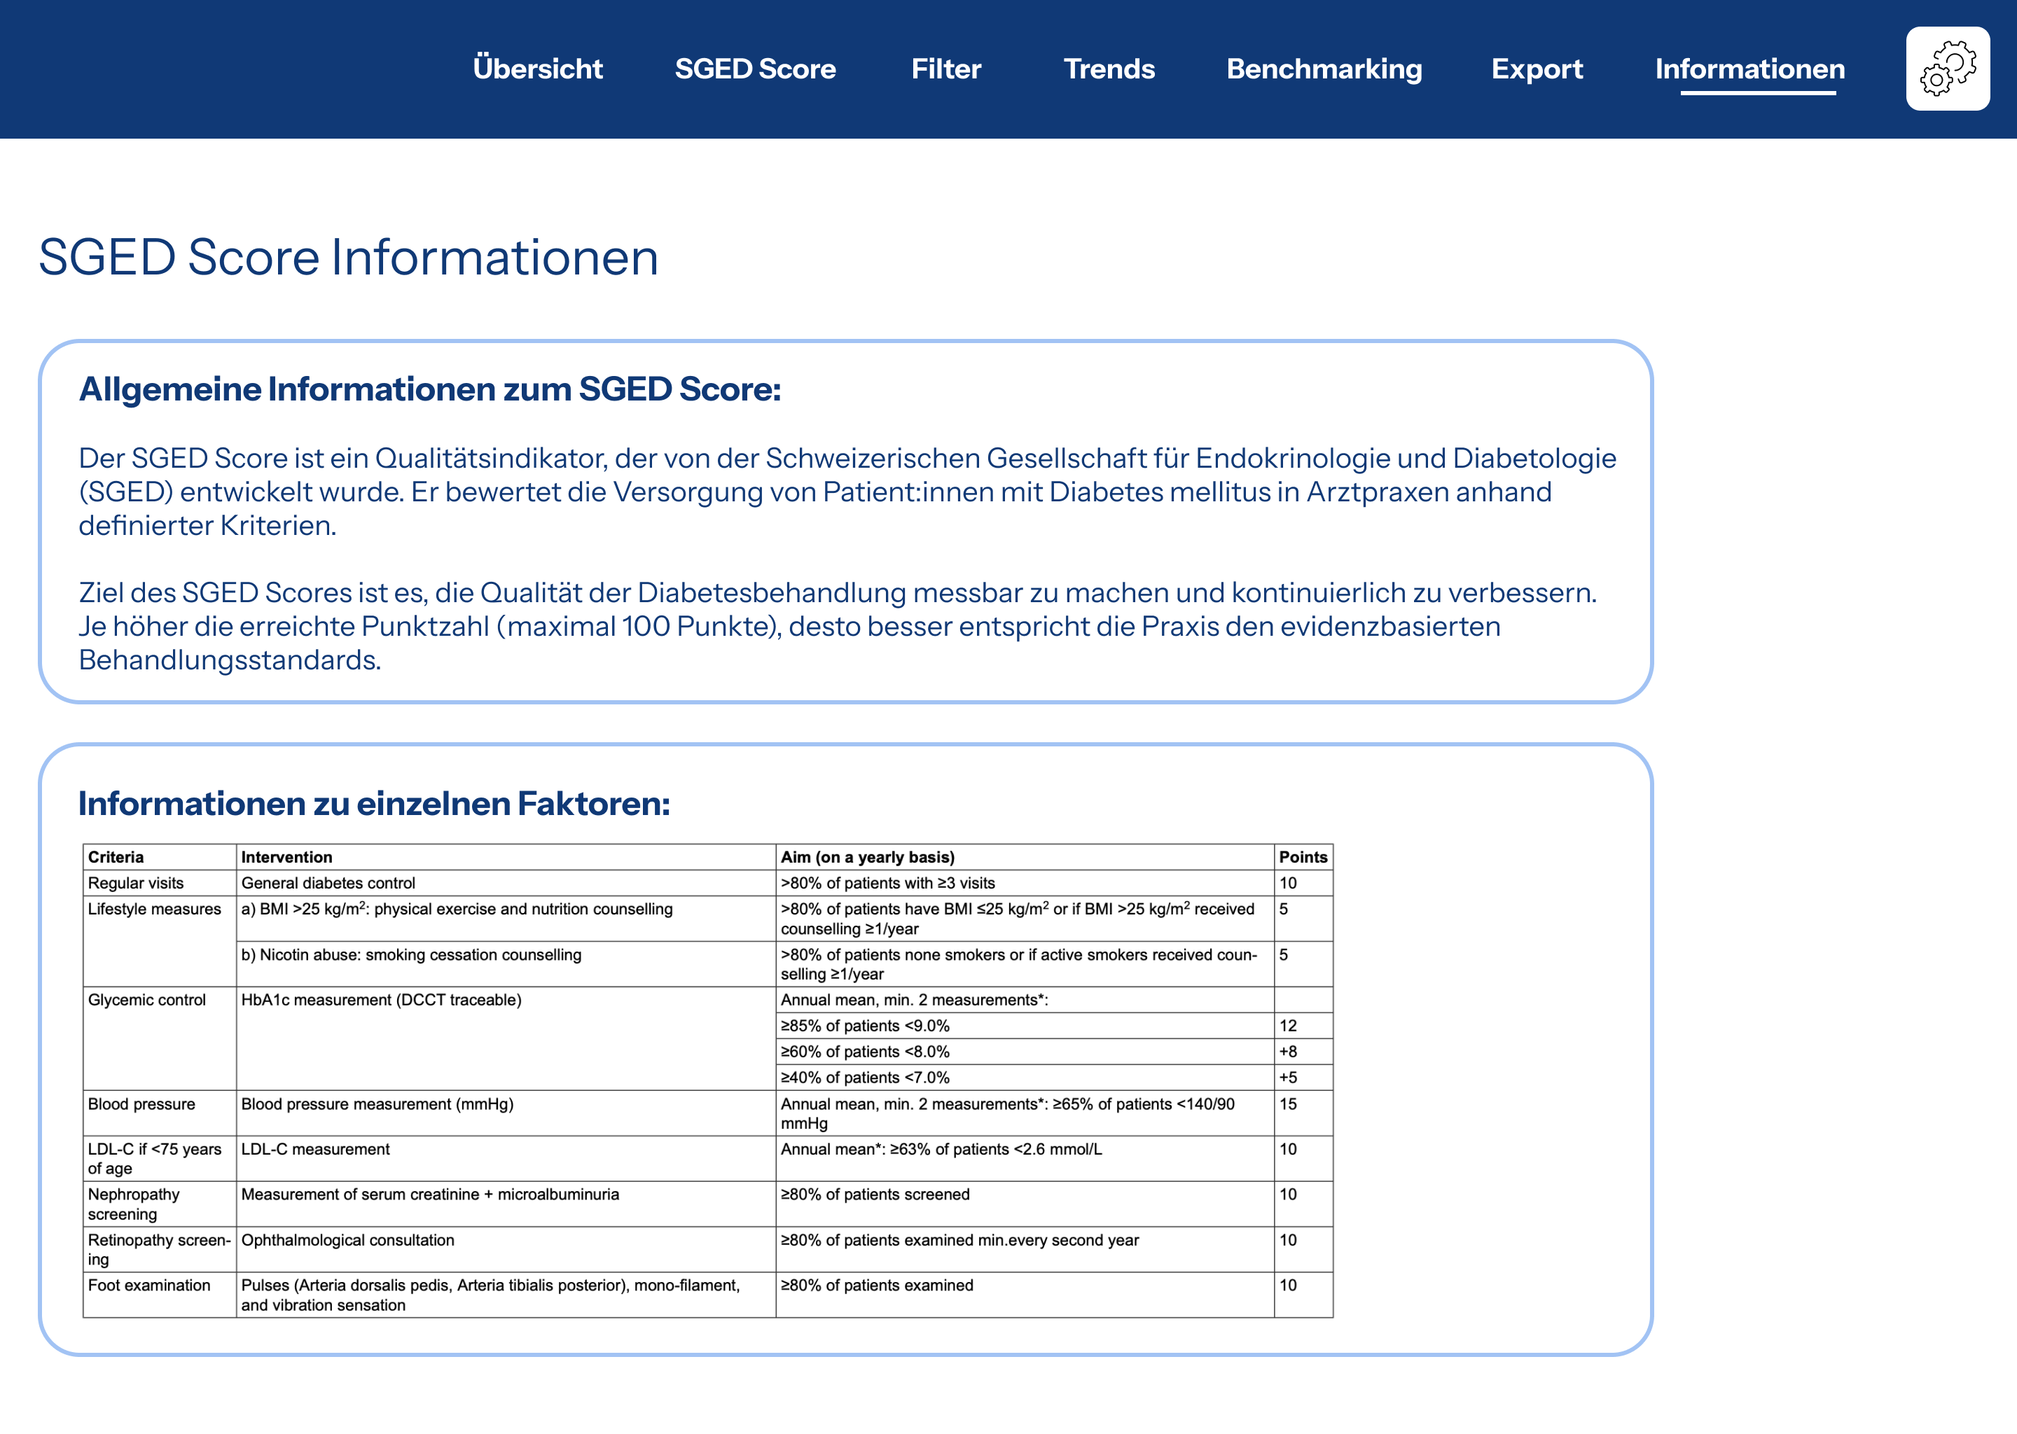
Figure 9: Information regarding the SGED score
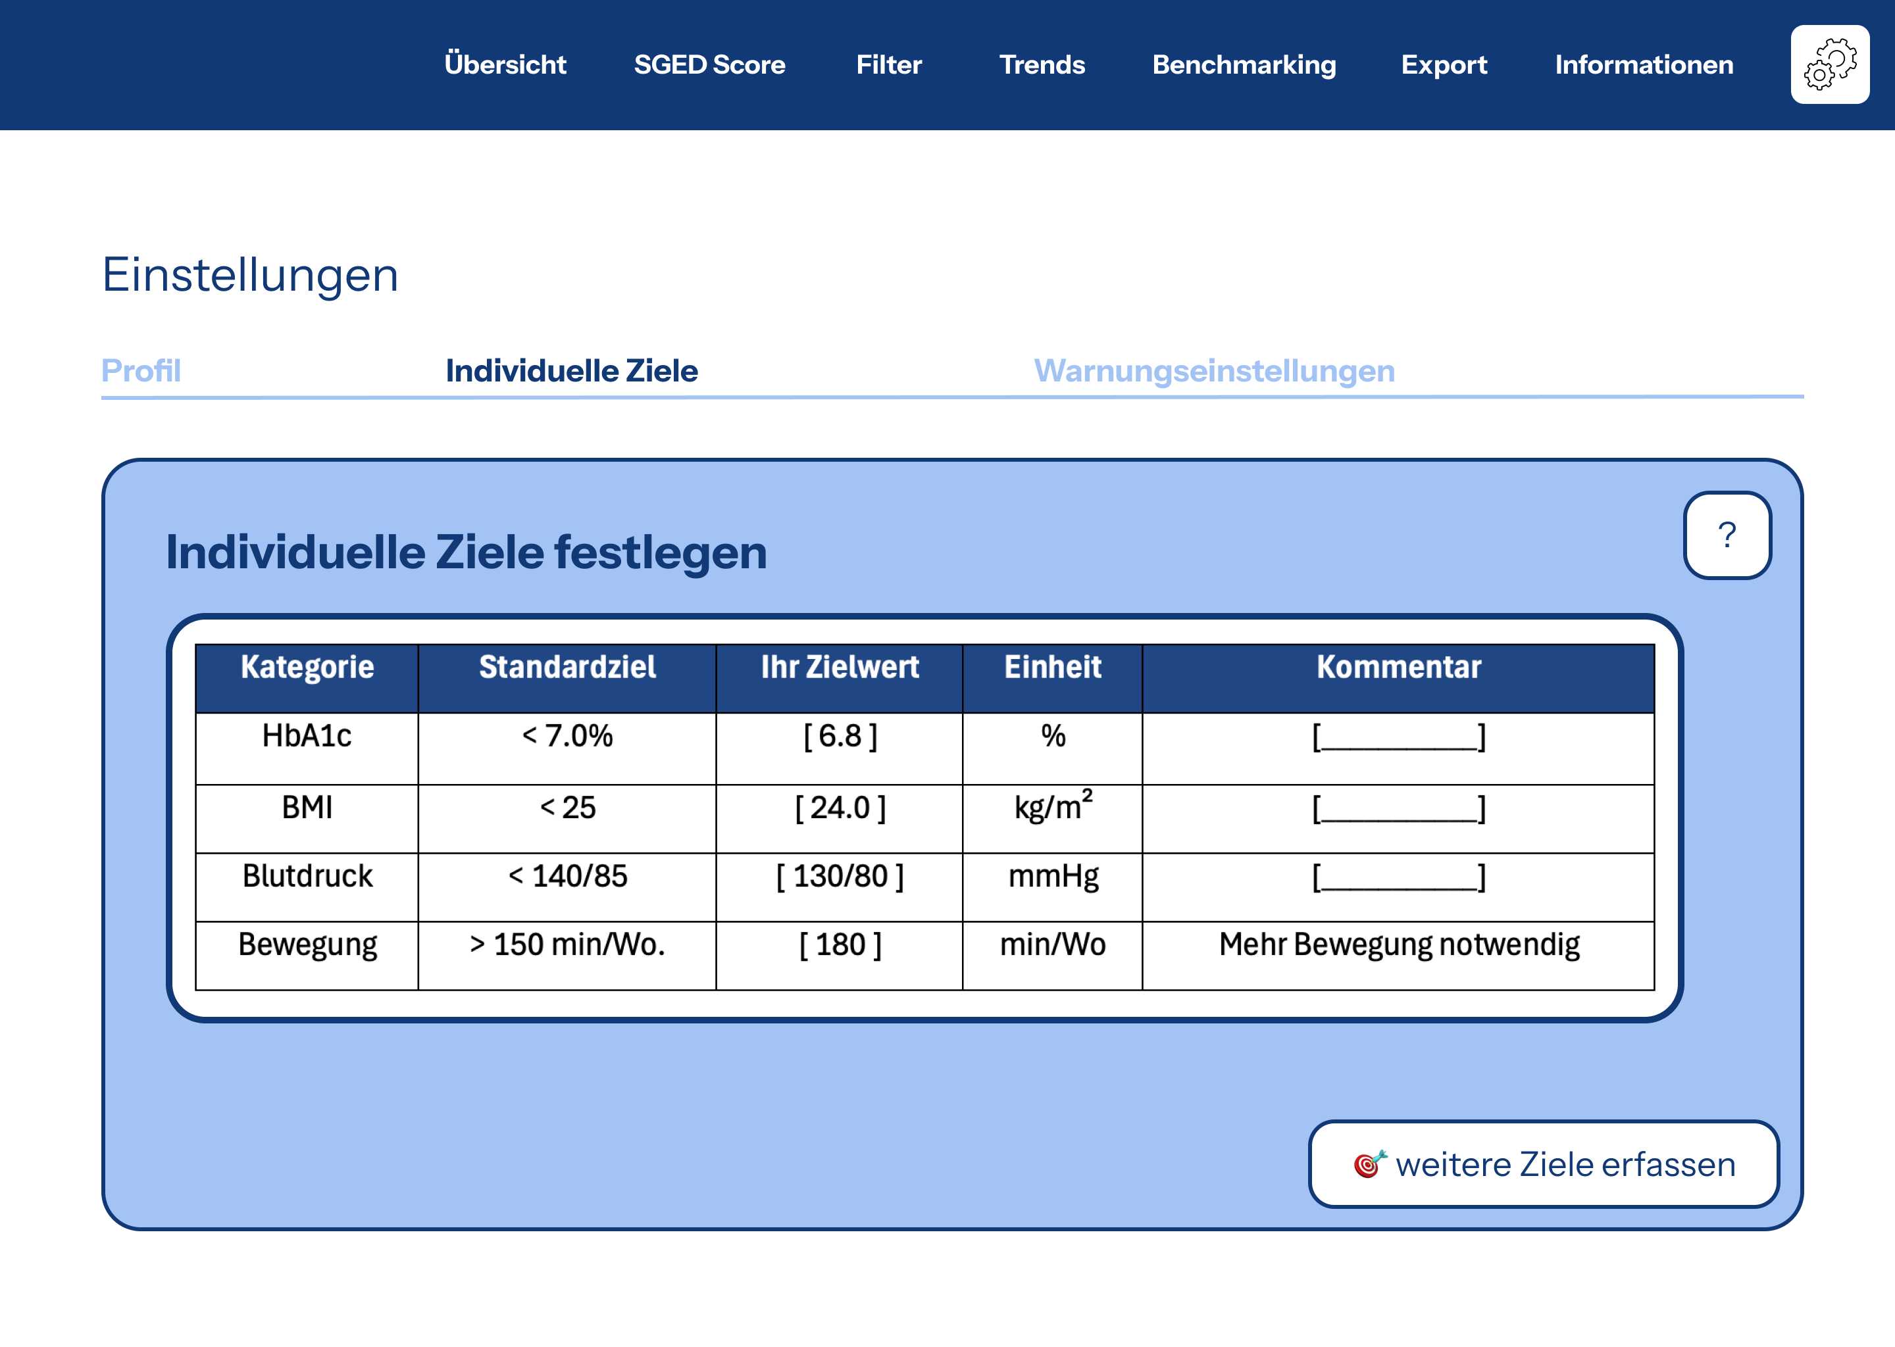
Figure 10: Customizable user flow (setting user specific goals)
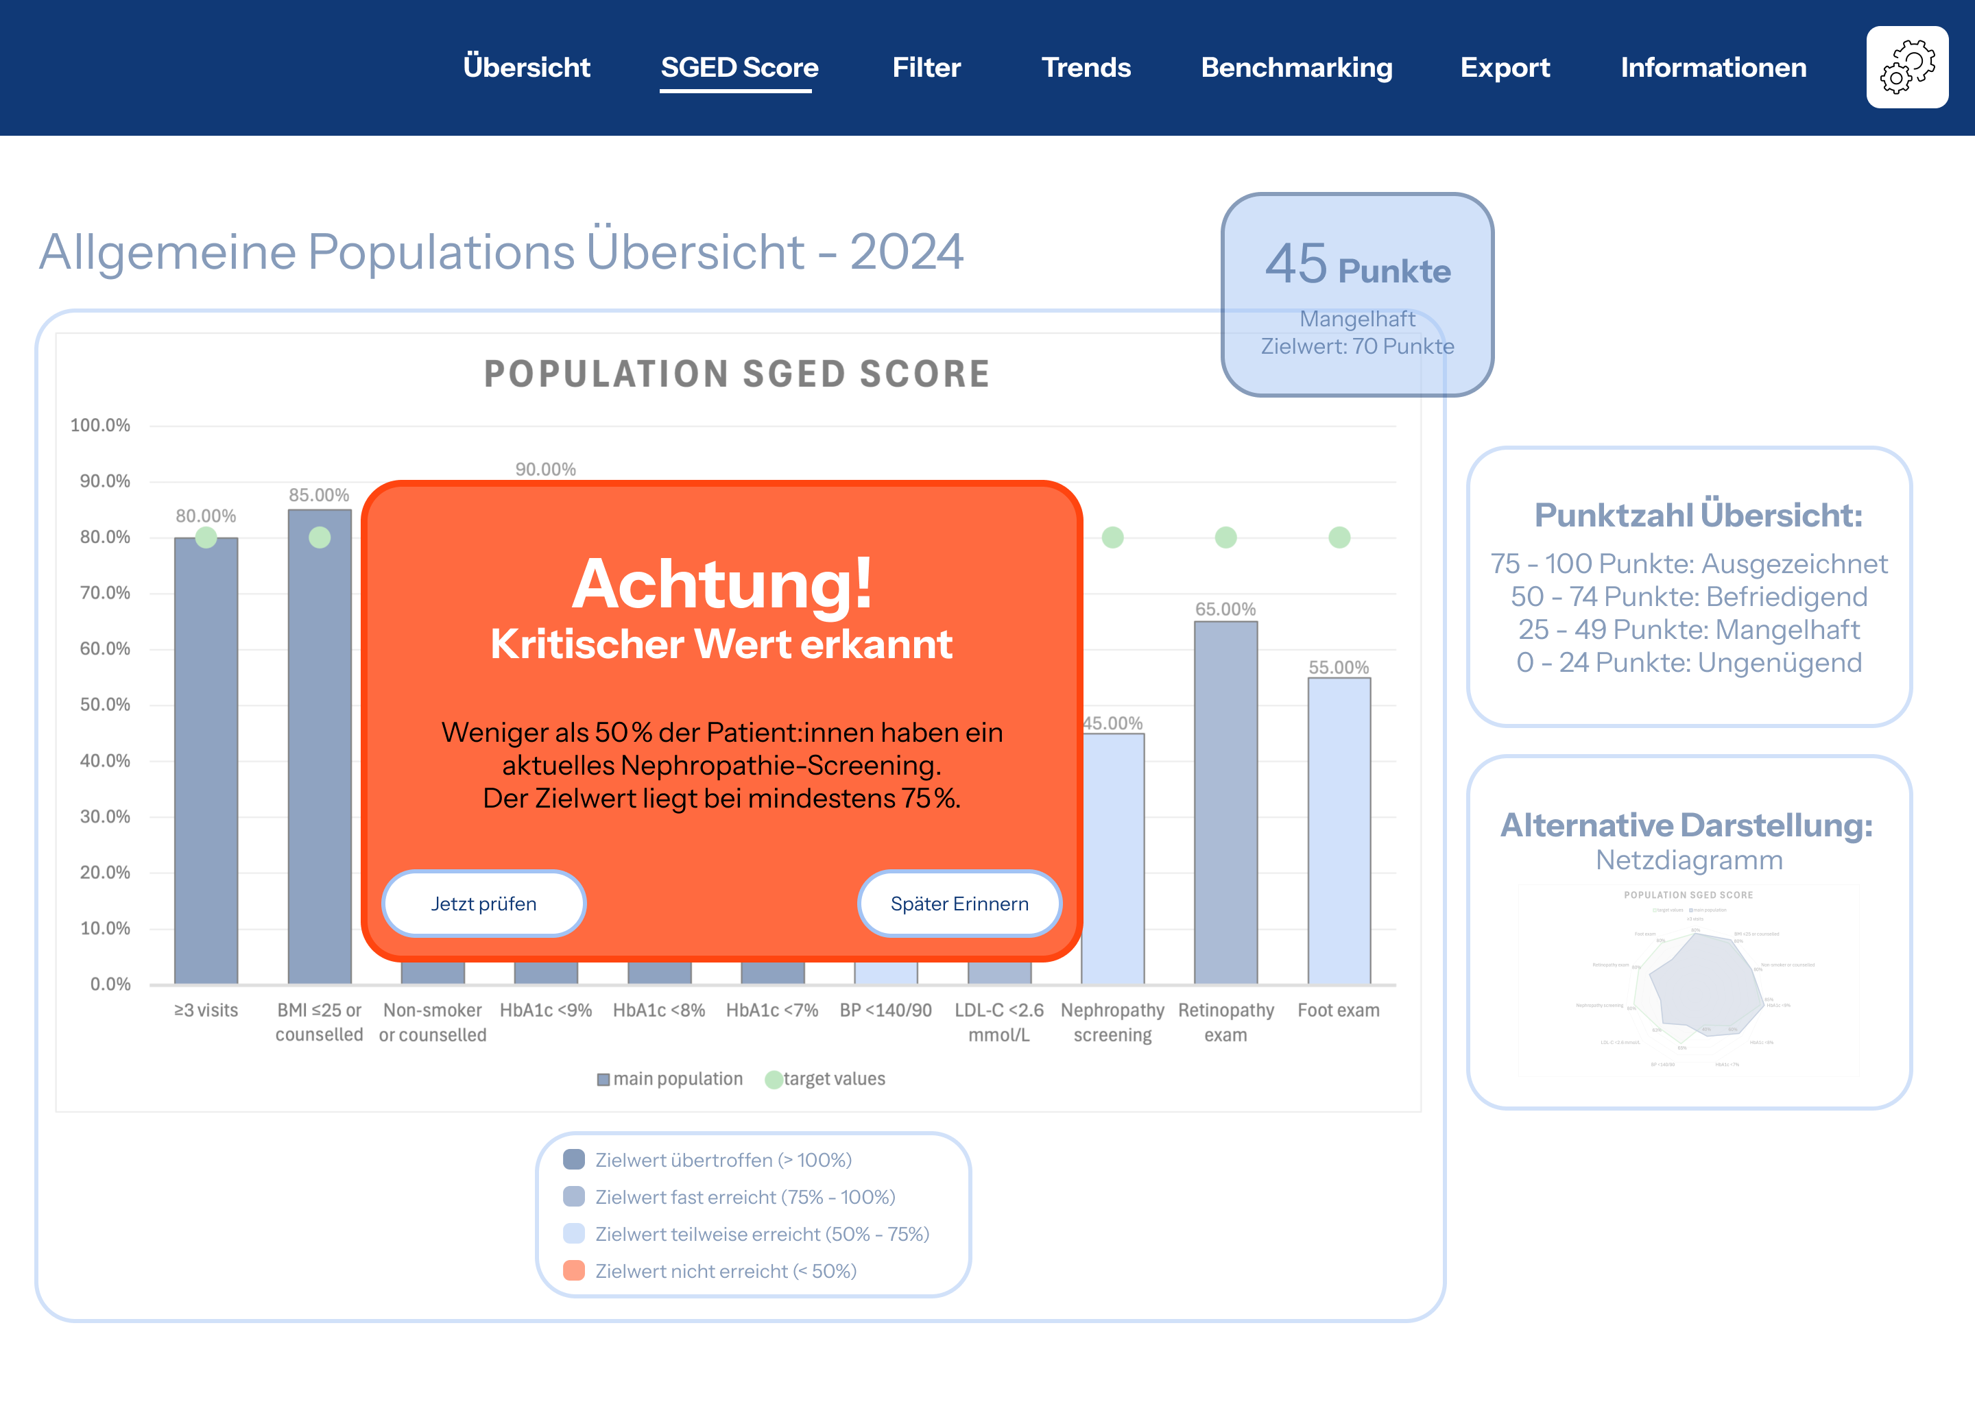
Figure 11: Reminder and alert functions
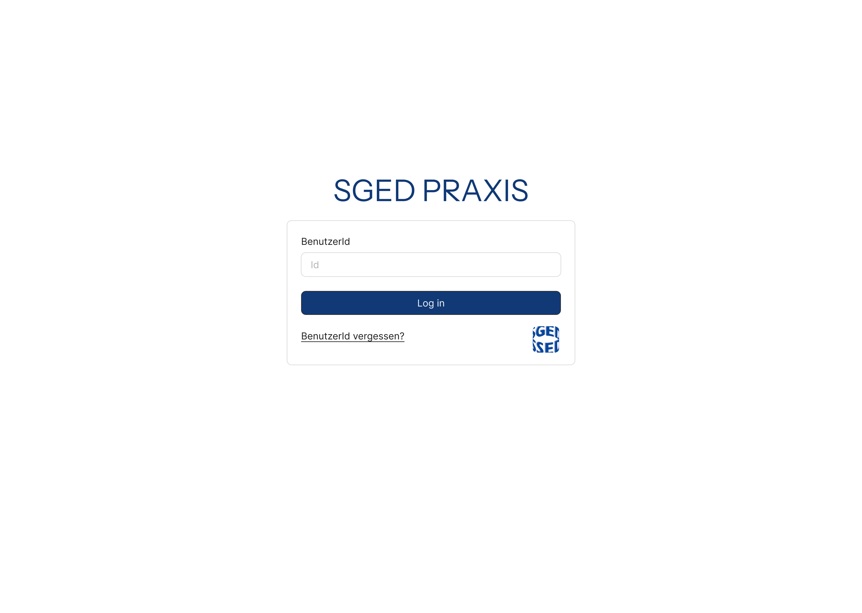
Figure 12: Role-based access

