Example for the Must have, Should have, Could have, Won’t have (MoSCoW) method prioritization framework
Green: “Must Have” (Absolutely essential elements that must be included at any cost.)
Yellow: “Should Have” (Important elements that should only be omitted with careful consideration.)
Orange: “Could Have” (Desirable elements that would ideally be included if resources allow.)
Red: “Won’t Have” (Elements that are out-of-scope, unfeasible or actively counterproductive.)
Prioritization of predefined functional requirements
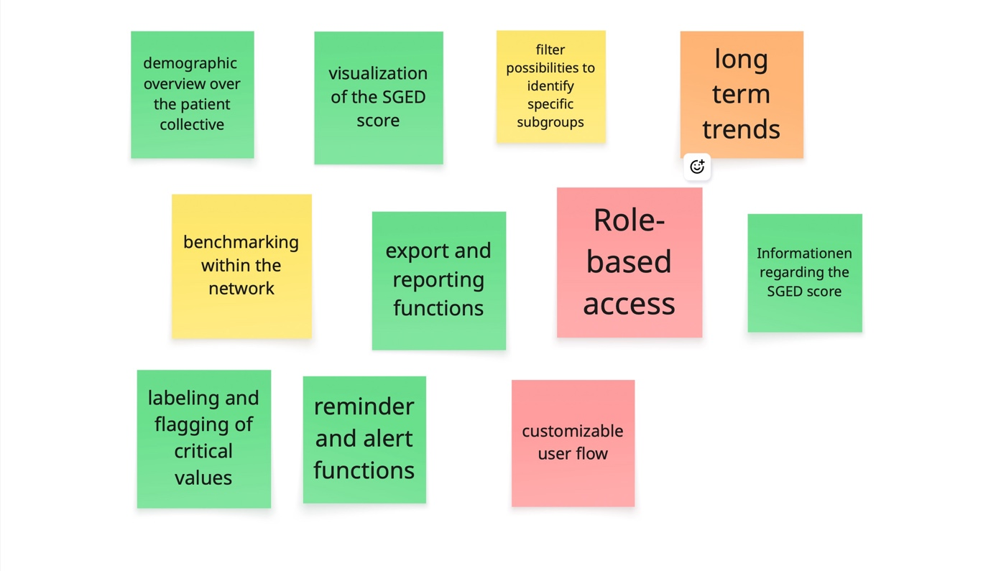
Prioritization of user-generated functional requirements:
