Enhanced GPR Imaging Using High-Resolution TR-MUSIC for Underground Object Localization
Hamidreza Karami^{1,2*}, Carlos Romero³, Marcos Rubinstein², Farhad Rachidi¹

¹ Ecole Polytechnique Fédérale de Lausanne (EPFL), Electromagnetic Compatibility Laboratory, CH-1015 Lausanne, Switzerland;
² School of Engineering and Management Vaud, HES-SO University of Applied Sciences and Arts Western, Switzerland;
³ Armasuisse Science and Technology, Thun, Switzerland

*hamidreza.karami@epfl.ch

Corresponding author: Hamidreza Karami
hamidreza.karami@epfl.ch

Contents of this file
The supplementary information contains 8 figures.

Figures
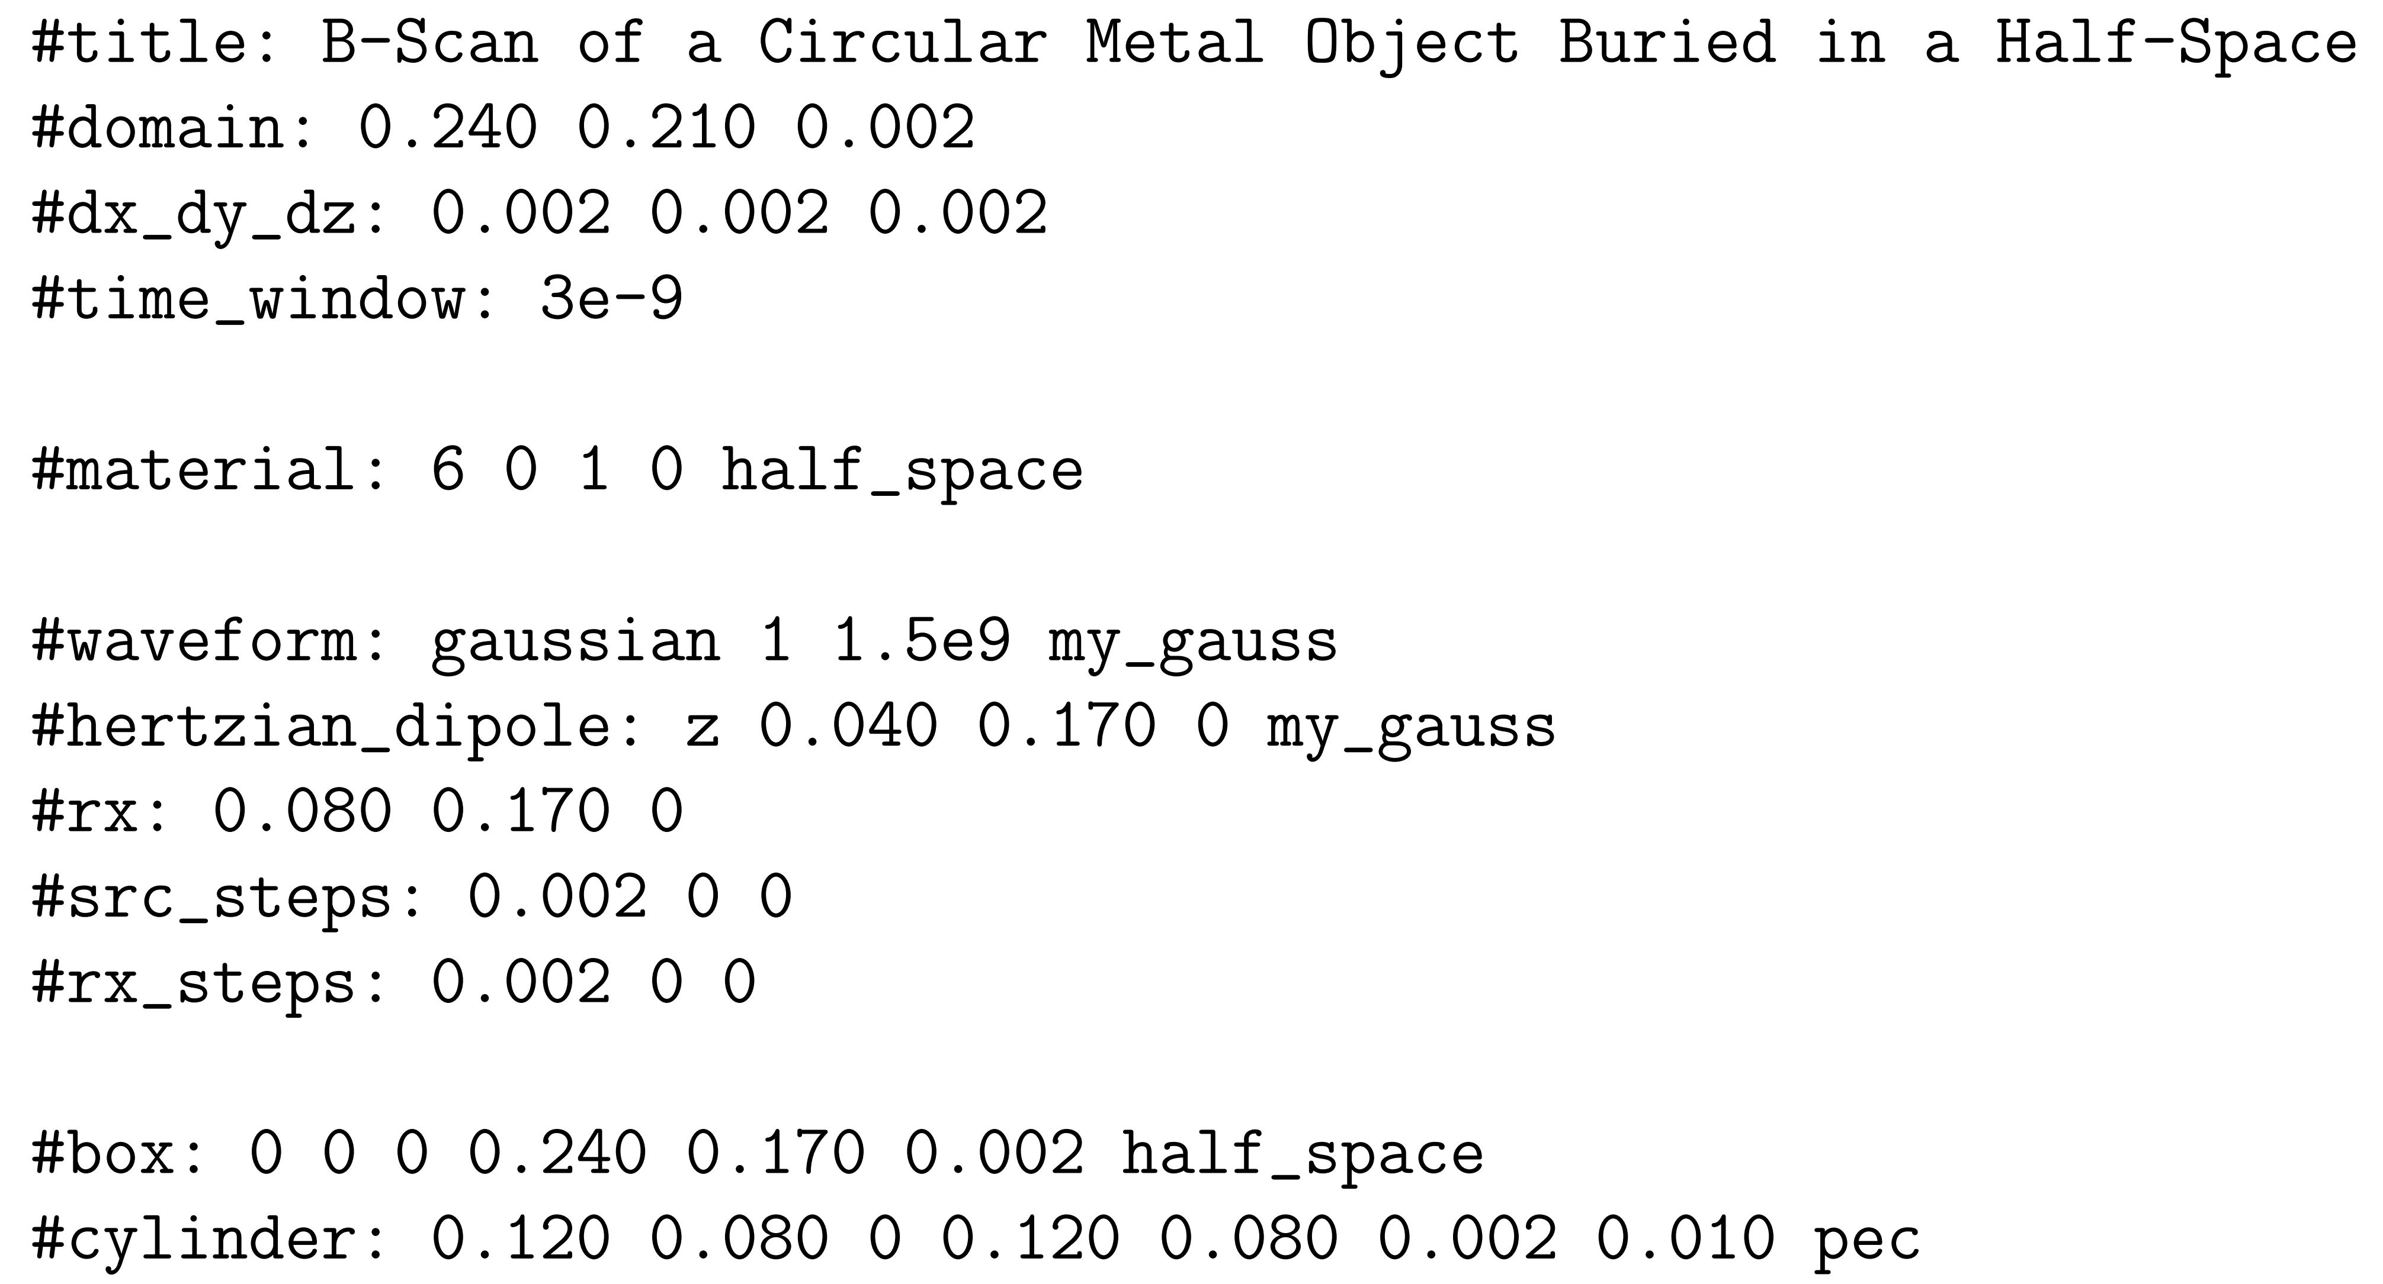
Figure S1 The input file for the gprMax software to create the results presented in Figure 3.

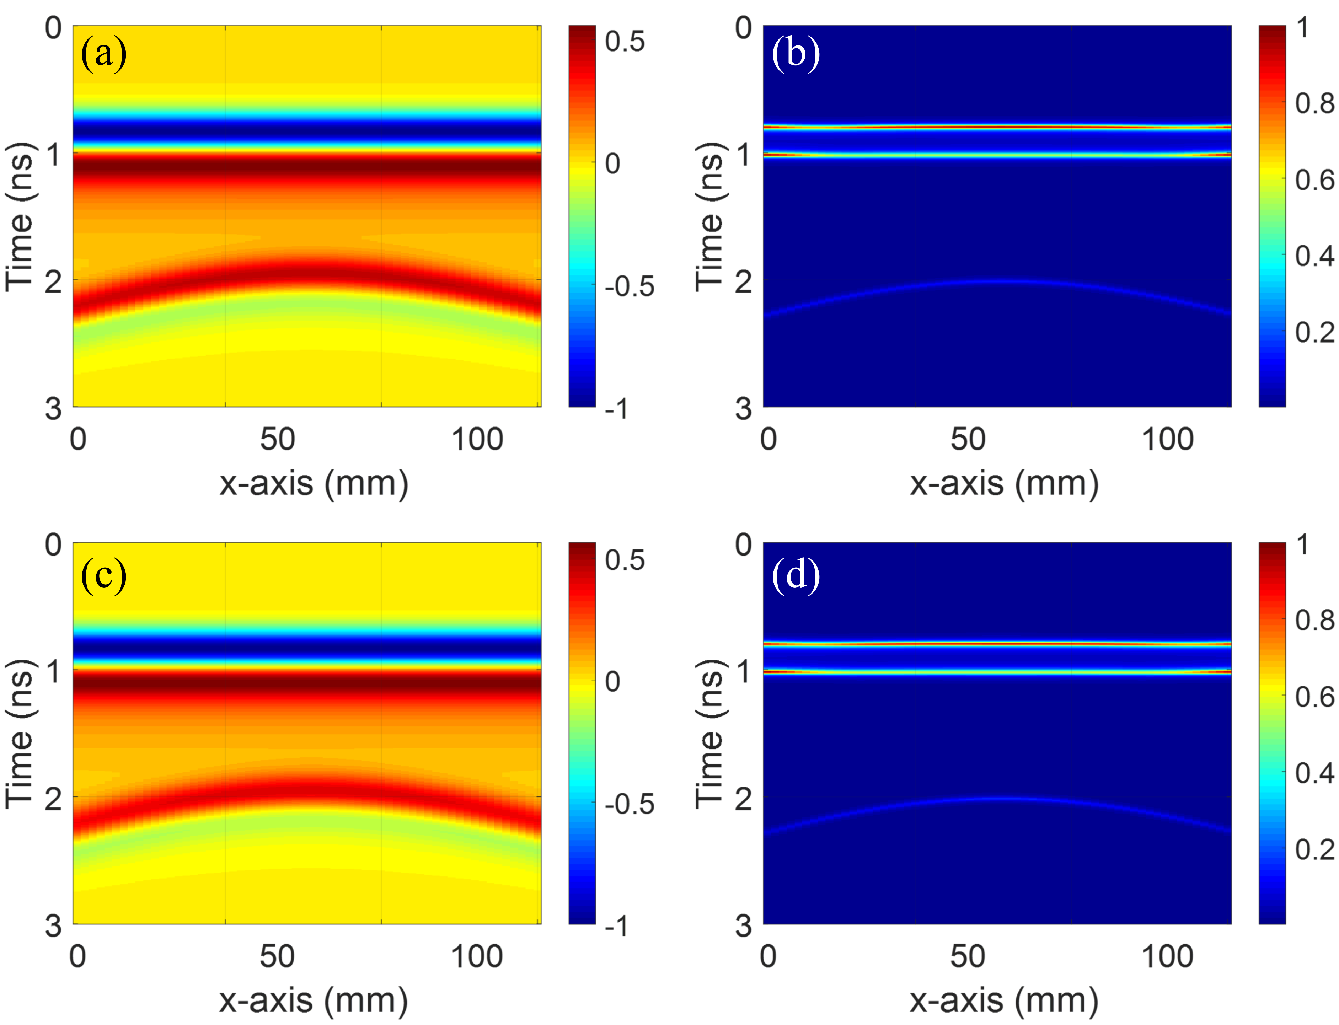

Figure S2 (a) Normalized GPR radargram obtained using gprMax in lossless ground. (b) Normalized HRTR pseudospectrum in lossless ground. (c) Normalized GPR radargram obtained using gprMax in lossy ground (σ = 0.01 S/m). (d) Normalized HRTR pseudospectrum in lossy ground (σ = 0.01 S/m).

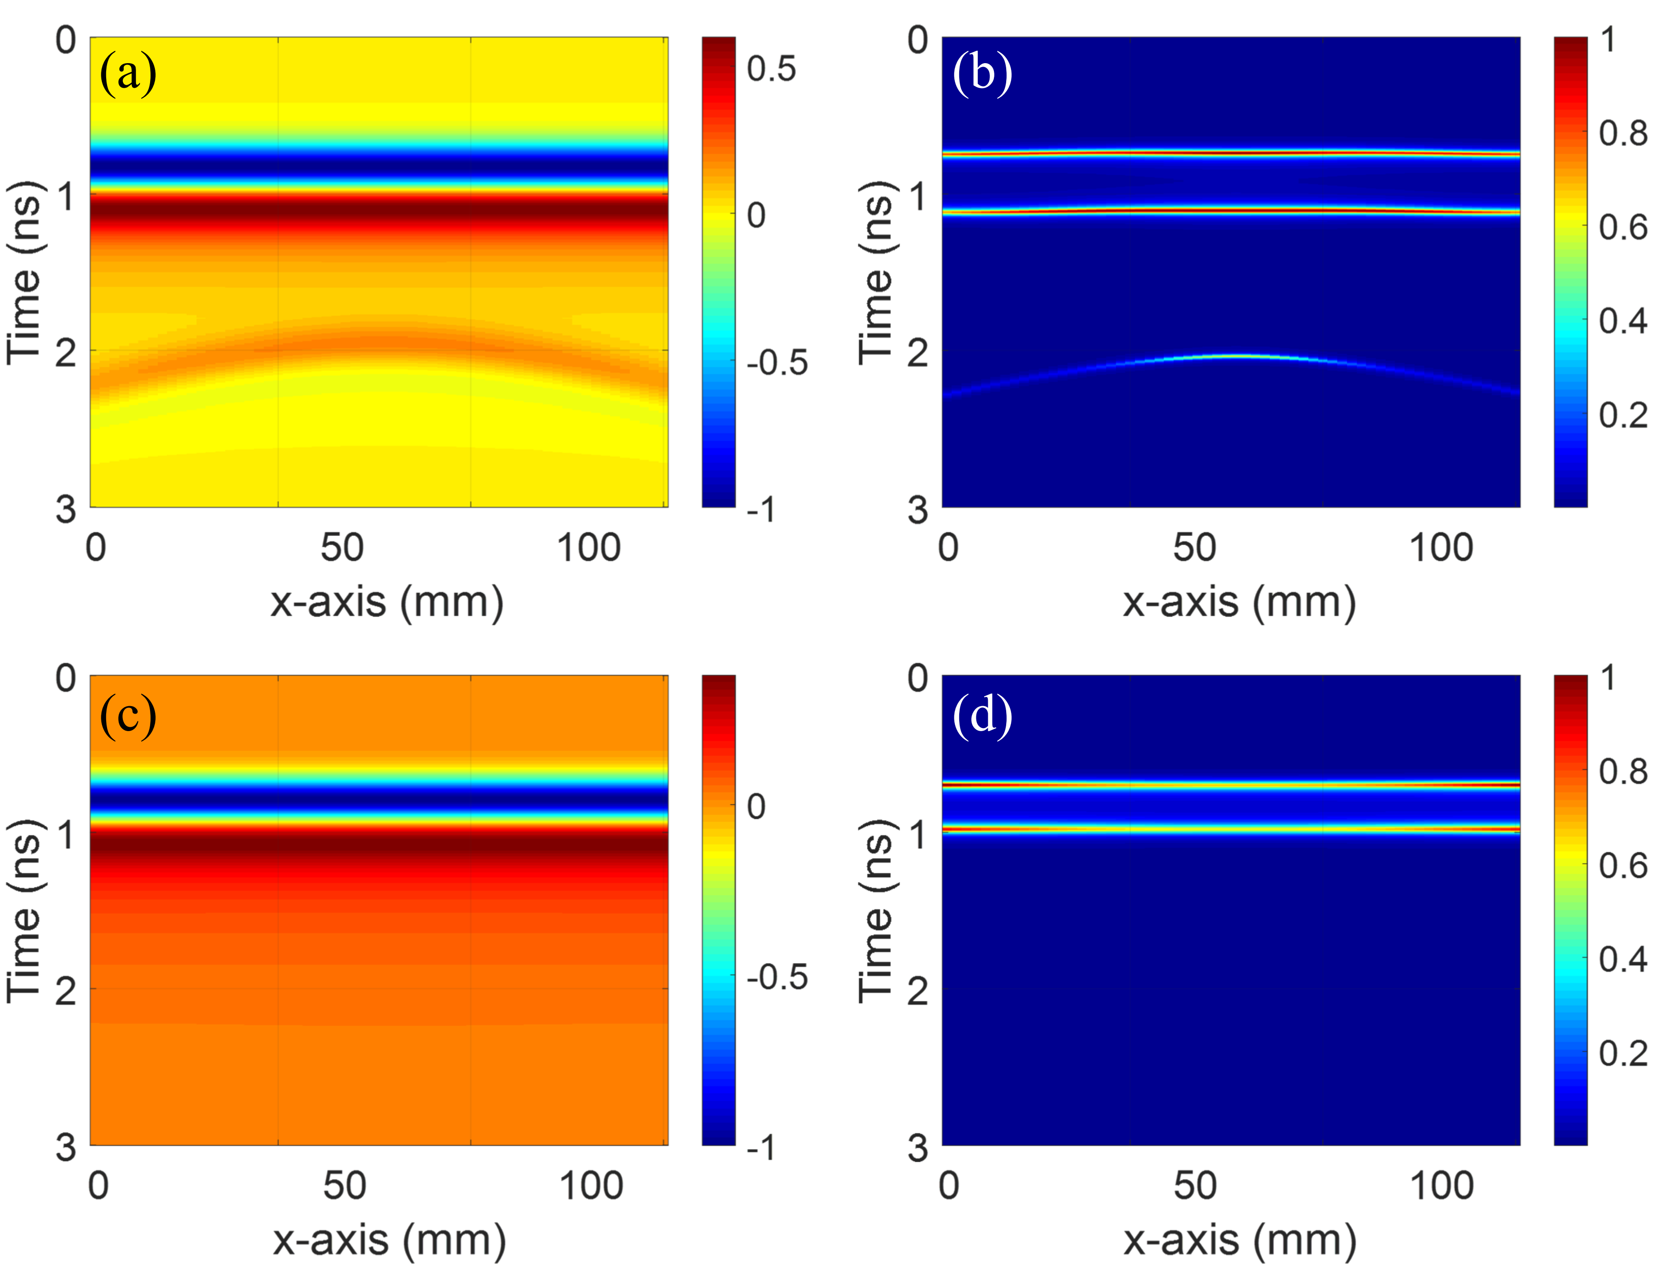

Figure S3 (a) Normalized GPR radargram obtained using gprMax in lossless ground. (b) Normalized HRTR pseudospectrum in lossless ground. (c) Normalized GPR radargram obtained using gprMax in lossy ground (σ = 0.1 S/m). (d) Normalized HRTR pseudospectrum in lossy ground in lossy ground (σ = 1 S/m).

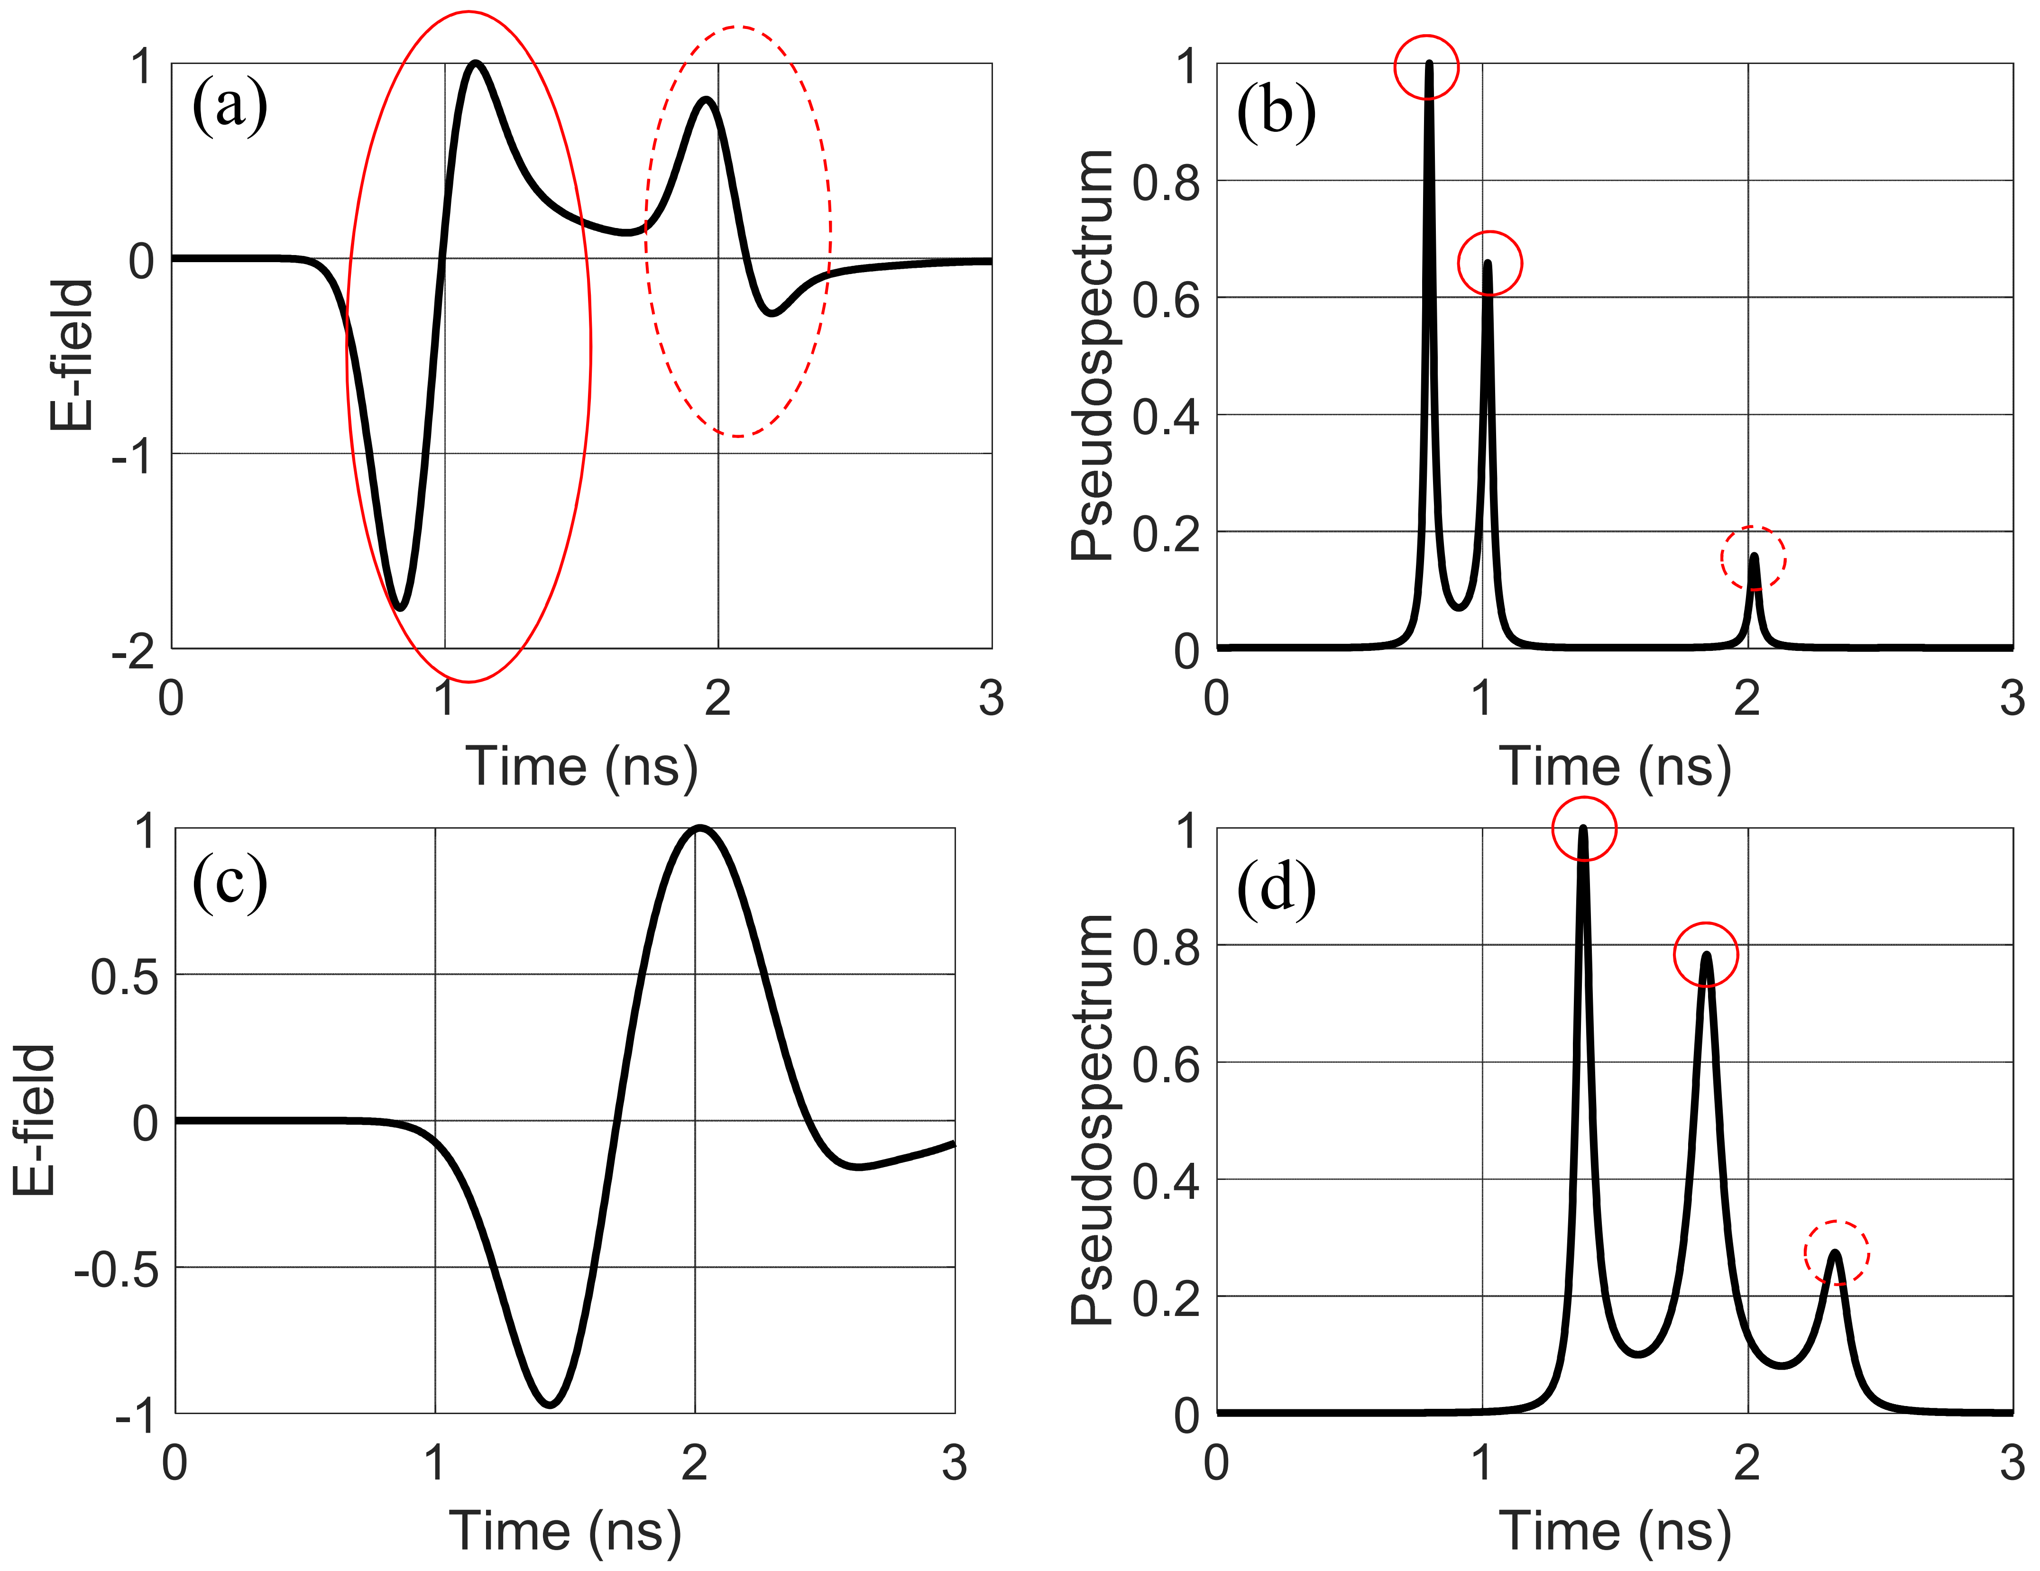
Figure S4 (a) Normalized radargram and (b) normalized pseudospectrum at x = 60 mm corresponding to Figure 3. (c) Normalized radargram and (d) normalized pseudospectrum at x = 60 mm corresponding to Figure 5.
It should be noted that the first radargram and time-domain pseudospectrum (i.e., (a) and (b)) are produced based on a Gaussian pulse with a center frequency of 1.5 GHz and an approximately one-octave bandwidth. For more information, see the pseudocode presented in Figure S1. In (a), the solid ellipse indicates the first reflection from the ground, while the dashed ellipse represents the reflection from the buried object. In (b), the solid circles show the positive and negative amplitudes of the ground reflection, and the dashed circles indicate the reflection from the object. In (a) and (b), the bandwidth and burial depth of the object are sufficient for both the conventional and HRTR methods to identify the reflections.
Figures (c) and (d) show the radargram and time-domain pseudospectrum produced for a Gaussian pulse with a center frequency of 750 MHz and an approximately one-octave bandwidth. As seen in (c), reducing the bandwidth decreases the resolution, causing the reflections from the ground and the object to merge. This means that object recognition with this limited bandwidth is not possible using the conventional method. In (d), the solid circles represent the positive and negative reflections from the ground, while the dashed circles show the reflection from the object. The recognition of the object is still possible at this bandwidth without any difficulty.


Figure S5 A top view of the GSSI 1.5 GHz antenna model in the gprMax software.

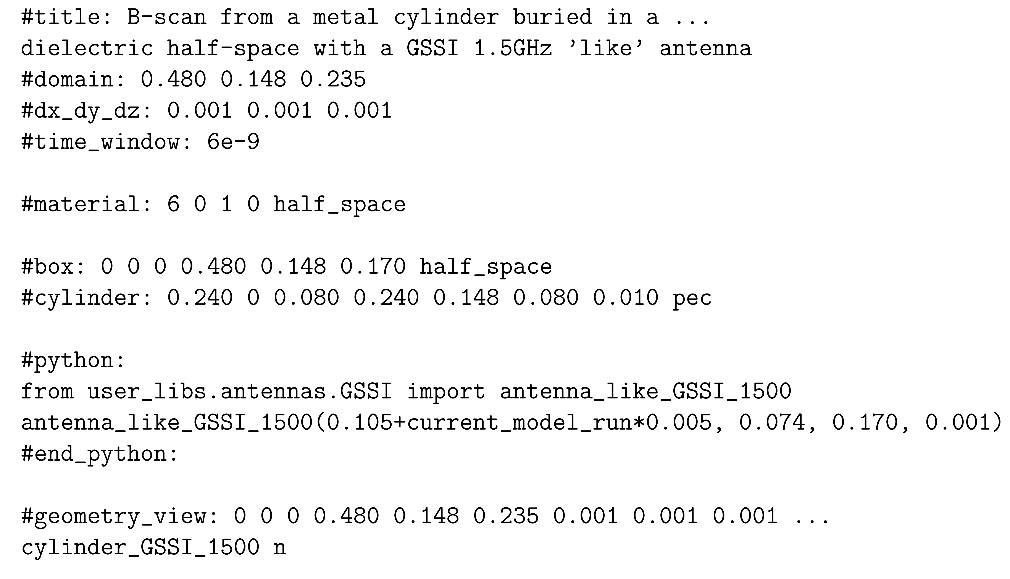
Figure S6 The input file for performing a B-scan using a GSSI 1.5 GHz antenna over a dielectric half-space containing a buried pipe.

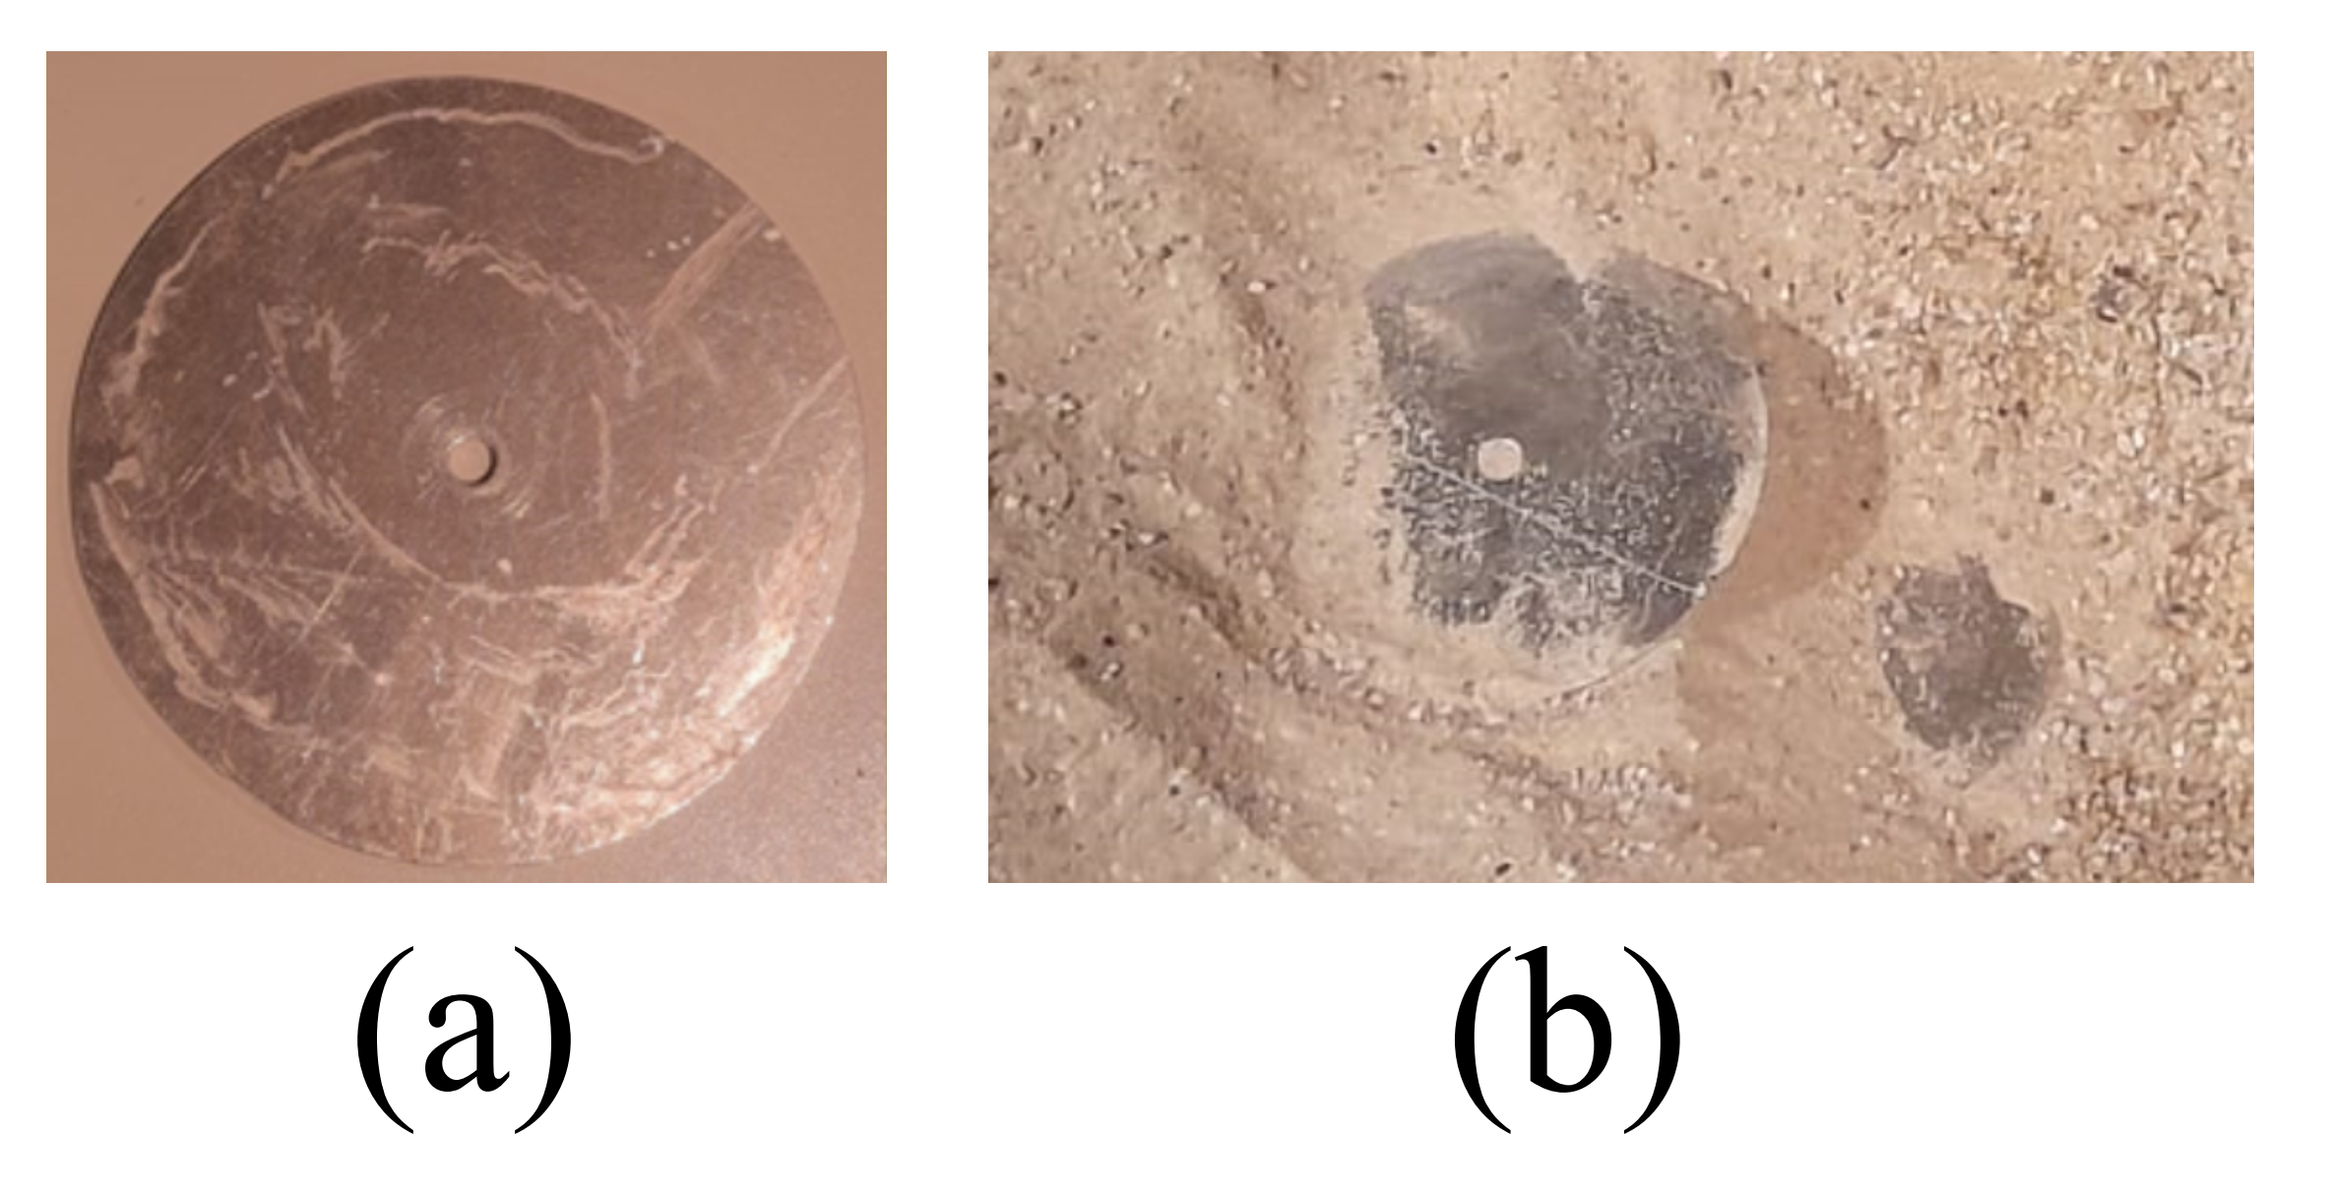
Figure S7 Landmines and other buried objects used in the test field experiment: (a) An anti-tank mine with a diameter of 17.5 cm and a thickness of 7 cm. (b) A copper ring with a diameter of 7.5 cm and a thickness of 3 cm. (c) An anti-personnel mine. (d) A metallic bar with a diameter of 2.5 cm and a length of 4.7 cm. (e) A metallic L-shaped object with dimensions of 4.5 × 4.5 cm².

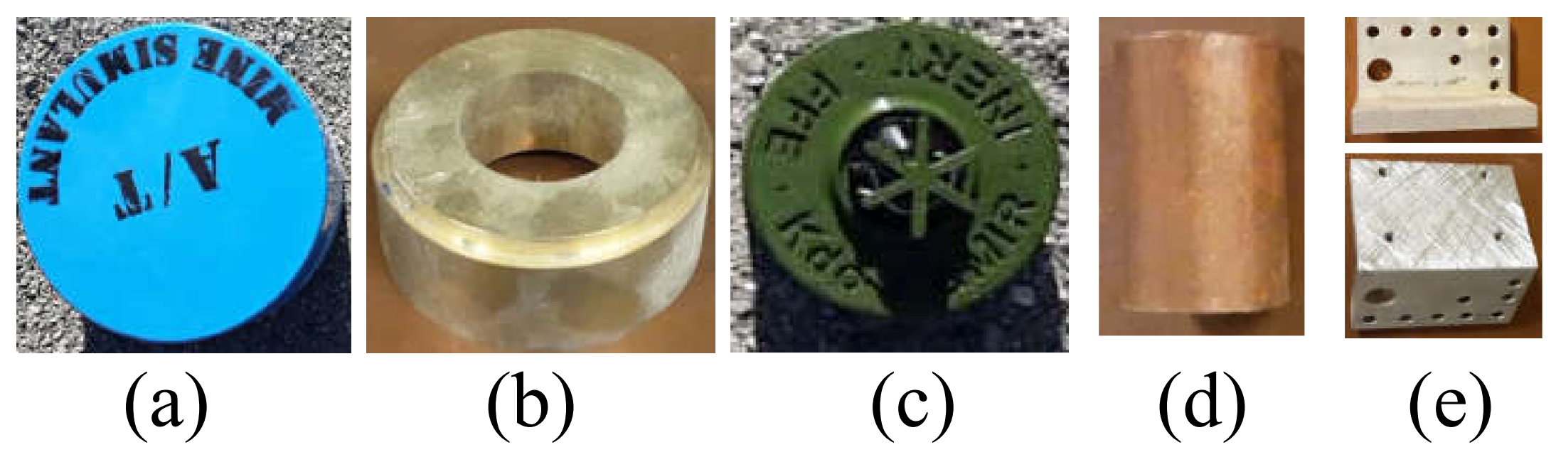

Figure S8 Landmines and other buried objects used in the test field experiment: (a) An anti-tank mine with a diameter of 17.5 cm and a thickness of 7 cm. (b) A copper ring with a diameter of 7.5 cm and a thickness of 3 cm. (c) An anti-personnel mine. (d) A metallic bar with a diameter of 2.5 cm and a length of 4.7 cm. (e) A metallic L-shaped object with dimensions of 4.5 × 4.5 cm².

