Sup. Fig.1
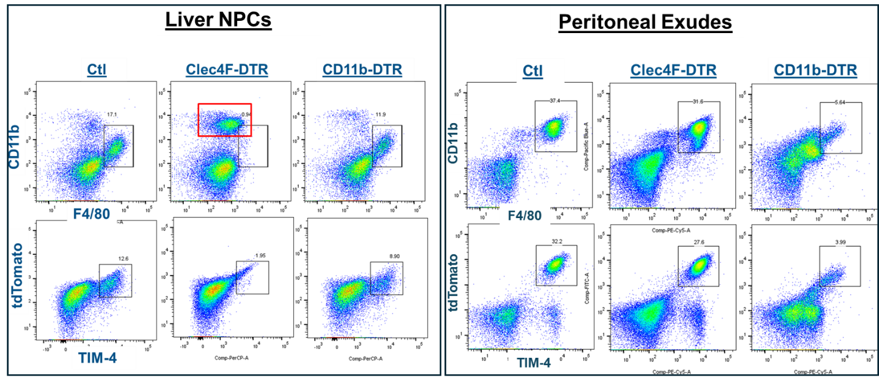
DT induced macrophage depletion in Clec4F- and CD11b-DTR mice. A single dose of DT (200ng, i.p.) was administered. Liver non-parenchymal cells (NPCs) or peritoneal cells from the same mouse were collected. One million cells were stained with fluorochrome-labeled Abs and analyzed by FACS. Representative dot plots were shown.

Sup. Fig.2
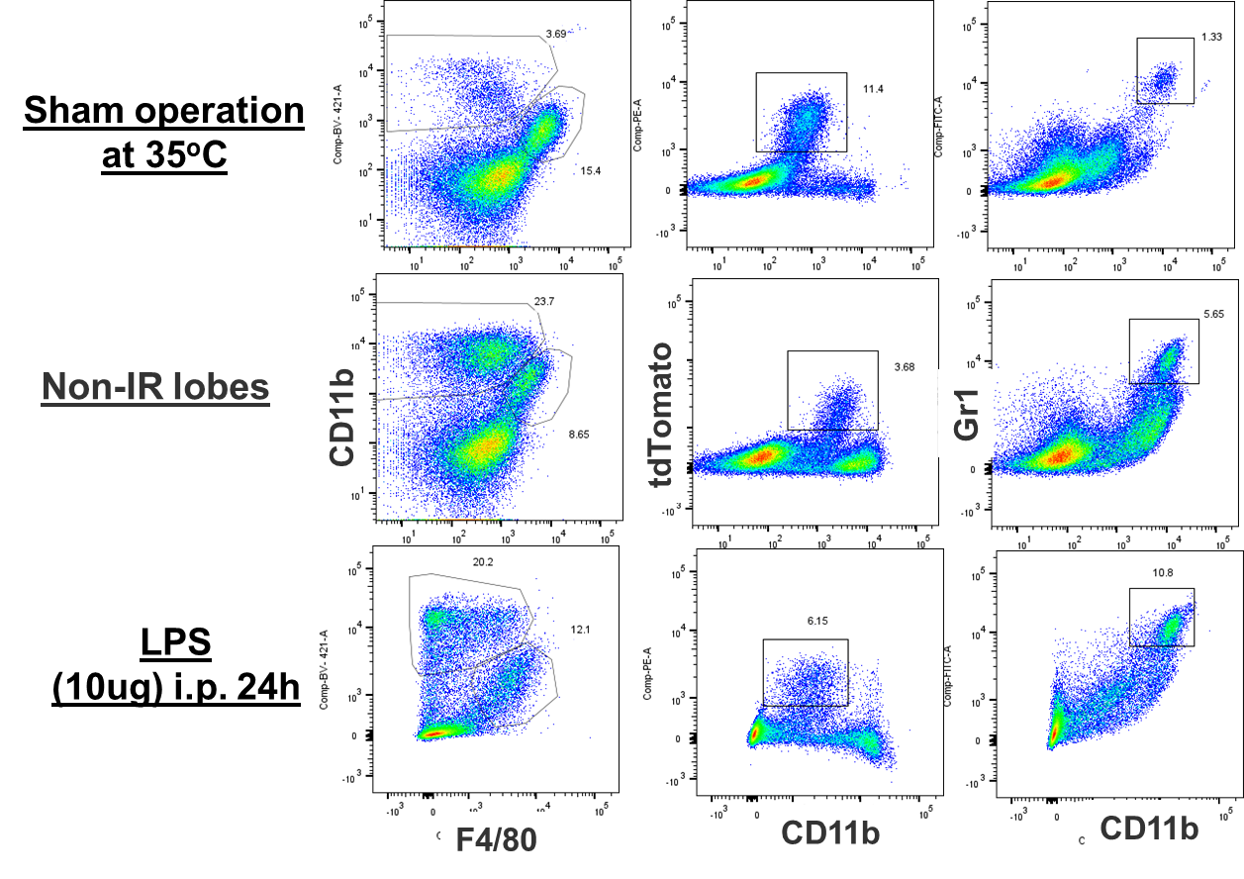

FACS analysis of liver myeloid cells in sham livers, non-ischemia lobes of IR livers and livers treated with LPS (10ug,i.p.) Liver non-parenchymal cells were isolated from the livers 24h post IR or treatment. One million cells were stained with fluorochrome-labeled Abs and analyzed by FACS. Representative dot plots were shown.

Sup. Fig.3
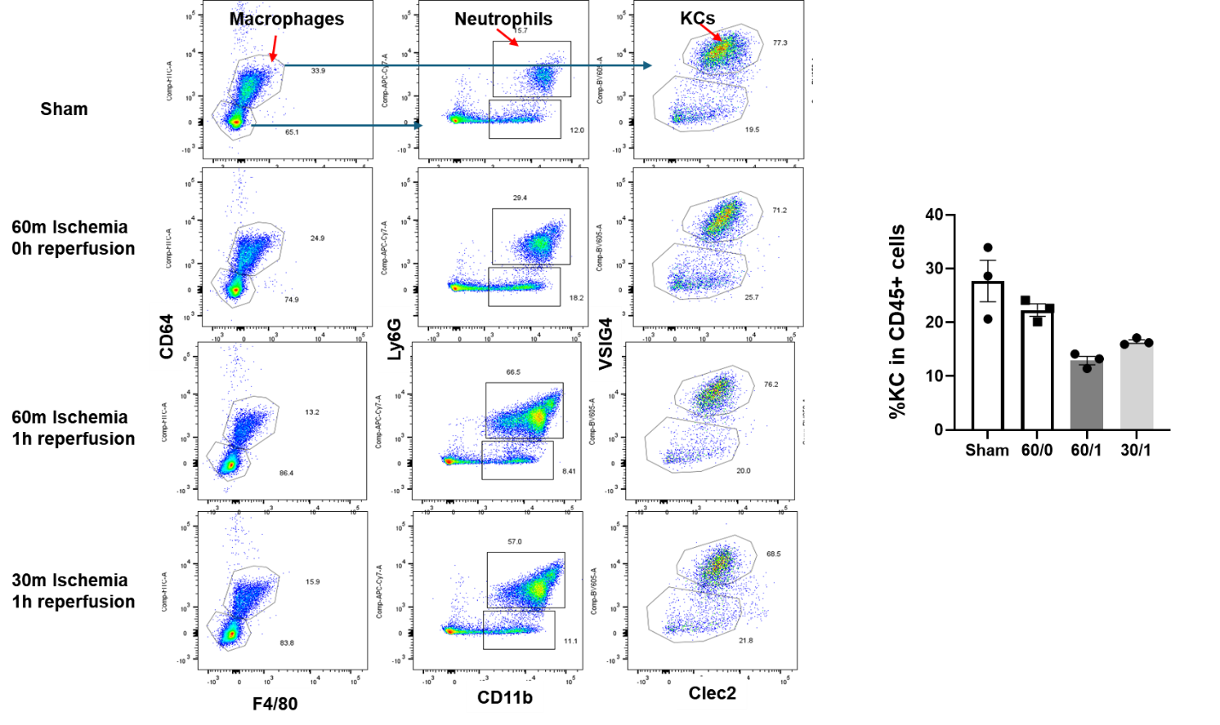
FACS analysis of liver myeloid cells in sham livers and IR livers subjected to 60m ischemia 0 or 1h reperfusion, or 30m ischemia and 1h reperfusion. Liver non-parenchymal cells were isolated from the livers. One million cells were stained with fluorochrome-labeled Abs and analyzed by FACS. Representative dot plots were shown.

Sup Fig.4
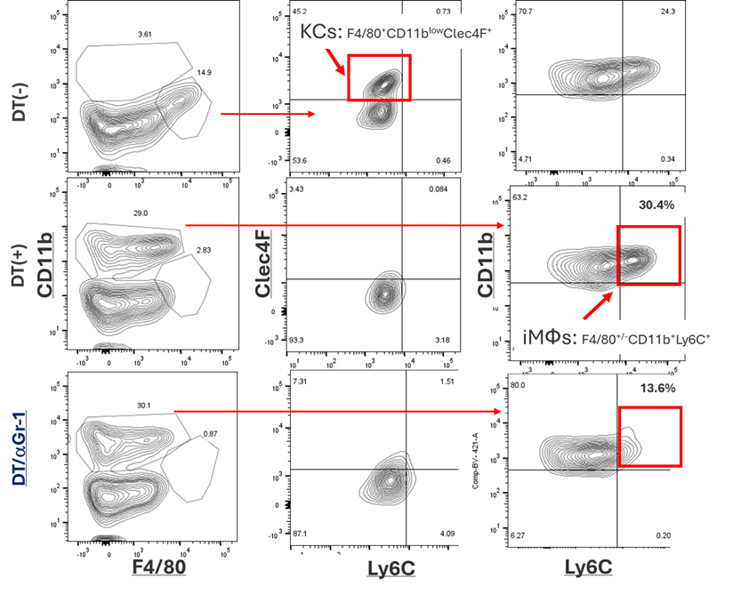

FACS analysis of liver NPCs from control DT(-), KC-depleted DT(+) and both KC and Gr-1 depleted mice.

Sup. Fig.5
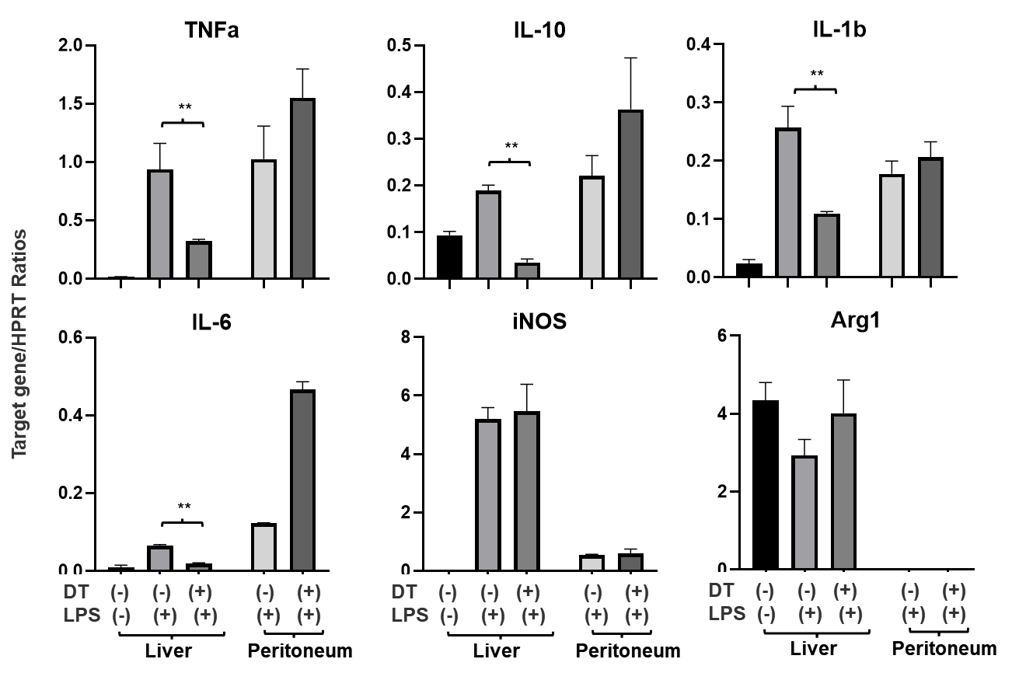
Inflammatory gene induction in livers and peritoneal cells by LPS. Groups of Clec4F-DTR mice were first treated with either PBS or DT, followed by 24h later LPS i.p.. Livers and peritoneal cells were collected from the same mice. Gene expressions were determined by qRT-PCR. Average ratios of target gene/HPRT were plotted. N=3/group. **p<0.05.

Sup. Fig.6
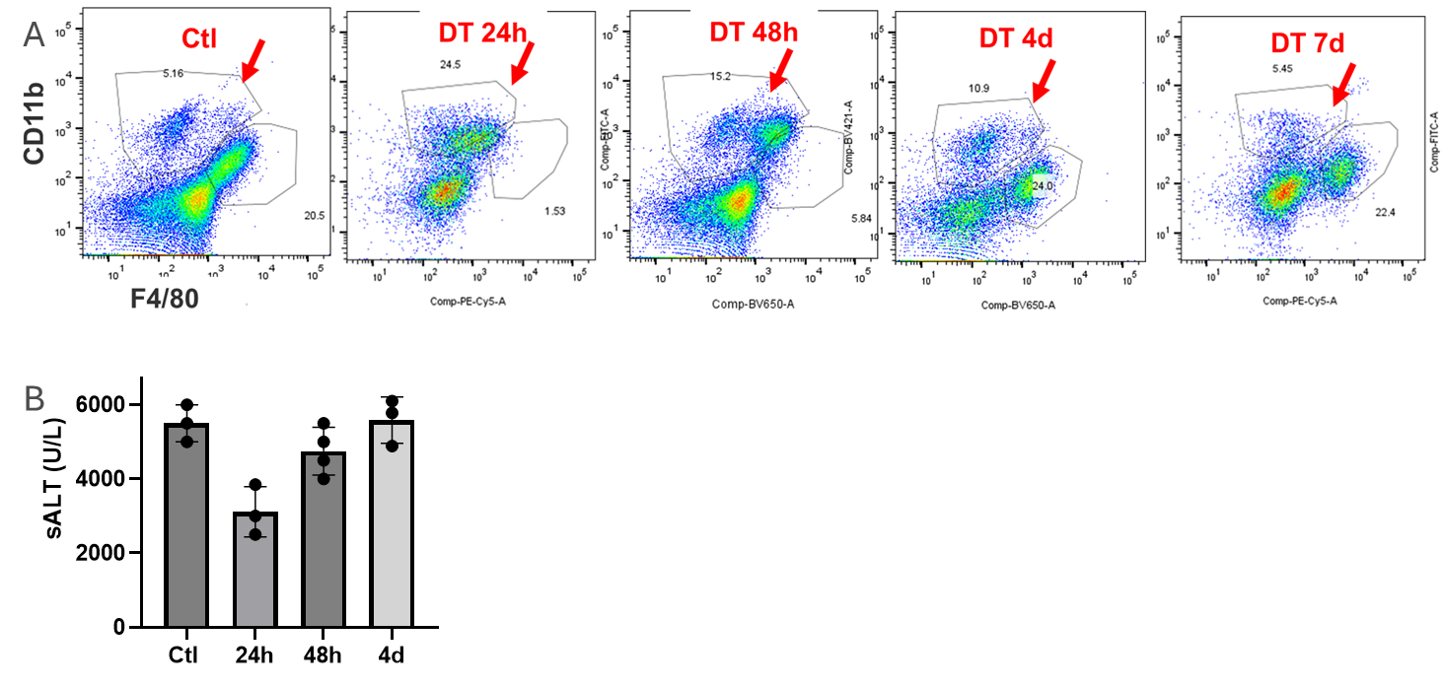
(A) FACS analysis of liver myeloid cells in control, KC-depleted livers of Clec4F-DTR mice after 24h, 48h, 4-day and 7-day post DT injection. Liver non-parenchymal cells were isolated and stained with fluorochrome-labeled Abs and analyzed by FACS. Representative dot plots were shown. (B) Average sALT levels in different experiment groups (control, 24h, 48h and 4-day post DT injection) were plotted.

Sup Fig.7

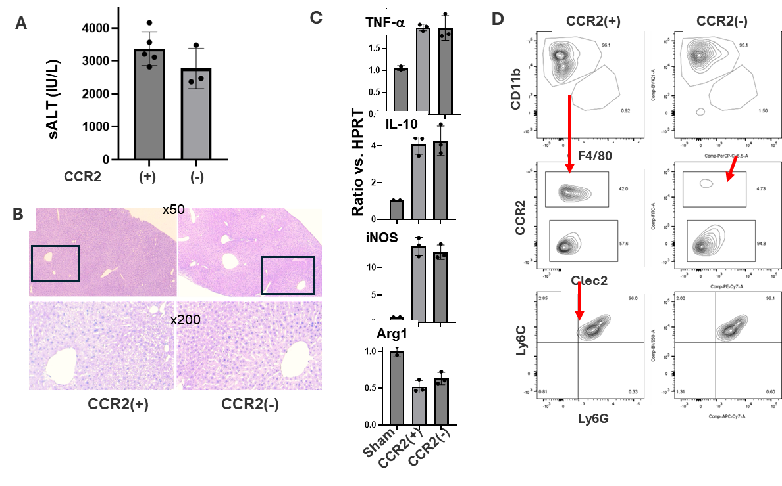
CCR2 deficiency inhibits monocyte infiltration in the acute phase of liver IRI, but not the severity of hepatocellular damage. Groups of CCR2-GFP heterozygous (CCR2h) and homozygous (CCR2 KO) mice were tested in the 60m liver ischemia model. Liver IRI was evaluated at 6h post reperfusion. (A) Average sALT levels and Suzuki’s scores of the two exp. groups were plotted. (B) Representative liver histopathology (H/E staining, x50 and x200) pictures were shown. Liver tissue RNA was isolated and analyzed for inflammatory gene expression by qRT-PCR. (C) Average ratios of target gene/HPRT of each exp. groups were plotted. (D) FACS analysis of liver myeloid cell infiltration. Representative plots were shown (n=3/group).

Sup Fig.8
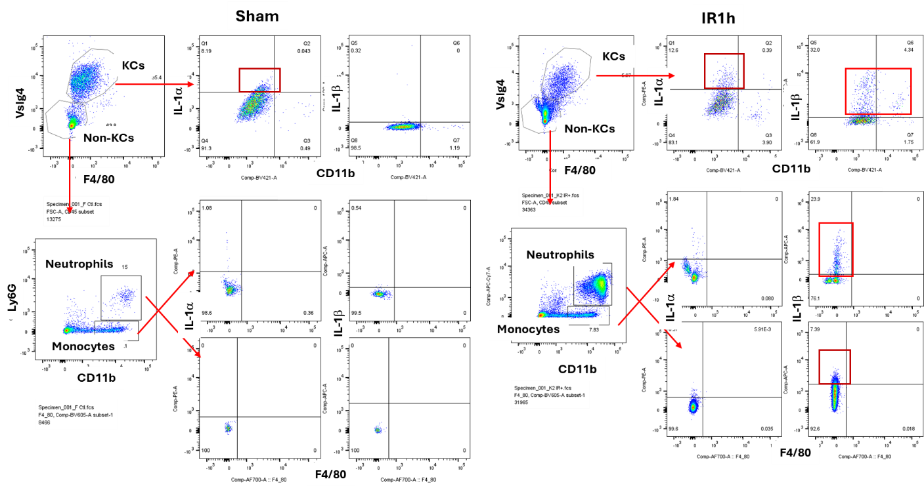
Intracellular cytokine staining of IL-1a and IL-1b in liver myeloid cells. Liver non-parenchymal cells were isolated from sham or IR livers (60m ischemia and 1h reperfusion). Cells were first stained with fluorochrome-labeled cell surface Abs, followed by fixation and permeablization and staining with fluorochrome-labeled anti-IL-1a/b Ab. Representative FACS dot plots were shown.

Sup Fig.9
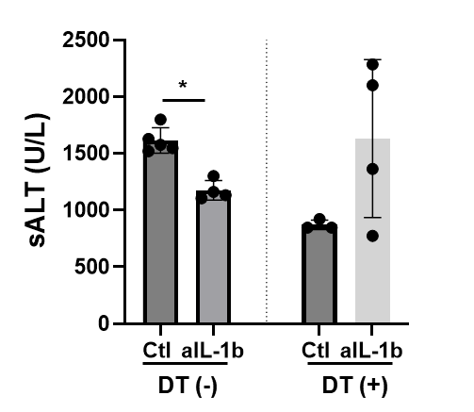
KCs promotes liver IRI via IL-1b. Average sALT levels of indicated exp. groups. *p<0.05.

