Supplementary Information

Efficient Ammonia Production from Nitric Oxide under Real Condition Using Photo-Modulated Cu Single-Atom Catalysts

Xiaoyan Liu^{1,#}, Zhuyu Luo^{1,#}, Shan Hu^{1,#}, Wanqi Tang^{2,#}, Linfeng He¹, Linwei Han¹, Qing Wang¹, Shuangjun Li¹, Xinyun Wang¹, Taoyuan Lu¹, Guisheng Li¹, Hexing Li¹, Dieqing Zhang ^{1,} *, Jun Lu^{2,} *

¹The Education Ministry Key Lab of Resource Chemistry, Joint International Research Laboratory of Resource Chemistry, Shanghai Key Laboratory of Rare Earth Functional Materials, Shanghai Frontiers Science Center of Biomimetic Catalysis, College of Chemistry and Materials Science, Shanghai Normal University, Shanghai 200234, P.R. China.
²College of Chemical and Biological Engineering, Zhejiang University, Hangzhou 310058, P.R. China.
#These authors contributed equally to this work.
*To whom correspondence should be addressed. Email: dqzhang@shnu.edu.cn; junzoelu@zju.edu.cn

This material contains:
- Supplementary Figures
- Supplementary Tables
- References

- Supplementary Figures
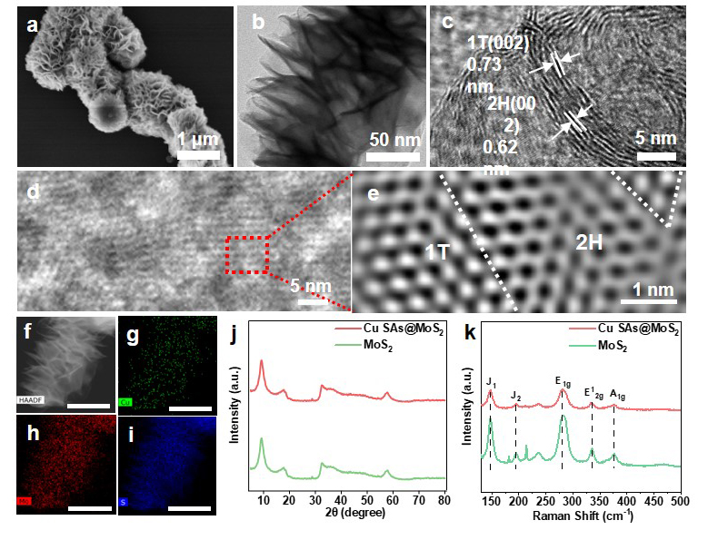
Fig. S1. (a) SEM image, (b-e) TEM images, (f-i) EDS elemental mapping images of Cu SAs@MoS₂ (green, red and blue represent Cu, Mo, and S elements respectively, and scale bar 200 nm). (j) XRD patterns and (k) Raman spectra of MoS₂ and Cu SAs@MoS₂.

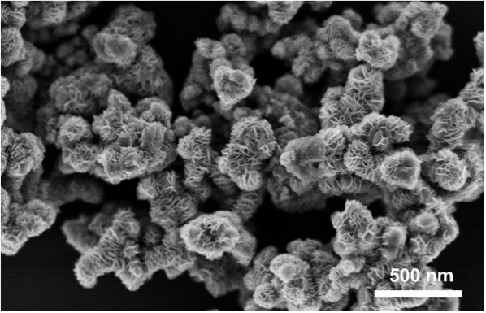
Fig. S2. SEM image of pure MoS₂.

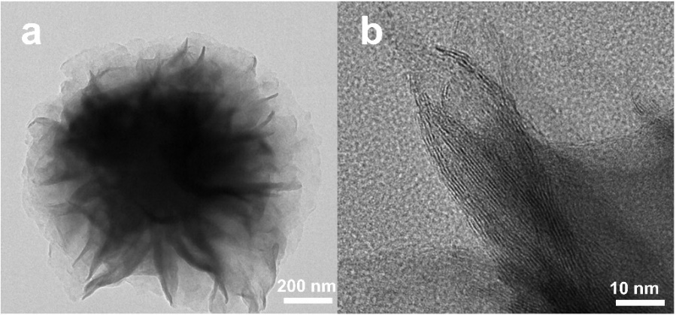
Fig. S3. TEM images of pure MoS₂.

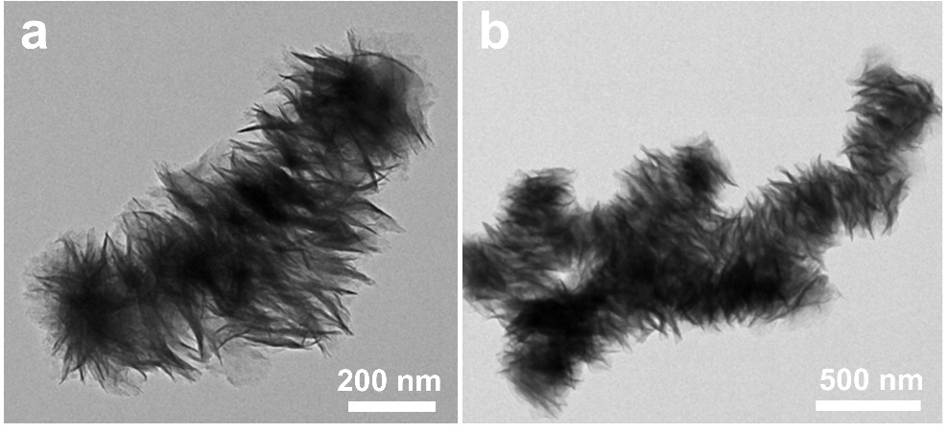
Fig. S4. TEM images of Cu SAs@MoS₂.

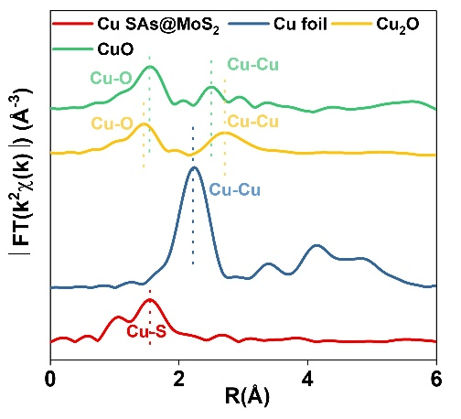
Fig. S5. k₃-weighted Fourier-transform EXAFS spectra of Cu SAs@MoS₂, Cu foil, Cu₂O, and CuO samples under dark condition.
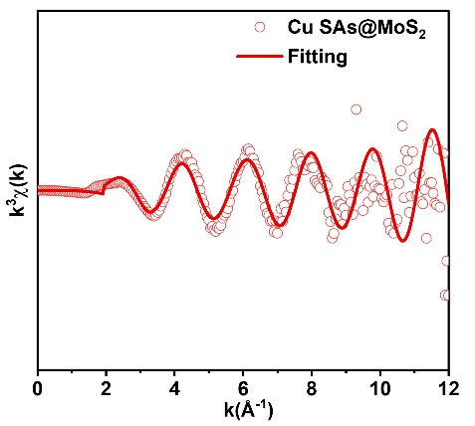
Fig. S6. The corresponding EXAFS k space fitting curves for Cu SAs@MoS₂ under dark condition.

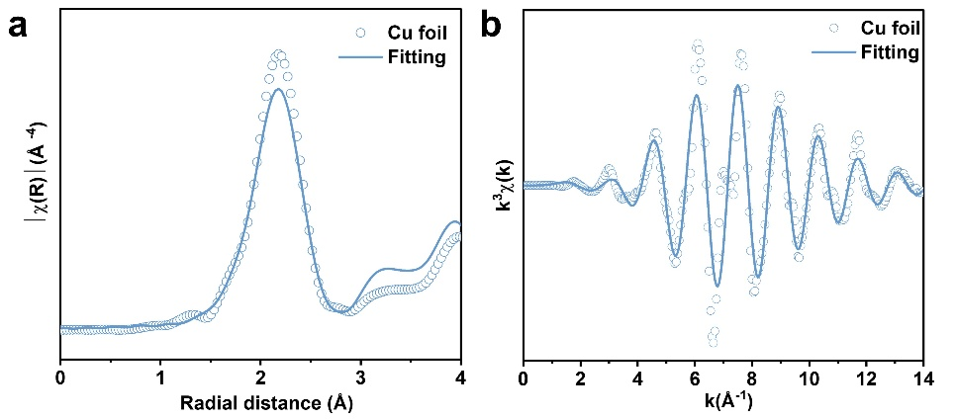
Fig. S7. (a, b) Corresponding EXAFS fitting curve and EXAFS k space fitting curves for Cu foil under dark condition.

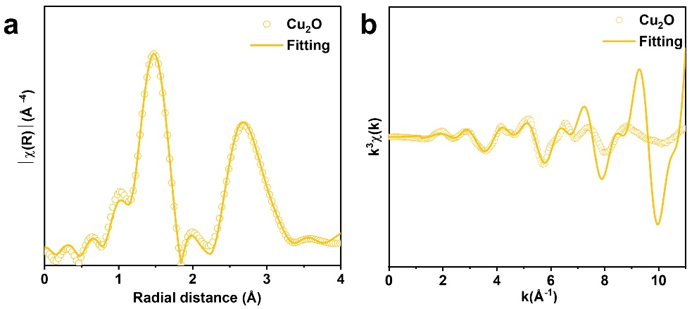
Fig. S8. (a, b) Corresponding EXAFS fitting curve and EXAFS k space fitting curves for Cu₂O under dark condition.

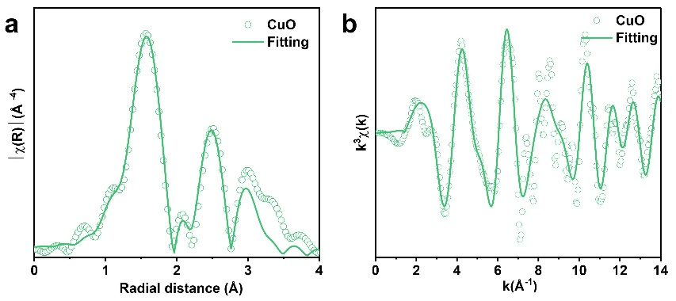
Fig. S9. (a, b) Corresponding EXAFS fitting curve and EXAFS k space fitting curves for CuO under dark condition.

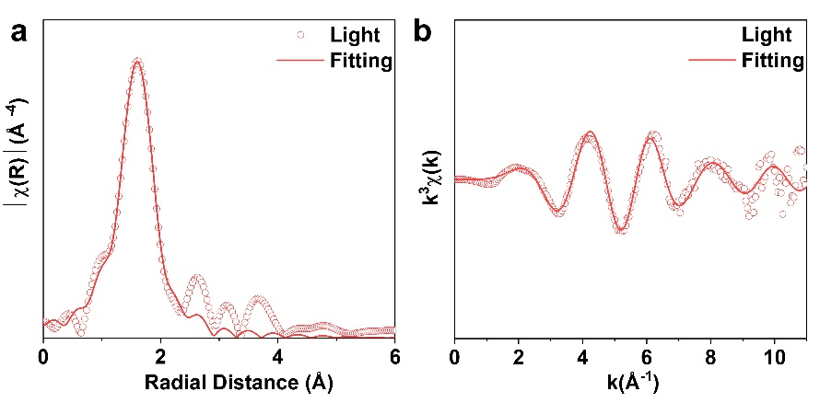
Fig. S10. (a, b) Corresponding in situ EXAFS fitting curve and in situ EXAFS k space fitting curves for Cu SAs@MoS₂ under light irradiation.

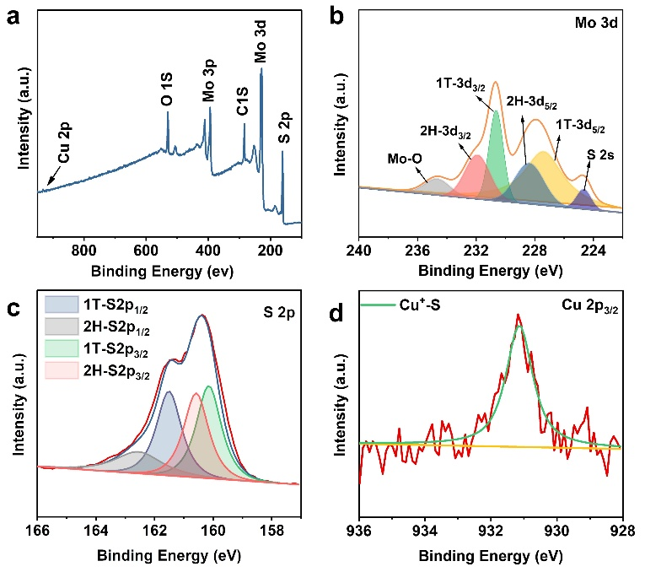
Fig. S11. (a) XPS full spectra of Cu SAs@MoS₂, (b) Mo 3d spectra of Cu SAs@MoS₂, (c) S 2p spectra of Cu SAs@MoS₂, (d) Cu 2p_{3/2} spectra of Cu SAs@MoS₂.

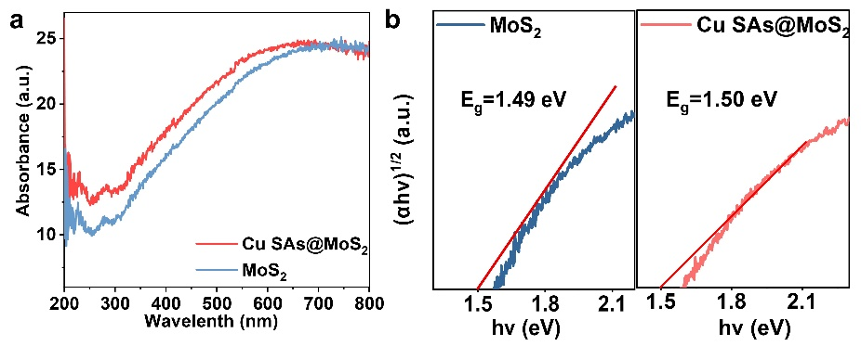
Fig. S12. (a) UV-vis spectra and of Cu SAs@MoS₂ and (b) tauc plots of Cu SAs@MoS₂ and MoS₂, respectively.

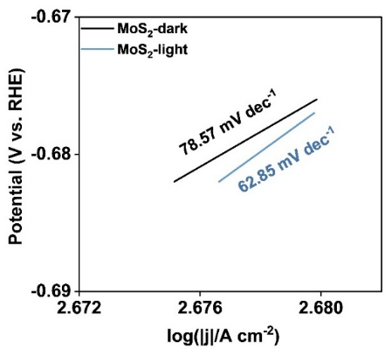
Fig. S13. Tafel slopes of MoS₂ under dark and light conditions.

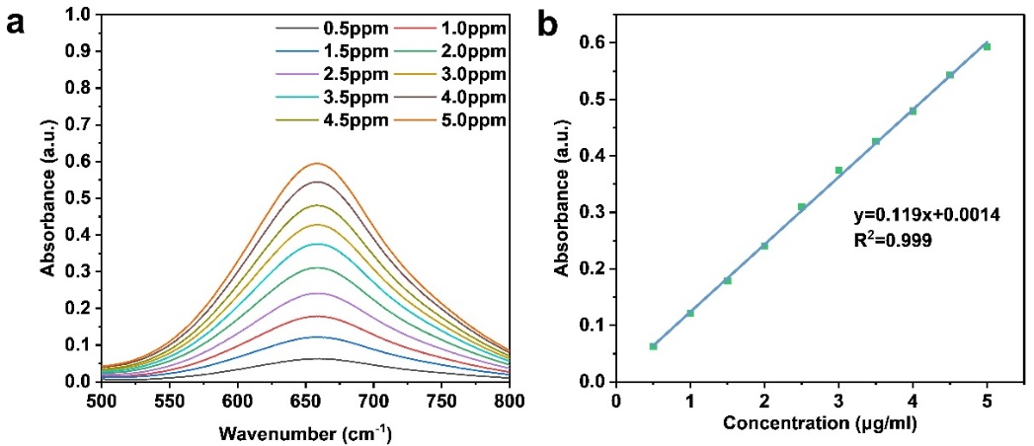
Fig. S14. (a) UV-Vis absorption spectra of indophenol assays with NH₄⁺ after incubated for 2 h at room temperature. (b) Calibration curve used for estimation of NH₄⁺ concentrations.

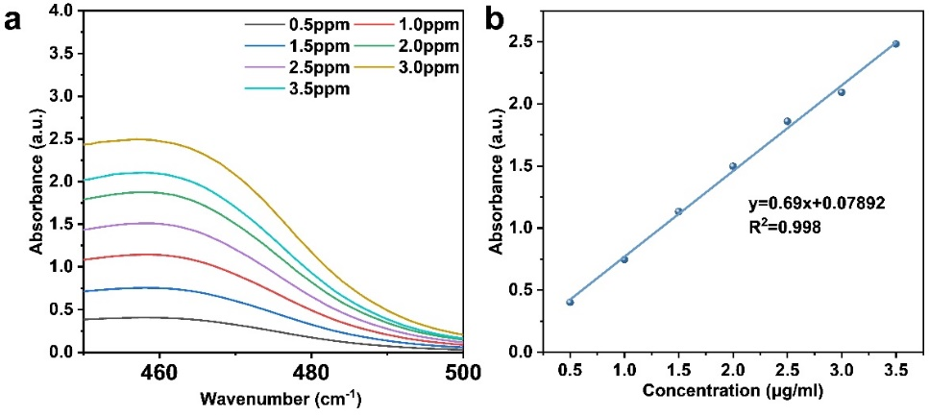
Fig. S15. (a) UV-Vis absorption spectra of various N₂H₄ concentrations after incubated for 15 min at room temperature. (b) Calibration curve used for quantification of N₂H₄ concentrations.
Fig. S16. N₂H₄ yield and FE of N₂, N₂H₄ plots of PMEC and EC NORR of Cu SAs@MoS₂.

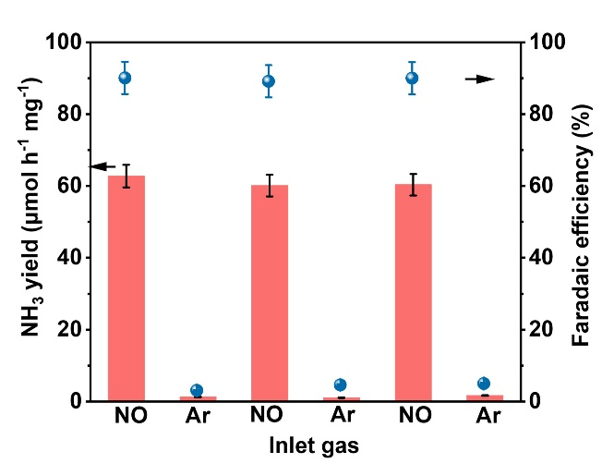
Fig. S17. The NH₃ yield and corresponding FE under alternating conditions with or without NO in PMEC-NORR at -0.3 V vs. RHE.

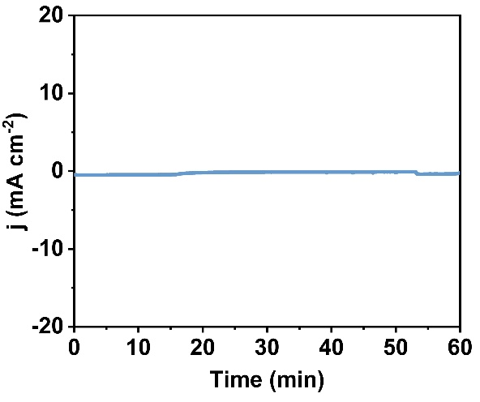
Fig. S18. The current density of Cu SAs@MoS₂ with Ar-saturated electrolyte at -0.3 V vs. RHE under light irradiation
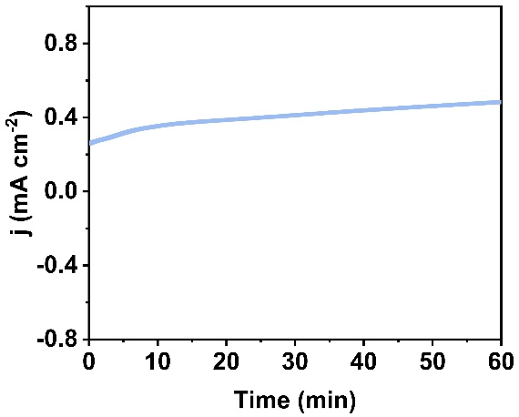
Fig. S19. The current density of Cu SAs@MoS₂ with NO-saturated electrolyte at OCP (open circuit potential) without light irradiation.

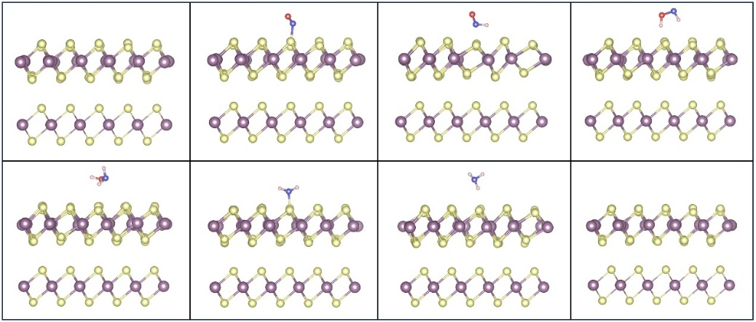
Fig. S20. Side views of optimized adsorption configurations for NO molecules on MoS₂.

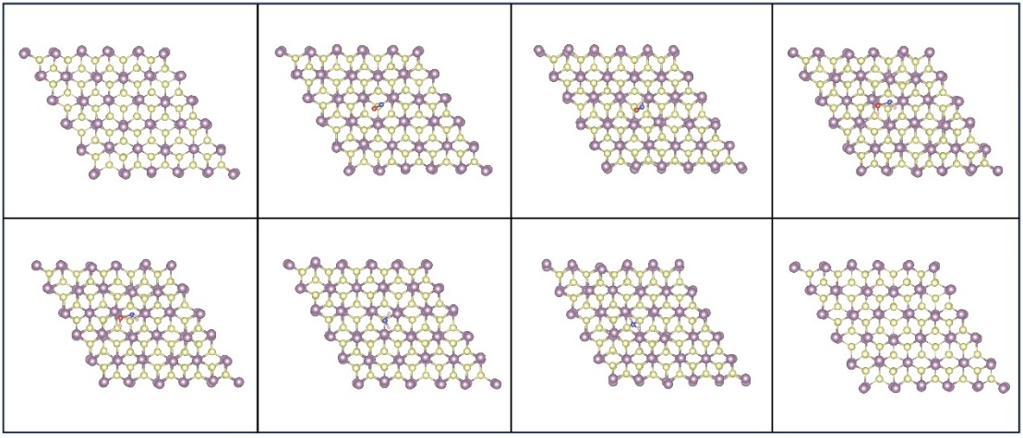
Fig. S21. Top views of optimized adsorption configurations for NO molecules on MoS₂.

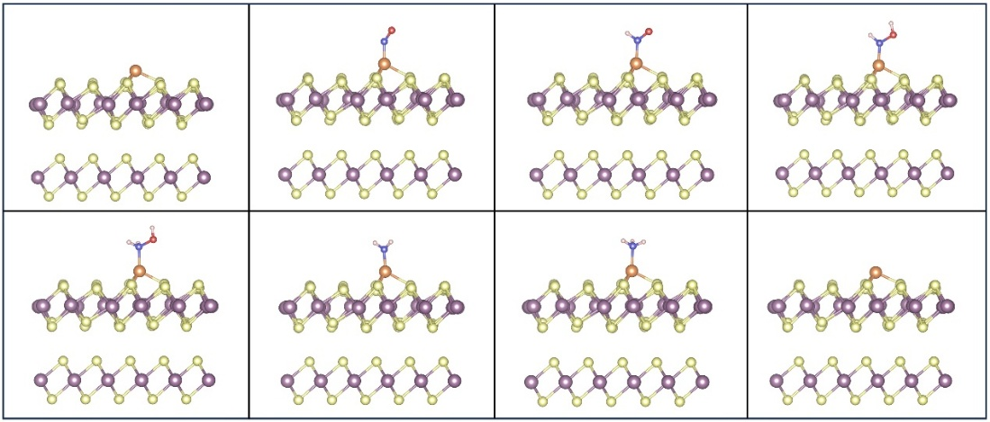
Fig. S22. Side views of optimized adsorption configurations for NO molecules on Cu SAs@MoS₂.

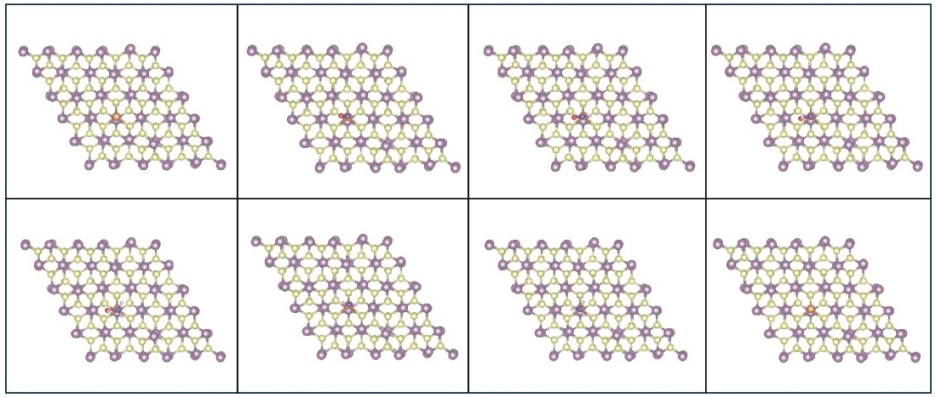
Fig. S23. Top views of optimized adsorption configurations for NO molecules on Cu SAs@MoS₂.

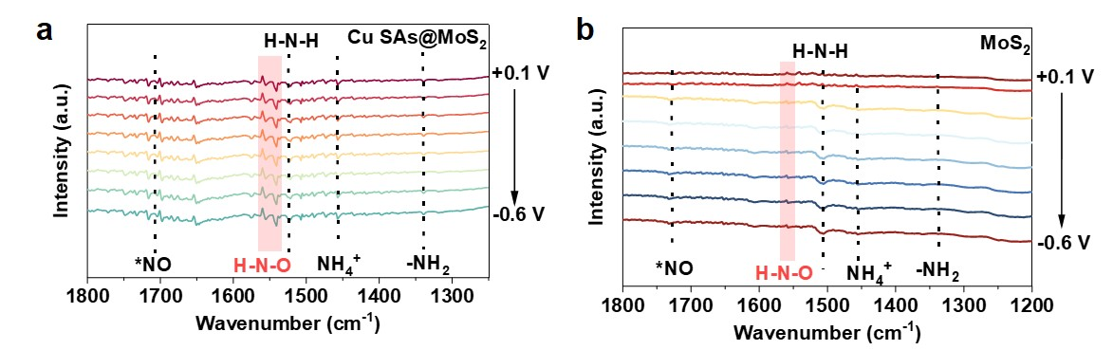

Fig. S24. Potential-dependent Operando ATR-FTIR spectra of PMEC-NORR over (a) Cu SAs@MoS₂ and (b) MoS₂.

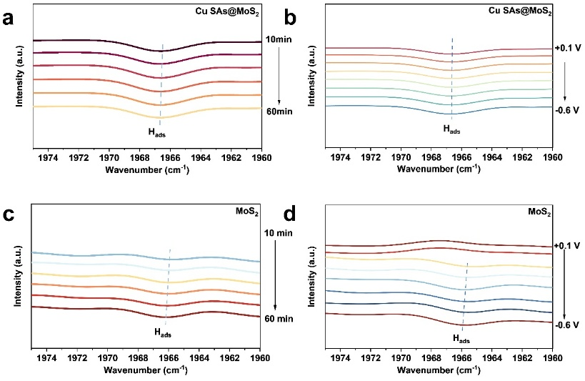
Fig. S25. (a) Potential-dependent and (b) time-dependent Operando photo-electrochemical ATR-FTIR spectra of PMEC-NORR over Cu SAs@MoS₂. (c) Potential-dependent and (d) time-dependent Operando photo-electrochemical ATR-FTIR spectra of PMEC-NORR over MoS₂.

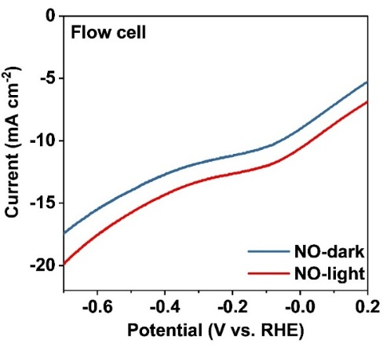
Fig. S26. LSV curves of Cu SAs@MoS₂ with NO atmosphere under light and dark conditions in flow cell.

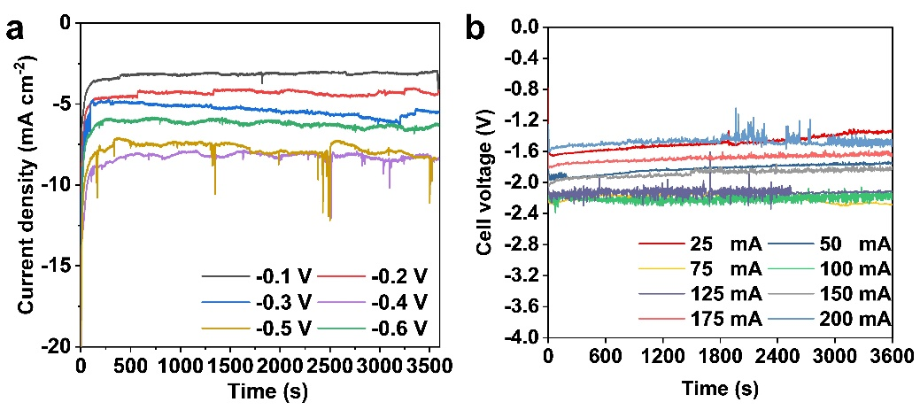
Fig. S27. (a) I-t curves under different potential, (b) V-t curves under different current density.

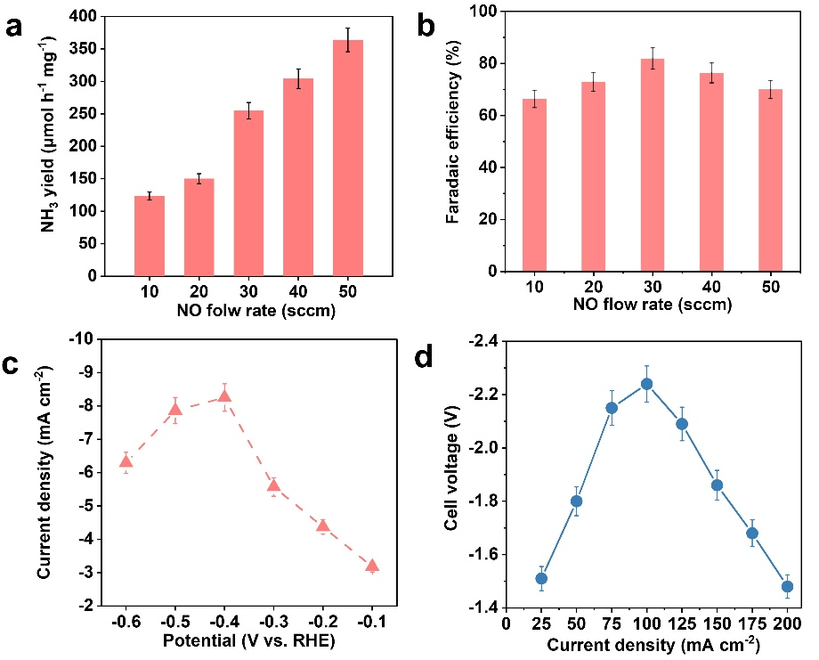
Fig. S28. (a, b) The experiment of gas flow rate was optimized. (c, d) Current density and cell voltage under different potential.

- Supplementary Tables

Table S1. The Cu content of different samples.
Sample | Cu content (wt%)
Cu SAs@MoS₂ | 0.64

Table S2. EXAFS fitting parameters at the Cu K-edge various sample.
Condition | Sample |  | Path | CN | R(Å) | σ ² (Å²) | R factor
Dark | Cu SAs@MoS₂ |  | Cu-S | 3 | 2.27 | 0.014 | 0.0085
Light | Cu SAs@MoS₂ |  | Cu-S | 3 | 2.34 | 0.007 | 0.0141
Dark |  | Cu foil | Cu-Cu | 12 | 2.54 | 0.0086 | 0.0039
 |  | CuO | Cu-Cu | 12 | 3.06 | 0.0032 | 0.0120
 |  | CuO | Cu-O | 4 | 2.15 | 0.0013 | 0.0120
 |  | Cu₂O | Cu-Cu | 12 | 3.03 | 0.0026 | 0.0166
 |  | Cu₂O | Cu-O | 4 | 1.85 | 0.0029 | 0.0166
CN is the coordination number; R is the interatomic distance (the bond length between central atoms and surrounding coordination atoms); σ² is the Debye-Waller factor (a measure of thermal and static disorder in absorber-scatter distances); ΔE₀ is the edge-energy shift (the difference between the zero kinetic energy value of the sample and that of the theoretical model). R factor is used to value the goodness of the fitting.

Table S3. Comparison of NH₃ yield and FE_{NH3} of Cu SAs@MoS₂ catalyst in our PMEC-NORR system with the reported EC-NORR system.
Catalyst | NO concentration | Reactor type | NH₃ Faradaic efficiency (%) | NH₃ yield rate | Potential (V vs. RHE) /Current density (mA cm⁻²) | Ref.
Ni₂P | 10% | H-cell | 76.9% | 33.47 μmol h⁻¹ mg⁻¹ | -0.2 V | ¹
HCNF/CP | 10% | H-cell | 88.33% | 22.35 μmol h⁻¹ cm⁻² | -0.6 V | ²
MnO_{2-x} NA/TM | 10% | H-cell | 82.8% | 9.900 μmol h⁻¹ cm⁻² | -0.7 V | ³
MoS₂/GF | 10% | H-cell | 76.6% | 99.60 μmol h⁻¹ cm⁻² | -0.7 V | ⁴
a-B_{2.6}C@TiO₂/Ti | 10% | H-cell | 87.6% | 147.0 μmol h⁻¹ cm⁻² | -0.9 V | ⁵
Cu@Co | 1% | H-cell | 76.54% | 6.15 μmol h⁻¹ mg⁻¹ | -0.5 V | ⁶
FeOCl-VCl | 1% | H-cell | 91.1% | 26.79 μmol h⁻¹ cm⁻² | -0.5 V | ⁷
hcp-RuCo | 1% | H-cell | 99.2% | 4.570 μmol h⁻¹ mg⁻¹ | -0.1 V | ⁸
Agn | 1% | Flow-cell | ~100% | 28.00 μmol h⁻¹ cm⁻² | −0.165 V | ⁹
Cu@Cu/C NWAs | 3% | Flow-cell | 85% | 244.5 μmol h⁻¹ mg⁻¹ | -0.5 V | ¹⁰
Fe/C | 10% | Flow-cell | 50.40 | 2379 μmol h⁻¹ mg⁻¹ | -0.6 V | ¹¹
Cu SAs@MoS₂ | 10% | Flow cell | 86.53% | 3228 μmol h⁻¹ mg⁻¹ | 100 mA cm⁻² | This work

3. References
1. Mou, T. et al. High-efficiency electrohydrogenation of nitric oxide to ammonia on a Ni₂P nanoarray under ambient conditions. J. Mater. Chem. A 9, 24268-24275 (2021).
2. Ouyang, L. et al. High-efficiency NO electroreduction to NH₃ over honeycomb carbon nanofiber at ambient conditions. J. Colloid Interface Sci. 616, 261-267 (2022).
3. Li, Z. et al. MnO₂ Nanoarray with oxygen vacancies: An efficient catalyst for NO electroreduction to NH₃ at ambient conditions. Mater. Today Phys. 22, 100586 (2022).
4. Zhang, L. et al. High-performance electrochemical NO reduction into NH₃ by MoS₂ nanosheet. Angew. Chem. Int. Ed. 60, 25263-25268 (2021).
5. Liang, J. et al. Amorphous boron carbide on titanium dioxide nanobelt arrays for high-efficiency electrocatalytic NO reduction to NH₃. Angew. Chem. Int. Ed. 61, e202202087 (2022).
6. Wu, Z. et al. Cu@Co with dilatation strain for high-performance electrocatalytic reduction of low-concentration nitric oxide. Adv. Mater. 36, 2309470 (2024).
7. Guo, X. et al. Aqueous electroreduction of nitric oxide to ammonia at low concentration via vacancy engineered FeOCl. Angew. Chem. Int. Ed. 63, e202318792 (2024).
8. Wang, D. et al. Ru-incorporation-induced phase transition in Co nanoparticles for low-concentration nitric oxide electroreduction to ammonia at low potential. Adv. Mater. 36, 2408580 (2024).
9. Kim, D. et al. Unveiling electrode-electrolyte design-based NO reduction for NH₃ synthesis. ACS Energy Lett. 5, 3647-3656 (2020).
10. Meng, J. et al. Carbon support enhanced mass transfer and metal-support interaction promoted activation for low-concentrated nitric oxide electroreduction to ammonia. J. Am. Chem. Soc. 146, 10044-10051 (2024).
11. Cheon, S. et al. Electro-synthesis of ammonia from dilute nitric oxide on a gas diffusion electrode. ACS Energy Lett. 7, 958-965 (2022).

