Supplementary Information for

Global Inequalities in Acute Exposure to Ambient Nitrogen Dioxide

Test S1
Figures S1-S17
Tables S1-S10

Text S1: Childhood asthma burden estimation and comparison
Asthma burden estimation. The long-term asthma burden attributable to annual NO₂ exposure was estimated using Disability-Adjusted Life Years (DALYs), which quantifies the years of healthy life lost due to disability and premature mortality, by adapting the GBD 2021 exposure–response function¹, reporting a RR of 1.082 (95% CI: 1.010–1.160) for childhood asthma per 5 ppb increase in annual NO₂ concentration, as shown below:

$${AB}_{g,y}=\frac{{PF}_{g,y}×({RR(x)}_{g,y}-1)}{{PF}_{g,y}×\left({RR(x)}_{g,y}-1\right)+1}×{POP}_{g,y}×{BAR}_{c,y} , (1)$$

$$RR(x)=\left\{\begin{aligned}1, &x<TMREL \\ e^{ρ∆x}, &x≥TMREL\end{aligned}\right. , (2)$$

where ${AB}_{g}$ represents the estimated long-term asthma burden (DALYs) in grid cell g in year y; ${RR(x)}_{g,y}$ represents the long-term relative risk in grid cell g in year y, calculated using the observed NO₂ concentration ($x$) relative to the theoretical minimum risk exposure level (TMREL). Here, β is the concentration–response coefficient, and$∆x$ denotes the difference between the NO₂ concentration and the TMREL, ranging from 8.65 to 11.66 μg m⁻³, as reported in the GBD 2021 study¹. ${PF}_{g,y}$​ is the population fraction exposed to NO₂ pollution in grid cell g in year y; ${POP}_{g,y}$ is the adjusted population in grid g in year y; ${BAR}_{c,y}$​ refers to baseline asthma rate, defined as the DALYs lost per capita for country c in year y.

Asthma burden comparison. We compared our annual ambient NO₂ estimates—averaged from daily data—and the associated long-term childhood asthma burden with the results reported by the GBD 2021 study¹, as comparisons at the daily level were not feasible. To avoid the confounding effects of COVID-19, we took the year 2019 as an example. We found that, despite broadly similar spatial patterns (Fig. S12), Our dataset consistently reports higher NO₂ levels in most regions in 2019, especially in South Korea and China (annual differences in population-weighted NO₂ of 11 and 9 μg m⁻³, respectively), compared to the GBD dataset, which is less accurate and reports much lower values than ground-based measurements (e.g., R = 0.56 vs. 0.97, Slope = 0.35 vs. 0.92; Fig. S13). These discrepancies may lead to a potential underestimation of NO₂-attributable childhood asthma burdens using the GBD NO₂ dataset, particularly in densely populated countries like India, China, the U.S., and Indonesia (6–33 thousand cases). This results in a global estimate of DALYs (175 thousand [95% CI: -154–739]) that is approximately two-thirds of our estimate (265 thousand [95% CI: 35–476]).

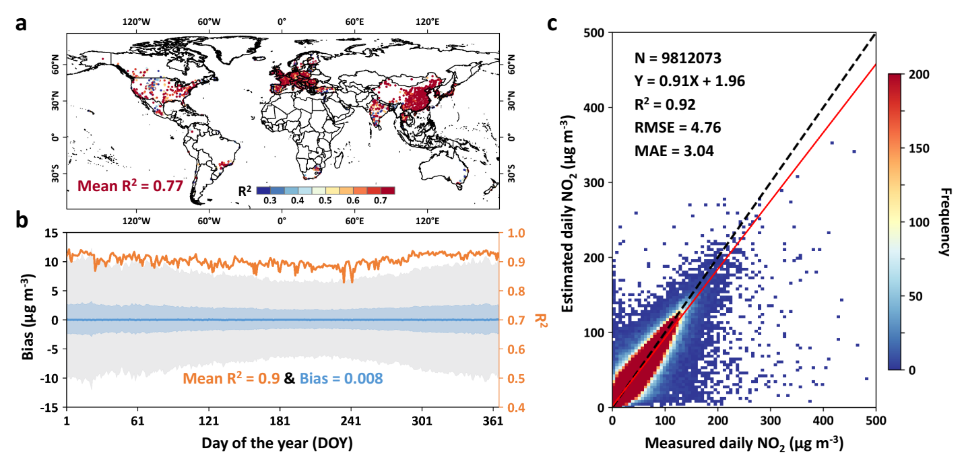

Fig. S1 | Global daily ambient NO₂ estimation accuracy. Spatial distribution of the coefficients of determination (R²) at each individual monitoring station; (b) time series of the day-to-day bias distribution (unit: μg m⁻³) and coefficients of determination (R², orange line); and (c) density scatterplots comparing daily NO₂ estimates (number of samples = 9,812,073) with ground-based measurements collected at all monitoring stations from 2018 to 2022 over land, using the sample-based 10-fold cross-validation approach. The map in (a) was created using ESRI ArcGIS Pro 3.0.1. In (b), the blue line represents the mean bias, while the blue and gray shaded areas indicate the 25th and 75th percentiles, respectively. In (c), the black dashed line represents the 1:1 line, while the red line indicates the best-fit line from linear regression.

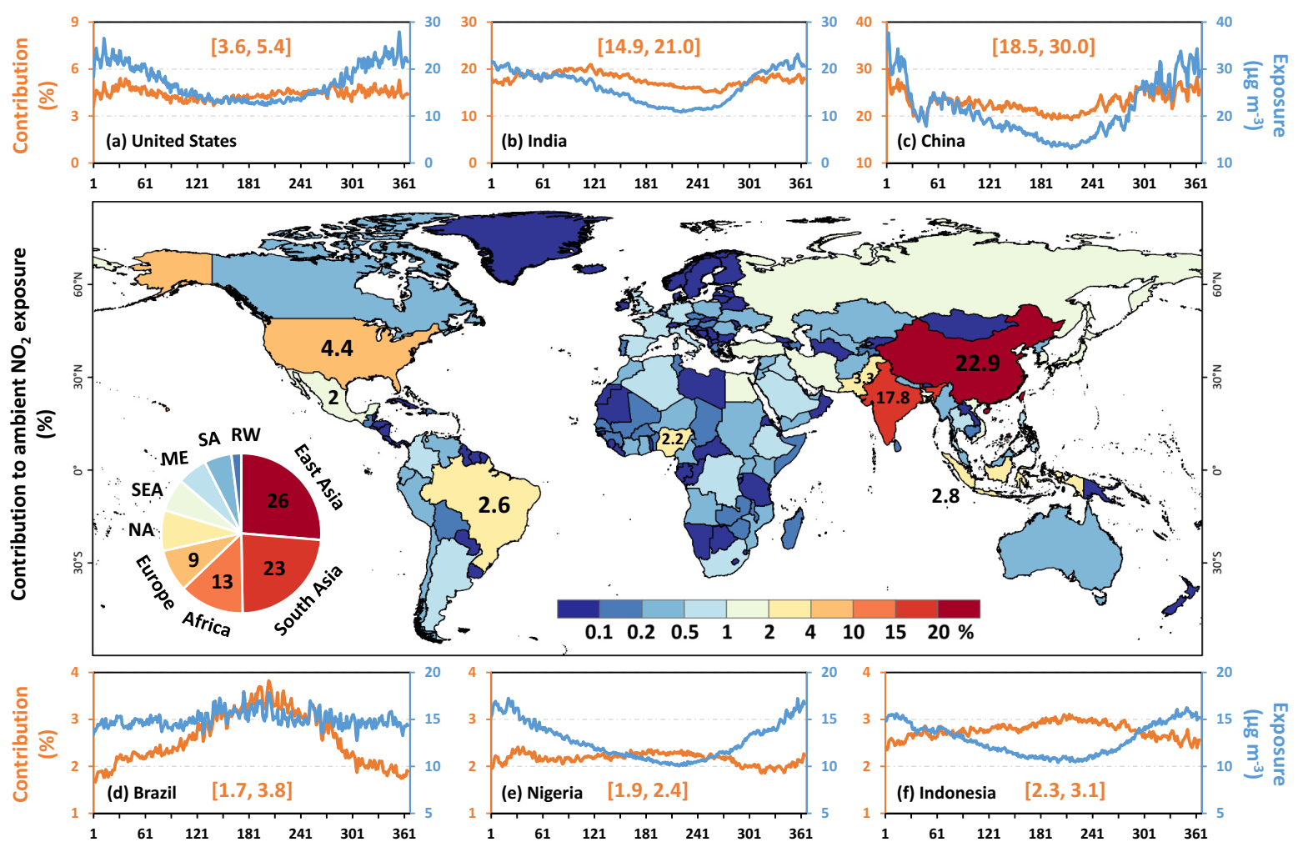

Fig. S2 | Daily contributions to global ambient NO₂ exposure. Spatial distribution of multi-year (2018–2022) average contributions (unit: %) to global daily population-weighted NO₂ exposure for each country, and the black numbers represent the contributions of the top eight countries. The pie chart represents the cumulative contributions for each continent, including East Asia, South Asia, Africa, Europe, North America (NA), Southeast Asia (SEA), the Middle East (ME), South America (SA), and the rest of the world (RW). The surrounding line charts show the time series of daily population-weighted ambient NO₂ exposure (unit: μg m⁻³, blue lines) and contributions (unit: %, orange lines) for six countries: (a) United States, (b) India, (c) China, (d) Brazil, (e) Nigeria, and (f) Indonesia, with the orange numbers indicating the range of daily contribution changes. The map was created using ESRI ArcGIS Pro 3.0.1.

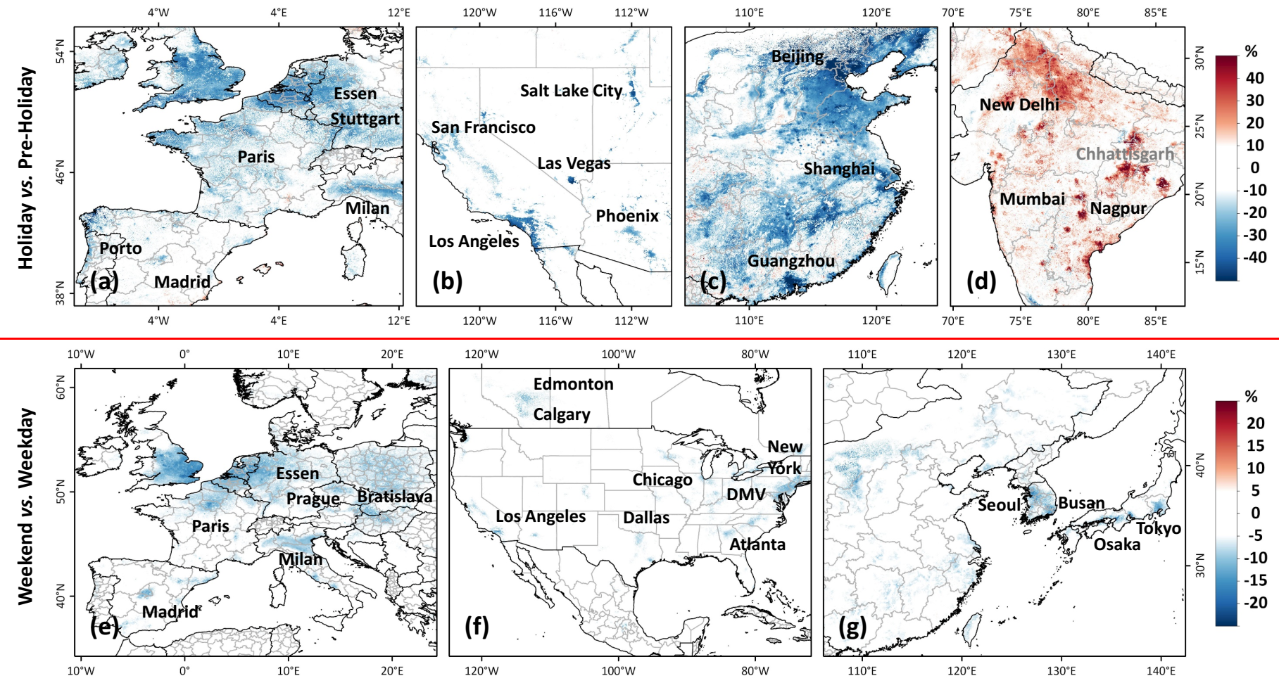

Fig. S3 | Holiday and weekday impacts on ambient NO₂ concentrations. Spatial distribution of the relative changes (unit: %) in ambient NO₂ concentrations during major holidays compared to the pre-holiday period (the two weeks prior) across densely populated areas (population density > 10 people per km²): Christmas in (a) western Europe and (b) the western United States, Lunar New Year in (c) eastern China, and Diwali in (d) India; also shown are relative differences (unit: %) in ambient NO₂ concentrations between weekends and weekdays across inhabited areas (population density > 0 people per km²) from 2019 to 2022 for (e) North America, (f) Europe, and (g) East Asia.

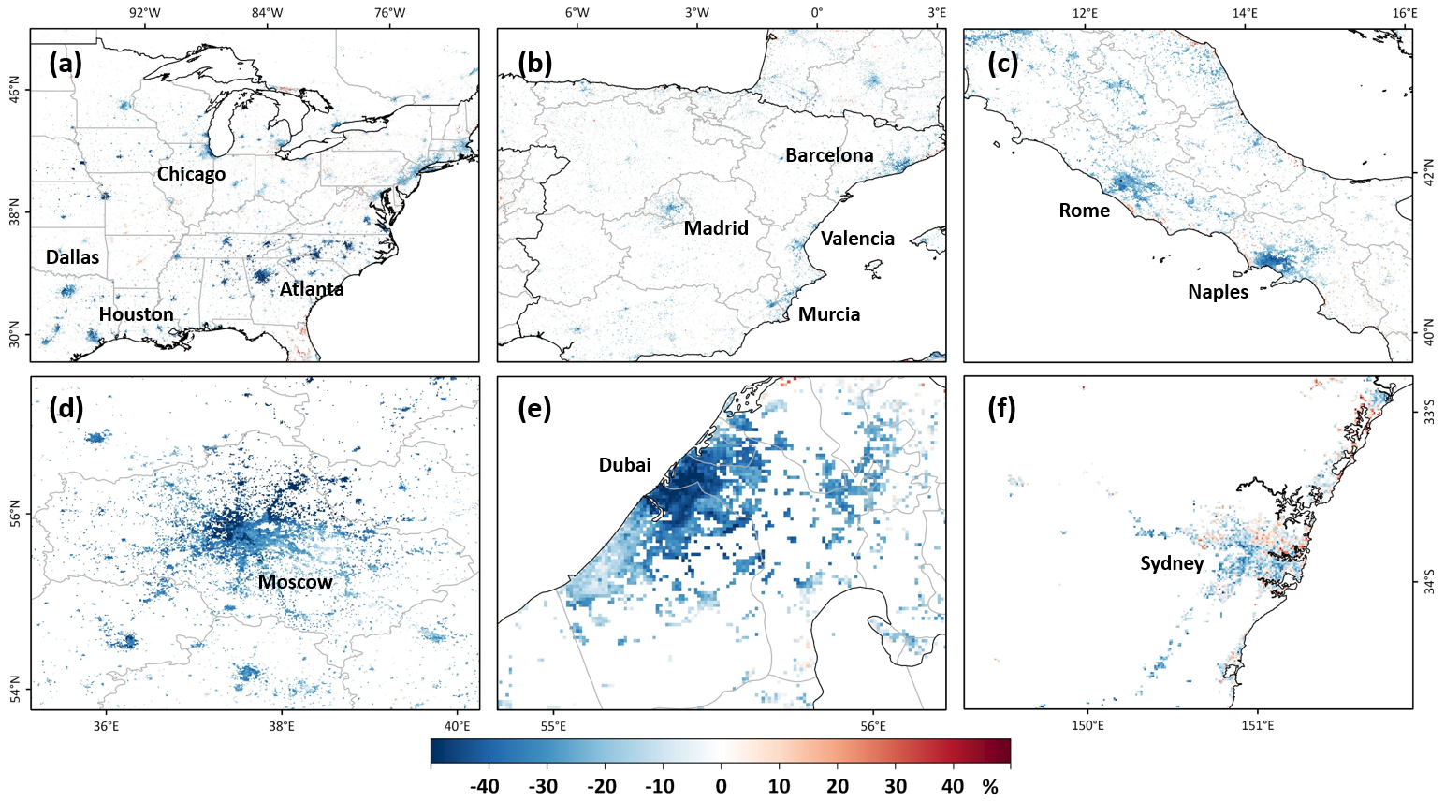

Fig. S4 | Ambient NO₂ changes during the New Year. Spatial distribution of relative changes in surface NO₂ concentrations (unit: %) between New Year's Day (1 January) and Eve (31 December) across major cities in selected countries known for significant fireworks celebrations: (a) United States, (b) Spain, (c) Italy, (d) Russia, (e) United Arab Emirates, and (f) Australia. Only populated areas with a population density exceeding 100 per km² are shown.

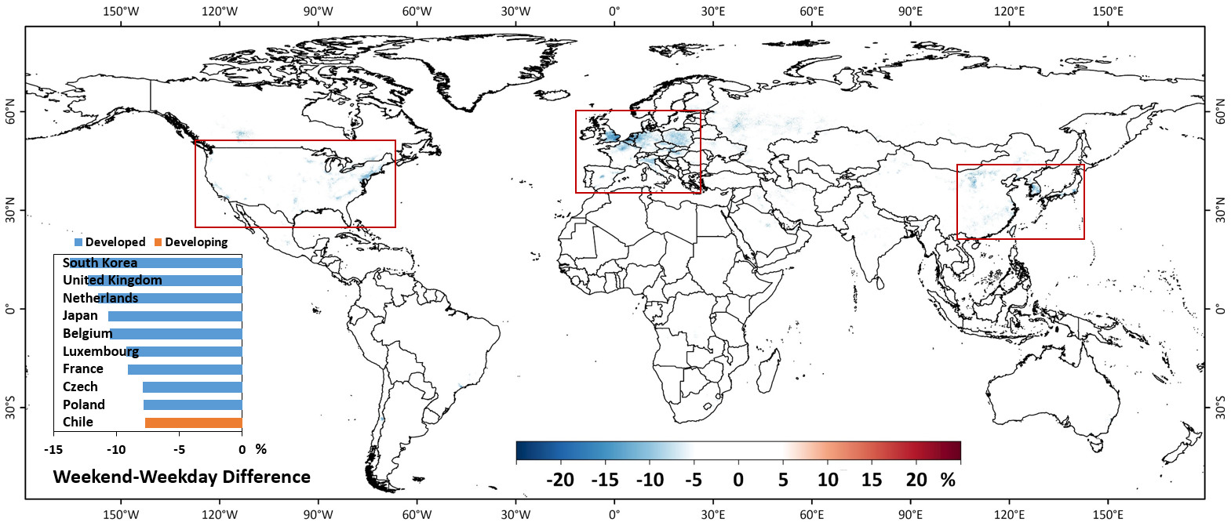

Fig. S5 | Weekday-weekend differences in global ambient NO₂ exposure. Spatial distribution of relative differences (unit: %) in ambient NO₂ concentrations between weekends and weekdays in inhabited areas from 2019 to 2022. The inset bar chart shows the ten countries with the largest reductions (%) in population-weighted mean ambient NO₂ concentrations on weekends compared to weekdays.

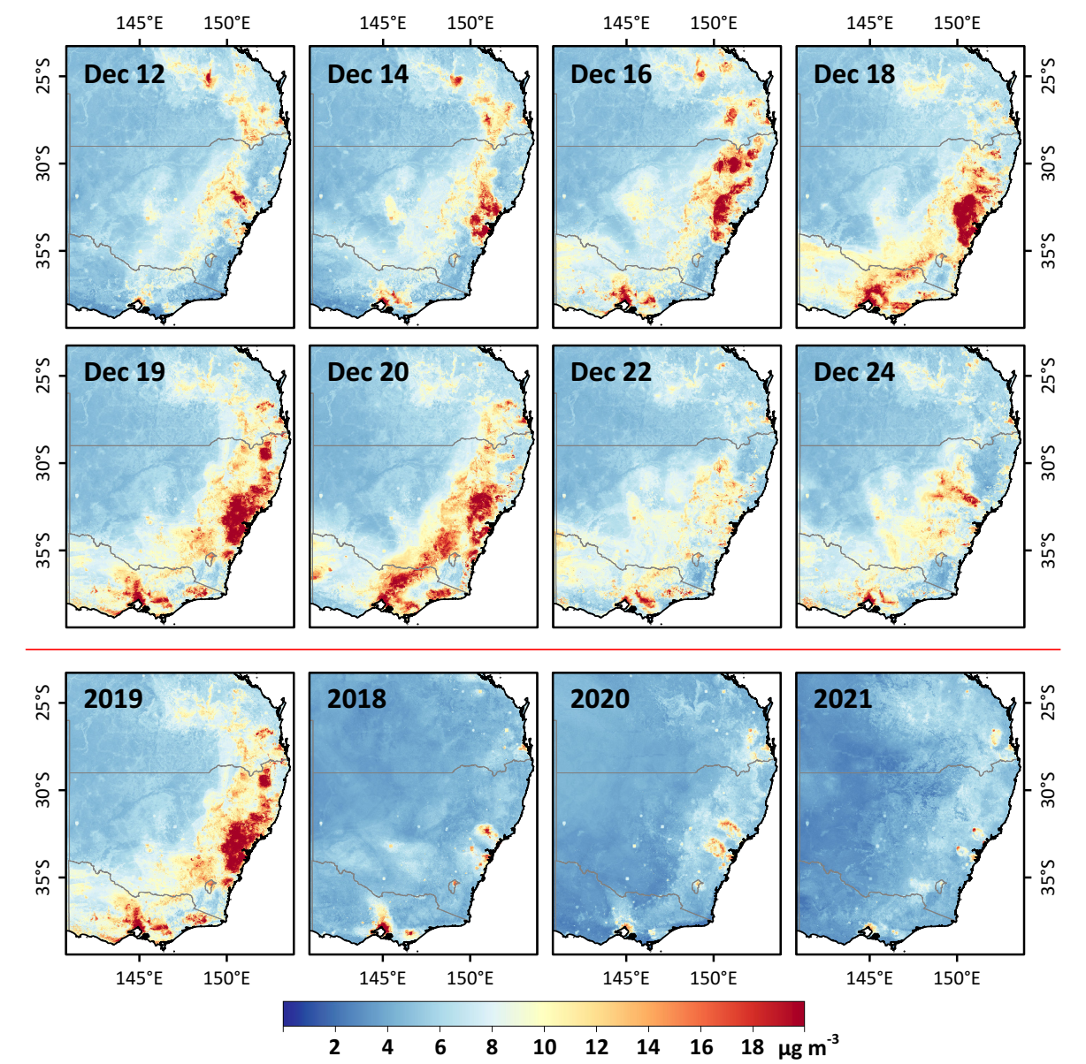

Fig. S6 | Ambient NO₂ changes during wildfires. Spatial distributions of day-to-day variations in satellite-derived surface NO₂ concentrations (unit: μg m⁻³) during a severe wildfire event in southeastern Australia (12–24 December 2019), along with a comparison of the most severe day (19 December 2019) to the same date in other years.

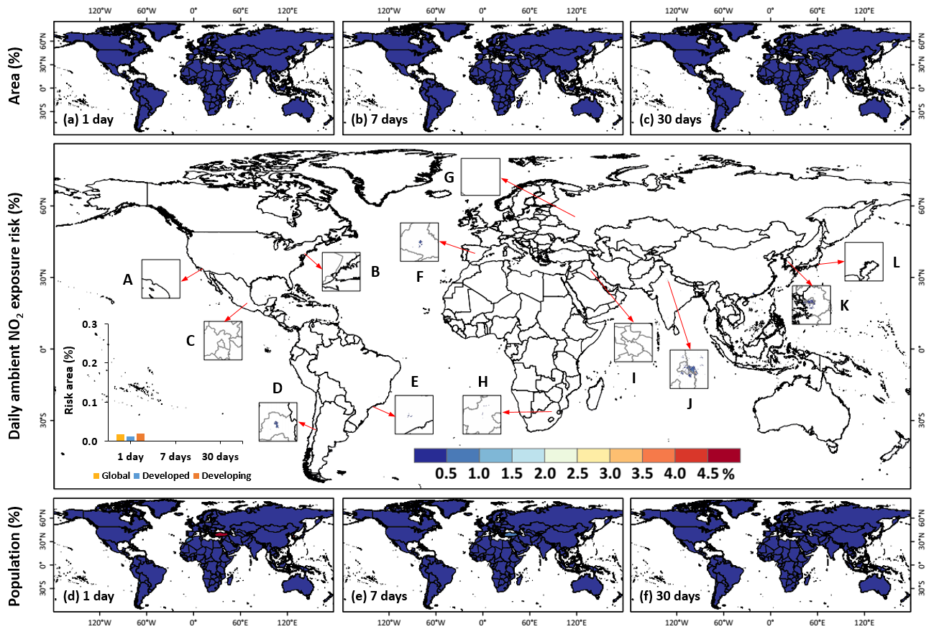

Fig. S7 | Daily exposure risk (interim target 1) to ambient NO₂ pollution. Spatial distribution of the percentage of days (unit: %) with surface NO₂ concentrations exceeding the World Health Organization (WHO) daily interim target 1 (IT-1) threshold of 120 μg m⁻³ at each 1 km² grid over land from 2019 to 2022. Inset bar charts illustrate the percentage (unit: %) of inhabited areas (population density > 0) that experienced at least 1, 7, or 30 days exceeding the IT-1 for the global, developed, and developing world. Square insets highlight major cities with the high daily NO₂ exposure risks (A–L). The surrounding maps display the percentage (unit: %) of (a–c) inhabited areas and (d–f) the population exposed to at least 1, 7, or 30 days exceeding the IT-1 in each country worldwide. The maps were created using ESRI ArcGIS Pro 3.0.1.
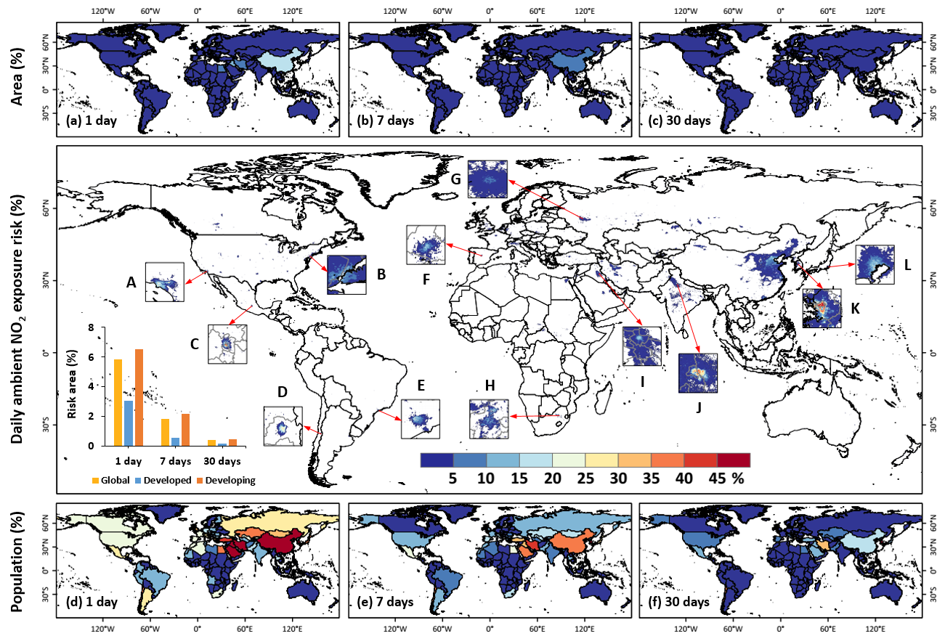

Fig. S8 | Daily exposure risk (interim target 2) to ambient NO₂ pollution. Spatial distribution of the percentage of days (unit: %) with surface NO₂ concentrations exceeding the World Health Organization (WHO) daily interim target 2 (IT-2) threshold of 50 μg m⁻³ at each 1 km² grid over land from 2019 to 2022. Inset bar charts illustrate the percentage (unit: %) of inhabited areas (population density > 0) that experienced at least 1, 7, or 30 days exceeding the IT-2 for the global, developed, and developing world. Square insets highlight major cities with the high daily NO₂ exposure risks (A–L). The surrounding maps display the percentage (unit: %) of (a–c) inhabited areas and (d–f) the population exposed to at least 1, 7, or 30 days exceeding the IT-2 in each country worldwide. The maps were created using ESRI ArcGIS Pro 3.0.1.

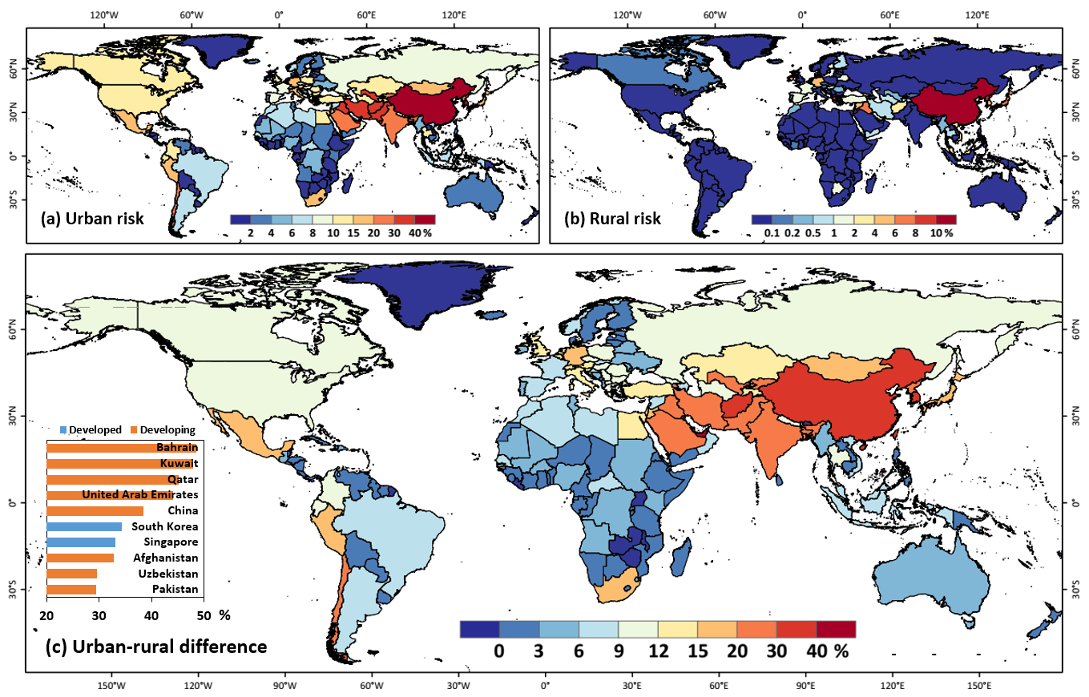

Fig. S9 | Urban-rural contrast in exposure risk to ambient NO₂ pollution. Country-level daily risk exposure to surface NO₂ pollution showing the percentages (unit: %) of days with surface NO₂ concentrations exceeding the World Health Organization (WHO) daily air quality guideline (AQG) of 25 μg m⁻³ from 2019 to 2022, for (a) urban areas, (b) rural areas, and (c) urban-rural differences. The inset bar chart shows the top 10 countries ranked by urban-rural differences in daily exposure risk.

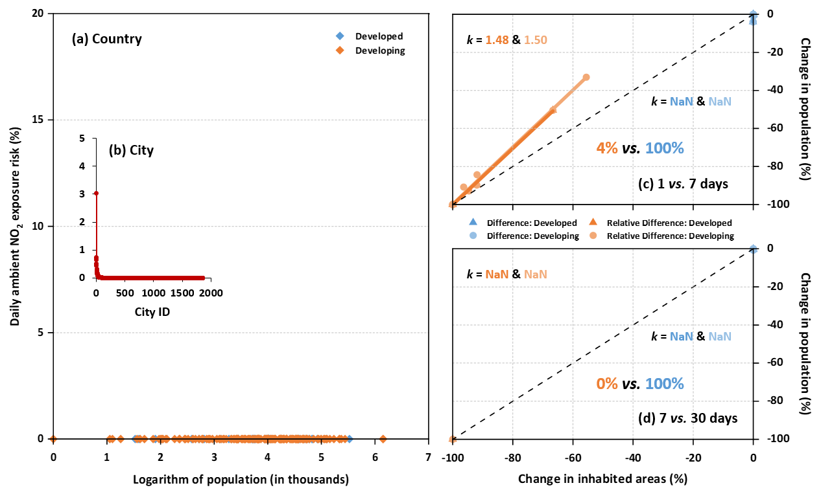

Fig. S10 | Rankings and changes in daily exposure risk (interim target 1) to ambient NO₂ pollution. Scatter plots showing the percentage (unit: %) of days with surface NO₂ concentrations exceeding the WHO daily interim target 1 (IT-1) threshold of 120 μg m⁻³ during 2019–2022: Panel (a) shows data for each country (orange and blue diamonds) as a function of the logarithm of population size (unit: thousand), and the inset subplot (b) presents the sorted daily exposure risk for major cities (red diamonds). The scatter plots on the right compare the direct differences (blue dots) and relative differences (orange dots) in the percentages of the population and inhabited areas (population density > 0) exceeding the IT-1 for each country, as the exposure duration extends: (c) 1 day vs. 7 days, and (d) 7 days vs. 30 days. Colored numbers indicate the percentage of countries where the differences fall below the 1:1 line (i.e., slope < 1).

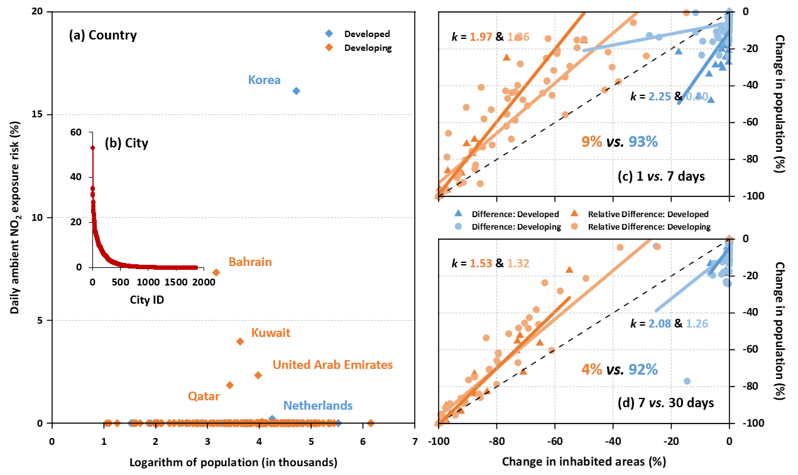

Fig. S11 | Rankings and changes in daily exposure risk (interim target 2) to ambient NO₂ pollution. Scatter plots showing the percentage (unit: %) of days with surface NO₂ concentrations exceeding the WHO daily interim target 2 (IT-2) threshold of 50 μg m⁻³ during 2019–2022: Panel (a) shows data for each country (orange and blue diamonds) as a function of the logarithm of population size (unit: thousand), and the inset subplot (b) presents the sorted daily exposure risk for major cities (red diamonds). The scatter plots on the right compare direct the differences (blue dots) and relative differences (orange dots) in the percentages of the population and inhabited areas (population density > 0) exceeding the IT-2 for each country, as the exposure duration extends: (c) 1 day vs. 7 days, and (d) 7 days vs. 30 days. Colored numbers indicate the percentage of countries where the differences fall below the 1:1 line (i.e., slope < 1).

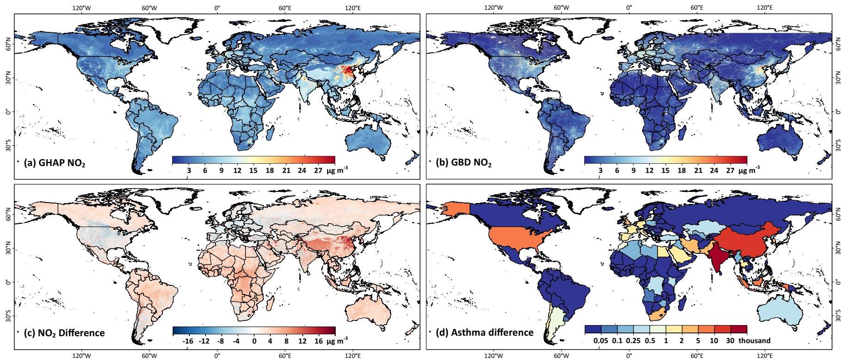

Fig. S12 | Comparison between ambient NO₂ datasets and attributed asthma burden. Spatial distributions of annual mean ambient NO₂ concentrations at 1 km resolution in 2019 from (a) our GlobalHighAirPollutants (GHAP) dataset and (b) the Global Burden of Disease (GBD) study, along with their differences in NO₂ levels (unit: μg m⁻³) and country-level attributed asthma burden (unit: thousand) in 2019.

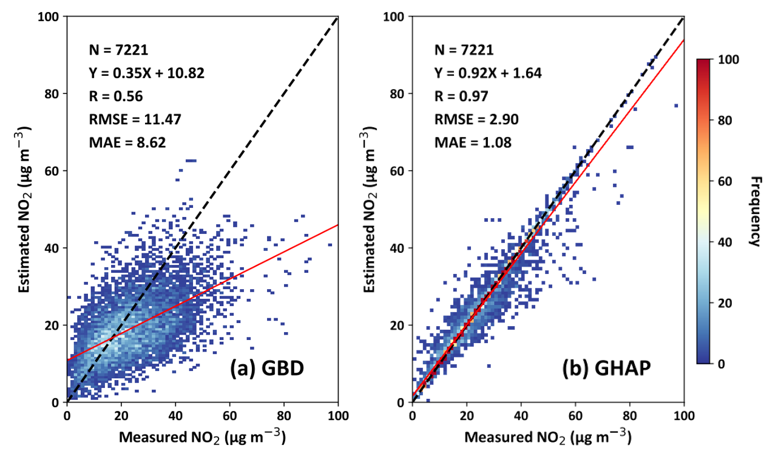

Fig. S13 | Validation and comparison of ambient NO₂ datasets. Comparison of global annual mean surface NO₂ concentrations (unit: μg m⁻³) from (a) the Global Burden of Disease (GBD) study and (b) our GlobalHighAirPollutants (GHAP) dataset, evaluated against ground-based NO₂ measurements from all available monitoring stations in 2019.

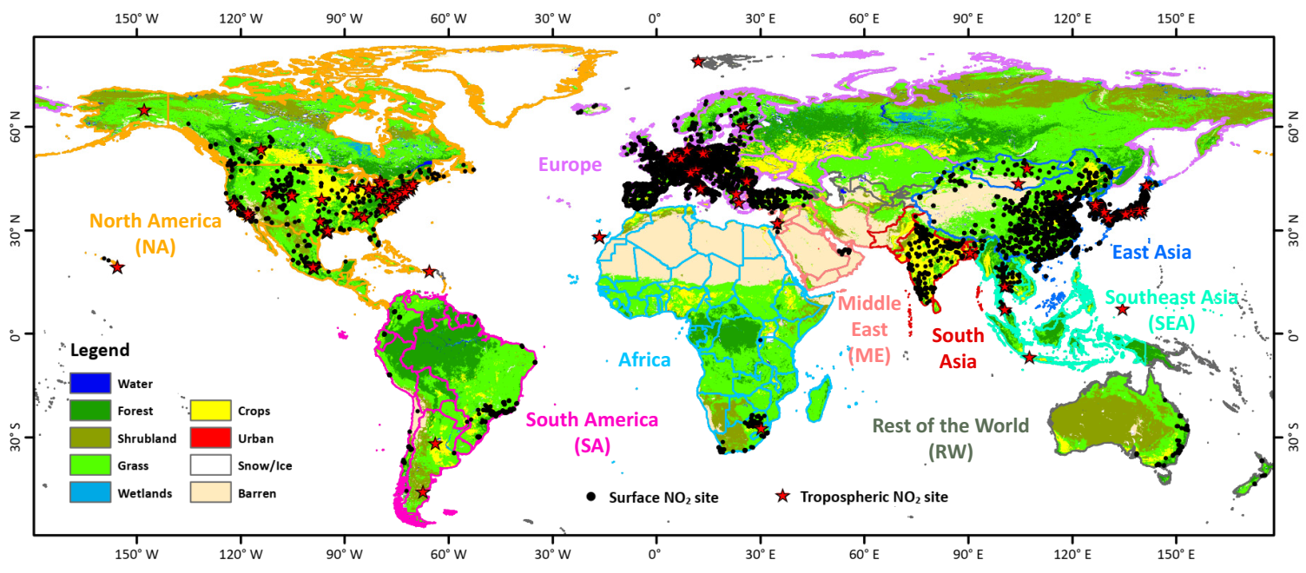

Fig. S14 | Locations of ambient NO₂ monitoring stations. Spatial distribution of ground-based surface NO₂ (black dots) and tropospheric (red stars) monitoring stations. The colored boundaries represent the eight custom-defined areas referenced in the main text. The background map is the MODIS land cover product. The map was created using ESRI ArcGIS Pro 3.0.1.

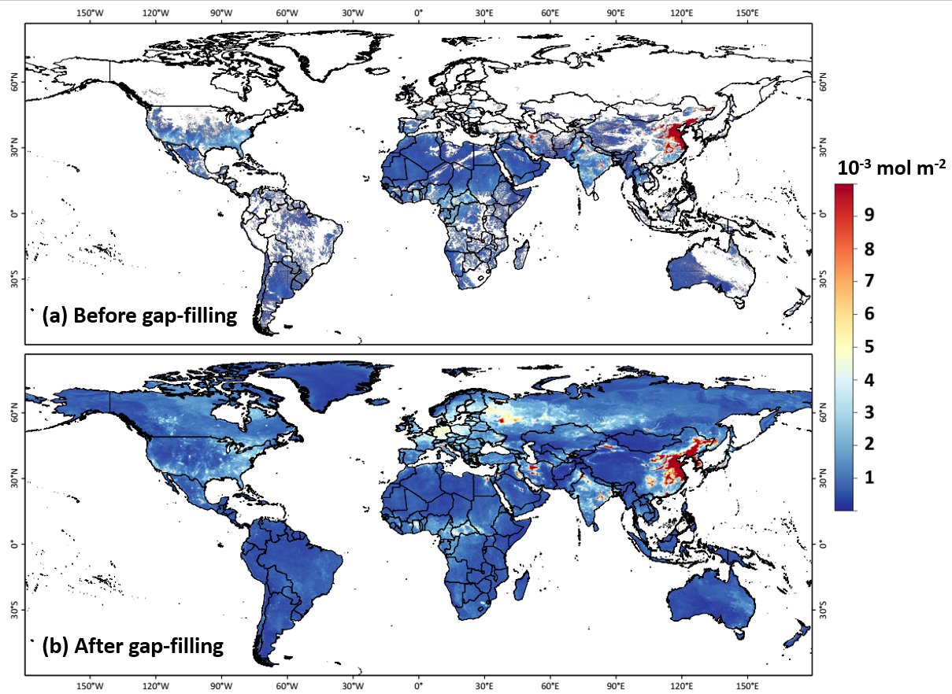

Fig. S15 | Daily satellite tropospheric NO₂ gap filling. Comparison of spatial patterns of daily TROPOMI tropospheric NO₂ retrievals (unit: 10⁻³ mol m⁻²) (a) before and (b) after gap-filling over land on 22 December 2020 using machine learning. Maps were generated using ESRI ArcGIS Pro 3.0.1.

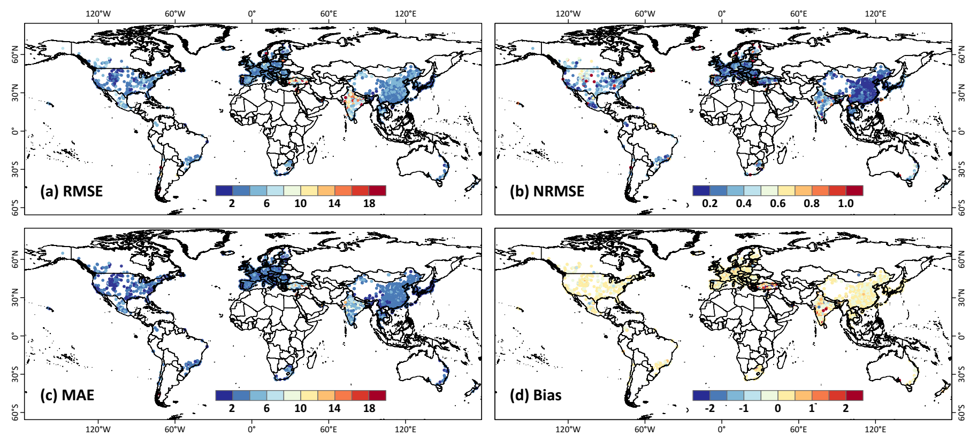

Fig. S16 | Individual site-scale daily ambient NO₂ estimation uncertainty. Spatial distribution of the (a) root-mean-square error (RMSE), (b) normalized RMSE (NRMSE), (c) mean absolute error (MAE), and (d) mean bias at each individual monitoring station comparing daily estimates with ground-based measurements collected at all monitoring stations from 2018 to 2022 over land, using the sample-based cross-validation approach. The maps were created using ESRI ArcGIS Pro 3.0.1.

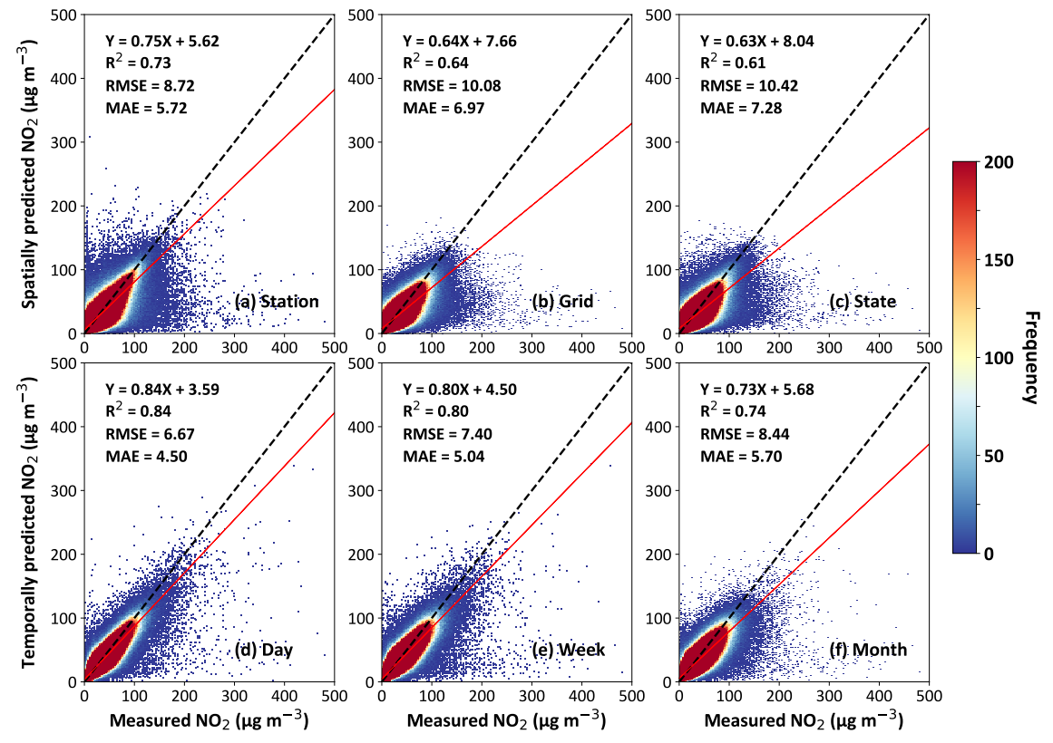

Fig. S17 | Global daily ambient NO₂ prediction accuracy. Density scatterplots of spatial (a) out-of-station, (b) out-of-grid, (c) out-of-state, and temporal (d) out-of-day, (e) out-of-week, and (f) out-of-month cross-validation results of daily ambient NO₂ predictions (unit: μg m⁻³) against ground-based measurements (unit: μg m⁻³) at all monitoring stations from 2018 to 2022 over land (number of samples = 9,812,073). Black dashed lines represent 1:1 lines, and red solid lines represent best-fit lines from linear regression.

Table S1. Summary of previous studies estimating global ambient NO₂ concentrations.
Model | R² | Satellite sources | Gap filling | Spatial resolution | Temporal resolution | Time Period
CTMS² | 0.32: Europe  0.64: North America | SCIAMACHY, GOME, GOME-2 | No | 0.1 | Annual | 1996–2012
LUR³ | 0.54 | SCIAMACHY, GOME-2 | No | 10 km | Annual | 2011
LUR⁴ | 0.47 | OMI | No | 50 m | Daily | 2005–2019
 | 0.59 |  |  |  | Monthly
 | 0.63 |  |  |  | Annual
CTMS⁵ | 0.55 | TROPOMI | No | 0.01 | Monthly | 2018–2020
 | 0.50 |  |  | 0.01 | Annual
Ours | 0.92 | TROPOMI | Yes | 0.01 | Daily | 2018–2022
LUR: Land Use Regression; CTMS: Chemical Transport Model-based Scaling.

Table S2. Top 10 countries ranked by average contribution (%) to global ambient NO₂ exposure from 2019 to 2022, alongside their population proportions in 2022.
Country | Contributions (%) |  |  | Population (%)
Country | Min | Mean | Max | Population (%)
China | 18.5 | 22.9 | 30.0 | 17.7
India | 14.9 | 17.8 | 21.0 | 17.8
United States | 3.6 | 4.4 | 5.4 | 4.2
Pakistan | 2.8 | 3.3 | 3.8 | 3.0
Indonesia | 2.3 | 2.8 | 3.3 | 3.5
Brazil | 1.7 | 2.6 | 3.8 | 2.7
Nigeria | 1.9 | 2.2 | 2.4 | 2.7
Mexico | 1.7 | 2.0 | 2.2 | 1.6
Egypt | 1.4 | 1.9 | 2.4 | 1.4
Bangladesh | 1.5 | 1.9 | 2.3 | 2.1
Note: Orange indicates developing countries; blue indicates developed countries.

Table S3. Top 10 countries ranked by the largest weekend reductions (%) in population-weighted ambient NO₂ exposure compared to weekdays from 2019 to 2022.
Country | Population-weighted ambient NO₂ concentration
Country | Weekday (μg m⁻³) | Weekend (μg m⁻³) | Relative Difference (%)
South Korea | 35.9 | 31.0 | -13.7
United Kingdom | 16.8 | 14.8 | -12.3
Netherlands | 18.7 | 16.6 | -11.5
Japan | 19.3 | 17.3 | -10.6
Belgium | 18.9 | 16.9 | -10.5
Luxembourg | 16.5 | 15.0 | -9.2
France | 14.3 | 13.0 | -9.1
Czech | 14.4 | 13.3 | -7.9
Poland | 14.6 | 13.4 | -7.8
Chile | 24.0 | 22.2 | -7.7
Note: Orange indicates developing countries; blue indicates developed countries.

Table S4. Top 20 cities ranked by the percentages (unit: %) of days exceeding the WHO-recommended short-term ambient NO₂ air quality guideline (AQG) level (daily ambient NO₂ = 25 μg m⁻³) for each major city.
Major City | Country | AQG | IT-2 | IT-1
Tehran* | Iran | 100.0 | 53.2 | 0.0
Riyadh* | Saudi Arabia | 99.2 | 10.9 | 0.0
Mexico City* | Mexico | 98.8 | 28.7 | 0.0
Eslamshahr | Iran | 97.9 | 23.7 | 0.0
Qods | Iran | 97.5 | 27.2 | 0.0
Baghdad* | Iraq | 97.5 | 14.6 | 0.0
Shahriyar | Iran | 97.2 | 23.6 | 0.0
Esfahan | Iran | 97.1 | 24.7 | 0.0
Cairo* | Egypt | 96.3 | 8.8 | 0.0
Santiago* | Chile | 91.8 | 23.8 | 0.2
Chongqing | China | 89.1 | 16.0 | 0.0
Taiyuan, Shanxi | China | 88.4 | 25.4 | 0.0
Chengdu | China | 88.3 | 18.3 | 0.0
Xi'an, Shaanxi | China | 87.9 | 29.2 | 0.0
Karaj | Iran | 85.9 | 21.5 | 0.0
Doha* | Qatar | 85.3 | 3.8 | 0.0
Seoul* | South Korea | 84.4 | 35.2 | 0.2
Wulumqi | China | 84.0 | 28.9 | 0.0
Gwangmyeong | South Korea | 83.8 | 34.6 | 0.2
Los Angeles | United States of America | 83.4 | 20.9 | 0.0
Note: Orange indicates developing countries; blue indicates developed countries; * indicates capital cities.

Table S5. Top 10 countries ranked by the percentage (%) of population (and inhabited areas) exposed to at least 1 (7 and 30 days) above the World Health Organization (WHO) recommended short-term interim target 1 (IT-1) level (daily ambient NO₂ = 120 μg m⁻³).
Country | 1 day |  | 7 days |  | 30 days
Country | Population | Area | Population | Area | Population | Area
Turkey | 4.7 | 0.0 | 0.7 | 0.0 | 0.0 | 0.0
South Korea | 4.4 | 0.1 | 0.5 | 0.0 | 0.0 | 0.0
Georgia | 0.8 | 0.0 | 0.0 | 0.0 | 0.0 | 0.0
Chile | 0.8 | 0.0 | 0.0 | 0.0 | 0.0 | 0.0
Morocco | 0.8 | 0.0 | 0.0 | 0.0 | 0.0 | 0.0
Indonesia | 0.5 | 0.0 | 0.0 | 0.0 | 0.0 | 0.0
Israel | 0.3 | 0.0 | 0.0 | 0.0 | 0.0 | 0.0
Portuguess | 0.2 | 0.0 | 0.1 | 0.0 | 0.0 | 0.0
Hellenic | 0.1 | 0.0 | 0.0 | 0.0 | 0.0 | 0.0
Spain | 0.1 | 0.0 | 0.0 | 0.0 | 0.0 | 0.0
Note: Orange indicates developing countries; blue indicates developed countries.

Table S6. Top 10 countries ranked by the percentage (%) of population (and inhabited areas) exposed to at least 1 (7 and 30 days) above the World Health Organization (WHO) recommended short-term interim target 2 (IT-2) level (daily ambient NO₂ = 50 μg m⁻³).
Country | 1 day |  | 7 days |  | 30 days
Country | Population | Area | Population | Area | Population | Area
Qatar | 94.5 | 38.8 | 80.9 | 14.6 | 3.9 | 0.1
Kuwait | 91.5 | 37.8 | 78.8 | 10.3 | 60.2 | 3.8
South Korea | 86.9 | 22.8 | 78.4 | 11.9 | 65.1 | 5.3
Bahrain | 86.2 | 78.5 | 85.8 | 66.9 | 82.1 | 41.8
United Arab Emirates | 72.3 | 22.0 | 61.3 | 10.5 | 48.3 | 5.3
Jordan | 54.8 | 4.5 | 31.3 | 1.0 | 7.4 | 0.1
Iran | 54.6 | 8.5 | 44.0 | 4.1 | 31.6 | 1.7
Iraq | 54.0 | 13.0 | 30.6 | 3.4 | 11.5 | 0.7
China | 53.8 | 16.7 | 38.0 | 7.5 | 18.5 | 1.8
Note: Orange indicates developing countries; blue indicates developed countries.

Table S7. Top 10 countries ranked by the percentage (%) of population (and inhabited areas) exposed to at least 1 (7 and 30 days) above the World Health Organization (WHO) recommended short-term air quality guidelines (AQG) level (daily ambient NO₂ = 25 μg m⁻³).
Country | 1 day |  | 7 days |  | 30 days
Country | Population | Area | Population | Area | Population | Area
Qatar | 99.6 | 97.4 | 99.5 | 94.7 | 98.5 | 66.6
Netherlands | 99.5 | 99.0 | 96.4 | 82.4 | 78.8 | 36.9
Israel | 99.1 | 91.9 | 96.9 | 68.0 | 85.2 | 33.3
Kuwait | 99.1 | 95.8 | 98.3 | 76.2 | 96.2 | 49.4
Singapore | 98.8 | 85.3 | 98.7 | 81.7 | 98.1 | 65.6
South Korea | 97.7 | 84.8 | 96.5 | 67.5 | 93.5 | 42.8
Belgium | 97.1 | 81.0 | 93.5 | 69.6 | 70.3 | 29.0
Jordan | 96.4 | 51.7 | 92.0 | 34.8 | 81.7 | 13.8
United Arab Emirates | 96.3 | 75.7 | 94.0 | 60.2 | 88.7 | 43.5
Iraq | 95.9 | 76.7 | 90.1 | 57.4 | 77.7 | 32.1
Note: Orange indicates developing countries; blue indicates developed countries.

Table S8. Top 10 countries ranked by the short-term total mortality burden (people) attributed to ambient NO₂ pollution in 2019.
Country | Mean | Lower | Upper
China | 869 | 715 | 1022
India | 301 | 247 | 354
United States | 119 | 98 | 140
Japan | 89 | 73 | 105
Russia | 81 | 67 | 95
Pakistan | 45 | 37 | 53
Indonesia | 41 | 34 | 48
Germany | 38 | 31 | 45
Bangladesh | 38 | 31 | 45
Brazil | 35 | 29 | 41
Note: Orange indicates developing countries; blue indicates developed countries.

Table S9. Summary of global and national ground-based monitoring networks for ambient NO₂ measurements used in this study.
Country | Source | Link | Number
Brazil | IEE | https://energiaeambiente.org.br/qualidadedoar/ | 133
China | CNEMC | https://www.mee.gov.cn/hjzl/ | 2028
Japan | NIES | https://tenbou.nies.go.jp/ | 1694
Korea | AirKorea | https://www.airkorea.or.kr/web | 646
New Zealand | Stats NZ | https://www.stats.govt.nz/indicators | 9
South Africa | SAAQIS | https://saaqis.environment.gov.za/ | 126
United States | EPA | https://www.mee.gov.cn/hjzl/ | 516
Others | OpenAQ | https://openaq.org/ | 6582
All | - | - | 11734
IEE: Institute of Energy and Environment; CNEMC: China National Environmental Monitoring Centre; NIES: National Institute for Environmental Studies; SAAQIS: South African Air Quality Information System.

Table S10. Summary of satellite and auxiliary datasets used in this study.
Variable | Description | Unit | Spatial Resolution | Temporal Resolution | Data Source
NO₂ | Tropospheric NO₂ | mol m⁻² | 1 km | Daily | TROPOMI (GEE)⁶
NO₂ | Tropospheric NO₂ | molec cm⁻² | 0.25° × 0.25° | Daily | HSTCM⁷
NO₂ | Tropospheric NO₂ | molec cm⁻² | 0.25° × 0.25° | Hourly | GEOS-CF⁸
NO₂ | Surface NO₂ | mg m⁻³ | 0.25° × 0.25° | Hourly | GEOS-CF⁸
NO_{x} | Nitrogen oxides | t | 0.1° × 0.1° | Monthly | CAMS-GLOB-ANT⁹
NDVI | Normalized difference vegetation index | - | 1 km | Monthly | MOD13A3
DEM | Surface elevation | m | 90 m | - | SRTM
NTL | Nighttime lights | nW cm⁻² sr⁻¹ | 500 m | Monthly | VIIRS
POP | Population density | - | 1 km | Annual | LandScanTM
TEM | 2-m air temperature | K | 0.1° × 0.1° | Hourly | ERA5-Land¹⁰
PRE | Precipitation | mm
ET | Evaporation | mm
WU | 10-m u-component | m s⁻¹
WV | 10-m v-component | m s⁻¹
SP | Surface pressure | hPa
BLH | Boundary layer height | m | 0.25°×0.25° | Hourly | ERA5¹¹
RH | Relative humidity | %

References
1 Brauer, M. et al. Global burden and strength of evidence for 88 risk factors in 204 countries and 811 subnational locations, 1990-2021: a systematic analysis for the Global Burden of Disease Study 2021. The Lancet 403, 2162-2203, doi:10.1016/S0140-6736(24)00933-4 (2024).
2 Geddes, J. A., Martin, R. V., Boys, B. L. & Donkelaar, A. v. Long-Term Trends Worldwide in Ambient NO₂ Concentrations Inferred from Satellite Observations. Environmental Health Perspectives 124, 281-289, doi:doi:10.1289/ehp.1409567 (2016).
3 Larkin, A. et al. Global Land Use Regression Model for Nitrogen Dioxide Air Pollution. Environmental Science & Technology 51, 6957-6964, doi:10.1021/acs.est.7b01148 (2017).
4 Larkin, A. et al. A global spatial-temporal land use regression model for nitrogen dioxide air pollution. Front. Environ. Sci. 11, doi:10.3389/fenvs.2023.1125979 (2023).
5 Cooper, M. J. et al. Global fine-scale changes in ambient NO₂ during COVID-19 lockdowns. Nature 601, 380-387, doi:10.1038/s41586-021-04229-0 (2022).
6 GEE. Sentinel-5P OFFL NO2: Offline Nitrogen Dioxide. Google Earth Engine Data Catalog (2018).
7 Qin, K. et al. The global daily High Spatial–Temporal Coverage Merged tropospheric NO₂ dataset (HSTCM-NO2) from 2007 to 2022 based on OMI and GOME-2. Earth Syst. Sci. Data 16, 5287-5310, doi:10.5194/essd-16-5287-2024 (2024).
8 Keller, C. A. et al. Description of the NASA GEOS Composition Forecast Modeling System GEOS-CF v1.0. Journal of Advances in Modeling Earth Systems 13, e2020MS002413, doi:10.1029/2020MS002413 (2021).
9 Soulie, A. et al. Global anthropogenic emissions (CAMS-GLOB-ANT) for the Copernicus Atmosphere Monitoring Service simulations of air quality forecasts and reanalyses. Earth Syst. Sci. Data 16, 2261-2279, doi:10.5194/essd-16-2261-2024 (2024).
10 Muñoz-Sabater, J. et al. ERA5-Land: a state-of-the-art global reanalysis dataset for land applications. Earth Syst. Sci. Data 13, 4349-4383, doi:10.5194/essd-13-4349-2021 (2021).
11 Hersbach, H. et al. The ERA5 global reanalysis. Q J R Meteorol Soc. 146, 1999-2049, doi:10.1002/qj.3803 (2020).

