Supplementary Data

Supplementary Figure 1
CONSORT diagram of study population (Enrolment to day 28 follow-up)
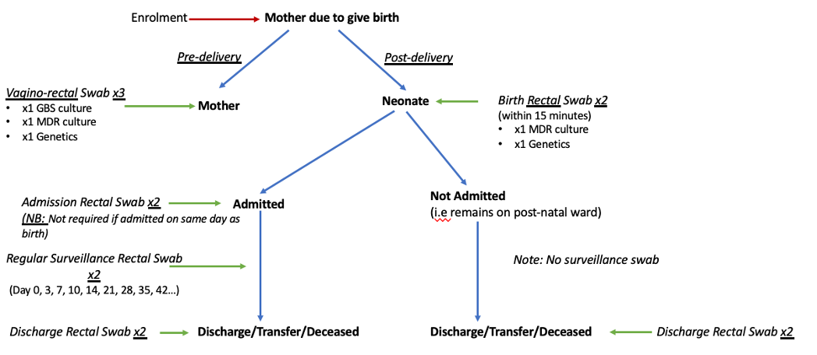
Supplementary Figure 2:
Sample collection timing of participants throughout the study period
Supplementary Figure 3: Time to colonisation for (a) any MDR-GN pathogen, (b) ESBL-producing pathogens, and (c) CREs; stratified by exposure to antibiotics

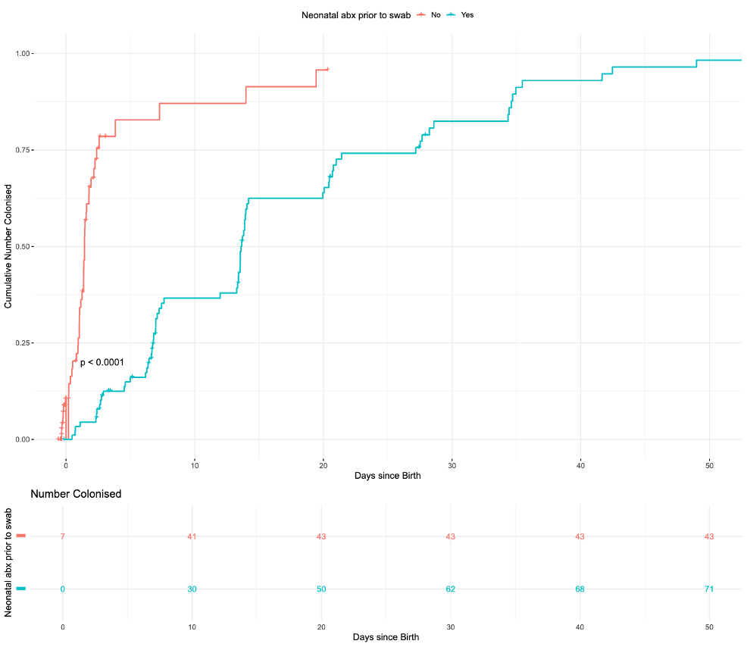
- Time-to-colonisation with any MDR-GN for colonised infants, stratified by exposure to antibiotics prior to colonisation swab
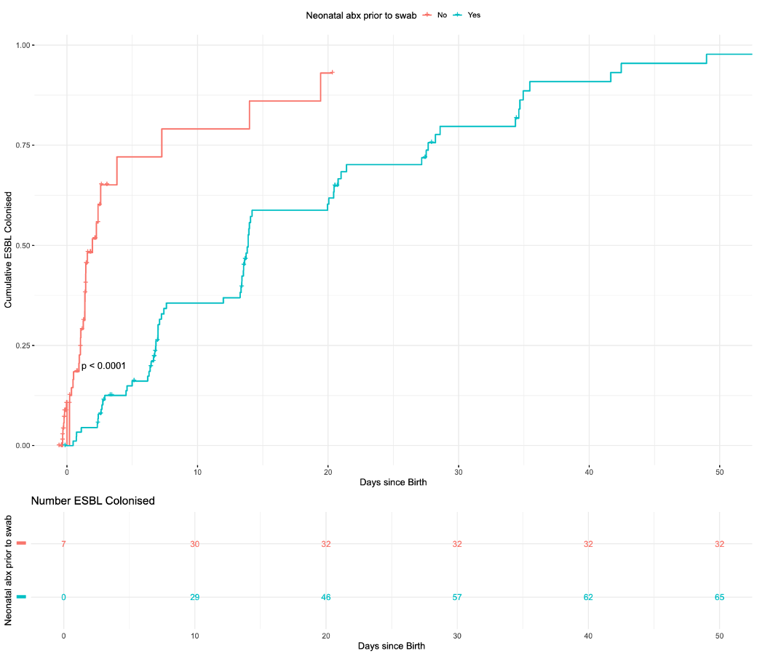
- Time-to-colonisation with any ESBL-producing organisms for ESBL-colonised infants, stratified by exposure to antibiotics prior to colonisation swab

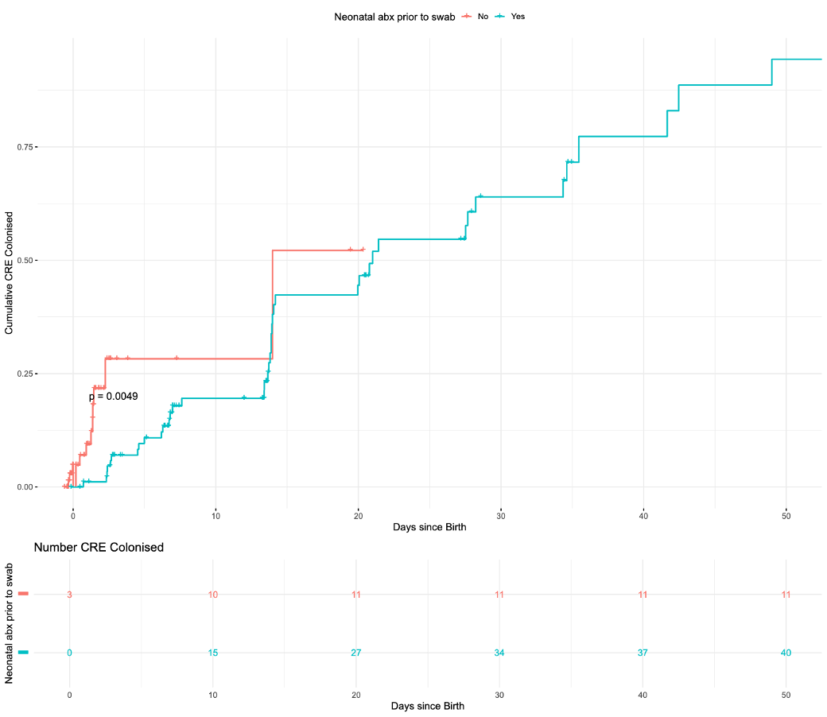
- Time-to-colonisation with any CRE organisms for CRE-colonised infants, stratified by exposure to antibiotics prior to colonisation swab

Supplementary Figure 4: Neonatal antibiotic class exposure prior to colonisation with MDR-GN organism.

Note: * represents statistically significant difference between colonised and not colonised groups
Supplementary Table 1: Colonising gram-negative organisms (neonates)
Organism | Count
Klebsiella pneumoniae | 112
Escherichia coli | 37
Acinetobacter baumannii | 29
Enterobacter hormaechei | 14
Pseudomonas aeruginosa | 3
Serratia marcescens | 3
Klebsiella aerogenes (Enterobacter aerogenes) | 2
Pseudomonas monteilii | 2
Stenotrophomonas maltophilia | 2
Acinetobacter pittii (Acinotebacter Baumannii Complex) | 1
Chryseobacterium arthrosphaerae | 1
Chryseobacterium daecheongense | 1
Leclercia adecarboxylata | 1
Pseudescherichia vulneris | 1
Pseudomona otitidis | 1
Pseudomonas putida | 1
Stenotrophomonas maltophilia | 1

Supplementary Table 2: Colonising gram negative organisms (maternal)
Organism | Count
Escherichia coli | 58
Acinetobacter baumannii | 19
Klebsiella pneumoniae | 14
Acinetobacter ursingii | 4
Enterobacter hormaechei | 5
Unidentified | 3
Enterobacter cloacae | 2
Acinetobacter nosocomialis | 1
Burkholderia cepacia | 1
Burkholderia vietnamiensis | 1
Chryseobacterium arthrosphaerae | 1
Chryseobacterium tructae | 1
Citrobacter freundii | 1
Kluyvera ascorbata | 1
Pseudomonas putida | 1
Pseudomonas citronellosis | 1
Pseudomonas nitroreducens | 1
Stenotrophomonas maltophilia | 1

Supplementary Table 3: Pathogens identified as causative of invasive neonatal infections:
Organism | Count | Infection onset ≤ 48 hours of life
Klebsiella pneumoniae | 4 | 1
Staphylococcus epidermidis | 3 | 1
Staphylococcus aureus | 1 | 0
Serratia marcescens | 1 | 0
Klebsiella oxytoca | 1 | 0
Acinetobacter baumannii | 1 | 0

Supplementary Table 4: Frequency of Infant and Maternal co-Colonisation
Mother_Colonised | Infant_Colonised | CRE | ESBL | CRGN
Yes | Yes | 1 | 55 | 9
No | Yes | 50 | 42 | 20
Yes | No | 5 | 48 | 24
No | No | 133 | 44 | 136

Supplementary Table 5: Maternal colonisation characteristics
Characteristic | Overall  N = 189 | Not colonised  N = 69 | Colonised  N = 120 | p-value
Maternal Age | 31.1 (26.6, 35.6) | 31.0 (27.7, 35.7) | 31.5 (26.2, 35.4) | >0.9
Maternal Education | NA | NA | NA | >0.9
Nil or Primary | 16 (8.5%) | 5 (7.2%) | 11 (9.2%) | NA
Secondary | 97 (51%) | 36 (52%) | 61 (51%) | NA
Tertiary | 76 (40%) | 28 (41%) | 48 (40%) | NA
Maternal Employment | NA | NA | NA | 0.5
Student or Employed | 58 (31%) | 24 (35%) | 34 (28%) | NA
Unemployed or Household Duties | 129 (68%) | 44 (64%) | 85 (71%) | NA
Unknown | 2 (1.1%) | 1 (1.4%) | 1 (0.8%) | NA
Household income (Indonesian rupiah) | 3,500,000 (0, 7,000,000) | 3,000,000 (0, 6,000,000) | 4,000,000 (0, 7,000,000) | >0.9
Household Population | NA | NA | NA | 0.8
<= 3 | 57 (33%) | 22 (34%) | 35 (32%) | NA
>= 7 | 7 (4.0%) | 3 (4.7%) | 4 (3.6%) | NA
4 - 6 | 111 (63%) | 39 (61%) | 72 (65%) | NA
Household Water Access | NA | NA | NA | >0.9
Limited or basic | 105 (56%) | 38 (55%) | 67 (56%) | NA
Safe | 73 (39%) | 27 (39%) | 46 (39%) | NA
Unknown | 10 (5.3%) | 4 (5.8%) | 6 (5.0%) | NA
Household Toilet Access | NA | NA | NA | 0.6
Limited or basic | 107 (57%) | 36 (52%) | 71 (60%) | NA
Safe | 71 (38%) | 29 (42%) | 42 (35%) | NA
Unknown | 10 (5.3%) | 4 (5.8%) | 6 (5.0%) | NA
Household Handwashing Access | NA | NA | NA | 0.6
Basic | 169 (90%) | 64 (93%) | 105 (88%) | NA
Limited or no facility | 10 (5.3%) | 2 (2.9%) | 8 (6.7%) | NA
Unknown | 9 (4.8%) | 3 (4.3%) | 6 (5.0%) | NA
Number of Time Bathing per Week | NA | NA | NA | 0.3
2-5 | 9 (4.8%) | 1 (1.4%) | 8 (6.7%) | NA
6-7 | 166 (88%) | 63 (91%) | 103 (87%) | NA
Unknown | 13 (6.9%) | 5 (7.2%) | 8 (6.7%) | NA
Accessed Antenatal Care | 188 (99%) | 68 (99%) | 120 (100%) | 0.4
Gravida | NA | NA | NA | 0.9
>= 5 | 13 (6.9%) | 5 (7.2%) | 8 (6.7%) | NA
2-4 | 109 (58%) | 41 (59%) | 68 (57%) | NA
Primagravida | 67 (35%) | 23 (33%) | 44 (37%) | NA
Parity | NA | NA | NA | 0.6
>= 5 | 5 (2.6%) | 2 (2.9%) | 3 (2.5%) | NA
2-4 | 172 (91%) | 61 (88%) | 111 (93%) | NA
Primaparity | 12 (6.3%) | 6 (8.7%) | 6 (5.0%) | NA
Admitted During Pregnancy | NA | NA | NA | 0.5
No | 132 (70%) | 52 (75%) | 80 (67%) | NA
Unknown | 8 (4.2%) | 2 (2.9%) | 6 (5.0%) | NA
Yes | 49 (26%) | 15 (22%) | 34 (28%) | NA
Antibiotics During Pregnancy | NA | NA | NA | 0.047
No | 155 (82%) | 60 (87%) | 95 (80%) | NA
Unknown | 9 (4.8%) | 0 (0%) | 9 (7.6%) | NA
Yes | 24 (13%) | 9 (13%) | 15 (13%) | NA
Cephalosporins | 10 (5.3%) | 4 (5.8%) | 6 (5.0%) | >0.9
Unknown class | 11 (5.8%) | 4 (5.8%) | 7 (5.8%) | >0.9
Metronidazole | 2 (1.1%) | 0 (0%) | 2 (1.7%) | 0.5
Penicillins | 2 (1.1%) | 0 (0%) | 2 (1.7%) | 0.5
Azithromycin | 3 (1.6%) | 3 (4.3%) | 0 (0%) | 0.047
Ciprofloxacin | 1 (0.5%) | 0 (0%) | 1 (0.8%) | >0.9

Supplementary Table 6: LASSO regression, outcome of neonatal colonisation
Term | Odds Ratio (95% CI) | Standard Error | Statistic | p Value
(Intercept) | 0.612 (0.391–0.945) | 0.224 | -2.192 | 0.028
NICU admission | 1.063 (1.023–1.114) | 0.022 | 2.804 | 0.005
Maternal antibiotics in pregnancy (Unknown) | 0.426 (0.083–1.962) | 0.789 | -1.083 | 0.279
Maternal antibiotics in pregnancy (Yes) | 2.072 (0.721–6.876) | 0.565 | 1.291 | 0.197
Neonatal antibiotic exposure | 1.684 (0.647–4.366) | 0.483 | 1.078 | 0.281

Supplementary Table 7: LASSO regression, outcome of neonatal infection episode
Term | Odds Ratio (95% CI) | Standard Error | Statistic | p Value
(Intercept) | 0.009 (0–0.055) | 1.199 | -3.944 | 0
Colonised | 1.363 (0.059–15.854) | 1.284 | 0.241 | 0.809
Neonatal antibiotic exposure | 3827.43 (492.945–104113.797) | 1.274 | 6.476 | 0

Supplementary Table 8: LASSO regression, outcome of neonatal mortality
Term | Odds Ratio (95% CI) | Standard Error | Statistic | p Value
(Intercept) | 0.068 (0.001–5.572) | 2.283 | -1.177 | 0.239
Colonised | 2.537 (0.537–12.96) | 0.798 | 1.166 | 0.244
NICU admission | 0.27 (0.01–7.455) | 1.482 | -0.884 | 0.377
Birthweight | 1.002 (1.001–1.004) | 0.001 | 2.955 | 0.003
Admission duration | 1.134 (1.039–1.28) | 0.052 | 2.394 | 0.017
Maternal antibiotics in pregnancy (Unknown) | 0.559 (0.045–14.283) | 1.363 | -0.427 | 0.669
Maternal antibiotics in pregnancy (Yes) | 3.3 (0.38–80.004) | 1.272 | 0.938 | 0.348
Neonatal antibiotic exposure | 0.118 (0.005–1.237) | 1.346 | -1.589 | 0.112

Supplementary Table 9: LASSO regression, outcome of neonatal mortality amongst ESBL colonised infants
Term | Odds Ratio (95% CI) | Standard Error | Statistic | p Value
(Intercept) | 0.048 (0–2.291) | 2.127 | -1.423 | 0.155
Colonised | 2.087 (0.495–9.276) | 0.736 | 0.999 | 0.318
Birthweight | 1.002 (1.001–1.004) | 0.001 | 3.043 | 0.002
Admission duration | 1.126 (1.04–1.256) | 0.048 | 2.475 | 0.013
Neonatal antibiotic exposure | 0.067 (0.006–0.569) | 1.159 | -2.332 | 0.02

Supplementary Table 10: LASSO regression, outcome of neonatal mortality amongst CRE colonised infants
Term | Odds Ratio (95% CI) | Standard Error | Statistic | p Value
(Intercept) | 0.037 (0–1.811) | 2.163 | -1.53 | 0.126
Colonised | 1.663 (0.345–10.045) | 0.841 | 0.605 | 0.545
Birthweight | 1.003 (1.001–1.004) | 0.001 | 3.17 | 0.002
Admission duration | 1.139 (1.045–1.283) | 0.052 | 2.512 | 0.012
Maternal antibiotics in pregnancy (Unknown) | 0.613 (0.052–16.012) | 1.366 | -0.358 | 0.721
Maternal antibiotics in pregnancy (Yes) | 3.524 (0.407–86.929) | 1.277 | 0.986 | 0.324
Neonatal antibiotic exposure | 0.069 (0.006–0.563) | 1.128 | -2.368 | 0.018

Supplementary Table 11: LASSO regression, outcome of neonatal mortality amongst CRGN colonised infants
Term | Odds Ratio (95% CI) | Standard Error | Statistic | p Value
(Intercept) | 0.05 (0–4.01) | 2.264 | -1.319 | 0.187
Colonised | 35202720.337 (0–NA) | 1858.094 | 0.009 | 0.993
NICU admission | 0.231 (0.008–6.39) | 1.486 | -0.988 | 0.323
Birthweight | 1.003 (1.001–1.004) | 0.001 | 3.153 | 0.002
Admission duration | 1.151 (1.051–1.312) | 0.056 | 2.52 | 0.012
Maternal antibiotics in pregnancy (Unknown) | 0.588 (0.044–15.877) | 1.403 | -0.378 | 0.705
Maternal antibiotics in pregnancy (Yes) | 5.236 (0.574–136.534) | 1.313 | 1.261 | 0.207
Neonatal antibiotic exposure | 0.156 (0.006–1.48) | 1.292 | -1.435 | 0.151

Supplementary Table 12: Unadjusted Cox Proportional Hazards Model, time to colonisation with any resistant gram-negative organism in those with an episode of infection vs no episode of infection
Variable | Hazard ratio | Confidence interval | p-value
Infection episode | 0.21 | 0.14 to 0.32 | <0.001

Supplementary Table 13: Adjusted Cox Proportional Hazards Model, time to colonisation with any resistant gram-negative organism in those with an episode of infection vs no episode of infection
Variable | Hazard ratio | Confidence interval | p-value
Infection episode | 0.81 | 0.43 to 1.53 | 0.52
NICU Admission | 0.15 | 0.06 to 0.37 | <0.001
Admission duration | 0.90 | 0.88 to 0.93 | <0.001

Supplementary Table 14: Unadjusted Cox Proportional Hazards Model, time to colonisation with any organism in neonates exposed to antibiotics prior to first positive screening colonisation swab

Variable | Hazard ratio | Confidence interval | p-value
Neonatal antibiotic exposure prior to swab | 0.18 | 0.12 to 0.28 | <0.001
Supplementary Table 15: Adjusted Cox Proportional Hazards Model, time to colonisation with any organism in neonates exposed to antibiotics prior to first positive screening colonisation swab
Variable | Hazard ratio | Confidence interval | p-value
Neonatal antibiotic exposure prior to swab | 0.63 | 0.32 to 1.23 | 0.17
NICU Admission | 0.16 | 0.07 to 0.41 | <0.001
Admission duration | 0.91 | 0.88 to 0.93 | <0.001

Supplementary Table 15: Positive environmental swabs
Environmental Site  (20 samples collected per site) | ESBL | CRE | CR-GN
Handwashing Sink | 1 (5.0%) | 1 (5.0%) | 8 (40.0%)
Computer Keyboard | 4 (20.0%) | 0 (0.0%) | 5 (25.0%)
Pulse Oximeter | 3 (15.0%) | 0 (0.0%) | 2 (10.0%)
Tip Of Hand sanitiser | 1 (5.0%) | 0 (0.0%) | 1 (5.0%)
Under Cot | 1 (5.0%) | 0 (0.0%) | 2 (10.0%)
Water reservoir of humidifier | 1 (5.0%) | 0 (0.0%) | 1 (5.0%)
Total | 11 | 1 | 19

Supplementary Table 16: Classification of pathogenic versus innocuous bacteria
Pathogen vs contaminant classification
DEFINITE pathogen | PROBABLE pathogen | POSSIBLE pathogen | Likely contaminant
Include | Include | Include if clinically symptomatic and no other pathogen identified | Exclude
Acinetobacter spp. | Streptococcus viridians | Coagulase-negative staphylococci | Arcanobacterium
Aeromonas spp. | Candida spp. | Corynebacterium jeikeium | Arthrobacter
Campylobacter jejuni | Morganella morganii |  | Arthrobacter oxydans
Citrobacter spp. | Nocardia spp. |  | Bacillus megaterium
Elizabethkingia meingosepticum | Moraxella spp. |  | Bacillus pumilus
Enterobacter spp. |  |  | Bacillus subtilis
Enterococcus spp. |  |  | Cellulosimicrobium cellulans
Escherichia coli |  |  | Corynebacterium amycolatum
Group A streptococcus |  |  | Corynebacterium freneyi
Group B streptococcus |  |  | Cutibacterium
Group D streptococcus |  |  | Dermabacter
Haemophilis influenzae |  |  | Diphtheroid
Klebsiella penumoniae |  |  | Exiguobacterium
Listeria monocytogenes |  |  | Geobacillus
Neisseria meningitidis |  |  | Helcobacillus
Proteus mirabilis |  |  | Janibacter
Pseudomonas aeruginosa |  |  | Knoellia
Salmonella spp. |  |  | Kocuria marina
Serratia marcescens |  |  | Kocuria palustris
Shigella spp. |  |  | Leifsonia
Staphylococcus aureus |  |  | Lysinibacillus boronitolerans
Streptococcus penumoniae |  |  | Microbacterium arborescens
 |  |  | Microbacterium barkeri
 |  |  | Microbacterium paraoxydans
 |  |  | Microbacterium testaceum
 |  |  | Micrococcus luteus
 |  |  | Nesterenkonia
 |  |  | Paenibacillus
 |  |  | Paenibacillus amylolyticus
 |  |  | Propionibacterium
 |  |  | Pseudoclavibacter
 |  |  | Exiguobacterium
Based on published data from:
1. Hossain, Belal MSc; Weber, Martin W. et al. Classification of Blood Culture Isolates Into Contaminants and Pathogens on the Basis of Clinical and Laboratory Data. The Pediatric Infectious Disease Journal 35(5):p S52-S54, May 2016.
2.Milton, Rebecca; Odumade, Oludare et al. Neonatal sepsis and mortality in low-income and middle-income countries from a facility-based birth cohort: an international multisite prospective observational study, The Lancet Global Health;10(5):e661-e672. May 2022.
3. Russell N, Stohr W, Plakkal N, Cook A…et al. Patterns of antibiotic use, pathogens and prediction of mortality in hospitalised neonates and young infants with sepsis: A global neonatal sepsis observational cohort study (NeoOBS). PLoS Med, 2003, 20(6).

Supplementary Table 17: Demographic and clinical variables collected for enrolled mother-infant dyads
Variable / Field Name | Section Header | Field Label | Options
mat_dob | Demographic & socioeconomic details: | Mothers date of birth (DOB):
mat_weight_preg |  | Mothers pre-pregnancy weight (estimated) (Kg):
mat_weight_now |  | Mothers current weight (estimated) (Kg):
mat_height |  | Mother's pre-pregnancy height (estimated) (cm):
mat_edu |  | Mother's highest level of education: | 0, None | 1, Primary | 2, Secondary | 3, Tertiary | 99, Unknown
mat_emp |  | Mother's employment status: | 0, Unemployed | 1, Household duties | 2, Student | 3, Civil Worker | 4, Manual work, including farming/fishing | 99, Unknown
hh_income |  | Estimated combined monthly household income:
hh_income_cur |  | Currency of estimated monthly household income: | 0, Indonesian rupiah | 1, Philippine peso | 2, United States Dollars (USD) | 99, Unknown
hh_location |  | Household location: | 0, Rural | 1, Peri-urban | 2, Urban | 99, Unknown
hh_pop |  | Number of household members (including mother & enrolled infants):
hh_rooms |  | Number of household rooms:
hh_water |  | Household water service-level: | 1, Safely Managed | 2, Basic | 3, Limited | 4, Unimproved | 5, Surface Water | 99, Unknown
hh_toilet |  | Household toilet service: | 1, Safely Managed | 2, Basic | 3, Limited | 4, Unimproved | 5, Open Defecation | 99, Unknown
hh_hwashing |  | Household handwashing access: | 1, Basic | 2, Limited | 3, No Facility | 99, Unknown
hh_bath |  | Access to bathing: days per week | 0, 0 | 1, 1 | 2, 2 | 3, 3 | 4, 4 | 5, 5 | 6, 6 | 7, 7 | 99, Unknown
mat_comorb_details |  | Maternal co-morbidity details:
mat_smoker |  | Smoking status: | 1, Non-smoker | 2, Smoked pre-pregnancy but not during | 3, Smoked pre- and during pregnancy | 99, Unknown
mother_outdoors |  | Regular outdoor activities during pregnancy: | 1, Yes | 0, No | 99, Unknown
gravida
parity
antenatal_care | Issues | Antenatal care received in pregnancy: | 1, Yes | 0, No | 99, Unknown
preg_cx |  | Medical Issues during pregnancy: | 0, Nil | 1, Hypertension | 2, Pre-eclampsia | 3, HELLP syndrome | 4, Gestational diabetes | 5, Thyroid disease | 6, Cholestasis | 7, Anaemia | 8, Congenital anomaly | 9, Breech or other abnormal lie | 10, Other {preg_cx_other} | 99, Unknown
preg_meds2 | Medications: | Medications during pregnancy: | 0, Nil | 1, Folic Acid | 2, Fatty acids/fish oil | 3, Probiotics | 4, Antimicrobials (please add details below) | 5, Other: please specify: {preg_meds} | 99, Unknown
preg_interventions | Interventions | Any medical interventions During Pregnancy | 0, Nil | 1, Instrumentation (eg. amniocentesis) | 2, Surgery | 3, Other {preg_interventions_other} | 99, Unknown
mat_admit_num | Hospitalisations | Number of hospitalisations during this pregnancy
mat_admit_t |  | Which trimester did the hospitalisation occur in?
mat_preg_abx_num | Antimicrobials in Pregnancy | 0, 0 | 1, 1 | 2, 2 | 3, 3 | 4, 4 | 5, 5 | 99, Unknown
mat_preg_abx1 |  | Antimicrobial 1: | 1, ANTIBIOTICS | 2, Amikacin | 3, Amoxicillin | 4, Amoxicillin with clavulanic acid | 5, Ampicillin | 6, Azithromycin | 7, Aztreonam | 8, Benzathine benzylpenicillin | 9, Benzylpenicillin | 10, Cefepime | 11, Cefixime | 12, Cefotaxime | 13, Ceftaroline | 14, Ceftazidime | 15, Ceftriaxone | 16, Cephalexin | 17, Cephazolin | 18, Chloramphenicol | 19, Ciprofloxacin | 20, Clarithromycin | 21, Clindamycin | 22, Cloxacillin | 23, Colistin | 24, Daptomycin | 25, Doxycycline | 26, Erythromycin | 27, Ethambutol | 28, Faropenem | 29, Fosfomycin | 30, Gentamicin | 31, Imipenem and cilastatin | 32, Isoniazid | 33, Levofloxacin | 34, Linezolid | 35, Meropenem | 36, Metronidazole | 37, Nitrofurantoin | 38, Phenoxymethylpenicillin | 39, Piperacillin-tazobactam | 40, Polymixin B | 41, Procaine benzylpenicillin | 42, Pyrazinamide | 43, Rifampicin | 44, Spectinomycin | 45, Sulfamethoxazole-trimethoprim | 46, Teicoplanin | 47, Tigecycline | 48, Vancomycin | 49, ANTIFUNGALS | 50, Amphotericin B | 51, Anidulafungin | 52, Caspofungin | 53, Flucytosine | 54, Fluconazole | 55, Itraconazole | 56, Micafungin | 57, Posaconazole | 58, Voriconazole | 59, ANTIVIRALS | 60, Abacavir (ABC) | 61, Aciclovir | 62, Dolutegravir (DTG) | 63, Emtricitabine (FTC) | 64, Efavirenz (EFV) | 65, Foscarnet | 66, Ganciclovir | 67, Lamivudine (3TC) | 68, Lopinavir/ritonavir (LPV/r) | 69, Nevirapine (NVP) | 70, Raltegravir (RAL) | 71, Tenofovir | 72, Valganciclovir | 73, Zidovudine (AZT) | 98, Other - please specify | 99, Unknown
mat_preg_abx1_other |  | Antimicrobial 1 Other - name:
mat_preg_abx1_ind |  | Antimicrobial 1 Indication: | 1, Community-acquired infection (symptoms present on, or within 48hrs of admission) | 2, Hospital-acquired infection (symptoms started >48h after admission) | 3, Medical prophylaxis | 4, Surgical prophylaxis | 99, Unknown
mat_preg_abx1_dx |  | Antimicrobial 1 Diagnosis: | 1, Chorioamnionitis | 2, Risk factors for chorioamnionitis (eg. Prolonged rupture of membranes) | 3, Sepsis/Bacteraemia | 4, Probable or proven venous line-related bloodstream infection | 5, Urinary tract infection | 6, Upper respiratory tract infection | 7, Proven or probable lower respiratory tract infection | 8, CNS infection (clinical or microbiologically confirmed) | 9, Treatment for surgical disease | 10, Skin or soft tissue infection | 11, Bone or joint infection | 12, Gastrointestinal infection | 13, Malaria | 14, Pyrexia of unknown origin | 15, HIV | 16, TB | 98, Other - please specify {mat_preg_abx1_dx_other} | 99, Unknown
mat_preg_abx1_dx_other |  | Antibiotic 1 Diagnosis (Other):
mat_preg_abx1_dur |  | Antimicrobial 1 Duration: | 1, ≤5 days | 2, 6-10 days | 3, >10 days | 99, Unknown
mat_preg_abx2 |  | Antimicrobial 2: | 1, ANTIBIOTICS | 2, Amikacin | 3, Amoxicillin | 4, Amoxicillin with clavulanic acid | 5, Ampicillin | 6, Azithromycin | 7, Aztreonam | 8, Benzathine benzylpenicillin | 9, Benzylpenicillin | 10, Cefepime | 11, Cefixime | 12, Cefotaxime | 13, Ceftaroline | 14, Ceftazidime | 15, Ceftriaxone | 16, Cephalexin | 17, Cephazolin | 18, Chloramphenicol | 19, Ciprofloxacin | 20, Clarithromycin | 21, Clindamycin | 22, Cloxacillin | 23, Colistin | 24, Daptomycin | 25, Doxycycline | 26, Erythromycin | 27, Ethambutol | 28, Faropenem | 29, Fosfomycin | 30, Gentamicin | 31, Imipenem and cilastatin | 32, Isoniazid | 33, Levofloxacin | 34, Linezolid | 35, Meropenem | 36, Metronidazole | 37, Nitrofurantoin | 38, Phenoxymethylpenicillin | 39, Piperacillin-tazobactam | 40, Polymixin B | 41, Procaine benzylpenicillin | 42, Pyrazinamide | 43, Rifampicin | 44, Spectinomycin | 45, Sulfamethoxazole-trimethoprim | 46, Teicoplanin | 47, Tigecycline | 48, Vancomycin | 49, ANTIFUNGALS | 50, Amphotericin B | 51, Anidulafungin | 52, Caspofungin | 53, Flucytosine | 54, Fluconazole | 55, Itraconazole | 56, Micafungin | 57, Posaconazole | 58, Voriconazole | 59, ANTIVIRALS | 60, Abacavir (ABC) | 61, Aciclovir | 62, Dolutegravir (DTG) | 63, Emtricitabine (FTC) | 64, Efavirenz (EFV) | 65, Foscarnet | 66, Ganciclovir | 67, Lamivudine (3TC) | 68, Lopinavir/ritonavir (LPV/r) | 69, Nevirapine (NVP) | 70, Raltegravir (RAL) | 71, Tenofovir | 72, Valganciclovir | 73, Zidovudine (AZT) | 98, Other - please specify | 99, Unknown
mat_preg_abx2_other |  | Antimicrobial 2 Other - name:
mat_preg_abx2_ind |  | Antibiotic 2 Indication: | 1, Community-acquired infection (symptoms present on, or within 48hrs of admission) | 2, Hospital-acquired infection (symptoms started >48h after admission) | 3, Medical prophylaxis | 4, Surgical prophylaxis | 99, Unknown
mat_preg_abx2_dx |  | Antibiotic 2 Diagnosis: | 1, Chorioamnionitis | 2, Risk factors for chorioamnionitis (eg. Prolonged rupture of membranes) | 3, Sepsis/Bacteraemia | 4, Probable or proven venous line-related bloodstream infection | 5, Urinary tract infection | 6, Upper respiratory tract infection | 7, Proven or probable lower respiratory tract infection | 8, CNS infection (clinical or microbiologically confirmed) | 9, Treatment for surgical disease | 10, Skin or soft tissue infection | 11, Bone or joint infection | 12, Gastrointestinal infection | 13, Malaria | 14, Pyrexia of unknown origin | 98, Other - please specify {mat_preg_abx2_dx_other} | 99, Unknown
mat_preg_abx2_dx_other |  | Antibiotic 2 Diagnosis (Other):
mat_preg_abx2_dur |  | Antimicrobial 2 Duration: | 1, ≤5 days | 2, 6-10 days | 3, >10 days | 99, Unknown
mat_preg_abx3 |  | Antimicrobial 3: | 1, ANTIBIOTICS | 2, Amikacin | 3, Amoxicillin | 4, Amoxicillin with clavulanic acid | 5, Ampicillin | 6, Azithromycin | 7, Aztreonam | 8, Benzathine benzylpenicillin | 9, Benzylpenicillin | 10, Cefepime | 11, Cefixime | 12, Cefotaxime | 13, Ceftaroline | 14, Ceftazidime | 15, Ceftriaxone | 16, Cephalexin | 17, Cephazolin | 18, Chloramphenicol | 19, Ciprofloxacin | 20, Clarithromycin | 21, Clindamycin | 22, Cloxacillin | 23, Colistin | 24, Daptomycin | 25, Doxycycline | 26, Erythromycin | 27, Ethambutol | 28, Faropenem | 29, Fosfomycin | 30, Gentamicin | 31, Imipenem and cilastatin | 32, Isoniazid | 33, Levofloxacin | 34, Linezolid | 35, Meropenem | 36, Metronidazole | 37, Nitrofurantoin | 38, Phenoxymethylpenicillin | 39, Piperacillin-tazobactam | 40, Polymixin B | 41, Procaine benzylpenicillin | 42, Pyrazinamide | 43, Rifampicin | 44, Spectinomycin | 45, Sulfamethoxazole-trimethoprim | 46, Teicoplanin | 47, Tigecycline | 48, Vancomycin | 49, ANTIFUNGALS | 50, Amphotericin B | 51, Anidulafungin | 52, Caspofungin | 53, Flucytosine | 54, Fluconazole | 55, Itraconazole | 56, Micafungin | 57, Posaconazole | 58, Voriconazole | 59, ANTIVIRALS | 60, Abacavir (ABC) | 61, Aciclovir | 62, Dolutegravir (DTG) | 63, Emtricitabine (FTC) | 64, Efavirenz (EFV) | 65, Foscarnet | 66, Ganciclovir | 67, Lamivudine (3TC) | 68, Lopinavir/ritonavir (LPV/r) | 69, Nevirapine (NVP) | 70, Raltegravir (RAL) | 71, Tenofovir | 72, Valganciclovir | 73, Zidovudine (AZT) | 98, Other - please specify | 99, Unknown
mat_preg_abx3_other |  | Antimicrobial 3 Other - name:
mat_preg_abx3_ind |  | Antibiotic 3 Indication: | 1, Community-acquired infection (symptoms present on, or within 48hrs of admission) | 2, Hospital-acquired infection (symptoms started >48h after admission) | 3, Medical prophylaxis | 4, Surgical prophylaxis | 99, Unknown
mat_preg_abx3_dx |  | Antibiotic 3 Diagnosis: | 1, Chorioamnionitis | 2, Risk factors for chorioamnionitis (eg. Prolonged rupture of membranes) | 3, Sepsis/Bacteraemia | 4, Probable or proven venous line-related bloodstream infection | 5, Urinary tract infection | 6, Upper respiratory tract infection | 7, Proven or probable lower respiratory tract infection | 8, CNS infection (clinical or microbiologically confirmed) | 9, Treatment for surgical disease | 10, Skin or soft tissue infection | 11, Bone or joint infection | 12, Gastrointestinal infection | 13, Malaria | 14, Pyrexia of unknown origin | 98, Other - please specify {mat_preg_abx3_dx_other} | 99, Unknown
mat_preg_abx3_dx_other |  | Antibiotic 3 Diagnosis (Other):
mat_preg_abx3_dur |  | Antimicrobial 3 Duration: | 1, ≤5 days | 2, 6-10 days | 3, >10 days | 99, Unknown
mat_preg_abx4 |  | Antimicrobial 4: | 1, ANTIBIOTICS | 2, Amikacin | 3, Amoxicillin | 4, Amoxicillin with clavulanic acid | 5, Ampicillin | 6, Azithromycin | 7, Aztreonam | 8, Benzathine benzylpenicillin | 9, Benzylpenicillin | 10, Cefepime | 11, Cefixime | 12, Cefotaxime | 13, Ceftaroline | 14, Ceftazidime | 15, Ceftriaxone | 16, Cephalexin | 17, Cephazolin | 18, Chloramphenicol | 19, Ciprofloxacin | 20, Clarithromycin | 21, Clindamycin | 22, Cloxacillin | 23, Colistin | 24, Daptomycin | 25, Doxycycline | 26, Erythromycin | 27, Ethambutol | 28, Faropenem | 29, Fosfomycin | 30, Gentamicin | 31, Imipenem and cilastatin | 32, Isoniazid | 33, Levofloxacin | 34, Linezolid | 35, Meropenem | 36, Metronidazole | 37, Nitrofurantoin | 38, Phenoxymethylpenicillin | 39, Piperacillin-tazobactam | 40, Polymixin B | 41, Procaine benzylpenicillin | 42, Pyrazinamide | 43, Rifampicin | 44, Spectinomycin | 45, Sulfamethoxazole-trimethoprim | 46, Teicoplanin | 47, Tigecycline | 48, Vancomycin | 49, ANTIFUNGALS | 50, Amphotericin B | 51, Anidulafungin | 52, Caspofungin | 53, Flucytosine | 54, Fluconazole | 55, Itraconazole | 56, Micafungin | 57, Posaconazole | 58, Voriconazole | 59, ANTIVIRALS | 60, Abacavir (ABC) | 61, Aciclovir | 62, Dolutegravir (DTG) | 63, Emtricitabine (FTC) | 64, Efavirenz (EFV) | 65, Foscarnet | 66, Ganciclovir | 67, Lamivudine (3TC) | 68, Lopinavir/ritonavir (LPV/r) | 69, Nevirapine (NVP) | 70, Raltegravir (RAL) | 71, Tenofovir | 72, Valganciclovir | 73, Zidovudine (AZT) | 98, Other - please specify | 99, Unknown
mat_preg_abx4_other |  | Antimicrobial 4 Other - name:
mat_preg_abx4_ind |  | Antimicrobial 4 Indication: | 1, Community-acquired infection (symptoms present on, or within 48hrs of admission) | 2, Hospital-acquired infection (symptoms started >48h after admission) | 3, Medical prophylaxis | 4, Surgical prophylaxis | 99, Unknown
mat_preg_abx4_dx |  | Antimicrobial 4 Diagnosis: | 1, Chorioamnionitis | 2, Risk factors for chorioamnionitis (eg. Prolonged rupture of membranes) | 3, Sepsis/Bacteraemia | 4, Probable or proven venous line-related bloodstream infection | 5, Urinary tract infection | 6, Upper respiratory tract infection | 7, Proven or probable lower respiratory tract infection | 8, CNS infection (clinical or microbiologically confirmed) | 9, Treatment for surgical disease | 10, Skin or soft tissue infection | 11, Bone or joint infection | 12, Gastrointestinal infection | 13, Malaria | 14, Pyrexia of unknown origin | 98, Other - please specify {mat_preg_abx4_dx_other} | 99, Unknown
mat_preg_abx4_dx_other |  | Antimicrobial 4 Diagnosis (Other):
mat_preg_abx4_dur |  | Antimicrobial 4 Duration: | 1, ≤5 days | 2, 6-10 days | 3, >10 days | 99, Unknown
mat_preg_abx5 |  | Antimicrobial 5: | 1, ANTIBIOTICS | 2, Amikacin | 3, Amoxicillin | 4, Amoxicillin with clavulanic acid | 5, Ampicillin | 6, Azithromycin | 7, Aztreonam | 8, Benzathine benzylpenicillin | 9, Benzylpenicillin | 10, Cefepime | 11, Cefixime | 12, Cefotaxime | 13, Ceftaroline | 14, Ceftazidime | 15, Ceftriaxone | 16, Cephalexin | 17, Cephazolin | 18, Chloramphenicol | 19, Ciprofloxacin | 20, Clarithromycin | 21, Clindamycin | 22, Cloxacillin | 23, Colistin | 24, Daptomycin | 25, Doxycycline | 26, Erythromycin | 27, Ethambutol | 28, Faropenem | 29, Fosfomycin | 30, Gentamicin | 31, Imipenem and cilastatin | 32, Isoniazid | 33, Levofloxacin | 34, Linezolid | 35, Meropenem | 36, Metronidazole | 37, Nitrofurantoin | 38, Phenoxymethylpenicillin | 39, Piperacillin-tazobactam | 40, Polymixin B | 41, Procaine benzylpenicillin | 42, Pyrazinamide | 43, Rifampicin | 44, Spectinomycin | 45, Sulfamethoxazole-trimethoprim | 46, Teicoplanin | 47, Tigecycline | 48, Vancomycin | 49, ANTIFUNGALS | 50, Amphotericin B | 51, Anidulafungin | 52, Caspofungin | 53, Flucytosine | 54, Fluconazole | 55, Itraconazole | 56, Micafungin | 57, Posaconazole | 58, Voriconazole | 59, ANTIVIRALS | 60, Abacavir (ABC) | 61, Aciclovir | 62, Dolutegravir (DTG) | 63, Emtricitabine (FTC) | 64, Efavirenz (EFV) | 65, Foscarnet | 66, Ganciclovir | 67, Lamivudine (3TC) | 68, Lopinavir/ritonavir (LPV/r) | 69, Nevirapine (NVP) | 70, Raltegravir (RAL) | 71, Tenofovir | 72, Valganciclovir | 73, Zidovudine (AZT) | 98, Other - please specify | 99, Unknown
mat_preg_abx5_other |  | Antimicrobial 5 Other - name:
mat_preg_abx5_ind |  | Antimicrobial 5 Indication: | 1, Community-acquired infection (symptoms present on, or within 48hrs of admission) | 2, Hospital-acquired infection (symptoms started >48h after admission) | 3, Medical prophylaxis | 4, Surgical prophylaxis | 99, Unknown
mat_preg_abx5_dx |  | Antimicrobial 5 Diagnosis: | 1, Chorioamnionitis | 2, Risk factors for chorioamnionitis (eg. Prolonged rupture of membranes) | 3, Sepsis/Bacteraemia | 4, Probable or proven venous line-related bloodstream infection | 5, Urinary tract infection | 6, Upper respiratory tract infection | 7, Proven or probable lower respiratory tract infection | 8, CNS infection (clinical or microbiologically confirmed) | 9, Treatment for surgical disease | 10, Skin or soft tissue infection | 11, Bone or joint infection | 12, Gastrointestinal infection | 13, Malaria | 14, Pyrexia of unknown origin | 98, Other - please specify {mat_preg_abx5_dx_other} | 99, Unknown
mat_preg_abx5_dx_other |  | Antimicrobial 5 Diagnosis (Other):
mat_preg_abx5_dur |  | Antimicrobial 5 Duration: | 1, ≤5 days | 2, 6-10 days | 3, >10 days | 99, Unknown
birth_onsite | Peri-partum period | Did the birth take place at the study hospital?
birth_admit_time |  | Date/Time of maternal admission for the birth:
mat_fever |  | Highest Maternal Temperature (degrees Celsius):
fetal_distress |  | Foetal distress or Non-reassuring CTG: | 1, Yes | 0, No | 99, Unknown
rom |  | Rupture of Membranes: | 0, Spontaneous rupture of membranes (SROM) | 1, Artificial rupture of membranes (AROM)
rom_time |  | Rupture of Membrane (Date/Time):
rom_duration |  | Rupture of Membrane Duration (Hours) (Calculated): | (datediff([rom_time], [dob], 'h'))
mecliquor |  | Meconium staining of liquor: | 1, Yes | 0, No | 99, Unknown
malodor_liquor |  | Malodorous liquor: | 1, Yes | 0, No | 99, Unknown
mum_steroids |  | Was the mother given antenatal steroids prior to delivery? | 1, Yes | 0, No | 99, Unknown
mgso4 |  | Was the mother given antenatal Magnesium Sulphate prior to delivery? | 1, Yes | 0, No | 99, Unknown
birth_type | Birth Details | Delivery Type: | 1, Vaginal (SVD/NVD) | 2, Vaginal assisted (ventouse/forceps) | 3, Elective LSCS (Lower-section caesarean section) | 4, Emergency LSCS (Lower-section caesarean section)
birth_location |  | Delivery location: | 1, Hospital | 2, Health centre | 3, Home
liveborne |  | Live-borne infant:
dob |  | Date/Time of Infant Birth:
sex |  | Sex: | 1, Female | 2, Male | 3, Indeterminant
bwt |  | Birthweight (grams):
gestation |  | Gestational Age (completed weeks):
apgar_1 |  | Apgar Score at 1 minute
apgar_5 |  | Apgar Score at 5 minutes
apgar_10 |  | Apgar Score at 10 minutes
neonatal_resus |  | Resuscitation required at birth:
birth_skintoskin |  | Estimated time to first skin to skin (hours):
birth_abx_num | Antibiotic Use (Mother) | 0, 0 | 1, 1 | 2, 2 | 3, 3 | 4, 4 | 5, 5 | 99, Unknown
birth_abx_bc_collect |  | Were blood cultures collected prior to commencing antimicrobials? | 1, Yes | 0, No | 99, Unknown
birth_abx1 |  | Antimicrobial 1: | 1, ANTIBIOTICS | 2, Amikacin | 3, Amoxicillin | 4, Amoxicillin with clavulanic acid | 5, Ampicillin | 6, Azithromycin | 7, Aztreonam | 8, Benzathine benzylpenicillin | 9, Benzylpenicillin | 10, Cefepime | 11, Cefixime | 12, Cefotaxime | 13, Ceftaroline | 14, Ceftazidime | 15, Ceftriaxone | 16, Cephalexin | 17, Cephazolin | 18, Chloramphenicol | 19, Ciprofloxacin | 20, Clarithromycin | 21, Clindamycin | 22, Cloxacillin | 23, Colistin | 24, Daptomycin | 25, Doxycycline | 26, Erythromycin | 27, Ethambutol | 28, Faropenem | 29, Fosfomycin | 30, Gentamicin | 31, Imipenem and cilastatin | 32, Isoniazid | 33, Levofloxacin | 34, Linezolid | 35, Meropenem | 36, Metronidazole | 37, Nitrofurantoin | 38, Phenoxymethylpenicillin | 39, Piperacillin-tazobactam | 40, Polymixin B | 41, Procaine benzylpenicillin | 42, Pyrazinamide | 43, Rifampicin | 44, Spectinomycin | 45, Sulfamethoxazole-trimethoprim | 46, Teicoplanin | 47, Tigecycline | 48, Vancomycin | 49, ANTIFUNGALS | 50, Amphotericin B | 51, Anidulafungin | 52, Caspofungin | 53, Flucytosine | 54, Fluconazole | 55, Itraconazole | 56, Micafungin | 57, Posaconazole | 58, Voriconazole | 59, ANTIVIRALS | 60, Abacavir (ABC) | 61, Aciclovir | 62, Dolutegravir (DTG) | 63, Emtricitabine (FTC) | 64, Efavirenz (EFV) | 65, Foscarnet | 66, Ganciclovir | 67, Lamivudine (3TC) | 68, Lopinavir/ritonavir (LPV/r) | 69, Nevirapine (NVP) | 70, Raltegravir (RAL) | 71, Tenofovir | 72, Valganciclovir | 73, Zidovudine (AZT) | 98, Other - please specify | 99, Unknown
birth_abx1_other |  | Antimicrobial 1 - Other:
birth_abx1_dose |  | Antimicrobial 1 Dose:
birth_abx1_doseunit |  | Antimicrobial 1 Dose Units: | 1, mg | 2, mg/kg | 3, mcg | 4, mcg/kg | 5, IU
birth_abx1_freq |  | Antimicrobial 1: Frequency of dose | 1, Daily | 2, Twice daily | 3, Three times daily | 4, Four times daily | 5, Continuous infusion | 6, Once
birth_abx1_route |  | Antimicrobial 1: Route of administration | 1, Oral | 2, Intravenous | 3, Intramuscular | 4, Topical | 98, Other
birth_abx1_inf |  | Antimicrobial 1: Was the intravenous antimicrobial given as a prolonged infusion?
birth_abx1_ind |  | Antimicrobial 1 Indication: | 1, Community-acquired infection (symptoms present on, or within 48hrs of admission) | 2, Hospital-acquired infection (symptoms started >48h after admission) | 3, Medical prophylaxis | 4, Surgical prophylaxis | 99, Unknown
birth_abx1_dx |  | Antimicrobial 1 Dx: | 1, Chorioamnionitis | 2, Risk factors for chorioamnionitis (eg. Prolonged rupture of membranes) | 3, Sepsis/Bacteraemia | 4, Probable or proven venous line-related bloodstream infection | 5, Urinary tract infection | 6, Upper respiratory tract infection | 7, Proven or probable lower respiratory tract infection | 8, CNS infection (clinical or microbiologically confirmed) | 9, Treatment for surgical disease | 10, Skin or soft tissue infection | 11, Bone or joint infection | 12, Gastrointestinal infection | 13, Malaria | 14, Pyrexia of unknown origin | 98, Other - please specify {birth_abx1_dx_other} | 99, Unknown
birth_abx1_dx_other |  | Antimicrobial 1 Diagnosis (Other):
birth_abx1_start |  | Antimicrobial 1 Start:
birth_abx1_stop |  | Antimicrobial 1 Stop:
birth_abx1_dur |  | Antimicrobial 1 Duration (days):
birth_abx1_change |  | Antimicrobial 1: Reason for stopping or changing antimicrobial: | 1, Course completed | 2, Clinical resolution | 3, Normalisation of inflammatory markers | 4, Clinical deterioration | 5, New clinical event/ diagnosis | 6, Drug toxicity | 7, Drug allergy | 8, Drug error | 9, Drug out of stock | 10, Microbiology result obtained: gram stain/ID | 11, Microbiology result obtained: susceptibility | 12, Microbiology result obtained: negative culture | 13, Imaging result | 14, Therapeutic drug monitoring | 15, Patient transferred | 16, Patient died | 17, Other
birth_abx2 |  | Antimicrobial 2: | 1, ANTIBIOTICS | 2, Amikacin | 3, Amoxicillin | 4, Amoxicillin with clavulanic acid | 5, Ampicillin | 6, Azithromycin | 7, Aztreonam | 8, Benzathine benzylpenicillin | 9, Benzylpenicillin | 10, Cefepime | 11, Cefixime | 12, Cefotaxime | 13, Ceftaroline | 14, Ceftazidime | 15, Ceftriaxone | 16, Cephalexin | 17, Cephazolin | 18, Chloramphenicol | 19, Ciprofloxacin | 20, Clarithromycin | 21, Clindamycin | 22, Cloxacillin | 23, Colistin | 24, Daptomycin | 25, Doxycycline | 26, Erythromycin | 27, Ethambutol | 28, Faropenem | 29, Fosfomycin | 30, Gentamicin | 31, Imipenem and cilastatin | 32, Isoniazid | 33, Levofloxacin | 34, Linezolid | 35, Meropenem | 36, Metronidazole | 37, Nitrofurantoin | 38, Phenoxymethylpenicillin | 39, Piperacillin-tazobactam | 40, Polymixin B | 41, Procaine benzylpenicillin | 42, Pyrazinamide | 43, Rifampicin | 44, Spectinomycin | 45, Sulfamethoxazole-trimethoprim | 46, Teicoplanin | 47, Tigecycline | 48, Vancomycin | 49, ANTIFUNGALS | 50, Amphotericin B | 51, Anidulafungin | 52, Caspofungin | 53, Flucytosine | 54, Fluconazole | 55, Itraconazole | 56, Micafungin | 57, Posaconazole | 58, Voriconazole | 59, ANTIVIRALS | 60, Abacavir (ABC) | 61, Aciclovir | 62, Dolutegravir (DTG) | 63, Emtricitabine (FTC) | 64, Efavirenz (EFV) | 65, Foscarnet | 66, Ganciclovir | 67, Lamivudine (3TC) | 68, Lopinavir/ritonavir (LPV/r) | 69, Nevirapine (NVP) | 70, Raltegravir (RAL) | 71, Tenofovir | 72, Valganciclovir | 73, Zidovudine (AZT) | 98, Other - please specify | 99, Unknown
birth_abx2_other |  | Antimicrobial 2 - Other:
birth_abx2_dose |  | Antimicrobial 2 Dose:
birth_abx2_doseunit |  | Antimicrobial 2 Dose Units: | 1, mg | 2, mg/kg | 3, mcg | 4, mcg/kg | 5, IU
birth_abx2_freq |  | Antimicrobial 2: Frequency of dose | 1, Daily | 2, Twice daily | 3, Three times daily | 4, Four times daily | 5, Continuous infusion | 6, Once
birth_abx2_route |  | Antimicrobial 2: Route of administration | 1, Oral | 2, Intravenous | 3, Intramuscular | 4, Topical | 98, Other
birth_abx2_inf |  | Antimicrobial 2: Was the intravenous antimicrobial given as a prolonged infusion?
birth_abx2_ind |  | Antimicrobial 2 Indication: | 1, Community-acquired infection (symptoms present on, or within 48hrs of admission) | 2, Hospital-acquired infection (symptoms started >48h after admission) | 3, Medical prophylaxis | 4, Surgical prophylaxis | 99, Unknown
birth_abx2_dx |  | Antimicrobial 2 Dx: | 1, Chorioamnionitis | 2, Risk factors for chorioamnionitis (eg. Prolonged rupture of membranes) | 3, Sepsis/Bacteraemia | 4, Probable or proven venous line-related bloodstream infection | 5, Urinary tract infection | 6, Upper respiratory tract infection | 7, Proven or probable lower respiratory tract infection | 8, CNS infection (clinical or microbiologically confirmed) | 9, Treatment for surgical disease | 10, Skin or soft tissue infection | 11, Bone or joint infection | 12, Gastrointestinal infection | 13, Malaria | 14, Pyrexia of unknown origin | 98, Other - please specify {birth_abx2_dx_other} | 99, Unknown
birth_abx2_dx_other |  | Antimicrobial 2 Diagnosis (Other):
birth_abx2_start |  | Antimicrobial 2 Start:
birth_abx2_stop |  | Antimicrobial 2 Stop:
birth_abx2_dur |  | Antimicrobial 2 Duration (days):
birth_abx2_change |  | Antimicrobial 2: Reason for stopping or changing antimicrobial: | 1, Course completed | 2, Clinical resolution | 3, Normalisation of inflammatory markers | 4, Clinical deterioration | 5, New clinical event/ diagnosis | 6, Drug toxicity | 7, Drug allergy | 8, Drug error | 9, Drug out of stock | 10, Microbiology result obtained: gram stain/ID | 11, Microbiology result obtained: susceptibility | 12, Microbiology result obtained: negative culture | 13, Imaging result | 14, Therapeutic drug monitoring | 15, Patient transferred | 16, Patient died | 17, Other
admit_time |  | Date/Time of Admission to the NICU:
admit_ind |  | Indication for Admission:
admit_source |  | Admission source: | 0, Birth-suite/delivery room | 1, Operating Theatre | 2, Post natal ward | 3, Other hospital | 4, Home | 5, Other {admission_source_other}
admission_source_other
nicu_dc_time |  | Date/Time of Discharge from NICU:
nicu_dc_reason |  | Discharge reason: | 0, Clinical improvement | 1, Patient flow (i.e NICU over capacity) | 2, Transfer to another facility | 3, Deceased | 4, Other
discharge_time |  | Discharge Time/Date:
neonate_admit_duration |  | Hospital admission duration (birth to discharge): | datediff ([dob], [discharge_time], "d")
dc_dest |  | Discharge Destination: | 1, Home | 2, Transfer | 3, Deceased
dc_wt |  | Discharge Weight (grams)
issues | Issues during admission | Issues during admission: | 0, Nil | 1, Congenital Infection (please include an infection episode) | 2, Risk of infection treated with antimicrobials (please include an infection) | 3, Infection (please include an infection episode for each) | 4, Hypoglycaemia requiring intravenous dextrose | 5, Jaundice requiring phototherapy | 6, Haemolysis | 7, Transient Tachypnonea of Newborn | 8, Respiratory Distress Syndrome | 9, Meconium Aspiration Syndrome | 10, Persistent Pulmonary Hypertension (PPHN) | 11, Apnoea | 12, Pneumothorax | 13, Necrotising Enterocolitis | 14, IVH or Stroke | 15, Perinatal Asphyxia | 16, Retinopathy of Prematurity (ROP) | 17, Fracture | 18, Congenital Cardiac Disease | 19, Congenital Respiratory Disease | 20, Congenital GIT Disease | 21, Congenital Renal Disease | 22, Genetic abnormality | 23, Other {issues_other}
issues_other
bc_tot_num | Blood Cultures | Number of blood cultures taken during admission:
bc_num_pos |  | Number of positive blood cultures with significant isolates:
all_bc_entered |  | Have all positive and negative blood cultures been added?
csf_tot_num | CSF Cultures | Number of CSF cultures taken during admission:
csf_num_sig |  | Number of positive CSF cultures with significant isolates:
all_csf_entered |  | Have all positive and negative CSF cultures been added?
infection_num | Infections | Number of infection episodes:
all_sepsis_entered |  | Have all infection episodes been added?
bf | Feeding | Ever successfully breastfed:
bf_days |  | Duration of breastfeeding (days):
formula |  | Ever received formula
formula_days |  | Duration of formula (days):
donormilk |  | Ever received donor milk:
donormilk_days |  | Duration of donor milk (days)
tpn |  | Ever received TPN:
tpn_duration |  | Duration of TPN (days):
feeding_dc |  | Feeding on discharge: | 0, Formula | 1, Breastfeeding | 2, Mixed
fortification |  | Ever received calorie fortification:
bottle_fed |  | Ever fed by a bottle: | 1, Yes | 0, No | 99, Unknown
ng_feeding |  | Ever received tube feeding (orogastric, nasogastric):
ivt |  | Ever received Intravenous fluids:
blood_products |  | Ever received blood products:
kmc | Protective Measures | Received Kangaroo Care: | 1, Yes | 0, No | 99, Unknown
kmc_duration |  | Duration receiving Kangaroo care (days):
neonate_admit_meds | Medications | Received the following medications during admission: | 0, Nil | 1, Acid reduction agents (PPI or H2 antagonist) | 2, Probiotics (Bifidobacterium) | 3, Probiotics (Lactobacillus) | 4, Probiotics (Streptococcus) | 5, Probiotics (Other) | 6, Aperients | 7, Vitamin D | 8, Multivitamin | 9, Iron | 10, Steroid | 11, Antimicrobials - please ensure these are all entered into the relevant infection episode | 12, Erythromycin - prokinetic
probiotic_duration |  | Duration of probiotics (days):
vent | Ventilation | Ventilation received during admission: | 1, No ventilation | 2, Oxygen (eg. Low flow nasal prongs, hudson mask, non-rebreather) | 3, Non-invasive ventilation (eg. HFNP, CPAP, BiPAP) | 4, Invasive Ventilation (eg. Intubation, HFOV)
niv_days |  | Duration of non-invasive ventilation (days):
vent_days |  | Duration of Invasive ventilation (days):
lines | Intravascular Lines | Lines inserted during admission: | 0, Nil | 1, Peripherally Inserted Vascular Catheter (PIVC/Cannula) | 2, Centrally Vascular Catheter (CVC) | 3, Indwelling Urinary Catheter (IDC) | 5, Intercostal catheter (ICC) | 4, Other Inserted tubes or drains: {lines_other}
lines_other
cvc_days |  | Duration central lines in-situ (days):
idc_days |  | Duration urinary catheter in-situ (days):
icc_days |  | Duration ICC in-situ (days):
surg | Surgery: | Received surgery during admission:
surg_details |  | Surgery details:
infection_ep_date |  | Date of Episode:
episode_signs | Clinical Features | Clinical Features: | 1, Tachycardia/Bradycardia | 2, Tachypnoea or Work of Breathing | 3, Apnoea | 4, Temperature Instability | 5, Change in mentation (eg. lethargy, abnormal tone) | 6, Seizures | 7, Hypoglycaemia | 8, Abnormal biomarkers (WCC, CRP, PCT) | 10, Phlebitis | 9, Other {episode_signs_other}
episode_signs_other |  | Other signs:
episode_type | Diagnosis | Infection Episode Type: | 1, Community-acquired infection (symptoms present on, or within 48hrs of admission) | 2, Hospital-acquired infection (symptoms started >48h after admission) | 3, Medical prophylaxis | 4, Surgical prophylaxis | 99, Unknown
episode_dx |  | Diagnosis | 1, Risk of sepsis | 2, Presumed sepsis (culture-negative sepsis) | 3, Bacteraemia (culture-positive sepsis) | 4, Probable or proven venous line-related bloodstream infection | 5, Meningoencephalitis | 6, Respiratory tract infection | 7, Necrotising enterocolitis or abdominal infection | 8, Urinary Tract Infection | 9, Skin and soft tissue infection | 10, Bone and Joint infection | 11, Surgical infection prophylaxis | 12, Treatment of surgical infection | 13, Congenital Infection (eg. CMV, Syphilis, HIV) | 14, Other (please specify): {episode_dx_other}
episode_dx_other
episode_bc_preabx | Cultures | Was a blood culture collected prior to commencing antibiotics?
episode_bc_num |  | Number of blood cultures collected during this episode:
episode_csf_num |  | Number of CSF samples collected during this episode:
episode_cultures_added |  | Have all blood and CSF cultures been added to the culture episodes?
episode_tests_other |  | Please detail any other diagnostics tests of relevance (eg. sputum, urine, molecular tests, serology) and their results:
neonate_abx_num | Antimicrobials | Number of antimicrobials used in this episode | 0, 0 | 1, 1 | 2, 2 | 3, 3 | 4, 4 | 5, 5
neonate_abx1 |  | Antimicrobial 1: | 1, ANTIBIOTICS | 2, Amikacin | 3, Amoxicillin | 4, Amoxicillin with clavulanic acid | 5, Ampicillin | 6, Azithromycin | 7, Aztreonam | 8, Benzathine benzylpenicillin | 9, Benzylpenicillin | 10, Cefepime | 11, Cefixime | 12, Cefotaxime | 13, Ceftaroline | 14, Ceftazidime | 15, Ceftriaxone | 16, Cephalexin | 17, Cephazolin | 18, Chloramphenicol | 19, Ciprofloxacin | 20, Clarithromycin | 21, Clindamycin | 22, Cloxacillin | 23, Colistin | 24, Daptomycin | 25, Doxycycline | 26, Erythromycin | 27, Ethambutol | 28, Faropenem | 29, Fosfomycin | 30, Gentamicin | 31, Imipenem and cilastatin | 32, Isoniazid | 33, Levofloxacin | 34, Linezolid | 35, Meropenem | 36, Metronidazole | 37, Nitrofurantoin | 38, Phenoxymethylpenicillin | 39, Piperacillin-tazobactam | 40, Polymixin B | 41, Procaine benzylpenicillin | 42, Pyrazinamide | 43, Rifampicin | 44, Spectinomycin | 45, Sulfamethoxazole-trimethoprim | 46, Teicoplanin | 47, Tigecycline | 48, Vancomycin | 49, ANTIFUNGALS | 50, Amphotericin B | 51, Anidulafungin | 52, Caspofungin | 53, Flucytosine | 54, Fluconazole | 55, Itraconazole | 56, Micafungin | 57, Posaconazole | 58, Voriconazole | 59, ANTIVIRALS | 60, Abacavir (ABC) | 61, Aciclovir | 62, Dolutegravir (DTG) | 63, Emtricitabine (FTC) | 64, Efavirenz (EFV) | 65, Foscarnet | 66, Ganciclovir | 67, Lamivudine (3TC) | 68, Lopinavir/ritonavir (LPV/r) | 69, Nevirapine (NVP) | 70, Raltegravir (RAL) | 71, Tenofovir | 72, Valganciclovir | 73, Zidovudine (AZT) | 98, Other - please specify | 99, Unknown | 74, Ampicillin-sulbactam | 75, Cefoperazone-sulbactam
neonate_abx1_other |  | Other antimicrobial 1:
neonate_abx1_start |  | Antimicrobial 1 Start:
neonate_abx1_stop |  | Antimicrobial 1 Stop:
neonate_abx1_dur |  | Antimicrobial 1 Duration (days):
neonate_abx1_dose |  | Antimicrobial 1 Dose:
neonate_abx1_doseunit |  | Antimicrobial 1 Dose Unit: | 1, mg | 2, mg/kg | 3, mcg | 4, mcg/kg | 5, IU
neonate_abx1_route |  | Route: | 1, Oral | 2, Intravenous | 3, Intramuscular | 4, Topical | 98, Other
neo_abx1_inf |  | Antimicrobial 1: Was the intravenous antimicrobial given as a prolonged infusion? | 1, Yes | 0, No | 99, Unsure
neonate_abx1_frequency |  | Frequency (doses per day):
neonate_abx1_stop_reason |  | Reason for stopping antimicrobial: | 1, Course completed | 2, Clinical resolution | 3, Normalisation of inflammatory markers | 4, Clinical deterioration | 5, New clinical event / diagnosis | 6, Drug toxicity | 7, Drug allergy | 8, Drug error | 9, Drug out of stock | 10, Microbiology result obtained: gram-stain or identification | 11, Microbiology result obtained: susceptibility | 12, Microbiology result obtained: negative culture | 13, Imaging result | 14, Therapeutic drug monitoring | 15, Patient transferred | 16, Patient died | 98, Other (please specify): | 99, Unknown
neonate_abx1_stop_other
neonate_abx2 |  | Antimicrobial 2: | 1, ANTIBIOTICS | 2, Amikacin | 3, Amoxicillin | 4, Amoxicillin with clavulanic acid | 5, Ampicillin | 6, Azithromycin | 7, Aztreonam | 8, Benzathine benzylpenicillin | 9, Benzylpenicillin | 10, Cefepime | 11, Cefixime | 12, Cefotaxime | 13, Ceftaroline | 14, Ceftazidime | 15, Ceftriaxone | 16, Cephalexin | 17, Cephazolin | 18, Chloramphenicol | 19, Ciprofloxacin | 20, Clarithromycin | 21, Clindamycin | 22, Cloxacillin | 23, Colistin | 24, Daptomycin | 25, Doxycycline | 26, Erythromycin | 27, Ethambutol | 28, Faropenem | 29, Fosfomycin | 30, Gentamicin | 31, Imipenem and cilastatin | 32, Isoniazid | 33, Levofloxacin | 34, Linezolid | 35, Meropenem | 36, Metronidazole | 37, Nitrofurantoin | 38, Phenoxymethylpenicillin | 39, Piperacillin-tazobactam | 40, Polymixin B | 41, Procaine benzylpenicillin | 42, Pyrazinamide | 43, Rifampicin | 44, Spectinomycin | 45, Sulfamethoxazole-trimethoprim | 46, Teicoplanin | 47, Tigecycline | 48, Vancomycin | 49, ANTIFUNGALS | 50, Amphotericin B | 51, Anidulafungin | 52, Caspofungin | 53, Flucytosine | 54, Fluconazole | 55, Itraconazole | 56, Micafungin | 57, Posaconazole | 58, Voriconazole | 59, ANTIVIRALS | 60, Abacavir (ABC) | 61, Aciclovir | 62, Dolutegravir (DTG) | 63, Emtricitabine (FTC) | 64, Efavirenz (EFV) | 65, Foscarnet | 66, Ganciclovir | 67, Lamivudine (3TC) | 68, Lopinavir/ritonavir (LPV/r) | 69, Nevirapine (NVP) | 70, Raltegravir (RAL) | 71, Tenofovir | 72, Valganciclovir | 73, Zidovudine (AZT) | 98, Other - please specify | 99, Unknown | 74, Ampicillin-sulbactam | 75, Cefoperazone-sulbactam
neonate_abx2_other |  | Other antimicrobial 2:
neonate_abx2_start |  | Antimicrobial 2 Start:
neonate_abx2_stop |  | Antimicrobial 2 Stop:
neonate_abx2_dur |  | Antimicrobial 2 Duration (days):
neonate_abx2_dose |  | Antimicrobial 2 Dose:
neonate_abx2_doseunit |  | Antimicrobial 2 Dose Unit: | 1, mg | 2, mg/kg | 3, mcg | 4, mcg/kg | 5, IU
neonate_abx2_route |  | Route: | 1, Oral | 2, Intravenous | 3, Intramuscular | 4, Topical | 98, Other
neo_abx2_inf |  | Antimicrobial 2: Was the intravenous antimicrobial given as a prolonged infusion? | 1, Yes | 0, No | 99, Unsure
neonate_abx2_frequency |  | Frequency (doses per day):
neonate_abx2_stop_reason |  | Reason for stopping antimicrobial: | 1, Course completed | 2, Clinical resolution | 3, Normalisation of inflammatory markers | 4, Clinical deterioration | 5, New clinical event / diagnosis | 6, Drug toxicity | 7, Drug allergy | 8, Drug error | 9, Drug out of stock | 10, Microbiology result obtained: gram-stain or identification | 11, Microbiology result obtained: susceptibility | 12, Microbiology result obtained: negative culture | 13, Imaging result | 14, Therapeutic drug monitoring | 15, Patient transferred | 16, Patient died | 98, Other (please specify): | 99, Unknown
neonate_abx2_stop_other
neonate_abx3 |  | Antimicrobial 3: | 1, ANTIBIOTICS | 2, Amikacin | 3, Amoxicillin | 4, Amoxicillin with clavulanic acid | 5, Ampicillin | 6, Azithromycin | 7, Aztreonam | 8, Benzathine benzylpenicillin | 9, Benzylpenicillin | 10, Cefepime | 11, Cefixime | 12, Cefotaxime | 13, Ceftaroline | 14, Ceftazidime | 15, Ceftriaxone | 16, Cephalexin | 17, Cephazolin | 18, Chloramphenicol | 19, Ciprofloxacin | 20, Clarithromycin | 21, Clindamycin | 22, Cloxacillin | 23, Colistin | 24, Daptomycin | 25, Doxycycline | 26, Erythromycin | 27, Ethambutol | 28, Faropenem | 29, Fosfomycin | 30, Gentamicin | 31, Imipenem and cilastatin | 32, Isoniazid | 33, Levofloxacin | 34, Linezolid | 35, Meropenem | 36, Metronidazole | 37, Nitrofurantoin | 38, Phenoxymethylpenicillin | 39, Piperacillin-tazobactam | 40, Polymixin B | 41, Procaine benzylpenicillin | 42, Pyrazinamide | 43, Rifampicin | 44, Spectinomycin | 45, Sulfamethoxazole-trimethoprim | 46, Teicoplanin | 47, Tigecycline | 48, Vancomycin | 49, ANTIFUNGALS | 50, Amphotericin B | 51, Anidulafungin | 52, Caspofungin | 53, Flucytosine | 54, Fluconazole | 55, Itraconazole | 56, Micafungin | 57, Posaconazole | 58, Voriconazole | 59, ANTIVIRALS | 60, Abacavir (ABC) | 61, Aciclovir | 62, Dolutegravir (DTG) | 63, Emtricitabine (FTC) | 64, Efavirenz (EFV) | 65, Foscarnet | 66, Ganciclovir | 67, Lamivudine (3TC) | 68, Lopinavir/ritonavir (LPV/r) | 69, Nevirapine (NVP) | 70, Raltegravir (RAL) | 71, Tenofovir | 72, Valganciclovir | 73, Zidovudine (AZT) | 98, Other - please specify | 99, Unknown | 74, Ampicillin-sulbactam | 75, Cefoperazone-sulbactam
neonate_abx3_other |  | Other antimicrobial 3:
neonate_abx3_start |  | Antimicrobial 3 Start:
neonate_abx3_stop |  | Antimicrobial 3 Stop:
neonate_abx3_dur |  | Antimicrobial 3 Duration (days):
neonate_abx3_dose |  | Antimicrobial 3 Dose:
neonate_abx3_doseunit |  | Antimicrobial 3 Dose Unit: | 1, mg | 2, mg/kg | 3, mcg | 4, mcg/kg | 5, IU
neonate_abx3_route |  | Route: | 1, Oral | 2, Intravenous | 3, Intramuscular | 4, Topical | 98, Other
neo_abx3_inf |  | Antimicrobial 3: Was the intravenous antimicrobial given as a prolonged infusion? | 1, Yes | 0, No | 99, Unsure
neonate_abx3_frequency |  | Frequency (doses per day):
neonate_abx3_stop_reason |  | Reason for stopping antimicrobial: | 1, Course completed | 2, Clinical resolution | 3, Normalisation of inflammatory markers | 4, Clinical deterioration | 5, New clinical event / diagnosis | 6, Drug toxicity | 7, Drug allergy | 8, Drug error | 9, Drug out of stock | 10, Microbiology result obtained: gram-stain or identification | 11, Microbiology result obtained: susceptibility | 12, Microbiology result obtained: negative culture | 13, Imaging result | 14, Therapeutic drug monitoring | 15, Patient transferred | 16, Patient died | 98, Other (please specify): | 99, Unknown
neonate_abx3_stop_other
episode_other_details | Additional information
culture_type | Culture type & result | Culture Type: | 1, Blood | 2, CSF
bloodcsf_date |  | Date & Time collected:
bloodcsf_culture_result |  | Culture result: | 1, Negative | 2, Positive | 3, Contaminant (Corynebacterium (Diptheroids) spp., Fusobacterium spp., Micrococcus spp., Propionibacterium spp., Bacillus spp.)
bloodcsf_pos_num |  | Number of positive species: | 0, 0 | 1, 1 | 2, 2 | 3, 3 | 4, 4 | 5, 5
csf_pmns |  | In the CSF, was there leukocytosis with a neutrophil predominance?
csf_glucose |  | In the CSF, was there a low glucose level?
csf_protein2 |  | In the CSF, was there an elevated protein level?
clabsi |  | Did the patient have a central line (umbilical or non-umbilical) for more than 2 calendar days before the day of onset positive culture?
bloodcsf_species1_type | Species 1 | Pathogen Type: | 1, Gram negative | 2, Gram positive | 3, Fungal
bloodcsf_species1 |  | Species 1: | 1, GRAM-NEGATIVE | 2, Acinetobacter baumannii | 3, Acinetobacter lwoffii | 4, Burkholderia cepacia | 5, Burkholderia mallei | 6, Burkholderia pseudomallei | 7, Campylobacter jejuni | 8, Campylobacter coli | 9, Citrobacter freundii | 10, Citrobacter koseri | 11, Enterobacter cloacae | 12, Enterobacter aerogenes | 13, Escherichia coli | 14, Haemophilus influenzae type b | 15, Haemophilus influenzae non-typeable strains | 16, Klebsiella oxytoca | 17, Klebsiella pneumoniae | 18, Proteus mirabilis | 19, Proteus vulgaris | 20, Pseudomonas aeruginosa | 21, Salmonella enterica var typhi | 22, Salmonella enterica var paratyphi | 23, Salmonella (non-typhoidal) | 24, Shigella dysenteriae | 25, Shigella flexneri | 26, Shigella sonnei | 27, Serratia marcescens | 28, GRAM-POSITIVE | 29, Coagulase Negative Staphylococcus Spp. (CoNS) | 30, Enterococcus faecalis | 31, Enterococcus faecium | 32, Listeria monocytogenes | 33, Streptococcus pyogenes (Group A Streptococcus, GAS) | 34, Streptococcus agalactiae (Group B Streptococcus, GBS) | 35, Streptococcus pneumoniae | 36, Staphylococcus aureus | 37, Staphylococcus saprophyticus | 38, FUNGAL | 39, Candida albicans | 40, Candida krusei | 41, Candida glabrata | 42, Candida guilliermondii | 43, Candida lusitaniae | 44, Candida parapsilosis | 45, Candida tropicalis | 98, Other - please specify
fu_timepoint | Follow-up time point is from time of RECRUITMENT (this is usually the babies chronological/non-corrected age) | Follow-up time-point: | 1, 28 days | 2, 3 months | 3, 6 months
fu28_actual |  | 28 day follow-up actual date:
fu3_actual |  | 3 month follow-up actual date:
fu6_actual |  | 6 month follow-up actual date:
followup_possible | Participant contactable | Was the participant's family able to be contacted? | 0, No | 1, Yes | 2, Still inpatient
vital_status | Condition | Vital status: | 0, Deceased | 1, Alive
cx_inf | Has the baby had any of the following since the last review (discharge or last follow-up): | Infection | 1, No | 2, Yes | 3, Unable to assess
cx_inf_attention |  | Infection requiring medical attention (visiting a doctor) | 1, No | 2, Yes | 3, Unable to assess
cx_inf_hosp |  | Infection requiring hospitalisation (overnight stay in hospital) | 1, No | 2, Yes | 3, Unable to assess
cx_seizure |  | Seizures | 1, No | 2, Yes | 3, Unable to assess
cx_dd_fam |  | Developmental concerns from family | 1, No | 2, Yes | 3, Unable to assess
cx_dd_doctor |  | Developmental concerns from doctor | 1, No | 2, Yes | 3, Unable to assess
cx_ab |  | Requirement for antimicrobials | 1, No | 2, Yes | 3, Unable to assess
cx_dd_fam_spec |  | Developmental domain of concern (from the family): | 1, Gross Motor (Gerak Kasar) | 2, Fine Motor (Gerak Halus) | 3, Language and Hearing (Bisabicara) | 4, Social (Sosialisasi) | 5, Vision
cx_dd_doctor_spec |  | Developmental domain of concern (from the doctor): | 1, Gross Motor (Gerak Kasar) | 2, Fine Motor (Gerak Halus) | 3, Language and Hearing (Bisabicara) | 4, Social (Sosialisasi) | 5, Vision
cx_ab_num |  | Number of antimicrobials | 1, 1 | 2, 2 | 3, 3
cx_ab1_name |  | Name of antimicrobial 1 | 1, ANTIBIOTICS | 2, Amikacin | 3, Amoxicillin | 4, Amoxicillin with clavulanic acid | 5, Ampicillin | 6, Azithromycin | 7, Aztreonam | 8, Benzathine benzylpenicillin | 9, Benzylpenicillin | 10, Cefepime | 11, Cefixime | 12, Cefotaxime | 13, Ceftaroline | 14, Ceftazidime | 15, Ceftriaxone | 16, Cephalexin | 17, Cephazolin | 18, Chloramphenicol | 19, Ciprofloxacin | 20, Clarithromycin | 21, Clindamycin | 22, Cloxacillin | 23, Colistin | 24, Daptomycin | 25, Doxycycline | 26, Erythromycin | 27, Ethambutol | 28, Faropenem | 29, Fosfomycin | 30, Gentamicin | 31, Imipenem and cilastatin | 32, Isoniazid | 33, Levofloxacin | 34, Linezolid | 35, Meropenem | 36, Metronidazole | 37, Nitrofurantoin | 38, Phenoxymethylpenicillin | 39, Piperacillin-tazobactam | 40, Polymixin B | 41, Procaine benzylpenicillin | 42, Pyrazinamide | 43, Rifampicin | 44, Spectinomycin | 45, Sulfamethoxazole-trimethoprim | 46, Teicoplanin | 47, Tigecycline | 48, Vancomycin | 49, ANTIFUNGALS | 50, Amphotericin B | 51, Anidulafungin | 52, Caspofungin | 53, Flucytosine | 54, Fluconazole | 55, Itraconazole | 56, Micafungin | 57, Posaconazole | 58, Voriconazole | 59, ANTIVIRALS | 60, Abacavir (ABC) | 61, Aciclovir | 62, Dolutegravir (DTG) | 63, Emtricitabine (FTC) | 64, Efavirenz (EFV) | 65, Foscarnet | 66, Ganciclovir | 67, Lamivudine (3TC) | 68, Lopinavir/ritonavir (LPV/r) | 69, Nevirapine (NVP) | 70, Raltegravir (RAL) | 71, Tenofovir | 72, Valganciclovir | 73, Zidovudine (AZT) | 98, Other - please specify | 99, Unknown
cx_ab1_name_other |  | Other antibiotic 1:
cx_ab_ind1 |  | Indication for antibiotic 1 | 1, Upper respiratory tract infection | 2, Lower respiratory tract infection | 3, Gastrointestinal infection | 4, Urinary Tract infection | 5, CNS infection | 6, Skin or soft tissue infection | 7, Bone or joint infection | 98, Other | 99, Unknown
cx_ab1_ind_other |  | Other indication for antibiotic 1:
cx_ab1_start |  | Antimicrobial 1 start date
cx_abx1_stop |  | Antimicrobial 1 stop date
fu_feeding | Feeding | Feeding since last review (discharge or last follow up): | 0, Formula | 1, Breastfeeding | 2, Mixed
exit_reason |  | Exit Reason: | 1, Study Completion (post 3 month follow-up) | 2, Lost to follow-up | 3, Participant decision to un-enroll | 4, Death | 5, Other
exit_time |  | Exit Date/Time:

