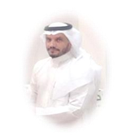 | AL AZZAM SAAD NASSER M  is currently pursuing a Ph.D. at the Institute of Computer Science and Digital Innovation (ICSDI), UCSI University, Kuala Lumpur, Malaysia. He earned a Master’s degree in Cybersecurity from the University of Bisha in 2022, a Master’s degree in Business Administration from King Khalid University in 2021, and a Master’s degree in International Law from the University of Jeddah in 2025. He also holds a Bachelor's degree in Communications and Network Engineering from King Khalid University, Kingdom of Saudi Arabia.  His academic background uniquely combines technical, managerial, and legal disciplines, which supports his diverse research interests in cybersecurity, digital forensics, legal technologies, and artificial intelligence applications in criminal investigations. He actively participates in academic research and is particularly interested in integrating technical frameworks with legal compliance in modern digital environments.  He has authored and co-authored over 50 scientific publications in various fields, including artificial intelligence, computer forensics, law, and management. He can be contacted at email: Snazzam.199@Gmail.Com. 1002372379@ucsiuniversity.edu.my
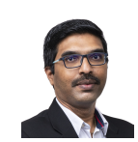 | Raenu ALKolandaisamy is currently serving as an Assistant Professor Ts. Dr. at the Institute of Computer Science and Digital Innovation (ICSDI), UCSI University, Kuala Lumpur, Malaysia. She obtained her Ph.D. in Computer Science and her Master’s degree from Universiti Putra Malaysia (UPM), with research focus in Vehicular Ad-Hoc Networks (VANET), Wireless Security, and Artificial Intelligence.  Her research interests include Internet of Things (IoT), VANET Security, Artificial Intelligence applications in intelligent transport systems, anomaly detection, and cybersecurity frameworks. She has published over 50 research articles in indexed journals and conferences, and has contributed to several high-impact research projects in collaboration with industry and government bodies.  She was awarded the Silver Medal at UPNM-INTELEX 2023 for the innovation “Just Queue,” and the Merit Award at the Malaysian Technology Expo (MTE 2023) for the project “Feather Fixer.” She also leads community and industry engagement programs focused on smart agriculture, IoT systems, and cybersecurity awareness.  She actively supervises postgraduate students and serves as reviewer for multiple international journals in the fields of AI, cybersecurity, and smart technologies. She can be contacted at email: raenu@ucsiuniversity.edu.my
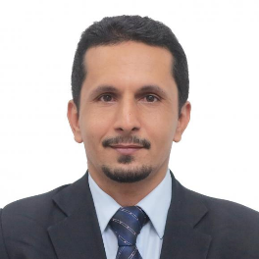 | Ghassan Saleh ALDharhani received the Master degree in Computer Science, and PhD degree / Doctor in Computer Science from Center of Artificial Intelligence and Technology (CAIT), Faculty of Information Science and Technology (FTSM), Universiti Kebangsaan Malaysia (UKM) in 2011 and 2017, respectively. Currently, He is Senior Lecturer, Asst. Professor Ts., and Head of Digital Innovation Department in Institute of Computer Science & Digital Innovation (ICSDI), UCSI University, Kuala Lumpur, Malaysia. He is IEEE Computer Society member, Train-the-Trainer (TTT) Certified HRDF Trainer, Artificial Intelligence and Cyber Security Instructor, practice and theory professional with experience in lecturing & teaching. Ability to explain, and (Demystifying Knowledge and Tutorials to students) with history of academic employment since 2001 with over 15 years of experience. He also received his B.Sc. in Computer Science from AL Ahgaff University Hadhramaut, Yemen in 2001. His current research interests are in Academic and Industrial Sectors: IR4.0, Artificial Intelligence, Machine Learning, Deep Learning, Cyber Security, Data Mining and Knowledge Discovery, Data Science & Analysis, Time Series Analysis, and Climate Informatics, Emerging Technology and Innovative Applications, Academic Research and Contributions for postgraduate students. He can be contacted at email: ghassan@ucsiuniversity.edu.my or ghassanxyz@gmail.com.

