Supplementary
Nuclear Conflict in Eastern Europe: Climate Disruption & Radiological Fallout
This supplementary has 3 sections
Section 1: Emission plausibility from source region
Section 2: Figures that are referenced in the main text of the manuscript
Section 3: 48-hour local fallout analysis after the detonation of hundred 15kt yield weapons near the Ukraine Russia border (32.1° E–45° E, 46.4–52.3° N)
Section 4: Long-term radioactive fallout from the global deposition of BC and long-lived radionuclides (Cs-137 and Sr-90).

Section 1: Emission plausibility from source region

Emission plausibility from the region: For the 6 × 10⁵ km² Ukraine-Russia border region (~30 million people), the total combustible fuel stock is estimated as M_{fuel} ≈ (2.1–4.5)×10⁸ ton using a per-capita urban fuel load of M_{f} = (1.1±0.4)×10⁷g / person¹. Adopting a 4% conversion of burned fuel to black carbon, an urbanization fraction U≈0.7 (urbanisation fractions of Ukraine = 0.7² and Russia = 0.75³), and an immediate-retention factor R≈0.8 after near-source losses (20% BC loss)¹, the resulting urban-scale BC available for atmospheric lofting is ~4.7 - 10 Tg. Assuming that 30-70% of this urban fuel mass lies within the ignition zones of nuclear detonations yields an emission range of ~1.4 - 7.1 Tg. This supports our use of a 5 Tg BC as a physically plausible scenario for a limited regional nuclear conflict in this region, although we acknowledge that the uncertainties in this estimate are large.

Section 2: Supplementary figures
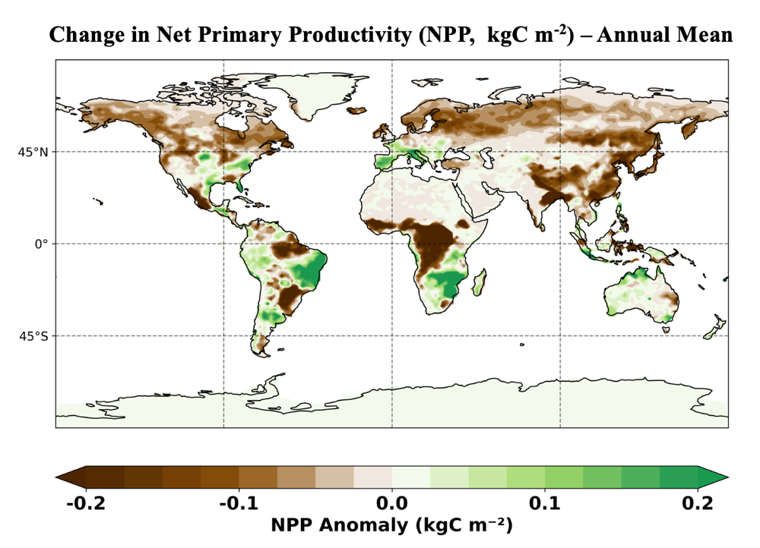
Figure S1 | Global annual‐mean (year 1) anomalies in net primary productivity (NPP) (kg C m⁻²) first-year post detonation. Negative anomalies (brown) dominate across the NH mid and high-latitude terrestrial ecosystems in North America, Asia and Europe. Positive responses (green) are seen in parts of the Amazon basin, Central Africa and Southeast Asia. The heterogeneous spatial pattern reflects how climate disruption following nuclear detonation alters photosynthetic carbon uptake.

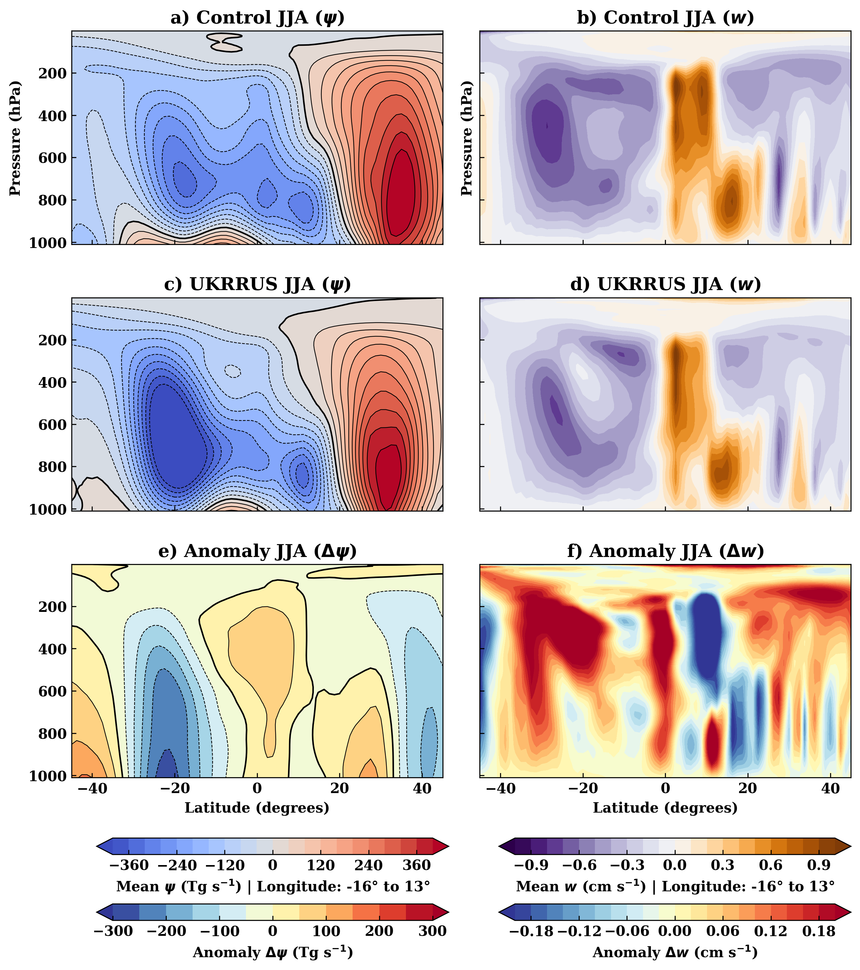
Figure S2 | Vertical structure of the atmospheric circulation (zonal mean between longitudes 16°W to 13°E) during June-July-August (JJA). The panels display the meridional stream function ($ψ$; left column) and vertical wind (w; right column). Rows represent the (a, b) Control simulation, (c, d) UKRRUS simulation, and (e, f) the Anomaly (UKRRUS - Control). The stream function is expressed in Tg s⁻¹, where positive values (red/solid) indicate clockwise circulation and negative values (blue/dashed) indicate counterclockwise circulation. Vertical wind positive values (orange) denote ascent and negative values (purple) denote descent.
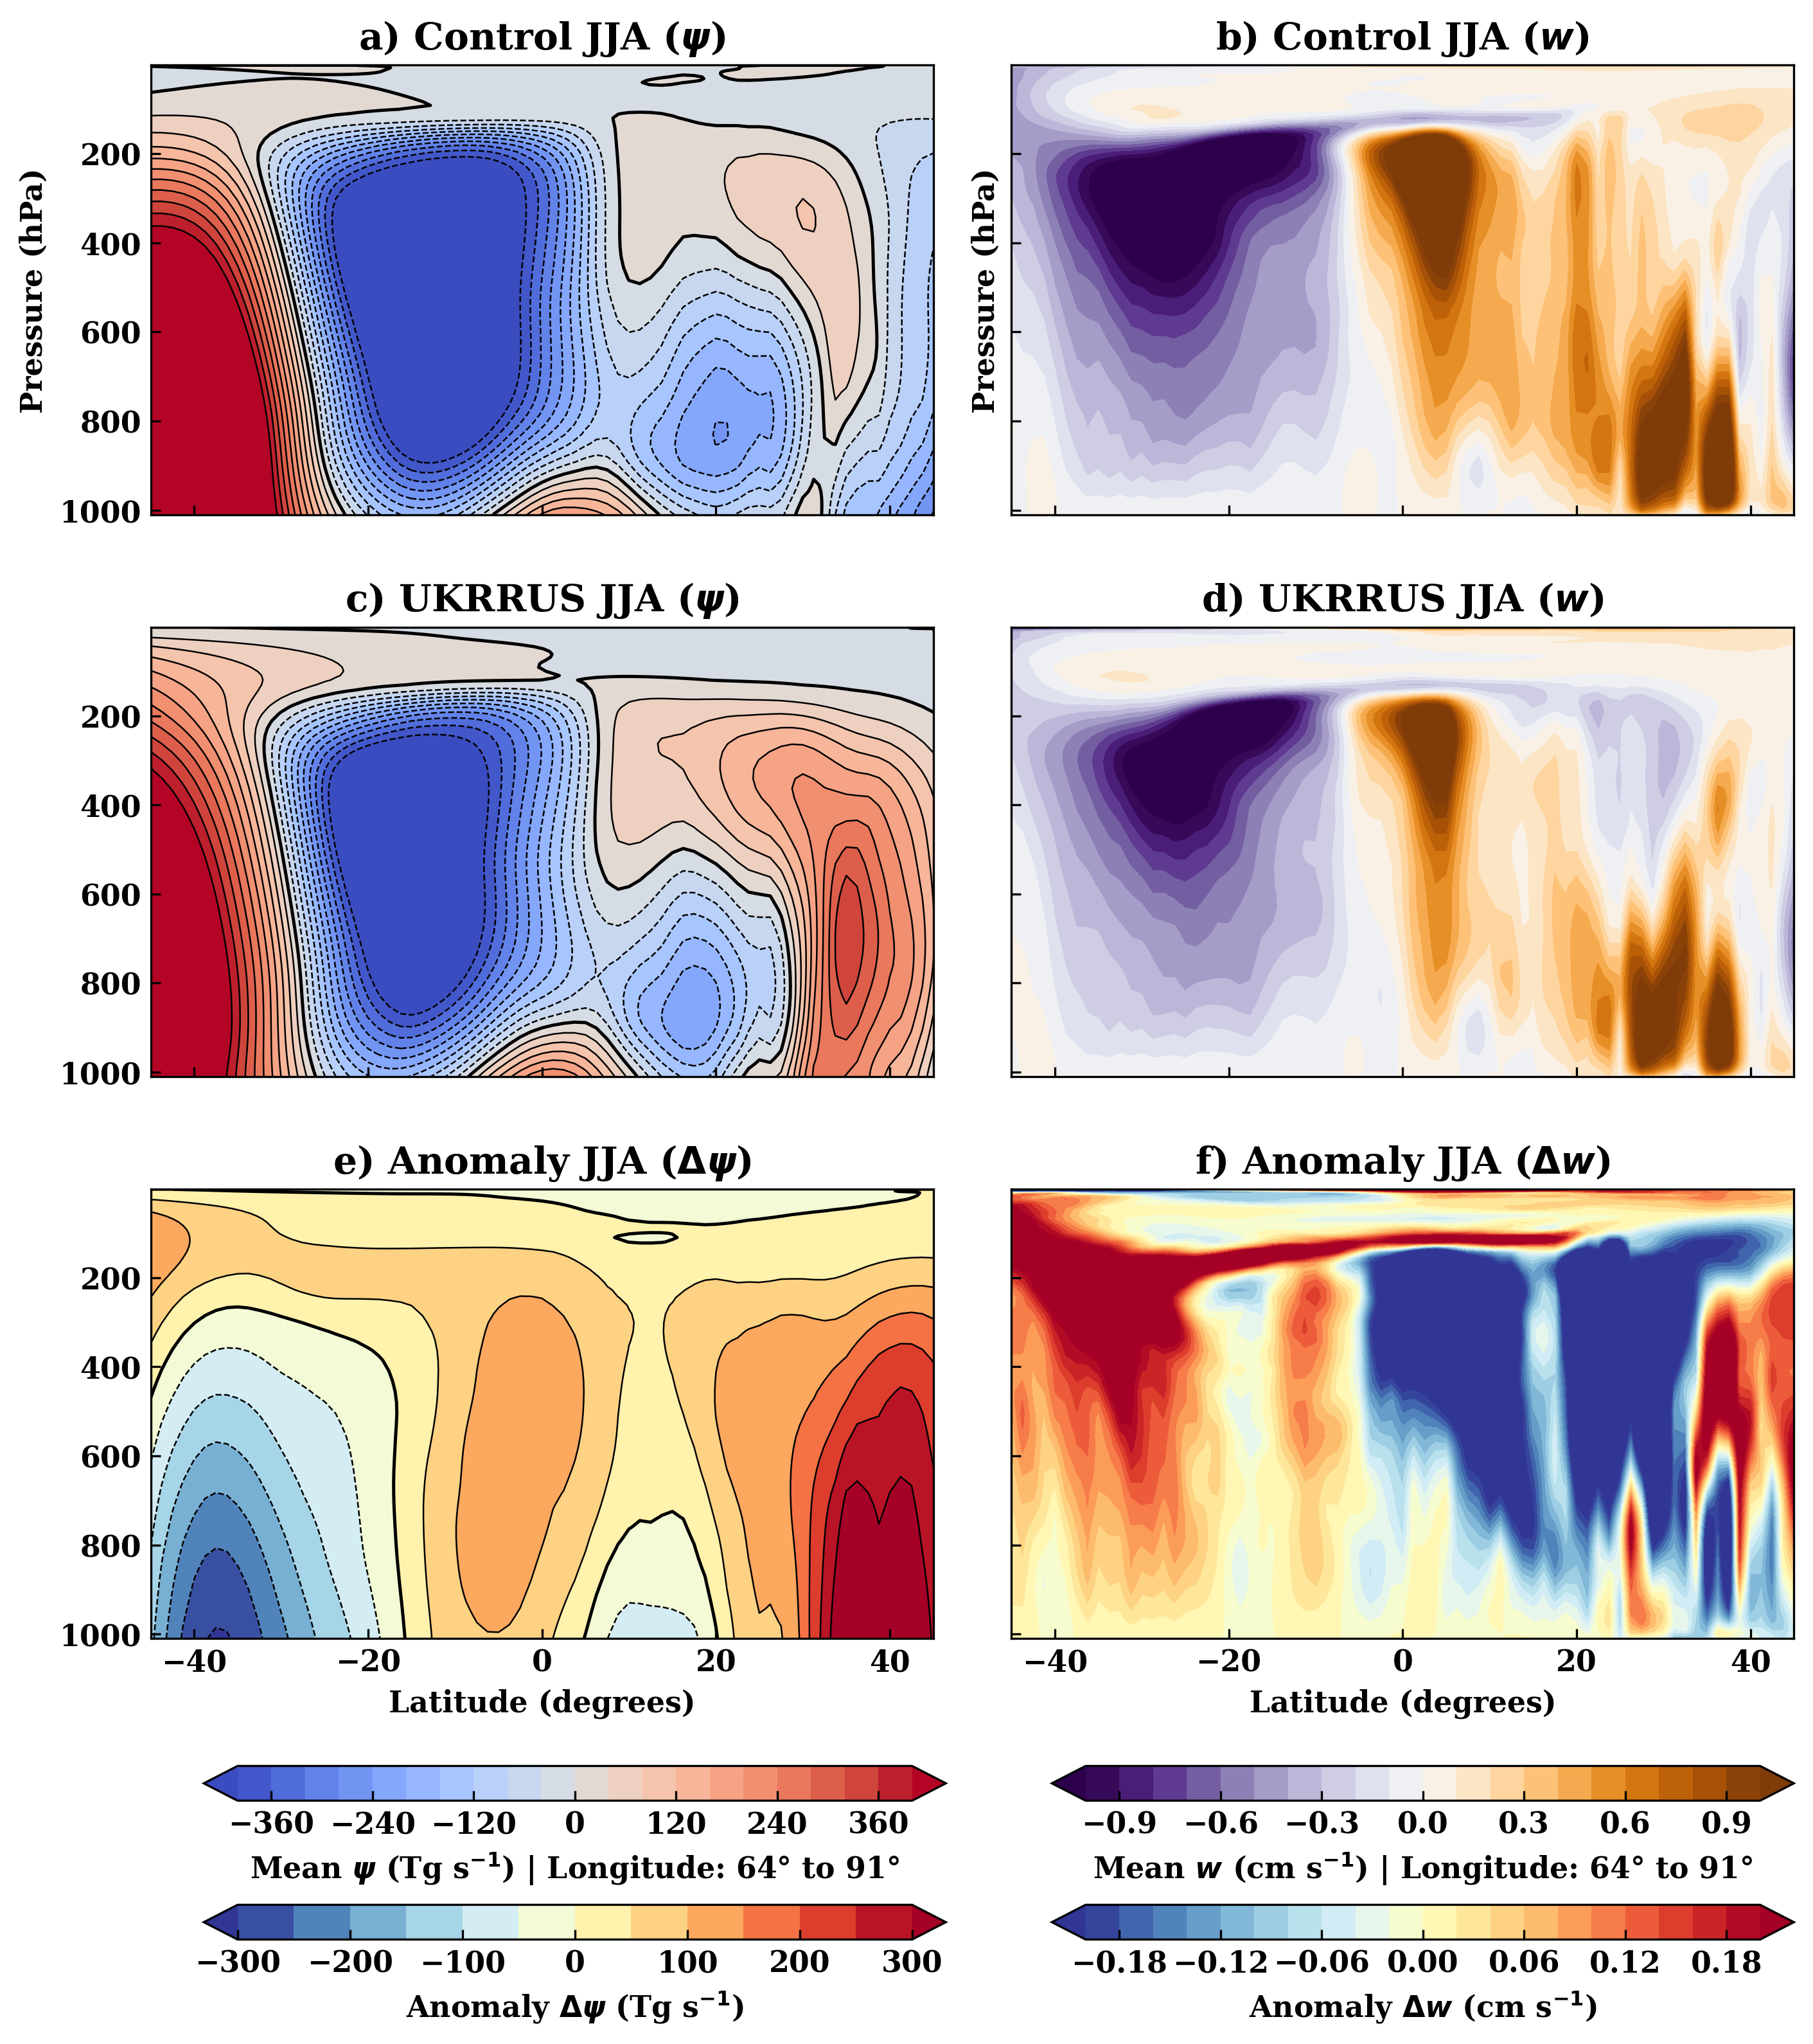
Figure S3 | Vertical structure of the atmospheric circulation (zonal-mean between longitudes 64°E to 91°E) during June-July-August (JJA). The panels display the zonal mean meridional stream function ($ψ$; left column) and vertical wind (w; right column). Rows represent the (a, b) Control simulation, (c, d) UKRRUS simulation, and (e, f) the Anomaly (UKRRUS - Control). The stream function is expressed in Tg s⁻¹, where positive values (red/solid) indicate clockwise circulation and negative values (blue/dashed) indicate counterclockwise circulation. Vertical wind positive values (orange) denote ascent and negative values (purple) denote descent.

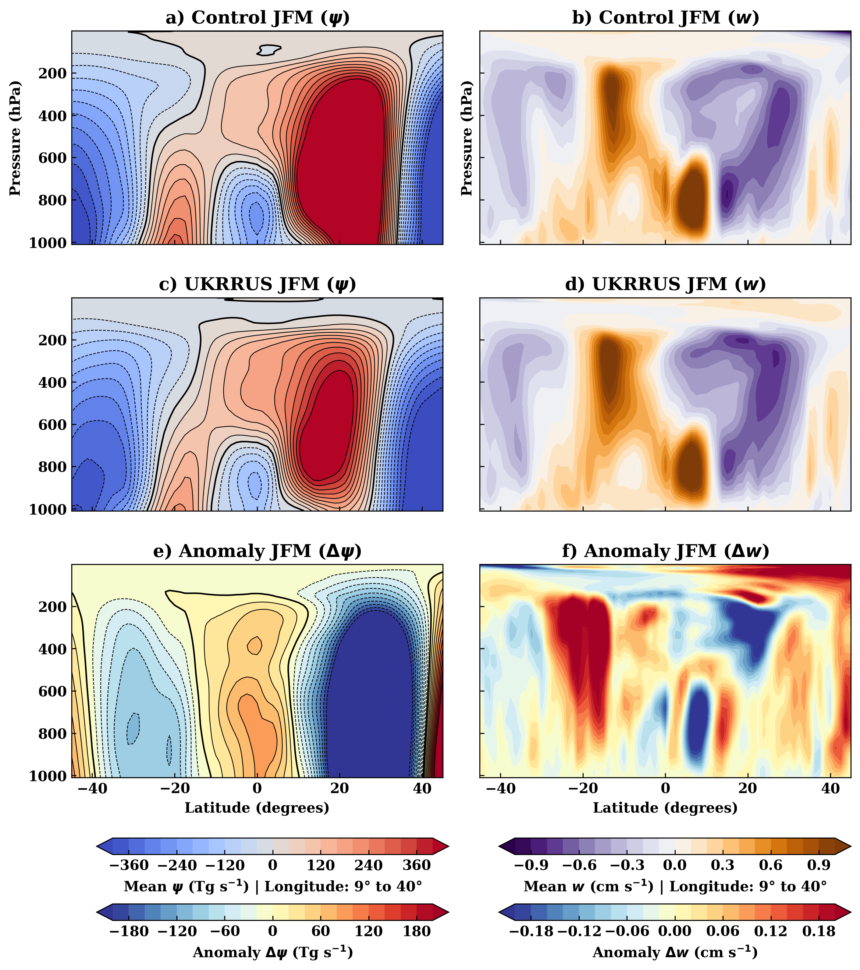
Figure S4 | Vertical structure of the atmospheric circulation (zonal-mean between longitudes 9°E to 40°E) during January-February-March (JFM). The panels display the zonal mean meridional stream function ($ψ$; left column) and vertical wind (w; right column). Rows represent the (a, b) Control simulation, (c, d) UKRRUS simulation, and (e, f) the Anomaly (UKRRUS - Control). The stream function is expressed in Tg s⁻¹, where positive values (red/solid) indicate clockwise circulation and negative values (blue/dashed) indicate counterclockwise circulation. Vertical wind positive values (orange) denote ascent and negative values (purple) denote descent.
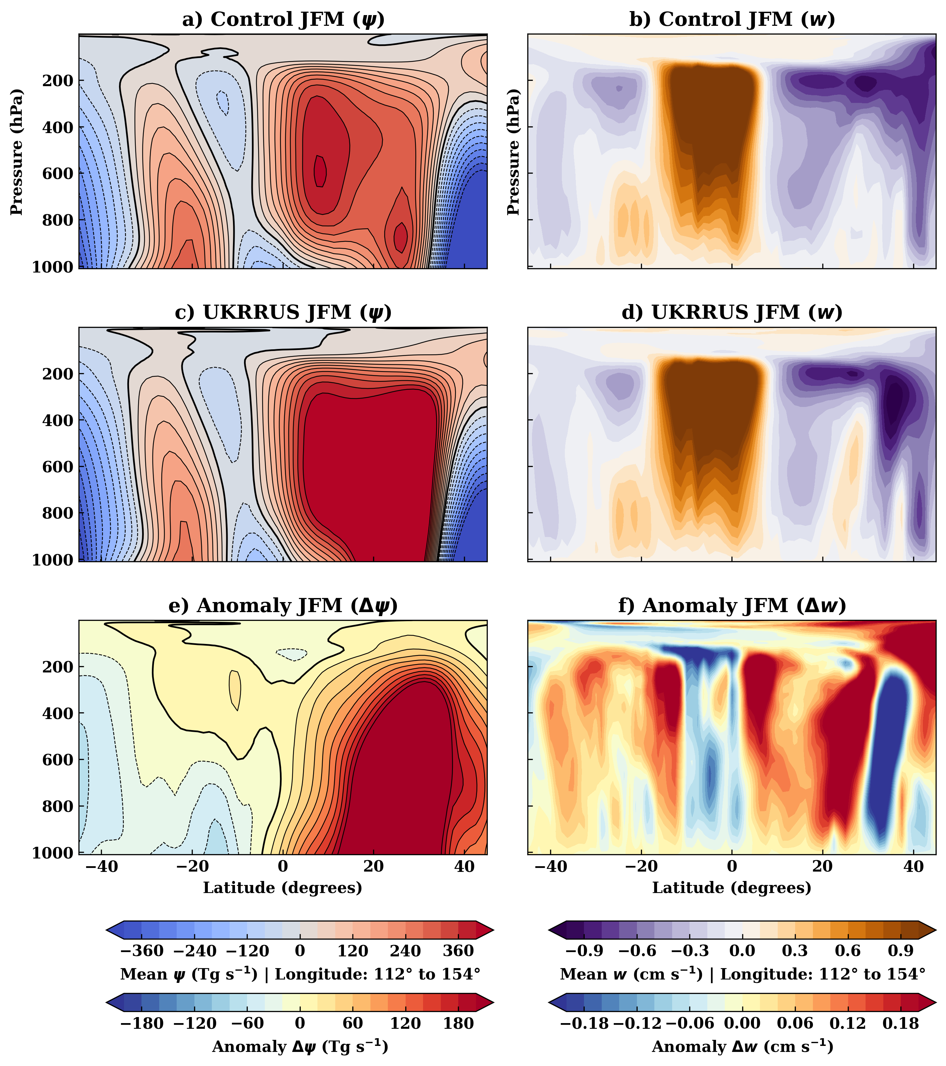

Figure S5 | Vertical structure of the atmospheric circulation between (zonal-mean between longitudes 112°E to 154°E) during January-February-March (JFM). The panels display the zonal mean meridional stream function ($ψ$; left column) and vertical wind (w; right column). Rows represent the (a, b) Control simulation, (c, d) UKRRUS simulation, and (e, f) the Anomaly (UKRRUS - Control). The stream function is expressed in Tg s⁻¹, where positive values (red/solid) indicate clockwise circulation and negative values (blue/dashed) indicate counterclockwise circulation. Vertical wind positive values (orange) denote ascent and negative values (purple) denote descent.

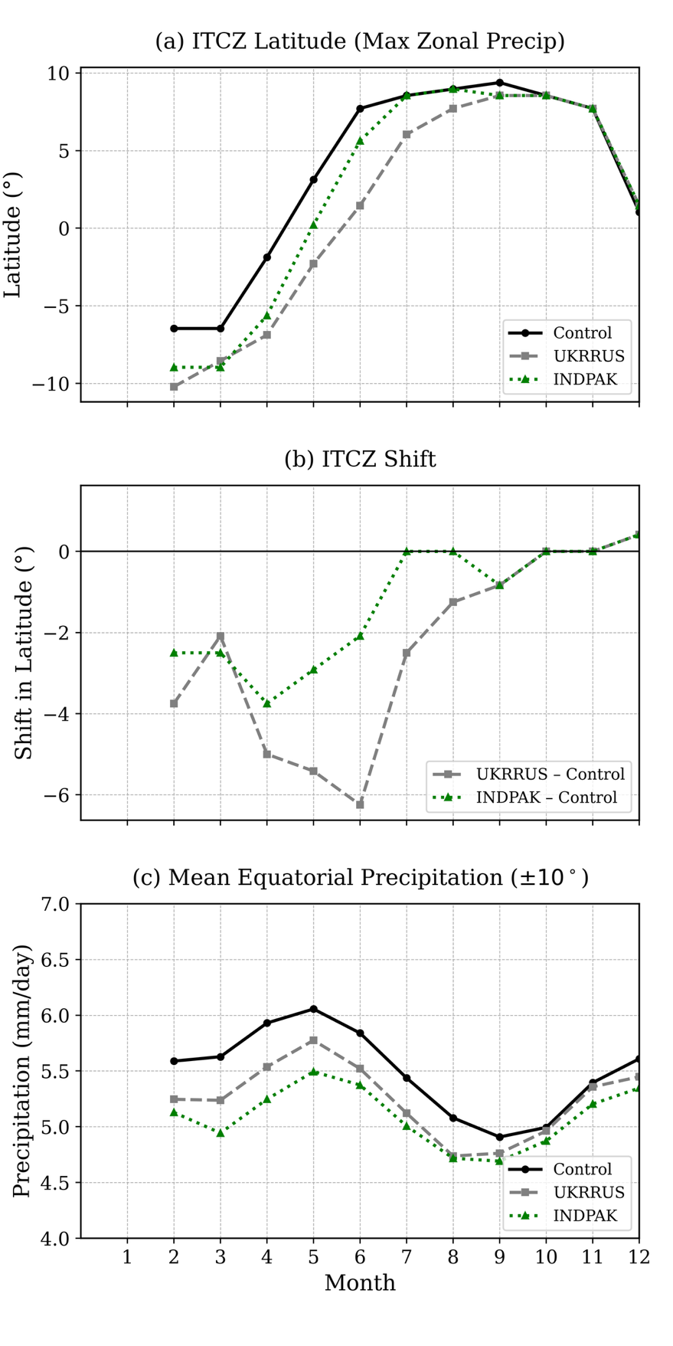
Figure S6 | Impact of Ukraine–Russia and India-Pakistan 5Tg BC nuclear conflict scenario on ITCZ position and equatorial rainfall (3 month rolling mean in Year 1).
(a) Monthly latitude of maximum zonal-mean precipitation (°) for the UKRRUS, INDPAK and control simulation showing the ITCZ migrating to the SH
(b) ITCZ shift
(c) Mean equatorial (±10°) precipitation (mm day⁻¹)

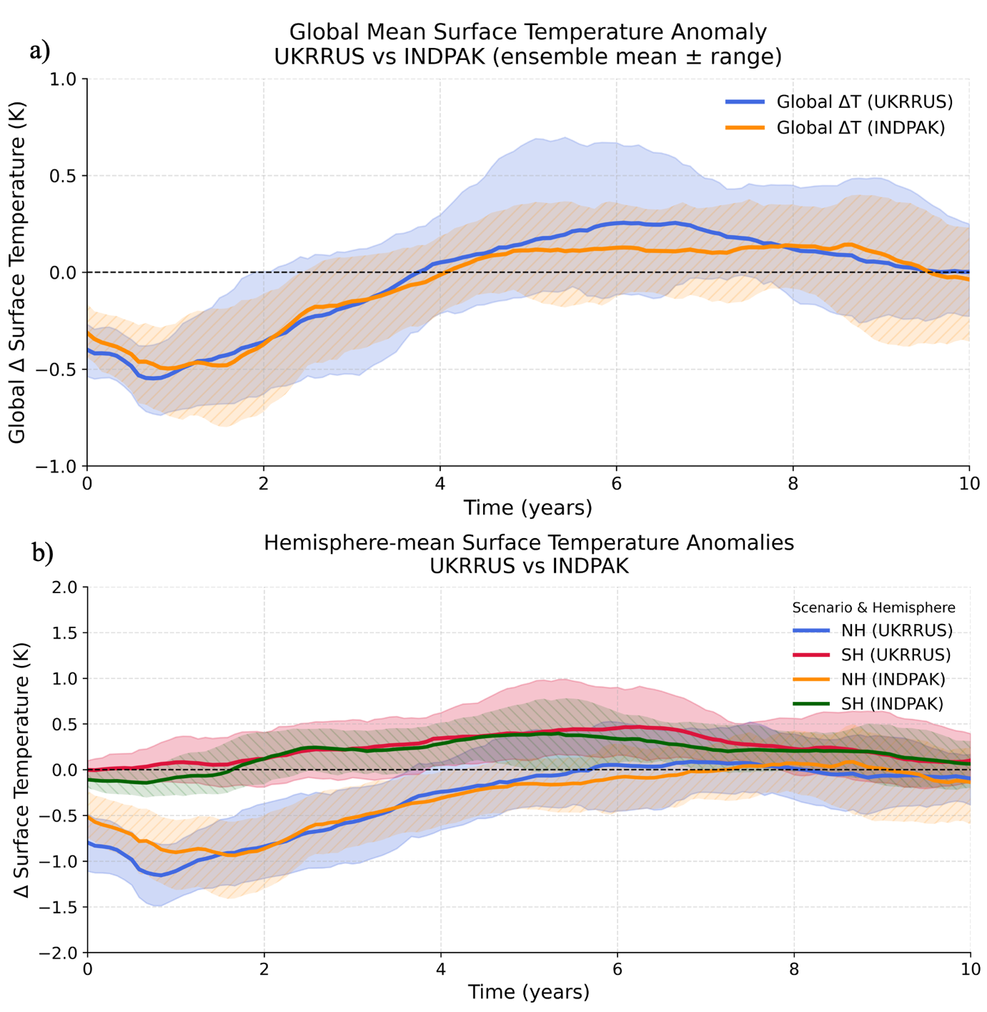
Figure S7 | Global and hemispheric surface temperature anomalies following a 5 Tg BC injection in the UKRRUS and INDPAK scenarios.
(a) Global-mean annual-mean surface temperature anomalies (relative to the control) for the UKRRUS (blue) and INDPAK (orange) simulations.
(b) Corresponding Northern Hemisphere (NH) and Southern Hemisphere (SH) mean surface temperature anomalies for UKRRUS (blue, red) and INDPAK (orange, green).
Solid lines show the ensemble mean and the shaded regions indicate the full ensemble range.

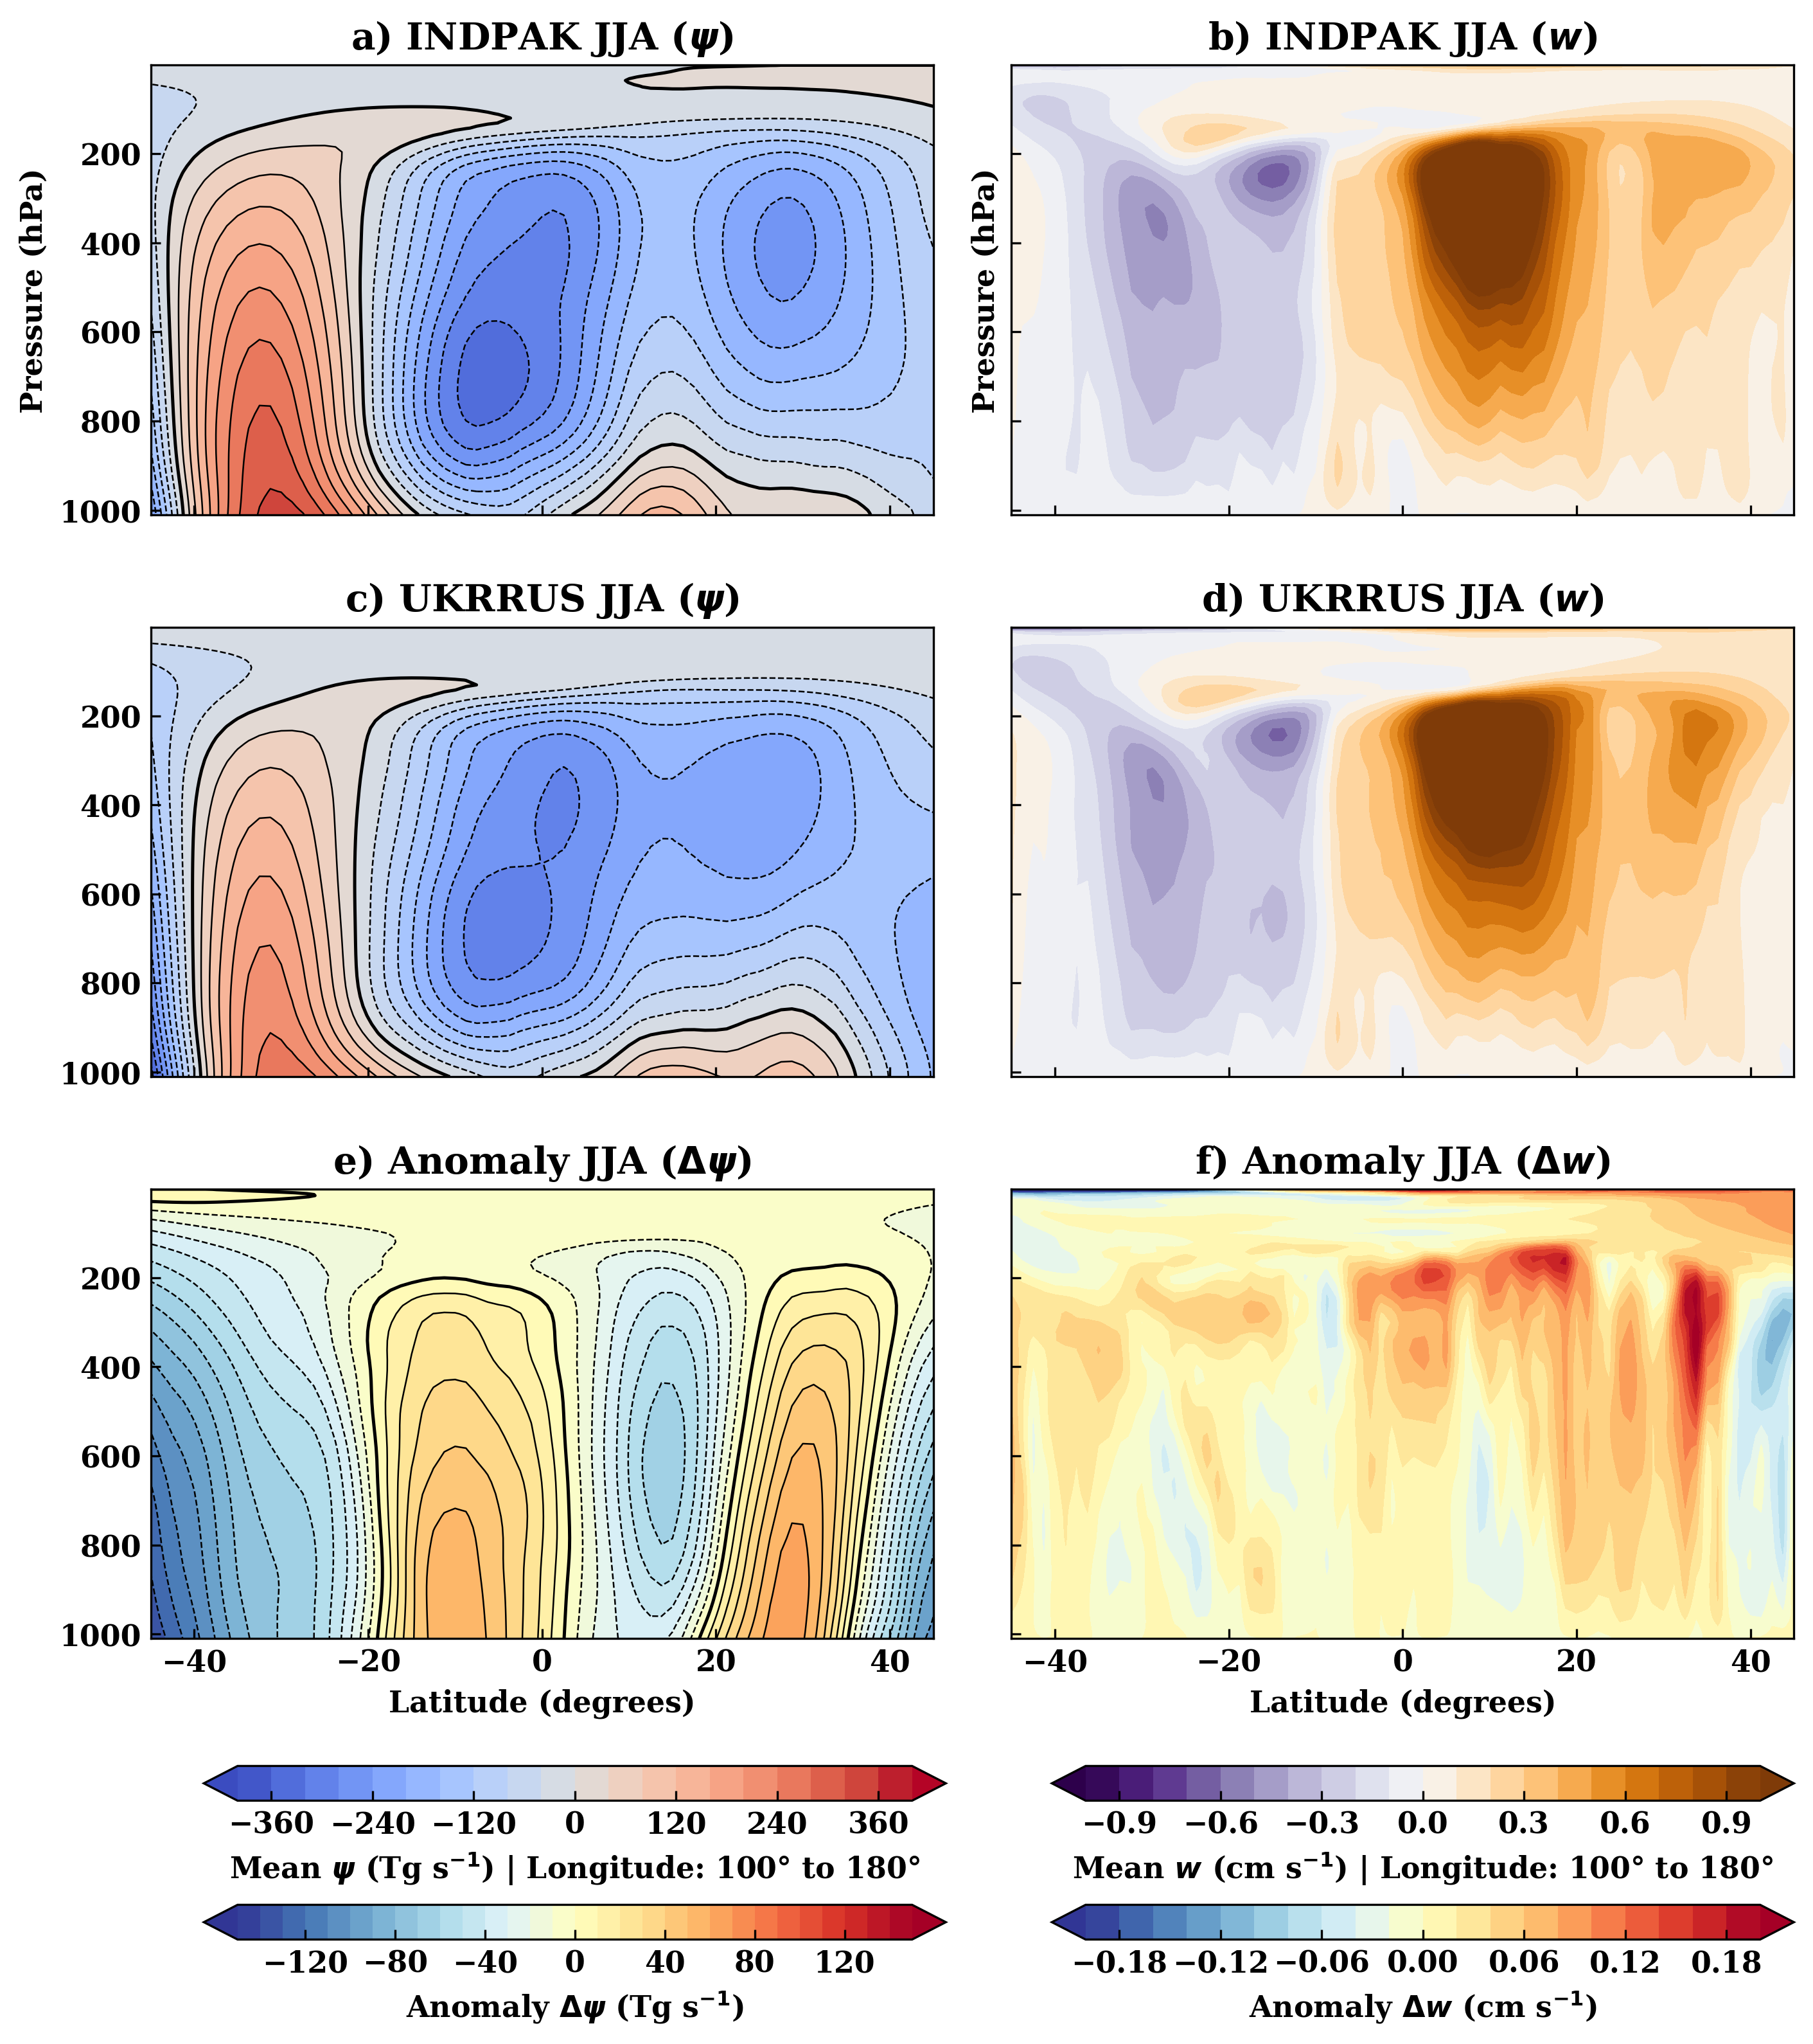
Figure S8 | Vertical structure of the atmospheric circulation (zonal-mean between longitudes 100°E to 180°E) during June-July-August (JJA). The panels display the zonal mean meridional stream function ($ψ$; left column) and vertical wind (w; right column). Rows represent the (a, b) INDPAK simulation, (c, d) UKRRUS simulation, and (e, f) the Anomaly (UKRRUS - INDPAK). The stream function is expressed in Tg s⁻¹, where positive values (red/solid) indicate clockwise circulation and negative values (blue/dashed) indicate counterclockwise circulation. Vertical wind positive values (orange) denote ascent and negative values (purple) denote descent.

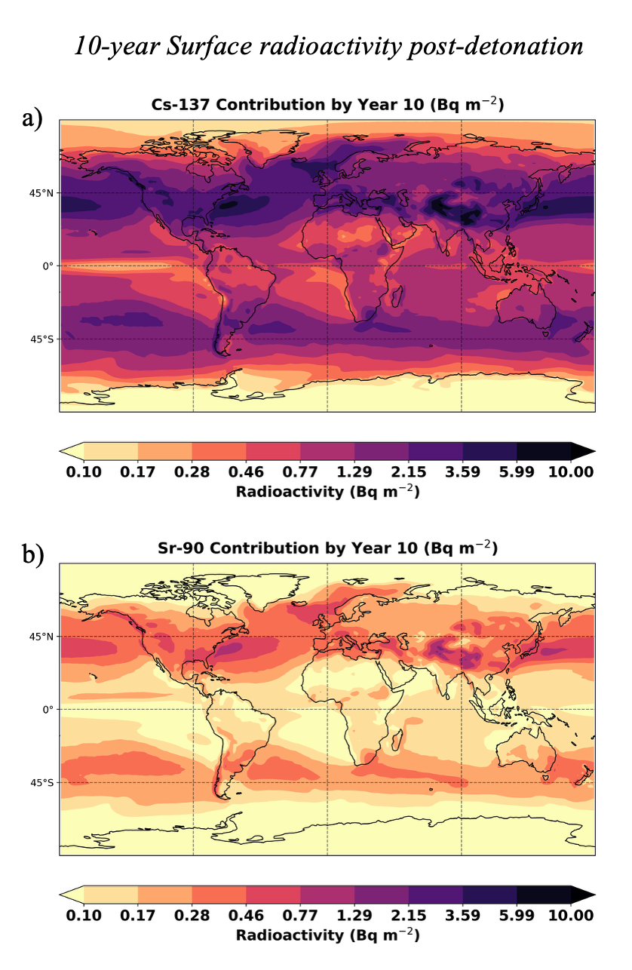
Figure S9 | Surface radioactivity contribution from Cs-137 and Sr-90, 10-years post detonation.
a, Cs-137 surface activity (Bq m⁻²) at year 10, with values up to 10 Bq m⁻² in NH mid-latitudes.
b, Sr-90 surface activity (Bq m⁻²) at year 10, mirroring Cs-137 patterns but at lower magnitudes.

Section 3: Short term Fallout estimates

1. Model framework
The fallout dose model is based on the Glasstone & Dolan (1977) fallout model ⁴, specifically the 15 kt surface-burst scenario under reference wind speed of 24 km/h. This model relates the unsheltered 48-hour whole-body gamma dose to down-wind distance by a power-law curve fitted to U.S. nuclear-test data. The 48-hour external gamma dose (in rad) on the plume centreline at downwind distance L (in km) is approximated as:
D₂₄(L) = K × L^{–1.838},
where K ≈ 2.66 × 10⁵ rad·km^{1.838}.
This equation gives the unsheltered whole-body dose after 48 hours of fallout deposition at different distances downwind of a ground-level detonation.

2. Scenario inputs

Location of 100 hypothetical 15 kt surface‐burst detonations (red asterisks) spaced evenly across the Ukraine-Russia border zone (46.4°-52.3° N, 32.1°-45.0° E) (main text Figure 4a). Mean surface winds of 19 km h⁻¹ from the North-East (40°) transports radioactive debris downwind, providing the basis for the subsequent fallout dose-distance and population-exposure calculations. Since the original model assumes 24 km h⁻¹ wind, and our observed regional wind is 19 km h⁻¹ (5.3 m s⁻¹), the dose must be scaled. The dose rate decays with time approximately as t^{-1.2}, meaning slower winds would reduce dose with increase in distance.
The dose under an arbitrary wind speed V (in km/h) becomes:
D₁₉(L) = D₂₄(L) × (19/24)^{1.2}
To find the distance L at which a given dose threshold Dₛ is reached under wind speed V:
L₁₉ = L₂₄× (19/24)^{0.653}
For V = 19 km h⁻¹, (V/24)^{0.653} ≈ 0.858

3. Dose (48-hour dose) and exposed population
The dose footprint is approximated as a rectangle of length L and width W downwind for each detonation. Region population: 30.2 million; area 612 857 km² ⇒ average population density ≈ 49 persons km⁻².
Table S1: 48-hour fallout analysis post detonation
Dose Threshold (Sv) | Downwind Distance (km) | Plume Width (km) | Area per Burst (km²) | Total Area (km²) | Exposed Population
≥ 1 Sv | 62.7 | 3.20 | 200.4 | 20,044 | 982,151
≥ 5 Sv | 26.1 | 1.32 | 34.5 | 3,453 | 169,214
≥ 10 Sv | 17.9 | 0.90 | 16.2 | 1,619 | 79,343

4. Key uncertainties
- Wind variability: Turbulence and rainfall could shorten plume transport distances but intensify local hot spots.
- Terrain: Rough ground or indoor shelter can reduce doses. Estimates here are worst-case, unsheltered.
- Population clustering: Population density of 49 km⁻² may under-count exposures if any radioactivate plume crosses a town or city rather than a rural area.
- Assuming 1Gy (gray) = 1Sv (Sievert), Glasstone & Dolan’s fallout model⁴ reports absorbed dose in rads (or grays (Gy), which tracks energy deposition but not biological effect. Converting Gray (Gy) to Sievert (Sv) requires a “radiation weighting factor” (Q) that accounts for the biological effectiveness of different particle types and energies. While Q ≈ 1 is often assumed for high-energy gamma rays^{5,6}, actual fallout can be a mixed field of γ-rays of varying energies, β-particles and low-energy photons.

Section 4: Long term fallout estimates
Overview
We use UKESM-modelled black carbon (BC) deposition from 100 nuclear detonations (15 kt each) as a tracer for radioactive fallout. The BC deposition (kg m⁻²) is converted to fission-product deposition by scaling to the total number of fissions. Each 15 kt bomb yields approximately 62.76×10¹² J (1 kt TNT ≈ 4.184×10¹² J). Assuming ~200 MeV per fission (1 eV = 1.602×10⁻¹⁹ J), one fission yields roughly 3.2×10⁻¹¹ J. Assuming a pure U-235 fission bomb, total fissions for 1500 kt is approximately 1.96×10²⁶. Fission products like Cs-137 and Sr-90 formed from U-235 are estimated using yields (0.061 for Cs-137 and 0.058 for Sr-90)⁷. The Atmospheric Release Fraction (ARF) which is determined by the volatility of radionuclides, it is 0.2 for Cs-137 and 0.03 for Sr-90⁸, and we assume a 50% adherence of radionuclides to BC (attachment fraction ≈ 0.5). The attachment fraction of Cs-137 and Sr-90 to black carbon aerosol is unavailable. However, studies have shown consistently the adherence of Cs-137 to the aerosol particulate phase (diameter = 0.1 – 2 µm)⁹ after the Fukushima nuclear fallout and, some studies report that 53–91% of Cs-134 and Cs-137 adherence to organic matter¹⁰. For our estimates we chose a conservative attachment fraction of 50% to BC aerosol particles.
We use the above methodology to estimate the number of atoms of radionuclides that adhere to 5Tg BC uniformly. At the end of year 10, we estimate their activity (Bq or Bq m⁻²) using a first order decay and convert activity to dosage using dose conversion factors^{4,6}. Below is a summary of parameters used:
Table S2: Parameter values for long term fallout estimates
Parameter | Value | Notes / Reference
Bomb yield (total) | 100 × 15 kt = 1500 kt | Total yield and 1kt = 4.18 × 10¹² J
Energy per nuclear fission | ~ 200 MeV
Total nuclear fissions | ~ 1.96 × 10²⁶ | Total yield/energy per fission
Cs-137 yield | 0.061 | Yield from U-235 fission⁷
Sr-90 yield | 0.058 | Yield from U-235 fission⁷
Atmospheric release fraction | 0.2 for Cs-137 and 0.03 for Sr-90 | US Department of energy Handbook⁸
Radionuclide attachment fraction to aerosol particles | 0.5 | Assuming 50% adherence of radionuclides to BC
Cs-137 Half life | 30.17 | CDC radiation emergencies¹¹
Sr-90 half life | 29.10 | CDC radiation emergencies¹²
Decay constant | $$λ=\frac{ln2}{T_{1/2}}$$
Transfer factor (dep->intake) Cs-137 | 4.2 Bq intake per Bq m⁻² | UNSCEAR 2000^{13,14}
Transfer factor (dep->intake) Sr-90 | 1.9 Bq intake per Bq m⁻² | UNSCEAR 2000^{13,14}
50-year Ingestion dose coefficient Cs-137 (adult) | 1.3 × 10⁻⁸ Sv per Bq | ICRP 119⁶
50-year Ingestion dose coefficient (adult) Sr-90 | 2.8 × 10⁻⁸ Sv per Bq | ICRP 119⁶
50-year External dose coefficient Cs-137 | 1.3 × 10¹ mSv per kBq m⁻² | IAEA¹⁵
50-year External dose coefficient Sr-90 | 2.1 × 10⁻² mSv per kBq m⁻² | IAEA¹⁵
References
1. Toon, O. B. et al. Atmospheric effects and societal consequences of regional scale nuclear conflicts and acts of individual nuclear terrorism. Atmos Chem Phys 7, 1973–2002 (2007).
2. Ukraine Percent urban population - data, chart | TheGlobalEconomy.com. https://www.theglobaleconomy.com/Ukraine/Percent_urban_population/.
3. Russia Percent urban population - data, chart | TheGlobalEconomy.com. https://www.theglobaleconomy.com/Russia/Percent_urban_population/.
4. Glasstone, S. & Dolan, P. J. The Effects of Nuclear Weapons. Third edition. https://doi.org/10.2172/6852629 (1977) doi:10.2172/6852629.
5. UNSCEAR. United Nations scientific committee on the effect of atomic radiation, sources and effects of ionizing radiation. United Nations I, 66 (2008).
6. Eckerman, K., Harrison, J., Menzel, H. G. & Clement, C. H. ICRP publication 119: Compendium of dose coefficients based on ICRP publication 60. Ann ICRP 42, e1 (2013).
7. Brown, D. A. et al. ENDF/B-VIII.0: The 8th Major Release of the Nuclear Reaction Data Library with CIELO-project Cross Sections, New Standards and Thermal Scattering Data. Nuclear Data Sheets 148, 1–142 (2018).
8. Airborne Release Fractions/Rates and Respirable Fractions for Nonreactor Nuclear Facilities, Volume I, Analysis of Experimental Data (Part 1 of 2, links to all Parts). https://www.standards.doe.gov/standards-documents/3000/3010-bhdbk-1994-v1.
9. Kristiansen, N. I., Stohl, A. & Wotawa, G. Atmospheric removal times of the aerosol-bound radionuclides 137Cs and 131I measured after the Fukushima Dai-ichi nuclear accident &ndash; A constraint for air quality and climate models. Atmos Chem Phys 12, 10759–10769 (2012).
10. Xu, S. et al. Speciation of radiocesium and radioiodine in aerosols from Tsukuba after the Fukushima nuclear accident. Environ Sci Technol 49, 1017–1024 (2015).
11. Cesium-137 | Radiation Emergencies | CDC. https://www.cdc.gov/radiation-emergencies/hcp/isotopes/cesium-137.html.
12. Strontium-90 | Radiation Emergencies | CDC. https://www.cdc.gov/radiation-emergencies/hcp/isotopes/strontium-90.html.
13. United Nations Scientific Committe on the Effects of Atomic Radiation. Sources and Effects of Ionizing Radiation Volume I: source. United Nations Scientific Committee on the Effects I, 1–654 (2000).
14. Kostiainen, E. et al. Transfer Factors for Nuclear Emergency Preparedness. Report from the NKS/BOK-1.4 Project Group Countermeasures in Agriculture and Forestry. (2003).
15. AGENCY, I. A. E. Generic Procedures for Assessment and Response During a Radiological Emergency. Generic Procedures for Assessment and Response During a Radiological Emergency 1–194 (2000).

