Supplementary Material

TABLE OF CONTENTS

S. Supplementary Methods and Results
S1. Detailed Dataset Description ............................................... 4
S1.1. Cohort Screening and TMA Construction ............................... 4
S1.2. WSI Digitization .................................................... 4
S1.3. WSI Annotation ...................................................... 4
S1.4. Dataset Composition ................................................. 4
S2. Model Implementation Details ............................................... 5
S2.1. Hardware and Software Environment ................................... 5
S2.2. Model Architecture .................................................. 5
S2.3. Training Configuration .............................................. 5
S2.4. Performance Evaluation Metrics ...................................... 5
S3. Patch Processing and WSI-Level Classification Algorithm .................... 5
S3.1. Patch Extraction .................................................... 5
S3.2. Color Normalization ................................................. 5
S3.3. Sampling Methods .................................................... 5
S3.4. WSI-Level Classification Algorithm .................................. 6
S4. WSI Inference and Visualization ............................................ 6
S4.1. Inference Process ................................................... 6
S4.2. Patch-Level Visualization ........................................... 6
S4.3. Pathologist Review .................................................. 6
S5. Reader Study Details ....................................................... 6
S5.1. Study Participants and Crossover Design ............................. 6
S5.2. Reader Study Interface and Environment .............................. 6
S5.3. Diagnostic Task and Sessions ........................................ 6
S5.4. Data Collection and Confidentiality ................................. 7
S5.5. Pathologist Performance Evaluation Metrics .......................... 7
S6. Detailed Model Performance Analysis ........................................ 7
S6.1. Patch-Level Classification .......................................... 7
S6.2. WSI-Level FHdRCC Classification .............................................................. 7
S7. Confounding Variables Analysis ................................................ 8
S7.1. Mixed-Effects Modeling Framework .................................... 8
S7.2. Carry-Over Effects Analysis ......................................... 8
S7.3. Learning and Fatigue Effects Analysis ............................... 8
S7.4. Dataset Source Effects Analysis ..................................... 8

Supplementary Tables
Supplementary Table 1. Antibody Details ......................................... 8
Supplementary Table 2. Detailed Number of Whole Slide Images of Surgical Specimens ... 9
Supplementary Table 3. Detailed Number of Whole Slide Images of Biopsy Specimens ... 10
Supplementary Table 4. Characteristics of the 30 Cases Used in the Reader Study ... 11
Supplementary Table 5. Classification of Diagnostic Scenarios Based on Initial Diagnosis and AI Prediction ......................................... 12
Supplementary Table 6. Patch-Level Classification Performance Across Datasets ... 13
Supplementary Table 7. WSI-Level Classification Performance Across Datasets ..... 14
Supplementary Table 8. Mixed-Effects Model for the Main Effect of AI Assistance and Carry-Over Effects ..................... 15
Supplementary Table 9. Analysis of Learning and Order Effects by Presentation Sequence ... 16
Supplementary Table 10. Mixed-Effects Model for Dataset Source and AI Interaction Effects ... 16
Supplementary Table 11. Performance Metrics by Pathologist Group ................ 18
Supplementary Table 12. Expertise-Level Contextual Human-AI Interaction Rates ... 19
Supplementary Table 13. Per-Pathologist Contextual Human-AI Interaction Rates ... 20
Supplementary Table 14. Persona-Level Contextual Human-AI Interaction Rates ..... 21
Supplementary Table 15. Expertise-Level Cognitive Load (Reading Time) of Optimal and Suboptimal Decisions ........................ 22
Supplementary Table 16. Persona-Level Cognitive Load (Reading Time) of Optimal and Suboptimal Decisions ............................... 23

Supplementary Figures
Supplementary Figure 1. Reader Study Interface .................................. 24
Supplementary Figure 2. Inter-Rater Reliability With and Without AI Assistance ............... 25
Supplementary Figure 3. Decoupling of Traditional Diagnostic Skill and AI-Interaction Proficiency ... 26
Supplementary Figure 4. Determining the Optimal Number of Clusters (k) for Persona Analysis ... 27
Supplementary Figure 5. AI Interaction Metrics Stratified by Traditional Expertise ... 28
Supplementary Figure 6. Cognitive Load Analysis Stratified by Traditional Expertise ... 29

TRIPOD Checklist: Prediction Model Development…………….. 31

References ...................................................................... 34

S1. Detailed dataset description

Cohort screening and TMA construction
From the 10,437 kidney tumor cases in our institution's archives (1989–2023), we systematically screened for FHdRCC and its histological mimickers. This screening yielded 977 potential cases based on criteria including high grade (World Health Organization/International Society of Urological Pathology (WHO/ISUP) histological grade 3 or 4), advanced stage (pT3 or higher), or prior IHC suspicion for fumarate hydratase/2-succinocysteine (FH/2SC).
From this pool, 575 cases with adequate archival tissue were selected for tissue microarray (TMA) construction. For older cases lacking original slides, new hematoxylin and eosin (H&E) slides were prepared by re-sectioning archived blocks. The tissue microarrays (TMAs) were constructed using two 1-mm cores from representative tumor areas(1). These TMAs were then stained with a comprehensive 19-antibody IHC panel, detailed in Supplementary Table 1.

WSI digitization
Whole-slide images (WSIs) were acquired using two different scanners. The internal and external 2 datasets were primarily scanned with a Philips Pathology Scanner SG300 (Philips, Amsterdam, The Netherlands) at 40× magnification (0.25 μm/pixel). The internal and external 1 datasets were scanned using a 3DHISTECH Pannoramic 250 FLASH II scanner (3DHISTECH Ltd., Budapest, Hungary) at 20× magnification (0.22 μm/pixel).

WSI annotation
We used the Automated Slide Analysis Platform (ASAP) version 2.1 to manually delineate regions of interest (ROIs) on the WSIs. The ROIs were categorized into three classes: FHdRCC, Others RCC (other subtypes of renal cell carcinoma), and Normal Kidney (including non-neoplastic renal parenchyma, blood, inflammation, and necrosis). Each ROI was defined by the largest possible rectangle inscribed within the annotated area, ensuring it encompassed at least 70% of the target class tissue.

Dataset composition
The total number of WSIs and their distribution are detailed in Table 2 and Supplementary Tables 2 and 3. The datasets were composed as follows:
- Internal Dataset: This set consisted of slides produced by the pathology department of Asan Medical Center and was used for model training, validation, and testing (randomly divided 6:2:2 at the slide level).
- External Dataset 1: This technical validation set included slides prepared in a personal research laboratory at Asan Institute for Life Sciences in 2023 by re-sectioning archived formalin-fixed paraffin-embedded (FFPE) tissue blocks from our institution, designed to evaluate performance on slides with different staining characteristics.
- External Dataset 2: This generalizability test set comprised consultation slides brought by patients from external hospitals. Among 539 consultation cases from the total 10,437 kidney tumor cases, 106 met the inclusion criteria, yielding 18 available slides from 14 different institutions. This dataset was used to assess real-world performance on slides from diverse clinical settings.

S2. Model implementation details

Hardware and software environment
- GPU: NVIDIA A6000 (48GB)
- Software: Python 3.9, PyTorch 1.51
- Random seed: 42 (for reproducibility)

Model architecture
We utilized the ResNeXt101_32x8d model as the baseline. The model's final fully connected layer was modified to perform a three-class classification task (Class 0: Normal Kidney; Class 1: Others RCC; Class 2: FHdRCC). This architecture was chosen for its enhanced representational power in capturing subtle histological differences(2).

Training configuration
- Loss function: Cross-entropy
- Optimizer: AdamW(3)
- Batch size: 128
- Learning rate: 1e-3 → 1e-4 (ReduceLROnPlateau scheduler based on validation loss)
- Data augmentation: Albumentations library (v1.4.3)(4); horizontal and vertical flipping, random rotations and shifts, scaling, dropout, gamma adjustments, brightness, hue, saturation modifications, elastic transformations, and grid distortions

Performance evaluation metrics
Model performance was evaluated at the patch level using standard metrics: Accuracy, Precision, Recall (Sensitivity), F1 score, and Area under the receiver operating characteristic curve (AUC)(5).

S3. Patch processing and WSI-level classification algorithm

Patch extraction
WSIs were partitioned into smaller image patches of 512 × 512 pixels at level 0 (original magnification and resolution). Patches with excessive background (average RGB values > threshold: calculated from more than 90% of the pixels) were excluded.

Color normalization
Due to significant staining variability, color normalization was applied using the method proposed by Reinhard et al(6).

Sampling methods
- Training: Monte Carlo random sampling was used to prioritize informative regions and avoid biases from overlapping regions(7).
- Validation/Testing: The sliding window method was employed for comprehensive WSI coverage.

WSI-level classification algorithm
A WSI-level binary diagnosis (FHdRCC vs. non-FHdRCC) was generated using a clinically-focused aggregation method:
- All patches from a WSI were processed through the trained 3-class model.
- All patches predicted as “Normal Kidney” were filtered out.
- Among the remaining patches (FHdRCC or Others RCC), the algorithm evaluated the relative proportion of FHdRCC predictions.
- WSIs with a higher relative proportion of FHdRCC patches were classified as FHdRCC at the slide level.

S4.WSI inference and visualization

Inference process
After model training and evaluation, inference on WSIs was performed. Patches were extracted from WSIs using the sliding window method with a size of 512 × 512 pixels to ensure complete coverage. Each patch was processed through the trained model to obtain class probability predictions.

Patch-level visualization
Based on predictions, patches were color-coded according to their most probable class, generating a visual map overlaid on the WSI:
- Color coding: green (FHdRCC), yellow (Others RCC), no color (Normal Kidney)
- Overlay: Visual map on original WSI allowing intuitive visualization of the model's classifications across the entire slide

Pathologist review
To assess the accuracy of the model's predictions, two pathologists independently reviewed the model-generated maps alongside the original WSIs to identify any discrepancies or areas of misclassification.

S5. Reader study details

Study participants and crossover design
As described in the main manuscript (Section 2.4), the study involved 21 pathologists (7 GU specialists, 7 non-GU subspecialists, 7 residents), randomly allocated into two arms (Group A, n=11; Group B, n=10) for a crossover study. A 2-week washout period separated the two diagnostic sessions (Unassisted vs. AI-Assisted) to minimize recall bias.
- Group A: Session 1 (Unassisted) → 2-week washout → Session 2 (AI-Assisted).
- Group B: Session 2 (AI-Assisted) → 2-week washout → Session 1 (Unassisted).

Reader study interface and environment
The study used a dual-monitor setup:
- Left Monitor (WSI Viewer): Participants used ASAP (v2.1) to navigate the full WSIs with standard digital pathology tools (zoom, pan).
- Right Monitor (Web-Based Test Application): A custom web application displayed the AI model's output (in the assisted session), registered the participant's diagnosis, and recorded reading times.

Diagnostic task and sessions
Participants evaluated 30 blinded WSI cases (Supplementary Table 4) and made a binary diagnostic choice: FHdRCC or non-FHdRCC.
- Unassisted Session: Participants used the WSI viewer (left monitor) only.
- AI-Assisted Session: Participants used both monitors. The right monitor displayed:
  - AI Binary Prediction: A text-based label (e.g., AI Prediction: non-FHdRCC).
  - AI Colormap: A visualization of the model's patch-level inferences (Green: FHdRCC, Yellow: Others RCC, Transparent: Normal Kidney) overlaid on a thumbnail, allowing intuitive visualization of the model's classifications.

Data collection and confidentiality
Reading time was automatically recorded (in 0.1-second increments). A "PAUSE" button was available, which stopped the timer and hid all case materials. Participants were instructed not to discuss the study, and the model’s performance and ground truth answers were not disclosed.

Pathologist performance evaluation metrics
Pathologist performance was evaluated using the following metrics:
- Accuracy: Proportion of all correct diagnoses, (True positives + True negatives) / 30
- Recall: Sensitivity, or the proportion of true FHdRCC cases correctly identified, True positives / (True positives + False negatives)
- Precision: Positive Predictive Value, or the proportion of FHdRCC diagnoses that were correct, True positives / (True positives + False positives)

S6. Detailed model performance analysis

Patch-level classification (Supplementary Table 6)
The model showed excellent and stable discrimination for Normal Kidney across all datasets (AUC > 0.95). For the FHdRCC class, the model prioritized high recall (sensitivity) at the expense of precision. On the internal dataset, recall was high (0.89) while precision was lower (0.48). This trade-off became more pronounced on the external datasets (Recall: 0.67–0.71, Precision: 0.18–0.24), confirming its suitability as a high-sensitivity screening tool.

WSI-level FHdRCC classification (Supplementary Table 7)
At the WSI level, the internal dataset achieved high performance (AUC: 0.968; Recall: 1.00; Precision: 0.54). Performance on the external datasets was more variable (External 1 AUC: 0.768; External 2 AUC: 0.867) and associated with substantially wider confidence intervals (e.g., AUC 95% CI for External 1: 0.337–0.986). This indicates limited statistical power for WSI-level validation due to the small number of slides in the external sets.

S7. Confounding variables analysis
To validate our primary findings, we used mixed-effects modeling to ensure observed effects were not attributable to confounding variables (Supplementary Tables 8–10)(8).
- Carry-over Effects: We found no significant impact from the session period (p = 0.772) or group sequence (p = 0.741).
- Learning/Fatigue Effects: We found no evidence of learning or fatigue effects across the 30-case sequence (p > 0.470).
- Dataset Source Effects: We found no significant main effects from the dataset source (p > 0.220). This analysis confirms that the observed benefits of AI assistance represent a genuine effect of the intervention and not an artifact of the experimental design.

Supplementary Table 1. Antibody details
Antibody | Dilution | Source | Clone | Catalog No. | Company
FH | 1:10,000 | Mouse monoclonal | J-13 | SC-100743 | SANTA CRUZ, CALIFORNIA, USA
2SC | 1:1,000 | Rabbit polyclonal | — | crb2005017 | CRB DISCOVERY, CAMBRIDGE, UK
SDHB | 1:400 | Rabbit polyclonal | — | HPA002868 | SIGMA, LOUIS, USA
TFE3 | RTU | Rabbit monoclonal | MRQ-37 | 760-4622 | VENTANA, TUCSON, USA
TFEB | 1:500 | Rabbit monoclonal | D2O7D | 37785 | CELL SIGNALING, MASSACHUSETTS, USA
ALK | 1:200 | Mouse monoclonal | 5A4 | NCL-L-ALK | NOVO, CALIFORNIA, USA
INI-1 | 1:100 | Mouse monoclonal | MRQ-27 | 272M-16 | CELL MARQUE, CALIFORNIA, USA
P504S | 1:200 | Rabbit monoclonal | 13H4 | 504R-16 | CELL MARQUE, CALIFORNIA, USA
CK7 | 1:400 | Mouse monoclonal | OV-TL 12/30 | M7018 | DAKO, GLOSTRUP, DENMARK
CD10 | 1:100 | Mouse monoclonal | 56C6 | 270 | NOVO, NEWCASTLE, UK
HMWCK | 1:100 | Mouse monoclonal | 34BE12 | M0630 | DAKO, GLOSTRUP, DENMARK
PAX8 | 1:50 | Rabbit monoclonal | MRQ50 | 363M-15 | CELL MARQUE, CALIFORNIA, USA
GATA-3 | 1:100 | Mouse monoclonal | L50-823 | 390M-16 | CELL MARQUE, CALIFORNIA, USA
CD117 | 1:200 | Rabbit monoclonal | YR145 | 117R-16 | CELL MARQUE, CALIFORNIA, USA
Vimentin | 1:500 | Mouse monoclonal | V9 | 18-0052 | ZYMED, CALIFONIA, USA
CA9 | 1:100 | Rabbit monoclonal | EP161 | 379R-16 | ZYMED, CALIFONIA, USA
CK20 | 1:200 | Mouse monoclonal | Ks 20.8 | M7019 | DAKO, GLOSTRUP, DENMARK
HMB45 | 1:50 | Mouse monoclonal | HMB45 | M0634 | DAKO, GLOSTRUP, DENMARK
MelanA | 1:50 | Mouse monoclonal | A103 | NCL-L-MELAN A | NOVO, NEWCASTLE, UK
Abbreviations: FH, Fumarate Hydratase; 2SC, (2-Succinyl)Cysteine; SDHB, Succinate Dehydrogenase B Subunit; TFE3, Transcription Factor E3; TFEB, Transcription Factor EB; ALK, Anaplastic Lymphoma Kinase; INI-1, Integrase Interactor 1; CK7, Cytokeratin 7; CD10, Cluster of Differentiation 10; HMWCK, High Molecular Weight Cytokeratin; GATA-3, GATA Binding Protein 3; PAX8, Paired Box 8; CD117, Cluster of Differentiation 117; HMB45, Human Melanoma Black 45; Melan A, Melanoma Antigen A; CA9, Carbonic Anhydrase 9; CK20, Cytokeratin 20; RTU, ready to use.

Supplementary Table 2. Detailed number of whole slide images of surgical specimens
Class | Internal |  |  | External 1 | External 2
Class | Train | Validation | Test | External 1 | External 2
FHdRCC | 17 | 5 | 6 | 5 | 2
Others | 111 | 31 | 30 | 69 | 13
PRCC, type 1 | 10 | 4 | 4 | 5 | 0
PRCC, type 2 | 28 | 9 | 8 | 11 | 6
ACDRCC | 13 | 2 | 2 | 3 | 0
ALKrRCC | 1 | 0 | 0 | 0 | 0
ChRCC | 1 | 0 | 0 | 3 | 0
CCPRCT | 1 | 0 | 0 | 0 | 0
CCRCC | 9 | 3 | 3 | 24 | 1
CDC | 2 | 1 | 1 | 0 | 1
ELOCmRCC | 1 | 0 | 0 | 0 | 0
ESCRCC | 5 | 1 | 2 | 0 | 0
IUC | 0 | 0 | 1 | 1 | 0
LOT | 1 | 0 | 0 | 0 | 0
MTSCC | 2 | 0 | 0 | 0 | 0
Oncocytic tumor, NOS | 1 | 1 | 0 | 1 | 0
Oncocytoma | 1 | 0 | 0 | 0 | 0
RCC, NOS | 11 | 3 | 3 | 16 | 5
TFE3rRCC | 20 | 5 | 5 | 3 | 0
TFEBaRCC | 3 | 1 | 1 | 1 | 0
TcRCC | 1 | 1 | 0 | 1 | 0
Abbreviations: FHdRCC, fumarate hydratase-deficient renal cell carcinoma; PRCC, papillary renal cell carcinoma; ACDRCC, acquired cystic disease-associated renal cell carcinoma; ALKrRCC, ALK-rearranged renal cell carcinoma; ChRCC, chromophobe renal cell carcinoma; CCPRCT, clear cell papillary renal cell tumor; CCRCC, clear cell renal cell carcinoma; CDC, collecting duct carcinoma; ELOCmRCC, ELOC-mutated renal cell carcinoma; ESCRCC, eosinophilic solid and cystic renal cell carcinoma; IUC, invasive urothelial carcinoma; LOT, low-grade oncocytic tumor; MTSCC, mucinous tubular and spindle cell carcinoma; Oncocytic tumor, NOS, oncocytic tumor, not otherwise specified; RCC, NOS, renal cell carcinoma, not otherwise specified; TFE3rRCC, TFE3-rearranged renal cell carcinoma; TFEBaRCC, TFEB-altered renal cell carcinoma; TcRCC, tubulocystic renal cell carcinoma.

Supplementary Table 3. Detailed number of whole slide images of biopsy specimens
Class | Internal |  |  | External 1 | External 2
Class | Train | Validation | Test | External 1 | External 2
FHdRCC | 2 | 0 | 1 | 0 | 1
Others | 22 | 8 | 10 | 0 | 2
PRCC, type 1 | 2 | 0 | 2 | 0 | 0
PRCC, type 2 | 2 | 1 | 2 | 0 | 0
CCRCC | 1 | 1 | 0 | 0 | 0
CDC | 1 | 1 | 1 | 0 | 0
RCC, NOS | 13 | 4 | 4 | 0 | 2
TFE3rRCC | 3 | 1 | 1 | 0 | 0
Abbreviations: FHdRCC, fumarate hydratase-deficient renal cell carcinoma; PRCC, papillary renal cell carcinoma; CCRCC, clear cell renal cell carcinoma; CDC, collecting duct carcinoma; RCC, NOS, renal cell carcinoma, not otherwise specified; TFE3rRCC, TFE3-rearranged renal cell carcinoma.

Supplementary Table 4. Characteristics of the 30 Cases Used in the Reader Study
Case ID | Diagnosis | Dataset | Specimen  acquisition year | Slide  preparation year | AI prediction
1 | TFE3rRCC | Internal | 2023 | 2023 | non-FHdRCC
2 | CCRCC | External 1 | 2009 | 2023 | non-FHdRCC
3* | CDC | Internal | 2012 | 2012 | FHdRCC
4* | FHdRCC | External 1 | 2005 | 2023 | non-FHdRCC
5 | FHdRCC | External 1 | 2006 | 2023 | FHdRCC
6 | FHdRCC | External 1 | 2008 | 2023 | FHdRCC
7 | FHdRCC | Internal | 2010 | 2010 | FHdRCC
8 | FHdRCC | Internal | 2013 | 2013 | FHdRCC
9 | FHdRCC | Internal | 2016 | 2016 | FHdRCC
10 | FHdRCC | Internal | 2018 | 2018 | FHdRCC
11 | FHdRCC | External 1 | 1997 | 2023 | FHdRCC
12 | PRCC, type 2 | Internal | 2022 | 2022 | non-FHdRCC
13* | FHdRCC | Internal | 2021 | 2021 | non-FHdRCC
14 | FHdRCC | Internal | 2022 | 2022 | FHdRCC
15 | FHdRCC | External 2 | 2022 | 2022 | FHdRCC
16 | PRCC, type 2 | External 2 | 2020 | 2020 | non-FHdRCC
17 | PRCC, type 1 | External 1 | 2018 | 2023 | non-FHdRCC
18 | PRCC, type 1 | Internal | 2022 | 2022 | non-FHdRCC
19* | PRCC, type 2 | Internal | 2015 | 2015 | FHdRCC
20 | RCC, NOS | External 1 | 2009 | 2023 | non-FHdRCC
21 | FHdRCC | External 2 | 2022 | 2022 | FHdRCC
22 | FHdRCC | External 1 | 2001 | 2023 | FHdRCC
23 | PRCC, type 1 | Internal | 2023 | 2023 | non-FHdRCC
24 | FHdRCC | Internal | 2022 | 2022 | FHdRCC
25 | TFEBaRCC | Internal | 2022 | 2022 | non-FHdRCC
26 | PRCC, type 2 | External 2 | 2017 | 2017 | non-FHdRCC
27* | CDC | External 2 | 2020 | 2020 | FHdRCC
28 | FHdRCC | External 2 | 2021 | 2021 | FHdRCC
29 | ACDRCC | External 1 | 2008 | 2023 | non-FHdRCC
30 | ChRCC | External 1 | 2000 | 2023 | non-FHdRCC
An asterisk (*) denotes a case where the AI prediction was incorrect. Abbreviations: FHdRCC, fumarate hydratase-deficient renal cell carcinoma; PRCC, papillary renal cell carcinoma; ACDRCC, acquired cystic disease-associated renal cell carcinoma; ChRCC, chromophobe renal cell carcinoma; CCRCC, clear cell renal cell carcinoma; CDC, collecting duct carcinoma; RCC, NOS, renal cell carcinoma, not otherwise specified; TFE3rRCC, TFE3-rearranged renal cell carcinoma; TFEBaRCC, TFEB-altered renal cell carcinoma.

Supplementary Table 5. Classification of Diagnostic Scenarios Based on Initial Diagnosis and AI Prediction Correctness
Scenario | Initial Diagnosis | AI Prediction | Optimal Decision | Description
S1 | Correct | Correct | Beneficial Confirmation | Both correct; maintain diagnosis
S2 | Incorrect | Correct | Beneficial Conversion | Human wrong, AI correct; accept AI correction
S3 | Correct | Incorrect | Beneficial Defiance | Human correct, AI wrong; reject AI suggestion
S4 | Incorrect | Incorrect | Beneficial Rejection | Both wrong; reject AI and find correct diagnosis
Note: S1 (Concordant Correct); S2 (AI Corrects Human); S3 (Human Corrects AI); S4 (Concordant Incorrect). All scenarios are defined relative to the ground truth
diagnosis. The 'Optimal Decision' represents the ideal action a pathologist should take in each scenario to achieve the correct final diagnosis.

Supplementary Table 6. Patch-level classification performance across datasets
Class | Performance Metric | Internal Dataset | External Dataset 1 | External Dataset 2
Normal Kidney
 | AUC | 0.995 [0.995–0.995] | 0.959 [0.959–0.960] | 0.989 [0.989–0.989]
 | F1-score | 0.966 [0.965–0.966] | 0.850 [0.849–0.851] | 0.920 [0.918–0.922]
 | Precision | 0.966 [0.965–0.967] | 0.827 [0.825–0.829] | 0.904 [0.901–0.906]
 | Recall | 0.965 [0.964–0.966] | 0.874 [0.872–0.875] | 0.938 [0.935–0.940]
Others
 | AUC | 0.931 [0.930–0.932] | 0.903 [0.903–0.904] | 0.888 [0.886–0.889]
 | F1-score | 0.810 [0.808–0.811] | 0.804 [0.803–0.806] | 0.758 [0.755–0.760]
 | Precision | 0.942 [0.940–0.943] | 0.919 [0.918–0.920] | 0.900 [0.897–0.902]
 | Recall | 0.710 [0.708–0.713] | 0.716 [0.714–0.717] | 0.654 [0.651–0.657]
FHdRCC
 | AUC | 0.951 [0.950–0.951] | 0.886 [0.884–0.888] | 0.842 [0.839–0.845]
 | F1-score | 0.626 [0.623–0.629] | 0.292 [0.288–0.295] | 0.354 [0.347–0.358]
 | Precision | 0.482 [0.478–0.485] | 0.184 [0.181–0.186] | 0.240 [0.235–0.244]
 | Recall | 0.893 [0.890–0.896] | 0.714 [0.708–0.721] | 0.670 [0.662–0.678]
Overall
 | Accuracy | 0.860 | 0.770 | 0.750
 | Macro Avg F1-score | 0.800 | 0.650 | 0.680
 | Weighted Avg F1-score | 0.870 | 0.800 | 0.780
All values are presented with their corresponding 95% confidence intervals. Abbreviations: FHdRCC, fumarate hydratase-deficient renal cell carcinoma; AUC, area under the receiver operating characteristic curve; Avg, average.

Supplementary Table 7. WSI-level classification performance across datasets
Class | Performance Metric | Internal Dataset | External Dataset 1 | External Dataset 2
FHdRCC
 | Precision | 0.540 [0.273–0.819] | 0.270 [0.056–0.500] | 0.330 [0.000–0.750]
 | Recall | 1.000 [1.000–1.000] | 0.800 [0.250–1.000] | 0.670 [0.000–1.000]
 | F1-Score | 0.700 [0.428–0.900] | 0.400 [0.100–0.640] | 0.440 [0.000–0.800]
non-FHdRCC
 | Precision | 1.000 [1.000–1.000] | 0.980 [0.948–1.000] | 0.920 [0.727–1.000]
 | Recall | 0.850 [0.730–0.951] | 0.840 [0.750–0.916] | 0.730 [0.467–0.933]
 | F1-Score | 0.920 [0.844–0.975] | 0.910 [0.852–0.950] | 0.810 [0.600–0.938]
Overall
 | Accuracy | 0.870 | 0.840 | 0.720
 | AUC | 0.968 [0.902–1.000] | 0.768 [0.337–0.986] | 0.867 [0.647–1.000]
All values are presented with their corresponding 95% confidence intervals. Abbreviations: FHdRCC, fumarate hydratase-deficient renal cell carcinoma; AUC, area under the receiver operating characteristic curve.

Supplementary Table 8. Mixed-effects model for the main effect of AI assistance and carry-over effects
Predictor | Coefficient (β) | Standard Error | p-value
Mode (With AI vs. Without AI) | –0.358 | 0.122 | 0.003
Period (Session 2 vs. 1) | –0.035 | 0.122 | 0.772

Supplementary Table 9. Analysis of learning and order effects by presentation sequence
Group | Predictor | Coefficient (β) | Standard Error | p-value
Group A (Without AI → With AI) | Presentation Order | –0.004 | 0.010 | 0.654
Group B (With AI → Without AI) | Presentation Order | –0.007 | 0.010 | 0.477

Supplementary Table 10. Mixed-effects model for dataset source and AI interaction effects
Predictor | Coefficient (β) | Standard Error | p-value
Mode (With AI vs. Without AI) | 0.034 | 0.041 | 0.407
Dataset (External 1 vs. Internal) | 0.050 | 0.041 | 0.221
Dataset (External 2 vs. Internal) | –0.007 | 0.041 | 0.868
Mode × Dataset (External 1) | 0.056 | 0.058 | 0.331
Mode × Dataset (External 2) | 0.117 | 0.058 | 0.046

Supplementary Table 11. Performance metrics by pathologist group
Metric | Group | Without AI | With AI | p-value
Recall (%) | All | 53.3 (53.3–73.3) | 66.7 (53.3–80.0) | 0.092
Recall (%) | GU | 46.7 (36.7–60.0) | 80.0 (60.0–80.0) | 0.035
Recall (%) | Non-GU | 73.3 (53.3–80.0) | 73.3 (60.0–86.7) | >0.999
Recall (%) | Resident | 60.0 (53.3–63.3) | 60.0 (56.7–60.0) | 0.832
Precision (%) | All | 66.7 (57.1–72.2) | 77.8 (72.2–81.2) | 0.003
Precision (%) | GU | 63.6 (62.0–75.0) | 80.0 (78.5–85.7) | 0.022
Precision (%) | Non-GU | 72.2 (64.1–79.8) | 77.8 (74.6–79.9) | 0.675
Precision (%) | Resident | 57.1 (54.8–66.7) | 66.7 (64.3–78.9) | 0.106
Accuracy (%) | All | 60.0 (56.7–70.0) | 73.3 (66.7–80.0) | 0.012
Accuracy (%) | GU | 60.0 (58.3–65.0) | 76.7 (71.7–81.7) | 0.022
Accuracy (%) | Non-GU | 76.7 (61.7–81.7) | 76.7 (70.0–80.0) | >0.999
Accuracy (%) | Resident | 56.7 (55.0–63.3) | 63.3 (63.3–70.0) | 0.172
Time (Second) | All | 39.1 (27.4–45.2) | 33.9 (24.6–46.0) | 0.224
Time (Second) | GU | 39.1 (37.8–59.1) | 38.4 (30.1–44.6) | 0.205
Time (Second) | Non-GU | 41.2 (25.4–44.9) | 25.4 (23.2–46.6) | 0.554
Time (Second) | Resident | 27.4 (24.3–42.2) | 29.2 (27.1–33.9) | 0.933
All values are presented as median with the interquartile range (IQR) in parentheses. P-values were calculated using the Wilcoxon signed-rank test. Abbreviations: GU, genitourinary.

Supplementary Table 12. Expertise-level contextual human-AI interaction rates
Metric | GU (n=7) (%) | non-GU (n=7) (%) | Resident (n=7) (%) | p-value
AI Acceptance Rate (AAR) | 60.0 (49.2–80.2) | 75.0 (50.0–77.5) | 55.6 (38.9–61.3) | 0.594
Automation Bias Rate (ABR) | 80.0 (50.0–80.0) | 60.0 (60.0–80.0) | 80.0 (60.0–90.0) | 0.690
Optimal Decision Rate (ODR) | 76.7 (71.7–81.7) | 76.7 (70.0–80.0) | 63.3 (63.3–70.0) | 0.090
All values are presented as median with the interquartile range (IQR) in parentheses. p-values were calculated using the Kruskal-Wallis test. Abbreviations: GU, genitourinary.

Supplementary Table 13. Per-pathologist contextual human-AI interaction rates
ID | Group | Persona Group | AI Acceptance Rate (AAR) (%) | Automation Bias Rate (ABR) (%) | Optimal Decision Rate (%)
1 | GU | Receptive | 90.9 | 100.0 | 80.0
2 | GU | Receptive | 55.6 | 80.0 | 70.0
3 | GU | Resistant | 30.0 | 40.0 | 66.7
4 | GU | Receptive | 88.9 | 60.0 | 83.3
5 | GU | Receptive | 71.4 | 80.0 | 76.7
6 | GU | Resistant | 60.0 | 40.0 | 83.3
7 | GU | Receptive | 42.9 | 80.0 | 73.3
8 | non-GU | Receptive | 75.0 | 60.0 | 66.7
9 | non-GU | Receptive | 75.0 | 80.0 | 73.3
10 | non-GU | Receptive | 50.0 | 100.0 | 76.7
11 | non-GU | Receptive | 80.0 | 60.0 | 83.3
12 | non-GU | Resistant | 10.0 | 60.0 | 50.0
13 | non-GU | Receptive | 100.0 | 80.0 | 83.3
14 | non-GU | Resistant | 50.0 | 40.0 | 76.7
15 | Resident | Resistant | 44.4 | 60.0 | 73.3
16 | Resident | Receptive | 33.3 | 100.0 | 63.3
17 | Resident | Resistant | 27.3 | 60.0 | 53.3
18 | Resident | Receptive | 62.5 | 80.0 | 63.3
19 | Resident | Receptive | 60.0 | 100.0 | 63.3
20 | Resident | Receptive | 80.0 | 80.0 | 80.0
21 | Resident | Resistant | 55.6 | 60.0 | 66.7
Abbreviations: GU, genitourinary.

Supplementary Table 14. Persona-level contextual human-AI interaction rates
Metric | Resistant (n=7) (%) | Receptive (n=14) (%) | p-value
AI Acceptance Rate (AAR) | 44.4 (28.6–52.8) | 73.2 (56.7–80.0) | 0.007
Automation Bias Rate (ABR) | 60.0 (40.0–60.0) | 80.0 (80.0–95.0) | <0.001
Optimal Decision Rate (ODR) | 66.7 (60.0–75.0) | 75.0 (67.5–80.0) | 0.259
All values are presented as median with the interquartile range (IQR) in parentheses. p-values were calculated using the Wilcoxon rank sum test. Abbreviations: GU, genitourinary.

Supplementary Table 15. Expertise-level Cognitive load (reading time) of optimal and suboptimal decisions in four scenarios
Decision Quality (Behavior) | GU | non-GU | Resident
Scenario: S1 (AI: Correct, Initial: Correct)
Optimal (Beneficial Confirmation) | 23.7 (17.2-38.8), n=112 | 24.4 (18.0-32.5), n=118 | 26.0 (18.5-36.7), n=101
Suboptimal (Detrimental Rejection) | 31.2 (27.0-41.8), n=5 | 38.2 (22.4-65.5), n=15 | 27.1 (25.4-43.5), n=16
p-value | 0.293 | 0.014 | 0.144
Scenario: S2 (AI: Correct, Initial: Incorrect)
Optimal (Beneficial Conversion) | 30.6 (15.7-47.0), n=37 | 27.9 (20.4-34.4), n=24 | 29.1 (21.9-35.5), n=30
Suboptimal (Detrimental Defiance) | 55.1 (27.7-65.2), n=21 | 27.9 (16.8-40.0), n=18 | 30.1 (22.7-42.5), n=28
p-value | 0.045 | 0.703 | 0.619
Scenario: S3 (AI: Incorrect, Initial: Correct)
Optimal (Beneficial Defiance) | 43.4 (40.6-58.2), n=8 | 45.6 (38.3-82.0), n=9 | 34.5 (27.0-46.2), n=5
Suboptimal (Detrimental Conversion) | 52.6 (24.9-77.7), n=4 | 28.6 (19.0-32.4), n=8 | 19.6 (18.8-21.9), n=3
p-value | 0.671 | 0.046 | 0.071
Scenario: S4 (AI: Incorrect, Initial: Incorrect)
Optimal (Beneficial Rejection) | 73.0 (59.6-83.0), n=3 | 21.6 (19.8-23.4), n=2 | 33.2 (31.4-50.5), n=3
Suboptimal (Detrimental Confirmation) | 23.6 (16.5-33.5), n=20 | 29.8 (24.6-44.3), n=16 | 28.9 (22.8-46.5), n=24
p-value | 0.012 | 0.206 | 0.393
All values are presented as median with the interquartile range (IQR) in parentheses. n represents the total count of corresponding interactions. p-values were calculated using the Wilcoxon rank sum test. Abbreviations: GU, genitourinary.

Supplementary Table 16. Persona-level Cognitive load (reading time) of optimal and suboptimal decisions in four scenarios
Decision Quality (Behavior) | All | Resistant | Receptive
Scenario: S1 (AI: Correct, Initial: Correct)
Optimal (Beneficial Confirmation) | 24.8 (17.8-36.6), n=331 | 26.0 (19.8-34.0), n=103 | 23.4 (17.0-39.2), n=228
Suboptimal (Detrimental Rejection) | 31.1 (23.6-49.5), n=36 | 26.9 (24.1-42.0), n=14 | 38.0 (23.3-60.0), n=22
P-value | 0.002 | 0.203 | 0.006
Scenario: S2 (AI: Correct, Initial: Incorrect)
Optimal (Beneficial Conversion) | 29.2 (19.5-43.1), n=91 | 33.9 (25.8-46.9), n=21 | 28.2 (16.4-41.7), n=70
Suboptimal (Detrimental Defiance) | 30.1 (23.3-52.5), n=67 | 28.0 (21.7-41.3), n=37 | 39.6 (27.1-60.7), n=30
P-value | 0.171 | 0.111 | 0.009
Scenario: S3 (AI: Incorrect, Initial: Correct)
Optimal (Beneficial Defiance) | 43.4 (33.4-60.0), n=22 | 43.2 (33.0-46.2), n=13 | 48.7 (39.4-83.7), n=9
Suboptimal (Detrimental Conversion) | 27.2 (18.8-32.9), n=15 | 15.8 (14.0-17.7), n=2 | 27.7 (21.3-33.8), n=13
P-value | 0.015 | 0.051 | 0.051
Scenario: S4 (AI: Incorrect, Initial: Incorrect)
Optimal (Beneficial Rejection) | 39.7 (28.6-69.0), n=8 | 27.4 (23.4-39.2), n=4 | 59.6 (43.0-78.0), n=4
Suboptimal (Detrimental Confirmation) | 27.6 (21.5-44.4), n=60 | 26.8 (22.3-45.0), n=16 | 28.8 (20.0-44.4), n=44
P-value | 0.119 | 0.963 | 0.032
All values are presented as median with the interquartile range (IQR) in parentheses. n represents the total count of corresponding interactions. p-values were calculated using the Wilcoxon rank sum test. Abbreviations: GU, genitourinary.

s

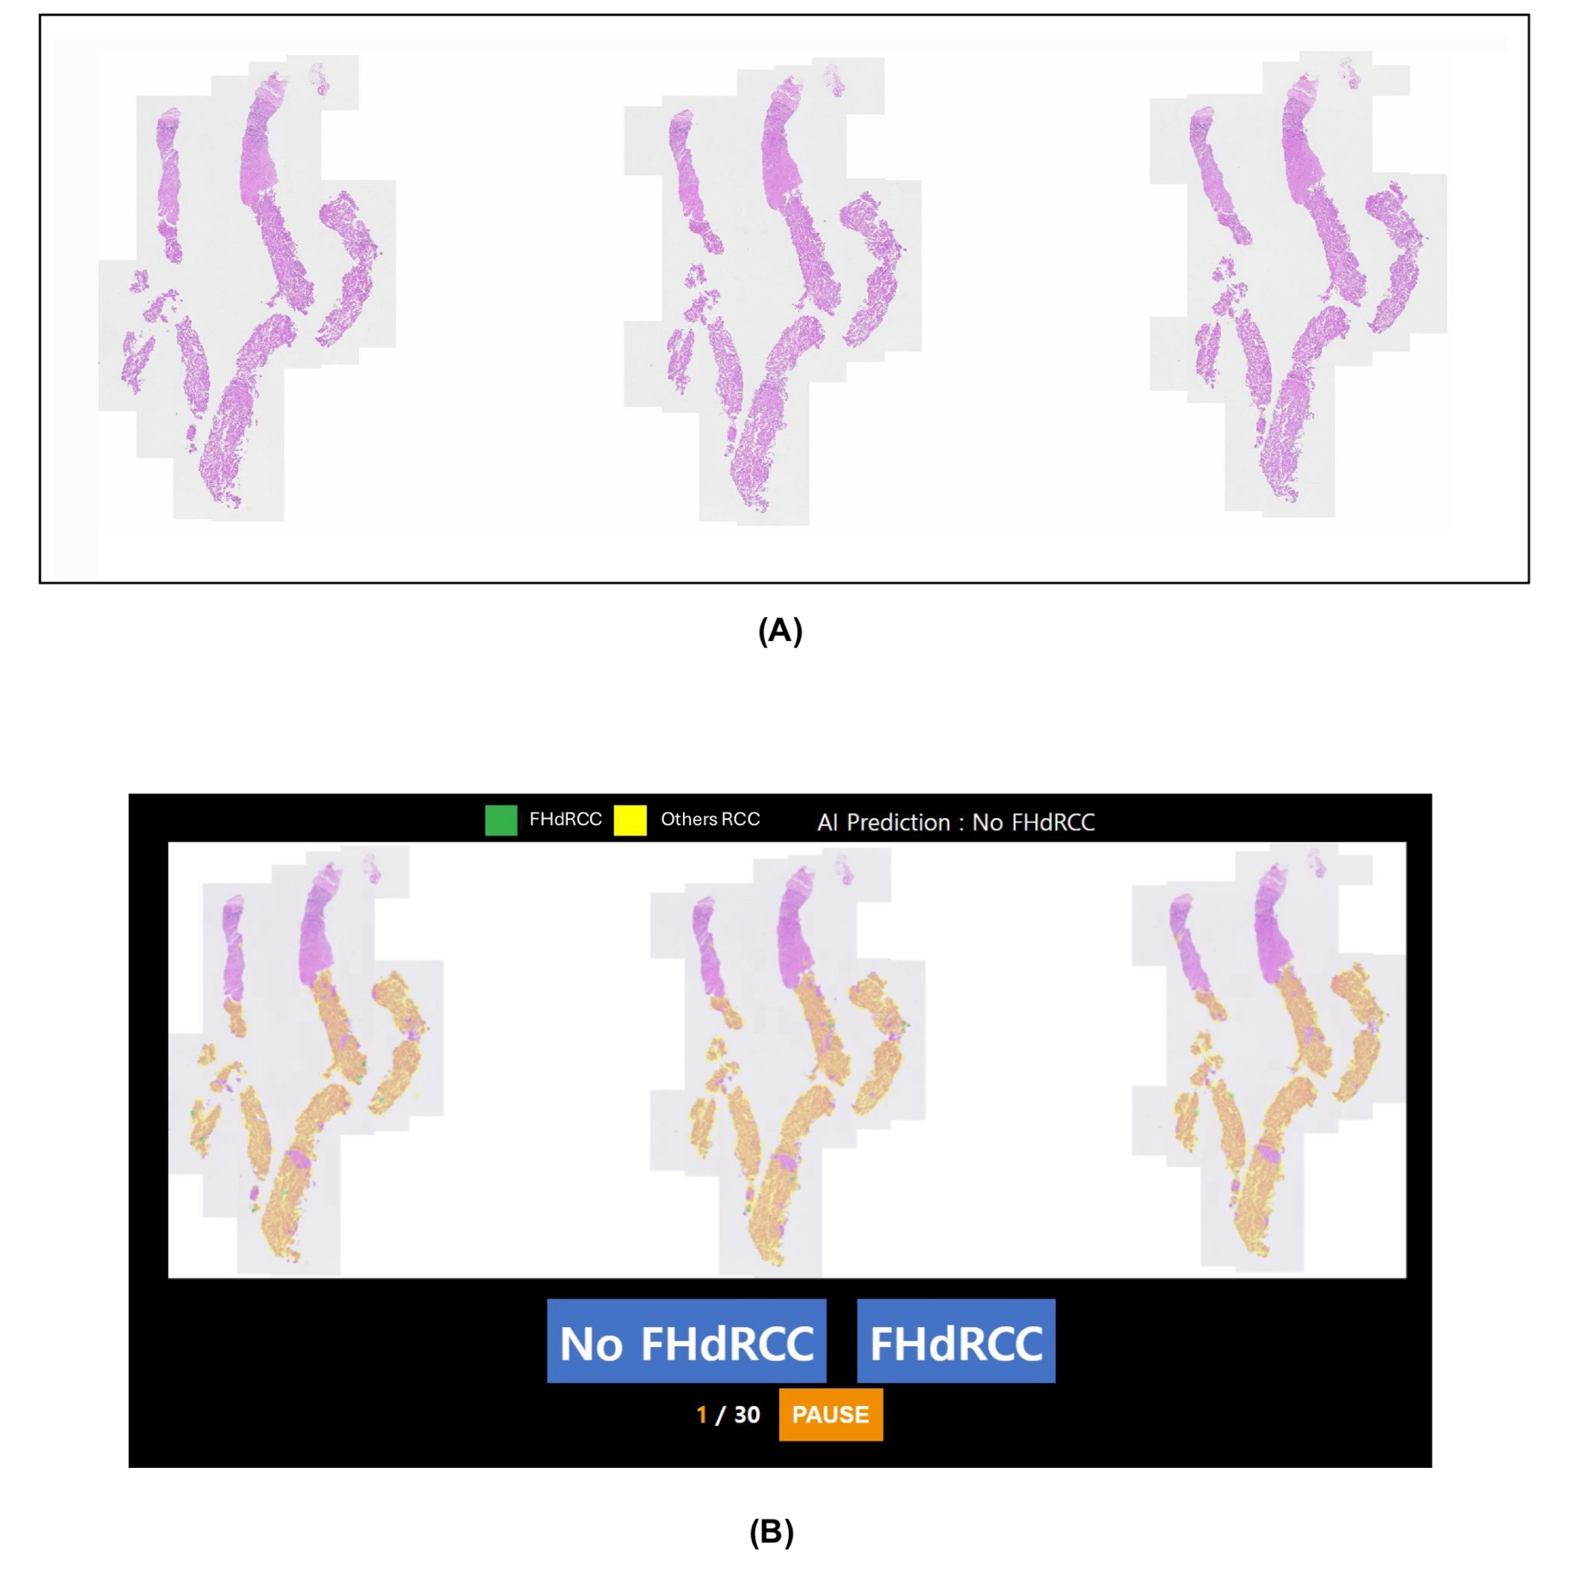
Supplementary Figure. 1. Reader study interface.
(A) The left monitor displayed the whole slide image (WSI) in Automated Slide Analysis Platform software (v2.1). (B) The right monitor displayed AI prediction (text-based label) and AI colormap: a visualization of the model's patch-level inferences (green: FHdRCC; yellow: Others RCC) overlaid on a thumbnail of the WSI.

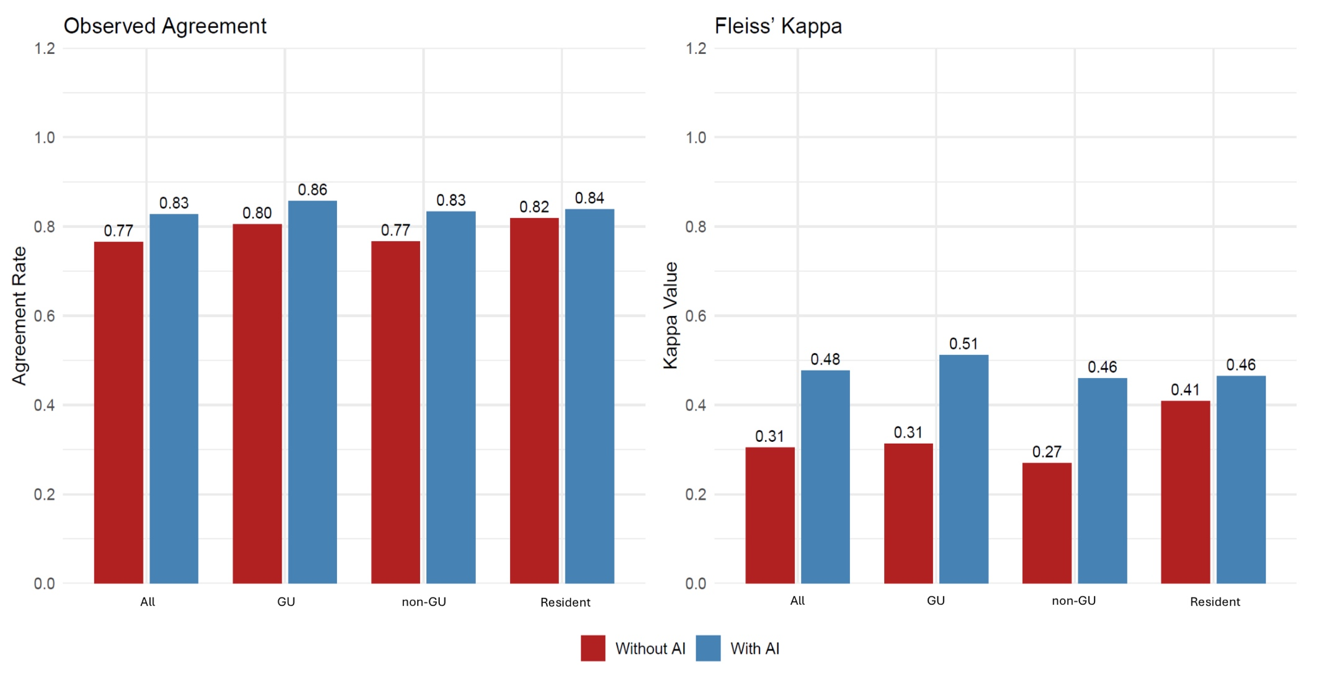
Supplementary Figure. 2. Inter-rater reliability with and without AI assistance.
AI assistance consistently improves diagnostic consensus across all pathologist groups. Abbreviation: GU, genitourinary specialists; non-GU, non-genitourinary specialists.

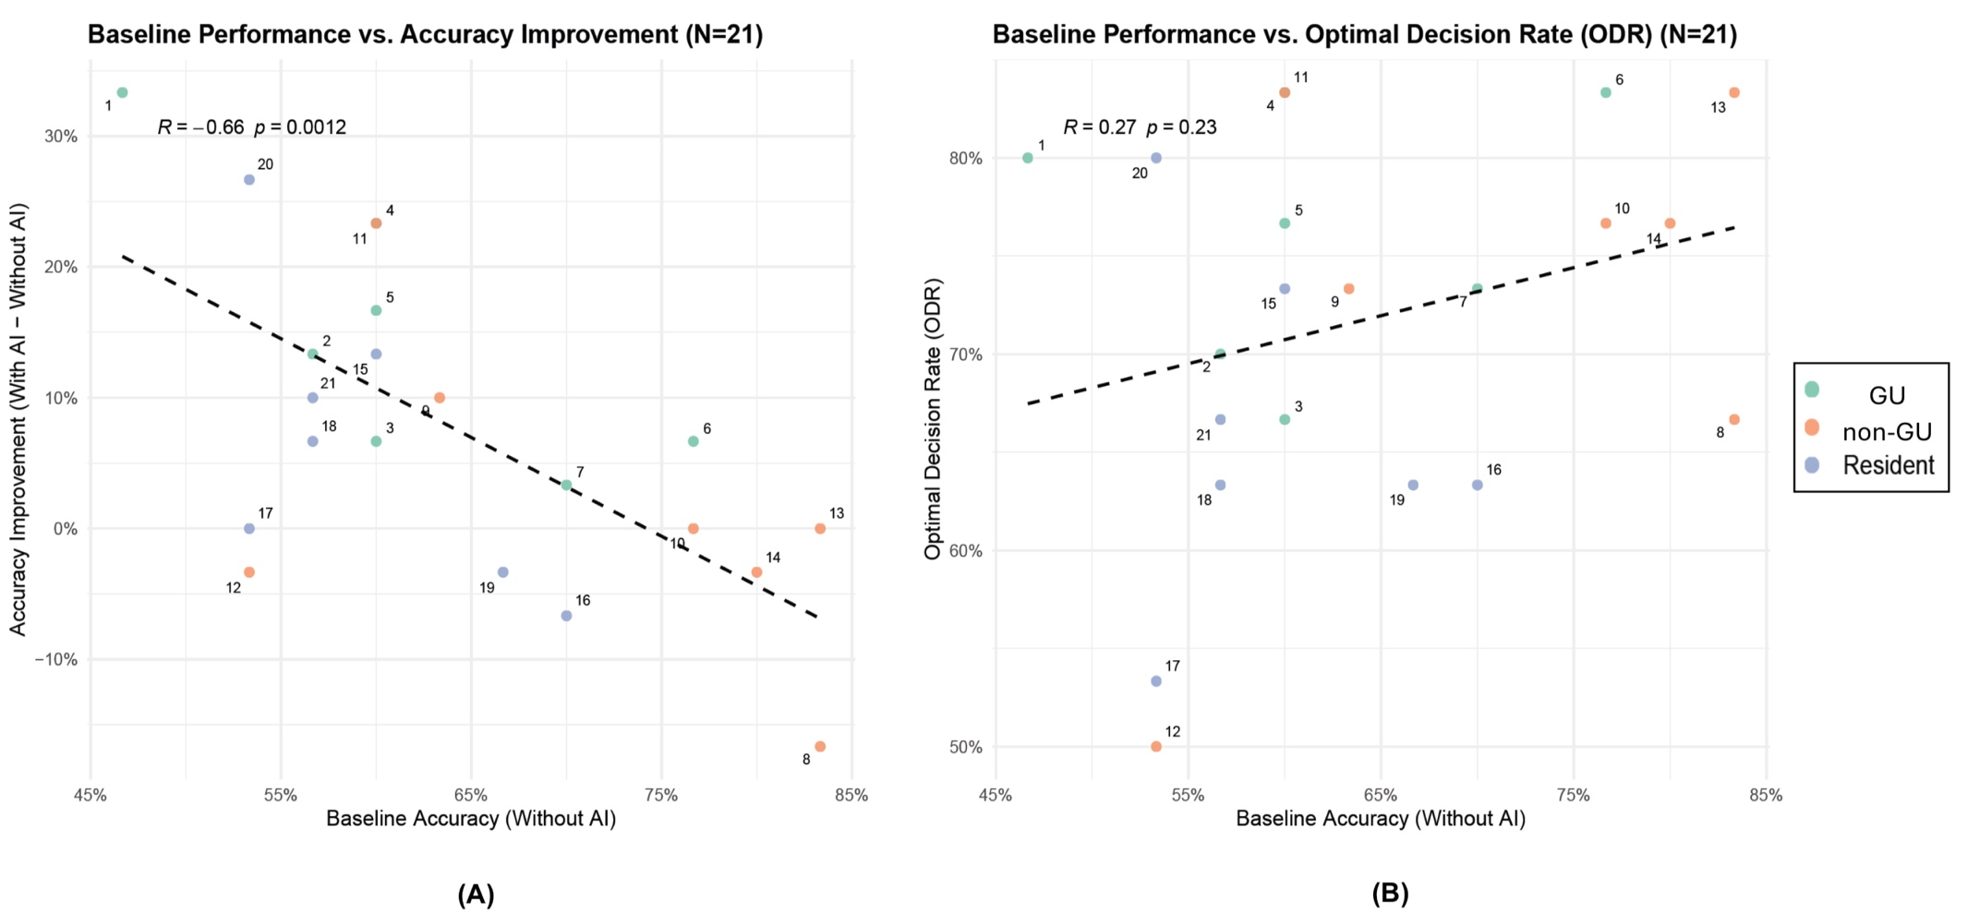
Supplementary Figure. 3. Decoupling of traditional diagnostic skill and AI-interaction proficiency.
(A) Scatter plot showing a strong negative correlation (R=–0.66, p=0.0012) between baseline (Without AI) accuracy and AI-driven accuracy gain, known as the expert paradox. (B) Scatter plot showing no correlation (R=0.27, p=0.23) between baseline accuracy and AI-collaboration skill (ODR). Abbreviation: GU, genitourinary specialists; non-GU, non-genitourinary specialists.

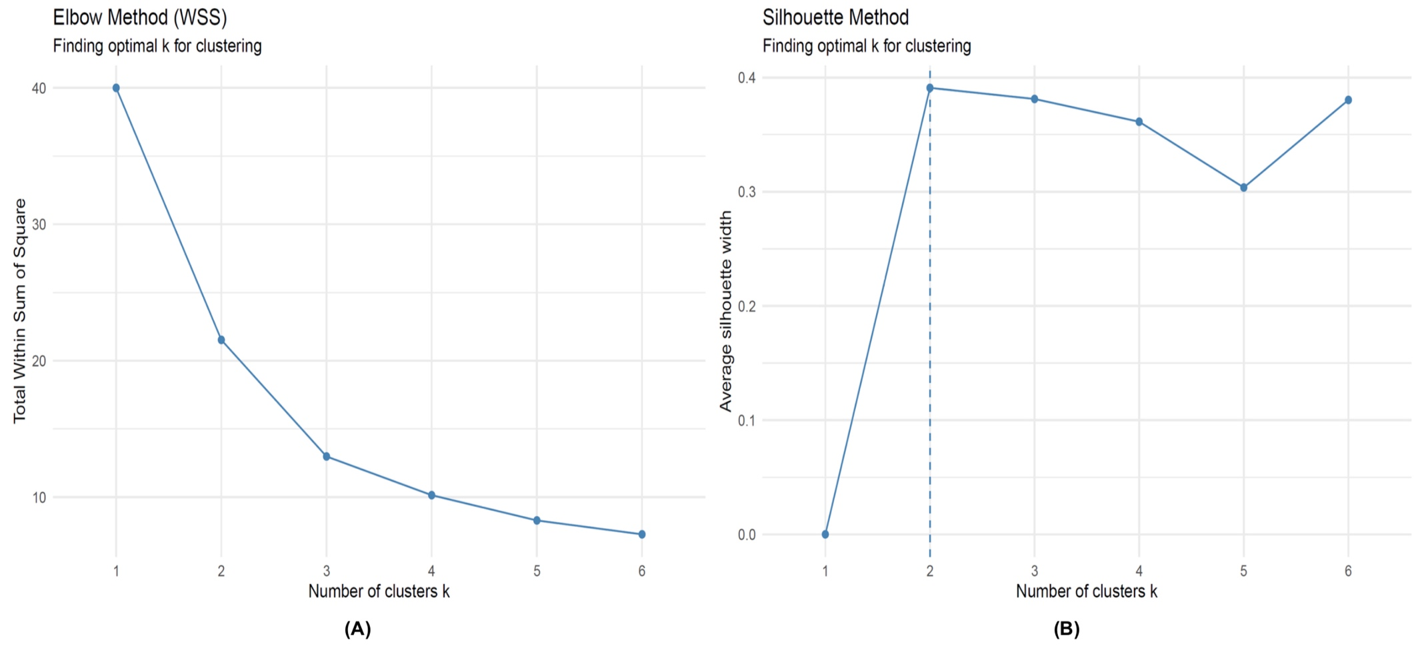
Supplementary Figure. 4. Determining the optimal number of clusters (k) for persona analysis.
(A) The Elbow Method, plotting the total within sum of square (WSS), shows an optimal elbow at k=2. (B) The Silhouette Method shows the peak average silhouette width at k=2. Both methods robustly confirmed k=2 as the optimal number of clusters.

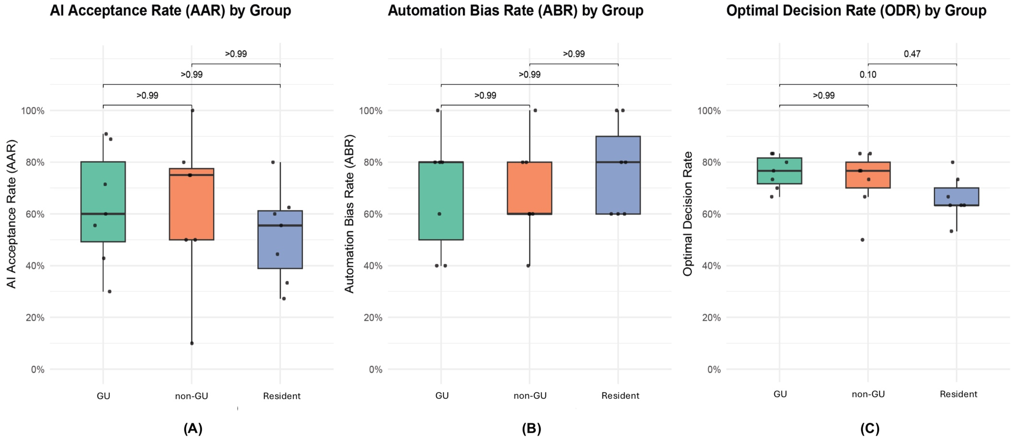
Supplementary Figure. 5. AI interaction metrics stratified by traditional expertise.
Box plots comparing AI Acceptance Rate (AAR), Automation Bias Rate (ABR), and Optimal Decision Rate (ODR) across the three expertise groups (GU, non-GU, Resident). There were no statistically significant differences between the groups for any of the key interaction metrics (Kruskal-Wallis p > 0.05 for all). Abbreviation: GU, genitourinary specialists; non-GU, non-genitourinary specialists.

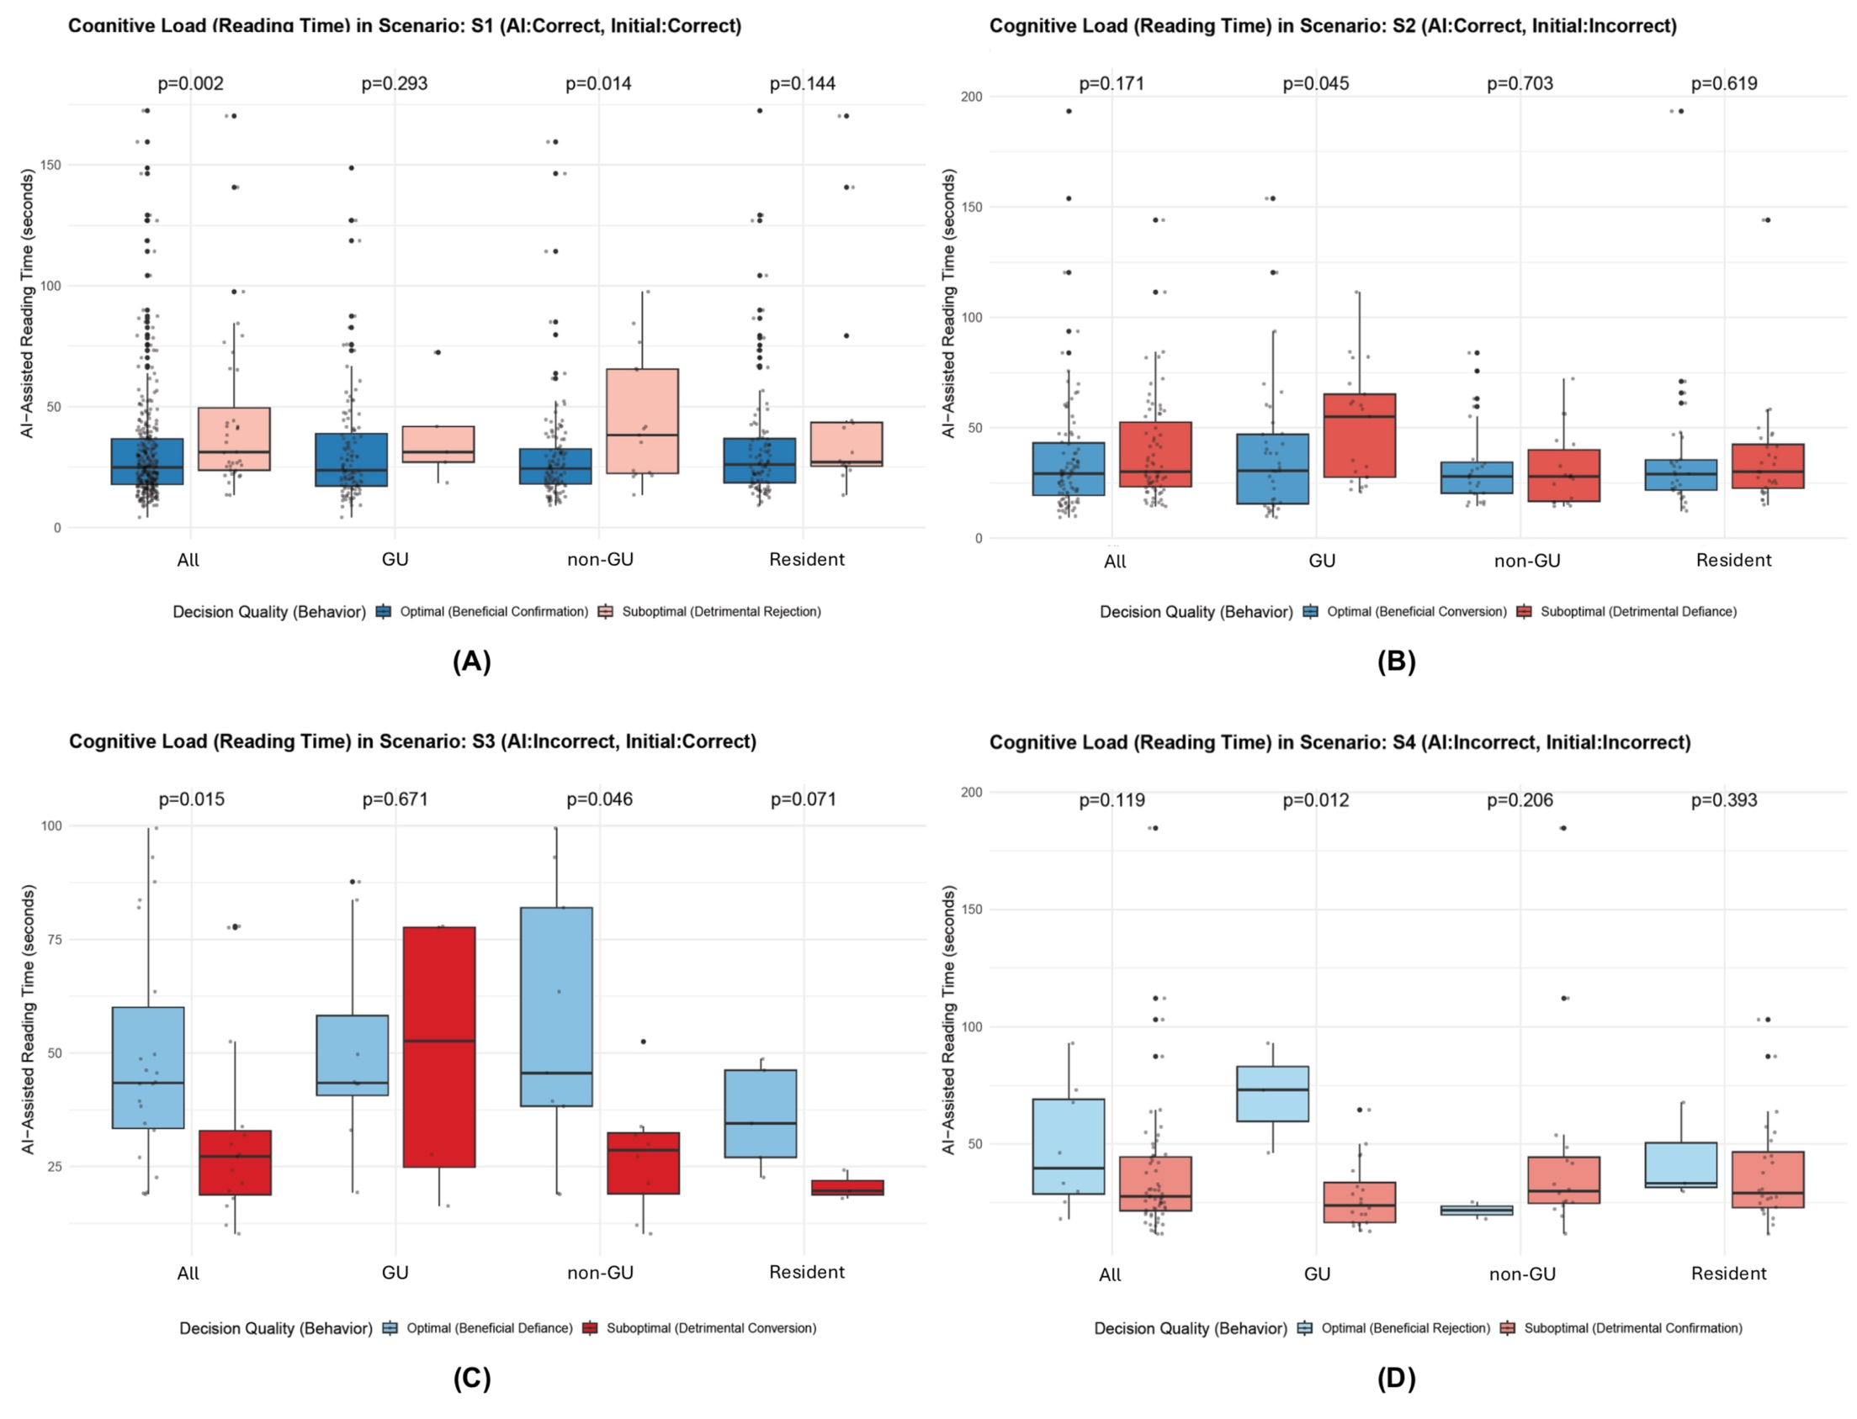
Supplementary Figure. 6. Cognitive load analysis stratified by traditional expertise.
Box plots comparing AI-assisted reading time (cognitive load) for Optimal (blue) vs. Suboptimal (red) decisions, stratified by expertise group (GU, non-GU, Resident) across the four diagnostic scenarios (S1-S4). Abbreviation: GU, genitourinary specialists; non-GU, non-genitourinary specialists.

TRIPOD Checklist: Prediction Model Development
Study: One AI Training Fits All? Exploring Behavioral Personas in Rare Cancer Diagnosis—Fumarate Hydratase-Deficient Renal Cell Carcinoma
Section/Topic | Item | Checklist Item | Page
TITLE AND ABSTRACT
Title | 1 | Identify the study as developing and/or validating a multivariable prediction model, the target population, and the outcome to be predicted. | 1
Abstract | 2 | Provide a summary of objectives, study design, setting, participants, sample size, predictors, outcome, statistical analysis, results, and conclusions. | 1
INTRODUCTION
Background and objectives | 3a | Explain the medical context (including whether diagnostic or prognostic) and rationale for developing or validating the multivariable prediction model, including references to existing models. | 2
Background and objectives | 3b | Specify the objectives, including whether the study describes the development or validation of the model or both. | 2
METHODS
Source of data | 4a | Describe the study design or source of data (e.g., randomized trial, cohort, or registry data), separately for the development and validation data sets, if applicable. | 3-4
Source of data | 4b | Specify the key study dates, including start of accrual; end of accrual; and, if applicable, end of follow-up. | 3
Participants | 5a | Specify key elements of the study setting (e.g., primary care, secondary care, general population) including number and location of centres. | 3
Participants | 5b | Describe eligibility criteria for participants. | 3
Participants | 5c | Give details of treatments received, if relevant. | N/A
Outcome | 6a | Clearly define the outcome that is predicted by the prediction model, including how and when assessed. | 3-4
Outcome | 6b | Report any actions to blind assessment of the outcome to be predicted. | 3, 5
Predictors | 7a | Clearly define all predictors used in developing or validating the multivariable prediction model, including how and when they were measured. | 3-4, S1
Predictors | 7b | Report any actions to blind assessment of predictors for the outcome and other predictors. | 4, S1
Sample size | 8 | Explain how the study size was arrived at. | 6-7
Missing data | 9 | Describe how missing data were handled (e.g., complete-case analysis, single imputation, multiple imputation) with details of any imputation method. | 4, S3
Statistical analysis methods | 10a | Describe how predictors were handled in the analyses. | 4, S2-S4
Statistical analysis methods | 10b | Specify type of model, all model-building procedures (including any predictor selection), and method for internal validation. | 4, S2
Statistical analysis methods | 10d | Specify all measures used to assess model performance and, if relevant, to compare multiple models. | 5-6, S2, S5
Risk groups | 11 | Provide details on how risk groups were created, if done. | 5-6
RESULTS
Participants | 13a | Describe the flow of participants through the study, including the number of participants with and without the outcome and, if applicable, a summary of the follow-up time. A diagram may be helpful. | 6-7, Fig. 1
Participants | 13b | Describe the characteristics of the participants (basic demographics, clinical features, available predictors), including the number of participants with missing data for predictors and outcome. | 6-7, Table 1-2
Model development | 14a | Specify the number of participants and outcome events in each analysis. | 7, Table 2
Model development | 14b | If done, report the unadjusted association between each candidate predictor and outcome. | N/A
Model specification | 15a | Present the full prediction model to allow predictions for individuals (i.e., all regression coefficients, and model intercept or baseline survival at a given time point). | 4, S2-S4
Model specification | 15b | Explain how to use the prediction model. | 4-5, S4
Model performance | 16 | Report performance measures (with CIs) for the prediction model. | 7-9, S6-S7
DISCUSSION
Limitations | 18 | Discuss any limitations of the study (such as nonrepresentative sample, few events per predictor, missing data). | 13
Interpretation | 19b | Give an overall interpretation of the results, considering objectives, limitations, and results from similar studies, and other relevant evidence. | 12-14
Implications | 20 | Discuss the potential clinical use of the model and implications for future research. | 13-14
OTHER INFORMATION
Supplementary information | 21 | Provide information about the availability of supplementary resources, such as study protocol, Web calculator, and data sets. | Throughout, Supplementary
Funding | 22 | Give the source of funding and the role of the funders for the present study. | Title page
*S = Supplementary Appendix. We recommend using the TRIPOD Checklist in conjunction with the TRIPOD Explanation and Elaboration document.

References

1. Kononen J, Bubendorf L, Kallionimeni A, Bärlund M, Schraml P, Leighton S, et al. Tissue microarrays for high-throughput molecular profiling of tumor specimens. Nature Medicine. 1998;4(7):844-7.
2. Xie S, Girshick R, Dollár P, Tu Z, He K, editors. Aggregated residual transformations for deep neural networks. Proceedings of the IEEE conference on computer vision and pattern recognition; 2017.
3. Loshchilov I, Hutter F. Decoupled weight decay regularization. arXiv preprint arXiv:171105101. 2017.
4. Buslaev A, Iglovikov VI, Khvedchenya E, Parinov A, Druzhinin M, Kalinin AA. Albumentations: Fast and Flexible Image Augmentations. Information. 2020;11(2):125.
5. Powers DM. Evaluation: from precision, recall and F-measure to ROC, informedness, markedness and correlation. arXiv preprint arXiv:201016061. 2020.
6. Reinhard E, Adhikhmin M, Gooch B, Shirley P. Color transfer between images. IEEE Computer graphics and applications. 2002;21(5):34-41.
7. Hastings WK. Monte Carlo sampling methods using Markov chains and their applications. 1970.
8. Bates D, Mächler M, Bolker B, Walker S. Fitting Linear Mixed-Effects Models Using lme4. Journal of Statistical Software. 2015;67(1):1 - 48.

