Appendix A: Primers used for the study
S/N | Primer name | Gene | Trait | Crops studied with selected primer | Sequence | Annealin Temp used | In-silico band determined (bp)at NCBI | References
1 | MeAGPL1-F | Cyanogenic glycosides | chemical defense mechanism  against herbivores, pests, and pathogens | Casssava | GCGATATCCCTGGATTTG | 53 | 1710 | Hu et al., 2016
2 | MeAGPL1-R | Cyanogenic glycosides |  | Casssava | ATTAAAGGACGTTCTAAGAAC | 53 | 1710 | Hu et al., 2016
3 | Ph-3 Resistance Gene-F | Ph-3 Resistance Gene | resistance to late blight caused by Phytophthora infestans | Tomato | AATATTGAAAATAGCTGCACTGA | 60 | 412 | Lakshmi et al., 2024
4 | Ph-3 Resistance Gene-R | Ph-3 Resistance Gene | resistance to late blight caused by Phytophthora infestans | Tomato | CGAGATTTGGAGGGAATGTAA | 60 | 412 | Lakshmi et al., 2024
5 | Ty-3-caps-F | Ty-3 | Tomato yellow leaf curl resistance | Tomato | TCTCAGGTGATGCTGAGCAC | 53 | 813 | Lakshmi et al., 2024
6 | Ty3-SNP17-R | Ty-3 | Tomato yellow leaf curl resistance | Tomato | AGAGAACGAAAACGAAATTTCAAACA | 53 | 813 | Lakshmi et al., 2024
7 | AiNAC3 -F | NAC | Stress reponse (drought) | Groundnut | TGGAGTGAAGAAAGCCCTTG | 55 °C | 151 | Suchithra et al., 2018
8 | AiNAC3 -R | NAC | Stress reponse (drought) | Groundnut | GCATAGCACCCACTCATCAA | 55 °C | 151 | Suchithra et al., 2018
9 | M2-F | Myo-Inositol-3-Phosphate Synthase | Phytic acid | Groundnut | AGATTTCATTGCTGCCAACC |  | 900 | Jagal Kishore et al., 2020
10 | MIPSV-R | Myo-Inositol-3-Phosphate Synthase | Phytic acid | Groundnut | GCTCACTTGTACTCCAGGATCATG | 58 | 900 | Jagal Kishore et al., 2020

Appendix B1: Cycling conditions of selected primers for sequencing
S/N | Primers | Initial Denaturation -degree celcious and time | Final Denaturation-degree celcious and time | Annealing-degree and time | Initial Extension-degree celcious and time | Number of cycles-degree celcious and time | Final extension-degree celcious and time | Hold -degree celcious and time
1 | MeAGPL1 | 95 - 5 mins | 95 - 10 secs | 53 - 30 secs | 72 - 1 min | 35 | 72 - 5 mins | 4- ∞
2 | Ph-3 | 94 - 4 mins | 94 - 30 secs | 60 - 30 secs | 72 - 1 min | 40 | 72 - 5 mins | 4- ∞

Appendix B2: Cycling conditions of selected primers for sequencing cont’d
S/N | Primers | Single cycle-Initial Denaturation -degree celcious and time | Final Denaturation -degree celcious and time | Annealing-degree and time | Extension-degree celcious and time | Number of cycles-degree celcious and time | Initial Denaturation -degree celcious and time | Annealing-degree and time | Extension-degree celcious and time | Number of cycles-degree celcious and time | Final extension-degree celcious and time | Hold -degree celcious and time
3 | TY-3-Caps/SNP17 | 94 - 3 mins | 94 - 30 secs | 60 - 30 secs (-0.6 /cycle) | 72 - 45 secs | 10 | 94 - 30 secs | 54 - 30 secs | 72 - 45 secs | 30 | 72 - 7 mins | 4- ∞
4 | AiNAC3 | 95 - 3 mins | 95 - 30 secs | 58 - 30 secs (-1 /cycle) | 72 – 2 mins | 10 | 95 - 30 secs | 50 - 30 secs | 72 - 2 min | 30 | 72 - 8 mins | 4- ∞
5 | M2-F/  MIPSV-R | 95 - 3 mins | 95 - 30 secs | 62 - 30 secs (-1 /cycle) | 72 – 2 mins | 10 | 95 - 30 secs | 52 - 30 secs | 72 – 2 mins | 30 | 72 - 10 mins | 4- ∞

Appendix C: Agarose gel images of amplicons sequenced

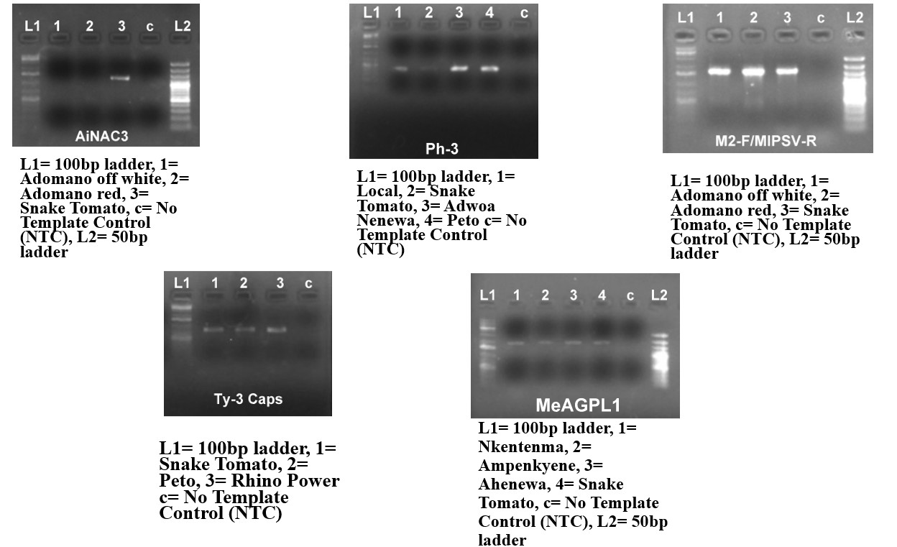

Appendix D: Properties of reads retained after filtering for BLAST
S/N | Reaction ID | % GC | Molecular Weight (kDa) | Sequence Length
1 | 02G_18_4A_Local_Ph-3-F | 36.10% | 108.91901 | 352
2 | 02H_19_7A_Adwoa_Ph-3-F | 37.50% | 109.7635 | 355
3 | 03A_20_8A_Peto_Ph-3-F | 36.80% | 106.75357 | 345
4 | 09A_78_8A_Peto_Ty-3Caps-F | 32.10% | 228.76127 | 742
5 | 09B_79_9A_RhinoPower_Ty-3Caps-F | 32.30% | 217.64801 | 706
6 | 09C_80_SN_SN_Ty-3Caps-F | 32.20% | 220.42283 | 715
7 | 11E_105_5A_Ahenewa_MeaGPL1-R (reversed) | 48.60% | 205.31209 | 664
8 | Adomano-off-White_M2-F/MIPSV-R | 34.70% | 112.07609 | 363
9 | AdomanoRed_M2-F/MIPSV-R | 25.30% | 52.6176 | 170
10 | Ampenkyene_MeaGPL1 | 46.40% | 192.07386 | 623
11 | P38376_11F_106_12A_Nkentema_MeaGPL1-F | 43.20% | 213.77718 | 692
12 | SN_MeaGPL1 | 56.70% | 453.84125 | 1476

Appendix E: Properties of References obtained after reads retained after filtering for BLAST
Accession | # Nucleotides | Bit-Score | Description | E Value | Molecular Weight (kDa) | Molecule Type | Query | Query coverage | Sequence Length
AF140613.1 | 1234 | 331.303 | Manihot esculenta N-hydroxylating cytochrome P450 (CYP79D1) mRNA, complete cds | 2.37E-89 | 592.7493 | mRNA | MeaGPL1 | 98.56% | 1845
AM941723.1 | 723 | 407.383 | Phaseolus vulgaris partial MIPS gene for myo-inositol 1-phosphate synthase, cultivar Taylor's Horticultural, exons 1-10 | 7.18E-109 | 1256.502 | DNA | M2-F/MIPSV-R | 99.17% | 4066
PV426896.1 | 705 | 625.252 | Solanum lycopersicum voucher 6493 Ph-3 resistance protein (Ph-3) gene, partial cds | 5.86E-177 | 127.398 | DNA | Ph-3-F | 100.00% | 412
XM_010323869.4 | 319 | 289.198 | Solanum lycopersicum RNA-dependent RNA polymerase (TY-1/TY-3), mRNA | 1.90E-75 | 1006.861 | mRNA | Ty-3Caps-F | 21.43% | 3129

Appendix F: Sequencing metrics of reads obtained after sequencing
S/N | Name | Primer | Gene | Trait | Read Length (bp) | Read HQ | Read Q. average | Trim length (bp) | Trim Q.Average
1 | 05A_41_15A_AdomanoWhie_M2-F | M2-F/MIPSV-R | Myo-Inositol-3-Phosphate Synthase | Phytic acid | 1340 | 801 | 29.1 | 802 | 41.9
2 | 05B_42_16A_Adomanooff-white_M2-F | M2-F/MIPSV-R | Myo-Inositol-3-Phosphate Synthase | Phytic acid | 1343 | 739 | 29.6 | 749 | 45.1
3 | Snake Tomato | M2-F/MIPSV-R | Myo-Inositol-3-Phosphate Synthase | Phytic acid | 1888 | 11 | 8.89 | 0 | 0
4 | 11F_106_12A_Nkentema_MeaGPL1-F | MeaGPL1 | Cyanogenic glycosides | Phosphatidylinositol kinases (PIKs) | 1330 | 878 | 39.8 | 926 | 52
5 | 11G_107_13A_Ampenkyene_MeaGPL1-F | MeaGPL1 | Cyanogenic glycosides | Phosphatidylinositol kinases (PIKs) | 1354 | 722 | 35.5 | 705 | 58.2
6 | 11E_105_5A_Ahenewa_MeaGPL1-R | MeaGPL1 | Cyanogenic glycosides | Phosphatidylinositol kinases (PIKs) | 1367 | 676 | 31.9 | 664 | 54.3
7 | Snake Tomato | MeaGPL1 | Cyanogenic glycosides | Phosphatidylinositol kinases (PIKs) | 1477 | 56 | 10.2 | 0 | 0
8 | 02G_18_4A_Local_Ph-3-F | Ph-3 | Ph-3 Resistance Gene | late blight resistance | 1050 | 357 | 21.6 | 352 | 63
9 | 02H_19_7A_Adwoa_Ph-3-F | Ph-3 | Ph-3 Resistance Gene | late blight resistance | 1361 | 353 | 16.6 | 355 | 62.5
10 | 03A_20_8A_Peto_Ph-3-F | Ph-3 | Ph-3 Resistance Gene | late blight resistance | 1362 | 354 | 16.4 | 345 | 62.9
11 | Snake Tomato | Ph-3 | Ph-3 Resistance Gene | late blight resistance | 1405 | 2 | 0.698 | 0 | 0
12 | 09A_78_8A_Peto_Ty-3Caps-F | Ty-3Caps | Ty-3 | Tomato yellow leaf curl virus resistance | 1300 | 741 | 36.7 | 742 | 63.2
13 | 09B_79_9A_RhinoPower_Ty-3Caps-F | Ty-3Caps | Ty-3 | Tomato yellow leaf curl virus resistance | 1401 | 701 | 34.1 | 706 | 59
14 | Snake Tomato | Ty-3Caps | Ty-3 | Tomato yellow leaf curl virus resistance | 1201 | 730 | 39.5 | 715 | 61.6
15 | Snake Tomato | AiNAC3 | NAC | regulating stress responses, including drought, and developmental processes | 1397 | 53 | 10.2 | 0 | 0

