Supplementary information

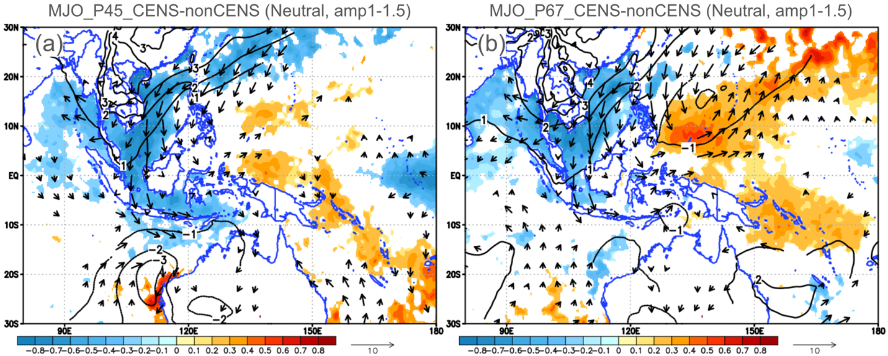
Fig. S1 Composite difference maps of SST, SLP, and surface wind fields between CENS and non-CENS days, based on a subsample restricted to Neutral years with MJO amplitude in the range of 1.0–1.5. Sample sizes (number of CENS vs. non-CENS days) are: phases 4–5 [31 vs. 126] and phases 6–7 [44 vs. 133]. Analysis is based on ERA5 reanalysis data (1940–2023). Color shading indicates SST (°C), contours indicate SLP (hPa), and arrows denote surface wind vectors (m/s). Only differences statistically significant at the 95% confidence level are shown. All plots were generated with GrADS v2.2.1 (http://cola.gmu.edu/grads/grads.php).

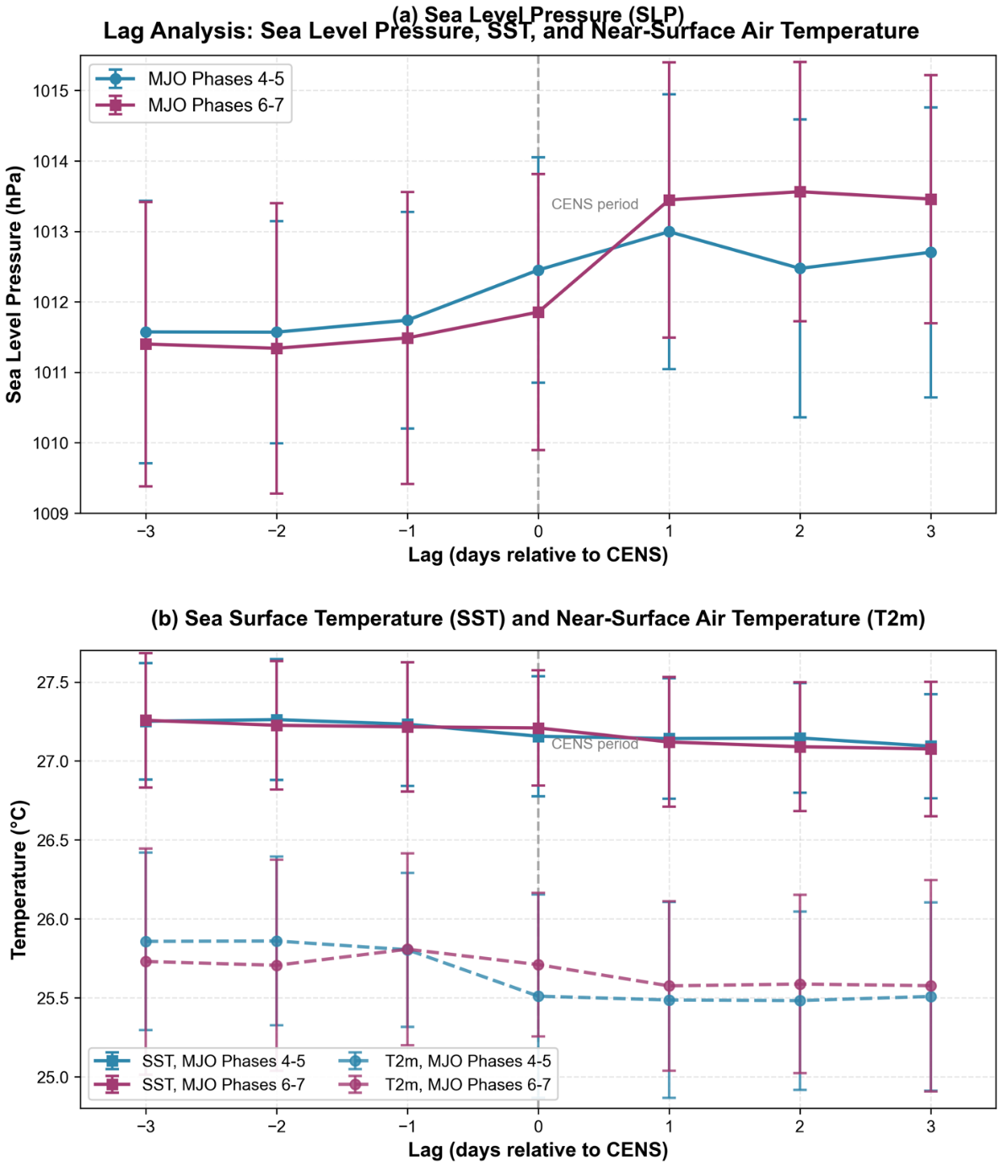
Fig. S2 Time series of region-averaged (130–150°E, 10–20°N) SLP, SST, and near-surface air temperature (T2m) from day -3 to day +3 relative to CENS occurrence, stratified by MJO phase. (a) SLP time series for MJO phases 4–5 (blue circles) and phases 6–7 (purple squares). (b) Combined SST and T2m time series for the same phases: SST is shown with solid lines and square markers, while T2m is shown with dashed lines and circular markers. Error bars indicate ±1 standard deviation. The vertical dashed line at day 0 marks the CENS period. The analysis is based on ERA5 reanalysis data (1940–2023) for all CENS events in January–February, with the constraint that days -3 to -1 and days +1 to +3 must all be non-CENS days. Representative sample sizes are approximately 20–30 events for MJO phases 4–5 and 15–25 events for phases 6–7, varying slightly by lag. The observed patterns—where SLP increases (indicating anticyclone extension), T2m decreases prior to SST cooling, and SST subsequently decreases—are consistent with cold advection from continental highs leading the oceanic response, supporting the interpretation that cold air outbreaks from the anticyclone precede SST cooling during CENS events. All plots were generated using Python 3.10.13 (http://www.python.org).

