GLUCAGON-LIKE PEPTIDE-1 RECEPTOR AGONISTS IMPROVE LIVER AND OTHER METABOLIC HEALTH OUTCOMES IN TYPE 2 DIABETES AND OBESITY REGARDLESS OF PRIOR DIAGNOSIS OF LIVER DISEASE IN ROUTINE CLINICAL PRACTICE

Kavin D. Parmar MBBS¹, Ana Carolina Beatriz Pereira MD¹, Vinay Jahagirdar MBBS¹, Ekaterina Smirnova PhD^{1,2} and Arun J. Sanyal MBBS MD¹.

Table of contents:

Supplemental Figure 1 page 2
Supplemental Figure 2 page 3
Supplemental Figure 3 page 4
Supplemental Figure 4 page 5
Supplemental Figure 5 page 6
Supplemental Table 1 page 7
Supplemental Table 2 page 10
Supplemental Table 3 page 11
Supplemental Table 4 page 12
Supplemental Table 5 page 13

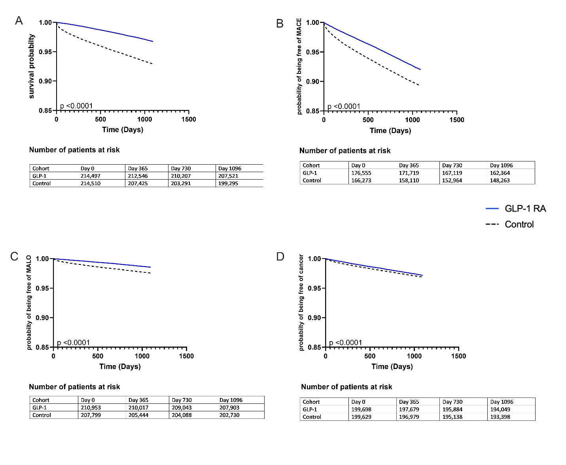
Supplemental Figure 1: Kaplan Meier plots for any GLP-1 RA use with a minimum exposure for 2 years and outcomes assessed within three additional years after exposure. (Composite outcomes). Data for mortality are shown in panel A. Panels B, C and D reflect time to outcome probability for MACE, MALO and cancers. For these analyses, only individuals who did not have the outcome prior to initiation of GLP-1 RA were included. These data demonstrate that GLP-1 RA prolonged time to all of the outcomes and the overall risk of outcomes (p< 0.0001 by log rank test).

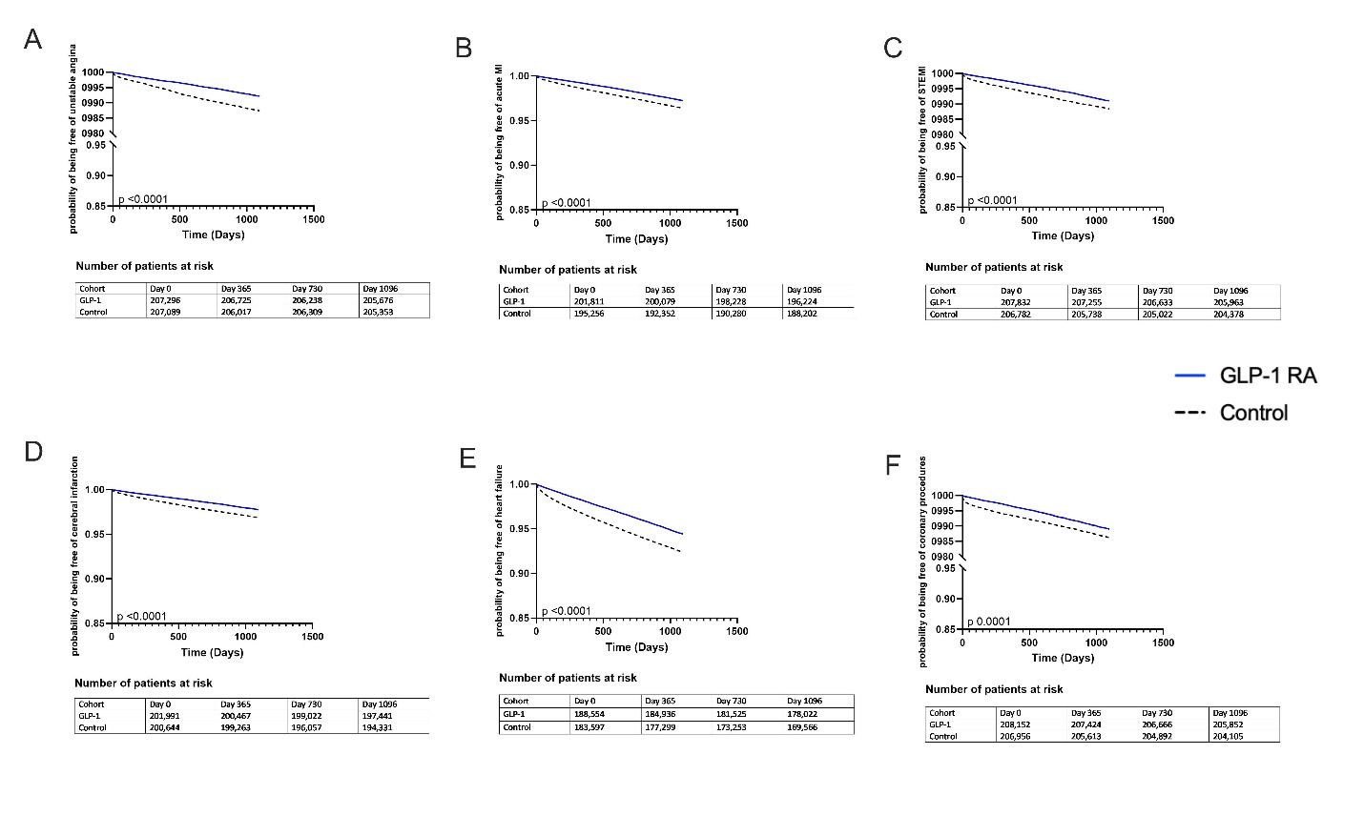
Supplemental Figure 2: Kaplan Meier plots for any GLP-1 RA use with a minimum exposure for 2 years and cardiovascular outcomes assessed within three additional years after exposure. Data for unstable angina (Panel A), acute myocardial infarction (MI) (Panel B), ST elevated MI (STEMI) (Panel C), cerebral infarction (Panel D), Heart failure (Panel E) and coronary revascularization (Panel F) are shown. For these analyses, only individuals who did not have the outcome prior to initiation of GLP-1 RA were included. These data demonstrate that GLP-1 RA prolonged time to all of the outcomes and the overall risk of outcomes (p< 0.0001 by log rank test).

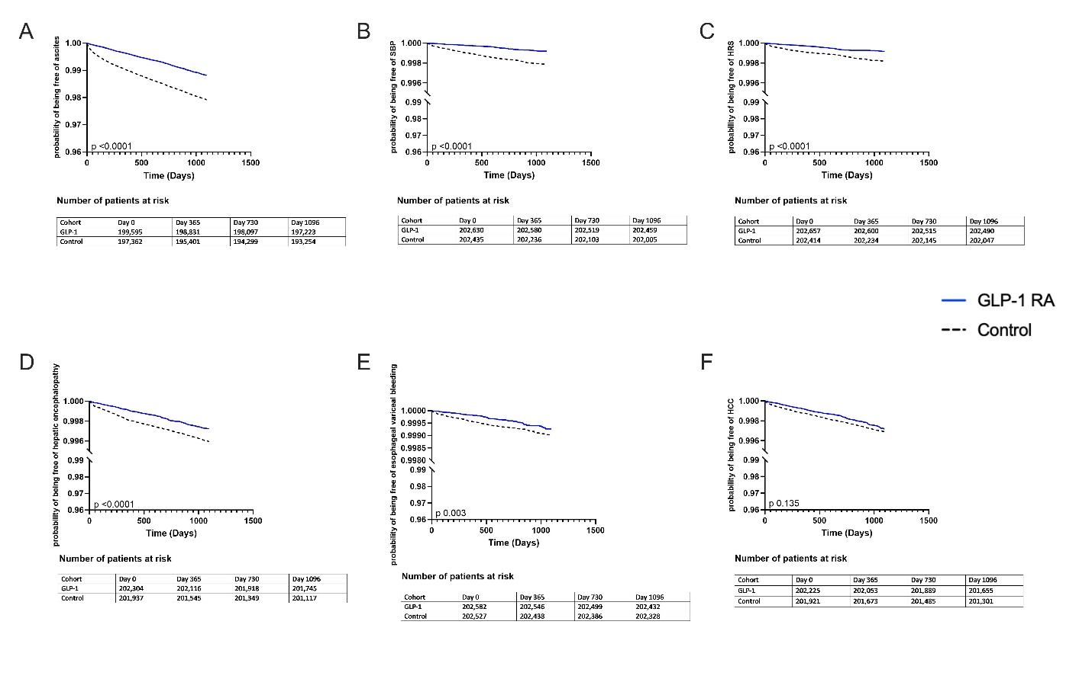
Supplemental Figure 3: Kaplan Meier plots for any GLP-1 RA use with a minimum exposure for 2 years and liver related outcomes assessed within three additional years after exposure. Data for ascites(Panel A), spontaneous bacterial peritonitis (SBP) (Panel B), hepatorenal syndrome (HRS) (Panel C), hepatic encephalopathy (Panel D), esophageal variceal bleeding (Panel E) and hepatocellular carcinoma (HCC) (Panel F) are shown. For these analyses, only individuals who did not have the outcome prior to initiation of GLP-1 RA were included. These data demonstrate that GLP-1 RA prolonged time to all of the outcomes and the overall risk of outcomes (p< 0.0001 by log rank test).

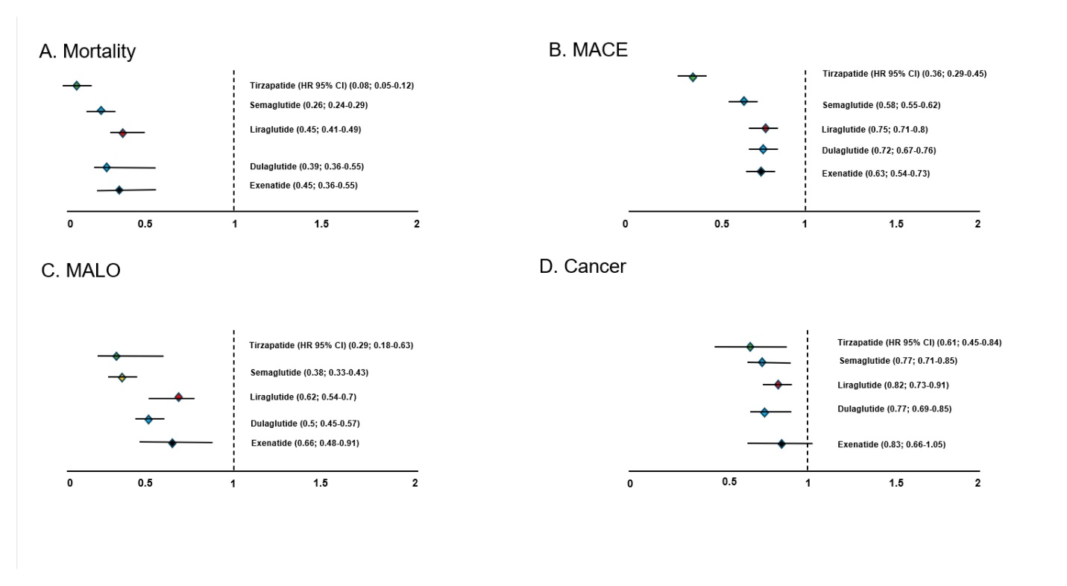
Supplemental Figure 4: Cox proportional hazards models were used to define hazard ratios (H.R.) with 95% CI for specific outcomes for individual GLP-1 RA based on a minimum exposure of 2 years plus three additional years of follow up. Each analysis compared the GLP-1 RA to a propensity matched control that did not receive GLP-1 RA and these analyses do not represent a head-to-head comparison of individual gLP-1 RA. All of the GLP-1 RA were improved mortality, MACE, MALO and cancer with the exception of Exenatide where the 95% CI intersected 1.

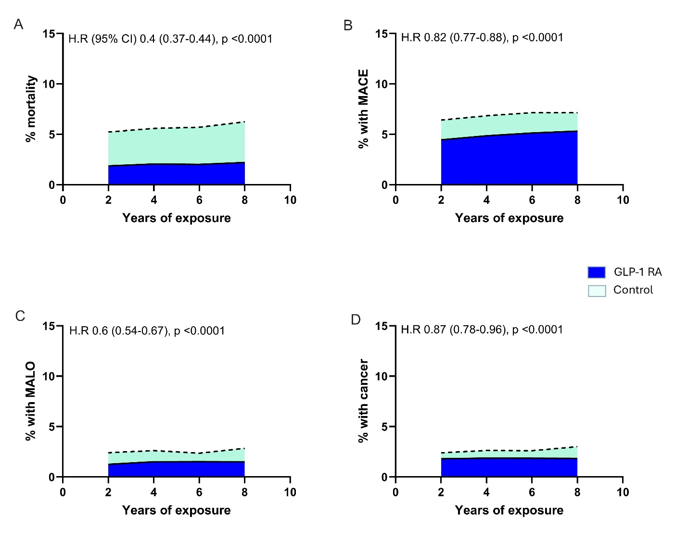
Supplemental Figure 5: The absolute risk of mortality (panel A), MACE (panel B), MALO (panel C) and cancers (panel D) in those with T2DM and obesity who also had a diagnosis of MASLD prior to the initiation of GLP-1 RA. The dotted line and shaded area below it represents the risks for control groups whereas the solid line and blue shaded area below it represent the risks for individuals receiving GLP-1 RA for at least 2, 4, 6 or 8 years followed by 3 additional years over which outcomes were measured.

Supplemental Table 1: codes
Diagnosis | ICD-10 /CPT/Trinetx (TNX) curated /RxNorm/ATC/VA codes
INCLUSION
T2DM + BMI ≥ 30 + GLP-1 | E11 + TNX 9083 + A10BJ/ 2601723/ 60548/ 1991302/ 475968/ 1551291
Cardiovascular related (MACE)
Unstable Angina | I20.0
Acute Myocardial Infarction | I21
STEMI | I21.0, I21.1, I21.2, I21.3, I21.29, I21.11, I21.21, I21.01, I21.02
NSTEMI | I21.4
Other MI | I21.A9
Stroke | I63
Heart Failure | I50
Heart Failure with reduced ejection fraction | I50.2
Heart Failure with preserved ejection fraction | I50.3
Coronary Procedures | 1021141
Liver Related (MALO)
Ascites | R18
Hepatic Encephalopathy | K76.82
Esophageal varices with bleeding | I85.01
Spontaneous Bacterial Peritonitis | K65.2
Hepatocellular Carcinoma | C22, C22.0
Hepatorenal Syndrome | K76.7
Cancers
Breast cancer | C50
Ovarian cancer | C56
Endometrial cancer | C54.1
Esophageal cancer | C15
Gastric cancer | C16
Gallbladder cancer | C23
Pancreatic cancer | C25
Hepatocellular cancer | C22, C22.0
Colon cancer | C18
Rectal cancer | C20
Renal cell cancer | C64, C65
Thyroid papillary cancer | C73
Prostate cancer | C61
Micro-angiopathic and other complications
Diabetic ophthalmic complications | E11.3, E11.51, E11.39, E11.311
Blindness | H54
Peripheral neuropathy | G62, E11.40
Hypertension | I10
Chronic kidney Disease | N18
Use of Dialysis | 1012740
Gastroparesis | K31.84
Acute cholecystitis | K81.0
cholecystectomy | 1014153, 47562, 45595009
Acute pancreatitis | K85
Any fracture | M84, M84.4, M84.40XA
Thyroid cancer | C73
Laboratory tests
Hemoglobin | TNX-9014
Platelets | TNX-9020
LDL-cholesterol | TNX-9002
Hb A1C | TNX-9037
AST | TNX-9047
Bilirubin | TNX-9050
INR | TNX-9032
Creatinine | TNX- 9024
ALT | TNX-9044
ALP | TNX-9046
Comorbid Conditions
BMI | TNX- 8083
Ischemic Heart Disease | I20-25
CKD | N18
Hypertension | I10
Heart Failure | I50
Fatty liver Disease | K76.0
NASH | K75.81
Cirrhosis | K74
Smoker | F17.20
Stroke | I63
Malignant (primary) neoplasm, unspecified | C80.1
Medications
GLP-1 analgues | ATC: A10BJ
Tirzapetide | RxNorm: 2601723
Semaglutide | RxNorm: 1991302
Liraglutide | RxNorm: 475968
Exenatide | RxNorm: 60548
Dulaglutide | RxNorm: 1551291
Diuretics | ATC: C03
Atorvastatin | RxNorm: 83367
Rosuvastatin | RxNorm: 301542
Simvastatin | RxNorm: 36567
Pravastatin | RxNorm: 42463
Lovastatin | RxNorm: 6472
Fluvastatin | RxNorm: 41127
Angiotensin 2 inhibitors | VA: CV805
SGLT-2 inhibitors | ATC: A10BK

Supplemental Table 2: Impact of GLP-1 RA on micro-angiopathic and other complications

 | After 4 years of exposure |  |  | After 8 years of exposure
 | GLP-1 RA (%)  N= 93,413 | Control (%)  N= 93,413 | HR (95% CI) | GLP-1 RA (%)  N= 20,661 | Control (%)  N= 20,661 | HR (95% CI)
Diabetic ophthalmic  complications | 5.51 | 4.44 | 1.5(1.43-1.57) | 6.03 | 5.12 | 1.51(1.37-1.65)
Blindness | 0.72 | 1.05 | 0.68(0.62-0.76) | 0.76 | 1.13 | 0.84(0.68-1.04)
Peripheral neuropathy | 5.39 | 6.54 | 0.98(0.94-1.03) | 4.91 | 6.95 | 0.88(0.8-0.97)
Hypertension | 15.96 | 25.54 | 0.67(0.64-0.71) | 15.59 | 29.62 | 0.58(0.51-0.66)
Chronic kidney Disease | 5.47 | 7.07 | 0.98(0.94-1.03) | 5.82 | 7.99 | 0.91(0.83-0.99)
Use of Dialysis | 0.49 | 1.36 | 0.42(0.37-0.46) | 0.47 | 1.48 | 0.38(0.3-0.48)
Gastroparesis | 0.76 | 0.86` | 1.06(0.95-1.17) | 0.72 | 0.91 | 1(0.8-1.24)
 | Safety endpoints
Acute cholecystitis | 0.23 | 0.38 | 0.72(0.61-0.86) | 0.23 | 0.45 | 0.63(0.44-0.91)
cholecystectomy | 0.45 | 0.67 | 0.78(0.68-0.88) | 0.48 | 0.75 | 0.78(0.6-1.01)
Acute pancreatitis | 0.48 | 0.92 | 0.6(0.54-0.68) | 0.41 | 0.93 | 0.54(0.41-0.7)
Any fracture | 0.37 | 0.56 | 0.78(0.68-0.9) | 0.4 | 0.6 | 0.84(0.63-1.12)
Thyroid cancer | 0.12 | 0.12 | 1.12(0.86-1.46) | 0.11 | 0.1 | 1.27(0.7-2.32)
Absolute rates of cumulative incidence are reported within 2 different time-frames (4 yrs and 8 years) of exposure.

Supplemental table 3: GLP in MASLD- MACE components after exposure for 2 and 8 years
 | After 2 years of exposure |  |  | After 8 years of exposure
 | GLP-1 RA (%) N=38395 | Control  (%) N=38395 | HR 95% CI | GLP-1 RA (%) N=4388 | Control (%) N=4388 | HR 95% CI
Unstable Angina | 0.47 | 0.72 | 0.77(0.64-0.94) | 0.54 | 0.71 | 0.89(0.51-1.54)
Acute MI | 1.5 | 2.2 | 0.8(0.72-0.89) | 1.79 | 2.71 | 0.78(0.58-1.06)
STEMI | 0.54 | 0.76 | 0.81(0.68-0.97) | 0.51 | 1.07 | 0.57(0.34-0.96)
NSTEMI/Other MI | 0.77 | 1.25 | 0.72(0.62-0.84) | 0.83 | 1.38 | 0.71(0.46-1.08)
Stroke | 1.25 | 1.74 | 0.84(0.74-0.95) | 1.43 | 2.05 | 0.8(0.57-1.12)
Heart Failure | 3.02 | 4.56 | 0.78(0.72-0.84) | 3.66 | 4.96 | 0.91(0.72-1.14)
HFrEF | 1.33 | 1.81 | 0.86(0.76-0.96) | 1.86 | 1.63 | 1.35(0.97-1.88)
HFpEF | 2.15 | 3.18 | 0.79(0.72-0.87) | 2.74 | 3.51 | 0.94(0.72-1.21)
Coronary Procedures | 0.63 | 0.8 | 0.91(0.77-1.08) | 0.63 | 0.95 | 0.8(0.49-1.31)
Absolute rates of cumulative incidence are reported within 2 different time-frames (2 yrs and 8 years) of exposure.

Supplemental table 4: GLP in MASLD- MALO components after exposure for 2 and 8 years
 | After 2 years of exposure |  |  | After 8 years of exposure
 | GLP-1 RA (%)  N=38403 | Control (%) N=38403 | HR 95% CI | GLP-1 RA (%)N=6272 | Control (%) N=6272 | HR 95% CI
Ascites | 1.04 | 2.22 | 0.53(0.47-0.6) | 1.25 | 2.34 | 0.42(0.31-0.55)
Hepatic Encephalopathy | 0.29 | 0.66 | 0.51(0.41-0.63) | 0.17 | 0.6 | 0.22(0.11-0.43)
Esophageal Varices with Bleeding | 0.07 | 0.13 | 0.61(0.39-0.98) | - | - | -
Spontaneous Bacterial Peritonitis | 0.06 | 0.21 | 0.3(0.19-0.47) | - | - | -
Heptorenal Syndrome | 0.07 | 0.31 | 0.27(0.18-0.41) | - | - | -
Hepatocellular Carcinoma | 0.24 | 0.43 | 0.67(0.52-0.87) | 0.25 | 0.33 | 0.58(0.3-1.11)
Absolute rates of cumulative incidence are reported within 2 different time-frames (2 yrs and 8 years) of exposure. (For Esophageal varices with bleeding, SBP and HCC at 8 years, the patient count was too small to report results). MALO stands for major adverse liver outcomes

Supplemental table 5: GLP in Cirrhosis- MALO components at 2 and 8 years
 | After 2 years of exposure |  |  | After 8 years of exposure
 | GLP-1 RA (%)  N=6333 | Control (%) N=6333 | HR 95% CI | GLP-1 RA (%)N=809 | Control (%) N=809 | HR 95% CI
Ascites | 4.93 | 9.52 | 0.56(0.48-0.65) | 4.52 | 9.76 | 0.53(0.34-0.83)
Hepatic Encephalopathy | 2.53 | 3.95 | 0.69(0.56-0.85) | 2.81 | 3.35 | 1.01(0.56-1.83)
Esophageal Varices with Bleeding | 0.65 | 0.87 | 0.8(0.53-1.2) | - | - | -
Spontaneous Bacterial Peritonitis | 0.57 | 1.25 | 0.49(0.33-0.73) | - | - | -
Heptorenal Syndrome | 0.79 | 1.62 | 0.52(0.37-0.73) | 1.7 | 1.73 | 1.14(0.52-2.46)
Hepatocellular Carcinoma | 1.29 | 1.62 | 0.88(0.65-1.18) | 1.86 | 1.77 | 1.18(0.55-2.53)
Absolute rates of cumulative incidence are reported within 2 different time-frames (2 yrs and 8 years) of exposure. (For Esophageal varices with bleeding and Spontaneous Bacterial Peritonitis at 8 years, the patient count was too small to report results). MALO stands for major adverse liver outcomes.

