Attachment
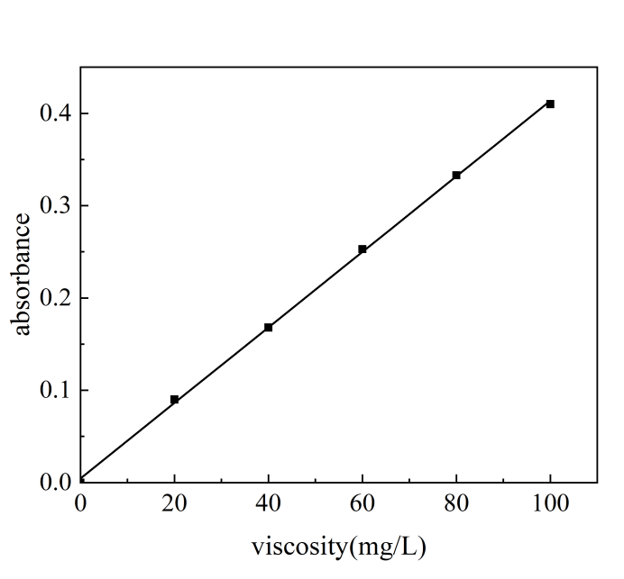
Figure S1 Standard curve of lodine cyclohexane solution
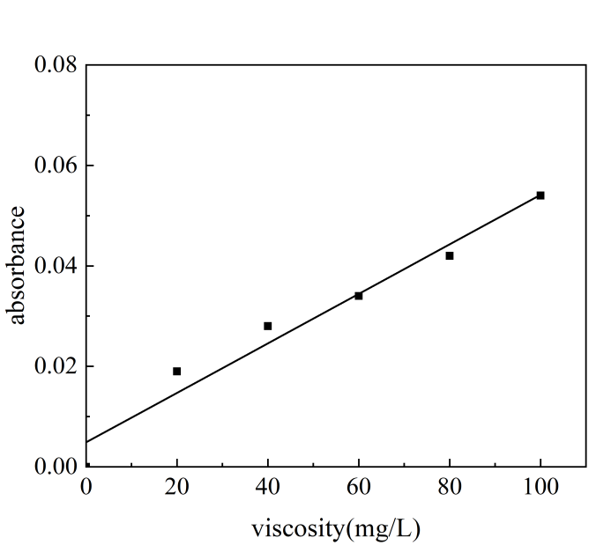
Figure S2 Standard curve of iodine aqueous solution

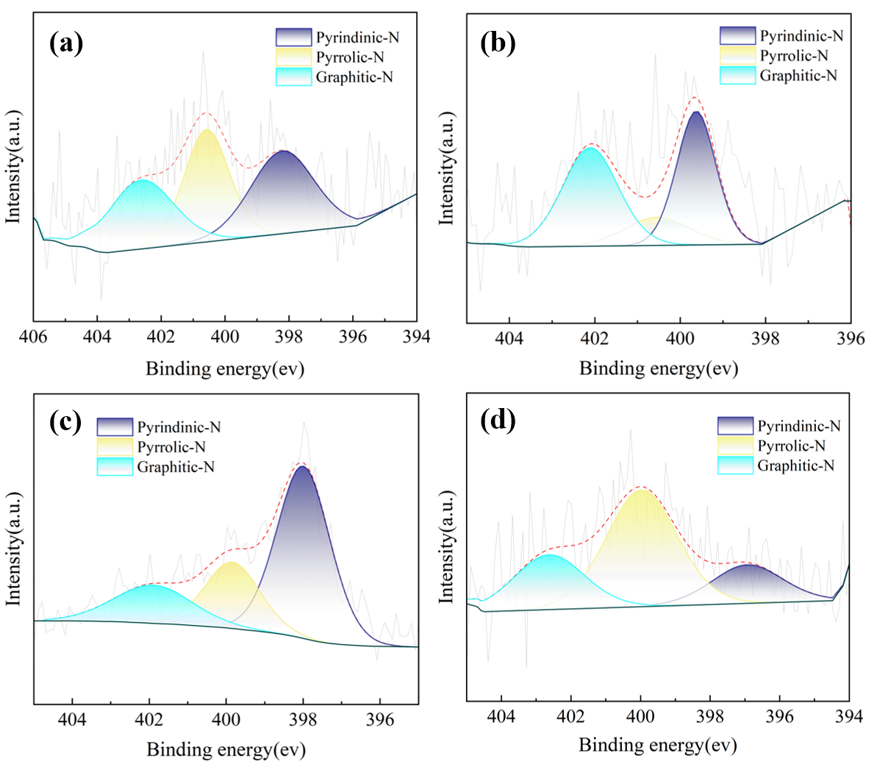
Figure S3 N 1s spectra of the NBC samples (a)RP;(b)CORN;(c)SB;(d)RAPE
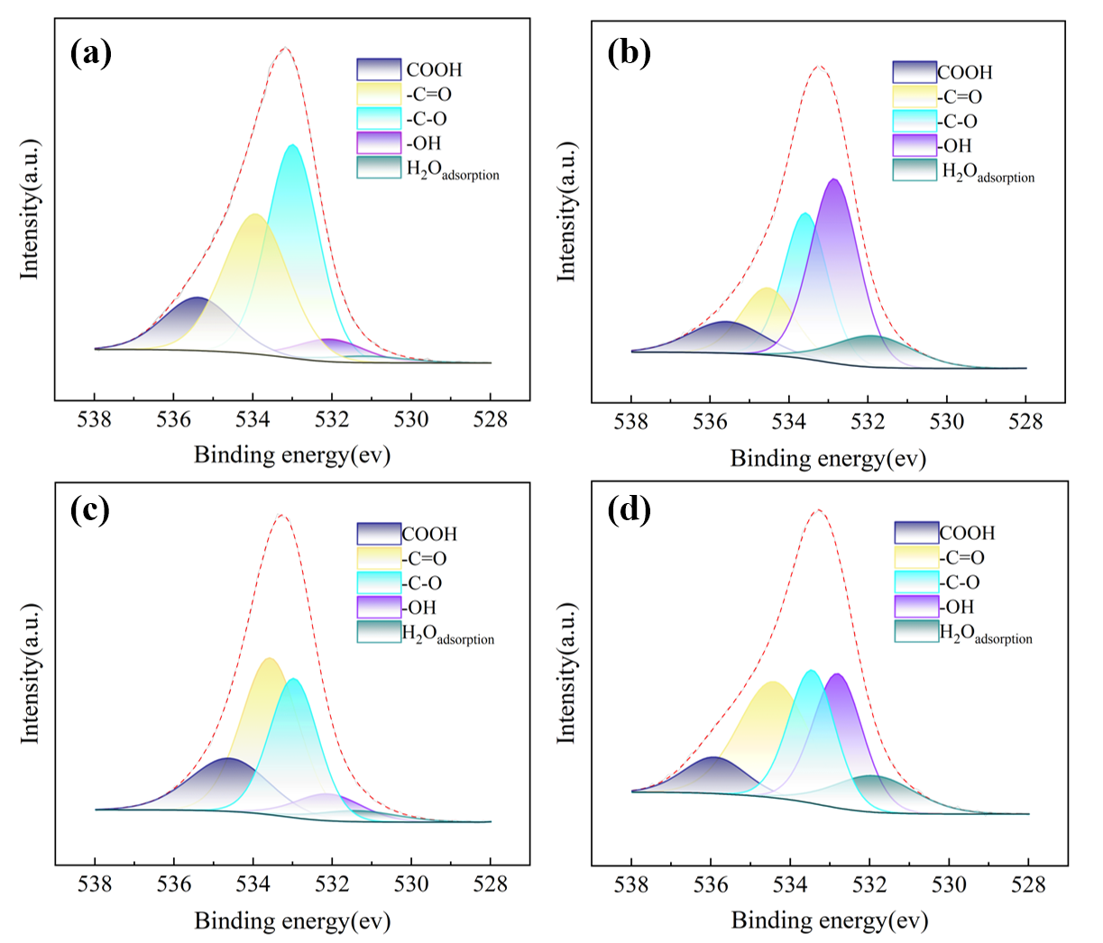
Figure S4 O 1s spectra of the NBC samples (a)RP;(b)CORN;(c)SB;(d)RAPE

