Supplementary Figures for Manuscript titled “How do Urban Interactions Influence Flood Resilience in Cities? A Land Use Simulation Framework for Flood Risk Regions”
- Figure S1
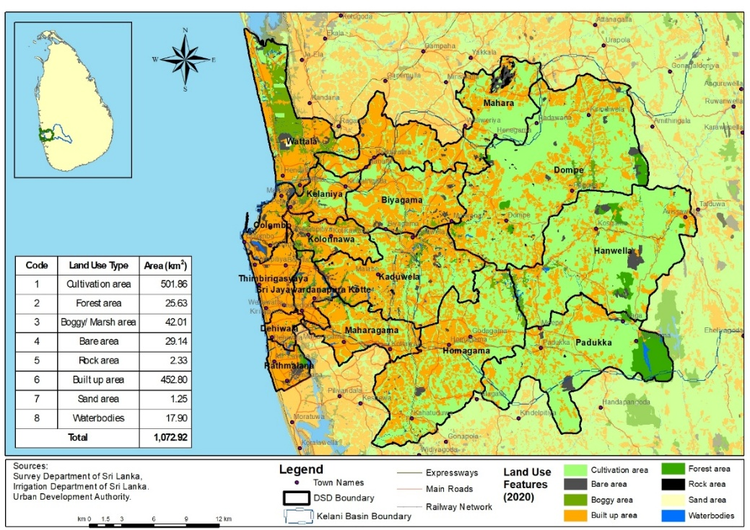
Supplementary Figure 1: Study Area Boundary with Land Use and Cover Features in Kelani River Basin

- Figure S2
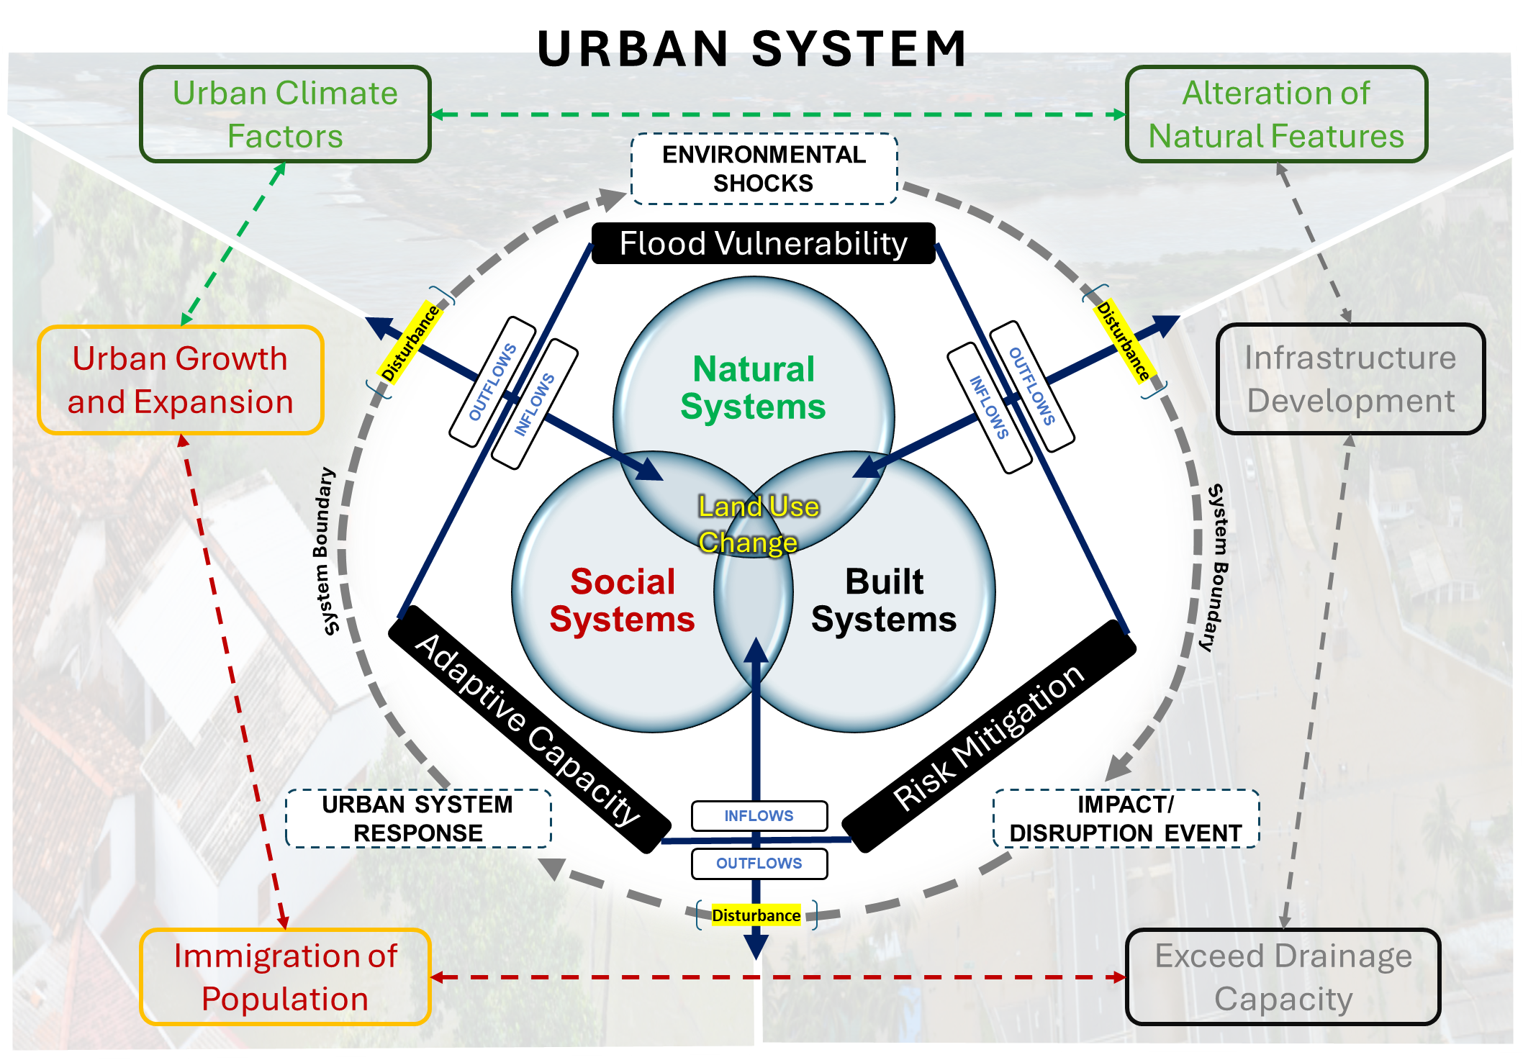
Supplementary Figure 2: Conceptual Framework proposed to quantify Urban Flood Resilience

- Figure S3:
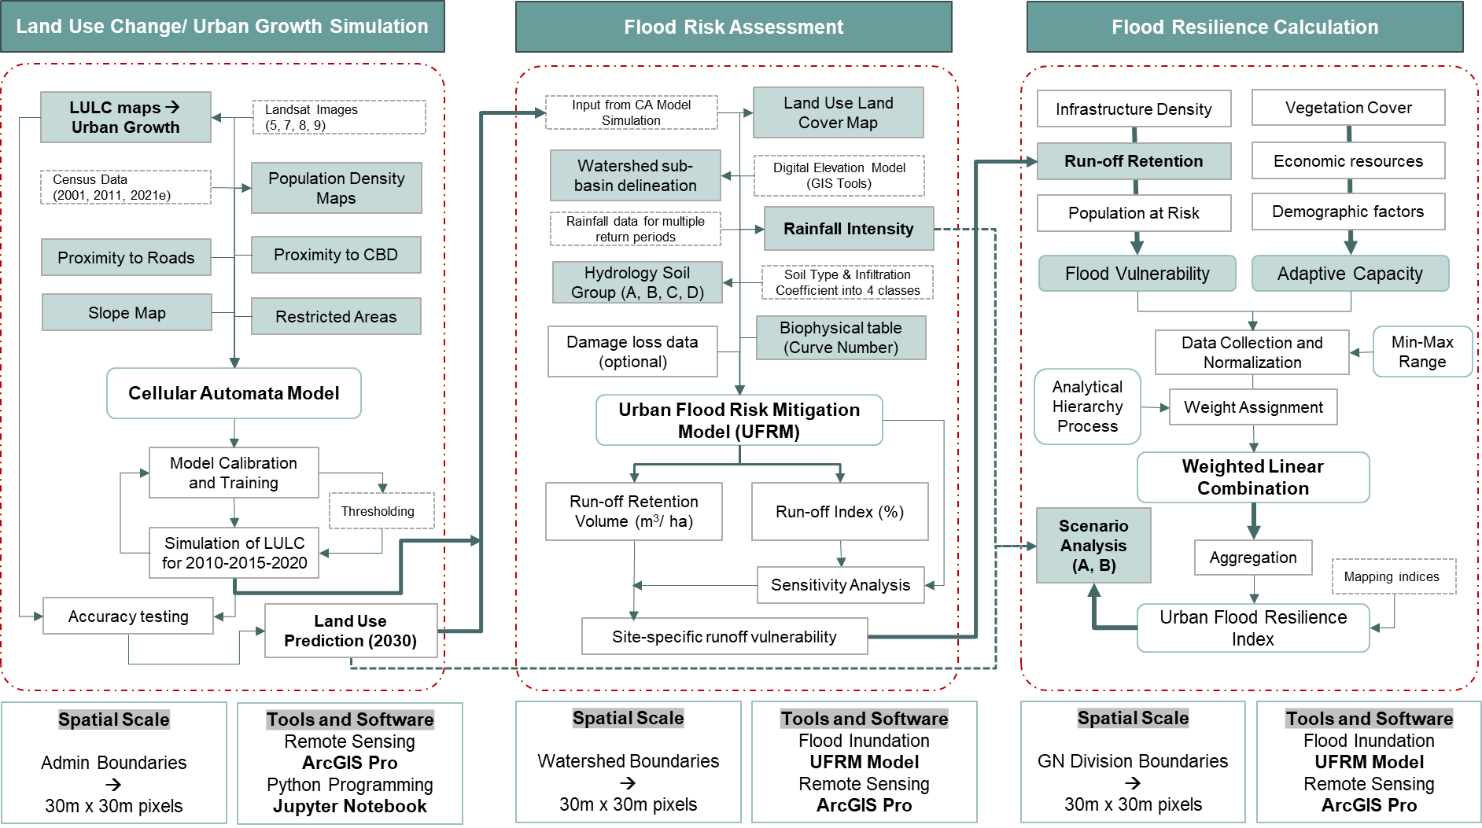
Supplementary Figure 3: Methodology adopted for Resilience Calculation

- Figure S4:
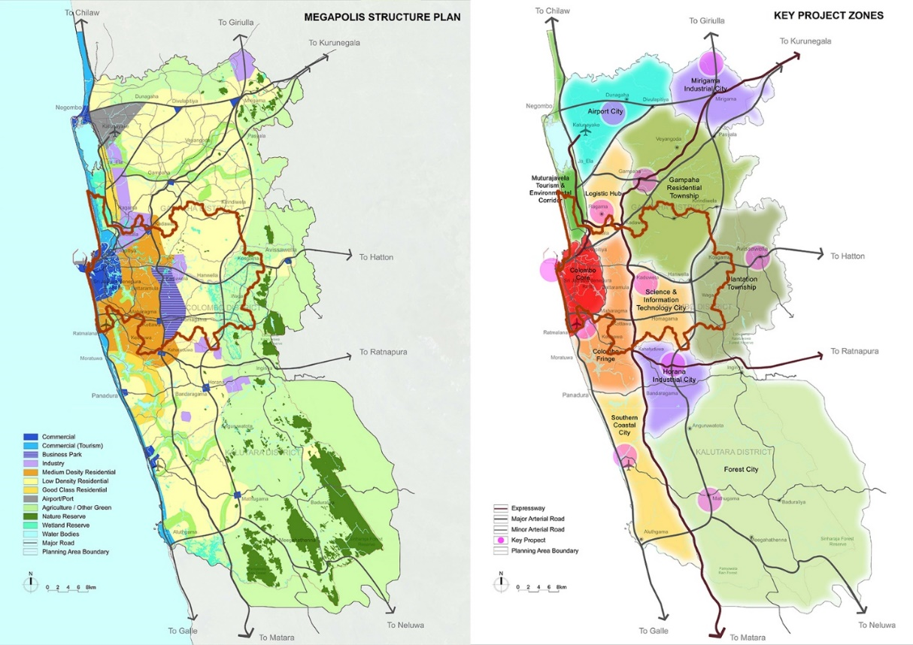
Supplementary Figure 4: Proposed Spatial Structure of Western Megapolis Plan (Left) and Key Project Zones (Right) (The study area boundary is marked in brown colour)
- Figure S5:
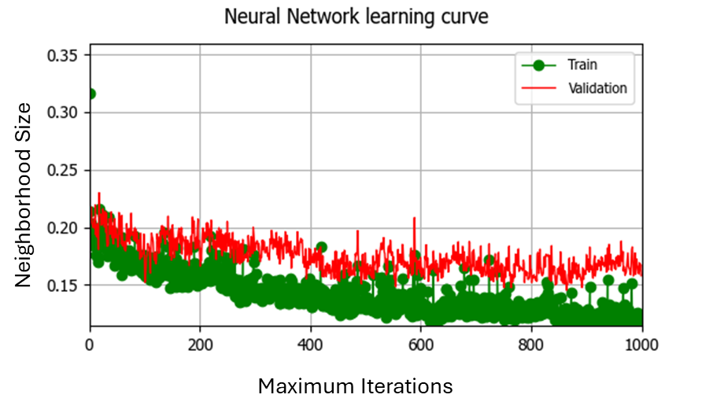
Supplementary Figure 5: Neural Network Learning Curve for Training and Validation of CA Model in Scenario One

- Figure S6:
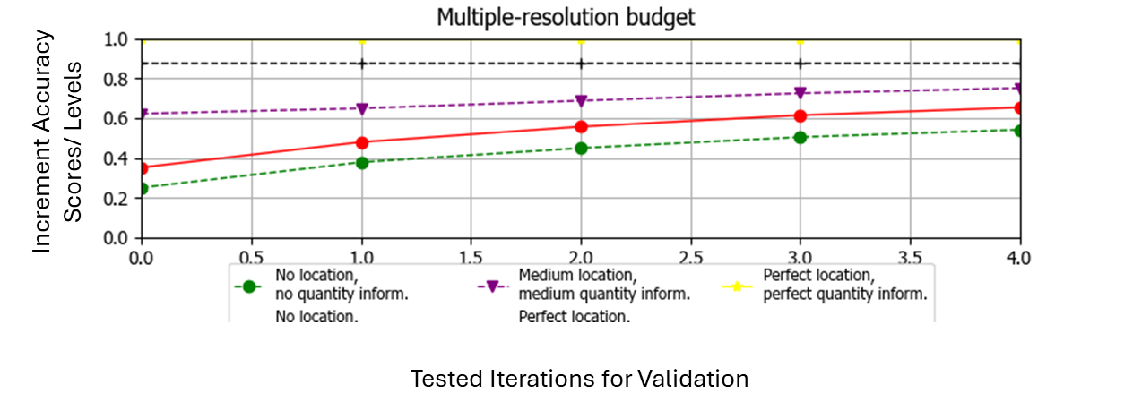
Supplementary Figure 6: Validation of the 2021 LULC Map Using the CA Model for Scenario Three

- Figure S7:
Supplementary Figure 7: LULC Change from 2001 to 2031 Under Three Proposed Scenarios

- Figure S8:

Supplementary Figure 8: Urban Flood Resilience Variation of Simulated Urban Growth (BAU Scenario) and Non-Simulated Version (Scenario Four) in 2031

