Phenotypic discovery of GABA_{A} receptor-mediated general anesthetics with analgesic activity

AUTHORS
Matthew N. McCarroll¹*†, Jarret A.P. Weinrich^{2,3}*, Alyssa H. Marinas⁴*, Amanda Dombroski⁵, Lain X. Pierce¹, Xilin Gu¹, Megan J. Larmore⁴, Jinfeng Teng⁴, Elizabeth J. Sisko¹, Christopher Andolina³, Ricardo Da Luz¹, Ralph Zhang¹, Jack C. Taylor⁶, Douglas Myers-Turnbull¹, Cole Helsell¹, Amanda Carbajal⁶, Reid Kinser⁶, Madison Jewell³, Karnika Bhardwaj³, Sian Rodriguez-Rosado³, Jennifer Deuis⁷, Asa Andersson⁷, Bruce Palmer Bean⁸, Irina Vetter⁷, Michael P. Bokoch², Brian K. Shoichet¹, David Kokel⁶, Ryan E. Hibbs^{4†}, Allan I. Basbaum^{3†}, Jason K. Sello^{1†}

AFFILIATIONS
¹Department of Pharmaceutical Chemistry, ²Department of Anesthesia and Perioperative Care and ³Department of Anatomy, University of California, San Francisco, California 94143, USA;
⁴Department of Neurobiology, University of California, San Diego, CA, 92093, USA;
⁵Department of Chemistry, Brown University, Providence, RI, 02912, USA and ⁶Institute for Neurodegenerative Diseases, University of California, San Francisco, California 94143, USA; ⁷Institute for Molecule Bioscience, University of Queensland, St Lucia QLD 4072, Australia; ⁸Blavatnik Institute of Neurobiology, Harvard Medical School, Boston, MA, 02115, USA

*These authors contributed equally to this manuscript
†Corresponding authors. E-mail: matthew.mccarroll@ucsf.edu, jason.sello@ucsf.edu, allan.basbaum@ucsf.edu, rehibbs@ucsd.edu

SUPPLEMENTARY FIGURES

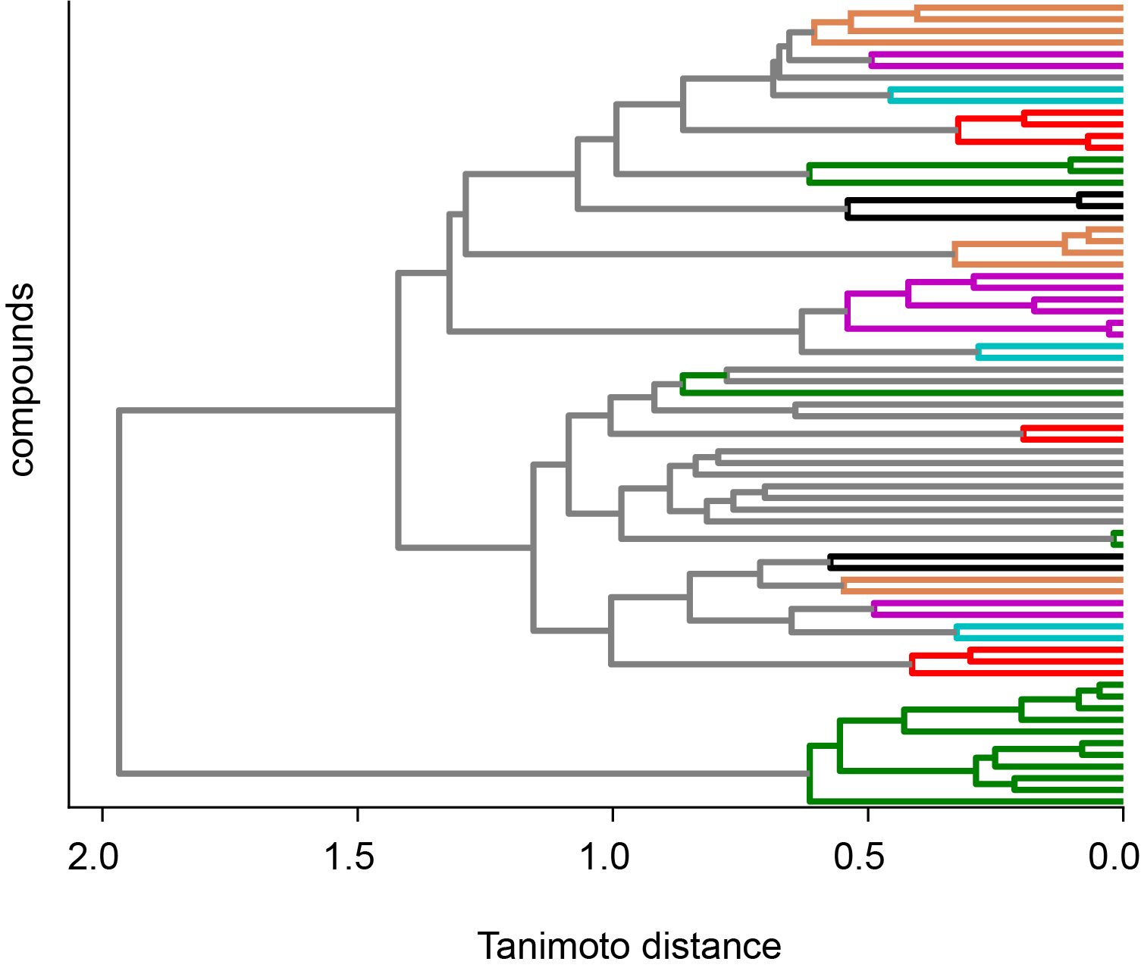

Supplementary Figure 1. Structural clustering of top screening hit compounds (y-axis) forms 22 distinct clusters using a Tanimoto similarity metric (x-axis).

Supplementary Figure 2. Chemical structures of 28 hit compounds selected for follow up retest experiments in larval and adult zebrafish.

Supplementary Figure 3. Chemical structures of 13 analog by catalog compounds selected for follow up retest experiments in larval and adult zebrafish. * Compound 9232646 (MM01) represents the parent hit molecule.

Supplementary Figure 4. Chemical structures of 28 in-house synthesized analogs generated for follow-up retest experiments in larval and adult zebrafish. *Compound AD-7-14 (MM01) represents the parent hit molecule.

Supplementary Figure 5. Pharmacokinetics of nidradine after single intraperitoneal dosing in mice (30 mg/kg). Concentration–time profiles in plasma, cerebrospinal fluid (CSF), and brain homogenate. Median Tmax values were 0.50 h (plasma), 0.25 h (CSF), and 0.50 h (brain), with corresponding C_max of 1,793 ng/mL (plasma), 17.1 ng/mL (CSF), and 1,576 ng/mL (brain), n = 3 animals per timepoint, error bars = SD.

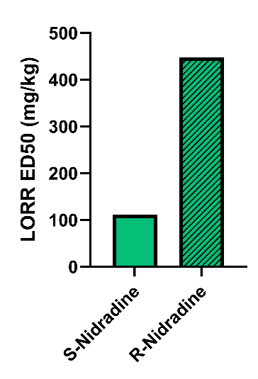
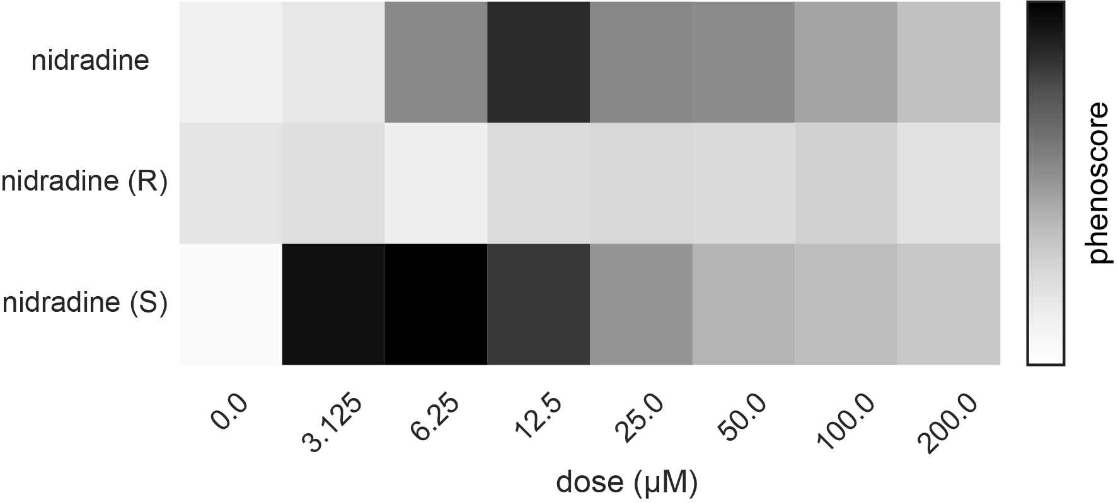

Supplementary Figure 6. S-nidradine is the more potent enantiomer in both fish and mice. Left: Dose response heatmap for racemic nidradine as well as the 2 stereoisomers (R & S) (rows). Each cell shows the mean etomidate similarity phenoscore (color bar) across n = 4 wells, 8 fish/well at the indicated concentrations (columns); 0.0 denotes on-plate vehicle controls. R nidradine causes loss of activity but very little soft tap response so score is low. Right: Dixon estimates of the ED50 for loss of righting reflex (LORR) of both S- and R-nidradine.
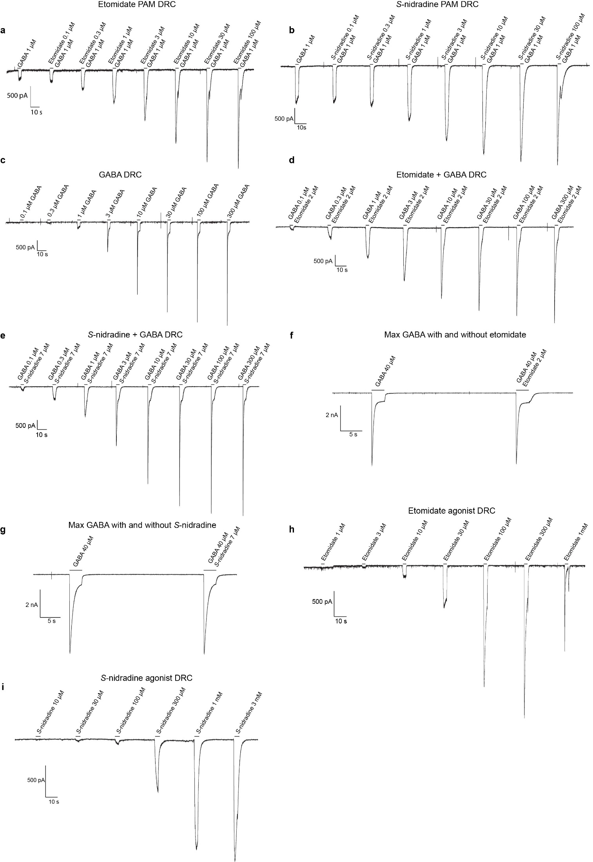

Supplementary Figure 7. Whole cell patch clamp electrophysiology representative traces. a, Etomidate PAM dose response curve with GABA at 1 µM and etomidate ranging from 0.1 µM to 100 µM in half log increments. b, S-nidradine PAM dose response curve with GABA at 1 µM and S-nid ranging from 0.1 µM to 100 µM in half log increments. c, GABA dose response curve with GABA ranging from 0.1 µM to 300 µM in half log increments. d, GABA dose response curve in the presence of etomidate at a constant concentration of 2 µM (PAM EC50). GABA concentrations range from 0.1 µM to 300 µM. e, GABA dose response curve in the presence of S-nid at a constant concentration of 7 µM. GABA concentrations range from 0.1 µM to 300 µM. f, Maximum GABA response (EC90, 40 µM) with and without etomidate (PAM EC50, 2 µM). g, Maximum GABA response (EC90, 40 µM) with and without S-nidradine (PAM EC50, 7 µM). h, Etomidate agonist dose response curve with concentrations ranging from 1 µM to 1mM in half log increments. i, S-nidradine agonist dose response curve with concentrations ranging from 10 µM to 3 mM in half log increments.

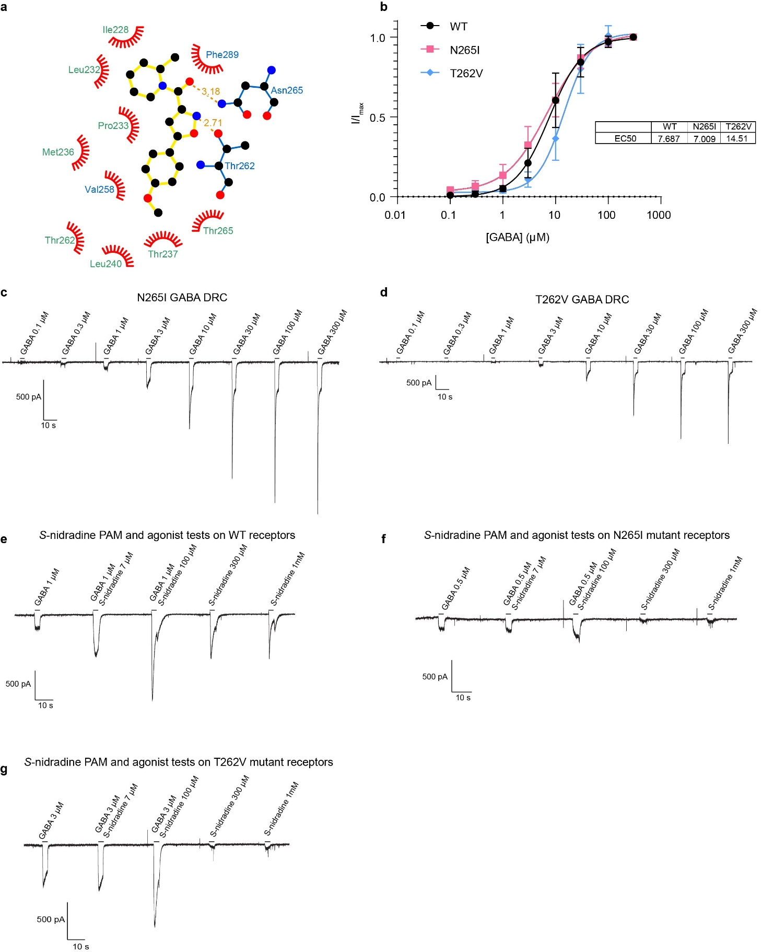

Supplementary Figure 8. S-nidradine binding site details and whole cell patch clamp electrophysiology on mutant receptors. a, LigPlot representation¹ of the S-nidradine binding site with residue names colored based on which subunit they are localized on. Blue = β1 and green = α1. The potential hydrogen bonds between S-nidradine and N265 and T262, both located on the β2 subunit, are depicted by the orange dashed lines with the angstrom distances between the atoms labeled. b, GABA dose response curves for the WT, and N265I and T262V mutant receptors. Hillslopes and EC50s for each curve are shown in the table. n = 4-5, error bars represent mean ± SEM for all conditions. c, Representative trace of the GABA dose response from cells expressing the N265I mutant receptor. GABA was applied at concentrations ranging from 0.1 µM to 300 µM in half log intervals. d, Representative trace of the GABA dose response from cells expressing the T262V mutant receptor. GABA was applied at concentrations ranging from 0.1 µM to 300 µM in half log intervals. e, Representative trace showing the S-nidradine PAM and agonist tests on cells expressing WT receptors. To test PAM activity, S-nidradine was co-applied at 7 µM then at 100 µM with GABA at 1 µM (EC5). Agonist activity was assessed by applying S-nidradine alone at 300 µM then 1 mM. f, Representative trace showing the S-nidradine PAM and agonist tests on cells expressing the mutant N265I receptors. To test PAM activity, S-nidradine was co-applied at 7 µM then at 100 µM with GABA at 1 µM (EC5). Agonist activity was assessed by applying S-nidradine alone at 300 µM then 1 mM. g, Representative trace showing the S-nidradine PAM and agonist tests on cells expressing the mutant T262V receptors. To test PAM activity, S-nidradine was co-applied at 7 µM then at 100 µM with GABA at 1 µM (EC5). Agonist activity was assessed by applying S-nidradine alone at 300 µM then 1 mM.

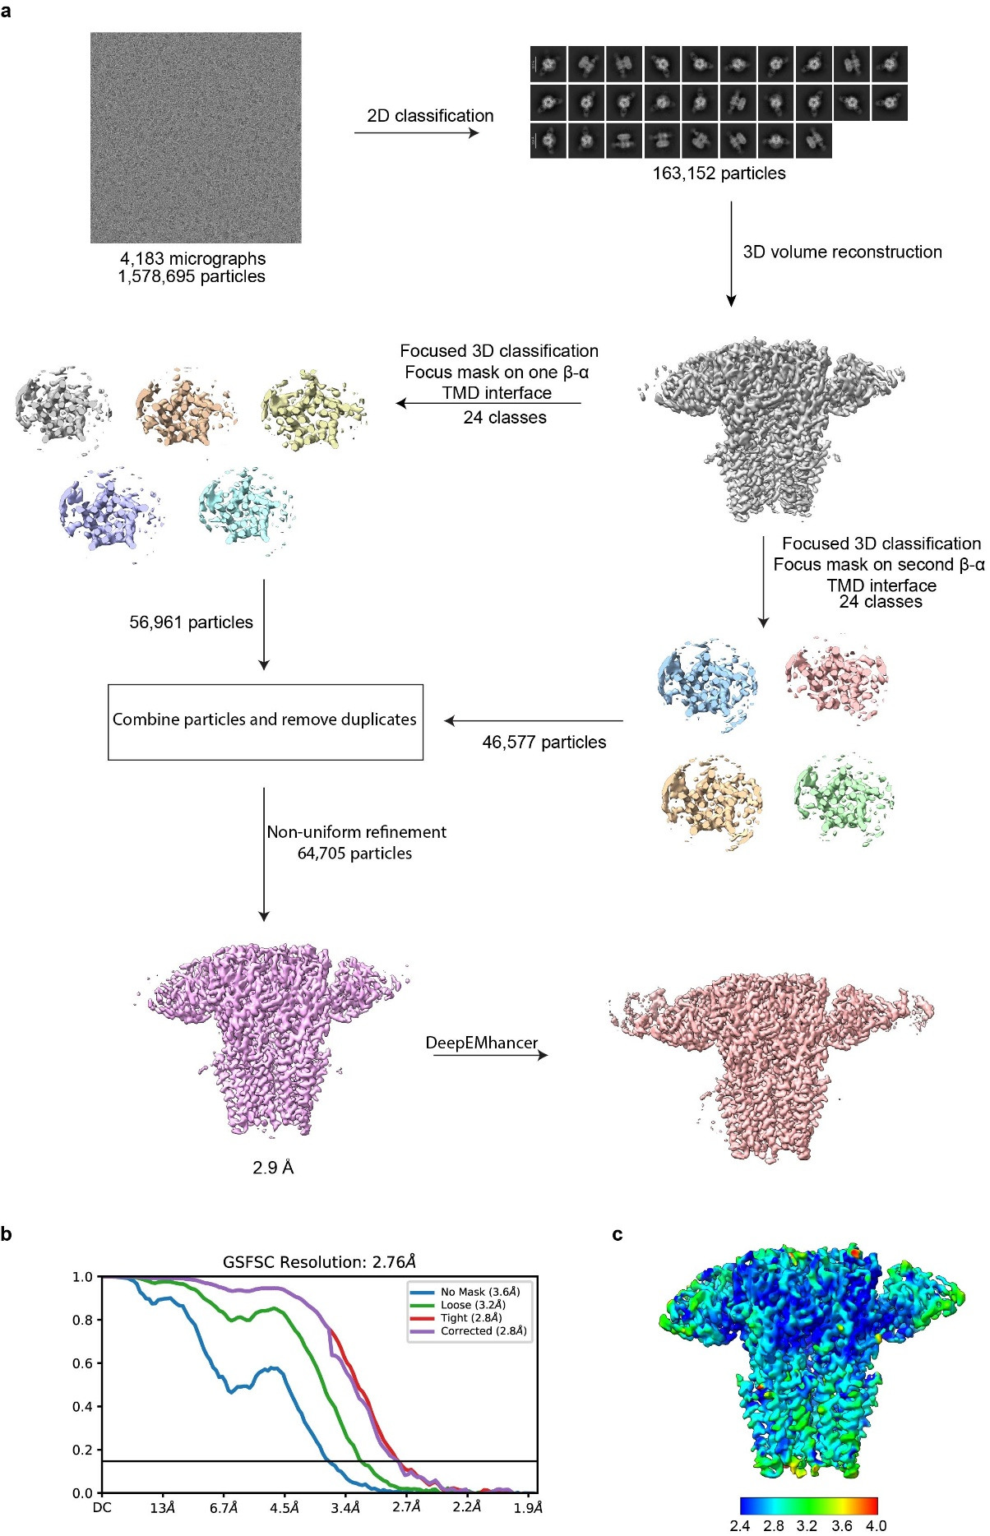

Supplementary Figure 9. Cryo-EM data processing workflow and global and local resolution estimates. a, GABA_{A}R-S-nidradine Cryo-EM data processing workflow. b, GABA_{A}R-S-nidradine FSC curve. c, GABA_{A}R-S-nidradine local resolution map estimated from CryoSPARC.

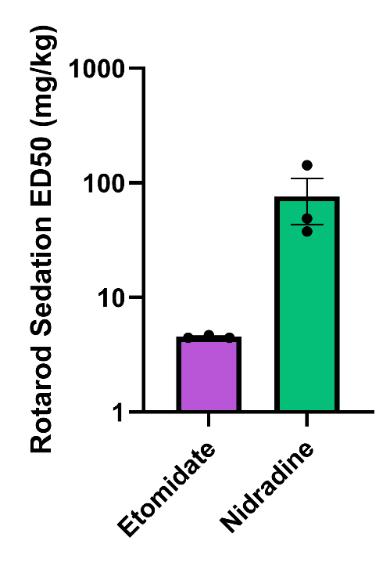
Supplementary Figure 10. Triplicate Dixon ED50 estimates of the sedative effects of nidradine. Both etomidate and nidradine produce sedative effects in mice (etomidate: log10(ED50) = 0.6583 ± 0.008, 3 Dixon tests, 6-8 mice each; nidradine: log10(ED50) = 1.807 ± 0.1763; 3 Dixon tests, 6-8 mice each; p ≤ 0.0225, lognormal Welch’s t test).

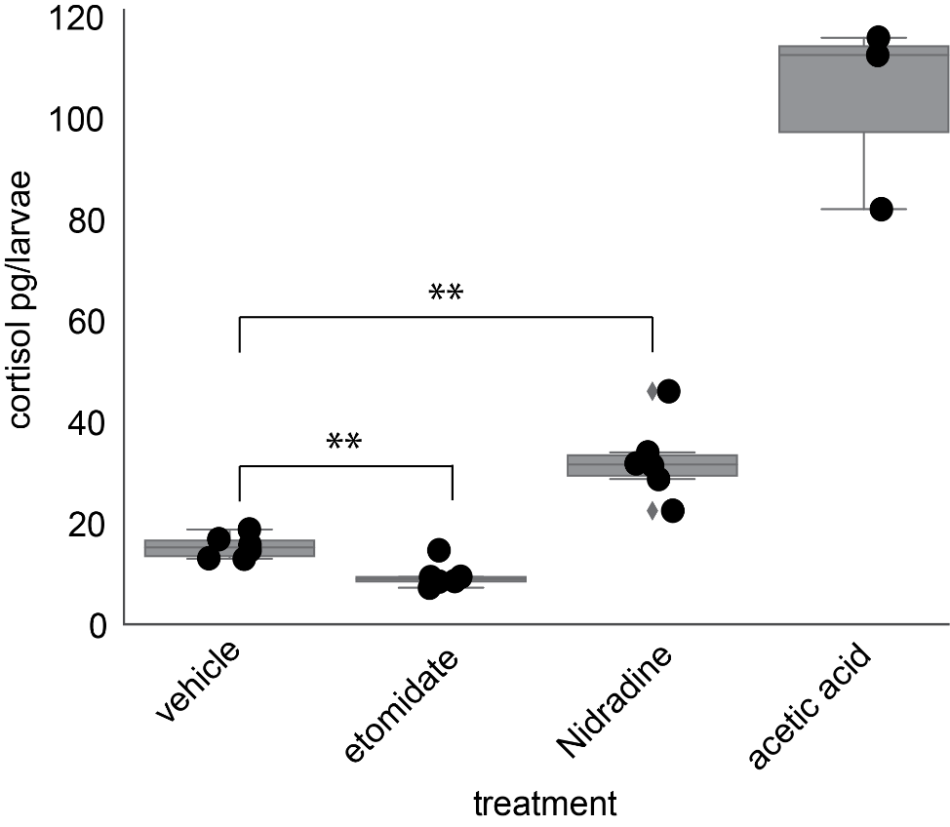

Supplementary Figure 11. Cortisol levels of larval zebrafish one hour after indicated treatments. Larval zebrafish were treated with < 1% DMSO (vehicle) 6.25µM etomidate, 25µM nidradine or <0.01% acetic acid for 1 hour then homogenized and tested for cortisol concentration, n = 3-6 replicates, 30 larval zebrafish pooled per replicate, p < 0.005, two-tailed Student’s t-test.

Supplementary Figure 12. CNS receptor profiling of radioligand displacement. Drug binding data of MM01 and 4 analogs including the lead compound nidradine against a panel of CNS targets expressed as a Ki in nM.

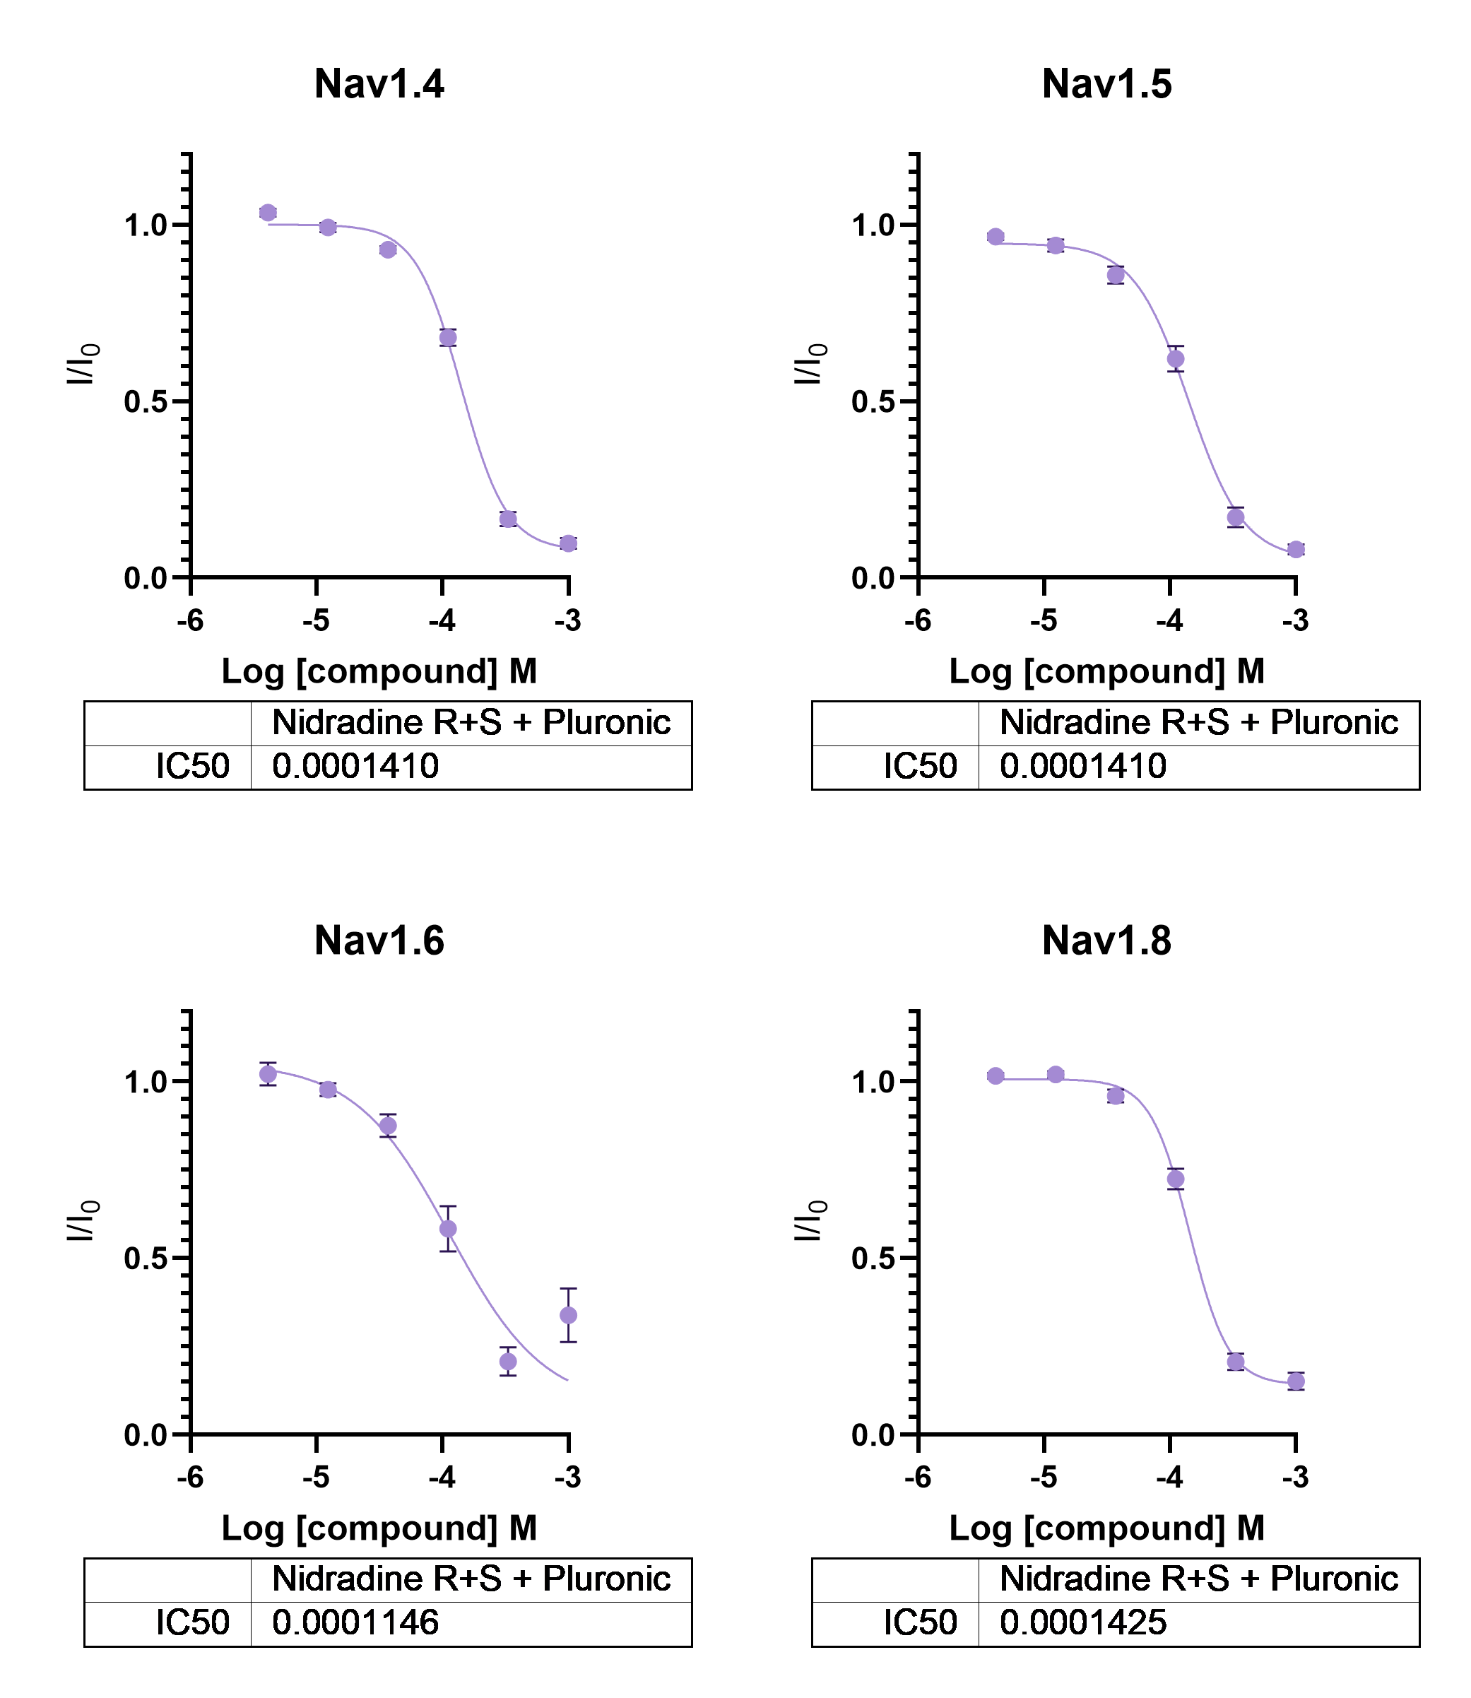
Supplementary Figure 13. Nidradine non-selectively inhibits voltage gated sodium channels. Nidradine inhibits NaV1.4 (IC50 = 141uM, 95%CI = 129uM to 156uM), NaV1.5 (IC50 = 141uM, 95%CI = 122uM to 165uM), NaV1.6 (IC50 = 115uM, 95%CI = 60.7uM to 170uM), and NaV1.8 (IC50 = 143uM, 95%CI = 128uM to 159uM). For all panels, n = 4-5 and error bars represent mean ± SEM.

SUPPLEMENTARY MOVIE LEGENDS

Movie S1. Loss of Righting Reflex Test of Adult Zebrafish. A 6-well plate of adult zebrafish treated with vehicle (top left well) or test compounds. Bottom left and middle wells indicate a positive response for LoRR. Heads are outlined.

Movie S2. Loss of Withdrawl Reflex Test of Adult Zebrafish. Tail pinch test of adult zebrafish treated with either etomidate (5µM) or nidradine (AD-7-219, 25µM).
SUPPLEMENTARY TABLES

Supplementary Table 5. Cryo-EM data collection, refinement and validation statistics
GABA_{A}R + S-nidradine
(EMD-73211)
(PDB 9YNN)
Data collection and processing
Magnification | 130,000x
Voltage (kV) | 300
Electron exposure (e–/Å²) | 60
Defocus range (μm) | -1.2 to -2.0
Pixel size (Å) | 0.935
Symmetry imposed | C1
Initial particle images (no.) | 1,578,695
Final particle images (no.) | 64,705
Model resolution (Å)  FSC threshold | 2.90  0.143
Refinement
Initial model used (PDB code) | 6X3V/modelangelo
Model resolution (Å)  FSC threshold | 3.01  0.5
Map sharpening B factor (Å²)  Model-to-map, CC_{mask} | -57.9  0.74
Model composition  Non-hydrogen atoms  Protein residues  Ligands  Water | 17,469  2,121  26  0
B factors (Å²)  Protein  Ligand  Water | 60.78  72.54  -
R.m.s. deviations  Bond lengths (Å)  Bond angles (°) | 0.007  0.673
Validation  MolProbity score  Clashscore  Poor rotamers (%) | 1.73  3.53  2.18
Ramachandran plot  Favored (%)  Allowed (%)  Disallowed (%) | 95.29  4.71  0.00

General Procedure for Synthesis of Oxazolecarboxamides and Schemes
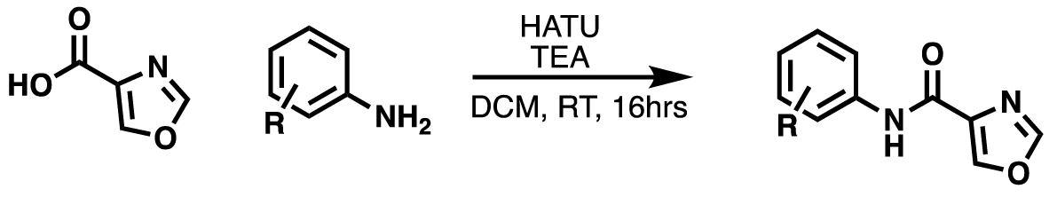
Scheme 1 Synthesis of Oxazolecarboxamides

Step 1: Oxazole carboxylic acid (0.5 mmol, 1.0 eq) was added to a round bottom flask with
dichloromethane (3.0mL, 0.16M). 1-[Bis(dimethylamino)methylene]-1H-1,2,3-triazolo[4,5-
b]pyridinium 3-oxide hexafluorophosphate (0.5mmol, 1.0 eq), also known as the coupling reagent
HATU, was added to the round bottom flask along with triethylamine (2.2mmol, 4.4 eq). The reaction was left to stir under an inert atmosphere (nitrogen balloon) for 30 minutes. A few drops of DMF were added to the reaction to help solubilize the oxazole carboxylic acid. Substituted aniline
(0.55mmol, 1.1 eq) was then added to the reaction mixture and stirred at room temperature for 16
hours. The solvent was removed in vacuo and the crude residue was diluted with ethyl acetate. The
organic layer was washed with dilute hydrochloric acid (1M), then separated, and dried over
magnesium sulfate. The magnesium sulfate was removed by vacuum filtration and the organic
layer was concentrated to yield desired oxazolecarboxamides as brown to dark brown solids
without further purification.
General Procedure for the Synthesis of Isoxazolecarboxamides and schemes
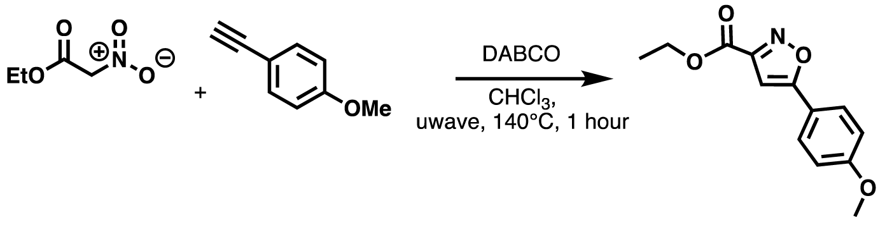
Scheme 2. Synthesis of isoxazole esters
Step 1: Ethyl nitroacetate (3.0 mmol, 1.0 eq) was added to a 2-5mL microwave vial equipped with a magnetic stir bar. Ethynylanisole (1.2mmol, 0.4 eq) and ethanol-free chloroform stabilized by amylenes (4mL, 0.75M) were also added to the vial. 1,4-diazabicylco[2.2.2]octane (DABCO) (0.6mmol, 0.2 eq) was added last and the microwave vial was sealed. The vial was heated at 140°C for 1 hour using a microwave reactor. The solvent was removed using a rotary evaporator and then the crude residue was diluted with diethyl ether. The ether layer was washed with water, separated, and then dried over magnesium sulfate. The organic layer was filtered and then concentrated using a rotary evaporator to give the crude product as a yellow-orange solid. The crude product was confirmed using NMR and ESI-MS and used in step 2 without further purification.
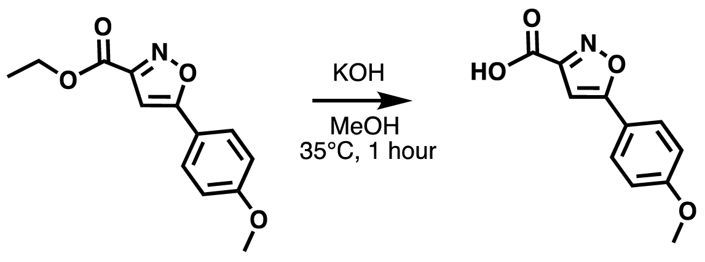
Scheme 3. Synthesis of Isoxazole Carboxylic Acids
Step 2: The isoxazole ethyl ester (2.0mmol, 1.0 eq) was dissolved in methanol (5mL, 0.4M) in a round bottom flask equipped with a magnetic stir bar. Potassium hydroxide (KOH) was added to the flask (4mmol, 2.0 eq). A nitrogen balloon was used to flush the reaction flask and keep it under an inert atmosphere as the reaction was heated at 35°C for 1 hour. The reaction was then quenched with water (5-10mL). The mixture was washed with diethyl ether to remove excess ester and then the aqueous layer was separated and acidified with concentrated hydrochloric acid (HCl). HCl was added dropwise until the reaction reached a pH of 3. The resulting tan solid was filtered off, confirmed with NMR and ESI-MS analysis to be the desired product and used directly in the next step without further purification.
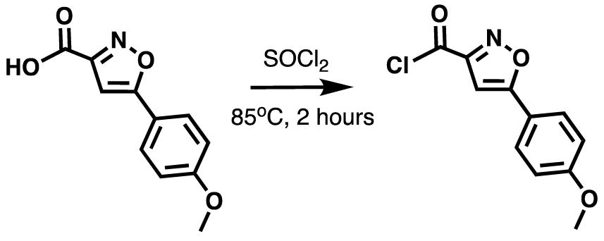
Scheme 4. Synthesis of isoxazole chlorides
Step 3: The isoxazole acid (2.0mmol, 1.0 eq) was added to a round bottom flask. Thionyl chloride (SOCl2) was added dropwise (22.0mmol, 11.0 eq) and the reaction was refluxed at 85°C for 2 hours. The remaining SOCl2 was removed using the rotary evaporator which decomposed into sulfur dioxide leaving only the isoxazole acid chloride as a tan to light brown solid. The product was confirmed using NMR and ESI-MS and was used in the next step without further purification.
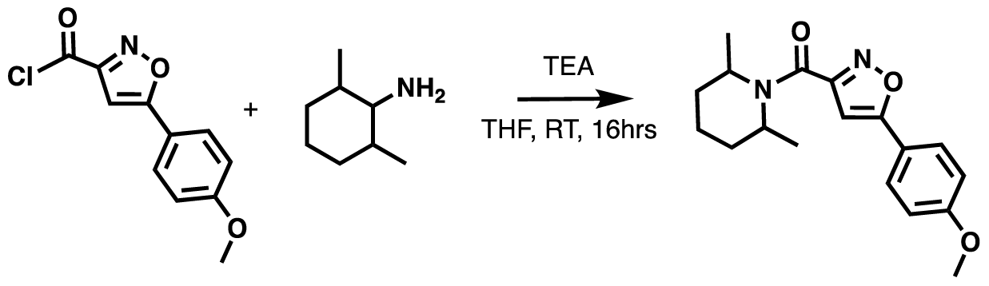
Scheme 5. Synthesis of isoxazole carboxamides
Step 4: The isoxazole acid chloride (2.0mmol, 1.0 eq) was added to a round bottom flask
containing tetrahydrofuran (THF, 5.1mL, 0.39M) and a magnetic stir bar. Triethylamine (TEA,
5.4mmol, 2.7 eq) was added to the reaction mixture and briefly stirred. 2,6-dimethylpiperidine
(1.8mmol, 0.9 eq) was added to an equal amount of THF (5.1mL, 0.19M). This solution was added dropwise to the reaction mixture containing the acid chloride, TEA, and THF. The reaction was left to stir for 16 hours at room temperature under a nitrogen balloon. The solvent was then removed using a rotary evaporator and the crude residue was purified using a silica gel column with 10-15% ethyl acetate: hexanes as mobile phase. The desired product was obtained as an off white solid.

Spectral Data for Synthesized Oxazolecarboxamides and Isoxazolecarboxamides

Raw NMR Spectra of Oxazolecarboxamides:

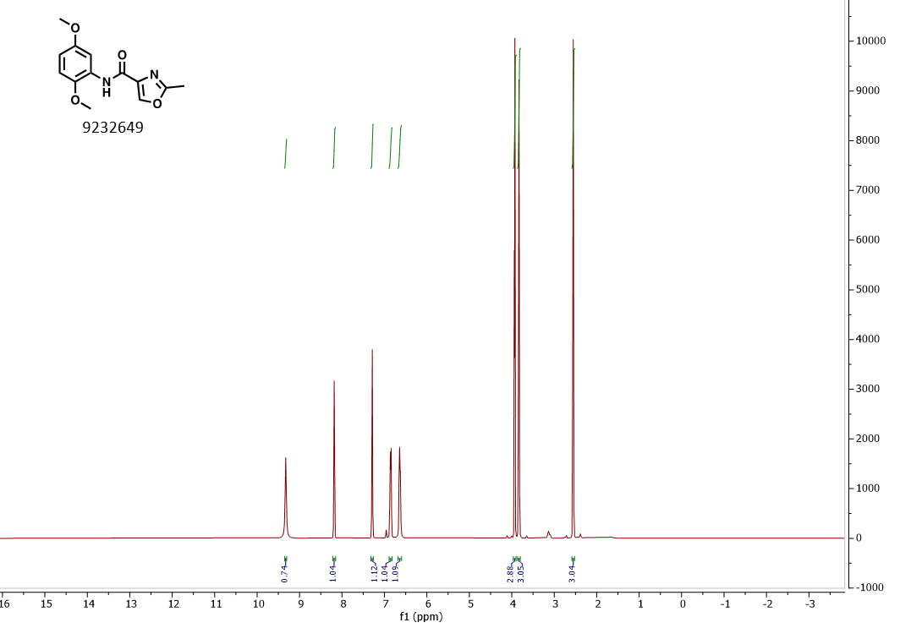
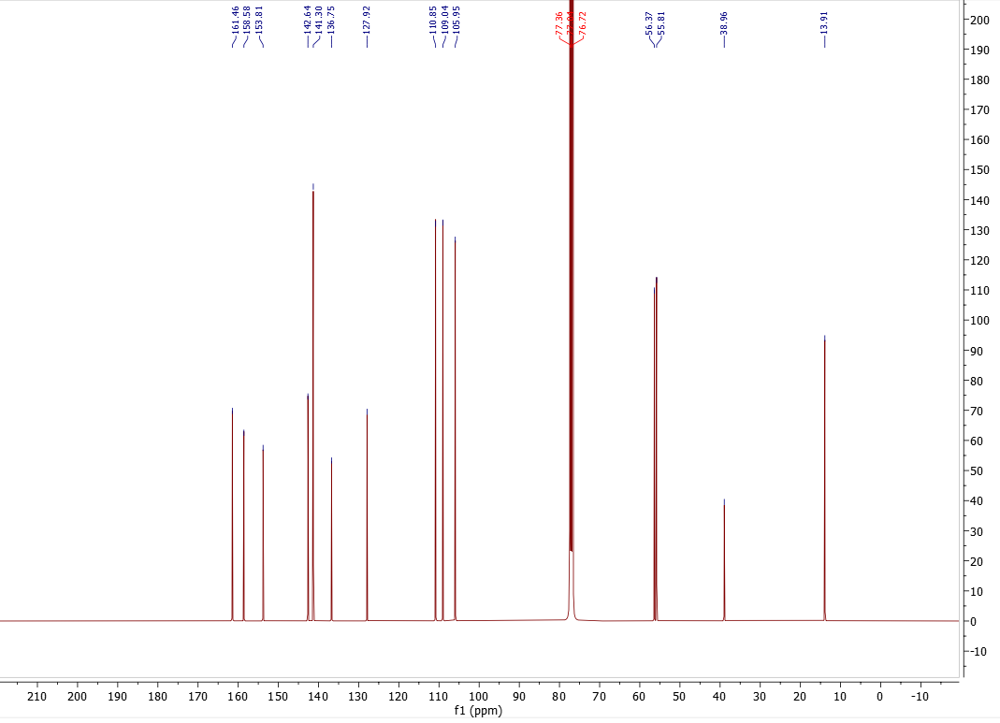
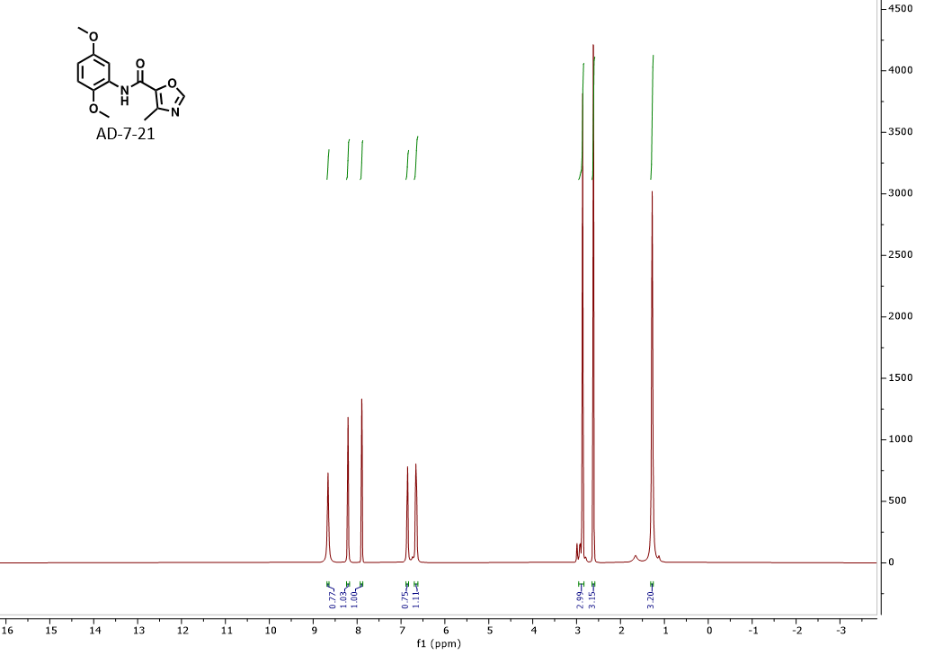

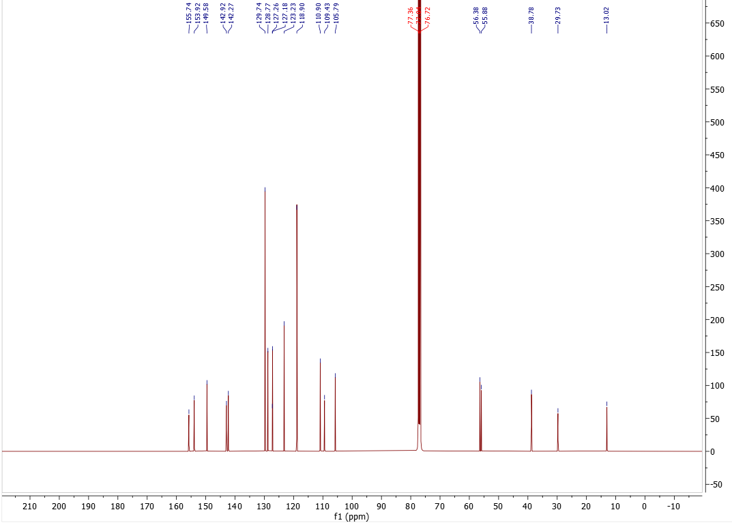
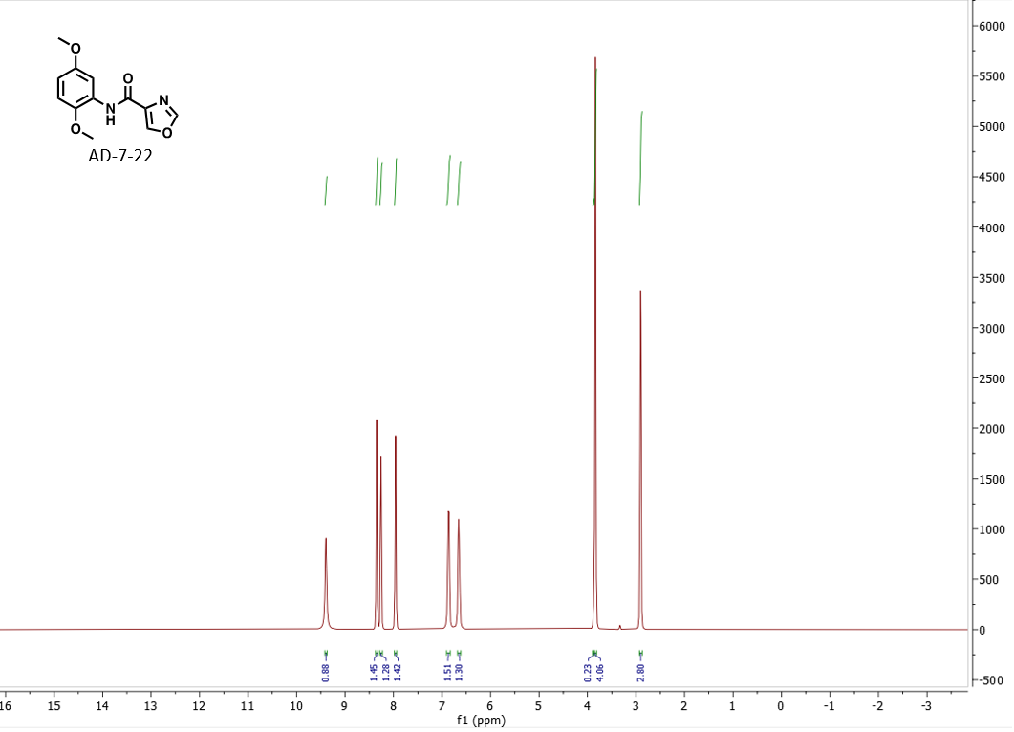
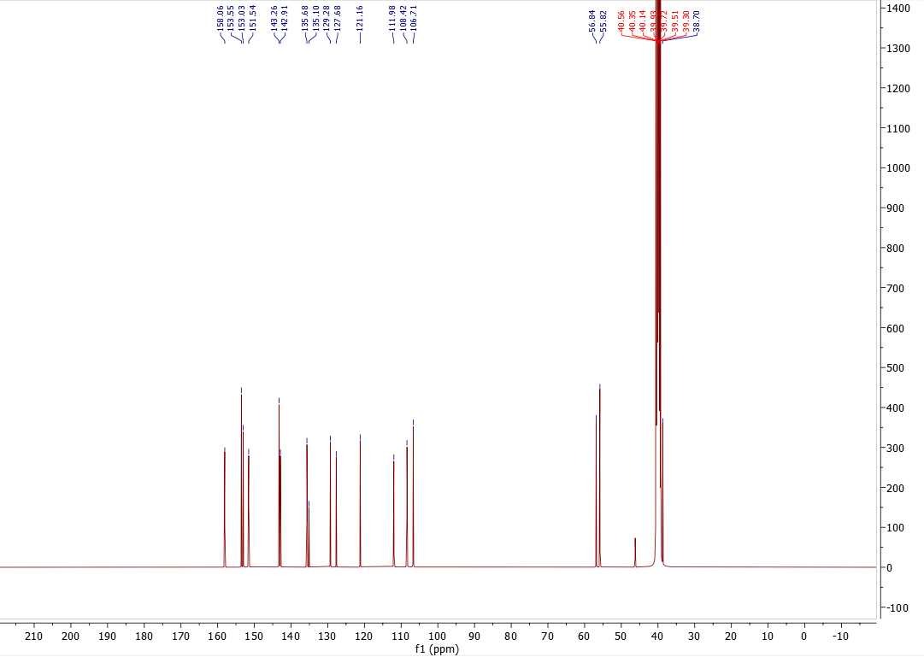
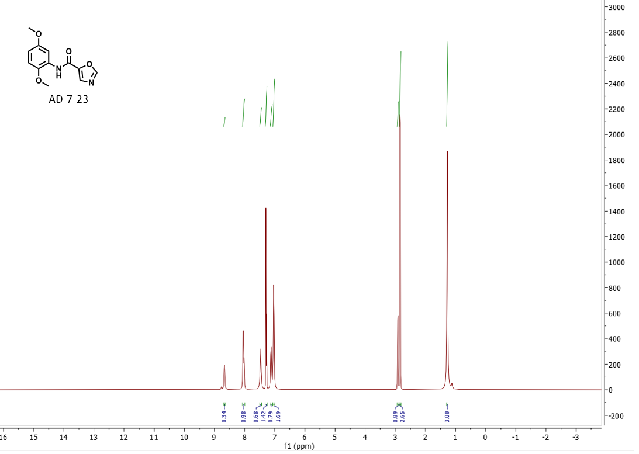
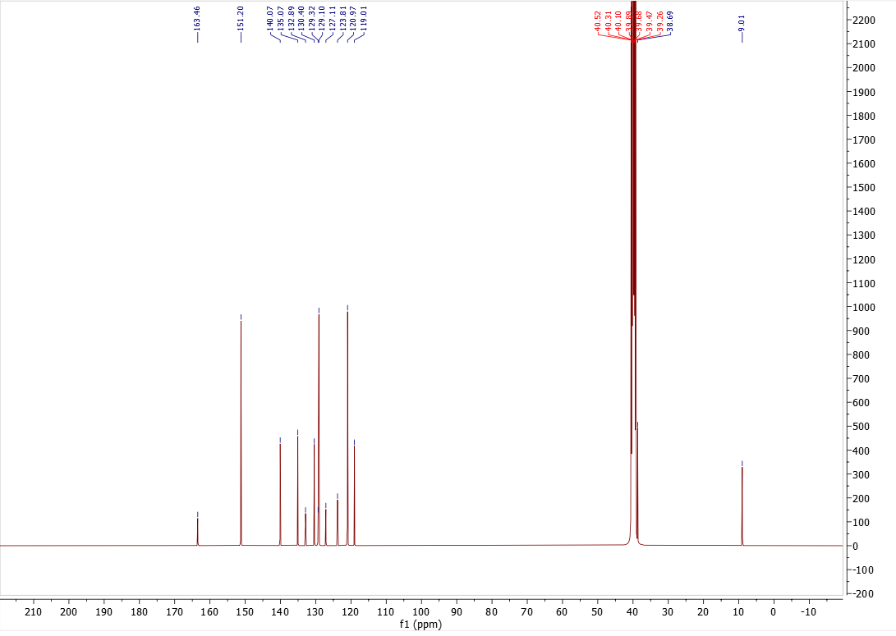

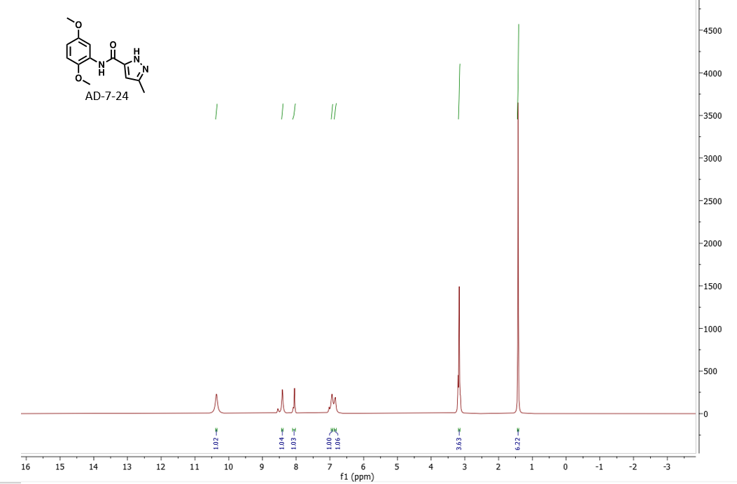
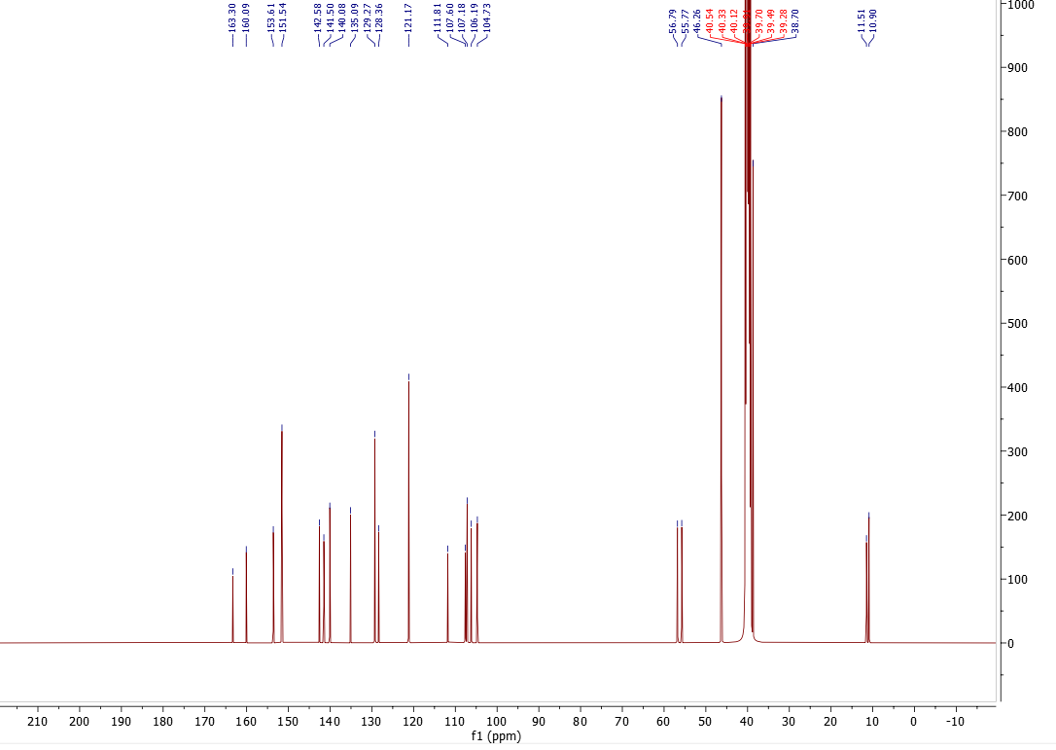
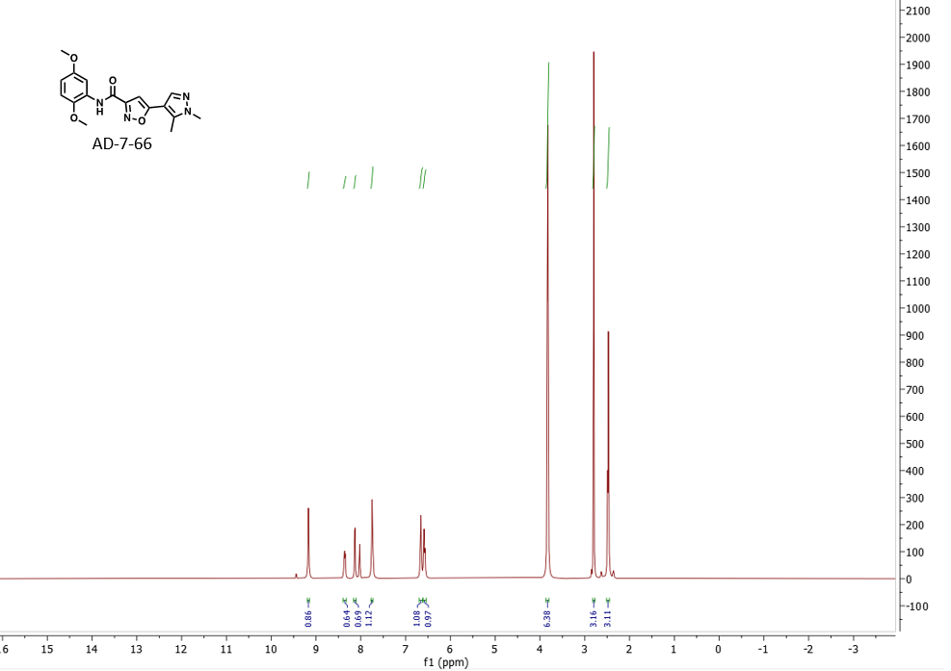
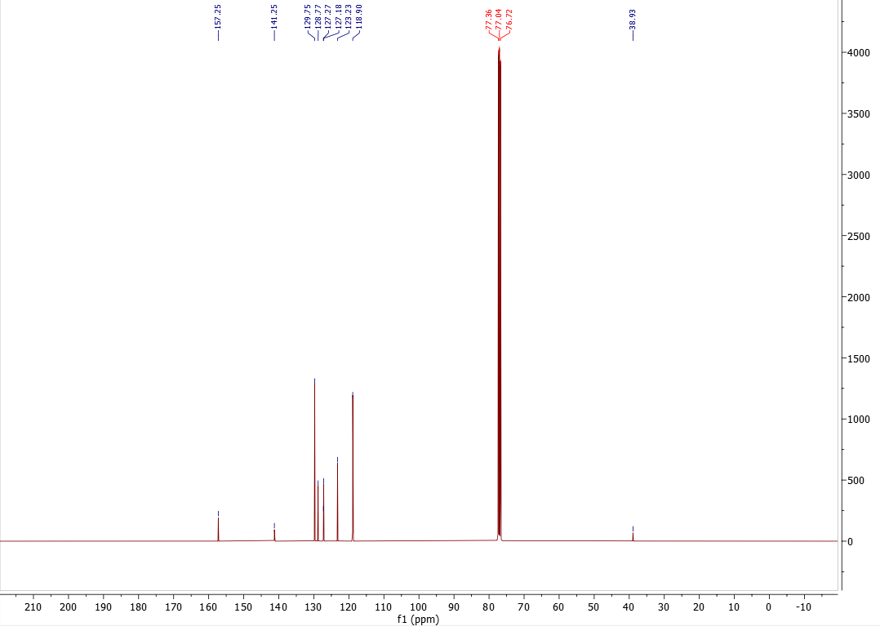
Annotated NMR Spectra and Mass Spectra of Oxazolecarboxamides:

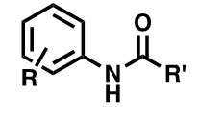

Compound Name | ¹H NMR | ¹³C NMR | M.W.  (g/mol) | ESI-MS (predicted) | ESI-MS (observed)
AD-7-14 (9232649) | ¹H NMR (400 MHz, CDCl₃) δ 9.33, 8.19, 8.18, 8.17, 7.30, 7.28, 6.96, 6.87, 6.86, 6.84, 6.66, 6.64, 6.63, 6.63, 6.62, 3.94, 3.93, 3.92, 3.84, 3.83, 3.82, 3.14, 2.56, 2.55, 2.54, 2.38, 1.66. | ¹³C NMR (101 MHz, CDCl₃ ) δ 161.46, 158.58, 153.81, 142.64, 141.30, 136.75, 127.92, 110.85, 109.04, 105.95, 77.36, 77.04, 76.72, 56.37, 55.81, 38.96, 13.91. | 262.27 | 263.3 | 263.2
AD-7-21 | ¹H NMR (400 MHz, DMSO-d₆ ) δ 8.66, 8.23, 8.22, 8.21, 8.20, 7.91, 7.90, 7.89, 6.86, 6.85, 6.74, 6.68, 6.67, 6.66, 6.65, 6.64, 6.64, 2.99, 2.99, 2.93, 2.91, 2.87, 2.86, 2.85, 2.79, 2.63, 2.62, 2.61, 2.61, 1.65, 1.28, 1.27, 1.12. | ¹³C NMR (101 MHz, DMSO-d₆) δ 155.74, 153.92, 149.58, 142.92, 142.27, 129.74, 128.77, 127.26, 127.18, 123.23, 118.90, 110.90, 109.43, 105.79, 56.38, 55.88, 38.78, 29.73, 13.02. | 262.27 | 263.3 | 263.1
AD-7-22 | ¹H NMR (400 MHz, DMSO-d₆ ) δ 9.39, 8.35, 8.34, 8.27, 8.25, 7.96, 7.95, 6.89, 6.88, 6.87, 6.85, 6.85, 6.67, 6.65, 6.64, 6.63, 3.85, 3.84, 3.83, 2.91, 2.90, 2.90. | ¹³C NMR (101 MHz, DMSO-d₆) δ 158.06, 153.55, 153.03, 151.54, 143.26, 142.91, 135.68, 135.10, 129.28, 127.68, 121.16, 111.98, 108.42, 106.71, 56.84, 55.82, 40.56, 40.35, 40.14, 39.93, 39.72, 39.51, 39.30, 38.70. | 248.24 | 249.2 | 249.1
AD-7-23 | ¹H NMR (400 MHz, DMSO-d₆ ) δ 8.77, 8.67, 8.05, 8.02, 7.48, 7.46, 7.29, 7.27, 7.13, 7.12, 7.10, 7.04, 7.02, 2.91, 2.90, 2.85, 2.83, 1.28, 1.12. | ¹³C NMR (101 MHz, DMSO-d₆) δ 163.46, 151.20, 140.07, 135.07, 132.89, 130.40, 129.32, 129.10, 127.11, 123.81, 120.97, 119.01, 40.52, 40.31, 40.10, 39.89, 39.68, 39.47, 39.26, 38.69, 9.01. | 248.24 | 249.2 | 249.1
AD-7-24 | ¹H NMR (400 MHz, DMSO-d₆) δ 10.36, 8.55, 8.53, 8.41, 8.09, 8.05, 8.04, 7.02, 6.94, 6.85, 6.83, 3.20, 3.17, 3.13, 1.42. | ¹³C NMR (101 MHz, DMSO-d₆) δ 163.30, 160.09, 153.61, 151.54, 142.58, 141.50, 140.08, 135.09, 129.27, 128.36, 121.17, 111.81, 107.60, 107.18, 106.19, 104.73, 56.79, 55.77, 46.26, 40.54, 40.33, 40.12, 39.91, 39.70, 39.49, 39.28, 38.70, 11.51, 10.90. | 261.28 | 262.3 | 262.1
AD-7-66 | ¹H NMR (400 MHz, DMSO-d₆ ) δ 9.45, 9.44, 9.17, 8.37, 8.36, 8.35, 8.14, 8.13, 8.03, 8.02, 7.75, 7.73, 7.72, 6.67, 6.66, 6.64, 6.59, 6.57, 3.84, 3.83, 3.82, 2.80, 2.63, 2.49, 2.47, 2.37, 2.36. | ¹³C NMR (101 MHz, DMSO-d₆) δ 157.25, 141.25, 129.75, 128.77, 127.27, 127.18, 123.23, 118.90, 77.36, 77.04, 76.72, 38.93. | 342.36 | 343.4 | 343.2

Raw NMR Spectra of Isoxazolecarboxamides:
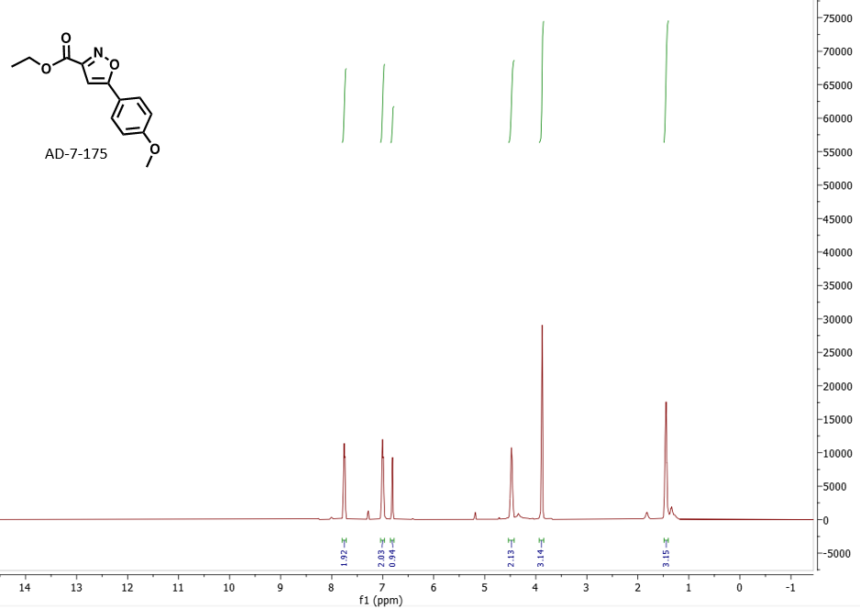
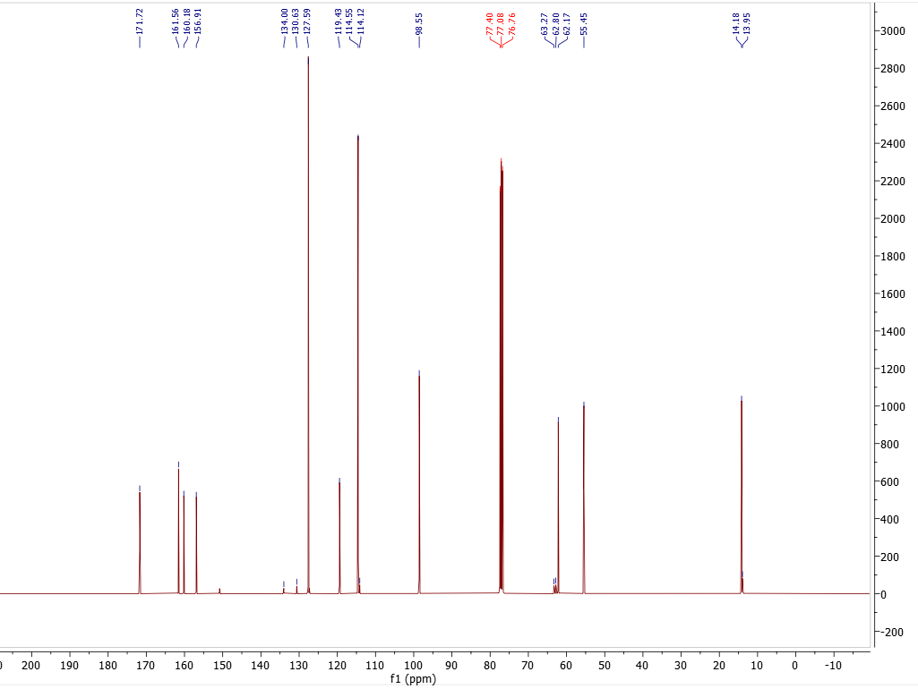
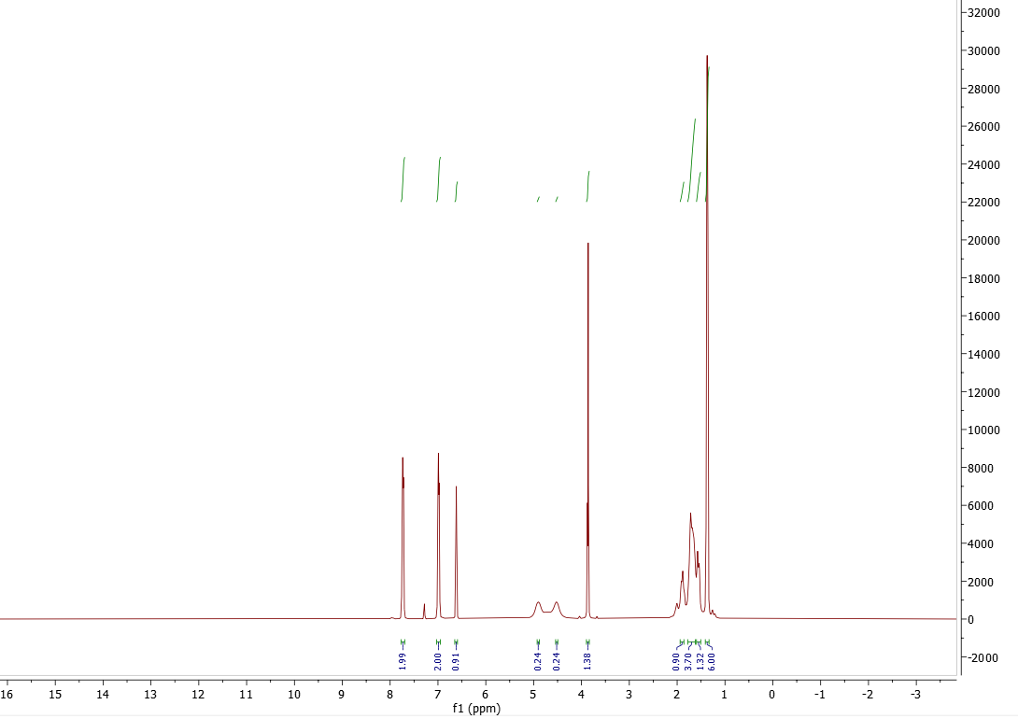
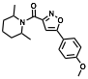
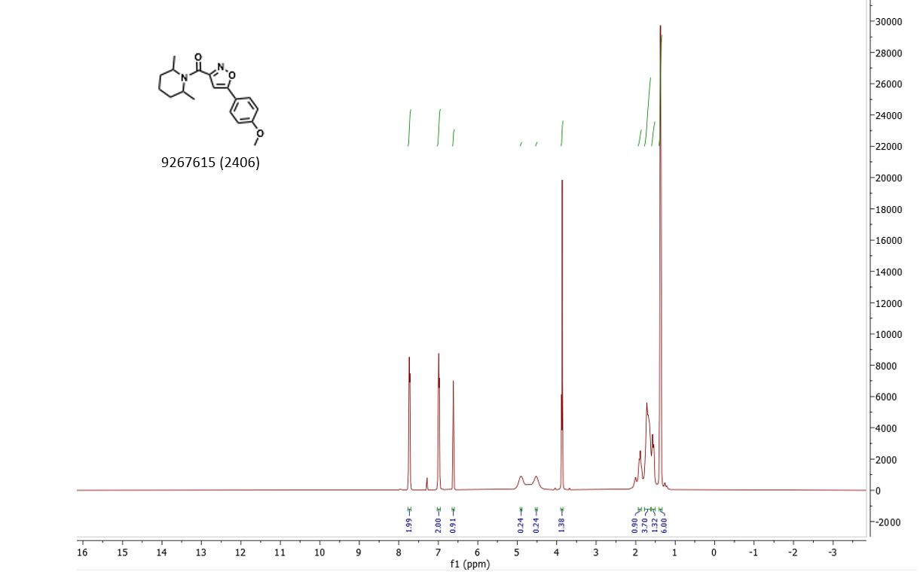
9267615 (2406)
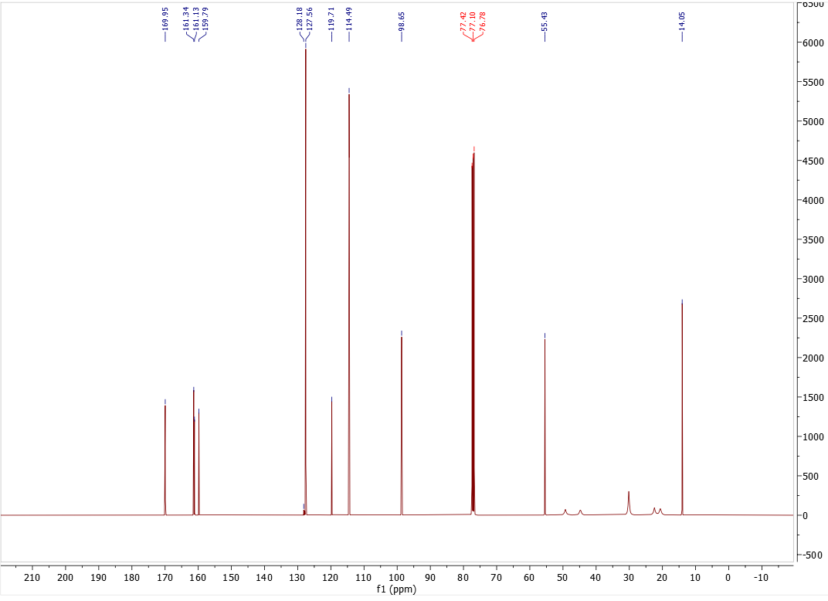
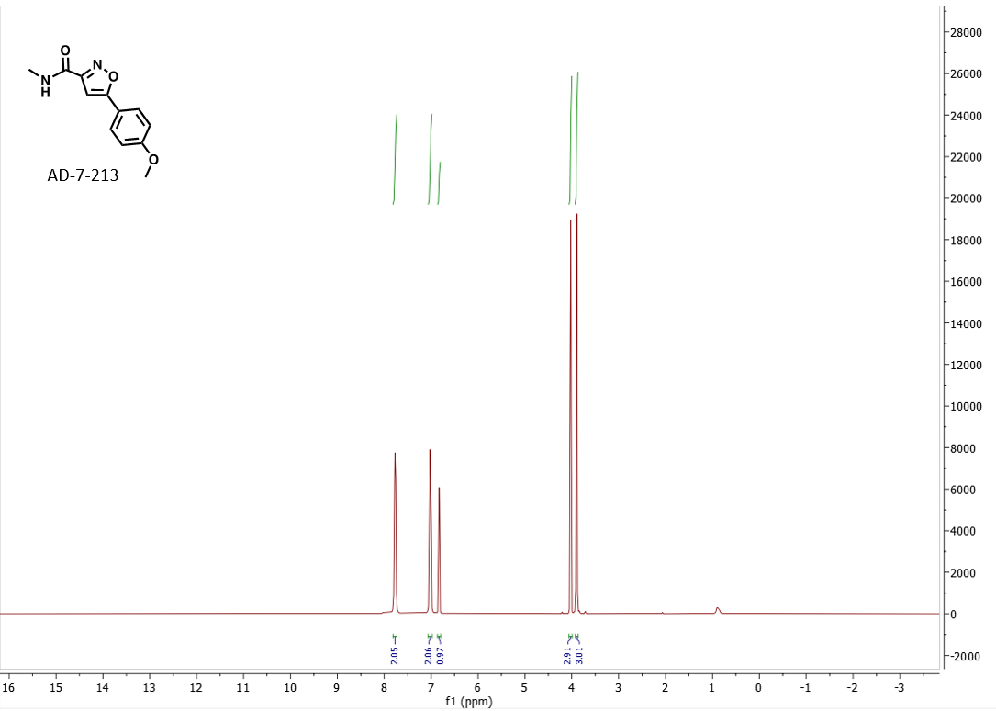
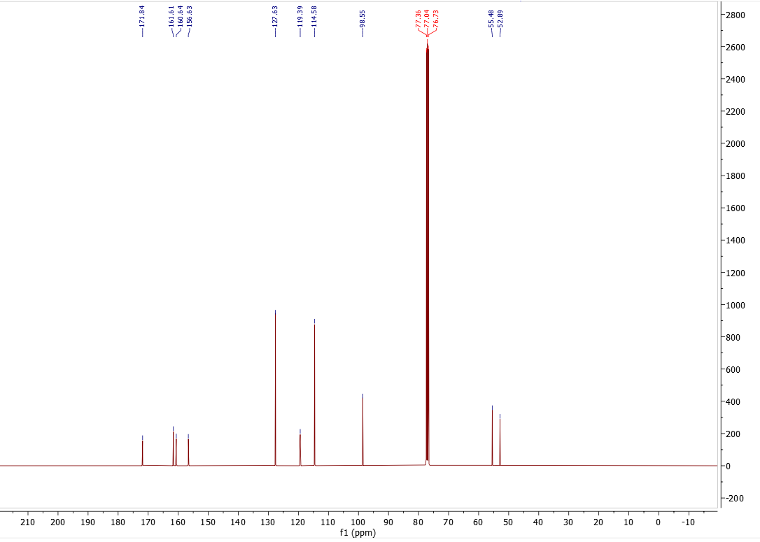
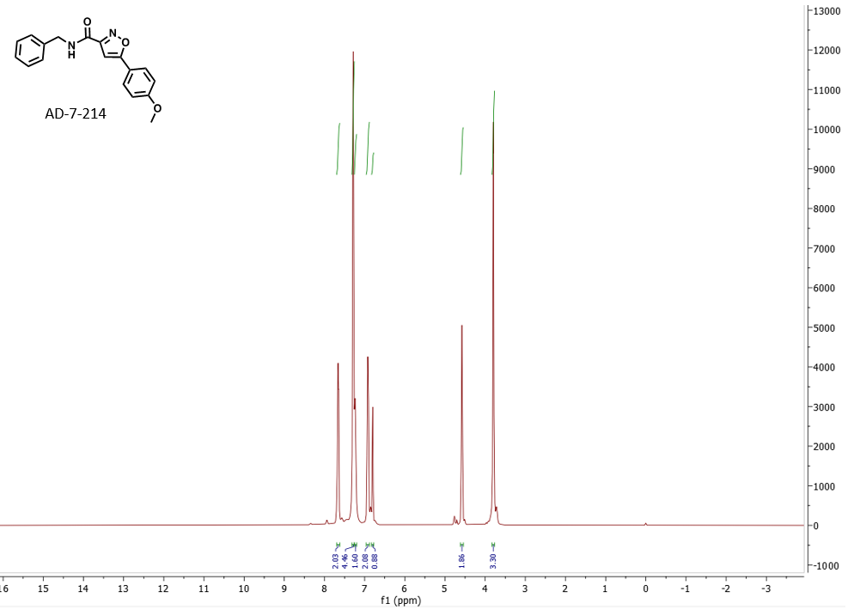
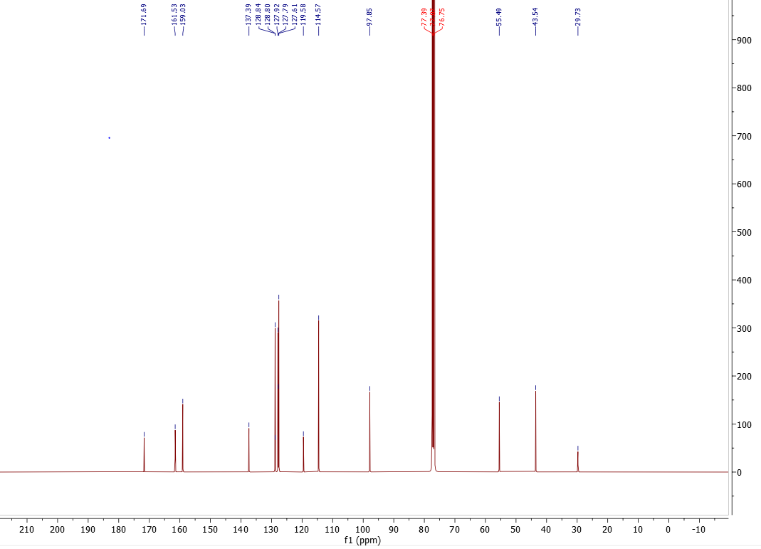
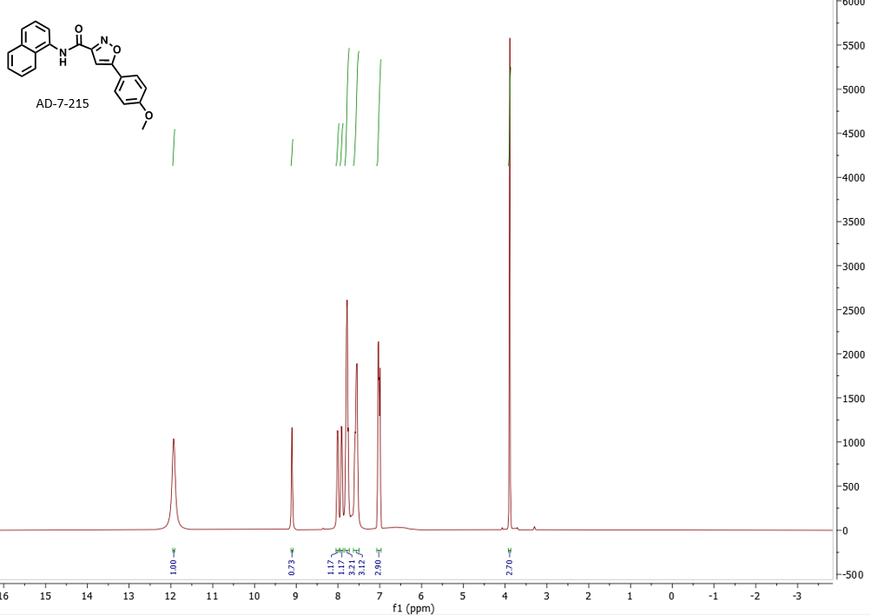
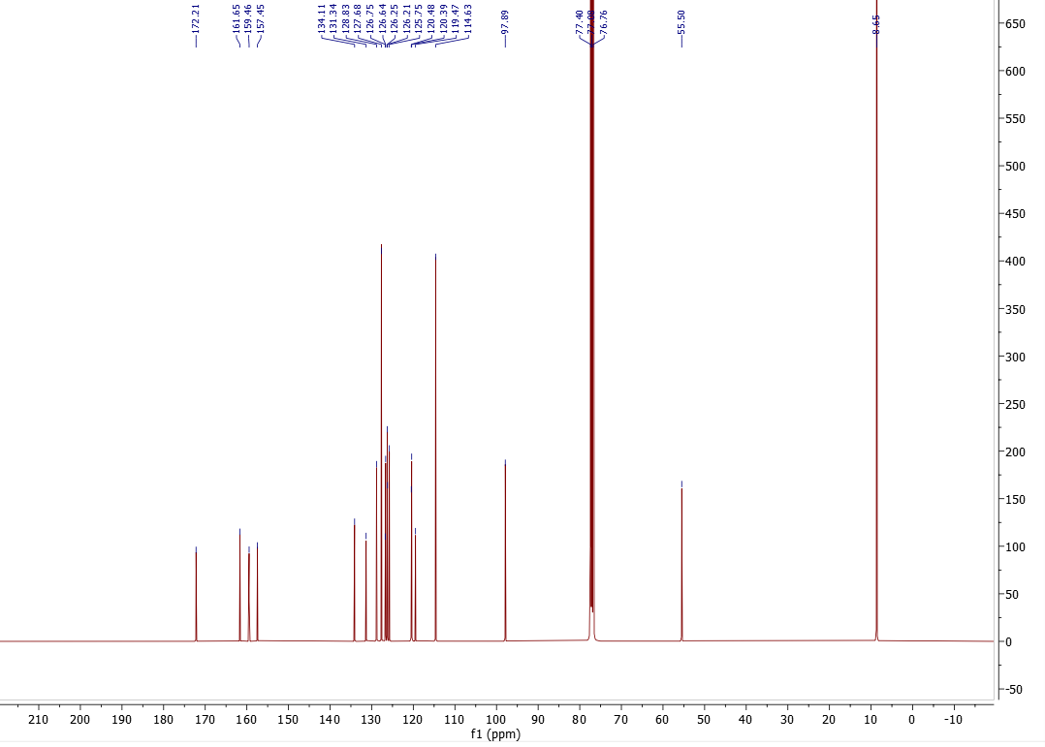
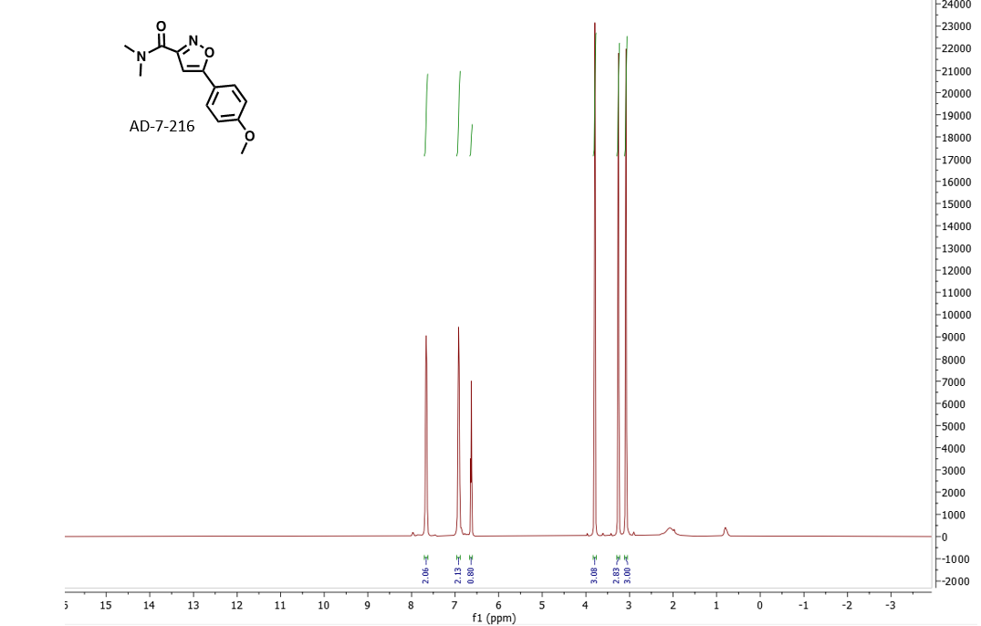
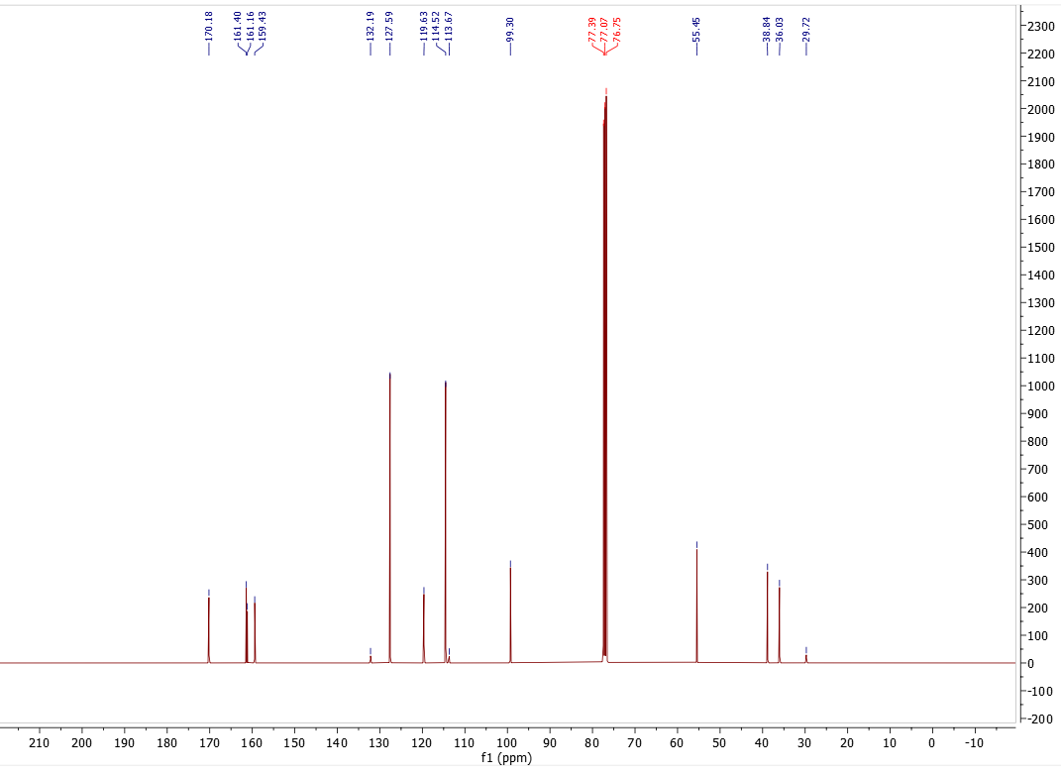
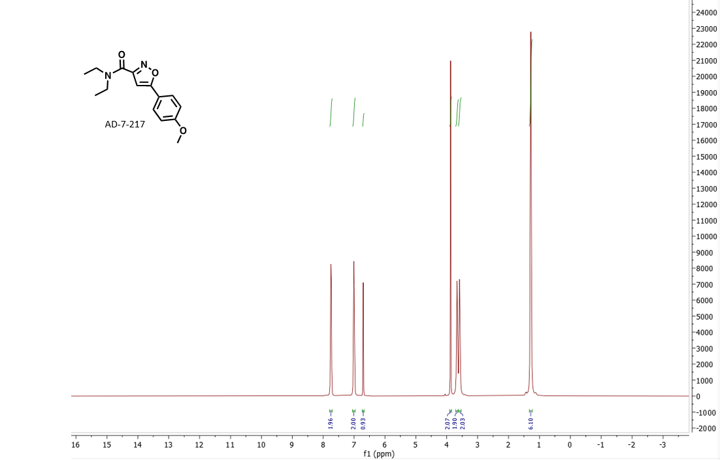
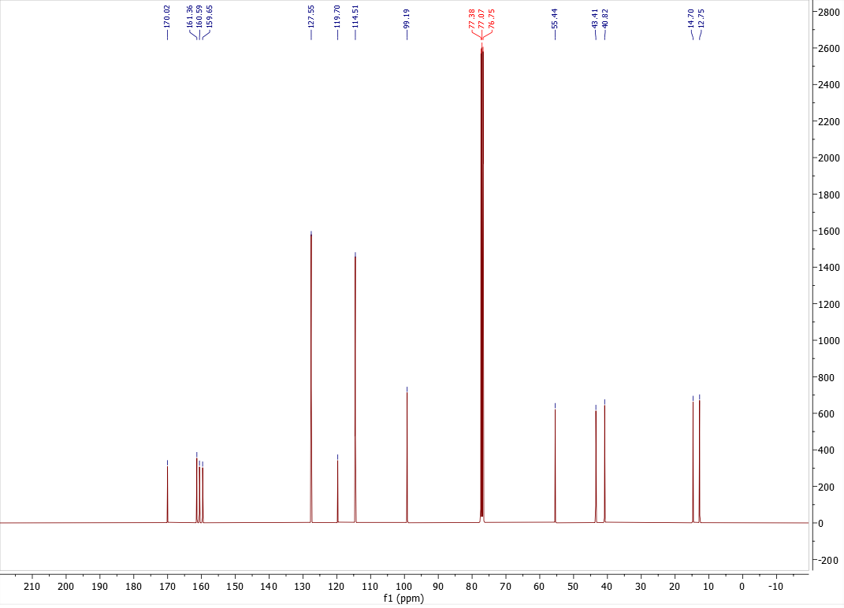
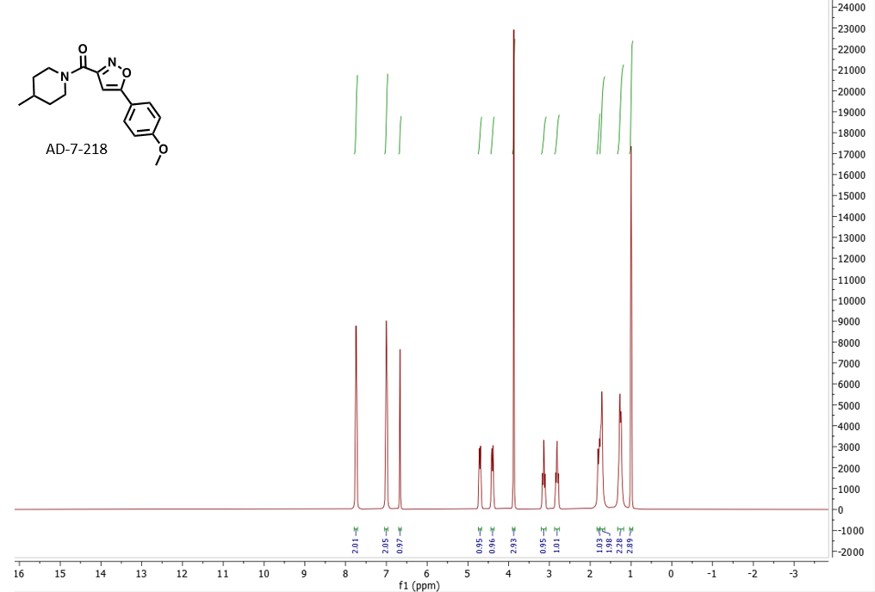
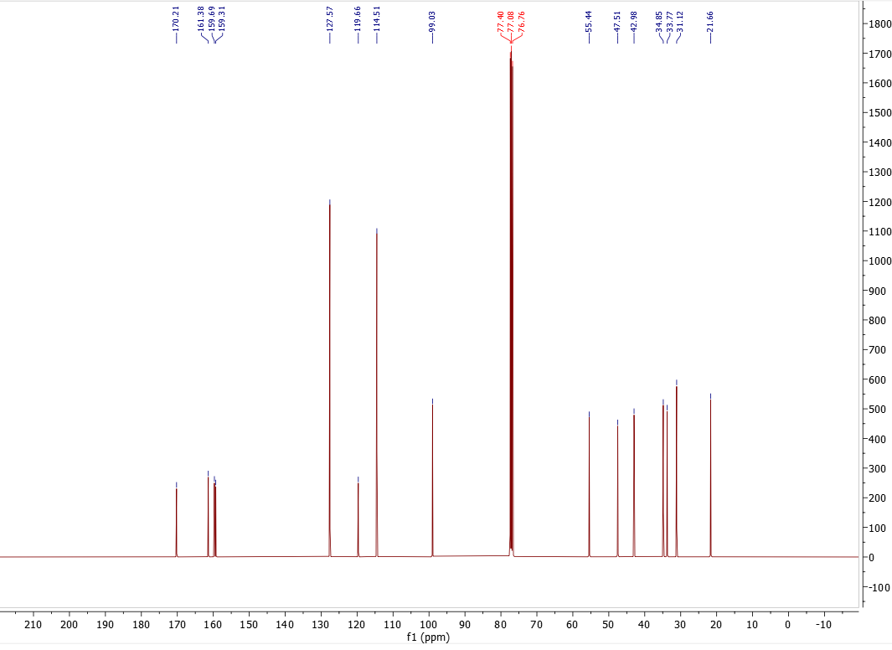
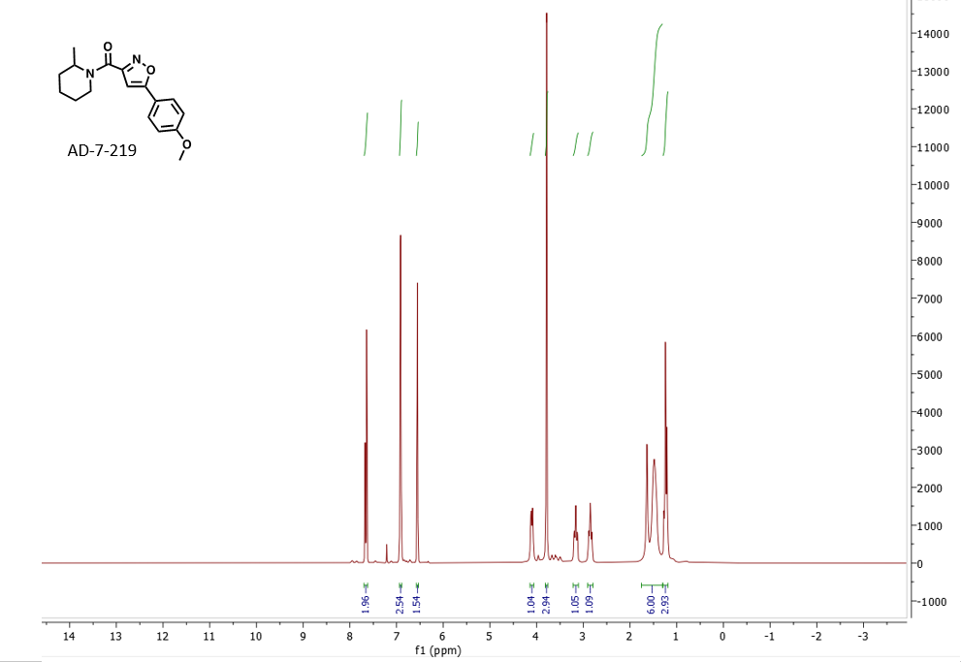
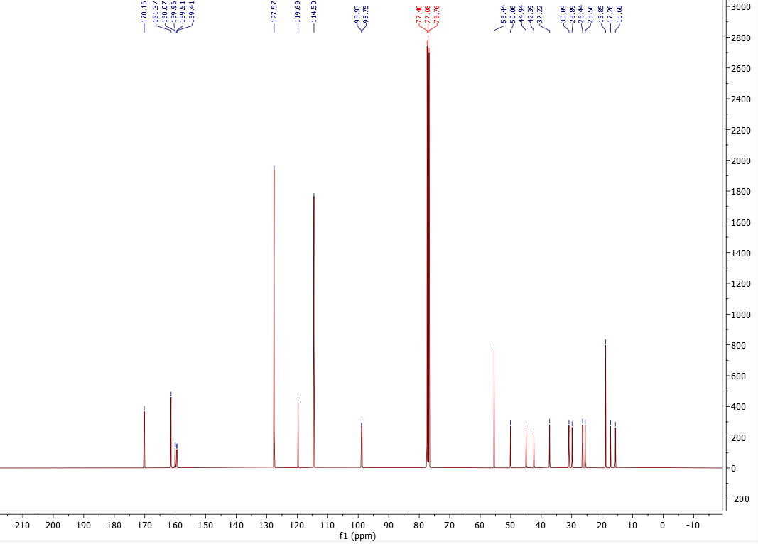
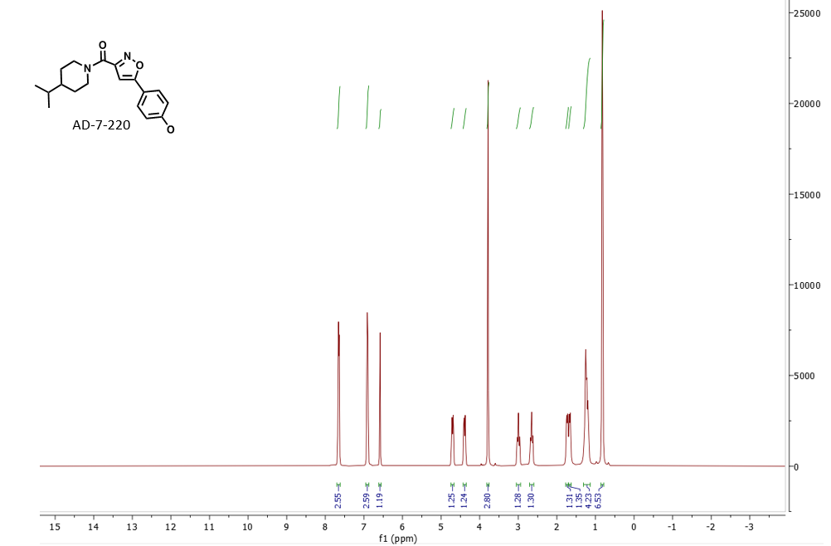
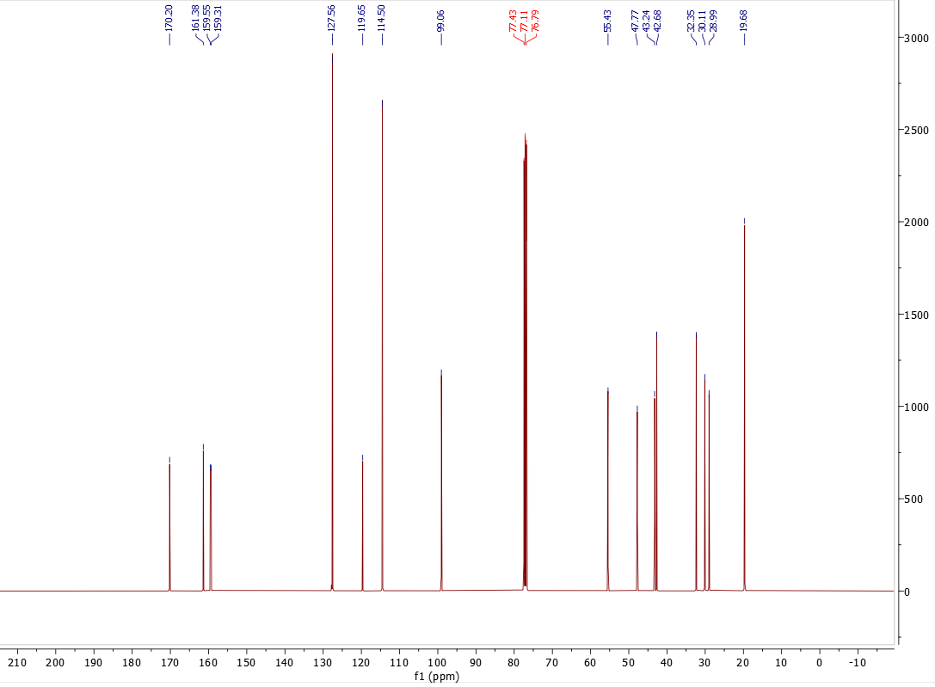
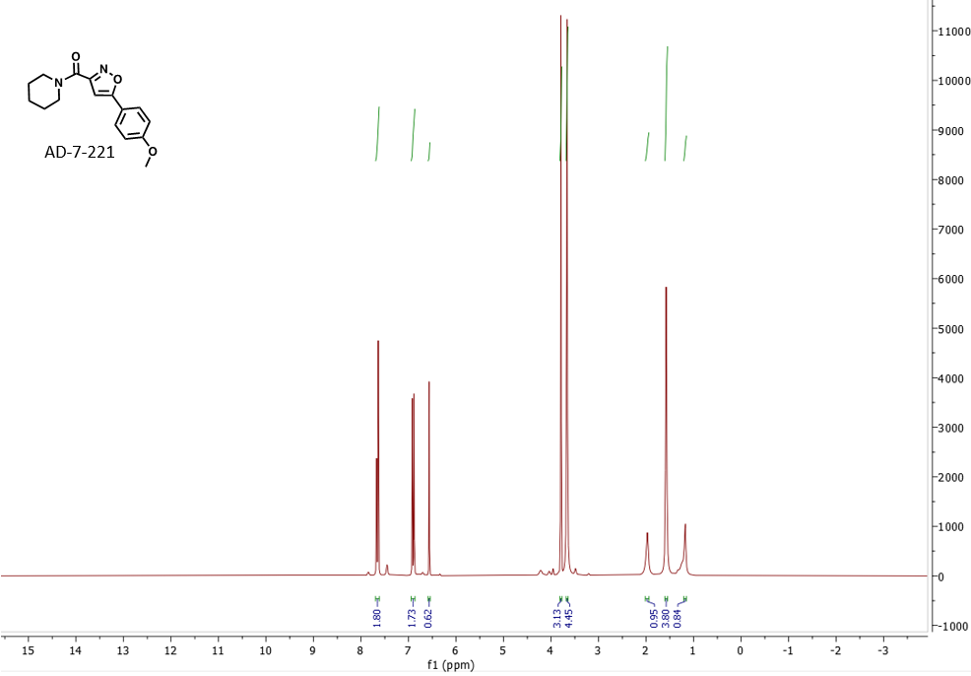
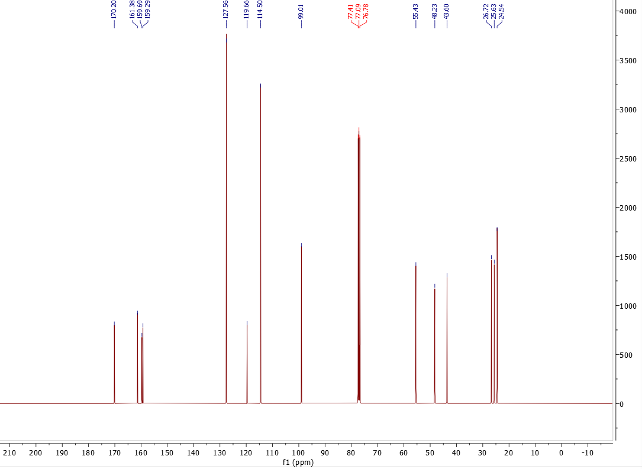
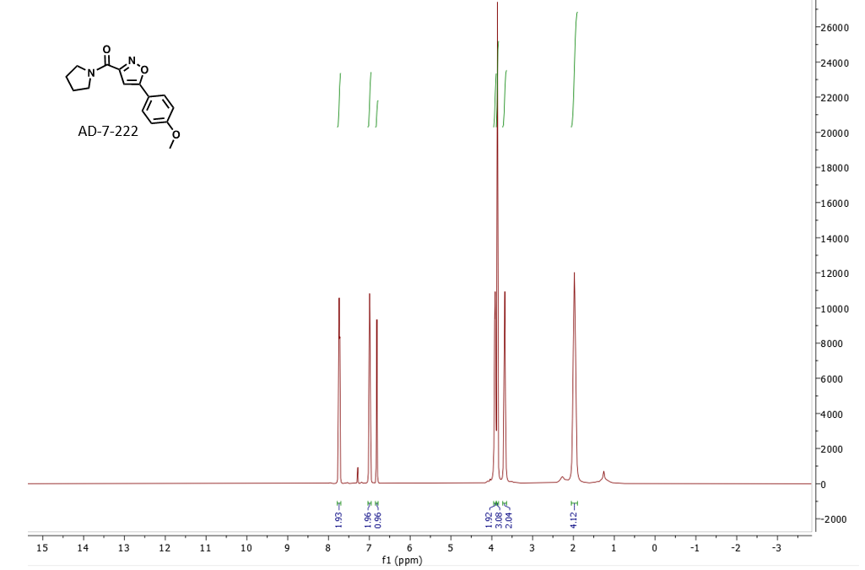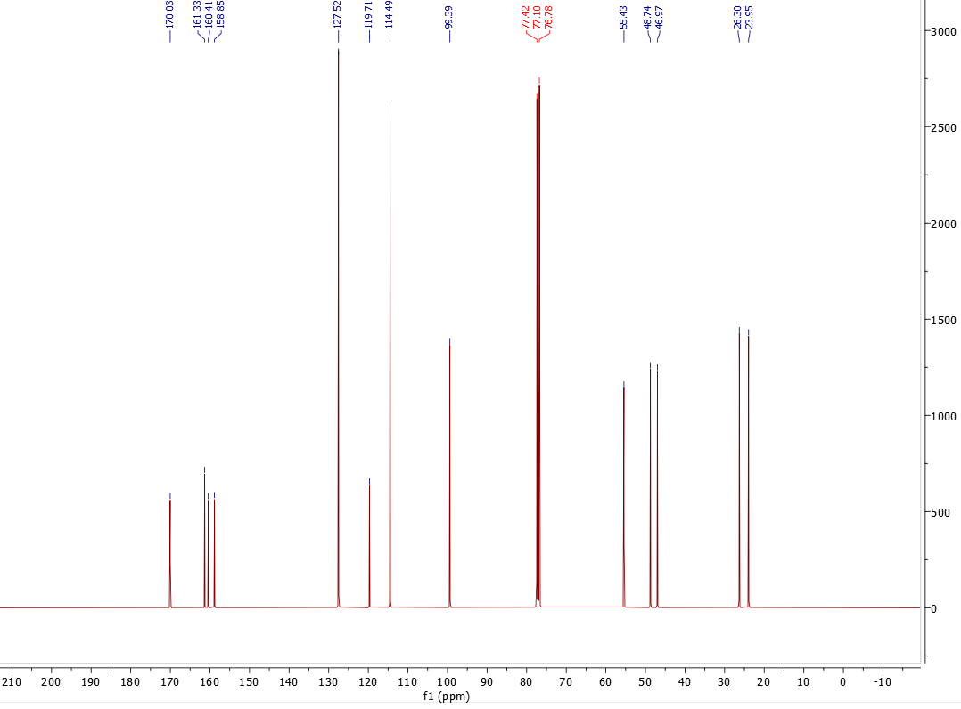
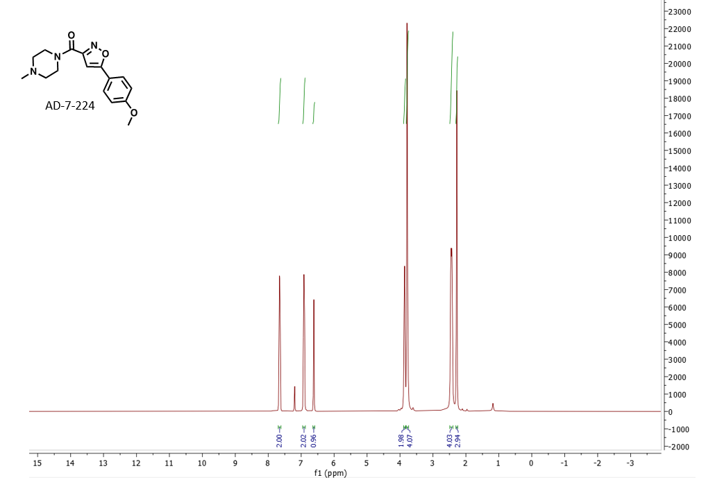
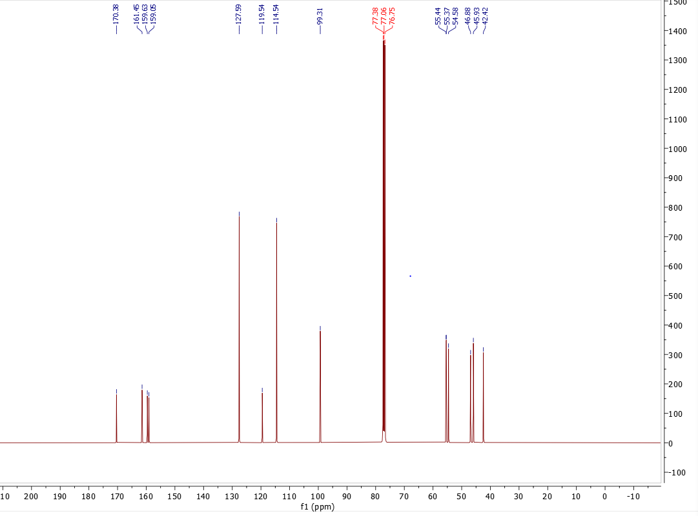
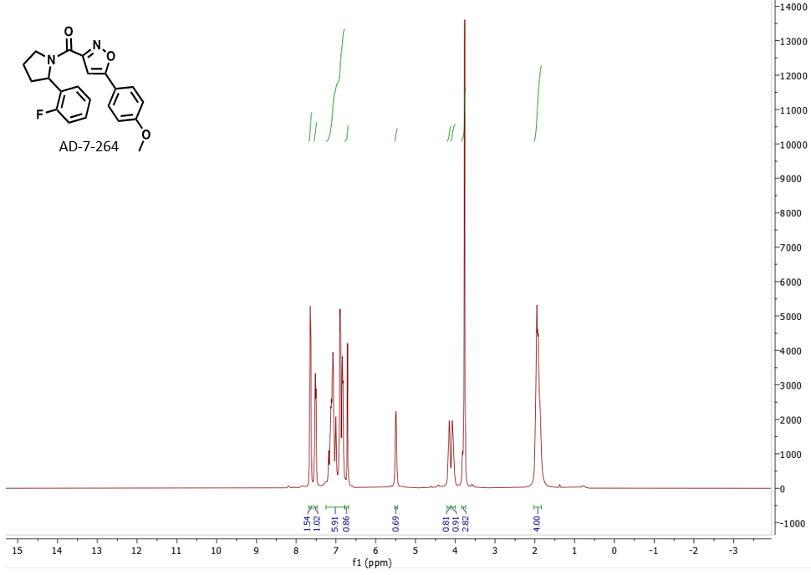
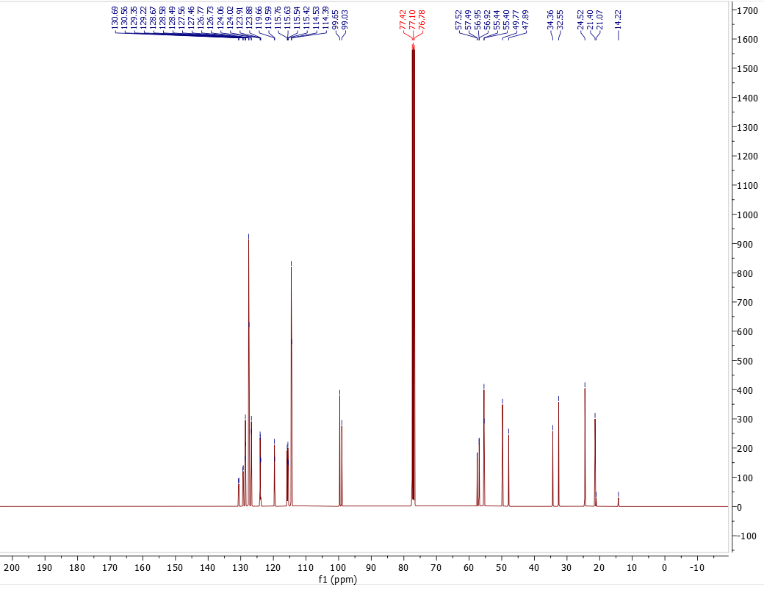
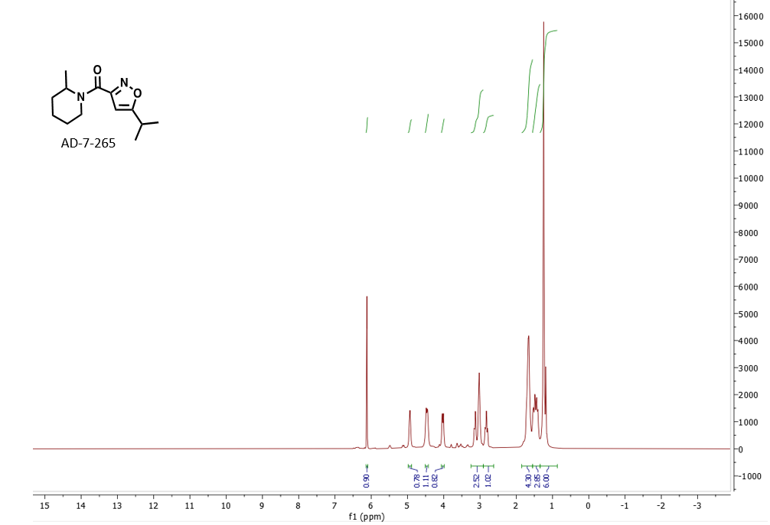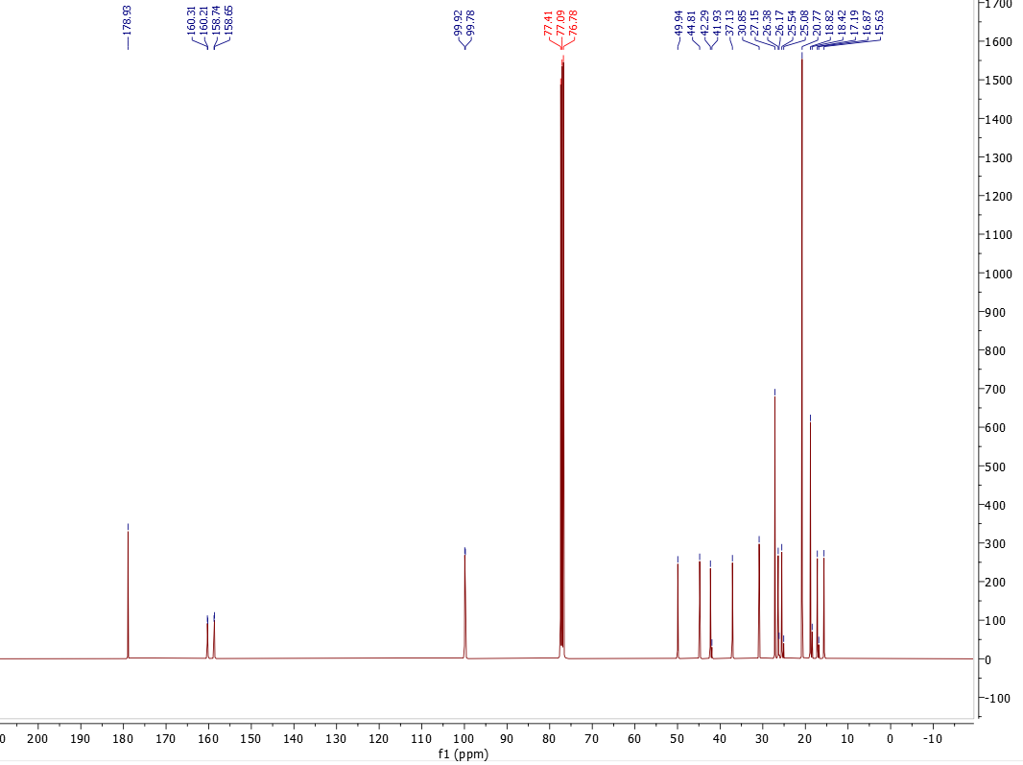
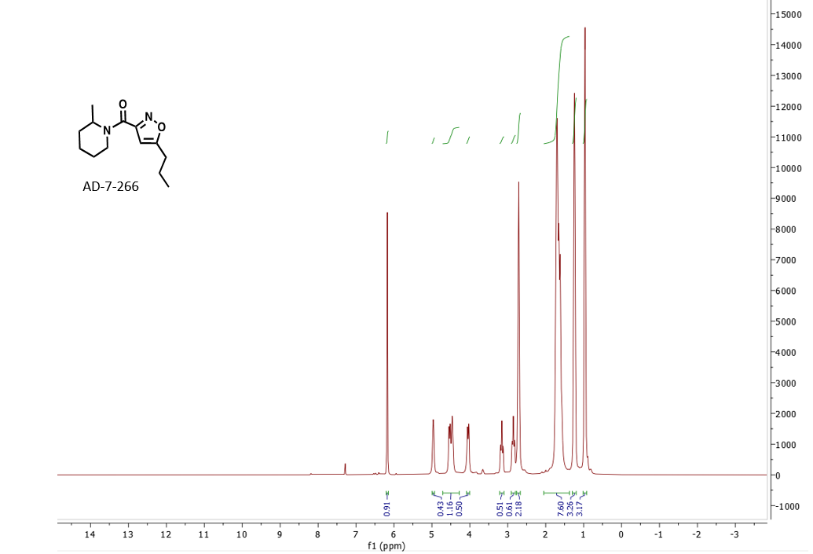
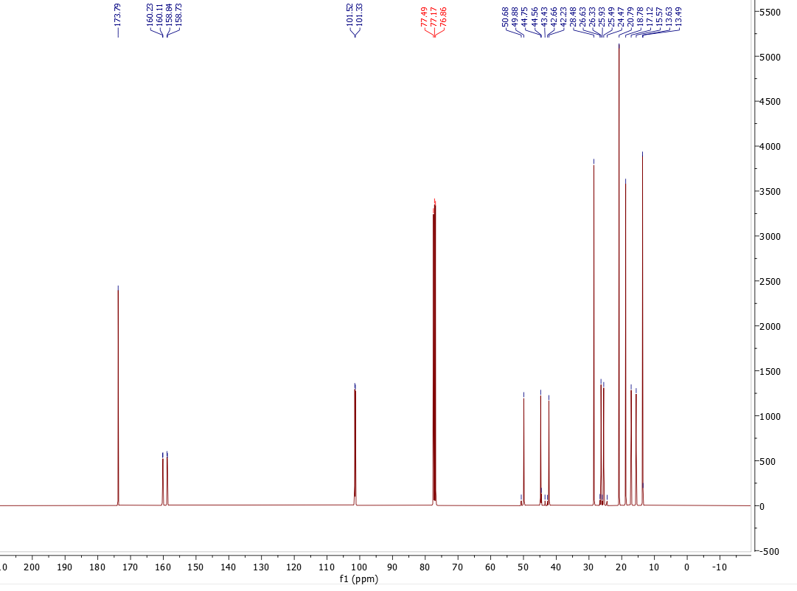
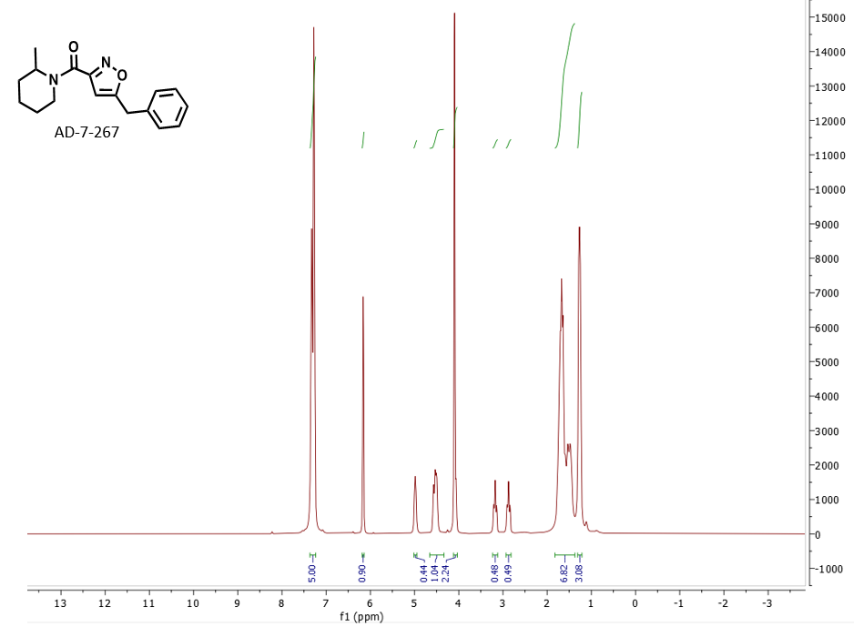
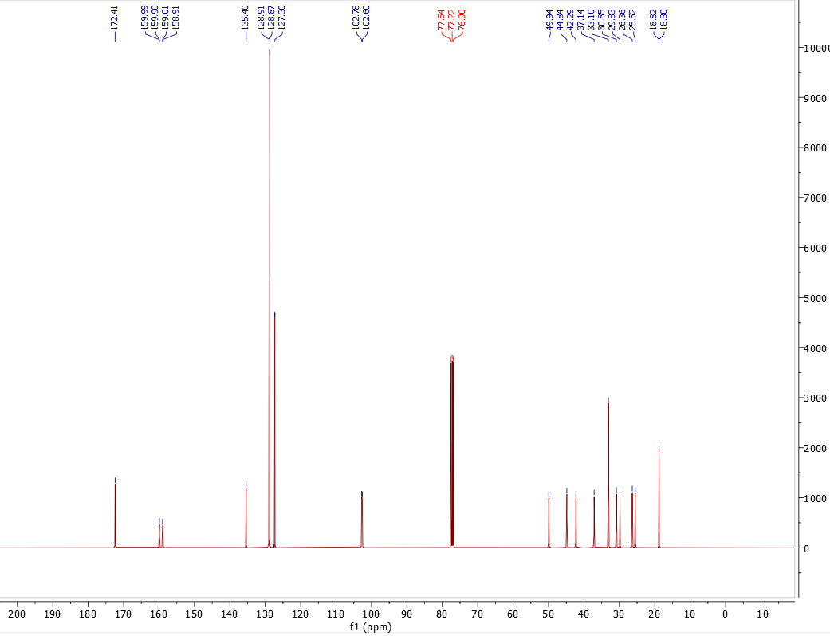
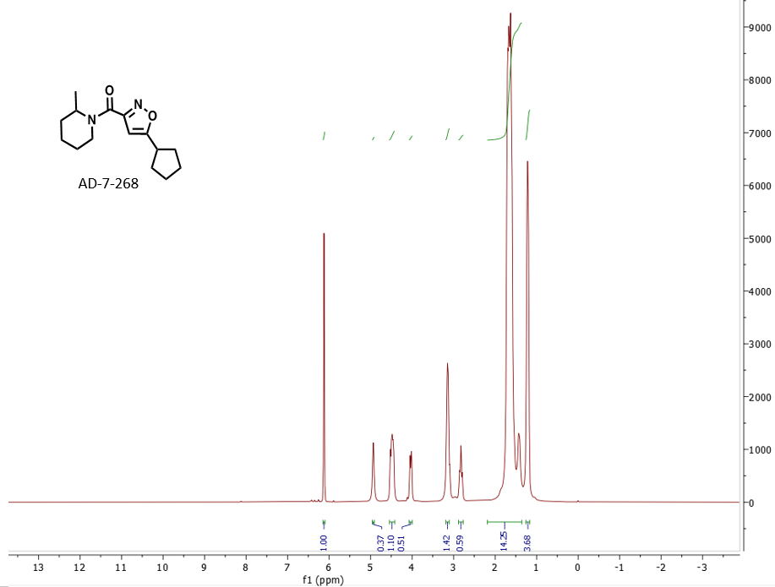
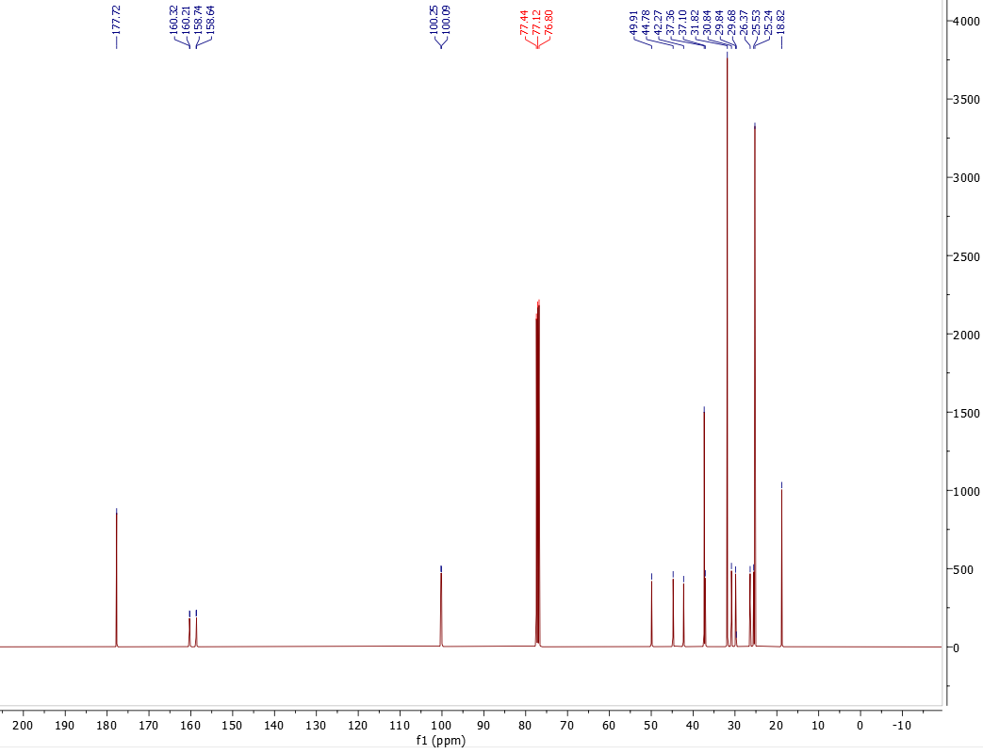
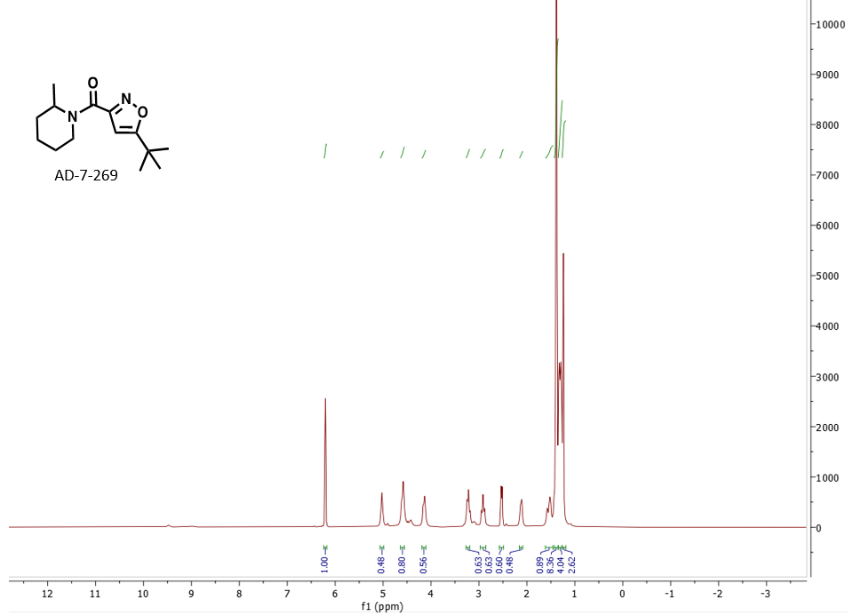
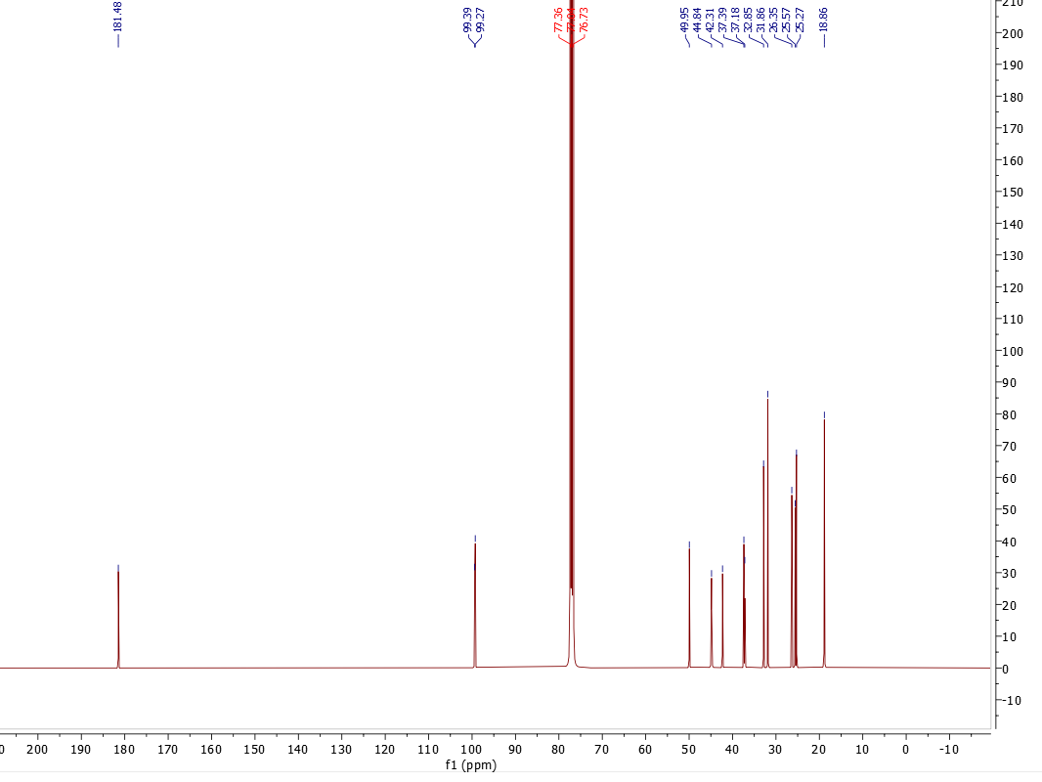
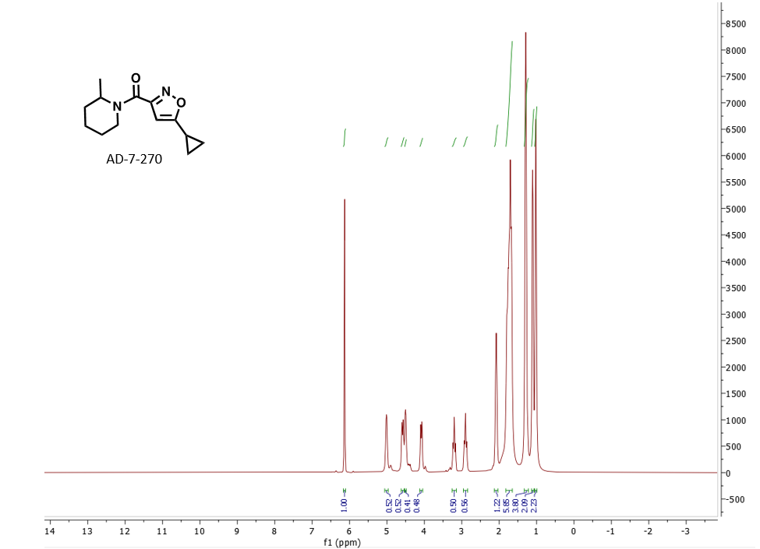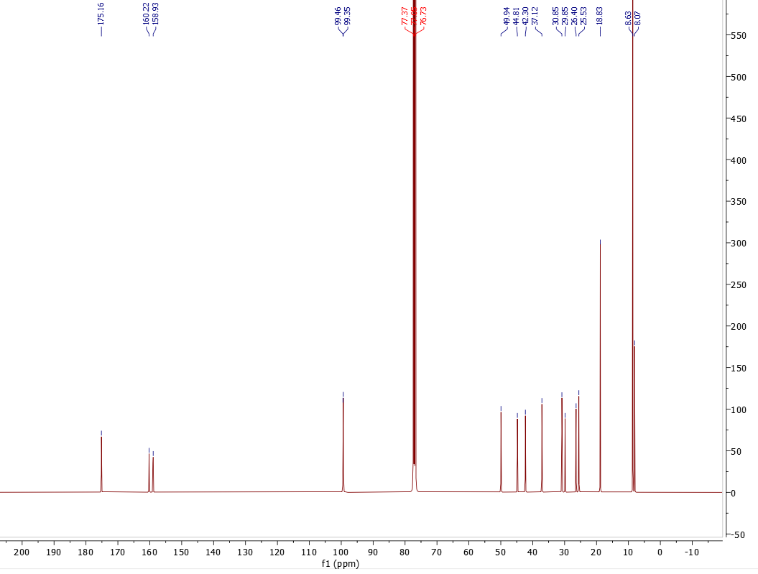
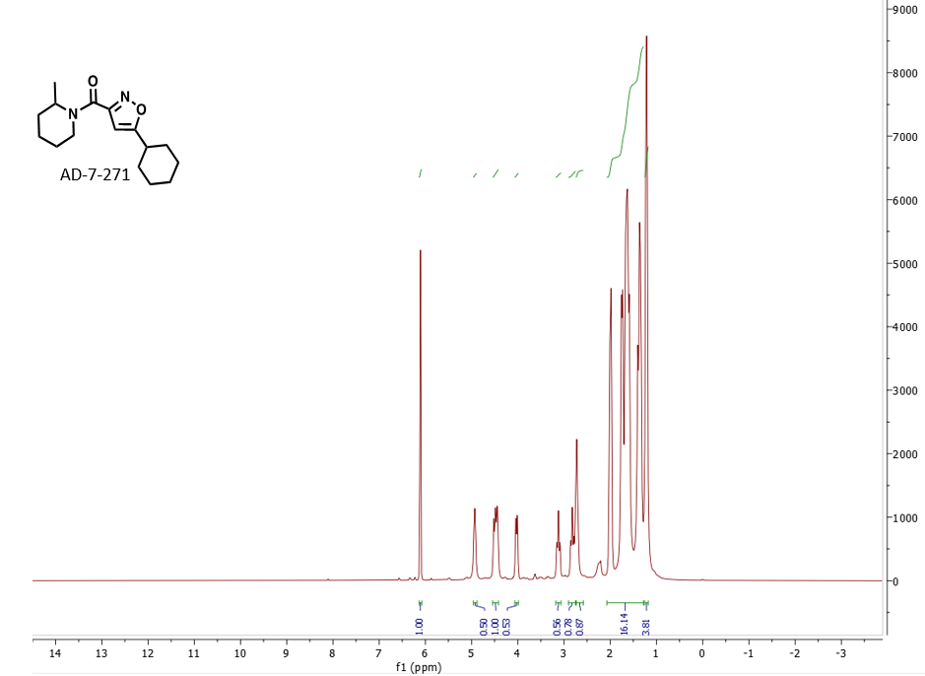
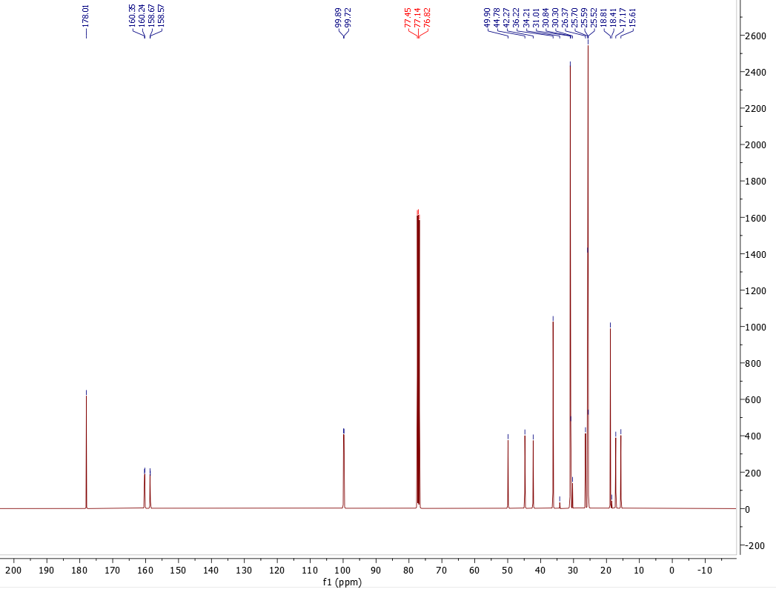
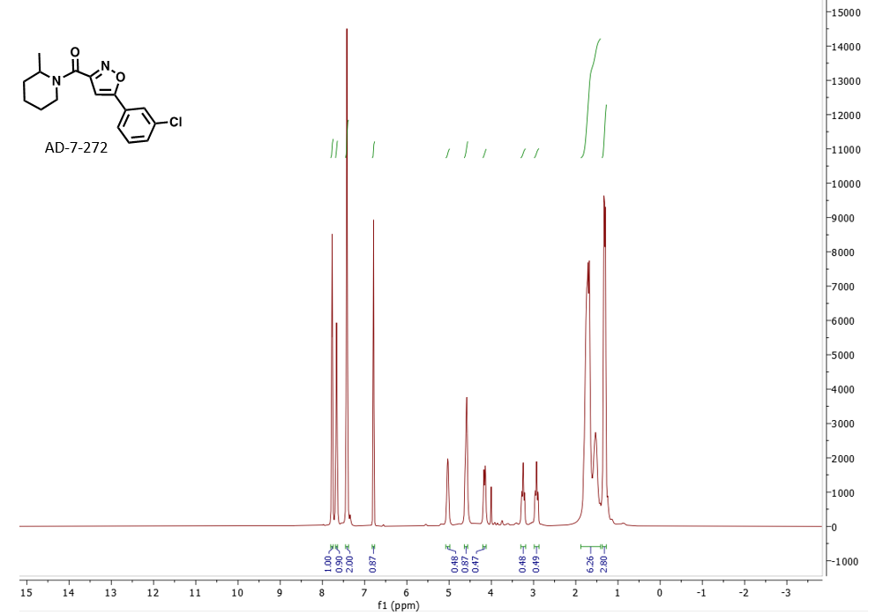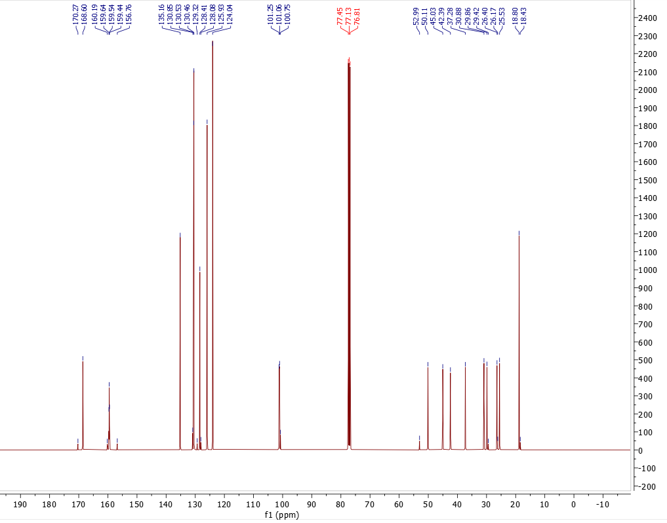
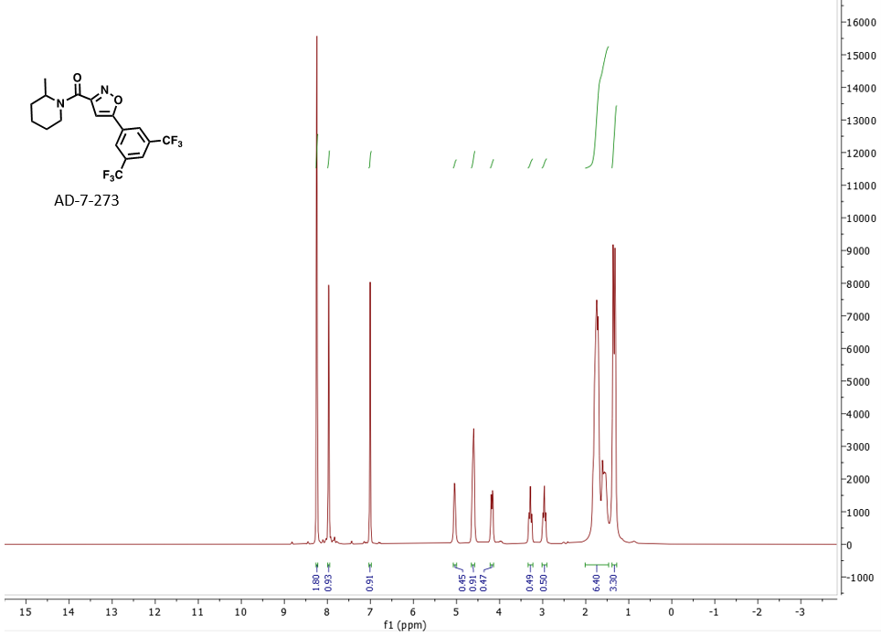
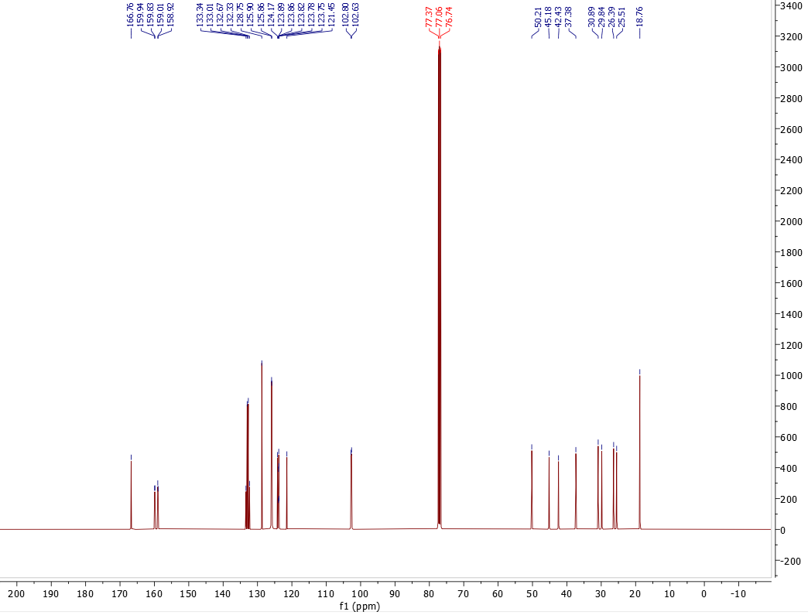
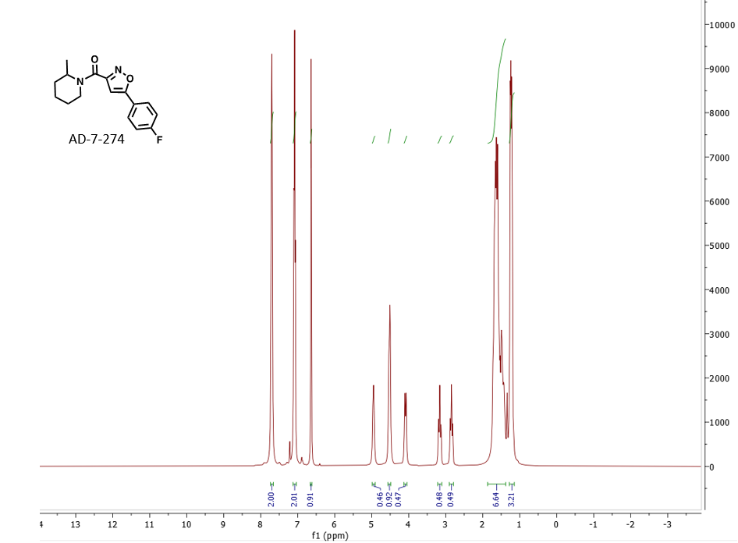
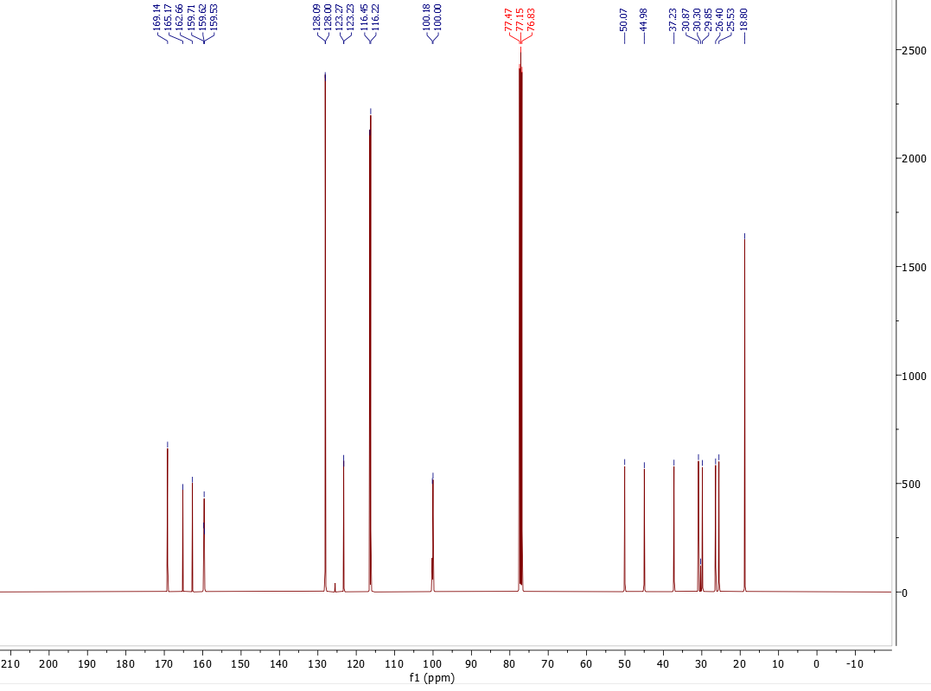
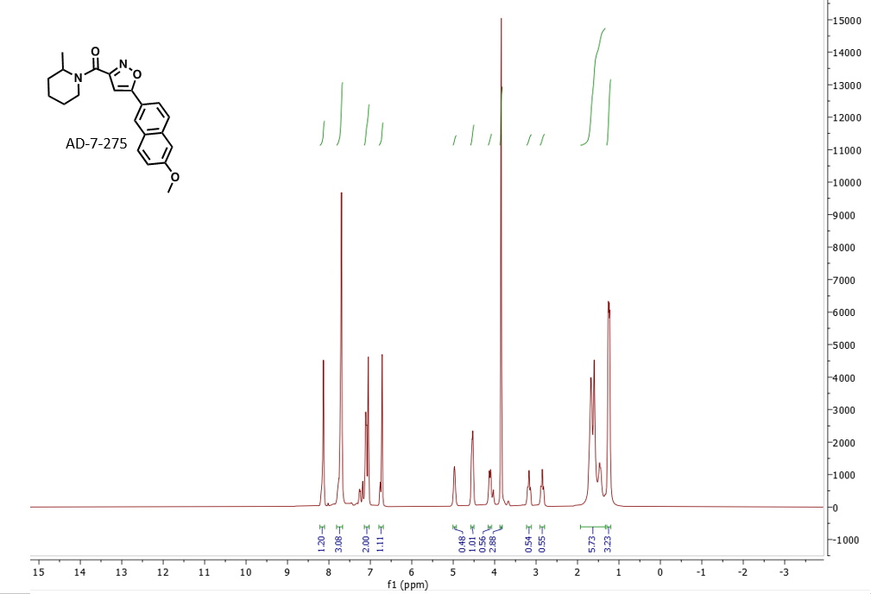
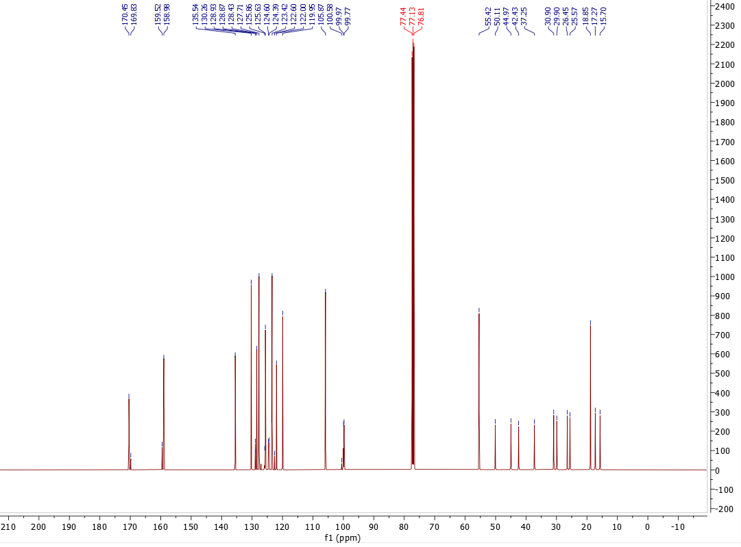
Annotated NMR Spectra and Mass Spectra of Isoxazolecarboxamides:

Compound Name | ¹H NMR | ¹³C NMR | M.W.  (g/mol) | ESI-MS (predicted) | ESI-MS (observed)
AD-7-175  (Step 1 intermediate) | ¹H NMR (400 MHz, CDCl) δ 8.01, 7.99, 7.77, 7.75, 7.74, 7.29, 7.28, 7.02, 7.00, 6.99, 6.82, 6.82, 6.81, 6.80, 5.20, 5.19, 5.18, 4.72, 4.50, 4.49, 4.48, 4.47, 4.46, 4.46, 4.44, 4.36, 4.36, 3.89, 3.88, 3.87, 3.87, 1.82, 1.48, 1.48, 1.46, 1.46, 1.45, 1.44, 1.43, 1.42, 1.40. | ¹³C NMR (101 MHz, CDCl₃) δ 171.72, 161.56, 160.18, 156.91, 134.00, 130.63, 127.59, 119.43, 114.55, 114.12, 98.55, 77.40, 77.08, 76.76, 63.27, 62.80, 62.17, 55.45, 14.18, 13.95. | 247.25 | 248.2 | 248.1
AD-7-207 (2406) | ¹H NMR (400 MHz, CDCl₃) δ 7.75, 7.73, 7.72, 7.29, 7.28, 7.01, 6.99, 6.97, 6.63, 6.61, 4.90, 4.68, 4.52, 3.87, 3.86, 2.01, 1.92, 1.88, 1.85, 1.76, 1.74, 1.73, 1.72, 1.71, 1.70, 1.68, 1.64, 1.57, 1.55, 1.54, 1.53, 1.39, 1.37, 1.36, 1.26. | ¹³C NMR (101 MHz, CDCl₃ ) δ 169.95, 161.34, 161.13, 159.79, 128.18, 127.56, 119.71, 114.49, 98.65, 77.42, 77.10, 76.78, 55.43, 14.05. | 314.16 | 315.2 | 315.1
AD-7-213 | ¹H NMR (400 MHz, CDCl₃) δ 7.79, 7.78, 7.77, 7.76, 7.75, 7.04, 7.03, 7.02, 7.01, 7.00, 6.84, 6.83, 6.82, 4.03, 4.03, 4.02, 4.01, 3.91, 3.90, 3.89, 3.88, 0.91, 0.89, 0.86. | ¹³C NMR (101 MHz, CDCl₃) δ 171.84, 161.61, 160.64, 156.63, 127.63, 119.39, 114.58, 98.55, 77.36, 77.04, 76.73, 55.48, 52.89. | 232.24 | 233.2 | 234.0
AD-7-214 | ¹H NMR (400 MHz, CDCl₃) δ 8.34, 7.94, 7.68, 7.66, 7.64, 7.57, 7.46, 7.29, 7.28, 7.27, 7.24, 7.23, 7.22, 6.94, 6.93, 6.92, 6.90, 6.85, 6.83, 6.81, 6.79, 6.74, 4.76, 4.59, 4.58, 4.56, 4.51, 3.81, 3.79, 3.79, 3.73, 3.72, 3.70. | ¹³C NMR (101 MHz, CDCl₃) δ 171.69, 161.53, 159.03, 137.39, 128.84, 128.80, 127.92, 127.79, 127.61, 119.58, 114.57, 97.85, 77.39, 77.07, 76.75, 55.49, 43.54, 29.73. | 308.34 | 309.3 | 309.0
AD-7-215 | ¹H NMR (400 MHz, CDCl₃) δ 11.93, 9.10, 8.03, 8.01, 7.99, 7.93, 7.92, 7.90, 7.82, 7.80, 7.78, 7.76, 7.67, 7.61, 7.59, 7.57, 7.56, 7.54, 7.52, 7.05, 7.04, 7.02, 7.01, 6.99, 6.84, 6.64, 6.49, 3.90, 3.89. | ¹³C NMR (101 MHz, CDCl₃) δ 172.21, 161.65, 159.46, 157.45, 134.11, 131.34, 128.83, 127.68, 126.75, 126.64, 126.25, 126.21, 125.75, 120.48, 120.39, 119.47, 114.63, 97.89, 77.40, 77.08, 76.76, 55.50, 8.65. | 344.37 | 345.4 | 345.1
AD-7-216 | ¹H NMR (400 MHz, CDCl₃) δ 7.97, 7.95, 7.69, 7.68, 7.68, 7.66, 7.65, 6.94, 6.94, 6.93, 6.92, 6.90, 6.64, 6.63, 3.81, 3.80, 3.79, 3.78, 3.27, 3.26, 3.25, 3.25, 3.09, 3.09, 3.08, 3.07, 2.07, 0.82, 0.80, 0.77. | ¹³C NMR (101 MHz, CDCl₃ ) δ 170.18, 161.40, 161.16, 159.43, 132.19, 127.59, 119.63, 114.52, 113.67, 99.30, 77.39, 77.07, 76.75, 55.45, 38.84, 36.03, 29.72. | 246.27 | 247.3 | 247.1
AD-7-217 | ¹H NMR (400 MHz, CDCl₃) δ 7.77, 7.76, 7.75, 7.74, 7.73, 7.02, 7.00, 6.99, 6.98, 6.71, 6.70, 6.70, 3.89, 3.88, 3.87, 3.68, 3.67, 3.65, 3.60, 3.59, 3.57, 3.55, 1.31, 1.30, 1.29, 1.28, 1.27, 1.26, 1.25. | ¹³C NMR (101 MHz, CDCl₃) δ 170.02, 161.36, 160.59, 159.65, 127.55, 119.70, 114.51, 99.19, 77.38, 77.07, 76.75, 55.44, 43.41, 40.82, 14.70, 12.75. | 274.32 | 275.3 | 275.2
AD-7-218 | ¹H NMR (400 MHz, CDCl₃ ) δ 7.76, 7.76, 7.75, 7.74, 7.73, 7.02, 7.02, 7.01, 7.00, 6.98, 6.68, 6.67, 6.66, 6.65, 4.72, 4.69, 4.42, 4.38, 3.89, 3.88, 3.87, 3.87, 3.69, 3.18, 3.17, 3.14, 3.11, 2.85, 2.84, 2.81, 2.78, 1.81, 1.78, 1.74, 1.71, 1.68, 1.31, 1.27, 1.24, 1.21, 1.01, 1.00, 0.99, 0.98, 0.98. | ¹³C NMR (101 MHz, CDCl₃) δ 170.21, 161.38, 159.69, 159.31, 127.57, 119.66, 114.51, 99.03, 77.40, 77.76, 55.44, 47.51, 42.98, 34.85, 33.77, 31.12, 21.66 | 300.36 | 301.4 | 301.1
AD-7-219 | ¹H NMR (400 MHz, CDCl₃) δ 7.67, 7.66, 7.64, 7.21, 7.20, 6.93, 6.92, 6.90, 6.57, 6.55, 4.12, 4.09, 3.79, 3.79, 3.60, 3.35, 3.20, 3.16, 3.13, 2.88, 2.85, 2.82, 2.11, 1.73, 1.69, 1.66, 1.64, 1.60, 1.56, 1.49, 1.43, 1.27, 1.26, 1.24, 1.23, 1.21. | ¹³C NMR (101 MHz, CDCl₃) δ 170.16, 16.37, 160.07, 159.96, 159.51, 127.57, 119.69, 114.50, 99.93, 98.75, 77.40, 77.08, 76.76, 55.44, 50.06, 44.94, 42.39, 37.72, 30.89, 29.89, 26.44, 25.56, 18.85, 17.26, 15.68 | 300.36 | 301.4 | 301.1
AD-7-220 | ¹H NMR (400 MHz, CDCl₃ ) δ 7.68, 7.67, 7.66, 7.65, 7.64, 6.93, 6.91, 6.89, 6.59, 6.58, 4.72, 4.69, 4.41, 4.37, 3.79, 3.78, 3.03, 3.00, 2.96, 2.69, 2.65, 2.62, 1.75, 1.72, 1.68, 1.65, 1.29, 1.26, 1.25, 1.23, 1.22, 1.20, 1.19, 1.17, 0.84, 0.83, 0.82, 0.81. | ¹³C NMR (101 MHz, CDCl₃) δ 170.20, 161.38, 159.55, 159.31, 127.56, 119.65, 114.50, 99.06, 77.43, 77.11, 76.79, 55.43, 47.77, 43.24, 42.68, 32.35, 30.11, 28.99, 19.68 | 328.41 | 329.4 | 329.2
AD-7-221 | ¹H NMR (400 MHz, CDCl₃) δ 7.67, 7.65, 7.63, 7.45, 6.92, 6.91, 6.89, 6.58, 6.57, 6.56, 4.22, 3.79, 3.78, 3.77, 3.68, 3.67, 3.66, 3.65, 1.99, 1.97, 1.96, 1.62, 1.57, 1.23, 1.18, 1.17. | ¹³C NMR (101 MHz, CDCl₃ ) δ 170.20, 16.38, 159.69, 159.29, 127.56, 119.66, 114.50, 99.01, 77.41, 77.09, 76.78, 55.43, 48.23, 43.60, 26.63, 24.54 | 286.33 | 287.3 | 287.1
AD-7-222 | ¹H NMR (400 MHz, CDCl₃) δ 7.76, 7.75, 7.74, 7.72, 7.28, 7.01, 7.01, 6.99, 6.97, 6.83, 6.82, 6.81, 6.81, 3.93, 3.91, 3.90, 3.88, 3.87, 3.86, 3.85, 3.71, 3.69, 3.68, 3.66, 2.27, 2.03, 2.01, 1.99, 1.98, 1.96, 1.94, 1.93, 1.27, 1.25, 1.23, 1.23. | ¹³C NMR (101 MHz, CDCl₃) δ0170.03, 161.33, 160.41, 127.52, 119.71, 114.49, 99.39, 77.42, 77.10, 76.78, 55.43, 48.74, 46.97, 26.30, 23.95 | 272.30 | 273.3 | 273.1
AD-7-224 | ¹H NMR (400 MHz, CDCl₃ CDCl₃) δ 7.67, 7.66, 7.64, 7.21, 7.20, 6.93, 6.92, 6.90, 6.62, 6.61, 3.87, 3.85, 3.80, 3.79, 3.77, 2.62, 2.46, 2.45, 2.43, 2.42, 2.28, 2.27, 1.18. | ¹³C NMR (101 MHz, CDCl₃ ) δ 173.38, 161.45, 159.63, 159.05, 127.99, 119.54, 114.54, 99.31, 77.36, 77.06, 76.75, 55.44, 55.37, 54.58, 46.88, 45.93, 42.42 | 301.35 | 302.4 | 302.2
AD-7-264 | ¹H NMR (400 MHz, CDCl₃ ) δ 7.66, 7.65, 7.63, 7.53, 7.52, 7.50, 7.27, 7.25, 7.19, 7.18, 7.15, 7.13, 7.11, 7.09, 7.08, 7.06, 7.02, 7.00, 6.98, 6.96, 6.94, 6.93, 6.91, 6.90, 6.88, 6.84, 6.82, 6.72, 6.71, 6.70, 6.49, 6.48, 6.48, 5.50, 5.49, 5.48, 4.42, 4.18, 4.17, 4.15, 4.14, 4.12, 4.09, 4.08, 4.06, 4.04, 4.02, 3.89, 3.87, 3.86, 3.84, 3.82, 3.78, 3.77, 3.74, 3.73, 3.73, 3.58, 2.38, 2.36, 2.34, 2.32, 2.31, 2.29, 2.00, 1.99, 1.97, 1.95, 1.93, 1.91, 1.90, 1.87. | ¹³C NMR (101 MHz, CDCl₃) δ 130.69, 130.56, 129.35, 129.22, 128.67, 128.58, 128.49, 127.56, 127.46, 126.77, 126.73, 124.06, 124.02, 123.91, 123.88, 119.66, 119.59, 115.76, 115.63, 115.54, 115.42, 114.53, 114.39, 99.65, 99.03, 77.42, 77.10, 46.78, 57.52, 57.49, 56.95, 56.92, 55.44, 55.40, 49.77, 47.89, 34.36, 32.55, 24.52, 21.40, 21.07, 14.22 | 366.39 | 367.4 | 367.1
AD-7-265 | ¹H NMR (400 MHz, CDCl₃) δ 6.13, 6.12, 5.13, 5.10, 4.96, 4.94, 4.93, 4.91, 4.71, 4.52, 4.49, 4.45, 4.44, 4.12, 4.04, 4.01, 3.89, 3.16, 3.13, 3.09, 3.06, 3.04, 3.02, 3.01, 2.99, 2.86, 2.82, 2.79, 1.72, 1.68, 1.65, 1.62, 1.59, 1.54, 1.52, 1.48, 1.47, 1.44, 1.42, 1.40, 1.28, 1.26, 1.25, 1.22, 1.20, 1.18. | ¹³C NMR (101 MHz, CDCl₃) δ 178.93, 160.31, 160.21, 158.74, 158.65, 99.92, 99.78, 77.41, 77.09, 76.78, 49.94, 44.81, 42.29, 21.93, 37.13, 30.85, 27.15, 26.38, 36.17, 25.54, 25.08, 20.77, 18.82, 1842, 17.19, 16.87, 15.63 | 236.32 | 237.3 | 237.1
AD-7-266 | ¹H NMR (400 MHz, CDCl₃) δ 6.18, 6.17, 4.97, 4.95, 4.55, 4.52, 4.47, 4.45, 4.06, 4.03, 3.19, 3.16, 3.12, 2.89, 2.85, 2.82, 2.74, 2.72, 2.71, 2.69, 1.75, 1.73, 1.71, 1.69, 1.68, 1.65, 1.62, 1.27, 1.26, 1.24, 1.22, 0.99, 0.98, 0.96, 0.94. | ¹³C NMR (101 MHz, CDCl₃ ) δ 173.79, 160.23, 160.11, 158.84, 158.73, 101.52, 101.33, 77.49, 77.17, 76.86, 50.68, 49.88, 44.75, 44.56, 43.43, 42.66, 42.23, 28.48, 26.63, 26.33, 25.93, 25.49, 24.47, 20.79, 18.78, 17.12, 15.57, 13.63, 13.49 | 236.32 | 237.3 | 237.1
AD-7-267 | ¹H NMR (400 MHz, CDCl₃) δ 7.34, 7.33, 7.31, 7.28, 7.26, 6.16, 4.99, 4.97, 4.57, 4.54, 4.50, 4.09, 4.06, 3.85, 3.21, 3.17, 3.14, 2.91, 2.87, 2.84, 1.77, 1.73, 1.70, 1.67, 1.64, 1.59, 1.58, 1.53, 1.48, 1.45, 1.29, 1.27, 1.25, 1.23, 1.11. | ¹³C NMR (101 MHz, CDCl₃ ) δ 172.41, 159.99, 159.90, 159.01, 158.91, 134.40, 128.91, 128.87, 127.30, 102.78, 102.60, 77.54, 77.22, 76.90, 49.94, 44.84, 42.29, 37.14, 33.10, 30.85, 29.83, 26.36, 25.52, 18.82, 18.80 | 284.36 | 285.4 | 285.1
AD-7-268 | ¹H NMR (400 MHz, CDCl₃ ) δ 6.12, 4.94, 4.92, 4.52, 4.49, 4.45, 4.05, 4.01, 3.16, 3.14, 3.13, 3.09, 2.86, 2.82, 2.79, 1.86, 1.71, 1.69, 1.67, 1.65, 1.62, 1.59, 1.54, 1.52, 1.49, 1.47, 1.44, 1.40, 1.23, 1.22, 1.20, 1.18. | ¹³C NMR (101 MHz, CDCl₃) δ 172.72, 160.32, 160.21, 158.74, 158.64, 100.25, 100.09, 77.44, 77.12, 76.80, 49.91, 44.78, 42.27, 37.36, 37.10, 31.82, 30.84, 29.84, 26.37, 25.53, 25.24, 18.82 | 262.35 | 263.4 | 263.1
AD-7-269 | ¹H NMR (400 MHz, CDCl₃) δ 7.29, 7.28, 7.28, 6.22, 6.20, 5.04, 5.02, 4.89, 4.62, 4.58, 4.42, 4.31, 4.26, 4.23, 4.17, 3.25, 3.22, 3.18, 2.95, 2.92, 2.88, 2.55, 2.54, 2.53, 2.51, 2.43, 2.13, 2.11, 1.57, 1.53, 1.52, 1.50, 1.43, 1.39, 1.38, 1.34, 1.32, 1.30, 1.29, 1.28, 1.25, 1.24, 1.23. | ¹³C NMR (101 MHz, CDCl₃) δ 181.48, 99.39, 99.27, 77.36, 77.04, 77.73, 49.95, 44.84, 42.31, 37.39, 37.18, 32.85, 31.86, 26.35, 25.57, 25.27, 18.86 | 250.24 | 251.2 | 251.0
AD-7-270 | ¹H NMR (400 MHz, CDCl₃ ) δ 6.14, 6.13, 5.04, 5.02, 5.00, 4.99, 4.90, 4.60, 4.56, 4.50, 4.42, 4.10, 4.07, 3.23, 3.20, 3.17, 2.93, 2.90, 2.87, 2.11, 2.09, 2.07, 2.06, 1.91, 1.80, 1.76, 1.32, 1.31, 1.29, 1.27, 1.24, 1.13, 1.11, 1.09, 1.03, 1.01, 0.87. | ¹³C NMR (101 MHz, CDCl₃ ) δ 175.16, 160.22, 158.93, 99.45, 99.35, 77.37, 77.05, 76.73, 49.94, 44.81, 42.30, 37.12, 30.85, 29.85, 26.40, 25.53, 18.83, 8.63, 8.07 | 234.40 | 235.4 | 235.1
AD-7-271 | ¹H NMR (400 MHz, CDCl₃) δ 6.11, 6.10, 4.94, 4.92, 4.91, 4.52, 4.48, 4.44, 4.04, 4.01, 3.15, 3.12, 3.09, 2.85, 2.82, 2.79, 2.75, 2.72, 2.69, 2.01, 1.98, 1.76, 1.73, 1.67, 1.65, 1.62, 1.59, 1.54, 1.52, 1.48, 1.46, 1.44, 1.40, 1.37, 1.35, 1.33, 1.30, 1.23, 1.21, 1.20, 1.18, 1.15. | ¹³C NMR (101 MHz, CDCl₃) δ 178.01, 160.35, 160.24, 158.67, 158.57, 99.89, 99.72, 77.45, 77.14, 76.82, 49.90, 44.78, 42.27, 36.22, 34.21, 31.01, 30.84, 30.30, 26.37, 25.70, 2559, 25.52, 18.81, 18.41, 17.17, 15.61 | 276.38 | 277.4 | 277.2
AD-7-272 | ¹H NMR (400 MHz, CDCl₃ ) δ 7.78, 7.76, 7.66, 7.43, 7.42, 7.40, 7.34, 7.29, 6.80, 6.78, 5.05, 5.04, 5.02, 5.01, 4.62, 4.58, 4.35, 4.18, 4.14, 4.01, 4.00, 3.74, 3.28, 3.24, 3.21, 2.96, 2.93, 2.89, 1.80, 1.77, 1.74, 1.71, 1.68, 1.64, 1.61, 1.58, 1.56, 1.53, 1.51, 1.35, 1.33, 1.31, 1.30, 1.28, 1.24. | ¹³C NMR (101 MHz, CDCl₃ ) δ 170.27, 168.60, 160.19, 159.64, 159.54, 156.76, 135.16, 130.85, 130.53, 130.46, 129.32, 128.41, 128.08, 125.93, 124.04, 101.25, 101.06, 100.75, 77.45, 77.13, 76.81, 52.99, 50.11, 45.03, 42.39, 37.28, 30.88, 29.86, 29.42, 26.40, 26.17, 25.53, 18.80, 18.43 | 304.77 | 305.8 | 305.9
AD-7-273 | ¹H NMR (400 MHz, CDCl₃) δ 8.24, 7.97, 7.83, 7.01, 7.00, 5.05, 5.04, 5.02, 4.63, 4.60, 4.35, 4.19, 4.16, 4.01, 3.32, 3.28, 3.25, 2.99, 2.96, 2.93, 1.84, 1.80, 1.77, 1.74, 1.71, 1.66, 1.61, 1.59, 1.57, 1.56, 1.55, 1.53, 1.52, 1.36, 1.35, 1.32, 1.30, 1.26, 0.87. | ¹³C NMR (101 MHz, CDCl₃) δ 166.75, 159.94, 159.83, 159.01, 158.92, 133.34, 133.01, 132.67, 132.33, 128.75, 125.91, 125.86, 124.17, 123.89, 123.86, 123.82, 123.78, 123.75, 123.45, 102.80, 102.63, 77.37, 77.06, 76.74, 50.21, 45.18, 42.43, 37.38, 30.89, 29.84, 26.39, 25.51, 18.76 | 406.33 | 407.3 | 407.1
AD-7-274 | ¹H NMR (400 MHz, CDCl₃ ) δ 7.72, 7.70, 7.68, 7.21, 7.10, 7.08, 7.06, 6.64, 4.97, 4.95, 4.93, 4.54, 4.51, 4.10, 4.07, 3.19, 3.16, 3.13, 2.88, 2.84, 2.81, 1.72, 1.68, 1.66, 1.63, 1.59, 1.55, 1.53, 1.50, 1.48, 1.45, 1.42, 1.34, 1.26, 1.24, 1.22, 1.20, 1.17. | ¹³C NMR (101 MHz, CDCl₃) δ 169.14, 165.17, 162.66, 159.71, 159.62, 159.53, 128.09, 128.00, 123.27, 123.23, 116.45, 116.22, 100.18, 100.00, 77.47, 77.15, 76.83, 50.07, 44.98, 37.23, 30.87, 30.30, 29.85, 26.40, 25.53, 18.80 | 288.32 | 289.3 | 289.1
AD-7-275 | ¹H NMR (400 MHz, CDCl₃ ) δ 8.20, 8.19, 8.16, 8.13, 7.79, 7.77, 7.73, 7.71, 7.70, 7.46, 7.35, 7.27, 7.26, 7.24, 7.19, 7.18, 7.13, 7.11, 7.09, 7.05, 6.77, 6.76, 6.73, 6.71, 4.98, 4.96, 4.95, 4.56, 4.53, 4.13, 4.10, 3.93, 3.85, 3.84, 3.21, 3.17, 3.14, 2.89, 2.85, 2.82, 1.72, 1.68, 1.66, 1.63, 1.60, 1.49, 1.47, 1.44, 1.28, 1.26, 1.24, 1.22, 1.21, 1.17, 1.16, 1.08. | ¹³C NMR (101 MHz, CDCl₃ ) δ 170.45, 169.83, 159.52, 158.98, 135.54, 130.25, 128.93, 128.87, 128.43, 127.71, 125.86, 125.63, 124.60, 124.39, 123.42, 122.60, 122.00, 119.95, 105.87, 100.58, 99.97, 99.77, 77.44, 77.13, 76.81, 55.42, 50.11, 44.97, 42.43, 37.25, 30.90, 29.90, 26.45, 25.57, 18.85, 17.27, 15.70 | 350.42 | 351.4 | 351.0

Supplementary References
1. Wallace, A. C., Laskowski, R. A. & Thornton, J. M. LIGPLOT: a program to generate schematic diagrams of protein-ligand interactions. Protein Eng. 8, 127–134 (1995).

