APPENDIX MATERIALS AND METHODS
1. Experimental Periodontitis Model
All animal procedures were approved by the Animal Care and Use Committee of Nanfang Hospital (No. IACUC-LAC-20230207-004). All animal experiments met relevant regulatory standards. The animal welfare and experimental procedures were approved by the Animal Care and Use Committee of Nanfang Hospital. Male C57BL6/N mice (aged 7 weeks) were obtained from Southern Medical University Animal Experimental Center (China). In this study, all animals were kept in a maintained facility, where they had free access to food and water under specific pathogen-free (SPF) conditions. Experimental periodontitis induction was accomplished by first anesthetizing the mice with sodium pentobarbital, which was administered through intraperitoneal injections. A sterile 5-0 silk suture was tied in a subgingival position around the right second maxillary molars, as previously described (Abe and Hajishengallis 2013). The ligatures remained in place throughout the experimental period and were checked every 2 days to ensure subgingival placement. The mice were randomly divided into five groups: control, ligature, ligature+DMSO, ligature+RIPK3 inhibitor (GSK’872), and ligature+AdipoAI. In the ligature+DMSO, ligature+GSK’872, and ligature+AdipoAI groups, after ligation, DMSO (ZOSEN), 50 mM GSK’872 (0.1 μL; MedChemExpress, Shanghai, P.R.C.) suspended in PBS (10 μL), or 250 μM AdipoAI (0.1 μL; Xinyao, Shenzhen, P.R.C.) suspended in DMSO (10 μL) was injected into the buccal and palatal gingiva of the ligated second maxillary molar every 2 days using a 33-gauge Hamilton syringe (Hamilton Company, NV, USA) for 14 days. On Day 14, the animals were euthanized, and the maxillae were collected for analysis. Each maxilla was isolated and prepared for histological analysis (n = 5) in each group. The maxillary gingiva was removed and prepared for quantitative real-time polymerase chain reaction (qRT‒PCR) analysis (n = 5), while the alveolar bone and teeth were prepared for microcomputed tomography (micro-CT) analysis (n = 5). All mice met the intended experimental endpoint, and none were excluded from the analysis.
2. Micro-CT Analysis
Mandibular bone specimens were placed in 4% paraformaldehyde for 24 h and then transferred to 75% ethanol for micro-CT scanning. A micro-CT system (SkyScan 1276, Bruker, Belgium) with a current of 200 μA, a voltage of 100 kV, and an isometric pixel size of 10 μm was used to evaluate the maxillae. The alveolar bone supporting the second maxillary molars was selected as the region of interest (ROI). Bone volume fraction (BV/TV), trabecular number (Tb.N), and trabecular separation/spacing (Tb.Sp) were measured using SkyScan CTAn software (version 1.20.3.0).
3. Tissue Embedding
Mouse maxillae, which had been fixed in paraformaldehyde for 48 h at 4°C, were demineralized in decalcifying fluid for 4 weeks. The samples were washed twice with 70% ethanol and embedded in paraffin for serial sectioning (4 μm thickness). Approximately 15 serial sections were prepared from each sample. To standardize the tissue location for the assays, the same axial level slide was used for all assays. For example, slide 1 was used for hematoxylin and eosin (H&E) staining, slide 2 was used for immunohistochemistry (IHC), and slide 3 was used for immunofluorescent staining (IF).
4. H&E Staining
H&E staining was carried out as per the manufacturer’s protocol (Leagene Biotech). The representative images indicate the distance between the cementoenamel junction and alveolar bone crest (CEJ-ABC). ROIs were imaged using a microscope (BX63; Olympus, Southborough, MA, USA).
5. IHC Assays
IHC was performed according to the manufacturer’s protocol (ZhongShan Biotech). The primary antibodies included rabbit monoclonal anti-phospho-RIPK3 (p-RIPK3; ab209384, Abcam, Inc., Cambridge, MA) diluted to 1:200 and rabbit monoclonal anti-phospho-MLKL (p-MLKL; ab187091, Abcam, Inc., Cambridge, MA) diluted to 1:400, against Adipo receptor 1 (cat# SC69-04, NOVUS, RRID: AB_2893422) diluted to 1:100, rabbit monoclonal anti-phospho-AMPKα (Thr172) (p-AMPKα; cat# 2535S, Cell Signaling Technology.) diluted to 1:200, and rabbit polyclonal antibody to APPL1 (cat# DF3983, Affinity, RRID: AB_2836343) diluted to 1:200. Negative controls included slides processed with the same protocol but without added primary antibody. ROIs were imaged using a microscope (BX63; Olympus, Southborough, MA, USA).
6. IF Assays
The slides were stained with primary antibodies, secondary antibodies, and DAPI. Microscopic images were taken using a fluorescence microscope (Pannoramic SCAN П; 3DHISTECH, Ltd., Hungary), and positively stained cells were counted using ImageJ software. The primary antibodies included rabbit monoclonal anti-p-RIPK3 (E7S1R, Chemical Book Shanghai Universal Biotech Co., Ltd., Shanghai, P.R.C.) diluted to 1:200, rabbit monoclonal anti-p-MLKL (ab187091, Abcam, Inc., Cambridge, MA) diluted to 1:400, and rabbit monoclonal anti-S100 calcium binding protein A4 (S100A4; ab197896, Abcam Inc., Cambridge, MA) diluted to 1:200. p-AMPK secondary antibodies included Alexa Flour TM 594 Tyramide Reagent (Thermo Fisher, MA) diluted to 1:400, Alexa Flour TM 488 Tyramide Reagent (Thermo Fisher, MA) diluted to 1:400, and Alexa Flour TM 647 Tyramide Reagent (Thermo Fisher, MA) diluted to 1:400. The rabbit polyclonal anti-RIPK3 (17563-1-AP, Proteintech, Inc., Wuhan, Hubei, P.R.C.) was diluted to 1:200.
7. hGF Isolation, Culture, and Treatment
Human gingival tissues were collected from the interdental papillae of healthy individuals. The sample collection and research were approved by the Ethics Committee of Southern Medical University (No. NFEC2021-031). hGFs were isolated from human gingival tissues according to an earlier study (Larjava et al. 1992). Human gingival tissues were washed three times, cut into pieces of 1 mm², and cultured in Dulbecco’s modified Eagle’s medium (DMEM; Gibco, USA) supplemented with 10% fetal bovine serum (FBS; Gibco, USA) and 1% penicillin/streptomycin solution (Gibco, USA). When the cells had grown to 80–100% confluence, the hGFs were passaged with 0.01% trypsin (Gibco, USA). The hGFs were used for experiments between passages three and seven. For all in vitro experiments, cells were seeded at a density of 4 x 10⁵ cells/mL in 2 mL of growth media/well in 6-well cell culture dishes or in 0.5 mL growth media/well in 24-well cell culture dishes. After 24–48 h, the medium was replaced with a complete medium containing 20 μM DMSO or 2.5, 5, 10, or 20 μM AdipoAI, and the hGFs were incubated for 24 h. Then, the cells were washed with PBS. Media containing LAZ plus 20 μg/mL Escherichia coli-derived lipopolysaccharide (LPS; Sigma‒Aldrich), 1 μM AZD’5582 (MedChemExpress, Shanghai, P.R.C.), and 50 μM z-VAD-fmk (MedChemExpress, Shanghai, P.R.C.) was added.
8. qRT‒PCR
Total RNA was extracted from cells using an EZ-press RNA Purification Kit (EZBioscience, Roseville, USA) and quantified using standard spectrophotometric methods. Complementary DNA (cDNA) was synthesized from 1000 ng of total RNA with the PrimeScript RT reagent kit (EZBioscience, Roseville, USA). GAPDH was used as an internal control for normalization. The primer sequences for qRT–PCR are listed in Appendix Table 1. Amplification using a SYBR Green qPCR Master Mix kit for qRT–PCR (EZBioscience, Roseville, USA) was performed using a LightCycler 480 thermal cycler. The 2^{–ΔΔCt} values were used to determine the fold changes of target gene messenger RNA (mRNA) expression, normalized to GAPDH.
9. Western Blotting
Total protein was extracted from cells or tissues using cell lysis buffer for 30 min, and the lysates were centrifuged at 14,000 rpm for 10 min at 4°C. Cytoplasmic and membrane proteins were isolated using a Minute TM Plasma Membrane Protein Isolation and Cell Fractionation Kit (Invent Biotechnologies, Eden Prairie, MN, USA) according to the manufacturer’s instructions. These proteins were subjected to gel electrophoresis. The membranes were immunoblotted overnight at 4°C with primary antibodies. The primary antibodies included rabbit polyclonal anti-RIPK3 (17563-1-AP, Proteintech Inc., Wuhan, Hubei, P.R.C.) diluted to 1:1000, rabbit monoclonal anti-p-RIPK3 (ab209384, Abcam, Inc., Cambridge, MA) diluted to 1:1000, rabbit monoclonal anti-MLKL (ab184718, Abcam, Inc., Cambridge, MA) diluted to 1:1000, and rabbit monoclonal anti-p-MLKL (ab187091, Abcam, Inc., Cambridge, MA) diluted to 1:800, against Adipo receptor 1 (cat# SC69-04, NOVUS, RRID: AB_2893422) diluted to 1:500, anti-AMPKα (AMPKα; cat# 2532S, Cell Signaling Technology.) diluted to 1:1000, rabbit monoclonal anti-phospho-AMPKα (Thr172) (p-AMPKα; cat# 2535S, Cell Signaling Technology) diluted to 1:1000, and rabbit polyclonal antibody to APPL1 (cat# DF3983, Affinity, RRID: AB_2836343) diluted to 1:4000. The membranes were washed three times, subjected to horseradish peroxidase (HRP)-conjugated secondary antibodies (B900210, Proteintech, Inc., Wuhan, Hubei, P.R.C.) diluted to 1:8000 for 60 min and developed using ECL reagent. Protein bands were visualized using a Tanon-5200 scanner. GAPDH was used as an internal control. The grey value of each protein band was calculated using ImageJ software.
10. Transmission Electron Microscopy (TEM) Analysis
The treated hGFs were gently detached by a cell scraper in 2.5% glutaraldehyde, washed once, prefixed in 2.5% glutaraldehyde for 2 h, and postfixed in 1% osmium tetroxide for another 2 h. Subsequently, the fixed hGFs were dehydrated using an ascending graded series of ethanol solutions, infiltrated, and embedded in resin. The resin-embedded samples were processed into ultrathin sections using an EM UC7 ultramicrotome (Leica, Wetzlar, Germany) and stained with uranyl acetate and lead citrate. The morphological characteristics of the hGF samples were observed using an HT7700 transmission electron microscope (Hitachi, Tokyo, Japan).
11. Flow Cytometry
hGFs were harvested, washed with PBS, and stained with Annexin V-FITC and propidium iodide (PI) for 15 min in the dark according to the manufacturer's instructions (UElandy, Shanghai). A BD FACSCalibur (BD Biosciences, San Jose, CA, USA) was used for flow cytometric analysis.
12. Cell Counting Kit 8 (CCK8) Assay
Cell suspensions (100 μL) containing 5,000 cells were seeded in 96-well plates. After 48 h, the medium was replaced with a complete medium containing 20 μM DMSO or 2.5, 5, 10, or 20 μM AdipoAI, and the hGFs were incubated for 24 h. Then, the cells were washed with PBS and stimulated with LAZ for 9 h. After incubated for the indicated times, the media was removed and replaced with 100 μL of culture media containing 10 μL of CCK8 solution per well according to the protocol. After adding CCK8 solution, the absorbance at 450 nm was measured at 1, 3, and 6 h.
13. Lactate Dehydrogenase (LDH) Assay
Cell suspensions (100 μL) containing 5,000 cells were seeded in 96-well plates. After 48 h, the hGFs were stimulated with 20 μM DMSO or 2.5, 5, 10, or 20 μM AdipoAI for 24 h. Then, the cells were stimulated with LAZ for 9 h. After incubated for the indicated times, a cytotoxicity assay was performed using an LDH assay kit (Beyotime, Shanghai, P.R.C.) according to the manufacturer’s protocol.
14. siRNA Transfection
Adipo1 receptor siRNA and control siRNA were chemically synthesized (RiboBio, China, AdipoR1 siRNA：5′-AAGGTACTACTCAACTAGAATGT-3′) and transfected into 60–70% confluent hGFs using a riboFECT CP transfection kit (cat# C10511-05, RiboBio, China). Dilution of the siRNA and transfection reagent and cell transfection were performed following the manufacturer's protocol. A total of 2 × 10⁵ hGFs were plated in 6-well plates and transfected with 50 nM siRNA. NC siRNA was used as the negative control. The processed hGFs were used in Western blotting (WB).
15. Co-Immunoprecipitation (Co-IP)
An assay was performed using a PROTEIN A+G assay kit (Beyotime, Shanghai, P.R.C.) according to the manufacturer’s protocol. Cells are lysed using an appropriate lysis buffer. To reduce nonspecific binding, we pre-cleared lysates using protein A/G agarose beads via incubation for 1 h at 4°C. The lysates were then incubated with a specific antibody or control IgG, after which protein A/G beads were added to capture the antibody–antigen complexes, which was allowed to stand overnight at 4°C. The beads were washed several times with lysis buffer. Immunoprecipitated proteins were eluted from the beads by boiling them in SDS sample buffer. The eluates were analyzed by WB to identify the proteins of interest.
16. Molecular docking analysis
The protein structures of p-AMPK (4RER) and RIPK3 (7MX3) were obtained from the Protein Data Bank. The protein structures of p-AMPK and RIPK3 were calculated using the AlphaFold 2 prediction model. Water molecules and heteroatoms were deleted from the structures, and hydrogen atoms were added using the UCSF Chimera visualization system. Finally, Amber99SB charges were allocated, and protonation states were also allocated using the H++3.0 program. AutoDock 4.2 software (Olson Laboratory, San Diego, California, USA) was used for molecular docking analysis. Molecular docking was performed in flexible docking mode, with p-AMPK as a receptor and RIPK3 as ligands. p-AMPK was taken as the docking centre, the box size was set to a cube with a side length of 4.05 Å, and the spacing step size was set to 0.375. The maximum limit for searching conformations was set to 10 000, and the Lamarckian genetic algorithm was used for conformational sampling with 100 conformation outputs per docking. After scoring, the top ten conformations were compared. The open-source software PyMOL (DeLano Scientific LLC, Gilbert, Arizona, USA) and Maestro Academic Edition (Schrödinger LLC, New York, New York, USA) were used for protein interaction analysis.
17. Statistical Analysis
All data in the figures are presented as the mean ± SEM of independent experiments. The data were analyzed using Prism 7 (GraphPad Software). One-way analysis of variance (ANOVA), followed by Tukey’s honestly significant difference post hoc test, was used to compare differences between multiple groups. Student’s t-test was used to compare differences between the groups. A P value of <0.05 was regarded as statistically significant.

Appendix FIGURES
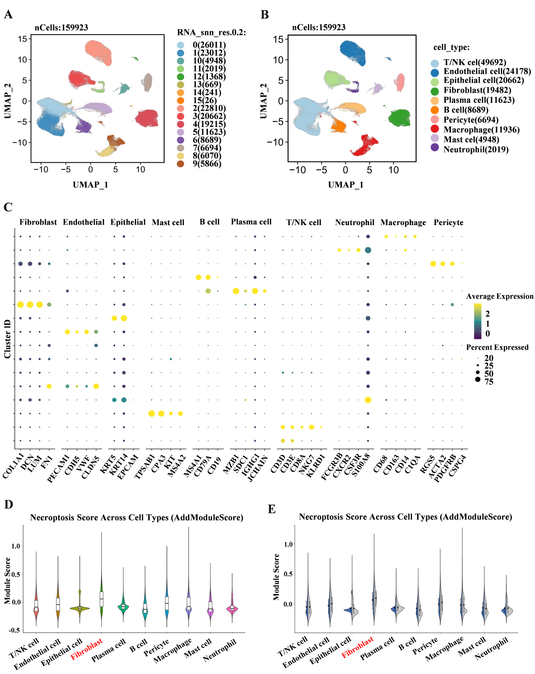
Appendix Figure 1. Single-cell transcriptomic landscape of periodontal tissues reveals fibroblast-enriched necroptosis signaling. (A) UMAP projection of 159,923 periodontal cells colored by Seurat cluster resolution 0.2 (15 clusters). (B) Same UMAP colored by major cell-type annotations: Fibroblast (19,482 cells), Endothelial (24,178), Epithelial (20,662), Mast cell (4,948), B cell (8,689), Plasma cell (11,623), T/NK cell (49,692), Neutrophil (2,019), Macrophage (11,936) and Pericyte (6,694). (C) Dot-plot showing average expression and percentage of cells expressing canonical necroptosis genes across the ten identified lineages; fibroblasts display the highest combined expression. (D) AddModuleScore-based necroptosis pathway activity projected on UMAP; warmer colors indicate higher scores. (E) Box-plot summarizing necroptosis scores per cell type; fibroblasts exhibit the highest median activity, implicating them as the primary necroptosis-susceptible population in periodontitis.

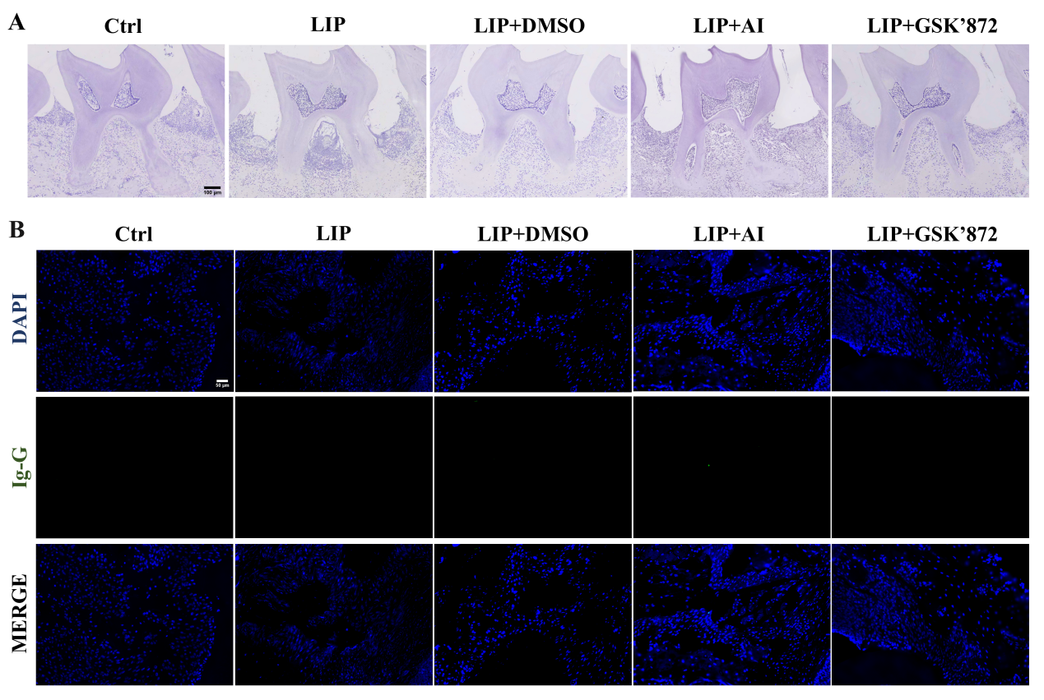
Appendix Figure 2. Negative control gingiva or maxilla were examined by IHC or IF. (A) Negative control maxilla in the blank mouse group were examined by IHC. (B) Negative control maxilla in the blank mouse group were examined by IF. All assays were performed without the primary antibody.

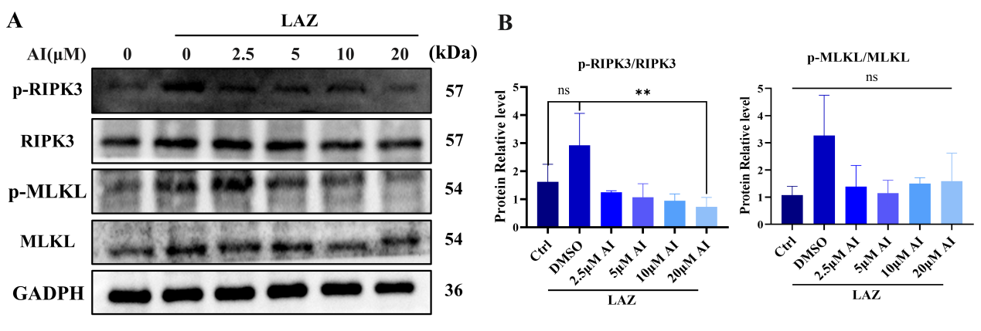
Appendix Figure 3. Necroptosis-related proteins in LAZ-stimulated hGFs. (A, B) Protein levels of necroptosis-related genes in hGFs stimulated with LAZ for 6h after pretreatment with different concentrations of AdipoAI were quantified by WB. n=3 per group.

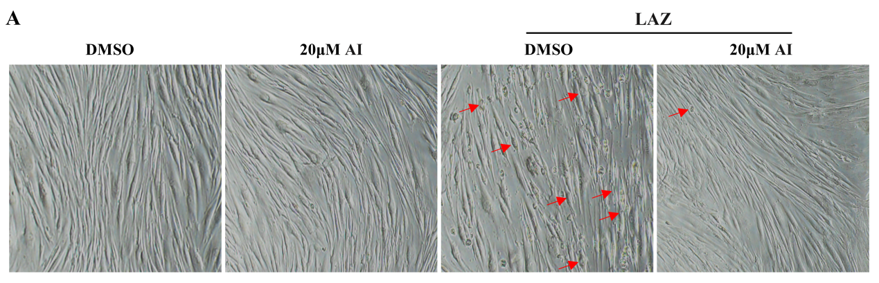
Appendix Figure 4. LAZ-induced necroptosis modulated the morphology of hGFs. (A) Representative microphotographs of electron light microscopy of the morphology of necroptosis of cells. Arrows: shrinking cell bodies, intracellular bubble-like changes.

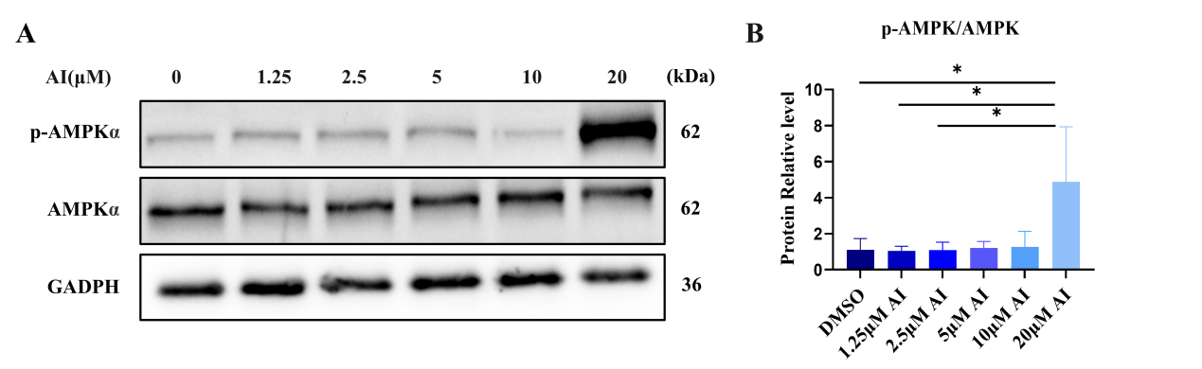
Appendix Figure 5. AdipoAI activates AMPK signaling in a concentration-dependent manner. (A, B) Protein levels of p-AMPK、AMPK in hGFs stimulated with different concentrations of AdipoAI were quantified by WB. n=3 per group.

Appendix TABLES
Appendix Table 1. Primer Sequences for qRT-PCR.
Gene | Forward Primer (5’-3’) | Reverse Primer (3’-5’)
hIL-6 | CCCCTGACCCAACCACAAAT | GTGCCCATGCTACATTTGCC
hIL-1β | ACGAATCTCCGACCACCA | GCAGGGAACCAGCATCTT
hCOX-2 | CTGGCGCTCAGCCATACAG | CGCACTTATACTGGTCAAATCCC
hGAPDH | CTGGGCTACACTGAGCACC | AAGTGGTCGTTGAGGGCAATG
mIL-6 | TCCAGTTGCCTTCTTGGGAC | GTGTAATTAAGCCTCCGACTTG
mIL-1β | GAAAGACGGCACACCCACCCT | GCTCTGCTTGTGAGGTGCTGATGTA
mCOX-2 | TTCCAATCCATGTCAAAACCGT | AGTCCGGGTACAGTCACACTT
mGAPDH | GACTTCAACAGCAACTCCCAC | TCCACCACCCTGTTGCTGTA

