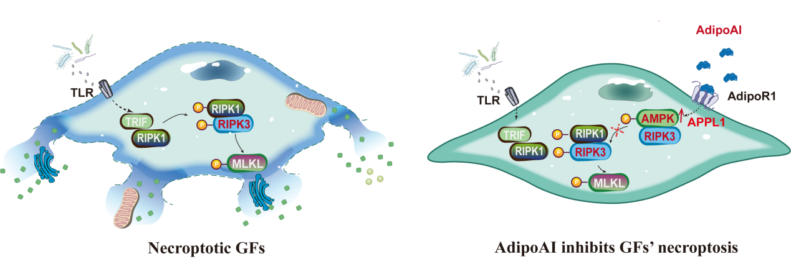

Graphical Abstract：Mechanism diagram of AdipoAI inhibiting GFs necroptosis. AdipoAI negatively regulates necroptosis by activating the AdipoR1/APPL1/AMPK pathway, where phosphorylated AMPK (p-AMPK) competitively binds to RIPK3, thereby suppressing the formation of the necrotic complex.

