Appendix A
This appendix provides the visual representations of the moderation results to complement the statistical findings reported in Section 5.3. Figures 2 and 3 illustrate the gender-specific interaction patterns observed in the analyses
- Results for Men
Figure 2 presents the AMOS results for the men sample (n = 996).
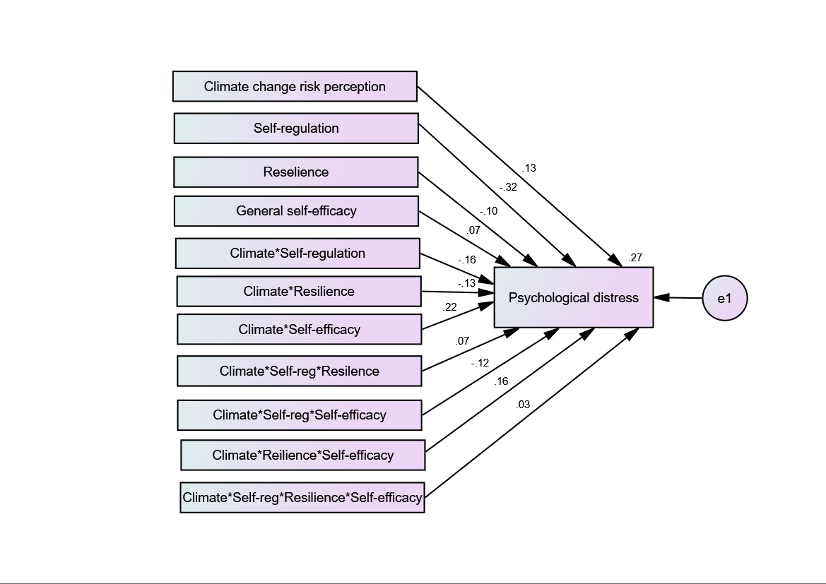

Figure 2 AMOS analysis of the moderating effects of three variables and their interactions on the relationship between climate change risk perception and psychological distress among men participants

2-Results for Women
Figure 3 presents the AMOS results for the women sample (n = 1096).

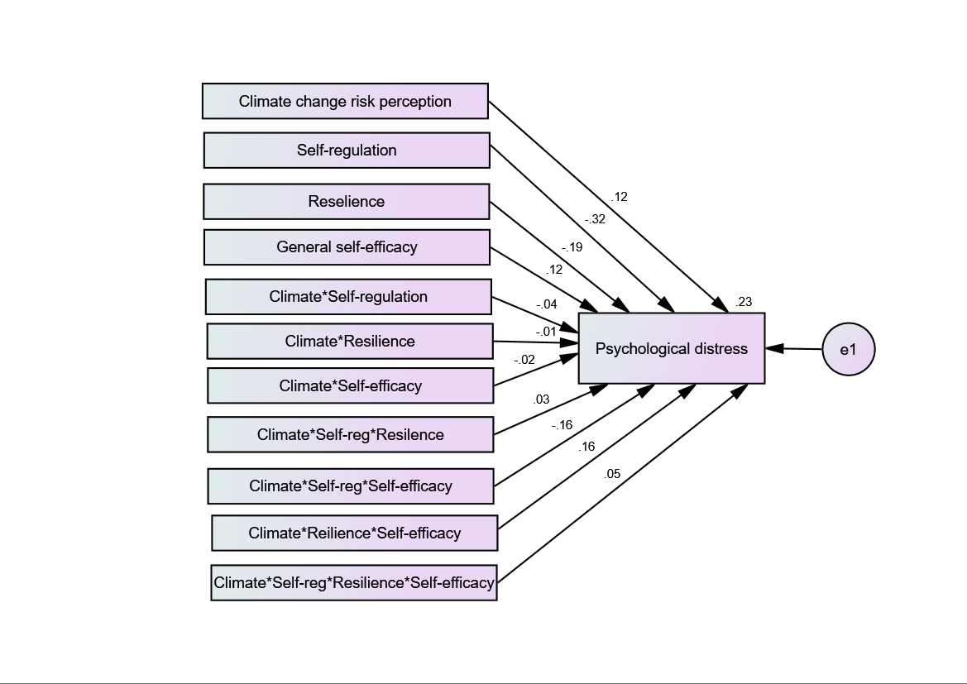

Figure 3 AMOS analysis of the moderating effects of three variables and their interactions on the relationship between climate change risk perception and psychological distress among women participants

