Supplementary Materials for “Semiparametric Outcome Regression-Based Estimator of the Mann-Whitney-type Causal Effect”

Web Appendix I: Simulation Approach for Estimation of True Theta ($\text{θ}$)
A pseudo-population of n=1,000,000 observations was generated according to the study’s data-generating process to estimate true values across various simulation scenarios. The methodology involved two steps:
Step 1: Parameter Specification and Data Generation
- n set to 1,000,000.
- Confounder coefficient (β) and treatment effect parameter (τ) selected
- Confounder sampled from a standard normal distribution
- Potential outcomes under both treatment and control generated using the exponential linear model with added noise as described in Section 3.1.
Step 2: Estimate Causal Effects via Pairwise Comparison
- Randomly sampled 1,000,000 independent pairs of potential outcomes (i, j)
- Calculated h(y_{i}, y_{j}) across all sampled pairs; h(y_{i}, y_{j}) = 1 if individual i had a greater outcome than j, h(y_{i}, y_{j}) = 0.5 if their outcomes were equal, and h(y_{i}, y_{j}) = 0 if individual i had a smaller outcome than j.
- Averaged results across all pairs to estimate the population-level Mann–Whitney-type causal effect

Web Appendix II: Comparison Models

- CPMs with correct link function:
$$\text{G}\text{[}\text{P}\left(\text{Y}\text{≤}\text{y} | \text{X}\text{,}\text{A}\right)\text{]=}\text{α}\left(\text{y}\right)\text{-}{{\text{β}}_{\text{1}}}^{\text{T}}\text{X}\text{-}{\text{β}}_{\text{2}}\text{A}$$
where G[.] is a probit link function
- CPMs with incorrectly specified link function:
$$\text{G}\text{[}\text{P}\left(\text{Y}\text{≤}\text{y} | \text{X}\text{,}\text{A}\right)\text{]=}\text{α}\left(\text{y}\right)\text{-}{{\text{β}}_{\text{1}}}^{\text{T}}\text{X}\text{-}{\text{β}}_{\text{2}}\text{A}$$
where G[.] is a logit link function
- CPMs that exclude the confounder variable:
$$\text{G}\text{[}\text{P}\left(\text{Y}\text{≤}\text{y} | \text{X}\text{,}\text{A}\right)\text{]=}\text{α}\left(\text{y}\right)\text{-}{\text{β}}_{\text{2}}\text{A}$$
where G[.] is a probit link function
- Correctly transformed parametric models:
$\text{log(}\text{Y}\text{)= }{\text{β}}_{\text{0}}\text{ +}{\text{β}}_{\text{1}}\text{X}\text{ + }{\text{β}}_{\text{2}}\text{A}\text{ + }\text{ε}\text{ , }\text{ε}\text{\sim N(0, }{\text{σ}}^{\text{2}}\text{)}$
- Incorrectly transformed parametric models:
$$\text{sqrt}\text{(}\text{Y}\text{)=}{\text{β}}_{\text{0}}\text{ +}{\text{β}}_{\text{1}}\text{X}\text{ + }{\text{β}}_{\text{2}}\text{A}\text{ + }\text{ε}\text{, }\text{ε}\text{\sim N(0, }{\text{σ}}^{\text{2}}\text{) }$$

Note that the intercept, $\text{α}\left(\text{y}\right)\text{, }$is estimated using a step function with the CPM. ${\text{β}}_{\text{1}}$ is the coefficient for the confounder variable X, ${\text{β}}_{\text{2}}$ is the coefficient for the treatment variable A, and $\text{ε}$ is the error term, which accounts for the randomness or other factors not included in the model.

Web Appendix III: Figures
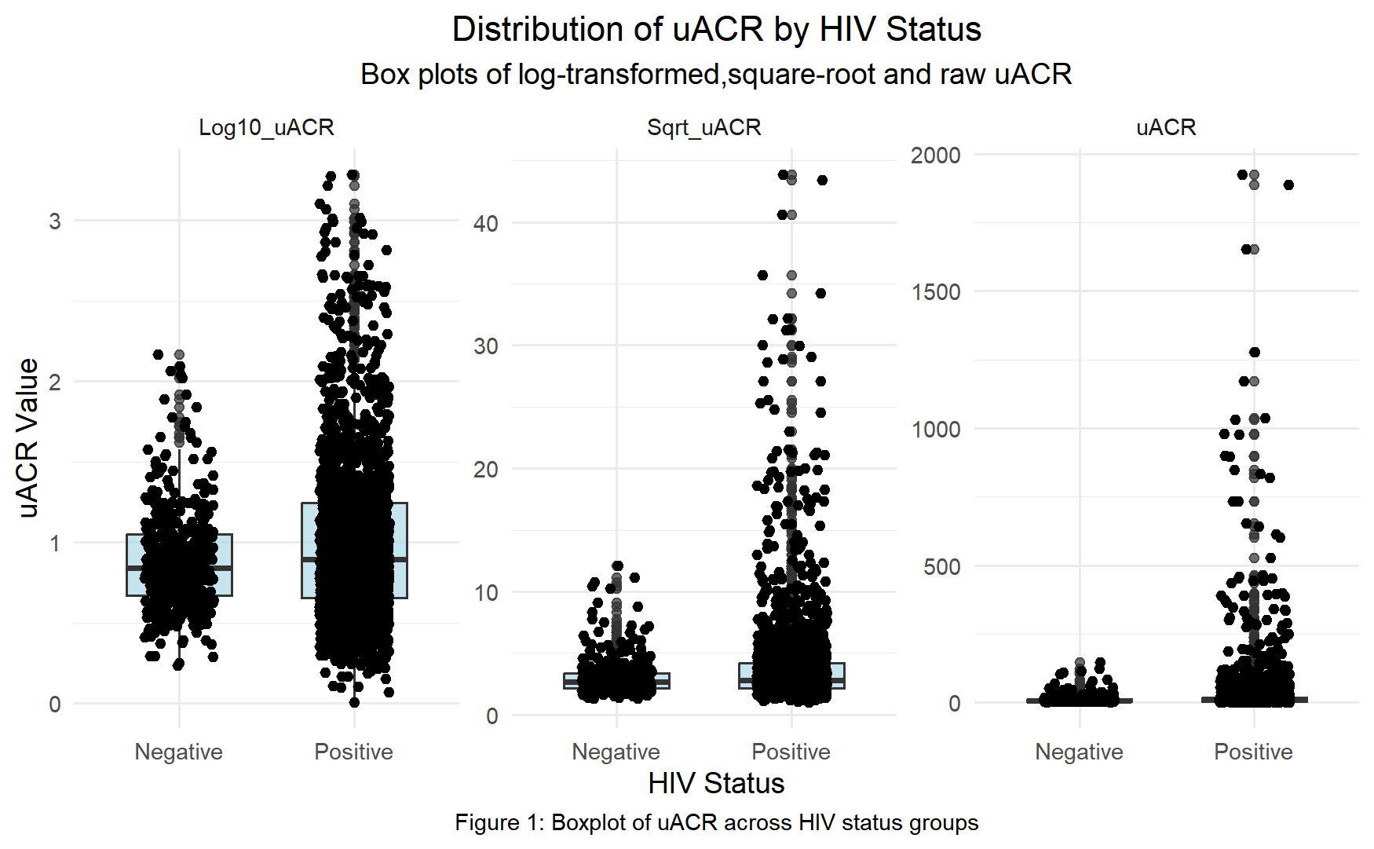

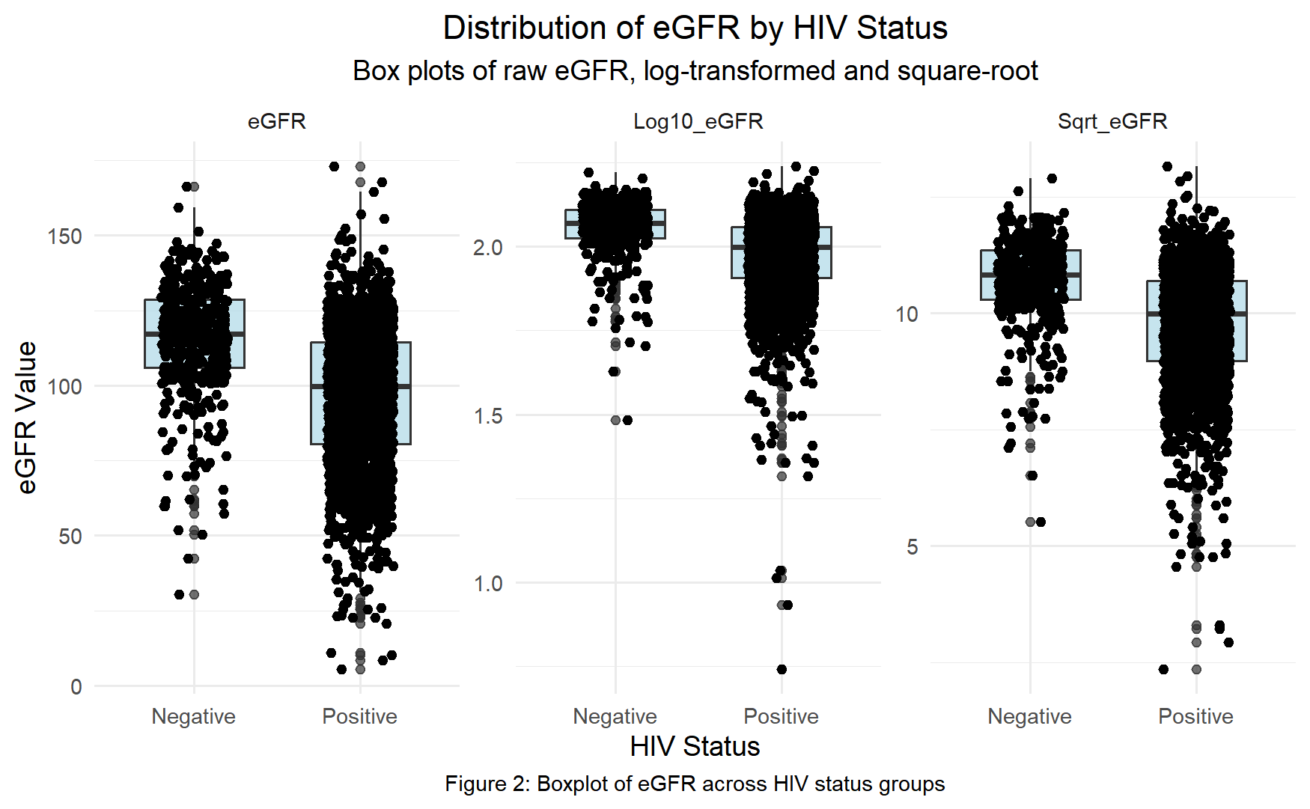

Web Appendix IV: R Codes

Function to fit cumulative probability model, predict F_{Y} and compute $\hat{\text{θ}}$

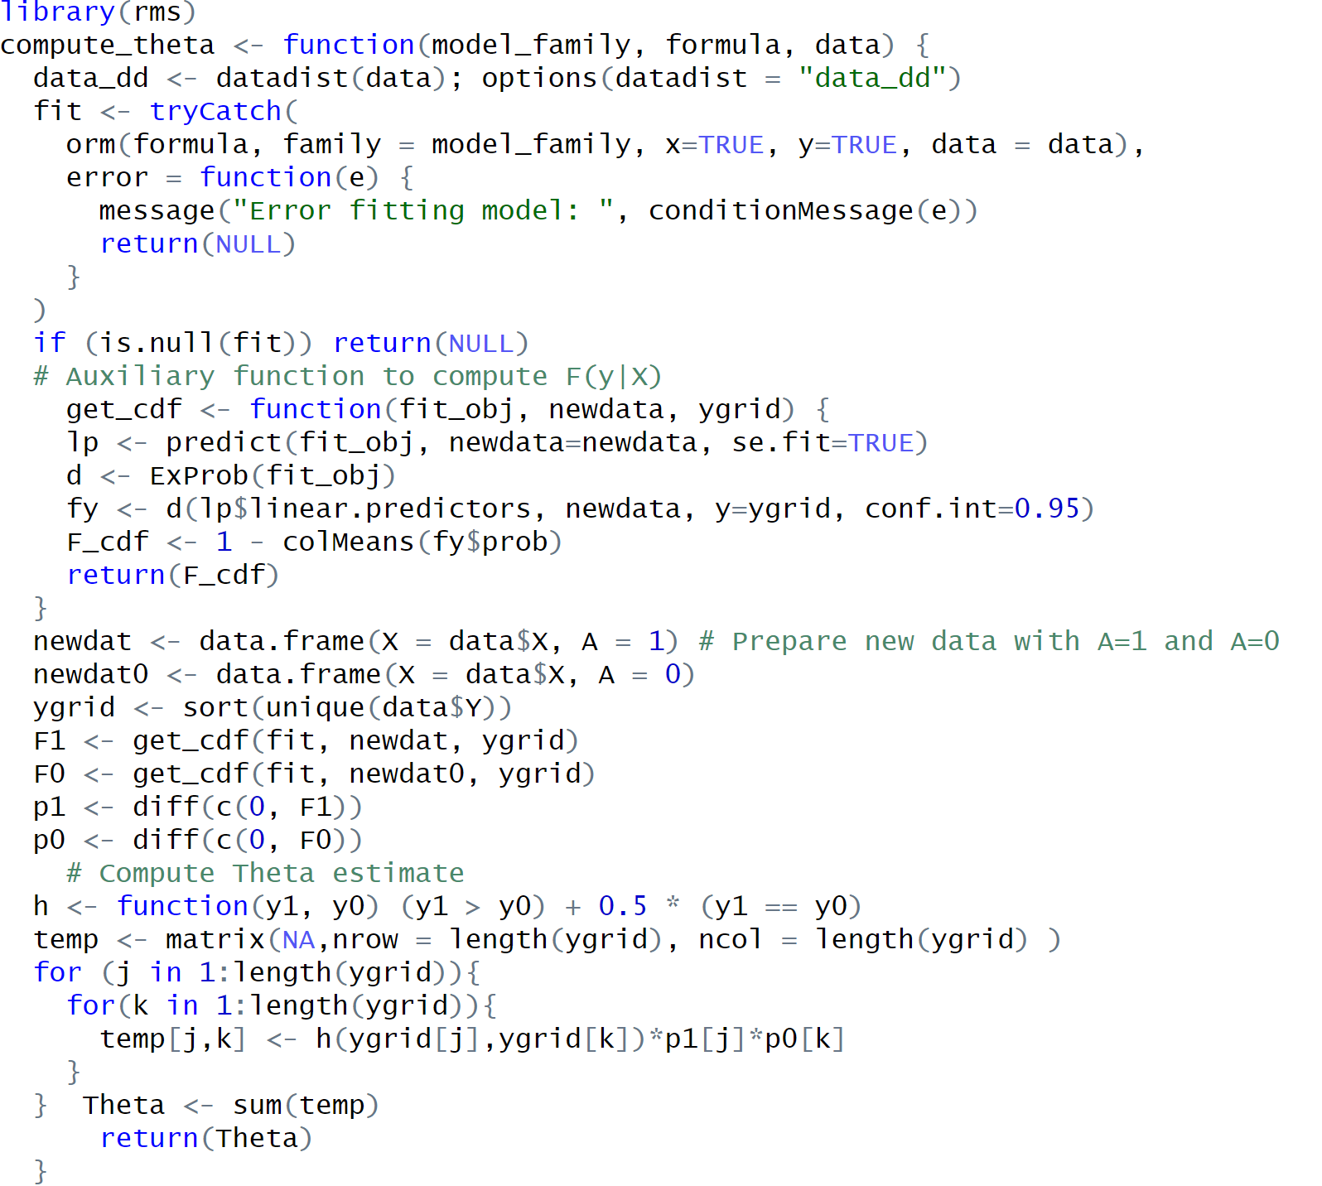

Function to fit transformed linear model, predict, and calculate $\hat{\text{θ}}$

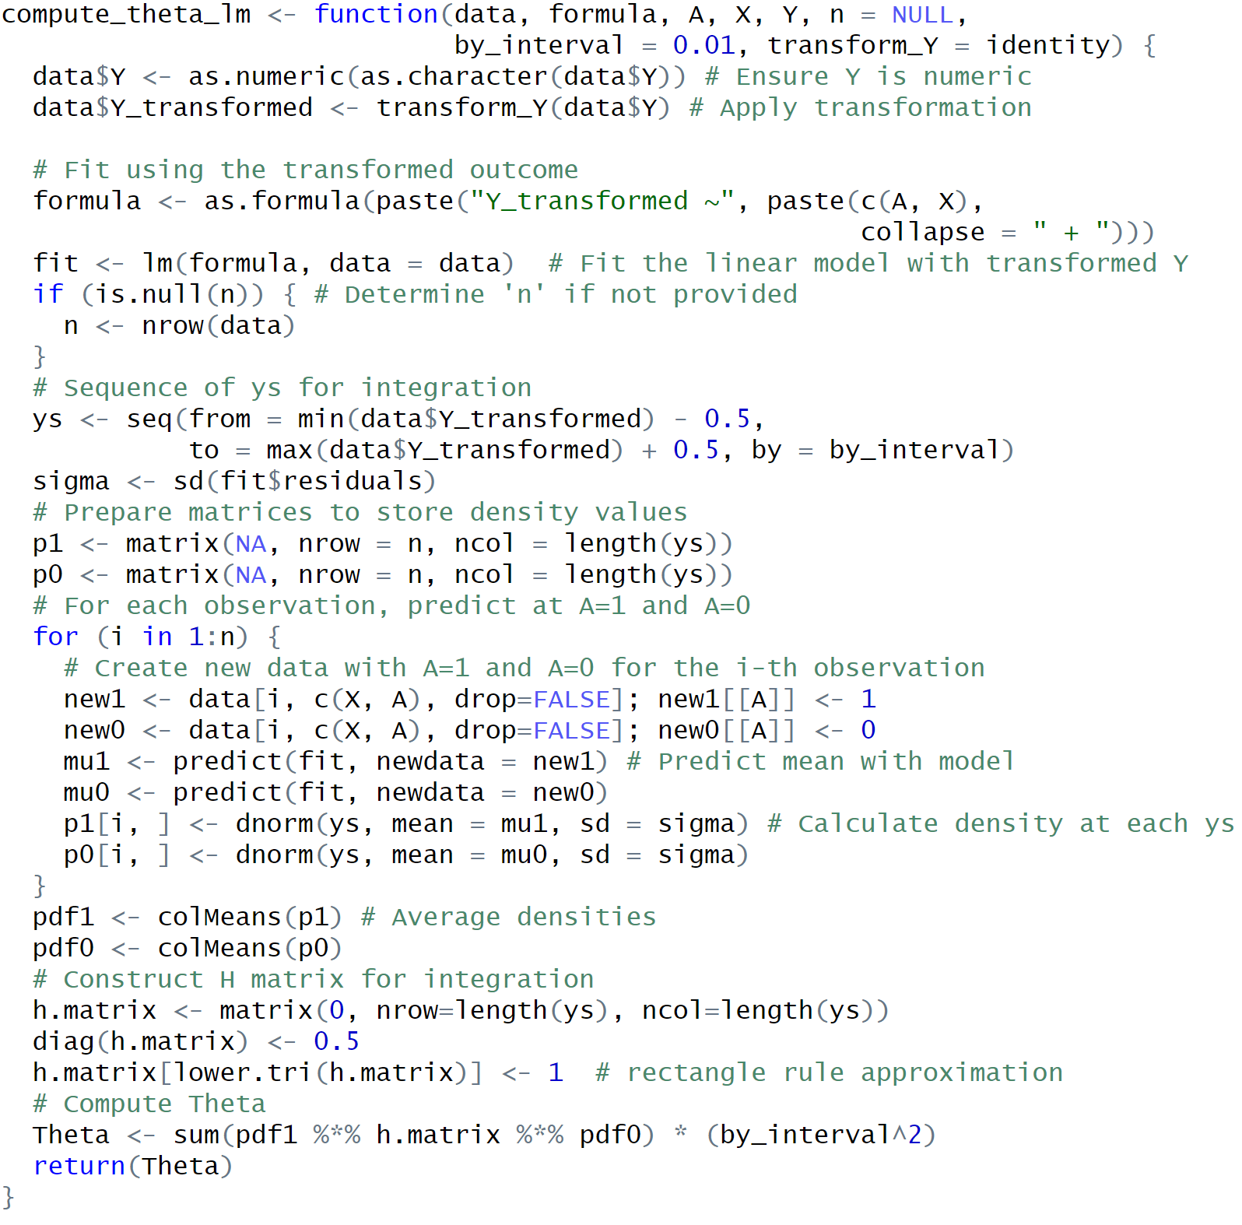

Web Appendix V: Model Fit and Residual Diagnostics

1. Model Fit Comparison Using Log-Likelihood
We compared loglikelihoods of cumulative probability models (CPMs) with different link functions for modeling uACR and eGFR:

Model | Details | uACR Log-likelihood | eGFR Log-likelihood
CPM 1 | Logit link function | -17780.88 | -16044.71
CPM 2 | Probit link function | -17777.09 | -16064.85
CPM 3 | Log-log link function | -17765.36 | -16135.79

With respect to uACR, the Log-log link yielded the highest log-likelihood, indicating the best statistical fit among the cumulative probability models—though the margin of improvement was modest. For eGFR, the Logit link clearly outperformed the alternatives, while the Log-log link showed the poorest fit.

2. QQ Plots of Empirical Residuals
We generated QQ plots of empirical residuals against a Uniform distribution for each model to detect departures from the assumption of no systematic error across the entire support. For the uACR models, all three link functions resulted in similar QQ plots. For the eGFR models, the logit link function most closely approximated the uniform distribution; minimal departures from uniformity are seen with the log-log link function.

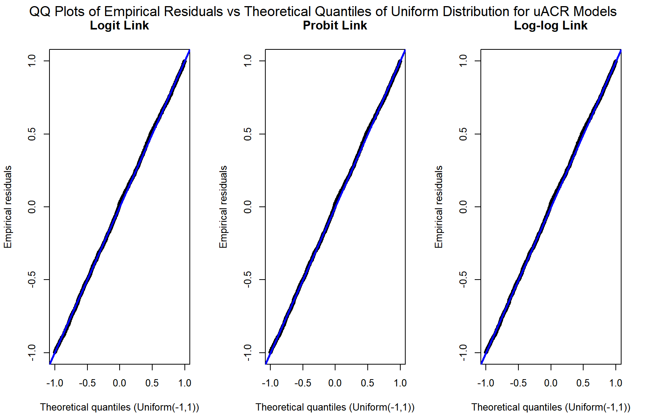
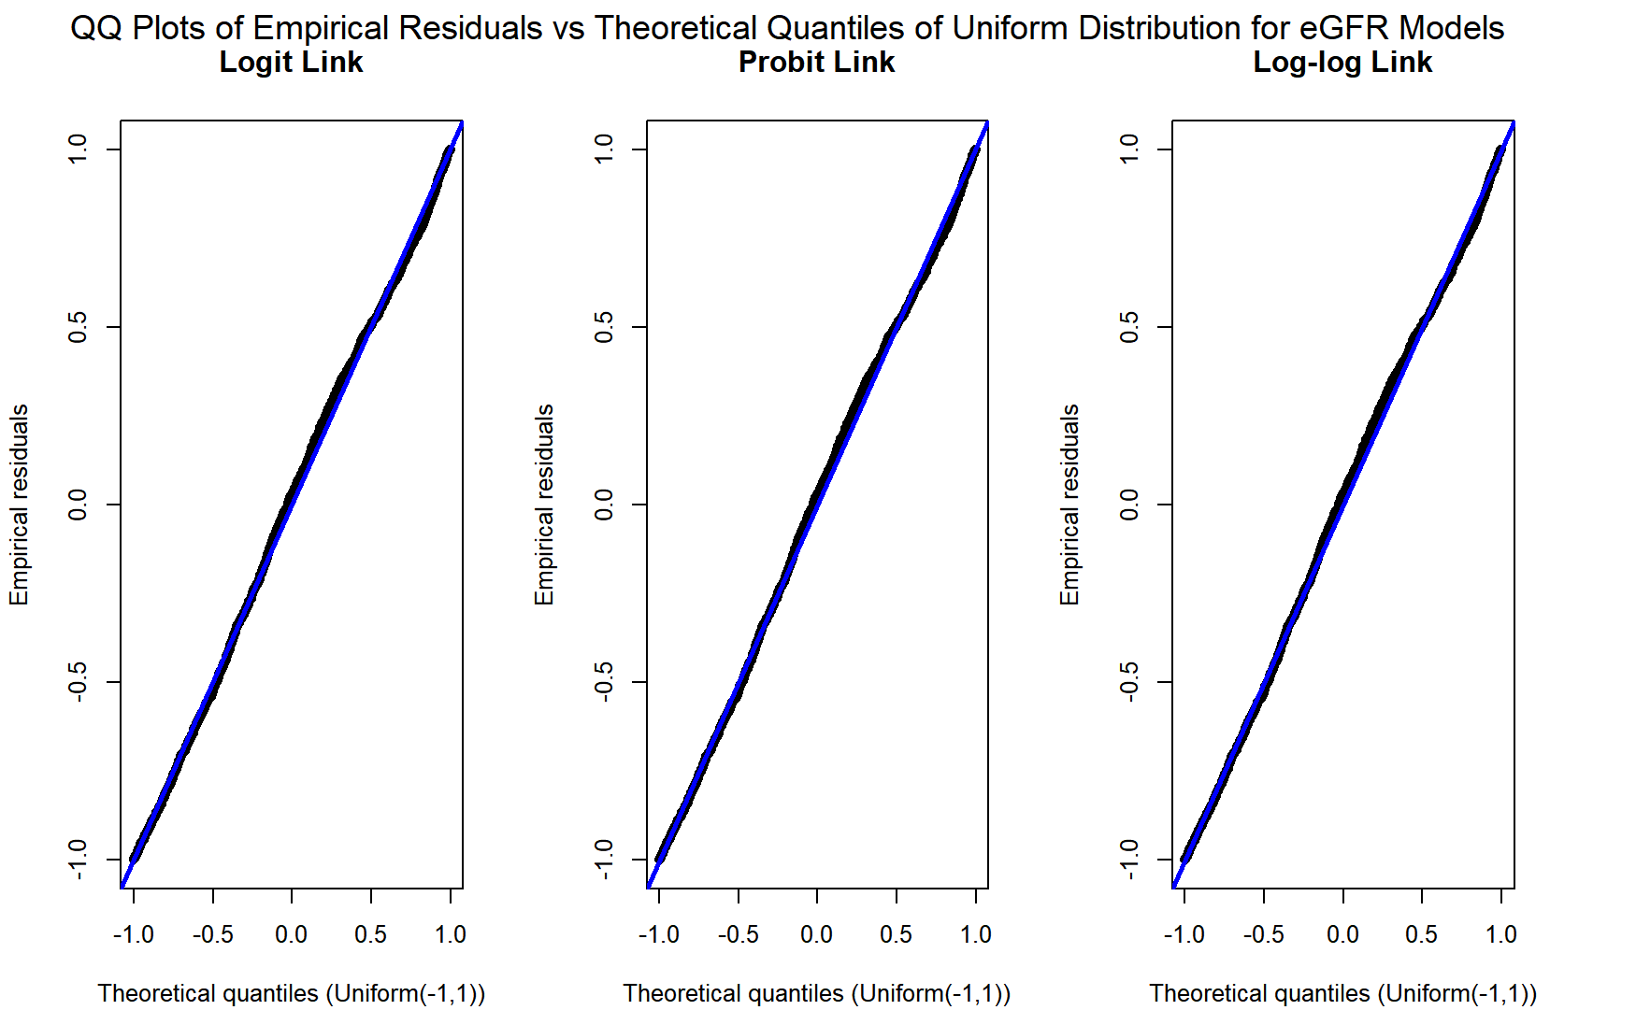
Additional Notes
- Bootstrapped estimates of treatment effects were also generated and are available upon request.

