Krishnapriya Thiyagarasaiyar¹, Dhiraj Paul¹, Johanna Kerttula¹, Milja Keski-Karhu¹, Kaido Soosaar², Ülo Mander², Sara Hallin³, Katerina Machacova⁴, Jukka Pumpanen¹, Henri M.P. Siljanen¹

¹ Department of Environmental and Biological Sciences, University of Eastern Finland, Kuopio, Finland
² Department of Geography, Tartu University, Tartu, Estonia
³ Department of Forest Mycology and Plant Pathology, Swedish University of Agricultural Sciences, Uppsala, Sweden
⁴ Department of Ecosystem Trace Gas Exchange, Global Change Research Institute of the Czech Academy of Sciences, Brno, Czech Republic
*Correspondence:
Email: krishnapriya.thiyagarasaiyar@uef.fi

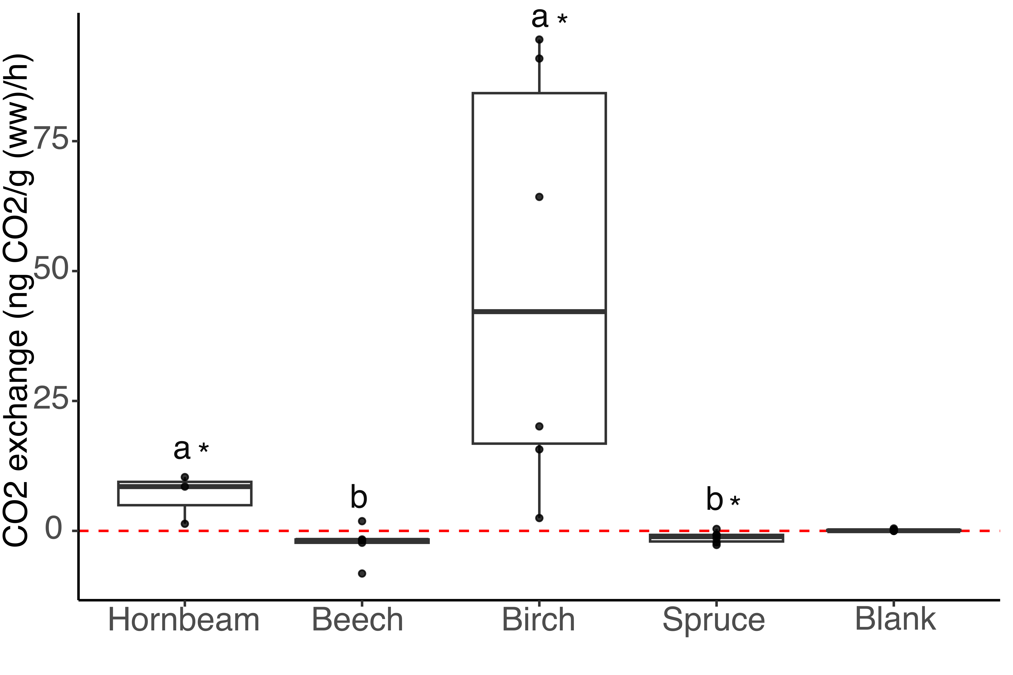
Fig.S1. CO₂ exchange rate for shoot sample from incubation studies using gas chromatography. The box plots showed all the data points in black dots, and black line inside the box represents the median (n ≥ 3). Significant differences are indicated by different letters and were determined separately for CO₂ exchanges across trees * indicate statistical difference (P < 0.05) between trees and blank.

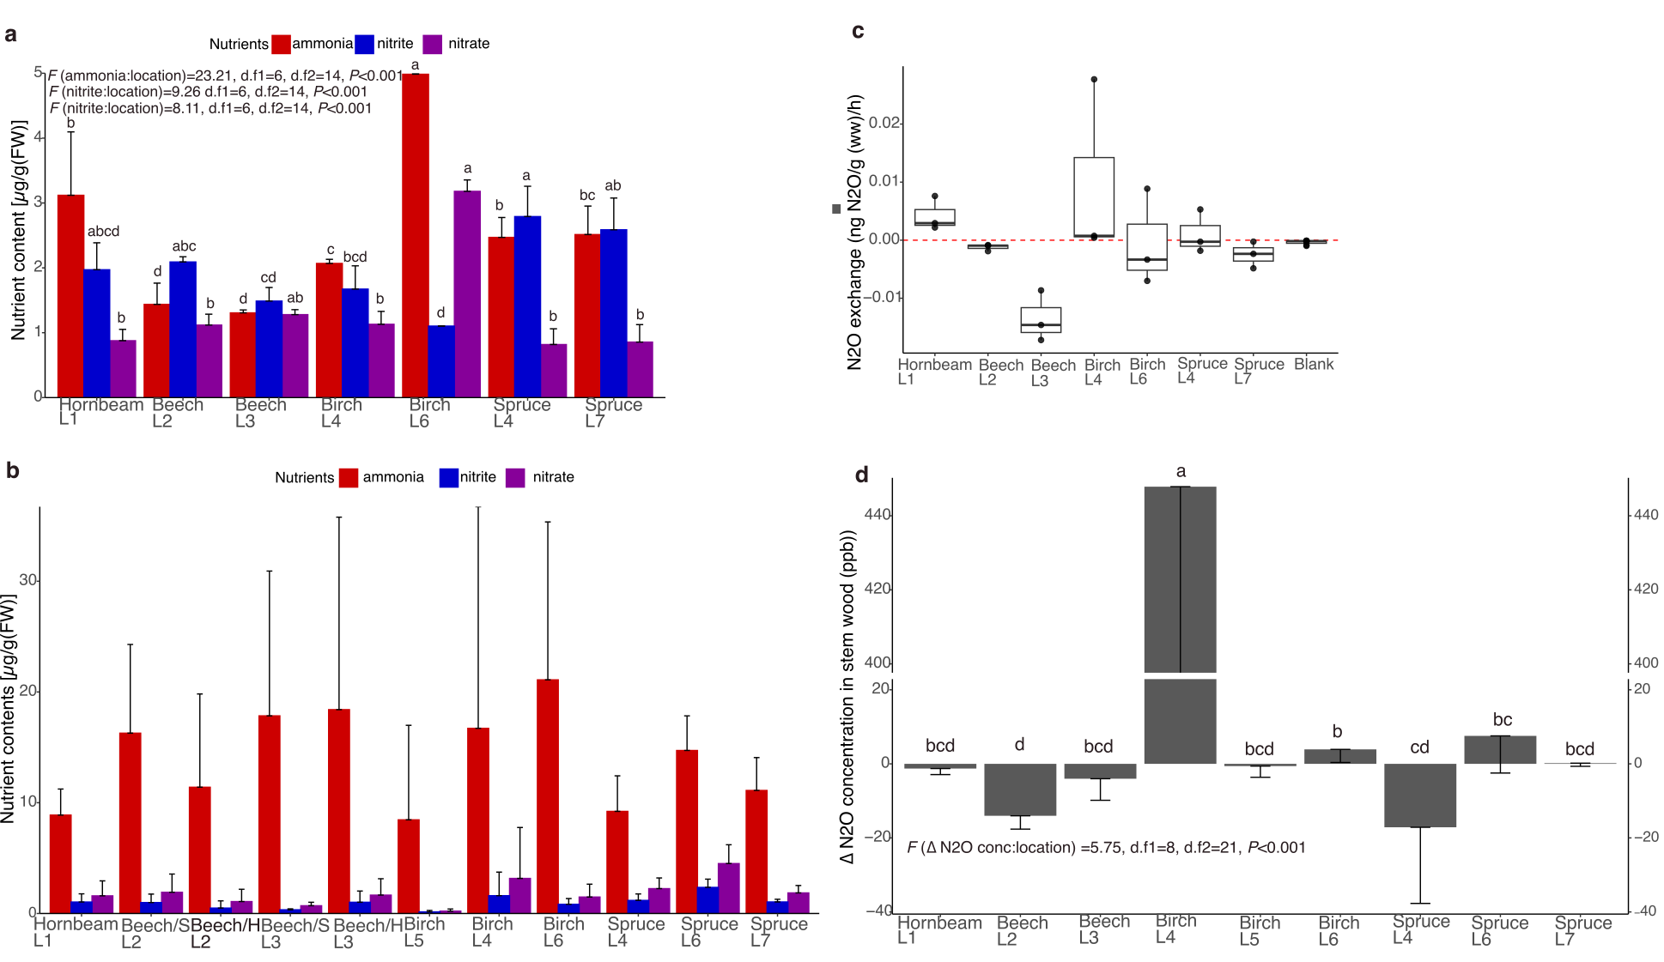
Figure S2: Nutrient content and N₂O fluxes in plant tissues collected from different locations. (a): NH₄⁺, NO₂– and NO₃– concentrations in shoots (mean+standard deviation), (b): NH₄⁺, NO₂– and NO₃– in wood cores (mean+standard deviation), (c): N₂O exchange of shoots (mean+standard deviation), (d): D N₂O concentration in stem wood (C_{stem wood} – C_{ambient air}; mean–standard deviation). Significant differences are indicated by different letters and were determined separately for each nutrients across locations (P < 0.05) in (a) and statistical difference between different locations in (d). No significant differences were observed in (b) and (c). Beech/S means beech sapwood and Beech/H means beech heartwood in b. L1= Lanžhot, Czech Republic; L2= Štítná nad Vláří, Czech Republic; L3= Bromarv, Finland; L4=Agali, Estonia; L5= Kiidjärve, Estonia; L6=Puijo, Finland; L7=Kenttärova-Pallas, Finland.

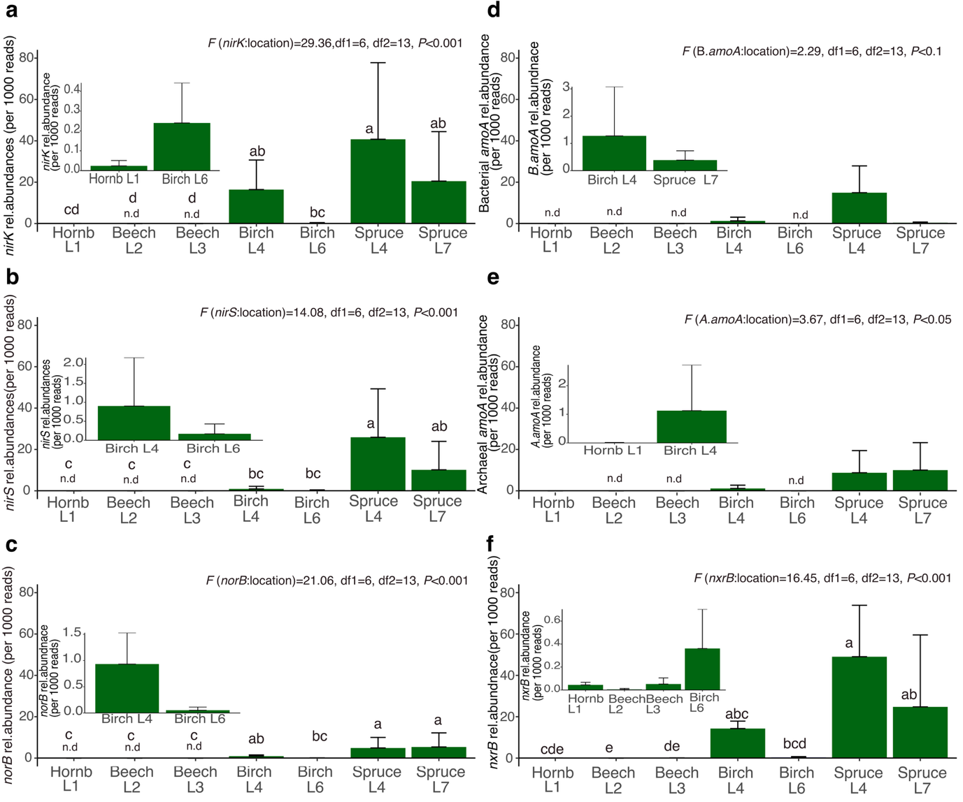
Figure S3: Relative abundances of denitrification and nitrification genes in shoot tissues from different locations. Relative abundances were calculated as total counts in relation to total reads (mean+standard deviation). (a) nirK, (b) nirS, (c) norB, (d) bacterial amoA, (e) archaeal amoA, (f) nxrB. Sites where N cycling genes were not detected are marked with n.d. L1= Lanžhot, Czech Republic; L2= Štítná nad Vláří, Czech Republic; L3= Bromarv, Finland; L4=Agali, Estonia; L6=Puijo, Finland; L7=Kenttärova-Pallas, Finland.

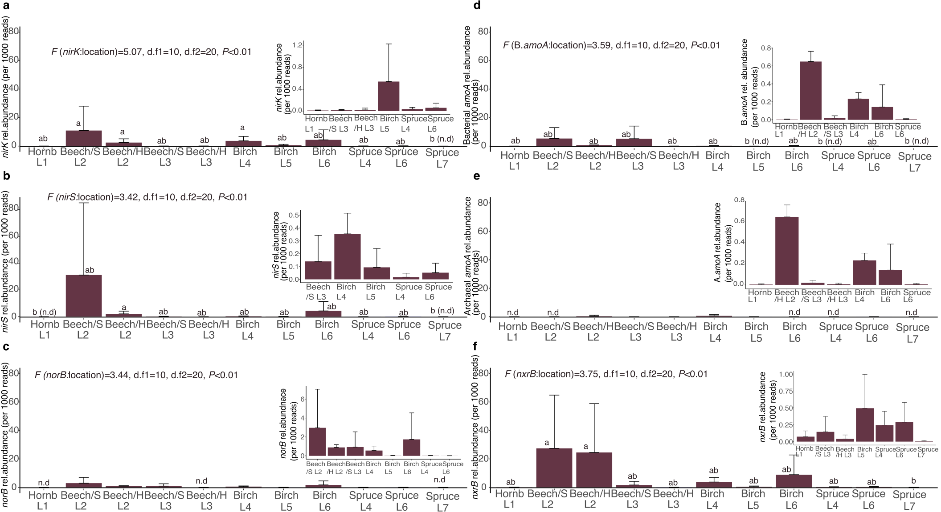
Figure S4: Relative abundances of denitrification and nitrification genes in wood cores from different locations. Relative abundances were calculated as total counts in relation to total reads (mean+standard deviation). (a) nirK, (b) nirS, (c) norB, (d) bacterial amoA, (e) archaeal amoA, (f) nxrB. Sites where N cycling genes were not detected are marked with n.d. Beech/S means beech sapwood and Beech/H means beech heartwood. L1= Lanžhot, Czech Republic; L2= Štítná nad Vláří, Czech Republic; L3= Bromarv, Finland; L4=Agali, Estonia; L5= Kiidjärve, Estonia; L6=Puijo, Finland; L7=Kenttärova-Pallas, Finland.

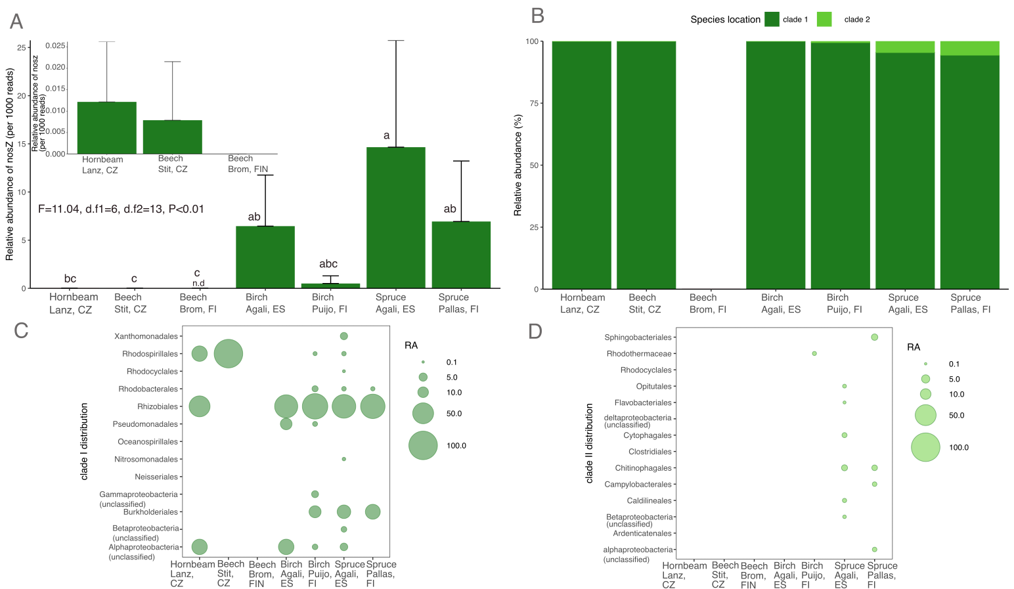
Figure S5: The nosZ genes in shoots. (a): Relative abundance of nosZ genes calculated as total counts in relation to total reads (mean+standard deviation). (b): Clade-specific relative abundance of nosZ normalized to total nosZ reads. (c) and (d): nosZ clade I and II distribution based on the classification at the order level. Sites where N cycling genes were not detected are marked with n.d. L1 = Lanžhot, Czech Republic; L2 = Štítná nad Vláří, Czech Republic; L3 = Bromarv, Finland; L4=Agali, Estonia; L6=Puijo, Finland; L7=Kenttärova-Pallas, Finland.

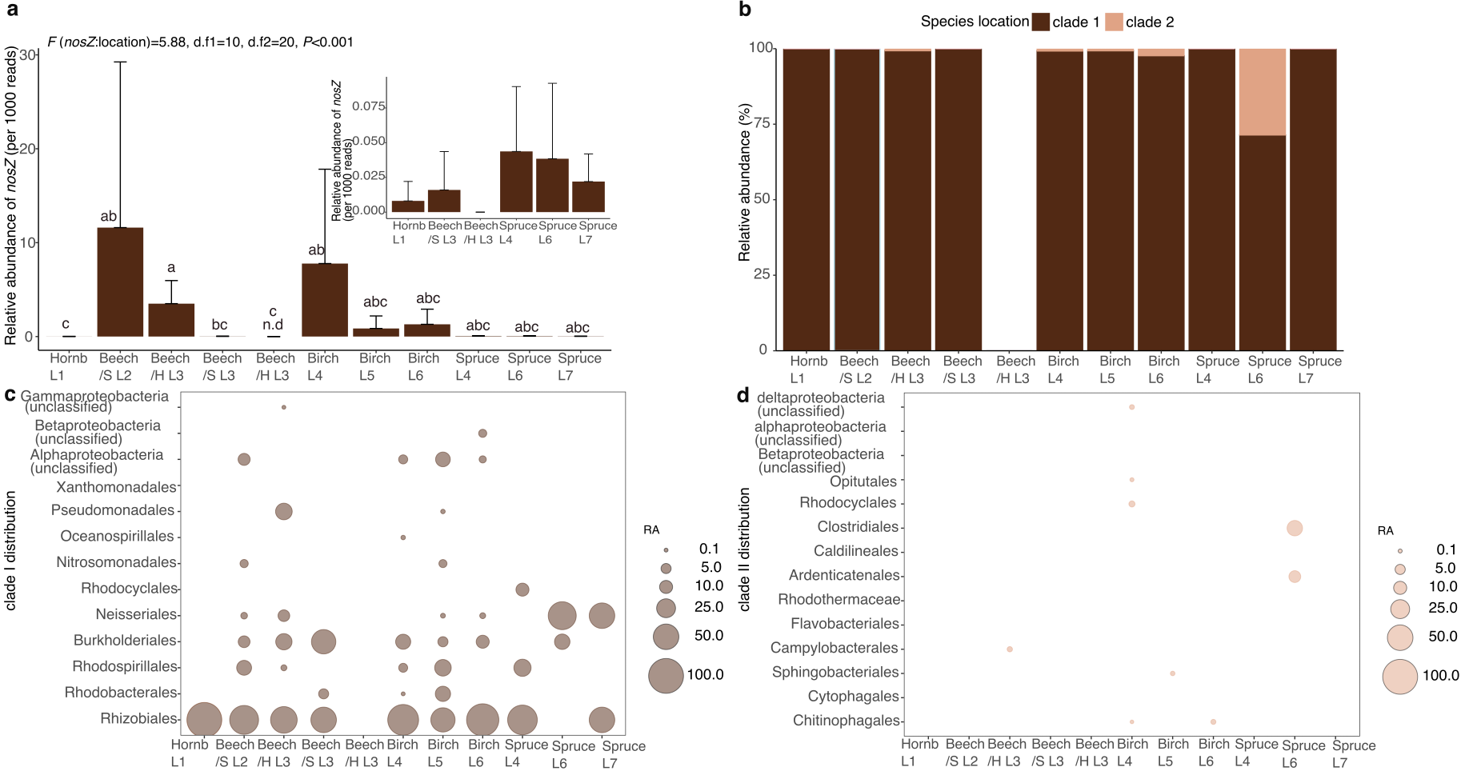
Figure S6: nosZ genes in wood core samples. (a): Relative abundance of nosZ calculated as total counts in relation to total reads (mean+standard deviation). (b): Clade-specific relative abundance of nosZ normalized to total nosZ reads. (c) and (d): nosZ clade I and II distribution based on the classification at the order level. Beech/S means beech sapwood and Beech/H means beech heartwood. Sites where N cycling genes were not detected are marked with n.d. L1= Lanžhot, Czech Republic; L2= Štítná nad Vláří, Czech Republic; L3= Bromarv, Finland; L4=Agali, Estonia; L5= Kiidjärve, Estonia; L6=Puijo, Finland; L7=Kenttärova-Pallas, Finland.

