Supplement to: Leaf wax isotopes reveal enhanced humidity and earlier growing season during Dansgaard-Oeschger warming events in Europe
Paul D. Zander^{1,2}, Frank Sirocko³, Xiaojing Du⁴, Chijun Sun⁵, Florian Rubach¹, Gerald H. Haug^{1,6}, Alfredo Martínez-García¹
¹Climate Geochemistry Department, Max Planck Institute for Chemistry, Mainz, 55128, Germany
²Center for Accelerator Mass Spectrometry, Lawrence Livermore National Laboratory, USA
³Institute of Geosciences, Johannes Gutenberg-University, Mainz, 55122, Germany
⁴Department of Atmospheric, Oceanic, and Earth Sciences, George Mason University, Fairfax, 22030, USA
⁵Department of Earth and Planetary Sciences, University of California Davis, Davis, 95616, USA
⁶Department of Earth Sciences, ETH Zurich, Zurich, 8092, Switzerland

*Corresponding authors: Paul D. Zander (paul.zander@mpic.de) and Alfredo Martínez-García (a.martinez-garcia@mpic.de)

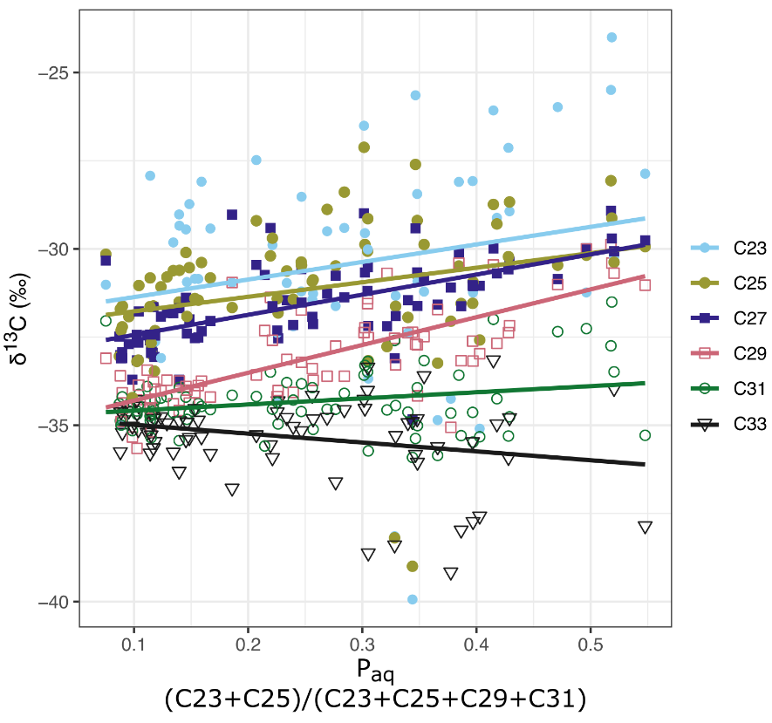
Fig. S1: Relationship between P_{aq}¹ and δ¹³C measured on different n-alkane chains showing variable contributions for aquatic material depending on chain length.
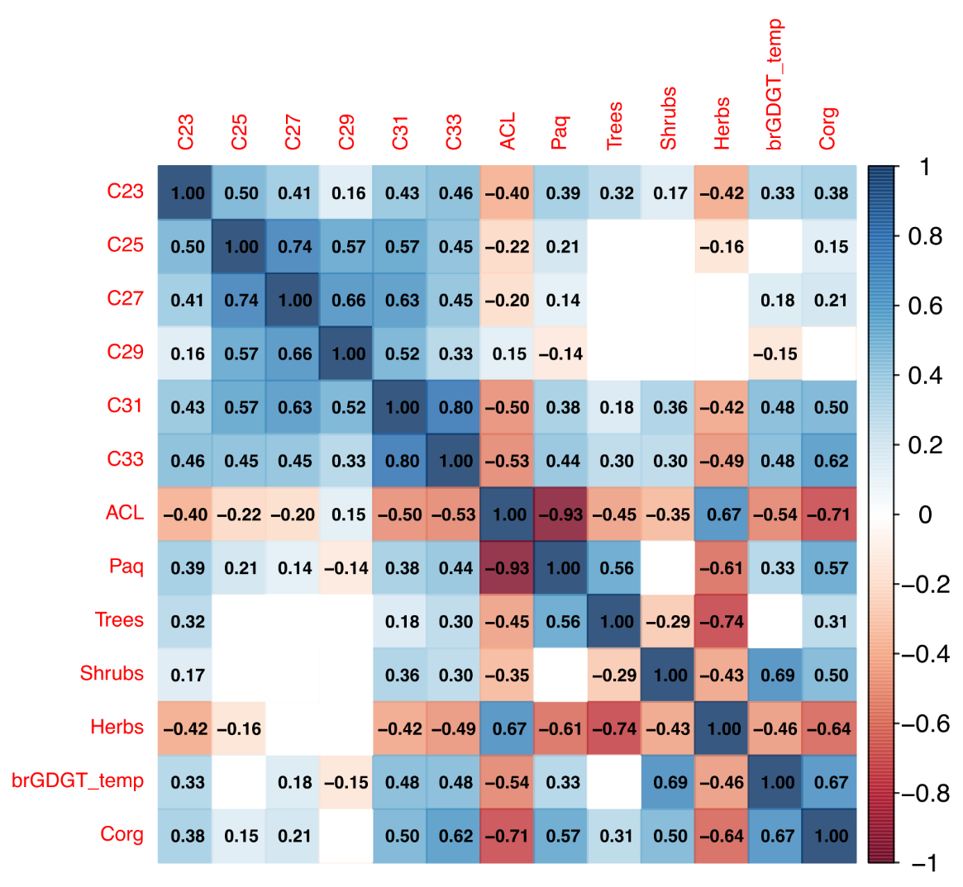
Fig. S2: Correlation matrix of δD and key proxies. Correlation coefficients are pearson r values. Correlation is not shown for P-values <0.05. P-values were corrected for multiple hypothesis testing using the false discovery rate method². Darker colors correspond to higher correlation or anticorrelation.
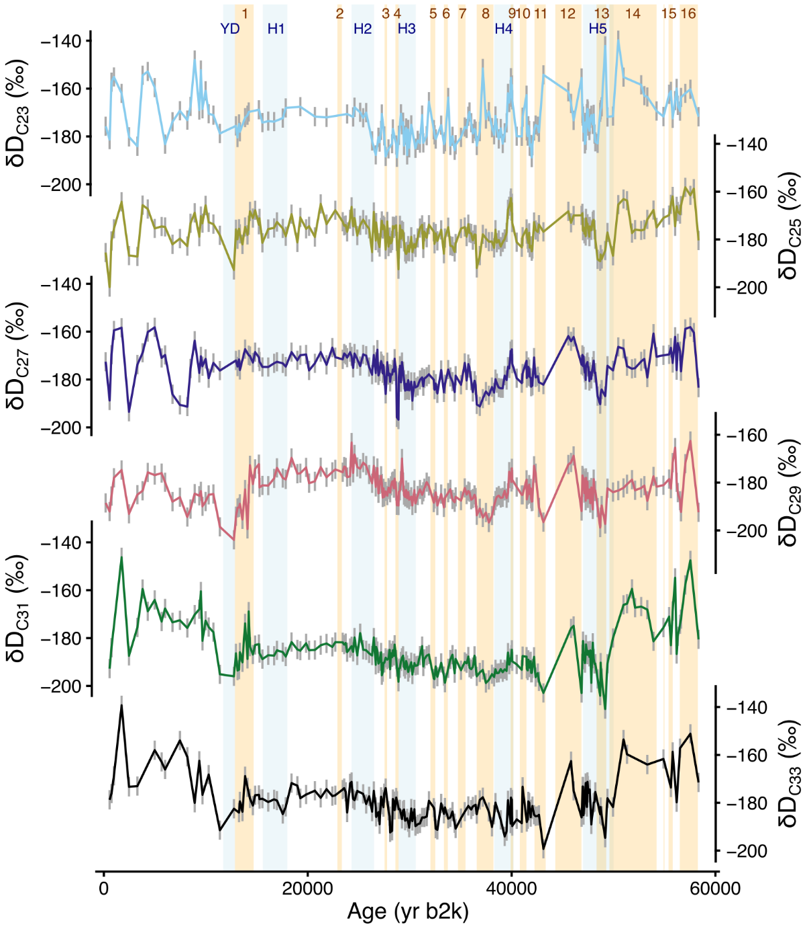
Fig. S3: Complete n-alkane δD dataset. Filled circles represent points with single measurements, open circles were measured in duplicate (or more) and error bars represent the pooled standard deviation of replicates (4 ‰)³.

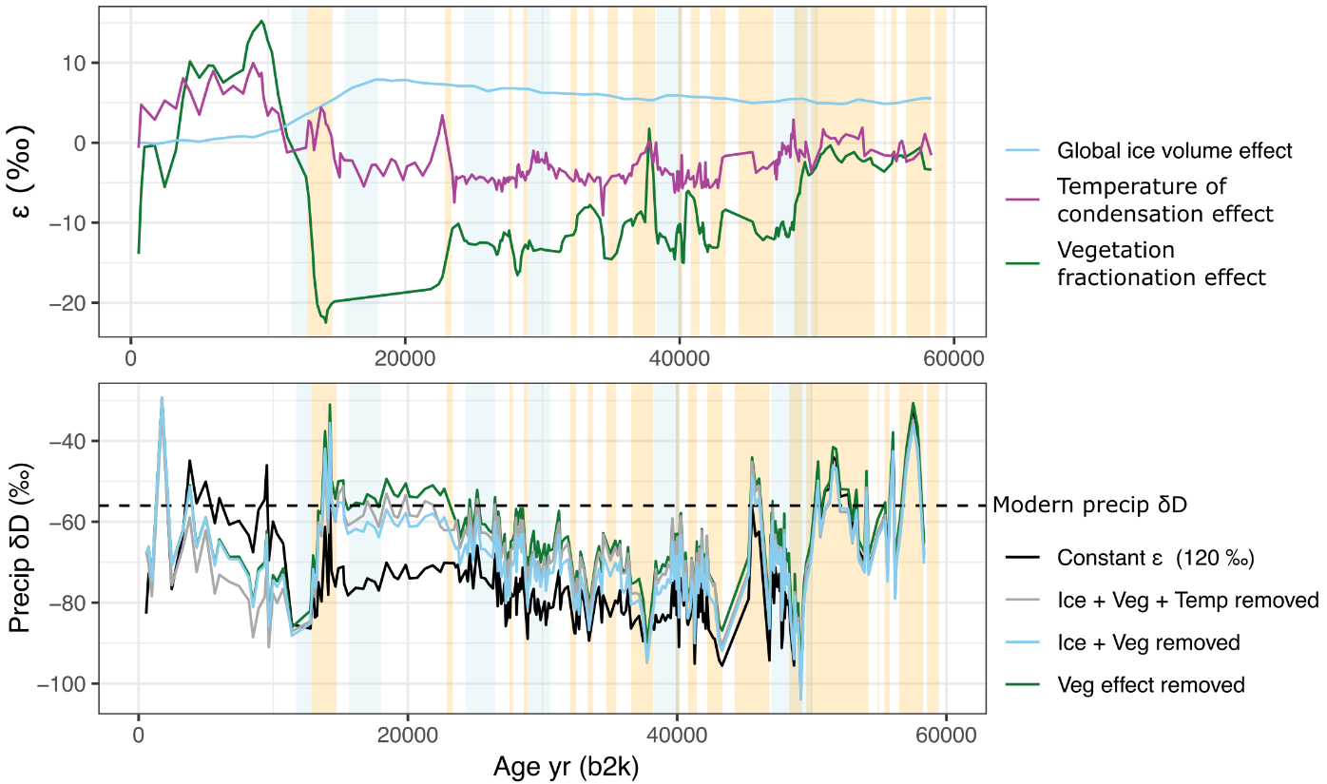
Fig. S4: Estimates of the effects of global ice volume changes, temperature, and vegetation on dD_{wax}. Vegetation effect calculated based on the proportion of herbs, shrubs and grasses in pollen data⁴ and the apparent fractionation factors estimated in Konecky et al⁵. The temperature effect was calculated based on the brGDGT temperature reconstruction for the ELSA study site⁶ and the relationship between precipitation isotopes and temperature observed in the two nearest GNIP stations, Koblenz and Trier⁷ (Fig. S7). Global ice volume effect was calculated using the method outline in Tierney et al⁸. The global marine benthic stack⁹ was scaled based on an assumption of 1 ‰ δ¹⁸O and 8 ‰ δD change in seawater composition between the LGM and present¹⁰.
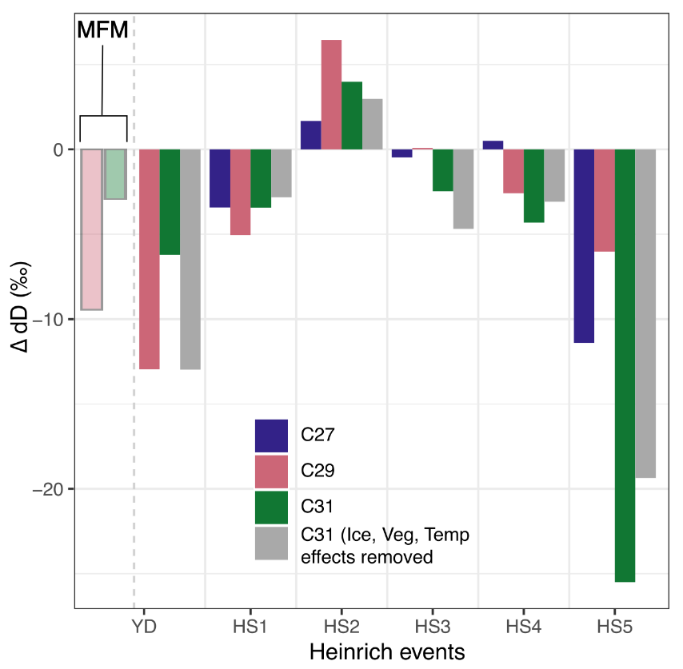
Fig S5: n-alkane δD response to Heinrich events. Offsets calculated as the mean δD of the Heinrich event minus the mean of the 500 years before the start of the event, except for HS1, where the baseline was extended to 1000 years to capture 2 data points. Our record contains only one data point during the YD, therefore data from nearby Meerfelder Maar (MFM) is also shown¹¹. Not that for MFM, the baseline period for the anomaly calculation is only 300 years. For details on ice, temperature and vegetation effects, see Fig. S4.
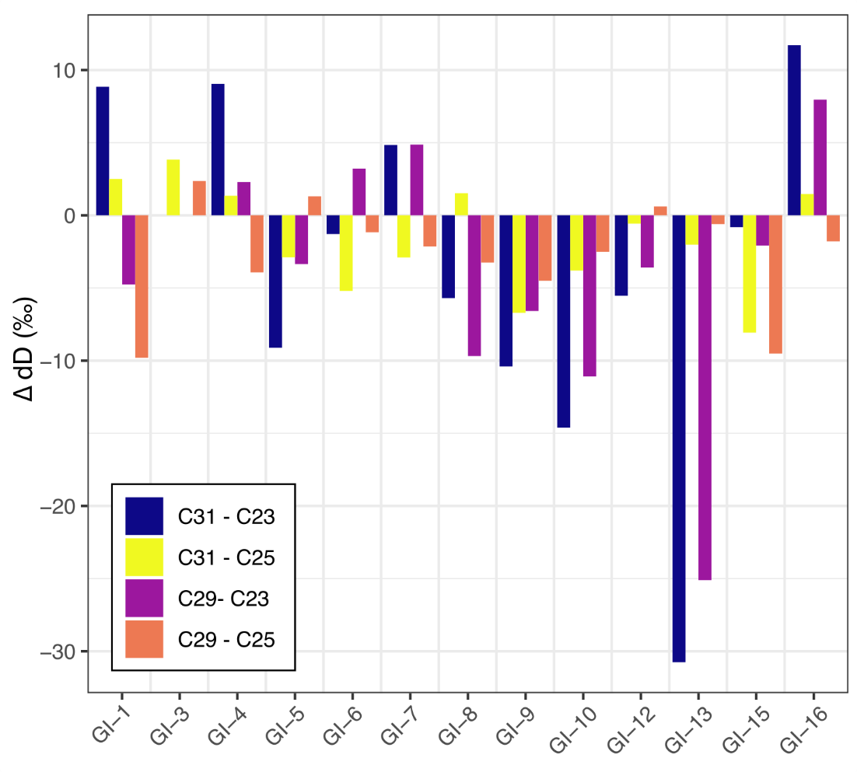
Fig. S6: Terrestrial minus aquatic δD changes across interstadial transitions. The dual biomarker method compares δD of terrestrial leaf wax n-alkanes and aquatic n-alkanes to assess evaporative enrichment¹². Each bar represents the change in terrestrial minus aquatic δD across GS to GI transitions, using the same calculation as in Fig. 4 in the main text. This calculation was done for four permutations of terr = C29 or C31 and aq = C23 or C25. Negative values indicate higher RH and less evaporative enrichment of terrestrial leaf water, assuming that lake water reflects precipitation δD¹².
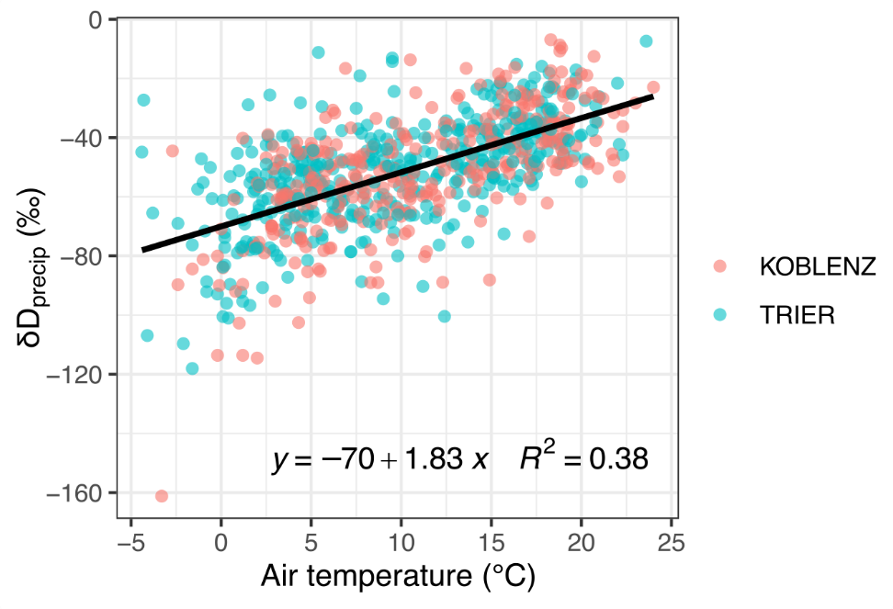
Fig. S7: Precipitation isotopes plotted versus temperature. Measured at GNIP stations at Koblenz and Trier, Germany⁷

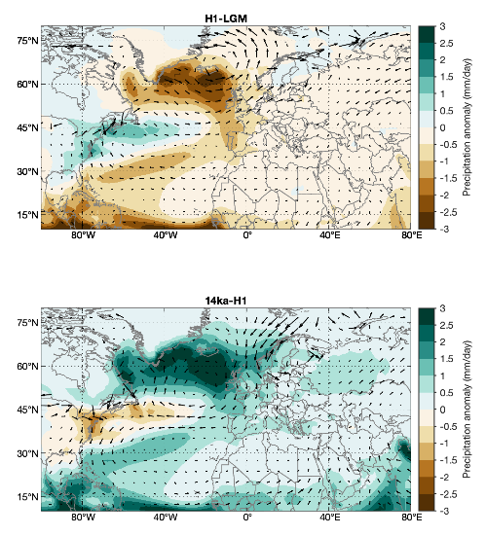
Fig. S8: Wind and precipitation anomalies from iTRACE simulation. Top panel: Heinrich 1 (17-15 ka BP) minus LGM (20-19 ka BP). Bottom panel: Bolling-Allerod (BA; 14-13 ka BP) minus Heinrich 1. Both panels show color contours of precipitation rate anomalies with arrows representing the wind vector anomaly.

References
1. Ficken, K. J., Li, B., Swain, D. L. & Eglinton, G. An n-alkane proxy for the sedimentary input of submerged/floating freshwater aquatic macrophytes. Org. Geochem. 31, 745–749 (2000).
2. Benjamini, Y. & Hochberg, Y. Controlling the False Discovery Rate: A Practical and Powerful Approach to Multiple Testing. J. R. Stat. Soc. Ser. B Methodol. 57, 289–300 (1995).
3. Zander, P. D., Rubach, F. & Martínez-García, A. Large‐Volume Injection and Assessment of Reference Standards for n‐Alkane δD and δ13C Analysis via Gas Chromatography Isotope Ratio Mass Spectrometry. Rapid Commun. Mass Spectrom. 39, e9943 (2025).
4. Britzius, S., Dreher, F., Maisel, P. & Sirocko, F. Vegetation Patterns during the Last 132,000 Years: A Synthesis from Twelve Eifel Maar Sediment Cores (Germany): The ELSA-23-Pollen-Stack. Quaternary 7, 8 (2024).
5. Konecky, B., Dee, S. G. & Noone, D. C. WaxPSM: A Forward Model of Leaf Wax Hydrogen Isotope Ratios to Bridge Proxy and Model Estimates of Past Climate. J. Geophys. Res. Biogeosciences 124, 2107–2125 (2019).
6. Zander, P. D. et al. Reconstruction of warm-season temperatures in central Europe during the past 60 000 years from lacustrine branched glycerol dialkyl glycerol tetraethers (brGDGTs). Clim. Past 20, 841–864 (2024).
7. IAEA/WMO. Global Network of Isotopes in Precipitation, GNIP database. (2024).
8. Tierney, J. E., DeMenocal, P. B. & Zander, P. D. A climatic context for the out-of-Africa migration. Geology 45, 1023–1026 (2017).
9. Lisiecki, L. E. & Raymo, M. E. A Pliocene-Pleistocene stack of 57 globally distributed benthic δ18O records. Paleoceanography 20, (2005).
10. Schrag, D. P., Hampt, G. & Murray, D. W. Pore Fluid Constraints on the Temperature and Oxygen Isotopic Composition of the Glacial Ocean. Science 272, 1930–1932 (1996).
11. Rach, O., Brauer, A., Wilkes, H. & Sachse, D. Delayed hydrological response to Greenland cooling at the onset of the Younger Dryas in western Europe. Nat. Geosci. 7, 109–112 (2014).
12. Rach, O., Kahmen, A., Brauer, A. & Sachse, D. A dual-biomarker approach for quantification of changes in relative humidity from sedimentary lipid D/H ratios. Clim. Past 13, 741–757 (2017).

