Supplementary materials
Table A1. Summary Statistics – categorical covariates
Variable | levels | Female |  | Male
Variable | levels | Frequency | Percent | Frequency | Percent
Quantile of learning demands | Not employed | 14,848 | 32.9 | 16,465 | 31.7
Quantile of learning demands | 1st | 4,366 | 9.7 | 7,879 | 15.2
Quantile of learning demands | 2nd | 9,290 | 20.6 | 8,035 | 15.5
Quantile of learning demands | 3rd | 8,276 | 18.4 | 9,643 | 18.6
Quantile of learning demands | 4th | 8,318 | 18.4 | 9,851 | 19
Birth place | West Germany/West Berlin | 33,668 | 74.7 | 37,912 | 73.1
Birth place | East Germany/East Berlin | 6,935 | 15.4 | 9,052 | 17.5
Birth place | Outside Germany | 4,495 | 10 | 4,909 | 9.5
Educational level | Medium or low | 21,874 | 48.5 | 25,132 | 48.4
Educational level | High | 23,224 | 51.5 | 26,741 | 51.6
Age group | 18-19 | 10,278 | 22.8 | 9,780 | 18.9
Age group | 20-24 | 14,814 | 32.8 | 15,446 | 29.8
Age group | 25-29 | 10,317 | 22.9 | 12,487 | 24.1
Age group | 30-34 | 5,313 | 11.8 | 7,727 | 14.9
Age group | 35-39 | 2,775 | 6.2 | 4,211 | 8.1
Age group | 40-45 | 1,601 | 3.6 | 2,222 | 4.3
Income group | Not employed | 14,849 | 32.9 | 16,437 | 31.7
Income group | Low | 4,501 | 10 | 3,336 | 6.4
Income group | Medium | 23,029 | 51.1 | 24,383 | 47
Income group | High | 2,719 | 6 | 7,717 | 14.9
Working/education status | In education | 21,921 | 48.6 | 24,330 | 46.9
Working/education status | Inactive | 175 | 0.4 | 146 | 0.3
Working/education status | Unemployed | 1,083 | 2.4 | 2,102 | 4.1
Working/education status | Employed | 21,919 | 48.6 | 25,295 | 48.8
Major occupation group | Managers | 625 | 1.4 | 1,286 | 2.5
Major occupation group | Professionals | 6,074 | 13.5 | 7,659 | 14.8
Major occupation group | Technicians and associate professionals | 8,665 | 19.2 | 5,309 | 10.2
Major occupation group | Clerical Support Workers | 6,625 | 14.7 | 3,083 | 5.9
Major occupation group | Service and Sales Workers | 4,973 | 11 | 2,805 | 5.4
Major occupation group | Skilled Agricultural, Forestry and Fishery Workers | 168 | 0.4 | 862 | 1.7
Major occupation group | Craft and Related Trades Workers | 1,203 | 2.7 | 9,847 | 19
Major occupation group | Plant and Machine Operators, and Assemblers | 475 | 1.1 | 2,074 | 4
Major occupation group | Elementary Occupations | 1,442 | 3.2 | 2,483 | 4.8
Major occupation group | Not employed | 14,848 | 32.9 | 16,465 | 31.7
Period | before 1990 | 10,199 | 22.6 | 9,874 | 19
Period | 1991-2003 | 23,628 | 52.4 | 26,512 | 51.1
Period | 2004-2007 | 5,598 | 12.4 | 7,346 | 14.2
Period | 2008-2012 | 4,098 | 9.1 | 5,823 | 11.2
Period | 2013-2019 | 1,508 | 3.3 | 2,218 | 4.3
Period | 2020-2022 | 67 | 0.1 | 100 | 0.2
Full-/part-time schedule | Part-time | 7,773 | 17.2 | 3,987 | 7.7
Full-/part-time schedule | Full-time | 22,477 | 49.8 | 31,421 | 60.6
Full-/part-time schedule | Not employed | 14,848 | 32.9 | 16,465 | 31.7
Sector | Public sector | 8,575 | 19 | 6,174 | 11.9
Sector | Private sector | 21,675 | 48.1 | 29,234 | 56.4
Sector | Not employed | 14,848 | 32.9 | 16,465 | 31.7
Total |  | 45,098 | 100 | 51,873 | 100

Source: Authors’ calculations based on NEPS data

Table A2. Baseline regression results
Predictors | Female samples  Model 1 | Male samples  Model 2
Quartile of learning demands (ref. 1st quartile)
Not employed | 1.246 | 0.056***
Not employed | (0.702) | (0.046)
2nd quartile | 0.947 | 1.517
2nd quartile | (0.223) | (0.710)
3rd quartile | 0.881 | 1.351
3rd quartile | (0.259) | (0.658)
4th quartile | 0.733 | 0.555
4th quartile | (0.294) | (0.600)
Age group (ref. 17-19)
20-24 | 1.484* | 3.338***
20-24 | (0.275) | (1.161)
25-29 | 1.793** | 7.891***
25-29 | (0.347) | (2.727)
30-34 | 1.136 | 7.108***
30-34 | (0.283) | (2.536)
35-39 | 0.437 | 4.008***
35-39 | (0.194) | (1.602)
40-45 | 0.203* | 1.260
40-45 | (0.150) | (0.763)
Learning demands and group (ref. 1st quartile and age 17 to 19)
Not employed and age 20 to 24 | 0.930 | 1.062
Not employed and age 20 to 24 | (0.207) | (0.440)
Not employed and age 25 to 29 | 1.208 | 0.940
Not employed and age 25 to 29 | (0.309) | (0.393)
Not employed and age 30 to 34 | 1.213 | 1.448
Not employed and age 30 to 34 | (0.484) | (0.689)
Not employed and age 35 to 39 | 1.726 | 1.224
Not employed and age 35 to 39 | (1.086) | (0.813)
Not employed and age 40 to 45 | 1.677 | -
Not employed and age 40 to 45 | (2.167) | -
2nd quartile and age 20 to 24 | 0.784 | 0.610
2nd quartile and age 20 to 24 | (0.200) | (0.300)
2nd quartile and age 25 to 29 | 1.212 | 0.544
2nd quartile and age 25 to 29 | (0.312) | (0.262)
2nd quartile and age 30 to 34 | 1.808 | 0.721
2nd quartile and age 30 to 34 | (0.557) | (0.355)
2nd quartile and age 35 to 39 | 1.794 | 0.841
2nd quartile and age 35 to 39 | (0.911) | (0.458)
2nd quartile and age 40 to 45 | 0.441 | 0.617
2nd quartile and age 40 to 45 | (0.457) | (0.524)
3rd quartile age 20 to 24 | 0.712 | 0.674
3rd quartile age 20 to 24 | (0.220) | (0.343)
3rd quartile age 25 to 29 | 1.293 | 0.588
3rd quartile age 25 to 29 | (0.396) | (0.294)
3rd quartile age 30 to 34 | 2.118* | 0.852
3rd quartile age 30 to 34 | (0.734) | (0.432)
3rd quartile age 35 to 39 | 3.076* | 1.226
3rd quartile age 35 to 39 | (1.599) | (0.666)
3rd quartile age 40 to 45 | 0.500 | 1.458
3rd quartile age 40 to 45 | (0.525) | (1.092)
4th quartile age 20 to 24 | 1.011 | 1.433
4th quartile age 20 to 24 | (0.413) | (1.571)
4th quartile age 25 to 29 | 1.440 | 1.193
4th quartile age 25 to 29 | (0.586) | (1.294)
4th quartile age 30 to 34 | 3.290** | 2.348
4th quartile age 30 to 34 | (1.433) | (2.549)
4th quartile age 35 to 39 | 4.570** | 3.184
4th quartile age 35 to 39 | (2.657) | (3.511)
4th quartile age 40 to 45 | 2.652 | 4.957
4th quartile age 40 to 45 | (2.345) | (5.960)
Major occupation groups (ref. managers)
Professionals | 0.896 | 0.940
Professionals | (0.144) | (0.122)
Technicians and associate professionals | 0.948 | 1.032
Technicians and associate professionals | (0.149) | (0.131)
Clerical support workers | 0.811 | 0.752
Clerical support workers | (0.140) | (0.116)
Service and sales workers | 0.875 | 0.814
Service and sales workers | (0.155) | (0.127)
Skilled agricultural, forestry and fishery workers | 1.167 | 0.943
Skilled agricultural, forestry and fishery workers | (0.347) | (0.183)
Craft and related trades workers | 0.859 | 0.917
Craft and related trades workers | (0.169) | (0.118)
Plant and machine operators, and assemblers | 1.096 | 0.847
Plant and machine operators, and assemblers | (0.239) | (0.135)
Elementary occupations | 0.765 | 0.928
Elementary occupations | (0.158) | (0.152)
Income group (ref.low)
Not employed | 0.213*** | 10.620**
Not employed | (0.108) | (7.686)
Middle | 0.950 | 1.105
Middle | (0.056) | (0.120)
High | 0.813* | 1.793***
High | (0.085) | (0.209)
Sector (ref. public)
Private sector | 0.849*** | 1.097
Private sector | (0.042) | (0.072)
Working schedule (ref. part-time)
Full-time | 0.627*** | 1.417**
Full-time | (0.031) | (0.152)
Working/education status (ref. employed)
In education | 0.453*** | 0.797***
In education | (0.029) | (0.053)
Inactive | 1.926 | 0.938
Inactive | (0.676) | (0.606)
unemployed | 1.927*** | 1.387
unemployed | (0.307) | (0.261)
Educational level (ref. low/middle)
High | 0.773*** | 0.914
High | (0.036) | (0.048)
Birth place (ref. West Germany/West Berlin)
East Germany/East Berlin | 1.740*** | 1.396***
East Germany/East Berlin | (0.097) | (0.084)
Outside Germany | 1.673*** | 1.953***
Outside Germany | -0.108 | (0.143)
Period (ref. before 1990)
1991-2003 | 0.804*** | 0.841
1991-2003 | (0.053) | (0.080)
2004-2007 | 0.705*** | 0.685***
2004-2007 | (0.061) | (0.075)
2008-2012 | 0.722*** | 0.669***
2008-2012 | (0.069) | (0.078)
2013-2019 | 0.755* | 0.773
2013-2019 | (0.103) | (0.105)
2020-2022 | 0.289 | 0.157
2020-2022 | (0.289) | (0.157)
Constant | 0.142*** | 0.007**
 | (0.036) | (0.003)
Observations | 45,098 | 57,873
Number of individuals | 3,488 | 3,267

Source: Authors’ analysis of data from O*NET and NEPS SC6

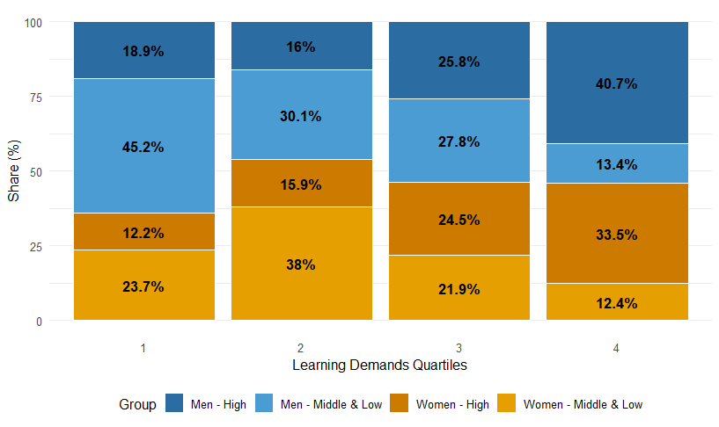
Figure A1. Composition of education & sex by learning demands quartile, shares based on spell count, Germany, 1965–1985 cohorts
Source: Authors’ analysis of data from O*NET and NEPS SC6

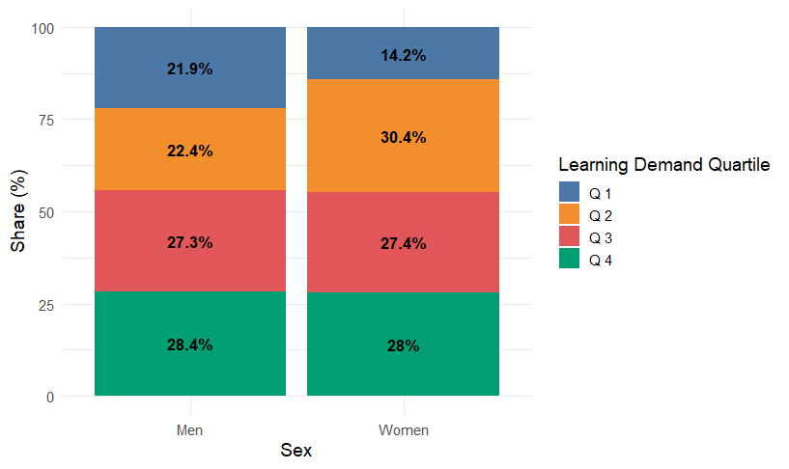
Figure A2. Composition of learning demands by sex, shares based on spell count, Germany, 1965–1985 cohorts
Source: Authors’ analysis of data from O*NET and NEPS SC6

Figure A 3.1. Predicted probability of first birth among women by learning-demand quartile of 3-digit occupational classification, Germany, 1965–1985 cohorts
Source: Authors’ analysis of data from O*NET and NEPS SC6

Figure A 3.2. Predicted probability of first birth among men by learning-demand quartile of 3-digit occupational classification, Germany, 1965–1985 cohorts
Source: Authors’ analysis of data from O*NET and NEPS SC6

Figure A4.1 Predicted probability of first birth among women by learning-demand quartile using different income imputation methods, Germany, 1965–1985 cohorts
Source: Authors’ analysis of data from O*NET and NEPS SC6

Figure A4.2 Predicted probability of first birth among men by learning-demand quartile using different income imputation methods, Germany, 1965–1985 cohorts
Source: Authors’ analysis of data from O*NET and NEPS SC6

