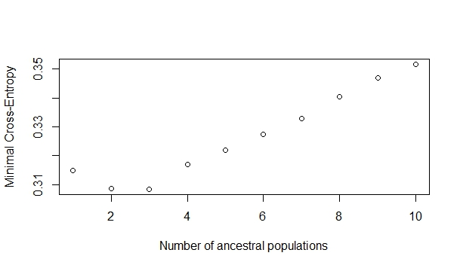
Figure S1: Cross-entropy criterion for SNMF runs (K = 1–10), showing minimal cross-entropy at K = 3, supporting three ancestral clusters.

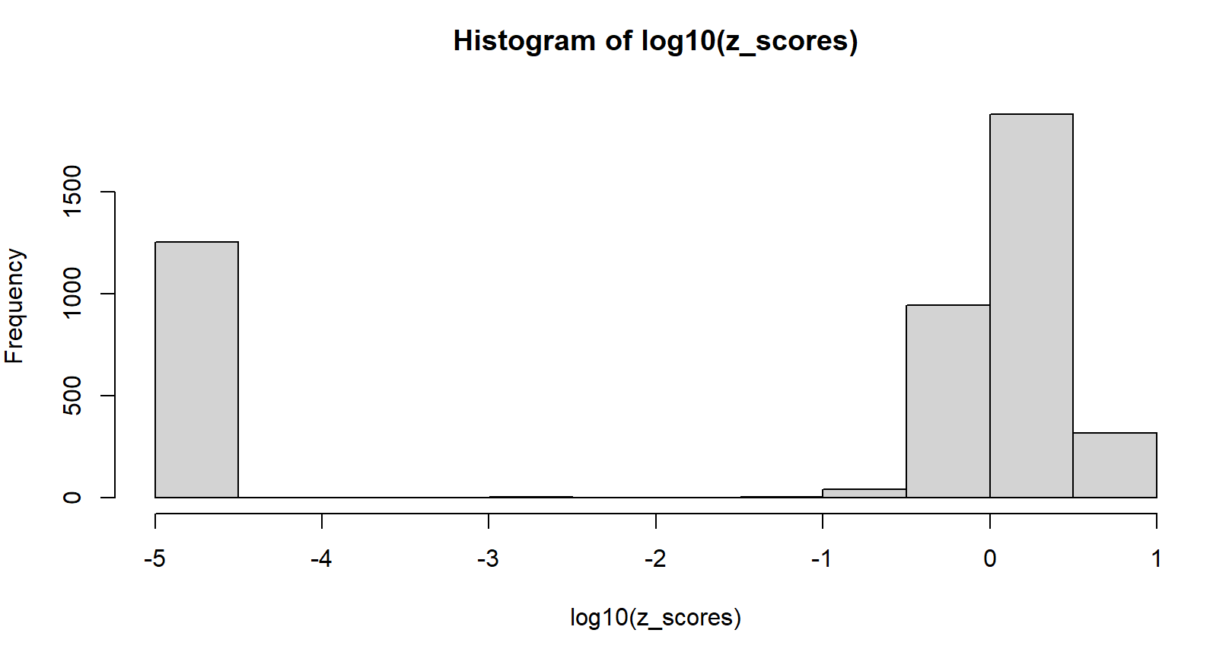

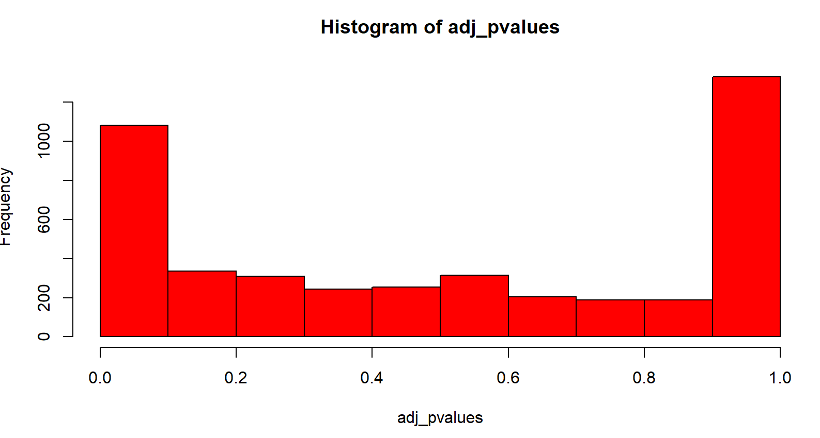

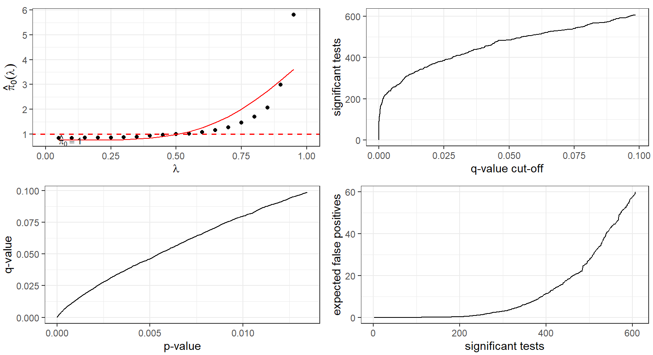

Figure S2: statistics to detect candidate SNPs

