Supplementary material
A dynamic pharmacometric framework defining the relationship between ivermectin exposure and mosquito lethality

Richard M. Hoglund, Kevin C. Kobylinski, Podjanee Jittamala, Borimas Hanboonkunupakarn, Narenrit Wamaket, Patchara Sriwichai, Siriporn Phasomkusolsil, Nicholas J. White, Nicholas P.J. Day, Joel Tarning
Table S1. Pharmacokinetic and pharmacodynamic parameters for different drivers of mosquito-killing effect.
An. Dirus
 | Whole blood  Ivermectin | Venous plasma  Ivermectin | Venous plasma  Ivermectin+metabolites
E_{max} (%) | 100 fix | 100 fix | 100 fix
EC₅₀ (nM) | 3.58 | 6.68 | 12.2
γ | 5.72 | 5.86 | 6.25
σ_{low_conc} | 0.184 | 0.185 | 0.182
σ_{high_conc} | 0.000001 fix | 0.000001 fix | 0.000001 fix
Κ | 0.5 fix | 0.5 fix | 0.5 fix
C_{cutoff} (nM) | 23.8 | 47.2 | 89.7

An. Minimus
 | Whole blood  Ivermectin | Venous plasma  Ivermectin |  | Venous plasma  Ivermectin+metabolites
E_{max} (%) | 100 fix |  | 100 fix | 100 fix
EC₅₀ (nM) | 0.530 |  | 0.985 | 1.98
γ | 4.43 |  | 4.72 | 5.55
σ_{low_conc} | 0.118 |  | 0.0992 | 0.124
σ_{high_conc} | 0.000001 fix |  | 0.000001 fix | 0.000001 fix
Κ | 0.5 fix |  | 0.5 fix | 0.5 fix
C_{cutoff} (nM) | 4.07 |  | 11.7 | 16.6

Ivermectin+metabolites is when the sum of ivermectin and all metabolites concentrations drives the effect. Ivermectin is when the concentrations of only ivermectin drives the effect. Venous plasma is when the venous plasma concentrations drives the effect. Whole blood is when the whole blood concentrations drive the effect. E_{max} is the maximum effect, EC₅₀, is the concentration resulting in 50% of maximum effect, Baseline is the baseline mortality, γ is the shape factor in the sigmoidal E_{max}-model. σ_{low_conc} is an additive residual error used at concentrations lower than the cutoff, σ_{high_conc} is the additive residual error used at concentration above the cutoff, Κ is the slope factor in the transition between low and high residual error, C_{cutoff} is the cutoff concentration (sum of molar concentrations of parent and metabolites) for the transition between low and high residual error.
- Parameter estimates from estimation in Pumas AI. IIVs are presented as variance and σ is presented as standard deviation.

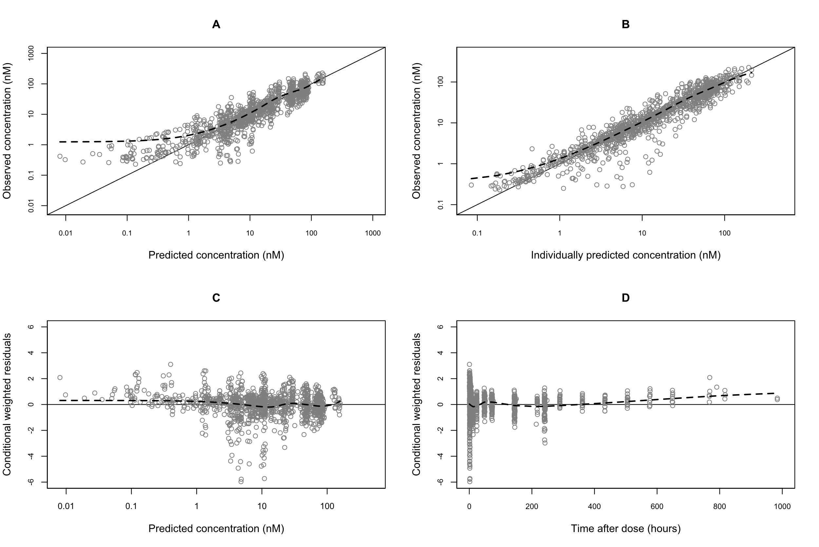
Figure S1. Goodness-of-fit plot for ivermectin. The plot in the top left (A) show population prediction versus observed concentration. The plot in the top right (B) show individual prediction versus observed concentration. The plot in the bottom right (C) show population prediction versus conditional weighted residuals. The plot in the bottom left (D) show time after dose versus conditional weighted residuals. The dashed black line in the LOESS (locally estimated scatterplot smoothing) regression line. The solid black line is line of identity.
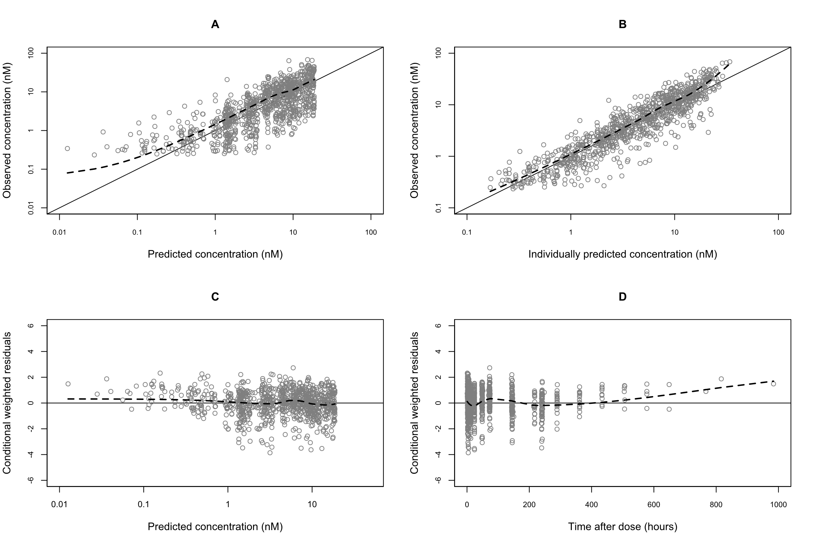
Figure S2. Goodness-of-fit plot for 3”-O-demethyl ivermectin (M1). The plot in the top left (A) show population prediction versus observed concentration. The plot in the top right (B) show individual prediction versus observed concentration. The plot in the bottom right (C) show population prediction versus conditional weighted residuals. The plot in the bottom left (D) show time after dose versus conditional weighted residuals. The dashed black line in the LOESS (locally estimated scatterplot smoothing) regression line. The solid black line is line of identity.

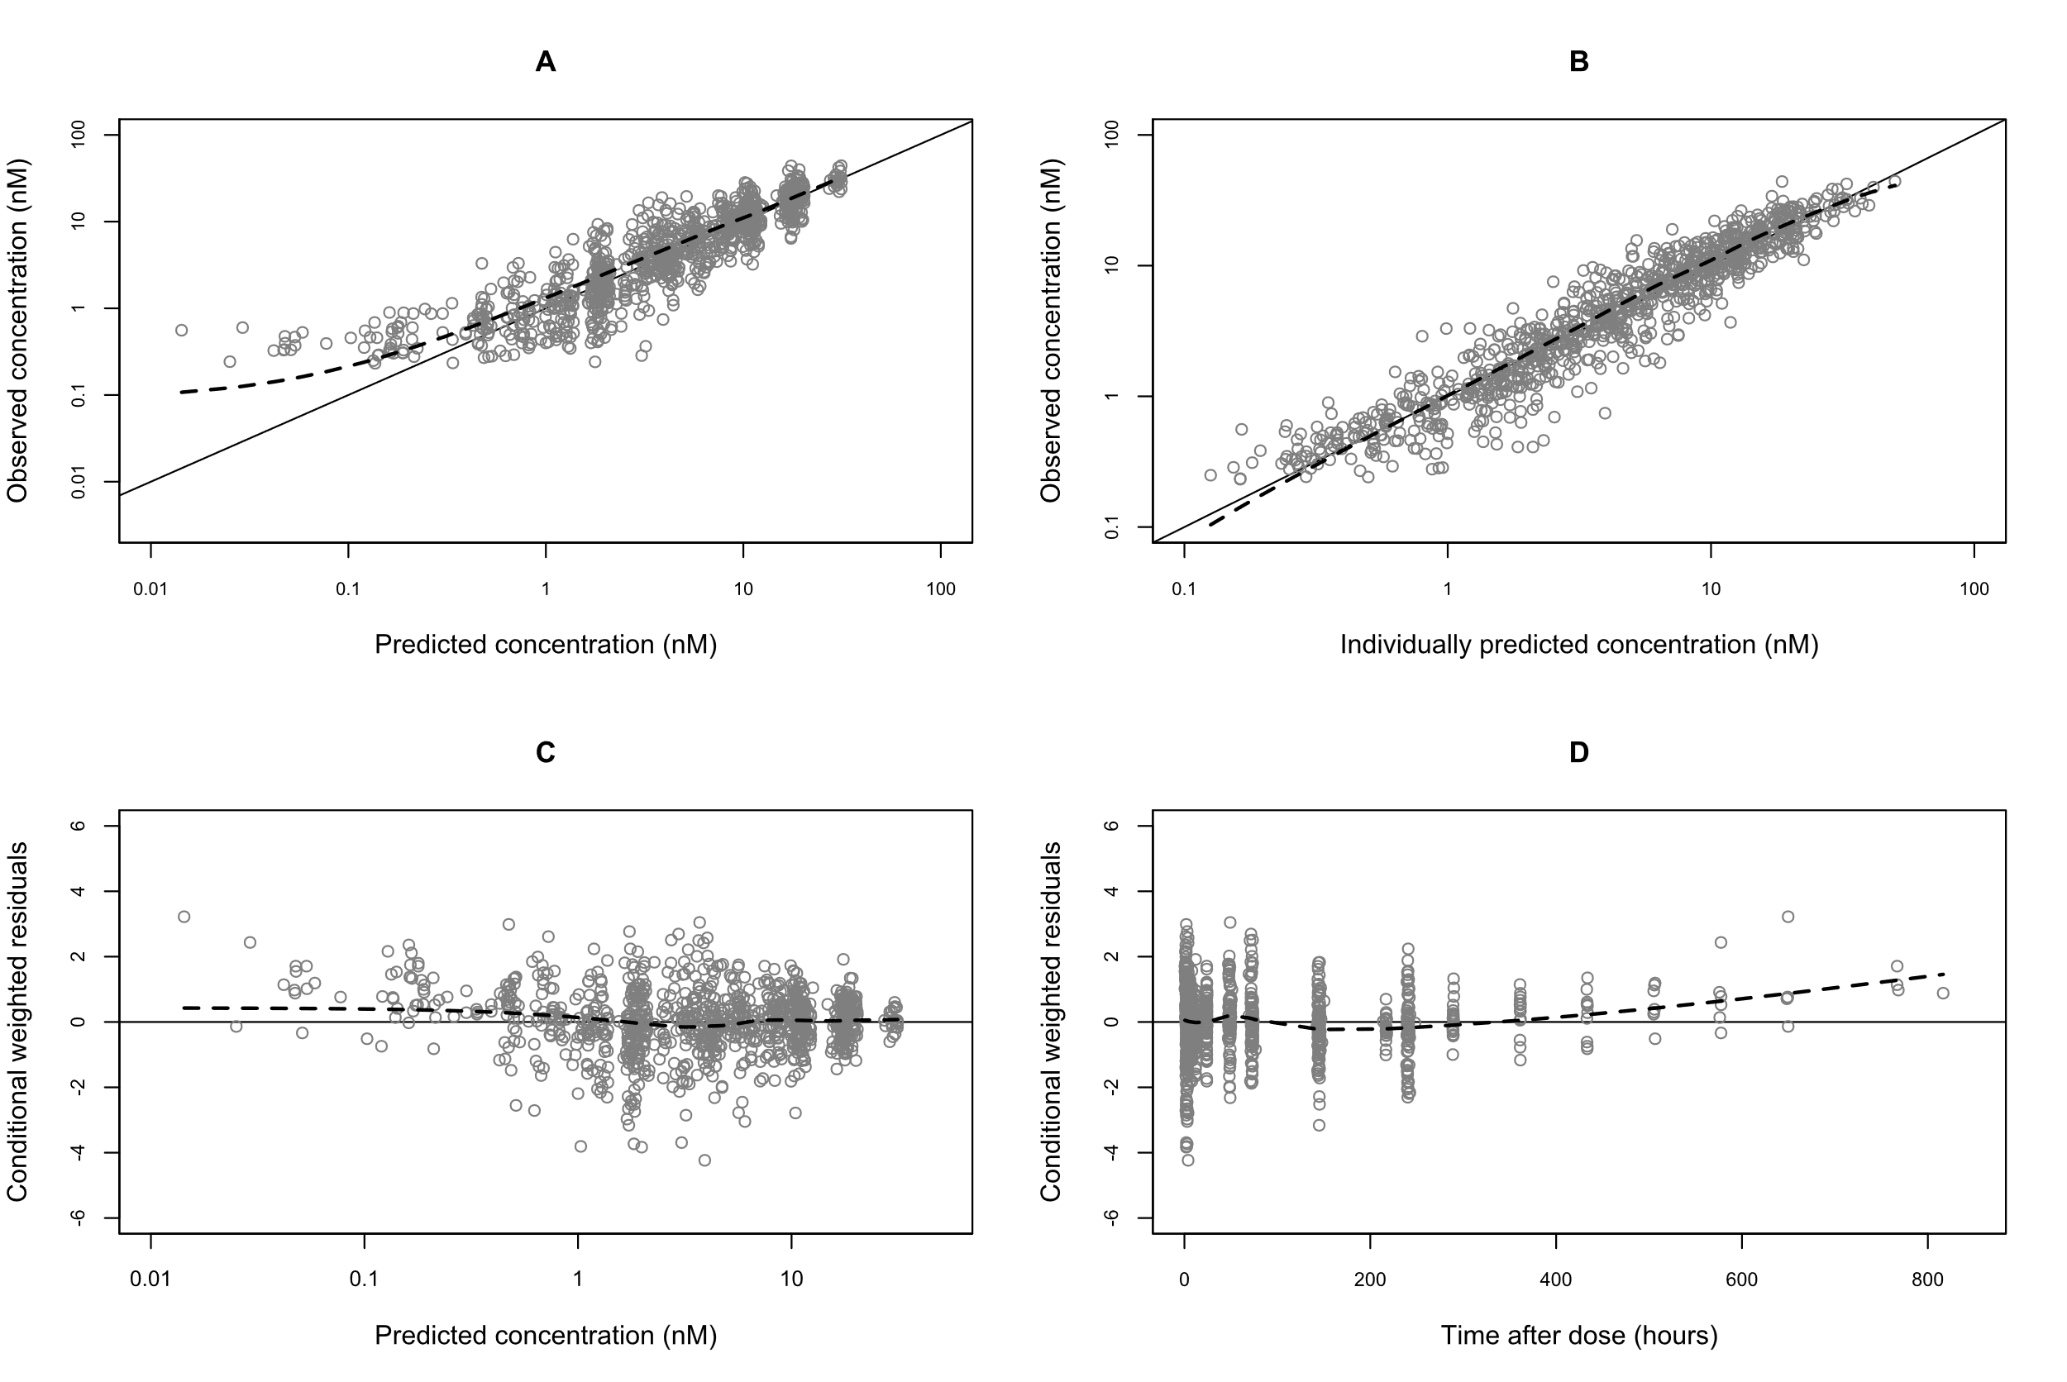
Figure S3. Goodness-of-fit plot for 4-hydroxyl ivermectin (M3). The plot in the top left (A) show population prediction versus observed concentration. The plot in the top right (B) show individual prediction versus observed concentration. The plot in the bottom right (C) show population prediction versus conditional weighted residuals. The plot in the bottom left (D) show time after dose versus conditional weighted residuals. The dashed black line in the LOESS (locally estimated scatterplot smoothing) regression line. The solid black line is line of identity.

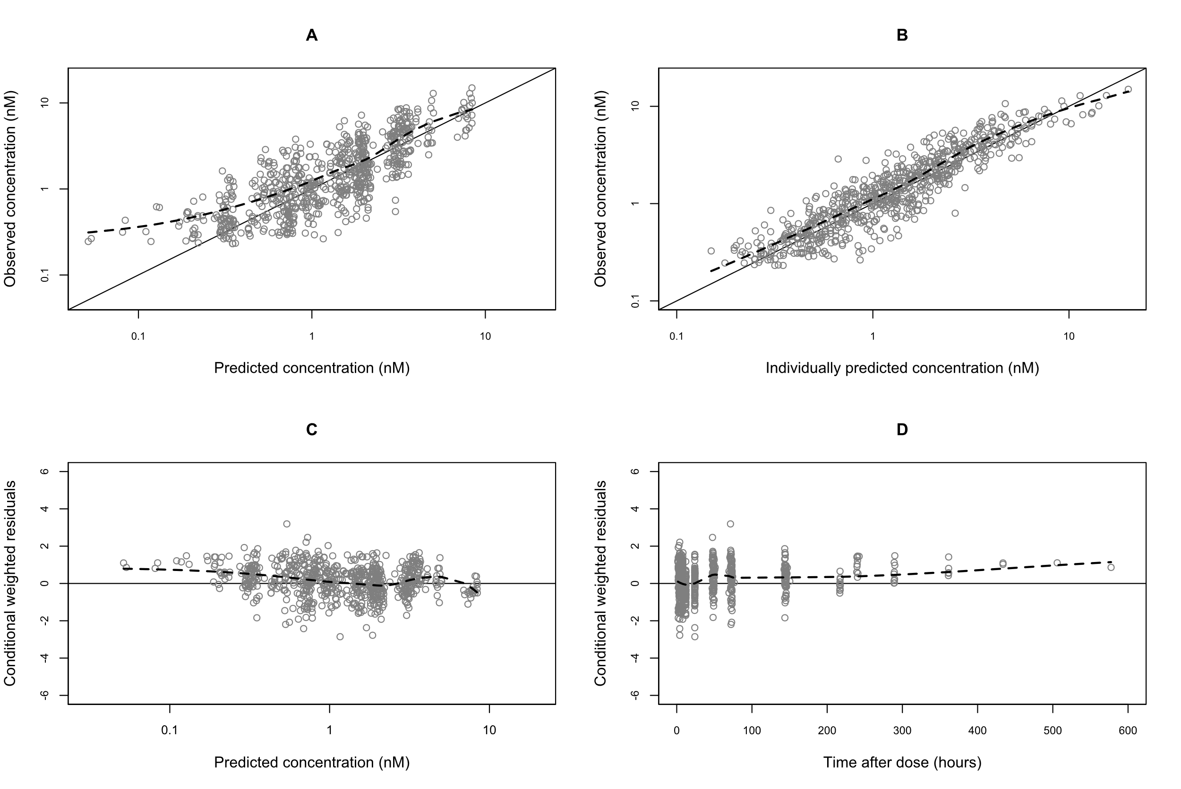
Figure S4. Goodness-of-fit plot for 3”-O-demethyl, 4-hydroxyl ivermectin (M6). The plot in the top left (A) show population prediction versus observed concentration. The plot in the top right (B) show individual prediction versus observed concentration. The plot in the bottom right (C) show population prediction versus conditional weighted residuals. The plot in the bottom left (D) show time after dose versus conditional weighted residuals. The dashed black line in the LOESS (locally estimated scatterplot smoothing) regression line. The solid black line is line of identity.

Figure S5. Kaplan-Meier curves illustrating the difference mosquito survival at baseline after membrane feeding between Study 1 (red) and 2 (green) for both An. Dirus and An. Minimus. The solid lines are the estimated survival and the shaded areas are the 95% confidence interval.

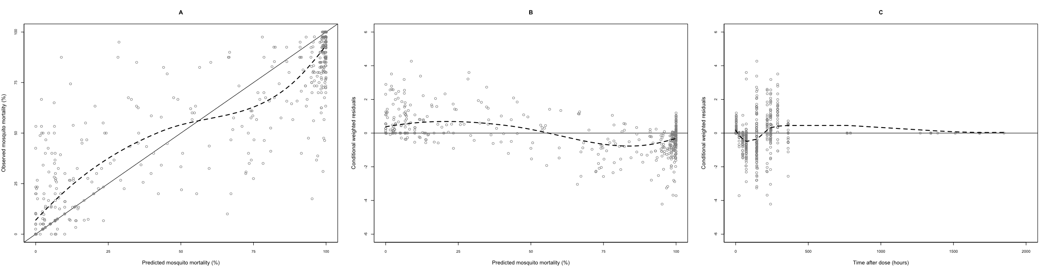
Figure S6. Goodness-of-fit plot for An. dirus model. The plot on the left (A) show population prediction versus observed concentration. The plot in the middle (B) show population prediction versus conditional weighted residuals. The plot on the right (C)show time after dose versus conditional weighted residuals. The dashed black line in the LOESS (locally estimated scatterplot smoothing) regression line. The solid black line is line of identity.

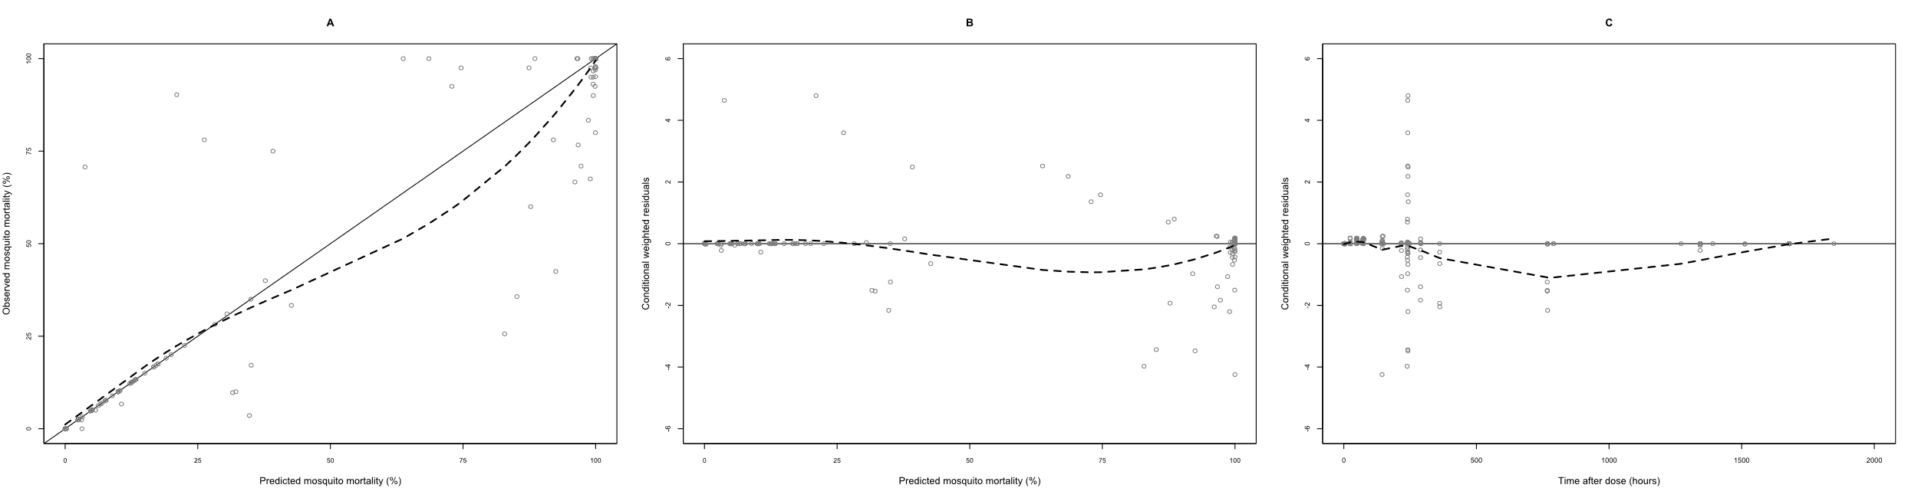
Figure S7. Goodness-of-fit plot for An. minimus model. . The plot on the left (A) show population prediction versus observed concentration. The plot in the middle (B) show population prediction versus conditional weighted residuals. The plot on the right (C)show time after dose versus conditional weighted residuals. The dashed black line in the LOESS (locally estimated scatterplot smoothing) regression line. The solid black line is line of identity.

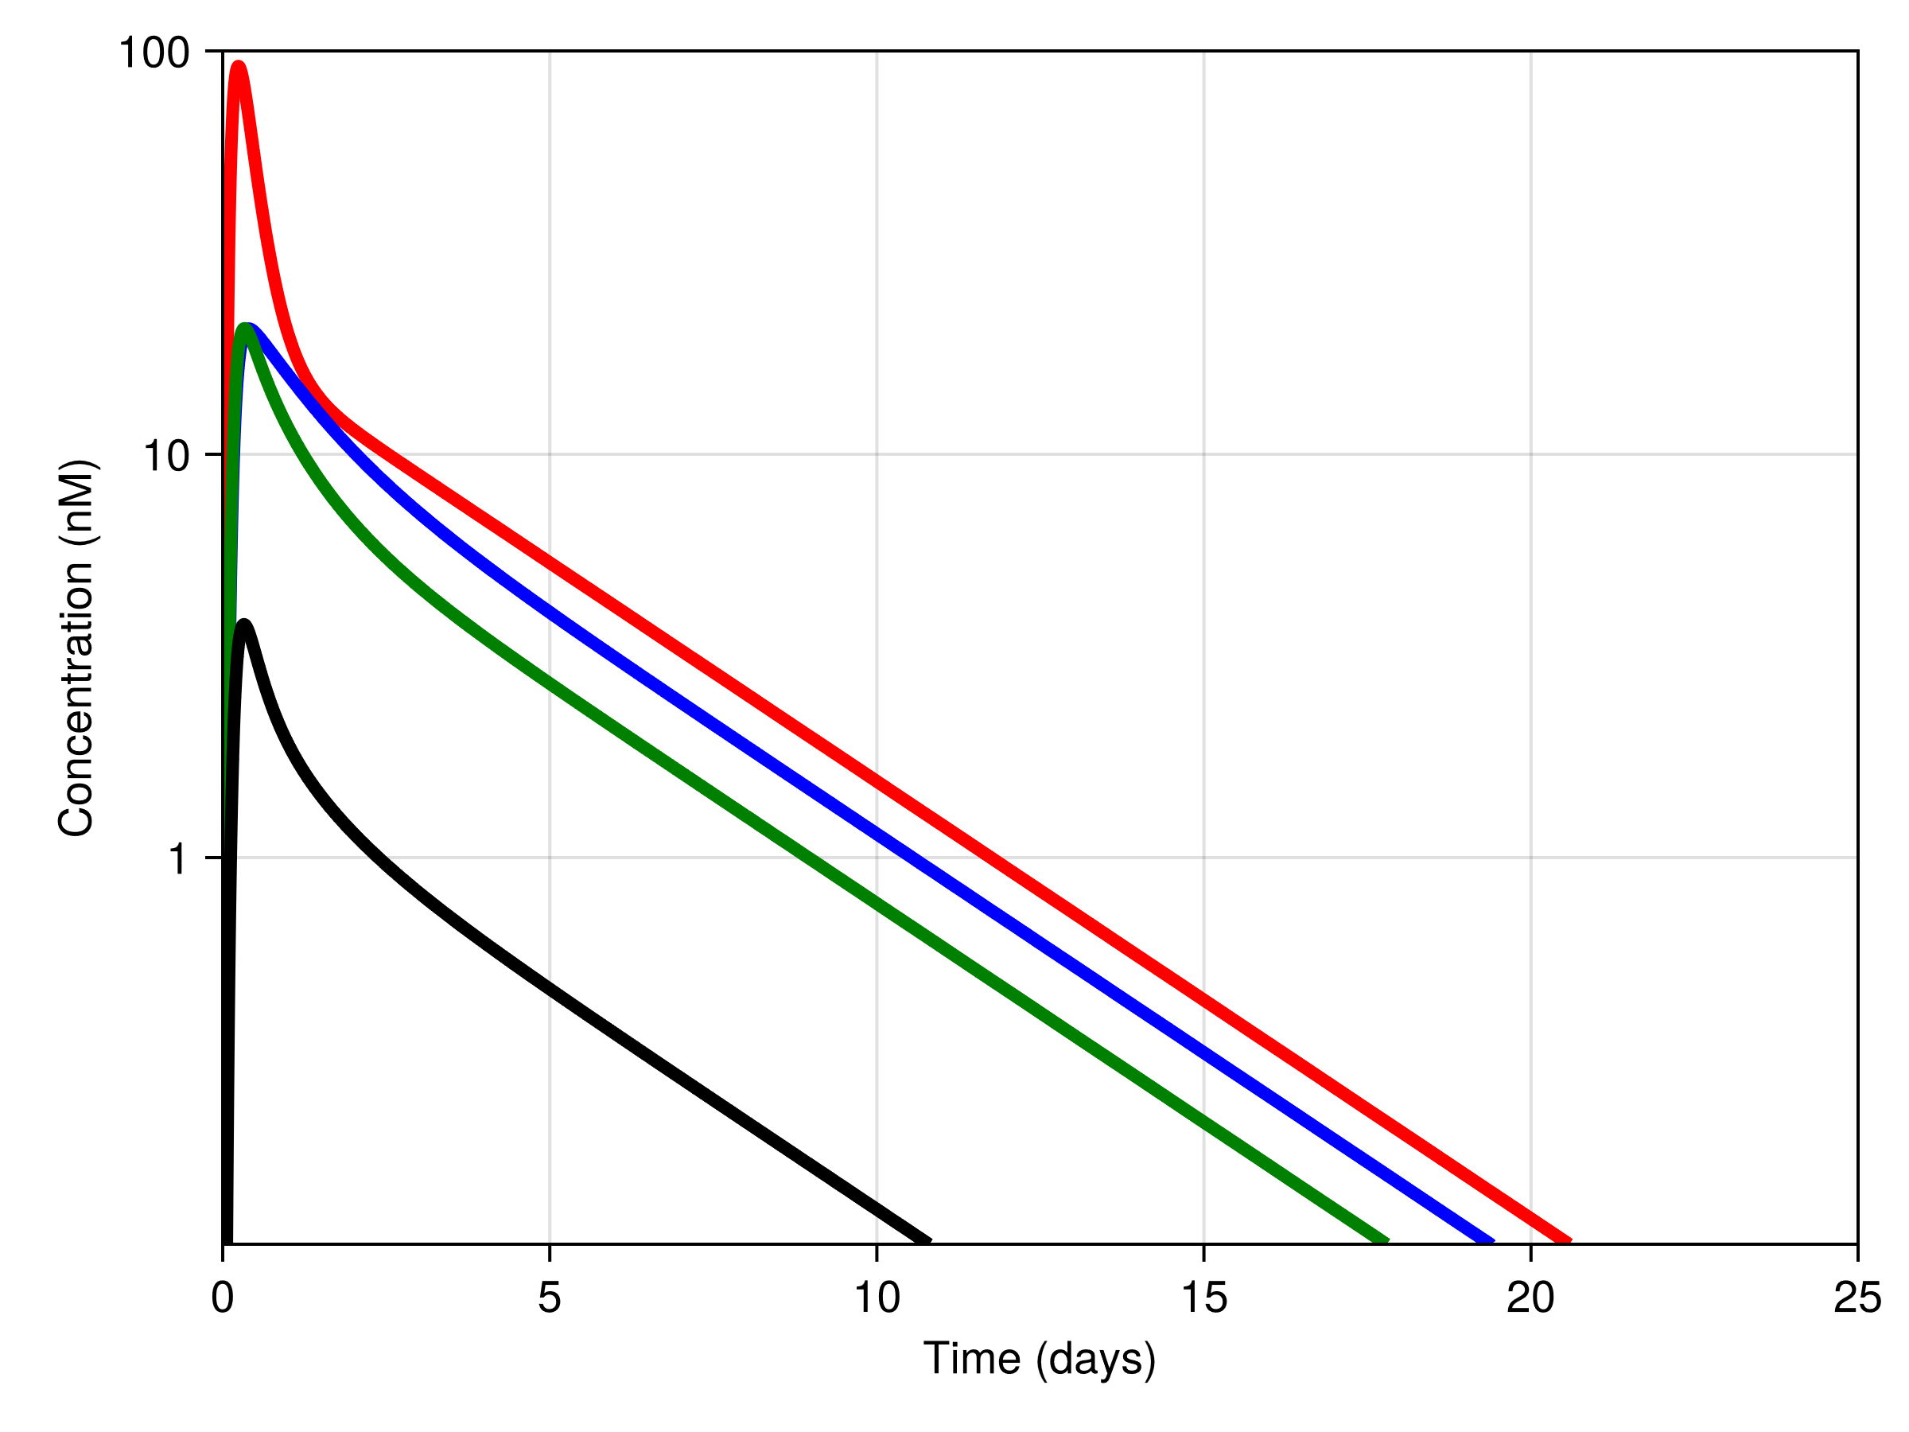
Figure S8. Simulated population concentration-time curves of ivermectin (red), metabolites 3”-O-demethyl ivermectin (M1) (blue), 4-hydroxyl ivermectin (M3) (green), and 3”-O-demethyl, 4-hydroxyl ivermectin (M6) (black), for a 60 kg male volunteer after a single dose of 400 µg/kg ivermectin alone.

Figure S9. The impact of biological sex on pharmacokinetics of ivermectin (left) and the mortality of An. diurs (middle) and An. minimus (right). Simulated population curves for a 60 kg male (solid black line) and female (dashed red line) volunteer after a single dose of 400 µg/kg ivermectin given alone.

Supplementary code.
pkpd_final =
@model begin
@metadata begin
desc = "IVM and metabolite model"
timeu = u"hr"
end
@param begin
"Clearance IVM (L/hr)"
tvcl_IVM ∈ RealDomain(lower = 0)
"Volume IVM (L)"
tvvc_IVM ∈ RealDomain(lower = 0)
"Intercompartmental Clearance IVM (L/hr)"
tvq_IVM ∈ RealDomain(lower = 0)
"Peripheral Volume IVM (L)"
tvvp_IVM ∈ RealDomain(lower = 0)
"Mean transit time IVM (h)"
tvmtt ∈ RealDomain(lower = 0)
"Plasma conversion factor IVM"
plaf_IVM ∈ RealDomain(lower = -1)

"Clearance M1 (L/hr)"
tvcl_M1 ∈ RealDomain(lower = 0)
"Volume M1 (L)"
tvvc_M1 ∈ RealDomain(lower = 0)
"Q M1 (L/hr)"
tvq_M1 ∈ RealDomain(lower = 0)
"Volume periferal M1 (L)"
tvvp_M1 ∈ RealDomain(lower = 0)

"Plasma conversion factor M1"
plaf_M1 ∈ RealDomain(lower = -1)

"Clearance M3 (L/hr)"
tvcl_M3 ∈ RealDomain(lower = 0)
"Volume M3 (L)"
tvvc_M3 ∈ RealDomain(lower = 0)
"Q M3 (L/hr)"
tvq_M3 ∈ RealDomain(lower = 0)
"Volume periferal M3 (L)"
tvvp_M3 ∈ RealDomain(lower = 0)

"Plasma conversion factor M3"
plaf_M3 ∈ RealDomain(lower = -1)

"Clearance M6 (L/hr)"
tvcl_M6 ∈ RealDomain(lower = 0)
"Volume M6 (L)"
tvvc_M6 ∈ RealDomain(lower = 0)

"Plasma conversion factor M6"
plaf_M6 ∈ RealDomain(lower = -1)
"Fraction direct to M6"
FPS ∈ RealDomain(lower = 0)

"Piperaquine effect on CL IVM"
PPQ_CL_IVM_cov ∈ RealDomain(lower = -1)
"Piperaquine effect on MTT"
PPQ_MTT_cov ∈ RealDomain(lower = -1)

"Sex effect on VP IVM"
SEX_VP_IVM_cov ∈ RealDomain(lower = -1)

######## PD Dirus ###############
"EC50 (uM)"
tv_ec50_dirus ∈ RealDomain(lower = 0)
"Hill"
tv_hill_dirus ∈ RealDomain(lower = 0)

######## PD Minimus ###############
"EC50 (uM)"
tv_ec50_minimus ∈ RealDomain(lower = 0)
"Hill"
tv_hill_minimus ∈ RealDomain(lower = 0)

"""
- ΩCL_IVM
- ΩQ_IVM
- ΩVp_IVM
- ΩCL_M1
- ΩVc_M1
- ΩCL_M3
- ΩVc_M3
- ΩCL_M6
- ΩF1
"""
Ω ∈ PDiagDomain(9)

"Proportional RUV IVM"
σ_a_IVM ∈ RealDomain(lower = 0.0000001)
"Proportional RUV M1"
σ_a_M1 ∈ RealDomain(lower = 0.0000001)
"Proportional RUV M3"
σ_a_M3 ∈ RealDomain(lower = 0.0000001)
"Proportional RUV M6"
σ_a_M6 ∈ RealDomain(lower = 0.0000001)
"Additive RUV Dirus"
σ_lowconc_dir ∈ RealDomain(lower=0) # Residual error below cut-off
cutoff_dir ∈ RealDomain(lower=0.1) # Concentration cut-off
"Additive RUV Minimus"
σ_lowconc_min ∈ RealDomain(lower=0) # Residual error below cut-off
cutoff_min ∈ RealDomain(lower=0.1) # Concentration cut-off
end
@random begin
η ~ MvNormal(Ω)
end

@covariates begin
"Body Weight"
BW
"Sex"
SEX
"Concomitant DHA-piperaquine treatment"
PPQ
"Plasma samples"
PLACON
"ARM"
ARM
"Assay"
FASSAY

end
@pre begin
CL = tvcl_IVM*(1+PPQ_CL_IVM_cov*PPQ) *((BW/60)^0.75) * exp(η[1])
Vc = tvvc_IVM *((BW/60)^1)
Q = tvq_IVM *((BW/60)^0.75)
Vp = tvvp_IVM*(1+SEX_VP_IVM_cov*SEX) *((BW/60)^1) * exp(η[2])
MTT = tvmtt*(1+PPQ_MTT_cov*PPQ) * exp(η[3])

CL_M1 = tvcl_M1 *((BW/60)^0.75) * exp(η[4])
Vc_M1 = tvvc_M1 *((BW/60)^1) * exp(η[5])
Q_M1 = tvq_M1 *((BW/60)^0.75)
Vp_M1 = tvvp_M1 *((BW/60)^1)

CL_M3 = tvcl_M3 *((BW/60)^0.75) * exp(η[6])
Vc_M3 = tvvc_M3 *((BW/60)^1) * exp(η[7])
Q_M3 = tvq_M3 *((BW/60)^0.75)
Vp_M3 = tvvp_M3 *((BW/60)^1)

CL_M6 = tvcl_M6 *((BW/60)^0.75) * exp(η[8])
Vc_M6 = tvvc_M6 *((BW/60)^1)

PLAEFF_IVM = (1+plaf_IVM*PLACON)

PLAEFF_M1 = (1+plaf_M1*PLACON)

PLAEFF_M3 = (1+plaf_M3*PLACON)

PLAEFF_M6 = (1+plaf_M6*PLACON)

nn=3
KTR = (nn+1)/MTT

K14=KTR
K45=KTR
K56=KTR
K62=KTR
K27=(1-FPS)*0.5*CL/Vc
K28=(1-FPS)*0.5*CL/Vc
K29=FPS*CL/Vc
K23=Q/Vc
K32=Q/Vp
K79 = CL_M1/Vc_M1
K7T10 = Q_M1/Vc_M1
K10T7 = Q_M1/Vp_M1
K89 = CL_M3/Vc_M3
K8T11 = Q_M3/Vc_M3
K11T8 = Q_M3/Vp_M3
K90 = CL_M6/Vc_M6

DEL=0.00001
############## PD Dirus ############
EC50_dirus = tv_ec50_dirus
Hill_dirus = tv_hill_dirus
BL_dirus = 0.03735

############## PD Minimus ############
EC50_minimus = tv_ec50_minimus
Hill_minimus = tv_hill_minimus
BL_minimus = 0.0818
end
@dosecontrol begin
bioav = ( ; A1=1 * exp(η[9]))

end
@dynamics begin
A1' = -K14*A1
A2' = K62*A6+ K32*A3 -K23*A2-K27*A2-K28*A2-K29*A2
A3' = K23*A2-K32*A3
A4' = K14*A1-K45*A4
A5' = K45*A4-K56*A5
A6' = K56*A5-K62*A6

A7' = K27*A2+K10T7*A10-K7T10*A7-K79*A7
A8' = K28*A2+K11T8*A11-K8T11*A8-K89*A8
A9' = K29*A2+K79*A7+K89*A8-K90*A9
A10' = K7T10*A7-K10T7*A10
A11' = K8T11*A8-K11T8*A11

end
@derived begin
cp_IVM := @. (A2/(Vc))*(PLAEFF_IVM)
cp_M1 := @. (A7/(Vc_M1))*(PLAEFF_M1)
cp_M3 := @. (A8/(Vc_M3))*(PLAEFF_M3)
cp_M6 := @. (A9/(Vc_M6))*(PLAEFF_M6)
cp_eff = cp_IVM+cp_M1+cp_M3+cp_M6

lcp_IVM := @. log((A2/(Vc))*(PLAEFF_IVM)+0.0000001)
lcp_M1 := @. log((A7/(Vc_M1))*(PLAEFF_M1)+0.0000001)
lcp_M3 := @. log((A8/(Vc_M3))*(PLAEFF_M3)+0.0000001)
lcp_M6 := @. log((A9/(Vc_M6))*(PLAEFF_M6)+0.0000001)

eff_dirus := @. BL_dirus+(((1-BL_dirus)*(cp_eff+DEL)^Hill_dirus)/(((EC50_dirus+DEL)^Hill_dirus)+((cp_eff+DEL)^Hill_dirus)))
eff_minimus := @. BL_minimus+(((1-BL_minimus)*(cp_eff+DEL)^Hill_minimus)/(((EC50_minimus+DEL)^Hill_minimus)+((cp_eff+DEL)^Hill_minimus)))

NDV ~ @. LogNormal(lcp_IVM, σ_a_IVM)
NDV_M1 ~ @. LogNormal(lcp_M1, σ_a_M1)
NDV_M3 ~ @. LogNormal(lcp_M3, σ_a_M3)
NDV_M6 ~ @. LogNormal(lcp_M6, σ_a_M6)

k = 1
σ_highconc = 0.000001

σ_dir = @. σ_lowconc_dir + (σ_highconc - σ_lowconc_dir) / (1 + exp(-k * (cp_eff - cutoff_dir)))
σ_min = @. σ_lowconc_min + (σ_highconc - σ_lowconc_min) / (1 + exp(-k * (cp_eff - cutoff_min)))

DV_MK_Dirus ~ @. Normal(eff_dirus, σ_dir)
DV_MK_Minimus ~ @. Normal(eff_minimus, σ_min)
end
end

pkpdparams_sim = (tvcl_IVM = 12.265,
tvvc_IVM = 211.19,
tvq_IVM = 17.655,
tvvp_IVM = 616.33,
tvmtt = 3.6639,
plaf_IVM = 0.86379,
tvcl_M1 = 7.9437,
tvvc_M1 = 29.063,
tvq_M1 = 19.21,
tvvp_M1 = 110.62,
plaf_M1 = -0.31091,
tvcl_M3 = 10.25,
tvvc_M3 = 21.628,
tvq_M3 = 12.347,
tvvp_M3 = 94.007,
plaf_M3 = 0.75674,
tvcl_M6 = 157.89,
tvvc_M6 = 93.77,
plaf_M6 = 1.572,
FPS = 0.23941,
PPQ_CL_IVM_cov = -0.40995,
PPQ_MTT_cov = 0.32282,
SEX_VP_IVM_cov = 0.74614,
tv_ec50_dirus = 7.889,
tv_hill_dirus = 6.0497,
tv_ec50_minimus = 1.2929,
tv_hill_minimus = 5.5006,
Ω = Diagonal([0.035104,0.11933,0.055861,0.25786,0.79699,0.078427,0.12605,0.1584,0.07126]),
σ_a_IVM = 0.51099,
σ_a_M1 = 0.54613,
σ_a_M3 = 0.41653,
σ_a_M6 = 0.44838,
σ_lowconc_dir = 0.1843,
cutoff_dir =58.591,
σ_lowconc_min = 0.14433,
cutoff_min =7.5613)

