Supplementary
Figure 2
Overview of relatedness and study variables measured before, during, and after team-sport training sessions.
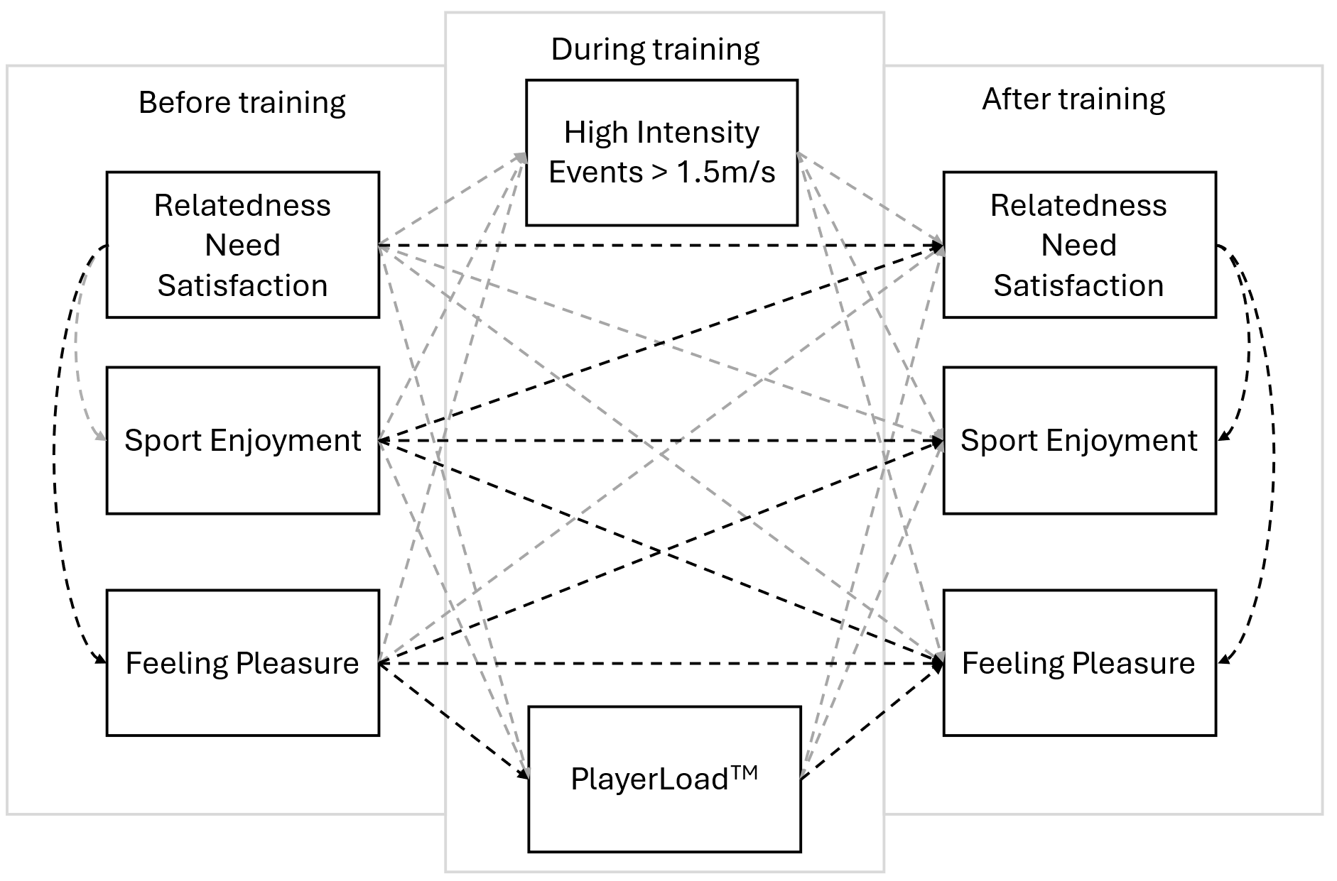
Note. Solid boxes represent the observed variables at each measurement point. Highlighted dashed arrows illustrate the significant within-person associations tested in the study’s models. PlayerLoad™ represents the accelerometer-derived index of external physical load, and high-intensity events reflect accelerations exceeding 1.5 m/s².

Figure 3
Overview of autonomy and study variables measured before, during, and after team-sport training sessions.
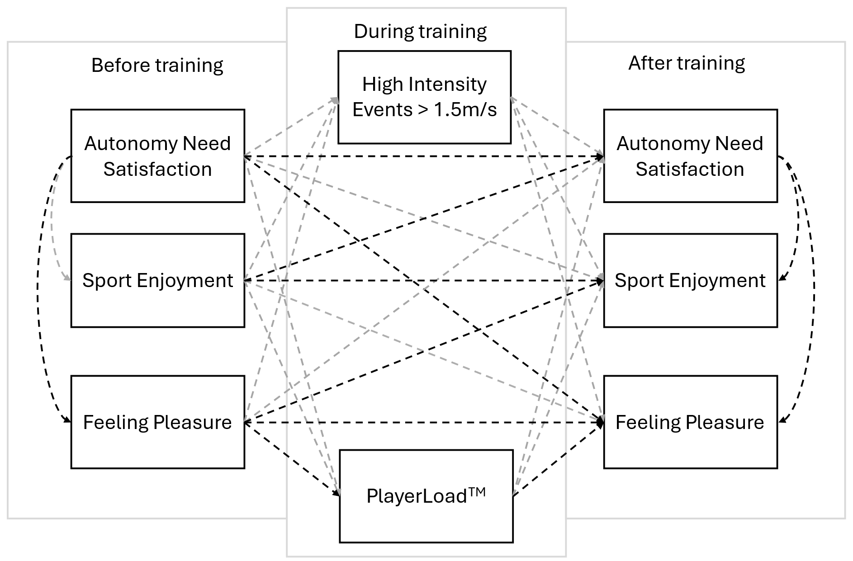
Note. Solid boxes represent the observed variables at each measurement point. Highlighted dashed arrows illustrate the significant within-person associations tested in the study’s models. PlayerLoad™ represents the accelerometer-derived index of external physical load, and high-intensity events reflect accelerations exceeding 1.5 m/s².

Figure 4
Overview of study competence and variables measured before, during, and after team-sport training sessions.

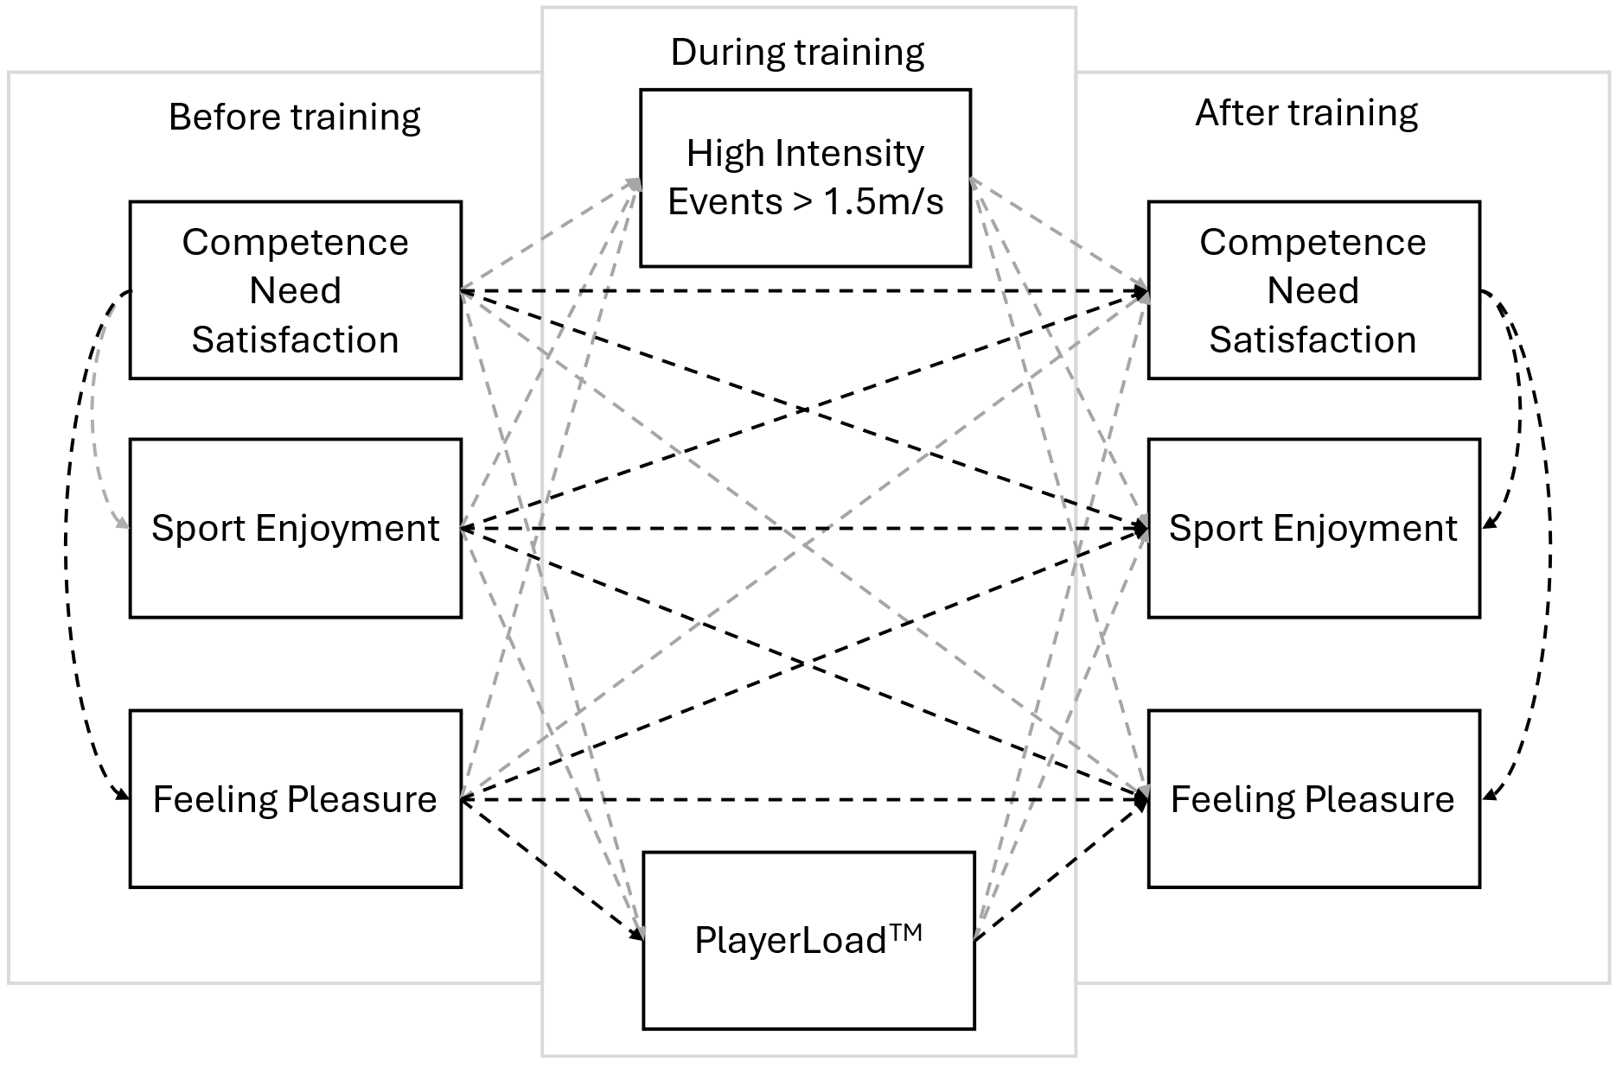

Note. Solid boxes represent the observed variables at each measurement point. Highlighted dashed arrows illustrate the significant within-person associations tested in the study’s models. PlayerLoad™ represents the accelerometer-derived index of external physical load, and high-intensity events reflect accelerations exceeding 1.5 m/s².

