Knowledge, attitudes, beliefs of Asian cancer survivors towards an exercise-based rehabilitation program in a community setting Study

Welcome to the research study. We are interested in understanding how Asian cancer survivors view cancer rehabilitation. You will be asked to answer some questions about it, and this will be used to improve our cancer rehabilitation services. Please be assured that your responses will be kept completely confidential.

Sociodemographic data

Age:
Gender:
Ethnicity:
Referral Source:
Cancer Type:
Cancer Stage:
Treatment Received:
DTPL:
EORTC:
CCI:

A. ILLNESS PERCEPTION

NB:
Done after the distress thermometer (DT).
“Illness” meaning side effects of cancer or cancer treatment – eg. Fatigue/ neuropathy
“Treatment” means cancer rehab
This may be a bit tricky as patients have different complaints eg fatigue, lymphedema, neuropathy.

For the following questions, please circle the number that best corresponds to your views:

6. How much does the side effects of cancer and treatment affect your life?

7. How long do you think the side effects of cancer and treatment will continue?

8. How much control do you feel you have over the side effects of cancer and treatment?

9. How much do you think a cancer rehabilitation program can help the side effects of cancer and treatment?
10. How much do you experience the side effects of cancer and treatment?
11. How concerned are you about the side effects of cancer and treatment?
12. How well do you feel you understand the side effects of cancer and treatment?
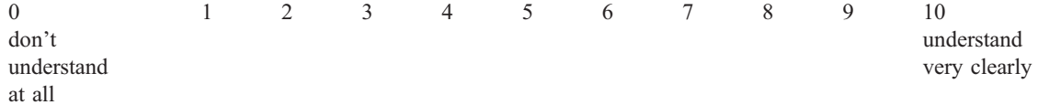
13. How much does the side effects of cancer and treatment affect you emotionally?
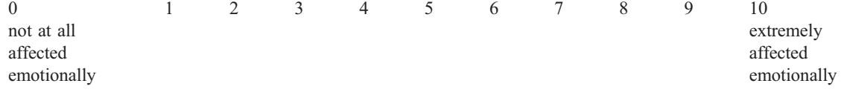

14. Please list in order the 3 most important factors that you believe caused your illness.

__________________________________________________________________________________

__________________________________________________________________________________

__________________________________________________________________________________

Adapted from The Brief Illness Perception Questionnaire
References:
- Broadbent E, Petrie KJ, Main J, Weinman J. The brief illness perception questionnaire. J Psychosom Res. 2006 Jun;60(6):631-7. doi: 10.1016/j.jpsychores.2005.10.020. PMID: 16731240.

B. BARRIERS TO REHABILITATION

4. What are the barriers you feel prevent you from coming for rehabilitation? Tick those that apply:

Patient barriers
I feel weakened due to my tumor therapy
Tiredness/Insomnia
I am not interested in an exercise program
I was not physically active before my cancer diagnosis
Fear of adverse events
I do not think it will have a positive impact on my QoL
Others, please specify_______________________

Social barriers
Transport fee
Stressful daily life
Lack of time
Too expensive
Others, please specify_______________________

References: Frikkel, J., Götte, M., Beckmann, M. et al. Fatigue, barriers to physical activity and predictors for motivation to exercise in advanced Cancer patients

C. CURRENT PHYSICAL ACTIVITY
Based on physical activity vital sign

1. On average, how many days per week do you engage in moderate to strenuous exercise (like a brisk walk)?

2. On average, how many minutes do you engage in exercise at this level?

3. How many days a week do you perform muscle strengthening exercises, such as bodyweight exercises or resistance training?

What’s moderate intensity?
You can talk, but not sing, while performing the activity.
Examples: brisk walking, slow biking, doubles tennis, various forms of dance, active home chores
and gardening, etc.

What’s vigorous intensity?
You can no longer talk easily during the activity and are somewhat out of breath.
Examples: jogging, fast bicycling, singles tennis, aerobic exercise class, swimming laps, etc

Reference
- https://www.elon.edu/u/academics/education/wellness-promotion/wp-content/uploads/sites/969/2019/11/EIM-Physical-Activity-Vital-Sign.pdf
- Coleman KJ, Ngor E, Reynolds K, Quinn VP, Koebnick C, Young DR, Sternfeld B, Sallis RE. Initial validation of an exercise "vital sign" in electronic medical records. Med Sci Sports Exerc. 2012 Nov;44(11):2071-6. doi: 10.1249/MSS.0b013e3182630ec1. PMID: 22688832.

D. Modified BANDURA’S EXERCISE SELF EFFICACY SCALE

5. How likely will you do each of the following:

 | Very likely | Likely | Unlikely | Very unlikely
Exercise regularly (3 times a week for  20 minutes) | 1 | 2 | 3 | 4
Exercise when you are feeling tired | 1 | 2 | 3 | 4
Exercise when you are feeling under  pressure to get things done | 1 | 2 | 3 | 4
Exercise when you are feeling down  or depressed | 1 | 2 | 3 | 4
Exercise when you have too much  work to do at home | 1 | 2 | 3 | 4
Exercise when there are other more  interesting things to do | 1 | 2 | 3 | 4
Exercise when your family or friends  do not provide any kind of support | 1 | 2 | 3 | 4
Exercise when you don’t really feel  like it | 1 | 2 | 3 | 4
Exercise when you are away from  home (e.g., traveling, visiting, on  vacation) | 1 | 2 | 3 | 4

Adapted from The Exercise Self Efficacy scale
Ref:
- Bandura A. Self-efficacy: toward a unifying theory of behavioral change. Psychol Rev. 1977 Mar;84(2):191-215. doi: 10.1037//0033-295x.84.2.191. PMID: 847061.
- Neupert SD, Lachman ME, Whitbourne SB. Exercise self-efficacy and control beliefs: effects on exercise behavior after an exercise intervention for older adults. J Aging Phys Act. 2009;17(1):1-16. doi:10.1123/japa.17.1.1

Additional open-ended questions

14. Do you know of other resources in the community with cancer rehab services?

If yes, please list down: ________

15. Did you ask to be referred to this program or was it your healthcare provider?

Self referred/Healthcare provider

16. Are you undergoing alternative forms of therapy for the side effects of cancer and treatment eg. acupuncture, traditional chinese medicine

If yes, please list down: _________

Why did you decide to attend this program?

Do you think this program (cancer rehab) is useful? (Y/N) Why?

What do you think could help you manage the side effects of treatment? (it would be useful to have a follow up open ended question that can give patients a chance to express their thoughts after the Brief Illness Perception questionnaire)

