Exosomal miR-4644 targets SPRY3 to promote proliferation and invasion of pancreatic cancer
Xiangyu Chu ^{1†}, Dongqi Li ^{2†}, Fusheng Zhang², Yongsu Ma², Yongqi Deng²,
Chen Wang^{3,4}, Xiaodong Tian ², Yanlian Yang ^{3,4}, and Yinmo Yang ²
¹Department of General Surgery, Beijing Friendship Hospital, Capital Medical University, State Key Lab of Digestive Health, National Clinical Research Center for Digestive Diseases, Beijing, 100050, China
²Department of Hepatobiliary and Pancreatic Surgery, Peking University First Hospital, Beijing 100034, China
³CAS Key Laboratory of Standardization and Measurement for Nanotechnology, CAS Key Laboratory of Biological Effects of Nanomaterials and Nanosafety, National Center for Nanoscience and Technology, Beijing, China
⁴University of Chinese Academy of Sciences, Beijing 100049, China
Correspondence: Yinmo Yang: yangyinmosci@bjmu.edu.cn
Xiaodong Tian: tianxiaodong@pkufh.com
Yanlian Yang: yangyl@nanoctr.cn
Chen Wang: wangch@nanoctr.cn
† Xiangyu Chu and Dongqi Li contributed equally to this work.

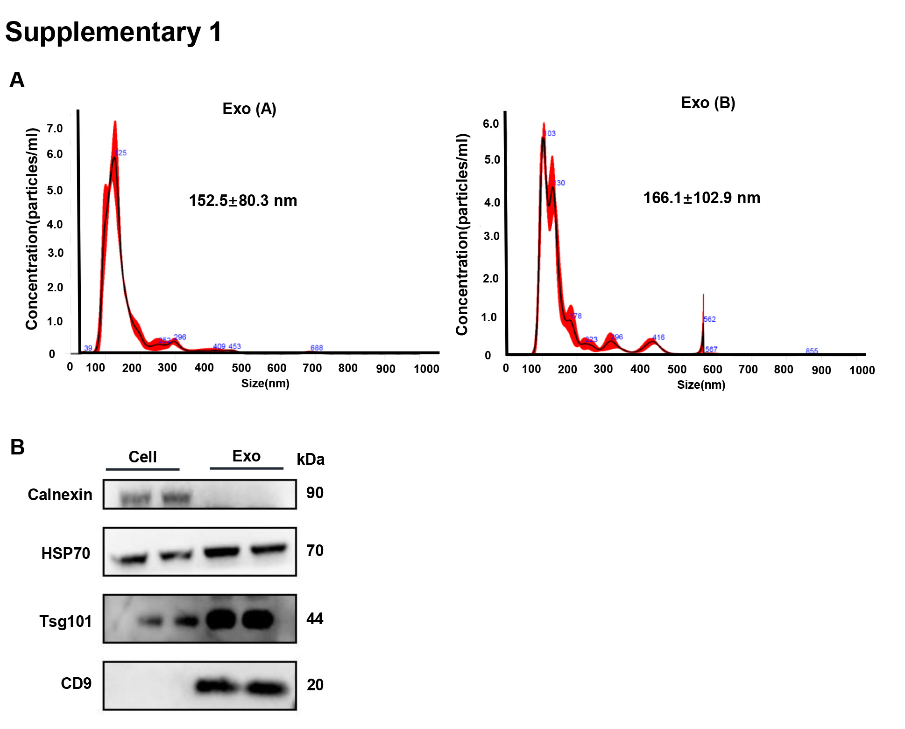
Figure S1. (A) Representative NTA images illustrating the size and particle distribution of AsPC-1-exos and BxPC-3-exos. (B) Isolated exosomes exhibited expression of key exosomal proteins relative to parental cells. All experiments were performed with 3 independent replicates.

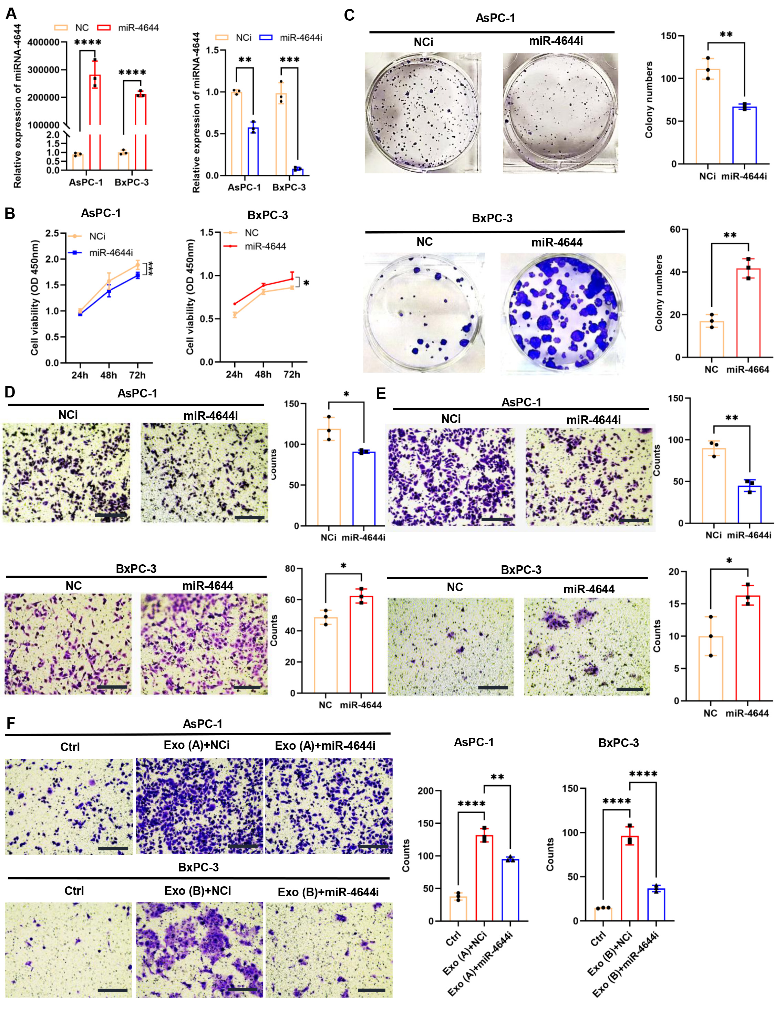
Figure S2. Upregulation of miR-4644 contributed to PC cell progression. (A) miR-4644 expression levels in AsPC-1 and BxPC-3 cells after transfecting with miR-4644 mimics, as assessed by RT-PCR. GAPDH served as an endogenous control. (B) CCK8 assays assessed the impact of miR-4644 overexpression and silencing on the capacity for growth of AsPC-1 and BxPC-3 cells. (C) Typical photos and counting results of colony formation tests in AsPC-1 and BxPC-3 cells when overexpressed or silenced miR-4644. (D-E) Migration and invasion assays with representative statistical data for AsPC-1 and BxPC-3 cells upon miR-4644 modulation. Scale bar: 100 μm. (F) Representative pictures and statistical results identifying the effect of miR-4644 inhibition on the migration of BxPC-3 cells treated with TDEs. Scale bar: 100 μm. All experiments were performed with 3 independent replicates. The student’s t-test was performed to assess the mean differences between groups, and One-way ANOVA was used to assess the differences among three groups. ∗p < 0.05, ∗∗p < 0.01, ∗∗∗p < 0.001, ∗∗∗∗p < 0.0001.

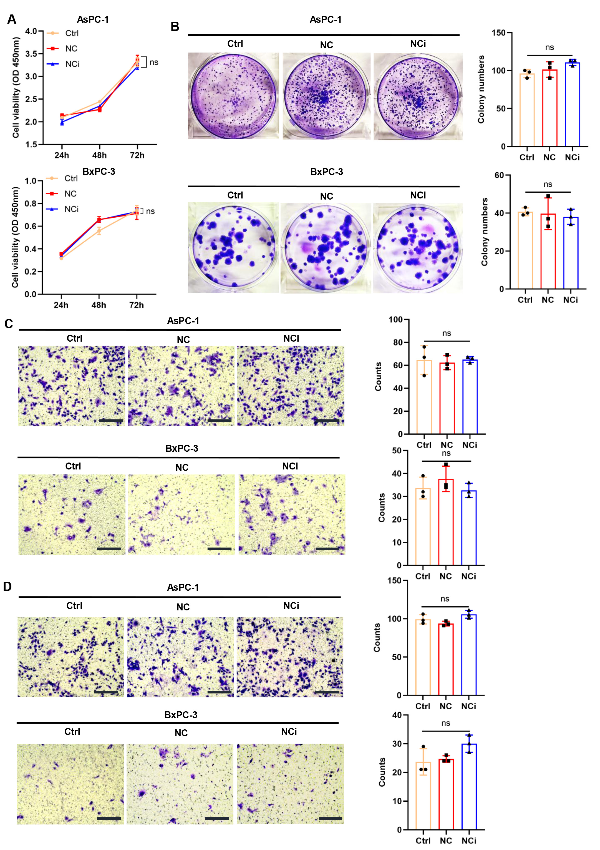
Figure S3. (A) CCK8 assays to evaluate the proliferative capacity of PC cells without treatment or following transfection with miRNA NC mimics and inhibitors. (B) Typical images of colony formation experiment in Ctrl, NC, and NCi groups. (C-D) Migration and invasion assays with corresponding statistical analyses of PC cells with or without treatment with NC and NCi. Scale bar: 100 μm. All experiments were performed with 3 independent replicates. One-way ANOVA was used to assess the differences among three groups.
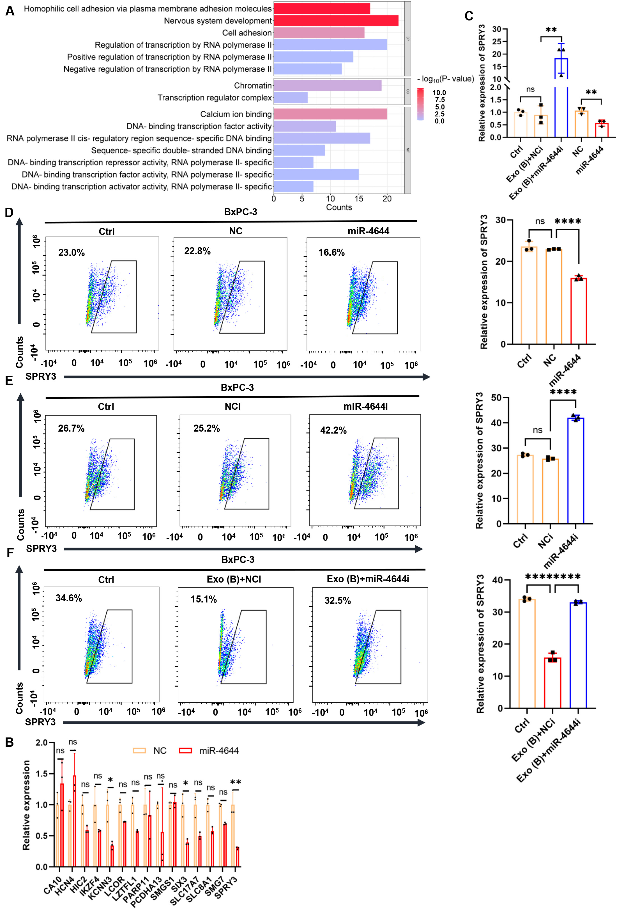
Figure S4. (A) GO enrichment analysis for target genes of miR-4644 using the DAVID database. (B) qPCR analysis of SPRY3 expression among the top-ranked genes associated with tumor progression following miR-4644 mimic transfection. (C) RT-PCR quantification of SPRY3 expression in BxPC-3 cells transfected with miR-4644 mimics and treated with miR-4644 inhibitors. GAPDH served as an endogenous control. (D-F) Flow cytometry analysis of SPRY3 expression in AsPC-1 cells following miR-4644 overexpression (D), inhibition (E), or inhibition in TDE-treated cells (F). All experiments were performed with 3 independent replicates. The student’s t-test was performed to assess the mean differences between groups, and One-way ANOVA was used to assess the differences among three groups. ∗p < 0.05, ∗∗p < 0.01, ∗∗∗p < 0.001, ∗∗∗∗p < 0.0001.
.

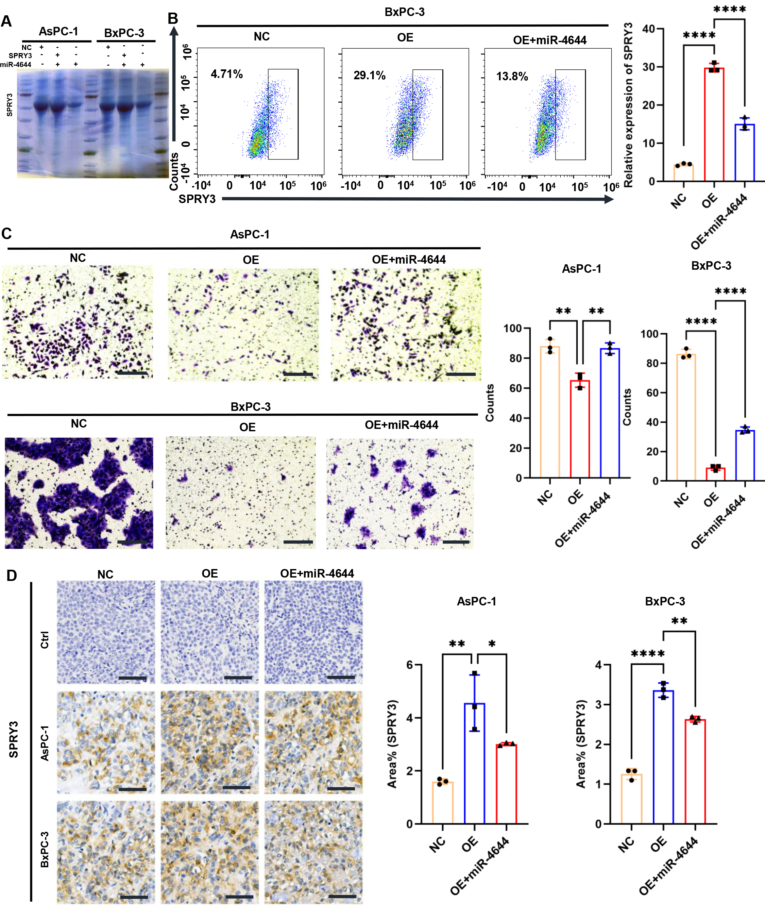
Figure S5. (A) Protein gel electrophoresis confirming the expression of SPRY3 in AsPC-1 and BxPC-3 cells after transfection with SPRY3 overexpression vectors and miR-4644 mimics. (B) Flow cytometry to quantify SPRY3 expression after transfection with lentiviral plasmids overexpressing SPRY3 and miR-4644 mimics. (C) Invasion rescue assays and statistical analysis following co-transfection with miR-4644 mimics and SPRY3 overexpression vectors. (D) IHC analysis of SPRY3 expression. Scale bar: 50 μm. All experiments were performed with 3 independent replicates. The student’s t-test was performed to assess the mean differences between groups, and One-way ANOVA was used to assess the differences among three groups. ∗p < 0.05, ∗∗p < 0.01, ∗∗∗p < 0.001, ∗∗∗∗p < 0.0001.

