Supplementary Figure 1. Evolution of price and capture weight in Galicia (Spain) from 1997 to 2023. Data obtained from PescaDeGalicia: https://www.pescadegalicia.gal/estadisticas/.

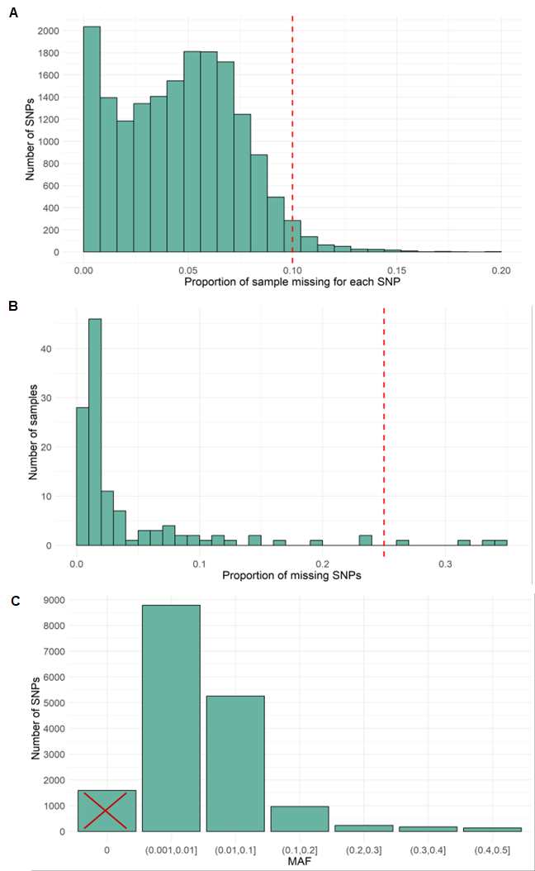
Supplementary Figure 2. Distribution of missingness by SNP (A), missingness by individual (B), and minor allele frequency (MAF) (C). Discontinuous red lines indicate the thresholds beyond which data were removed. The red cross marks the SNPs removed by the MAF filter (those that presented a MAF < 0.01 in the metapopulation).

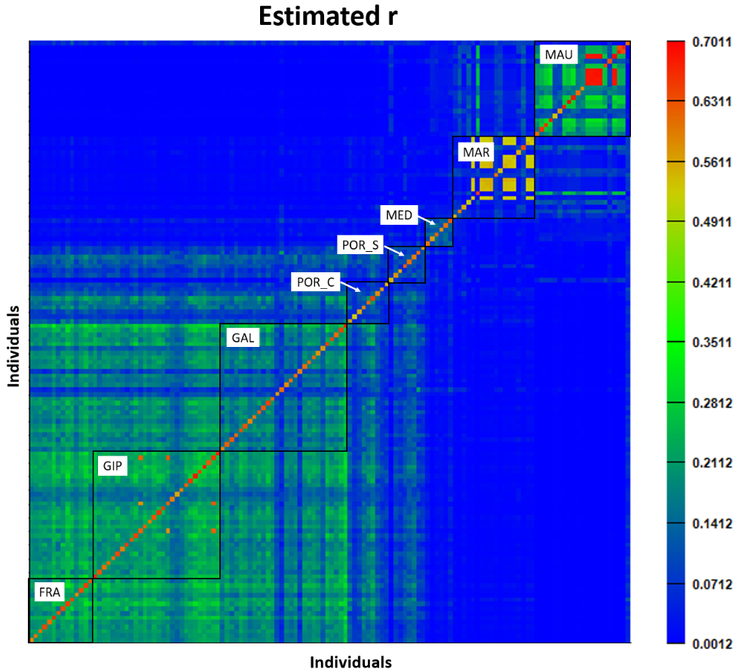
Supplementary Figure 3. Relatedness matrix among Octopus vulgaris samples (EIBD9 method). Each population is enclosed within a black square. Note the detection of related individuals: three in GIP, nine in MOR, and seven in MAU.

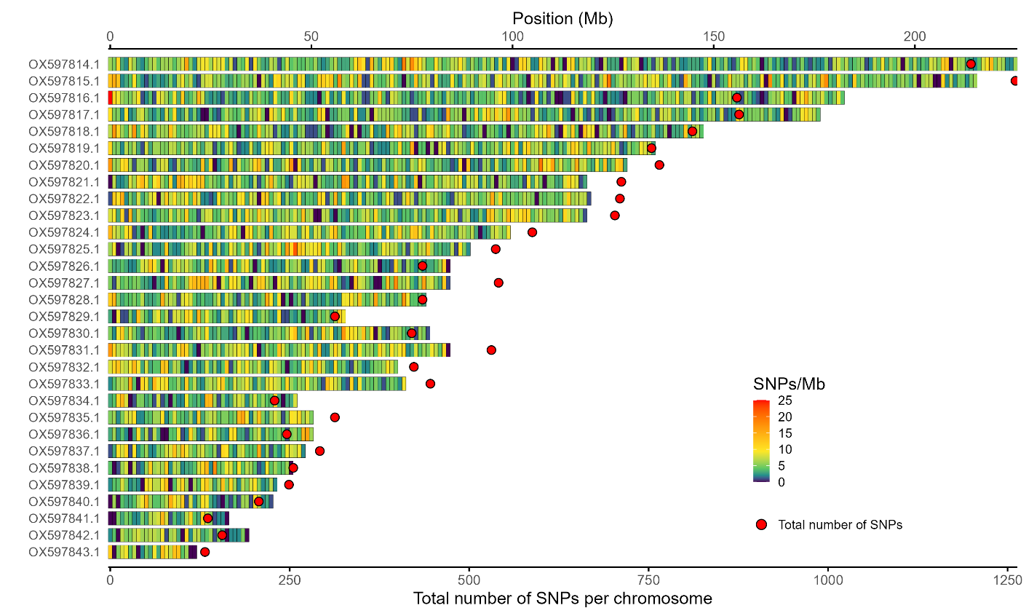Supplementary Figure 4. SNP density along the 30 chromosomes of Octopus vulgaris. Chromosome lengths are shown on the top X-axis in megabases (Mb), with each chromosome represented on the Y-axis. Each coloured tile indicates the number of SNPs within a 1 Mb window. The total number of SNPs per chromosome is represented by a red dot on the bottom X-axis. The mean SNP density is 5.6 SNPs/Mb.

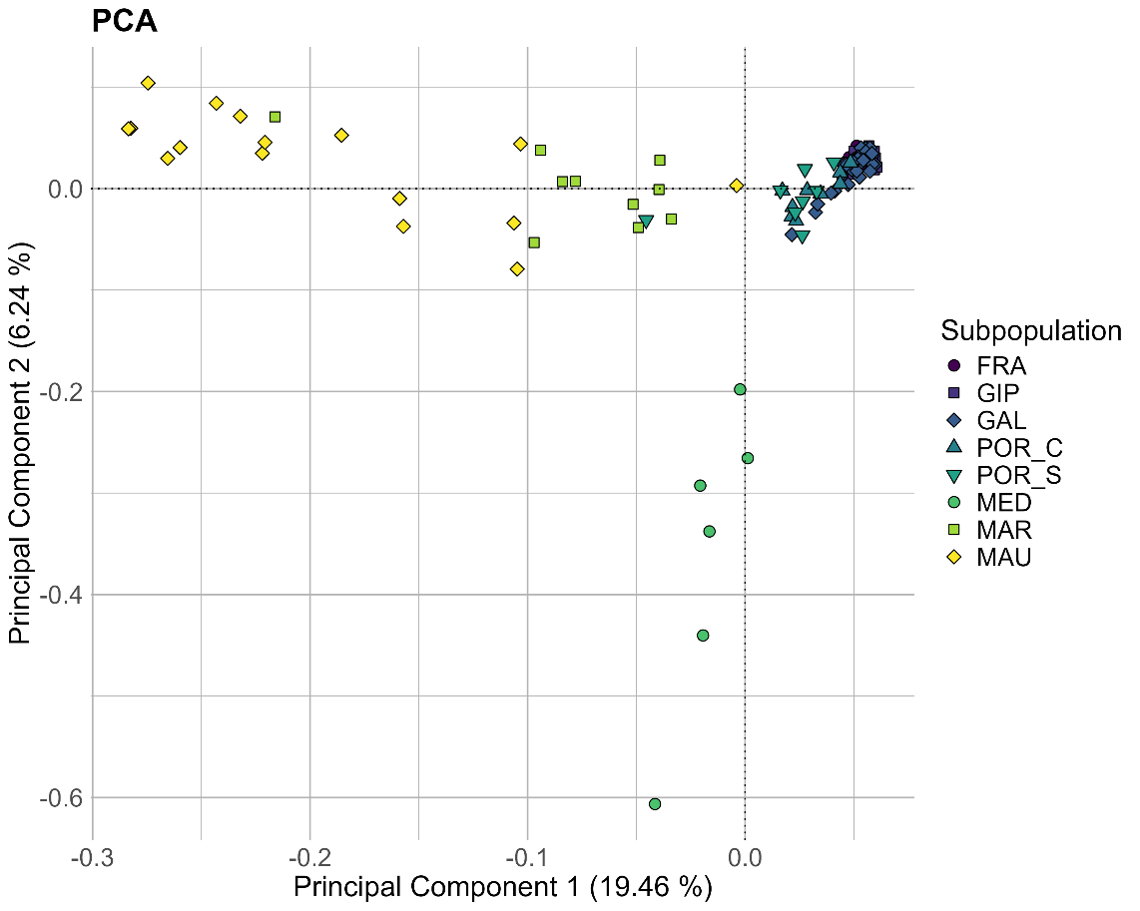
Supplementary Figure 5. Principal Component Analysis. The proportion of variance explained by the first and second principal components is indicated on the respective axes.

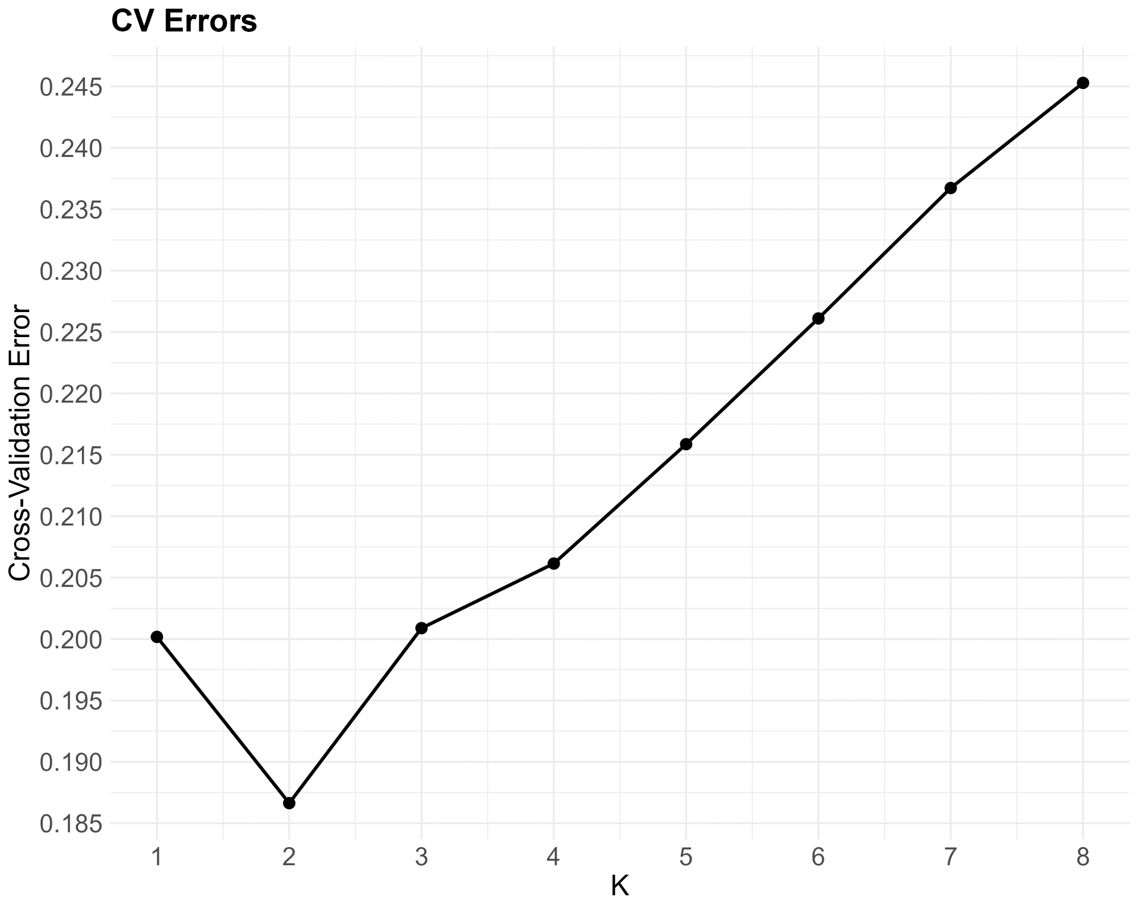
Supplementary Figure 6. Cross-validation error across different values of K (ancestral populations).
Supplementary Figure 7. A. Pairwise F_{ST} values ordered by geographic distance, with a 95% confidence interval based on 1,000 bootstrap replicates. B. Geographic distances heatmap.

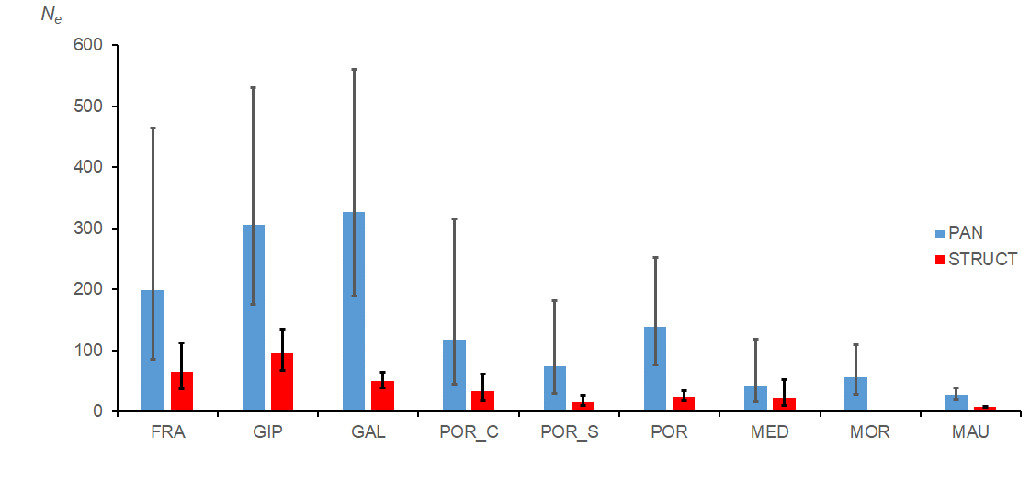
Supplementary Figure 8. Estimates of N_{e} assuming 1cM/Mb and panmixia (PAN) or population structure (STRUCT).

