Additional File 1. Supplementary Figures and Tables
This file contains Supplementary Figures S1–S4 and Supplementary Table S1 referenced in the manuscript:
From the leaf to the gut and back again: the fate and influence of phyllosphere bacteria in a gnotobiotic Arabidopsis – Pieris brassicae system
Moritz Müller, Maryse Huve, Michael Kunzler, Mitja N. P. Remus-Emsermann, Rudolf O. Schlechter, Luis R. Paniagua Voirol

Contents
- Supplementary Figure S1. Composition of SynComs used in each experimental run.
- Supplementary Figure S2. Classification of 16S rRNA gene sequencing reads.
- Supplementary Figure S3. Effect of Magenta Box vs. Pot growth system in Pieris brassicae larval survival and biomass.
- Supplementary Figure S4. Correlation between larval weight and SynComs.
- Supplementary Table S1. Bacterial strain pool for SynCom assembly.

Supplementary Figures
Supplementary Figure S1.
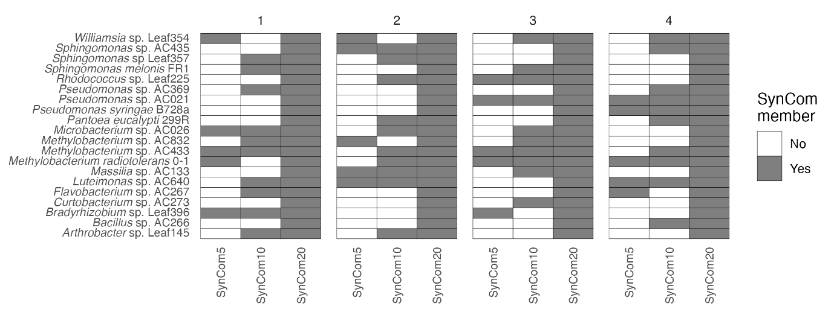
Figure S1. Composition of SynComs used in each experimental run. For all experiments in which SynCom5 (5 strains), SynCom10 (10 strains) and Syncom20 (20 strains) were used, the specific strains present in the SynCom5 and SynCom10 bacterial communities were drawn randomly out of the SynCom20 strain-pool. Strains present in a SynCom used in an experimental replication are coloured dark.

Supplementary Figure S2.
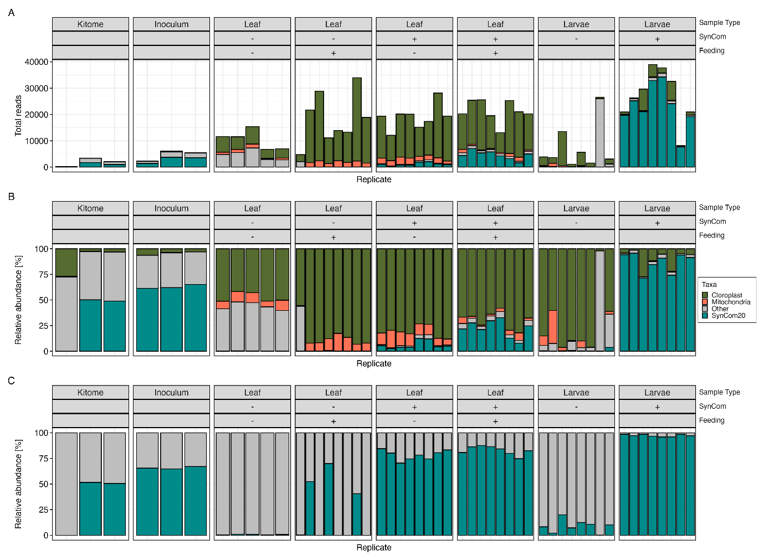
Figure S2. Classification of 16S rRNA gene sequencing reads. OTUs were classified using the SILVA rRNA database grouped by sample type. Chloroplast reads are shown in green, mitochondrial reads in orange, SynCom20 reads in teal, and other/unclassified reads in grey. (A) Total number of 16S rRNA gene amplicon reads. (B) Relative abundance of 16S rRNA gene amplicon reads. (C) Relative abundance of 16S rRNA gene amplicon reads after removal of chloroplasts and mitochondrial reads.

Supplementary Figure S3.
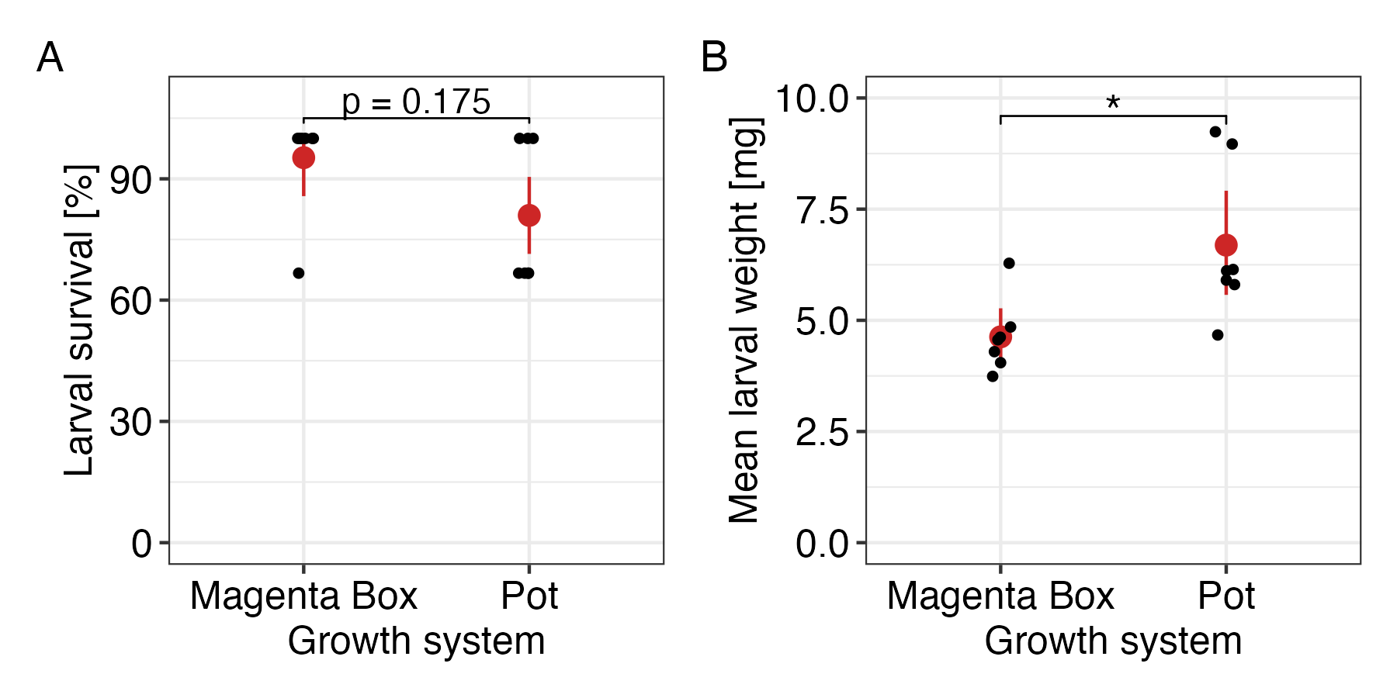
Figure S3: Effect of Magenta Box vs. Pot growth system in Pieris brassicae larval survival and biomass. (A) Larval survival, Fischer’s exact test (n = 7); (B) Mean larval weight (n = 7). Significant differences between groups are indicated by stars (𝛼 = 0.05; Wilcoxon signed-rank test).

Supplementary Figure S4.
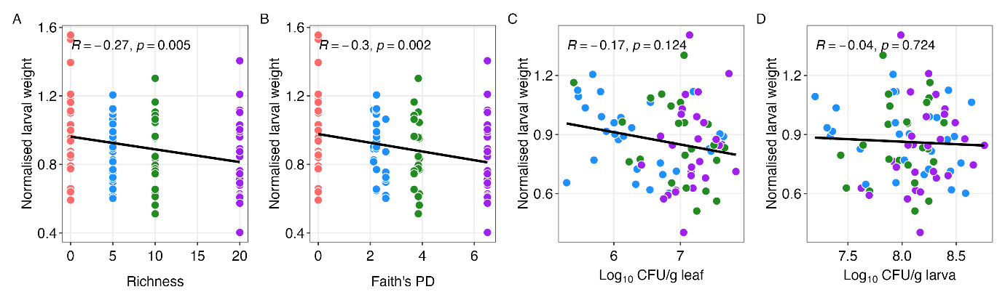
Figure S4. Correlation between larval weight and SynComs. In all cases, Spearman’s correlations (R) are computed against the normalised larval weight depending on treatment with synthetic bacterial communities of different richness. (A) SynCom richness (Number of strains per SynCom). (B) SynCom phylogenetic diversity (Faith’s PD). (C) CFU found on the leaves after larval feeding (log10-scale). (D) Correlation between CFU found in larvae (log10-scale).

Supplementary Tables
Supplementary Table S1.
Table S1. Bacterial strain pool for SynCom assembly. For each strain additional information regarding SynCom assembly and the growth medium used during culturing are given.
Strain | Reference | Ratio (colonies of strain at OD₆₀₀ 1.0 / mean colonies at OD₆₀₀ 2.0) | OD₆₀₀ at assembly* | Growth medium
Luteimonas sp. AC640 | Miebach et al. personal communication | 3.436 | 1 | R2A agar
Curtobacterium sp. AC273 | Miebach et al. personal communication | 0.508 | 1 | liquid R2A
Microbacterium sp. AC026 | Miebach et al. personal communication | 3.436 | 0.1 | liquid R2A
Arthrobacter sp. Leaf145 | [25] | 1.027 | 0.1 | liquid R2A
Rhodococcus sp. Leaf225 | [25] | 0.278 | 1 | liquid R2A
Williamsia sp. Leaf354 | [25] | 0.063 | 1 | R2A agar
Bacillus sp. AC266 | Miebach et al. personal communication | 0.003 | 10 | liquid R2A
Flavobacterium sp. AC267 | Miebach et al. personal communication | 6.572 | 0.1 | R2A agar
Bradyrhizobium sp. Leaf396 | [25] | 0.299 | 1 | liquid R2A
Pantoea eucalypti 299R | [86] | 0.763 | 1 | liquid R2A
Methylobacterium sp. AC433 | Miebach et al. personal communication | 0.039 | 1 | R2A agar
Methylobacterium sp. AC832 | Miebach et al. personal communication | 0.066 | 1 | R2A agar
Methylobacterium radiotolerans 0-1 | [87] | 0.204 | 1 | liquid R2A
Massilia sp. AC133 | Miebach et al. personal communication | 0.314 | 1 | liquid R2A
Pseudomonas sp. AC369 | Miebach et al. personal communication | 0.299 | 1 | liquid R2A
Pseudomonas syringae B728a | [88] | 0.607 | 1 | liquid R2A
Pseudomonas sp. AC021 | Miebach et al. personal communication | 0.724 | 1 | liquid R2A
Sphingomonas sp. Leaf357 | [25] | 0.691 | 1 | liquid R2A
Sphingomonas sp. AC435 | Miebach et al. personal communication | 0.052 | 1 | R2A agar
Sphingomonas melonis FR1 | [89] | 0.568 | 1 | liquid R2A
*During SynCom assembly, all strains were mixed to the same volume but with differing optical densities to account for differences in the relation between optical density and cell count for different strains.

