Supplementary Methods

Sparse Canonical Correlation Analyses (sCCA)
Canonical correlation analysis (CCA) is a multivariate method used to identify relationships between two sets of variables (X and Y datasets) measured in the same individuals [1]. It can be considered a generalization of multiple linear regression, as it aims to find linear combinations of variables from each dataset that maximize the correlation (i.e., canonical correlation) between the two sets. Given two variable sets, X = (x₁, x₂, …., x_{p}) and Y = (y₁, y₂, ...., y_{q}), CCA constructs pairs of canonical variates: W_{n} = a_{1n}x₁ + a_{2n}x₂ +….+ a_{np}x_{p} and V_{n} = b_{1n}y₁ + b_{1n}y₂ +….+ b_{1nq}y_{q} , such that the correlation C_{n} between W_{n} and V_{n} is maximized while ensuring orthogonality between successive canonical variates. However, traditional CCA has several limitations: 1) it assumes that variables are uncorrelated, which may not hold in real-world datasets. 2) it assigns non-zero weights to all contributing variables, making it difficult to infer the importance of individual features. 3) it is prone to overfitting [2], particularly when the number of features exceeds the number of observations. To address these limitations, sparse CCA (sCCA) was introduced, incorporating an L₁ penalty to shrink the weights of negligible variables to zero [3, 4]. This regularization technique allows sCCA to retain only a subset of variables that significantly contribute to the canonical variates, improving interpretability and robustness in high-dimensional datasets.
In this study, we applied sCCA to investigate multivariate relationships between ACEs profiles and behavioral variables while accounting for high-dimensionality and complex interactions. The analysis followed these steps: 1) data preprocessing: ACEs variables and behavioral variables were standardized to a mean of 0 and a standard deviation of 1 before entering the sCCA models; 2) sparse parameter selection: Candidate sparsity parameters were tested within the range of 0.1/√p to 1 (in 0.1 increments, where p represents the number of features in the dataset). The combination that yielded the highest canonical correlation was selected as the optimal sparsity criterion; 3) model estimation and validation: The optimal sCCA model was fitted, and its significance was evaluated through permutation testing. The discovery dataset was randomly permuted, and the sCCA algorithm was rerun on the permuted dataset. The resulting feature weights were then applied to the unpermuted test dataset. The exact P-value was calculated by dividing the number of permuted canonical correlations that were equal to or greater than the observed canonical correlation by the total number of permutations. False Discovery Rate (FDR) correction was applied to control for multiple comparisons, with P_{FDR} < 0.05 considered statistically significant. For significant sCCA modes, variable weights and loadings were reported only if they met the standard criterion of > |0.1|, indicating at least a small effect size based on established guidelines [2, 4].

Neuroimaging measures

Structural Imaging
Structural MRI (sMRI) data were acquired using a 3D weighted magnetization prepared rapid acquisition gradient echo (MPRAGE) sequence for cortical parcellation and subcortical segmentation. The imaging parameters were as follows:: image matrix=256×256; voxel resolution=1×1×1 mm³ isotropic; repetition time (TR)=2,500 ms; echo time (TE)=2.88 ms; field of view (FOV)=256×256 mm; flip angle=8 degrees. To minimize motion artifacts during data acquisition, prospective motion correction was implemented in the ABCD imaging protocol for the sMRI acquisitions.
sMRI data were processed using FreeSurfer (version 5.3.0) through standardized pipelines established by the ABCD Study Data Acquisition and Integration Core. The preprocessing steps included non-brain tissue removal using a hybrid watershed/surface deformation procedure [5], automated Talairach transformation for spatial normalization, segmentation of subcortical white matter and deep gray matter volumetric structures, intensity normalization, tessellation of the gray/white matter boundary, and automated topology correction with surface deformation to refine cortical boundaries [6]. Cortical regions were registered to the Desikan atlas, which aligns individual cortical folding patterns across subjects. The cerebral cortex was parcellated into 34 regions per hemisphere based on gyral and sulcal anatomy, and a total of 68 cortical and 20 subcortical volumes were included in the analysis. Only sMRI data that met rigorous quality control criteria, including passing the recommended imaging inclusion standards and MRI clinical report, were retained for analysis (n = 10,855) [7].

Diffusion Magnetic Resonance Imaging
The diffusion magnetic resonance imaging (dMRI) data were acquired using a multiband echo-planar imaging (EPI) sequence with a slice acceleration factor 3 and 96 diffusion directions. The acquisition parameters included a voxel resolution of 1.7 mm isotropic, seven b = 0 frames, and four b-values (6 directions with b = 500 s/mm², 15 directions with b = 1,000 s/mm², 15 directions with b = 2,000 s/mm², and 60 directions with b = 3,000 s/mm²). Each dMRI acquisition block included fieldmap scans for B₀ distortion correction. The dMRI metrics were estimated using a linear approach with log-transformed, diffusion-weighted signals [8]. Fractional anisotropy (FA) metrics were derived by first diagonalizing the diffusion tensor using singular value decomposition, producing three eigenvectors and three corresponding eigenvalues, from which FA was computed [8]. Major white matter tracts are labeled using AtlasTrack, a probabilistic atlas-based method for automated segmentation of white matter fiber tracts [9]. Only dMRI data that met the quality control criteria, including adherence to the recommended imaging inclusion standards and MRI clinical report, were retained for analysis(n = 9,814) [7].

Resting-State Functional Imaging
Resting-state functional magnetic resonance imaging (rsfMRI) data were acquired using a multiband echo-planar imaging (EPI) sequence with a slice acceleration factor of 6, a voxel resolution of 2.4 mm isotropic, and a TR of 800 ms. Each of the fMRI acquisition blocks included fieldmap scans for B₀ distortion correction. Data were processed using a standardized analysis pipeline [6, 10]. In terms of motion correction, motion correction included six motion parameters along with their derivatives and squared terms. Only frames with framewise displacement < 0.3 mm were included in the regression, and all rsfMRI metrics accounted for average motion. Functional connectivity was assessed through pairwise correlations between regions of interest within functionally defined parcellations, specifically the Gordon networks [11]. The Fisher Z-transform of the correlation values was computed within each of the 13 Gordon networks across 78 additional between-network rsfMRI metrics. Only rsfMRI data that met the quality control criteria, including adherence to the recommended imaging inclusion standards and MRI clinical report, were retained for analysis (n = 6,873) [7].

Reliability and Stability Assessments
The following analyses were conducted to evaluate the robustness and reliability of the sCCA results: 1) stability of sCCA analysis: To assess the stability of sCCA results with respect to sample size and composition, we performed bootstrapping to resampling the original dataset with 1,000 times. Each bootstrap sample consisted of resampled datasets ranging from 10% to 150% of the original dataset in 10% increments, resulting in a total of 1,500 subsamples; 2) random resampling: To evaluate the consistency of the findings, 80% of the discovery dataset was randomly resampled 100 times. The sCCA algorithm was then rerun on each resampled subset, and the canonical correlations between the resulting feature weights in the remaining 20% of the dataset were calculated. The feature weight vectors of the resampled datasets were aligned with the original data by maximizing the correlation between their weight matrices and reordering the resampled matrices to match the original dataset as closely as possible; 3) leave-one-site-out framework: To ensure that the results were independent of individual data collection sites, we employed a leave-one-site-out approach. Due to the small sample size at each site, analyses using single-site data alone would be underpowered. Instead, we repeated the sCCA analyses after excluding one site at a time and calculated the correlation between the feature loadings in the training dataset and those in the dataset with one site excluded; 4) assessment of sex bias: Since the aim was to identify population-level modes rather than subgroup-specific patterns, we assessed the canonical weights and the feature loadings for each mode separately in males (n = 5,159) and females (n = 4,637). The between-sex correlation coefficient (r) was then computed to evaluate potential sex-related biases; 5) impact of data imputation: To examine the influence of the imputation on model stability, we applied the weights derived from the analysis of the discovery dataset to a non-imputed dataset comprising only individuals with complete data. This allowed us to test the robustness of the findings in the absence of imputation.

Polygenic risk scores calculation

Base GWAS Datasets
GWAS summary statistics were obtained for five major psychiatric disorders in European ancestry: MDD [12], ADHD [13], SCZ [14], BIP [15], and ASD [16]. These disorders were selected based on their well-powered GWAS and broad age-of-onset and clinical presentations. The base datasets provided effect allele frequencies, association P-values, and effect size estimates (odds ratios, ORs) for single nucleotide polymorphisms (SNPs) associated with each disorder. Details of the GWAS cohorts and sample sizes for these traits are provided in Table S4.

Target GWAS dataset
Genotype data from the ABCD Study (Release 5.1) were processed using Axiom Analysis Suite (version 2.11) based on raw intensities from the Affymetrix Smokescreen array, using either saliva or whole blood samples. Sample selection prioritized higher genotyping success rates, non-missingness, concordance between genetic and reported sex, and reduced excessive identity-by-state (IBS). Initial quality control was performed by ABCD using calling signals and variant call rates, followed by the RICOPILI (Rapid Imputation and Computational Pipeline) permutation-based QC procedures. The full QC details applied to the target dataset are described at https://doi.org/10.15154/z563-zd24. After applying these procedures, 515,270 SNPs and 11,666 participants were retained for further analysis. To enhance the quality of the genetic data, additional QC steps were applied after stratifying the dataset into European ancestry and trans-ancestry subsamples. Pre-imputed variants were filtered with call rates (<5% missingness), Hardy-Weinberg equilibrium (HWE < 1 × 10⁻⁹), and heterozygosity rate (> 3SD from the mean). From the imputed variants, we further removed SNPs with minor allele frequency (MAF < 0.005) and mputation information (INFO < 0.5) using PLINK [17]. A pruned set of SNPs (r² = 0.1) was used to estimate 10 genetic principal components within each subsample, which were included as covariates in subsequent analyses to control for population stratification. Genetic data was phased and imputed using the TOPMed imputation server and only SNPs with high imputation quality (INFO > 0.9) were retained.
Among the ABCD participants, 52.3% (n = 4,269) were of European ancestry. To mitigate population stratification, primary PRS analyses were conducted in European ancestry participants, with additional trans-ancestry analyses to assess generalizability in a more diverse population.

PRS Computation
PRS were computed using PRSice-2 (version 2.3.5) with clumping and thresholding parameters set as clump-kb 250kb, clump-r² 0.1, and clump-p 1.0. PRS were generated for multiple significance thresholds: 0.001, 0.05, 0.1, 0.2, 0.3, 0.5, and 1.0. For each participant, PRS were calculated by summing the weighted number of risk alleles (0, 1, or 2) at each SNP, with weights assigned based on the logarithm of the OR (logOR) from the corresponding GWAS dataset.

Supplementary Results

Reliability and Stability Assessments
We assessed reliability and stability of the sCCA results through multiple approaches. First, the sCCA was rerun 1,500 times with varying sample sizes and the canonical correlations were found to be largely stable, as shown in Fig. S5D. Second, using the same 80%/20% split proportions as in the original discovery/test datasets, 80% of the discovery dataset was resampled, the sCCA algorithm was rerun, and the correlation between the resulting feature loadings and those from the remaining 20% of the dataset were calculated. These resampled results provided an estimate of stability across subsamples (Fig. S5B). Third, the correlation between original SCCA feature weights and the weights from the leave-one site out analysis are obviously high for the two modes (Fig. S6D and Table S5). Fourth, in the sex-stratified analysis the calculated correlation coefficients between variables feature loadings in males and females was over 0.9 in the discovery and test dataset, which showed a high degree of correlation (Fig. S6C and Table S7). In calculating stratified canonical correlations, the r-values between ACEs profiles and individual behavioral groups in males were similar to the primary analysis results (r_{discovery}= 0.607, r_{test} = 0.570, P_{perm} = 0.001) for model 1, and (r_{discovery}= -0.240, r_{test} = -0.273, P_{perm} = 0.020) for model 2. In females, only the first model was significant (r_{discovery}= 0.617, r_{test} = 0.557, P_{perm} = 0.001), with the second model was insignificant (r_{discovery}= -0.245, P_{FDR} = -0.262, P_{perm} = 0.049), indicating the covariation pattern of model 2 is specific in males (Fig. S6A-B and Table S7).Fourth, the contributions of variables to the models estimated based on the non-imputed dataset (n = 5,351) were significantly correlated with those calculated based on discovery dataset (Model 1: r = 0.980 for ACEs, r = 0.999 for individual behavioral groups; Model 2: r = 0.980 for ACEs, r = 0.987 for individual behavioral groups (Fig. S5A and Table S7). The canonical correlation of the two models also shown (Fig. S6C).

Supplementary Figures
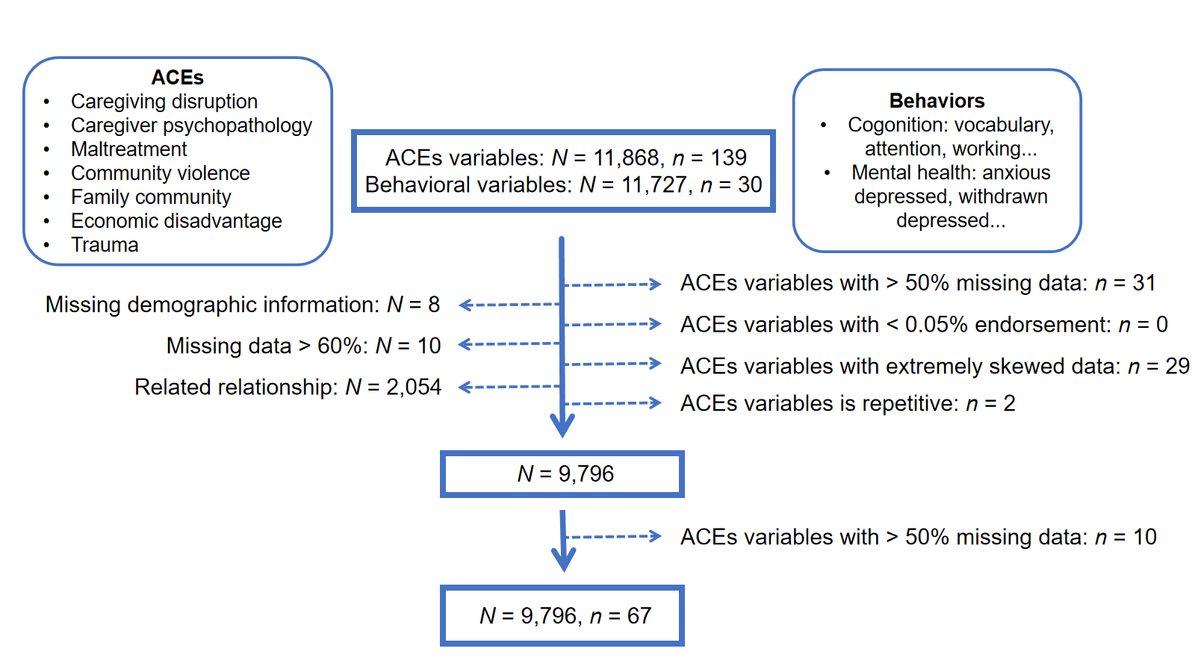

Fig. S1 Data processing workflow for ACEs and behavioral variables. This diagram illustrates the data processing steps for the ACEs and behavioral variables used in the study.

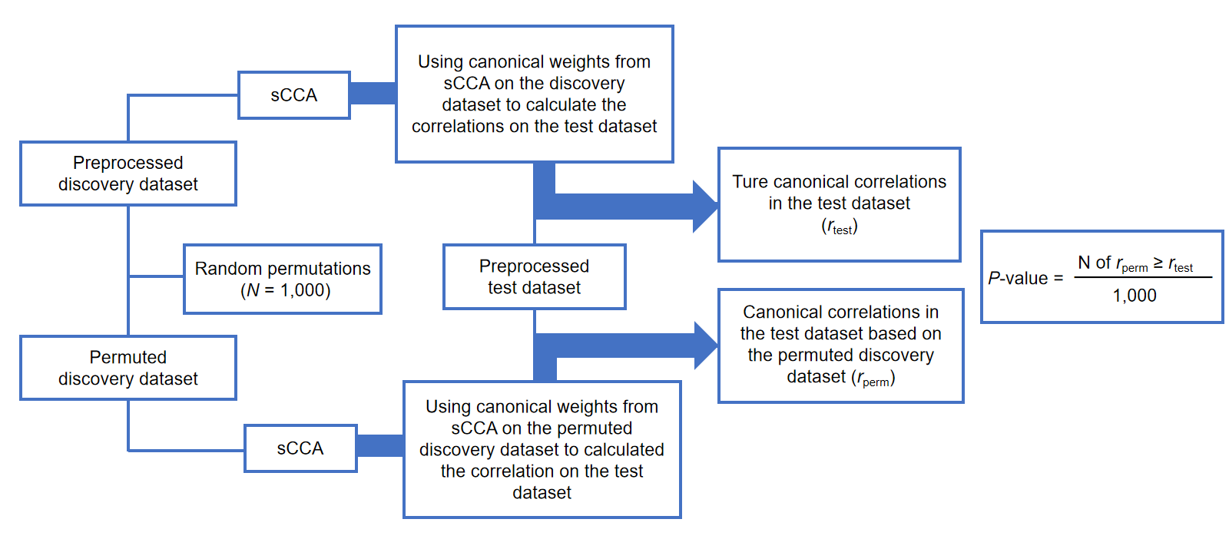

Fig. S2 Workflow of permutation testing for sCCA analysis method.

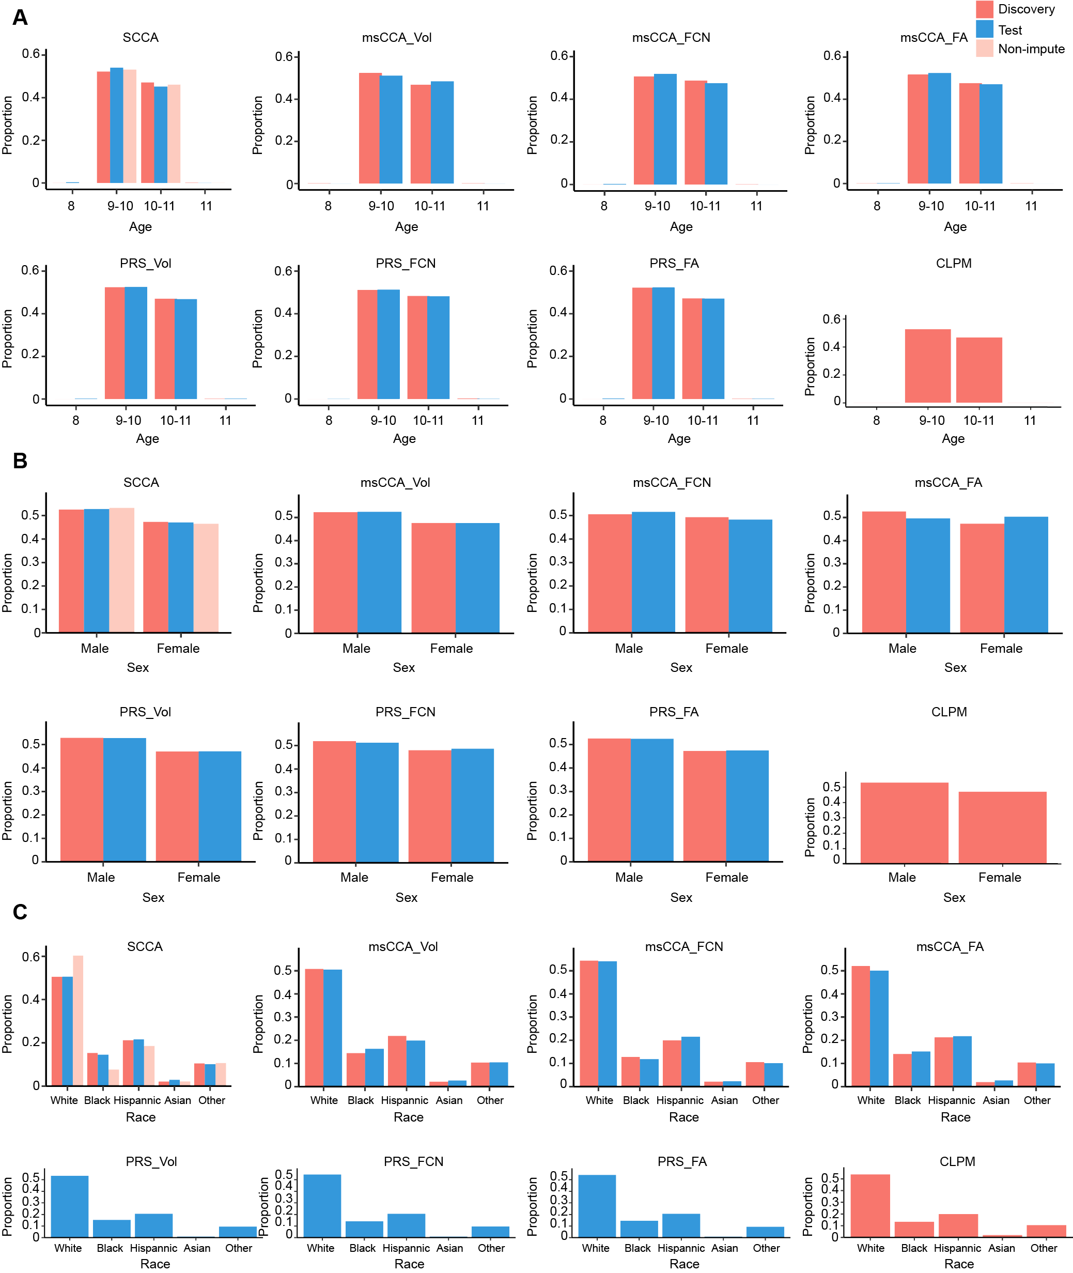

Fig. S3 Histograms of demographic characteristics in sCCA. The histograms of demographic characteristics for each analysis, including age distribution (A), sex distribution (B), and race composition (C). Orange represents the discovery dataset, blue represents the test dataset, and pink represents the non-imputed data.

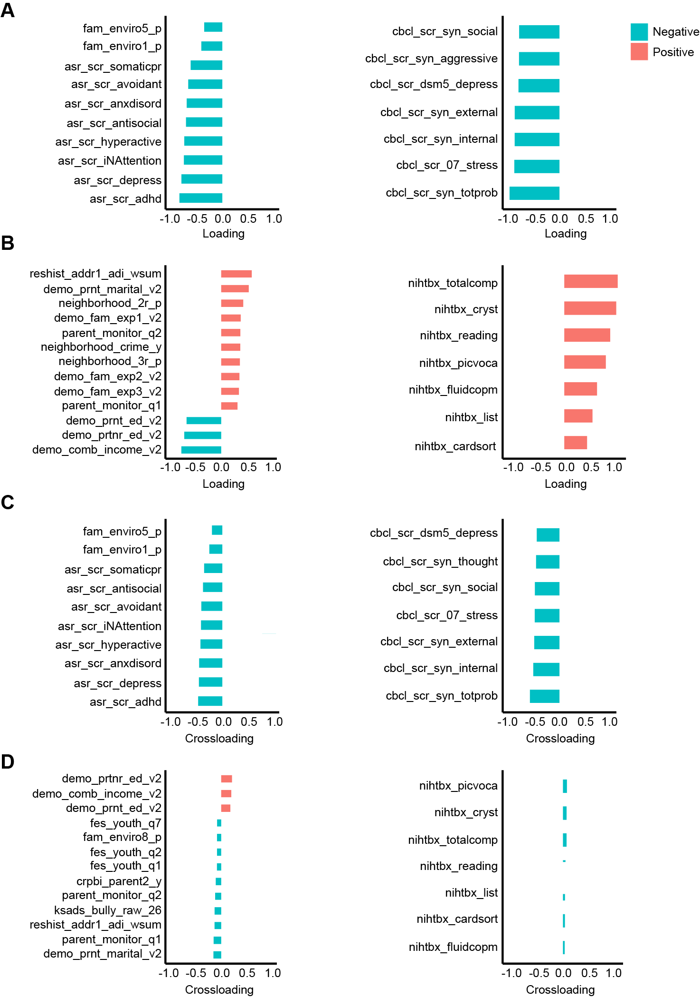

Fig. S4 Canonical loadings and cross-loadings of variables in the sCCA analysis. (A & B) The first and second significant canonical models, respectively. The left side illustrates the canonical loadings of variables contributing to the ACEs profile, while the right side displays the canonical loadings of variables contributing to the individual behavioral group. (C & D) The first and second significant canonical models, respectively. The left side shows the cross-loadings of variables contributing to the ACEs profile and the right side showing the cross-loadings of variables contributing to the individual behavioral group. Orange indicates positive values, and green represents negative values.

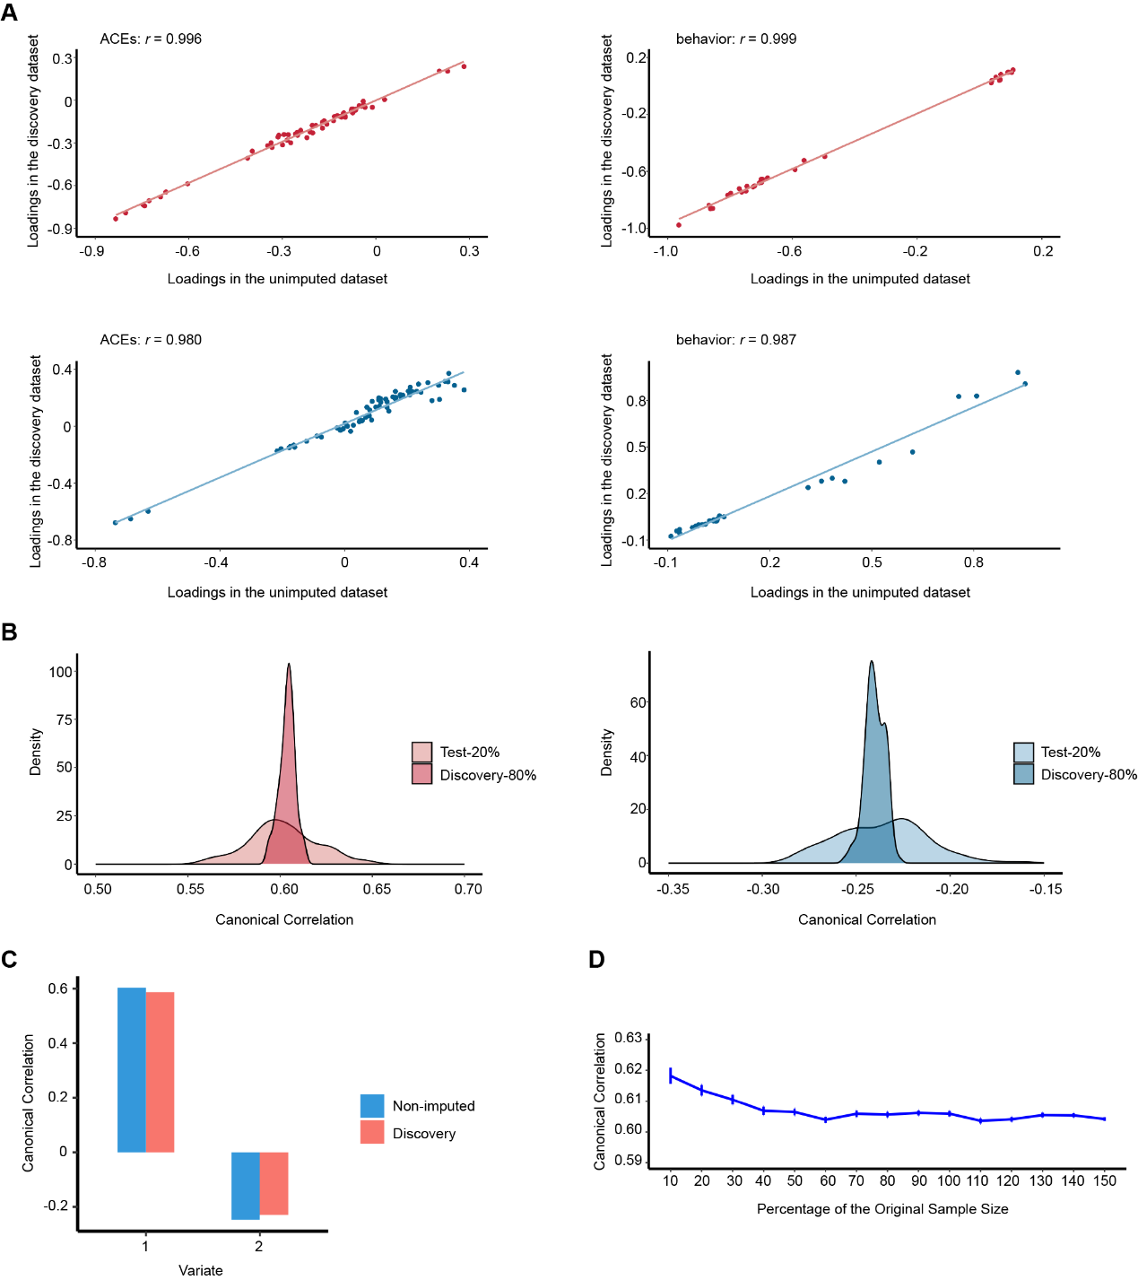

Fig. S5 Results of the sensitive analysis. (A) The left side shows correlations between loadings (i.e. variate to variable correlations) on ACEs variables in the original discovery dataset and the non-imputed dataset for the two significant modes, and the right side shows correlations between loadings on individual behavior variables in the original discovery dataset and non-imputed dataset in the two significant modes. Red represents the first model, and blue represents the second model. (B) Canonical correlations for the first mode across 100 randomly sampled discovery and test sets. Red represents the first model, and blue represents the second model. (C) Canonical correlation coefficients in the full non-imputed dataset and the imputed discovery set. (D) Canonical correlation for each modality as a function of sample size using a bootstrapping approach (sampling with replacement).

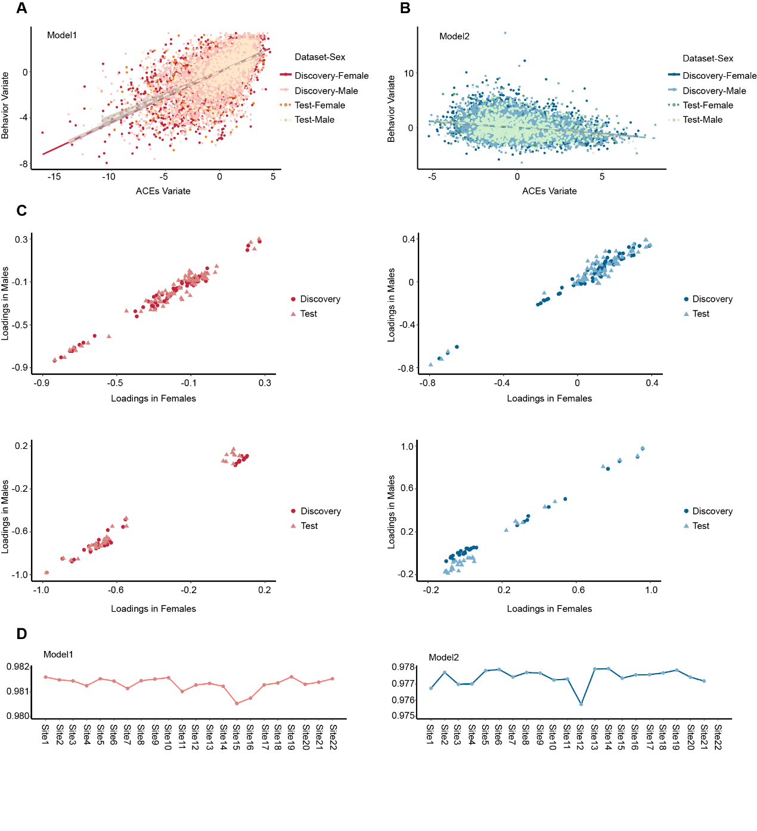

Fig. S6 Results of the sensitive analysis. (A & B) The correlation for males and females between ACEs profiles and individual behavioral groups for two canonical modes in both the discovery dataset (dark points) and the test dataset (light points). (C) The left side shows correlations between loadings (i.e. variate to variable correlations) on ACEs variables in males and females across the two significant modes, and the right side shows correlations between loadings on individual behavior variables in males and females across the two significant modes. (D) The correlation between the original loadings and the loadings obtained from the leave-one site out analysis for the two significant models. Red indicates the first model, and blue indicates the second model.

Fig. S7 Correlations of msCCA for significant models. (A & B, Model 1 & Model 2 respectively) The correlations between ACEs profile and behavioral group with sMRI variates (Volume) in both the discovery and test datasets. (C, Model 1) The correlations between ACEs profile and behavioral group with rsfMRI variates (FCNs) in both the discovery and test datasets. (D & E, Model 1 & Model 2 respectively) The correlations between ACEs profile and behavioral group with dMRI variates (FA) in both the discovery and test datasets.

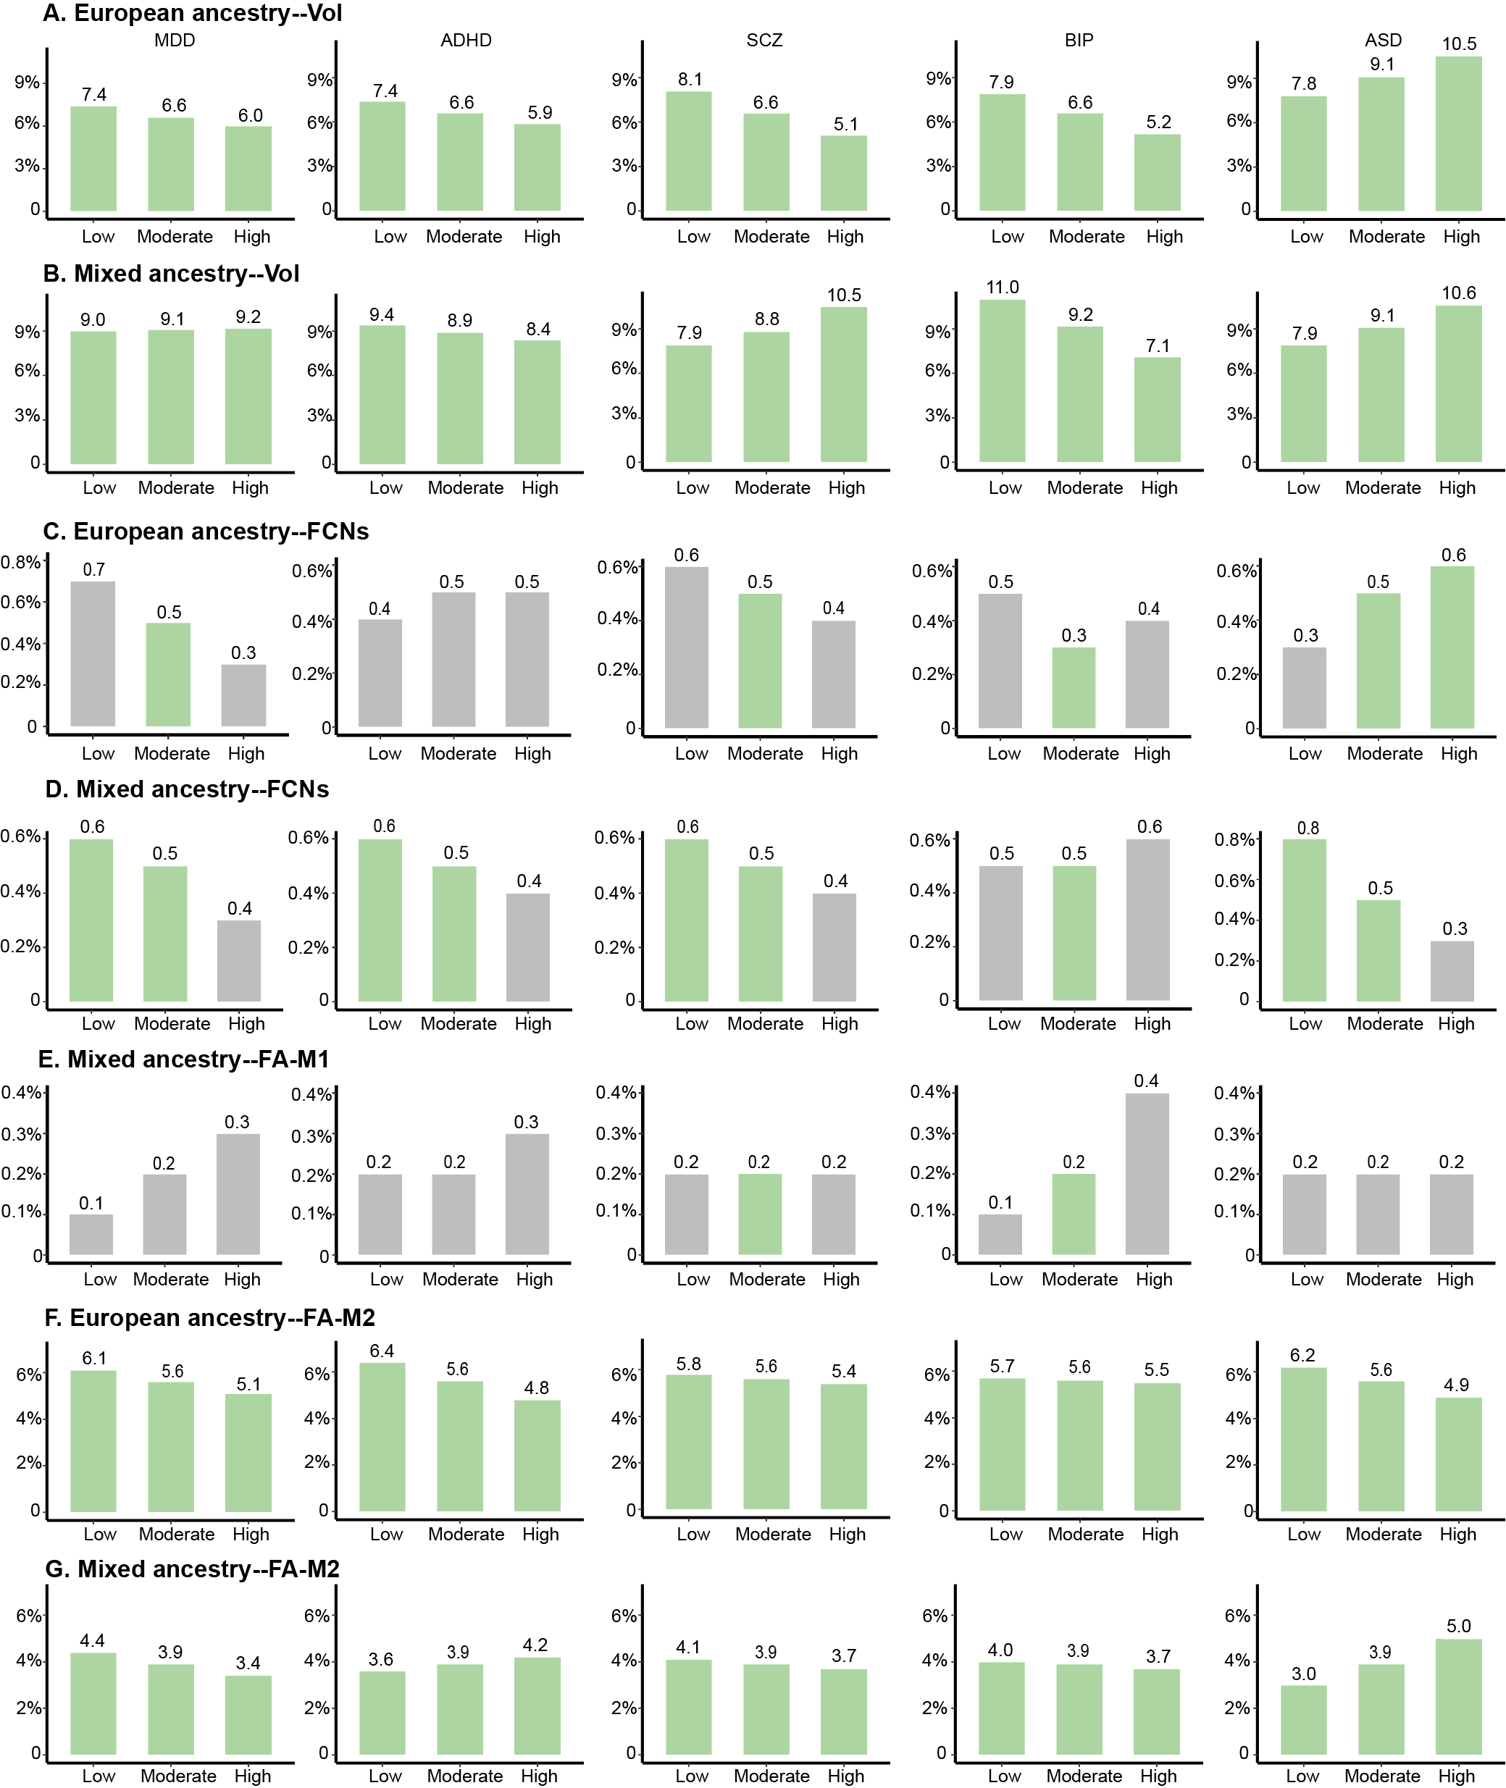

Fig. S8 Results of moderated mediation analysis across different modes. The proportion of mediation explained at varying levels of the moderating factors is shown. Grey bars mean nonsignificant mediation at the corresponding level of the moderator, while green bars represent significant mediation effects. (A & B) The mediation pathways with brain components of regional brain volume as mediators in individuals of European and mixed ancestry, respectively. (C & D) The mediation pathways with brain components of regional FA as mediators in individuals of European and mixed ancestry, respectively. (E) The mediation pathways with brain components of FCN as mediators in individuals of mixed ancestry in the first model. (F & G) The mediation pathways with brain components of FCN as mediators in individuals of European and mixed ancestry in the second model, respectively.

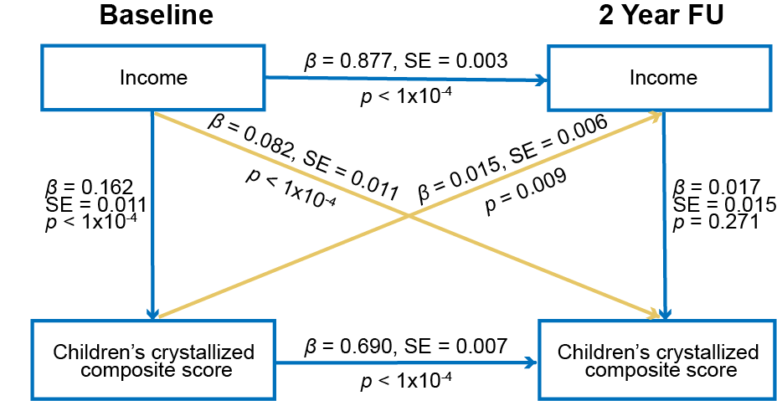

Fig. S9 Result of CLPM for the second model.

Supplementary Tables

Table S1. Definition of all variables.
 | Variable | Note | Detail | Sample size | Percentage of missing data
Age | demo_brthdat_v2 | How old is the child? | years old | 11 868 | 0.09%
Sex | demo_sex_v2 | What sex was the child assigned at birth, on the original birth certificate? | 1 = Male; 2 = Female; 3 = Intersex-Male; 4 = Intersex-Female; 999 = Don't know; 777 = Refuse to answer Prefiero no responder | 11 868 | 0%
Race | race_ethnicity | Race Ethnicity (Child) | 1 = White; 2 = Black; 3 = Hispanic; 4 = Asian; 5 = Other | 11 868 | 0.01%
Handness | ehi_y_ss_scoreb | Handedness score rating | 1 = right handed; 2 = left handed; 3 = mixed handed | 11 868 | 0%
Height | anthroheightcalc | Standing Height Average (inches) |  | 11 863 | 0.03%
Weight | anthroweightcalc | Average Measured Weight (lbs) |  | 11 863 | 0.03%
Scanner site | site_id_l | Site ID at each event |  | 11 868 | 0%
Puberty | pds_1_p | Would you say that your child's growth in height | 1 = has not yet begun to grow; 2 = has barely started to grow; 3 = is definitely underway Definitivamente; 4 = seems complete ; 999 = I don't know | 11 868 | 4%
 | pds_2_p | And how about the growth of your child's body hair ("body hair" means hair any place other than their head, such as under their arms)? Would you say that your child's body hair growth | 1 = has not yet begun to grow; 2 = has barely started to grow; 3 = is definitely underway Definitivamente; 4 = seems complete ; 999 = I don't know | 11 868 | 2.6%
 | pds_3_p | Have you noticed any changes to their skin, especially pimples? | 1 = skin has not yet started changing; 2 = skin has barely started changing; 3 = skin changes are definitely underway Definitivamente; 4 = skin changes seem complete; 999 = I don't know | 11 868 | 1.8%
 | pds_m5_p | Has he begun to grow hair on his face? | 1 = facial hair has not yet started growing; 2 = facial hair has barely started growing; 3 = facial hair has definitely started Definitivamente; 4 = facial growth seems complete; 999 = I don't know | 11 868 | 48.7%
 | pds_m4_p | Have you noticed a deepening of his voice? | 1 = voice has not yet started changing; 2 = voice has barely started changing; 3 = voice changes are definitely underway Definitivamente; 4 = voice changes seem complete; 999 = I don't know | 11 868 | 48.6%
 | pds_f4_p | Have you noticed that your child's breasts have begun to grow? | 1 = have not yet started growing; 2 = have barely started growing; 3 = breast growth is definitely underway Definitivamente; 4 = breast growth seems complete; 999 = I don't know | 11 868 | 52.8%
 | pds_f5b_p | Has your child begun to menstruate? | 4 = Yes Sí; 1 = No No; 999 = I don't know No sé | 11 868 | 52.8%
Adverse childhood experiences variables | famhx_ss_fath_prob_alc_p | father alcohol problem | 0=no problem endorsed; 1=problem endorsed | 11 868 | 4.0%
Adverse childhood experiences variables | famhx_ss_fath_prob_dg_p | father drug use problem | 0=no problem endorsed; 1=problem endorsed | 11 868 | 3.2%
Adverse childhood experiences variables | famhx_ss_moth_prob_alc_p | mother alcohol problem | 0=no problem endorsed; 1=problem endorsed | 11 868 | 4.1%
Adverse childhood experiences variables | famhx_ss_moth_prob_dg_p | mother drug use problem | 0=no problem endorsed; 1=problem endorsed | 11 868 | 3.0%
Adverse childhood experiences variables | famhx_4d_p___1 | biological mother (Marital Matrimonial) | 0 = No; 1 = Yes | 11 868 | 0.9%
Adverse childhood experiences variables | famhx_4d_p___2 | biological mother (Work Laboral) | 0 = No; 1 = Yes | 11 868 | 0.9%
Adverse childhood experiences variables | famhx_4d_p___3 | biological mother (Arrests/DUI Arrestos/DUI) | 0 = No; 1 = Yes | 11 868 | 0.9%
Adverse childhood experiences variables | famhx_4d_p___6 | biological mother (Isolated self, arguments, drunk a lot, familia, Discusiones, drogado/a con frecuencia) | 0 = No; 1 = Yes | 11 868 | 0.9%
Adverse childhood experiences variables | famhx4a_p___1 | biological father (Marital Matrimonial) | 0 = No; 1 = Yes | 11 868 | 0.7%
Adverse childhood experiences variables | famhx4a_p___2 | biological father (Work Laboral) | 0 = No; 1 = Yes | 11 868 | 0.7%
Adverse childhood experiences variables | famhx4a_p___3 | biological father (Arrests/DUI Arrestos/DUI) | 0 = No; 1 = Yes | 11 868 | 0.7%
Adverse childhood experiences variables | famhx_4a_p___6 | biological father (Isolated self, arguments, drunk a lot, familia, Discusiones, drogado/a con frecuencia) | 0 = No; 1 = Yes | 11 868 | 0.9%
Adverse childhood experiences variables | fam_history_q5d_drugs___1 | biological mother (Marital Matrimonial) | 0 = No; 1 = Yes | 11 868 | 0.4%
Adverse childhood experiences variables | fam_history_q5d_drugs___2 | biological mother (Work Laboral) | 0 = No; 1 = Yes | 11 868 | 0.4%
Adverse childhood experiences variables | fam_history_q5d_drugs___3 | biological mother (Arrests/DUI Arrestos/DUI) | 0 = No; 1 = Yes | 11 868 | 0.4%
Adverse childhood experiences variables | fam_history_q5d_drugs___6 | biological mother (Isolated self, arguments, drunk a lot, familia, Discusiones, drogado/a con frecuencia) | 0 = No; 1 = Yes | 11 868 | 0.4%
Adverse childhood experiences variables | fam_history_q5a_drugs___1 | biological father (Marital Matrimonial) | 0 = No; 1 = Yes | 11 868 | 0.6%
Adverse childhood experiences variables | fam_history_q5a_drugs___2 | biological father (Work Laboral) | 0 = No; 1 = Yes | 11 868 | 0.6%
Adverse childhood experiences variables | fam_history_q5a_drugs___3 | biological father (Arrests/DUI Arrestos/DUI) | 0 = No; 1 = Yes | 11 868 | 0.6%
Adverse childhood experiences variables | fam_history_q5a_drugs___6 | biological father (Isolated self, arguments, drunk a lot, familia, Discusiones, drogado/a con frecuencia) | 0 = No; 1 = Yes | 11 868 | 0.6%
Adverse childhood experiences variables | asr_scr_depress_r | Depressive Problems ASR DSM-5-Oriented Scale (raw score) |  | 11 868 | 0%
Adverse childhood experiences variables | asr_scr_anxdisord_r | Anxiety Problems ASR DSM-5-Oriented Scale (raw score) |  | 11 868 | 0%
Adverse childhood experiences variables | asr_scr_somaticpr_r | Somatic Problems ASR DSM-5-Oriented Scale (raw score) |  | 11 868 | 0%
Adverse childhood experiences variables | asr_scr_avoidant_r | Avoidant Personality Problems ASR DSM-5-Oriented Scale (raw score) |  | 11 868 | 0%
Adverse childhood experiences variables | asr_scr_adhd_r | AD/H Problems ASR DSM-5-Oriented Scale (raw score) |  | 11 868 | 0%
Adverse childhood experiences variables | asr_scr_antisocial_r | Antisocial Personality Problems ASR DSM-5-Oriented Scale (raw score) |  | 11 868 | 0%
Adverse childhood experiences variables | asr_scr_inattention_r | Inattention ASR DSM-5-Oriented Scale (raw score) |  | 11 868 | 0%
Adverse childhood experiences variables | asr_scr_hyperactive_r | Hyperactivity-Impulsivity ASR DSM-5-Oriented Scale (raw score) |  | 11 868 | 0%
Adverse childhood experiences variables | fam_history_q6a_depression | biological father | 0 = No; 1 = Yes; 999 = Don't know | 11 868 | 51.0%
Adverse childhood experiences variables | fam_history_q6d_depression | biological mother | 0 = No; 1 = Yes; 999 = Don't know | 11 868 | 48.7%
Adverse childhood experiences variables | fam_history_q7a_mania | biological father | 0 = No; 1 = Yes; 999 = Don't know | 11 868 | 87.5%
Adverse childhood experiences variables | fam_history_q7d_mania | biological mother | 0 = No; 1 = Yes; 999 = Don't know | 11 868 | 46.8%
Adverse childhood experiences variables | fam_history_q8a_visions | biological father | 0 = No; 1 = Yes; 999 = Don't know | 11 868 | 46.5%
Adverse childhood experiences variables | fam_history_q8d_visions | biological mother | 0 = No; 1 = Yes; 999 = Don't know | 11 868 | 46.5%
Adverse childhood experiences variables | fam_history_q9a_trouble | biological father | 0 = No; 1 = Yes; 999 = Don't know | 11 868 | 39.7%
Adverse childhood experiences variables | fam_history_q9d_trouble | biological mother | 0 = No; 1 = Yes; 999 = Don't know | 11 868 | 39.6%
Adverse childhood experiences variables | fam_history_q10a_nerves | biological father | 0 = No; 1 = Yes; 999 = Don't know | 11 868 | 44.0%
Adverse childhood experiences variables | fam_history_q10d_nerves | biological mother | 0 = No; 1 = Yes; 999 = Don't know | 11 868 | 43.8%
Adverse childhood experiences variables | fam_history_q13a_suicide | biological father | 0 = No; 1 = Yes; 999 = Don't know | 11 868 | 45.8%
Adverse childhood experiences variables | fam_history_q13d_suicide | biological mother | 0 = No; 1 = Yes; 999 = Don't know | 11 868 | 45.7%
Adverse childhood experiences variables | demo_prnt_marital_v2 | Are you now married, widowed, divorced, separated, never married or living with a partner? | 1 = Married; 2 = Widowed; 3 = Divorced; 4 = Separated; 5 = Never married; 6 = Living with partner ; 777 = Refused to answer | 11 868 | 0.8%
Adverse childhood experiences variables | demo_prim | You are the: Usted es: | 1 = Child's Biological Mother; 2 = Child's Biological Father; 3 = Adoptive Parent Padre o madre adoptivo(a); 4 = Child's Custodial Parent; 5 = Other | 11 868 | 0%
Adverse childhood experiences variables | crpbi_parent1_y | First caregiver. Makes me feel better after talking over my worries with him/her | 1 = Not like him/her; 2 = Somewhat like him/her; 3 = A lot like him/her | 11 868 | 0.3%
Adverse childhood experiences variables | crpbi_parent2_y | First caregiver. Smiles at me very often. | 1 = Not like him/her; 2 = Somewhat like him/her; 3 = A lot like him/her | 11 868 | 0.3%
Adverse childhood experiences variables | crpbi_parent3_y | First caregiver. Is able to make me feel better when I am upset. | 1 = Not like him/her; 2 = Somewhat like him/her; 3 = A lot like him/her | 11 868 | 0.3%
Adverse childhood experiences variables | crpbi_parent4_y | First caregiver. Believes in showing his/her love for me. | 1 = Not like him/her; 2 = Somewhat like him/her; 3 = A lot like him/her | 11 868 | 0.3%
Adverse childhood experiences variables | crpbi_parent5_y | First caregiver. Is easy to talk to. | 1 = Not like him/her; 2 = Somewhat like him/her; 3 = A lot like him/her | 11 868 | 0.3%
Adverse childhood experiences variables | crpbi_caregiver12_y | Makes me feel better after talking over my worries with them. | 1 = Not like them ; 2 = Somewhat like them ; 3 = A lot like them | 11 868 | 7.7%
Adverse childhood experiences variables | crpbi_caregiver13_y | Second caregiver. Smiles at me very often. | 1 = Not like them ; 2 = Somewhat like them ; 3 = A lot like them | 11 868 | 7.7%
Adverse childhood experiences variables | crpbi_caregiver14_y | Second caregiver. Is able to make me feel better when I am upset. | 1 = Not like them ; 2 = Somewhat like them ; 3 = A lot like them | 11 868 | 7.7%
Adverse childhood experiences variables | crpbi_caregiver15_y | Believes in showing their love for me. | 1 = Not like them ; 2 = Somewhat like them ; 3 = A lot like them | 11 868 | 7.7%
Adverse childhood experiences variables | crpbi_caregiver16_y | Second caregiver. Is easy to talk to. | 1 = Not like them ; 2 = Somewhat like them ; 3 = A lot like them | 11 868 | 7.7%
Adverse childhood experiences variables | fam_enviro1_p | We fight a lot in our family | 1 = True; 0 = False | 11 868 | 0%
Adverse childhood experiences variables | fam_enviro2r_p | Family members rarely become openly angry | 0 = True; 1 = False | 11 868 | 0%
Adverse childhood experiences variables | fam_enviro3_p | Family members sometimes get so angry they throw things | 1 = True; 0 = False | 11 868 | 0%
Adverse childhood experiences variables | fam_enviro4r_p | Family members hardly ever lose their tempers. | 0 = True; 1 = False | 11 868 | 0%
Adverse childhood experiences variables | fam_enviro5_p | Family members often criticize each other | 1 = True; 0 = False | 11 868 | 0%
Adverse childhood experiences variables | fam_enviro6_p | Family members sometimes hit each other | 1 = True; 0 = False | 11 868 | 0%
Adverse childhood experiences variables | fam_enviro7r_p | If there is a disagreement in our family, we try hard to smooth things over and keep the peace | 0 = True; 1 = False | 11 868 | 0%
Adverse childhood experiences variables | fam_enviro8_p | Family members often try to one-up or outdo each other | 1 = True; 0 = False | 11 868 | 0%
Adverse childhood experiences variables | fam_enviro9r_p | In our family, we believe you don't ever get anywhere by raising your voice. | 0 = True; 1 = False | 11 868 | 0.1%
Adverse childhood experiences variables | fes_1_p | Family members really help and support one another | 1 = True; 0 = False | 11 868 | 100%
Adverse childhood experiences variables | fes_2r_p | Family members often keep their feelings to themselves | 0 = True; 1 = False | 11 868 | 100%
Adverse childhood experiences variables | fes_9_p | Activities in our family are pretty carefully planned | 1 = True; 0 = False | 11 868 | 100%
Adverse childhood experiences variables | fes_19_p | We are generally very neat and orderly. | 1 = True; 0 = False | 11 868 | 100%
Adverse childhood experiences variables | fes_29r_p | It's often hard to find things when we need them in our household | 0 = True; 1 = False | 11 868 | 100%
Adverse childhood experiences variables | fes_31_p | There is a feeling of togetherness in our family | 1 = True; 0 = False | 11 868 | 100%
Adverse childhood experiences variables | fes_32_p | We tell each other about our personal problems. | 1 = True; 0 = False | 11 868 | 100%
Adverse childhood experiences variables | fes_39_p | Being on time is very important in our family | 1 = True; 0 = False | 11 868 | 100%
Adverse childhood experiences variables | fes_42_p | If we feel like doing something on the spur of the moment, we often just pick up and go | 1 = True; 0 = False | 11 868 | 100%
Adverse childhood experiences variables | fes_49r_p | People change their minds often in our family | 0 = True; 1 = False | 11 868 | 100%
Adverse childhood experiences variables | fes_51_p | Family members really back each other up | 1 = True; 0 = False | 11 868 | 100%
Adverse childhood experiences variables | fes_52r_p | Someone usually gets upset if you complain in our family. | 0 = True; 1 = False | 11 868 | 100%
Adverse childhood experiences variables | fes_59_p | Family members make sure their rooms are neat | 1 = True; 0 = False | 11 868 | 100%
Adverse childhood experiences variables | fes_69_p | Each person's duties are clearly defined in our family. | 1 = True; 0 = False | 11 868 | 100%
Adverse childhood experiences variables | fes_72r_p | We are usually careful about what we say to each other. | 0 = True; 1 = False | 11 868 | 100%
Adverse childhood experiences variables | fes_79r_p | Money is not handled very carefully in our family. | 0 = True; 1 = False | 11 868 | 100%
Adverse childhood experiences variables | fes_81_p | There is plenty of time and attention for everyone in our family. | 1 = True; 0 = False | 11 868 | 100%
Adverse childhood experiences variables | fes_youth_q1 | We fight a lot in our family. | 1 = True; 0 = False | 11 868 | 0.2%
Adverse childhood experiences variables | fes_youth_q2 | Family members rarely become openly angry. | 0 = True; 1 = False | 11 868 | 0.2%
Adverse childhood experiences variables | fes_youth_q3 | Family members sometimes get so angry they throw things |  | 11 868 | 0.2%
Adverse childhood experiences variables | fes_youth_q4 | Family members hardly ever lose their tempers. | 0 = True; 1 = False | 11 868 | 0.2%
Adverse childhood experiences variables | fes_youth_q5 | Family members often criticize each other. | 1 = True; 0 = False | 11 868 | 0.2%
Adverse childhood experiences variables | fes_youth_q6 | Family members sometimes hit each other. | 1 = True; 0 = False | 11 868 | 0.2%
Adverse childhood experiences variables | fes_youth_q7 | If there's a disagreement in our family, we try hard to smooth things over and keep the peace. | 0 = True; 1 = False | 11 868 | 0.2%
Adverse childhood experiences variables | fes_youth_q8 | Family members often try to one-up or outdo each other. | 1 = True; 0 = False | 11 868 | 0.2%
Adverse childhood experiences variables | fes_youth_q9 | In our family, we believe you don't ever get anywhere by raising your voice. | 0 = True; 1 = False | 11 868 | 0.2%
Adverse childhood experiences variables | ksads_ptsd_raw_754_p | A car accident in which your child or another person in the car was hurt bad enough to require medical attention | 0 = No; 1 = Yes | 11 568 | 0.1%
Adverse childhood experiences variables | ksads_ptsd_raw_755_p | Another significant accident for which your child needed specialized and intensive medical treatment | 0 = No; 1 = Yes | 11 568 | 0.1%
Adverse childhood experiences variables | ksads_ptsd_raw_756_p | Witnessed or caught in a fire that caused significant property damage or personal injury | 0 = No; 1 = Yes | 11 568 | 0.1%
Adverse childhood experiences variables | ksads_ptsd_raw_757_p | Witnessed or caught in a natural disaster that caused significant property damage or personal injury | 0 = No; 1 = Yes | 11 568 | 0.1%
Adverse childhood experiences variables | ksads_ptsd_raw_758_p | Witnessed or present during an act of terrorism (e.g., Boston marathon bombing) | 0 = No; 1 = Yes | 11 568 | 0.1%
Adverse childhood experiences variables | ksads_ptsd_raw_759_p | Witnessed death or mass destruction in a war zone | 0 = No; 1 = Yes | 11 568 | 0.1%
Adverse childhood experiences variables | ksads_ptsd_raw_760_p | Witnessed someone shot or stabbed in the community | 0 = No; 1 = Yes | 11 568 | 0.1%
Adverse childhood experiences variables | ksads_ptsd_raw_761_p | Shot, stabbed, or beaten brutally by a non-family member | 0 = No; 1 = Yes | 11 568 | 0.1%
Adverse childhood experiences variables | ksads_ptsd_raw_762_p | Shot, stabbed, or beaten brutally by a grown up in the home | 0 = No; 1 = Yes | 11 568 | 0.1%
Adverse childhood experiences variables | ksads_ptsd_raw_763_p | Beaten to the point of having bruises by a grown up in the home | 0 = No; 1 = Yes | 11 568 | 0.1%
Adverse childhood experiences variables | ksads_ptsd_raw_764_p | A non-family member threatened to kill your child | 0 = No; 1 = Yes | 11 568 | 0.1%
Adverse childhood experiences variables | ksads_ptsd_raw_765_p | A family member threatened to kill your child | 0 = No; 1 = Yes | 11 568 | 0.1%
Adverse childhood experiences variables | ksads_ptsd_raw_766_p | Witness the grownups in the home push, shove or hit one another | 0 = No; 1 = Yes | 11 568 | 0.07%
Adverse childhood experiences variables | ksads_ptsd_raw_767_p | A grown up in the home touched your child in their privates, had your child touch their privates, or did other sexual things to your child | 0 = No; 1 = Yes | 11 568 | 0.1%
Adverse childhood experiences variables | ksads_ptsd_raw_768_p | An adult outside your family touched your child in their privates, had your child touch their privates or did other sexual things to your child | 0 = No; 1 = Yes | 11 568 | 0.1%
Adverse childhood experiences variables | ksads_ptsd_raw_769_p | A peer forced your child to do something sexually | 0 = No; 1 = Yes | 11 568 | 0.1%
Adverse childhood experiences variables | ksads_ptsd_raw_770_p | Learned about the sudden unexpected death of a loved one | 0 = No; 1 = Yes | 11 568 | 0.04%
Adverse childhood experiences variables | reshist_addr1_adi_wsum | Residential history derived - Area Deprivation Index |  | 11 568 | 7.5%
Adverse childhood experiences variables | demo_prnt_ed_v2 | What is the highest grade or level of school you have completed or the highest degree you have received? | 0 = Never attended/Kindergarten only; 1 = 1st grade; 2 = 2nd grade; 3 = 3rd grade; 4 = 4th grade; 5 = 5th grade; 6 = 6th grade; 7 = 7th grade; 8 = 8th grade; 9 = 9th grade; 10 = 10th grade; 11 = 11th grade; 12 = 12th grade; 13 = High school graduate Preparatoria terminada ; 14 = GED or equivalent Diploma General de Equivalencia (GED) o equivalente ; 15 = Some college; 16 = Associate degree: Occupational; 17 = Associate degree: Academic Program ; 18 = Bachelor's degree (ex. BA; 19 = Master's degree (ex. MA; 20 = Professional School degree (ex. MD; 21 = Doctoral degree (ex. PhD; 777 = Refused to answer Prefiero no responder | 11 868 | 0.1%
Adverse childhood experiences variables | demo_prtnr_ed_v2 | What is the highest grade or level of school your partner completed or highest degree they received? | 0 = Never attended/Kindergarten only; 1 = 1st grade; 2 = 2nd grade; 3 = 3rd grade; 4 = 4th grade; 5 = 5th grade; 6 = 6th grade; 7 = 7th grade; 8 = 8th grade; 9 = 9th grade; 10 = 10th grade; 11 = 11th grade; 12 = 12th grade; 13 = High school graduate Preparatoria terminada ; 14 = GED or equivalent Diploma General de Equivalencia (GED) o equivalente ; 15 = Some college; 16 = Associate degree: Occupational; 17 = Associate degree: Academic Program ; 18 = Bachelor's degree (ex. BA; 19 = Master's degree (ex. MA; 20 = Professional School degree (ex. MD; 21 = Doctoral degree (ex. PhD; 777 = Refused to answer Prefiero no responder | 11 868 | 20.8%
Adverse childhood experiences variables | demo_comb_income_v2 | What is your TOTAL COMBINED FAMILY INCOME for the past 12 months? | 1= Less than $5,000; 2=$5,000 through $11,999; 3=$12,000 through $15,999; 4=$16,000 through $24,999; 5=$25,000 through $34,999; 6=$35,000 through $49,999; 7=$50,000 through $74,999; 8= $75,000 through $99,999; 9=$100,000 through $199,999; 10=$200,000 and greater. 999 = Don't know No lo s√É¬© ; 777 = Refuse to answer No deseo responder | If Separated/Divorced, please average the two household incomes. Si es Separado(a) / Divorciado(a), por favor promedie los dos ingresos familiares | 11 868 | 0%
Adverse childhood experiences variables | demo_fam_exp1_v2 | In the past 12 months, has there been a time when you and your immediate family experienced any of the following: Needed food but couldn't afford to buy it or couldn't afford to go out to get it? | 0 = No; 1 = Yes | 11 868 | 0.6%
Adverse childhood experiences variables | demo_fam_exp2_v2 | In the past 12 months, has there been a time when you and your immediate family experienced any of the following: Were without telephone service because you could not afford it? | 0 = No; 1 = Yes | 11 868 | 0.4%
Adverse childhood experiences variables | demo_fam_exp3_v2 | In the past 12 months, has there been a time when you and your immediate family experienced any of the following: Didn't pay the full amount of the rent or mortgage because you could not afford it? | 0 = No; 1 = Yes | 11 868 | 0.5%
Adverse childhood experiences variables | demo_fam_exp4_v2 | In the past 12 months, has there been a time when you and your immediate family experienced any of the following: Were evicted from your home for not paying the rent or mortgage? | 0 = No; 1 = Yes | 11 868 | 0.3%
Adverse childhood experiences variables | demo_fam_exp5_v2 | In the past 12 months, has there been a time when you and your immediate family experienced any of the following: Had services turned off by the gas or electric company, or the oil company wouldn't deliver oil because payments were not made? | 0 = No; 1 = Yes | 11 868 | 0.4%
Adverse childhood experiences variables | demo_fam_exp6_v2 | In the past 12 months, has there been a time when you and your immediate family experienced any of the following: Had someone who needed to see a doctor or go to the hospital but didn't go because you could not afford it? | 0 = No; 1 = Yes | 11 868 | 0.3%
Adverse childhood experiences variables | demo_fam_exp7_v2 | In the past 12 months, has there been a time when you and your immediate family experienced any of the following: Had someone who needed a dentist but couldn't go because you could not afford it? | 0 = No; 1 = Yes | 11 868 | 0.4%
Adverse childhood experiences variables | parent_monitor_q1_y | How often do your parents/guardians know where you are? | 1 = Never; 2 = Almost Never; 3 = Sometimes; 4 = Often; 5 = Always or Almost Always | 11 868 | 0.2%
Adverse childhood experiences variables | parent_monitor_q2_y | How often do your parents know who you are with when you are not at school and away from home? | 1 = Never; 2 = Almost Never; 3 = Sometimes; 4 = Often; 5 = Always or Almost Always | 11 868 | 0.2%
Adverse childhood experiences variables | parent_monitor_q3_y | If you are at home when your parents or guardians are not, how often do you know how to get in touch with them? | 1 = Never; 2 = Almost Never; 3 = Sometimes; 4 = Often; 5 = Always or Almost Always | 11 868 | 0.2%
Adverse childhood experiences variables | parent_monitor_q4_y | How often do you talk to your parent or guardian about your plans for the coming day, such as your plans about what will happen at school or what you are going to do with friends? | 1 = Never; 2 = Almost Never; 3 = Sometimes; 4 = Often; 5 = Always or Almost Always | 11 868 | 0.2%
Adverse childhood experiences variables | parent_monitor_q5_y | In an average week, how many times do you and your parents/guardians, eat dinner together? | 1 = Never; 2 = Almost Never; 3 = Sometimes; 4 = Often; 5 = Always or Almost Always | 11 868 | 0.2%
Adverse childhood experiences variables | kbi_p_c_live_full_time | Since we last saw you on, has your child lived with you full time? | 1=Yes;0=No | 11 863 | 0.0%
Adverse childhood experiences variables | kbi_p_c_guard___5 | Who else does your child live with at least part of the time? | 0 = No; 1 = Yes | 11 863 | 94.2%
Adverse childhood experiences variables | kbi_p_c_guard___6 | Who else does your child live with at least part of the time? | 0 = No; 1 = Yes | 11 863 | 94.2%
Adverse childhood experiences variables | kbi_p_c_guard___7 | Who else does your child live with at least part of the time? | 0 = No; 1 = Yes | 11 863 | 94.2%
Adverse childhood experiences variables | kbi_p_c_guard___8 | Who else does your child live with at least part of the time? | 0 = No; 1 = Yes | 11 863 | 94.2%
Adverse childhood experiences variables | kbi_p_c_guard___9 | Who else does your child live with at least part of the time? | 0 = No; 1 = Yes | 11 863 | 94.2%
Adverse childhood experiences variables | kbi_p_c_guard___10 | Who else does your child live with at least part of the time? | 0 = No; 1 = Yes | 11 863 | 94.2%
Adverse childhood experiences variables | kbi_p_c_guard___11 | Who else does your child live with at least part of the time? | 0 = No; 1 = Yes | 11 863 | 94.2%
Adverse childhood experiences variables | kbi_p_c_guard___12 | Who else does your child live with at least part of the time? | 0 = No; 1 = Yes | 11 863 | 94.2%
Adverse childhood experiences variables | neighborhood1r_p | I feel safe walking in my neighborhood, day or night | 1 = Strongly Disagree; 2 = Disagree ; 3 = Neutral (neither agree nor disagree); 4 = Agree; 5 = Strongly Agree | 11 868 | 0.1%
Adverse childhood experiences variables | neighborhood2r_p | Violence is not a problem in my neighborhood. | 1 = Strongly Disagree; 2 = Disagree ; 3 = Neutral (neither agree nor disagree); 4 = Agree; 5 = Strongly Agree | 11 868 | 0.2%
Adverse childhood experiences variables | neighborhood3r_p | My neighborhood is safe from crime. | 1 = Strongly Disagree; 2 = Disagree ; 3 = Neutral (neither agree nor disagree); 4 = Agree; 5 = Strongly Agree | 11 868 | 0.3%
Adverse childhood experiences variables | neighborhood_crime_y | My neighborhood is safe from crime. | 1 = Strongly Disagree; 2 = Disagree; 3 = Neutral (neither agree nor disagree); 4 = Agree; 5 = Strongly Agree | 11 868 | 0.2%
Adverse childhood experiences variables | ksads_bully_raw_26 | Do you have any problems with bullying at school or in your neighborhood? | 1 = Yes; 0 = No | 11 844 | 1.6%
Adverse childhood experiences variables | kbi_y_sex_orient_probs | Has this caused any problems for you with your family or with kids at school? | 1 = Not at all; 2 = Some; 3 = A lot; 777 = Refuse to answer | 11 849 | 98.7%
Adverse childhood experiences variables | kbi_y_trans_prob | Has this caused any problems for you with your family or with kids at school? | 1 = Not at all; 2 = Some; 3 = A lot; 777 = Refuse to answer | 11 853 | 99.6%
Adverse childhood experiences variables | kbi_p_c_bully | Does your child have any problems with bullying at school or in your neighborhood? | 1=Yes; 0=No | 11 863 | 0.0%
Adverse childhood experiences variables | kbi_p_c_gay_problems | Has this caused any problems for you/your child with your family or with kids at school? | 1 = Not at all; 2 = Some ; 3 = A lot ; 4 = Decline to answer | 11 863 | 92.3%
Adverse childhood experiences variables | kbi_p_c_trans_problems | Has this caused any problems for you/your child with your family or with kids at school? | 1 = Not at all; 2 = Some ; 3 = A lot ; 4 = Decline to answer | 11 868 | 98.9%
Behavioral variables | cbcl_scr_syn_anxdep_t | AnxDep CBCL Syndrome Scale (t-score) |  | 11 862 | 0%
Behavioral variables | cbcl_scr_syn_anxdep_t | AnxDep CBCL Syndrome Scale (t-score) |  | 11 862 | 0%
Behavioral variables | cbcl_scr_syn_somatic_t | Somatic CBCL Syndrome Scale (t-score) |  | 11 862 | 0%
Behavioral variables | cbcl_scr_syn_social_t | Social CBCL Syndrome Scale (t-score) |  | 11 862 | 0%
Behavioral variables | cbcl_scr_syn_thought_t | Thought CBCL Syndrome Scale (t-score) |  | 11 862 | 0%
Behavioral variables | cbcl_scr_syn_attention_t | Attention CBCL Syndrome Scale (t-score) |  | 11 862 | 0%
Behavioral variables | cbcl_scr_syn_rulebreak_t | RuleBreak CBCL Syndrome Scale (t-score) |  | 11 862 | 0%
Behavioral variables | cbcl_scr_syn_aggressive_t | Aggressive CBCL Syndrome Scale (t-score) |  | 11 862 | 0%
Behavioral variables | cbcl_scr_syn_internal_t | Internal CBCL Syndrome Scale (t-score) |  | 11 862 | 0%
Behavioral variables | cbcl_scr_syn_external_t | External CBCL Syndrome Scale (t-score) |  | 11 862 | 0%
Behavioral variables | cbcl_scr_syn_totprob_t | TotProb CBCL Syndrome Scale (t-score) |  | 11 862 | 0%
Behavioral variables | cbcl_scr_dsm5_depress_t | Depress CBCL DSM5 Scale (t-score) |  | 11 862 | 0%
Behavioral variables | cbcl_scr_dsm5_anxdisord_t | AnxDisord CBCL DSM5 Scale (t-score) |  | 11 862 | 0%
Behavioral variables | cbcl_scr_dsm5_somaticpr_t | SomaticPr CBCL DSM5 Scale (t-score) |  | 11 862 | 0%
Behavioral variables | cbcl_scr_dsm5_adhd_t | ADHD CBCL DSM5 Scale (t-score) |  | 11 862 | 0%
Behavioral variables | cbcl_scr_dsm5_opposit_t | Opposit CBCL DSM5 Scale (t-score) |  | 11 862 | 0%
Behavioral variables | cbcl_scr_dsm5_conduct_t | Conduct CBCL DSM5 Scale (t-score) |  | 11 862 | 0%
Behavioral variables | cbcl_scr_07_sct_t | Sluggish Cognitive Tempo (SCT) CBCL Scale2007 Scale (t-score) |  | 11 862 | 0%
Behavioral variables | cbcl_scr_07_ocd_t | Obsessive-Compulsive Problems (OCD) CBCL Scale2007 Scale (t-score) |  | 11 862 | 0%
Behavioral variables | cbcl_scr_07_stress_t | Stress CBCL Scale2007 Scale (t-score) |  | 11 862 | 0%
Behavioral variables | nihtbx_picvocab_fc | NIH Toolbox Picture Vocabulary Test Age 3+ v2.0 Fully-Corrected T-score |  | 11 727 | 5.3%
Behavioral variables | nihtbx_flanker_fc | NIH Toolbox Flanker Inhibitory Control and Attention Test Ages 8-11 v2.0 Fully-Corrected T-score |  | 11 727 | 5.3%
Behavioral variables | nihtbx_list_fc | NIH Toolbox List Sorting Working Memory Test Age 7+ v2.0 Fully-Corrected T-score |  | 11 727 | 5.7%
Behavioral variables | nihtbx_cardsort_fc | NIH Toolbox Dimensional Change Card Sort Test Ages 8-11 v2.0 Fully-Corrected T-score |  | 11 727 | 5.3%
Behavioral variables | nihtbx_pattern_fc | NIH Toolbox Pattern Comparison Processing Speed Test Age 7+ v2.0 Fully-Corrected T-score |  | 11 727 | 5.5%
Behavioral variables | nihtbx_picture_fc | NIH Toolbox Picture Sequence Memory Test Age 8+ Form A v2.0 Fully-Corrected T-score |  | 11 727 | 5.4%
Behavioral variables | nihtbx_reading_fc | NIH Toolbox Oral Reading Recognition Test Age 3+ v2.0 Fully-Corrected T-score |  | 11 727 | 5.4%
Behavioral variables | nihtbx_cryst_fc | Crystallized Composite Fully-Corrected T-score |  | 11 727 | 6.7%
Behavioral variables | nihtbx_fluidcomp_fc | Cognition Fluid Composite Fully-Corrected T-score |  | 11 727 | 7.1%
Behavioral variables | nihtbx_totalcomp_fc | Cognition Total Composite Score Fully-Corrected T-score |  | 11 727 | 7.2%

Table S2. Descriptive Statistics of the variates included in the sCCA analysis.
Variables | Discovery Dataset | Test Dataset
Age (years) | 9.48 (0.51) | 9.45 (0.51)
Male sex | 4123 (52.6) | 1036 (52.8)
Race, white | 3965 (50.5) | 971 (49.5)
Right handed | 6209 (79.2) | 1571 (80.1)
BMI | 18.92 (4.27) | 18.97 (4.47)
Puberty | 1.71 (0.59) | 1.71 (0.60)
famhx_ss_fath_prob_alc_p | 963 (12.2) | 241 (12.2)
famhx_ss_fath_prob_dg_p | 706 (9.0) | 182 (9.2)
famhx4a_p_1 | 445 (5.6) | 108 (5.5)
famhx4a_p_3 | 600 (7.6) | 141 (7.1)
famhx4a_p_6 | 554 (7.0) | 135 (6.8)
asr_scr_depress_r | 3.98 (3.67) | 4.00 (3.64)
asr_scr_anxdisord_r | 3.78 (2.56) | 3.78 (2.57)
asr_scr_somaticpr_r | 1.93 (2.37) | 1.96 (2.40)
asr_scr_avoidant_r | 2.00 (2.16) | 2.07 (2.17)
asr_scr_adhd_r | 3.78 (3.65) | 3.94 (3.68)
asr_scr_antisocial_r | 2.12 (2.53) | 2.21 (2.44)
asr_scr_inattention_r | 2.33 (2.35) | 2.44 (2.39)
asr_scr_hyperactive_r | 1.45 (1.74) | 1.50 (1.73)
demo_prnt_marital_v2 | 5200 (66.3) | 1307 (66.6)
demo_prim | 6668 (85.0) | 1675 (85.4)
crpbi_parent1_y | 163 (2.0) | 49 (2.5)
crpbi_parent2_y | 161 (2.0) | 42 (2.1)
crpbi_parent3_y | 144 (1.8) | 46 (2.3)
crpbi_parent4_y | 34 (0.4) | 13 (0.6)
crpbi_parent5_y | 226 (2.8) | 59 (3.0)
crpbi_caregiver12_y | 353 (4.5) | 100 (5.1)
crpbi_caregiver13_y | 328 (4.1) | 93 (4.7)
crpbi_caregiver14_y | 285 (3.6) | 77 (3.9)
crpbi_caregiver15_y | 86 (1.0) | 25 (1.2)
crpbi_caregiver16_y | 401 (5.1) | 105 (5.3)
fam_enviro1_p | 1282 (16.3) | 321 (16.3)
fam_enviro2r_p | 3938 (50.2) | 1018 (51.9)
fam_enviro3_p | 992 (12.6) | 246 (12.5)
fam_enviro4r_p | 4043 (51.5) | 1029 (52.5)
fam_enviro5_p | 2579 (32.9) | 625 (318)
fam_enviro6_p | 888 (11.3) | 234 (11.9)
fam_enviro7r_p | 891 (11.3) | 203 (10.3)
fam_enviro8_p | 1344 (17.1) | 328 (16.7)
fam_enviro9r_p | 3796 (48.4) | 934 (47.6)
fes_youth_q1 | 1893 (24.1) | 463 (23.6)
fes_youth_q2 | 2595 (33.1) | 655 (33.4)
fes_youth_q3 | 933 (11.9) | 267 (13.6)
fes_youth_q4 | 2824 (36.0) | 706 (36.0)
fes_youth_q5 | 1520 (19.3) | 373 (19.0)
fes_youth_q6 | 1622 (21.2) | 427 (21.7)
fes_youth_q7 | 705 (8.9) | 196 (10.0)
fes_youth_q8 | 1740 (22.2) | 427 (21.7)
fes_youth_q9 | 1898 (24.2) | 475 (24.2)
ksads_ptsd_raw_766_p | 618 (7.8) | 154 (7.8)
ksads_ptsd_raw_770_p | 1891 (24.1) | 438 (22.3)
reshist_addr1_adi_wsum | 98.66 (14.04) | 99.13 (13.80)
demo_prnt_ed_v2 | 1.66 (2.81) | 16.58 (2.79)
demo_prtnr_ed_v2 | 1.63 (3.09) | 16.26 (3.11)
demo_comb_income_v2 | 7.18 (2.45) | 7.17 (2.46)
demo_fam_exp1_v2 | 619 (7.8) | 160 (8.1)
demo_fam_exp2_v2 | 463 (5.9) | 119 (6.0)
demo_fam_exp3_v2 | 844 (10.7) | 205 (10.4)
demo_fam_exp5_v2 | 434 (5.5) | 117 (5.9)
demo_fam_exp6_v2 | 403 (5.1) | 105 (5.3)
demo_fam_exp7_v2 | 820 (10.4) | 201 (10.2)
parent_monitor_q1_y | 14 (0.1) | 3 (0.1)
parent_monitor_q2_y | 151 (1.9) | 42 (2.1)
parent_monitor_q3_y | 200 (2.5) | 57 (2.9)
parent_monitor_q4_y | 537 (6.8) | 126 (6.4)
parent_monitor_q5_y | 136 (1.7) | 37 (1.8)
kbi_p_c_live_full_time | 7385 (94.2) | 1835 (93.6)
neighborhood1r_p | 233 (2.9) | 54 (2.7)
neighborhood2r_p | 376 (4.7) | 112 (5.7)
neighborhood3r_p | 448 (5.7) | 125 (6.3)
neighborhood_crime_y | 271 (3.4) | 73 (3.7)
ksads_bully_raw_26 | 1375 (17.5) | 332 (16.9)
kbi_p_c_bully | 1219 (15.5) | 304 (15.5)
cbcl_scr_syn_anxdep_t | 53.54 (6.01) | 53.63 (5.98)
cbcl_scr_syn_anxdep_t | 53.52 (5.73) | 53.77 (6.13)
cbcl_scr_syn_somatic_t | 55.07 (6.12) | 55.04 (6.11)
cbcl_scr_syn_social_t | 52.85 (4.76) | 52.87 (4.84)
cbcl_scr_syn_thought_t | 53.97 (6.03) | 53.92 (5.91)
cbcl_scr_syn_attention_t | 54.09 (6.28) | 53.89 (6.15)
cbcl_scr_syn_rulebreak_t | 52.85 (4.97) | 52.76 (4.80)
cbcl_scr_syn_aggressive_t | 52.88 (5.53) | 52.78 (5.51)
cbcl_scr_syn_internal_t | 48.70 (10.61) | 48.89 (10.76)
cbcl_scr_syn_external_t | 45.89 (10.35) | 45.79 (10.19)
cbcl_scr_syn_totprob_t | 46.23 (11.28) | 45.94 (11.52)
cbcl_scr_dsm5_depress_t | 53.72 (5.78) | 53.67 (5.77)
cbcl_scr_dsm5_anxdisord_t | 53.58 (6.19) | 53.63 (6.18)
cbcl_scr_dsm5_somaticpr_t | 55.67 (6.70) | 55.62 (6.67)
cbcl_scr_dsm5_adhd_t | 53.39 (5.76) | 53.26 (5.74)
cbcl_scr_dsm5_opposit_t | 53.54 (5.46) | 53.44 (5.37)
cbcl_scr_dsm5_conduct_t | 53.07 (5.56) | 52.96 (5.37)
cbcl_scr_07_sct_t | 53.17 (5.52) | 52.95 (5.35)
cbcl_scr_07_ocd_t | 53.80 (6.20) | 53.79 (6.05)
cbcl_scr_07_stress_t | 53.39 (6.01) | 53.53 (6.17)
nihtbx_picvocab_fc | 52.53 (11.12) | 52.87 (10.66)
nihtbx_flanker_fc | 46.04 (9.20) | 46.39 (9.10)
nihtbx_list_fc | 49.56 (9.98) | 49.57 (9.84)
nihtbx_cardsort_fc | 47.40 (9.64) | 47.69 (9.73)
nihtbx_pattern_fc | 45.01 (14.33) | 45.69 (14.53)
nihtbx_picture_fc | 49.38 (11.02) | 45.00 (11.13)
nihtbx_reading_fc | 49.48 (11.50) | 49.96 (12.03)
nihtbx_cryst_fc | 51.14 (11.29) | 51.64 (11.29)
nihtbx_fluidcomp_fc | 45.69 (11.22) | 46.27 (11.25)
nihtbx_totalcomp_fc | 47.80 (11.32) | 48.47 (11.07)
Continuous variables are reported as mean (standard deviation; SD); Categorical variables are reported as number (percentage; %); definitions of all variables are provided in Table S1.

Table S3. Neuroimaging measures.
Measure | Regional brain measures
Subcortical  volumes  (20） | left_Lateral Ventricle,  left_Cerebellum Cortex,  left_Thalamus,  left_Caudate,  left_Putamen,  left_Pallidum,  left_Hippocampus,  left_Amygdala,  left_Accumbens area,  left_VentralDC,  right_Lateral Ventricle,  right_Cerebellum Cortex,  right_Thalamus,  right_Caudate,  right_Putamen,  right_Pallidum,  right_Hippocampus,  right_Amygdala,  right_Accumbens area,  right_VentralDC
Cortical Volumes  (18) | left_bankssts,  left_caudalanteriorcingulate,  left_caudalmiddlefrontal,  left_cuneus,  left_entorhinal,  left_fusiform,  left_inferiorparietal,  left_inferiortemporal,  left_isthmuscingulate,  left_lateraloccipital,  left_lateralorbitofrontal,  left_lingual,  left_medialorbitofrontal,  left_middletemporal,  left_parahippocampal,  left_paracentral,  left_parsopercularis,  left_parsorbitalis,  left_parstriangularis,  left_pericalcarine,  left_postcentral,  left_posteriorcingulate,  left_precentral,  left_precuneus,  left_rostralanteriorcingulate,  left_rostralmiddlefrontal,  left_superiorfrontal,  left_superiorparietal,  left_superiortemporal,  left_supramarginal,  left_frontalpole,  left_temporalpole,  left_transversetemporal,  left_insula,  right_bankssts,  right_caudalanteriorcingulate,  right_caudalmiddlefrontal,  right_cuneus,  right_entorhinal,  right_fusiform,  right_inferiorparietal,  right_inferiortemporal,  right_isthmuscingulate,  right_lateraloccipital,  right_lateralorbitofrontal,  right_lingual,  right_medialorbitofrontal,  right_middletemporal,  right_parahippocampal,  right_paracentral,  right_parsopercularis,  right_parsorbitalis,  right_parstriangularis,  right_pericalcarine,  right_postcentral,  right_posteriorcingulate,  right_precentral,  right_precuneus,  right_rostralanteriorcingulate,  right_rostralmiddlefrontal,  right_superiorfrontal,  right_superiorparietal,  right_superiortemporal,  right_supramarginal,  right_frontalpole,  right_temporalpole,  right_transversetemporal,  right_insula
Fractional anisotropy  (19) | fornix,  cingulate cingulum,  parahippocampal cingulum,  corticospinal tract (pyramidal tract),  anterior thalamic radiations,  uncinate,  inferior longitudinal fasciculus,  inferior frontal occipital fasciculus,  forceps major,  forceps minor,  corpus callosum,  superior longitudinal fasciculus,  temporal superior longitudinal fasciculus (arcuate fasciculus),  parietal superior longitudinal fasciculus,  superior corticostriate,  frontal superior corticostriate,  parietal superior corticostriate,  striatal inferior frontal cortex tract,  inferior frontal to superior frontal cortical tract
Between and within network  Connectivity  (78) | auditory_and_auditory,  auditory_and_cingulo_opercular,  auditory_and_cingulo_parietal,  auditory_and_default,  auditory_and_dorsal_attention,  auditory_and_fronto_parietal,  auditory_and_retrosplenial_temporal,  auditory_and_sensorimotor_hand,  auditory_and_sensorimotor_mouth,  auditory_and_salience,  auditory_and_ventral_attention,  auditory_and_visual,  cingulo_opercular_and_cingulo_opercular, cingulo_opercular_and_cingulo_parietal,  cingulo_opercular_and_default,  cingulo_opercular_and_dorsal_attention, cingulo_opercular_and_fronto_parietal, cingulo_opercular_and_retrosplenial_temporal, cingulo_opercular_and_sensorimotor_hand, cingulo_opercular_and_sensorimotor_mouth, cingulo_opercular_and_salience, cingulo_opercular_and_ventral_attention,  cingulo_opercular_and_visual,  cingulo_parietal_and_cingulo_parietal,  cingulo_parietal_and_default,  cingulo_parietal_and_dorsal_attention, cingulo_parietal_and_fronto_parietal, cingulo_parietal_and_retrosplenial_temporal, cingulo_parietal_and_sensorimotor_hand, cingulo_parietal_and_sensorimotor_mouth, cingulo_parietal_and_salience,  cingulo_parietal_and_ventral_attention,  cingulo_parietal_and_visual,  default_and_default,  default_and_dorsal_attention,  default_and_fronto_parietal,  default_and_retrosplenial_temporal,  default_and_sensorimotor_hand,  default_and_sensorimotor_mouth,  default_and_salience,  default_and_ventral_attention,  default_and_visual,  dorsal_attention_and_dorsal,  dorsal_attention_and_fronto_parietal,  dorsal_attention_and_retrosplenial, dorsal_attention_and_sensorimotor_hand, dorsal_attention_and_sensorimotor_mouth,  dorsal_attention_and_salience,  dorsal_attention_and_ventral,  dorsal_attention_and_visual,  fronto_parietal_and_fronto_parietal, fronto_parietal_and_retrosplenial_temporal,  fronto_parietal_and_sensorimotor_hand, fronto_parietal_and_sensorimotor_mouth,  fronto_parietal_and_salience,  fronto_parietal_and_ventral_attention,  fronto_parietal_and_visual,  retrosplenial_temporal_and_retrosplenial, retrosplenial_temporal_and_sensorimotor_hand,  retrosplenial_temporal_and_sensorimotor_mouth, retrosplenial_temporal_and_salience,  retrosplenial_temporal_and_ventral,  retrosplenial_temporal_and_visual, sensorimotor_hand_and_sensorimotor_hand, sensorimotor_hand_and_sensorimotor_mouth, sensorimotor_hand_and_salience,  sensorimotor_hand_and_ventral,  sensorimotor_hand_and_visual, sensorimotor_mouth_and_sensorimotor_mouth, sensorimotor_mouth_and_salience,  sensorimotor_mouth_and_ventral,  sensorimotor_mouth_and_visual,  salience_and_salience,  salience_and_ventral_attention,  salience_and_visual,  ventral_attention_and_ventral,  ventral_attention_and_visual,  visual_and_visual

Table S4. European discovery cohort counts in main analysis.
European GWAS | N cases | N controls | N total
MDD | 371,184 | 978,703 | 1,349,887
ADHD | 38,691 | 186,843 | 225,534
BIP | 41,917 | 371,549 | 413,466
SCZ | 53,386 | 77,258 | 130,644
ASD | 18,382 | 27,969 | 46,351
ADHD attention-deficit/hyperactivity disorder; ASD autism spectrum disorder; BIP bipolar disorder; GWAS genome-wide association studies; MDD major depressive disorder; SCZ schizophrenia.

Table S5. Sample size per site.
Site Number | Sample Size
1 | 361
2 | 319
3 | 568
4 | 640
5 | 328
6 | 529
7 | 297
8 | 310
9 | 411
10 | 645
11 | 394
12 | 531
13 | 640
14 | 362
15 | 407
16 | 824
17 | 520
18 | 352
19 | 322
20 | 465
21 | 535
22 | 36

Table S6. Weight of ACEs exposure profiles and individual behavioral groups in sCCA. Only variables with absolute weights of |w| > 0.1 are reported
Model | ACEs | Weights | Behaviors | Weights
Model 1 | asr_scr_adhd_r | -0.356 | cbcl_scr_syn_totprob_t | -0.709
 | asr_scr_depress_r | -0.356 | cbcl_scr_syn_internal_t | -0.413
 | asr_scr_hyperactive_r | -0.318 | cbcl_scr_syn_external_t | -0.390
 | asr_scr_inattention_r | -0.307 | cbcl_scr_07_stress_t | -0.258
 | asr_scr_anxdisord_r | -0.306 | cbcl_scr_dsm5_depress_t | -0.219
 | asr_scr_antisocial_r | -0.305 | cbcl_scr_syn_aggressive_t | -0.170
 | asr_scr_avoidant_r | -0.298 | cbcl_scr_syn_social_t | -0.153
 | asr_scr_somaticpr_r | -0.270
 | fam_enviro1_p | -0.167
 | fam_enviro5_p | -0.154
 | fam_enviro3_p | -0.145
 | fam_enviro8_p | -0.107
 | ksads_ptsd_raw_766_p | -0.105
 | demo_fam_exp1_v2 | -0.104
Model 2 | parent_monitor_q3_y | 0.113 | nihtbx_totalcomp_fc | 0.549
 | demo_fam_exp5_v2 | 0.114 | nihtbx_cryst_fc | 0.549
 | fes_youth_q3 | 0.114 | nihtbx_reading_fc | 0.442
 | parent_monitor_q5_y | 0.114 | nihtbx_picvocab_fc | 0.335
 | fes_youth_q7 | 0.120 | nihtbx_list_fc | 0.197
 | neighborhood_crime_y | 0.129 | nihtbx_cardsort_fc | 0.158
 | neighborhood2r_p | 0.129 | nihtbx_fluidcomp_fc | 0.149
 | demo_fam_exp2_v2 | 0.134
 | fes_youth_q1 | 0.144
 | demo_fam_exp3_v2 | 0.146
 | ksads_bully_raw_26 | 0.155
 | parent_monitor_q1_y | 0.208
 | demo_prnt_marital_v2 | 0.260
 | parent_monitor_q2_y | 0.297
 | reshist_addr1_adi_wsum | 0.322
 | demo_prnt_ed_v2 | -0.256
 | demo_comb_income_v2 | -0.419
 | demo_prtnr_ed_v2 | -0.434

Table S7. Results of the sensitivity analysis.
 | Models | Discovery, Females | Discovery, Males | Test, Females | Test, Males
Canonical Correlations for Males and Females for significant modes | Model 1 | 0.617 | 0.607 | 0.557 | 0.570
 | Molde 2 | -0.245 | -0.240 | -0.262 | -0.273
 | Models | Discovery, ACEs | Discovery, Behavior | Test, ACEs | Test, Behavior
Correlation between variable loadings in males and females for significant modes | Model 1 | 0.993 | 0.996 | 0.977 | 0.996
 | Molde 2 | 0.985 | 0.998 | 0.966 | 0.996
 | Models | ACEs | Behavior
Correlation between variable loadings in non-imputed dataset and discovery dataset for significant modes | Model 1 | 0.996 | 0.999
 | Molde 2 | 0.98 | 0.987

Table S8. Weights for brain volumes simultaneously associated with ACEs and behavior in msCCA.
Models | Brain Image | Weights
Model 1 | Right middletemporal gyrus | 0.539
 | Right postcentral gyrus | 0.459
 | Left supramarginal gyrus | 0.453
 | Right supramarginal gyrus | 0.332
 | Left postcentral gyrus | 0.258
 | Right superiortemporal gyrus | 0.202
 | Right precentral gyrus | 0.176
 | Left precuneus gyrus | 0.161
 | Left superiorparietal gyrus | 0.104
 | Left inferiortemporal gyrus | 0.081
 | Left inferiorparietal gyrus | 0.039
 | Left hippocampus | 0.010
Model 2 | Right middletemporal gyrus | 0.626
 | Left precentral gyrus | 0.344
 | Left cerebellum-cortex | 0.287
 | Right inferiortemporal gyrus | 0.278
 | Left middletemporal gyrus | 0.250
 | Right cerebellum-cortex | 0.249
 | Left inferiortemporal gyrus | 0.249
 | Left lateral orbitofrontal gyrus | 0.217
 | Left fusiform gyrus | 0.176
 | Left hippocampus | 0.156
 | Right superiortemporal gyrus | 0.112
 | Right fusiform gyrus | 0.105
 | Left postcentral gyrus | 0.103
 | Right caudate | 0.066
 | Right lateral orbitofrontal gyrus | 0.044
 | Left ventral DC | 0.013
 | Left superiortemporal gyrus | 0.007

Table S9. Weights for brain functional connectivity simultaneously associated with ACEs and behavior in msCCA.
Models | Brain Image | Weights
Model 1 | default network and dorsal attention network | 0.858
 | sensorimotor hand network and sensorimotor mouth network | 0.321
 | dorsal attention network and ventral attention network | 0.261
 | cingulo-opercular network and default network | 0.146
 | cingulo-opercular network and retrosplenial temporal network | 0.045
 | sensorimotor hand network and sensorimotor hand network | 0.030
 | default network and fronto-parietal network | 0.027
 | default network and default network | -0.105
 | dorsal attention network and dorsal attention network | -0.239

Table S10. Weights for brain average fractional anisotropy simultaneously associated with ACEs and behavior in msCCA.
Models | Brain Image | Weight
Model 1 | Left superior corticostriate fiber-frontal cortex only | -0.559
 | Left superior corticostriate fiber | -0.544
 | Left superior corticostriate-parietal cortex only | -0.412
 | Right superior corticostriate fiber | -0.290
 | Right superior corticostriate fiber-parietal cortex only | -0.251
 | Left corticospinal/pyramidal tract | -0.234
 | Right superior corticostriate fiber-frontal cortex only | -0.144
Model 2 | left superior longitudinal fasiculus | -0.536
 | left parietal superior longitudinal fasiculus | -0.531
 | left temporal superior longitudinal fasiculus | -0.453
 | Right parietal superior longitudinal fasiculus | -0.278
 | Right superior longitudinal fasiculus | -0.273
 | Right temporal superior longitudinal fasiculus | -0.157
 | Right parahippocampal cingulum | -0.117
 | Left inferior longitudinal fasiculus | -0.114
 | Left parahippocampal cingulum | -0.106
 | Left inferior-fronto-occipital fasiculus | -0.081
 | Left superior corticostriate-frontal cortex only | -0.048
 | Right inferior frontal superior frontal cortex | -0.029
 | Left superior corticostriate fiber | -0.012

Table S11. Results of moderated mediation relationships among ACEs profiles, disorder’ PRS, behavior groups, and brain components in the mixed ancestry sample.
Mediation pathway | Moderator | Moderated level | Conditional direct effect (SE) | 95% Bootstrap CI | P value | Conditional indirect effect (SE) | 95% Bootstrap CI | P value
ACEs-brain component (Vol)-behavior  Model 2 | MDD_PRS | Low | -0.244 (0.016) | -0.278 to -0.211 | < 0.001 | -0.024 (0.004) | -0.033 to -0.016 | 6.20e-8
ACEs-brain component (Vol)-behavior  Model 2 | MDD_PRS | Moderate | -0.229 (0.011) | -0.248 to -0.206 | < 0.001 | -0.023 (0.003) | -0.029 to -0.017 | 1.66e-13
ACEs-brain component (Vol)-behavior  Model 2 | MDD_PRS | High | -0.219 (0.015) | -0.242 to -0.183 | < 0.001 | -0.022 (0.005) | -0.031 to -0.013 | 2.86e-6
ACEs-brain component (Vol)-behavior  Model 2 | ADHD_PRS | Low | -0.241 (0.016) | -0.272 to -0.208 | < 0.001 | -0.025 (0.004) | -0.034 to -0.016 | 1.25e-8
ACEs-brain component (Vol)-behavior  Model 2 | ADHD_PRS | Moderate | -0.227 (0.011) | -0.250 to -0.205 | < 0.001 | -0.022 (0.003) | -0.028 to -0.016 | 4.91e-13
ACEs-brain component (Vol)-behavior  Model 2 | ADHD_PRS | High | -0.214 (0.015) | -0.240 to -0.184 | < 0.001 | -0.019 (0.004) | -0.028 to -0.011 | 1.49e-5
ACEs-brain component (Vol)-behavior  Model 2 | BIP_PRS | Low | -0.236 (0.015) | -0.265 to -0.208 | < 0.001 | -0.029 (0.004) | -0.038 to -0.021 | 1.07e-11
ACEs-brain component (Vol)-behavior  Model 2 | BIP_PRS | Moderate | -0.226 (0.011) | -0.249 to -0.208 | < 0.001 | -0.023 (0.003) | -0.029 to -0.016 | 9.62e-12
ACEs-brain component (Vol)-behavior  Model 2 | BIP_PRS | High | -0.216 (0.016) | -0.250 to -0.187 | < 0.001 | -0.017 (0.005) | -0.026 to -0.007 | 4.92e-4
ACEs-brain component (Vol)-behavior  Model 2 | SCZ_PRS | Low | -0.251 (0.014) | -0.280 to -0.226 | < 0.001 | -0.022 (0.004) | -0.028 to -0.014 | 5.91e-9
ACEs-brain component (Vol)-behavior  Model 2 | SCZ_PRS | Moderate | -0.230 (0.011) | -0.251 to -0.211 | < 0.001 | -0.022 (0.003) | -0.028 to -0.016 | 1.05e-13
ACEs-brain component (Vol)-behavior  Model 2 | SCZ_PRS | High | -0.198 (0.017) | -0.236 to -0.166 | < 0.001 | -0.023 (0.005) | -0.034 to -0.013 | 1.06e-5
ACEs-brain component (Vol)-behavior  Model 2 | ASD_PRS | Low | -0.239 (0.014) | -0.268 to -0.212 | < 0.001 | -0.021 (0.004) | -0.028 to -0.013 | 1.32e-7
ACEs-brain component (Vol)-behavior  Model 2 | ASD_PRS | Moderate | -0.229 (0.011) | -0.248 to -0.207 | < 0.001 | -0.023 (0.003) | -0.029 to -0.017 | 1.34e-13
ACEs-brain component (Vol)-behavior  Model 2 | ASD_PRS | High | -0.217 (0.015) | -0.244 to -0.186 | < 0.001 | -0.026 (0.005) | -0.034 to -0.017 | 5.15e-8
ACEs-brain component (FA)-behavior  Model 1 | MDD_PRS | Low | 0.585 (0.017) | 0.552 to 0.621 | < 0.001 | 0.001 (0.001) | -0.001 to 0.003 | 0.254
ACEs-brain component (FA)-behavior  Model 1 | MDD_PRS | Moderate | 0.598 (0.012) | 0.575 to 0.621 | < 0.001 | 0.001 (0.001) | 0.001 to 0.003 | 0.052
ACEs-brain component (FA)-behavior  Model 1 | MDD_PRS | High | 0.610 (0.016) | 0.580 to 0.640 | < 0.001 | 0.002 (0.001) | -0.001 to 0.004 | 0.107
ACEs-brain component (FA)-behavior  Model 1 | ADHD_PRS | Low | 0.592 (0.016) | 0.559 to 0.620 | < 0.001 | 0.001 (0.001) | -0.001 to 0.003 | 0.222
ACEs-brain component (FA)-behavior  Model 1 | ADHD_PRS | Moderate | 0.598 (0.012) | 0.576 to 0.622 | < 0.001 | 0.001 (0.001) | -0.001 to 0.003 | 0.058
ACEs-brain component (FA)-behavior  Model 1 | ADHD_PRS | High | 0.605 (0.017) | 0.571 to 0.639 | < 0.001 | 0.002 (0.001) | -0.001 to 0.004 | 0.191
ACEs-brain component (FA)-behavior  Model 1 | BIP_PRS | Low | 0.597 (0.015) | 0.564 to 0.627 | < 0.001 | 0.001 (0.001) | -0.001 to 0.002 | 0.378
ACEs-brain component (FA)-behavior  Model 1 | BIP_PRS | Moderate | 0.598 (0.011) | 0.577 to 0.621 | < 0.001 | 0.001 (0.001) | 0.001 to 0.003 | 0.046
ACEs-brain component (FA)-behavior  Model 1 | BIP_PRS | High | 0.599 (0.017) | 0.564 to 0.632 | < 0.001 | 0.002 (0.001) | -0.001 to 0.005 | 0.059
ACEs-brain component (FA)-behavior  Model 1 | SCZ_PRS | Low | 0.609 (0.015) | 0.583 to 0.642 | < 0.001 | 0.001 (0.001) | -0.001 to 0.003 | 0.125
ACEs-brain component (FA)-behavior  Model 1 | SCZ_PRS | Moderate | 0.598 (0.011) | 0.578 to 0.624 | < 0.001 | 0.001 (0.001) | 0.001 to 0.003 | 0.040
ACEs-brain component (FA)-behavior  Model 1 | SCZ_PRS | High | 0.585 (0.019) | 0.549 to 0.622 | < 0.001 | 0.002 (0.001) | -0.001 to 0.004 | 0.202
ACEs-brain component (FA)-behavior  Model 1 | ASD_PRS | Low | 0.598 (0.016) | 0.565 to 0.627 | < 0.001 | 0.001 (0.001) | -0.001 to 0.003 | 0.192
ACEs-brain component (FA)-behavior  Model 1 | ASD_PRS | Moderate | 0.598 (0.011) | 0.576 to 0.621 | < 0.001 | 0.001 (0.001) | 0.001 to 0.003 | 0.055
ACEs-brain component (FA)-behavior  Model 1 | ASD_PRS | High | 0.599 (0.016) | 0.564 to 0.629 | < 0.001 | 0.001 (0.001) | -0.001 to 0.004 | 0.168
ACEs-brain component (FA)-behavior  Model 2 | MDD_PRS | Low | -0.240 (0.016) | -0.271 to -0.210 | < 0.001 | -0.011 (0.003) | -0.017 to -0.006 | 2.28e-5
ACEs-brain component (FA)-behavior  Model 2 | MDD_PRS | Moderate | -0.243 (0.012) | -0.267 to -0.221 | < 0.001 | -0.010 (0.002) | -0.014 to -0.007 | 2.10e-8
ACEs-brain component (FA)-behavior  Model 2 | MDD_PRS | High | -0.247 (0.017) | -0.280 to -0.216 | < 0.001 | -0.009 (0.002) | -0.014 to -0.004 | 0.001
ACEs-brain component (FA)-behavior  Model 2 | ADHD_PRS | Low | -0.236 (0.015) | -0.265 to -0.205 | < 0.001 | -0.009 (0.002) | -0.014 to -0.005 | 2.15e-4
ACEs-brain component (FA)-behavior  Model 2 | ADHD_PRS | Moderate | -0.243 (0.011) | -0.266 to -0.221 | < 0.001 | -0.010 (0.002) | -0.013 to -0.006 | 7.02e-8
ACEs-brain component (FA)-behavior  Model 2 | ADHD_PRS | High | -0.250 (0.016) | -0.284 to -0.221 | < 0.001 | -0.011 (0.003) | -0.017 to -0.006 | 8.24e-5
ACEs-brain component (FA)-behavior  Model 2 | BIP_PRS | Low | -0.228 (0.013) | -0.253 to -0.212 | < 0.001 | -0.010 (0.002) | -0.014 to -0.006 | 1.99e-6
ACEs-brain component (FA)-behavior  Model 2 | BIP_PRS | Moderate | -0.243 (0.011) | -0.266 to -0.221 | < 0.001 | -0.010 (0.002) | -0.013 to -0.007 | 5.53e-9
ACEs-brain component (FA)-behavior  Model 2 | BIP_PRS | High | -0.262 (0.014) | -0.288 to -0.233 | < 0.001 | -0.010 (0.002) | -0.015 to -0.006 | 4.52e-6
ACEs-brain component (FA)-behavior  Model 2 | SCZ_PRS | Low | -0.237 (0.015) | -0.266 to -0.205 | < 0.001 | -0.010 (0.002) | -0.016 to -0.006 | 3.95e-5
ACEs-brain component (FA)-behavior  Model 2 | SCZ_PRS | Moderate | -0.243 (0.012) | -0.265 to -0.219 | < 0.001 | -0.010 (0.002) | -0.014 to -0.007 | 5.45e-8
ACEs-brain component (FA)-behavior  Model 2 | SCZ_PRS | High | -0.250 (0.016) | -0.281 to -0.219 | < 0.001 | -0.009 (0.002) | -0.014 to -0.005 | 1.35e-4
ACEs-brain component (FA)-behavior  Model 2 | ASD_PRS | Low | -0.252 (0.015) | -0.280 to -0.219 | < 0.001 | -0.008 (0.002) | -0.012 to -0.004 | 2.00e-4
ACEs-brain component (FA)-behavior  Model 2 | ASD_PRS | Moderate | -0.243 (0.011) | -0.264 to -0.221 | < 0.001 | -0.010 (0.002) | -0.014 to -0.007 | 3.91e-8
ACEs-brain component (FA)-behavior  Model 2 | ASD_PRS | High | -0.233 (0.016) | -0.266 to -0.202 | < 0.001 | -0.012 (0.003) | -0.019 to -0.007 | 4.07e-5
ACEs-brain component (FCNs)-behavior  Model 1 | MDD_PRS | Low | 0.610 (0.021) | 0.569 to 0.651 | < 0.001 | 0.004 (0.002) | 0.001 to 0.009 | 0.039
ACEs-brain component (FCNs)-behavior  Model 1 | MDD_PRS | Moderate | 0.601 (0.014) | 0.575 to 0.630 | < 0.001 | 0.003 (0.001) | 0.001 to 0.006 | 0.012
ACEs-brain component (FCNs)-behavior  Model 1 | MDD_PRS | High | 0.593 (0.019) | 0.556 to 0.630 | < 0.001 | 0.002 (0.002) | -0.001 to 0.006 | 0.170
ACEs-brain component (FCNs)-behavior  Model 1 | ADHD_PRS | Low | 0.605 (0.020) | 0.567 to 0.645 | < 0.001 | 0.004 (0.002) | 0.001 to 0.008 | 0.020
ACEs-brain component (FCNs)-behavior  Model 1 | ADHD_PRS | Moderate | 0.602 (0.014) | 0.572 to 0.627 | < 0.001 | 0.003 (0.001) | 0.001 to 0.006 | 0.009
ACEs-brain component (FCNs)-behavior  Model 1 | ADHD_PRS | High | 0.598 (0.019) | 0.560 to 0.635 | < 0.001 | 0.002 (0.002) | -0.001 to 0.007 | 0..221
ACEs-brain component (FCNs)-behavior  Model 1 | BIP_PRS | Low | 0.606 (0.020) | 0.571 to 0.648 | < 0.001 | 0.003 (0.001) | 0.001 to 0.006 | 0.052
ACEs-brain component (FCNs)-behavior  Model 1 | BIP_PRS | Moderate | 0.602 (0.014) | 0.574 to 0.629 | < 0.001 | 0.003 (0.001) | 0.001 to 0.006 | 0.005
ACEs-brain component (FCNs)-behavior  Model 1 | BIP_PRS | High | 0.597 (0.017) | 0.566 to 0.631 | < 0.001 | 0.003 (0.002) | 0.001 to 0.008 | 0.069
ACEs-brain component (FCNs)-behavior  Model 1 | SCZ_PRS | Low | 0.605 (0.018) | 0.571 to 0.643 | < 0.001 | 0.004 (0.001) | 0.001 to 0.007 | 0.011
ACEs-brain component (FCNs)-behavior  Model 1 | SCZ_PRS | Moderate | 0.602 (0.014) | 0.575 to 0.629 | < 0.001 | 0.003 (0.001) | 0.001 to 0.006 | 0.005
ACEs-brain component (FCNs)-behavior  Model 1 | SCZ_PRS | High | 0.599 (0.017) | 0.569 to 0.631 | < 0.001 | 0.003 (0.002) | -0.001 to 0.006 | 0.108
ACEs-brain component (FCNs)-behavior  Model 1 | ASD_PRS | Low | 0.590 (0.019) | 0.551 to 0.629 | < 0.001 | 0.004 (0.002) | 0.002 to 0.009 | 0.012
ACEs-brain component (FCNs)-behavior  Model 1 | ASD_PRS | Moderate | 0.599 (0.013) | 0.575 to 0.627 | < 0.001 | 0.003 (0.001) | 0.001 to 0.006 | 0.011
ACEs-brain component (FCNs)-behavior  Model 1 | ASD_PRS | High | 0.609 (0.018) | 0.578 to 0.646 | < 0.001 | 0.002 (0.002) | -0.002 to 0.005 | 0.354
Note: Low values are defined as those below one SD from the mean, moderate values as those within mean ± SD, and high values as those above one SD from the mean. The bootstrap bias corrected confidence interval (CI) was estimated by 1000 bootstrap samples. CI confidence interval; SD standard deviation; SE standard error.

Table S12. Results of moderated mediation relationships among ACEs profiles, disorder’ PRS, behavior groups, and brain components in the European ancestry sample.
Mediation pathway | Moderator | Moderated level | Conditional direct effect (SE) | 95% Bootstrap CI | P value | Conditional indirect effect (SE) | 95% Bootstrap CI | P value
ACEs-brain component (Vol)-behavior  Model 2 | MDD_PRS | Low | -0.203 (0.022) | -0.244 to -0.161 | < 0.001 | -0.016 (0.004) | -0.027 to -0.009 | 1.82e-4
ACEs-brain component (Vol)-behavior  Model 2 | MDD_PRS | Moderate | -0.221 (0.015) | -0.250 to -0.191 | < 0.001 | -0.016 (0.003) | -0.022 to -0.010 | 1.23e-8
ACEs-brain component (Vol)-behavior  Model 2 | MDD_PRS | High | -0.239 (0.020) | -0.279 to -0.202 | < 0.001 | -0.015 (0.004) | -0.024 to -0.009 | 2.45e-5
ACEs-brain component (Vol)-behavior  Model 2 | ADHD_PRS | Low | -0.210 (0.020) | -0.252 to -0.172 | < 0.001 | -0.017 (0.004) | -0.026 to -0.001 | 4.39e-5
ACEs-brain component (Vol)-behavior  Model 2 | ADHD_PRS | Moderate | -0.222 (0.015) | -0.251 to -0.193 | < 0.001 | -0.016 (0.003) | -0.022 to -0.011 | 1.21e-8
ACEs-brain component (Vol)-behavior  Model 2 | ADHD_PRS | High | -0.233 (0.020) | -0.275 to -0.194 | < 0.001 | -0.015 (0.004) | -0.027 to -0.009 | 1.05e-4
ACEs-brain component (Vol)-behavior  Model 2 | BIP_PRS | Low | -0.218 (0.020) | -0.256 to -0.179 | < 0.001 | -0.019 (0.004) | -0.027 to -0.012 | 2.09e-6
ACEs-brain component (Vol)-behavior  Model 2 | BIP_PRS | Moderate | -0.223 (0.014) | -0.251 to -0.195 | < 0.001 | -0.016 (0.003) | -0.022 to -0.011 | 2.68e-9
ACEs-brain component (Vol)-behavior  Model 2 | BIP_PRS | High | -0.227 (0.020) | -0.268 to -0.189 | < 0.001 | -0.012 (0.004) | -0.021 to -0.006 | 8.16e-4
ACEs-brain component (Vol)-behavior  Model 2 | SCZ_PRS | Low | -0.220 (0.020) | -0.261 to -0.181 | < 0.001 | -0.019 (0.004) | -0.030 to -0.012 | 2.34e-6
ACEs-brain component (Vol)-behavior  Model 2 | SCZ_PRS | Moderate | -0.223 (0.015) | -0.252 to -0.192 | < 0.001 | -0.016 (0.003) | -0.021 to -0.011 | 9.11e-9
ACEs-brain component (Vol)-behavior  Model 2 | SCZ_PRS | High | -0.226 (0.021) | -0.268 to -0.187 | < 0.001 | -0.012 (0.004) | -0.020 to -0.006 | 7.53e-4
ACEs-brain component (Vol)-behavior  Model 2 | ASD_PRS | Low | -0.240 (0.015) | -0.270 to -0.210 | < 0.001 | -0.020 (0.004) | -0.029 to -0.013 | 4.89e-7
ACEs-brain component (Vol)-behavior  Model 2 | ASD_PRS | Moderate | -0.229 (0.011) | -0.250 to -0.208 | < 0.001 | -0.023 (0.003) | -0.030 to -0.017 | 8.91e-13
ACEs-brain component (Vol)-behavior  Model 2 | ASD_PRS | High | -0.218 (0.015) | -0.247 to -0.188 | < 0.001 | -0.026 (0.005) | -0.035 to -0.016 | 9.59e-8
ACEs-brain component (FA)-behavior  Model 1 | MDD_PRS | Low | 0.594 (0.023) | 0.549 to 0.638 | < 0.001 | 0.001 (0.001) | -0.001 to 0.004 | 0.422
ACEs-brain component (FA)-behavior  Model 1 | MDD_PRS | Moderate | 0.592 (0.016) | 0.560 to 0.623 | < 0.001 | 0.001 (0.001) | 0.001 to 0.003 | 0.180
ACEs-brain component (FA)-behavior  Model 1 | MDD_PRS | High | 0.589 (0.022) | 0.547 to 0.637 | < 0.001 | 0.001 (0.002) | -0.002 to 0.005 | 0.447
ACEs-brain component (FA)-behavior  Model 1 | ADHD_PRS | Low | 0.590 (0.023) | 0.542 to 0.632 | < 0.001 | 0.002 (0.002) | -0.001 to 0.006 | 0.284
ACEs-brain component (FA)-behavior  Model 1 | ADHD_PRS | Moderate | 0.592 (0.016) | 0.560 to 0.622 | < 0.001 | 0.001 (0.001) | -0.001 to 0.003 | 0.199
ACEs-brain component (FA)-behavior  Model 1 | ADHD_PRS | High | 0.594 (0.021) | 0.550 to 0.634 | < 0.001 | 0.001 (0.001) | -0.001 to 0.004 | 0.511
ACEs-brain component (FA)-behavior  Model 1 | BIP_PRS | Low | 0.584 (0.024) | 0.538 to 0.629 | < 0.001 | 0.001 (0.001) | -0.001 to 0.003 | 0.568
ACEs-brain component (FA)-behavior  Model 1 | BIP_PRS | Moderate | 0.592 (0.016) | 0.560 to 0.622 | < 0.001 | 0.001 (0.001) | -0.001 to 0.003 | 0.189
ACEs-brain component (FA)-behavior  Model 1 | BIP_PRS | High | 0.560 (0.022) | 0.564 to 0.632 | < 0.001 | 0.002 (0.002) | -0.001 to 0.007 | 0.239
ACEs-brain component (FA)-behavior  Model 1 | SCZ_PRS | Low | 0.613 (0.023) | 0.568 to 0.659 | < 0.001 | 0.001 (0.001) | -0.001 to 0.004 | 0.318
ACEs-brain component (FA)-behavior  Model 1 | SCZ_PRS | Moderate | 0.592 (0.016) | 0.558 to 0.622 | < 0.001 | 0.001 (0.001) | -0.001 to 0.003 | 0.181
ACEs-brain component (FA)-behavior  Model 1 | SCZ_PRS | High | 0.571 (0.022) | 0.530 to 0.614 | < 0.001 | 0.002 (0.002) | -0.001 to 0.005 | 0.594
ACEs-brain component (FA)-behavior  Model 1 | ASD_PRS | Low | 0.597 (0.023) | 0.551 to 0.640 | < 0.001 | 0.001 (0.001) | -0.001 to 0.003 | 0.638
ACEs-brain component (FA)-behavior  Model 1 | ASD_PRS | Moderate | 0.592 (0.016) | 0.561 to 0.622 | < 0.001 | 0.001 (0.001) | -0.001 to 0.004 | 0.209
ACEs-brain component (FA)-behavior  Model 1 | ASD_PRS | High | 0.587 (0.023) | 0.542 to 0.631 | < 0.001 | 0.002 (0.002) | -0.001 to 0.006 | 0.204
ACEs-brain component (FA)-behavior  Model 2 | MDD_PRS | Low | -0.229 (0.021) | -0.271 to -0.190 | < 0.001 | -0.015 (0.004) | -0.022 to -0.008 | 5.10e-5
ACEs-brain component (FA)-behavior  Model 2 | MDD_PRS | Moderate | -0.246 (0.015) | -0.279 to -0.217 | < 0.001 | -0.015 (0.003) | -0.021 to -0.010 | 3.27e-7
ACEs-brain component (FA)-behavior  Model 2 | MDD_PRS | High | -0.264 (0.020) | -0.305 to -0.225 | < 0.001 | -0.014 (0.004) | -0.023 to -0.008 | 1.43e-4
ACEs-brain component (FA)-behavior  Model 2 | ADHD_PRS | Low | -0.248 (0.023) | -0.290 to -0.198 | < 0.001 | -0.017 (0.005) | -0.027 to -0.008 | 4.00e-4
ACEs-brain component (FA)-behavior  Model 2 | ADHD_PRS | Moderate | -0.247 (0.016) | -0.277 to -0.213 | < 0.001 | -0.015 (0.003) | -0.021 to -0.009 | 3.00e-7
ACEs-brain component (FA)-behavior  Model 2 | ADHD_PRS | High | -0.246 (0.023) | -0.293 to -0.203 | < 0.001 | -0.012 (0.004) | -0.021 to -0.006 | 4.992e-4
ACEs-brain component (FA)-behavior  Model 2 | BIP_PRS | Low | -0.234 (0.019) | -0.272 to -0.197 | < 0.001 | -0.014 (0.003) | -0.021 to -0.008 | 3.76e-5
ACEs-brain component (FA)-behavior  Model 2 | BIP_PRS | Moderate | -0.247 (0.016) | -0.279 to -0.218 | < 0.001 | -0.015 (0.003) | -0.020 to -0.010 | 1.14e-7
ACEs-brain component (FA)-behavior  Model 2 | BIP_PRS | High | -0.260 (0.020) | -0.298 to -0.220 | < 0.001 | -0.015 (0.004) | -0.023 to -0.009 | 4.51e-5
ACEs-brain component (FA)-behavior  Model 2 | SCZ_PRS | Low | -0.228 (0.019) | -0.266 to -0.191 | < 0.001 | -0.014 (0.004) | -0.022 to -0.008 | 1.21e-4
ACEs-brain component (FA)-behavior  Model 2 | SCZ_PRS | Moderate | -0.247 (0.016) | -0.275 to -0.214 | < 0.001 | -0.015 (0.003) | -0.021 to -0.009 | 9.18e-9
ACEs-brain component (FA)-behavior  Model 2 | SCZ_PRS | High | -0.264 (0.020) | -0.302 to -0.222 | < 0.001 | -0.015 (0.004) | -0.024 to -0.009 | 8.39e-5
ACEs-brain component (FA)-behavior  Model 2 | ASD_PRS | Low | -0.272 (0.022) | -0.315 to -0.229 | < 0.001 | -0.018 (0.005) | -0.028 to -0.010 | 1.35e-4
ACEs-brain component (FA)-behavior  Model 2 | ASD_PRS | Moderate | -0.247 (0.016) | -0.277 to -0.215 | < 0.001 | -0.015 (0.003) | -0.022 to -0.009 | 6.90e-7
ACEs-brain component (FA)-behavior  Model 2 | ASD_PRS | High | -0.221 (0.023) | -0.266 to -0.177 | < 0.001 | -0.011 (0.004) | -0.021 to -0.005 | 0.002
ACEs-brain component (FCNs)-behavior  Model 1 | MDD_PRS | Low | 0.566 (0.026) | 0.521 to 0.624 | < 0.001 | 0.004 (0.003) | 0.001 to 0.011 | 0.128
ACEs-brain component (FCNs)-behavior  Model 1 | MDD_PRS | Moderate | 0.592 (0.019) | 0.556 to 0.630 | < 0.001 | 0.003 (0.002) | 0.001 to 0.007 | 0.050
ACEs-brain component (FCNs)-behavior  Model 1 | MDD_PRS | High | 0.618 (0.026) | 0.566 to 0.669 | < 0.001 | 0.002 (0.002) | -0.001 to 0.007 | 0.226
ACEs-brain component (FCNs)-behavior  Model 1 | ADHD_PRS | Low | 0.590 (0.026) | 0.543 to 0.647 | < 0.001 | 0.002 (0.002) | -0.001 to 0.006 | 0.188
ACEs-brain component (FCNs)-behavior  Model 1 | ADHD_PRS | Moderate | 0.594 (0.019) | 0.556 to 0.635 | < 0.001 | 0.003 (0.001) | -0.002 to 0.016 | 0.054
ACEs-brain component (FCNs)-behavior  Model 1 | ADHD_PRS | High | 0.598 (0.025) | 0.542 to 0.646 | < 0.001 | 0.003 (0.003) | -0.001 to 0.010 | 0.226
ACEs-brain component (FCNs)-behavior  Model 1 | BIP_PRS | Low | 0.572 (0.027) | 0.522 to 0.626 | < 0.001 | 0.003 (0.002) | 0.001 to 0.010 | 0.181
ACEs-brain component (FCNs)-behavior  Model 1 | BIP_PRS | Moderate | 0.596 (0.019) | 0.561 to 0.636 | < 0.001 | 0.003 (0.001) | 0.001 to 0.006 | 0.039
ACEs-brain component (FCNs)-behavior  Model 1 | BIP_PRS | High | 0.620 (0.028) | 0.570 to 0.675 | < 0.001 | 0.003 (0.002) | -0.001 to 0.008 | 0.208
ACEs-brain component (FCNs)-behavior  Model 1 | SCZ_PRS | Low | 0.595 (0.026) | 0.544 to 0.642 | < 0.001 | 0.003 (0.002) | 0.001 to 0.010 | 0.135
ACEs-brain component (FCNs)-behavior  Model 1 | SCZ_PRS | Moderate | 0.596 (0.019) | 0.555 to 0.631 | < 0.001 | 0.003 (0.002) | 0.001 to 0.007 | 0.062
ACEs-brain component (FCNs)-behavior  Model 1 | SCZ_PRS | High | 0.597 (0.025) | 0.549 to 0.645 | < 0.001 | 0.020 (0.002) | -0.001 to 0.007 | 0.265
ACEs-brain component (FCNs)-behavior  Model 1 | ASD_PRS | Low | 0.566 (0.025) | 0.507 to 0.609 | < 0.001 | 0.002 (0.002) | -0.001 to 0.007 | 0.297
ACEs-brain component (FCNs)-behavior  Model 1 | ASD_PRS | Moderate | 0.596 (0.018) | 0.558 to 0.632 | < 0.001 | 0.003 (0.001) | 0.001 to 0.006 | 0.049
ACEs-brain component (FCNs)-behavior  Model 1 | ASD_PRS | High | 0.626 (0.026) | 0.578 to 0.679 | < 0.001 | 0.004 (0.002) | 0.001 to 0.010 | 0.076
Note: Low values are defined as those below one standard deviation (SD) from the mean, moderate values as those within mean ± SD, and high values as those above one SD from the mean. The bootstrap bias-corrected confidence interval (CI) was estimated using 1,000 bootstrap samples. CI confidence interval; SD standard deviation; SE standard error.

Table S13. The parameters of the Cross-Lagged Panel Model (CLPM).
 | RMSEA | CFI | TLI
Depress score - Psychiatric problems total score | 0.033 | 0.989 | 0.985
ADHD score - Psychiatric problems total score | 0.032 | 0.990 | 0.987
Income - Crystallized Composite score | 0.111 | 0.901 | 0.866
CFI Comparative Fit Index; RMSEA root mean square error of approximation; TLI Tucker–Lewis Index.

References
1. Als TD, Kurki MI, Grove J, Voloudakis G, Therrien K, Tasanko E, Nielsen TT, Naamanka J, Veerapen K, Levey DF, Bendl J, Bybjerg-Grauholm J, Zeng B, Demontis D, Rosengren A, Athanasiadis G, Bækved-Hansen M, Qvist P, Bragi Walters G, Thorgeirsson T, Stefánsson H, Musliner KL, Rajagopal VM, Farajzadeh L, Thirstrup J, Vilhjálmsson BJ, McGrath JJ, Mattheisen M, Meier S, Agerbo E, Stefánsson K, Nordentoft M, Werge T, Hougaard DM, Mortensen PB, Stein MB, Gelernter J, Hovatta I, Roussos P, Daly MJ, Mors O, Palotie A, Børglum AD (2023) Depression pathophysiology, risk prediction of recurrence and comorbid psychiatric disorders using genome-wide analyses. Nat Med 29:1832-1844
2. Basser PJ, Mattiello J, LeBihan D (1994) Estimation of the effective self-diffusion tensor from the NMR spin echo. J Magn Reson B 103:247-254
3. Demontis D, Walters GB, Athanasiadis G, Walters R, Therrien K, Nielsen TT, Farajzadeh L, Voloudakis G, Bendl J, Zeng B, Zhang W, Grove J, Als TD, Duan J, Satterstrom FK, Bybjerg-Grauholm J, Bækved-Hansen M, Gudmundsson OO, Magnusson SH, Baldursson G, Davidsdottir K, Haraldsdottir GS, Agerbo E, Hoffman GE, Dalsgaard S, Martin J, Ribasés M, Boomsma DI, Soler Artigas M, Roth Mota N, Howrigan D, Medland SE, Zayats T, Rajagopal VM, Nordentoft M, Mors O, Hougaard DM, Mortensen PB, Daly MJ, Faraone SV, Stefansson H, Roussos P, Franke B, Werge T, Neale BM, Stefansson K, Børglum AD (2023) Genome-wide analyses of ADHD identify 27 risk loci, refine the genetic architecture and implicate several cognitive domains. Nat Genet 55:198-208
4. Fair DA, Miranda-Dominguez O, Snyder AZ, Perrone A, Earl EA, Van AN, Koller JM, Feczko E, Tisdall MD, van der Kouwe A, Klein RL, Mirro AE, Hampton JM, Adeyemo B, Laumann TO, Gratton C, Greene DJ, Schlaggar BL, Hagler DJ, Jr., Watts R, Garavan H, Barch DM, Nigg JT, Petersen SE, Dale AM, Feldstein-Ewing SW, Nagel BJ, Dosenbach NUF (2020) Correction of respiratory artifacts in MRI head motion estimates. Neuroimage 208:116400
5. Gordon EM, Laumann TO, Adeyemo B, Huckins JF, Kelley WM, Petersen SE (2016) Generation and Evaluation of a Cortical Area Parcellation from Resting-State Correlations. Cereb Cortex 26:288-303
6. Grove J, Ripke S, Als TD, Mattheisen M, Walters RK, Won H, Pallesen J, Agerbo E, Andreassen OA, Anney R, Awashti S, Belliveau R, Bettella F, Buxbaum JD, Bybjerg-Grauholm J, Bækvad-Hansen M, Cerrato F, Chambert K, Christensen JH, Churchhouse C, Dellenvall K, Demontis D, De Rubeis S, Devlin B, Djurovic S, Dumont AL, Goldstein JI, Hansen CS, Hauberg ME, Hollegaard MV, Hope S, Howrigan DP, Huang H, Hultman CM, Klei L, Maller J, Martin J, Martin AR, Moran JL, Nyegaard M, Nærland T, Palmer DS, Palotie A, Pedersen CB, Pedersen MG, dPoterba T, Poulsen JB, Pourcain BS, Qvist P, Rehnström K, Reichenberg A, Reichert J, Robinson EB, Roeder K, Roussos P, Saemundsen E, Sandin S, Satterstrom FK, Davey Smith G, Stefansson H, Steinberg S, Stevens CR, Sullivan PF, Turley P, Walters GB, Xu X, Stefansson K, Geschwind DH, Nordentoft M, Hougaard DM, Werge T, Mors O, Mortensen PB, Neale BM, Daly MJ, Børglum AD (2019) Identification of common genetic risk variants for autism spectrum disorder. Nat Genet 51:431-444
7. Hagler DJ, Jr., Ahmadi ME, Kuperman J, Holland D, McDonald CR, Halgren E, Dale AM (2009) Automated white-matter tractography using a probabilistic diffusion tensor atlas: Application to temporal lobe epilepsy. Hum Brain Mapp 30:1535-1547
8. Hagler DJ, Jr., Hatton S, Cornejo MD, Makowski C, Fair DA, Dick AS, Sutherland MT, Casey BJ, Barch DM, Harms MP, Watts R, Bjork JM, Garavan HP, Hilmer L, Pung CJ, Sicat CS, Kuperman J, Bartsch H, Xue F, Heitzeg MM, Laird AR, Trinh TT, Gonzalez R, Tapert SF, Riedel MC, Squeglia LM, Hyde LW, Rosenberg MD, Earl EA, Howlett KD, Baker FC, Soules M, Diaz J, de Leon OR, Thompson WK, Neale MC, Herting M, Sowell ER, Alvarez RP, Hawes SW, Sanchez M, Bodurka J, Breslin FJ, Morris AS, Paulus MP, Simmons WK, Polimeni JR, van der Kouwe A, Nencka AS, Gray KM, Pierpaoli C, Matochik JA, Noronha A, Aklin WM, Conway K, Glantz M, Hoffman E, Little R, Lopez M, Pariyadath V, Weiss SR, Wolff-Hughes DL, DelCarmen-Wiggins R, Feldstein Ewing SW, Miranda-Dominguez O, Nagel BJ, Perrone AJ, Sturgeon DT, Goldstone A, Pfefferbaum A, Pohl KM, Prouty D, Uban K, Bookheimer SY, Dapretto M, Galvan A, Bagot K, Giedd J, Infante MA, Jacobus J, Patrick K, Shilling PD, Desikan R, Li Y, Sugrue L, Banich MT, Friedman N, Hewitt JK, Hopfer C, Sakai J, Tanabe J, Cottler LB, Nixon SJ, Chang L, Cloak C, Ernst T, Reeves G, Kennedy DN, Heeringa S, Peltier S, et al. (2019) Image processing and analysis methods for the Adolescent Brain Cognitive Development Study. Neuroimage 202:116091
9. Li ZA, Cai Y, Taylor RL, Eisenstein SA, Barch DM, Marek S, Hershey T (2023) Associations Between Socioeconomic Status, Obesity, Cognition, and White Matter Microstructure in Children. JAMA Netw Open 6:e2320276
10. Modabbernia A, Reichenberg A, Ing A, Moser DA, Doucet GE, Artiges E, Banaschewski T, Barker GJ, Becker A, Bokde ALW, Quinlan EB, Desrivières S, Flor H, Fröhner JH, Garavan H, Gowland P, Grigis A, Grimmer Y, Heinz A, Insensee C, Ittermann B, Martinot JL, Martinot MP, Millenet S, Nees F, Orfanos DP, Paus T, Penttilä J, Poustka L, Smolka MN, Stringaris A, van Noort BM, Walter H, Whelan R, Schumann G, Frangou S (2021) Linked patterns of biological and environmental covariation with brain structure in adolescence: a population-based longitudinal study. Mol Psychiatry 26:4905-4918
11. Mullins N, Forstner AJ, O'Connell KS, Coombes B, Coleman JRI, Qiao Z, Als TD, Bigdeli TB, Børte S, Bryois J, Charney AW, Drange OK, Gandal MJ, Hagenaars SP, Ikeda M, Kamitaki N, Kim M, Krebs K, Panagiotaropoulou G, Schilder BM, Sloofman LG, Steinberg S, Trubetskoy V, Winsvold BS, Won HH, Abramova L, Adorjan K, Agerbo E, Al Eissa M, Albani D, Alliey-Rodriguez N, Anjorin A, Antilla V, Antoniou A, Awasthi S, Baek JH, Bækvad-Hansen M, Bass N, Bauer M, Beins EC, Bergen SE, Birner A, Bøcker Pedersen C, Bøen E, Boks MP, Bosch R, Brum M, Brumpton BM, Brunkhorst-Kanaan N, Budde M, Bybjerg-Grauholm J, Byerley W, Cairns M, Casas M, Cervantes P, Clarke TK, Cruceanu C, Cuellar-Barboza A, Cunningham J, Curtis D, Czerski PM, Dale AM, Dalkner N, David FS, Degenhardt F, Djurovic S, Dobbyn AL, Douzenis A, Elvsåshagen T, Escott-Price V, Ferrier IN, Fiorentino A, Foroud TM, Forty L, Frank J, Frei O, Freimer NB, Frisén L, Gade K, Garnham J, Gelernter J, Giørtz Pedersen M, Gizer IR, Gordon SD, Gordon-Smith K, Greenwood TA, Grove J, Guzman-Parra J, Ha K, Haraldsson M, Hautzinger M, Heilbronner U, Hellgren D, Herms S, Hoffmann P, Holmans PA, Huckins L, Jamain S, Johnson JS, Kalman JL, et al. (2021) Genome-wide association study of more than 40,000 bipolar disorder cases provides new insights into the underlying biology. Nat Genet 53:817-829
12. Parkhomenko E, Tritchler D, Beyene J (2009) Sparse canonical correlation analysis with application to genomic data integration. Stat Appl Genet Mol Biol 8:Article 1
13. Purcell S, Neale B, Todd-Brown K, Thomas L, Ferreira MA, Bender D, Maller J, Sklar P, de Bakker PI, Daly MJ, Sham PC (2007) PLINK: a tool set for whole-genome association and population-based linkage analyses. Am J Hum Genet 81:559-575
14. Ségonne F, Dale AM, Busa E, Glessner M, Salat D, Hahn HK, Fischl B (2004) A hybrid approach to the skull stripping problem in MRI. Neuroimage 22:1060-1075
15. Trubetskoy V, Pardiñas AF, Qi T, Panagiotaropoulou G, Awasthi S, Bigdeli TB, Bryois J, Chen CY, Dennison CA, Hall LS, Lam M, Watanabe K, Frei O, Ge T, Harwood JC, Koopmans F, Magnusson S, Richards AL, Sidorenko J, Wu Y, Zeng J, Grove J, Kim M, Li Z, Voloudakis G, Zhang W, Adams M, Agartz I, Atkinson EG, Agerbo E, Al Eissa M, Albus M, Alexander M, Alizadeh BZ, Alptekin K, Als TD, Amin F, Arolt V, Arrojo M, Athanasiu L, Azevedo MH, Bacanu SA, Bass NJ, Begemann M, Belliveau RA, Bene J, Benyamin B, Bergen SE, Blasi G, Bobes J, Bonassi S, Braun A, Bressan RA, Bromet EJ, Bruggeman R, Buckley PF, Buckner RL, Bybjerg-Grauholm J, Cahn W, Cairns MJ, Calkins ME, Carr VJ, Castle D, Catts SV, Chambert KD, Chan RCK, Chaumette B, Cheng W, Cheung EFC, Chong SA, Cohen D, Consoli A, Cordeiro Q, Costas J, Curtis C, Davidson M, Davis KL, de Haan L, Degenhardt F, DeLisi LE, Demontis D, Dickerson F, Dikeos D, Dinan T, Djurovic S, Duan J, Ducci G, Dudbridge F, Eriksson JG, Fañanás L, Faraone SV, Fiorentino A, Forstner A, Frank J, Freimer NB, Fromer M, Frustaci A, Gadelha A, Genovese G, Gershon ES, et al. (2022) Mapping genomic loci implicates genes and synaptic biology in schizophrenia. Nature 604:502-508
16. Witten DM, Tibshirani R, Hastie T (2009) A penalized matrix decomposition, with applications to sparse principal components and canonical correlation analysis. Biostatistics 10:515-534
17. Witten DM, Tibshirani RJ (2009) Extensions of sparse canonical correlation analysis with applications to genomic data. Stat Appl Genet Mol Biol 8:Article28

