Supplemental images
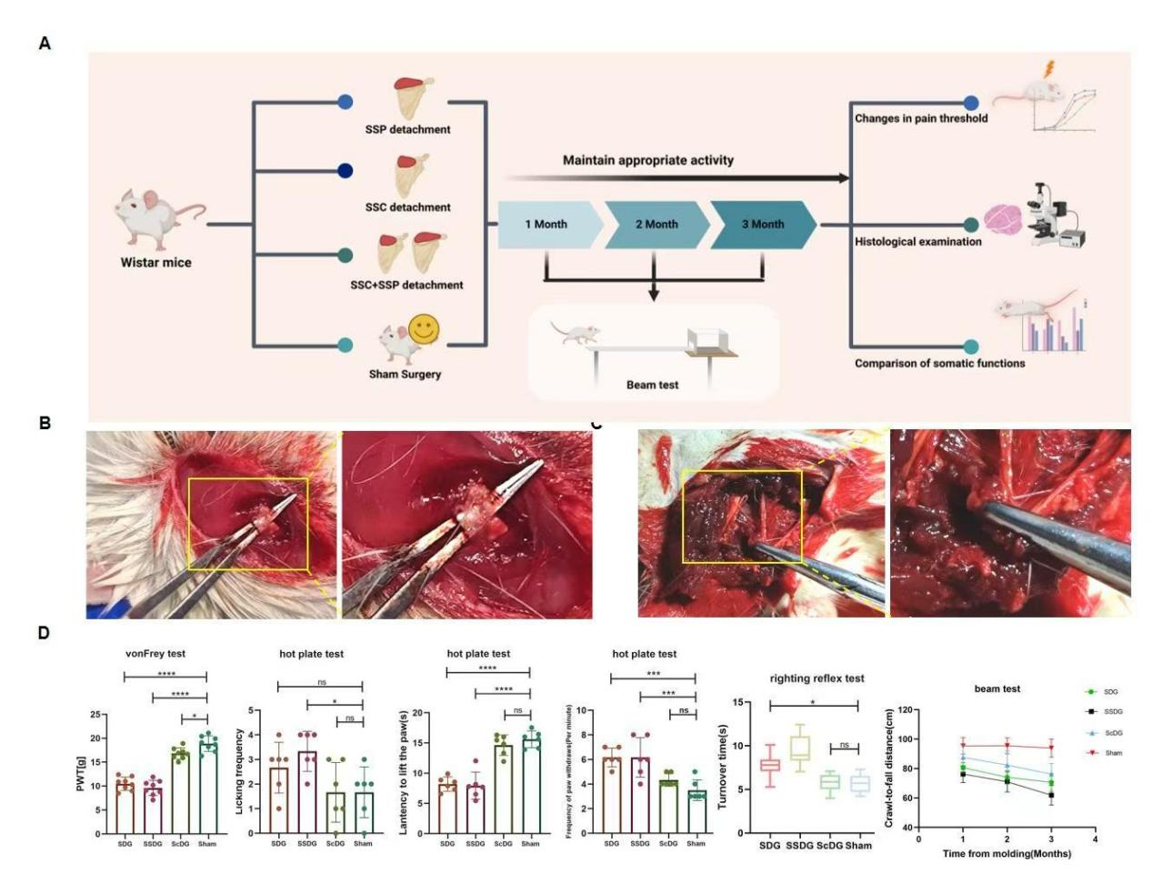
Figure S1. The SDG showed the most stable and pronounced modeling performance (A) Schematic diagram of modeling group and subsequent experimental flow. (B) Rat supraspinatus muscle surgical drawings, enlarged in the yellow box on the right side (C) subscapularis muscle surgical drawings, enlarged in the yellow box on the right side. (D) Analysis of modeling performance data by group.
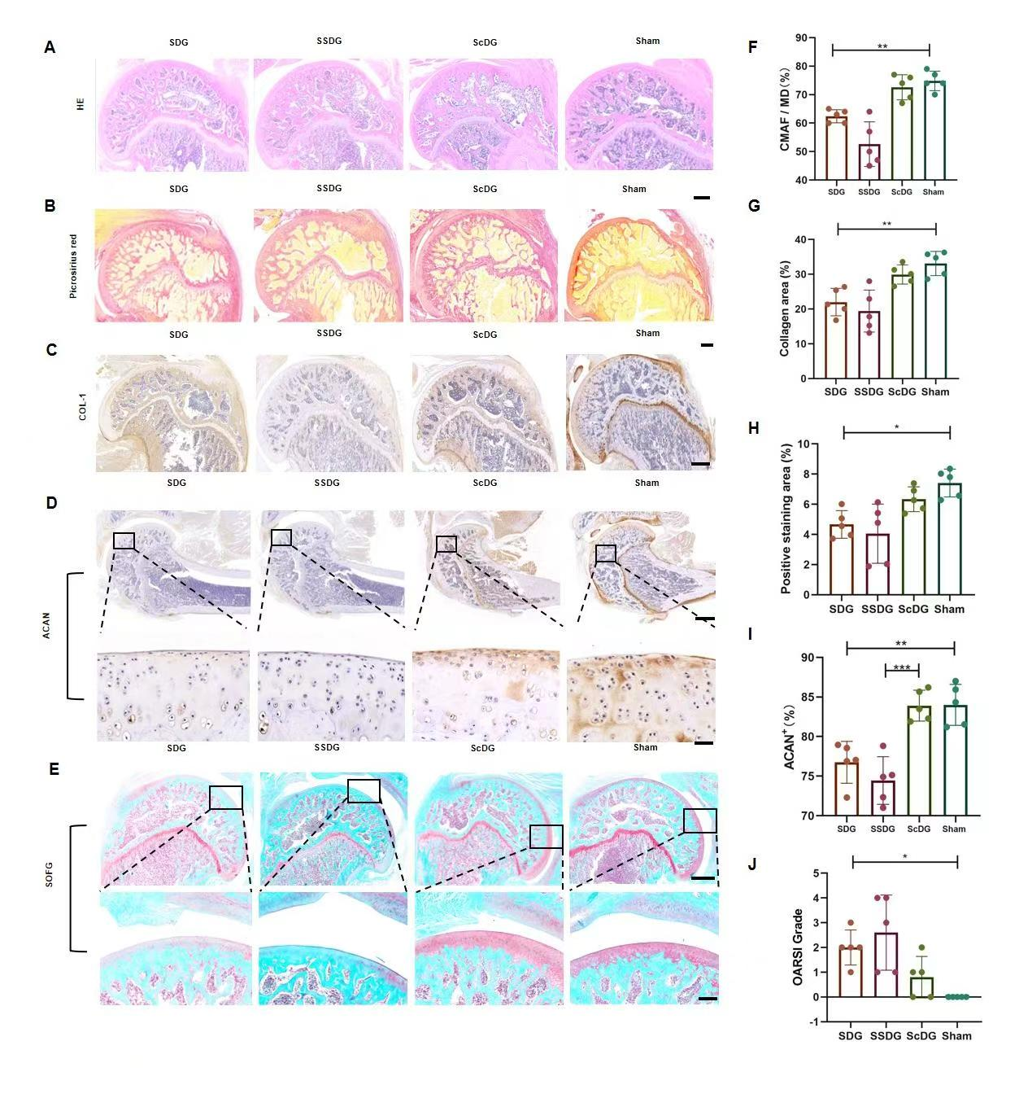
Figure S2. Histological staining of cartilage and tendon injuries in the SDG more closely matches expectations. (A) HE staining of the rotator cuff and humeral head, scale bar: 1 mm. (B) Picrosirius red staining of rotator cuff and humeral head, scale bar: 500 μm. (C) Immunohistochemical COL1(Collagen type I) staining of rotator cuff and humeral head , scale bar: 500 μm. (D) Immunohistochemical ACAN staining of rotator cuff and humeral head , scale bar: 500 μm. (E) SOFG staining of rotator cuff and humeral head, scale bar: 500 μm. (F) Percentage of collagen positive for Sirius red staining. (G) Percentage of positive COL1 staining. (H) Percentage of positive ACAN staining. (I) SOFG staining osteoarthritis grade.
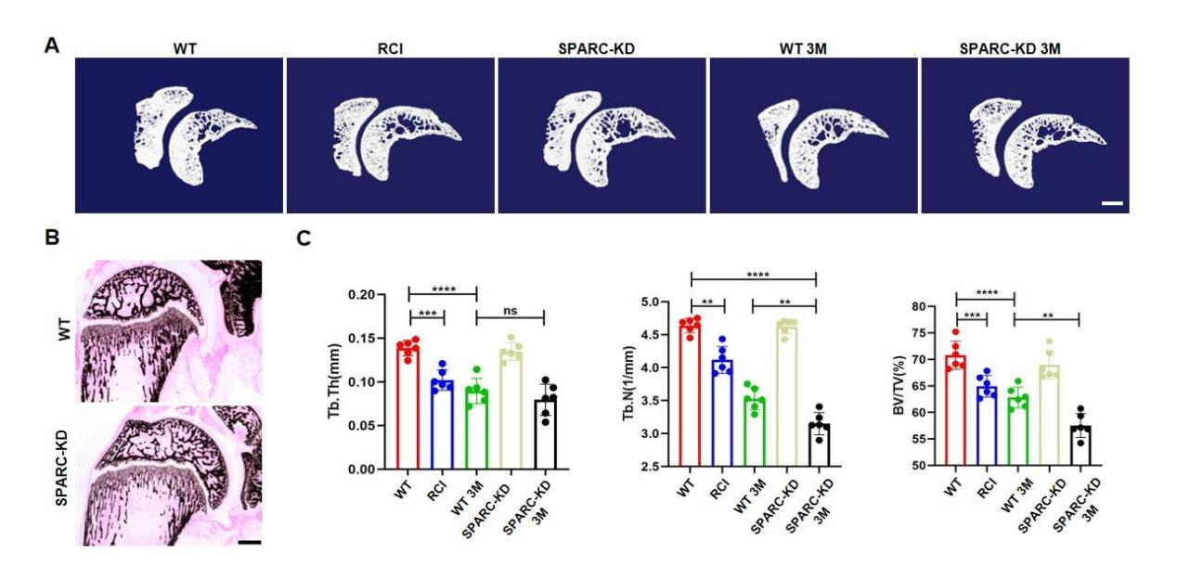
Figure S3. Effects of SPARC on the bones of the rotator cuff joints. (A)µCT analysis. scale bar: 500 µm (B) Comparison of VonKossa staining in WT and SPARC(AAV) rats, scale bar: 1 mm. (C) Quantification of BV/TV, Tb.Th, Tb.N.

