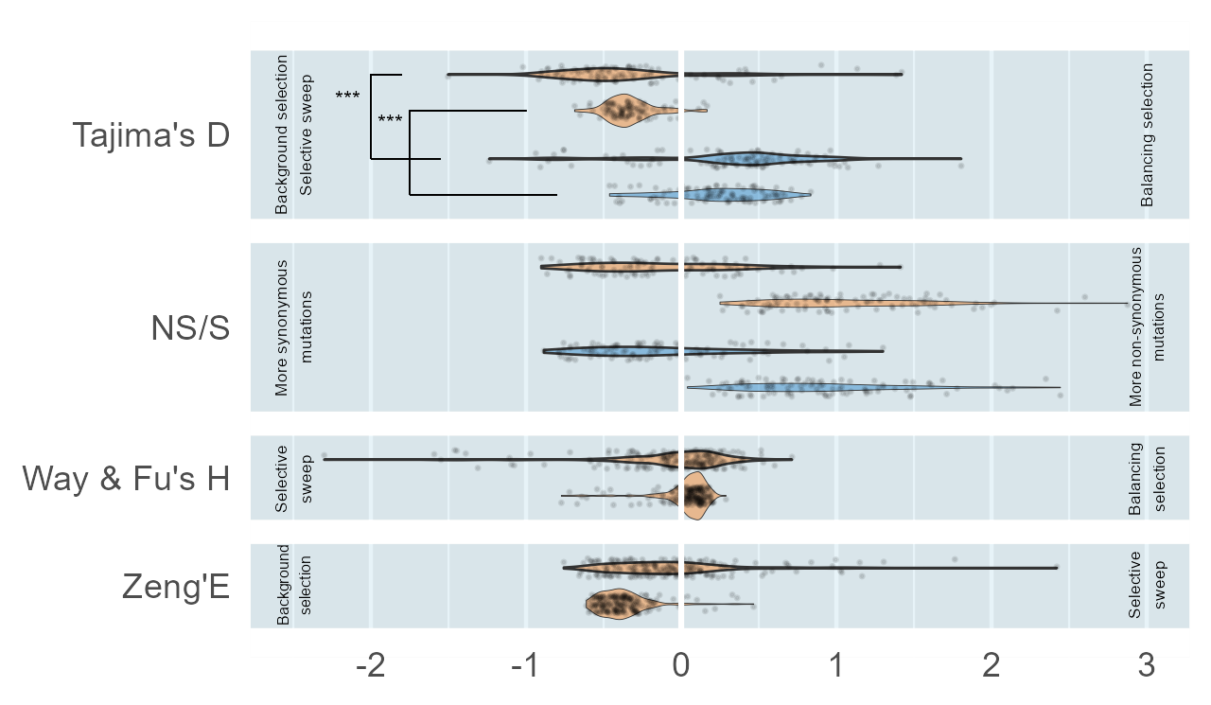
Figure S1. Distribution of values obtained for different population genetic statistics. Values are the mean values for terrestrial (orange) and aquatic (blue) plants within the orthogroups selected by sPLSDA_{D} and sPLSDHA_{NS/S}. The violins surrounded by a thick line were obtained with the scaled values within each species. *** indicate a significant difference between the means (P-value < 0.001). The values for Zeng's E and Way & Fu's H are those associated with genes obtained by the sPLS-DA using either Tajima’s D or NS/S values, indifferently

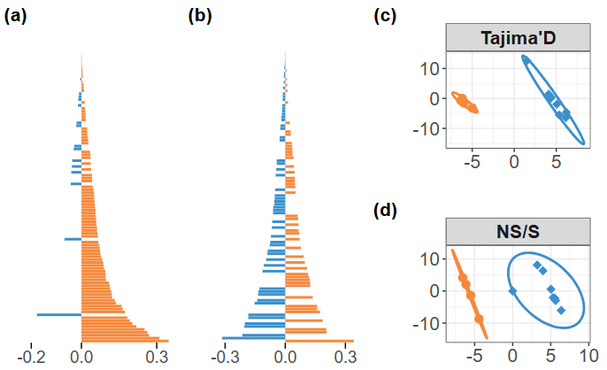
Figure S2. sPLS-DA results obtained from scaled NS/S and Tajima’s D values, between a set of terrestrial and aquatic plants. (a) Overall trend of the results obtained from Tajima’s D values, representing the loadings on the X-variate-1 of the 100 orthogroups associated with the strongest loadings. Blue bars indicate orthogroups where aquatic plants are associated with lower average scaled Tajima’s D values, and orange bars indicate those where terrestrial plants are associated with lower average scaled Tajima’s D values. (b) Same as (a) with NS/S values. (c) Representation of terrestrial (orange) and aquatic (blue) species in the space defined by the first two axes from the sPLS-DA obtained from Tajima's D or (d) NS/S values.

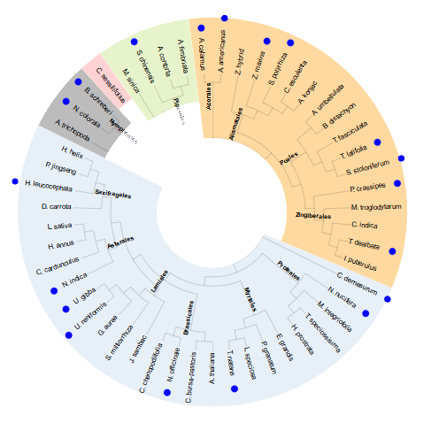

Figure S3. Phylogenetic tree of species used for gene expansion comparison, according to NCBI and APG IV taxonomies. Aquatic species are marked with a blue dot. Orders are written on the branches, and colored backgrounds indicate major clades. Gray = basal angiosperms, pink = Chloranthales, green = Magnoliids, orange = Monocots, blue = Eudicots.

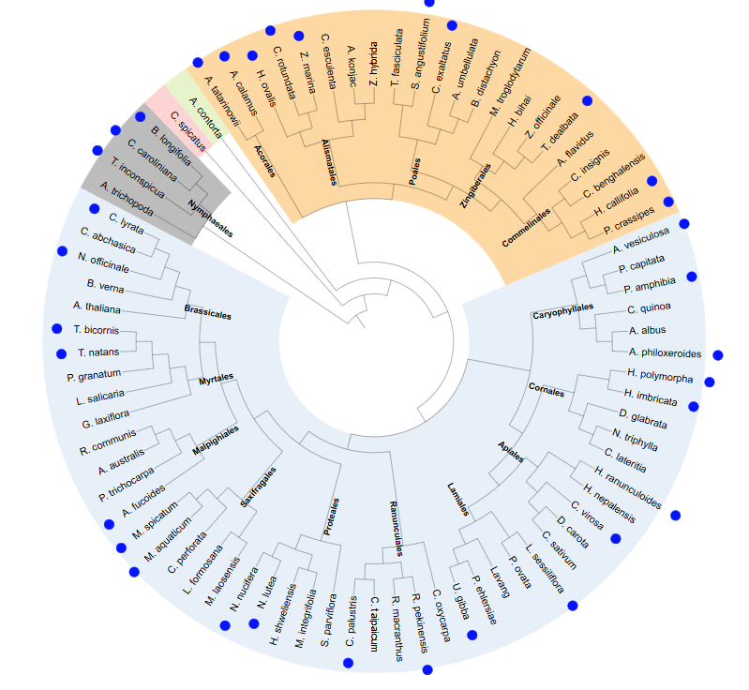
Figure S4. Phylogenetic tree of species used for chloroplast gene evolution comparison, according to NCBI and APG IV taxonomies. Aquatic species are marked with a blue dot. Orders are written on the branches, and colored backgrounds indicate major clades. Gray = basal angiosperms, pink = Chloranthales, green = Magnoliids, orange = Monocots, blue = Eudicots.

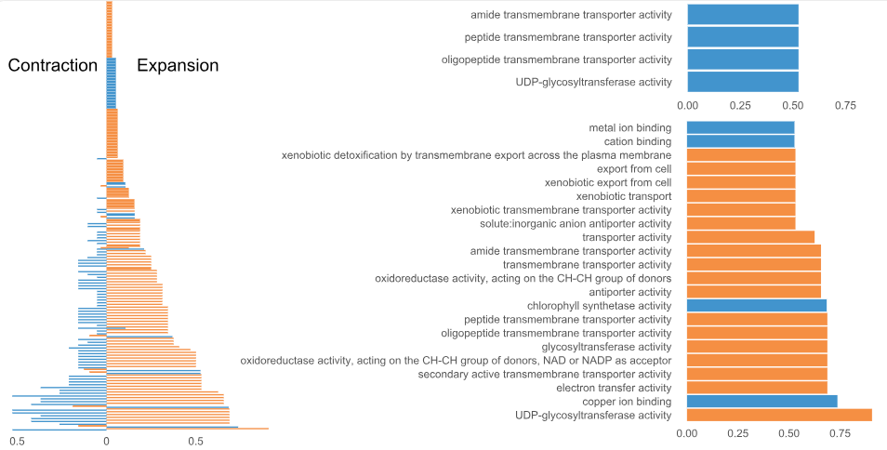
Figure S5. Frequency of GO term enrichments among genes selected by sPLS-DA from the number of orthologs inside each orthogorup. (a) Global contraction and expansion trends among aquatic plants (blue) and terrestrial plants (orange). The X-axis shows the ratio of species for which the term is enriched. (b) Zoom in on the most contracted GO terms. (c) Zoom in on the most expanded GO terms. Note that for clarity, only GO terms with a frequency greater than 0.5 are shown.

