Effect of Molybdenum and Vanadium Substitution in Langbeinite Phosphates: Structural and Thermal Expansion Investigation of KPbCr₂P_{3-x}M_{x}O₁₂ (M = V, Mo and x = 0.1, 0.2)
Daneshwaran Balaji¹, Triveni Rajashekhar Mandlimath², and Sathasivam Pratheep Kumar²*
¹ The Water Research Center, The Hydro-Chemistry Laboratory, Geophysics and Earth Sciences, Raymond and Beverly Sackler Faculty of Exact Sciences, Tel Aviv
University, Tel Aviv, 69978, Israel.
² Department of Chemistry, School of Advanced Sciences, VIT-AP University, Inavolu, Beside AP Secretariat, Amaravati 522241, Andhra Pradesh, India.
ORCID: 0000-0002-8929-7482¹,

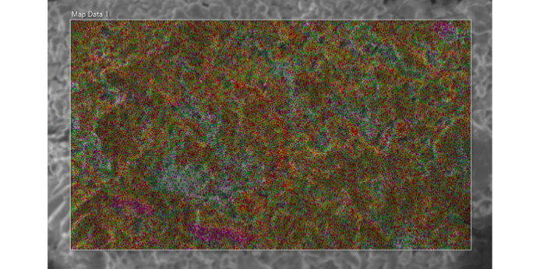
(a) V01: KPbCr₂P_{2.9}V_{0.1}O₁₂

(b) M01: KPbCr₂[P_{2.9}Mo_{0.1}]^{+0.1}O₁₂
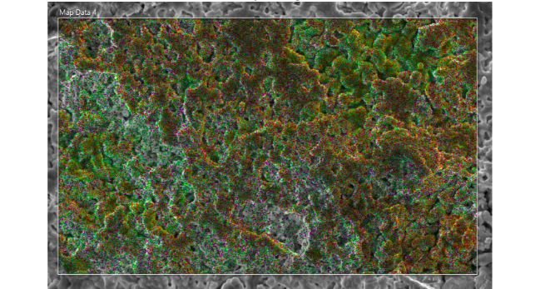

Fig. S1: SEM mappings of (a) V01, (b) M01.

