Supplementary Material

Manuscript: Local changes in individual spider silk fibers from tubuliform and major-ampullate glands under varying humidity and tensile strain
Karolina Peter¹, Michael Sztucki², Sebastian Kalbfleisch³, Manfred Burghammer², Christian Riekel², Jiliang Liu², Sarah Stadlmayr^{4,5}, Aida Naghilou⁵, Leon Ploszczanski¹, Gerhard Sinn¹, Harald Rennhofer¹, Christine Radtke⁵, Helga C. Lichtenegger¹
- Institute of Physics and Materials Science (IPM), BOKU University, Vienna, Austria
- The European Synchrotron, ESRF, CS40220, F-38043 Grenoble Cedex 9, France
- MAX IV Laboratory, Lund University, Lund, Sweden
- Department of Medicine, Huddinge, Stockholm, Sweden
- Department of Plastic, Reconstructive and Aesthetic Surgery, Medical University of Vienna, Vienna, Austria

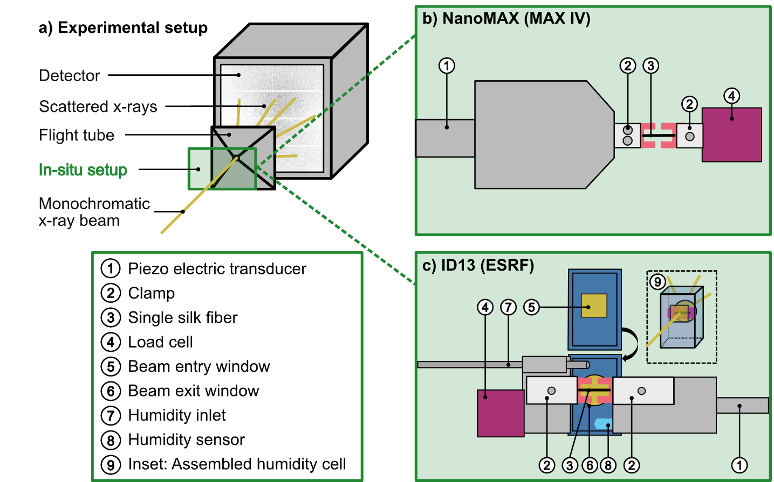
Figure S1 Experimental Setup. (a) General setup with incoming x-ray beam, in-situ setup, flight tube and detector. (b) Sample setup at NanoMAX (MAX IV) with a nanoindenter device used for stretching the fiber. The sample support with the silk fiber is held by a clamping mechanism fixated by screws. (c) Sample setup at ID13 (ESRF) with a stretching setup and a humidity cell with entry and exit window (SI3N4) and humidity inlet and sensor.

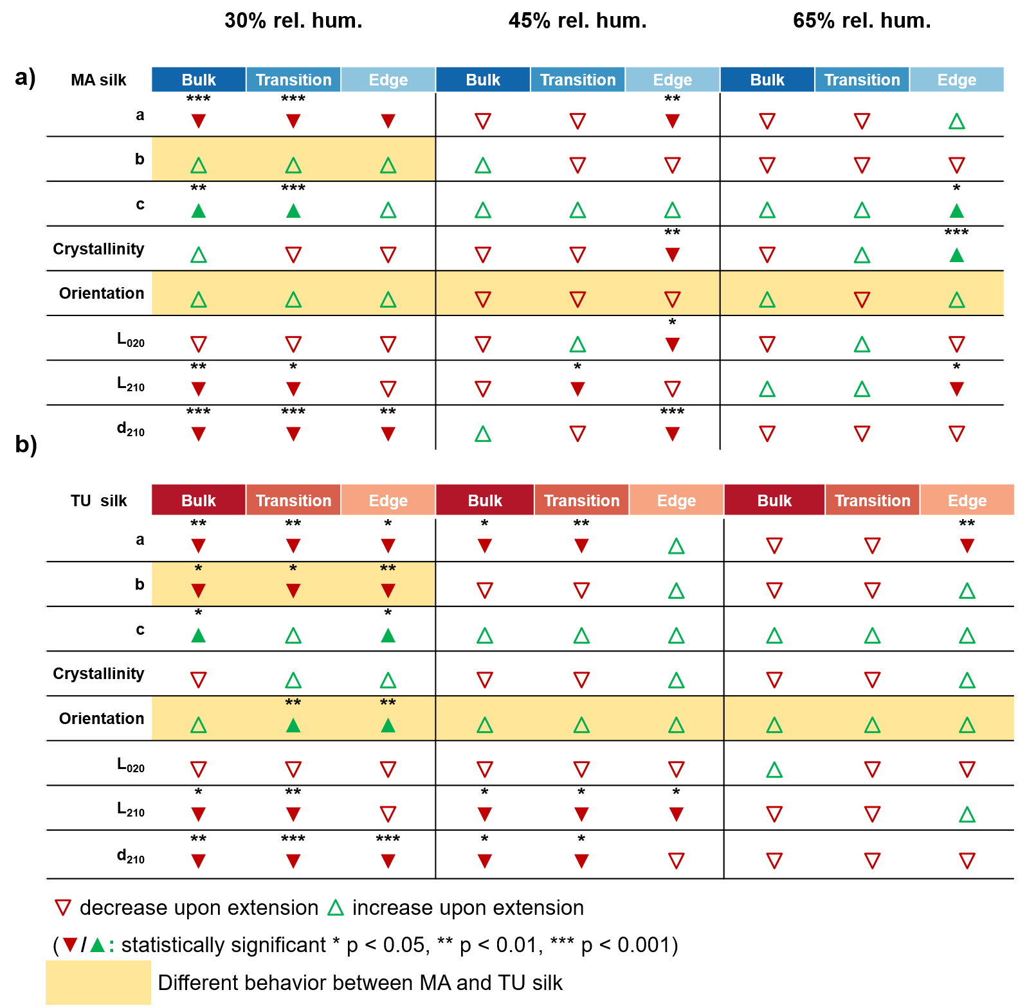
Figure S2 Trends of silk fiber parameters vs. extension. Overview shows the direction and significance of weighted linear regression slopes for each parameter as a function of silk extension, separated by fiber zone and RH. Arrows indicate the direction of the trend (▲increasing, ▼decreasing), and significance levels are indicated by asterisks. Empty arrows mean no significant trend but indicate if slope has a positive or negative number.
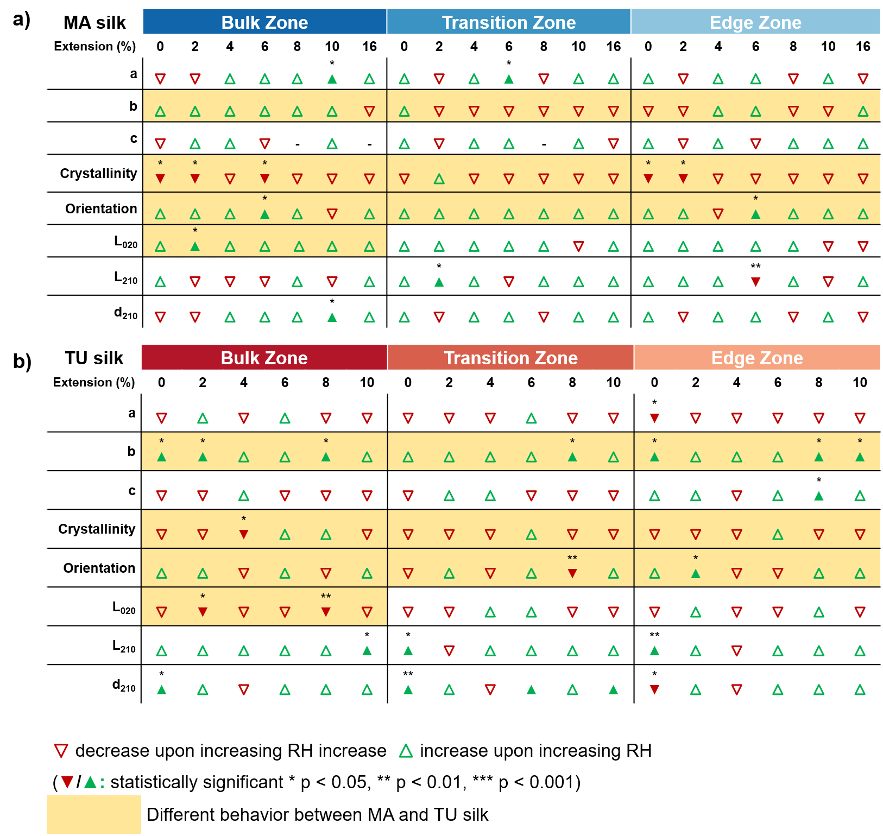
Figure S3 Trends of silk fiber parameters vs. RH. Table shows the direction and significance of weighted linear regression slopes for each parameter as a function of relative humidity, separated by fiber zone and extension step. Arrows indicate the direction of the trend (▲increasing, ▼decreasing), and significance levels are indicated by stars. Empty arrows mean no significant trend but indicate if slope is positive or negative. – means that there were not enough datapoints to perform a statistical analysis.

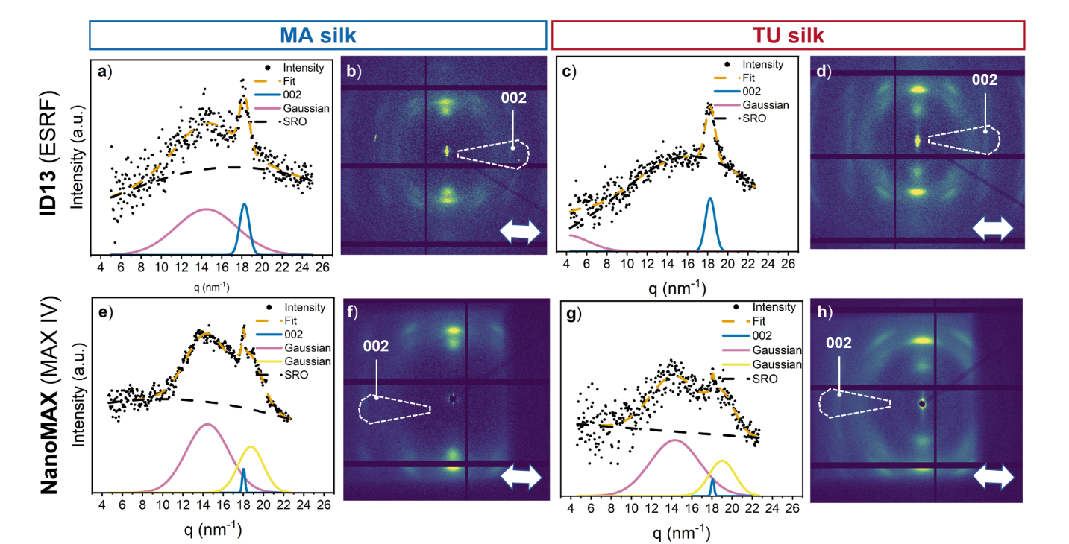
Figure S4 Exemplary Scattering data at 2% extension from a-d) ID13 (ESRF) beamline and e-h) NanoMAX (MAX IV) beamline. A-b) and e-f) are showing data from MA silk, where a) and e) are the 1d scattering curves with Intensity versus scattering vector q and b) and f) are the corresponding 2d scattering patterns. In c-d) and g-h) data from TU silk is displayed. C) and g) are the 1d scattering curves and d) and h) the 2d scattering patterns. In the 1d scatting curves Bragg and short-range-order (SRO) peaks are displayed by Gaussians. The corresponding area in the 2d scattering pattern is indicated by white dashed lines and the corresponding (002) peak as labels. The double-sided white arrow points in the long axis of the silk fiber.
Figure S5 Crystallinity parameter dependent on extension and at different levels of relative humidity (RH). The average values for each zone are separately shown indicated by a color code. All values are mean values ± SD.
Figure S6 Herman’s orientation factor dependent on extension and at different levels of relative humidity (RH). The average values for each zone are separately shown indicated by a color code. All values are mean values ± SD.
Figure S7 L₀₂₀ parameter dependent on extension and at different levels of relative humidity (RH). The average values for each zone are separately shown indicated by a color code. All values are mean values ± SD.

Figure S8 L₂₁₀ parameter dependent on extension and at different levels of relative humidity (RH). The average values for each zone are separately shown indicated by a color code. All values are mean values ± SD.

Figure S9 d₂₁₀ parameter dependent on extension and at different levels of relative humidity (RH). The average values for each zone are separately shown indicated by a color code. All values are mean values ± SD.
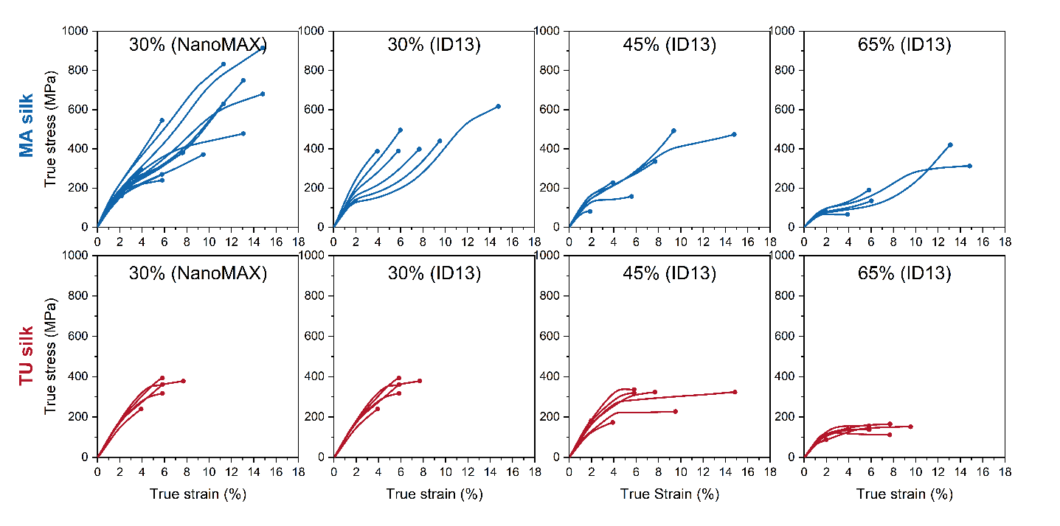
Figure S10 True stress-strain curves from in-situ tensile tests. Dot at the end of each curve indicates the end of the stretching process not rupture of the fiber.
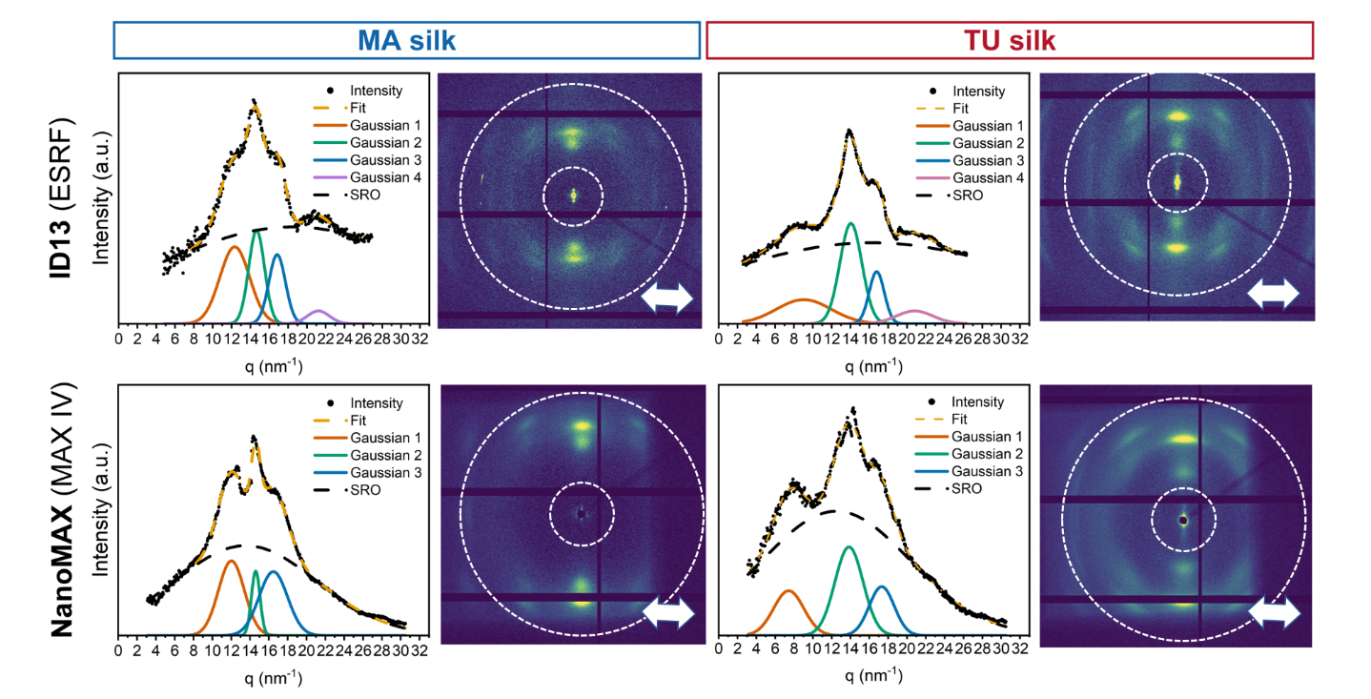
Figure S11 Exemplary Scattering data at 2% extension from a-d) ID13 (ESRF) beamline and e-h) NanoMAX (MAX IV) beamline averaged to calculate a crystallinity parameter. A-b) and e-f) are showing data from MA silk, where a) and e) are the 1d scattering curves with Intensity versus scattering vector q and b) and f) are the corresponding 2d scattering patterns. In c-d) and g-h) data from TU silk is displayed. C) and g) are the 1d scattering curves and d) and h) the 2d scattering patterns. In the 1d scatting curves Bragg and short-range-order (SRO) peaks are displayed by Gaussians. The corresponding area in the 2d scattering pattern is indicated by white dashed lines and the corresponding 020 and 210 peaks as labels.

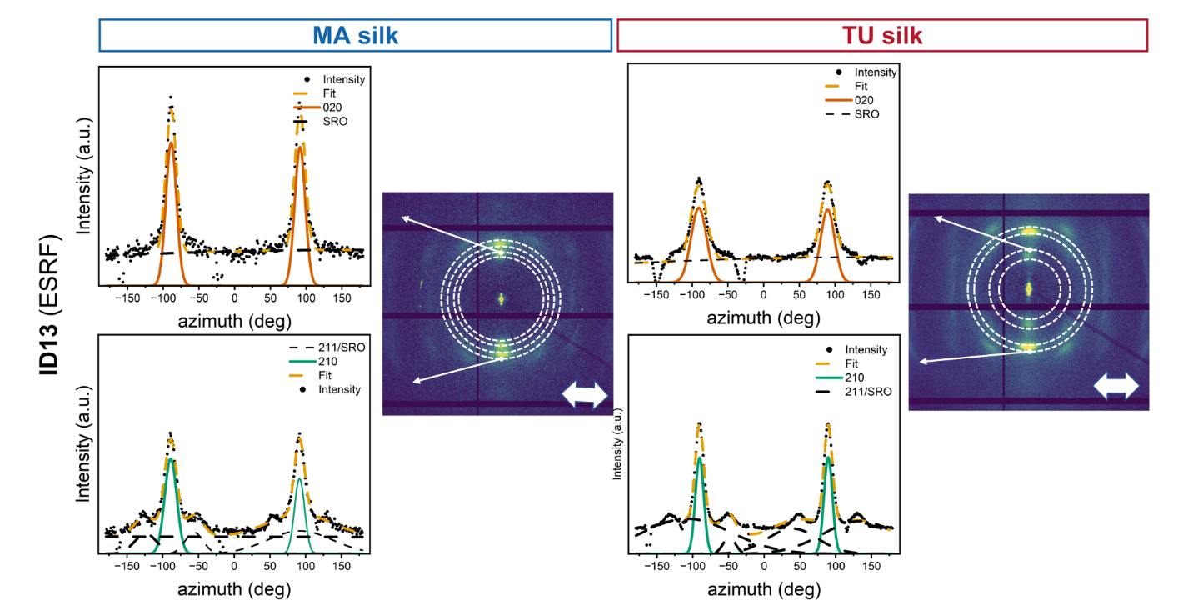
Figure S12 Average scattering intensity versus azimuth (ID13) for MA silk and TU silk for the region with the (020) peak. Gaussian curve is used to fit the (020) peaks and equally the region where the (210) peak. Full-width at half maximum for Herman’s orientation parameter is derived from these.

